
15th International Conference on Strangeness in Quark Matter (SQM2015) IOP Publishing
Journal of Physics: Conference Series 668 (2016) 012022 doi:10.1088/1742-6596/668/1/012022

Strange hadron production at SIS energies: an
update from HADES
M. Lorenz8,f,J. Adamczewski-Musch4, O. Arnold10,9, E.T. Atomssa15,
C. Behnke8, J.C. Berger-Chen10,9, J. Biernat3, A. Blanco2,
C. Blume8, M. Bohmer10, P. Bordalo2, S. Chernenko7, C. Deveaux11,
A. Dybczak3, E. Epple10,9, L. Fabbietti10,9, O. Fateev7, P. Fonte2,a,
C. Franco2, J. Friese10, I. Frohlich8, T. Galatyuk5,6, J. A. Garzon17,
K. Gill8, M. Golubeva12, F. Guber12, M. Gumberidze5,6,
S. Harabasz5,3, T. Hennino15, S. Hlavac1, C. Hohne11, R. Holzmann4,
A. Ierusalimov7, A. Ivashkin12, M. Jurkovic10, B. Kampfer6,c,
T. Karavicheva12, B. Kardan8, I. Koenig4, W. Koenig4, B. W. Kolb4,
- Korcyl3, G. Kornakov5, R. Kotte6, A. Krasa16, E. Krebs8,
- Kuc3,15, A. Kugler16, T. Kunz10, A. Kurepin12, A. Kurilkin7,
P. Kurilkin7, V. Ladygin7, R. Lalik10,9, K. Lapidus10,9, A. Lebedev13,
L. Lopes2, T. Mahmoud11, L. Maier10, A. Mangiarotti2, J. Markert8,
V. Metag11, J. Michel8, C. Muntz8, R. Munzer10,9, L. Naumann6,
M. Palka3, Y. Parpottas14,d, V. Pechenov4, O. Pechenova8,
V. Petousis14, J. Pietraszko4, W. Przygoda3, B. Ramstein15,
L. Rehnisch8, A. Reshetin12, A. Rost5, A. Rustamov8, A. Sadovsky12,
P. Salabura3, T. Scheib8, K. Schmidt-Sommerfeld10, H. Schuldes8,
P. Sellheim8, J. Siebenson10, L. Silva2, Yu.G. Sobolev16, S. Spataroe,
- Strobele8, J. Stroth8,4, P. Strzempek3, C. Sturm4, O. Svoboda16,
A. Tarantola8, K. Teilab8, P. Tlusty16, M. Traxler4, H. Tsertos14,
T. Vasiliev7, V. Wagner16, C. Wendisch4, J. Wirth10,9,
J. Wustenfeld6, Y. Zanevsky7, P. Zumbruch4
(HADES collaboration)
1Institute of Physics, Slovak Academy of Sciences, 84228 Bratislava, Slovakia
2LIP-Laboratório de Instrumentacao e Fisica Experimental de Particulas , Coimbra, Portugal
3Smoluchowski Institute of Physics, Jagiellonian University of Cracow, 30-059 Krakow, Poland
4GSI Helmholtzzentrum fair Schwerionenforschung GmbH, 64291 Darmstadt, Germany
5Technische Universitat Darmstadt, 64289 Darmstadt, Germany
6Institut fur Strahlenphysik, Helmholtz-Zentrum Dresden-Rossendorf, 01314 Dresden, Germany
Joint Institute of Nuclear Research, 141980 Dubna, Russia
8Institut fur Kernphysik, Goethe-Universitat, 60438 Frankfurt, Germany
9Excellence Cluster ’Origin and Structure of the Universe’ , 85748 Garching, Germany
10Physik Department E12, Technische Universitat Munchen, 85748 Garching, Germany
11II.Physikalisches Institut, Justus Liebig Universitat Giessen, 35392 Giessen, Germany
12Institute for Nuclear Research, Russian Academy of Science, 117312 Moscow, Russia
13Institute of Theoretical and Experimental Physics, 117218 Moscow, Russia
14Department of Physics, University of Cyprus, 1678 Nicosia, Cyprus
15Institut de Physique Nucleaire (UMR 8608), F-91406 Orsay Cedex, France
16Nuclear Physics Institute, Academy of Sciences of Czech Republic, 25068 Rez, Czech Republic
17LabCAF. F. Fisica, Univ. de Santiago de Compostela, 15706 Santiago de Compostela, Spain
Content from this work may be used under the terms of the Creative Commons Attribution 3.0 licence. Any further distribution
of this work must maintain attribution to the author(s) and the title of the work, journal citation and DOI.
1
Published under licence by IOP Publishing Ltd
15th International Conference on Strangeness in Quark Matter (SQM2015) IOP Publishing
Journal of Physics: Conference Series 668 (2016) 012022 doi:10.1088/1742-6596/668/1/012022
a also at ISEC Coimbra, Coimbra, Portugal
b also at ExtreMe Matter Institute EMMI, 64291 Darmstadt, Germany
c also at Technische Universitat Dresden, 01062 Dresden, Germany
d also at Frederick University, 1036 Nicosia, Cyprus
e also at Dipartimento di Fisica and INFN, Universita di Torino, 10125 Torino, Italy
f also at Utrecht University, 3584 CC Utrecht, The Netherlands
E-mail: m.lorenz@gsi.de
Abstract. We present and discuss recent experimental activities of the HADES collaboration
on open and hidden strangeness production close or below the elementary NN threshold. Special
emphasis is put on the feed-down from 0 mesons to antikaons, the presence of the S- excess in
cold nuclear matter and the comparison of statistical model rates to elementary p+p data. The
implications for the interpretation of heavy-ion data are discussed as well.

1. Introduction
In the last two decades strange hadrons have been considered to represent particularly suitable
probes of the high density phase of nuclear matter produced in relativistic heavy-ion collisions.
For example, the relation of subthreshold-produced K+ in light and heavy systems has been
connected to the nuclear equation of state (EOS) at up to three times nuclear saturation [1, 2, 3],
while phase space distributions and flow patterns are considered to be sensitive to the in-medium
kaon-nucleon potential [4, 5, 6, 7].
Various aspects of strangeness production at energies available the Schwerionen Synchrotron
(SIS) at GSI Darmstadt (up to kinetic beam energies of 2 A GeV) have been investigated by
the FOPI and KaoS experiments and lately also by HADES (for reviews see [8, 9]). In contrast
to strange particle production in elementary NN collisions, in heavy ion reactions multi-step
processes as well as strangeness-exchange reactions like nA ^ NK- are possible. Hence for
any detailed understanding of strangeness production one has also to understand strangeness
dynamics in the hot and dense medium. It is therefore important to measure as many particles
with open or hidden strangeness as possible. Only recently data from FOPI [10] and HADES
[11] has come close to fulfilling this requirement, and several still puzzling aspects have been
revealed, e.g.:
- The strength of the kaon-nucleon potential, as derived from the comparison of data to
models, yields values varying by about 50% for different data samples [12, 13, 14].
- The discovery of neutron stars with masses larger than 1.5 solar masses [15, 16] challenges
the previously extracted constraints on the softness of the EOS [17].
- The large 0/K- ratio reported in [18, 19] and the resulting feed-down which affects
significantly the slope of the K- questions the common interpretation of a later freeze-
out of the K- compared to K + [20]. In addition, new mechanisms seem to be required to
reproduce microscopically the enhanced 0 production [21, 22].
- Although transport codes do not reach chemical equilibrium within the lifetime of such
collisions [9], the yields of produced hadrons can be well described within the framework of
statistical models [11, 23], except for the 2- (see below).
- The deep-subthreshold production of the 2- which exceeds thermal model predictions by
an order of magnitude [24, 25], can up to now, only be reproduced by one model [26].
In this paper we will review and investigate the status of the last three aspects.

2. Antikaons: slopes, yields and freeze-out
Systematic investigations of the KaoS collaboration in the nineties revealed a similar rise of
kaon and antikaon yields with increasing centrality of the collision. In addition, the inverse
slope parameters of the antikaons obtained from transverse spectra are systematically lower
2
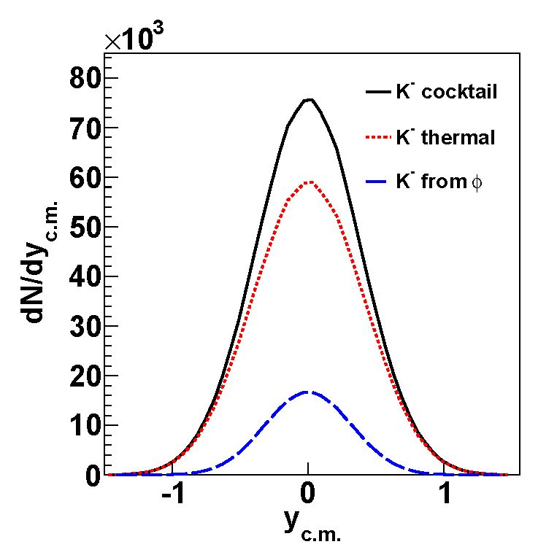
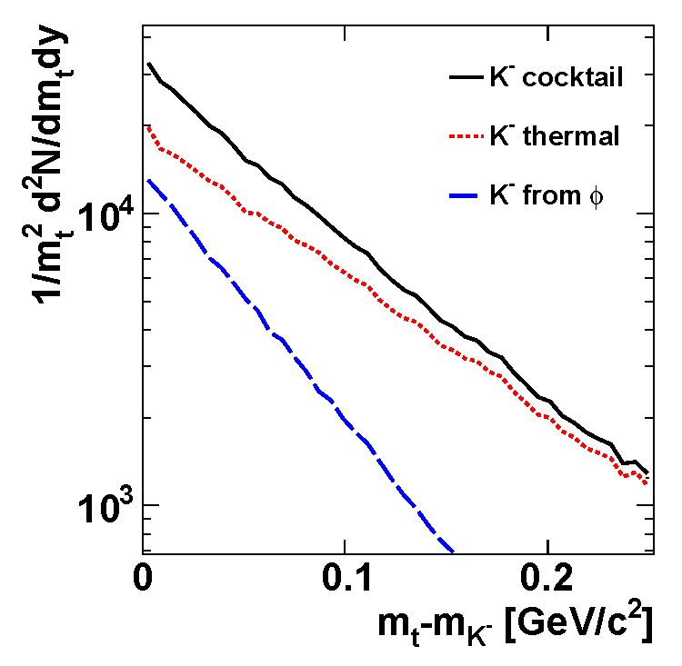
15th International Conference on Strangeness in Quark Matter (SQM2015) IOP Publishing
Journal of Physics: Conference Series 668 (2016) 012022 doi:10.1088/1742-6596/668/1/012022
Figure 1. Left panel: Normalized rapidity density distributions of the thermal K- and the
ones resulting of a 0 according to the measured yields in [19] . The black solid line shows the
sum of the two distributions. Right panel: Simulated transverse mass spectra for K- coming
from a thermal source with a temperature of 89 MeV and those which stem from a 0 decay.
The resulting cocktail spectrum is shown as a black solid line.
than those observed for the kaons [8]. These findings have been interpreted with the help
of transport models and the following conclusion has been drawn: the production of kaons
and antikaons is coupled via strangeness exchange reactions, e.g. n- + A ^ p + K-. As a
consequence, the antikaons experience a later freeze-out than the kaons and hence have steeper
transverse spectra. Furthermore people concluded that strangeness production close or below the
elementary nucleon-nucleon (NN) threshold is very different to the one in elementary reactions
[9]. The antikaon abundance has also been connected to the reduction of the effective antikaon
mass via the strength of the strangeness exchange channels with an antikaon in the final state
in [27].
Newer data from FOPI and HADES showed that for energies around jsnn = 2.6 GeV the
fraction of antikaons originating from a decay of the 0 meson is about 20% and is hence not
negligible [18, 19]. The resulting effect of the 0 meson feed-down on the antikaon slopes has
first been investigated in our previous work [20]. Simulating a cocktail of thermal and antikaons
resulting from 0 meson feed-down, according to the measured contributions in the Ar+KCl
system, we found that within errors the inverse slope of the resulting K- spectra agrees with
the experimentally observed one, see Fig. 1. Hence the different slopes of the kaon and antikaon
spectra do not necessarily call for a sequential freeze-out of the two kaon species but can be
explained solely by 0 feed-down. Meanwhile this issue has been investigated in greater detail by
the FOPI collaboration [28].
Preliminary HADES Au+Au data taken at jsNN = 2.4 GeV, where the complete set of particles
carrying open and hidden strangeness is produced below the free nucleon-nucleon threshold,
indicate a strong rise of the 0/K- ratio towards lower energies [29], as predicted in a statistical
model calculation [19]. For minimization of systematic errors due to efficiency corrections and
extrapolations in rapidity, ratios of the corrected yields at mid-rapidity are used in this analysis.
The resulting K-/K + ratio can be directly compared to the previously obtained systematics
at similar energy. The measured ratio K-/K + fits into the trend observed at higher energies
and extrapolated down to the beam energy of 1.23 A GeV, see left side of Fig.2: The 0/K-
3
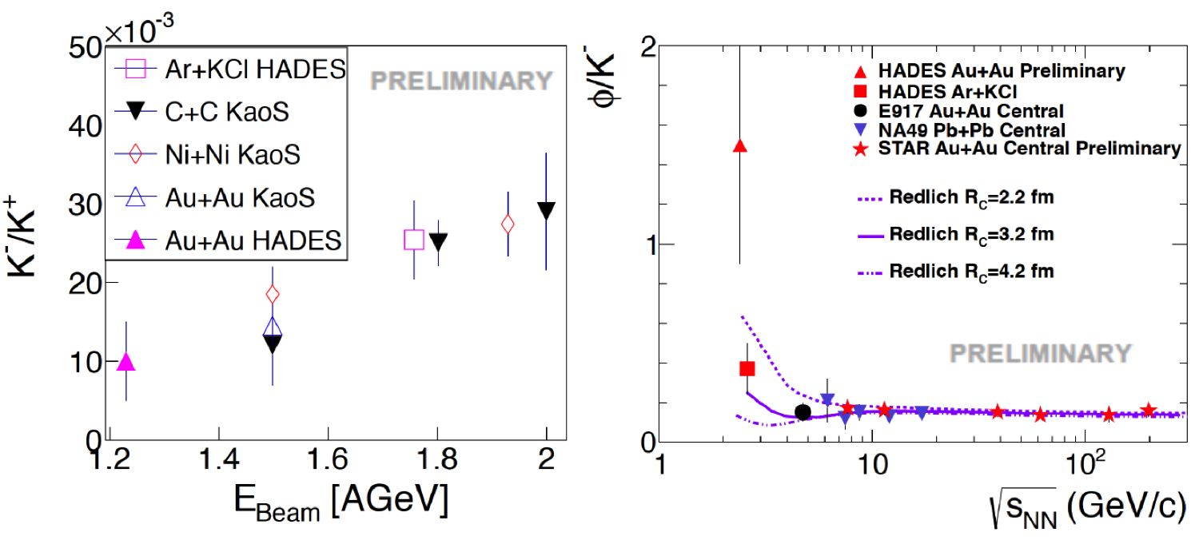
15th International Conference on Strangeness in Quark Matter (SQM2015) IOP Publishing
Journal ofPhysics: Conference Series 668 (2016) 012022 doi:10.1088/1742-6596/668/1/012022
ratio is displayed on the right side of Fig.2; it shows a flat trend at high energies, and a rise
towards lower energies. This rise can be reproduced in the framework of a statistical model,
if the suppression of strangeness is handled by introducing a strangeness correlation radius Rc
within which strangeness has to be exactly conserved [30]. In this context it is important to
realize that, as the ^ conserves strangeness by definition, it is not suppressed by the strangeness
correlation parameter in contrast to the other particles containing strange quarks.
Recently, feed down from higher lying baryonic resonances have been included in UrQMD in
order to be able to describe the energy dependence of the - ratio also in a transport code [31].
The authors tuned the mass depending branching ratio of high lying baryon resonances, namely
the N*(1990), N*(2080), N*(2190), N*(2220) and N*(2250), in a transport code to match
elementary data on (f) meson production. As a result, the - in Ar+KCl is successfully
reproduced, as well as the shape of the excitation function. At higher energies the model
undershoots the data and the preliminary Au+Au data point is also not fully reproduced.
It will be very interesting, as soon as the final data becomes available, to compare besides the
pure yields, the shape of the transverse particle spectra, as they are strongly dependent on the
contribution from resonances as investigated in [32] for kaons with respect to the sensitivity of
the spectral shape to the kaon nucleon potential.
Figure 2. Left: Kinetic beam energy excitation function of the K-/K+ ratio for various
colliding systems. Data is taken from [8, 19]. The preliminary ratio at midrapidity extracted in
this work, fits nicely to the trend. Right: The 0/K- ratio shows a flat trend at high energies
and a sharp rise towards lower energies, which can be explained within the statistical model
framework using a proper strangeness correlation radius Rc. The data is taken from [19].

3. Statistical equilibrium rates
In the last 30 years statistical hadronization models have been established as a successful tool
to fit particle yields or yield ratios from relativistic and ultrarelativistic heavy-ion collisions
[33, 34, 35] with only a few parameters. The extracted freeze-out parameters show a striking
regularity, lining up on a curve in the temperature-baryochemical potential plane, connecting
smoothly data from the GeV to the TeV regime [36] . These findings have been widely inter-
preted as a hint that (local) chemical equilibrium is achieved in such collisions.
Since the days of Hagedorn [37], statistical methods have also been used to predict particle
production in elementary reactions. Recently two groups applied the same model, which suc-
cessfully describes hadron yields in heavy-ion collisions, also for elementary reactions but reached
very different conclusions. While the authors of [38, 39] found good agreement for yields and
even transverse momentum spectra obtained in elementary e+ + e-, the authors of [40] found
significantly worse agreement between model and experimental yields.
4
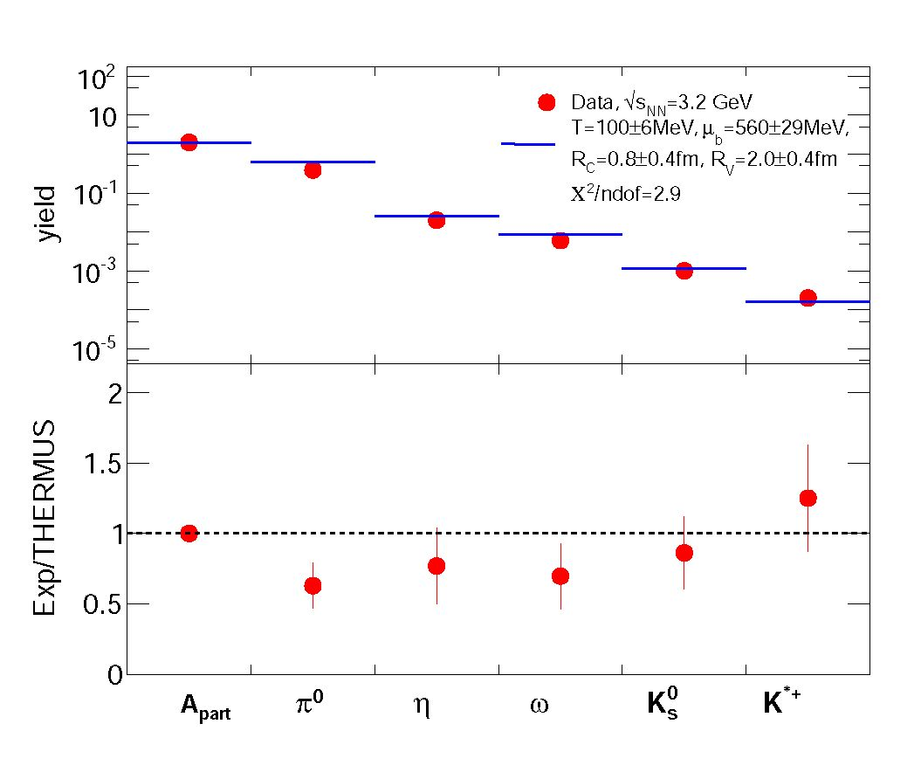
15th International Conference on Strangeness in Quark Matter (SQM2015) IOP Publishing
Journal of Physics: Conference Series 668 (2016) 012022 doi:10.1088/1742-6596/668/1/012022
Figure 3. The up-
per plot shows the
yields of secondary
hadrons in p+p re-
actions (filled red
circles) and the cor-
responding THER-
MUS fit values (blue
bars) as well as the
obtained fit param-
eters. The lower
plot shows the ratio
of the experimental
value and the statis-
tical model value.
In order to investigate this issue, we use the yields of hadrons produced in elementary p+p
collisions at jsnn = 3.2 GeV measured with HADES, which have recently become available
[41, 42, 43]. We apply a similar fit as in our previous work [11] but use an updated version
of THERMUS (v3.0) [44]. We use the mixed canonical ensemble where strangeness is exactly
conserved while all other quantum numbers are calculated grand canonically and constrain the
charge chemical potential ^q using the ratio of the baryon and charge numbers of the collision
system.
We state that the yield of the 0 meson is of particular interest, because of its different sensi-
tivity to the strangeness suppression parameters ys and Rc. As the 0 conserves strangeness by
definition as a ss state its yield is not suppressed in the Rc formalism, while strongly suppressed
when Ys is used. We found in [11] that the 0 yield is well described using Rc and therefore stick
to this way of suppressing strange particle yields in our statistical model calculations.
We simultaneously fit the yields of the neutral pions, the n, the w and the kaons, as well as
the mean number of participants (Apart) and constrain the charge chemical potential ^q by the
initial charge to baryon ratio. We find the following values for chemical freeze-out parameters:
Tchem = (100 ± 6) MeV, ^b = (560 ± 29) MeV, the strangeness correlation radius results as
Rc = (0.8 ± 0.4) fm and the radius of the whole fireball R = (2.0 ± 0.4) fm with %2/d.o.f.=2.9.
A detailed comparison of the data with our the statistical model fit is shown in the upper part
of Fig. 3, while the lower part of this figure depicts the ratio of data. The overall agreement
between model and data is comparable to the outcome of our previous work where we fitted
hadron yields obtained from Ar+KCl collisions at jsNN = 2.6 GeV. This is rather surprising
as one naively expects a larger amount of thermalization in the larger Ar+KCl system and
hence less deviation from statistical equilibrium values. Furthermore, the p+p freeze-out point
fits quite well to the previously observed regularity of freeze-out points in the T — plane,
displayed in Fig. 4, where the extracted point of this work are displayed together with similar
points extracted in [45] and [36].
This brings us back to the introduction; while the success of the statistical model in describing
particle rates from heavy-ion collision is often implicitly connected to a thermalization of the
created system, the success of the model in describing the p+p data at jsNN = 3.2 GeV strongly
questions this connection.
5
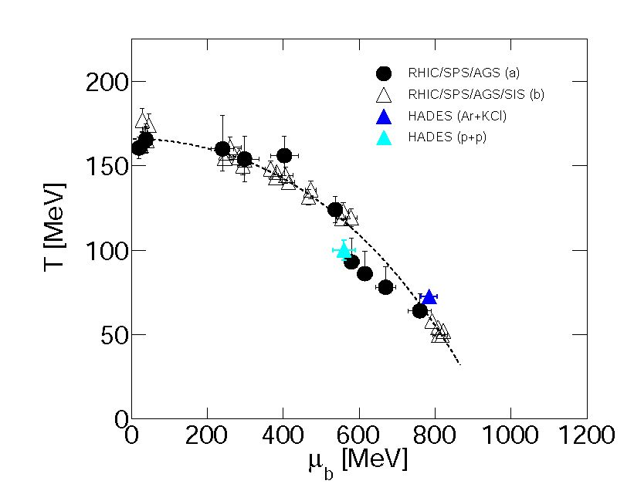
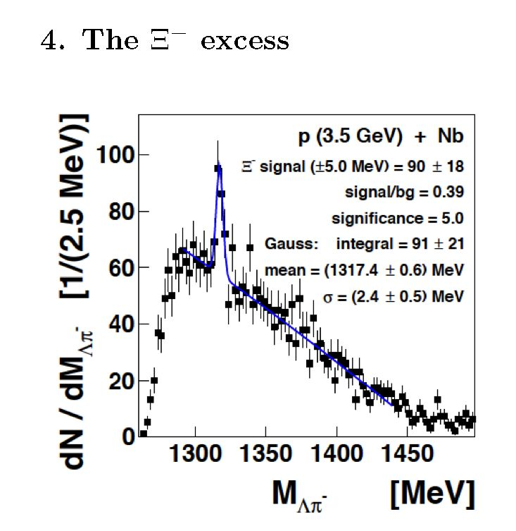
15th International Conference on Strangeness in Quark Matter (SQM2015) IOP Publishing
Journal ofPhysics: Conference Series 668 (2016) 012022 doi:10.1088/1742-6596/668/1/012022
Figure 4. Freeze-out points in
the T — plane obtained from
statistical model fits to hadron
yields or yield ratios [45] (filled
symbols) and [36] (open symbols).
In addition, the HADES points for
Ar+KCl [11] (blue triangle) and the
p+p point (cyan triangle) from this
work are displayed. The dotted line
corresponds to a common freeze-
out condition of 1 GeV fixed energy
per baryon.
Figure 5. Invariant mass spec-
trum of A hyperons and negative
pions obtained in p+Nb collisions
at y/sNN = 3.2 GeV. A clear peak
corresponding to the s- signal is
visible.
Recent data of HADES revealed that the excess of the S- over several state of the art models
shows up also in p+Nb reactions at jsnn = 3.2 GeV [46]. The extracted experimental signal in
the invariant mass spectrum is displayed in Fig. 5. In addition, the energy excitation function
of the S- Lambda ratio for various colliding systems is displayed in Fig. 6. While the open
symbols correspond to heavy-ion data, the filled symbols represent proton induced collisions on
nuclei. The black line corresponds to a simple parameterization fitted to the proton induced
data of the form
t r ig\h
f(jsnn) = C x ^ -[j^J j . (1)
The inlay shows a zoom to the area of the HADES p+Nb data point and the comparison to three
different models. The upper star symbol corresponds to the yield obtained from a THERMUS
(v2.3) fit to p+Nb data similar to the one discussed in this work. While the lower star symbol
corresponds to the yield obtained via the UrQMD (v3.4) transport code, the intermediate point
results from a GiBUU transport calculation.
The presence of the s- excess in cold nuclear matter has several interesting implications for the
interpretation of the heavy-ion data as its origin seems to be already in the elementary channels
without the involvement of many body effects in the medium [26, 47]. Therefore, the increased
cross sections of strangeness exchange reactions, which were found to be sufficient to explain the
high yield in, seem to be questionable as they are highly unlikely to play an important role in
6
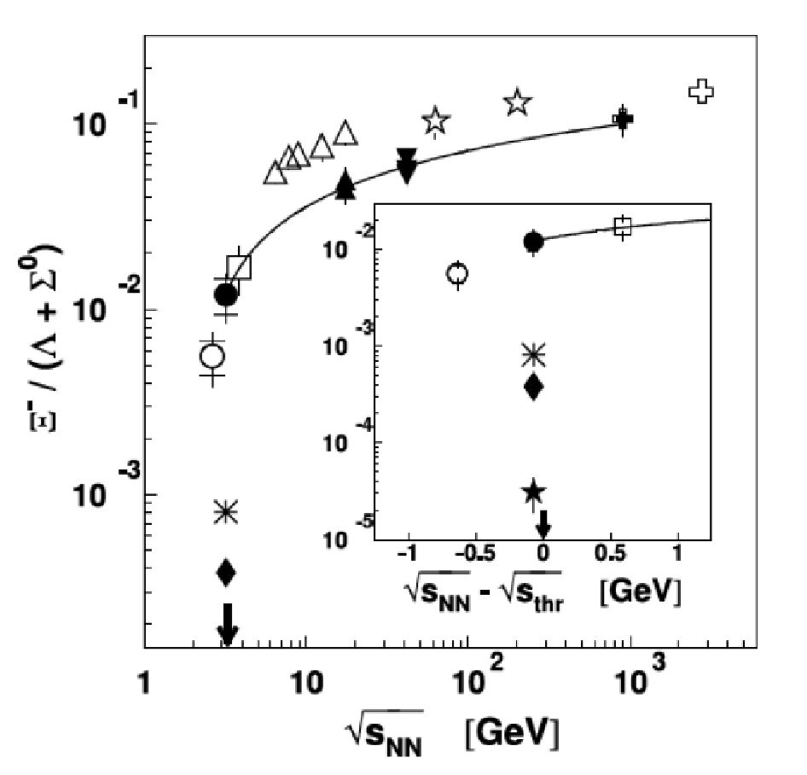
15th International Conference on Strangeness in Quark Matter (SQM2015) IOP Publishing
Journal of Physics: Conference Series 668 (2016) 012022 doi:10.1088/1742-6596/668/1/012022
p+Nb reactions. Also, the invoked [23] catalytic strangeness production by secondary processes
like n + Y ^ 2 + K are strongly suppressed in cold nuclear matter.
Figure 6. Excitation function of the
5-/A ratio for various colliding systems.
The open symbols correspond to heavy-ion
data, the filled symbols represent data from
p+A collisions. The black line corresponds
to a simple parameterization fitted to the
p+A data, see text for details. The inlay
shows a zoom to the area of the HADES
p+Nb data point and the comparison to
three different models. The upper star
symbol corresponds to a the yield obtained
from a THERMUS (v2.3) fit to p+Nb
data. The lower star symbol corresponds
to the yield obtained via the UrQMD (v3.4)
transport code and the intermediate point
a GiBUU transport calculation.
Recently the same mechanism of feed-down of the high invariant mass tails of baryonic res-
onances used to explain the 0 meson yield by the UrQMD group was also used for the 2-
hyperon. Due to the lack of elementary data the model is tuned to match our p+Nb data [32].
After this tuning it is not too surprising that the model is able to describe the excess observed
in Ar+KCl without further tuning.
The technique of mass dependent branching ratios for broad resonances has been successfully
applied in order to describe the dilepton spectra at low energies as pointed out in several pub-
lications [48, 49]. Note, how even that tuned branching ratios are still consistent with the OZI
rule there is yet no experimental evidence for the decay of the N* resonance to final states
containing a 0 meson or a 2 hyperon.
5. Summary
We showed that for all three topics discussed here elementary and cold nuclear matter data are
needed for the interpretation of heavy-ion data. In particular:
- The observed large 0/K- ratio and the resulting feed-down lowers significantly the slope of
the K- . Hence a later freeze-out of antikaons compared to kaons is not necessarily needed
to explain the different slopes of both kaon species. Furthermore, the rise towards lower
energies can also be reproduced, at least to some extent, in transport codes after tuning of
the 0 cross sections on elementary data.
- We find that a statistical model fit to elementary p+p data is able to describe the yields
with the same parameters as used for Ar+KCl with comparable accuracy and this questions
the often implicitly used connection to a thermalized system.
- The presence of the 2- excess also in cold nuclear matter rules out more exotic explanations
involving multistep processes in heavy-ion collisions. Feed-down from high mass tails of
baryonic resonances remains a possible explanation but at the moment it is not very well
constrained by both the experimental data and the theoretical treatment.
The collaboration gratefully acknowledges support by PTDC/FIS/113339/2009 (LIP
Coimbra), NCN grant 2013/10/M/ST2/00042 (SIP JUC Cracow), Helmholtz Alliance
7
15th International Conference on Strangeness in Quark Matter (SQM2015) IOP Publishing
Journal of Physics: Conference Series 668 (2016) 012022 doi:10.1088/1742-6596/668/1/012022
HA216/EMMI (GSI Darmstadt), VH-NG-823, Helmholtz Alliance HA216/EMMI (TU
Darmstadt), 283286, 05P12CRGHE (HZDR), Helmholtz Alliance HA216/EMMI, HIC for
FAIR (LOEWE), (GSI F&E Goethe-University Frankfurt) VH-NG-330, BMBF 06MT7180
(TU Munchen), Garching BMBF:05P12RGGHM (JLU Giessen, Giessen) UCY/3411-23100
(University Cyprus) CNRS/IN2P3, (IPN Orsay), Orsay MSMT LG 12007, AS CR M100481202,
GACR 13-06759S NPI AS CR, Rez, EU Contract No. HP3-283286. One of us (M.L.)
acknowledges the support of the Humboldt Foundation.
- C. Sturm et al. [KaoS Collaboration], Phys. Rev. Lett. 86, 39 (2001).
- C. Fuchs, A. Faessler, E. Zabrodin, Phys. Rev. Lett. 86, 1974 (2001).
- C. Hartnack, H. Oeschler, J. Aichelin, Phys. Rev. Lett. 96, 012302 (2006).
- J. Schaffner-Bielich, J. Bondorf, A. Mishustin, Nucl. Phys. A 625, 325 (1997).
- W. Cassing, E. L. Bratkovskaya, U. Mosel, S. Teis, A. Sibirtsev, Nucl . Phys. A 614 415 (1997).
- L. Adamczyk et al. [STAR Collaboration], Phys. Rev. Lett. 110 142301 (2013).
- V. Zinyuk et al. [FOPI Collaboration], arXiv:1403.1504 [nucl-ex].
- A. Forster, F. Uhlig, I. Bottcher, D. Brill, M. Debowski et al., Phys. Rev. C 75 024906 (2007).
- C. Hartnack, H. Oeschler, Y. Leifels, E. L. Bratkovskaya, J. Aichelin, Phys. Rept. 510 119 (2012).
- N. Bastid et al. [FOPI Collaboration], Phys. Rev. C 76 024906 (2007).
- G. Agakishiev et al. [HADES Collaboration], Eur. Phys. J. A 47 21 (2011).
- M. L. Benabderrahmane et al. [FOPI Collaboration], Phys. Rev. Lett. 102 182501 (2009).
- G. Agakishiev et al. [HADES Collaboration], Phys. Rev. C 82 044907 (2010).
- G. Agakishiev et al. [HADES Collaboration], arXiv:1404.7011 [nucl-ex].
- P. Demorest et al., Nature 476, 1081 (2010).
- J. Antoniadis et al., Science 340, 6131 (2013).
- A. W. Thomas et al., EPJ Web of Conferences 63, 03004 (2013).
- A. Mangiarotti et al. [FOPI Collaboration], Nucl. Phys. A 714 89 (2003).
- G. Agakishiev et al. [HADES Collaboration], Phys. Rev. C 80 025209 (2009).
- M. Lorenz et al. [HADES Collaboration], PoS BORMIO 2010 038 (2010).
- B. Tomasik and E. E. Kolomeitsev, Acta Phys. Polon. Supp. 5 201 (2012).
- B. Kampfer, R. Kotte, C. Hartnack, J. Aichelin, J. Phys. G 28 2035 (2002).
- E. E. Kolomeitsev, B. Tomasik, D. N. Voskresensky, Phys. Rev. C 86 054909 (2012).
- G. Agakishiev et al. [HADES Collaboration], Phys. Rev. Lett. 103 132301 (2009).
- J. Steinheimer, T. Lang, H. van Hees, A. S. Botvina et al., J. Phys. Conf. Ser. 509 012002 (2014).
- F. Li, L. -W. Chen, C. M. Ko and S. H. Lee, Phys. Rev. C 85 064902 (2012).
- W. Cassing, E. L. Bratkovskaya, U. Mosel, S. Teis, A. Sibirtsev, Nucl. Phys. A 614 (1997) 415.
- K. Piasecki et al. [FOPI Collaboration], Phys. Rev. C 91 5, 054904, (2015).
- M. Lorenz [HADES Collaboration], Nucl. Phys. A 931, 785, (2014).
- J. Cleymans et al., Phys. Rev. C 59, 1663 (1999).
- J. Steinheimer, M. Bleicher, arXiv:1503.07305 [nucl-th].
- J. Steinheimer, M. Bleicher, EPJ Web Conf. 97, 00026 (2015).
- P. Braun-Munzinger, K. Redlich and J. Stachel, arXiv:nucl-th/0304013 (2003).
- A. N. Tawfik, Int. J. Mod. Phys. A 29 17, 1430021 (2014).
- M. Floris, Nucl. Phys. A 931 103 (2014).
- J. Cleymans, H. Oeschler, K. Redlich and S. Wheaton, Phys. Rev. C 73, 034905 (2006).
- R. Hagedorn, Nuovo Cim. Suppl. 3 147 (1965).
- F. Becattini, G. Passaleva, Eur. Phys. J. C 23 551 (2002).
- F. Becattini, P. Castorina, J. Manninen, H. Satz, Eur. Phys. J. C 56 493 (2008).
- A. Andronic, F. Beutler, P. Braun-Munzinger, K. Redlich, J. Stachel, Phys. Lett. B 675, 312, (2009).
- G. Agakishiev et al. [HADES Collaboration], Eur. Phys. J. A 48, 64, (2012).
- G. Agakishiev et al. [HADES Collaboration], Phys. Rev. C 90, 015202, (2014).
- G. Agakishiev et al. [HADES Collaboration], Phys. Rev. C 92, 024903, (2015).
- S. Wheaton, J. Cleymans, Comput. Phys. Commun. 180 84 (2009).
- A. Andronic, P. Braun-Munzinger and J. Stachel, Nucl. Phys. A 772, 167 (2006).
- G. Agakishiev et al. [HADES Collaboration], Phys. Rev. Lett. 114 21, 212301, (2015).
- G. Graef, J. Steinheimer, F. Li, M. Bleicher, Phys. Rev. C 90, 064909, (2014).
- E. L. Bratkovskaya, J. Aichelin, M. Thomere, S. Vogel, M. Bleicher, Phys. Rev. C 87 064907 (2013).
- J. Weil, H. van Hees, U. Mosel, Eur. Phys. J. A 48 111 (2012).
8

