4th Symposium on Prospects in the Physics of Discrete Symmetries (DISCRETE2014) IOP Publishing
Journal of Physics: Conference Series 631 (2015) 012018 doi:10.1088/1742-6596/631/1/012018

A direct test of T symmetry in the neutral K meson
system at KLOE-2

Aleksander Gajos on behalf of the KLOE-2 Collaboration
Marian Smoluchowski Institute of Physics, Jagiellonian University
Łojasiewicza 11, 30-348 Cracow, Poland
E-mail: aleksander.gajos@uj.edu.pl
Abstract. This work presents prospects for conducting a novel direct test of time-reversal
symmetry at the KLOE-2 experiment. Quantum entanglement of neutral K meson pairs
uniquely available at KLOE-2 allows to probe the T symmetry directly and independently of
CP violation. This is achieved by a comparison of probabilities for a transition and its inverse
obtained through an exchange of initial and final states. Such transitions between flavor and
CP-definite states of the neutral kaons are only connected by the T conjugation which ensures
the CP-independence of the test. While a similar measurement was performed by the BaBar
experiment with neutral B mesons, the KLOE-2 detector can test T-violation in the neutral
kaons system. Such a test requires i.a. reconstruction of the KL ^ 3n0 decay accompanied by
Ks ^ n±£T v with good timing information. Therefore a new reconstruction method for the
Kl ^ 3n0 decay is also presented which is capable of reconstructing this process with decay
time resolution of O(1rS).

1. Introduction
The fact that CP symmetry is not conserved in the neutral meson system has been well known for
almost fifty years. Conversely, the time-reversal symmetry in this system, although its violation
should follow from the well confirmed CPT invariance, lacked a direct experimental evidence for
decades after CP violation discovery with neutral kaons in 1964 [1]. The reason for this is that a
direct measurement of T non-invariance would require observation of a probability asymmetry
between a process and the same process inverted in time and such an experiment is difficult to
realize for any unstable system.
Since for neutral mesons, as zero-spin particles, the transitions to compare are conjugated by
an exchange of initial and final states, the oscillation phenomenon is one of the few processes
that can be used to obtain both transitions. It was first used to test the time-reversal symmetry
by the CPLEAR experiment in 1998, yielding a non-zero probability asymmetry in K0 ^ K0
and K0 ^ K0 oscillations [2]. However, the fact that the initial and final states in this case
are conjugated both by the T and CP operations has lead to a controversy as to whether this
result can be attributed solely to T violation independently of CP violation. While some authors
pointed out the role of decay as initial state interaction in this process [3, 4] and others argued
that is not relevant in this case [5, 6], it remained clear that another way to directly test the
time reversal symmetry violation independently of CP would be highly desirable [4].
A suitable measurement comparing selected transitions between CP-definite and flavour-
definite states with their time-reversal conjugates was proposed for the neutral B meson system
l@ © 1 Content from this work may be used under the terms of the Creative Commons Attribution 3.0 licence. Any further distribution
Ka^H!Z^^lof this work must maintain attribution to the author(s) and the title of the work, journal citation and DOI.
Published under licence by IOP Publishing Ltd 1
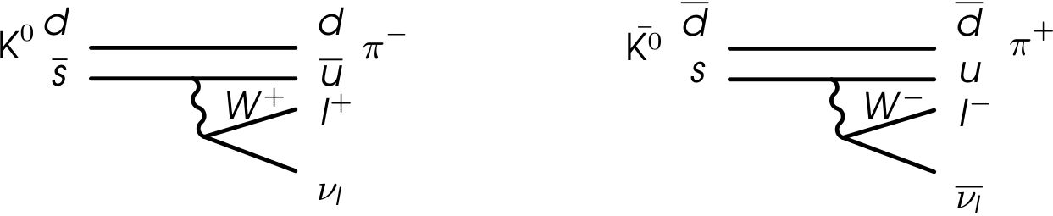
4th Symposium on Prospects in the Physics of Discrete Symmetries (DISCRETE2014) IOP Publishing
Journal of Physics: Conference Series 631 (2015) 012018 doi:10.1088/1742-6596/631/1/012018
by Bernabeu et al. in 2012 [7] and soon followed by a similar proposition realizable with neutral
kaons [8]. For the transitions’ reversibility, quantum entanglement in the system must be used
which is available at B-factories and at the DATNE 0-factory. Among the former, the BaBar
experiment has already measured a T-violating asymmetry at 14a level [9] constituting the first
direct observation of T-violation in transitions that are only connected by the time-reversal
transformation. In case of K mesons, since entangled KsKl pairs are uniquely available at the
DATNE collider, KLOE-2 is the only experiment presently able to provide the first time-reversal
violation evidence in the neutral kaon system. Prospects for such a measurement at KLOE-2
and first analysis steps are presented in the remainder of this work.
- A T-symmetry test independent of CP
The principle of the time-reversal symmetry test at KLOE-2 is based on defining
transitions between states of neutral kaons being either states with definite strangeness
{K0 (S = +1), K0 (S = +1)} or eigenstates of the CP operator which can be expressed using
the former as:
|K+} = T [|K°> + |K°}] (CP = +1), (1)
|K_} = T [|K°} - |K°}] (CP = -1). (2)
State of a neutral kaon can be identified in one of these two bases at the moment of its decay
by observation of the decay final state. With an assumption of the AQ = AS rule (well tested
in semileptonic kaon decays [10]), each charge of secondary lepton can only be created from a
strangeness-definite state of the decaying kaon, as shown in the diagrams in Figure 1. In the
following, final states with a positively and negatively charged leptons will be indicated as I+
and l_, respectively.
Figure 1. Diagrams of semileptonic decays of neutral kaons. The AS = AQ rule guarantees
that the state with a positively-charged lepton comes from K° decay whereas K° always decays
into a final state with a lepton of negative charge.
On the other hand, hadronic final states which are CP-even (e.g. two pions, hereafter named
the nn final state) can only be produced from the K+ kaon state and CP-odd states like 3n°
come from decays of K_. It can be shown that CP violation may be safely neglected in these
considerations [8].
Although the above facts allow for identification of the decaying kaon, observing a transition
between two kaon states also requires tagging of the kaon state also a certain time before its
decay. This can be achieved using neutral kaon pairs available at KLOE-2 which exhibit quantum
entanglement of their states. Once the state of the first decaying kaon is identified by observation
of its decay, its entangled and still-living partner is known to be in an orthogonal state at the
same time. Consequently, observation of its decay after a time interval At can lead to the
observation of a kaon transition where both initial and final state are tagged in the strangeness
or CP-basis.
2
4th Symposium on Prospects in the Physics of Discrete Symmetries (DISCRETE2014) IOP Publishing
Journal of Physics: Conference Series 631 (2015) 012018 doi:10.1088/1742-6596/631/1/012018

3. Time-reversal symmetry violation observables at KLOE-2
There are four possible transitions between flavour and CP-definite states of neutral K mesons, as
listed in Table 1. As these transitions are not irreversible, there can be a T-conjugated process
defined for each of them. Comparison of rates between each transition and its time-reversal
conjugate would constitute a direct T symmetry test and its independence of CP violation
follows from a comparison of the T-and CP-conjugated processes shown in Table 1, which are
not identical.
Table 1. Four possible transitions between flavour and CP-definite states of neutral kaons and
their time-reversal conjugates obtained by exchange of initial and final states. The T-conjugated
transitions are not identical with the CP conjugates given in the last column. Each of the
transitions is experimentally identified by a time-ordered pair of decays given in parentheses.
Transition T-conjugate CP-conjugate
- K0 ^ K+ (C,nn) K+ ^ K0 (3nV+) K0 ^ K+
- K0 ^ K- (£-, 3n0) K- ^ K0 (nn,f+) K0 ^ K-
- K0 ^ K+ (f+,nn) K+ ^ K0 (3nV-) K0 ^ K+
- K0 ^ K- (£+, 3n0) K- ^ K0 (nn,f-) K0 ^ K-
The time-reversal asymmetry can be defined using ratios of probabilities of transitions at
time At to probabilities of their T-inverses at the same time. Four theoretical ratios may be
defined this way:
Each of the transitions used in the above ratios is experimentally identified by a time-ordered
pair of kaon decays given in brackets in Table 1. For transitions 1 and 3, the conjugated process
would involve the first kaon to decay into 3n0, for which little statistics is expected as the
search for CP-violating decay KS ^ 3n0 at KLOE yielded no candidates [11]. For the remaining
transitions 2 and 4, however, large statistics is available at KLOE-2 and their probabilities can be
measured through numbers of double kaon decays to states f, f2 separated by time At, denoted
as I(fi, f2; At). Experimental equivalents of ratios R2 and R4 are thus defined as follows:
The theoretical ratios (R^(At)) are easily extracted from Re^p and Re4xp as shown in Eq. 4, 5
by using coefficients dependent on neutral kaon branching fractions and widths [8]:
C(l-, 3n0) ^ C(l+, 3n0) ^ BR(Kl ^ 3n0)
C(nn,l+) “ C(nn, l-) “ BR(Ks ^ nn) rS, ()
all of which have been measured by KLOE [12] and whose precision should be further improved
by KLOE-2 [13].
3
R _ P[K0(0) ^ K+(At)] R (At) _ P[K0(0) ^ K-(At)]
Ri( t) P[K+ (0) ^ K0(At)], R2( t) P[K-(0) ^ K0(At)],
r _ P[K0(0) ^ K+(At)], _ P[K0(0) ^ K-(At)]. ( )
P[K+ (0) ^ K0(At)] P[K-(0) ^ K0(At)]
Rexp(At) _ I(l , 3n ;At)_ R (At) '' C(l , 3n ) (4)
R (At)_ I(nn,l+;At)_ R2(At) X C(nn,l+) , (4)
RexP(At) _ I(l+, 3n0;At)_ r (At) w C(l+, 3n0) (5)
R (At)_ I(nn,l-;At)_ R(At) X C(nn,l-) ' (5)
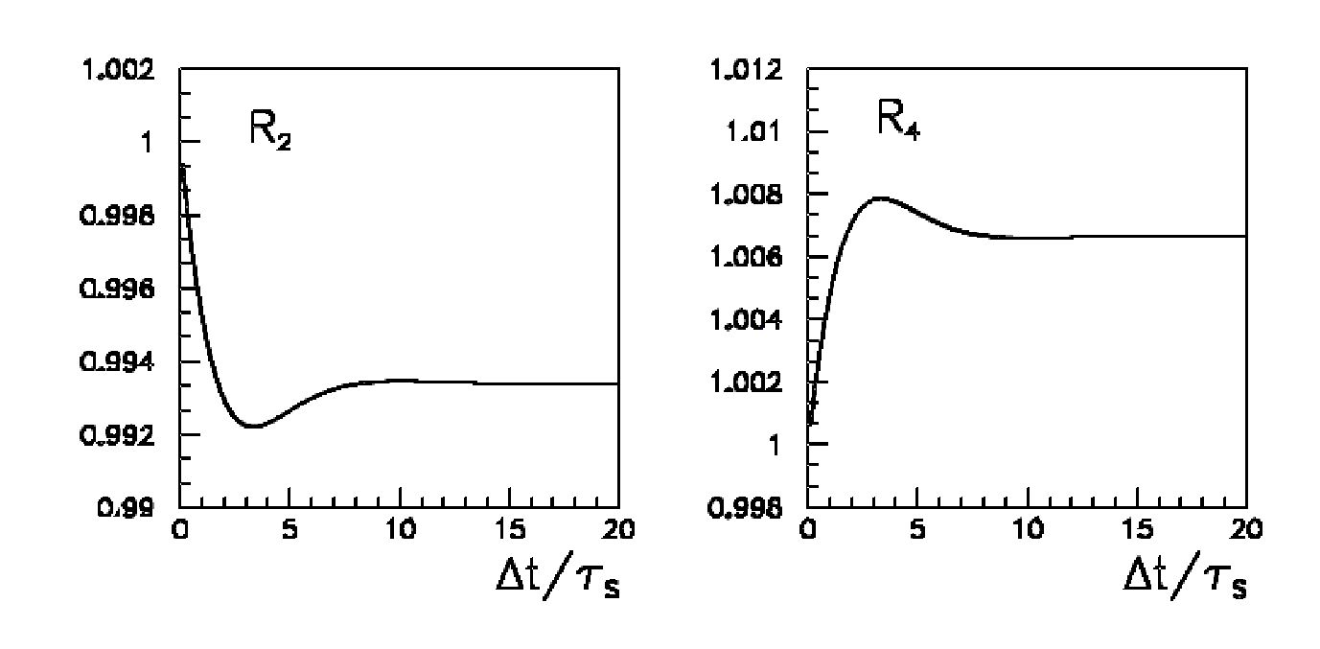
4th Symposium on Prospects in the Physics of Discrete Symmetries (DISCRETE2014) IOP Publishing
Journal of Physics: Conference Series 631 (2015) 012018 doi:10.1088/1742-6596/631/1/012018
Figure 2. Expected behaviour of the Ri ratios as a function of decay time difference. The
figure was adapted from [8].
Finally, determination of an asymptotic behaviour of theoretical ratios R2(At) and R4(At)
would measure violation of time-reversal symmetry in the neutral kaon system. Figure 2
shows the expected dependence of these ratios with assumed time-reversal violation. If T was
conserved, the ratios should tend to unity for large time intervals At. Indeed, it can be shown
[8] that asymptotic discrepancy of R2(At) and R4(At) from 1 is related to the T-violating
parameter e as:
R2(At » ts) ^ 1 - 4Re, (7)
R4(At » ts) ~ 1 + 4-Re. (8)
Therefore, a measurement of Re^v and R<4xp as functions of At for large time differences at
KLOE-2 will provide measurement of degree of T symmetry violation in the neutral K meson
system.
4. KLOE-2 and DATNE
4-1. The DA&NE 0-factory
DATNE is an electron-positron collider located at the accelerator complex of INFN National
Laboratory of Frascati (LNF). It is composed of two separate storage rings, each storing a beam
of 0.51GeV. The rings intersect at two regions, one of which provides events to the KLOE
detector (Figure 3). The center-of-mass energy of the colliding beams (y% ^1020MeV) is the
mass of the phi-meson resonance, which is produced with a cross-section of about 3^b.
The 0-mesons are produced almost at rest (^ « 0.015), with only a small momentum
component in the direction perpendicular to the beam axis. Their almost immediate decays
(t<£ = 1.55 ± 0.01 x 10-22s) provide pairs of K mesons, either charged (with a branching fraction
of 48.9%) or neutral (34.2%). The K+K- and KLKS pairs are widely used to study kaon
properties as the possibility of tagging kaons by their partner’s decay allows absolute branching
ratios to be measured. Furthermore, the neutral kaon pairs provided by DATNE have an
additional unique feature. Due to quantum numbers conservation in a strong 0 meson decay,
the KSKl pairs are produced in an anti-symmetric zero-strangeness state:
|i) = -= (|K°(+p)> \K°(-p)> - \K°(+p)> |K°(-p)» , (9)
or as expressed in the basis of CP eigenstates:
|i) = - (|K+(+p)> |K_(-p)) - |K-(+jS)> |K+(-jS))). (10)
4
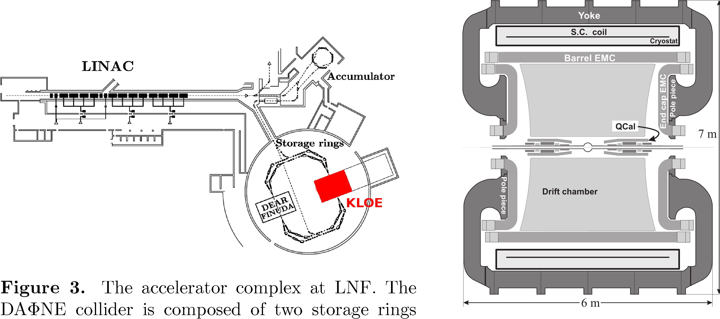
4th Symposium on Prospects in the Physics of Discrete Symmetries (DISCRETE2014) IOP Publishing
Journal of Physics: Conference Series 631 (2015) 012018 doi:10.1088/1742-6596/631/1/012018
This initial state of the neutral kaon system produced by DATNE exhibits quantum
entanglement of the two kaon states in the genuine EPR sense [14]. What follows is that
whereas state of each kaon is undefined until the observation of the first decay, measurement
of one of the states (by observation of its decay) guarantees the partner particle to be in the
orthogonal state at the same time.
This feature allows for a broad range of kaon interferometry based tests of fundamental
symmetries [15] such as CPT and Lorentz Symmetry tests [16]. Moreover, it is the property
which opens a possibility of a time-reversal symmetry at KLOE-2.
intersecting at two points, at one of which the KLOE
detector is located. The figure was adapted from [12]. Figure 4. Longitudinal section °f
the KLOE detector. The figure was
adapted from [12].
  - The KLOE detector
Tho KLOE (K LOng Experiment) detector is shaped as a barrel surrounding one of the DATNE
interaction points, with a radius of 2 m and length of almost 3.5 m. Its large size is dictated by
the mean path travelled by the long-lived neutral kaons produced there, which is about 3.4 m.
The detector is constituted by a cylindrical drift chamber surrounded by an electromagnetic
calorimeter (see the longitudinal detector section in Figure 4) which provides good coverage
around the interaction point (98% of solid angle).
The drift chamber [17] uses a gas mixture based on helium (90%) and isobutane (10%) which
ensures small material budget in order to prevent KL regeneration and photon conversion in the
gas. The resolution of the KLOE Drift Chamber (DC) is 150 ^m in the transverse plane and
2 mm in the z direction. Momentum of charged particles can be reconstructed with the relative
resolution of 0.4% whereas vertexing resolution is of the order of 1 mm [17]. The whole detector
is immersed in a magnetic field of 0.52 T provided by a superconducting coil.
The calorimeter [18] is a sampling electromagnetic detector with scintillating fibers as active
material and passive lead layers to enhance electromagnetic shower production. It provides an
excellent timing resolution and high detection efficiency for photons in the 20-500 MeV energy
range [18], which is crucial for the reconstruction presented in section 5.2. Spatial and time
resolution of the KLOE calorimeter is given below:
54 ps 5.7%E 1.2 cm
= 7!ppI ®140ps’ = 1 'yfpPi (11)
5
4th Symposium on Prospects in the Physics of Discrete Symmetries (DISCRETE2014) IOP Publishing
Journal of Physics: Conference Series 631 (2015) 012018 doi:10.1088/1742-6596/631/1/012018
Ą.3. Upgrade of KLOE to KLOE-2
KLOE started its operation at the DATNE collider in 1999 and was taking data collecting a total
integrated luminosity of 2.5 fb-1 which corresponds to about 1010 of produced f mesons. During
KLOE runs DATNE reached a peak value of instantaneous luminosity of 1.4 ■ 1032 cm-2s-1.
In the recent years, the KLOE detector has undergone a thorough upgrade to start new
measurements as KLOE-2. The upgrades involved the addition of new calorimeters at small
angles around the beam axis to increase acceptance for photons and instrument the final focusing
region [19, 20]. Moreover, new sets of detectors have been installed close to the beam line for
tagging 77 events through detection of scattered high and low energy e+e- [21, 22]. Finally,
a novel tracking device was constructed and installed in the region between the interaction
point and drift chamber inner wall. This KLOE-2 Inner Tracker is a pioneer construction of a
cylindrical Gas Electron Multiplier (GEM) tracker [23] composed of 4 layers of a triple-GEM
detector barrel-shaped around the KLOE-2 interaction point. Its addition to KLOE-2 improves
vertexing capabilities and increases acceptance for tracks with low transverse momentum.
The KLOE-2 detector restarted operation in 2014 in view of collecting a sample of the order
of 10 fb-1 in the next years. The physics programme of KLOE-2 is rich [13] and includes the
possibility to conduct the first direct T symmetry test with neutral kaons described in this work.

5. Prospects for experimental realization of the T test at KLOE-2
- Required reconstruction of events
In order to measure the double decay rates used in Re2xp and Re4xp (Eq. 4-5) reconstruction must
be performed for the following two classes of events, each composed of a pair of kaon decays
separated by a time interval of At:
f ^ KsKl ^ 2n £±n, (12)
f ^ KSKL ^ n±£Tv 3n0. (13)
As the time-reversal symmetry test observables (Eq. 4-5) are time-dependent, it is important to
reconstruct the time interval between decays with good accuracy. In turn, the resolution of kaon
decay times in the asymptotic plateau region of At » ts should be O(1rS) which to translates
to decay point spatial resolution O(1 cm).
Figure 5 schematically shows the reconstruction of these two classes of events. In case of
a two-pion final state, charged pions (n+n-) may be chosen rather than n0n0 to profit from
pion tracks reconstructed by the KLOE drift chamber. Both kaon decay vertices can then be
easily reconstructed using charged particle tracks (Figure 5, left). The other class of processes,
shown in Figure 5, right, is significantly more challenging to reconstruct as one of the decays,
Kl ^ 3n0, only involves neutral particles. Moreover, as the kinematics of the accompanying
KS decay is not closed due to a missing neutrino, reconstruction of KL ^ 3n0 must rely solely
on information on clusters created in the EMC by photons originating in n0 decays. Therefore
a special vertex reconstruction method was devised for this decay.
- New Kl ^ 3n0 reconstruction method for KSKL ^ n±eTve 3n0
The new reconstruction method presented in this work aims at providing spatial coordinates of
the Kl decay point and KL decay time by using only the photons from KL ^ 3n0 ^ 67 recorded
by the electromagnetic calorimeter (Figure 6).
Each EMC cluster contains information on its location as well as recording time
(Xi,Yi,Zi,Ti). Thus, one might consider a set of possible points at which the corresponding
photon originated. Such a set constitutes a sphere centered at cluster position with a radius
equal to path length travelled by the 7. The latter, however, is unknown due to its dependence
on the unknown decay time of the kaon t, which is also the 7 creation time if the n0 lifetime
6
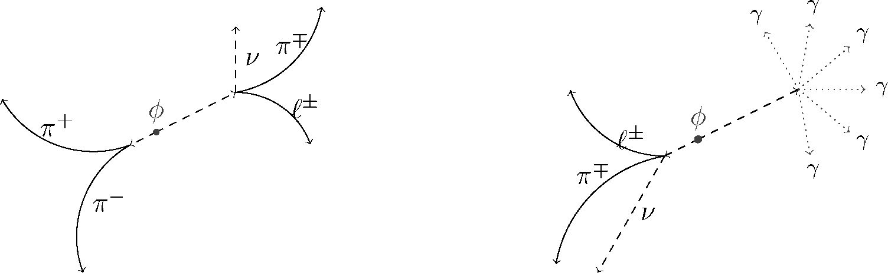
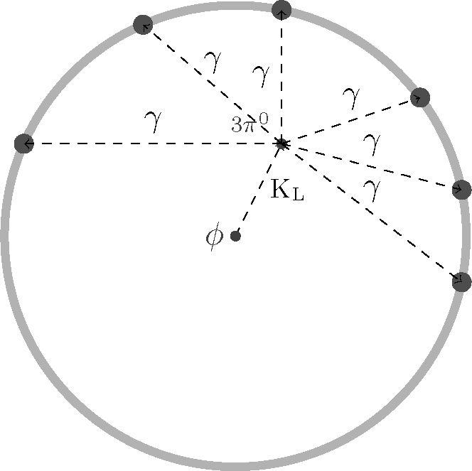
4th Symposium on Prospects in the Physics of Discrete Symmetries (DISCRETE2014) IOP Publishing
Journal of Physics: Conference Series 631 (2015) 012018 doi:10.1088/1742-6596/631/1/012018
Figure 5. Schematic view of the two classes of processes whose reconstruction is required to
measure Re^p and Re4xp for the T test. Continuous lines denote DC tracks of charged particles
while dashed and dotted lines correspond to neutral particles. Process shown in the right poses
a reconstruction challenge due to the KL ^ 3n° decay involving neutral particles only.
Figure 6. The Kl ^ 3n° ^ 67
process in the cross-section view of the
detector. The neutral kaon nor the pions
are recorded by the tracking detectors and
the only experimental information on this
decay are up to six clusters in the KLOE
electromagnetic calorimeter (grey band)
created by photons to which the neutral
pions decay almost immediately.
is neglected (Figure 7). The equation describing the sphere of origin points for i-th calorimeter
cluster is:
(Ti — t)2c2 = (Xi — x)2 + (Yi — y)2 + (Zi — z)2. (14)
Such a sphere can be defined for each recorded EMC cluster. The KL decay vertex is the
common origin of all the photons and therefore can be reconstructed as the intersection of the
photon spheres as shown in Figure 6. If at least 4 photons are recorded, their corresponding
system of equations (Eq. 14) can be solved analytically. This yields two solutions for the KL
decay vertex coordinates and decay time, among which the physical solution is identified by a
set of criteria and the other one is rejected as a mathematical artifact. Possible presence of up
to six recorded photons is used to numerically solve an overdetermined system of equations to
obtain improved accuracy.
It should be stressed that this reconstruction method directly yields the kaon decay time
in addition to vertex location, which eliminates the need to calculate it with kaon travelled
path length and momentum which would introduce additional uncertainty to its evaluation. In
conjunction with the excellent timing properties of the KLOE electromagnetic calorimeter, this
reconstruction yields a good resolution of long-lived kaon decay time although being based on
calorimetric information only.
7
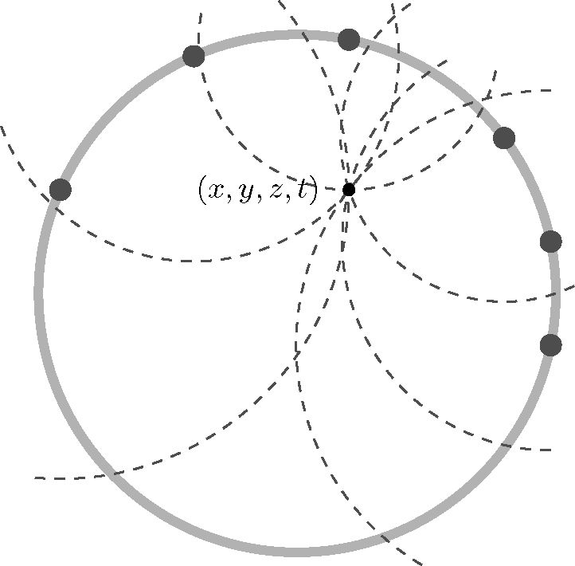
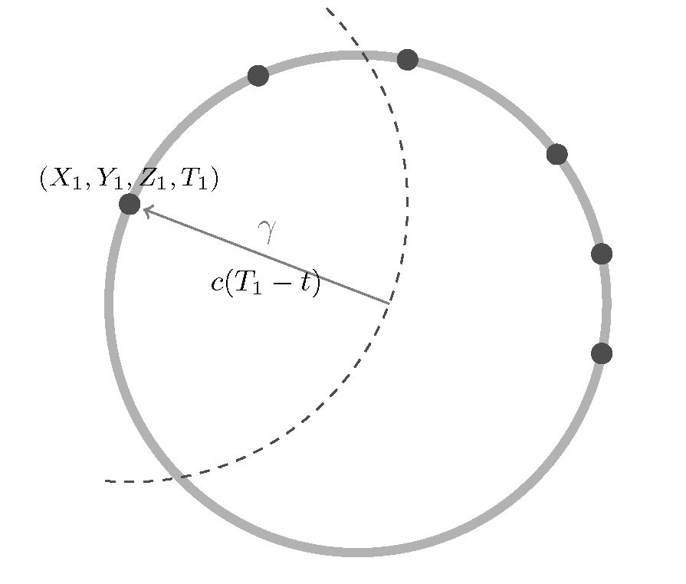
4th Symposium on Prospects in the Physics of Discrete Symmetries (DISCRETE2014) IOP Publishing
Journal of Physics: Conference Series 631 (2015) 012018 doi:10.1088/1742-6596/631/1/012018
Figure 7. For each of the EMC
clusters its position and recording time is
reconstructed by the calorimeter with a
good resolution (see 11). This allows to
define a set of possible origin points of the
incident photon as a sphere centered at
the cluster whose radius is proportional to
the difference of cluster time and KL decay
time.
Figure 8. The KL decay vertex is also
a common origin points of the 6 photons
which hit the calorimeter. Therefore, its
location can be found analytically as the
intersection of at least 4 of the spheres
defined for each EMC clusters.
- Resolution of KL decay time reconstruction
The reconstruction was tested using a MC simulated sample of KL ^ 3n0 events (generated
with the official KLOE software [24]) including complete detector response and run-by-run data
taking conditions. Time resolution, crucial for the time-reversal symmetry test at KLOE-2, was
studied as a function of the decay vertex distance from the 0-meson decay vertex, i.e. the path
length travelled by the kaon before its decay. The result, shown in Figure 9 proves that this
reconstruction algorithm has an almost constant resolution at the level of 2ts independently
of the decay vertex location. This is a promising result for the future test of time-reversal
symmetry at KLOE-2 and studies on the required processes will continue towards this test.
This will allow T to be tested in the asymptotic region of At » ts as stated in Section 5.1. This
new reconstruction method for the challenging Kl ^ 3n0 decay opens the way for KLOE-2 to
provide the first direct evidence for time-reversal symmetry violation in the neutral kaon system.
8
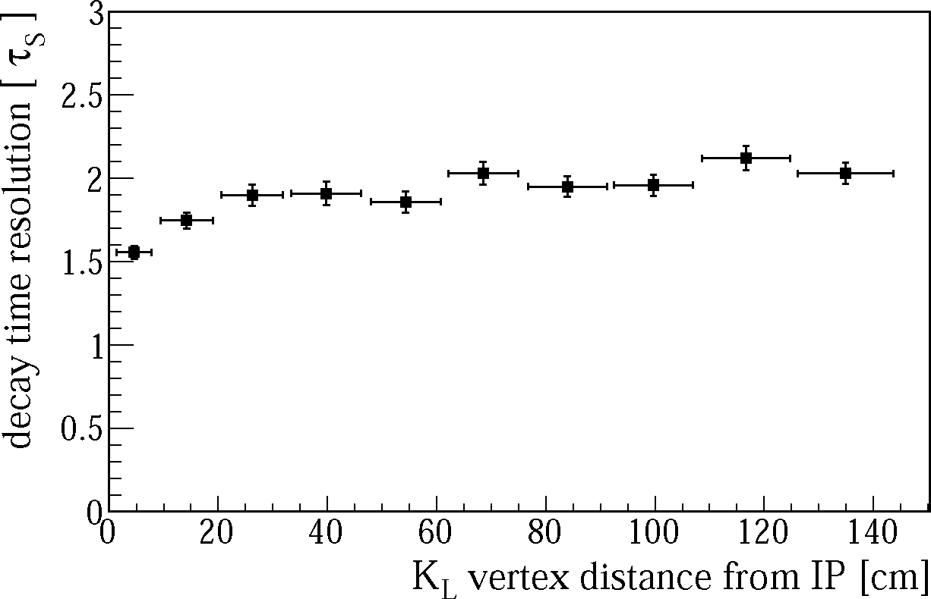
4th Symposium on Prospects in the Physics of Discrete Symmetries (DISCRETE2014) IOP Publishing
Journal of Physics: Conference Series 631 (2015) 012018 doi:10.1088/1742-6596/631/1/012018
Figure 9. The KL decay time resolution as a function of the decay distance from 0 decay point.
Acknowledgments
We warmly thank our former KLOE colleagues for the access to the data collected during the
KLOE data taking campaign. We thank the DATNE team for their efforts in maintaining low
background running conditions and their collaboration during all data taking. We want to thank
our technical staff: G.F. Fortugno and F. Sborzacchi for their dedication in ensuring efficient
operation of the KLOE computing facilities; M. Anelli for his continuous attention to the gas
system and detector safety; A. Balla, M. Gatta, G. Corradi and G. Papalino for electronics
maintenance; M. Santoni, G. Paoluzzi and R. Rosellini for general detector support; C. Piscitelli
for his help during major maintenance periods.
This work was supported in part by the EU Integrated Infrastructure Initiative
Hadron Physics Project under contract number RII3-CT- 2004-506078; by the Euro-
pean Commission under the 7th Framework Programme through the Research Infra-
structures action of the Capacities Programme, Call: FP7-INFRASTRUCTURES-2008-
1, Grant Agreement No. 227431; by the Polish National Science Centre through
the Grants No. 2011/03/N/ST2/02641, 2011/01/D/ST2/ 00748, 2011/03/N/ST2/02652,
2013/08/M/ST2/00323, DEC-2014/12/S/ST2/00459, 2013/11/B/ST2/04245 and by the Foun-
dation for Polish Science through the MPD programme and the project HOMING PLUS
BIS/2011-4/3.
References
- Christenson J, Cronin J, Fitch V and Turlay R 1964 Phys.Rev.Lett. 13 138-140
- Angelopoulos A et al. (CPLEAR Collaboration) 1998 Phys.Lett. B444 43-51
- Wolfenstein L 1999 Int.J.Mod.Phys. E8 501-511
- Bernabeu J and Martinez-Vidal F 2014 (Preprint 1410.1742)
- Ellis J R and Mavromatos N 1999 Phys.Rept. 320 341-354 (Preprint hep-ph/9903386)
- Gerber H 2004 Eur.Phys.J. C35 195-196
- Bernabeu J, Martinez-Vidal F and Villanueva-Perez P 2012 JHEP 1208 064 (Preprint 1203.0171)
- Bernabeu J, Di Domenico A and Villanueva-Perez P 2013 Nucl.Phys. B868 102-119 (Preprint 1208.0773)
- Lees J et al. (BaBar Collaboration) 2012 Phys.Rev.Lett. 109 211801 (Preprint 1207.5832)
- Beringer J et al. (Particle Data Group) 2012 Phys.Rev. D86 010001
- Babusci D et al. (KLOE Collaboration) 2013 Phys.Lett. B723 54-60 (Preprint 1301.7623)
9
4th Symposium on Prospects in the Physics of Discrete Symmetries (DISCRETE2014) IOP Publishing
Journal of Physics: Conference Series 631 (2015) 012018 doi:10.1088/1742-6596/631/1/012018
- Bossi F, De Lucia E, Lee-Franzini J, Miscetti S and Palutan M (KLOE Collaboration) 2008 Riv.Nuovo Cim.
31 531-623 (Preprint 0811.1929)
- Amelino-Camelia G, Archilli F, Babusci D, Badoni D, Bencivenni G et al. 2010 Eur.Phys.J. C68 619-681
(Preprint 1003.3868)
- Einstein A, Podolsky B and Rosen N 1935 Phys. Rev. 47 777-780
- Di Domenico A 2007 Frascati Physics Series 43 1-38
- Babusci D et al. (KLOE-2 Collaboration) 2014 Phys.Lett. B730 89-94 (Preprint 1312.6818)
- Adinolfi M, Ambrosino F, Andryakov A, Antonelli A, Antonelli M et al. 2002 Nucl.Instrum.Meth. A488
51-73
- Adinolfi M, Ambrosino F, Antonelli A, Antonelli M, Anulli F et al. 2002 Nucl.Instrum.Meth. A482 364-386
- Cordelli M, Corradi G, Happacher F, Martini M, Miscetti S et al. 2010 Nucl.Instrum.Meth. A617 105-106
(Preprint 0906.1133)
- Cordelli M, Dan E, Giovannella S, Gatta M, Happacher F et al. 2013 Nucl.Instrum.Meth. A718 81-82
- Babusci D, Gonnella F, Iafolla L, Iannarelli M, Mascolo M et al. 2013 Nucl.Instrum.Meth. A718 577-579
(Preprint 1206.0680)
- Babusci D, Bini C, Ciambrone P, Corradi G, De Santis A et al. 2010 Nucl.Instrum.Meth. A617 81-84
(Preprint 0906.0875)
- Balla A, Bencivenni G, Branchini P, Budano A, Capodiferro M et al. 2013 Nucl.Instrum.Meth. A732 221-224
- Ambrosino F, Antonelli A, Antonelli M, Bini C, Bloise C et al. 2004 Nucl.Instrum.Meth. A534 403-433
(Preprint physics/0404100)
10

