

ORIGINAL RESEARCH
published: 06 January 2016
doi: 10.3389/fnmol.2015.00082
OPEN ACCESS
Edited by:
Torben Moos,
Aalborg University, Denmark
Reviewed by:
Sandra Blaess,
University of Bonn, Germany
Andreas Martin Grabrucker,
Ulm University, Germany
Correspondence:
Paweł Lipiński
p. lipinski@ighz.pl;
Rafał R. Starzyński
r.starzynski@ighz.pl
Received: 23 September 2015
Accepted: 11 December 2015
Published: 06 January 2016
Citation:
GajowiakA, Stys A, Starzyński RR,
Bednarz A, Lenartowicz M, Staroń R
and Lipński P (2016) Mice
Overexpressing Both Non-Mutated
Human SOD1 and Mutated
SOD1G93A Genes: A Competent
Experimental Model for Studying Iron
Metabolism in Amyotrophic Lateral
Sclerosis. Front. Mol. Neurosci. 8:82.
doi: 10.3389/fnmol.2015.00082
Mice Overexpressing Both
Non-Mutated Human SOD1 and
Mutated SOD1G93A Genes: A
Competent Experimental Model for
Studying Iron Metabolism in
Amyotrophic Lateral Sclerosis
Anna Gajowiak1, Agnieszka Styś1, Rafał R. Starzyński1*, Aleksandra Bednarz2,
Małgorzata Lenartowicz2, Robert Staroii1 and Paweł Lipifiski1*
1 Department of Molecular Biology, Institute of Genetics and Animal Breeding, Polish Academy of Sciences, Magdalenka,
Poland, 2 Department of Genetics and Evolution, Institute of Zoology, Jagiellonian University, Kraków, Poland
Amyotrophic lateral sclerosis (ALS) is a progressive neurodegenerative disease
characterized by degeneration and loss of motor neurons in the spinal cord, brainstem
and motor cortex. Up to 10% of ALS cases are inherited (familial, fALS) and associated
with mutations, frequently in the superoxide dismutase 1 (SOD1) gene. Rodent
transgenic models of ALS are often used to elucidate a complex pathogenesis of this
disease. Of importance, both ALS patients and animals carrying mutated human SOD1
gene show symptoms of oxidative stress and iron metabolism misregulation. The aim of
our study was to characterize changes in iron metabolism in one of the most commonly
used models of ALS - transgenic mice overexpressing human mutated SOD1G93A gene.
We analyzed the expression of iron-related genes in asymptomatic, 2-month-old and
symptomatic, 4-month-old SOD1G93A mice. In parallel, respective age-matched mice
overexpressing human non-mutated SOD1 transgene and control mice were analyzed.
We demonstrate that the overexpression of both SOD1 and SOD1G93A genes account
for a substantial increase in SOD1 protein levels and activity in selected tissues and
that not all the changes in iron metabolism genes expression are specific for the
overexpression of the mutated form of SOD1.
Keywords: ALS, SOD1, G93A, neurons, iron, skeletal muscle, heme oxygenase 1, oxidative stress

INTRODUCTION
Amyotrophic lateral sclerosis (ALS) is the most widespread motor neuron disease. It is
characterized by a progressive and selective degeneration of neurons in motor cortex and lower
motor neurons projecting from the brainstem and spinal cord. In consequence, the disease leads to
gradual skeletal muscle weakness, atrophy and paralysis and it is usually fatal within 2-3 years from
the onset. The most common cause of death among ALS patients is respiratory failure caused by the
Abbreviations: ALS, amyotrophic lateral sclerosis; Cp, ceruloplasmin; Fpn, ferroportin; H-Ft, H feritin chain; L-Ft, L ferritin
chain; HO1, heme oxygenase 1; IRP1, iron regulatory protein 1; SOD, superoxide dismutase; TfR1, transferrin receptor 1.
Frontiers in Molecular Neuroscience | www.frontiersin.org
1
January 2016 | Volume 8 | Article 82
Gajowiak et al.
Iron in Mouse ALS Models
degeneration of the nerves and muscles that control breathing
(Pratt et al., 2012). Although ALS is mostly a sporadic disease
(sALS) of generally unknown etiology, approximately 10% of
ALS cases, designed as familial ALS (fALS), are due to genetic
factors and have an autosomal dominant pattern of transmission
(Rothstein, 2009). Mutations found within the SOD1 gene
encoding an antioxidant enzyme, (SOD1, CuZn-SOD) were the
first established genetic cause of ALS (Rosen et al., 1993) and
are nowadays estimated to account for up to 20 and 3% of
fALS and sALS cases, respectively. In addition to SOD1 gene
mutations, defects in some other genes have also been involved
in fALS (Pratt et al., 2012). Importantly, how the various ALS-
linked gene products determine similar course of the disease
is incompletely understood. The two forms of ALS (fALS and
sALS) share similar clinical and pathological features, suggesting
common molecular pathogenic mechanisms. Oxidative stress (a
condition arising from an imbalance between the production of
reactive oxygen species and the efficiency of antioxidant defense
systems) has been proposed to be implicated in ALS pathogenesis
mostly by interfering with other pathogenic mechanisms, such
as motor neuron excitotoxicity, mitochondrial and cytoskeletal
dysfunction, protein aggregation, neuroinflammation, and deficit
in neutrophic growth factors (Barber et al., 2006). The evidence
of the involvement of oxidative stress in ALS pathology originates
from studies on ALS patients (Carri et al., 2003) as well as from
experiments on rodent models of this disease, which are in vast
majority transgenic mice that overexpress mutated human SOD1
gene (Turner and Talbot, 2008). Although in general these mouse
models recapitulate human disease, some critical differences
exist between the animal and human pathology. An important
one concerns an increased enzymatic activity of the SOD1 in
some transgenic mice widely used in ALS research (for example
SOD1G37R and SOD1G93A), a phenomenon, which does not occur
in humans. Of importance, SOD1 is a particular antioxidant
enzyme as it converts the superoxide anion radical (O2-) to
another reactive oxygen species (ROS) - hydrogen peroxide
(H2O2) (McCord and Fridovich, 1969). It seems therefore that
the final effect of SOD1 overexpression depends on the balance
between the beneficial effects of the O2_ scavenging and the
destructive effects of H2O2 production. In this context, it is not
surprising that the toxicity induced by oxidative stress has been
reported in both, SOD1 null mice (Reaume et al., 1996) and
in mice overexpressing human wild-type SOD1 gene (Lee et al.,
2001).
The commonly accepted paradigm of iron dichotomy in
biological systems states that iron is essential for the function
of many enzymes and thus it is absolutely fundamental for most
biological life forms, but, on the other hand, it is toxic in excess
(Pantopoulos et al., 2012). Toxicity of iron is usually explained
by its ability to induce oxidative stress through the catalysis of
the Fenton reaction that leads to the formation of the hydroxyl
radical (-OH), a highly destructive oxidant. Both aforementioned
ROS interact with iron in the Fenton reaction: O2_ as a rate-
limiting reducing factor for the pre-existing pool of free iron
active in the generation of -OH, and H2O2, as a factor that
directly reacts with ferrous iron to yield this radical. Apart from
the participation in the Fenton reaction, both H2O2 and O2_
have been shown to alter the expression of iron-related genes by
various molecular mechanisms (reviewed by Orino et al., 2001).
Misregulation of iron homeostasis in the central nervous
system, which results in the pathological iron accumulation and
in increased formation of ROS is a frequent phenomenon, largely
documented in neurodegenerative diseases (Oshiro et al., 2011;
Hadzhieva et al., 2014). The elevated amounts of iron deposits
have been also reported in the brain and spinal cord of ALS
patients (Kasarskis et al., 1995; Kwan et al., 2012; Ignjatovic,
- and mice overexpressing mutated human SOD1 gene
(Jeong et al., 2009; Lee et al., 2015). Presumably, the most
convincing argument supporting pathological involvement of
iron accumulation and iron-mediated oxidative stress in the
progression of ALS derives from studies showing beneficial effects
of iron chelation therapy in transgenic mice overexpressing
human mutated SOD1 gene (Jeong et al., 2009; Kupershmidt
et al., 2009; Wang et al., 2011; Lee et al., 2015). Based on
the analysis of the complex interplay between oxidative stress
and disturbed iron homeostasis in these models, Hadzhieva
et al., 2014 proposed that in ALS, oxidative stress strongly
affects cellular iron balance leading to iron overload in motor
neurons, and thus creates a vicious circle to exacerbate oxidative
injury. However, it remains unclear, up to what extent SOD1
mouse models of ALS reproduce the mechanisms of oxidative
stress induction in human pathology. In particular, an intriguing
question remains open: how (if at all) the increased SOD1
activity observed in the CNS of transgenic SOD1G93A and
SOD1G37R mice affects their iron metabolism. Of importance,
to our knowledge, only these two mouse models were used
so far in in vivo studies of iron metabolism dysregulation in
ALS. Strictly speaking, it is still unclear, which iron metabolism
dysregulation mechanisms can be regarded as a disease-specific
(and thus can be used to draw conclusions in humans), and
which should be regarded as a secondary, model-associated
effects.
Here, to clear up this issue, in addition to mice overexpressing
human mutated SOD1G93A gene we used two types of control
age-matched mice - wild-type mice and mice overexpressing
human wild-type SOD1 gene. In those mice we compared the
expression pattern of iron-related genes in their brain stems
(Medulla oblongata), spinal cords, skeletal muscles (represented
by gastrocnemius and broadest dorsal - Latissimus dorsi muscles)
and livers. We have also determined iron content and distribution
in their gastrocnemius muscles.
We demonstrate that the overexpression of both SOD1 and
SOD1G93A genes accounts for a substantial increase in SOD1
protein levels and activity in selected tissues and that not all
the changes in iron metabolism genes expression are specific for
the overexpression of the mutated form of SOD1. Furthermore,
not all the changes are specific to the disease-affected human
tissues. Importantly, amongvarious analyzed genes, only Hmox1,
encoding HO1, an important oxidative stress responder was
found to be induced solely in mice overexpressing human
mutated SOD1 gene and only in tissues known to be affected
by ALS. Similarly, iron accumulation in the gastrocnemius
muscle was also exclusively restricted to mice carrying SOD1G93A
mutation in the symptomatic stage of disease.
Frontiers in Molecular Neuroscience | www.frontiersin.org
2
January 2016 | Volume 8 | Article 82
Gajowiak et al.
Iron in Mouse ALS Models
MATERIALS AND METHODS

Mice
Following mice provided by The Jackson Laboratory (Bar
Harbor, ME, USA) were used in the study: males [strain
B6SJL-Tg(SOD1-G93A)1Gur/J] hemizygous for the SOD1G93A
transgene, with transgenic expression of a G93A mutant form
of human SOD1 (harboring a single amino acid substitution
of glycine to alanine at codon 93) (Gurney et al., 1994),
transgenic males [strain B6SJL-Tg(SOD1)2Gur/J] carrying the
normal allele of the human SOD1 gene (called SOD1), and
males (strain B6129PF2/J) used as controls for genetically
engineered mice from the above mentioned strains. SOD1G93A
mice exhibit a phenotype similar to ALS in humans. All analyses
were performed in age-matched 2- and 4-month-old mice,
designed as asymptomatic and symptomatic (showing apparent
symptoms of paralysis in the case of mice overexpressing human
mutated gene), respectively. The age of mice from the two
control groups (wild-type and mice overexpressing human wild-
type SOD1) was the same as for the ALS model mice. Mice
arrived at the age of 4 weeks and were housed at 24-25°C,
relative humidity 50-60% with a light-dark cycle of 12 h.
Mice received a standard diet (Labo-feed, Kcynia, Poland) and
water ad libitum. Animals were euthanized by intraperitoneal
injection of Vetbutal (Biovet, Puławy, Poland). All procedures
were conducted according to the guidelines of the Directive
2010/63/EU of the European Parliament and of the Council of 22
September 2010 on the Protection of Animals Used for Scientific
Purposes.

Measurement of SOD1 Activity
Superoxide dismutase 1 activity in tissue total extracts was
measured by gel electrophoresis using the Nitroblue Tetrazolium
(NBT)/riboflavin method as described previously (Beauchamp
and Fridovich, 1971). Briefly, 15 mg samples of the tissue total
extracts were resolved by electrophoresis on 12% polyacrylamide
gels under non-denaturing and non-reducing conditions. After
electrophoresis, the activity of SOD was visualized by immersion
of the gels in staining buffer [50 mM potassium phosphate (pH
7.8), 0.1 mM EDTA, 28 mM TEMED, 3 mM riboflavin, 0.25 mM
NBT] for 30 min in the dark at RT. Gels were then exposed to
light until the SOD activity bands became visible as bright bands
on a dark blue background. The reaction was stopped by rinsing
the gels with water. Activities of CuZn-SOD, and Mn-SOD were
distinguished by a selective inhibition of the former activity by
incubation of gels in a buffer containing 3 mM KCN prior to the
staining, as described by Salin and Bridges (1981).

Hematoxylin/Eosin and Prussian Blue
Staining of the gastrocnemius Muscle
The gastrocnemius muscle was excised from both hind limbs,
dissected from fat and connective tissue, immediately fixed in
Bouin’s solution for 24 h, and stored in 70% ethanol before further
preparation. After dehydration, muscle was embedded in paraffin
and cut into 7 ^m sections with a microtome (Reichert-Jung,
Germany) on the horizontal plane, transversely to the long axis of
the muscle. The sections were placed on a slide and stained with
haematoxylin and eosin. The morphology of muscle structure
was studied by standard light microscopy (Olympus, type CH2)
under x 2 and x 40 objectives.
Non-heme iron staining of the gastrocnemius muscle samples
was analyzed using Accustain Iron Deposition Kit (Sigma-
Aldrich). After mounting on glass slides, muscle sections were
deparaffinized, incubated with working solution containing Perls’
Prussian blue for 30 min, counterstained with pararoseaniline
solution for 2 min and analyzed under standard light microscopy
(Olympus, type CH2).

RNA Preparation and Real-Time
Quantitative RT-PCR
Total RNA was extracted using the TRIzol reagent (Invitrogen).
0.5 ^g (spinal cord), 1 ^g (gastrocnemius) or 2 ^g (liver,
broadest dorsal muscle) of total RNA was reverse-transcribed
using random hexamers and Transcription First Strand
cDNA Synthesis Kit (Roche). Real-time quantitative PCR was
performed using the Roche Light Cycler 96 system and the
FastStart Essential DNA Green Master Kit (Roche) together
with the following primers: TfR1, 5;-TCG CTT ATA TTG GGC
AGA CC-3' (forward) and 5;-CCA TGT TTT GAC CAA TGC
TG-3' (reverse); HO1, 5/-TCT TGC CTG GCT CTC TTC
TC-3' (forward) and 5/- GTC GTG GTC AGT CAA CAT GG
-3/ (reverse); 18 S ribosomal RNA (18S), 5/-CTG AGA AAC
GGC TAC CAC ATC-3/ (forward) and 5/-CGC TCC CAA
GAT CCA ACT AC-3/ (reverse). Data were analyzed with the
Light Cycler 3.5 software. mRNA expression was standardized
to 18S ribosomal RNA levels mRNA levels, as indicated in
legends.

Preparation of Tissues Protein Extracts
and Western Blot Analysis
Following mouse tissues were collected: M. oblongata, spinal
cord, the gastrocnemius muscle and the L. dorsi (broadest dorsal)
muscle, liver and kidney. Total extracts, cytosolic fractions
and crude membrane extracts were prepared as described
previously (Canonne-Hergaux et al., 1999; Starzynski et al., 2009).
Protein concentration was determined spectrophotometrically
using the Bio-Rad protein assay. SOD1 was detected in total
protein extracts obtained from tissues using rabbit polyclonal
anti-superoxide dismutase 1 antibody (Abcam; ab16831). H-
(H-Ft) and L-ferritin (L-Ft) subunit expression was analyzed
using cytosolic extracts and rabbit antisera raised against,
respectively, the recombinant mouse ferritin H and L subunits
(kindly provided by Dr. Paolo Santambrogio, San Raffaele
Scientific Institute, Milano, Italy). L-Ft was also analyzed
using purified rabbit mouse liver ferritin antiserum (kindly
provided by Dr. J. Brock, Glasgow University, Glasgow,
UK) (Bouton et al., 2002). Fpn, Cp and HO1 levels in
crude membrane extracts were detected using, respectively, a
rabbit polyclonal antibody raised against mouse Fpn (MTP11-
A, Alpha Diagnostics), a rabbit polyclonal antibody raised
against human Cp (DAKO) and a rabbit polyclonal antibody
raised against rat HO1 (ADI-OSA-150-F, Enzo Life Sciences).
Frontiers in Molecular Neuroscience | www.frontiersin.org
3
January 2016 | Volume 8 | Article 82
Gajowiak et al.
Iron in Mouse ALS Models
The loading controls - P-actin and tubulin in protein
extracts were detected using goat polyclonal and mouse
monoclonal antibodies, respectively (both from Santa Cruz
Biotechnology). Peroxidase-conjugated anti-rabbit, anti-chicken,
anti-mouse, or anti-goat secondary antibodies (Santa Cruz
Biotechnology) were used. Immunoreactive bands were detected
using the Western Bright ECL Western blotting detection kit
(Advansta). Tissue extracts from Hmox1-/- or Irp1-/- mice or
recombinant L- and H-Ft proteins (kindly provided by Dr. Paolo
Santambrogio) were used as controls. Western blot analyses were
performed using extracts prepared separately for each mouse
(six experimental groups: two age groups and three genotypes
for each age; three mice in each group; total 18 extracts per
tissue).

Statistical Analysis
All experiments were performed in biological triplicates, and
error bars indicate standard deviation. Statistica 10 software was
used for all of the statistical analyses. The assays were performed
by two way ANOVA and means comparisons were adjusted by
Tukey (P < 0.05 and P < 0.01).

RESULTS
Increased SOD1 Expression and Activity
in Tissues of Transgenic SOD1 and
SOD1G93A Mice
Before investigating iron metabolism genes in mice from 3
experimental groups, first we measured SOD1 activity and
expression in tissues affected by ALS (neuronal tissues and
skeletal muscles) and in the two tissues important for systemic
iron metabolism (liver and kidney). In all analyzed tissues:
skeletal muscles (Figure 1A), neuronal tissues (Figure 1B),
liver (Figure 1C, left-hand), and kidney (Figure 1C, right-
hand) from both transgenic SOD1 and SOD1G93A mice, the
superoxide-scavenging activity of SOD1 was markedly higher
compared to age-matched 2- and 4-month-old wild-type
animals. We found that this increase was due to significantly
(P < 0.01) elevated SOD1 protein level, detected by western
immunoblotting (Supplementary Table). We found that in spinal
cord, M. oblongata (Figure 1B), liver and kidney (Figure 1C)
of the transgenic SOD1 mice SOD1 protein was expressed at a
higher level than in the corresponding tissues of the ALS mice
although these differences did not reach statistical significance.
Accordingly, the SOD1 superoxide-scavenging activity was
higher in those tissues of mice overexpressing human wt SOD1
gene.

Pathological Changes and Iron
Distribution in the gastrocnemius Muscle
from Symptomatic ALS Mice
Skeletal muscle atrophy observed in SOD1 models of ALS is
usually considered as a consequence of motor neuron loss,
although there is some evidence that it is a direct target of SOD1-
mediated pathology (Dobrowolny et al., 2008). We analyzed
myopathology of the gastrocnemius muscle upon staining with
eosin/hematoxylin. We did not find any abnormalities in this
muscle in 2-month-old mice - neither in the wild-type strain,
nor in the transgenic ones - SOD1 and SOD1G93A (data not
shown). Similarly, no abnormalities were detected in 4-month-
old wild-type and transgenic SOD1 animals. In contrast, the
gastrocnemius muscle from symptomatic transgenic SOD1G93A
mice showed changes in the muscle architecture characteristic
for ALS (Figure 2F). In particular, fibers had similar size
(Figures 2A,B) in the muscle of 4-month-old control mice
(wild-type and SOD1). In contrast, on the muscle section
of the 4-month-old SOD1G93A mice we observed grouped
angular atrophic muscle fibers (Figure 2F) and among small
and degenerative muscle fibers we identified hypertrophic ones
(Figures 2C-E). Few characteristic pyknotic nuclear clumbs were
observed mainly in the group of degenerated fibers (Figure 2F).
Microscopic analysis of gastrocnemius muscle sections from
4-month old wild-type and transgenic SOD1 mice stained for
non-heme iron with Perls’ Prussian blue showed no evidence
of non-heme iron accumulation (Figures 3A,B). In contarst,
non-heme iron accumulation was detected in the gastrocnemius
muscles derived from 4-month-old SOD1G93A symptomatic
mutants (Figures 3C-E). Deposits of iron had a form of irregular
cytoplasmic inclusions, localized in some (not all) muscle fibers
close the cell nuclei.

IRP1 Protein Levels are Unaffected in
SOD1 and SOD1G93A Mice
Iron regulatory protein 1 (IRP1) is a cytoplasmic bifunctional
protein showing either aconitase or trans-regulatory activity
involved in the mechanisms that control iron metabolism in
mammalian cells. IRP1 lacking its iron-sulfur cluster acts as a
trans-regulatory element that modulates the expression of iron-
related proteins such as ferritin subunits, TfR1 and Fpn at a
post-transcriptional level by binding to specific iron regulatory
elements (IREs) on their mRNAs (Wilkinson and Pantopoulos,
- . We have previously shown that in SOD1 knock-out mice
the expression of IRP1 is strongly reduced (Starzynski et al.,
2005). On the other hand, the effect ofincreased SOD1 activity on
IRP1 protein level has been investigated in cells overexpressing
wild-type SOD1 gene as well as in transgenic SOD1G93A and
SOD1G37R ALS cellular (Danzeisen et al., 2006) and mouse
(Massignan et al., 2007; Jeong et al., 2009) models, but discrepant
data on IRP1 regulation have been reported. As intracellular
protein IRP1 level is important for modifications of its IRE-
binding affinity (Lipinski et al., 2000; Starzynski et al., 2006) we
compared its expression at the protein level in cytosolic extracts
obtained from tissues of wild-type, SOD1 and SOD1G93A mice.
Our Western blot analysis shows permanently high stability of
IRP1 protein in all analyzed tissue tissues obtained from both
asymptomatic and symptomatic SOD1G93A mice, in age-matched
mice overexpressing wild-type SOD1 gene and in wild-type
controls (Figure 4). Our results militate against the possibility
that in our model of ALS changes in IRP1 expression may account
for its IRE-binding activity and in consequence for the regulation
of its target mRNAs.
Frontiers in Molecular Neuroscience | www.frontiersin.org
4
January 2016 | Volume 8 | Article 82
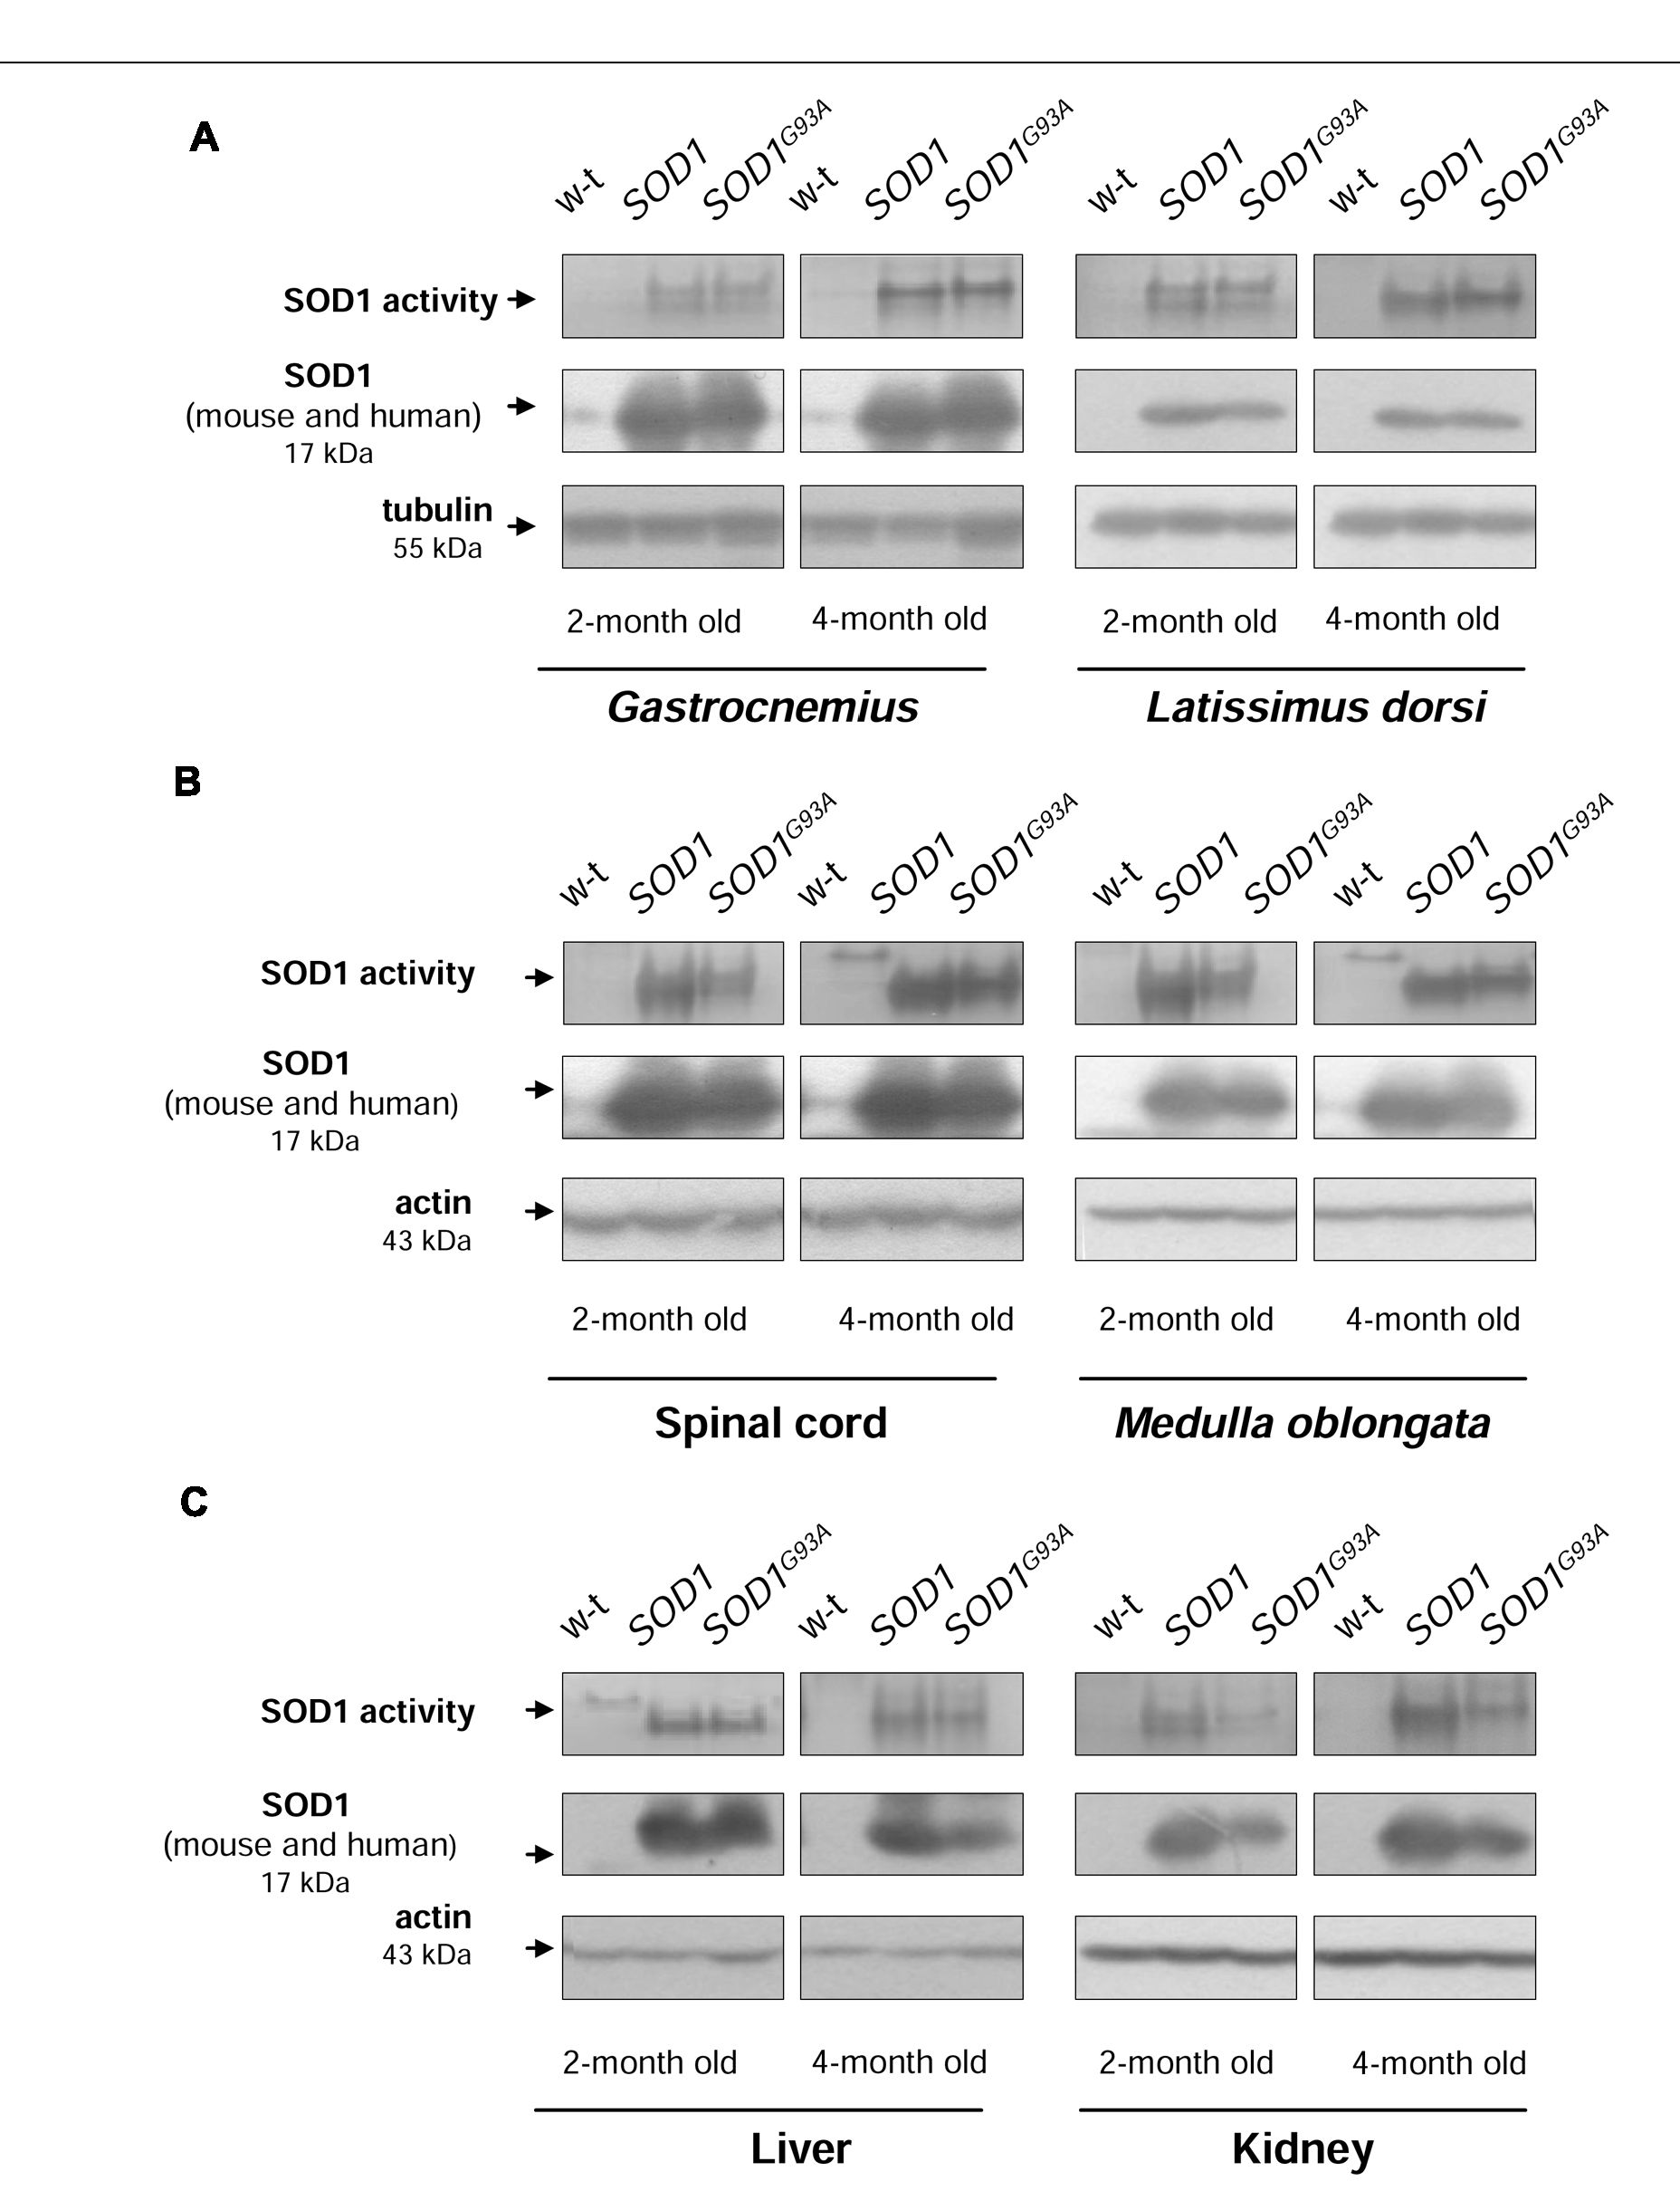
Gajowiak et al.
Iron in Mouse ALS Models
FIGURE 1 | CuZn-SOD1 (SOD1) activity and expression in tissues of experimental mice. In-gel activity staining for SOD1 activity in total protein extracts
obtained from skeletal muscles (A), neuronal tissues (B), liver, and kidney (C) (upper). Results of Western blot analysis of SOD1 in the same protein extracts are
shown in (middle). Blots were also re-probed with monoclonal anti-tubulin or anti-p-actin antibodies from mouse as a loading control (lower). Data are representative
for three independent Western blot analyses performed using extracts from 3 mice of each experimental group. The intensity of the SOD1 bands (relative to the
intensity of tubulin or actin bands) was quantified with a Molecular Imager using Quantity One software (Bio-Rad) and is shown in arbitrary units to present protein
level (Supplementary Table). Results are expressed as mean ± SD for three mice in each experimental group. Significant differences (P < 0.01) in SOD1 protein
levels were found between transgenic (SOD1 and SOD1G93A) and wild-type mice in a given tissue and age group.

Increased H-Ft Protein Levels in SOD1
and SOD1G93A Mice
Ferritin level within the cell is a hallmark of intracellular iron
accumulation (Harrison and Arosio, 1996). Among two types
of subunits forming a hollow shell of the protein, H-ferritin
possessing ferroxidase activity has been also shown to be
regulated by oxidants and to prevent pro-oxidant labile iron from
exacerbating oxidative stress (Orino et al., 2001). Bearing this in
mind and referring to the concept of the involvement of oxidative
stress in ALS pathology, we aimed to check whether changes in
ferritin expression in tissues are specific for SOD1G93A mouse
model of ALS. We determined both H- and L-ferritin expression
at the protein level (Figures 5A-C). We noticed a substantial
(from ~3- to 25-fold depending on tissue, Supplementary Table)
upregulation of H-ferritin protein in all analyzed tissues in
both SOD1 and SOD1G93A mice. This increase has been already
observed in 2-month-old mice, strongly suggesting that it is
rather caused by the enhanced SOD1 activity and is not directly
linked strictly to the ALS pathology. In all tissues L-ferritin
protein levels remained largely unaffected (Figures 5A-C).

Similar Expression Patterns of Iron
Importer and Exporter Genes in SOD1,
SOD1G93A and Wild-type Mice
The cellular iron status is largely influenced by the balance
between iron influx to the cell and its export from the cell to the
Frontiers in Molecular Neuroscience | www.frontiersin.org
5
January 2016 | Volume 8 | Article 82
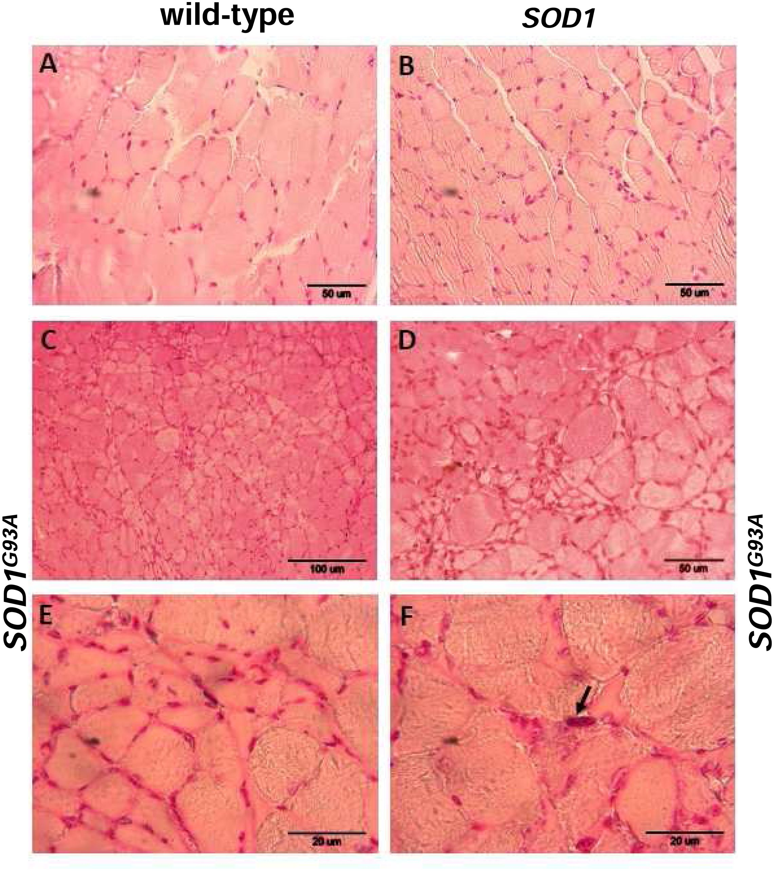
Gajowiak et al.
Iron in Mouse ALS Models
FIGURE 2 | Pathological changes in the gastrocnemius muscle of symptomatic ALS mice. Haematoxylin and eosin-stained cross-sections of the
gastrocnemius muscle from 4-month-old wild-type (A) and SOD1 transgenic (B) mice show similar regular size of muscle fibers and normal architecture of the
muscle; bar = 50 pm. Sections from aged-matched symptomatic SOD1G93A mice show pathological changes in muscle structure characteristic for ALS (C-F).
Larger regions of the muscle sections at lower magnification (bar = 100 pm) show characteristic grouped atrophy in the muscle of SOD1G93A mice (C). Muscle
tissue from symptomatic SOD1G93A mice shows the presence of mixed fiber types of different size. Group of small and atrophic muscle fibers and presence of
hypertrophied fibers in the gastrocnemius muscle from 4-month-old symptomatic mouse (D); bar = 50 pm. Group of the small and angular fibers at a higher
magnification (bar = 20 pm) (E). Pyknotic nuclear clumb (arrow) present in the muscle of symptomatic SOD1G93A mice (F); bar = 20 pm.
extracellular environment. Therefore in selected tissues (such as
muscles, spinal cord, and liver) of mice from three experimental
groups we determined the expression of the main iron importer
gene, TfR1. Of importance, TfR1 is predominantly regulated at
the level of its transcript stability via the post-transcriptional
system IRP/IRE (Wilkinson and Pantopoulos, 2014). As show
in Figures 6A-D the TfR1 mRNA levels measured by real-time
quantitative RT-PCR show tendency to decrease in all analyzed
tissues of SOD1G93A mice compared with wild-type and SOD1
mice. However, the only statistically significant decrease in TfR1
mRNA level was found in the case of L. dorsi muscle of SOD1G93A
symptomatic mice (Figure 6B). As regards proteins cooperating
in iron export - Fpn and Cp, their levels in all analyzed tissues of
SOD1G93A and SOD1 mice assessed by Western blotting are the
same as those found in control animals (wild-type and SOD1) in
the two analyzed periods (Figures 7A-D).
Frontiers in Molecular Neuroscience | www.frontiersin.org
6
January 2016 | Volume 8 | Article 82
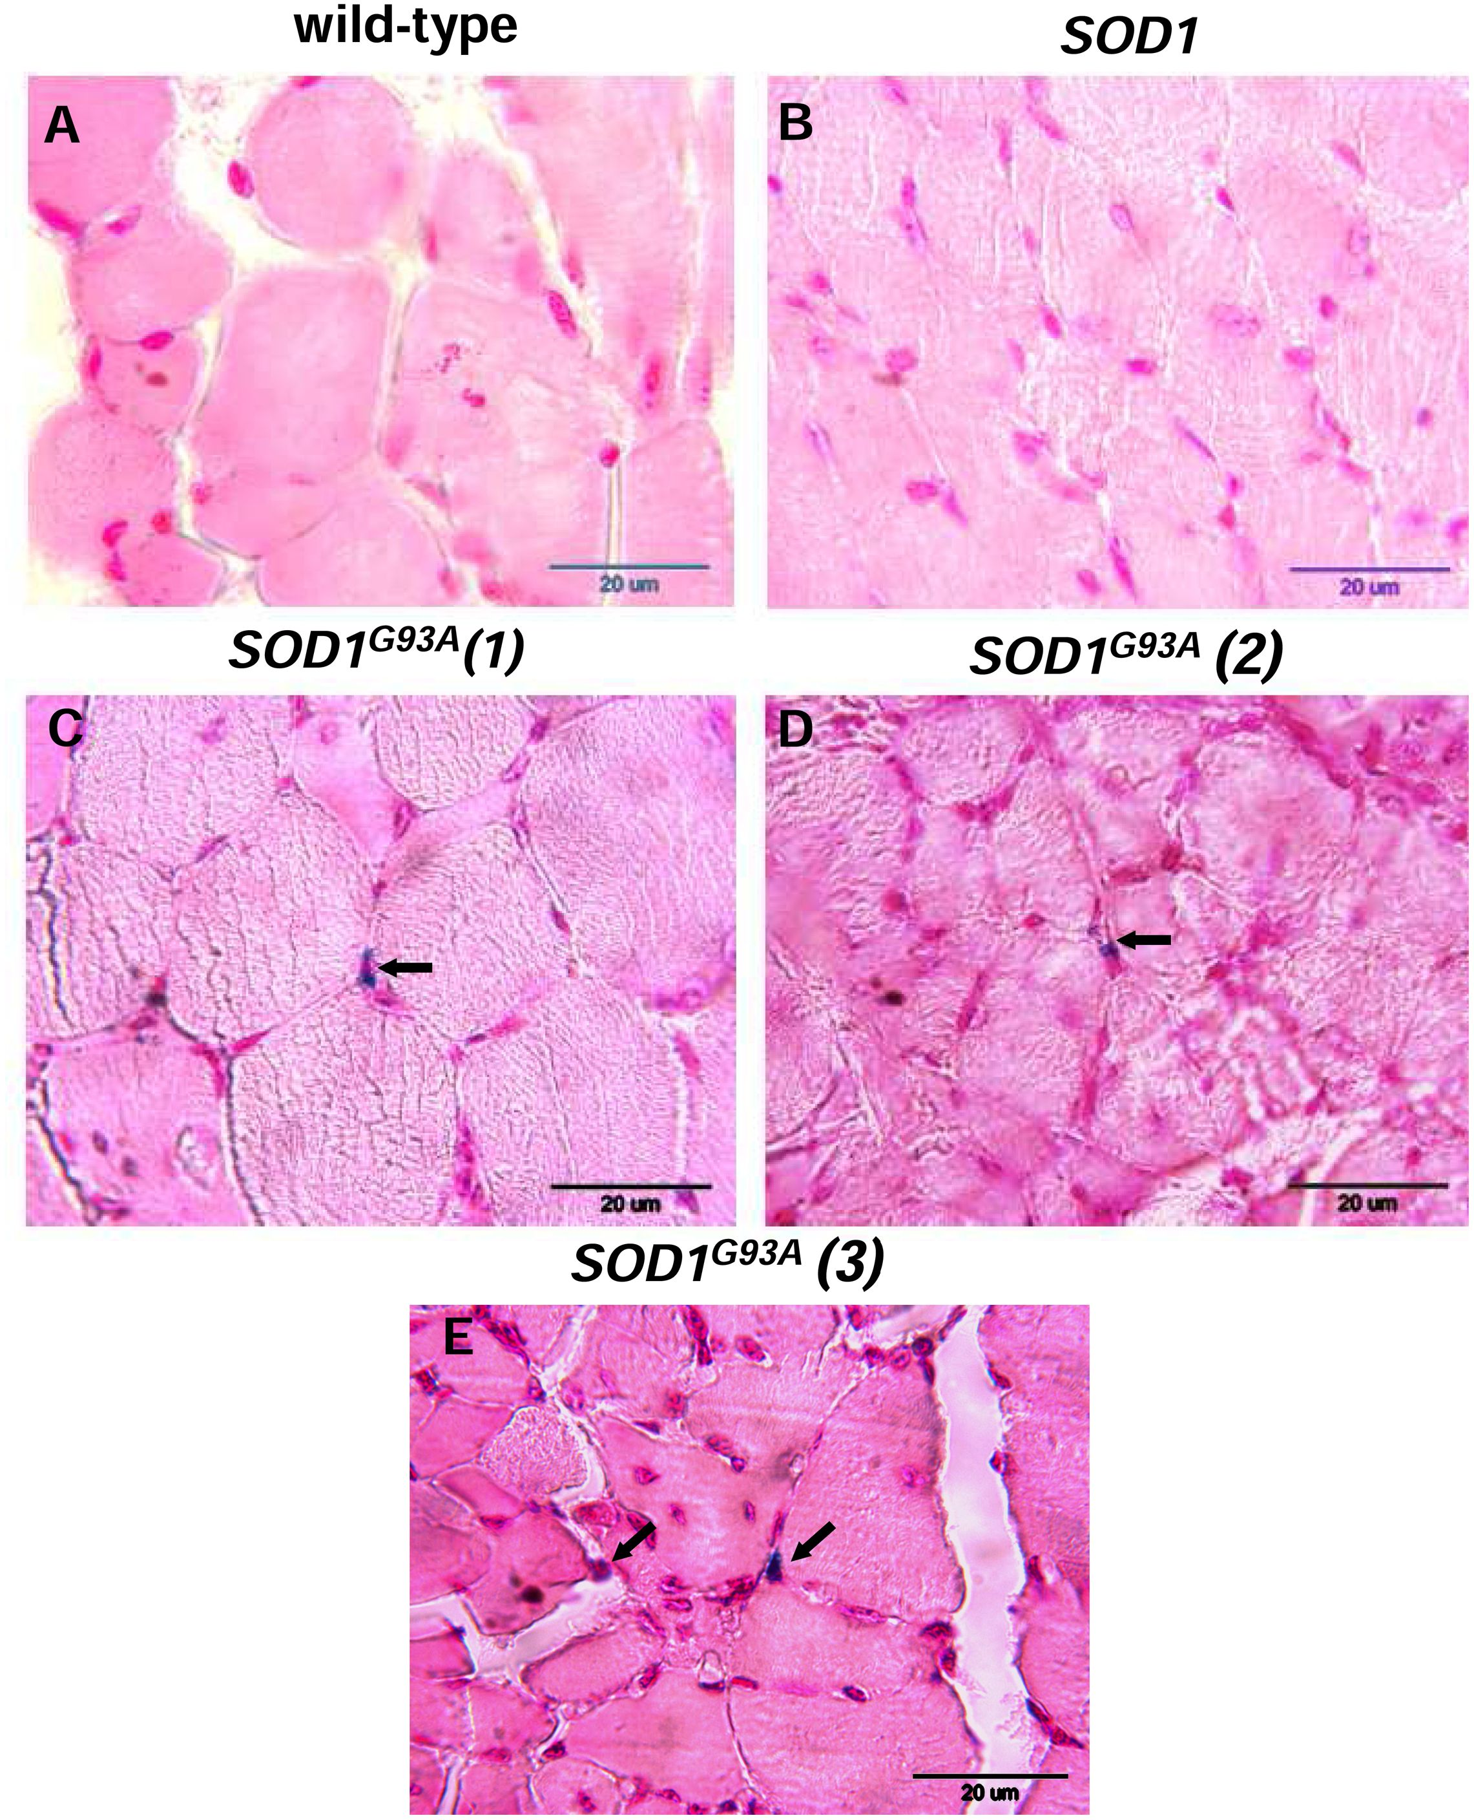
Gajowiak et al.
Iron in Mouse ALS Models
FIGURE 3 | Histological examination of iron loading in the gastrocnemius muscle of 4-month-old experimental mice. Non-heme iron deposits were
detected by staining with Perls Prussian Blue in the gastrocnemius muscle of wild-type (A) and SOD1 mice (B). Blue staining (indicated by arrows) was present
exclusively in the muscle section of symptomatic SOD1G93A mice. Staining of muscle sections from three SOD1G93A mice are shown (C,D,E).
Heme Oxygenase 1 (HO1) mRNA and
Protein Levels are Specifically Increased
in Muscles and Spinal Cord of
Symptomatic SODG93A Mice
Activation of HO1, a heme-degrading, inducible enzyme
responsive to a wide range of cellular stimuli, is considered to
convey adaptive responses to various stress conditions including
oxidative stress (Grochot-Przeczek et al., 2012). Surprisingly,
HO1 expression has been intermittently investigated in ALS
pathology (Dwyer et al., 1998). Here we show that Hmoxl gene is
specifically induced at both mRNA and protein levels in muscles
(Figures 8A,B) and spinal cord (Figure 8C) of symptomatic
SODG93A mice. In the gastrocnemius muscle the up-regulation
Frontiers in Molecular Neuroscience | www.frontiersin.org
7
January 2016 | Volume 8 | Article 82
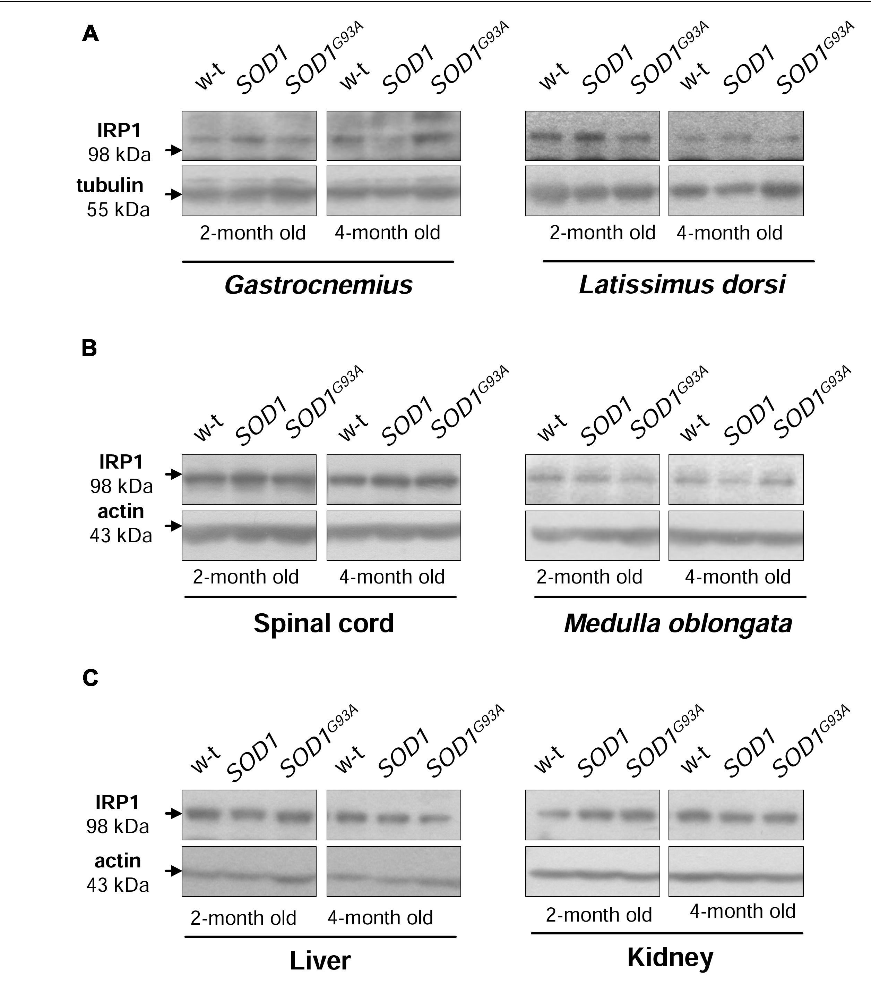
Gajowiak et al.
Iron in Mouse ALS Models
FIGURE 4 | Wild-type, SOD1 and SOD1G93A mice show similar IRP1 protein levels in all examined tissues. IRP1 levels were assessed in total skeletal
muscle (A), neuronal tissues (B), hepatic and renal (C) extracts by Western blotting as described under “Material and Methods”. Blots were also re-probed with
monoclonal anti-tubulin or anti-p-actin antibodies from mouse as a loading control. Data are representative for three independent Western blot analyses performed
using extracts from 3 mice of each experimental group. The intensity of the IRP1 bands (relative to the intensity of tubulin or actin bands) was quantified with a
Molecular Imager using Quantity One software (Bio-Rad) and is shown in arbitrary units to present protein level (Supplementary Table).
of Hmox1 gene was already observed in asymptomatic mice
(Figure 8A). Importantly, in the liver of SOD1G93A mice, tissue
not affected by ALS pathology, we did not observe any HO1
up-regulation, neither at the mRNA nor at the protein levels
(Figure 8D).

DISCUSSION
Among antioxidant enzymes the family of ubiquitous SODs
deserves special attention because the reaction catalyzed by SODs
converts one ROS (O2_) to another (H2O2), and thus these
enzymes play a subtle role in the regulation of ROS balance (Zelko
et al., 2002). Accordingly, both deficiency and overexpression of
Cu,Zn-SOD (SOD1), mostly cytosolic enzyme, induce oxidative
stress in a wide range of organisms (Reaume et al., 1996;
Lee et al., 2001; Missirlis et al., 2003; Starzynski et al., 2009).
On the other hand, it is tempting to propose that enhanced
SOD1 activity may lead to the excessive H2O2 formation, and
subsequent iron-related exacerbation of oxidative stress through
the redox reaction of H2O2 with ferrous iron but also through
the H2O2-dependent disturbance of iron homeostasis regulatory
mechanisms (Orino et al., 2001).
Identification of mutations in SOD1 gene as causative ones in
familial amyotrophic lateral sclerosis (fALS) (Rosen et al., 1993)
was immediately followed by the generation of transgenic mice
constitutively overexpressing mutated human SOD1 (Gurney
et al., 1994). Nowadays these animals are widely used in ALS
research (Turner and Talbot, 2008). However, investigation of
some pathogenic aspects of this disease in rodent models of
mutant SOD1-mediated fALS requires special consideration
of increased SOD1 activity, which does not occur in human
pathology. It seems that this remark is of particular importance
when studying a potential role of iron in the pathogenesis of ALS.
Misregulated iron homeostasis that promotes excessive oxidative
stress in the motor neurons has been postulated to contribute
to the disease pathogenesis (Carri et al., 2003). This proposal
is now strengthened by several lines of evidence coming from
studies on ALS patients (Kasarskis et al., 1995; Mitchell et al.,
2010; Kwan et al., 2012; Ignjatovic, 2013), animal ALS models
Frontiers in Molecular Neuroscience | www.frontiersin.org
8
January 2016 | Volume 8 | Article 82
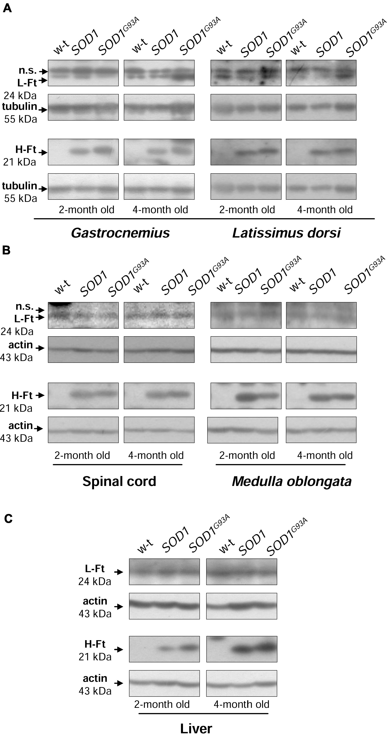
Gajowiak et al.
Iron in Mouse ALS Models
FIGURE 5 | Analysis of ferritin protein levels in tissues of experimental mice. Western blot analysis of L-Ft and H-Ft protein levels in skeletal muscle (A),
neuronal tissues (B), and liver (C) cytosolic extracts. Tubulin and actin were used as a loading controls, as indicated. n.s. - non-specific band detected with purified
rabbit mouse liver ferritin antiserum. Data are representative for three independent Western blot analyses performed using extracts from 3 mice of each experimental
group. The intensity of the H- and L-Ft bands (relative to the intensity of tubulin or actin bands) was quantified with a molecular Imager using Quantity One software
(Bio-Rad) and is shown in arbitrary units to present proteins level (Supplementary Table). Statistically significant differences (P < 0.01) in H-Ft protein levels were
found between transgenic (SOD1 and SOD1G93A) and wild-type mice in a given tissue and age group.
(Jeong et al., 2009; Wang et al., 2011; Lee et al., 2015) and
cellular ALS models (Danzeisen et al., 2006; Hadzhieva et al.,
- . Transgenic SOD1G93A (Wang et al., 2011; Lee et al., 2015)
and SOD1G37R (Jeong et al., 2009) mice, abundantly expressing
active mutant SOD1 and showing fast and slow progression of the
disease, respectively, are the most intensely studied in vivo models
for investigating the contribution of iron to the pathogenesis
of ALS. However, in these studies the results obtained from
mice overexpressing mutated SOD1 gene were not compared
with those from transgenic mice overexpressing human wild-type
SOD1.
In our study, we adopted an experimental approach aimed
at comparing changes in iron metabolism in 2-month-old and
4-month-old age-matched mice carrying mutated SOD1G93A
Frontiers in Molecular Neuroscience | www.frontiersin.org
9
January 2016 | Volume 8 | Article 82
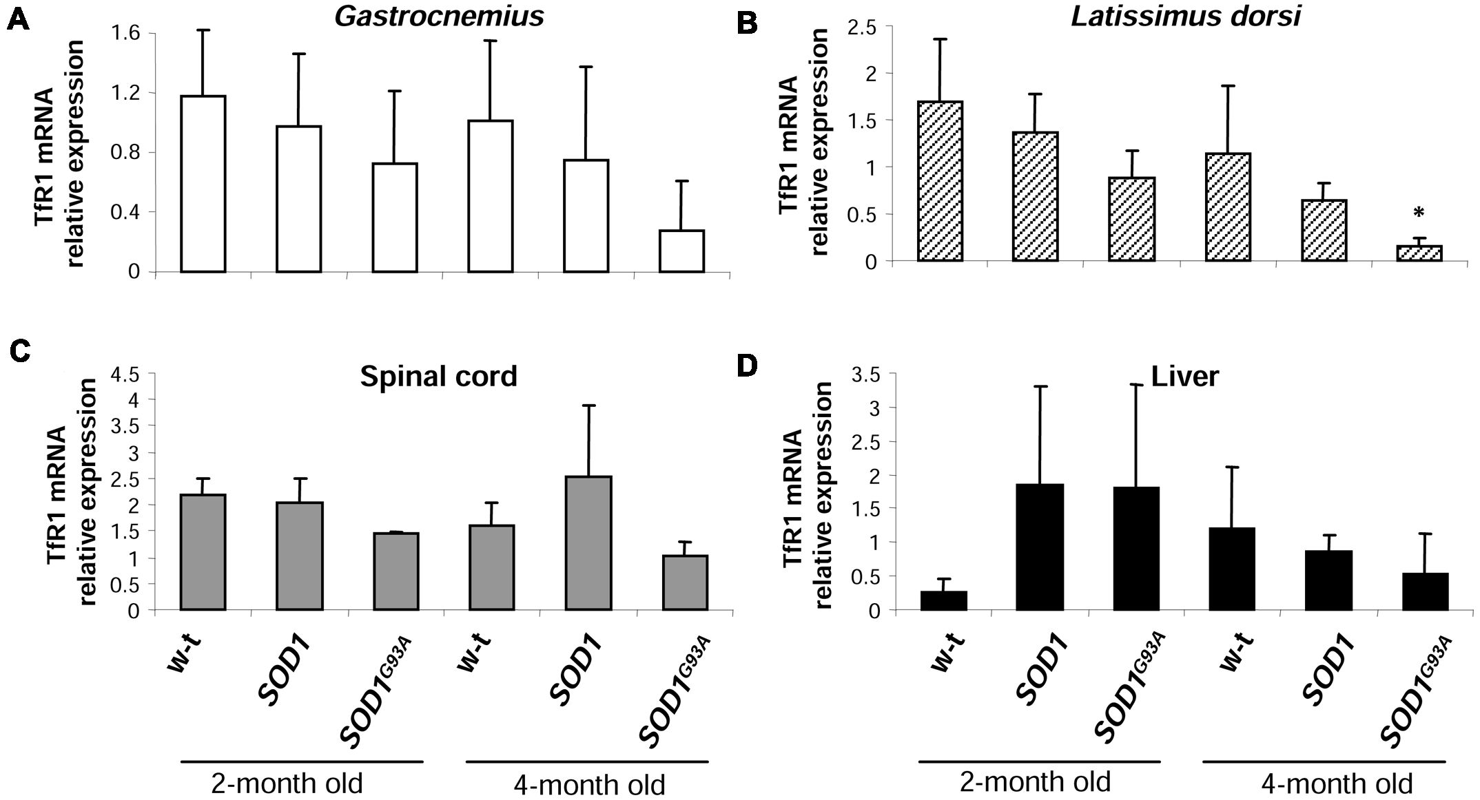
Gajowiak et al.
Iron in Mouse ALS Models
FIGURE 6 | Analysis of TfR1 mRNA abundance in tissues of experimental mice. TfR1 mRNA abundance in skeletal muscles (A,B), spinal cord (C), and liver
(D) was measured by real-time RT-PCR as described under “Materials and methods.” The histograms display TfR1 mRNA levels after normalization to 18S
ribosomal RNA levels. Each column represents the mean ± SD of three biological amplification reactions. RNA from each mouse was extracted separately using
TRIZOL reagent, reverse-transcribed and amplified as described in M&M; therefore, 18 cDNA samples (biological triplicates for each condition) were finally used in
the analysis of gene expression in each tissue. *, significant difference versus wild-type in the group of symptomatic, 4-month-old mice (P < 0.05).
and non-mutated human SOD1 genes, as well as in control
non-transgenic mice. We show that in all analyzed tissues the
expression and SOD1 activity was similar in both SOD1G93A and
SOD1 mice and highly raised in both of the transgenic strains
in comparison to the wild-type animals. Our results stay in
accordance with the prediction of a high copy number of the
transgene in SOD1G93A mice (Gurney et al., 1994). Considering
the evidence that skeletal muscle weakness and atrophy, followed
by paralysis is a final major cause of disability and death
in ALS (Pratt et al., 2012; Pansarasa et al., 2014), we first
wanted to determine histological hallmarks of myopathology in
mice from three experimental groups. Importantly, we found
pathological changes in the gastrocnemius muscle morphology
only in symptomatic SOD1G93A mice, which indicates that the
enhanced activity of SOD1 in those animals is not sufficient for
the induction of skeletal muscle pathology, and which confirms
progressive character of the disease. Our findings corroborate
results of a comprehensive examination of various aspects of
muscle pathology from animal SOD1 models of ALS (Pansarasa
et al., 2014) and from clinically confirmed ALS patients (Leger
et al., 2006). The impairment of iron metabolism that leads
to excessive accumulation of this metal in tissues altered in
ALS has been mainly demonstrated in relation to neuronal
system (Kasarskis et al., 1995; Kwan et al., 2012; Ignjatovic,
- . Here, we provide histological evidence that among mice
from 3 experimental groups analyzed at two stages of the
disease, deposits of iron were strictly specific for skeletal muscles
of symptomatic SOD1G93A animals. Accordingly, progressive
increase in muscle iron content has been shown in SOD1G93A rats
from the disease onset up to the end-stage of ALS (Halon et al.,
- .
Enhanced ferritin level reflects iron accumulation but may
be also considered as an element of the adaptive response to
oxidative stress that limits the bioavailability of the free iron,
which participates in the generation of -OH. Our analysis of
H- and L-ferritin expression clearly shows that only H-Ft is
upregulated at the protein level in SOD1G93A mice, not only in
tissues primarily affected by ALS (muscles, M. oblongata, and
spinal cord) but also in the liver, a tissue, which is not directly
related to the ALS pathology. Unexpectedly, similar increase in
H ferritin chains expression was also observed in all analyzed
tissues of mice that overexpress a wild-type human SOD1 gene.
This uniform ferritin upregulation in SOD1G93A and SOD1 mice
strongly suggests that it results from oxidative stress induced by
increased SOD1 activity. Although increased ferritin expression
has been reported in skeletal muscles of SOD1G93A rats (Halon
et al., 2010, 2014), in spinal cord of SOD1G93A mice (Massignan
et al., 2007) and microglia of SOD1G37R mice (Jeong et al., 2009),
the question of the specificity of this upregulation associated with
ALS pathology remains uncertain as in all those studies only
wild-type animals were used as controls. Ferritin is commonly
considered as a hallmark of cellular iron status, and an increase in
ferritin mirrors iron accumulation. Our observation of both iron
deposits and high ferritin levels in the gastrocnemius muscle of
symptomatic SOD1G93A mice seems to confirm this rule. On the
other hand, as shown in this study, high level of cytosolic ferritin
in the gastrocnemius muscle of SOD1 mice is not associated
with detectable iron deposits and, as shown by others, iron
accumulation in neurons of SOD1G37R mice is not correlated
with any increase in intracellular ferritin content (Jeong et al.,
2009). All these data strongly suggest that ferritin may not be
a valuable indicator of intracellular iron status in SOD1 ALS
Frontiers in Molecular Neuroscience | www.frontiersin.org
10
January 2016 | Volume 8 | Article 82
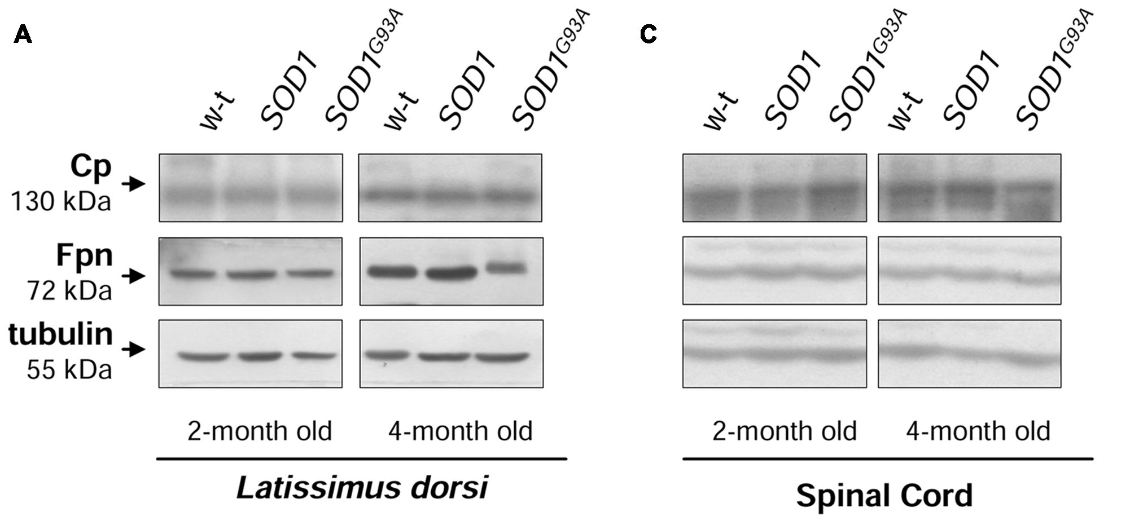
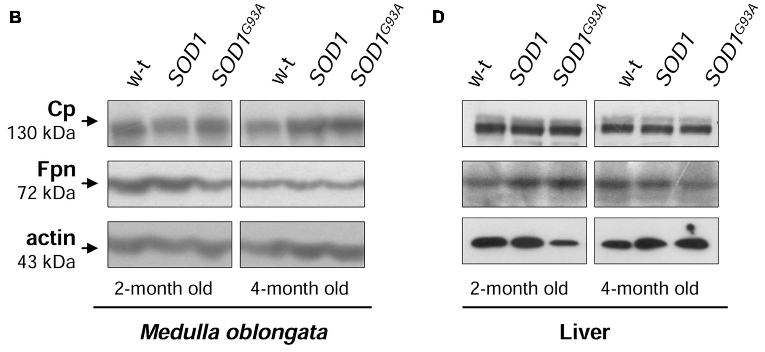
Gajowiak et al.
Iron in Mouse ALS Models
FIGURE 7 | Analysis of Cp and Fpn protein levels in tissues of experimental mice. Western blot analysis of Cp and Fpn protein levels in the Latissimus dorsi
muscle (A), neuronal tissues (B,C), and liver (D) membrane extracts Tubulin and actin were used as loading controls. Data are representative for three independent
Western blot analyses performed using extracts from three mice of each experimental group). The intensity of the IRP1 bands (relative to the intensity of tubulin or
actin bands) was quantified with a Molecular Imager using Quantity One software (Bio-Rad) and is shown in arbitrary units to present proteins levels (Supplementary
Table).
models. Regulation of ferritin subunits is mediated by various
factors at various regulatory levels such as transcription (Torti
and Torti, 2002), translation (Wilkinson and Pantopoulos, 2014)
and protein stability (De Domenico et al., 2006). In addition,
both ferritin subunits are up-regulated by iron via iron regulatory
proteins (IRP1 and IRP2) (Wilkinson and Pantopoulos, 2014).
We have previously shown that IRP1 protein level is strongly
(by 80%) down-regulated in SOD1 knockout mice (Starzynski
et al., 2005). Here, we demonstrate that under the opposite
conditions of a marked increase in SOD1 activity - in SOD1G93A
and SOD1 mice, IRP1 level is unchanged. Accordingly, analysis
of IRP1 in the spinal cord of SOD1G93A mice (Jeong et al., 2009)
and in U373 MG glial cells overexpressing SOD1G93A and wild-
type SOD1 (Danzeisen et al., 2006) show no changes in IRP1
protein expression (based on the EMSA assay with 2% ME). In
contrast to these findings, proteomic analysis of the spinal cord
of presymptomatic ALS SOD1G93A mice demonstrated nearly
threefold reduction in IRP1 protein level when compared to
wild-type mice. However, this decrease has not been validated
by direct evaluation of IRP1 level by Western blot analysis
(Massignan et al., 2007). Interestingly, the two aforementioned
studies (Danzeisen et al., 2006; Jeong et al., 2009) show that
increased activity of SOD1 results in the activation of IRP1, i.e., in
inducing its ability to bind to the IRE (iron responsive element)
sequences contained in mRNAs encoding several iron-related
proteins such as ferritin chains, TfR1 and Fpn (Wilkinson and
Pantopoulos, 2014). It is tempting to propose that such regulation
of IRP1 IRE-binding activity is mediated by H2O2 (Martins
et al., 1995; Pantopoulos and Hentze, 1995) produced under
conditions of increased SOD1 activity. Nevertheless, according
to the principles of the IRP/IRE system, this increased binding
of IRP1 to the IREs located in the 5'UTR of H-Ft, L-Ft and
Fpn mRNAs, should inhibit their translation (Wilkinson and
Pantopoulos, 2014). Therefore, considering that ferritin has been
shown to be increased in animals and cells overexpressing
SOD1G93A, multiple but yet unknown mechanisms may override
the IRP1-mediated Ft inhibition in ALS.
TfR1 is a cell surface protein, providing iron bound to
transferrin to the cells via endocytosis (Pantopoulos et al.,
2012). Its expression is regulated by the IRP/IRE system in
Frontiers in Molecular Neuroscience | www.frontiersin.org
11
January 2016 | Volume 8 | Article 82
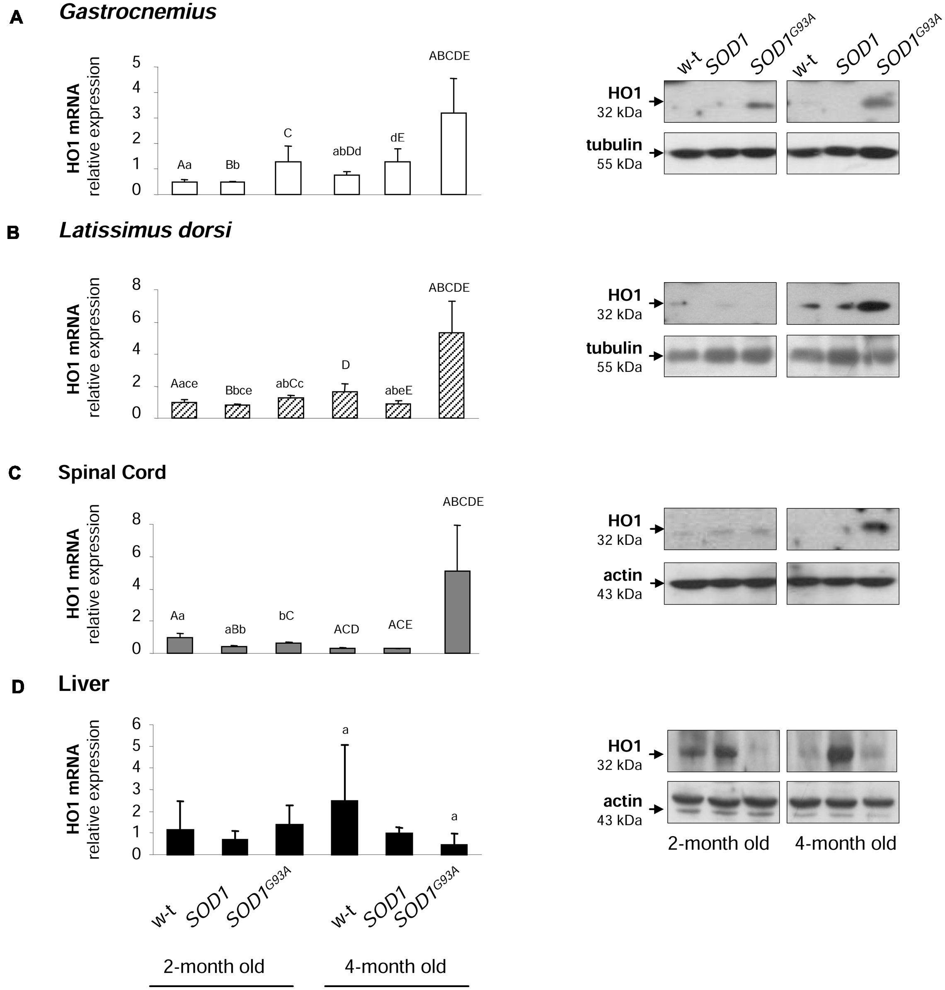
Gajowiak et al.
Iron in Mouse ALS Models
FIGURE 8 | Analysis of HO1 mRNA abundance and protein levels in tissues of experimental mice. HO1 transcript abundance was measured in skeletal
muscle (A,B), neuronal tissues (C), and liver (D) (left-hand) by real-time RT-PCR as described in M&M. The histograms display HO1 mRNA levels after normalization
to 18S ribosomal RNA levels. Each column represents the mean ± SD of three biological amplification reactions. RNA from each mouse was extracted separately
using TRIZOL reagent, reverse-transcribed and amplified as described in M&M; therefore, 18 cDNA samples (biological triplicates for each condition) were finally
used in the analysis of gene expression in each tissue. The same capital and small letter indicates groups between which statistically significant differences were
found at P < 0.01 and P < 0.05, respectively. Western blot analysis of HO1 protein levels was performed in membrane extracts obtained from the above-mentioned
tissues (right-hand). Data are representative for three independent Western blot analyses performed using extracts from three mice of each experimental group. The
intensity of the HO1 bands (relative to the intensity of tubulin or actin bands) was quantified with a molecular Imager using Quantity One software (Bio-Rad) and is
shown in arbitrary units to present protein level. Results are expressed as mean ± SD for three mice in each experimental group.
an opposite manner to Ft and Fpn. This means that activated
IRP1 stabilizes TfR1 transcript by binding to several IRE
motifs located in its 3'UTR (Wilkinson and Pantopoulos,
- . The expression of TfR1 transcript in all analyzed
ALS target tissues, such as skeletal muscles (gastrocnemius
and L. dorsi) and spinal cord of SOD1G93A mice shows the
tendency to be decreased when compared with SOD1 and
WT animals. Results of previous studies showing the TfR1
expression in SOD1 ALS animal and cellular models are not
conclusive: cellular studies report the increase of TfR1 at both
mRNA and protein levels (Danzeisen et al., 2006; Hadzhieva
et al., 2013), but TfR1 protein expression in cervical cord
of SOD1G37R mice has been shown unchanged (Jeong et al.,
2009). Again, as in the case of Ft, the increase in TfR1
levels were reported in human glioblastoma astrocytoma cells
overexpressing mutated and WT SOD1 gene, which denotes no
specificity of the regulation for the ALS pathology (Danzeisen
et al., 2006).
Frontiers in Molecular Neuroscience | www.frontiersin.org
12
January 2016 | Volume 8 | Article 82
Gajowiak et al.
Iron in Mouse ALS Models
An alternatively spliced, glycosylphosphatidylinositol (GPI)
anchored form of Cp is a copper-dependent ferroxidase that
oxidizes ferrous iron exported from the cells by Fpn, and thus
enables binding of ferric iron to transferrin. The cooperation
of this protein tandem is crucial for protecting the central
nervous (CNS) system from toxic iron deposition. Accordingly,
aceruloplasminemia in humans results in iron accumulation in
the CNS and neurodegeneration (Hellman and Gitlin, 2002).
Likewise, reduced Fpn expression was also associated with
increased iron content in central nervous system cells under
inflammatory conditions (Urrutia et al., 2013). Here, we show
that neither the expression of GPI-Cp nor that of Fpn is
altered in skeletal muscles and spinal cord of SOD1G93A mice.
A recent study showed Fpn decrease in the soleus but not
in the tibialis muscle of SOD1G93A rats (Halon et al., 2014).
Authors argue that Fpn downregulation in the soleus muscle is
due to the increased hepcidin, a peptide that binds Fpn and
induces its degradation (Ganz and Nemeth, 2012). However,
they do not explain why the systemic effect of hepcidin
activity is restricted only to the one type of muscles. As
regards Cp, to our knowledge, the expression of membrane
anchored form was not studied in ALS, however, increased
concentration of its soluble form (sCp, especially relative
abundance of more basic sCp isoforms) has been reported
in cerebrospinal fluid of ALS patients (Conti et al., 2008).
Although serum Cp pattern has been proposed as disease
feature, our results do not support the role of Cp in ALS
pathogenesis.
The rationale for analyzing the expression of HO1 encoded
by Hmox1 gene in both SOD1 and SOD1G93A mice is that
this ubiquitous enzyme is induced by a great number of stress
stimuli (including oxidative stress) and that is strictly connected
with intracellular and systemic iron metabolism (Kovtunovych
et al., 2010; Starzynski et al., 2013). HO1 mediates a broad
range of beneficial effects by catalyzing the first and rate-
limiting step in the heme degradation pathway, resulting in
the formation of biologically active molecules such iron, carbon
monoxide (CO) and biliverdin (Grochot-Przeczek et al., 2012).
In consequence, increased HO1 expression has been considered
as a cytoprotective, adaptive cellular response under conditions of
oxidative stress and inflammation occurring inter alia in several
neurodegenerative diseases (Schipper et al., 2009). Importantly,
in this study we have shown that HO1 expression is increased
in tissues of the transgenic SOD1G93A mice. Among few genes
fundamental for cellular iron homeostasis and analyzed in this
study, the upregulation of Hmox1 gene seems to be strictly
specific for skeletal muscles and neuronal tissues of symptomatic
SOD1G93A mice. The only exception is gastrocnemius muscle,
where HO1 protein level is increased also in asymptomatic

REFERENCES
Atkin, J. D., Scott, R. L., West, J. M., Lopes, E., Quah, A. K., and Cheema, S. S.
- . Properties of slow- and fast-twitch muscle fibres in a mouse model
of amyotrophic lateral sclerosis. Neuromuscul. Disord. 2005, 377-388. doi:
10.1016/j.nmd.2005.02.005
mice overexpressing mutant SOD1. Of importance, this muscle,
in contrast to the broadest dorsal muscle, is made up of
mostly fast twitch (type II) muscle fibers, that are preferentially
affected by ALS (Atkin et al., 2005). Therefore, it is tempting
to speculate, that the oxidative stress precedes the onset of iron
metabolism dysregulation in ALS. In contrast to our results,
previous studies do not provide any evidence of increased
HO1 expression in the spinal cord of SOD1G93A mice (Dwyer
et al., 1998). The reason of this discrepancy is not known.
Our analysis of Hmox1 gene expression in SOD1G93A mice
includes the evaluation of both HO1 mRNA and protein levels
in various tissues and unambiguously shows a homogenous
pattern of Hmox1 gene induction. It has been postulated
that cytoprotective effect of HO1 requires the co-induction
of H-ferritin chain, which limits the pro-oxidant effect of
the free iron released from the protoporphyrin IX ring of
heme following HO1-mediated enzymatic reaction (Gozzelino
and Soares, 2014). Coming back to the concept of the iron-
mediated toxicity in ALS, it is tempting to propose that in
SOD1G93A mice HO1 acts together with ferritin to limit the
reactivity of heme-derived intracellular iron as it was originally
demonstrated in endothelium under hemolytic conditions (Balla
etal., 1992).

AUTHOR CONTRIBUTIONS
AG supported the design of the study, performed the research,
and analyzed data. AS designed and performed the research,
analyzed data, and contributed to the writing of the paper.
RS contributed to the conception of the work, performed the
research and analyzed data. AB performed the research and
analyzed data. ML supported the design of the study, performed
the research, revised the work for important intellectual content.
RS performed the research, analyzed data, and drafted the work.
PL designed the study and wrote the paper. All authors read and
approved the final manuscript.

FUNDING
This work was supported byNCN grant no. 2011/01/B/N223/00632.

SUPPLEMENTARY MATERIAL
The Supplementary Material for this article can be found
online at: http://journal.frontiersin.org/article/10.3389/fnmol.
2015.00082
Balla, G., Jacob, H. S., Balla, J., Rosenberg, M., Nath, K., Apple, F., et al. (1992).
Ferritin: a cytoprotective antioxidant strategem of endothelium. J. Biol. Chem
267, 18148-18153.
Barber, S. C., Mead, R. J., and Shaw, P. J. (2006). Oxidative stress in ALS: a
mechanism of neurodegeneration and a therapeutic target. Biochim. Biophys.
Acta 1762, 1051-1067. doi: 10.1016/j.bbadis.2006.03.008
Frontiers in Molecular Neuroscience | www.frontiersin.org
13
January 2016 | Volume 8 | Article 82
Gajowiak et al.
Iron in Mouse ALS Models
Beauchamp, C., and Fridovich, I. (1971). Superoxide dismutase: improved assays
and an assay applicable to acrylamide gels. Anal. Biochem. 44, 276-287. doi:
10.1016/0003-2697(71)90370-8
Bouton, C., Chauveau, M. J., Lazereg, S., and Drapier, J. C. (2002). Recycling of
RNA binding iron regulatory protein 1 into an aconitase after nitric oxide
removal depends on mitochondrial ATP. J. Biol. Chem. 277, 31220-31227. doi:
10.1074/jbc.M203276200
Canonne-Hergaux, F., Gruenheid, S., Ponka, P., and Gros, P. (1999). Cellular and
subcellular localization of the Nramp2 iron transporter in the intestinal brush
border and regulation by dietary iron. Blood 93, 4406-4417.
Carri, M. T., Ferri, A., Cozzolino, M., Calabrese, L., and Rotilio, G. (2003).
Neurodegeneration in amyotrophic lateral sclerosis: the role of oxidative
stress and altered homeostasis of metals. Brain Res. Bull. 61, 365-374. doi:
10.1016/S0361-9230(03)00179-5
Conti, A., Iannaccone, S., Sferrazza, B., De Monte, L., Cappa, S., Franciotta, D., et al.
- . Differential expression of ceruloplasmin isoforms in the cerebrospinal
fluid of amyotrophic lateral sclerosis patients. Proteomics Clin. Appl. 2, 1628—
1637. doi: 10.1002/prca.200780081
Danzeisen, R., Achsel, T., Bederke, U., Cozzolino, M., Crosio, C., Ferri, A., et al.
(2006). Superoxide dismutase 1 modulates expression of transferrin receptor.
J. Biol Inorg. Chem. 11,489-498. doi: 10.1007/s00775-006-0099-4
De Domenico, I., Vaughn, M. B., Li, L., Bagley, D., Musci, G., Ward, D. M.,
et al. (2006). Ferroportin-mediated mobilization of ferritin iron precedes
ferritin degradation by the proteasome. EMBO J. 25, 5396-5404. doi:
10.1038/sj.emboj.7601409
Dobrowolny, G., Aucello, M., Rizzuto, E., Beccafico, S., Mammucari, C.,
Boncompagni, S., et al. (2008). Skeletal muscle is a primary target
of SOD1G93A-mediated toxicity. Cell Metab. 8, 425-436. doi:
10.1016/j.cmet.2008.09.002
Dwyer, B. E., Lu, S. Y., and Nishimura, R. N. (1998). Heme oxygenase
in the experimental ALS mouse. Exp. Neurol. 150, 206-212. doi:
10.1006/exnr.1997.6763
Ganz, T., and Nemeth, E. (2012). Hepcidin andiron homeostasis. Biochim. Biophys.
Acta 1823, 1434-1443. doi: 10.1016/j.bbamcr.2012.01.014
Gozzelino, R., and Soares, M. P. (2014). Coupling heme and iron metabolism
via ferritin H chain. Antioxid. Redox Signal. 20, 1754-1769. doi:
10.1089/ars.2013.5666
Grochot-Przeczek, A., Dulak, J., and Jozkowicz, A. (2012). Haem oxygenase-1:
non-canonical roles in physiology and pathology. Clin. Sci. (Lond.) 122, 93-103.
doi: 10.1042/CS20110147
Gurney, M. E., Pu, H., Chiu, A. Y., Dal Canto, M. C., Polchow, C. Y., Alexander,
D. D., et al. (1994). Motor neuron degeneration in mice that express a
human Cu,Zn superoxide dismutase mutation. Science 264, 1772-1775. doi:
10.1126/science.8209258
Hadzhieva, M., Kirches, E., and Mawrin, C. (2014). Review: iron metabolism and
the role of iron in neurodegenerative disorders. Neuropathol. Appl. Neurobiol.
40,240-257. doi: 10.1111/nan.12096
Hadzhieva, M., Kirches, E., Wilisch-Neumann, A., Pachow, D., Wallesch, M.,
Schoenfeld, P., et al. (2013). Dysregulation of iron protein expression in the
G93A model of amyotrophic lateral sclerosis. Neuroscience 230, 94-101. doi:
10.1016/j.neuroscience.2012.11.021
Halon, M., Kaczor, J. J., Ziolkowski, W., Flis, D. J., Borkowska, A., Popowska, U.,
et al. (2014). Changes in skeletal muscle iron metabolism outpace amyotrophic
lateral sclerosis onset in transgenic rats bearing the G93A hmSOD1 gene
mutation. Free Radic. Res. 48, 1363-1370. doi: 10.3109/10715762.2014.955484
Halon, M., Sielicka-Dudzin, A., Wozniak, M., Ziolkowski, W., Nyka, W.,
Herbik, M., et al. (2010). Up-regulation of ferritin ubiquitination in skeletal
muscle of transgenic rats bearing the G93A hmSOD1 gene mutation.
Neuromuscul. Disord. 20,29-33. doi: 10.1016/j.nmd.2009.08.014
Harrison, P. M., and Arosio, P. (1996). The ferritins: molecular properties, iron
storage function and cellular regulation. Biochim. Biophys. Acta 1275, 161-203.
doi: 10.1016/0005-2728(96)00022-9
Hellman, N. E., and Gitlin, J. D. (2002). Ceruloplasmin metabolism and
function. Annu. Rev. Nutr. 22, 439-458. doi: 10.1146/annurev.nutr.22.012502.
114457
Ignjatovic, A., Stevie, Z., Lavrnic, S., Dakovic, M., and Bacic, G. (2013). Brain iron
MRI: a biomarker for amyotrophic lateral sclerosis. J. Magn. Reson. Imaging 38,
1472-1479. doi: 10.1002/jmri.24121
Jeong, S. Y., Rathore, K. I., Schulz, K., Ponka, P., Arosio, P., and David, S.
- . Dysregulation of iron homeostasis in the CNS contributes to disease
progression in a mouse model of amyotrophic lateral sclerosis. J. Neurosci. 29,
610-619. doi: 10.1523/JNEUROSCI.5443-08.2009
Kasarskis, E. J., Tandon, L., Lovell, M. A., and Ehmann, W. D. (1995). Aluminum,
calcium, and iron in the spinal cord of patients with sporadic amyotrophic
lateral sclerosis using laser microprobe mass spectroscopy: a preliminary study.
J. Neurol. Sci. 130, 203-208. doi: 10.1016/0022-510X(95)00037-3
Kovtunovych, G., Eckhaus, M. A., Ghosh, M. C., Ollivierre-Wilson, H., and
Rouault, T. A. (2010). Dysfunction of the heme recycling system in heme
oxygenase 1-deficient mice: effects on macrophage viability and tissue iron
distribution. Blood 116, 6054-6062. doi: 10.1182/blood-2010-03-272138
Kupershmidt, L., Weinreb, O., Amit, T., Mandel, S., Carri, M. T., and Youdim,
M. B. (2009). Neuroprotective and neuritogenic activities of novel multimodal
iron-chelating drugs in motor-neuron-like NSC-34 cells and transgenic
mouse model of amyotrophic lateral sclerosis. FASEB J. 23, 3766-3779. doi:
10.1096/fj.09-130047
Kwan, J. Y., Jeong, S. Y., Van Gelderen, P., Deng, H. X., Quezado, M. M., Danielian,
L. E., et al. (2012). Iron accumulation in deep cortical layers accounts for MRI
signal abnormalities in ALS: correlating 7 tesla MRI and pathology. PLoS ONE
7:e35241. doi: 10.1371/journal.pone.0035241
Lee, J. K., Shin, J. H., Gwag, B. J., and Choi, E. J. (2015). Iron accumulation
promotes TACE-mediated TNF-a secretion and neurodegeneration in a mouse
model of ALS. Neurobiol. Dis. 80, 63-69. doi: 10.1016/j.nbd.2015.05.009
Lee, M. H., Hyun, D.-H., Jenner, P., and Halliwell, B. (2001). Effect of
overexpression of wild-type and mutant Cu/Zn-superoxide dismutases on
oxidative damage and antioxidant defences: relevance to Down's syndrome
and familial amyotrophic lateral sclerosis. J. Neurochem. 76, 957-965. doi:
10.1046/j.1471-4159.2001.00107.x
Leger, B., Vergani, L., Soraru, G., Hespel, P., Derave, W., Gobelet, C., et al.
- . Human skeletal muscle atrophy in amyotrophic lateral sclerosis reveals
a reduction in Akt and an increase in atrogin-1. FASEB J. 20, 583-585.
Lipinski, P., Drapier, J. C., Oliveira, L., Retmanska, H., Sochanowicz, B., and
Kruszewski, M. (2000). Intracellular iron status as a hallmark of mammalian
cell susceptibility to oxidative stress: a study of L5178Y mouse lymphoma cell
lines differentially sensitive to H(2)O(2). Blood 95, 2960-2966.
Martins, E. A., Robalinho, R. L., and Meneghini, R. (1995). Oxidative stress induces
activation of a cytosolic protein responsible for control of iron uptake. Arch.
Biochem. Biophys. 316, 128-134. doi: 10.1006/abbi. 1995.1019
Massignan, T., Casoni, F., Basso, M., Stefanazzi, P., Biasini, E., Tortarolo, M.,
et al. (2007). Proteomic analysis of spinal cord of presymptomatic amyotrophic
lateral sclerosis G93A SOD1 mouse. Biochem. Biophys. Res. Commun. 353,
719-725. doi: 10.1016/j.bbrc.2006.12.075
McCord, J. M., and Fridovich, I. (1969). Superoxide dismutase. An enzymic
function for erythrocuprein (hemocuprein). J. Biol. Chem. 244, 6049-6055.
Missirlis, F., Hu, J., Kirby, K., Hilliker, A. J., Rouault, T. A., and Phillips, J.
(2003). Compartment-specific protection of iron-sulfur proteins by superoxide
dismutase. J. Biol. Chem. 278, 47365-47369. doi: 10.1074/jbc.M307700200
Mitchell, R. M., Simmons, Z., Beard, J. L., Stephens, H. E., and Connor, J. R.
- . Plasma biomarkers associated with ALS and their relationship to iron
homeostasis. Muscle Nerve 42, 95-103. doi: 10.1002/mus.21625
Orino, K., Lehman, L., Tsuji, Y., Ayaki, H., Torti, S. V., and Torti, F. M. (2001).
Ferritin and the response to oxidative stress. Biochem. J. 357, 241-247. doi:
10.1042/bj3570241
Oshiro, S., Morioka, M. S., and Kikuchi, M. (2011). Dysregulation of iron
metabolism in Alzheimers disease, Parkinsons disease, and amyotrophic
lateral sclerosis. Adv. Pharmacol. Sci. 2011:378278. doi: 10.1155/2011/
378278
Pansarasa, O., Rossi, D., Berardinelli, A., and Cereda, C. (2014). Amyotrophic
lateral sclerosis and skeletal muscle: an update. Mol. Neurobiol. 49, 984-990.
doi: 10.1007/s12035-013-8578-4
Pantopoulos, K., and Hentze, M. W. (1995). Rapid responses to oxidative stress
mediated by iron regulatory protein. EMBO J. 14, 2917-2924.
Pantopoulos, K., Porwal, S. K., Tartakoff, A., and Devireddy, L. (2012).
Mechanisms of mammalian iron homeostasis. Biochemistry 51, 5705-5724. doi:
10.1021/bi300752r
Pratt, A. J., Getzoff, E. D., and Perry, J. J. (2012). Amyotrophic lateral sclerosis:
update and new developments. Degener. Neurol. Neuromuscul. Dis. 2012, 1-14.
Frontiers in Molecular Neuroscience | www.frontiersin.org
14
January 2016 | Volume 8 | Article 82
Gajowiak et al.
Iron in Mouse ALS Models
Reaume, A. G., Elliott, J. L., Hoffman, E. K., Kowall, N. W., Ferrante, R. J., Siwek,
D. F., et al. (1996). Motor neurons in Cu/Zn Superoxide dismutase deficient
mice develop normally but exhibit enhanced cell death after axonal injury. Nat.
Genet. 13,43-47. doi: 10.1038/ng0596-43
Rosen, D. R., Siddique, T., Patterson, D., Figlewicz, D. A., Sapp, P., Hentati, A.,
et al. (1993). Mutations in Cu/Zn superoxide dismutase gene are associated with
familial amyotrophic lateral sclerosis. Nature 362, 59-62. doi: 10.1038/362059a0
Rothstein, J. D. (2009). Current hypotheses for the underlying biology
of amyotrophic lateral sclerosis. Ann. Neurol. 65(Suppl. 1), S3-S9. doi:
10.1002/ana.21543
Salin, M. L., and Bridges, S. M. (1981). Absence of the iron-containing superoxide
dismutase in mitochondria from mustard (Brassica campestris). Biochem. J. 195,
229-233. doi: 10.1042/bj1950229
Schipper, H. M., Song, W., Zukor, H., Hascalovici, J. R., and Zeligman, D. (2009).
Heme oxygenase-1 and neurodegeneration: expanding frontiers of engagement.
J. Neurochem. 110, 469-485. doi: 10.1111/j.1471-4159.2009.06160.x
Starzynski, R. R., Canonne-Hergaux, F., Lenartowicz, M., Krzeptowski, W.,
Willemetz, A., Stys, A., et al. (2013). Ferroportin expression in haem oxygenase
1-deficient mice. Biochem. J. 449, 69-78. doi: 10.1042/BJ20121139
Starzynski, R. R., Canonne-Hergaux, F., Willemetz, A., Gralak, M. A., Wolüski, J.,
Stys, A., et al. (2009). Haemolytic anaemia and alterations in hepatic iron
metabolism in aged mice lacking Cu,Zn-superoxide dismutase. Biochem. J. 420,
383-390. doi: 10.1042/BJ20082137
Starzynski, R. R., Gonęalves, A. S., Muzeau, F., Tyrolczyk, Z., Smuda, E., Drapier,
J. C., et al. (2006). STAT5 proteins are involved in down-regulation of iron
regulatory protein 1 gene expression by nitric oxide. Biochem. J. 400, 367-375.
doi: 10.1042/BJ20060623
Starzynski, R. R., Lipiński, P., Drapier, J. C., Diet, A., Smuda, E., Bartłomiejczyk, T.,
et al. (2005). Down-regulation of iron regulatory protein 1 activities and
expression in superoxide dismutase 1 knock-out mice is not associated
with alterations in iron metabolism. J. Biol. Chem. 280, 4207-4212. doi:
10.1074/jbc.M411055200
Torti, F. M., and Torti, S. V. (2002). Regulation of ferritin genes and protein. Blood
99, 3505-3516. doi: 10.1182/blood.V99.10.3505
Turner, B. J., and Talbot, K. (2008). Transgenics, toxicity and therapeutics in rodent
models of mutant SOD1-mediated familial ALS. Prog. Neurobiol. 85, 94-134.
doi: 10.1016/j.pneurobio.2008.01.001
Urrutia, P., Aguirre, P., Esparza, A., Tapia, V., Mena, N. P., Arredondo, M., et al.
(2013). Inflammation alters the expression of DMT1, FPN1 and hepcidin, and
it causes iron accumulation in central nervous system cells. J. Neurochem. 126,
541-549. doi: 10.1111/jnc.12244
Wang, Q., Zhang, X., Chen, S., Zhang, X., Zhang, S., Youdium, M., et al.
- . Prevention of motor neuron degeneration by novel iron chelators in
SOD1(G93A) transgenic mice of amyotrophic lateral sclerosis. Neurodegener.
Dis. 8, 310-321. doi: 10.1159/000323469
Wilkinson, N., and Pantopoulos, K. (2014). The IRP/IRE system in vivo:
insights from mouse models. Front. Pharmacol. 5:176. doi: 10.3389/fphar.2014.
00176
Zelko, I. N., Mariani, T. J., and Folz, R. J. (2002). Superoxide dismutase multigene
family: a comparison of the CuZn-SOD (SOD1), Mn-SOD (SOD2), and EC-
SOD (SOD3) gene structures, evolution, and expression. Free Radic. Biol. Med.
33, 337-349. doi: 10.1016/S0891-5849(02)00905-X
Conflict of Interest Statement: The authors declare that the research was
conducted in the absence of any commercial or financial relationships that could
be construed as a potential conflict ofinterest.
Copyright © 2016 Gajowiak, Stys, Starzynski, Bednarz, Lenartowicz, Starori and
Lipimki. This is an open-access article distributed under the terms of the Creative
Commons Attribution License (CC BY). The use, distribution or reproduction in
other forums is permitted, provided the original author(s) or licensor are credited
and that the original publication in this journal is cited, in accordance with accepted
academic practice. No use, distribution or reproduction is permitted which does not
comply with these terms.
Frontiers in Molecular Neuroscience | www.frontiersin.org
15
January 2016 | Volume 8 | Article 82

