Ireneusz KACZMARCZYK
Andrzej KRAŚNIAK
Maciej DROŻDŻ
Eve CHOWANIEC
Mariusz GAJDA
Andrzej RADZISZEWSKI Władysław SUŁOWICZ

The influence of sodium profiling on blood volume and ÎnÎrââialytic hypotension in patients on maintenance hemodialysis
Chair and Departament of Nephrology, Jagiellonian University, Kraków, Poland Head: Prof. Dr hab. Władysław Sułowicz
Additional key words:
intradialytic hypotension hemodialysis
sodium profiling
Dodatkowe słowa kluczowe:
hipotonia śróddializacyjna hemodializa
profilowanie sodu
Corresponding author:
Dr med. Ireneusz Kaczmarczyk Chair and Department of Nephrology Jagiellonian University
Kopemika 15c, 31-501 Krakow
Phone: 012 4247892; Fax: 012 424 7149 e-mail: irekkacz@wp. pl
An accurate evaluation of water content in the body of hemodialyzed patients seems to be an important problem in chronic dialysotherapy. Acute intradialytic hypotension observed in 20-33 % of hemodialysis patients is a very common complication of this kind of renal replacement therapy. The study was performed in 40 uremic patients, treated with hemodialysis at the Nephrology Clinic of the University Hospital in Cracow. In every patient, 3 model dialysis sessions were carried out. Total fluid removal was the same during every hemodialysis. The first model hemodialysis (HD1) was performed with constant dialysate sodium concentration (140 mmol/L), the second (HD2) with linear and the third (HD3) with expotential decrease of dialysate sodium concentration (from 144 to 136 mmol/L). Every hemodialysis was also monitored continuously with Crit-Line 2 R system (In-Line Diagnostics, Riverdale, UT). Before and after the first model hemodialysis (HD1), ultrasound examination of abdominal cavity was performed. The measurement of inferior vena cava diameter (mm), circumference (mm), area (mm2), at hepatic veins orifice-level, on expiration was performed. The fluid removal during the first model hemodialysis resulted in significant reduction of the vena cava inferior diameter, circumference and area, measured with ultrasound on expiration. The statistically significant lower fall of blood volume after the first and second hour of the second model hemodialysis session (HD2) was observed when compared to the first hemodialysis (HD1) - p<0. 05 was observed. The statistically significant lower frequency of hypotension during the second hemo-dialysis session (HD2) as compared to HD1 (-/J=5. 25 p<0. 05). Differences among HD1 and HD3 and HD2 and HD3 did not reach statistical significance. The monitoring of hemodialysis with the Crit-Line instrument permits for optimalization of
Prawidłowe nawodnienie pacjentów hemodializowanych jest ważnym problemem przewlekłej dializoterapii. Epizody hipotonii śróddializacyjnej są bardzo częstym powikłaniem leczenia nerkozastępczego, obserwowanym u 20-33% pacjentów hemodializowanych. Badanie przeprowadzono u 40 pacjentów ze schyłkową niewydolnością nerek leczonych hemodializami w Klinice Nefrologii Szpitala Uniwersyteckiego Krakowie. U każdego pacjenta przeprowadzono 3 modelowe hemodializy z taką samą ultrafiltracją. Pierwszą modelową hemodializę (HD1) przeprowadzono ze stałym stężeniem sodu w płynie dializacyjnym (140 mmol/l), drugą (HD2) z liniowym, natomiast trzecią (HD3) z ekspotencjalnym spadkiem stężenia sodu w płynie dializacyjnym (od 144 do 136 mmol/l). Każda hemodializa była monitorowana urządzeniem Crit-Line 2 R system (In-Line Diagnostics, Riverdale, UT). Przed i po pierwszej modelowej hemodializie (HD1) wykonano USG jamy brzusznej z oceną średnicy (mm), obwodu (mm) i pola powierzchni (mm2) vena cava inferior na swobodnym wydechu, na wysokości ujścia żył wątrobowych. Ultra- filtracja podczas pierwszej modelowej hemodializy spowodowała istotną redukcję średnicy, obwodu i pola powierzchni vena cava inferior na swobodnym wydechu. Otrzymano statystycznie znamiennie mniejszy spadek objętości krwi krążącej po pierwszej i drugiej godzinie drugiej sesji modelowej hemodializy (HD2) w porównaniu do pierwszej hemodializy (HD1)- p<0, 05. Otrzymano znamiennie statystycznie mniejszą ilość epizodów hipotonii śróddializacyjnej w trakcie drugiej hemodializy (HD2) w porównaniu do pierwszej hemodializy (HD1) (%2=5. 25 p<0. 05). Różnice pomiędzy HD1 a HD3 oraz HD2 a HD3 nie osiągnęły statystycznej istotności. Monitorowanie przebiegu hemodializy urządzeniem Crit-Line prowadzi do optymalizacji suchej masy ciała i pozwala na większą ultrafiltrację podczas he-
476
Przegląd Lekarski 2007 / 64 / 7-8
I. Kaczmarczyk et al.

dry weight of dialyzed patients and allows reaching higher ultrafiltration rates during dialysis without hypotensive episodes. The changes in the blood volume, approximately 5% per one hour of dialysis session are an optimal value for these patients.
modializy bez epizodów hipotonii śróddializacyjnej. Zmiany objętości krwi krążącej ok. 5% w trakcie godziny sesji dializacyjnej są optymalną wartością dla pacjentów hemo- dializowanych.
An accurate evaluation of water content in the body of hemodialyzed patients seems to be an important problem in chronic dialysotherapy [10]. Correct hydration is particularly essential because it influences the cardiovascular system. The cardiovascular disorders are reasons of mortality in about 50% of patients treated by maintenance hemodialysis. In physiological conditions the blood volume and proper hydration are regulated mainly by kidneys through: decrease of diuresis as the effect of vasopressin which is secreted in the response to increased osmolarity of blood plasma and because of the anti-natriuretic mechanism of the renin-angiotensin-aldosteron system which is triggered by decreased kidney blood flow. Substances which increase diuresis are: atrial natriuretic peptide (ANP) produced in response to increased plasma volume [31], brain natriuretic peptide (BNP), natriuretic peptide C (NCP) and urodilatine, which is synthesized in the distal part of the nephron. In the end stage renal failure patients, physiological mechanisms of fluid homeostasis regulation are malfunctioning. The loss of water is limited to excretion by skin, respiratory and intestinal tracts, as well as hemodialytic ultrafiltration because of low or lacking diuresis. The calculations of adequate hydration of hemodialysis patients is involved in estimation of "dry weight" which is the lowest weight of the patient without clinical symptoms of overhydration and at the same time no episodes of intradialytic hypotension. The determination of "dry weight" is especially difficult in elder patients with advanced atherosclerosis because the balance between overhydration symptoms and appearance of hypotension is more unstable than in young persons and in extreme cases amounts to 300-500 g. Overhydration leads to many cardiovascular system complications as: hypertension, left and right ventricular hypertrophy, congestive cardiomyopathy, heart failure, cerebral stroke, or brain edema [10]. On the other hand, hypovolemia may cause dysfunction of arterio-venous dialysis shunt, thrombotic and embolic complications, hypotonia, muscle cramps, or myocardial, cerebral and gastrointestinal ischemia [10, 13].
Acute intradialytic hypotension observed in 20-33% of hemodialysis patients is a very common complication of this type of renal replacement therapy [26, 21]. Within the last 10 years it is more frequent than before [8, 9]. The reason for this state is significant increase in percentage of elder hemodialysis patients, which are at high risk of cardiovascular diseases [8]. Pathomechanisms of this phenomenon are complicated and unclear [16, 32]. Shinzato et al. separates two types of intradialytic hypotension: type 1- slow decrease of blood pressure without clinical manifestation, and type 2-dynamic
fall of blood pressure with rapid clinical signs [42]. Blood volume decrease during hemodialysis procedure [27], inappropriate venous vessel reactivity and decreased plasma osmolarity seem to be main factors responsible for incidence of hypotension. Some authors emphasize the role of increased synthesis of strong vasodilating substance as nitric oxide in the middle of dialysis [22, 23, 36]. Other substances potentially responsible for intradialytic hypotension are adrenomedulline or metabolites of adenosine: inosine, hypoxanthine and xanthine [42, 41]. Autonomous nervous system lesion, which is present in 50 % of uremic patients [14, 19], lower response to adrenergic stimulation and depressed baroreceptors sensivity [17], are also not of no importance in appearance of intradialytic hypotension. The filling of the vascular bed with a water shift from interstitial and cellular spaces during hemodialytic ultrafiltration is called refilling [1, 3, 18]. The frequency of hypotensive episodes is related to the ratio of refilling and ultrafiltration velocity [5]. The dynamics of refilling depends on patient hydration and plasma osmolarity [46]. Hemodialysis with use of changeable dialysate sodium concentration also increases the refilling value [38]. It has been identified as one of the most effective methods in prevention of intradialytic hypotension [7]. High dialysate sodium concentration at the start of dialysis procedure causes increase in plasma osmolarity, at the same time it increases refilling and gives the possibility for higher dehydration of the patient without hypotension [11, 25, 29]. Low dialysate sodium concentration at the end of dialysis reduces plasma osmolarity and prevents thirst sensation in patients during the intradialytitic period. Low ultrafiltration rate at the end of dialysis session is also indicated because of high risk of hemoconcentration [39]. Coli et al. proved that changeable ultrafiltration rate and dialysate sodium concentration decreases the frequency of acute intradialytic hypotension by 50 % at the same dehydratation in comparison to standard hemodialysis [8]. Lack of comprehensive studies carried out in our country led us to undertake current examination, which should evaluate the influence of changeable ultrafiltration rate and dialysate sodium concentration which observing refilling value and the occurrence of intradialytic hypotension episodes.
Patients and methods
The study was performed in 40 uremic patients, treated with hemodialysis at the Nephrology Department of the University Hospital in Cracow. There were 16 females aged 18-71 years and 24 males aged 33-75 years, the mean age was 55. 25 years (range 18-75). The causes of end stage renal failure were: chronic glomerulonephritis 32% (n=13), pyelonephritis 27% (n=11 ), unknown reason (nephrocirrhosis) 20 % (n=8), diabetic nephropathy 13% (n=5), and adult polycystic kidney disease 8%
(n=3). Patients had been on hemodialysis for 3 to 193 months (median 45. 6 ± 44. 1), treated three times weekly (3 to 5 hours). Fifteen patients had persistent hypertension (prehemodialysis mean arterial pressure MAP higher than 110 mmHg). MAP was calculated according to the formula:
MAP=diastolic BP+1/3 (systolic BP-diastolic BP)
The protocol was approved by the Medical Bioethics Committee of the Jagiellonian University.
All participants gave informed consent.
Study protocol
Hemodialysis was performed with Dialog (Braun) and Fresenius 4008B machines. Polysulphon dialyzers F6, F7 and F8 from Fresenius were used. In every patient 3 model dialysis sessions were carried out. Duration of each session was 240 min. The blood and dialysate flow rates were maintained at 250 ml/min and 500 ml/min respectively. We used a bicarbonate dialysate (33 mmol/L). Total fluid removal was the same during every hemodialysis. Ultrafiltration rate in the first hour of the session was 1000 ml, in the second hour it was 0 ml, and 1000 ml in the third and fourth hours (total 3000 ml). The first model hemodialysis (HD1) was performed with constant dialysate sodium concentration (140 mmol/L), the second (HD2) with linear and the third (HD3) with expotential decrease of dialysate sodium concentration (from 144 to 136 mmol/L). During every dialysis, in short 15 minutes periods, arterial blood pressure was measured with Siemens SC 6000 automatic manometer. The fall of mean arterial pressure by at least 30 mmHg in hypertensive patients or minimum 20 mmHg in normo- tensive patients with accompanying clinical symptoms was defined as an intradialytic hypotension episode. Every hemodialysis was also monitored continuously with Crit-Line 2 R system (In-Line Diagnostics, Riverdale, UT). The Instrument uses optical techniques to measure the absorption and scattering properties of red blood cells passing through the extracorporeal circuit to determine hematocrit and SaO2. Changes in blood volume are calculated from changes in hematocrit. Crit-Line 2 R system provides 20-second averages of blood volume and hematocrit value.
Hourly refilling (Ref) in the first and second hour of dialysis was calculated according to the formula:
Ref= UFR‘(Hct1*Hct3-Hct1*Hct2)
/(2Hct 1 *Hct3-Hct2*Hct3-Hct1 *Hct2)
Hct1 - hematocrit value before model
hemodialysis (%)
Hct2 - hematocrit value after first hour
of model hemodialysis (%)
Hct3 - hematocrit value after second hour
of model hemodialysis (%)
UFR - definite ultrafiltration rate (ml/hr) Ultrasound
Before and after the first model of hemodialysis (HD1) ultrasound examination of the abdominal cavity was performed. The measurement of inferior vena cava diameter- IVCD (mm), circumference (mm), area (mm2), at hepatic veins orifice-level on expiration was performed. The results were converted with reference to body surface.
Biochemical studies
Before and after the first model of hemodialysis (HD1) in every patient we determined serum levels of urea, creatinine, potassium and sodium. Additionally before HD1- serum levels of total protein, albumin, ionised calcium and blood cell count were measured. All determinations were performed at Biochemical Laboratories of the University Hospital in Cracow, with use of routine methods.
Statistical analysis
For data management and statistical analysis Sta-
Przegląd Lekarski 2007 / 64 / 7-8
477

tistica 5. 1 ('97 Edition, StatSoft, Inc. ) software was used. Parameters as: diameter (mm), circumference (mm) and area (mm2) of inferior vena cava before and after HD1, hourly values of systolic and diastolic blood pressure and blood volume changes during HD1, HD2 and HD3 were analysed by Student's t-test for paired data. Type of data dependence and correlation between mean value of refilling and diameter (mm), circumference (mm) and area (mm2) of vena cava inferior before and after HD1 were calculated with linear Pearson's correlation test.
Results
The fluid removal during first model haemodialysis resulted in significant reduction of the vena cava inferior diameter, circumference and area, measured with ultrasound on expiration (Table I).
Arterial blood pressure (BP) values before and after three consecutive haemodialyses (HD1, HD2, HD3) are showed in Table II.
Figure 1 shows systolic 1-hourly periods of BP values during the first model hemodialysis (HD1).
During the first hemodialysis session, the statistically significant fall in value of the systolic blood pressure in following hours
- e. of first (p<0. 05), second (p<0. 05), third (p<0. 005) and fourth (p<0. 005) were observed as compared to the initial value. The drop of systolic blood pressure during the first model hemodialysis after second, third and the fourth hour did not reach statistical characteristic with relation to the previous hour (Figure 1).
Values of the diastolic pressure during the first model hemodialysis at intervals of 1 hour fluctuated differently than the systolic blood pressure remained in a different manner from than the systolic blood pressure (Figure 2).
Statistically significant fall of diastolic blood pressure was obtained after the second hour as compared to the value after the first hour of the procedure: 80. 92±13. 12 mmHg vs. 76. 63±12. 61 mmHg (p<0. 001). The diastolic blood pressure decrease after first, third and the fourth hour did not reach statistical significance with relation to the previous hour.
During the second model hemodialysis the value of the systolic and diastolic blood pressure after first, second, third and fourth hour did not differ when compared to the value in the previous hour (Figure 3, Figure 4).
Values of the systolic blood pressure during second, third and fourth hour of the second hemodialysis model differed indeed with relation to initial values (Figure 3), however we did not observe such differences in the case of diastolic blood pressure (Figure 4).
During the third model hemodialysis, the statistically significant fall in the value of the systolic blood pressure was observed after the first hour of the session when compared with the value 145. 92 ± 19. 8 mmHg vs. 136. 96 ± 26. 96 mmHg (p<0. 01). Values of the systolic blood pressure in following hours i. e. in second, third and fourth were also lower (Figure 5), but did not essentially differ with relation to of the previous hour.
Values of the diastolic pressure during the third model hemodialysis at 1-hour intervals are represented in Figure 6.
After the first hour of the third model
Table I
Measurements of vena cava inferior before and after the first model hemodialysis (HD1).
Pomiary żyły próżnej dolnej przed i po pierwszej modelowej hemodializie (HD1).
 | Before HD1 | After HD1 | P
diameter (mm/m2) | 12. 45 ± 2. 54 | 10. 23 ± 2. 36 | <0. 001
circumference (mm/m2) | 36. 80 ± 8. 45 | 31. 87 ±8. 10 | <0. 001
area (mm2/m2) | 170. 45 ± 75. 41 | 138. 70 ± 68. 44 | <0. 001
Table II
BP values (mmHg) before and after model hemodialyses. Wartości CTK (mmHg) przed i po modelowych hemodializach.
 | Systolic blood pressure |  |  | Diastolic blood pressure
 | Before HD | After HD | P | Before HD | After HD | P
HD1 | 146. 58 ± 24. 54 | 129. 46 ± 20. 77 | <0. 0005 | 81. 04 ± 11. 97 | 78. 04 ± 10. 76 | =0. 21 ns
HD2 | 146. 08 ± 20. 53 | 132. 46 ± 23. 24 | <0. 01 | 81. 88 ±9. 38 | 81. 46 ±9. 92 | =0. 8 ns
HD3 | 145. 92 ± 19. 80 | 128. 54 ± 24. 91 | <0. 0001 | 80. 80 ± 8. 84 | 76. 0 ± 12. 73 | <0. 05
Table III
The hourly fluctuations of blood volume during model hemodialysis with relation to output values. Godzinne zmiany objętości krwi krążącej podczas modelowych hemodializ w relacji do wartości wyjściowych.
 | HD1 | HD2 | HD3 | P
A BV after 1 hour | 6. 03 ± 4. 72% | 4. 07 ± 2. 86% | 4. 95 ±3, 16% | HD1 vs HD2 p<0. 05
A BV after 2 hours | 3. 41 ± 5. 25% | 0. 89 ±5. 01% | 2. 23 ± 4. 35% | HD1 vs HD2 p<0. 05
A BV after 3 hours | 7. 91 ± 4. 97% | 6. 16 ± 3. 98% | 6. 87 ± 3. 12% | ns
A BV after 4 hours | 14. 02 ± 6. 74% | 11. 85 ± 5. 72% | 12. 92 ± 4. 65% | ns
Table IV
The hourly fluctuations of blood volume during model hemodialysis with relation to values after the first
hour.
Godzinne zmiany objętości krwi podczas modelowych hemodializ w relacji do wartości po pierwszej godzinie.
 | HD1 | HD2 | HD3 | P
A BV after 2 hours | 2. 62 ± 4. 39% | 3. 18 ± 2. 73% | 2. 72 ± 3. 02% | HD1 vs HD2 p<0. 05
A BV after 3 hours | 1. 88 ± 3. 16% | 2. 09 ± 2. 85% | 1. 92 ± 3. 04% | ns
A BV after 4 hours | 7. 99 ± 4. 47% | 7. 78 ± 3. 68% | 7. 97 ± 3. 31% | ns
Table V
The hourly fluctuations of blood volume during model hemodialysis with relation to values after the second hour.
Godzinne zmiany objętości krwi podczas modelowych hemodializ w relacji do wartości po drugiej godzinie.
 | HD1 | HD2 | HD3 | P
A BV after 3 hours | 4. 5 ± 3. 21% | 5. 27 ± 2. 74% | 4. 64 ± 2. 86% | ns
A BV after 4 hours | 10. 61 ±4. 16% | 10. 95 ±3. 18% | 10. 69 ± 3. 26% | ns
Table VI
The hourly fluctuations of blood volume during model hemodialysis with relation to values after the third
hour.
Godzinne zmiany objętości krwi podczas modelowych hemodializ w relacji do wartości po trzeciej godzinie.
 | HD1 | HD2 | HD3 | P
A BV after 4 hours | 6. 11 ± 4. 26% | 5. 69 ± 3. 69% | 6. 05 ± 3. 34% | ns
Table VII
Intradialytic hypotension episodes during three following models of hemodialysis sessions. Epizody śróddializacyjnej hipotonii podczas trzech modelowych hemodializ.
 | Amount of dialysis without hypotension episodes | Amount of dialysis with presence of hypotension episodes | Statistical significance
HD 1 | 28 | 12 | p<0. 05 HD1 vs. HD2
HD 2 | 36 | 4 | HD1 vs HD3 ns
HD 3 | 34 | 6 | HD2 vs HD3 ns
hemodialysis, we obtained statistically significant decrease in value of diastolic blood pressure with relation to initial values: 80. 79
± 8. 84 mmHg vs. 76. 67 ± 14. 7 mmHg (p<0. 05). Values of the diastolic pressure in second, third and to fourth hour of the he-
478
Przegląd Lekarski 2007 / 64 / 7-8
I. Kaczmarczyk et al.

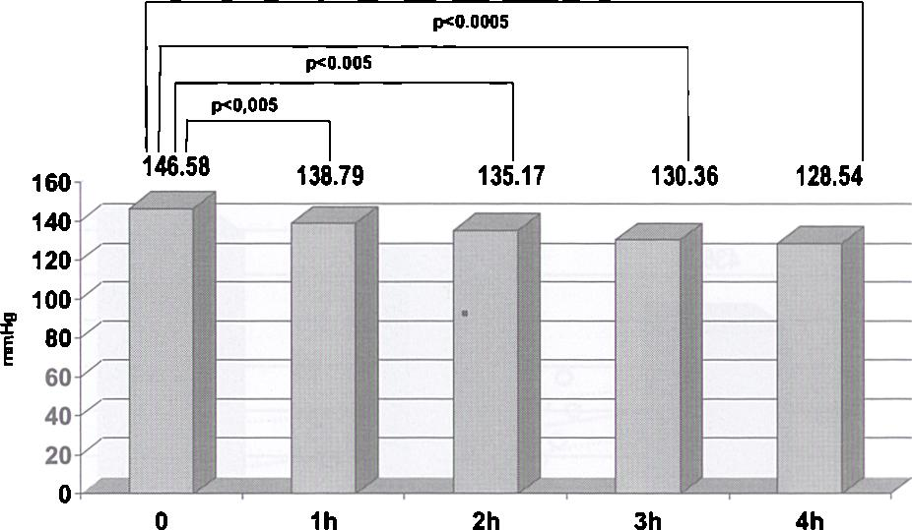
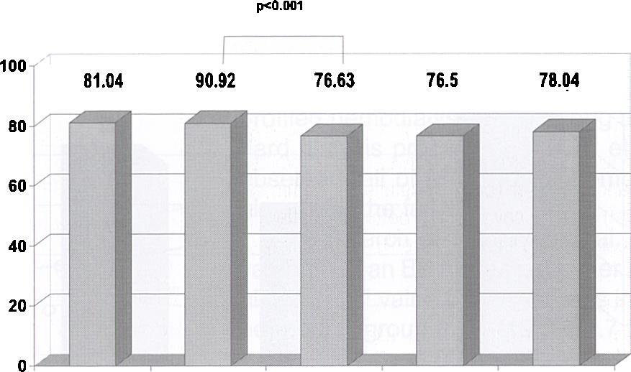
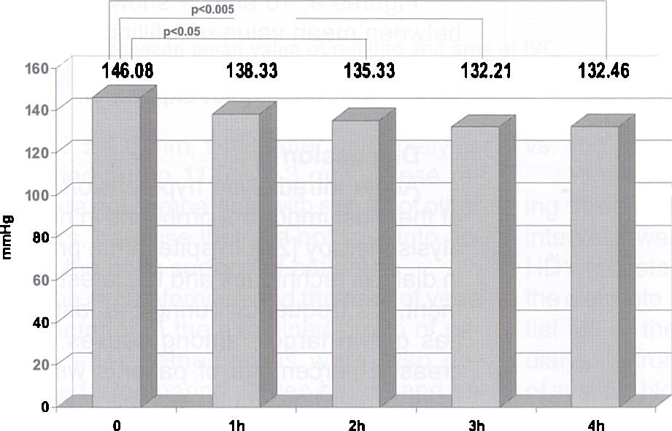
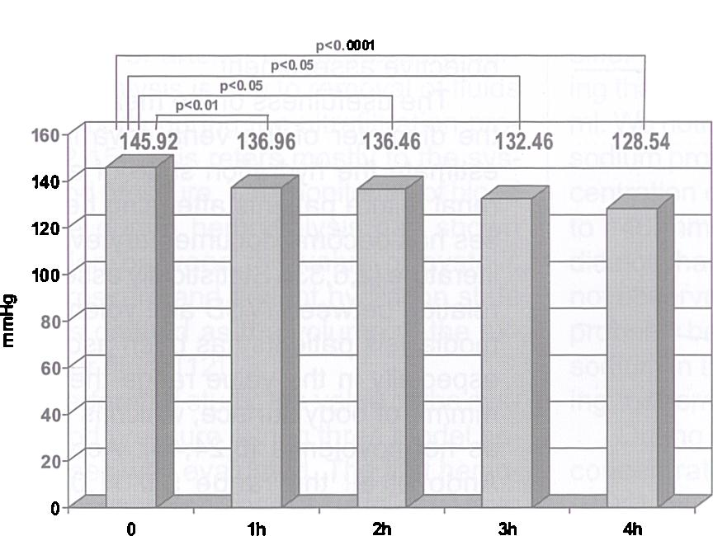
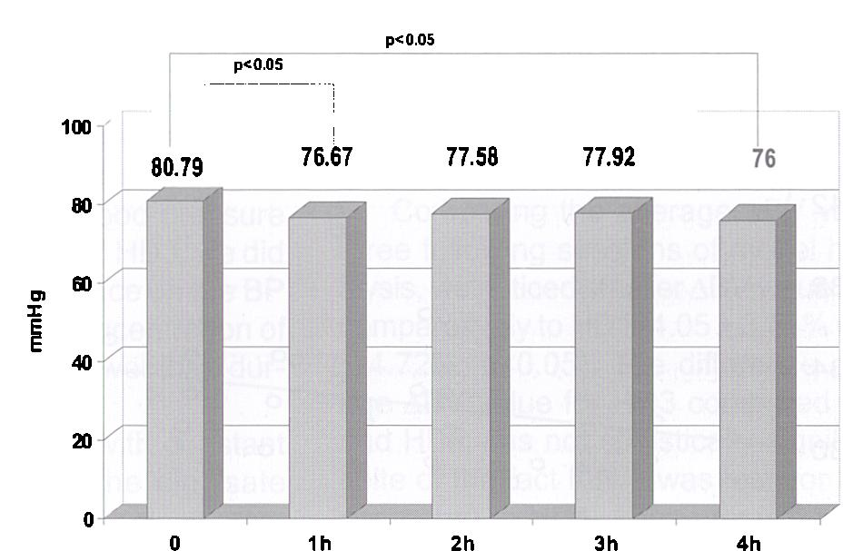
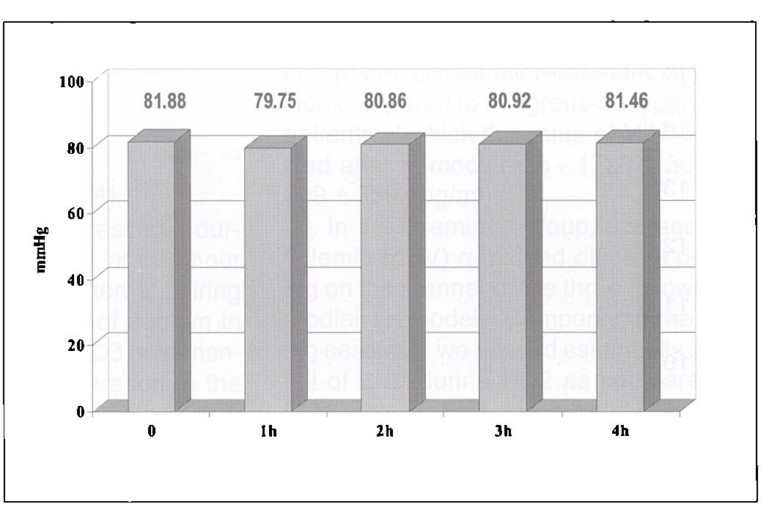
ĘK0. 0005
Figure 1
Systolic blood pressure during first HD session. Ciśnienie skurczowe w czasie pierwszej sesji HD.
0 1h 2h 3h 4h
Figure 2
Diastolic blood pressure during first HD session.
Ciśnienie rozkurczowe w czasie pierwszej sesji HD.
p<0. 01
Figure 3
Systolic blood pressure during second HD session.
Ciśnienie skurczowe w czasie drugiej sesji HD.
Figure 4
Diastolic blood pressure during second HD sesion.
Ciśnienie rozkurczowe w czasie drugiej sesji HD.
Figure 5
Systolic blood pressure during third HD session. Ciśnienie skurczowe w czasie trzeciej sesji HD.
Figure 6
Diastolic blood pressure during third HD session.
Ciśnienie rozkurczowe w czasie trzeciej sesji HD.
modialysis did not differ significantly with relation to the previous hour. Values of the diastolic pressure in the fourth hour were also indeed significantly lower (p<0. 05).
Changes of the blood volume (ABV) measured during three model hemodialysis procedures (HD1, HD2, HD3) at intervals of one hour with relation to initial values are represented in Table III.
We observed statistically significant fall of blood volume after the first and second hour of the second session of the model
hemodialysis (HD2) as compared to the first hemodialysis (HD1) - p<0. 05.
Changes of BV during model hemodialyses comparatively to the value after the first, second and third hour are presented in Tables IV, V, and VI.
Statistically significant! increase of blood volume after two hours of the model hemodialysis (HS) were observed as compared with the first hour of the model hemodialysis.
The mean fall of the BV (ABV) during the following three model hemodialysis ses
sions showed diverse values (Figure 7).
The average decrease of blood volume during the second model hemodialysis was essentially lower as compared to the first hemodialysis (4. 05 ± 3. 51% vs. 6. 18 ± 4. 72%; p<0. 05). The difference of average fall of volemia during third comparatively to the first and second session did not reach statistical significance.
The value of hourly average refilling (Figure 8) during the first two hours of the first hemodialysis session was less compared to
Przegląd Lekarski 2007 / 64 / 7-8
479

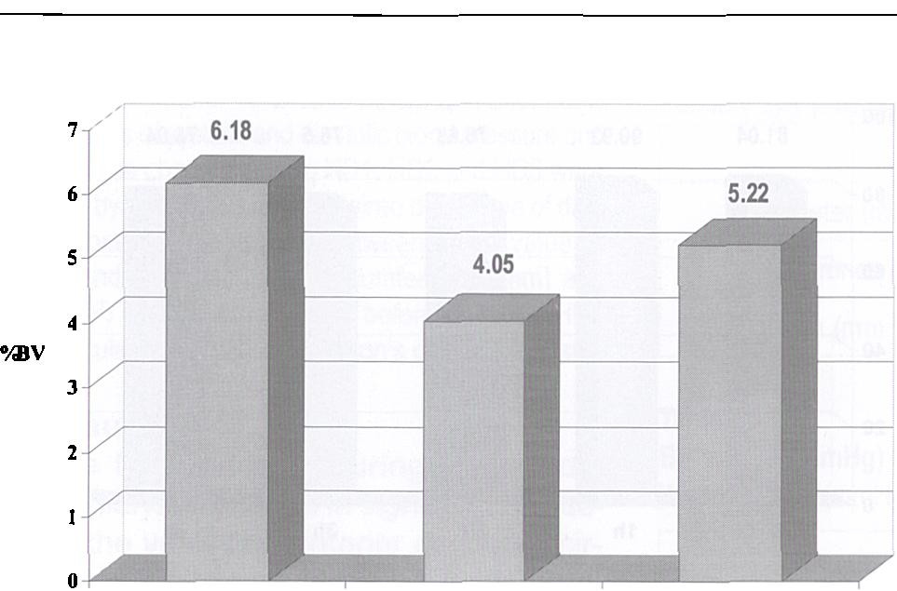
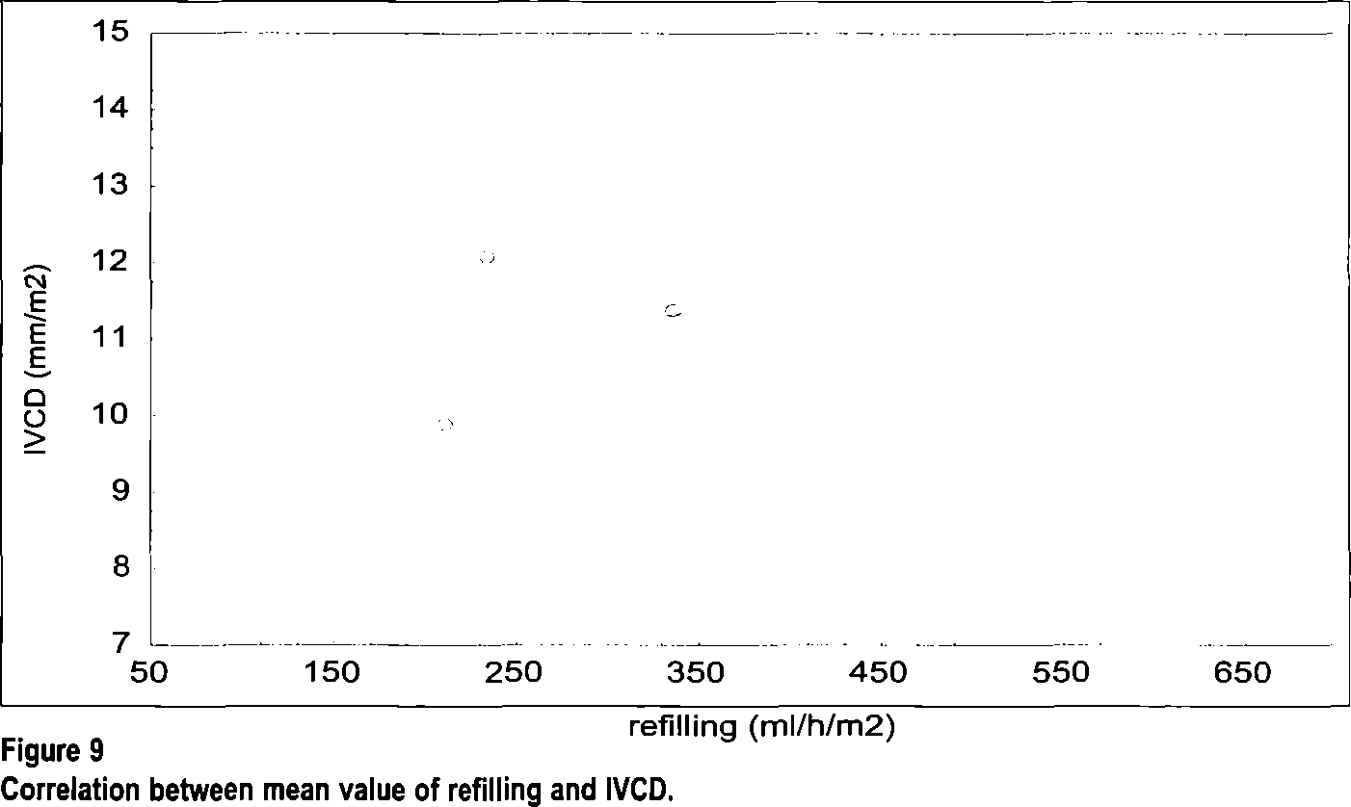
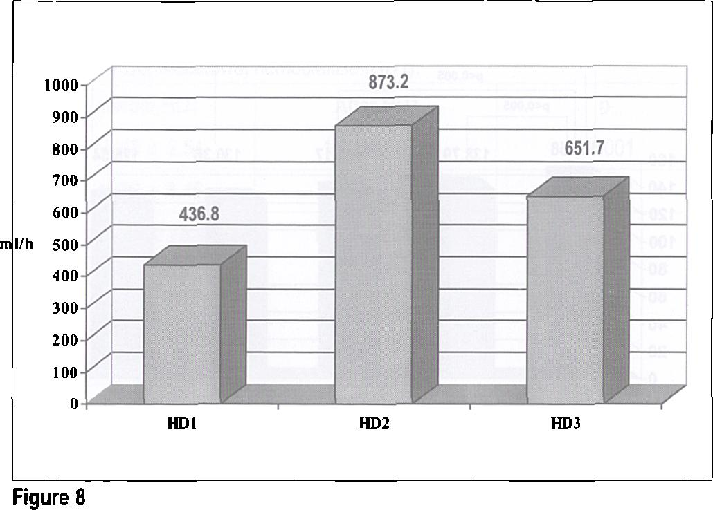
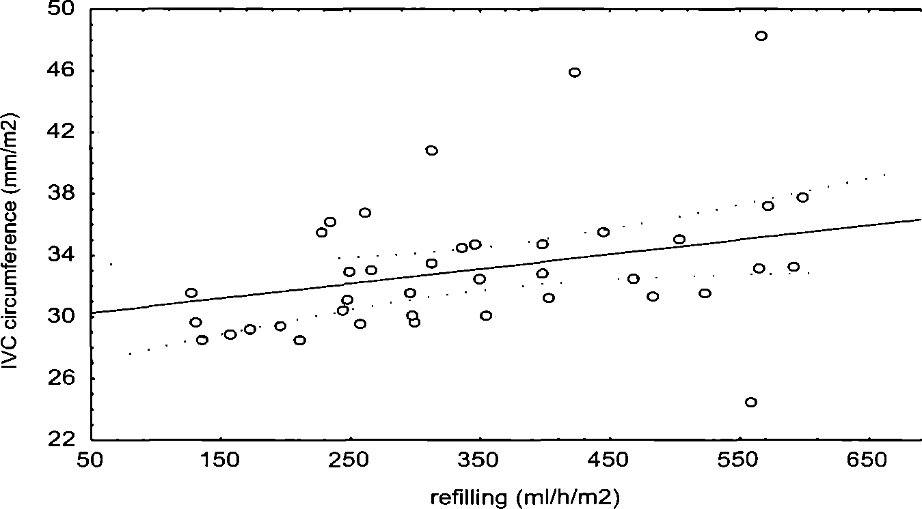
HDl HD2 HD3
Figure 7
Mean fall of the BV during three following model HD sessions. Średni spadek objętości krwi w czasie trzech kolejnych sesji modelowych.
Korelacja między średnią wartością refilingu a średnicą IVC.
Mean hourly refilling during first two hours of model HD sessions. Średni godzinny refilling w czasie trzech kolejnych sesji modelowych.
Figure 10
Correlation between mean value of refilling and circumference of IVC Korelacja między średnią wartością refilingu a obwodem IVC.
the refilling value during the second (436. 84 ± 218. 6 ml/hour vs. 873. 2 ± 527. 9 ml/hour HD1 vs. HD2 p<0. 001) and the third hemodialysis session (436. 84 ± 218. 6 ml/hour vs. 651. 7 ± 433. 8 ml/hour HD1 vs. HD3 p<0. 05).
The difference of refilling magnitude during the first two hours of the second and third procedure did not reach statistical significance (873. 2 + 527. 9 ml/hour vs. 651. 7 ± 433. 8 ml/hour HD2 vs. HD3 p=0. 06).
The number episodes of intradialytic hypotension episodes during three following model hemodialysis sessions was diverse (Table VII).
We obtained significantly lower frequency of episodes of hypotension during the second session of hemodialysis (HD2) as compared to HD1 (%2=5. 25 p<0. 05). Differences among HD1 and HD3, and HD2 and HD3 did not reach statistical significance.
Figures 9, 10 and 11 show correlation between mean value of refilling and diameter, circumference and area of the inferior vena cava during quiet expiration.
Discussion
Acute intradialytic hypotension is one of the most important problems in hemodialysis therapy [21]. In spite of the progress in dialysis techniques and the latest equipment, it's frequency during the last years has grown larger; among causes, as increased percentage of patients with high risks of cardiovascular complications are taken into account [7, 8, 34]. The frequency of hypotension occurrence is dependent on correct volemia of hemodialysed patients [5]. Clinical parameters of hydration state estimation used in every day medical practice are unfortunately not carried out rigorously [4, 13, 30, 35], which has caused development of new methods permitting for objective assessment.
The usefulness of the measurement of the diameter of the vena cava inferior to estimate the hydration state of end stage renal failure patients attending hemodialyses has become documentary evidence in literature [2, 6, 33]. Statistically essential correlation between IVCD and volemia in hemodialysis patients has been ascertained, especially in the value range the 8. 0-11. 5 mm/m2 of body surface, which is accepted as normovolemia [6, 24, 45]. According to Ando et al. the range 5. 0-11. 0 mm/m2, should be accepted as the reference values, while values above 22. 0 mm/m2 determine considerable retention of fluids in the body [2].
In the group of investigated patients the IVCD value before the hemodialysis session amounted to 12. 54 ± 2. 54 mm/m2 - this average value was situated above the normal range, what seems logical considering existing overhydration. Whereas measurement of IVCD immediately after hemodialysis (ultrafiltration rate-2800 ml according to the protocol) - showed statistically essential diameter decrease of the vena cava inferior to 10. 23 ± 2. 36 mm/m2. The average value was situated in the range of reference values, which proves that the "dry weight" was correctly estimated.
In Kusaba et al. research [28] IVCD values before the hemodialysis amounted
480
Przegląd Lekarski 2007 / 64 / 7-8
I. Kaczmarczyk et al.

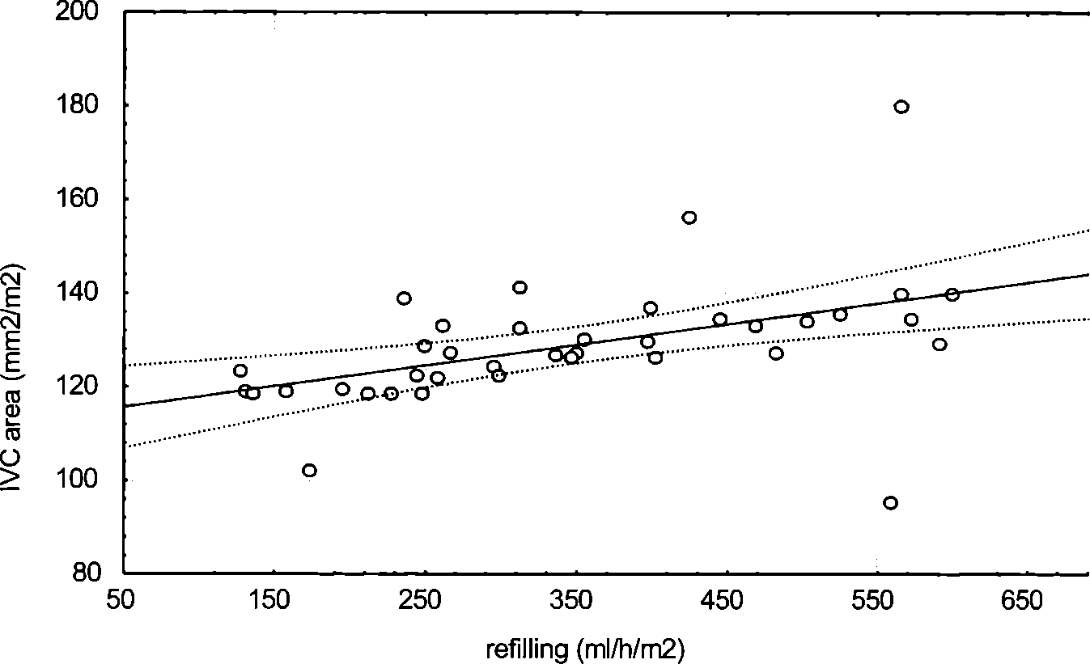
Fugure 11
Correlation between mean value of refilling and area of IVC. Korelacja między średnią wartością refilingu a powierzchnią IVC.
to 15. 3 ± 4. 6 mm, while after hemodialysis it carried out to 11. 0 ± 4. 3 mm. These results are not comparable with results of other authors, because they did not take into account the body surface of patients.
The circumference and the area of vena cava inferior in the examined group of patients after hemodialysis were also decreased. Comparing values before and after hemodialysis - circumference and area respectively decreased from 36. 80 ± 8. 45 to 31. 87 ± 8. 1 mm/m2 and 170. 45 ± 75. 41 to 138. 70 + 68. 44 mm/m2. These values cannot be compared because only the measurement of the inferior vena cava diameter appears in literature, most often normalized to patient body area.
The fall of arterial blood pressure during hemodialysis is due to removal of fluids from the body during the ultrafiltration process [12, 15]. This refers mostly to the systolic blood pressure. The monitoring of blood pressure during hemodialysis has shown correlation between the value of systolic blood pressure and patient hydration state (which is defined as the volume of the extracellular fluid) [12].
In performed study, the value of the systolic blood pressure during three model hemodialyses was evaluated. The first hemodialysis caused decrease of systolic BP from the value 146. 58 ± 24. 54 to 129. 46 ± 20. 77mmHg (p<0. 001). During the second hemodialysis BP decreased from the value 146. 06 ± 20. 53 to 132 ± 23. 14mmHg (p<0. 01), while during the third model procedure before hemodialysis it amounted to 145. 92 ± 19. 80 and after hemodialysis the value decreased to 128. 54 ± 24. 91 mmHg (p<0. 005).
Values of the systolic blood pressure before and after hemodialysis did not differ when compared in the three hemodialyses models.
During hemodialysis values of the diastolic blood pressure also decreased. The statistically significant decrease of the value of diastolic blood pressure followed only during the third hemodialysis (80. 80 ± 8. 84
vs. 76. 0 ± 12. 73mmHg, p<0. 05).
When comparing blood pressures during three model hemodialysis, at one-hour intervals, we noticed their patterns. During HD1 (constant concentration of sodium in the dialysate 140mmol/l) and HD3 (exponential fall of the sodium concentration in the dialysate from 144 to 136mmol/l) the value of systolic blood pressure after every following hour of the procedure was indeed lower with relation to initial values. Instead, during HD2 (with the lineal fall of sodium concentration from 144 to 136mmol/l)the value of the systolic BP was essentially lower after second, third and fourth hour of dialysis. The value of systolic blood pressure after the first hour of HD2 did not significant differ from initial values. Ultrafiltration during the first hour of dialysis carried out 1000 ml. We noticed that during hemodialysis with sodium profiling (HD2), where average concentration of sodium in dialysate amounted to 140 mmol/l, the systolic blood pressure did not change. During profiled HD3, we did not observe substantial influence on the BP probably because average concentration of sodium in the dialysate was lower than during the remaining sessions.
During the hemodialysis with constant concentration of sodium in the dialysate (HD1), only the value of diastolic blood pressure after the second hour of dialysis was significantly lower when compared to the value after the first hour. During HD2, the value of the diastolic pressure at hourly intervals did not essentially differ. Instead, in the case of HD3, the value of diastolic blood pressure after the first and fourth hour significantly differed with relation to initial values. Similarly as with reference to systolic blood pressure for HD2 (with the lineal fall of the concentration of sodium in the dialysate) it was most profitable, because it assured preservation of the diastolic blood pressure value when compared to initial values. Similar dependences were in accordance with other authors. Santoro et al. [39] showed the decreased systolic blood pressure fall during the monitored hemodialysis
session as compared with standard hemodialysis (12. 4 vs. 20. 0%). Coli et al. (6) also obtained smaller arterial pressure decrease, expressed as the mean BP (MAP), during profiled hemodialysis than during the standard dialysis procedure. Steuer et al. [43] observed fall of MAP during hemodialysis along with the fall of BV.
In research of Fishbane et al. [15] the value of mean BP normalized after hemodialysis. MAP value increased less in the hypertensive group from 119. 5 ± 2. 7 to 100. 8 ± 3. 7mmHg p<0. 0001; however it did not change in the group of normotensive patients (94. 9 + 1. 9 vs. 93. 1 ± 1. 8mmHg). In the group of patients with "ultrafiltration-resistant" hypertension, in which the MAP value during hemodialysis did not change (134. 4 ± 3. 8 vs. 133. 8 ± 2. 9) existing overhydration was shown (ANP concentration before hemodialysis was higher in the group with "ultrafiltration-resistant" hypertension compared to the group of hypertensive patients at which the value of MAP normalized after hemodialysis - 1728 ± 309. 9 vs. 809 ± 359. 1 pg/ml).
In the examined group, average fall of volemia (ABV) remained different depending on the manner of the three following hemodialysis models. Comparing three following sessions, we noticed essentially smaller fall of ABV during HD2 as compared with HD1 after the first and second hour of procedure with relation to initial values, respectively 4. 07 ± 2. 86 vs. 6. 03 ± 4. 72% HD2 vs. HD1 after first hour, and 0. 89 ±5. 01 vs. 3. 41 ± 5. 25% HD2 vs. HD1 after the second hour of dialysis. Remaining values did not differ, though one should notice the lesser ABV value during HD3 when compared to the value in HD1 (which however was not statistically significant).
In the case of ABV, final values after the first hour of dialysis, we observed greater ABV after the second hour of HD2 vs. HD1, properly 3. 18 ± 2. 73% vs. 2. 62 ± 4. 39%. Remaining values did not differ significantly.
Comparing the average ABV value for three following sessions of model hemodialysis, we noticed smaller ABV value for HD2 comparatively to HD1 (4. 05 ± 3. 51 % vs. 6. 18 + 4. 72%, p<0. 05). The difference of average ABV value for HD3 compared to HD1 and HD2 was not statistically significant in spite of the fact that it was less for HD3 as compared to HD1. These results are comparable with results of other authors [5, 44]. In the research of Santoro et al., they observed the decreased fall of BV during hemodialysis with monitoring of volemia, when compared to standard hemodialysis (10. 6% vs. 12. 3%) [39].
Analysing the quantity of the intradialytic hypotension episodes during three model sessions, we observed their statistically significant decrease during HD2 comparatively to HD1 (4 vs. 12, x2=5. 25; p<0. 05). The number of hypotensive episodes during HD3 was smaller than during HD1 (6 vs. 12); however the difference did not reach statistical significance, similarly as for HD3 vs. HD2. In their own study Steuer et al. observed decreased number of intradialytic hypotension episodes in patients undergoing hemodialysis with monitoring of blood volume (26
Przegląd Lekarski 2007 / 64 / 7-8
481

vs. 57%) [44]. Similar results obtained Santoro et al. [39, 40] and Jenson et al. [20]. According to Raja, hemodialysis with profiling of sodium concentration in dialysate, reduces the frequency of hypotensive episodes compared to dialysis with constant sodium concentration (among other things due to refilling enlargement, and further smaller BV changes [37]).
The value of mean hourly refilling for the first two hours of three following model hemodialysis amounted respectively to 436. 8 ± 218. 6 ml/hourfor HD1, 873. 2 ± 527. 9 ml/ hour for HD2 and 651. 7 + 433. 8 ml/hour for HD3. The smallest mean refilling value reached for HD1-the difference with reference to HD2 and HD3 was statistically significant; respectively p<0. 001 and p<0. 05. The value of average refilling for HD3 was smaller than for HD2; however, we did not note statistical differences among mean values. Profiled hemodialysis (HD2 and HD3) caused enlargement of average hourly refilling compared to standard procedure. Existing differences between HD2 and HD3, though were not statistically significant, can be explained by other different average dialysate sodium concentrations. These results are agreeable with results of other authors [39, 40, 37]. Hemodialysis with sodium concentration modeling enlarges refilling, which causes greater hemodynamic stability, especially in these patients in whom one expects episodes of intradialytic hypotension during standard dialysis [39, 40].
In the investigated group of patients, we additionally showed positive correlation between average refilling and diameter (r=0. 34; p<0. 05), circumference (r=0. 32; p<0. 05) and with area (r=0. 49; p<0. 05) of the vena cava inferior measured on quiet exhalation before the model hemodialysis. Similar conclusions are presented in studies of other authors [5, 46].
Comparing three following sessions of model hemodialysis, one ought to notice the positive influence of profiled hemodialysis with linear decrease of sodium concentration in dialysate (HD2) on maintenance of both systolic and diastolic blood pressure values. Observed are smaller changes of blood volume during dialysis due to enlargement of refilling - and what further presents - reduction of frequency of intradialytic hypotensive episodes compared to standard methods (HD1) and hemodialysis with expotential decrease of sodium concentration (HD3). Hemodialysis HD3 compared to HD1 is also characterized with smaller decrease of the BP and blood volume, with reduction of intradialytic hypotensive episode number and with enlargement of refilling value. However, statistical significance was noticed only for differences in refilling value. Negative correlations among refilling value and average BP, duration of dialysis treatment, intima/media ratio of common carotid arteries, as well as positive correlations between refilling and diameter, circumference and area of vena cava inferior before the start of HD were observed.
Monitoring of hemodialysis course with
the Crit-Line instrument permits for optima- lization of patient dry weight and achieving higher ultrafitration rates during dialysis without hypotensive episods. The change in blood volume, approximately 5% per one hour of dialysis session is an optimal value for patients.
References
- Abe R., Wakabayashi T., Takeuchi H.: Measurement of relative plasma volume and plasma refilling rate during ultrafiltration of hemodialysis by measuring apparatus of plasma colloidal osmotic pressure. Nippon Hinyokika Gakkai Zasshi 1997, 88, 684.
- Ando Y., Yanagiba S., Asano Y.: The inferior vena cava diameter as a marker of dry weight in chronic hemodialyzed patients. Artif. Organs 1995, 19, 1237.
- Arrigo G., Bucci R., Colasanti G. et al.: Blood volume modeling and refilling rate estimation in hemodialysis by continuous hemoglobin monitoring. Int. J. Artif. Organs 1995, 18, 509.
- Basile C.: Intradialytic hypotension: The role of volemia. G. Ital. Nefrol. 2006, 23, 22.
- Bogaard H. J., de Vries J. P., de Vries P. M.: Assessment of refill and hypovolaemia by continuous surveillance of blood volume and extracellular fluid volume. Nephrol. Dial. Transplant. 1994, 9, 1283.
- Cheriex E. C., Leunissen K. M., Janssen J. H. et al.: Echography of the inferior vena cava is a simple and reliable tool for estimation of 'dry weight' in haemodialysis patients. Nephrol. Dial. Transplant. 1989, 4, 563.
- Coli L., Bonomini M., La Manna G. et al.: Clinical use of profiled hemodialysis. Artif. Organs 1998, 22, 724.
- Coli L., Ursino M., Donati G. et al.: Clinical application of sodium profiling in the treatment of intradialytic hypotension. Int. J. Artif. Organs. 2003, 26, 715.
- Davenport A.: Intradialytic complications during hemodialysis. Hemodial. Int. 2006, 10, 162.
- De Vries J. P., Bogaard H. J., Kouw P. M. et al.: The adjustment of post dialytic dry weight based on non- invasive measurement of extracellular fluid and blood volumes. ASAIO J. 1993, 39, 368.
- De Vries P. M., Olthof C. G., Solf A. et al.: Fluid balance during haemodialysis and haemofiltration: the effect of dialysate sodium and a variable ultrafiltration rate. Nephrol. Dial. Transplant. 1991, 6, 257.
- Dionisio P., Valenti M., Bergia R. et al.: Influence of the hydration state on blood pressure values in a group of patients on regular maintenance hemo-di- alysis. Blood Purif. 1997, 15, 25.
- Donauer J.: Hemodialysis-induced hypotension: impact of technologic advances. Semin. Dial. 2004, 17, 333.
- Enzmann G., Bianco F., Paolini F. et al.: Autonomic nervous function and blood volume monitoring during hemodialysis. Int. J. Artif. Organs 1995, 18, 504.
- Fishbane S., Natke E., Maesaka J. K.: Role of volume overload in dialysis-refractory hypertension. Am. J. Kidney Dis. 1996, 28, 257.
- Franssen C. F.: Adenosine and dialysis hypotension. Kidney Int. 2006, 69, 789.
- Heber M. E., Lahiri A., Thompson D. et al.: Baroreceptor, not left ventricular dysfunction is the cause of hemodialysis hypotension. Clin. Nephrol. 1989, 32, 79.
- limura O., Tabei K., Nagashima H. et al.: A study on regulating factors of plasma refilling during hemodialysis. Nephron 1996, 74, 19.
- Jassal S. V., Douglas J. F., Stout R. W.: Prevalence of central autonomic neuropathy in elderly dialysis patients. Nephrol. Dial. Transplant. 1998, 13, 1702.
- Jenson B. M., Dobbe S. A., Squillace D. P. et al.: Clinical benefits of high and variable sodium concentration dialysate in hemodialysis patients. ANNA J. 1994, 21, 115.
- Johner C., Chamney P. W., Schneditz D. et al.: Evaluation of an ultrasonic blood volume monitor. Nephrol. Dial. Transplant. 1998, 13, 2098.
- Kang E. S., Acchiardo S. R., Wang Y. B. et al.: Hypotension during hemodialysis: role for nitric oxide. Am. J. Med. Sci. 1997, 313, 138.
- Kang E. S., Tevlin M. T., Wang Y. B. et al.: Hemodialysis hypotension: interaction of inhibitors, ¡NOS, and the interdialytic period. Am. J. Med. Sci. 1999, 317, 9.
- Katzarski K. S., Nisell J., Randmaa I. et al.: A critical evaluation of ultrasound measurement of inferior vena cava diameter in assessing dry weight in nor- motensive and hypertensive patients. Am. J. Kidney Dis. 1997 30 459.
- Kouw P. M., Olthof C. G., Gruteke P. et al.: Influence of high and low sodium dialysis on blood volume preservation. Nephrol. Dial. Transplant. 1991, 6, 876.
- Koziolek M. J., Gauczinski S., Kahler E. et al.: Bioimpedance analysis and intradialytic hypotension in intermittent hemodialysis. Clin Nephrol. 2006, 66, 39.
- Krepel H. P., Nette R. W., Akcahuseyin E. et al.: Variability of relative blood volume during hemo-di- alysis. Nephrol. Dial. Transplant. 2000, 15, 673.
- Kusaba T., Yamaguchi K., Oda H.: Echography of the inferior vena cava for estimating fluid removal from patients undergoing hemodialysis. Nippon Jinzo Gakkai Shi 1996, 38, 119.
- Lindsay R. M., Kiaii M., Prakash S. et al.: Extracellular fluid and blood volume changes during hemodialysis. J. Am. Soc. Nephrol. 2001, 12, 394.
- Locatelli F., Buoncristiani U., Canaud B. et al.: Haemodialysis with on-line monitoring equipment: tools or toys? Nephrol. Dial. Transplant. 2005, 20, 22.
- Maack T.: Role of atrial natriuretic factor in volume control. Kidney Int. 1996, 49, 1732.
- Maeda K., Shinzato T., Nakai S. et al.: Mechanism of dialysis-induced hypotension. Nagoya J. Med. Sci. 1992, 54, 1.
- Mandelbaum A., Link A., Wambach G. et al.: Vena cava ultrasonography for the assessment of hydration status in kidney insufficiency. Dtsch. Med. Wochenschr. 1993, 118, 1309.
- Martinez-Maldonalo M.: Hemodynamic stability during dialysis and cardiovascular disease in end-stage renal disease patients. Am. J. Kidney Dis. 1999, 33, 49.
- McMahon M. P., Campbell S. B., Shannon G. F. et al.: A non-invasive continuous method of measuring blood volume during haemodialysis using optical techniques. Med. Eng. Phys. 1996, 18, 105.
- Nagase S., Hirayama A., Ueda A. et al.: Light- shielded hemodialysis prevents hypotension and lipid peroxidation by inhibiting nitric oxide production. Clin. Chem. 2005, 51, 2397.
- Raja R. M.: Sodium profiling in elderly haemodialysis patients. Nephrol. Dial. Transplant. 1996, 11, 42.
- Raja R. M., Po C. L.: Plasma refilling during hemodialysis with decreasing ultrafiltration. Influence of dialysate sodium. ASAIO J. 1994, 40, 423.
- Santoro A., Mancini E., Paolini F. et al.: Blood volume regulation during hemodialysis. Am. J. Kidney Dis. 1998, 32, 739.
- Santoro A., Mancini E., Paolini F. et al.: Automatic control of blood volume trends during hemodialysis. ASAIO J. 1994, 40, 419.
- Shinzato T., Miwa M., Nakai S. et al.: Role of adenosine in dialysis-induced hypotension. J. Am. Soc. Nephrol. 1994, 4, 1987.
- Shinzato T., Nakai S., Odani H. et al.: Relationship between dialysis induced hypotension and adenosine released by ischemic tissue. ASAIO J. 1992, 38, 286.
- Steuer R. R., Leypoldt J. K., Cheung A. K. et al.: Hematocrit as an indicator of blood volume and a predictor of intradialytic morbid events. ASAIO J. 1994, 40, 691.
- Steuer R. R., Leypoldt J. K., Cheung A. K. et al.: Reducing symptoms during hemodialysis by continuously monitoring the hematocrit. Am. J. Kidney Dis. 1996, 27, 525.
- Tetsuka T., Ando Y., Ono S. et al.: Change in inferior vena caval diameter detected by ultrasonography during and after hemodialysis. ASAIO J. 1995, 41, 105.
- Wizemann V., Lelbinger A., Mueller K. et al.: Influence of hydration state on plasma volume changes during ultrafiltration. Artif. Organs 1995, 19, 416.
482
Przegląd Lekarski 2007 / 64 / 7-8
I. Kaczmarczyk et al.

