
OPEN 3 ACCESS Freely available online
PLOS one

Will Temperature Effects or Phenotypic Plasticity
Determine the Thermal Response of a Heterothermic
Tropical Bat to Climate Change?

Clare Stawski*”, Fritz Geiser
Centre for Behavioural and Physiological Ecology, Zoology, University of New England, Armidale, New South Wales, Australia

Abstract
The proportion of organisms exposed to warm conditions is predicted to increase during global warming. To better
understand how bats might respond to climate change, we aimed to obtain the first data on how use of torpor, a crucial
survival strategy of small bats, is affected by temperature in the tropics. Over two mild winters, tropical free-ranging bats
(Nyctophilus bifax, 10 g, n = 13) used torpor on 95% of study days and were torpid for 33.5±18.8% of 113 days measured.
Torpor duration was temperature-dependent and an increase in ambient temperature by the predicted 2°C for the 21st
century would decrease the time in torpor to 21.8%. However, comparisons among Nyctophilus populations show that
regional phenotypic plasticity attenuates temperature effects on torpor patterns. Our data suggest that heterothermy is
important for energy budgeting of bats even under warm conditions and that flexible torpor use will enhance bats' chance
of survival during climate change.
Citation: Stawski C, Geiser F (2012) Will Temperature Effects or Phenotypic Plasticity Determine theThermal Response of a Heterothermic Tropical Bat to Climate
Change? PLoS ONE 7(7): e40278. doi:10.1371/journal.pone.0040278
Editor: Frank Seebacher, University of Sydney, Australia
Received May 2, 2012; Accepted June 4, 2012; Published July 3, 2012
Copyright: © 2012 Stawski, Geiser. This is an open-access article distributed under the terms of the Creative Commons Attribution License, which permits
unrestricted use, distribution, and reproduction in any medium, provided the original author and source are credited.
Funding: Financial support was provided by an Australian Postgraduate Award, Bat Conservation International, Jagiellonian University and the University of New
England to Clare Stawski and the Australian Research Council to Fritz Geiser. The funders had no role in study design, data collection and analysis, decision to
publish, or preparation of the manuscript.
Competing Interests: The authors have declared that no competing interests exist.
* E-mail: clare.stawski@gmail.com
n Current address: Institute of Environmental Sciences, Jagiellonian University, Krakow, Poland

Introduction
It is predicted that global warming will expose organisms to new
thermal challenges and will result in poleward or altitudinal shifts
of animals [1]. While a change in distribution to deal with climate
change may be an option for some species, the response of animals
is often too slow and not all can move, resulting in mismatching
phenologies with potentially detrimental effects [2-3]. However,
predictions on how animals might respond to climate change often
rely on geographic ranges of species and the climate within these
- and generally assume that species are static and have limited
functional flexibility. Contrary to this, endothermic mammals,
which have received little attention with regard to climate change
- , may adjust form and function to better suit the thermal
conditions they were exposed to during their development [6-7].
This is especially true for heterothermic mammals capable of
expressing torpor, which are known to be highly flexible in
adjusting their energy requirements seasonally and regionally [8-
13]. Importantly, the phenotypic plasticity of energy expenditure
afforded by the opportunistic use of torpor appears to be a key
factor in reducing the risk of extinction in mammals [14-15] and
may be crucial in dealing with climate change and other
anthropogenic disturbances.
Heterothermic endotherms use reductions in metabolic rate
(MR) and body temperature (T_{b}) during periods of torpor for
energy conservation [16]. Torpor is used by diverse birds and
mammals, often when food is limited, but also without apparent
energetic stress to enhance fat stores for future energy demanding
events, or to avoid predators [17-20]. Heterothermy is used by
members of more than half of all mammalian orders [14] and is
expressed especially in small species because their thermoregula-
tory energy expenditure can become costly during exposure to low
ambient temperatures (Ta).
Torpor use appears paramount in small temperate bats and it is
well established that they often express a sequence of multiday
torpor bouts (i.e. hibernation) during winter and short bouts of
torpor lasting for part of the day in summer [21-23]. In contrast, it
was believed in the past that bats inhabiting tropical regions do not
use torpor at all because of mild environmental conditions [24].
This view is no longer supported because short bouts of torpor
have been observed in captive tropical bats [25-27], and because
subtropical bats express multiday torpor in the wild [28-30].
However, in the tropics essentially all information on the use of
mammalian torpor in nature is currently limited to dwarf lemurs
and tenrecs [31-34], despite the enormous diversity of tropical
bats. Although bats comprise >20% of all mammals and the vast
majority of these live in the tropics [27], only two individuals of a
single species have been examined with regard to torpor in the
wild [11].
Global warming is predicted to increase the numbers of bats
exposed to tropical or at least warm conditions. Because this will
affect energy use and foraging requirements, understanding the
thermal biology of tropical bats in the wild will provide potential
insights into how bats from other climates might respond to
PLoS ONE | www.plosone.org
July 2012 | Volume 7 | Issue 7 | e40278

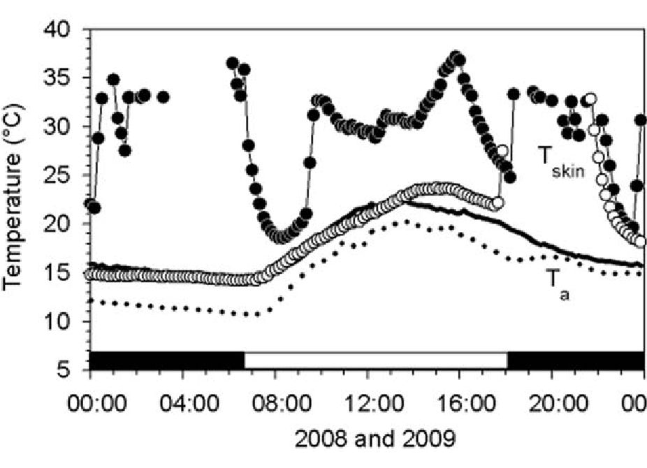
Torpor in a Tropical Bat and Climate Change
climate change. Although an increased T_{a} will reduce energy
expenditure for normothermic thermoregulation at high T_{b}, if bats
do not use torpor at all their energy requirements will be
substantially increased even under warm conditions [35]. The
purpose of our study was twofold. We (i) aimed to provide the first
long-term quantitative data on torpor use and activity patterns in
relation to ambient conditions by tropical free-ranging northern
long-eared bats, Nyctophilus bifax, that are entirely restricted to
subtropical/tropical regions. We (ii) used these data and data from
the literature to make predictions about how thermal energetics
and torpor patterns of bats from tropical and other climate zones
may be affected by climate change.

Materials and Methods
Permits to undertake the research were provided by the UNE
Animal Ethics Committee (AEC08/046, AEC09/058) and
Queensland Parks and Wildlife Service (WITK04955708). A
small subset of the data were published previously [36], however, a
substantial amount of new data were added and all were re-
analysed.
The field study was undertaken over two consecutive austral
winters in June 2008 and July/August 2009 at Djiru National Park
(17°50'S, 146°03'E), located in the tropical north of the Australian
east coast and within the northern parts of the distribution range of
N. bifax [37]. During both years, T_{a} was measured with
temperature data loggers (±0.5°C, iButton thermochron
DS1921G, Maxim Integrated Products, Inc., USA) in the shade
2 m above the ground. Thermal conditions during the two winters
were similar: the overall mean T_{a} was 18.8±1.6°C and the mean
T_{a} minima and maxima were 16.4±2.4°C and 21.9±1.7°C,
respectively. The lowest and highest Ta recorded was 10.6 and
25.3°C, respectively.
Bats were netted for several hours after sunset. Captured bats
were weighed to the nearest 0.1 g using an electronic scale and
kept overnight. Captive bats were hand fed with mealworms and
given water. On the following afternoon a small patch of fur from
between the shoulder blades was removed and a temperature-
sensitive radio-transmitter (~0.5 g, LB-2NT, Holohil Systems
Inc., Canada) was glued to the exposed skin using a latex adhesive
(SkinBond, Smith and Nephew United, Australia). The pulse rate
of these transmitters is temperature-dependent and all transmitters
were calibrated to the nearest 0.1 °C in a water bath between 5 and
40° C against a precision thermometer before attachment. External
transmitters provide a reasonable measure of core T_{b} as T_{skin} of
resting or torpid small mammals differs by <2°C from core T_{b}
[38]. Transmitters worn and shed by bats (3 in 2008; 1 in 2009)
were retrieved and re-calibrated 21 to 26 days after the initial
calibration and were within 0.5°C of the initial calibration over the
entire temperature range.
Bats were released at their capture site and on the following
morning and on every day bats retained the transmitter each
individual, identified by the frequency of its transmitter, was radio-
tracked to its roost location. To automatically record Tskin every
10 min, remote receiver/loggers with antennae [39] were placed
within range of the bats’ transmitter signal. Receiver/loggers were
checked every morning when bats were located to ensure
transmitter reception. Manual readings of the transmitter signals
were taken daily to certify the accuracy of receiver/logger
readings. Data from receiver/loggers were downloaded and
batteries replaced every three days.
Data were obtained for a total of 35 bat days (n =7 individuals,
4 females, 3 males; body mass: 10.4±0.7 g) inJune 2008. During
July/August 2009 data were obtained for a total of 78 bat days
(n = 6 individuals, 4 females, 2 males; body mass: 9.9±0.7 g,).
Mean body mass did not differ between years (P = 0.3, T= 1.1).
Torpor bouts are often defined as periods with T_{b} <30°C [40].
As the T_{b}-T_{skin} differential during torpor is generally <2°C, we
defined torpor bouts as the time when T_{skin} was <28°C. Data
analyses were performed using StatistiXL (V 1.8, 2007); data are
reported as means ± SD (n = number of individuals, N =
number of observations). Means of each individual were used to
calculate means for repeated measures. Results were considered
significant when alpha was <0.05. To determine whether timing
of arousals and torpor entries differed significantly from random, a
Rayleigh test was used. T-tests were used to compare independent
means; data of the sexes were pooled because they were
statistically indistinguishable. Linear regressions were fitted by
the least squares method and ANCOVAs were used to compare
linear regressions. If no difference in slope between individuals or
study periods was observed, data were pooled and regressed
together.

Results
Torpor Patterns
A total of 210 torpor bouts were recorded over both winters.
Torpor was used on 83% (June 2008) and 100% (July/August
2009; both years combined 95%) of days on which data were
collected. In both years, bats expressed different patterns of
thermoregulation, entering 0 to 4 torpor bouts/day; some bats
remained torpid for an entire day (5.7% of torpor days; Fig. 1).
The two most common temporal patterns were one torpor bout/
day (31.1%) and two torpor bouts/day (33.0%), typically with one
bout in the morning and the other in the afternoon. Four bouts/
day were rare (6.6%), but three bouts/day were relatively common
(23.6%; Fig. 1), with the third bout occurring during the night
before a possible early morning foraging period.
Mean torpor bout duration for both winters was 4.5±3.1 h
(n =13, N =210; years did not differ: P = 0.7, T_{n} = 0.4). The
longest torpor bout recorded was 33.3 h and a total of 31 torpor
bouts (out of 210) were >10 h. Torpor bouts were negatively
correlated with minimum T_{a} (R² = 0.2, P<0.001; Fig. 2). The two

Figure 1. T_{skin} of two different individual N. bifax and T_{a}
showing different patterns of torpor. The patterns shown are (i,
T_{skin}: open circles, T_{a}: dotted line) an individual that remained torpid
during the whole day and aroused only in the evening to possibly
forage, and the second pattern shows (ii, T_{skin}: closed circles, T_{a}: smooth
line) an individual displaying the typical morning and afternoon bouts
of torpor along with an additional torpor bout during the night. The
horizontal black and white bars at the bottom of the graphs represent
night and day, respectively.
doi:10.1371/journal.pone.0040278.g001
PLoS ONE | www.plosone.org
2
July 2012 | Volume 7 | Issue 7 | e40278
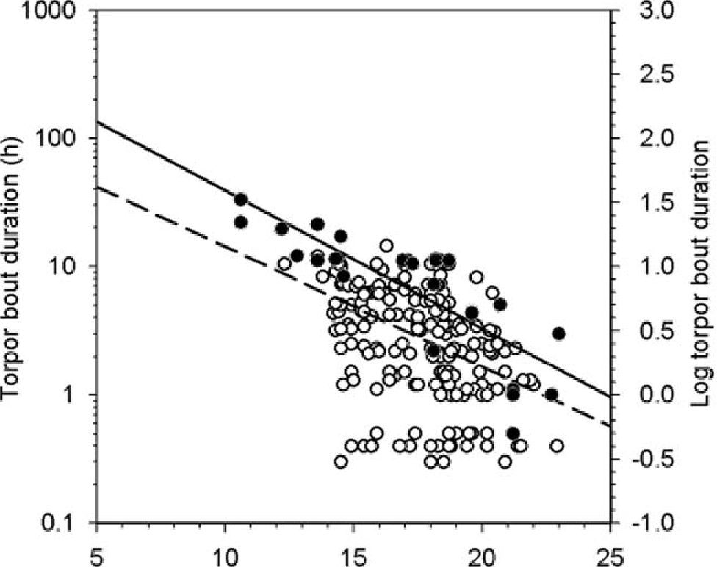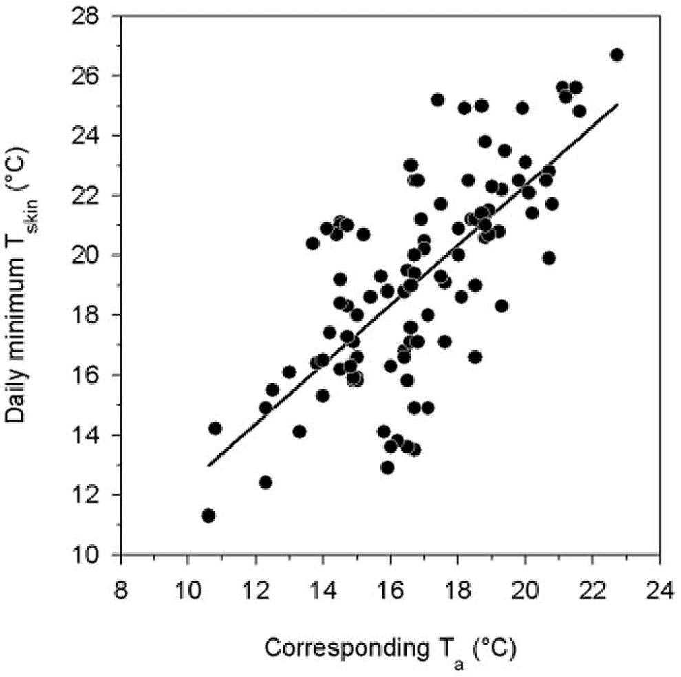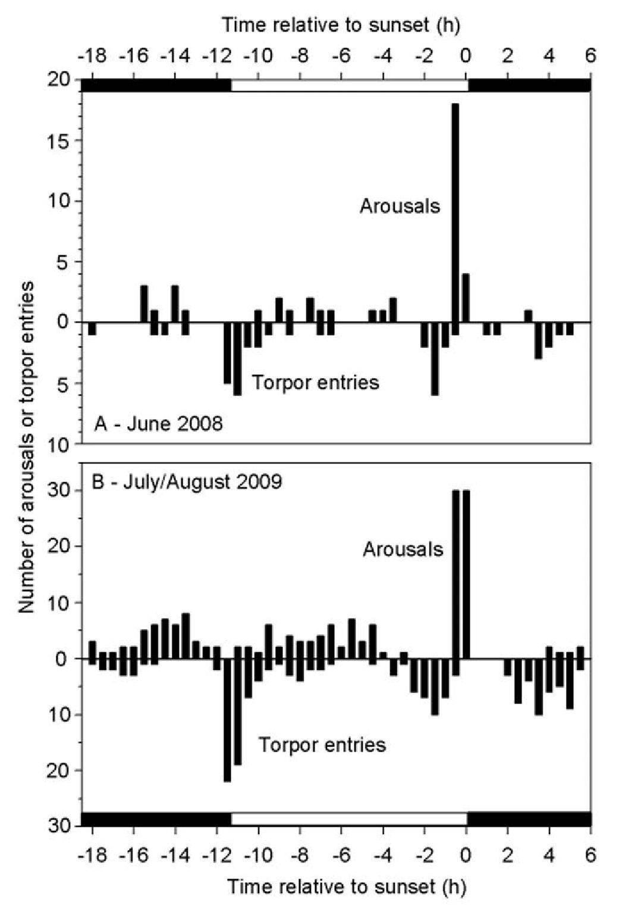
Torpor in a Tropical Bat and Climate Change

Minimum during torpor bout (°C)
P = 0.1, T_{n} = 1.8). The lowest individual T_{skin} value recorded was
11.3°C (T_{a}=10.6°C). The daily minimum torpid T_{skin} was
correlated with T_{a} (R² = 0.5, P<0.001; Fig. 3). The mean
differential between daily minimum Tskin during torpor and the
corresponding T_{a} was 2.1±1.7°C (n = 13, N = 101; years did not
differ: P = 0.7, T₆ = 0.4).

Timing of Torpor and Activity
Entries into torpor in 2008 (Fig. 4) displayed a peak at a mean
time (angle) of 8:14±5:10 h (n = 7, N =43); in 2009 the mean time
was 2:50±5:15 h (n = 6, N =167; 2009), but timing of torpor
entries did not differ significantly from random (2008: Rayleigh
Z = 0.3, P = 0.2; 2009: Z = 0.5, P = 0.2). Arousals were non-
randomly distributed in 2008 (Z = 6.0, P = 0.002) with a mean
time of 16:20±4:17 h (n =7, N =43), but not in 2009 (mean:
15:02±5:04 h, n = 6, N = 167, Z = 2.5, P = 0.1). Evening arousals
likely for foraging occurred at sunset ±00:06 h (n = 7, N =22;
- and slightly before sunset 00:06±00:04 h (n = 6, N =60;
- . The proportion of a night N bifax remained normothermic
Figure 2. Duration of torpor bouts (log₁₀) as a function of the
minimum Ta of each torpor bout. All torpor bouts recorded are
represented by the open circles and dashed line (log₁₀ TBD = 2.1-
0.09[T_{a} °C]; R² = 0.2, P<0.001, F₁₂₀₉ = 55.0). The two longest bouts
recorded for each individual are represented by the closed circles and
solid line (log₁₀ TBD = 2.7 - 0.1[T_{a} °C]; R² = 0.8, P<0.001, F,,₂₅ = 73.3).
doi:10.1371/journal.pone.0040278.g002
longest torpor bouts recorded for each individual were strongly
affected by minimum T_{a} (R² = 0.8, P<0.001; Fig. 2) and the
thermal response for this relationship was pronounced (Qi₀ = 10).
Skin Temperature
Mean daily minimum T_{skin} in torpid
winters was 20.1±3.1°C (n =13, N =102;
N. bifax during both
years did not differ:

Figure 3. Daily torpid minimum T_{skin} of N. bifax as a function of
T_{a} during winter. This relationship is represented by the following
equation: minimum T_{skin}(°C) = 2.4+1.0[T_{a}°C]; R² = 0.5, P<0.001,
F1,100 = 101.2.
doi:10.1371/journal.pone.0040278.g003
Figure 4. Timing of activity and torpor. Distribution of times of
arousals from torpor (top half of graphs) and entries into torpor
(bottom half of graphs) of N. bifax during (A) June 2008 and (B) July/
August 2009 relative to the time of sunset (0 hours). Each individual
contributed several points to these graphs, ranging from 2 to 41 data
points. Each bar represents a 30 minute period. The horizontal black
and white bars at the top and bottom of the graphs represent night
and day, respectively.
doi:10.1371/journal.pone.0040278.g004
PLoS ONE | www.plosone.org
July 2012 | Volume 7 | Issue 7 | e40278
3

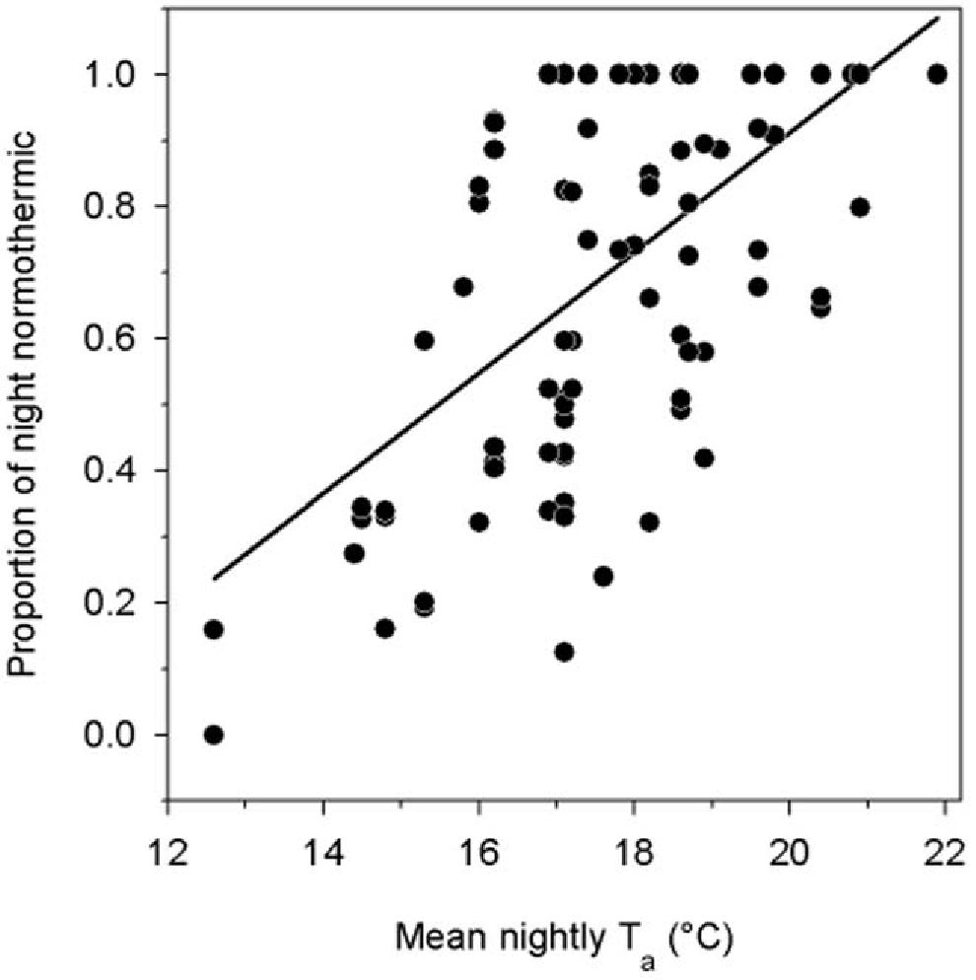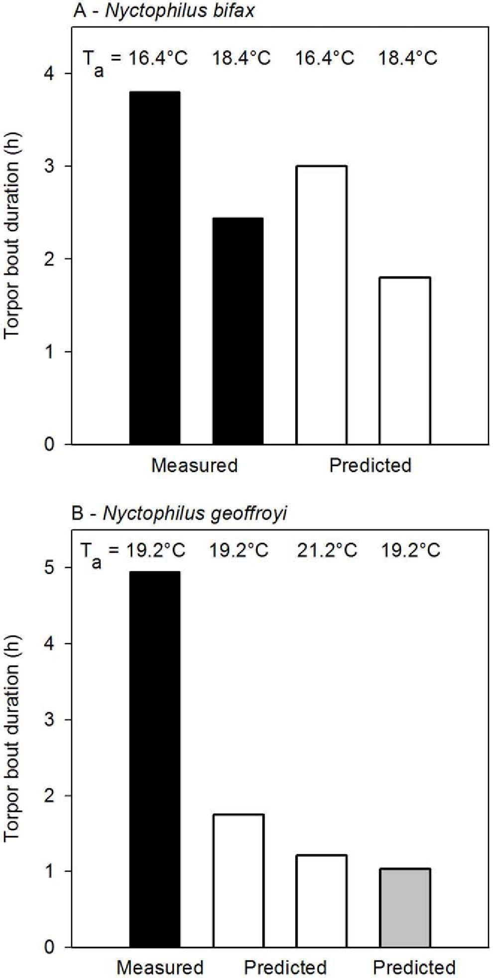
Torpor in a Tropical Bat and Climate Change

Figure 5. The proportion of a night that N. bifax spent
normothermic as a function of mean nightly T_{a}. This relationship
is represented by the following equation: proportion night normother-
mic = -0.9+0.09[T_{a} °C]; R² = 0.4, P<0.001, F,,₉₅ = 51.1.
doi:10.1371/journal.pone.0040278.g005
during both winters was positively correlated with mean nightly Ta
(R² = 0.4, P<0.001; Fig. 5).

Discussion
Our study provides the first long-term quantitative data of
torpor use and patterns in a tropical bat in its natural
environment. It also is the first to show that tropical bats can
remain torpid for >1 day. While this was a rare occurrence, torpor
was frequently used (95% of all study days) even though weather
conditions were mild. Our extensive field study of N. bifax and a
recent brief field study on two individual N geoffroyi during winter
in a tropical habitat [11] confirm earlier findings from laboratory
work [25-26] that torpor is indeed widely used by tropical bats for
energy conservation in the wild. Further, data on tropical bats and
on other mammals such as lemurs and tenrecs from Madagascar
[31-33] show that, contrary to the widely held view, torpor use is
prevalent in tropical regions. Frequent use of torpor by bats during
winter in tropical regions, as reported here for N. bifax, highlights
the importance of energy conservation for small microbats even
under relatively mild conditions.
Several different patterns of torpor were expressed by N. bifax
during both winters, with a peak in arousals from torpor bouts just
before sunset. The variation in use of torpor by N. bifax is likely in
response to variations in weather conditions and food abundance
and N. bifax were normothermic/active longer on warmer nights
like other bat species [23,30]. For insectivorous bats specifically it
makes sense to use more torpor at low T_{a} to save energy when
feeding is difficult. In the current study torpor bout duration at
minimum T_{a}s >14°C varied widely above and below the
regression line, whereas at minimum T_{a}s <14°C all torpor bouts
fell above the regression line (Fig. 2). This effect of T_{a} may reflect
insect availability, which decreased significantly at T_{a}s <16°C in
the study region [41]. It is also important to note in this context
that the thermal response of torpor bout duration of N. bifax was

Figure 6. Measured and predicted changes in torpor bout
duration in relation to predicted increases in T_{a}. Measured (black
bars) and predicted (white and grey bars) torpor bout duration in
tropical and subtropical N. bifax (A), and in tropical and temperate N.
geoffroyi (B). Measured values are those obtained at the tropical sites at
the mean minimum T_{a} (T_{a} 16.4°C and T_{a} 16.4+2°C N. bifax, T_{a} 19.2°C
only for N. geoffroyi because no T_{a}-torpor bout duration regression is
available). Predicted torpor bout durations were calculated from
regressions in subtropical N. bifax [36] and from temperate N. geoffroyi
in summer (white bars, [22]) and winter (grey bar, [23]).
doi:10.1371/journal.pone.0040278.g006
pronounced (Qi₀=10), which is about 3-fold of that usually
observed in temperate bats (Qj₀ = 2.6 to 3.9, [42]). This high
thermal sensitivity will permit tropical N. bifax to use relatively long
torpor bouts in response to a small reduction of T_{a} and, on the
other hand, be active for much of the night when T_{a} increases.
The T_{skin} of torpid N bifax approached T_{a}, with a minimum T_{a}-
T_{skin} differential of ~2°C. Even on particularly cold days when
PLoS ONE | www.plosone.org
July 2012 | Volume 7 | Issue 7 | e40278
4

Torpor in a Tropical Bat and Climate Change
T_{skin} was very low, bats apparently continued to thermo-conform
because the Ta-Tskin differential remained constant suggesting that
torpid bats did not thermoregulate. The lowest T_{skin} recorded was
11.3° C, which is rather low for a tropical mammal and suggests
that individuals of this population of N. bifax can approximate the
low T_{b}s that are characteristic of hibernation in cold climates
[16,35]. This is supported by laboratory data showing that tropical
N. bifax commenced to thermoregulate during torpor only at T_{a}
6.7°C and the minimum T was 7.3°C [43]. Therefore, the
generally high Tskin in the current study compared to cold-climate
hibernators appears to be mainly a reflection of the high T_{a}s bats
experienced. However, the minimum T_{b} measured in the
laboratory was also somewhat higher than in temperate hiberna-
tors and this trait appears to be selected by the T_{a} animals are
exposed to in the wild [8,36].
What are the implications of our data for the effect of climate
change on bats? We used two approaches to assess this: (i) We
assumed that the thermal physiology of bats is constant and
estimated using data from the present study and published data
[43] how a predicted Ta increase by 2°C will affect torpor patterns
and consequently energy use, and (ii) used data on thermal biology
from free-ranging subtropical and temperate Nyctophilus popula-
tions to test these predictions.
If we (i) use data presented here and those on thermal energetics
of tropical N bifax [43], we can estimate energy expenditure
during torpor from mean T_{skin} and MR regressions because the
animals were thermo-conforming and rewarmed largely passively,
in comparison to normothermic thermoregulation over the same
time period. At a mean T_{a} of 18.8°C, N. bifax remained torpid for
33.5% of the time, or 8.02 h/day, with a mean T_{skin} of 24.3°C
during torpor using 525 J (assuming 19.7 kJ/lO₂ for metabolised
fat, [44]). Resting normothermic bats at T_{a} 18.8°C would have
used 7,710 J, and the energy saved by using torpor would be
7,185 J (895.8 J/h) or 28% of the daily energy expenditure of a
10-g temperate bat (25.88 kJ/d, [45]). The thermal response of
torpor bout duration (Fig. 2) predicts that a 2°C increase in Ta will
shorten the duration of torpor to 21.8% of the time (5.23 h/day),
and energy expenditure during torpor will be 467 J. Resting
normothermic bats at Ta 20.8°C would need less energy for
thermoregulation (4,131 J) and energy savings due to torpor would
decrease to 3,664 J (700 J/h) or 14% of the predicted daily energy
expenditure [45]. Thus, even at the higher T_{a}, energy savings by
using torpor are substantial and biologically meaningful.
Pronounced discrepancies were observed when we (ii) examined
whether and how the thermal biology of populations of bat species
in the wild differs from that predicted from regressions. In N. bifax
mean torpor bout duration of a subtropical population [36] is
predicted to decrease from 3.0 to 1.8 h if T_{a} increases by 2°C from
the tropical mean minimum T_{a} of 16.4°C to 18.4°C (Fig. 2, 6).
However, measured torpor bout duration at the tropical site at Ta
16.4°C is in fact 3.8 h (127% of predicted) and 2.4 h at T_{a} 18.4°C
(136% of predicted). This shows that temperature effects on torpor
bout duration vary among populations and suggests that either the
tropical bats have acclimated or have been selected to maintain

References
- Portner HO, Farrell AP (2008) Physiology and climate change. Science 322:
690-692.
- Inouye DW, Barr B, Armitage KB, Inouye BD (2000) Climate change is
affecting altitudinal migrants and hibernating species. P Natl Acad Sci USA 97:
1630-1633.
- Visser ME (2012) Birds and butterflies in climate debt. Nature Clim Change 2:
77-78.
- Kearney M, Porter W (2009) Mechanistic modelling: combining physiological
and spatial data to predict species’ range. Ecol Lett 12: 334-350.
relatively long torpor bouts at warm Ta. Measured and predicted
values differ even more in the congener N. geoffroyi (Fig. 6),
distributed over almost the entire Australian continent. Data from
N. geoffroyi from a temperate region in summer [22] predict that
torpor bout duration at the mean minimum T_{a} of 19.2°C in
tropical Northern Territory is only 1.7 h and will decline to 1.2 h
with a 2°C rise of T_{a}. Measured torpor bout duration in tropical N
geoffroyi at a mean minimum T_{a} of 19.2°C is in fact 4.9 h [11], 2.8-
times that predicted from temperate bats. Winter data [23] predict
that torpor bout duration of temperate N. geoffroyi at a minimum
T_{a} of 19.2°C and a mean T_{skin} of 26.2°C is only 1.0 h, only 21%
of that measured in the tropics.
As torpor is usually associated with cold, whereas climate
change with global warming, what do our projections actually tell
us about bats in a warming climate? During periods of high
temperatures, heat waves are known to induce hyperthermia and
can kill large pteropodid bats [46]. However, pteropodids
comprise only a rather small number (~20%) of bat species and
many large members of this family may roost at exposed sites often
directly affected by T_{a} extremes. In contrast, most ‘microbats’
roost in sheltered areas like caves, mines, houses, under bark or
leaves that are buffered from thermal extremes, and, in addition to
using torpor, can also be tolerant of extremely high T_{a} exceeding
50°C [47]. Thus, our and previously available data suggest that by
using torpor opportunistically and by being able to tolerate high
Ta, small bats may be better equipped to deal with climate change
than is predicted from bio-climatic data, especially those species
that can shift their distribution to cooler habitats [48].
Obviously, there will be a limit to how far T_{a} can rise before
torpor will become ineffective and a tolerance of high T_{a} will be
exceeded. Moreover, some hibernating mammals are restricted to
mountain tops that do not permit further altitudinal adjustments to
climate change [2,49]. Consequently, those heterothermic mam-
mals with a period of winter dormancy that is strongly dependent
on historical phenological patterns, which are also often those
restricted to limited mountain habitats, are likely to be adversely
affected. Recent evidence also shows that hibernating bats are
susceptible to new pathogens, such as white-nose syndrome, which
kills bats by interfering with their seasonal hibernation [50]. In
contrast, opportunistic heterothermic species and those able to use
torpor efficiently even under varying thermal conditions, may be
able to deal with climate change and other detrimental factors
better than predictions from current models might suggest.

Acknowledgments
We thank Alexander Foster, Gerhard Kortner, Alexander Riek and
Margaret Stawski for their help with field work.

Author Contributions
Conceived and designed the experiments: CS FG. Performed the
experiments: CS FG. Analyzed the data: CS FG. Contributed reagents/
materials/analysis tools: CS FG. Wrote the paper: CS FG.
- Boyles JG, Seebacher F, Smit B, McKechnie AE (2011) Adaptive thermoreg-
ulation in endotherms may alter responses to climate change. Integr Comp Biol
51: 676-690.
- Heath M, Ingram DL (1983) Thermoregulatory heat production in cold-reared
and warm-reared pigs. Am J Physiol 244: R273-R278.
- Riek A, Geiser F (2012) Developmental phenotypic plasticity in a marsupial
mammal. J Exp Biol 215: 1552-1558.
- Geiser F, Ferguson C (2001) Intraspecific differences in behaviour and
physiology: effects of captive breeding on patterns of torpor in feathertail
gliders. J Comp Physiol B 171: 569-576.
PLoS ONE | www.plosone.org
5
July 2012 | Volume 7 | Issue 7 | e40278
Torpor in a Tropical Bat and Climate Change
- Dunbar MB, Brigham RM (2010) Thermoregulatory variation among
populations of bats along a latitudinal gradient. J Comp Physiol B 180: 885-893.
- Canale CI, Henry P-Y (2010) Adaptive phenotypic plasticity and resilience of
vertebrates to increasing climatic unpredictability. Climate Res 43: 135-147.
- Geiser F, Stawski C, Bondarenco A, Pavey CR (2011) Torpor and activity in a
free-ranging tropical bat: implications for the distribution and conservation of
mammals? Naturwissenschaften 98: 447^52.
- Zervanos SM, Maher CR, Waldvogel JA, Florant GL (2010) Latitudinal
differences in the hibernation characteristics of woodchucks (Marmota monax).
Physiol Biochem Zool 83: 135-141.
- Turbill C, Bieber C, Ruf T (2011) Hibernation is associated with increased
survival and the evolution of slow life histories among mammals. Proc R Soc B
278: 3355-3363.
- Geiser F, Turbill C (2009) Hibernation and daily torpor minimize mammalian
extinctions. Naturwissenschaften 96: 1235-1240.
- Liow LH, Fortelius M, Lintulaakso K, Mannila H, Stenseth NC (2009) Lower
extinction in sleep-or-hide mammals. Am Nat 173: 264-272.
- Boyer BB, Barnes BM (1999) Molecular and metabolic aspects of mammalian
hibernation. Bioscience 49: 713-724.
- Carpenter FL, Hixon MA (1988) A new function for torpor: fat conservation in a
wild migrant hummingbird. Condor 90: 373-378.
- Bieber C, Ruf T (2009) Summer dormancy in edible dormice (Glis glis) without
energetic constraints. Naturwissenschaften 96: 165-17.
- Stawski C, Geiser F (2010) Fat and fed: frequent use of summer torpor in a
subtropical bat. Naturwissenschaften 97: 29-35.
- Geiser F, Brigham RM (2012) The other functions of torpor. In: Ruf T, Bieber
C, Arnold W, Millesi E, eds. Living in a seasonal world. Berlin Heidelberg:
Springer-Verlag. 109-121.
- Speakman JR, Thomas DW (2003) Physiological ecology and energetics ofbats.
In: Kunz TH, Fenton MB, eds. Bat Ecology. Chicago: University of Chicago
Press. 430-492.
- Turbill C, Kortner G, Geiser F (2003) Natural use of torpor by a small, tree-
roosting bat during summer. Physiol Biochem Zool 76: 868-876.
- Turbill C, Geiser F (2008) Hibernation by tree-roosting bats. J Comp Physiol B
178: 597-605.
- Henshaw RE (1970) Thermoregulation in bats. In: Slaughter BH, Walton DW,
eds. About bats. Dallas: Southern Methodist University Press. 188-232.
- Bartels W, Law BS, Geiser F (1998) Daily torpor and energetics in a tropical
mammal, the northern blossom-bat Macroglossus minimus (Megachiroptera).
J Comp Physiol B 168: 233-239.
- Kelm DH, von Helversen O (2007) How to budget metabolic energy: torpor in a
small Neotropical mammal. J Comp Physiol B 177: 667-677.
- Geiser F, Stawski C (2011) Hibernation and torpor in tropical and subtropical
bats in relation to energetics, extinctions, and the evolution of endothermy.
Integr Comp Biol 51: 337-348.
- Stawski C, Turbill C, Geiser F (2009) Hibernation by a free-ranging subtropical
bat (Nyctophilus bifax). J Comp Physiol B 179: 433-441.
- Cory Toussaint D, McKechnie AE, van der Merwe M (2010) Heterothermy in
free-ranging male Egyptian free-tailed bats (Tadarida aegyptiaca) in a subtropical
climate. Mammal Biol 75: 466-470.
- Liu J-N, Karasov WH (2011) Hibernation in warm hibernacula by free-ranging
Formosan leaf-nosed bats, Hipposideros terasensis, in subtropical Taiwan. J Comp
Physiol B 181: 125-135.
- Dausmann KH, Glos J, Ganzhorn JU, Heldmaier G (2004) Hibernation in a
tropical primate. Nature 429: 825-826.
- Lovegrove BG, Genin F (2008) Torpor and hibernation in a basal placental
mammal the lesser hedgehog tenrec Echinops telfairi. J Comp Physiol B 178: 691-
698.
- Schmid J, Speakman JR (2009) Torpor and energetic consequences in free-
ranging grey mouse lemurs (Microcebus murinus): a comparison of dry and wet
forests. Naturwissenschaften 96: 609-620.
- McKechnie AE, Mzilikazi N (2011) Heterothermy in Afrotropical mammals and
birds: a review. Integr Comp Biol 51: 349-363.
- Geiser F (2004) Metabolic rate and body temperature reduction during
hibernation and daily torpor. Annu Rev Physiol 66: 239-274.
- Stawski C (2012) Comparisons of variables of torpor between populations of a
hibernating subtropical/tropical bat from different latitudes. In: Ruf T, Bieber
C, Arnold W, Millesi E, eds. Living in a seasonal world. Berlin Heidelberg:
Springer-Verlag. 99-108.
- Churchill S (2008) Australian Bats, 2nd edn. Crows Nest: Allen and Unwin.
- Barclay RMR, Kalcounis MC, Crampton LH, Stefan C, Vonhof MJ, et al.
(1996) Can external radiotransmitters be used to assess body temperature and
torpor in bats?J Mammal 77: 1102-1106.
- Kortner G, Geiser F (2000) Torpor and activity patterns in free-ranging sugar
gliders Petaurus breviceps (Marsupialia). Oecologia 123: 350-357.
- Barclay RMR, Lausen CL, Hollis L (2001) What’s hot and what’s not: defining
torpor in free-ranging birds and mammals. Can J Zool 79: 1885-1890.
- Richards GC (1989) Nocturnal activity of insectivorous bats relative to
temperature and prey availability in tropical Queensland. Aust Wildlife Res
16: 151-158.
- TwenteJW, TwenteJ, Brack V (1985) The duration of the period of hibernation
of three species of vespertilionid bats. II Laboratory studies. Can J Zool 63:
2955-2961.
- Stawski C, Geiser F (2011) Do season and distribution affect thermal energetics
of a hibernating bat endemic to the tropics and subtropics? Am J Physiol 301:
R542-R547.
- Schmidt-Nielsen K (1997) Animal Physiology. Cambridge: Cambridge Univer-
sity Press.
- Nagy KA, Girard IA, Brown TK (1999) Energetics of free-ranging mammals,
reptiles and birds. Annu Rev Nutr 19: 247-277.
- Welbergen JA, Klose SM, Markus N, Eby P (2008) Climate change and the
effects of temperature extremes on Australian flying foxes. Proc R Soc B 275:
419-425.
- Maloney SK, Bronner GN, Buffenstein R (1999) Thermoregulation in the
Angolan free-tailed bat Mops condylurus: A small mammal that uses hot roosts.
Physiol Biochem Zool 72: 385-396.
- Humphries MM, Thomas DW, Speakman JR (2002) Climate-mediated
energetic constraints on the distribution of hibernating mammals. Nature 418:
313-316.
- Geiser F, Broome LS (1993) The effect of temperature on the pattern of torpor
in a marsupial hibernator. J Comp Physiol B 163: 133-137.
- Warnecke L, Turner JM, Bollinger TK, Lorch JM, Misra V, et al. (2012)
Inoculation of bats with European Geomyces destructans supports the novel
pathogen hypothesis for the origin of white-nose syndrome. Proc Natl Acad Sci
109: 6999-7003.
PLoS ONE | www.plosone.org
6
July 2012 | Volume 7 | Issue 7 | e40278

