ROCZNIKI BIESZCZADZKIE 17 (2009), str. 253-266
Józef Mitka, Barbara Szajna Received: 30.06.2009
Jagiellonian University, Institute of Botany, Botanical Garden Reviewed: 15.07.2009
Kopernika 27, 31-501 Kraków, Poland
j.mitka@uj.edu.pl
A PHENETIC STUDY ON ACONITUM
xHEBEGYNUM DC. (RANUNCULACEAE)
in the eastern Carpathians
Abstract: The aim of the study was to re-evaluate the taxon limits of the putative hybrid
A. xhebegynum (A. degenii x A. variegatum). The nothospecies was described on the
specimen originated from a region of the Swiss Alps. Its occurrence in the Eastern
Carpathians is controversial since one of the putative parents A. variegatum is extremely
rare there. A phenetic analysis using quantitative and qualitative floral and leaf morphology
characters in 159 herbarium specimens (OTUs) of Aconitum sect. Aconitum ser. Variegata
(A. variegatum), ser. Toxicum (A. degenii and A. lasiocarpum and putative hybrid A. xgayeri)
and nser. Toxigata (A. xhebegynum) from the Eastern Carpathians was carried out. The
analyses included Detrended Correspondence Analysis (DCA), Canonical Correspondence
Analysis (CCA), Monte Carlo permutation tests, and description statistics. This confirmed
the intermediate position of the nothospecies in a morphospace delimited by the putative
parents. One of the morphotypes showed introgression towards species of the ser. Toxicum.
The other, relatively rare morphotype , was similar to that occurring in the Alps. The Helmet
Index of the nothotaxon was exactly between the values found for the putative parents.
The findings did not directly point to the existence of the genetic hybrid in the Eastern
Carpathians; more molecular DNA and cytogenetic data are needed. They pointed to the
existence of distinct morphotypes which, in the case of the rejection of the hypothesis of
nothotaxon existence in the region, should be circumscribed in a low-rank taxon within
A. degenii.
Key words: Aconitum sect. Cammarum, hybrids, Linnaean taxonomy, phenetics, species
concept.

Introduction
The taxonomic classification of aconites is very difficult, since the group
exhibits a wide range of geographic and ecological variation wherever it occurs
(Kadota 1981). In the Carpathians the diploid species - circumscribed in the sect.
Cammarum DC. subsect. Cammarum DC. Rapaics - are a typical example of
254
ROCZNIKI BIESZCZADZKIE 17 (2009)
a group of closely related diploid species, easily interbreeding. One of the most
controversial nothospecies is A. xhebegynum DC., a putative hybrid between
A. degenii Gayer and A. variegatum L.
Aconitum xhebegynum was named by de Candolle’a in 1817 and based on
a specimen “cultive, provenant d’un pied vivant recolte a la Gemmi - G-DC” from
the Swiss Alps. The history of the taxon and the typification of its name is given
by Starmuhler (1997). Recently, Mitka (2000, 2003) pointed to its existence in the
Eastern Carpathians. The controversy arises from the fact that in the region of the
Eastern Carpathians one of the putative parental species, A. variegatum, is very
rare found only in the Rodna Mts (Mitka 2000). For this reason the nothospecies
was claimed as an orphaned hybrid (Mitka 2003). However, it is also possible that
the Carpathian morphotypes, circumscribed as A. xhebegynum, form an extreme
wing of the A. degenii variability.
Sectio Cammarum series Toxicum is a group of species of the same evolutio-
nary lineage (Joachimiak et al. 1999), highly variable in morphology, not only due
to ecological reasons, but also as an effect of their crossability (Oh & Park 1998).
The aim of the present study is to show the morphological variability of the pu-
tative hybrid A. xhebegynum against the group of allied taxa. The main question
is whether the putative hybrid possesses its own morphological identity and to
determine what its morphological limits are. In order to elucidate the problem
a phenetic study based on the herbarium material was carried out. Specimens
under study originated from the herbarium of the Institute of Botany of the Ja-
giellonian University (KRA) which carry rich collection of the Carpathian flora,
and from materials collected by one of the author (JM) in the region between
1995-2007. A portion of the collected material has been previously published
(Mitka 2000).

Materials and methods
The studies were carried out on 159 herbarium specimens, i.e. Operatio-
nal Taxonomic Units (OTUs), belonging to three species and two nothospecies,
from several localities in the Eastern Carpathians and the Alps (see Appendix).
The samples encompassed 75 OTUs of Aconitum degenii, 13 of A. xgayeri, 33
of A. xhebegynum, 13 A. lasiocarpum, and 25 of A. variegatum. All of them but
A. variegatum resembled, at first glance, A. xhebegynum. They are circumscribed
in the following series (Mitka 2003): ser. Variegata Steinberg ex Starmuhl. (Aconi-
tum variegatum L.), ser. Toxicum (A. degenii Gayer, A. lasiocarpum (Rchb.) Gayer,
A. xgayeri Starmuhl.), nothoser. Toxigata Starmuhl. (A. xhebegynum DC.).
Each OTU was described with the use of qualitative characters 1-12 (27
character states). Additionally, 5 dimensions of helmets and leaves under a Nikon
SMZ800 binocular were measured to the nearest 1 mm (characters 13-20, Table

J. Mitka, B. Szajna - A phentic study on Aconitum xhebegynum DC. ...
1). Measurements were taken on the second leaf borne at the node below the lo-
west axillary inflorescence. The measurements were made for the following cha-
racters: a - distance between proximal end of the middle lobe and the point of
the primary incision of the lobe, mm; b - distance between the primary incision
and the distal end of the middle lobe of the leaf, mm; c - terminal lacinia breadth
of the middle lobe of the leaf; helmet height (h), mm; and helmet width (w), mm
(Table 1). The shapes of the leaves and helmets of the exemplary OTUs of A. xhe-
begynum were drawn (Fig. 1).
Table 1. Characters coded for phenetic analysis. Binary characters 1-13 coded as 0 or 1.
The values used for multistate characters are separated by the slash (/).
- Hairiness of pedicels above bracteoles - (1) glabrous / (2) poor / (3) moderate /
(4) strong
- Hairiness of pedicels below bracteoles - (1) glabrous / (2) poor / (3) moderate /
(4) strong
- Shape of bracteoles - (1) linear / (2) lanceolate / (3) lanceolate-ovate
- Hairiness of helmet - (1) glabrous / (2) poor / (3) moderate / (4) strong
- Shape of helmet - (1) conical / (2) hemispherical
- Hairiness of carpels - (1) glabrous / (2) on the suture / (3) poor / (4) entirely-moder-
ate / (5) entirely-strong
- Filaments ciliate - (0) no, (1) yes
- Claws of nectarines erected - (0) no, (1) yes
- Spurs of nectaries reaching the top helmet - (0) no, (1) yes
- Spurs acephalous or capitate - no (0) backward bent or semispiral curved, (1) yes
- Nectaries teethed - (0) no, (1) yes
- Nectaries ciliate - (0) no, (1) yes
- Height of the helmet h* - [mm]
- Width of the helmet w* - [mm]
- Length of the leaf segment a* - [mm]
- Length of the leaf segment b*- [mm]
- Length of the leaf segment c* - [mm]
- Helmet index - character 13/character 14 [ratio]
- Lobe index - character 16/character 15 [ratio]
- Lobe Shape Leaf Index (character 15+character 16)/character 17 [ratio]
*see Fig. 1
By combining of these variables, the following parameters were also consi-
dered: Helmet Index (HI), indicating helmet shape, Lobe Index (LI), indicating
depth of lobe incision, and Lobe Shape Index (LSI), indicating lobe shape (Table
1). A matrix of 32 qualitative and quantitative characters x 159 OTUs was used
in numerical analyses (Falniowski 2003). A phenogram was obtained using an
UPGMA algorithm and Jaccard’s similarity (NTSYS-pc ver. 2.11 - Rohlf 2002)
and ordination of OTUs by a Detrended Correspondence Analysis (DCA). To
display the effect of quantitative variables on the distribution of OTUs in the
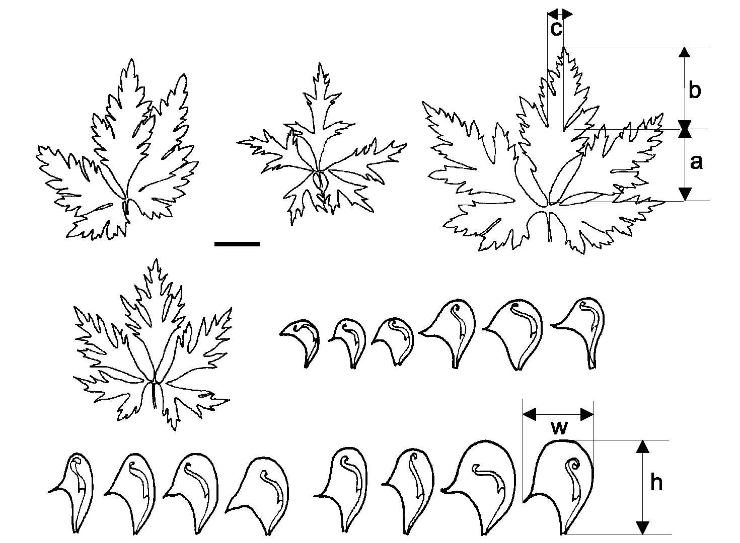
256
ROCZNIKI BIESZCZADZKIE 17 (2009)
Fig. 1 . Variation of leaves of A. xhebegynum in the Bieszczady Mts. and helmets in the Eastern Car-
pathians. Bar inside - 1 cm.
morphospace a Canonical Correspondence Analysis (CCA) was carried out. The
ordinations procedures were done using CANOCO for WINDOWS (ter Braak &
Smilauer 2002).
Statistical significance of the quantitative data was analysed using Monte
Carlo permutation tests which do not require normality of errors. The characters
13-20 (Table 1) were treated as predictor “environmental” variables, and species
taxonomic groups of OTUs as dummy variables. Permutations (499 runs) under
reduced model were conditioned by the dummy variables treated as covariables.
Forward automatic selection was chosen. The relationships between the “environ-
mental” and phenetic space for all OTUs were interrogated using General Linear
Modelling (GLM) (McCullagh & Nelder 1983).
Basic statistics (mean, standard deviations and 95% confidence intervals)
were calculated using STATISTICA ver. 8 (StatSoft, Inc. 1984-2007).
In sum 9 taxa recognized in the group of OTUs generally resembled A. xhe-
begynum (Fig. 2, Appendix). The classification of data (results not shown) gave

Results

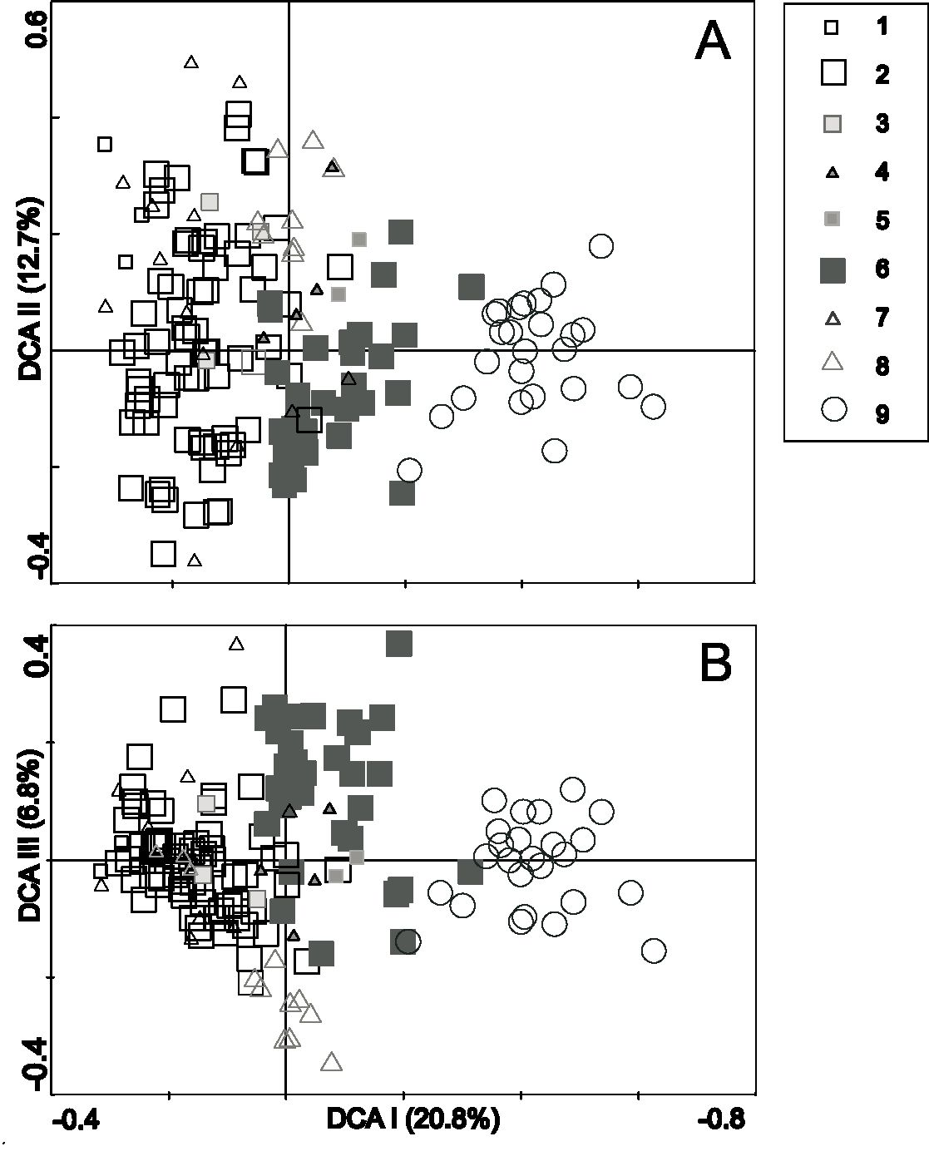
J. Mitka, B. Szajna - A phentic study on Aconitum xhebegynum DC. ...
two main clusters: the first composed of Aconitum variegatum and Aconitum
xhebegynum, and the second of the remaining taxa. In the diagram the Alpine
OTUs form a small cluster of six OTUs, with xgayeri and A. degenii, which have
moderately pubescent pedicels. Two Carpathian A. xhebegynum specimens in the
cluster have weakly pubescent helmets and glabrous carpels and pedicels below
bracteoles, pointing to the introgression from other taxa of ser. Toxicum. The two
OTUs of A. xhebegynum from the Alps (see Appendix) accompany the group of
the Carpathian conspecific OTUs, however in the their marginal position. The
Alpine specimens had glabrous helmets and moderately pubescent carpels and
pedicels below bracteoles. This morphotype is similar to that in the Carpathians.
The ordination (Fig. 2a,b) along DCA Axis I and Axis II pointed to three groups.
Two of them had extreme positions along the DCA Axis I. The first group formed
Fig. 2. Ordination of Aconitum OTUs using Detrended Correspondence Analysis alongside A: Axis
I and II, and B: Axis I and III. 1 - Aconitum degenii subsp. degenii fo. craciunelense, 2 - A. degenii
subsp. degenii, A. d. subsp. paniculatum, 3 - A. degenii subsp. gandogerii, 4 - A. xgayeri, 5 - A. xhebe-
gynum - the Alps, 6 - A. xhebegynum - the Eastern Carpathians, 7 - A. lasiocarpum subsp. kotulae;
8 - A. lasiocarpum subsp. lasiocarpum, 9 - A. variegatum subsp. variegatum.

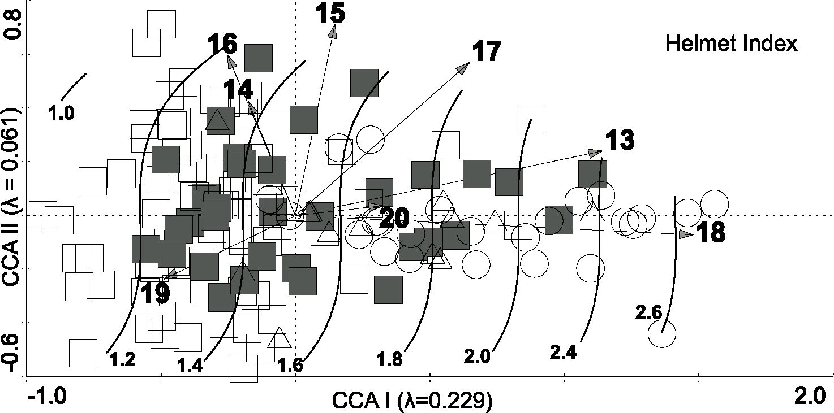
258
ROCZNIKI BIESZCZADZKIE 17 (2009)
A. degenii, which is opposed by the A. variegatum in the right side of the diagram.
Between them a transitional group of A. xhebegynum is localised, partially over-
lapping with A. lasiocarpum and other taxa (Fig. 2a).
The ordination of OTUs along DCA Axis I and Axis III enable the discrimi-
nation of A. lasiocarpum in the lower part of the diagram (Fig. 2b).
The detailed analysis of the transitional group (Szajna 2008) showed three
morphotypes. The first consists of OTUs with glabrous carpels and weakly pube-
scent helmets and pedicels. The second with weakly pubescent carpels, and gla-
brous helmets and pedicels. The third group had moderately pubescent carpels,
helmets and pedicels. The first two morphotypes were designated as A. xhebegy-
num, and the third as A. lasiocarpum with allied hybrids.
Monte Carlo permutation tests pointed to the statistical significance of three
characters: no. 14, width of the helmet (p = 0.019), no. 15, length of leaf lobe “a”
(p = 0.002) and no. 18, HI (p= 0.038). Only character no. 18 is related with the
taxonomic structure. The OTUs can be arranged according to increasing values
of HI along the CCA Axis I (Fig. 3). A clear trend exists in the General Linear
Modelling with HI growing from 1.0 in A. degenii to 2.7 in A. lasiocarpum and
A. variegatum. A. xhebegynum covers middle range of the HI values. The exem-
plary helmets drawn from the herbarium specimens showed the pattern of their
variability in the Eastern Carpathian population (Fig. 1). Basic statistics in Table
2 shows the non-overlapping 95% confidence intervals for HI values in A. degenii
(1.3—1.4) and A. variegatum (1.8—2.1). A. xhebegynum had 95% confidence inter-
val of HI ranging between 1.5-1.7.

Fig. 3. Ordination of Aconitum OTUs using Canonical Corresponding Analysis with imposed the
results of General Linear Modelling respective to the character no. 18, Helmet Index. The trend in
the character’s values and changing taxonomic structure is visible from the left to right side of the
diagram: A. degenii A. hebegynum and A. lasiocarpum A. variegatum. Symbols as in Fig. 2.

No. of char-  acter  Table 2. Mean ± standard devation and 95% confidence intervals for quantitative characters 13-20 (see Table 1). P - probability of  Type I error for the quantitative characters under the null model (i.e. only for the first canonical axis) based on the Monte Carlo unre-  stricted permutation test conditioned on the blocks (taxonomic structure). | Aconitum degenii | Aconitum xgayeri | Aconitum  xhebegynum | Aconitum  lasiocarpum | Aconitum varie-  gatum | Total | P
 | n=75 | n=13 | n=33 | n=13 | n=25 | n=159 | _
13 | 18.7±3.9 | 18.5±6.0 | 20.5±5.6 | 23.2±2.8 | 25.3±5.5 | 20.4±5.2 | 0.574
 | 17.8-19.6 | 14.8-22.1 | 18.5-22.4 | 21.5-24.8 | 23.1-27.6 | 19.6-21.3
14 | 14.1±2.9 | 13.3±4.0 | 13.2±3.0 | 14.2±2.7 | 13.2±2.4 | 13.7±2.9 | 0.018
 | 13.4-14.8 | 10.9-15.7 | 12.2-14.3 | 12.6-15.8 | 12.2-14.1 | 13.3-14.2
15 | 25.5±10.2 | 23.5±10.2 | 26.4±7.3 | 25.2±8.3 | 25.4±6.9 | 25.5±9.0 | 0.002
 | 23.1-27.8 | 17.3-29.7 | 23.8-29.0 | 20.1-30.2 | 22.5-28.3 | 24.1-26.9
16 | 40.2±14.1 | 39.5±15.8 | 43.2±12.8 | 32.1±7.5 | 33.8±10.4 | 39.1±13.4 | 0.880
 | 36.9-43.5 | 30.0-49.1 | 38.7-47.7 | 27.6-36.6 | 29.5-38.1 | 37.0-41.2
17 | 6.1±2.9 | 5.7±4.2 | 6.8±2.1 | 6.8±2.4 | 7.8±2.0 | 6.5±2.8 | 0.188
 | 5.5-6.8 | 3.2-8.2 | 6.1-7.6 | 5.3-8.2 | 6.9-8.6 | 6.1-7.0
18 | 1.3±0.2 | 1.4±0.3 | 1.6±0.3 | 1.7±0.3 | 1.9±0.3 | 1.5±0.3 | 0.038
 | 1.3-1.4 | 1.2-1.6 | 1.5-1.7 | 1.5-1.8 | 1.8-2.1 | 1.5-1.6
19 | 1.7±0.5 | 1.7±0.3 | 1.7±0.5 | 1.4±0.6 | 1.4±0.5 | 1.6±0.5 | 0.194
 | 1.5-1.8 | 1.6-1.9 | 1.5-1.9 | 1.1-1.8 | 1.2-1.6 | 1.5-1.7
20 | 1.7±0.4 | 1.6±0.1 | 1.6±0.2 | 1.8±0.4 | 1.8±0.3 | 1.7±0.3 | 0.136
 | 1.6-1.8 | 1.5-1.7 | 1.6-1.7 | 1.6-2.0 | 1.7-1.9 | 1.6-1.7
NJ
UH
to
J. Mitka, B. Szajna - A phentic study on Aconitum xhebegynum DC. ...
260
ROCZNIKI BIESZCZADZKIE 17 (2009)

Discussion
The results of DCA ordination clearly show morphotypes filling the gap in
the morphospace between A. degenii and A. variegatum (Fig. 2). The morphoty-
pes are well discriminated from A. variegatum (Axis I) and from A. lasiocarpum
subsp. lasiocarpum (Axis III). However, the transitional OTUs marked as A. xhe-
begynum are continuously, without any limit, distributed towards A. degenii. Hel-
met Index for A. xhebegynum is exactly between values found for A. degenii and
A. variegatum.
Among diagnostic characters for A. xhebegynum in the Eastern Carpathians
Mitka (2003) gives “carpels glabrous and pedicels below bracteoles glabrous or
carpels pubescent and helmet and pedicels below bracteoles glabrous”. The expec-
ted morphotype of A. xhebegynum should encompass glabrous carpels, helmets
and pedicels. Such a combination was unique and found only in two specimens
from the Chornogora region. In fact Zapałowiczs (1908) specimens of Aconitum
intermedium and A. pratense, found in the mountain range and forelands, seem
conspecific to A. xhebegynum. In the Eastern Carpathians a morphotype with gla-
brous carpels and helmets, and pubescent pedicels can be also found. The other
morphotype, relatively rare, had slightly pubescent carpels, glabrous pedicels be-
low bracteoles, and glabrous helmets. It was found in the Gorgans Mts. and on
Mała Rawka Mt. in the Western Bieszczady mountain range. In the latter moun-
tains, the region of Mała and Wielka Rawka Mts. was considered as a local center
of occurrence of A. degenii and its hybrids (Mitka, Zemanek 1997). However, in
the present study the most common encountered morphotype had glabrous car-
pels and pedicels below bracteoles, and slightly pubescent helmets. It looks like an
introgressive form towards ser. Toxicum.
Two of the Alpine specimens had a combination of the characters not found
in the Carpathian OTUs. The difference lies in the combination of glabrous hel-
mets and pubescent carpels. In the Eastern-Carpathian population the glabrous
helmets and pubescent carpels as a rule accompanied glabrous pedicels (at least
below bracteoles). In the Alpine OTUs the pedicels were weakly pubescent. Thus,
the key characters common for both the Carpathian and Alpine A. xhebegynum
were glabrous helmets and pubescent carpels.
Statistical analyses (Monte Carlo permutations and General Linear Model-
ling) showed that HI was linked with the taxonomic structure of the data set. This
result is similar to the previous morphometric analysis of A. degenii and A. lasio-
carpum (Mitka, Jodłowski 1977). In that study a significant difference was found
between A. lasiocarpum and A. degenii in helmet height (p = 0.02) and Helmet
Index (p = 0.0001).
All these results showed that in the Eastern Carpathians morphotypes of in-
termediate character between A. degenii and A. variegatum do exist, and can be
J. Mitka, B. Szajna - A phentic study on Aconitum xhebegynum DC. ...
circumscribed as A. xhebegynum. However, the existence of the taxon in the Eas-
tern Carpathians cannot be stated conclusively. The crucial point is the general
lack in the Eastern Carpathians of A. variegatum. The species is very rare here,
but its wider occurrence in the past cannot be ruled out (Mitka 2005). The nearest
localities of the species are in the Beskid Niski and the Doły Jasielsko-Sanockie
Basin (the Western Carpathians) to the west, and in the Rodna Mts (the Eastern
Carpathians) to the east. On the other hand, A. degenii is also rare species in the
Bieszczady Mts. (Mitka, Zemanek 1997, Mitka 2001). Recently, its locality in Wet-
lina village on the Wetlinka torrent as noted by Jasiewicz (1965), and confirmed
in 2001 (Mitka 2008), was destroyed by the building of touristic infrastructure.
The cytogenetic studies on the series Toxicum, encompassing A. degenii and
A. lasiocarpum, and on the series Variegata with A. variegatum, showed structural
differences between the two series (Joachimiak et al. 1999). In ser. Toxicum the
structural heterozygosity in two NOR-chromosome pairs (1 and 3) was found.
In opposite, A. variegatum showed structural homozygosity in this respect. It is
not clear whether the observed heterozygosity of two NOR-chromosome pairs in
the karyotype of A. degenii and A. lasiocarpum arose through crossing between
two different forms/taxa (with and without satellites on chromosomes 1 and 3).
On the other hand, it can be argued that the observed polymorphism is caused by
intraspecific structural variations in NOR-chromosomes (Joachimiak et al. 1999).
A. xhebegynum was not studied in this respect, however it can be expected that in
this hybrid species cytogenetic polymorphism, i.e. both homo- and heterozygosi-
ty, should be found (Ilnicki, pers. comm.).
In conclusion, the phenetic analyses presented here clearly pointed to the exis-
tence, in the Eastern Carpathians, of the morphotypes of intermediate character
between A. degenii and A. variegatum. Future cytogenetic and molecular analyses
of these morphotypes will enable a final conclusion to be reached. If the hypothe-
sis on the existence of the hybrid taxon in the Eastern Carpathians will be refuted
then the morphotypes should be circumscribed as low, intraspecific rank within
A. degenii, presumably in the subspecies rank.
Acknowledgements. The collection of plant material for the study in the Eas-
tern and Western Carpathians was facilitated by two grants: by the State Commi-
ttee for Scientific Research no. 2P04C 072 29 in 2001-2004 and by the Ministry of
Higher Education: no. 2P04G 064 30 in 2006-2009. Jacqueline Trojan (New Mexico
State University) is acknowledged for improving the English text.
262
ROCZNIKI BIESZCZADZKIE 17 (2009)

Literature
Falniowski A. 2003. Metody numeryczne w taksonomii. Wyd. Uniwersytetu Jagiellońskiego, Kraków.
Jasiewicz A. 1965. Vascular plants of the Western Bieszczady Mts. (Eastern Carpathians). Monogr.
Bot. 22: 1-340 [in Polish with English summary].
Joachimiak A., Ilnicki T., Mitka J. 1999. Karyological studies on Aconitum lasiocarpum (Rchb.) Gayer
(Ranunculaceae). Acta Biol. Cracoviensia, ser. Bot. 41: 205-211.
Kadota Y. 1981. A taxonomic study of Aconitum (Ranunculaceae) of the Akaishi Mountain Range in
Central Japan. Bull. Natn. Sci. Mus., Tokyo, Ser. B, 7(3): 91-112.
McCullagh P. & Nelder J. A. 1983. Generalized linear models. Chapman & Hall, London.
Mitka J. 2000. Systematics of Aconitum subgen. Aconitum in the Eastern Carpathians - preliminary
results. Roczniki Bieszczadzkie 9: 79-116 [in Polish with English summary].
Mitka J. 2001. Aconitum degenii Gayer, Tojad wiechowaty. In: R. Kaźmierczakowi & K. Zarzycki (eds.)
Polska Czerwona Księga Roślin. Paprotniki i rośliny kwiatowe. Instytut Botaniki im. W. Szafera,
PAN, Kraków, s.: 125-126.
Mitka J. 2005. Historical-biogeographical backgrounds of the endemism in the genus Aconitum
(monkshood - Ranunculaceae) in Central Europe. Roczniki Bieszczadzkie 13: 41-66 [in Polish
with English summary].
Mitka J. 2008. Tojad wiechowaty Aconitum degenii Gayer subsp. degenii. In: Mirek Z., Piękoś-Mirkowa
H. (eds.) Czerwona Księga Karpat Polskich. Rośliny naczyniowe. Instytut Botaniki im. W. Szafera
PAN, Kraków, s.: 64-65.
Mitka J. & Jodłowski J. 1997. Phenetic variability of Aconitum lasiocarpum and Aconitum degenii in
the Western Bieszczady Mts (Polish Eastern Carpathians). Rev. Valdotaine Hist. Nat. 51, Suppl.:
135-145.
Mitka J. & Zemanek B. 1997. The distribution of Aconitum degenii Gayer, A. lasiocarpum (Rchb.)
Gayer and their hybrids in the Bieszczadzki National Park. Roczniki Bieszczadzkie 6: 97-111
[in Polish with English summary].
Mitka J. 2003. The genus Aconitum L. (Ranunculaceae) In Poland and adjacent countries. Instytut
Botaniki UJ, Kraków.
Oh S.-H. & Park Ch.-W. 1998. Crossability ofthe Aconitum jaluense species complex (Ranunculaceae)
in Korea. Korean J. Biol. Sci. 2: 435-438.
Rohlf F. J. 2002. NTSYS-pc: numerical taxonomy and multivariate analysis system, version 2.11.
Exeter Software, Setauket, NY.
StatSoft, Inc. 1984-2007. STATISTICA for WINDOWS. StatSoft Inc., Tulsa, USA.
Szajna B. 2008. Aconitum xhebegynum DC. (Ranunculaceae) na tle zmienności przypuszczalnych
gatunków rodzicielskich w Karpatach. MSc. Thesis, Institute of Botany, Jagiellonian University.
ter Braak C. J. F. and Smilauer P. (2002). CANOCO Reference Manual and CanoDraw for Windows
User‘s Guide: Software for Canonical Community Ordination (version 4.5). Microcomputer
Power , Ithaca NY, USA.

Streszczenie
Celem badań było określenie granic zmienności morfologicznej (Fig. 1)
hipotetycznego mieszańca A. xhebegynum (A. degenii x A. variegatum) na tle
zmienności przypuszczalnych rodziców. Jego obecność w Karpatach Wschodnich
jest kontrowersyjna z powodu bardzo rzadkiego występowania w tym obszarze
J. Mitka, B. Szajna - A phentic study on Aconitum xhebegynum DC. ...
jednego z przypuszczalnych rodziców, tj. A. variegatum. Stąd postulowany status
notogatunku to osierocony mieszaniec (Mitka 2003). Badania fenetyczne, z wy-
korzystaniem cech jakościowych i ilościowych, dotyczących zmienności kształtu
kwiatów i liści (Tab. 1), zostały przeprowadzone na 159 okazach zielnikowych
(OTU), pochodzących z zielnika Instytutu Botaniki UJ (KRA) oraz zbiorów włas-
nych (JM) z lat 1995-2007. Należały one do Aconitum sect. Aconitum ser. Aconi-
tum (A. variegatum), ser. Toxicum (A. degenii i A. lasiocarpum, A. xgayeri) oraz
ser. Toxigata (A. xhebegynum) z Karpat Wschodnich i Alp. Macierz cech zosta-
ła poddana analizom numerycznym z wykorzystaniem nietendencyjnej analizy
zgodności (DCA), kanonicznej analizy zgodności (CCA), permutacyjnych testów
Monte Carlo i podstawowych statystyk opisowych. Przeprowadzone analizy po-
twierdziły pośrednie umiejscowienie notogatunku w przestrzeni morfologicznej,
zdefiniowanej przez przypuszczalne gatunki rodzicielskie (Fig. 2). Najczęstszy
morfotyp mieszańca wykazywał introgresję w kierunku gatunków ser. Toxicum
(A. degenii i A. lasiocarpum). Najrzadszy był podobny do okazów pochodzących
z Alp. Indeks hełmu przypuszczalnego mieszańca posiadał wartości pośrednie
pomiędzy indeksem stwierdzonym dla gatunków rodzicielskich (Fig. 3, Tab. 2).
Uzyskane wyniki nie wskazują bezpośrednio na istnienie genetycznego gatunku
mieszańcowego. Potrzebne są w tym celu badania cytogenetyczne i molekularne
DNA. Udowodniono istnienie odrębnych morfotypów, których pozycja taksono-
miczna, w przypadku odrzucenia hipotezy o mieszańcowym pochodzeniu, po-
winna być ustalona przypuszczalnie w randze podgatunku A. degenii.
Appendix
Specimina visa
Aconitum degenii Gayer subsp. degenii: ROMANIA [Bihor] Skerisoara, Fa-
getum; 02.08.2007; J. Mitka (KRA).- Dobrin 1100 m, nad potokiem; 31.07.2003;
J. Mitka (KRA). [Eastern Carpathians] Ceahlau, Fagetum; 08.08.2007; J. Mitka
(KRA).- Rarau, Pietrele Doamnei 1500 m; 24.07.2003; J. Mitka (KRA). UKRA-
INE Eastern Carpathians [Chornogora] m. Pożyżewską a Dancerzem, ziołoro-
śla; 22.07.2002; B. Zemanek & al. (KRA 0224812).- Bystrzec 1740 m, zarośla;
03.08.1997; J. Mitka (KRA).- Pożyżewska 1300 m, nad potokiem; 01.18.1997;
J. Mitka (KRA).- Potok Homulski pod Homulem 1295 m, ziołorośla; 01.08.1997;
J. Mitka (KRA).- Dolina Bystrzyca pod Czarną Horą, 20.08.1875; A. Ślendziński
(KRA 003764).- między Howerlą a Pożyżewską nad wodospadem ok. 1500 m;
24.07.2002; M. Graniszewska (KRA 0224997).- Dancerz Mt., po drodze z Zaro-
ślaka nad jezioro Niesamowite, stoki Dancerza ok. 1460 m; 27.07.2002; M. Grani-
szewska (KRA 0224488). [Svidovec] E Świdowiec, potok Rostinieckij 710 m, terasa
264
ROCZNIKI BIESZCZADZKIE 17 (2009)
zalewowa; 29.07.1997; J. Mitka (KRA). [Bucovina] Hriebta Jarovicja; 05.08.1992;
Cornej (KRA).- S. Vyssnia Jablonica; 19.08 1993; Cornej (KRA).- Sarata, Pastik;
13.08.1991; Cornej; (KRA).- S. Sarata; 18.07. 1990; Cornej (KRA). [Maramures
Mts.] Javornik; 29.07.2002; A. Prokopiv; (KRA 0239284). [Gorgans] nad poto-
kiem wpadającym do potoku Żeńca, ziołorośla; 15.08.1997; K. Zarzycki (KRA
- .- nad potokiem Bystra (dopływ Łomnicy), przy torze kolejki wąskoto-
rowej ok. 950 m; 02.08.2002; M. Graniszewska (KRA 0224491).- nad Czarną (do-
pływ Młodej) ok. 960 m; 08.08.2002; M. Graniszewska (KRA 0223533).- Sywula
1790 m, stok płn.-wsch., murawa na grechocie; 12.08.1939; A. Środoń (KRAM
000704).- Sywula Wielka 1750 m, stok zachodni, ziołorośla na piargu; 12.08.1939;
A. Środoń (KRAM 000699). [Chivchin] w potoku Albin ok. 1260 m; 15.07.2002;
M. Graniszewska (KRA 0223526).- w dolinie Czarnego Czeremoszu, ok. 8 km
przed potok Albin, ok. 960 m; 08.07.2002; M. Graniszewska (KRA 0223529).- ok.
1620 m, Hnitesa od pn. - skraj Rumicetum alpini; 24.07 1934; B. Pawłowski (KRA
003759).- Bałtaguł, Dolina Czeremosza; 25.07.1934; T. Sulma (KRA 003760).- Hni-
tesa od pn. - skraj Rumicetum alpini, ok. 1620 m; 28.04.1934; B. Pawłowski (KRA
116657).- Czywczyn NE, 1650 m, przy skałkach; 19.08.1997; K. Zarzycki (KRA
- .- Czywczyn N ; 14.09.1990; Zalevska (KRA).- Perkalab, Pereval’ Szija;
11.18.1992; Cornej, Budzak (KRA).- na shiłach góry Hnitesa; 20.07.1991; Cornej
(KRA). ROMANIA [Rodna Mts] NW-Hang des Pietrosul (Nagy Pietrosz) 1500 m
alt, Waldichtung; 04.08.1996; C. Dragulescu & W. Starmuhler (KRA).- Mt. Cailor;
15.08.1997; J. Mitka (KRA). POLAND Eastern Carpathians [Western Bieszczady]
Wetlina, nad potokiem k. mostu; 06.09.1995; J. Mitka (KRA 0224514).- Wetlina,
nad potokiem k. mostu; 30.09.1999; J. Mitka (KRA 0224510). - Dwernik 490 m,
na brzegu Sanu; 03.09.1996; J. Jodłowski (KRA).- dolina Terenowca, Alnetum ok.
700 m, FG 6968; 13.08.1996; T. Winnicki (KRA 0224517).
Aconitum degenii subsp. degenii forma craciunelense Gayer: UKRAINE
Eastern Carpathians [Bucovina] Pidvicznij, Hriebta Jarovicja; 05.08.1992; Cornej
(KRA).- S. Sarata; 16.08.1991; Cornej (KRA). [Chornogora] Howerla, wilgotna
młaka ziołoroślowa; 22.07.2002; B. Zemanek & al. (KRA 0224809).- Gutin Tom-
natyk 1620 m, nad brzegiem jeziorka; 02.08.1997; J. Mitka (KRA).
Aconitum degenii subsp. paniculatum (Arcangeli) Mucher: SWITZER-
LAND Schweitz, Kt. Waadt, N 46º14,47' E 07º06,58', 1450 m; 31.08.1998; W.
Starmuhler (KRA 0276795). CROATIA Kroatien, Istrien, Planik-Gipfen, Wei-
den - Buchen-Gebusch, 1270m; 14.08.1991; W. Mucher (KRA 0277184). ITALY
Italien, Wenetien, Dolomiten, an der Straże Auronzo nach Ginalba, Waldrand
1140 m; 16.08.1991; W. Mucher (KRA 0277183). AUSTRIA Karnten, Steiner Al-
pen, Kotschnatal, Waldrand, 975 m; 20.08.1990; W. Mucher (KRA 0277192).-
Hohe Tauren, Worth Krumltal, brzeg rzeki; 11.09.1996; D. Tumidajowicz (KRA).
SLOVENIA Alpes Juliae, Komna, in locis saxosis, inter frutices, solo calcareo
1520 m; 14.08.1957; B. Pawłowski (KRA 003769).- Triglavski PN, k. Slap Most-
J. Mitka, B. Szajna - A phentic study on Aconitum xhebegynum DC. ...
nice, zarośla nad potokiem 730 m; 31.07.2003; M. & A. Zając (KRA 0265661).-
Alpy; 22.08.1991; T. Ster & F. Steffan (KRA 0277168).- Steiner Alpen (Kaminske
Alpe) 1465m; 20.09.1991; W. Mucher (KRA 0277182).- Steiner Alpen (Kamins-
ke Alpe), Strate von Kanker (Kokre), Waldrand 745 m; 20.08.1991; W. Mucher
(KRA 0277181).- Steiner Alpen (Kaminske Alpe); Suhodolnik, Waldrand, 960 m;
20.08.1991; W. Mucher (KRA 0277180).- Kranjska (Krain), Steiner Alpen, am Weg
von Bistrica (Feistitz) Tal zum Kaminisko sedlo; 18.08.2002; U. & W. Starmuhler
(KRA 0277279).- Steiner Alpen (Kaminske Alpe) 1440m; 20.08.1991; W. Mucher
(KRA 0277185).
Aconitum degenii Gayer nsubsp. gandogeri Mucher
GERMANY Tyrol, In fruticesis subalpinis, Inter Trins et Gschnitz 4000-
-5000'; A. Kerner (KRA 003753).
Aconitum xgayeri Starmuhl. (A. degenii x A.lasiocarpum)
UKRAINE Eastern Carpathians [Bucovina] S. Sarata, Hrebto Cornyj Dil‘;
18.07 1990; Cornej (KRA). [Gorgans], nad rzeką Kotelec 1150 m; 04.08.2002;
M. Graniszewska (KRA 0224493).- Sywula Wielka, 1790 m, stok poł.-wsch., mura-
wa na grechocie; 12.08.1939; A. Środoń (KRAM 000706). [Chivchin] Góry Czyw-
czyńskie; 27.07.1999; K. Zarzycki (KRA).- S. Burkut, G. Chivchin; 31.07.2002;
Cornej (KRA).- Perkalab, Gora Hnitesa; 14.07.1998; Cornej (KRA).- S. Burkut,
Popodnica; 31.07.2002; Cornej (KRA).- między Czywczynem a Seligułem przy
granicy ukraińsko-rumuńskiej na połoninie, ok. 1500 m; 09.07.2002; M. Grani-
szewska (KRA 0223531). [Chornogora] między Pożyżewską a Dancerzem 1580 m,
ziołorośla; 22.07.2002; B. Zemanek & al. (KRA 0224811). POLAND Eastern Car-
pathians [Western Bieszczady] Chmiel, k. cerkwii nad stawem rybnym, Alnetum
z Matteucia struthiopteris; 09.09.1996; J. Jodłowski & J. Mitka (KRA 0224509).-
Procisne, potok Wołosaty, ok. 400 m za mostem w górę potoku, Alnetum ok. 515
m; 03.09.1996; J. Jodłowski, J. Mitka (KRA 0224508, 0224511).
Aconitum xhebegynum DC. (A. degenii x A. varegatum)
FRANCE Alpy francuskie; ??; ?? (KRA 003613). GERMANY Bayern, Natio-
nalpark Berchtesgaden, In der Roth, Weg von der Wasser - Alm zum Wildtorl,
Hochstandenflur, 1455 m s.m.; 23.08.1994; W. Starmuhler (KRA). UKRAINE
Eastern Carpathians [Chornogora] Czarnohora; 09.08.1935; B. Pawłowski (KRA
003748).- Karpaty Pokuckie, Zawojela, Howerla, w paśmie Czarnej Hory; 07.1911;
M. Raciborski; (KRA 003761).- Karpaty Pokuckie, nad brzegiem Prutu i koło dro-
gi w Zawojeli pod Howerlą; 08.1911; M. Raciborski (KRA 003758).- Dolina Prutu,
przy drodze w rowie w stronę Zaroślaka, 1150 m; 16.08.1996; P Bochenek (KRA
0225148).- Worochta nad Prutem;17.08.1888; E. Wołoszczak (KRAM 33630).-
Pożyżewska; 24.07.1999; K. Zarzycki (KRA 0224515).- Foreszczenka; 16.09.1911;
K. Huppenthal (KRA 003766).- Zaroślak, nad potokiem koło schroniska, ok. 700
m; 30.07.1997; J.Mitka (KRA 0224502).- Zaroślak; 06.08.2006; J.Mitka (KRA).
[Gorgans] nad potok Negrowa pod Sywulą; 02.08.2002; M. Graniszewska (KRA
266
ROCZNIKI BIESZCZADZKIE 17 (2009)
0224492).- Sywula 1790 m, stok płn.-wsch., murawa na grechocie; 12.08.1939;
A. Środoń (KRAM 000698, 000705). POLAND Eastern Carpathians [Western
Bieszczady] Mała Rawka, potok W od schroniska, ok. 1100 m; 12.09.1995; J. Mit-
ka (KRA 0224504, 0225145).- Mała Rawka, nad potokiem, Fagetum ok. 1030
m; 09.09.1995; J. Mitka (KRA 0224512).- Górna Solinka FG6879, ok. 900 m;
02.08.1993; M. Szewczyk (KRA 0225140).- Dwernik, Potok Nasiczniański; 07/08.
2003; T. Ilnicki (KRA).- Dolina Sanu, Rusinowa Polana; 02.09.2003; T. Ilnicki
(KRA).- Nasiczne, potok Nasiczniański, Alnetum, ok. 750 m; 08.09.1995; J. Jod-
łowski & J. Mitka (KRA 0224506).- Procisne, potok Wołosaty ok. 400 m w górę za
mostem, ok. 515 m; 03.09.1993; J. Jodłowski (KRA 0225166).- Dolina Terebow-
ca, Alnetum; 20.09.1999; J. Mitka (KRA 0224505).- Dolina Terebowca, Alnetum;
13.08.1996; J. Jodłowski (KRA 0224518).- Dolina Terebowca; 1994; T. Winnicki
(KRA 0225142).- potok Terebowiec, 400 m przed ujęciem wody w górę poto-
ku; 12.08.1996; J. Jodłowski (KRA 0224516).- Dolina Moczarnego, przy drodze;
06.09.1995; J. Mitka (KRA 0225143).- Fedkowskie, k. mostu, Alnetum ok. 705
m; 09.09.1995; J. Jodłowski & J. Mitka (KRA 0224507).- Ustrzyki Górne, potok
Terebowiec, naprzeciw budynku dyrekcji BPN; 12.08.1996; J. Jodłowski (KRA
0225141).
Aconitum lasiocarpum (Rchb.) Gayer subsp. kotulae (Pawł.) Starmuhl. &
Mitka
POLAND Eastern Carpathians [Western Bieszczady] Górny Dział FG6849,
młaka przy grani, ok. 1120 m; 11.08.1993; M. Szewczyk (KRA 0225146). UKRAI-
NE [Chornogora] 7 km powyżej Zaroślaka nad Prutem; 30.07.1997; J. Mitka (KRA
0224501). [Gorgans] okol. Świcy 900 m; 11.08.2003; M. Graniszewska (KRA).
Acnitum lasiocarpum (Rchb.) Gayer subsp. lasiocarpum
POLAND Eastern Carpathians [Western Bieszczady] Połonina Wetlińska;
22.08.2007; B. Szajna (KRA).- potok Wołosatka; 0,5 km powyżej stanicy harcer-
skiej; 24.08.1996; J. Jodłowski (KRA).
Aconitum variegatum L.
SLOVAKIA Western Carpathians [Strazovske vrchy] Sulov (pod skałami);
04.09.2001; J. Mitka (KRA). [Babia Góra] Rabczyce 830 m, ziołorośla; 25.08.2005;
J. Parusel (KRA). [Slovensky raj] Podlesok; 16.08.2002; J. Mitka (KRA). [Nizke
Tatry] Tale, Bistricanka torrent, 690-830 m; 18.08.2007; J. Mitka (KRA).- NW
zbocze góry Skalka (1548 m), lewy dopływ potoku Luznanka, świerczyna gór-
noreglowa; 19.08.2003; Z. Szeląg (KRA). POLAND Western Carpathians [Beskid
Żywiecki] Pilsko, Korbielów; 30.08.2003; J. Mitka (KRA). [Doły Jasielsko-Sano-
ckie Basin] Targowiska, Fraxinetum; 24.08.2001; J. Mitka (KRA). [Beskid Niski]
Kornuty; 10.09.1998; J. Mitka (KRA). góra Kornuty 830 m, NE część, (Magurski
PN), podmokły las jesionowy; 04.08.1998; K. Oklejewicz (KRA). [Pieniny] Wąwóz
Homole, w zaroślach nad potokiem na dnie wąwozu; 01.09.2000; K. Oklejewicz
(KRA).

