Original article

Relationship between chronic obstructive pulmonary
disease and in-hospital management and outcomes
in patients with acute myocardial infarction

Artur Dziewierz1, Zbigniew Siudak1, Tomasz Rakowski1, Michał Brzeziński1, Joanna Zdzienicka1,
Waldemar Mielecki1, Jacek S. Dubiel1, Dariusz Dudek2
- 2nd Department of Cardiology, Jagiellonian University Medical College, Krakow, Poland
- Department of Interventional Cardiology, Jagiellonian University Medical College, Krakow, Poland
Abstract
Background: Chronic obstructive pulmonary disease (COPD) is associated with unfavourable short- and long-term outcome in
patients with coronary artery disease undergoing revascularisation procedures.
Aim: To assess the associations of COPD with in-hospital management and mortality in patients with acute myocardial
infarction (MI) admitted to hospitals without on-site invasive facilities.
Methods: We identified 81 (11.3%) patients with COPD and 633 (88.7%) without COPD treated in the Krakow Registry of Acute
Coronary Syndromes from February 2005 to March 2005 and from December 2005 to January 2006. Data concerning in-hospital
management and mortality were assessed.
Results: Patients with COPD were older and were more likely to have prior angina, prior heart failure symptoms, prior stroke, and
lower left ventricular ejection fraction. Patients with COPD diagnosis were less likely to be transferred for invasive treatment [COPD
(-) vs. COPD (+), 12.3 vs. 34.9%; p < 0.0001] and to receive aspirin and clopidogrel during index hospital stay. In-hospital mortality
was higher in patients with COPD diagnosis [COPD (-) vs. COPD (+), 58 of 412 (14.1%) vs. 21 of 71 (29.6%); p = 0.002]. COPD was an
independent predictor of in-hospital death in multivariate Cox regression analysis.
Conclusions: Coexistence of COPD with acute MI may be associated with less frequent transfer for invasive treatment, less
aggressive pharmacotherapy, and higher in-hospital mortality in patients admitted to community hospitals without on-site invasive
facilities. These differences may be partially driven by a higher risk profile of COPD patients.
Key words: chronic obstructive pulmonary disease, acute myocardial infarction, management, mortality

Introduction
Chronic obstructive pulmonary disease (COPD) is a very
common, smoking-related disease characterised by
persistent airway obstruction due to chronic bronchitis or
emphysema [1]. Importantly, COPD is now the fourth
leading cause of death in the United States and Europe,
and it is the only common cause of death that is increasing
in incidence [1]. In industrialised countries cigarette
smoking accounts for most cases of COPD, and as cigarette
smoking is a well-known risk factor for coronary artery
disease (CAD), it is expected that a considerable number
of patients hospitalised with CAD diagnosis also have
concomitant COPD [1]. In previous studies coexistence of
COPD was associated with unfavourable outcome in
patients after myocardial infarction (MI) [2], and in patients
Kardiol Pol 2010; 68: 294-301
with CAD undergoing percutaneous coronary intervention
(PCI) [3, 4] or coronary artery bypass grafting (CABG) [5, 6].
To the best of our knowledge, this is one of the first
studies examining the associations between COPD and in-
hospital management and mortality in patients with acute
MI admitted to hospitals without on-site invasive facilities.

Methods
The Krakow Registry of Acute Coronary Syndromes was
a prospective, multicentre, observational registry designed
to examine current epidemiology, in-hospital management
and outcome of patients with acute coronary syndromes
in this region of Poland (Krakow, Malopolska Region). The
design of the Registry was described previously [7, 8].
Cardiogenic shock was defined as reduced blood pressure
Address for correspondence:
Dariusz Dudek MD, PhD, Zakład Hemodynamiki i Angiokardiografii, Uniwersytet Jagielloński Collegium Medicum, ul. Kopernika 17, 31-501 Kraków,
tel.: +48 12 424 71 81, fax: +48 12 424 71 84, e-mail: mcdudek@cyf-kr.edu.pl
Received: 19 August 2009. Accepted: 03 December 2009.
Kardiologia Polska 2010; 68: 3
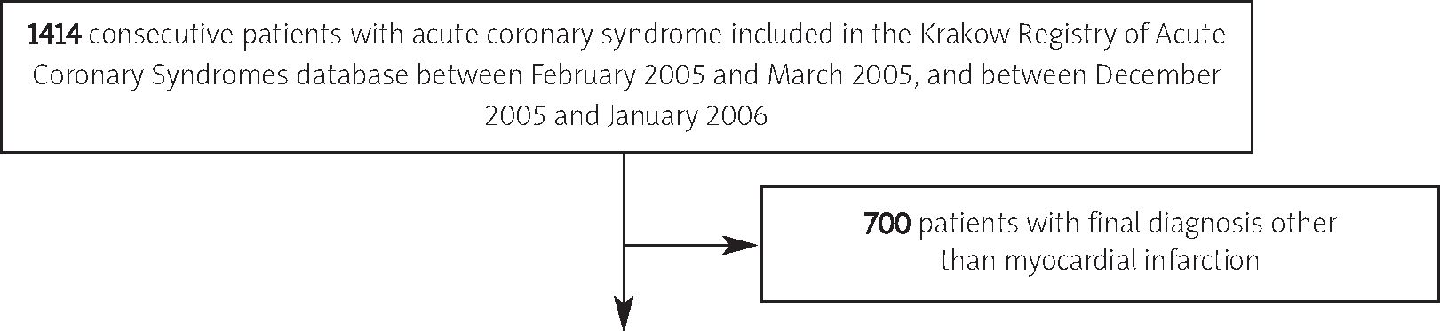
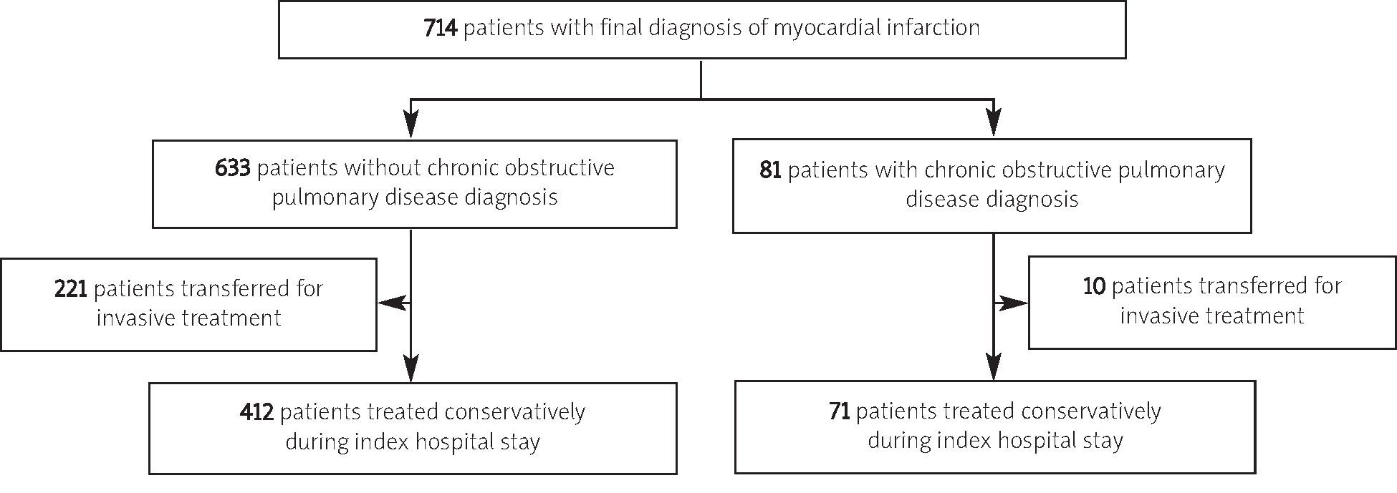
Chronic obstructive pulmonary disease and outcome in patients with acute MI
295
(systolic blood pressure < 90 mmHg or a drop of mean
arterial pressure by > 30 mmHg) and/or low urine output
(< 0.5 ml/kg/h), with a pulse rate > 60 beats per minute
with or without evidence of organ congestion [9]. Patients
were classified as NSTEMI and STEMI based on their final
diagnosis. STEMI was diagnosed if ST-segment elevation
> 1 mm occurred in > 1 lead or new left bundle branch
block was found in the electrocardiogram with biochemical
evidence of myocardial necrosis (> 1 positive biochemical
cardiac necrosis marker measurement). NSTEMI was
diagnosed in patients with > 1 positive biochemical cardiac
necrosis marker measurement without new ST-segment
elevation in the electrocardiogram. Patients with previous
history of COPD treated with bronchodilators or steroids
at index hospital admission were classified as COPD
patients. All-cause in-hospital mortality was assessed in
patients remaining in community hospitals for conservative
treatment. Occurrence of other ischaemic and bleeding
events was also analysed in this group of patients.
Statistical analysis
Data were analysed according to the established
standards of descriptive statistics. Continuous variables
are expressed as mean ± standard deviation. Categorical
variables are presented as percentages. Statistical
comparisons between groups were performed using x2
test and Fisher's exact test for categorical variables and
independent samples Student's t-test for continuous
variables, as appropriate. Additionally, frequency of transfer
for invasive treatment and in-hospital mortality was
assessed in pre-specified groups (age < 75 vs. > 75 years,
cardiogenic shock vs. no cardiogenic shock presence,
NSTEMI vs. STEMI final diagnosis) and the Breslow-Day
test for homogeneity was used to prove possible
interactions. Multivariate Cox regression analysis was
performed to find significant predictors of in-hospital
death. Forward selection in Cox regression with the
probability value for covariates to enter the model was set
at the level of 0.05. The following covariates were tested:
age, gender, body mass index, presence of diabetes
mellitus, arterial hypertension, hyperlipidaemia, prior
angina, prior MI, prior heart failure symptoms, left
ventricular ejection fraction (LVEF), prior PCI, prior CABG,
prior stroke transient ischaemic attack, history of smoking,
peripheral arterial disease, chronic renal insufficiency,
COPD, parameters on admission (chest pain presence,
cardiogenic shock presence, heart rate, systolic blood
pressure, diastolic blood pressure), time from chest pain
onset to admission and final diagnosis (STEMI, NSTEMI).
Risk of in-hospital death was expressed as hazard ratio
with 95% confidence intervals. All tests were 2-tailed, and
a p value of < 0.05 was considered statistically significant.

Results
The Krakow Registry of Acute Coronary Syndromes
database included 1414 patients with acute coronary
syndrome admitted between February 2005 and March
2005, and between December 2005 and January 2006.
A total of 700 patients with final diagnosis other than MI
(e.g. unstable angina, stable angina, extracardiac cause of
Figure 1. Scheme of groups' distribution in the registry
Kardiologia Polska 2010; 68: 3

296
Artur Dziewierz et al.
chest pain) were excluded from the analysis. COPD was
diagnosed in 81 (11.3%) of the remaining 714 patients
(Figure 1). Baseline demographic and clinical characteristics
of patients with and without COPD diagnosis are
summarised in Table I. Patients with COPD were older and
were more likely to have prior angina, prior heart failure
symptoms, prior stroke, and lower LVEF. Heart rate on
admission was higher and diastolic blood pressure on
admission was lower in patients with COPD. As shown in
Table I there was no difference in discharge diagnosis and
cardiogenic shock rates between study groups.
Patients with COPD diagnosis were less likely to be
transferred for invasive treatment during index hospital
stay than patients without COPD [221 of 633 (34.9%) vs.
10 of 81 (12.3%); p < 0.0001]. The proportions of transferred
patients with and without COPD stratified by age,
cardiogenic shock presence on admission, and discharge
diagnosis are shown in Figure 2 A.
As shown in Table II patients with COPD diagnosis were
less likely to receive aspirin and clopidogrel during index
hospital stay. Use of other pharmacological agents,
including beta-blockers, was similar among study groups.
Among patients treated conservatively during index
hospital stay, in-hospital mortality was higher in patients
with COPD diagnosis [COPD (-) vs. COPD (+), 58 of 412
(14.1%) vs. 21 of 71 (29.6%); p=0.002]. In-hospital mortality
for patients with and without COPD stratified by age,
cardiogenic shock presence on admission, and discharge
diagnosis is shown in Figure 2B. Tests for interaction and
multivariate Cox regression analysis (see Table III) have
confirmed that COPD diagnosis was independently
associated with in-hospital mortality in patients with acute
MI treated conservatively during index hospital stay.
Among patients remaining in remote hospitals,
patients with COPD diagnosis were at higher risk of atrial
fibrillation [COPD (-) vs. COPD (+), 2.2 vs. 7.0%, p = 0.041]
Table I. Baseline demographic and clinical characteristics
Parameters | COPD (-)  n = 633 | COPD (+)  n = 81 | p
Male | 60.0% | 61.7% | 0.8
Age [years] | 67.9 ± 12.9 | 71.8 ± 10.7 | 0.003
Age > 75 years [%] | 31.6 | 46.9 | 0.008
Body mass index [kg/m2] | 27.3 ± 7.1 | 26.1 ± 4.0 | 0.1
Diabetes mellitus [%] | 23.1 | 23.5 | 1
Arterial hypertension [%] | 70.6 | 76.5 | 0.3
Hyperlipidaemia [%] | 47.1 | 37.0 | 0.1
Prior angina [%] | 55.5 | 80.2 | < 0.0001
Prior myocardial infarction [%] | 28.6 | 34.6 | 0.3
Prior heart failure symptoms [%] | 19.3 | 30.9 | 0.019
Prior percutaneous coronary intervention [%] | 5.8 | 4.9 | 0.8
Prior coronary artery bypass graft [%] | 2.5 | 0.0 | 0.2
Prior stroke/transient ischaemic attack [%] | 6.6 | 13.6 | 0.039
Current smoker [%] | 32.1 | 40.7 | 0.1
Family history of coronary artery disease [%] | 13.3 | 16.0 | 0.6
Peripheral arterial disease [%] | 11.7 | 14.8 | 0.5
Chronic renal insufficiency [%] | 6.2 | 11.1 | 0.1
Chest pain on admission [%] | 67.5 | 61.7 | 0.3
Time from chest pain onset to admission [hours] | 14.7 ± 19.5 | 14.7 ± 20.3 | 0.9
Time from chest pain onset to admission < 12 hours [%] | 68.4 | 70.1 | 0.8
Heart rate on admission [beat/min] | 84.8 ± 24.3 | 93.8 ± 26.3 | 0.002
Systolic blood pressure on admission [mmHg] | 142.0 ± 35.2 | 137.0 ± 35.0 | 0.2
Diastolic blood pressure on admission [mmHg] | 87.1 ± 16.6 | 83.6 ± 16.2 | 0.1
Cardiogenic shock on admission [%] | 7.7 | 6.2 | 0.7
Left ventricular ejection fraction [%] | 49.8 ± 13.3 | 44.6 ± 13.7 | 0.005
Discharge diagnosis of STEMI [%] | 47.9 | 38.3 | 0.1
Values are presented as percentages or mean ± SD.
Abbreviations: COPD - chronic obstructive pulmonary disease, STEMI - ST-segment elevation myocardial infarction
Kardiologia Polska 2010; 68: 3
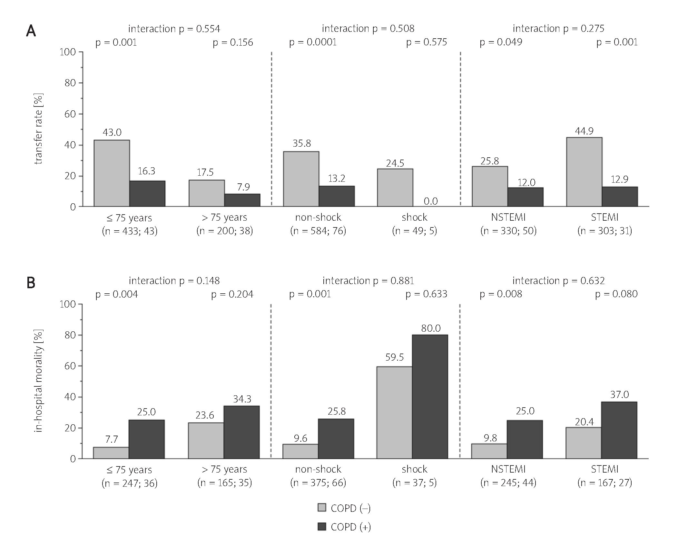
Chronic obstructive pulmonary disease and outcome in patients with acute MI
297
Figure 2. Proportion of patients transferred for invasive treatment (A) and in-hospital mortality (B) in patients
without (gray bars) and with (black bars) chronic obstructive pulmonary disease (COPD) stratified by age,
cardiogenic shock presence on admission, and discharge diagnosis
and ventricular tachycardia/ventricular fibrillation (1.5 vs.
7.0%, p = 0.014) occurrence during index hospital stay.
Rates of 2nd and 3rd grade atrioventricular block (1.7 vs.
0.0%, p = 0.601), pulmonary oedema (5.6 vs. 9.9%,
p = 0.288), ischaemic stroke (1.0 vs. 2.8%, p = 0.216), and
blood transfusion (2.4 vs. 2.8%, p = 0.692) were similar in
the study groups.

Discussion
Our study is the first to date showing that patients with
acute MI and concomitant COPD are less frequently
treated with antiplatelet agents, as well as transferred for
invasive treatment, and experience higher in-hospital
mortality than patients without COPD. In our registry, more
than 1 in 10 patients admitted with acute MI had already
the diagnosis of COPD. In previous studies the frequency
of COPD ranged from 4.3% in patients with CAD
undergoing PCI [3], 15.6% in patients after MI [2], up to
26.1% in patients with CAD undergoing CABG [5]. Similarly
to previous reports, COPD patients were older and were
more likely to have had higher prevalence of age-related
and smoking-related comorbidities [1, 3-6]. For example,
prior stroke was more frequently observed in patients with
COPD than in patients without COPD [1, 3, 4]. Importantly,
reduced lung function has been shown to be a significant
predictor of non-fatal and fatal stroke [10, 11].
We have confirmed that COPD patients were less likely
to be transferred for invasive diagnostics and treatment
during index hospital stay. This difference in the proportion
of transferred patients may be driven by the difference in
baseline characteristics, especially higher age and more
frequent prevalence of other comorbidities in COPD patients,
Kardiologia Polska 2010; 68: 3

298
Artur Dziewierz et al.
Table II. Pharmacological treatment during hospital stay
Characteristics | COPD (-)  n = 633 | COPD (+)  n = 81 | p
Aspirin [%] | 96.7 | 86.4 | < 0.0001
Clopidogrel [%] | 19.1 | 8.6 | 0.020
Ticlopidine [%] | 16.6 | 18.5 | 0.8
Glycoprotein IIb/IIIa inhibitor [%] | 5.8 | 1.2 | 0.1
Thrombolysis [%] | 8.4 | 3.7 | 0.2
Low-molecular-weight heparin [%] | 72.2 | 81.5 | 0.1
Beta-blocker [%] | 69.4 | 72.8 | 0.5
Angiotensin-converting enzyme inhibitor /  angiotensin II antagonist [%] | 66.2 | 63.0 | 0.6
Calcium antagonist [%] | 7.0 | 6.2 | 0.8
Nitrates [%] | 64.5 | 63.0 | 0.8
Statins [%] | 77.4 | 79.0 | 0.8
Values are presented as percentages.
Abbreviations: COPD - chronic obstructive pulmonary disease
Table III. Multivariate Cox regression analysis for in-hospital death
Variable | Hazard ratio | 95% confidence  interval | p
Age (per 1 year) | 1.03 | 1.01-1.06 | 0.005
Cardiogenic shock | 5.04 | 3.06-8.29 | < 0.001
Chronic obstructive pulmonary disease | 2.15 | 1.30-3.55 | 0.003
STEMI (vs. NSTEMI) | 1.87 | 1.20-2.92 | 0.006
Results are presented as hazard ratios with 95% confidence intervals.
Abbreviations: STEMI - ST-segment elevation myocardial infarction, NSTEMI - non-ST-segment elevation myocardial infarction
which may influence the decision concerning transfer for
invasive treatment. On the other hand, patients with COPD
may receive less aggressive invasive diagnostics and
revascularisation procedures due to the fear of increased
periprocedural mortality in those patients who have
undergone CABG [5, 6] or PCI [3, 4]. We expect that in the
remaining, conservatively treated cohort there were a lot of
patients who would have benefited from the invasive
strategy. In COPD patients, especially with exacerbation of
COPD symptoms, acute MI can also be unrecognised and
due to atypical presentation may be associated with no
reperfusion treatment or longer time delays to reperfusion
therapy [12].
Regardless of the risk profile (age, cardiogenic shock,
discharge diagnosis) COPD was associated with a more than
twofold increase in in-hospital mortality in patients with
acute MI treated conservatively. There are many potential
mechanisms responsible for poor short- and long-term
prognosis in patients with CAD and COPD. First of all, it is
still debatable whether COPD itself poses a risk for patients
with CAD, or it is only a benign marker of disease severity.
COPD is frequently associated with advanced age and higher
prevalence of age-related diseases (e.g. renal insufficiency,
diabetes mellitus, stroke), which have themselves been
shown to be associated with adverse outcomes in patients
with CAD, especially patients with acute coronary syndromes
[13-16]. Moreover, we have found that COPD patients were
less likely to receive guideline-recommended therapies,
including acute aspirin and clopidogrel. On the other hand,
the observed difference in antiplatelet treatment may be
partially related to the difference in baseline characteristics
(i.e. age) and concomitant medication use. A lower rate of
beta-blockers use was also reported in previous studies in
patients with COPD [2, 4, 17]. There is reluctance to use them
in patients with COPD, due to the expected adverse
reactions and bronchospasm. As in the more recent studies
the observed benefits of cardioselective beta-blockers in
COPD patients appear to outweigh any potential risk of side
effects, they should not be withheld in COPD patients [18].
Importantly, the Can Rapid Risk Stratification of Unstable
Angina Patients Suppress Adverse Outcomes with Early
Implementation of the ACC/AHA Guidelines (CRUSADE)
registry data [19, 20], as well as our previous report [7],
demonstrated that patients who present with acute
coronary syndrome and do not receive guideline-
recommended therapies (including aspirin, clopidogrel, and
beta-blocker) have a higher mortality rate.
In addition, the use of inhaled beta-agonists among
COPD patients could also contribute to the elevated
arrhythmia risk, which potentially may influence in-hospital
Kardiologia Polska 2010; 68: 3
Chronic obstructive pulmonary disease and outcome in patients with acute MI
299
outcome. In our cohort the risk of atrial fibrillation and
ventricular tachycardia/ventricular fibrillation was higher
among COPD patients, but due to the lack of information
concerning current COPD treatment the interaction
between such treatment and arrhythmia risk was not
possible to assess. On the other hand, a link between
COPD and systemic inflammatory response, confirmed by
elevated plasma levels of acute phase proteins, i.e.
C-reactive protein, interleukin-6, and fibrinogen, was
suggested [21]. That way COPD may hasten the
progression of atherosclerotic disease as well as the
destabilisation of existing atherosclerotic plaques [11]. It
must be emphasised that a systemic inflammatory
response measured by elevation of C-reactive protein and
interleukin-6 levels has been shown to be associated with
worse prognosis in patients with unstable angina and MI
[22, 23]. Long-term outcome in COPD patients may also
be affected by decreased likelihood of cardiac rehabilitation
attendance after MI [24].
Several important limitations of the present report
should be acknowledged. First of all, the study has all the
limitations of a registry. Secondly, according to the purpose
of the analysis, the study focused only on in-hospital
clinical outcomes of patients treated conservatively in
centres without on-site invasive facilities. Data concerning
mortality in the group of patients transferred for invasive
treatment, as well as long-term clinical follow-up data for
all patients, were not available. The most important
limitation of the study is that COPD was diagnosed based
on local physician assessment only and no pulmonary
function testing to confirm the diagnosis was performed.
This may lead to underestimation of COPD frequency, but
similar methods to define COPD were used in the previous
studies [2, 4]. On the other hand, patients with chronic
heart failure presenting with dyspnoea may be incorrectly
classified as COPD patients. Also, we were unable to
classify the COPD severity, and it is probable that the
relative impact of COPD on outcome is dependent on
disease severity. However, the observed associations
between COPD diagnosis and in-hospital management
and mortality are clinically important.
In conclusion, coexistence of COPD in patients with
acute MI may be associated with less frequent transfer for
invasive treatment, less aggressive pharmacotherapy, and
higher in-hospital mortality in patients remaining in
community hospitals without on-site invasive facilities.
These differences may be partially driven by a higher risk
profile of COPD patients.
References
- Barnes PJ. Chronic obstructive pulmonary disease. N Engl J Med
2000; 343: 269-80.
- Salisbury AC, Reid KJ, Spertus JA. Impact of chronic obstructive
pulmonary disease on post-myocardial infarction outcomes. Am
J Cardiol 2007; 99: 636-41.
- Berger JS, Sanborn TA, Sherman W, et al. Effect of chronic
obstructive pulmonary disease on survival of patients with coronary
heart disease having percutaneous coronary intervention. Am
J Cardiol 2004; 94: 649-51.
- Selvaraj CL, Gurm HS, Gupta R, et al. Chronic obstructive pulmonary
disease as a predictor of mortality in patients undergoing
percutaneous coronary intervention. Am J Cardiol 2005; 96: 756-9.
- Gardner SC, Grunwald GK, Rumsfeld JS, et al. Risk factors for
intermediate-term survival after coronary artery bypass grafting.
Ann Thorac Surg 2001; 72: 2033-7.
- Gao D, Grunwald GK, Rumsfeld JS, et al. Time-varying risk factors
for long-term mortality after coronary artery bypass graft surgery.
Ann Thorac Surg 2006; 81: 793-9.
- Dziewierz A, Siudak Z, Rakowski T, et al. More aggressive
pharmacological treatment may improve clinical outcome in
patients with non-ST-elevation acute coronary syndromes treated
conservatively. Coron Artery Dis 2007; 18: 299-303.
- Dudek D, Siudak Z, Dziewierz A, et al. Local hospital networks for
STEMI treatment for a population of half a million inhabitants increase
the use of invasive treatment of acute coronary syndromes to the
European recommended level. The Malopolska Registry of Acute
Coronary Syndromes 2005-2006. Kardiol Pol 2008; 66: 489-97.
- Nieminen MS, Bohm M, Cowie MR, et al. Executive summary of the
guidelines on the diagnosis and treatment of acute heart failure:
the Task Force on Acute Heart Failure of the European Society of
Cardiology. Eur Heart J 2005; 26: 384-416.
- Truelsen T, Prescott E, Lange P, et al. Lung function and risk of fatal
and non-fatal stroke. The Copenhagen City Heart Study. Int
J Epidemiol 2001; 30: 145-51.
- Tamagawa E, van Eeden SF. Impaired lung function and risk for
stroke: role of the systemic inflammation response? Chest 2006;
130: 1631-3.
- Brekke PH, Omland T, Smith P, et al. Underdiagnosis of myocardial
infarction in COPD - Cardiac Infarction Injury Score (CIIS) in patients
hospitalised for COPD exacerbation. RespirMed 2008; 102: 1243-7.
- Yan AT, Yan RT, Tan M, et al. Treatment and one-year outcome of
patients with renal dysfunction across the broad spectrum of acute
coronary syndromes. Can J Cardiol 2006; 22: 115-20.
- Dudek D, Chyrchel B, Siudak Z, et al. Renal insufficiency increases
mortality in acute coronary syndromes regardless of TIMI risk score.
Kardiol Pol 2008; 66: 28-34.
- Donahoe SM, Stewart GC, McCabe CH, et al. Diabetes and mortality
following acute coronary syndromes. JAMA 2007; 298: 765-75.
- Cooper HA, Domanski MJ, Rosenberg Y, et al. Acute ST-segment
elevation myocardial infarction and prior stroke: an analysis from
the Magnesium in Coronaries (MAGIC) trial. Am Heart J 2004; 148:
1012-9.
- Egred M, Shaw S, Mohammad B, et al. Under-use of beta-blockers
in patients with ischaemic heart disease and concomitant chronic
obstructive pulmonary disease. QJM 2005; 98: 493-7.
- Au DH. Use of beta blockers in patients with COPD. Thorax 2008;
63: 296-8.
- Ohman EM, Roe MT, Smith SC Jr., et al. Care of non-ST-segment
elevation patients: insights from the CRUSADE national quality
improvement initiative. Am Heart J 2004; 148: S34-9.
- Roe MT, Peterson ED, Newby LK, et al. The influence of risk status
on guideline adherence for patients with non-ST-segment elevation
acute coronary syndromes. Am Heart J 2006; 151: 1205-13.
- Gan WQ, Man SF, Senthilselvan A, et al. Association between
chronic obstructive pulmonary disease and systemic
Kardiologia Polska 2010; 68: 3
300
Artur Dziewierz et al.
inflammation: a systematic review and a meta-analysis. Thorax
2004; 59: 574-80.
- Lindahl B, Toss H, Siegbahn A, et al. Markers of myocardial
damage and inflammation in relation to long-term mortality in
unstable coronary artery disease. FRISC Study Group. Fragmin
during Instability in Coronary Artery Disease. N Engl J Med 2000;
343: 1139-47.
- Liuzzo G, Biasucci LM, Gallimore JR, et al. The prognostic value
of C-reactive protein and serum amyloid a protein in severe
unstable angina. N Engl J Med 1994; 331: 417-24.
- King KM, Humen DP, Teo KK. Cardiac rehabilitation: the forgotten
intervention. Can J Cardiol 1999; 15: 979-85.
Kardiologia Polska 2010; 68: 3
301

Związek pomiędzy współistniejącą przewlekłą
obturacyjną chorobą płuc a rokowaniem
wewnątrzszpitalnym u pacjentów z ostrym zawałem serca

Artur Dziewierz1, Zbigniew Siudak1, Tomasz Rakowski1, Michał Brzeziński1, Joanna Zdzienicka1,
Waldemar Mielecki1, Jacek S. Dubiel1, Dariusz Dudek2
- II Klinika Kardiologii, Uniwersytet Jagielloński Collegium Medicum, Kraków
- Zakład Hemodynamiki i Angiokardiografii, Uniwersytet Jagielloński Collegium Medicum, Kraków
Streszczenie
Wstęp: Współistnienie przewlekłej obturacyjnej choroby płuc (COPD) u pacjentów z chorobą niedokrwienną serca poddawanych
zabiegom przezskórnej interwencji wieńcowej jest związane z niekorzystnym rokowaniem krótko- i długoterminowym.
Cel: Ocena zależności pomiędzy obecnością COPD a postępowaniem leczniczym i śmiertelnością wewnątrzszpitalną u pacjentów
z ostrym zawałem serca przyjmowanych do szpitali bez pracowni hemodynamiki.
Metody: W Małopolskim Rejestrze Ostrych Zespołów Wieńcowych w okresach od lutego do marca 2005 r. oraz od grudnia 2005
do stycznia 2006 r. wśród chorych z rozpoznaniem ostrego zawału serca było 81 (11,3%) pacjentów z COPD i 633 (88,7%) pacjentów
bez COPD. Oceniono dane dotyczące postępowania leczniczego i śmiertelności w okresie hospitalizacji.
Wyniki: Pacjenci z COPD byli starsi, częściej stwierdzano u nich wcześniejsze objawy dusznicowe, objawy niewydolności krążenia,
przebyty udar mózgu i obniżoną kurczliwość lewej komory serca. Rzadziej byli oni przekazywani do leczenia inwazyjnego [COPD (-)
vs COPD (+), 12,3 vs 34,9%, p < 0,0001] oraz rzadziej otrzymywali kwas acetylosalicylowy i klopidogrel w okresie hospitalizacji.
Śmiertelność wewnątrzszpitalna była wyższa wśród pacjentów z rozpoznaniem COPD [COPD (-) vs COPD (+), 58 z 412 (14,1%) vs 21
z 71 (29,6%), p = 0,002]. W analizie wieloczynnikowej regresji Coksa COPD była niezależnym czynnikiem ryzyka wystąpienia zgonu
w okresie hospitalizacji.
Wnioski: U chorych z ostrym zawałem serca współistnienie COPD może być związane z rzadszym podejmowaniem diagnostyki
inwazyjnej, mniej agresywnym leczeniem farmakologicznym oraz wyższą śmiertelnością wewnątrzszpitalną wśród pacjentów
pozostających w szpitalach bez pracowni hemodynamiki. Obserwowane różnice mogą być częściowo związane z wysokim ryzykiem
pacjentów z COPD.
Słowa kluczowe: przewlekła obturacyjna choroba płuc, zawał mięśnia sercowego, leczenie, śmiertelność
Kardiol Pol 2010; 68: 294-301
Adres do korespondencji:
dr hab. n. med. Dariusz Dudek, Zakład Hemodynamiki i Angiokardiografii, Uniwersytet Jagielloński Collegium Medicum, ul. Kopernika 17,
31-501 Kraków, tel.: +48 12 424 71 81, faks: +48 12 424 71 84, e-mail: mcdudek@cyf-kr.edu.pl
Praca wpłynęła: 19.08.2009. Zaakceptowana do druku: 03.12.2009.
Kardiologia Polska 2010; 68: 3

