GEOLOGICA CARPATHICA, 52, 6, BRATISLAVA, DECEMBER2001
343-348

TITHONIAN-BERRIASIAN CALPIONELLIDS
FROM THE ŚTRAMBERK-TYPE LIMESTONES, POLISH FLYSCH
CARPATHIANS

TOMASZ CIBOROWSKI¹ and BOGUSŁAW KOŁODZIEJ²
'Institute of Oceanography, University of Gdańsk, Al. Marszałka Piłsudskiego 46, 81-378 Gdynia, Poland; tciborow@ocean.univ.gda.pl
²Institute of Geological Sciences, Jagiellonian University, ul. Oleandry 2a, 30-063 Kraków, Poland; bogdan@ing.uj.edu.pl
(Manuscript received January 18, 2001; accepted in revised form June 13, 2001)
Abstract: Calpionellid fauna from the coral-bearing exotics of the Stramberk-type limestones from Polish Flysch
Carpathians has been studied. Calpionellids of the Remanei Subzone and the Intermedia Subzone as well as the Calpionella
Zone indicate the Late Tithonian (most of exotics) and the Early Berriasian age of exotics studied. In contrast to the
Stramberk Limestone (Moravia), calpionellids of the Chitinoidella Zone have not been recognized in the studied
material.
Key words: Polish Carpathians, Tithonian-Berriasian, Stramberk facies, calpionellids.

Introduction
The best developed Tithonian-Early Berriasian coral reef de-
posits are known from the Stramberk Limestone (Outer Car-
pathians, Moravia — Czech Republic). Great blocks of these
limestones derived from the Baśka cordillera occur within
Cretaceous flysch of the Silesian Unit, particularly in the vi-
cinity of Stramberk (Eliaś & Eliaśova 1984, 1986).
Within the uppermost Jurassic-Paleogene flysch sequences
of the Polish Flysch (Outer) Carpathians, exotics of the Stram-
berk-type limestones occur as pebbles, boulders and rarely
klippes. The source areas of the exotic rocks, periodically
emerged and eroded, were in continental margins of the Car-
pathian Basin and intrabasinal ridges (cordilleras) separating
particular sedimentary basins (e.g. Książkiewicz 1965). The
Stramberk facies both from Moravia and Poland is assumed to
be of Tithonian-Early Berriasian age, however small size and
lack of index fossils in most of exotics make it difficult to es-
tablish the spatial and age relationship between exotics.
Shallow water limestones of Tithonian or Tithonian-Berria-
sian age are also known from other parts of the Carpathian
range: Austria (Ernstbrunn Limestone), Hungary, Romania,
Ukraine (e.g. Patrulius et al. 1976). The term Stramberk-type
limestones is also used for shallow water limestones older than
Tithonian, for example, the Oxfordian-Tithonian deposits of
the Apuseni Mts, Romania (Sâsâran et al. 1999).
Analysis of exotics called Stramberk-type limestones from
the Polish Carpathians made by Hoffmann (1992) showed that
they are really developed in various facies reflecting different
environments of sedimentation: from lagoon to basin. Accord-
ing to Hoffmann (1992) coral-microbial reefs were developed
as patch reefs within cortoidal and grapestones facies in an en-
vironment of moderate energy. Apart from corals (Morycowa
1964, 1968, 1974; Kołodziej 1997) microbial structures played
important role in formation of these reefs (Hoffmann 1992;
Hoffmann & Kołodziej 1997).

Material and methods
The studies of calpionellids were based on exotics, which
previously were the subject of coral taxonomy studies
(Kołodziej 1997). Of about 400 pebbles and boulders from 15
localities of the Silesian, Sub-Silesian and Skole units of the
Polish Flysch Carpathians 260 thin sections were made from
96 exotics. The pebbles and boulders studied are usually well
rounded and creamy in colour.
Fig. 1 shows the general position of 7 localities from
which coral-bearing limestones including calpionellids
come. The localities and stratigraphic position of exotics-
containing deposits as well as the museum numbers of exot-
ics discussed in the paper are listed below. Only coral-bear-
ing exotics (see Fig. 2.1) have been taken into consideration.
- — stream in Leńcze village, 5 km north of Kalwaria Ze-
brzydowska; Lower Istebna Beds (Late Senonian), Silesian
Unit;
- — Gródek on the Dunajec (Lake Rożnowskie), 15 km
north of Nowy Sącz; Ciężkowice Beds (Eocene), Silesian
Unit;
- — Krzywa stream in Krzywica village, 7 km west of
Skawina; Verovice Beds (Barremian), Sub-Silesian Unit: exot-
ics UJ 140P/12, UJ 140P/112;
- — Jastrzębia stream in Jastrzębia village, 1.5 km east of
Lanckorona; Grodziszcze Beds (Early Aptian), Sub-Silesian
Unit: exotic UJ 140P/10;
- — Rędzina stream in Woźniki village, 6 km north of Wad-
owice; Gaize Beds (Late Aptian-Albian), Sub-Silesian Unit:
exotics UJ 140P/103, UJ 140P/115, UJ 140P/116; UJ 140P/
117 come from black shales within Gaize Beds;
- — Lipnik Hill (Wapielnica) near Przemyśl, 5 km south-
east of Przemyśl; Ropianka Formation (Inoceramus Beds)
(Maastrichtian-Paleocene), Skole Unit: exotic UJ 140P/14
was collected from the hill in the vicinity of the Kruhel klippe,
now poorly exposed;
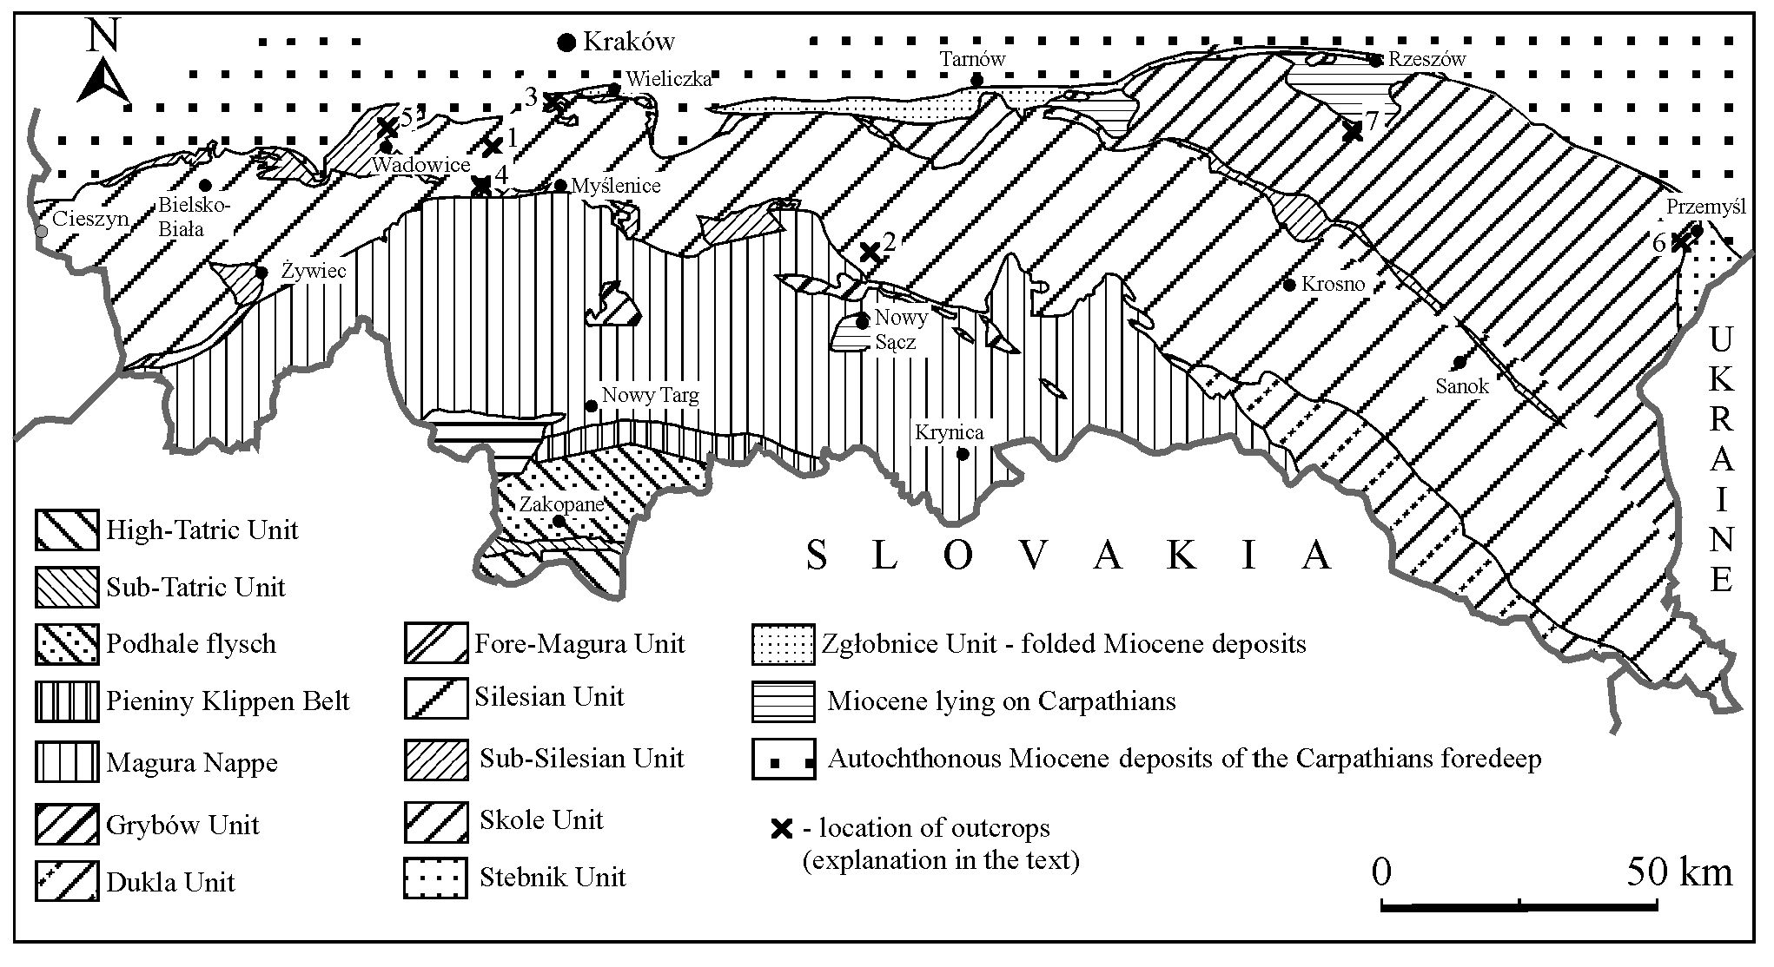
344
CIBOROWSKI and KOŁODZIEJ

Fig. 1. Geological sketch-map of the Polish Carpathians (simplified after Książkiewicz 1972; Malata et al. 1996) and the localities of the
studied outcrops.
7 — Lubeńka stream in Lubenia village, 12 km south of Rz-
eszów; Babica Clays (Late Paleocene), Skole Unit: exotic UJ
140P/1.
Exotics and thin-sections can be found in the collection of
the Institute of Geological Sciences of Jagiellonian University.

Previous study of the stratigraphie position of
Stramberk facies from Moravia and Poland
The age of Stramberk Limestone from Moravia was often
discussed mainly by Czech and Slovak geologists.
Housa (1990), on the basis of calpionellid fauna, stated that
limestones from the Kotouc quarry (Stramberk) can be divided
into two parts. The younger part contains calpionellids belong-
ing to Chitinoidella, Crassicollaria and Calpionella Zones
(without Calpionella elliptica Subzone), which indicates the
age of Late Middle Tithonian-Early Berriasian. The older part
does not contain calpionellids, however, its age has been esti-
mated as Early Tithonian on the basis of ammonite fauna
(Oloriz & Tavera 1982). According to Housa (1990) the basal
part of these limestones was formed during the Early Titho-
nian. The ammonites present in the Stramberk-type limestones
from the uppermost Jurassic-Lower Cretaceous deposits from
the Silesian Unit of Moravia also confirm that sedimentation
of the Stramberk facies continued during the Early Berriasian
(Elias & Vasmek 1995).
Recently Housa et al. (1999) have presented the correla-
tion of magnetostratigraphy and calpionellid biostratigraphy
on the Tithonian/Berriasian boundary interval in the Western
Carpathians, including also the Stramberk section (Kotouc
quarry).
Up to now age determinations show that Stramberk-type
limestone sedimentation from the Polish Carpathians is of
similar age to the Stramberk Limestone. Wójcik (1913, 1914)
on the basis of macrofauna (mainly bivalves, gastropods, am-
monites and brachiopods) determined the age of “coral klippe”
from Kruhel Wielki near Przemyśl as Tithonian and suggested
that it can also represent the Kimmeridgian and Berriasian.
Studies on calpionellid fauna (Geroch & Morycowa 1966;
Morycowa 1964, 1988) indicate the Late Tithonian age in
most of the Stramberk-type limestones from Kruhel (klippe
and pebbles). The study of these authors confirmed Wójcik’s
supposition that some of the limestones were deposited during
the Early Berriasian. According to Morycowa (1988) shallow
water carbonate sedimentation could persist locally till the
Early Valanginian. The presence of calpionellids pointing to
Berriasian age has been determined by Morycowa (1968) in
exotics from vicinity of Rożnowskie Lake. The age of the
block from Woźniki based on calpionellids and ammonites
was determined as the middle part of Late Tithonian
(Książkiewicz 1974; Morycowa 1974; Kutek 1994), and lime-
stones from Inwałd as Middle or Late Tithonian (Nowak
1976).

Discussion on studied calpionellids and
stratigraphical implications
Coral-bearing limestones containing calpionellids represent
biolithites and bioclastic limestones. Calpionellids occur with-
in sediment (biopelmicrite/biopelsparite) between the reefal
fauna or biodetritus. Apart of corals high diversity biota occur,
namely microbial structures, algae, foraminifers, molluscs,
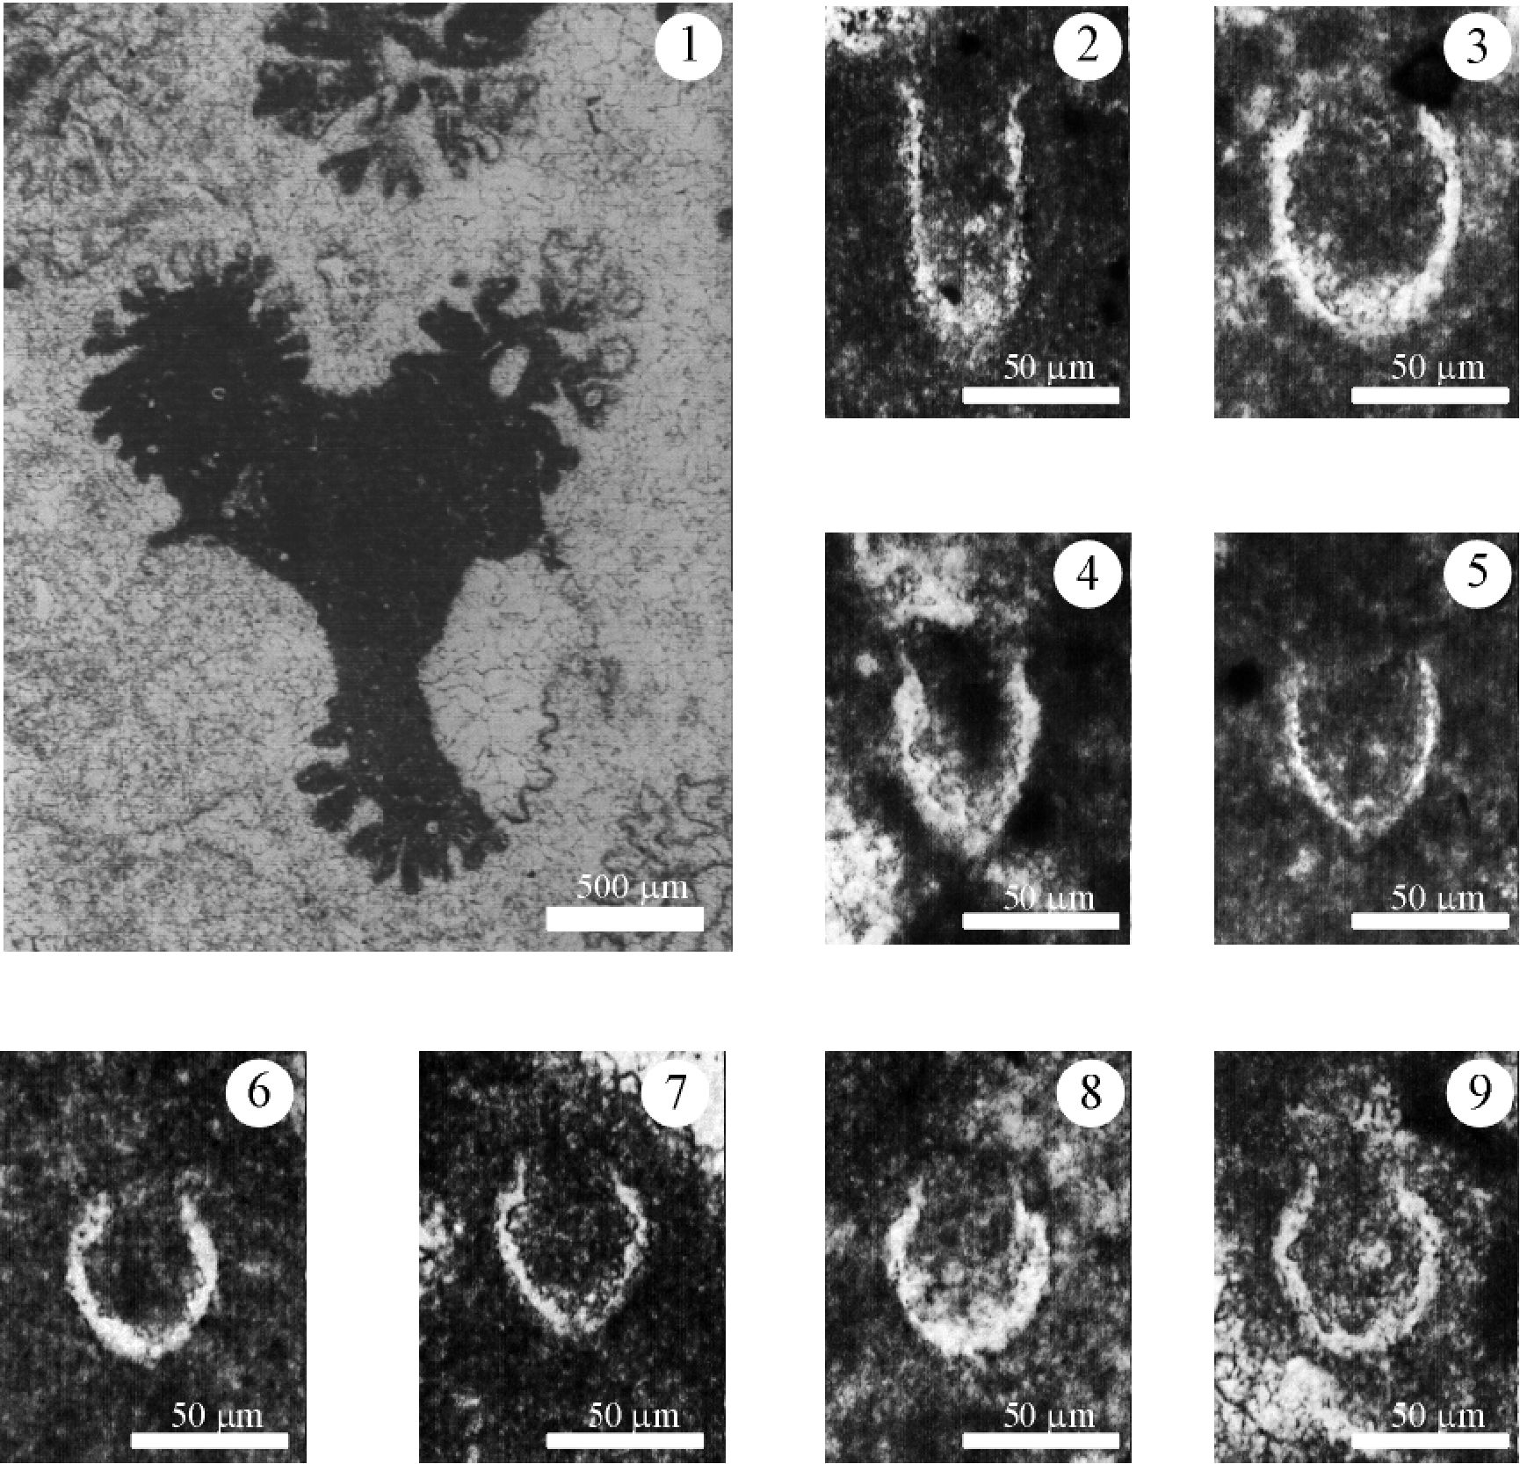
TITHONIAN-BERRIASIAN CALPIONELLIDS FROM STRAMBERK-TYPE LIMESTONES
345

Fig. 2. Representative micrographs of the studied material. 1 — general view of coral-bearing limestone with calpionellids; 2 — Crassi-
collaria intermedia, exotic UJ 140P/12; 3 — Calpionella alpina (large form), exotic UJ 140P/1; 4 — Crassicollaria brevis, exotic UJ
140P/1; 5 — Tintinopsella carpathica, exotic UJ 140P/103; 6 — Calpionella alpina (small, sphericular form), exotic UJ 140P/10; 7-9 —
Calpionella alpina (small, spherical form), exotic UJ 140P/112.
sclerosponges, brachiopods, polychaetes, echinoderms, bryo-
zoans.
Microscopic studies of coral-bearing exotics revealed the
presence of calpionellid fauna in 15 of them. Minute quantities
of calpionellids were found in 6 exotics. Moreover, the ob-
served sections of these specimens were equatorial and ob-
lique, which made their indication impossible. In the case of 9
exotics stratigraphical indication was provided.
Calpionellid fauna occurs in the material studied in a small
amount, but it was able to document the following species:
Crassicollaria intermedia (Durand-Delga 1957); Crassicollar-
ia brevis Remane 1962; Calpionella alpina Lorenz 1902; Tinti-
nopsella carpathica (Murgeanu & Filipescu 1933). As the ma-
terial does not come from the continuous sedimentary section,
the age of the exotics was determined on the calpionellid as-
semblage from the particular exotics. The Rome Standard
Zones (Allemann et al. 1971) were used with their subdivision
in standard subzone according to the Sümeg meeting (Remane
et al. 1986). The most actual biochronological calpionellid zo-
nations (Pop 1997; Rehakova & MichaHk 1997; Grün & Blau
1997; Remane 1998) were taken into consideration to deter-
mine the stratigraphical position of the particular exotics.
Moreover, the argumentation of the age determination was
based on important recent biostratigraphic publications on
calpionellids, namely Housa (1990), Rehakova (1995), Lako-
va et al. (1999).
Calpionellid fauna occurring in particular exotics is de-
scribed below along with the interpretation of the stratigraphi-
cal span of the possible stratigraphic position of the exotics
(Fig. 3).
Exotic — UJ 140P/14. The exotic contains the oldest
calpionellid assemblage. Fully hyaline calpionellids belong
to the Remanei Subzone of the Standard Crassicollaria Zone.
Moreover Crassicollaria intermedia has been found. This
form appears in the upper part of the Remanei Subzone (e.g.
Remane 1985; Grün & Blau 1997). The whole calpionellid
assemblage occurring in this exotic pointed to the upper part
of the Remanei Subzone.
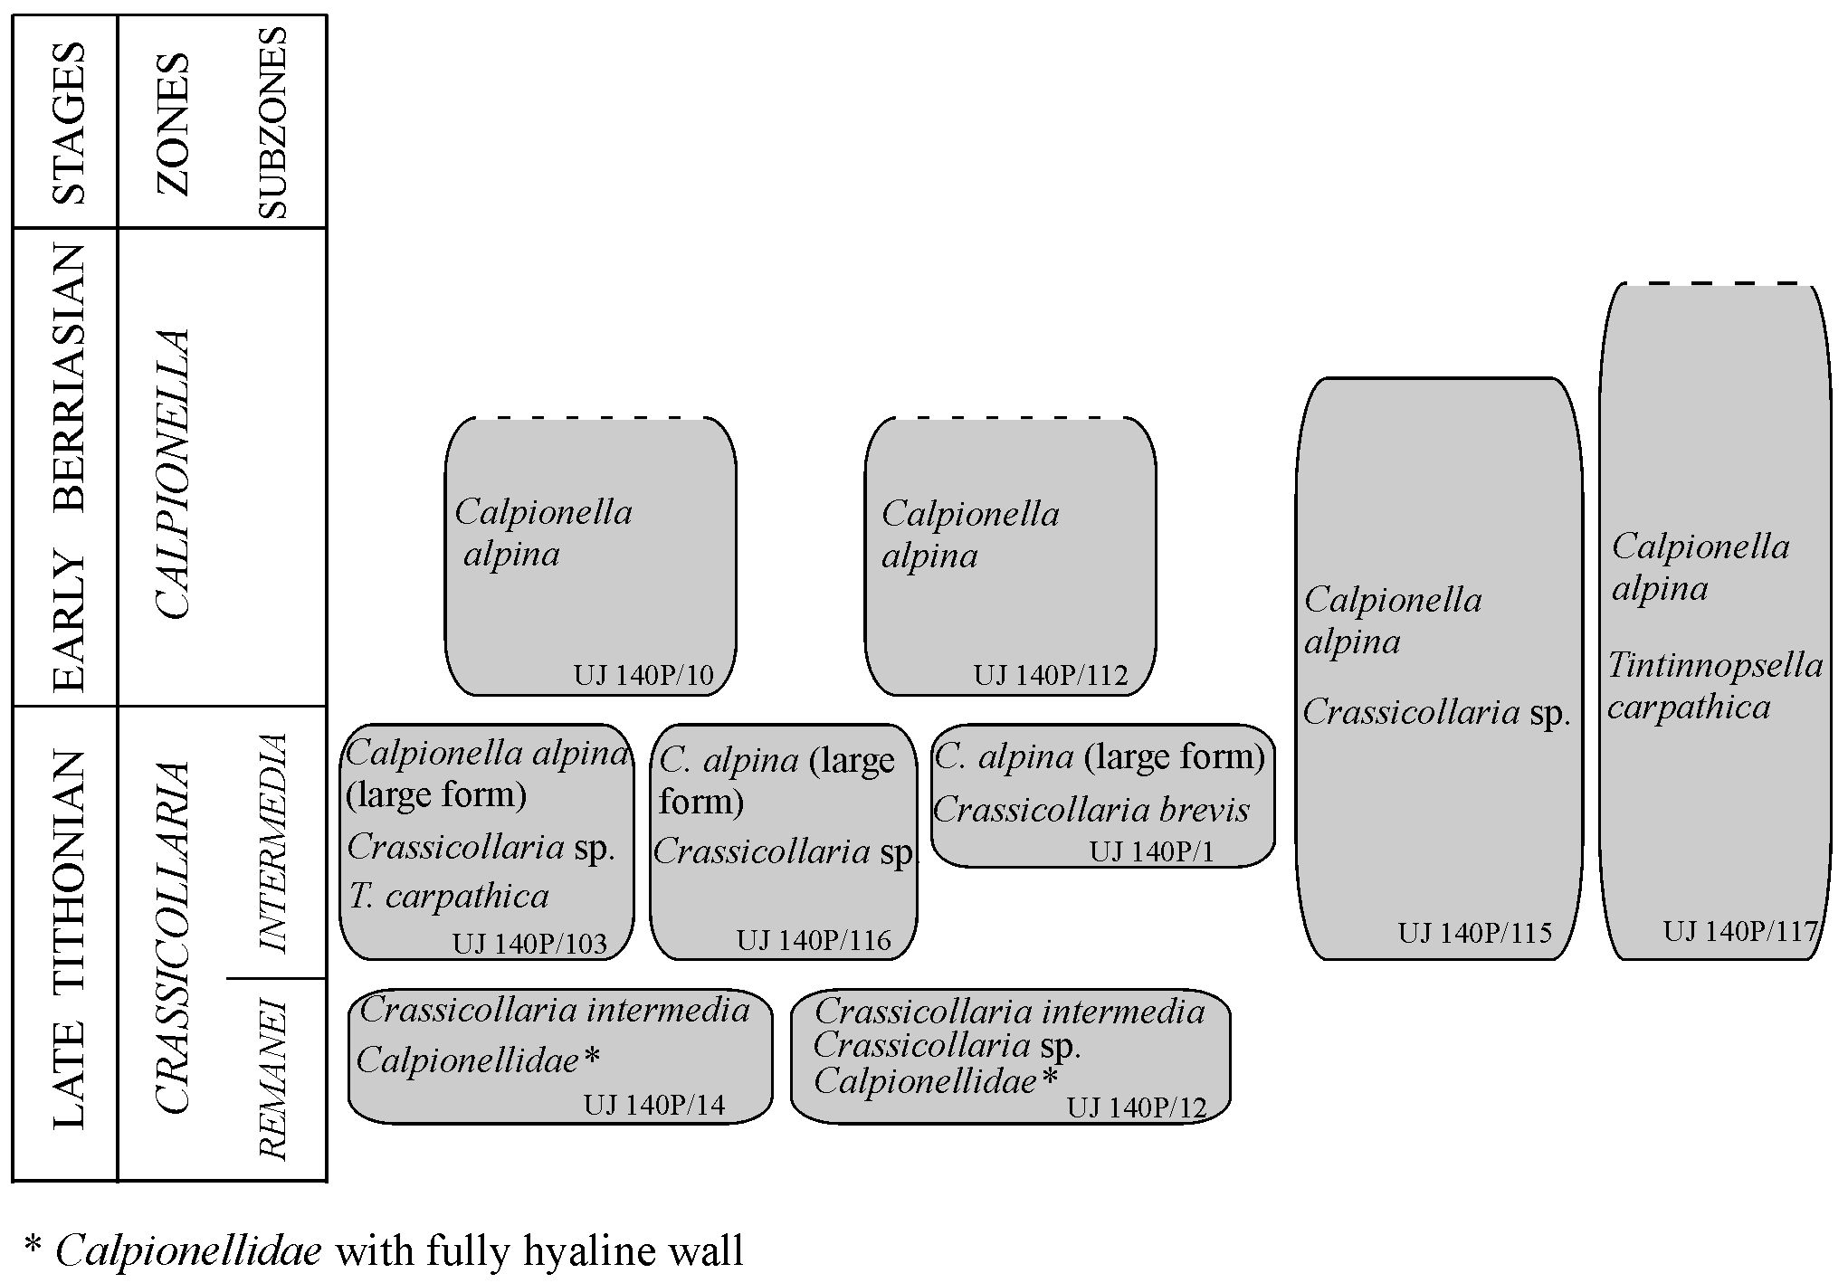
346
CIBOROWSKI and KOŁODZIEJ

Fig. 3. Calpionellid assemblages occurring in the particular exotics with stratigraphical span of possible stratigraphie position of the ex-
otics (Calpionellid zonation after Remane et al. 1986 — Rome Standard Zones and their subdivision into standard subzones according to
the Sümeg meeting).
Exotic — UJ 140P/12. A similar calpionellid assemblage,
which means specimens of Crassicollaria intermedia (Fig.
2.2) and other Calpionellidae (with fully hyaline wall) was
observed in this exotic. There are also specimens with char-
acteristic crassicollarian collar (described as Crassicollaria
sp.). This suggests the Late Tithonian age, namely the upper
part of the Remanei Subzone, for the examined exotic.
Exotics — UJ 140P/103, UJ 140P/116, UJ 140P/1. In all
these three exotics the age has been determined as Late Ti-
thonian — Intermedia Subzone. Its base is defined by the ap-
pearance of the large form of Calpionella alpina (Remane et
al. 1986). In these three exotics the large form of Calpionella
alpina has been found (Fig. 2.3). Apart from Calpionella al-
pina (large form) specimens, some Crassicollaria sp. (in UJ
140P/103, UJ 140P/116), Crassicollaria brevis (Fig. 2.4; in
UJ 140P/1), Tintinopsella carpathica (Fig. 2.5; in UJ 140P/
103) have been observed. Crassicollaria brevis is typical in
the upper part of the Intermedia Subzone which allows us to
state a more precise age for the exotic UJ 140P/1. Some au-
thors prefer to use the name Calpionella grandalpina Nagy
1986 for the large form of Calpionella alpina, but the taxon-
omy of the genus Calpionella presented by Nagy (1986) is
controversial.
Exotics — UJ 140P/112, UJ 140P/10. Only Calpionella
alpina (small, spherical form) occurs in both of these exotics
(Figs. 2.6-2.9). Their loricas are much smaller and more
globular if compared to Late Tithonian forms. Moreover
these specimens are more abundant than in Late Tithonian
exotics. The lower boundary of the Calpionella Zone is de-
termined on the basis of the event, described as an “explo-
sion” of Calpionella alpina and transition to smaller, globu-
lar forms (Allemann et al. 1971). Considering the size, shape
and abundance of the occurring specimens it is possible to
suggest that the Calpionella alpina specimens belong to the
lower part of the Calpionella Zone — Calpionella alpina
Subzone sensu Rehakova & MichaHk (1997).
Exotics — UJ 140P/115, UJ 140P/117. In the case of
these exotics a minute quantity of Calpionella alpina has
been found. The size and shape of the specimens are not con-
clusive enough to determine the precise calpionellid zone.
The age might be provisionally determined as not older than
the Intermedia Subzone. Specimens of Crassicollaria sp.
found in exotic UJ 140P/115 enable determination of the up-
per boundary for the age of the exotic. It is known that the
occurrence of Crassicollaria sp. is limited to the Crassicol-
laria and Calpionella Zones, however in the upper part of the
Calpionella Zone (Vocontian C Zone) Crassicollaria sp. is
observed sporadically (Remane 1964). In the exotic UJ
140P/117 Calpionella alpina and Tintinopsella carpathica
have been found. This makes determination of the precise
age impossible. The most approximate determination is the
Calpionella Zone.
In the examined material the calpionellid fauna represent the
Crassicollaria Zone in five cases. In two cases the Remanei
TITHONIAN-BERRIASIAN CALPIONELLIDS FROM STRAMBERK-TYPE LIMESTONES
347
Subzone was identified, and in three others the Intermedia
Subzone. In the case of two exotics, calpionellid fauna charac-
teristic for the Calpionella Zone has been observed, suggesting
Early Berriasian age. The age of two other exotics can be esti-
mated as either Late Tithonian (Intermedia Subzone) or Early
Berriasian (Calpionella Zone). In the case of the 6 undescribed
exotics more precise estimation of their stratigraphical posi-
tion was impossible.
According to the literature dealing with the exotics of
Stramberk-type specimens of Crassicollaria parvula and
Calpionella cf. elliptica have been illustrated (Morycowa
1968) as well as Calpionella elliptica has been described (e.g.
Morycowa 1964). Both species are characteristic for the upper
part of the Calpionella Zone, which confirms the Middle Ber-
riasian age of some exotics. Some specimens presented by
Morycowa (1968, Table IX, Figs. 7, 8, 9, 10, 12) determined
as Calpionellites darderi do not seem to represent this species.
The specimen on the Table IX, Fig. 12 (Morycowa 1968) is al-
most certain to be a specimen from the genus Remaniella. The
present study has not observed Crassicollaria parvula, Calpi-
onella elliptica or Remaniella in the investigated material,
however, the appearance of such calpionellids has been de-
scribed by Morycowa (1964, 1968, 1974).
Generally, the studies on the calpionellid fauna of the exot-
ics of Stramberk-type have shown some similarities to the
calpionellid fauna occurring in allodapic limestones of the
Lower Cieszyn Limestones (basinal equivalent of the Stram-
berk facies) from the western part of the Polish Flysch Car-
pathians, where Crassicollaria and Calpionella Zones have
been determined (Ciborowski 2000).

Conclusions
Generally, the whole calpionellid fauna occurring in the ma-
terial studied suggests a Late Tithonian-Early Berriasian age
for the Stramberk-type limestones. On the basis of the detailed
studies of exotics, Crassicollaria and Calpionella Zones have
been recognized. Within the Crassicollaria Zone, known from
the Stramberk Limestone (Housa 1990), Remanei and Inter-
media Subzones have been determined by the present authors.
Compared to the calpionellid zonation of Stramberk Lime-
stone from Moravia (Housa 1990) the present authors have not
observed the Chitinoidella Zone. The youngest examined ex-
otics show a similar age to the youngest part of Stramberk
Limestone according to the Housa (1990) scheme. However, it
must be admitted that Calpionella elliptica occurring in the
Stramberk-type limestones (Morycowa 1964, 1968) suggests
the possibility of extension of the Stramberk facies to the
Calpionella elliptica Subzone.
According to Housa (1990) the thickness of the Stramberk
Limestone in Kotouc quarry close to Stramberk attains 140 m
in the case of the Crassicollaria Zone and 200 m in the case of
the Calpionella Zone. However, there is a dispute whether
Stramberk Limestone from the Kotouc quarry exist as
olistholiths containing boulders and blocks belonging to dif-
ferent zones of reef and different ages (Elias 1983; Elias &
Eliasova 1984) or, as presumed by Housa (1983), huge tecton-
ic blocks show internal unity showing the standard succession
of calpionellids.
Both previous works and the study of Stramberk-type lime-
stones stratigraphy from the Polish Carpathians presented here
show mainly Late Tithonian (Crassicollaria Zone) calpionellid
assemblage.
It cannot be excluded that some of exotics called Stramberk-
type limestones from the Polish Flysh Carpathians are older
than Tithonian. According to Malik (1979), analysis of exotics
from the Grodziszcze Beds shows that some exotics contain-
ing corals represent Oxfordian-?Early Tithonian and can be
correlated to the Oxfordian and Kimmeridgian of the Foreland
of the Polish Carpathians, where corals are known (Morycowa
& Moryc 1976).

References
Allemann F., Catalano R., Farès F. & Remane J. 1971: Standard
calpionellid zonation (Upper Tithonian-Valanginian) of the
western Mediterranean Province. Proc. II Plankt. Conf., Roma
1970, 2, 1337-1340.
Ciborowski T. 2000: Microfacies and sedimentary environment of
Lower Cieszyn Limestones in Polish West Carpathians. PhD
Thesis, Inst. of Geol. Sci., Pol. Acad. Sci., Warszawa, 1-103 (in
Polish).
Elias M. 1983: Remarks on the origin of accumulations of the
Stramberk Limestone. Vést. Üstr. Üst. Geol. 58, 235-239 (in
Czech).
Elias M. & Eliasova H. 1984: Facies and palaeogeography of the Ju-
rassic in the western part of the Outer Flysch Carpathians in
Czechoslovakia. Sbor. Geol. Ved 39, 105-170.
Elias M. & Eliâsovâ H. 1986: Elevation facies of the Malm in Mora-
via. Geol. Zbor. Geol. Carpath. 37, 4, 533-550.
Elias M. & Vasicek Z. 1995: Early Berriasian ammonites from the
Stramberk Limestone of Kotouc quarry (Outer Carpathians,
Silesian Unit, Stramberk, Czech Republic). Vest. Ces. Geol.
Üst. 70, 1, 27-32.
Geroch S. & Morycowa E. 1966: Contribution to knowledge on fa-
cies and fossils of Tithonian limestone from Kruhel Wielki
near Przemyśl. Rocz. Pol. Tow. Geol. 36, 295-301 (in Polish
with French summary).
Grün B. & Blau J. 1997: New aspects of calpionellid biochronology:
proposal for a revised calpionellid zonal and subzonal division.
Rev. Paléobiol. 16, 1, 197-214.
Hoffmann M. 1992: Deep and shallow water reef-facies pattern of
the Late Jurassic from Polish Outer Carpathians. Platform
Margins. Internat. Symp. Chichiliane, 1992, Abstracts, 54.
Hoffmann M. & Kołodziej B. 1997: Microbial contribution to reef
formation — Stramberk-type limestone, Upper Jurassic, Outer
Carpathians. 3rd IFAA Regional Symposium & IGCP 380 Inter-
national Meeting, Kraków, 1997, Guidebook & Abstracts, 72.
Housa V. 1983: The origin of the bodies of the Stramberk Limestone
near Stramberk. Vest. Üstr. Üst. Geol. 58, 193-203 (in Czech).
Housa V. 1990: Stratigraphy and calpionellid zonation of the Stram-
berk Limestone and associated Lower Cretaceous beds. Atti II
Conv. Int. F. E. A. Pergola, 1987, 365-370.
Housa V., Krs M., Man O., Pruner P. & Venhodova D. 1999: Corre-
lation of magnetostratigraphy and calpionellid biostratigraphy
of the Jurassic/Cretaceous boundary strata in the Western Car-
pathians. Geol. Carpathica 50, 125-144.
Kołodziej B. 1997: Scleractinia from the Stramberk-type exotic
limestones from the Polish Flysch Carpathians. PhD Thesis,
Jagiellonian Library, Kraków, 1-103 (in Polish).
Książkiewicz M. 1965: The coldilleras in the Cretaceous and Paleo-
gene seas of the Northern Carpathians. Bull. Soc. Geol. Franc.,
Ser. 7 7, 443-445 (in French).
348
CIBOROWSKI and KOŁODZIEJ
Książkiewicz M. 1972: Carpathians. In: Geology of Poland. V. 4,
Part 3. Tectonic. Wydawnictwa Geologiczne, Warszawa, 1-228
(in Polish).
Książkiewicz M. 1974: Contribution to knowledge of Tithonian fau-
na from Woźniki (Polish Western Carpathians). Acta Geol. Pol.
24, 437-456 (in French).
Kutek J. 1994: The Scythicus Zone (Middle Volgian) in Poland: its
ammonites and biostratigraphic subdivision. Acta Geol. Pol.
44, 1-34.
Lakova I., Stoykova K. & Ivanova D. 1999: Calpionellid, nannofos-
sils and calcareous dinocyst bioevents and integrated biochro-
nology of the Tithonian to Valanginian in the West Balkan
Mountains, Bulgaria. Geol. Carpathica 50, 2, 151-168.
Malata E., Malata T. & Oszczypko N. 1996: Litho- and biostratigra-
phy of the Magura Nappe in the eastern part of the Beskid
Wyspowy Range (Polisch Western Carpathians). Ann. Soc.
Geol. Pol. 66, 269-284.
Malik K. 1979: Sedimentation of conglomerates of Grodziszcze
Beds and microfacies of their carbonate exotics. PhD Thesis,
Inst. of Geol. Sci., Jagiellonian University, Kraków, 1-218 (in
Polish).
Morycowa E. 1964: Corals from klippe of Kruhel Wielki near Prze-
myśl (upper Tithonian, Polish Carpathians). Rocz. Pol. Tow.
Geol. 34, 489-508 (in French).
Morycowa E. 1968: Exotics of Stramberk-type limestones bearing
corals from Rożnów Lake. Rocz. Pol. Tow. Geol. 38, 19-32 (in
Polish with French summary).
Morycowa E. 1974: Hexacorallia from exotic carbonate block from
Woźniki near Wadowice (Polish Western Carpathians). Acta
Geol. Pol. 24, 457-484 (in French).
Morycowa E. 1988: Klippes of Kruhel Wielki. In: Kotlarczyk J.
(Ed.): Przewodnik LIX Zjazdu Pol. Tow. Geol., Przemyśl 16-
18.09.1988. Wydawnictwo AGH, Kraków, 259-266 (in Polish).
Morycowa E. & Moryc W. 1976: The Upper Jurassic sediments in
the Foreland of the Polish Carpathians (Sandomierz Basin).
Rocz. Pol. Tow. Geol. 46, 231-288 (in Polish with English
summary).
Nagy I. 1986: Investigation of Calpionellides from the Mecsek
Mountain (S. Hungary). Acta Geol. Hung. 29, 1-2, 45-64.
Nowak W. 1976: The Outer (Flysch) Carpathians. In: Sokołowski S.
(Ed.): Geology of Poland. V. 1, Part 2. Stratigraphy. Mesozoic.
Wydawnictwa Geologiczne, Warszawa, 401-421 (in Polish).
Patrulius D., Neagu T., Avram E. & Pop G. 1976: The Jurassic-Cre-
taceous boundary beds in Romania. An. Inst. Geol. Geof. 1, 71-
125.
Oloriz F. & Tavera J. M. 1982: Stratigraphic position of the Stram-
berk Limestones (CSSR). Studies on preliminary hypothesis.
Neu. Jb. Geol. Palaont., Abh., Mh. 1, 41-49 (in German).
Pop G. 1997: Tithonian to Hauterivian praecalpionellids and calpi-
onellids bioevents and biozones. Miner. Slovaca 29, 304-305.
Rehakova D. 1995: Calpionellid distribution in Upper Jurassic and
Lower Cretaceous sequences of the Western Carpathians. Min-
er. Slovaca 27, 308-318.
Rehakova D. & Michalik J. 1997: Evolution and distribution of
calpionellids — the most characteristic constituents of Lower
Cretaceous Tethyan microplankton. Cretaceous Research 18,
493-504.
Remane J. 1964: Investigation on systematic and stratigraphy of
Calpionellids at the Jurassic-Crataceous transitional beds from
Vocontian Through. Palaeontographica, Abt. A 123, 1-57 (in
German).
Remane J. 1985: Calpionellids. In: Bolli H.M., Saunders J.B. &
Perch-Nielsen K. (Eds.): Plankton stratigraphy. Cambridge
Univ. Press, 555-572.
Remane J. 1998: Calpionellids: possibilities of biostratigraphic cor-
relations versus palaeobiogeographic limitations. Bull. Soc.
Géol. France 168, 6, 829-839 (in French with abridged En-
glish version).
Remane J., Bakalova-Ivanova D., Borza K., Knauer J., Nagy I., Pop
G. & Tardi-Filacz E. 1986: Agreement on the subdivision of
the standard calpionellid zones defined at the IInd Planktonic
Conference, Roma 1970. Acta Geol. Hung. 29, 1-2, 5-14.
Sasaran E., Hosu A., Spalnacan R. & Bucur I.I. 1999: Microfacies,
microfossils and sedimentary evolution of the Sandulesti Lime-
stone Formation in Cheile Turzii (Apuseni Mountains, Roma-
nia). Acta Palaeontol. Rom. 2, 453-462.
Wójcik K. 1913: Jurassic of Kruhel Wielki near Przemyśl. Part I, II.
Spraw. Kom. Fizjogr. Pol. Akad. Umiejęt., Ser. B 53, 409-490,
543-619 (in Polish).
Wójcik K. 1914: Jurassic of Kruhel Wielki near Przemyśl. Part III,
IV, Spraw. Kom. Fizjogr. Pol. Akad. Umiejęt., Ser. B 54, 13-69,
141-182 (in Polish).

