



PlantSoil(2018)428:195–211
https://doi.org/10.1007/s11104-018-3660-3

REGULARARTICLE

Therelationshipsbetweensoilchemicalproperties
andvegetationsuccessionintheaspectofchangesofdistance
fromtheglacierforeheadandtimeelapsedafterglacierretreat
intheIrenebreenforeland(NWSvalbard)

PaulinaWietrzyk &KajaRola&PiotrOsyczka&
PawełNicia&WojciechSzymański&MichałWęgrzyn

Received:15January2018/Accepted:18April2018/Publishedonline:7May2018
#TheAuthor(s)2018

Abstract
AimsTheaimofthisstudywastodeterminerelation-shipsbetweensoilchemicalparameters(i.e.contentoftotalorganiccarbon,totalnitrogen,totalsulphur,soil

ResponsibleEditor:ZucongCai.

ElectronicsupplementarymaterialTheonlineversionofthisarticle(https://doi.org/10.1007/s11104-018-3660-3)containssupplementarymaterial,whichisavailabletoauthorizedusers.

P.Wietrzyk(*):P.Osyczka:M.Węgrzyn
ProfessorZ.CzeppeDepartmentofPolarResearchandDocumentation,InstituteofBotany,JagiellonianUniversity,
Gronostajowa3,30-387Cracow,Poland
e-mail:paulina.wietrzyk@doctoral.uj.edu.pl

P.Osyczka
e-mail:piotr.osyczka@uj.edu.pl

M.Węgrzyn
e-mail:michal.wegrzyn@uj.edu.pl

K.Rola
DepartmentofPlantEcology,InstituteofBotany,JagiellonianUniversity,Gronostajowa3,30-387Cracow,Poland
e-mail:kaja.skubala@uj.edu.pl

P.Nicia
DepartmentofSoilScienceandSoilProtection,UniversityofAgricultureinKrakow,Mickiewicza21,31-120Cracow,Polande-mail:rrnicia@cyf-kr.edu.pl

W.Szymański
DepartmentofPedologyandSoilGeography,InstituteofGeographyandSpatialManagement,JagiellonianUniversity,
Gronostajowa7,30-387Cracow,Polande-mail:w.szymanski@uj.edu.pl
pH)andvegetationdevelopmentinrelationtodistancefromthecurrentglacierforeheadandtimeelapsedafterglacierretreatintheIrenebreenforeland.
MethodsThreetransectsweredesignatedalongthe
foreland.Speciesandvegetationcoverwereinvestigat-edin1m2plots,placedevery50malongeachtransect;correspondingsoilsampleswerecollectedandchemi-callyanalysed.
ResultsThetotalorganiccarbonandtotalnitrogencon-
tentsinsoilchangeaccordingtopowerandexponentialfunctions,respectively,whereassoilpHdecreasesline-arlywithincreasedtimeelapsedafterglacierretreat.Thewidevariationintotalsulphurcontentspreventthedeterminationofclearrelationships.Bryophytesandvas-cularplantsdominateintheyoungerpartoftheforeland,whereasepigeiclichensprevailintheolderpart.ConclusionsVegetationcoverseemstobethemainfactoreffectsonsoilproperties;however,chemicalsoilpropertiesanddistancefromtheglacierforeheadaffectspeciesdistributionandvegetationcover.Consideredsofarasthefirstpioneers,theepigeiclichensneedmoretimethanbryophytesandvascularplantstocolonisetheforeland.

KeywordsArctic.Carbon.Cryptogamicspecies.Nitrogen.Sulphur.Tundrasoils

Introduction

TheArcticisoneoftheregionsmostthreatenedbyclimatechange(Arndtetal.2010;Hansenetal.2012;

IPCC2007,2014).ManystudiessuggestthatclimatechangesmayhaveanimportantimpactonelementcyclesintheforelandsofArcticglaciers,andthusonthedevelopmentofvegetationcoverduringtheprimarysuccession(e.g.OechelandVourlitis1994;Wietrzyketal.2016;Yoshitakeetal.2011).Documentationofglacierrangechangesisverybroadandincludesbothpolarandmountainregions(Burgaetal.2010;Daietal.2002;Dümigetal.2011;Elberlingetal.2004;Grieve2000;KabalaandZapart2012;Nakatsuboetal.2005).Studiesclearlyshowalossofglaciersonallcontinents,progressingespeciallyinthesecondhalfofthetwentiethcentury(Nuthetal.2013;Zempetal.2008).InSval-bard,theprogressiverecessionofglaciershasbeenobservedsincetheendoftheLittleIceAge(Błaszczyketal.2009).Glaciershavebeenreducedintermsofboththicknessandarea(e.g.Jamesetal.2012;Kohleretal.2007;Nuthetal.2013).Retreatingglaciersuncovernewlandsurfaceswithinpostglacialvalleysandthesefreshlydeglaciatedsurfacesarecharacterisedbyalackofbio-logicallife,includingvegetationcover,whosedevelop-mentisconnectedwiththeavailabilityofnutrientsandwaterinsoil(Burgaetal.2010).Ontheotherhand,thesupplyofdeadorganicmatterincreasesalongwithvegetationdevelopment,whichresultsinincreasingcarbonaccumulationinthesoil.Nowadays,thephe-nomenonofglacierrecessionaffordsanopportunitytoinvestigatechangesincarbonandnitrogenaccumula-tioninsoilsdevelopedinforelandsfromthebarrengroundintheimmediatevicinityoftheactualglacierfronttotheoldestpartoftheforeland,aswellastheinterrelatednatureofvegetationsuccessionandchemi-calpropertiesofsoils.
InpreviousstudiesintheglacierforelandsoftheHighArctic(Elberlingetal.2004;KabalaandZapart2012;Nakatsuboetal.2005)andinalpineregions(Burgaetal.2010;Daietal.2002;Dümigetal.2011;Grieve2000),greatattentionwaspaidtocarbonaccu-mulationanditscycle.Veryfewstudiesrefertotherelationshipbetweencarbonstorageandvegetation
(e.g.Nakatsuboetal.2005;Vilmundardóttiretal.2015;Yoshitakeetal.2011).Apartfromcarbon,severalstudiesconsidernitrogenaccumulationinthesoilofArcticglacierforelands(CrockerandDickson1957;Hodkinsonetal.2003;JacobsonandBirks1980;KabalaandZapart2012;Yoshitakeetal.2007)andalpineglaciers(NollandWellinger2008).Uptonow,totalsulphurcontenthasnotbeenstudiedinthesoilsofArcticglacierforelands,despitethefactthatsulphuris
oneofthemostimportantelementstakingpartinthemetabolicprocessesofplantssuchasphotosynthesisandfixationofnitrogen(BradyandWeil2004).More-over,itscontentinthesoilmayberesponsibleforprimaryvegetationsuccessionintheglacierforeland.SulphateandsulphurcontentshavebeenexaminedonlyintheforelandoftheDammaGlacierinSwitzerlandandwerepositivelycorrelatedwiththeorganiccarbondis-tribution(NollandWellinger2008;Prietzeletal.2013).
Intermsofvegetationsuccession,themostdetailedanalysesinSvalbard’sglacierforelandswereassociatedwithstudiesofvascularplants(e.g.PirożnikowandGórniak1992;PrachandRachlewicz2012;Yoshitakeetal.2011).Othercomponentsofglacierforelandveg-etation,inparticularcryptogams,haveusuallybeenoverlookedandhavenotbeenidentifiedatthespecieslevel.Thehighnumberofcryptogamicspeciescolonisingfreshlydeglaciatedforelands,considerablyexceedsthenumberofvascularplantsspecies(Wietrzyketal.2016,2017).Thisindicatestheneedforcomprehensiveresearchincludingbothvascularplantsandcryptogamicspeciesinanalysesofvegetationdevelopmentanditsrelationshipswithsoilproperties.Intheearlytwentiethcentury,thetheoryofalinearanddirectionalcharacterofprimarysuccessionofvegeta-tionhadbeguntobequestionedbecausebesidesthetimeafterglacierretreat,localenvironmentalvariableshadstartedtobeconsideredasfactorsaffectingvegeta-tiondevelopmentaswell(WalkerandDelMoral2003).PreviousresearchconductedinSvalbardshowsthatinadditiontotheactivityofglacierrivers(Moreauetal.2008),distancefromtheglacierforehead(Wietrzyketal.2016)isalsoanimportantfactorinfluencingtheprocessofvegetationsuccession.
Themainaimofthepresentstudywastodeterminehowselectedchemicalpropertiesofthesoil,i.e.contentoftotalorganiccarbon(TOC),totalnitrogen(TN),totalsulphur(TS),andsoilpH,changewith(1)distancefromthecurrentglacierforehead;(2)timeelapsedaftergla-cierretreat;(3)vegetationcoverdevelopmentintheforelandofIrenebreen.Thesecondaim,consideringthesameproblemfromanotherside,wastoestimatewhichfactor,i.e.distancefromthecurrentglacierfore-head,timeelapsedafterglacierretreatorsoilproperties,isofstrongerimpactforsuccessionofvegetation.Inaddition,relationshipsbetweenparticularspeciesoccur-rence,distancefromtheglacierforehead,timeelapsedafterglacierretreatandsoilchemicalpropertieswereanalysed.Wesetthefollowinghypotheses:(1)both

increaseddistancefromthecurrentglacierforeheadandtimeelapsedafterdeglaciationpositivelyinfluenceTOC,TN,andTScontentsinsoilandnegativelyinflu-encesoilpH;(2)withregardtothevaryingrateoftheglacier’sretreatovertime,therelationshipbetweentimeelapsedafterglacierretreatandsoilpropertiesisclosetobeinglinear;incontrast,therelationshipofdistancetosoilpropertiesisnon-linearincharacter;(3)spontane-ousdevelopmentofvegetationcontributestoincreasedcontentsofTOC,TNandTSandreducedpHinthesoildevelopedintheforeland;(4)developmentofvegeta-tioncoverisdependentmainlyonthedistancefromtheglacierforehead.

Materialsandmethods

Studyarea

ThefieldworkwasconductedintheIrenebreenforeland(Fig.1).TheIrenebreen,oneoftheforelandsborderingtheKaffiøyraPlain(OscarIILand,NWSpitsbergen),isapolythermalvalleyglacierwithanareaof4.1km2,approximately4kminlengthandbetween1km(initsfrontalzone)and1.5km(intheeasternsection)inwidth(Sobota2011,2014;SobotaandLankauf2010;Sobotaetal.2016).Theglacier’saverageretreatrateis13mperyear(SobotaandLankauf2010).However,therateofglacierrecessionis,apparently,notconstant,andthisprocesshasclearlyacceleratedsincethebeginningof
thetwenty-firstcentury(IPCC2007,2014;Sobotaetal.2016).TheIrenebreenforelandisapproximately1700mwideand1200mlong(Fig.2).Thesouthernpartoftheforelandisrelativelyflatandcoveredbyproglacialriversediments.Incontrast,thenorthernpartischaracterisedbyhillyrelief.TheIrenebreenforelandconsistsofaseriesofVendianrocksknownastheHeclaHoekformation,whichalsocomprisesthepeakpartsofthemountainssurroundingtheKaffiøyraglaciers.TheHeclaHoekformationconsistsmainlyofquartzite,phyllite,diamictite,marble,andgreenslate.Further-more,themountainseastoftheKaffiøyraPlainconsistofthicktilloids,phylliteswithfrequentintercalationsofmarble,greenphyllites,andoccasionalmetabasicrocks(metadiabaseandmetagabbro)(SobotaandLankauf2010).TheimmediatevicinityoftheIrenebreeniscom-posedoftheComfortlessbreendiamictiteformationofCryogenianand/orEdiacaranage.
TheclimateoftheKaffiøyraPlainisaffectedbytheWestSpitsbergenCurrent.Summermeanairtempera-turereaches4.6°C;themeanannualairtemperatureis
−5.8°C.Januaryisthecoldestmonth,whileJulyisthe
warmest(meanmonthlyairtemperature:−14.2°Cand
4.9°C,respectively).Cloudcover,whichaveragesmorethan70%insummerandautumn,islowerinwinterandspring,affectingthenumberofhoursofsunshine,whichinAprilandMayreaches250h.IntheKaffiøyraregionduringthesummermonths,meanairhumidityis89%andmeanprecipitationamountsto51mm(PrzybylakandAraźny2006).ThevegetationwhichsurroundstheIrenebreenanditsforelandbelongstotheallianceLuzulionarcticaeGjærev.1950andiscomposedmainlyofthefollowingspecies:Cerastiumarcticum,Salixpolaris,Saxifragacernua,S.cespitosa,S.oppositifolia,Brachytheciumglaciale,Polytrichastrumalpinum,Cetrarielladelisei,Ochrolechiafrigida,Cetrariaislandica(WęgrzynandWietrzyk2015).IntheIrenebreenforeland,vegetationismainlyrepresentedbyinitialstagesofplantcommunitiesinwhichlichensandbryophytesarethedominantorganisms.

Datasampling

Fieldworkwascarriedoutinsummer2012.Thestudydesignincludedinvestigationalongtransectsfromthecurrentglacierforeheadtotheterminalmoraine.Prelim-inaryfieldworkwascarriedoutacrosstheentireglacierforelandinordertodeterminethepartwiththemosthomogeneoussiteconditions.Threelineartransects,each1150mlong,weredesignatedalongtheforeland.Sam-plingsitesweredesignatedroughlyevery50malongthetransectsandincludedvarioussitesintermsofparentmaterial,geomorphology,andwetness.Ateachsamplingsite,overallvegetationcover,includinglichen,bryo-phytes,andvascularplants,wascollectivelyestimatedonapercentagescalewithina1m2plot,andthepercent-agecoverforeachspecieswasdeterminedaswell.Inthecaseoftaxonomicallyproblematicspecimens,sampleswerecollectedforpreciseidentificationinthelaboratory.Simultaneously,soilsamplesfromthesurfacetoadepthof5cmwerecollectedfromeachsamplingsite.Conse-quently,72samplingsitesintotalweretakenintoac-count,i.e.24pertransect(Fig.1).Moreover,threerep-resentativesoilprofileswereexcavatedatthreedifferentdistances(i.e.0m,550m,and1150m)fromthecurrentglacierforeheadinordertoidentifygeneralchangesinsoilparameterswithdepthandsoilsamplesfromeach

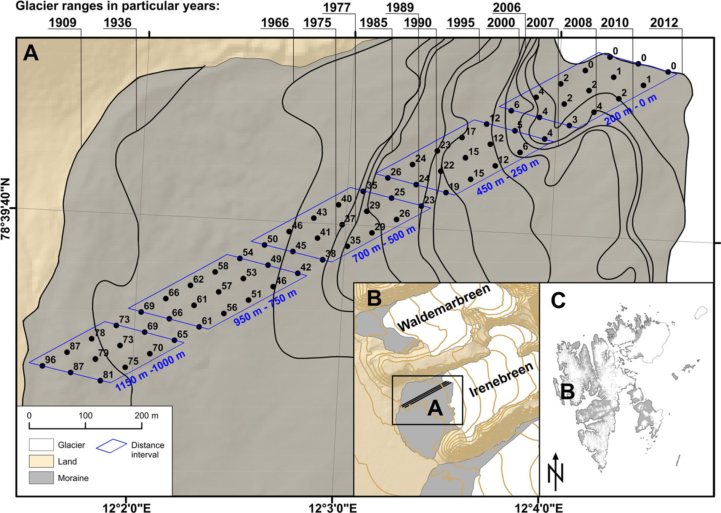
Fig.1Locationofstudyarea:A–threeparalleltransectsdesig-natedalongIrenebreenforeland.Thepointsalongthethreetran-sectsmarkthesamplingsites,thenumbersindicatetheyearsafterglacierretreatforeachofsamplingsitesandtheblueframes
indicatethedistanceintervalsdesignatedalongIrenebreenfore-land;B–Irenebreenanditsforeland;C–SvalbardArchipelago.©NorwegianPolarInstitute,npolar.no

horizon(AC,Cg1,Cg2)beingtaken.Inaddition,thedepthofdead-iceoccurrencewasdeterminedforeachprofile.Thesamplingdepthdifferedfromprofiletoprofile,dependingonthenatureofthesoilprofile.
GlacierrangesinthepastandestimatedagesofforelandmaterialsintheproglacialzonewereassessedbasedonSobotaandLankauf(2010).Thetimeperiodbetweentwodifferentglacierranges(isochrones)wasdividedinto

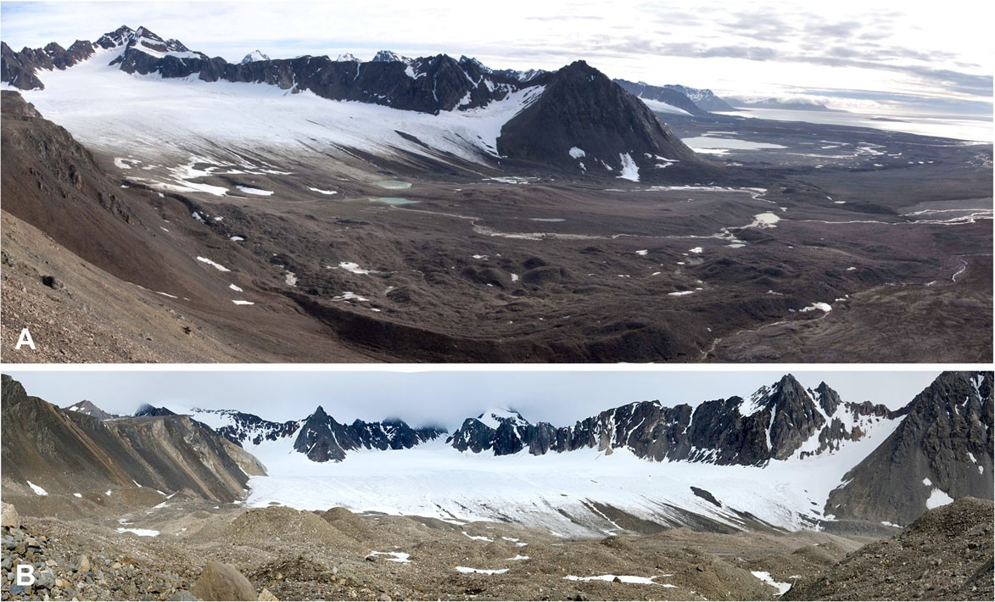
Fig.2ViewonIrenebreenforelandfromtheGråfjelletMt
(a)andviewonIrenebreenforeheadfromitsmoraine(b)(Phot.M.Węgrzyn)

equalpartsappropriateforthenumberofyearsineachparticulartimeperiod.Then,aspecificagewasassignedtogivensamplingsite.Thisinterpolationenabledesti-mationofthetimeelapsedsincedeglaciationforeachsamplingsite.

Soilanalyses

Soilsampleswerecarefullycleanedofplantdebristoavoidcontaminationbyorganicmatterduringanalysis.Thesampleswereair-dried,gentlycrushed,andsievedthrougha2-mmsieve.Alllaboratoryanalysesweredoneonfine-earthmaterial(fraction<2mm).ConcentrationsofTOC,TN,andTSweredeterminedforeachsoilsample.Previously,allcalcareoussoilsampleshadbeentreatedwith10%HCltoremovecarbonates.Three1-greplicateswereanalysedbymeansofdrycombustiontechniqueusingaLECOCNS2000automatedanalyser(LECO1996),andthemeanvaluewastreatedasoneobservationinfurtheranalysis.SoilpHwasmeasuredindistilledwaterina1:2.5(w/v)ratioaccordingtothepotentiometricmethod(Tan1995)usingapHmeter(ElmetronCPI-505)withaglasselectrode(ElmetronERH-11).

Speciesidentification

Standardlightmicroscopywereusedfortaxonomicde-terminationofspecimens;thefollowingpublicationswereused:Athertonetal.(2010);Brodoetal.(2001);OsyczkaandWęgrzyn(2008);Rønning(1996);Smithetal.(2009);andThomson(1984;1997).Additionally,chem-icalanalysesoflichensubstanceswereconductedaccord-ingtothetechniqueofOrangeetal.(2001).HerbalmaterialsweredepositedintheHerbariumoftheInstituteofBotanyatJagiellonianUniversityinKraków(KRA).

Statisticalanalyses

Twodatamatriceswerecreatedforstatisticalanalyses.Thefirst,whichincludeddataonsoilchemicalproper-tiesandvegetationcoverineachanalysedplotatacertaindistancefromtheglacierforehead,willbere-ferredtohereafterasthedistancedatamatrix;thesec-ond,whichincludeddataonsoilchemicalpropertiesandvegetationcoveraveragedforparticularnumbersofyearselapsedafterglacierretreat,willbereferredtohereafterasthetimedatamatrix.First,eachsamplingsitewasassignedtooneoffivedistanceintervalswithineachtransectbasedonthegeomorphologicaldiversity
ofthestudiedmoraine(Fig.1andS1).ThenormalityofthedistributionofthevariablesTOC,TN,andTScon-tentsandpHinthedistinguishedintervalswasverifiedusingtheKolmogorov-Smirnovtest.DatawhichdidnotmeettheassumptionsofnormalitywereBox-Coxtrans-formedinordertofindanoptimalnormalisingtransfor-mation.Then,one-wayanalysisofvariance(ANOVA)wasperformed,followedbyTukey’s(HSD)test,totestdifferencesinparticularelementcontentsandpHacrossthestudiedintervals.Priortotheanalysis,Levene’stestwasperformedtoassesstheequalityofvariances.
Therelationshipsbetweenelementcontents,soilpH,distancefromtheglacierforehead,timeelapsedafterglacierretreat,andvegetationcoverwerecalculatedseparately,usingPearsoncorrelationcoefficientsfordistancematrixandtimematrixseparately.Next,scatterplotswerecreatedforaninitialevaluationofthenatureoftheaforementionedrelationships.Subsequently,var-iousfunctions,i.e.linear,quadratic,power,exponential,logistic,Michaelis,andthird-andfourth-degreepoly-nomials,werefittedtothedatausingLevenberg-Marquardtoptimisation.TheAkaikeInformationCrite-rion(AIC)wasusedtoselectthebest-fittingmodel.Theanalysesofrelationshipsbetweensoilparametersandtime/distancewereperformedonthebasisofvaluesaveragedforthesamevaluesofdistanceandtimeelapsedafterglacierretreatdefinedforthreetransects;whereastheanalysesofrelationshipsbetweensoilpa-rametersandvegetationcoverwereperformedontwoseparatedatamatricesseparately.
Clusteranalysesofallanalysedsoilparameters,dis-tancefromtheglacierforehead,andtimeelapsedafterglacierretreatwerecarriedoutusinganunweightedpair-groupaverage(UPGMA)clusteringalgorithmandEuclid-eandistanceseparatelyforthedistanceandtimematrices.
Asregardsepigeicvegetationdata,canonicalcorre-spondenceanalysis(LegendreandLegendre1998)wasappliedtorelatethecoverofaparticularspeciesinthestudiedplotstosoilvariables,distancefromtheglacierforeheadandtimeelapsedafterglacierretreat.Datafromplotswithoutepigeicvegetationwereexcludedfromtheanalysis.Aforwardselectionprocedureoftheexplanatoryvariablefromthesetofallvariablesavailablewasapplied.AMonteCarlopermutationtest(499permutations)wasusedinordertoassessthestatisticalsignificanceofrelationshipsbetweenspecies,environmentalfactors,andaxes(TerBraakandŠmilauer,2002).Furthermore,theeffectofsoilvari-ables,distancefromtheglacierforeheadandtime

elapsedafterglacierretreatonthevegetationcoverinthestudiedplotswereevaluatedbyseparatestepwisemultiplelinearregressionsusingforwardvariableselec-tionwithathresholdofp<0.05toentry.Stronglycorrelatedvariables(R>0.95)wereremovedfromtheanalysis.Adetailedresidualanalysiswasperformedinordertoobtainreliableregressioncoefficientsanddetectpotentialoutliers(extremecases).Finally,aseriationofallspecies(presence/absencevalues)recordedintheexaminedplots,combinedforthreetransects,wasper-formedusinganunconstrainedalgorithm(BrowerandKile1988).
TheanalyseswerecarriedoutusingSTATISTICA12(Statsoft,Tulsa,OK,USA),PAST3.10(Hammeretal.2001)andCANOCO4.5(TerBraakandŠmilauer,2002).

Results

Soildevelopmentintheglacierforeland

Alongthestudiedtransects,TOCinthesurfacesoillayerincreasedfromaverylowcontentof0.69%atthenewlyexposedsites,whichwereclosetothecurrentedgeoftheglacier,to3.81%intheoldestforelandsoils,whichwereapproximately100yearsold;thecontentofTNincreasedfrom0.04%to0.15%.ThecontentofTSwasthemostdiversifiedalongthetransects,reachingthelowestvalueswithinthefirst200m(~0.02%)andthehighestat750and900m(0.09%).Contrastingly,soilpHdecreasedalongthetransects,rangingfrom8.1inthevicinityoftheglacierforeheadto6.3atthefurthestdistancefromthecurrentglacierposition.Ac-cordingtoANOVA,significantdifferenceswerefoundinsoilparametersbetweenparticulardistanceintervals(TOC:F=164.67;TN:F=97.81;TS:F=9.63;pH:
F=62.65;p<0.05forallcases).Moreover,thetwointervalslocatedfurthestfromtheglacierforeheadwerecharacterisedbythehighestTOCandTNconcentra-tions,inbothcasessignificantlydifferentfromtheothers(Fig.3a,b).Conversely,soilpHvaluesweresignificantlylowerinthelasttwointervals(Fig.3d).DifferencesinTSconcentrationwerenotasdistinct;however,thehighestmeanTScontentsweredeterminedinthelasttwointervals(Fig.3c).ClusteranalysisofsoilparametersanddistancefromtheglacierforeheadshowedthatdistancewasmoststronglyassociatedwithTOCcontent(Fig.S2a),whereasTOCandTNcontents
werehighlycorrelatedwithtimeelapsedafterglacierretreat(Fig.S2b).
WefoundthatbothTOCandTNcontentspositivelydependondistancefromtheglacierforeheadandtimeelapsedafterglacierretreat(Table1).Generally,bothTOCandTNcontentsincreasedwithtimeanddistancefromtheglacier(Figs.4,S2).Similarly,thecontentofTSwaspositivelyassociatedwithbothdistanceandtime;however,thecorrelationwasnotasstrong(Table1).Contrastingly,soilpHdecreasedsignificantlywithdistanceandtime(Table1).However,scatterplotsprovidedabasisforbelievingthatatleastsomeoftheserelationshipsarenon-linearinnature.Thebest-fittingfunctionsbasedonAICvaluesforeachrelationshipareprovidedinTableS1.Althoughdifferenttypesoffunc-tionsweredefinedforTOC-distanceandTN-distancerelationships,theshapesofthecurvesofthesefunctionsweregenerallysimilar(Fig.4a,c).Fittingfunctiongraphsindicatedthattheincreasesinthecontentsoftheseelementswithdistancewereinitiallyslow,butgraduallyincreased(Fig.4a,c).AsimilartrendappliedtoTOCcontentandtime(Fig.4b).Contrastingly,TNcontentincreasedlinearlywithtimeelapsedafterglacierretreat(Fig.4d).LinearfunctionsalsoprovedtobestfitrelationshipsbetweenTScontentandpHwithdistanceandtime(Fig.4e–h).
Generally,inthestudiedsoilprofiles,TOCandTN
contentsdecreasedwithdepth(TableS3).ThehighestconcentrationsoftheseelementswerefoundinsurfaceAChorizons.Thegreatestdeclinewasrecordedbe-tweentheACandCg1horizons,especiallyattheendofthestudiedtransects(Profile3).ThecontentofTSwasalmostevenlydistributedthroughoutallofthestudiedsoilprofiles(TableS3).ThedistinctincreaseinpHwithdepthwasnoticeableonlyatthesitelocatedfurthestfromtheglacierforehead(Profile3);howeveraslightincreaseinpHwithdepthinthesoilprofileexcavatedinthemiddlepartofthetransect(Profile2)wasalsoobserved(TableS3).Thedead-icelayerinthesoilprofilelocatedatthebeginningofthetransectsstartedatanapproximately20cmdepth;inthemiddlepartoftransects,dead-icewasrecordedatanapproxi-mately35cmdepth,andattheendoftransectsatanapproximately45cmdepth.

Vegetationdevelopmentintheglacierforeland

Intotal,52specieswererecordedwithinthestudiedplots:13speciesofbryophytes,30speciesoflichens,

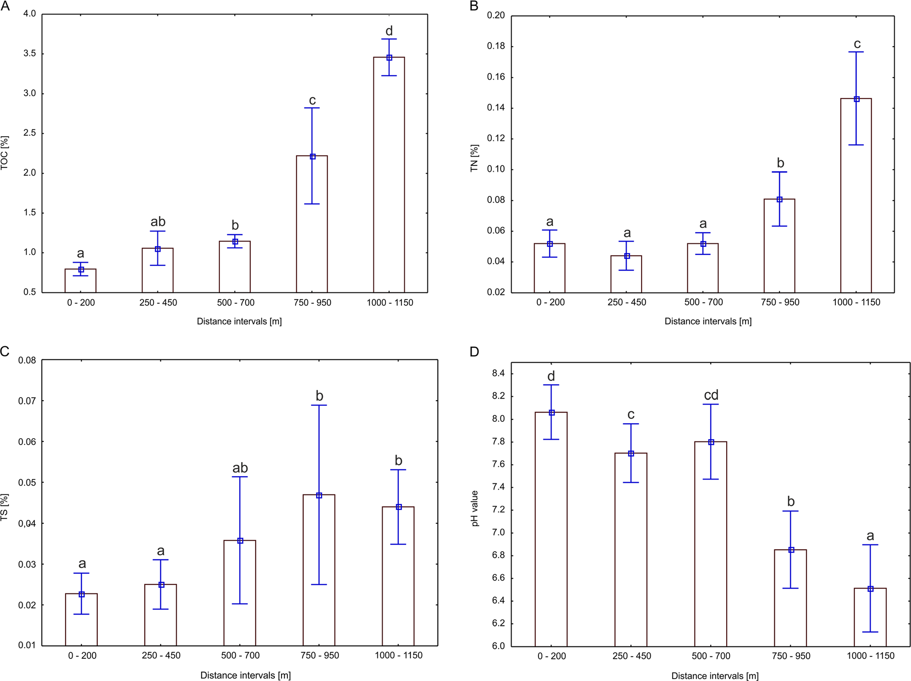
Fig.3Totalorganiccarbon–TOC(a),totalnitrogen–TN(b),totalsulphur–TS(c)contentsinsurfacesoillayerandsoilpH(d)forparticulardistanceintervalsdesignatedalongtransects.Points
indicatemeanvalues;whiskersindicatestandarddeviation.LettersdenotetheresultsofTukey’s(HSD)test;differentlettersindicatesignificantdifferencesatthep<0.05level

Table1Pearson’scorrelationcoefficientsbetweensoilchemicalparametersdeterminedineachsamplingsiteanddistancefromtheglacierforehead(Distance),timeelapsedafterglacierretreat(Time)andvegetationcover(Veg)

Parameter |  | TOC | TN | TS | pH | Veg
Distancematrix | TN | 0.880** | –
 | TS | 0.508* | 0.413* | –
 | pH | −0.887** | −0.763** | −0.483* | –
 | Veg | 0.816** | 0.663** | 0.564* | −0.788** | –
 | Distance | 0.884** | 0.765** | 0.502* | −0.869** | 0.857**
Timematrix | TN | 0.894** | –
 | TS | 0.507** | 0.423* | –
 | pH | −0.806** | −0.703** | −0.450* | –
 | Veg | 0.684** | 0.566** | 0.506** | −0.592** | –
 | Time | 0.885** | 0.804** | 0.481* | −0.810** | 0.736**
*P<0.05;**P<0.001

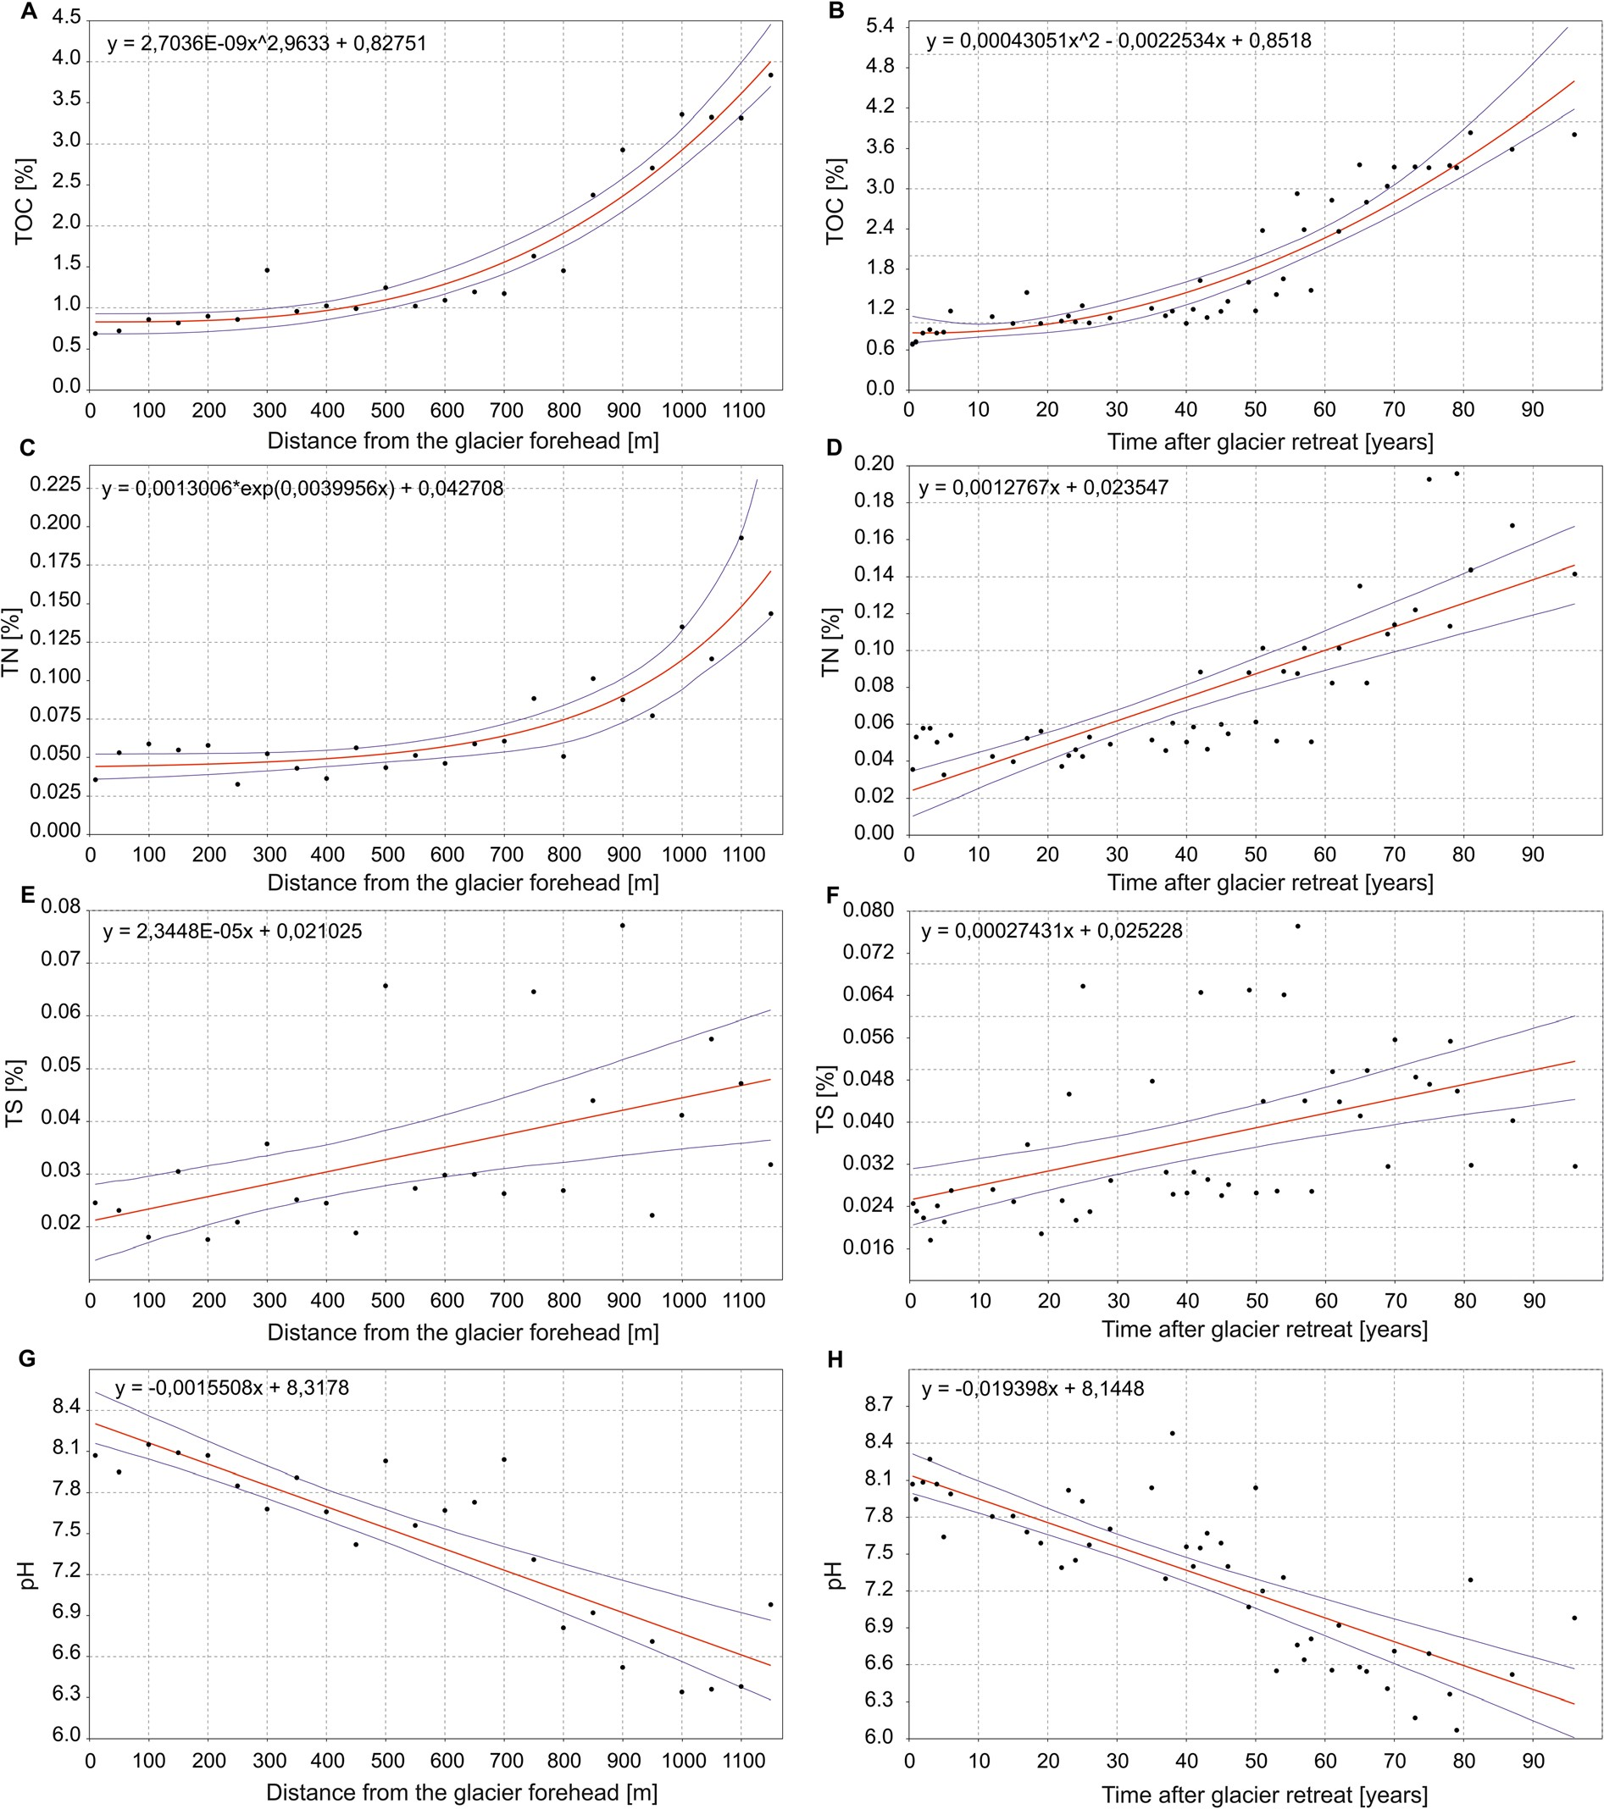
Fig.4Relationshipsbetweensoilproperties(TOC,TN,TS,andpH)andthedistancefromtheglacierforehead(a,c,e,g)andrelationshipsbetweensoilproperties(TOC,TN,TS,andpH)and
timeelapsedafterglacierretreat(b,d,f,h).Fittedfunctionformulasarepresentedinthescatterplots

and9speciesofvascularplants(Fig.7).Intheanalysisoftheoccurrenceofparticularspeciesalongtheglacier
foreland,groupsofearlyandlatecolonisersmaybedistinguished:bryophytes,namelyBryumcalophyllum

andEncalyptaalpina,werethefirstspeciestocolonisethefreshlydeglaciatedarea,whereaslichensbegantooccurstartingat350mfromtheglacierforeheadanddominatedtowardstheendoftheforeland(Fig.7).Vascularplantswerepresentfromadistanceof200mfromtheglacierforeheadthroughtherestofthefore-land.ThemostabundantspeciesofvascularplantswereSaxifragaoppositifoliaandCerastiumarcticum(Fig.7).Relationshipsbetweenspeciesdistributionandsoilchemicalproperties,distancefromtheglacierforeheadandtimeelapsedafterglacierretreatweredeterminedusingCCAanalysis(Fig.9).TheMonteCarlopermu-tationtestshowedthatboththefirstaxisandallcanon-icalaxestakentogetherwerestatisticallysignificant(p=0.02andp=0.04,respectively).Cladoniapyxidata,Lecanoraepibryon,Lecidearamulosa,Ochrolechiaandrogyna,CaloplacanivalisandPolyblastiasendtneriwereassociatedwithhighTOC,TN,andTScontent.ThesespecieswerealsoassociatedwithlowersoilpHandwerepresentintheolderpartofIrenebreenforeland(Fig.7).Bryophytes,suchasAndreaeablyttii,Bryumpseudotriquetrum,
B.turgidum,Ditrichumcylindricum,E.alpina,andPohliawahlenbergiiexhibitedoppositetrend(Figs.7and9).Nevertheless,theforwardselectionprocedureofthevariablesshowedthatspeciesdistributionisassoci-atedonlywithdistancefromtheglacierforeheadandTOCcontent(F=3.64;p=0.001andF=2.94;p=0.002,respectively).TheobtainedresultsindicatedthatdistancefromtheglacierforeheadandTOCcontentexplained7.75%oftheoverallvariabilityofspeciesoccurrence.However,concerningoverallvegetationcover,forwardstepwiseregressionanalysiswithdis-tancefromtheglacierforehead,timeelapsedaftergla-cierretreatandsoilvariablesaspredictorvariables(F=6.51;p<0.05)showedthatvegetationcoverwasmainlyrelatedtofouroftheanalysedfactors,i.e.soilpH(p=0.027),distancefromtheglacierforehead(p=0.030),contentofTOC(p=0.043)andTN(p=0.024).Thismodelexplained38.4%ofthevariabilityofvegetationcover.
Althoughthereweresomefluctuationsinvegetationcoveralongthetransects(Fig.9),thisparameterwasevidentlycorrelatedwithdistancefromtheglacierfore-headandtimeelapsedafterglacierretreat(Table1).Vegetationcoverandsoilparameterswerealsointerre-lated.Linearfunctionsprovedtobethebestfittedforrelationshipsbetweensoilparametersandvegetationcover(TableS2).Withincreasingdevelopmentof

vegetationcover,contentsofTOC,TN,andTSgradu-allyincreased,whereaspHdecreased;however,thecorrelationsbetweentheseparameterswerestrongerforthedistancematrixthanforthetimematrix(Table1,Fig.5).

Discussion

Inthispaper,amodifiedchronosequencemethodisproposed.Thisnovelapproachprovidesnear-continuousinformationonsoildevelopment,vegetationsuccession,andglacierretreatspanningonecentury.Despitethefactthatthedistancefromtheglacierfore-headandtimeelapsedafterglacierretreatarecorrelated,weexaminedtheirinfluenceonthedevelopmentofsoilandsuccessionofvegetationseparately.Suchanap-proachwasappliedbecausetherateofglacierretreatmaybenotconstantovertime.Becauseofthat,themodelofsoildevelopmentandvegetationsuccessioninrelationtodistanceandtimecouldbedifferent.Thisenabledustoidentifythenatureoftheserelationships,whichisparticularlyimportantinthecontextoftheincreasingrateofdeglaciationprocessinrecentyears.

Soildevelopmentintheglacierforeland

Soildevelopmentisdependentuponvarioussoil-formingfactors(parentmaterial,topography,climate,biota,andtime)andtheirfluctuationsandinterferences(BradyandWeil2004).Theobtainedresultsconfirmedourfirsthypothesisassumingthatbothincreaseddis-tancefromthecurrentglacierforeheadandtimeelapsedafterdeglaciationpositivelyinfluenceTOC,TN,andTScontentsinsoilandalsotheystandinlinewithourthirdhypothesisthatchangesinsoilpropertiesaremainlyinfluencedbyspontaneousdevelopmentofvegetation.
ThenatureofchangesinTOCandTNcontentsissimilar,withslowincreasesattheoutsetfollowedbymorerapidincreasesbeginningatadistanceof800mfromtheglacier.Itwasobservedthatsoildevelopmentintheglacierforelandssignificantlyacceleratesundercontinuousvegetationcover(AlexanderandBurt1996;HeandTang2008;Mavrisetal.2010).Thismayexplainthenatureoftheobtainedresults,sincevegeta-tioncoverdidnotexceed30%uptoadistanceof700mfromtheglacierforehead,whileatgreaterdistancesitreachedsignificantlyhighervalues(Figs.7and9).Asvegetationsuccessionproceeded,anincreaseinTOC

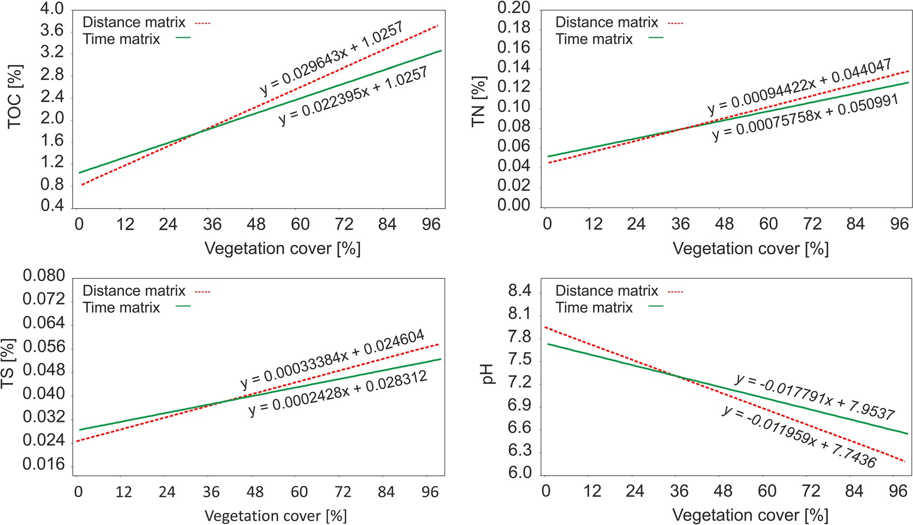
Fig.5RelationshipsbetweenvegetationcoverandTOC,TN,TScontentsinsurfacesoillayerandsoilpH.Combinedfunctiongraphswerepreparedbasedonanalysesperformedontwosepa-ratedatamatricesforaveragedvaluesofsoilparametersforthe
samevaluesofthedistanceandtimeelapsedafterglacierretreatdefinedforthreetransects.Fittedfunctionformulasarepresentedinthegraphs

andTNcontentsinsoilwasrecorded(Fig.5).ApartfromTOCandTNcontents,TScontentalsofollowsasimilarpattern.Sulphurisanessentialnutrientformi-croorganisms,plants,andanimals.InpristineregionswithgeologicalparentmaterialcategorisedasS-poorduetolittleatmosphericSinputandyoungsoils,thebioavailabilityofSmaylimitecosystemproductionandspeciessuccession(SchmalenbergerandNoll2010).WefoundthattheTScontentinthesurfacesoillayergenerallyincreasedwithtimeelapsedafterglacierre-treatanddistancefromthecurrentglacierforehead;however,widefluctuationswerenoticeable(Fig.4).Moreover,intermsofdistanceintervals,thehighestmeancontentofTSwasrecordedat750–950mfromthecurrentglacierforehead,comparedtoalowermeancontentforthegreatestdistanceinterval,i.e.1000–1150m(Fig.3).SimilarobservationsweremadebyPrietzeletal.(2013)inforelandsurfacesoillayersattheDammaGlacierinSwitzerland,wheretheconcentrationofTSwasatitslowestlevelinthefreshforelandmaterialanditshighestinmaturesoils,butgenerallywasgreaterfor70-to79-year-oldthanfor111-to121-year-oldsoils.Intheforelandsurfacesoillayerofthe
DammaGlacier,thecontentofTSwaspositivelycor-relatedwithTOCcontent(Prietzeletal.2013).Inthepresentstudywealsofoundsignificantpositivecorre-lationsbetweenTSandTOCcontents.However,oldersoilsarenotalwayscharacterisedbyhigherTScontentsthanyoungersoils.Similarrelationshipswerealsoob-servedinthesoilsoftheforelandsofFranzJosefGlacierandDammaGlacier(Allisonetal.2007;Prietzeletal.2013).
Thevariablerateofglacierretreatovertimeiscer-tainlyoneoftheimportantfactorsinfluencingtheob-servedpatternofdependencebetweendistanceandsoilproperties.Intermsofdistance,thisratewasconsider-ablyhigheroverthepastseveralyearsthanpreviously(Fig.6).TheresultsindicatethatthecontentsofTOCandTNinsoilsdevelopedintheforelandoftheIrenebreenare,ingeneral,afunctionoftimeanddis-tancefromtheglacierforehead.Nevertheless,theaccu-mulationoftheseelementsdoesnotfitasimplelinearmodelinaccordancewithdistancefromtheglacierforehead.Thepatternsofchangeswithdistanceareverycharacteristicandtheincreaseinthecontentsoftheseelementsisexpressedbynon-linearfunctions.These

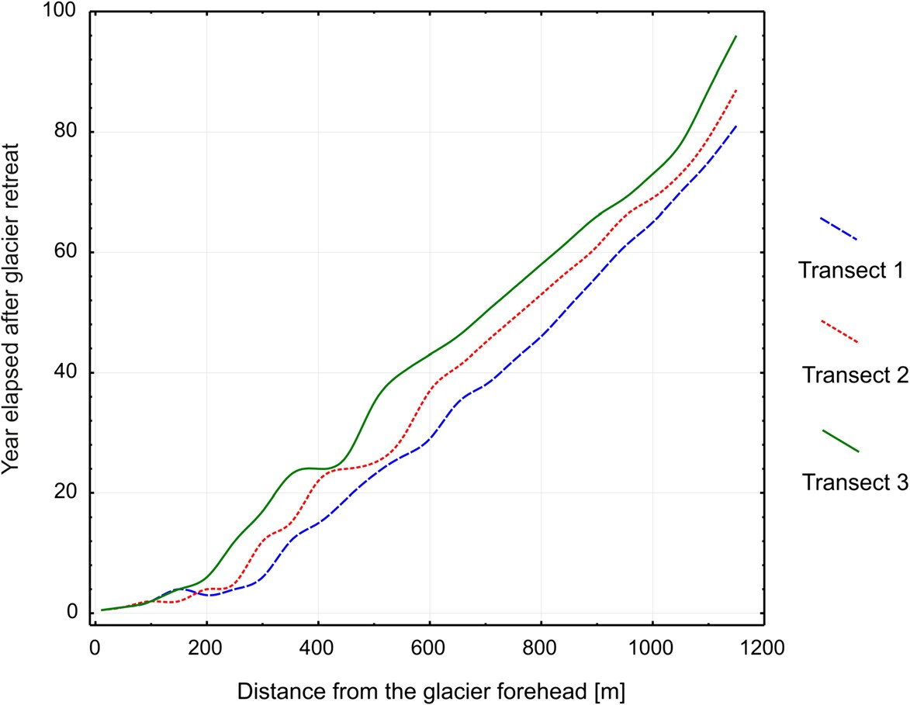
Fig.6Therelatioshipbetweenthetimeelapsedafterglacierretreatandthedistancefromtheglacierforeheadforparticulartransects

soildevelopmentmeasuresaredistance-relatedandfitpowerandexponentialmodelsforTOCandTN,respec-tively.Consequently,theaccumulationofTOCandTNatdistancessuchasthefirst500mfromthecurrentglacierforeheadwaslowerthanforthenext500m;thiswasalsoconnectedwithashorterperiodofsoildevel-opment.Nevertheless,themodelscreatedinthisstudystandincontradictiontorelationshipsobservedintheWerenskioldbreenforeland(south-westernpartofSpits-bergen),whereTOCandTNaccumulationfitsaloga-rithmicmodeland,inthefourth/fifthdecadeafterde-glaciation,ithasreachedaquasi-steadystateoveratimespanof80years(KabalaandZapart2012).Thesedifferencesmightbeduetothedifferentmethodologyusedbytheseauthors,namely,theclassicalchronosequencemethod,whichalsoresultedinasmall-ernumberofsamplesbeingcollectedintheforelandoftheWerenskioldbreenglacier.Inaddition,KabalaandZapart(2012)includedintheirstudysoilslocatedonlyontypicalmorainetill,whereassoilsformedfromout-washsandsandgravels,glaciofluvialandlimnicde-positswereexcludedfromtheirstudy.Wecollectedsoilsamplesfromvarioussitesintheforeland(notonlyatsiteslocatedontypicalmorainetill)withoutexclusionofanysitesandthisismostlikelythesecondreasonforadifferentpatternofTOCandTNcontentincreasealongthetransectsinourstudyincomparisonwiththepatternobtainedbyKabalaandZapart(2012).Further-more,thegeomorphologicalcharacterofeachforeland,connectedwiththawingicecoresandthussurface
stability,mayinfluencethecontentsofTOCandTNalongtheforeland.Theabsenceordeeperoccurrenceofthawingicecoresresultsinamorestableforelandsurface,enablingfastervegetationcolonisationandgreateraccumulationofelementssuchasTOCandTN.Ontheotherhand,thegeneralincreasingtrendinTNcontentfoundinthepresentstudyseemssimilartothatobservedintheMidtreLovénbreenforeland(Hodkinsonetal.2003),althoughtheauthorsdidnotdeterminethebest-fittingfunctionfornitrogencontent.Theincreaseinthecontentofthiselementwasrelativelyslowatfirst,butbecamemorepronounced60yearsafterglacierretreat.DifferentrelationshipswereobservedintheforelandoftheMidtreLovénbreenbyDongetal.(2016),wherelinearfunctionsprovidedthebestfitandTOCandTNcontentsincreasedsteadilyoveratimespangreaterthan80yearsafterdeglaciation.Conse-quently,oursecondhypothesisassumingthattherela-tionshipbetweentimeelapsedafterglacierretreatandsoilpropertiesisclosetobeinglinearwasconfirmedonlyinthecaseofTNcontent,becausetherelationshipbetweenTOCcontentandtimeelapsedafterglacierretreatwasnon-linear.Similarly,theabove-mentionedhypothesiswasnotfullyconfirmedinthecaseofTScontent,becausethecharacterofTSchangeswaslinearwithtimeelapsedafterglacierretreatandalsowiththedistancefromtheglacierforehead.ThepatternsandtimetrendsofthesurfacesoillayerTSstatusofyoungforeland-derivedsoilsincool,humidperiglacialenvi-ronmentsduringinitialstagesofpedogenesisand

vegetationsuccessionwerecausedbythecombinedeffectsofmineralweathering,accumulationandpro-gressivemicrobialturnoverofsoilorganicmatter,andtypeofvegetationsuccession(Prietzeletal.2013).SincetheparentmaterialofsoilsintheforelandofIrenebreenisS-poor(Bjørnerud2010),wesupposedthatorganicmatterandvegetationcoverwerethemajorfactorsaffectingtheincreaseinTScontentalongwithsoildevelopmentinthestudiedforeland.ThewidevariationsinTScontentwithtimeanddistancecouldbesomehowexplainedbyparentmaterialheterogeneity,influenceofatmosphericaerosolscontainingsulphates(Udistietal.2016)orvolcaniceruptions(e.g.Icelandicvolcanos)duringwhichlargevolumeofashescontain-ingsulphurareproduced,transportedintotheatmo-sphereandspreadwidely(Kekonenetal.2005).Nev-ertheless,anincreasingtrendintheTScontentisstillobservableduetothelargecontributionoftheaccumu-lationofTSinthesurfacesoillayerasaconsequenceoftheestablishmentofvegetation.
TheexpectednegativecorrelationofsoilpHwithdistanceandtimefactorsaswellaswithspontaneousdevelopmentofvegetationwasalsoconfirmedbyourresults,whichisinlinewithourfirstandthirdhypoth-esis.ThepHoffreshforelandglacialtillisquitehigh,fluctuatingaround8.ThisismainlyduetothetypesofrocksrepresentingtheHeclaHoekFormationandthemineralogicalcompositionofglacialtill,whichincludesahighproportionofcalciumandmagnesiumcarbonate(Chlebowski1989).Sincevegetationcoverdevelopsinforelands,organicacidsfromdecayingplantdebriscauseaprogressivedecreaseinsoilpH(Fig.5).Inaddition,theinfluenceofsummerprecipitationandthawingofsnowcovermayalsoberesponsibleforleachingofcarbonatesfromuppersoilhorizonsleadingtoadecreaseinsoilpH.TheincreaseinpHwithdepthinthestudiedsoilprofileslocatedinthemiddleandespeciallyatthefurthestsitesfromthecurrentpositionoftheglacierforeheadindicatestheleachingofcarbon-ates(TableS3).However,itisnotpossibletodeterminewhichfactor(i.e.developmentofvegetationcoverorleaching)playsamoreimportantroleindecreasingsoilpHinthestudiedforeland.WealsofoundthatthedecreaseinsoilpHisalinearfunctionoftimeintheforelandsoilsofIrenebreen(Fig.4).SimilartrendsinpHwerealsofoundforthesoilsoftheMidtreLovénbreenforeland(Dongetal.2016).Ontheotherhand,KabalaandZapart(2012)foundthatpHde-creasedwithtimeandbecamefinallystabilised
approximately80yearsafterglacierretreat.HeandTang(2008)alsoobservedthatpHinsurfacesoilhori-zonstendedtochangeasymptoticallywithtimeandthusprogressivedecreasesinsoilpHslowedwithsoildevel-opmentandfinallystabilised.ThesamepHchangeswerefoundintherecessionalforelandsoftheHerbertandMendenhallGlaciersinsouth-easternAlaskawhere,afteraninitialrapidrateofdeclineinpH,changesbecomelessrapidandfinallystabilise(CrockerandDickson1957).
AlthoughalinearfunctionofpHdeclineprovedtofitourdatabest,theincreaseinsoilpHrecordedatthelastsamplingsitesmayindicatethatpHtendstostabiliseintheIrenebreenforelandaswell.Nevertheless,oursec-ondhypothesisassumingthattherelationshipbetweentimeelapsedafterglacierretreatandsoilpHislinearwasconfirmed;however,theresultsstandincontrasttothehypothesisthattherelationshipbetweendistanceandsoilpHisnon-linearincharacter.

Vegetationdevelopmentintheglacierforeland

Theincreaseinthenumberofspeciesandtheircoverwithdistancefromtheglacierforeheadindicatesthatvegetationgraduallychangesalongthestudiedtransect(Figs.7and9).Thecolonisationorderisasfollows:firstappearbryophytes,thenvascularplantsandlichens.However,inthecaseoflichens,thefirstrecordedspe-cieswereepilithictaxawhichovergrowrocksuncov-eredbytheretreatingice,whileepigeicspeciesoccurlast(Fig.7).AccordingtophytosociologicalresearchontheclimaxMinuartiabifloracommunity(WęgrzynandWietrzyk2015),whichsurroundstheIrenebreenfore-land,agradualtransitionofspeciescomposition,fromthepioneerstagetonear-climaxvegetationcommuni-ties,canbeobservedintheglacierforeland.AccordingtoastudycarriedoutintheMidtreLovénbreenandAustreLovénbreen(Moreauetal.2008),theincreasefoundinthefrequencyandcoverofStereocaulonalpinumisanindicatorofclimaxvegetation.IntheIrenebreenforeland,S.alpinumstartstooccurapprox-imately500mfromthecurrentglacierforehead.Thismaysuggestthatthepresenceofthislichenisnotrelatedstrictlytoclimaxcommunities.S.alpinum,suchasanotherspeciesofterricolouslichen,Rostaniaceranisca(dominanttaxonintheIrenebreenforeland),isahostforcyanobacterialsymbiontswiththeabilitytobindatmo-sphericnitrogen.Thisfeatureincreasesthecolonisationpotentialoftheselichens(Sanchoetal.2011).

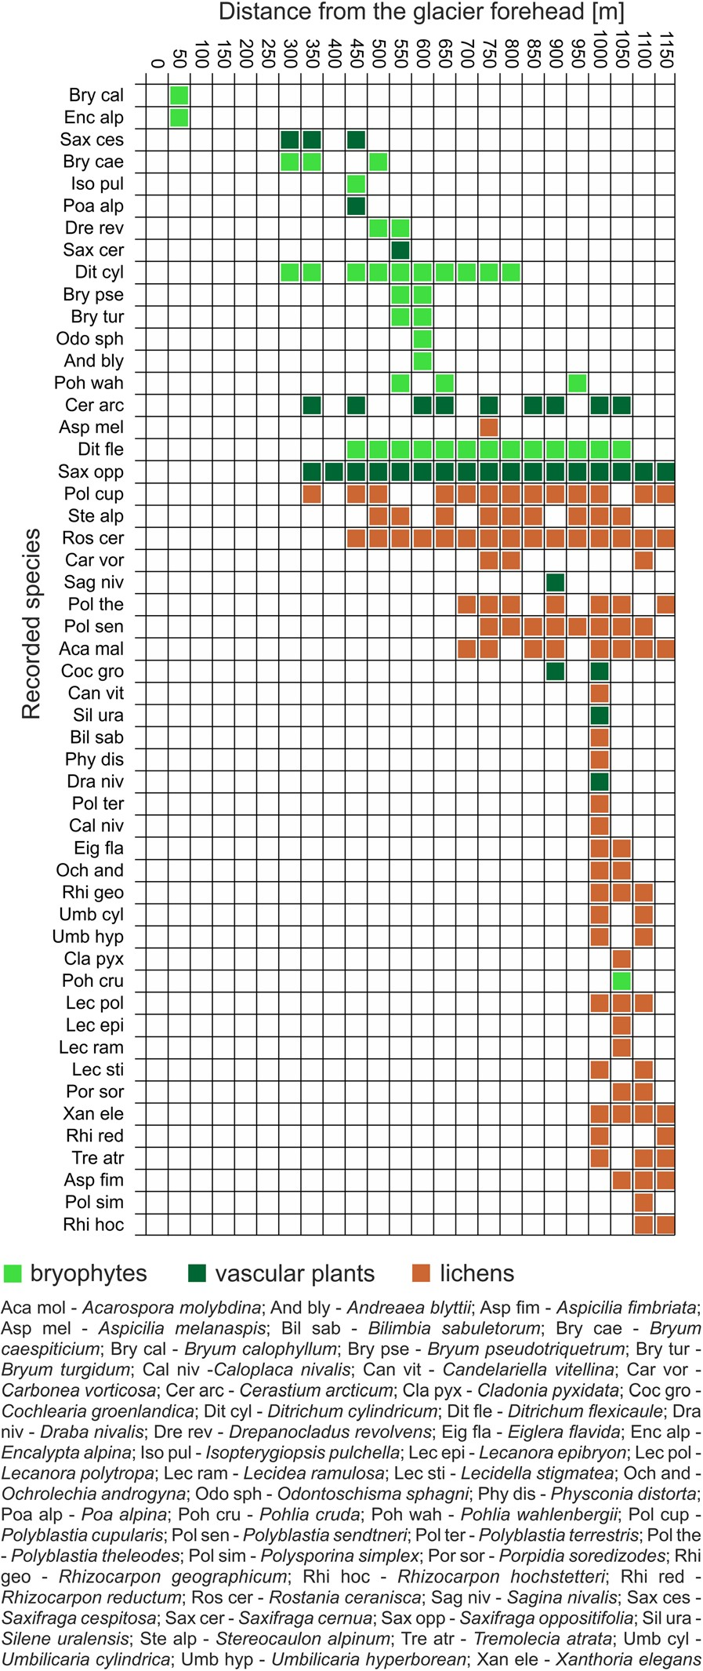
Fig.7Theseriationdiagramusingunconstrainedalgorithmofspeciespresence/absenceintheexaminedplotscombinedforthreetransects

InthemajorityofEarth’secosystems,vegetationcoverisconsideredtobearesponsetothegradientofsoilparameters;however,intheArcticregion,inareassurroundedbyglaciers,animportantfactorinfluencing
vegetationcoverisalsothemicroclimaticimpactofaglacier’spresence.Accordingtomultipleregressionanalysis,exceptforsoilpropertiessuchaspH,TOCandTN,vegetationcoverdependsondistancefromtheglacierforehead.Thisresultpartlyconfirmedourfourthhypothesisassumingthatthedevelopmentofvegetationcoverisdependentmainlyonthedistancefromtheglacierforehead(Fig.9).Withregardtostatis-ticalsignificance,distancewasthesecondsignificantfactor(aftersoilpH)affectingthevegetationcover.Nevertheless,thismodelexplainedonly38.4%ofthevariabilityofvegetationcover.Thisindicatesthatfur-therresearchfocusedonfactorsinfluencingthedevel-opmentofvegetationcoverinaglacierforelandsuchasnutrientsavailabletoplants,soilhumidity,soiltexture,andpresenceofbiologicalsoilcrusts(BSCs)isneeded.Concerningtheoccurrenceofparticularspecies,theanalysisofCCAalongwithforwardselectionprocedureshowsthatdistancefromtheglacierforeheadandTOCcontentinthesoilaffectspeciesdistributionthemost(Fig.9).Nevertheless,regardingTOCcontent,itismainlyrelatedtolichens,suchasC.pyxidata,
L.epibryon,L.ramulosa,andO.androgyna(Fig.9).TheoccurenceofthesespeciesiscausedbythepresenceofplantdebrisandBSCs,whichprovidethemwiththesubstratetogrowon(Smithetal.2009).Duetothisfact,itseemsthatthepositiverelationshipbetweenthemen-tionedspeciesandTOCcontentisindirectandconnect-edwithreadilyavailableplantdebrisandBSCs,whichdirectlyresultinhighTOCcontentinthesoil.Themajorityofepigeiclichensdominateintheolderpartofthestudiedforeland(Fig.7).Thisindicatesthehighestlevelofspeciesdiversityintheareaswhereicedisappearedearly,thespecieshadenoughtimetocolo-nisethesubstrate,andwheretheinfluenceofdead-icethawingandglacier-affectedmicroclimateislower.AgreatabundanceoflichensinthepartsoftheforelandexposedearliestwasalsoobservedintheMidtreLovénbreen(Moreauetal.2008).InstudiesconductedintheforelandoftheWerenskioldbreen,Tishkov(1986)emphasisedtheimportanceofso-calledmicro-depressions,whichacceleratetheprocessofprimarysuccessionduetooptimalsnowaccumula-tionconditions.Apartfromthat,variousgeomorpholog-icalprocessestransformglacialtillinforelands.Amongthem,themostimportantgeomorphologicalprocessesarerelatedtothemeltingofice-coresandactivityofproglacialrivers.Manystudies(e.g.Borysiaketal.2015;LafflyandMercier2002;MercierandLaffly

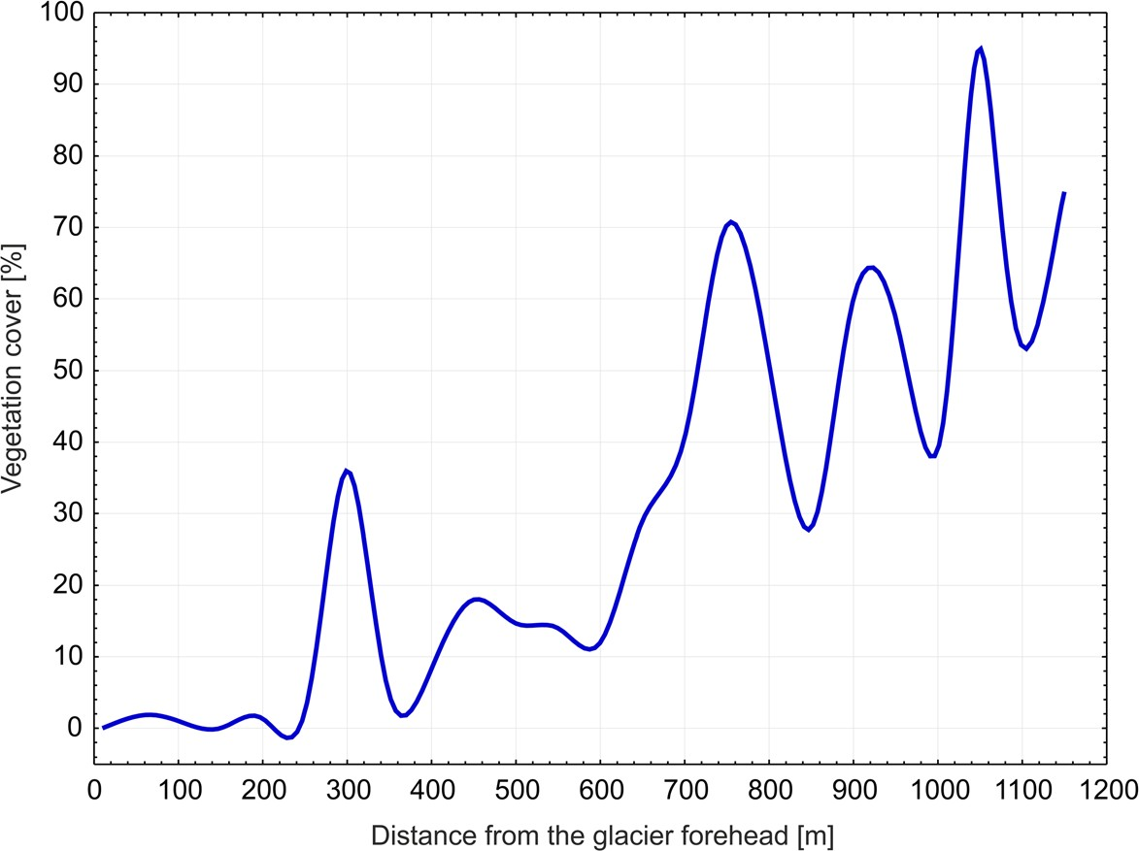
Fig.8Therelationshipbetweenvegetationcoverandthedistancefromtheglacierforeheadaveragedforthreetransects

2005;Moreauetal.2008;Östrem1959;PrachandRachlewicz2012;)indicatethattheabove-mentionedprocessesarethemainandmostinfluentialinthefor-mationoflowlandsandmoundsinglacierforelands,andthusappeartoexertanimportantimpactonvege-tationdevelopment.Incontrasttoepigeiclichens,bryo-phytesdominateintheyoungerpartofthestudiedforeland(Fig.7).Theseincludemainlyminerotrophicspecies,whichinhabitmoistareas(Athertonetal.2010;Walkeretal.2001)andseemtotoleratetheerosionalactivityofproglacialriverswhichoccursperiodicallyin
theareaslocatednearthecurrentglacierforehead(Fig.7).Ditrichumcylindricum,inparticular,prefersadistinctlywethabitatthatundergoesperiodicflooding(Walkeretal.2001).ThisisconfirmedbyCCAanalysis,whichshowsthatthemajorityofbryophytesareassociatedwithsub-strateswithlessercontentofTOC,TN,andTS,buthighersoilpH(Fig.9).Bryophytespeciesrecordedintheolderpartofforelandwereassociatedwithlocalmicro-depres-sions,whichprovidehighermoisturecontentinthesub-strateincomparisonwithsurroundingmounds(Fig.S1).Inthecaseofvascularplants,thosewhosepresenceis

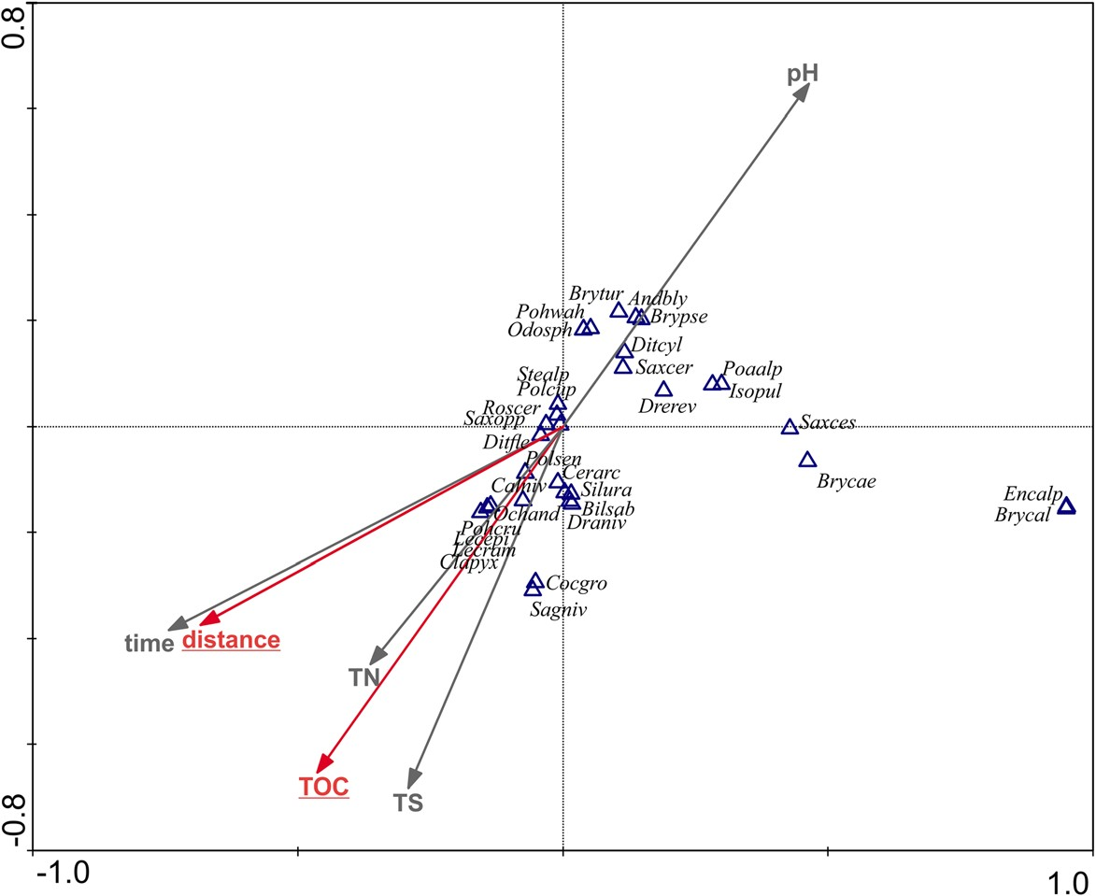
Fig.9Canonicalcorrespondenceanalysisordinationdiagramshowingrelathionshipbetweenspecies(speciesabbreviationsare
explainedinFig.7),soilvariables
(TOC,TN,TS,pH),distancefromthecurrentglacierforehead(distance)andtimeelapsedafterglacierretreat(time).Theredar-rowsandunderlinedvariablesmarkthestatisticallysignificantfactors.Thevarianceexplainedbythefirstcanonicalaxisreaches45%whereasbyallcanonicalaxes79%

connectedtothemicroclimaticinfluenceofglacierandice-cores,occurfirstinthecolonisationprocessandarepresentonlyintheyoungerpartoftheforeland,e.g.:
S.cesposita,S.cernuaandP.alpina(Figs.7and9).
Conversely,S.oppositifoliaandC.arcticum,whichap-pearasthefirstvascularplantspecies,dominatetowardstheendoftheforelandandshowagreatertoleranceforhabitatconditionsthatchangealongtheforeland(Fig.7).TheimportantroleofS.oppositifoliaanditsdominationinthesuccessionprocesswasalsonotedintheforelandsofotherglaciersinthenorthern(Hodkinsonetal.2003;Moreauetal.2005,2009;Tishkov1986),southern(PirożnikowandGórniak1992;Wojtuńetal.2008),north-eastern(Yoshitakeetal.2010),andcentral(PrachandRachlewicz2012)partsoftheSvalbardArchipelago.

Conclusions

Thispaperprovidesanovelapproachtostudiesconcerningsoildevelopmentandplantsuccessioninaglacierforeland.Theappliedmethodologyprovidesnear-continuousinformationonthesoildevelopmentandvegetationsuccessionspanningonecentury.OurresultsshowthatthecontentsofTOCandTNinsoilsdevelopedintheIrenebreenforeland,ratherthanfittingasimplelinearmodelintermsoftheirvariationwithdistancefromtheglacierforehead,fitpowerandexponentialmodels,respectively.ThegradualcolonisationoftheforelandbycryptogamsandvascularplantsalsoaffectssoilpH,whichdecreaseswithtimeaccordingtoalinearfunction;howevertheadditionalimpactofsoilleachingrelatedtosummerprecipitationandthethawingofsnowcovercannotbeentirelyexcluded.Similarly,thecontentofTSinsoilsappearstobeaffectedbytheformationofvegetationcoverandaccumulationoforganicmatter;however,itswidevariationswithtimeanddistancefromthecurrentglacierforeheadmayalsobeexplainedbytheheterogeneityofparentmaterialand/ortheinfluenceofatmosphericaerosolsand/orvolcanicdeposits.Bryo-phytesandvascularplantsdominateintheyoungerpartofthestudiedforeland,whereasepigeiclichensprevailintheolderpart.Thisindicatesthatepigeiclichensneedmoretimethanbryophytesandvascularplantstocolo-niseaglacierforeland.ThestudyshowedthataparticularspeciesdistributionisassociatedwiththedistancefromtheglacierforeheadandTOCcontentinsoil.Neverthe-less,concerningtheoverallvegetationcover,apartfrom
theabove-mentionedfactors,pHandTNseemtoalsoimpactthedevelopmentofvegetationcover.

AcknowledgementsWearegratefultoAssociateProfessorIreneuszSobota,theStationLeaderofNicolausCopernicusUni-versityPolarStationinKaffiøyrafortheopportunitytostayattheresearchstation.WewishtothankDoctorBeataCykowska-Marzencka(InstituteofBotany,PolishAcademyofSciences)forherhelpinbryophytesidentification.Wearealsogratefultoanon-ymousreviewersfortheirsuggestionsandremarksonourmanu-script.ThecontributionmadebyMichałWęgrzynin2012wasfinanciallysupportedbyastatutoryfundfromtheInstituteofBotany,JagiellonianUniversity.ThecontributionmadebyPaulinaWietrzykreceivedfinancialsupportfromthestatutoryfundoftheInstituteofBotanyoftheJagiellonianUniversity(K/DSC/004623).

OpenAccessThisarticleisdistributedunderthetermsoftheCreativeCommonsAttribution4.0InternationalLicense(http://creativecommons.org/licenses/by/4.0/),whichpermitsunrestrict-eduse,distribution,andreproductioninanymedium,providedyougiveappropriatecredittotheoriginalauthor(s)andthesource,providealinktotheCreativeCommonslicense,andindicateifchangesweremade.

References

AlexanderEB,BurtR(1996)SoildevelopmentonmorainesofMendenhallglacier,SoutheastAlaska.1.Themorainesandsoilmorphology.Geoderma72:1–17.https://doi.org/10.1016
/0016-7061(96)00021-3
AllisonVJ,CondronLM,PeltzerDA,RichardsonSJ,TurnerBL(2007)Changesinenzymeactivitiesandsoilmicrobialcom-munitycompositionalongcarbonandnutrientgradientsattheFranzJosefchronosequence,NewZealand.SoilBiolBiochem39:1770–1781.https://doi.org/10.1016/j.soilbio.2007.02.006
ArndtDS,BaringerMO,JohnsonMR,DiamondHJ,FogtRL,LevyJM,ThornePW,VincentLA,WatkinsAB,WillettKM(2010)Stateoftheclimatein2009.BullAmMeteorolSoc91(7):S1–S223.https://doi.org/10.1175/BAMS-91-7-StateoftheClimate
AthertonI,BosanquetS,LawleyM(2010)MossesandliverwortsofBritainandIreland:afieldguide.BritishBryologicalSociety,London
BjørnerudMG(2010)StratigraphicrecordofNeoproterozoicicesheetcollapse:theKappLyelldiamictitesequence,SWSpitsbergen,Svalbard.GeolMag147(3):380–390.https://doi.org/10.1017/S0016756809990690
BłaszczykM,JaniaJA,HagenJO(2009)TidewaterglaciersofSvalbard:recentchangesandestimatesofcalvingfluxes.PolPolarRes30(2):85–142
BorysiakJ,GrześM,PulinaM,SzpikowskaG(2015)HydrogeochemicalandbiogeochemicalprocessesinKaffiøyraRivercatchments(Spitsbergen,Norway).QuaestGeographicae34(1):111–124.https://doi.org/10.1515
/quageo-2015-0010
BradyNC,WeilRR(2004)Thenatureandpropertiesofsoils.
PearsonEducationInc,Delhi

BrodoIM,SharnoffSD,SharnoffS(2001)LichensofNorthAmerica.YaleUniversityPress,NewHaven
BrowerJC,KileKM(1988)Sedationofanoriginaldatamatrixasappliedtopaleoecology.Lethaia21:79–93.https://doi.org/10.1111/j.1502-3931.1988.tb01756.x
BurgaCA,KrüsiB,EgliM,WernliM,ElsenerS,ZiefleM,FischerT,MavrisC(2010)Plantsuccessionandsoildevel-opmentontheforelandoftheMorteratschglacier(Pontresina,Switzerland):straightforwardorchaotic?FloraMorpholDistribFunctEcolPlants205:561–576.https://doi.org/10.1016/j.flora.2009.10.001
ChlebowskiR(1989)Petrographieandmineralogicalcharacteris-ticsofrocksoftheHeclaHoekformationintheareaofthesouthBellsundcoast,WestSpitsbergenWyprawyGeograficznenaSpitsbergen,pp51–59
CrockerRL,DicksonBA(1957)Soildevelopmentonthereces-sionalmorainesoftheHerbertandMendenhallglaciers,south-easternAlaska.BrEcolSoc45:169–185.https://doi.org/10.2307/2257083
DaiLM,WuG,ZhaoJZ,KongHM,ShaoGF,DengHB(2002)CarboncyclingofalpinetundraecosystemsonChangbaiMountainanditscomparisonwithArctictundra.SciChinaSerDEarthSci45:903–910.https://doi.org/10.1360/02yd9089
DongK,TripathiB,MoroenyaneI,KimW,LiN,ChuH,AdamsJ(2016)SoilfungalcommunitydevelopmentinahighArcticglacierforelandfollowsadirectionalreplacementmodel,withamid-successionaldiversitymaximum.SciRep6:26360.https://doi.org/10.1038/srep26360
DümigA,SmittenbergR,Kögel-KnabnerI(2011)ConcurrentevolutionoforganicandmineralcomponentsduringinitialsoildevelopmentafterretreatoftheDammaglacier,Switzerland.Geoderma163:83–94.https://doi.org/10.1016
/j.geoderma.2011.04.006
ElberlingB,JakobsenBH,BergP,SondergaardJ,SigsgaardC(2004)Influenceofvegetation,temperature,andwatercon-tentonsoilcarbondistributionandmineralizationinfourhighArcticsoils.ArctAntarctAlpRes36:528–538.https://doi.org/10.1657/1523-0430(2004)036[0528:IOVTAW]2.0.CO;2
GrieveIC(2000)EffectsofhumandisturbanceandcryoturbationonsoilironandorganicmatterdistributionsandoncarbonstorageathighelevationsintheCairngormMountains,Scotland.Geoderma95:1–14.https://doi.org/10.1016
/S0016-7061(99)00060-9
HammerØ,HarperDAT,RyanPD(2001)PAST-palaeontologicalstatistics,ver.1.89.PalaeontolElectron4(1):1–9
HansenJ,SatoM,RuedyR(2012)Perceptionofclimatechange.
ProcNatlAcadSci109:E2415–E2423.https://doi.org/10.1073/pnas.1205276109
HeL,TangY(2008)SoildevelopmentalongprimarysuccessionsequencesonmorainesofHailuogouglacier,GonggaMountain,Sichuan,China.Catena72:259–269.https://doi.org/10.1016/j.catena.2007.05.010
HodkinsonID,CoulsonSJ,WebbNR(2003)Communityassem-blyalongproglacialchronosequencesinthehighArctic:vegetationandsoildevelopmentinnorth-WestSvalbard.JEcol91:651–663.https://doi.org/10.1046/j.1365-2745.2003.00786.x
IPCC(2007)Climatechange2007:thephysicalsciencebasis.
ContributionofworkinggroupItothefourthassessment

reportoftheintergovernmentalpanelonclimatechange.SummaryforPolicymakers.IPCC,Geneva
IPCC(2014)Climatechange2014:synthesisreport.ContributionofworkinggroupsI,IIandIIItotheFifthAssessmentReportoftheIntergovernmentalPanelonClimateChange.IPCC,Geneva
JacobsonGL,BirksHJB(1980)Soildevelopmentonrecentend
morainesoftheKlutlanglacier,Yukonterritory,Canada.QuatRes14:87–100.https://doi.org/10.1016/0033-5894(80
)90008-3
JamesTD,MurrayT,BarrandNE,SykesHJ,FoxAJ,KingMA(2012)ObservationsofenhancedthinningintheupperreachesofSvalbardglaciers.Cryosphere6:1369–1381.https://doi.org/10.5194/tc-6-1369-2012
KabalaC,ZapartJ(2012)InitialsoildevelopmentandcarbonaccumulationonmorainesoftherapidlyretreatingWerenskioldglacier,SWSpitsbergen,Svalbardarchipelago.Geoderma175–176:9–20.https://doi.org/10.1016/j.geoderma.2012.01.025
KekonenT,MooreJ,PerämäkiP,MartmaT(2005)TheIcelandic
LakivolcanictephralayerintheLomonosovfonnaicecore,Svalbard.PolarRes24(1–2):33–40.https://doi.org/10.3402
/polar.v24i1.6251
KohlerJ,JamesTD,MurrayT,NuthC,BrandtO,BarrandNE,AasHF,LuckmanA(2007)AccelerationinthinningrateonwesternSvalbardglaciers.GeophysResLett34:L18502.https://doi.org/10.1029/2007GL030681
LafflyD,MercierD(2002)GlobalchangeandparaglacialmorphodynamicmodificationinSvalbard.IntJRemoteSens23:4743–4760.https://doi.org/10.1080
/01431160110113872
LegendreP,LegendreL(1998)NumericalEcology.Elsevier,Amsterdam
MavrisC,EgliM,PlötzeM,BlumJD,MirabellaA,GiaccaiD,HaeberliW(2010)InitialstagesofweatheringandsoilformationintheMorteratschproglacialarea(upperEngadine,Switzerland).Geoderma155:359–371.https://doi.org/10.1016/j.geoderma.2009.12.019
MercierD,LafflyD(2005)ActualparaglacialprogradationofthecoastalzoneintheKongsfjordenarea,WestSpitsbergen(Svalbard).In:HarrisC,MurtonJ(eds)CryosphericSystems:GlaciersandPermafrost.GeologicalSociety,London,pp111–117
MoreauM,LafflyD,JolyD,BrossardT(2005)Analysisofplant
colonizationonanarcticmorainesincetheendoftheLittleIceAgeusingremotelysenseddataandaBayesianapproach.RemoteSensEnviron99:244–253.https://doi.org/10.1016/j.rse.2005.03.017
MoreauM,MercierD,LafflyD,RousselE(2008)Impactsof
recentparaglacialdynamicsonplantcolonization:acasestudyonMidtreLovénbreenforeland,Spitsbergen(79°N).Geomorphology95:48–60.https://doi.org/10.1016/j.geomorph.2006.07.031
MoreauM,LafflyD,BrossardT(2009)Recentspatialdevelop-mentofSvalbardstrandflatvegetationoveraperiodof31years.PolarRes28(3):364–375.https://doi.org/10.1111
/j.1751-8369.2009.00119.x
NakatsuboT,BekkuYS,UchidaM,MuraokaH,KumeA,OhtsukaT,MasuzawaT,KandaH,KoizumiH(2005)Ecosystemdevelopmentandcarboncycleonaglacierfore-landinthehighArctic,Ny-Alesund,Svalbard.JPlantRes118(3):173–179.https://doi.org/10.1007/s10265-005-0211-9

NollM,WellingerM(2008)Changesofthesoilecosystemalongarecedingglacier:testingthecorrelationbetweenenviron-mentalfactorsandbacterialcommunitystructure.SoilBiolBiochem40(10):2611–2619.https://doi.org/10.1016/j.soilbio.2008.07.012
NuthC,KohlerJ,KönigM,vonDeschwandenA,HagenJO,Kääb
A,MoholdtG,PetterssonR(2013)Decadalchangesfromamulti-temporalglacierinventoryofSvalbard.Cryosphere7:1603–1621.https://doi.org/10.5194/tc-7-1603-2013
OechelWC,VourlitisGL(1994)Theeffectsofclimatechargeonland-atmospherefeedbacksinArctictundraregions.TrendsEcolEvol9(9):324–329.https://doi.org/10.1016/0169-5347(94)90152-X
OrangeA,JamesPW,WhiteFJ(2001)Microchemicalmethodsfortheidentificationoflichens.BritishLichenSociety,London
ÖstremG(1959)Icemeltingunderathinlayerofmoraine,andthe
existenceoficecoresinmoraineridges.GeogrAnn41(4):228–230.https://doi.org/10.1080/20014422.1959.11907953
OsyczkaP,WęgrzynM.(2008)LichensonlignuminthecoastalregionsofwesternSpitsbergen(Svalbard).Biologia63(6):1069–1072.https://doi.org/10.2478/s11756-008-0158-0
PirożnikowE,GórniakA(1992)ChangesinthecharacteristicsofthesoilandvegetationduringtheprimarysuccessioninthemarginalzoneoftheWerenskioldglacier,Spitsbergen.PolPolarRes13(1):19–29
PrachK,RachlewiczG(2012)SuccessionofvascularplantsinfrontofretreatingglaciersinCentralSpitsbergen.PolPolarRes33(4):319–328.https://doi.org/10.2478/v10183-012-0022-3
PrietzelJ,WuY,DümigA,ZhouJ,KlysubunW(2013)SoilsulphurspeciationintwoglacierforefieldsoilchronosequencesassessedbySK-edgeXANESspectroscopy.EurJSoilSci64(2):260–272.https://doi.org/10.1111/ejss.12032
PrzybylakR,AraźnyA(2006)Climaticconditionsofthenorth−westernpartofOscarIIland(Spitsbergen)intheperiodbetween1975and2000.PolPolarRes27(2):133–152
RønningOI(1996)ThefloraofSvalbard.NorwegianPolarInstitute,Tromso
SanchoLG,PalaciosD,GreenATG,VivasM,PintadoA(2011)Extremehighlichengrowthratesdetectedinrecentlydegla-ciatedareasinTierradelFuego.PolarBiol34:813–822.https://doi.org/10.1007/s00300-010-0935-4
SchmalenbergerA,NollM(2010)Shiftsindesulfonatingbacterialcommunitiesalongasoilchronosequenceintheforefieldofarecedingglacier.FEMSMicrobiolEcol71(2):208–217.https://doi.org/10.1111/j.1574-6941.2009.00799.x
SmithCW,AptrootA,CoppinsBJ,FletcherA,GilbertOL,James
PW,WolseleyPA(2009)ThelichensofgreatBritainandIreland.BritishLichenSociety,London
SobotaI(2011)Snowaccumulation,melt,massloss,andthenear-surfaceicetemperaturestructureofIrenebreen,Svalbard.PolarSci5(3):327–336.https://doi.org/10.1016/j.polar.2011.06.003
SobotaI(2014)ChangesindynamicsandrunofffromthehighArcticglacialcatchmentofWaldemarbreen,Svalbard.Geomorphology212:16–27.https://doi.org/10.1016/j.geomorph.2013.04.001
SobotaI,LankaufKR(2010)RecessionofKaffiøyraregion
glaciers,OscarIIland,Svalbard.BullGeogrPhysGeogrSer3:27–45.https://doi.org/10.2478/232
SobotaI,NowakM,WeckwerthP(2016)Long-termchangesofglaciersinNorth-WesternSpitsbergen.GlobPlanetChang144:182–197.https://doi.org/10.1016/j.gloplacha.2016.07.006
TanKH(1995)Soilsampling,preparation,andanalysis.MarcelDekkerInc,NewYork

TerBraakCJF,ŠmilauerP(2002)CANOCO4.5referencemanualandCanoDrawforWindowsuser’sguide:softwareforcanonicalcommunityordination.Ithaca:MicrocomputerPower,NewYorkThomsonJW(1984)AmericanArcticlichensI:themacrolichens.
ColumbiaUniversityPress,NewYork
ThomsonJW(1997)AmericanArcticlichensII:themicrolichens.
UniversityofWisconsinPress,Madison
TishkovAA(1986)PrimarysuccessioninarctictundraonthewestcoastofSpitsbergen(Svalbard).PolarGeogrGeol10:148–156.https://doi.org/10.1080/10889378609377282
UdistiR,BazzanoA,BecagliS,BolzacchiniE,CaiazzoL,CappellettiD,FerreroL,FrosiniD,GiardiF,GrottiM,LupiA,MalandrinoM,MazzolaM,MoroniB,SeveriM,TraversiR,ViolaA,VitaleV(2016)SulfatesourceapportionmentintheNy-Ålesund(SvalbardIslands)Arcticaerosol.RendicontiLincei27:85–94.https://doi.org/10.1007/s12210-016-0517-7
VilmundardóttirOK,GísladóttirG,LalR(2015)Soilcarbonaccre-
tionalonganagechronosequenceformedbytheretreatoftheSkaftafellsjökullglacier,SE-Iceland.Geomorphology228:124–133.https://doi.org/10.1016/j.geomorph.2014.08.030
WalkerLR,DelMoralR(2003)Primarysuccessionandecosys-temrehabilitation.CambridgeUniversityPress,Cambridge
WalkerDA,BockheimJG,ChapinFSIII,EugsterW,NelsonFE,PingCL(2001)Calcium-richtundra,wildlife,andtheBmammothsteppe^.QuatSciRev20:149–163.https://doi.org/10.1016/S0277-3791(00)00126-8
WęgrzynM,WietrzykP(2015)Phytosociologyofsnowbedand
exposedridgevegetationofSvalbard.PolarBiol38(11):1905–1917.https://doi.org/10.1007/s00300-015-1751-7
WietrzykP,WęgrzynM,LisowskaM(2016)VegetationdiversityandselectedabioticfactorsinfluencingtheprimarysuccessionprocessontheforelandofGåsbreen,Svalbard.PolPolarRes37(4):493–509.https://doi.org/10.1515/popore-2016-0026
WietrzykP,WęgrzynM,LisowskaM(2017)Lichendiversityon
glaciermorainesinSvalbard.CryptogamMycol38(1):67–80.https://doi.org/10.7872/crym/v38.iss1.2017.67
WojtuńB,MatułaJ,PereymaJ(2008)PlantandlichencolonizationsontheWerenskiőldglacierforefieldinWestSpitsbergen.In:KowalskaA,LatochaA,MaszałekH,PereymaJ(eds)Środowiskoprzyrodniczeobszarówpolarnych.WydziałNaukoZiemiiKształtowaniaŚrodowiska,GAJT,Wrocław,pp228–236YoshitakeS,UchidaM,KoizumiH,NakatsuboT(2007)Carbonandnitrogenlimitationofsoilmicrobialrespirationinahigh
ArcticsuccessionalglacierforelandnearNy-Ålesund,Svalbard.PolarRes26:22–30.https://doi.org/10.1111
/j.1751-8369.2007.00001.x
YoshitakeS,UchidaM,KoizumiH,KandaH,NakatsuboT(2010)ProductionofbiologicalsoilcrustsintheearlystageofprimarysuccessiononahighArcticglacierforeland.NewPhytol186:451–460.https://doi.org/10.1111/j.1469-8137.2010.03180.x
YoshitakeS,UchidaM,OhtsukaT,KandaH,KoizumiH,NakatsuboT(2011)VegetationdevelopmentandcarbonstorageonaglacierforelandinthehighArctic,Ny-Ålesund,Svalbard.PolarSci5(3):391–397.https://doi.org/10.1016/j.polar.2011.03.002
ZempM,PaulF,HoelzleM,HaeberlieW(2008)Glacierfluctu-
ationsintheEuropeanAlps,1850-2000:anoverviewandspatio-temporalanalysisofavailabledata.In:OrloveB,WiegandtE,LuckmanBH(eds)Thedarkeningpeaks:Glaciarretreat,scienceandsociety.UniversityofCaliforniaPress,Berkeley,pp152–167

