Vol. 51 (2020) Acta Physica Polonica B No 1

CHARACTERISATION OF COMPONENTS
OF A SCINTILLATION-FIBER-BASED COMPTON CAMERA∗
- Wrońskaa,†, R. Hetzelb, J. Kasperb, R. Lalika
  - Magieraa, K. Rusieckaa, A. Stahlb
aM. Smoluchowski Institute of Physics, Jagiellonian University, Kraków, Poland
bPhysics Institute III B, RWTH Aachen University, Aachen, Germany

(Received October 7, 2019)

The next awaited breakthrough in proton therapy is the inclusion of the tools for online monitoring of beam range into clinical practice. Full, three-dimensional information on the deposited dose distribution can be obtained by means of prompt gamma imaging using Compton cameras. Large gamma detection efficiency and high-rate capacity can be achieved using detectors of high granularity made of a heavy scintillator. One of the possible design options is a stack of scintillating fibers. As the overall performance of such a camera depends on the position, time and energy resolution of the fibers, we investigate those properties both experimentally in measurements with a test bench as well as via Monte Carlo simulations. The obtained results point at LYSO:Ce as the best candidate for a sensitive material of a Compton camera of the discussed type.

DOI:10.5506/APhysPolB.51.17

    - Introduction
Particle therapy has become a very popular treatment modality of tu- mours thanks to a favourable dose depth profile compared to conventional radiotherapy. However, over the last decade, an opinion has been estab- lished in the community that the next steps to fully utilize the potential of proton therapy should be to develop methods for its online monitoring [1]. The quantity which should be verified in the course of the therapy is pro- ton beam range or — in a differential approach — spatial distribution of the dose deposited in the course of the therapy. One of the possible ways
∗ Presented at the 3rd Jagiellonian Symposium on Fundamental and Applied Subatomic Physics, Kraków, Poland, June 23–28, 2019.
† Corresponding author: aleksandra.wronska@uj.edu.pl

(17)

to achieve it is based on registration of prompt gamma (PG) radiation, a by-product of beam interaction with the patient’s tissue. An overview of different approaches to the problem can be found in [2].

    - Rationale for a fiber-based design of a Compton camera
Among the methods exploiting PG, most advanced in R&D are those requiring simple detection techniques and delivering information on beam range, such as a slit-camera [3] or a spectroscopic setup described in Ref. [4]. To investigate the spatial distribution of a delivered dose, one needs a Comp- ton camera (CC), capable of delivering a three-dimensional image. The working principle of a CC requires registration of a position and energy of each detected PG quantum in two modules of the detector. The position and energy resolution, together with collected statistics, define the resolu- tion of the reconstructed image. The latter seems to be a limiting factor for setups based on semiconducting detectors. Therefore, the interest has been directed towards detectors based on heavy scintillators [5–7]. In this work, we present activities towards a development of a CC consisting of fibers made from such a material. The design ensures, apart from large detection efficiency, also high count rate capacity, and the position resolution can be tuned by fiber dimensions. Moreover, some modern materials exhibit also excellent timing resolution, allowing to impose tight cuts on coincidences between hits in two modules, which reduces background from accidental co- incidences. In this work, we present the investigation of properties of fibers made from various materials along with the algorithms for position and en- ergy reconstruction developed using Geant4 simulations.

    - Experimental survey of available materials
While designing a detector for medical imaging purposes, a number of requirements for the scintillating material has to be considered in order to provide the best performance of the device [8]. In the case of the proposed detection setup, those requirements include: a large density and Zeff , an emission spectrum compatible with available SiPMs spectral range and a short decay constant, which is important from the point of view of rate capacity of the detector. Also large light yield is desired, since it directly influences the energy and position resolution. Moreover, excellent energy resolution is required for precise determination of the Compton scattering angle in the image reconstruction process. The selected scintillating material should also be transparent for its own scintillating light, so the correlated signals stemming from the same interaction can be registered at both ends of the fiber. On the other hand, the position resolution is proportional to the attenuation length, thus large attenuation lengths are not desired. A rea-

sonable compromise is 10–20 cm. Many available scintillating materials are radioactive themselves due to content of heavy elements or doping with rare earth elements. Intrinsic activity of the scintillator is a source of additional accidental coincidences and background, which affects reconstructed image quality. Thus, scintillating material of low or none intrinsic activity is pre- ferred. Additionally, the mechanical properties of the material should allow for machining in the desired elongated shape. Finally, price and availability have to be taken into account.
Based on those criteria, the following scintillating materials have been chosen for further investigation: LYSO:Ce, LuAG:Ce and GAGG:Ce1. In order to examine their properties, a dedicated test bench featuring an elec- tronic collimation system has been built based on the design of Ref. [9]. The investigated fiber was coupled at both ends to Hamamatsu SiPMs (S13360- 3050VE) with the use of Saint Gobain silicone gel and the signal wave forms were recorded using a CAEN Desktop Digitizer DT5742. For each fiber, a series of position-dependent measurements with an Na-22 radioactive source was recorded. All of the investigated samples had an elongated shape of the dimensions: 1 1 100 mm3. In the following part of this section, the investigated properties of the scintillators are described along with re- sults obtained for the LYSO:Ce material that turned out to be best for the proposed detector design [10].
× ×
Assuming a simple model for the attenuation of the optical photons in the fiber, the deposited energy and the position of the interaction can be reconstructed by using only the number of recorded photons from the SiPMs at two ends of the fiber. The model assumes that the attenuation of the optical photons can be described by an attenuation factor caused by the material λatt and an attenuation factor caused by the geometry of the fiber λgeo. The signals recorded by the two SiPMs (S1, S2) are described by Eqs. (1), (2)

and
S1(y) = S0 e−y/λatt f (λgeo(y), y) (1)

S2(y) = S0 e−(L−y)/λatt f (λgeo(L − y), L − y) , (2)
where y is the position of the interaction along the fiber and L is its length. The ratio of correlated signals registered at both ends of the fiber allows to estimate light losses occurring during light propagation along the fiber using the quantity
il \

MLR
(y) = ln S1(y) = a
S2(y) 0
y
+
λatt
. (3)

1 Producers of the used scintillating fibers: LYSO:Ce — MetaLaser, LuAG:Ce — Cry- tur, GAGG:Ce — Fomos Materials.

Having a series of position-dependent measurements and associated MLR distributions, one can determine the attenuation length λatt by fitting Eq. (3) to the experimental points [11], as shown in Fig. 1. Light attenuation values for investigated fiber samples are the following: λatt,LYSO:Ce = 165 mm, λatt,GAGG:Ce = 204 mm, and λatt,LuAG:Ce = 204 mm.
The light output of the scintillating fiber is calculated as follows:
nPE (1 − fCT)
LO =
E CPDE ey/λatt
(4)
where nPE is a number of photoelectrons corresponding to the E = 511 keV peak, fCT is crosstalk probability and CPDE is photodetection efficiency. It needs to be noted that the formula does not account for the losses due to fiber-SiPM coupling and geometry-specific effects (λgeo). An example of summed light yield from both ends of the LYSO:Ce fiber as a function of the source position is shown in Fig. 1. For comparison, light output of GAGG:Ce is 93% of LYSO:Ce and light output of LuAG:Ce is 43% of LYSO:Ce.
∼ ∼

0.3
λatt
= 1
65(
2) m
m
ln(M )
LR

0.2

0.1

0

−0.1

12.8
12.6
light output [ph/MeV]
12.4
12.2
12
11.8
11.6
11.4
11.2
×103

−0.2

10 20 30 40 50 60 70 80 90
source position [mm]
11
10.8

10 20 30 40 50 60 70 80 90
= 11
59
8(17
9)
MeV
LO
ph/
source position [mm]
Fig. 1. Left: attenuation curve for LYSO:Ce fiber along with the fitted function given by Eq. (3). Right: dependence of summed light yield on radioactive source position for a LYSO:Ce fiber. Averaged light output LO for this series is given. Error bars include contribution stemming from the energy resolution.

In order to determine the energy resolution σE /E, charge spectra from both ends of the investigated fiber, summed and corrected for light attenu- ation, have been used. The energy resolutions for the investigated materials determined for the 511 keV peak are as follows: 6.6% for LYSO:Ce, 6.5% for GAGG:Ce and 8.1% for LuAG:Ce. Energy resolution of scintillating fibers is almost position-independent.
∼
∼ ∼

The decay constants of the investigated scintillators are determined by fitting a decay function to the falling slope of the registered signals (Fig. 2). In order to reduce the influence of statistical fluctuations, signals are aver- aged taking into account their amplitude and the time T0, when the regis- tered voltage reaches a set threshold. LYSO:Ce is characterized by a single decay process, thus the decay function can be presented as follows:
f (t) = A e−(t−t0)/τ + BL , (5)
where A denotes the amplitude, t0 is a time offset connected with the time when the signal reaches its maximal amplitude, τ is the decay constant and BL is the base line level. It needs to be noted that the used experimen- tal technique and analysis methods allow to determine an effective decay constant, which results from the properties of both scintillating material and front-end electronics. The timing capacity of the proposed detection setup will in the end depend on the used scintillating material as well as electronic components, therefore, it is essential to determine such effective decay constants. The decay constant of the LYSO:Ce material determined as described above is τ 64 ns. In contrast to LYSO:Ce, GAGG:Ce and LuAG:Ce are characterized by a double decay process. Decay constants of GAGG:Ce are τfast ≈ 100 ns (∼ 80%) and τslow ≈ 450 ns (∼ 20%). For LuAG:Ce τfast ≈ 140 ns (∼ 30%) and τslow exceeds 1 µs2.
≈

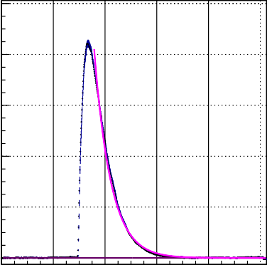
100
amplitude [mV]

80

τ = 64(1) ns
1.5

1
 |  | = 0 | .34 | (1) n | s
 | σTD

mean of the TD distribution [ns]

0.5
60

0

40
−0.5

20 −1

0
0 200 400 600 800 1000
time [ns]

−1.5

10 20 30 40 50 60 70 80 90
source position [mm]
Fig. 2. Left: averaged signal registered from LYSO:Ce fiber along with the fitted decay function. Right: dependence of the mean TD on the radioactive source position. Vertical error bars represent time resolution. Average time resolution σTD calculated for the series is given.
2 The applied acquisition window of 1 µs was insufficient to determine the long decay constant τslow with a better accuracy.

The time resolution is determined by analysing the time differences be- tween correlated signals registered at both ends of the fiber TD = T0,ch0 T0,ch1. Figure 2 shows a dependence of the mean TD on the source position for a LYSO:Ce fiber. Vertical error bars correspond to the time resolu- tion. In order to eliminate the walk effect, only events forming the 511 keV peak have been included. Obtained timing resolution for LYSO:Ce fiber is σTD = 0.34 ns. For comparison, the timing resolutions of GAGG:Ce and LuAG:Ce are 0.48 ns and 2.1 ns, respectively.
−

    - Geant4 simulations of fiber performance
A single fiber, coupled to two SiPMs at the ends, is simulated in Geant4 with the purpose to determine resolutions as functions of gamma energy. Additionally, the results of these simulations are used to develop a method to reconstruct the deposited energy and the position of the interaction along the fiber.
The simulated setup is shown in Fig. 3 on the left side. The simulation contains a LYSO:Ce-fiber, which performed best in the laboratory tests, of the size 1 1 100 mm3. While in Section 3 the results for a naked fiber are presented, in the simulations the fiber is coated with a dispersive titanium paint of a thickness of 0.01 mm and coupled to two 1 mm2 SiPMs via a
× ×
0.1 mm thick layer of optical gel. The used Geant4 version is 10.04.p02 and in addition to the predefined physics list QGSP_BIC_HP_EMZ, the simulation of optical photons is activated. The number of simulated optical photons counted by an SiPM is adjusted taking into consideration a model of an SiPM describing its PDE, dark noise and cross talk.

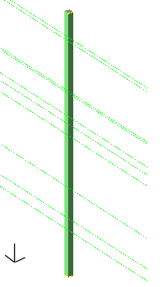
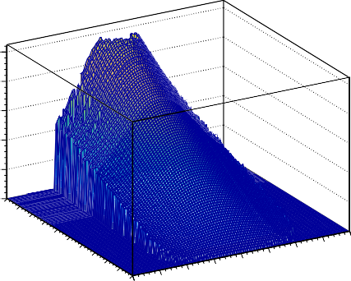
5
reconstructed energy [MeV]
4
3
2
1
0
2000
1800
1600
Q
1400
1200
1000
y 800
Average
600
z x 400
−1
[p.e.]
200 0 −2 −1.5

−0.5 0 0.5 1

1.5 2
LR
Fig. 3. Left: sketch of the simulated setup. The LYSO:Ce fiber is coated with a titanium paint and coupled via an optical gel to the SiPMs. The direction of the simulated primary photons is also shown. Right: look-up table for the deposited energy.
M
Equations (1), (2) show that QAverage = √S1S2 is proportional to the number of scintillation photons produced in the fiber S0 and thus to the de- posited energy Edep. The variable MLR introduced before is proportional to the position of the interaction along the fiber. Based on these two variables, look-up tables (LUTs) to reconstruct the energy and position of the inter- action are constructed. To take into account the influence of f (λgeo(y), y), the tables are built depending on both variables. To build the LUTs, the interactions of photons with energies from 0.5 MeV to 6 MeV are simulated all along the fiber. For each interaction, MLR and QAverage are calculated and sorted into bins. For each resulting MLR and QAverage pair, the distri- butions of the energy and position are fitted with a Gaussian function to determine the most probable values for the reconstruction. For the uncer- tainty of a reconstructed value, two more LUTs are built, which are filled with the standard deviations resulting from the fits instead of mean values. The resulting LUT for the energy reconstruction is shown in Fig. 3.
These LUTs are used to perform reconstruction of position and energy deposits on a different set of simulated events. The differences of the simu- lated and reconstructed positions and energies are given in Figs. 4 and 5. The resulting resolutions are shown as well.

1
reconstructed energy - deposited energy [MeV]
0.8
0.6
0.4

×103 40
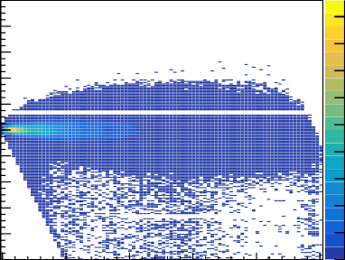
90

σE/Ereconstructed [%]
35
80
70 30
0.2 60
0 50
−0.2 40
−0.4 30
−0.6 20
−0.8 10
−1 0
0 1 2 3 4 5
deposited energy [MeV]
25
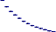
20

15

10

5

0
0 0.5 1 1.5 2 2.5 3 3.5 4 4.5
deposited energy [MeV]
Fig. 4. Left: difference between the reconstructed and simulated energies plotted versus the simulated energy. Right: resulting resolution of the energy reconstruc- tion via LUTs.
The LUTs yield to an energy resolution of 7% at 511 keV, which improves for higher energies to 3%. The position resolution is strongly dependent on the position along the fiber. In the middle of the fiber, a resolution of about 6.5 mm is reached which improves towards the ends to about 0.5 mm. This effect is caused by photons that are not reflected at the surface of the fiber but reach directly the SiPMs. Closer to the fiber ends the number of these photons drastically increases which yields to the improved resolution. The position resolution averaged over the fiber improves by a factor of ∼ 2.5 from the energy of 511 keV to 4.4 MeV.
∼
∼

15
reconstructed position - simulated position[mm]

10

5

0

−5

−10

−15

0 20 40 60 80 100
simulated position [mm]
×103
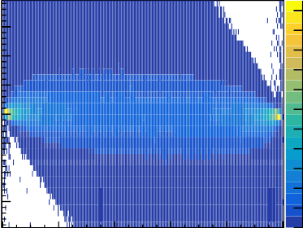
22
20
18
16
14
12
10
8
6
4
2
0

8

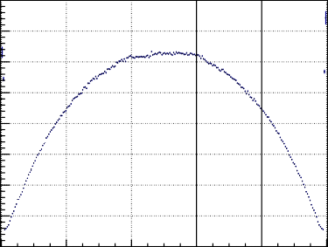
7
σposition [mm]
6

5

4
3

2
1
0
0 20 40 60 80 100
position [mm]
Fig. 5. Left: difference between the reconstructed and simulated positions plotted against the simulated position. Right: resolution of the LUT method of position reconstruction.

    - Conclusions
We have conducted a series of real and virtual experiments aiming at the determination of scintillating fiber properties. The dimensions of the investigated fibers were 1 1 100 mm3. Among the three tested materials: LuAG:Ce, LYSO:Ce and GAGG:Ce, LYSO shows the best performance in terms of light output, and is comparable or better in terms of energy and time resolution and signal duration. It is also widely available and inexpen- sive, compared with other materials. The drawback of intrinsic radioactivity turns out negligible when building coincident events from hits in the two de- tector modules. The simulated and measured energy resolution agree at 511 keV and yield 6–7%. The simulations indicate, that at higher energies a resolution as good as 3% can be expected. Position resolution along the fiber found in the simulations is about 6 mm near the fiber center and < 1 mm close to the ends. This is insufficient for a CC, therefore, other methods al- lowing to improve it are investigated. One of the possible solutions is a setup geometry in which the neighbouring layers have different fiber orientation. This option is currently under study.
× ×

The research is funded under the SONATA BIS grant of the National Science Centre, Poland (NCN) No. 2017/26/E/ST2/00618, and DSC 2017 and DSC 2018 grants for young researchers and Ph.D. students of the Faculty of Physics, Astronomy and Applied Computer Science of the Jagiellonian University, the Polish Ministry of Science and Higher Education (MNiSW) Nos. 7150/E-338/M/2017 and 7150/E-338/M/2018.

REFERENCES

- NuPECC report 2014: Nuclear Physics for Medicine,
http://www.nupecc.org/pub/npmed2014.pdf
- J. Krimmer et al., Nucl. Instrum. Methods Phys. Res. A 878, 58 (2018).
- Ch. Richter et al., Radiother. Oncol. 118, 232 (2016).
- F. Hueso-González et al., Phys. Med. Biol. 63, 185019 (2018). [5] A. Koide et al., Sci. Rep. 8, 8116 (2018).
- P. Bennati et al., JINST 12, C05009 (2017).
- K. Shimazoe et al., Nucl. Instrum. Methods Phys. Res. A (2018), DOI:10.1016/j.nima.2018.10.177.
- P. Lecoq, Nucl. Instrum. Methods Phys. Res. A 809, 130 (2016).
- P. Anfré et al., IEEE Trans. Nucl. Sci. 54, 391 (2007).
- K. Rusiecka et al., in: Engineering of Scintillation Materials and Radiation Technologies Selected Articles of ISMART2018, (Eds.) M. Korzhik,
  - Gektin, Springer, 2019, p. 195.
- K. Pauwels et al., JINST 8, P09019 (2013).

