
International Conference on Particle Physics and Astrophysics IOP Publishing
IOP Conf. Series: Journal of Physics: Conf. Series 798 (2017) 012114 doi:10.1088/1742-6596/798/1/012114

Recent Results from Borexino

D Jeschke1 for the Borexino Collaboration
M Agostini2, K Altenmuller1, S Appel1, V Atroshchenko3, G Bellini4, J Benziger28,
D Bick14, G Bonfini7, D Bravo8, B Caccianiga4, F Calaprice5, A Caminata6, M Carlini7,
P Cavalcante7,8, A Chepurnov9, K Choi10, D D’Angelo4, S Davini2, A Derbin11, L Di
Noto6, I Drachnev2, A Etenko3, K Fomenko12, D Franco13, F Gabriele7, C Galbiati5,
C Ghiano6, M Giammarchi4, M Goeger-Neff1, A Goretti5, M Gromov9, C Hagner14,
E Hungerford15, Aldo Ianni7, Andrea Ianni5, A Jany16, K Jedrzejczak16, D Jeschke1,
- Kobychev17, D Korablev12, G Korga7, D Kryn13, M Laubenstein7, B Lehnert18,
E Litvinovich3,19, F Lombardi7, P Lombardi4, L Ludhova20,21, G Lukyanchenko3,
- Machulin3,19, S Manecki8,22, W Maneschg23, G Manuzio6, S Marcocci2,E Meroni4,
M Meyer14, L Miramonti4, M Misiaszek7,16, M Montuschi24, P Mosteiro5, V Muratova11,
B Neumair1, L Oberauer1, M Obolensky13, F Ortica25, M Pallavicini6, L Papp1,
A Pocar29, G Ranucci4, A Razeto7, A Re4, A Romani25, R Roncin7,13, N Rossi7,
S Schonert1, D Semenov11, M Skorokhvatov3,19, O Smirnov12, A Sotnikov12, S Sukhotin3,
- Suvorov3,26, R Tartaglia7, G Testera6, J Thurn18, M Toropova3, E Unzhakov11,
A Vishneva12, R B Vogelaar8, F von Feilitzsch1, H Wang26, S Weinz27, J Winter27,
M Wojcik16, M Wurm27, Z Yokley8, O Zaimidoroga12, S Zavatarelli6, K Zuber18 and
G Zuzel16
1Physik-Department and Excellence Cluster Universe, Technische Universitat Miinchen, 85748
Garching, Germany
- Gran Sasso Science Institute (INFN), 67100 L’Aquila, Italy
- National Research Center Kurchatov Institute, 123182 Moscow, Russia
- Dipartimento di Fisica, Universita degli Studi e INFN, 20133 Milano, Italy
- Physics Department, Princeton University, Princeton, NJ 08544, USA
- Dipartimento di Fisica, Universita degli Studi e INFN, Genova 16146, Italy
- INFN Laboratori Nazionali del Gran Sasso, 67010 Assergi (AQ), Italy
- Physics Department, Virginia Polytechnic Institute and State University, Blacksburg, VA 24061, USA
- Lomonosov Moscow State University Skobeltsyn Institute of Nuclear Physics, 119234 Moscow, Russia
- Department of Physics and Astronomy, University of Hawaii, Honolulu, HI 96822, USA
- St. Petersburg Nuclear Physics Institute NRC Kurchatov Institute, 188350 Gatchina, Russia
- Joint Institute for Nuclear Research, 141980 Dubna, Russia
13AstroParticule et Cosmologie, Universite Paris Diderot, CNRS/IN2P3, CEA/IRFU, Observatoire de
Paris, Sorbonne Paris Cite, 75205 Paris Cedex 13, France
- Institut fur Experimentalphysik, Universitat, 22761 Hamburg, Germany
- Department of Physics, University of Houston, Houston, TX 77204, USA
- M. Smoluchowski Institute of Physics, Jagiellonian University, 30059 Krakow, Poland
- Kiev Institute for Nuclear Research, 06380 Kiev, Ukraine
- Department of Physics, Technische Universitat Dresden, 01062 Dresden, Germany
- National Research Nuclear University MEPhI (Moscow Engineering Physics Institute), 115409
Moscow, Russia
- RWTH Aachen University, 52062 Aachen, Germany
- IKP-2 Forschungzentrum Jualich, 52428 Jualich, Germany
- Physics Department, Queen’s University, Kingston ON K7L 3N6, Canada
- Max-Planck-Institut fur Kernphysik, 69117 Heidelberg, Germany
- Dipartimento di Fisica e Scienze della Terra Universita degli Studi di Ferrara e INFN, Via Saragat
1-44122, Ferrara, Italy
- Dipartimento di Chimica, Biologia e Biotecnologie, Universita e INFN, 06123 Perugia, Italy
- Physics and Astronomy Department, University of California Los Angeles (UCLA), Los Angeles,
California 90095, USA
- Institute of Physics and Excellence Cluster PRISMA, Johannes Gutenberg-Universitaat Mainz,
55099 Mainz, Germany
- Chemical Engineering Department, Princeton University, Princeton, NJ 08544, USA
- Amherst Center for Fundamental Interactions and Physics Department, University of
Massachusetts, Amherst, MA 01003, USA
Content from this work may be used under the terms of the Creative Commons Attribution 3.0 licence. Any further distribution
of this work must maintain attribution to the author(s) and the title of the work, journal citation and DOI.
Published under licence by IOP Publishing Ltd
1
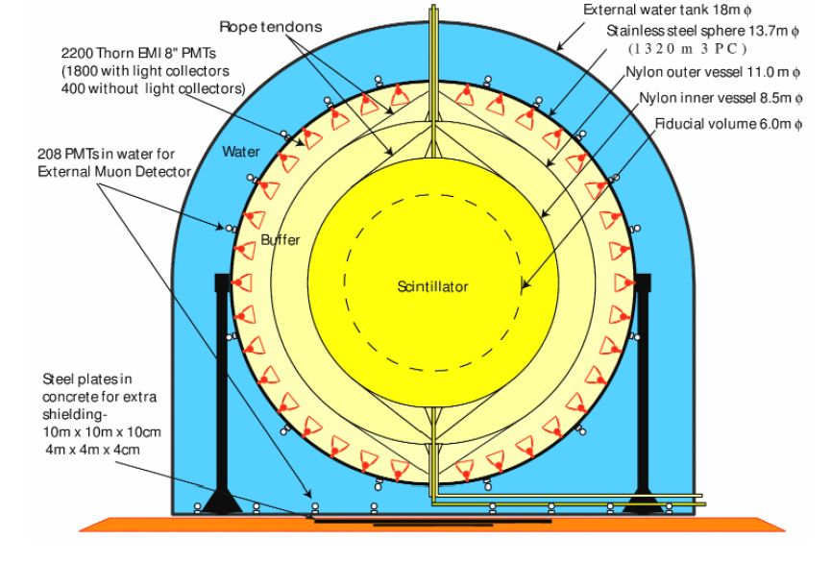
International Conference on Particle Physics and Astrophysics
IOP Conf. Series: Journal of Physics: Conf. Series 798 (2017) 012114
IOP Publishing
doi:10.1088/1742-6596/798/1/012114
E-mail: dominik.jeschke@tum.de
Abstract. The Borexino experiment is taking data since 2007 at the Laboratori Nazionali del
Gran Sasso in Italy accomplishing outstanding achievements in the field of neutrino physics. Its
success is strongly based on the unprecedented ultra-high radio-purity of the inner scintillator
core. The main features of the detector and the impressive results for solar and geo-neutrinos
obtained by Borexino so far are summarized. The main focus is laid on the most recent results,
i.e. the first real-time measurement of the solar pp neutrino flux and the detection of the
signal induced by geo-neutrinos with a significance as high as 5.9a. The measurement of the
pp neutrino flux represents a direct probe of the major mechanism of energy production in the
Sun and its observation at a significance of 10a proves the stability of the Sun over a time of
at least 10 years. It further puts Borexino in the unique position of being capable to test the
MSW-LMA paradigm across the whole solar energy range. The geo-neutrino data allow to infer
information concerning important geophysical properties of the Earth that are also discussed.
The perspectives of the final stage of the Borexino solar neutrino program that are centered on
the goal of measuring the CNO neutrinos that so far escaped any observation are outlined.

1. The Borexino Detector
The Borexino detector is located at the Laboratori Nazionali del Gran Sasso in Italy and shielded
by 3800m.w.e., thus reducing the cosmic muon flux by a factor ~ 106 compared to the surface.
A schematic view is shown in figure 1.
The whole detector is encompassed in a steel dome containing 2.1 kt of water. This part of
Borexino Experiment
Figure 1. Schematic view of the Borexino detector.
the detector is used as a neutron and gamma shield and especially as a highly efficient muon
veto. The Cherenkov light emitted by passing muons is collected by 208 photomultiplier tubes
(PMTs) placed on the Stainless Steel Sphere (SSS) and the floor of the water rank. The SSS
separates the outer water Cherenkov detector (OD) from the inner scintillator detector (ID),
thus creating two independent detectors in terms of light propagation. On the inside surface
of the SSS, 2212 PMTs are mounted to collect the scintillation light from the innermost part
of the detector providing an optical coverage of 34%. The scintillator core is contained in the
inner nylon vessel (IV) at a radius of 4.25 m that acts as a radon barrier. It is composed of 2701
of pseudocumene (PC, 1,2,4-trimethylbenzene, C6H3(CH3)3) with PPO (2,5-diphenyloxazole,
C15HuNO) at a concentration of 1.5g/l added as a wavelength shifter. The so called buffer
region between the IV and the SSS is filled with a mixture of PC and DMP (dimethylphytalate)
as a quencher. Events from this region are strongly suppressed to prevent the external gamma
background originating mainly from the PMTs and the SSS producing a signal. A further nylon
vessel is placed at 5.5 m radius. For a detailed description of the Borexino detector, see [1].
2
International Conference on Particle Physics and Astrophysics IOP Publishing
IOP Conf. Series: Journal of Physics: Conf. Series 798 (2017) 012114 doi:10.1088/1742-6596/798/1/012114

2. Results of Solar Neutrino Measurements
Table 1 summarizes Borexino’s solar neutrino measurements. With the measurements of all solar
neutrino fluxes of the pp-chain but the hep-neutrinos, Borexino is the only experiment being
capable to probe the entire solar neutrino spectrum and puts it in the unique position to test
the Mikheyev-Smirnov-Wolfenstein large-mixing angle (MSW-LMA) paradigm across the whole
solar energy range. Besides the measurements of the pp-chain, Borexino also provides the world-
leading limit for the flux of neutrinos originating in the secondary CNO cycle. In addition,
Table 1. Solar Neutrino Measurements.
Species | Rate cpd/100t | Flux cm 2s 1 | Reference
pp  7Be  pep  8B  CNO | 144 ± 13 ± 10  46 ± 1.5+1-g  3.1 ± 0.6 ± 0.3  0.22 ± 0.04 ± 0.01  < 7.9(95% C.L.) | (6.6 ± 0.7) ■ 1010  (4.48 ± 0.24) ■ 109  (1.6 ± 0.3) ■ 108  (2.4 ± 0.4 ± 0.1) ■ 106  < 7.7 ■ 108(95% C.L.) | Nature512(2014)7515  PRL107(2011)141302  PRL108(2012)051302  PRD82(2010)033006  PRL108(2012)051302
the absence of a day-night asymmetry in the 7Be neutrino flux [5] and its yearly modulation [6]
could be explored. Detailed studies of neutrons and further cosmogenic backgrounds [8] as well
as the seasonal modulation of the muon flux [7] have been performed and the best limit on the
e- decay could be set recently [9].

3. Measurement of the solar pp-neutrino flux
In 99.76%, the solar pp-chain starts with the fusion of two protons into a Deuteron under the
emission of a positron and an electron-neutrino. These neutrinos range from 0-420 keV, thus
transferring a maximum energy of 264 keV to electrons in the scintillator via elastic scattering,
the detection reaction. In order to extract the interactions from the solar pp-neutrinos, 408 live
days of data acquired between January 2012 and May 2013 have been carefully analyzed above a
threshold energy of 165 keV and within a fiducial volume of 85.51. This time period followed an
extensive purification campaign performed in 2010 and 2011 during which especially the contents
of 85Kr and 210Bi, important background sources in the low energy regime, were further reduced.
Before, the pp-neutrino flux could only be inferred indirectly through the combination of the
radiochemical experiments GALLEX and SAGE above a threshold energy of 233 keV [2].
Figure 2 shows the Borexino energy spectrum between 165-590 keV with fits of the pp-neutrino
flux as well as relevant background sources. Due to its huge effect on the pp-neutrino
measurement, the 14C rate has been measured independently. In order to overcome trigger
threshold effects, the shape and rate have been obtained by analyzing events that are found
within the trigger window of 16 ^s after an event that already issued a trigger. The measurement
yields a 14C rate of (40 ± 1)Bq/100t. To estimate the contribution of pile-up events, i.e.
events that occur so closely in time that they cannot be separated, a data driven method has
been applied. Real triggered events without any selection cuts are overlaid by random data
and the combined synthetic events selected and reconstructed. These events, thus, feature by
construction all possible pile-up event combinations.
The pp-neutrino rate was obtained through a fit of the data between 165 and 590 keV with
the 14C and the synthetic pile being constrained and the 7Be neutrino rate as measured in [3].
The 214Pb rate has been fixed to the measured rate of fast, time correlated 214Bi(^) —214 Po(a)
coincidences, the CNO and the pep neutrino rate to their values in the Standard Solar Model
(SSM). Other free parameters of the fit are the 210Po, the 85Kr, and the 210Bi background rates.
3
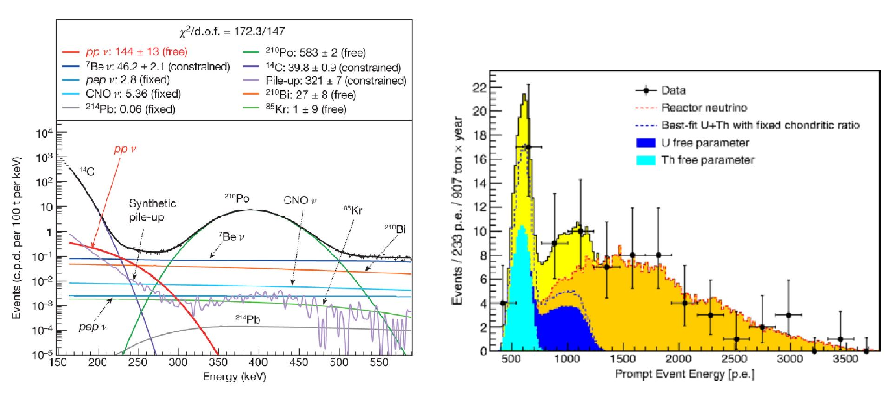
International Conference on Particle Physics and Astrophysics IOP Publishing
IOP Conf. Series: Journal of Physics: Conf. Series 798 (2017) 012114 doi:10.1088/1742-6596/798/1/012114
Figure 2. Energy spectrum between 165 and
590 keV. Data is shown in black together with
fits to the pp-neutrino flux in red and several
background sources. The 14C spectrum is
shown in dark and the synthetic pile-up in
light purple. The best fit yields (144 ± 13) cpd
as the pp-neutrino interaction rate.
Figure 3. Light yield spectrum of Ve candidates
and the best fit, where 500 p.e. ~ 1 MeV. Dotted
lines show the best fit for geo and reactor
Ve assuming the chondritic ratio, colored areas
show the result of a separate fit with U (blue)
and Th (light blue) left as free and independent
parameters.
The solar pp-neutrino rate measured by Borexino is (144 ± 13(stat.) ± 10(syst.)) cpd/100t
[2]. The stability of the result was verified by altering the initial fit conditions, such as the
energy range or data selection criteria. The absence of a pp-neutrino signal can be excluded
a 10a. The measured interaction rate by Borexino corresponds to a solar pp-neutrino flux of
T(Borexino) = (6.6 ± 0.7) ■ 1010 cm-2s-1 and is in good agreement with the prediction from the
SSM of T(SSM) = (5.98 ■ (1 ± 0.006)) ■ 1010 cm-2s-1 as well as with the combined best fit value
of the radiochemical and other solar experiments of T(other) = (6.14 ± 0.61) ■ 1010 cm-2s-1[4].
The survival probability of pp-neutrinos is found to be P(ve ^ ve) = 0.63 ± 0.12 putting a
constraint on the MSW-LMA solution.
With the first direct measurement of the pp-neutrino flux made possible by the unprecedented
radio-purity of the detector, Borexino could prove the proton-proton fusion reaction to be
the major process for energy production in the Sun and Sun-like stars as well as the Sun’s
stability over a timescale of at least 105 years. Although the experimental uncertainty does not
allow the discrimination between low or high metallicity solar models, future Borexino inspired
experiments might reach the necessary 1% precision.
4. Geo Neutrino Results
Geo neutrinos are electron-antineutrinos (Ve) that are produced in radioactive fi decays of long-
lived radio-isotopes naturally abundant in the Earth’s crust and mantle such as elements from
the 238U and 232Th chains or 40K. Borexino detects Ve via the inverse fi decay Ve + p ^ n + e+
at a threshold energy of 1.806 MeV. This threshold leaves only the decays of 238U and 232Th
to contribute to the signal at Borexino. The deposited energy by the Ve results in a prompt
signal from the positron, to which the kinetic energy of the Ve is transferred, and the emission
of a y after the neutron was captured on Hydrogen (99%) or Carbon (1%). The delayed
coincidence between the positron signal and the capture y with the mean neutron capture
4
International Conference on Particle Physics and Astrophysics IOP Publishing
IOP Conf. Series: Journal of Physics: Conf. Series 798 (2017) 012114 doi:10.1088/1742-6596/798/1/012114
time of 259.7± 1.3(stat.) ±2.0(syst.) ^s [8] constitutes an unambiguous signal. The only relevant
background source producing more than one event in the data sample are reactor Ve. 75% of
the events that could mimic a Ve signal are produced by 9Li or 8He decays, a — n reactions, and
accidental coincidences. These mimicking backgrounds have been estimated independently and
been found to contribute in sum less than one coincidence in the data sample.
Figure 3 shows an un-binned likelihood fit of the energy spectrum of the 77 selected prompt Ve
candidate events in a total exposure of 907 ± 441 ■ yr. The spectra of geo and reactor-neutrino
spectra are obtained from Monte Carlo simulations. In the fit, the signal contributions from
geo and reactor-neutrinos are left free, whereas the contributions of the mentioned background
sources are constrained to their estimated values. Remaining minor background sources are left
out due to uncertainties of their energy spectra and contribute ~ 1% to the best fit. Their
contribution to the systematic uncertainty is covered in the uncertainty of the energy scale.
Under assumption of the ratio for the masses of U and Th as suggested by the chondritic
model of m(Th)/m(U) = 3.9, the best fit yields Sgeo = 23.7-g 7(stat.)-09(syst.) events =
43.5lJ0;8(stat.)+2'I(syst.) TNU and Sreactor = 52.7—8 . f(stat.)+0 ' 9(syst.) events=96.6—14 . |(stat.)
+5 ' o(syst.)TNU, where 1 Terrestrial Neutrino Unit = 1 event / year / 1032 protons and the
prediction for reactor neutrino events being (87 ± 4) TNU [10].
With this measurement, Borexino alone observes geo-neutrinos at 5.9a significance. The fluxes
of Ve for U and Th are measured to be T(U) = (2.7 ± 0.7) ■ 106 cm-2s-1 and T(Th) =
(2.3 ± 0.6) ■ 106 cm-2s-1, respectively. Leaving the U and Th contributions as free parameters in
the fit, Borexino would with more exposure be able to separate those contributions and perform
real-time geo-neutrino spectroscopy. The radiogenic heat production H(U+Th) for the present
result is limited to the range of 23-36 TW, including the uncertainty of the distribution of heat
producing elements inside the Earth. Considering the estimation of the total geo-neutrino signal
from the local crust and the contribution from the rest of the crust, a signal from the mantle of
20.9—I5. 1 TNU is measured excluding the absence of a mantle contribution at 98% C.L.

5. Prospects and Goals of Borexino Phase II
The goals of the second phase of the Borexino solar neutrino program are mainly centered around
improving the limit of the CNO neutrino flux and possibly measure it. To allow this, a strong
effort was made to control the temperature of the detector and prevent convective motions that
disturb the measurement of the 210Bi contamination in the detector. Its precise estimation is
crucial for a possible CNO neutrino measurement since its spectrum and the CNO neutrino
spectrum are quasi-degenerate. Besides this, all the results of Phase I for fluxes of the pp-chain
shall be updated with the special goal of a precision better than 3% for the 7Be neutrino flux.
With already approximately five years of high quality data after the purification campaign being
already acquired and about one year until the SOX campaign will start, six years of excellent
data will be available for Borexino to enhance the extraordinary results already obtained.

References
- Alimonti G et al. 2009 Nucl. Instr. and Meth. 600(3) 568-93
- Borexino Collaboration 2014 Nature 512 583-6
- Bellini G et al. 2011 Phys. Rev. Lett. 107 141302
- Ianni A 2014 Physics of the Dark Universe 4 44-9
- Bellini G et al. 2012 Phys. Lett. B 707 22-6
- Bellini G et al. 2014 Phys.Rev. D 89 112007
- Bellini G et al. 2012 Journ. of Cos. and Astropart. Phys. 2012(05) 015
- Bellini G et al. 2013 Journ. of Cos. and Astropart. Phys. 2013(08) 049
- Agostini M et al. 2015 Phys. Rev. Lett. 115 231802
[10] Agostini M et al. 2015 Phys. Rev. D 92 031101
5

