
Signature:©PolJRadiol,2010;75(2):82-87
CASEREPORT
MRIdiagnosisofdiastematomyeliaina78-year-old
Received:2010.02.19
Accepted:2010.03.16
woman:Casereportandliteraturereview
UrszulaZaleska-Dorobisz1,JoannaBladowska1,AnnaBiel1,LeszekW.Pałka2,DanielHołownia1
1DepartmentofRadiology,WrocławMedicalUniversity,Wroclaw,Poland2PrivateMedicalPractice,Wrocław,Poland

Author’saddress:UrszulaZaleska-Dorobisz,DepartmentofRadiology,WrocławMedicalUniversity,MariiSkłodowskiej-Curie58Str.,Wrocław,Poland,e-mail:ulador@rad.am.wroc.pl
Summary
Diastematomyeliaisararecongenitalmalformationofthespinalcord,whichbelongstothegroupofoccultspinaldysraphisms.Thisdisorderconsistsintheseparationofthespinalcordintotwopartsinthesagittalplane(hemicords).Diastematomyeliamaycoexistwithotherspinaldysraphisms,suchasmyelomeningocele,meningocele,spinallipoma,neuroentericcystsordermalsinusesandvertebralabnormalities,suchashemivertebrae,butterflyvertebraeorscoliosis.
Wereportedacaseof a womanwithacongenitaldefectof thespinalcord, intheformofdiastematomyelia,whichwasdiagnosedattheageof78.Thepatienthadbeencomplainingofbackpainformanyyears.TheX-rayradiogramsshowedthefusionofvertebraL3–L4,defectivefusionofposteriorspinalbonyelementsL5–S1.Moreover,abnormalhairgrowth(hypertrichosis)inthelumbarregionwasfound.TheseparationofthespinalcordwasonlydiagnosedinMRimagingwhichwasperformedattheageof78.
Diastematomyeliaismostlydiagnosedintheprenatalperiodorinchildren;muchlessofteninadults.ThisdisorderhastobetakenintoaccountindifferentialdiagnosisinpatientswithX-raysrevealingdefectsofthespineintheformofhemivertebrae,butterflyvertebraeorthefusionofvertebrae,especiallywhenthereareadditionalskinlesionsinthebackarea,atthelevelofthediagnosedosseousanomalies.
Background:
CaseReport:
Conclusions:
Keywords:
diastematomyelia•spinaldysraphism•hypertrichosis•MRI
PDFfile:
http://www.polradiol.com/fulltxt.php?ICID=878521
Background
butterflyvertebrae,andscoliosis[1,2,4,5].Thismalforma-tionmayalsobeaccompaniedbyabnormalitiesofinter-nalorgans– kidneys,anusor reproductiveorgans[4]. Mostauthorsbelievethatcasesofanisolateddiastematomyeliaareconnectedwithbetterprognosis[1,3,4].
Diastematomyeliaisararedysraphiclesionofthespinalcordinwhichapartofthespinalcordissplitinthesagit-talplaneintotwohemicords[1–3].Eachofthemincludesthecentralcanal,onedorsalandoneventralroot.Thesplittingofthecordiscausedbythepresenceofanosseousorafibrocartilaginousseptum.Thedefectisaresultofanincorrectdevelopmentofthenotochordbetweenthe15thandthe18thdayofpregnancy[1–3].
Wereportedacaseofawomanwithacongenitaldefectofthespinalcord,intheformofdiastematomyelia,whichwasdiagnosedattheageof78years.
Theliteraturepresentsmultiplecasesofdiastematomye-liarevealedintheprenatalperiodbymeansofUSGandconfirmedbyMRI[1,4,6,7].Mostpatientswithadiag-noseddiastematomyeliaarechildrenundertheageof7[5].Inadultpatients,suchaspinalabnormalityisdiagnosed
Diastematomyeliamaybeaccompaniedbyotherspinaldysraphisms,suchasmyelomeningocele,meningocele,spi-nallipoma,neuroentericcystsordermalsinus,aswellascongenitaldefectsofthespine,includinghemivertebrae,
82

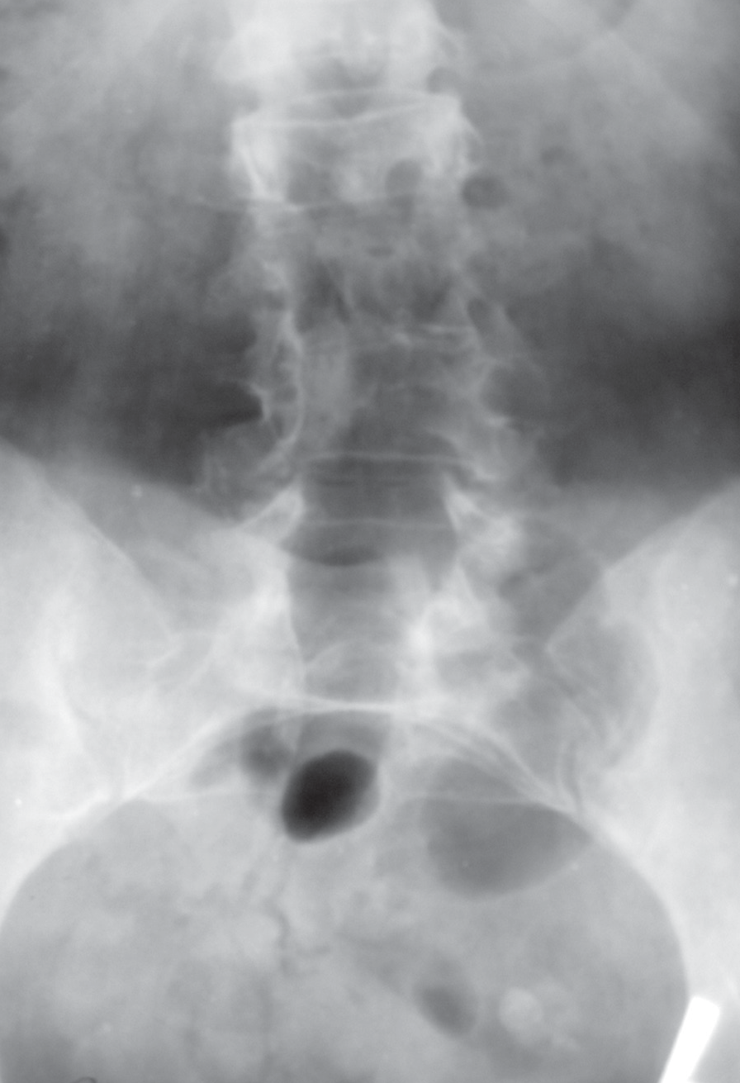
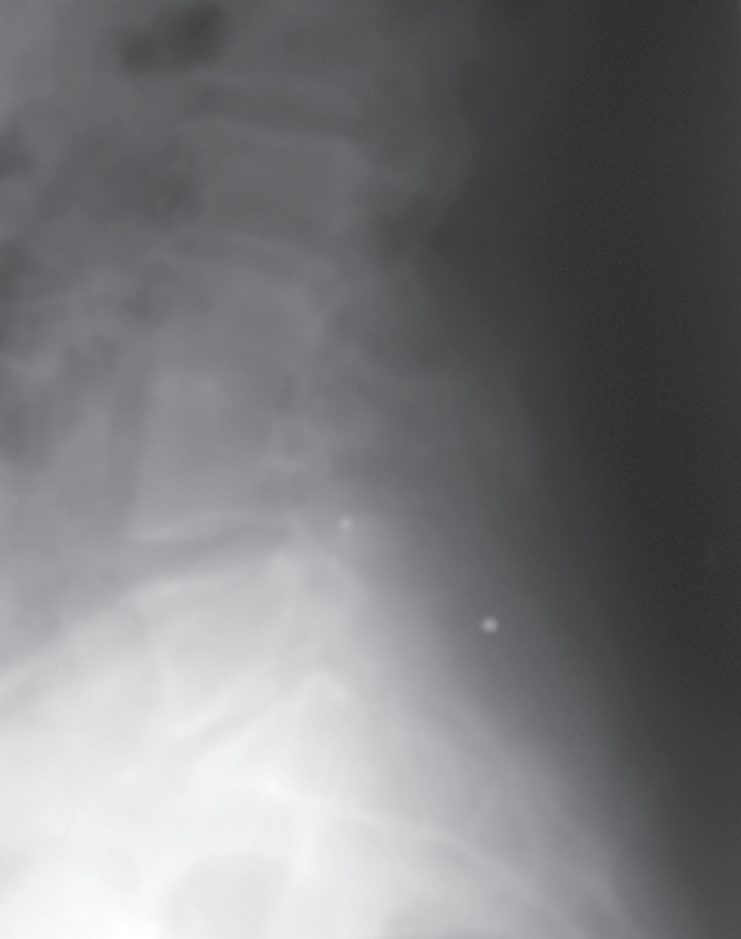
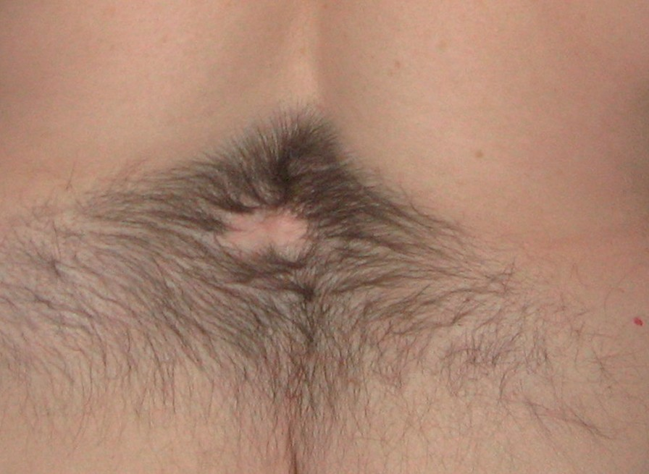
©PolJRadiol,2010;75(2):82-87
Zaleska-DorobiszUetal–MRIdiagnosisofdiastematomyelia…
Figure2.Pictureofthelumbarregion.Hypertrichosisof„fauntail”type.
advancedageandtheoldestdescribedpatientwas44yearsoldwhenshewasdiagnosedwithdiastematomyelia[8].
CaseReport
The78-year-oldwoman,experiencingbackpainformanyyears,presentedfordiagnosticprocedures.Herfirstpainsymptomswithinthesacrolumbarspineappearedwhensheturned30.ThefirstdiagnosticexaminationwasanX-rayofthesacrolumbarback,performed7yearsafterthefirstpainsymptoms.TheX-raysshoweddegenerativelesionsofthelowerlumbarvertebrae.Therewasalsoafusionofthe3rdand4thlumbarvertebraeandaflatteningofthe L3vertebralbody.
Duetopersistingandperiodicallyaggravatingpainattheageof46,thepatientunderwentanotherX-rayofthespine,revealinganincompletefusionoftheL3–L4verte-braeandadefectiveclosureofthevertebralarchesfromL5toS1(Figure1A,B).Thepatientreportedasignificantincreaseinpainintensityonreaching50yearsofage.Inthefollowingyears,shewasundergoingonlycontrolX-raysoftheL-Sspine,whichshoweddegenerativelesionsanddiscopathieswithachronicpainsyndromeofthespine.
Familyhistory:Healthyparents.Motherdiedattheageof84years,father–54(unknowncauseofhissuddendeath).Siblings–twosisters:healthy.
Gynaecologicalhistory:2pregnancies,2deliveries(sponta-neous),attheageof23and24;2children(males):thefirstsonhealthy,thesecondonewithdiastematomyelia,oper-atedonattheageof20duetourineincontinence.
Forthelastfewyears,thepatienthasbeenexperiencinganincreasingmuscleweaknessinthelowerlimbsandpro-gressivewalkingdifficulty.Moreover,theexaminationsrevealed:anischaemicheartdisease,hypertension,athrop-icgastritisandanaemia.
Figure1.X-rayofthelumbarspine:anterior-posteriorplane(A),lateralplane(B).Scoliosis,partialfusionoftheL3–L4bodies,anddefectivefusionofposteriorspinalbonyelementswithinL5–S1.
PhysicalexaminationcarriedoutinNovember2008revealedacompulsorystandingposture,flatfeet,patho-logicalvalgityoftherightkneeandanadvanced,fixedrightthoracicandleftlumbarscoliosis,uncompensated,
lessfrequently[8,9].Theavailableliteraturedoesnotreportanycasesofdiastematomyeliadiagnosedatsuchan
83

A

B

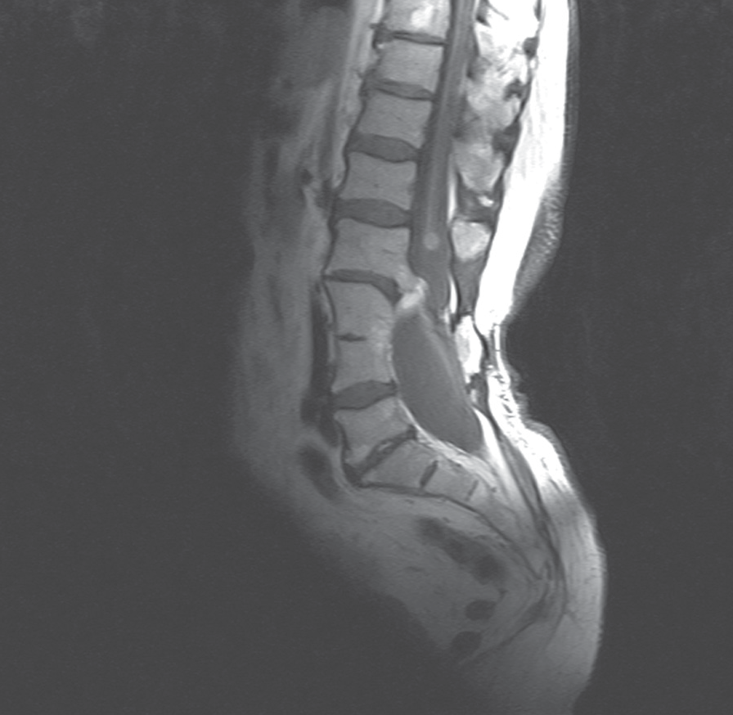
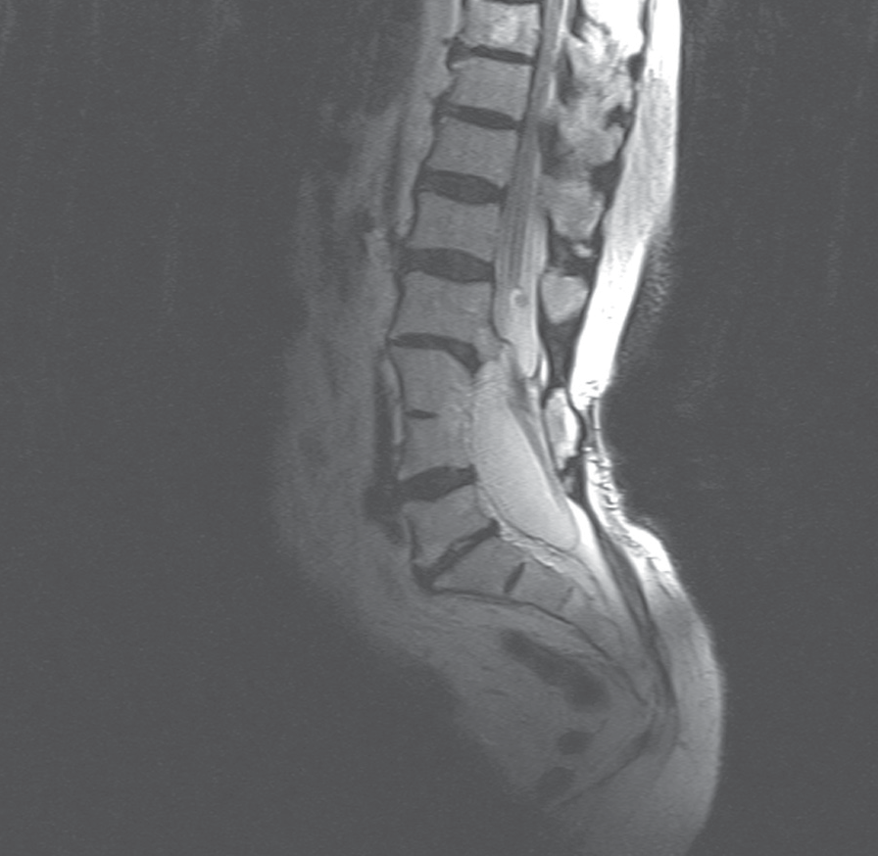
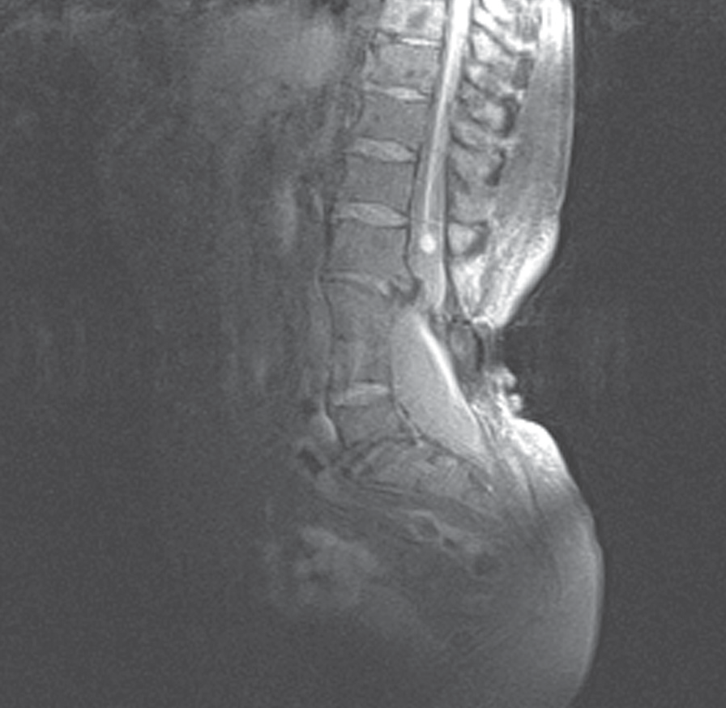
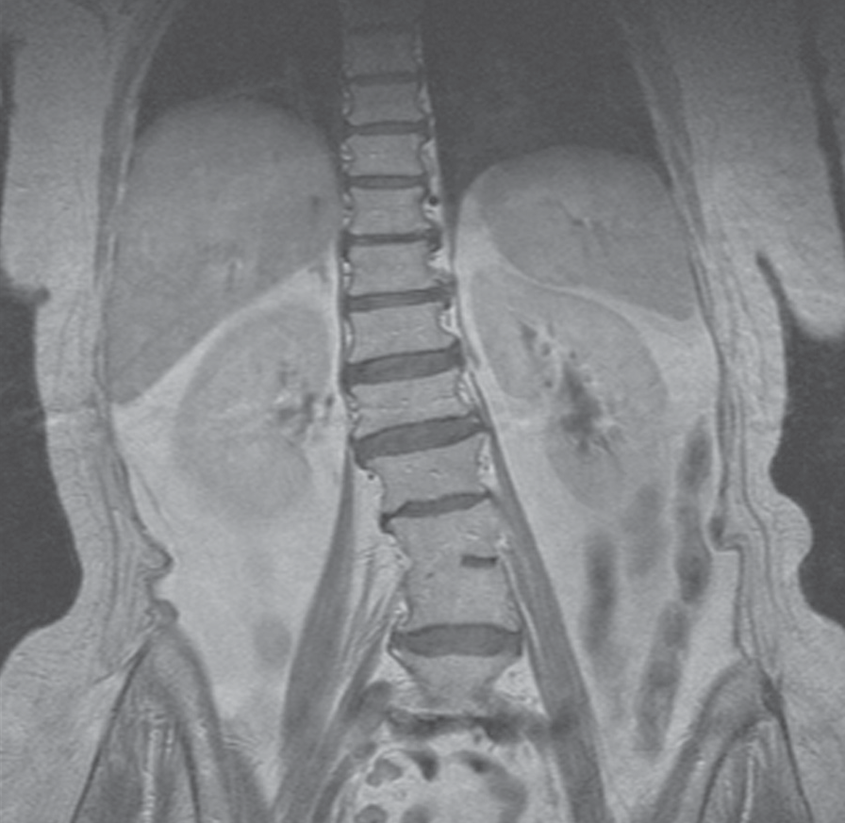
CaseReport
©PolJRadiol,2010;75(2):82-87
Figure3.T1-weightedimage,coronalplane.S-typescoliosisandpartialfusionoftheL3–L4bodies.
Figure4.MRimageinsagittalplane:T1-weightedimage(A),
T2-weightedimage(B),PD-weightedimage(C).Partialfusion ofvertebraL3–L4,anosseocartilaginousseptumontheL2–L5level.OntheL2level,thereisaroundstructure,possiblycorrespondingtoanepidermoidcyst.
withthespinalaxisdisplacedtotherightandasignifi-cantly increasedkyphosisandlordosis.Withinthelumbosa-cralspinetherewasacharacteristicareaofabnormalhairgrowth(hypertrichosis)(Figure2).Noothergaitabnormali-tieswererevealed;onlythedisturbancesofarticularmobil-ity,correspondingtothedescribed degenerativelesionsandmalformations.Moreover,largejointsofthelowerlimbsweremobile, withan inhibitedexternalrotation.
withapartiallypresentintervertebraldiscintheanteriorpart(Figures3,4A–C).Atthislevelofthespine,dorsally,theresubcutaneoustissuewasatrophied.Therewerealsomalformationsofthelumbarandsacralvertebrae,includ-ingL5andS1archcleavage,aswellasspinalcanalwiden-ing atthelevelL3–S2.
TheterminalconewasreachingtheL5level;nofeaturesofthetering.Whatismore,atthelevelofL1/L2spine,thespinalcordwasdividedintotwohemicordslocatedinonecommonduraltubeuptotheupperpartoftheL3body(Figures5,6).Below,therewasaanosseocartilaginousseptum,dividingthespinalcanalintotwoseparatecanalsincludingtwohemicordsinseparateduraltubes(Figure7).AttheleveloftheupperL4border,thehemicordswereagainrunningthroughonecommonduraltube,whichwassignificantlydilated,measuring2.7×2.6cm(Figure8).
Afterorthopaedicconsultation,thepatientwasreferredforanMRIofthelumbosacralspine,whichwasperformedinJanuary2010,intheMRILaboratoryofWroclawMedicalUniversity.Theexaminationwascarriedoutwitha1.5Tscanner,inFSEsequence(T1-andT2-weightedimages),PD,insagittal,transverseandcoronalplanes.OnthebasisoftheperformedsequencesoftheMRI,aleft-convexrota-tionalscoliosis andloss oflumbarlordosiswasfound.Moreover,therewasafusionofL3–L4vertebralbodies
84
A

B

C

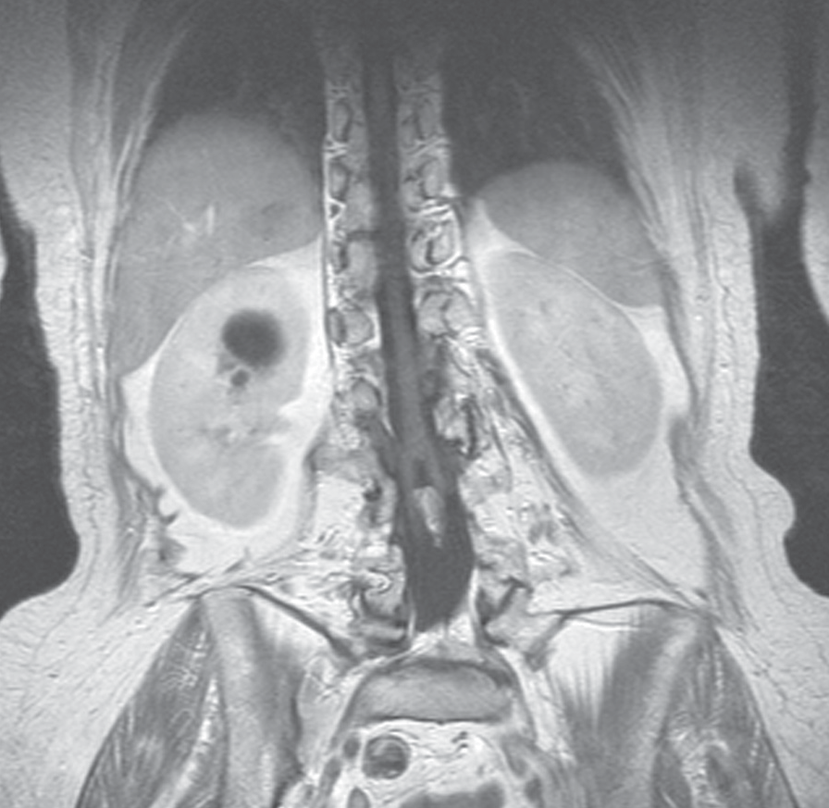
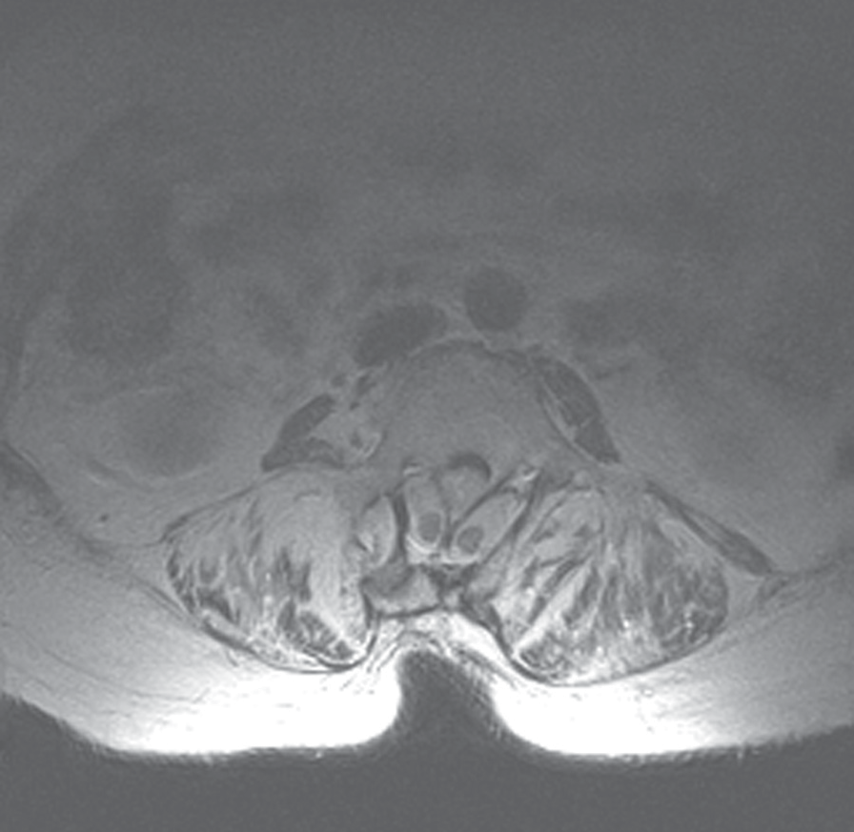
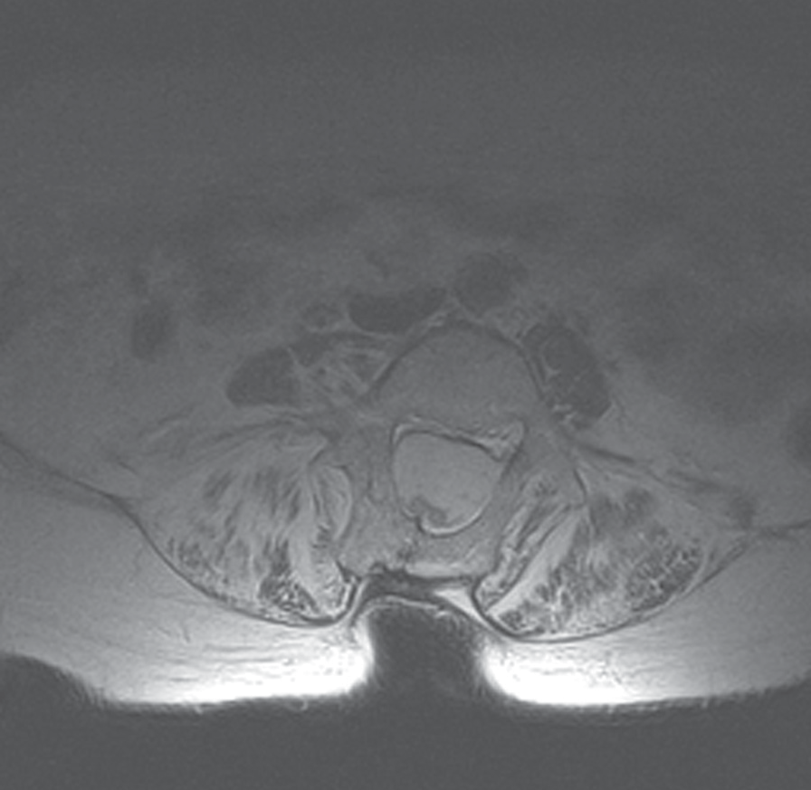
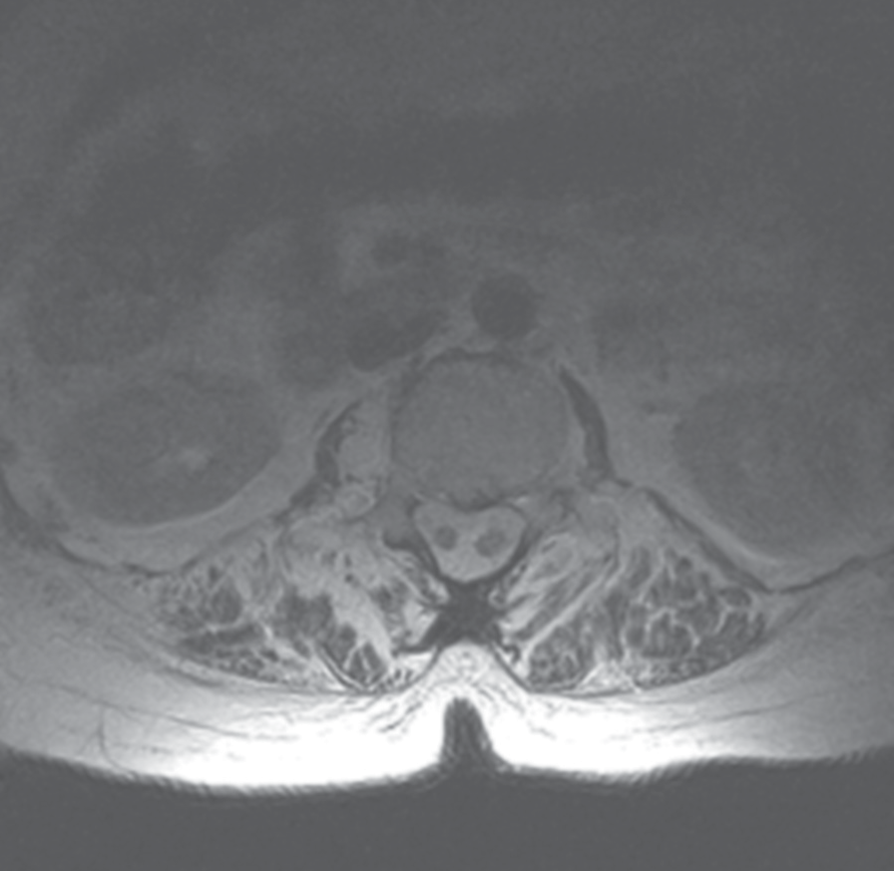
©PolJRadiol,2010;75(2):82-87
Zaleska-DorobiszUetal–MRIdiagnosisofdiastematomyelia…
Figure5.T1-weightedimage,coronalplane.Thereissagittaldivisionofthespinalcordintotwohemicordsduetothepresenceofanosseocartilaginousseptum.
Figure7.T2-weightedimage,axialplane,levelL3:twohemicords,eachcontainedinaseparateduraltubeandseparatedbyanosseocartilaginousseptum.
Figure6.T2-weightedimage,axialplane,levelL2:asingleduralsaccontainingbothhemicords.
Figure8.T2-weightedimage,axialplane,levelL4:asingleduralsaccontainingbothhemicords.
AtthelevelofL2,onthelateralsurfaceofthelefthemi-cord,therewasasharplydelineatedroundstructureof
0.7cmindiameter,hyperintenseinT2-andPD-weightedimages,andhypointenseinT1-weightedsequences(Figure4A–C).ThelesionwasoccupyingthelateralrecessoftheleftspinalcanalandcouldcorrespondtoanepidermoidcystonMRI.
Moreover,theevaluatedsegmentrevealeddegenerativelesionsofthevertebralbodiesandintervertebraljoints.
Discussion
Dysraphiclesionsconstitutethemostnumerousgroupofdevelopmentalabnormalitiesofthespinalcordandcanal[5].Theyaremostlydiagnosedintheneonatalperiod,andsometimesinolderchildrenoradults[5,10].Theselesionsmaybedividedintothreegroups,dependingontheloca-tionofthelesionwithrespecttothesurfaceoftheback.Thereareopendysraphiclesionwithadorsalprotrusionofsofttissuesofthespinalcanal,notcoveredbyskin,thenthereareclosedysraphismswithaprotrusioncov-eredbyskin,andoccultspinaldysraphisms,withoutanydorsalprotrusionsofsofttissuesofthespinalcanal[5,10].
T1-andT2-weightedsequencesshowedahyperintenseareawithintheTh10body,measuring1.3×1.2cm,withfat-saturationinPDsequence.Theareacorrespondedtoafattyislet,indicatedfordifferentiationfromvertebralhae-mangioma(Figure4A–C).
Intervertebraldiscsintheexaminedpartshowedapatho-logicalloweringofsignalintensityinT2-weightedimages.
85

CaseReport
©PolJRadiol,2010;75(2):82-87
Themostimportantdiagnosticimagingmodalityofdys-raphismsofthespinalcordistheMRI,whichallowsforestablishingafinaldiagnosisandforplanningapotentialsurgery[4,10].USGofthespinalcanalandofthespineisthe first-line treatment of open neonatal lesions and in pre-nataldiagnostics[1,3,4].
(11%)orotherdermalnaeviandcrypts[1,8,10,12,14].Moreover,thediastematomyeliamaybeaccompaniedbyspinalabnormalitiessuchashemivertebrae,butterflyver-tebrae,fusionofvertebraeandnarrowingoftheintraver-tebralspace.Veryoftenthereisalsoascoliosis–evenin30–60%ofcases[1,4,10,12,14].Patientswithdiastemato-myeliamaypresentwithdifferentneurologicalandortho-paedicabnormalities,suchasfootdeformities(in50%ofcases),muscularatrophy,legshortening,paraesthesias,disturbedreflectresponse[8,12].Therewerealsocasesoftheterningofthespinalcordoroftheterminalconesolely,syringomyelia,Klippel-Feil’ssyndrome,epidermoidanddermoidcysts,lipomasandduralcysts,especiallythearachnoidcysts.Diastematomyeliaispresentin15–20%ofcasesofArnold-ChiariIIsyndrome[10,12].
Themostcommondysraphismsisthemyelomeningocele,presentinapprox.1caseperevery1200–1400livebirths[5].Itconstitutesasmuchas98.8%ofallopendysraphismsofthespinalcord[10].
Diastematomyeliaisararecongenitalmalformationofthespinalcord,whichbelongstothegroupofoccultspinaldysraphisms[10].Itwasfirstdescribedin1837byFrenchresearcherC.P.Ollivier,whousedtheterm‘diastematomy-elia’[11].Anewclassificationandterm(‘splitcordmalfor-mation,SCM)wasintroducedbyD.Pang[13],whodistin-guishedtwotypesofdiastematomyelia.IntypeI(SCMtypeI),twopartsofthesplitcord(hemicords)areplacedintheirseparateduraltubes.Thespinalcanalisdividedintwobyaseptum,osseocartilaginousinmostofthecases(75%)or,rarely,afibrousone(25%).TypeII(SCMtypeII)ischarac-terisedbythepresenceofonecommonduraltube,withoutanyosseousseptuminmostofthecases,orwithafibrousseptum,ifany.TypeIIcasesareasymptomatic[1,4,9–11].
Inthepresentedcase,the78-year-oldwomanhadbeenexperiencingspinepainforover40years.Despitethecon-firmedosseousanomaliesofthelumbarspineandabnor-malhairgrowth(hypertrichosis)oftheback,thecorrectdiagnosiswasestablishedonlyafterperformingtheMRIinJanuary2010.Takingintoaccountthepresenceoftheosse-ous-cartilaginousseptumdividingthespinalcanalintotwopartswithtwohemicordsintwoseparateduraltubes,dia-stematomyeliaoftypeI(SCMtypeI)shouldbediagnosed,althoughaboveandbelowtheseptum,thehemicordsfusedinonecordlyinginonecommonduralsacagain.Intheavailableliterature,manyauthorssuggestthatSCMtypeIconcernssymptomaticpatientswithserious,progressiveneurologicaland/ororthopaedicabnormalities[1,4,9–11].Itisinterestingthatthewomenpresentedinourworkdidnotshowanysignificantneurologicalororthopaedicabnormali-tiesatyoungerage,apartfromlong-termbackpain.Shealsogavebirthtotwochildren(bothdeliverieswerespontaneousanduncomplicated;onechildwashealthy).OnlyattheL2level,onthelateralsurfaceofthelefthemicord,therewasastructureof0.7cmindiameter,potentiallycorrespondingtoanepidermoidcyst.Otherwise,therewerenoconcomitantcongenitalabnormalities.Mostprobably,animportantfactisheretheabsenceofspinalcordtheterningandthepres-enceofaverylow-reachingterminalcone(toL5).
Diastematomyeliaismorecommoninwomen(80–90%)andtendstoappearwithinthethoracolumbarspine(85%).Itisrarelyconfinedtothelumbarortothethoracicspinesole-ly.There were also cases of cervicalor multilevel diastema-tomyelia[4,10,12].
Occultdysraphismsmaybecoveredwithanormalskinlayer.However,they arefrequently(i.e.in50–75%ofcases)connectedwiththepresenceofmultipleskinlesions.Dysraphismsaccompaniedbyskinlesionswerefirstdescribedin1940byB.W.Lichtenstein[9].Themostcommonskinmarkerofdiastematomyeliaisanabnormalhairgrowth(hypertrichosis)oftheback,atthelevelofthemalformation,observedin56%ofallcasesofdiaste-matomyelia[1,9].AccordingtoY.Izci,therateofanoma-liesinthestudygroupamountedtoasmuchas79%[9].Moreover,Y.Izcipresentedtwotypicalhairgrowthpat-ternsinhiswork:‘fauntail’and‘silkydown’.The‘fauntail’concernsthick,roughhaircoveringawidetriangularorrhombus-shapedareaofthelumbosacralback,measur-ingmostlyfromafewtoovertencentimetresinlength.‘Silkydown’isasmallconcentrationoffine,softhairinthemidline[9].Thequotedworkshowedthatthereisastatistically significantcorrelationbetweenthetype ofabnormalhairgrowthpatternandthetypeofdiastema-tomyelia.The‘fauntail’patternisconnectedwithSCMtypeI,whilethe‘silkydown’issignificantlymorecommoninSCMtypeIIlesions[9].Inourcase,thiswasobviouslythe‘fauntail’pattern(Figure2),whichspeaksforY.Izci’sthesisontherelationshipbetweenthishairgrowthpatternandtypeIdiastematomyelia(thepresenceofosseocartilag-inousseptumsplittingthespinalcanalintotwoparts,i.e.twohemicordsplacedwithintheirseparateduraltubes).
Diastematomyeliadiagnosedintheother,younger,sonofthepresentedpatientmayspeakforgeneticcondition-ingofthismalformation.Althoughtheexactaetiologyofspinaldysraphisms(ofopen,closeandoccultones)isstillunknown,authorshavereporteddifferentfactorsinflu-encingthefuturemotherinherfertilityorearlygestationperiod.Approx.50%ofallcasesareconnectedwithnutri-tionaldeficiency.Other,genetic,aremultifactoriallycon-ditioned[5].Amongthecausesofspinaldysraphisms,therearechromosomalmutations,single-genemutations,envi-ronmentalfactorsandotherfactors,ofunknownorigin.Nutritionalfactorsincludei.a.consumptionofcytochalasinametaboliteofthefungesPhytophthorainfestans(foundinblightedpotatoes),folicacidorzincdeficiency,highcon-sumptionof nitrates (e.g. in ground water or innitrate-pre-servedmeat),vitaminAdeficiencyorhyperconsumption[5].Moreover,mothers ofchildren withspinaldysraphismswereoftenreportedtorevealanabnormalcarbohydratemetabolism(e.g.diabetesorhyperinsulinemia).Motherswithdiabetesaremorepronetodeliverachildwithsuchapathology[15].
Other,frequentlycoexistingskinlesionsincludecapillaryangiomas(26%),dermalsinuses(22%),subdermallipomas
86

©PolJRadiol,2010;75(2):82-87
Zaleska-DorobiszUetal–MRIdiagnosisofdiastematomyelia…
Itisbelievedthatoneofthemostimportantnutritionalfactorsconnectedwithspinaldysraphismsisthefolicaciddeficiency.Folicacidsupplementationincludedinapreg-nantwoman’sdietmaydecreasetheriskofabnormallydevelopingneuraltubebyasmuchas72%[5].
takenintoaccountinthedifferentialdiagnosisinpatientswithX-raysrevealingsuchdefectsofthespineas:hemi-vertebrae,butterflyvertebraeorvertebralfusion,especial-lywhenthepatientrevealssomeadditionalskinlesionsatthelevelofthediagnosedosseousanomalies,dorsally.
Conclusions
Beingawareofthefactthatabnormalhairgrowth(hyper-trichosis)withinthelumbosacralbackaccompaniesthedysraphiclesionsofthespinalcord,shouldresultinanearlyandcorrectdiagnosis,aswellasintroductionofanappropriatetreatment.
Diastematomyeliaisararedysraphicdefectofthespinalcord.Itismostlydiagnosedintheprenatalperiodorinchildren;muchlessofteninadults.Thisdisorderhastobe
References:
- KarasahinKE,GezgincK,AlanbayIetal:Ultrasonographicdiagnosisofdiastematomyeliaduringthe14thweekofgestation.TaiwanJObstetGynecol,2009;48:163–66
- PangD, HoffmanHJ,RekateHL: Split cordmalformation,partII:clinicalsyndrome.Neurosurgery,1992;31:481–500
- AndersonNG,JordanS,MacFarlaneMRetal:Diastematomyelia:diagnosisbyprenatalsonography.AJR,1994;163:911–14
- KulkarniM,RuparelM,RedkarR:Fetaldiastematomyelia:MRimaging:acasereport.IndianJRadiolImging,2009;19:78–80
- NettoJMB,BastosAN,FigueiredoAAetal:Spinaldysraphism:aneurosurgicalreviewfortheurologist.RevUrol,2009;11:71–81
- BiriAA,TurpAB,KurdogluMetal:Prenataldiagnosisofdiastematomyeliaina15-week-oldfetus.FetalDiagnTher,2005;20:258–61
- Sonigo-CohenP,SchmitP,ZerahMetal:Prenataldiagnosisofdiastematomyelia.ChildsNervSyst,2003;19:555–60
- LewandrowskiKU,RachlinJR,GlazerPA:Diastematomyeliapresentingasprogressiveweaknessinanadultafterspinalfusionforadolescentidiopathicscoliosis.SpineJ,2004;4:116–19
- IzciY,GonulM,GonulE:Thediagnosticvalueofskinlesionsinsplitcordmalformations.JClinNeuroscience,2007;14:860–63
- RossiA,BiancheriR,CamaAetal:Imaginginspineandspinalcordmalformations.EJR,2004;50:177–200
- IzciY,GurkanlarD,GonulE:Anunusualtypeofsplitcordmalformation.JClinNeuroscience,2007;14:383–86
- ParmarH,PatkarD,ShahJ:Diastematomyeliawithterminallipomyelocystocelearisingfromonehemicord.JClinImaging,2003;27:41–43
- PangD,DiasMS,Ahab-BarmadaM:Splitcordmalformation.PartI:Aunifiedtheoryofembryogenesisfordoublespinalcordmalformations.Neurosurgery,1992;31:451–80
- TomaszewskaM,SiekE,Czekajska-ChehabEetal:SpiltcordmalformationtypeIdetectedonmultislicecomputedtomography.AnnUMCS–SectioD:Medicina,2007;62:346–51
- KitzmillerJL,BuchananTA,KjosSetal:Preconceptioncareofdiabetes,congenitalmalformations,andspontaneousabortions.DiabetesCare,1996; 19:514–41
87

