

Availableonlineatwww.sciencedirect.com

ScienceDirect

EnergyProcedia125(2017)268–272

www.elsevier.com/locate/procedia

EuropeanGeosciencesUnionGeneralAssembly2017,EGUDivisionEnergy,Resources&Environment,ERE

EffectsofheatshocksonbiofilmformationandtheinfluenceoncorrosionandscalinginageothermalplantintheNorthGermanBasin

AnneKleyböckera,TobiasLienena,MonikaKasinaa,b,AnkeWestphala,SebastianTeitzc,
FlorianEichingerd,AndreaSeibte,MarkusWolfgrammf,HilkeWürdemanna,g,*

aGFZGermanResearchCentreforGeosciences,Section5.3Geomicrobiology,D-14473Potsdam,Germany
bInstituteofGeologicalScience,JagiellonianUniversity,30-387Krakow,Poland
cFirmaTeitz,D-18334Dettmannsdorf,Germany
dHydroisotopGmbH,D-85301Schweitenkirchen,Germany
eBWGGeochemischeBeratungGmbH,D-17041Neubrandenburg,GermanyfGeothermieNeubrandenburgGmbH(GTN),D-17041Neubrandenburg,GermanygMerseburgUniversityofAppliedSciences,D-060217Merseburg,Germany

Abstract

Atgeothermalplants,processfailuresoftenoccurduetocorrosionandscalingprocesses.Especiallyafterheatextraction,sulfatereducingbacteriacontributetocorrosionprocessesbyproducingreducedsulfurcompounds.Inbiofilmscontainingscalessuchasironsulfides,corrosionprocessesareenhanced.InamobilebypasssystemlocatedatthegeothermalplantinNeubrandenburg(NorthGermanBasin),theinfluenceofbiofilmformationoncorrosionandscalingwasinvestigated.Short-termheatshocksweresuccessfullytestedinthebypasssysteminordertoreducebiofilmformationandthustodiminishcorrosionandscalingprocesses.

©2017TheAuthors.PublishedbyElsevierLtd.
Peer-reviewunderresponsibilityofthescientificcommitteeoftheEuropeanGeosciencesUnion(EGU)GeneralAssembly2017–DivisionEnergy,ResourcesandtheEnvironment(ERE).

Keywords:microbialinfluencedcorrosion(MIC);scaling;biofilm;sulfatereducingbacteria(SRB)

*Correspondingauthor.Tel.:+49-3461-46-2019;Fax:+49-3461-46-2192.E-mailaddress:wuerdemann@hs-merseburg.de

1876-6102©2017TheAuthors.PublishedbyElsevierLtd.
Peer-reviewunderresponsibilityofthescientificcommitteeoftheEuropeanGeosciencesUnion(EGU)GeneralAssembly2017–DivisionEnergy,ResourcesandtheEnvironment(ERE).
10.1016/j.egypro.2017.08.173

Introduction

Ingeothermalfluidsafterheatextraction,frequentlysulfatereducingbacteria(SRB)arefound[1].SRBcontributetothecorrosionprocessindirectlybytheformationofreducedsulfidesand/ordirectlybytheuptakeofelectronsfromthemetaltothemicrobialcell[2,3].SRBformbiofilmsonthemetalsurface.Thedissolvedironionsprecipitatewiththesulfides.Thus,SRBdonotonlycontributetothecorrosionprocess,butalsodeliverthereactantforthescalingprocess[4].Lermetal.[5]showedahighabundanceofSRBatthecoldsideofageothermalheatstoreinNeubrandenburg(NorthGermanBasin).There,thesubmersiblepumpwasstronglyaffectedbypittingcorrosion.Lermetal.[5]concludedthattheformationofbiofilmsonthepumpcontainingcorrosionrelevantSRBwasthemainreasonforthedamages.Würdemannetal.[1]observedastrongreductionintheinjectivityandthus,acloggingofthenearwellareaduetoscalingproductsandbiofilmformationinthecoldstoreattheBerlinerReichstag.Inthejointproject“BioKS”,measurestodiminishbiofilmformationareinvestigatedinordertoreducecorrosionandscalingprocessesingeothermalplants.However,theinhibitionofmicroorganismswithbiocidesisdifficultintermsofenvironmentalconcernsandlocalregulations.Inaddition,highfluidflowratesrequirehighamountsofbiocidesresultinginhighcosts.Thus,othermeasuresneedtobedeveloped.Inthispaper,firstresultsoftheinfluenceofheatshocks–short-termnon-heat-extractingperiods–onthebiofilmformationinabypasssystemarepresented.

MaterialandMethods

  - Experimentalsetup

ThebypasssystemwaslocatedinNeubrandenburgatageothermalheatstore.Theheatstoreconsistsoftwosides,a“warm”sidewithatemperatureofapproximately80°Candacoldsidewithatemperatureofaround47°C.Thesalinityis130gL-1,thesulfateconcentrationvariesbetween900mgL-1atthecoldsideand1100mgL-1atthewarmside.MoreinformationaboutthesiteisgivenatKabusandWolfgramm[7],ObstandWolfgramm[8]aswellasLermetal.[5].Thebypasssystemwasinstalledatthetopfacilityatthewarmside.Thehotgeothermalfluidfromthewarmsidewascooleddownwithaheatexchangerinthebypasssystemto40°Candflowedthroughtwoparallelpipes.Inthesepipes,ungroundandground(120grit)corrosioncouponswereinstalled.MoreinformationregardingthebypasssystemisprovidedinWürdemannetal.[6].
Theexperimentlasted59days.Everytwoweeks,theheatexchangerwasswitchedofffor6h,whileonepipewasclosedandonepiperemainedopen.Thus,intheclosedpipethetemperatureremainedat~40°Candintheopenpipe,thetemperatureincreasedto78°Cduetothehotgeothermalfluid.Attheendoftheexperiment,thepipeswereremovedfromthebypasssystem,transportedtothelaboratoryandthecouponswerewithdrawnunderananaerobicmobilegloveboxtoavoidanyexposuretooxygen.

  - Chemicalandmolecularbiologicalanalyses

Inordertodeterminethecorrosionrates,thecleancouponswereweightedbeforeandrightaftertheexposuretothefluid.Afterthefluidexposure,thesurfaceofthecouponswascleanedwith3MHCl.Thematerialofthecouponswasmildsteel(1.0038)withadensity(ρC)of7.856g/cm³andthedimensionsof3mmx25mmx100mm.Thus,subtractingtheholesinthecouponsforitsfixationinthebypasstube,thesurfaceareaofthecoupons(AC)was5683mm².Thecorrosionrate(CR)wascalculatedaccordingtoEq.(1).

CR=∆m/(ρC*AC*t) [mm/a] (1)

ThebiofilmlayerandscalesonthecouponswereanalyzedusingaScanningElectronMicroscope(SEM)fromHitachiS-4700withaNoranNordlysIIEnergyDispersiveSpectrometer(EDS).BacteriaandSRBonthecouponswerequantifiedbyquantitativePCR(qPCR).Analysesofbacterial16SrRNA[9]anddsrAgenesforSRB[10,11]

wereconductedwiththeStepOnePlusTMreal-timePCRSystem(AppliedBiosystems,Carlsbad,CA,USA)usingPowerSYBR®GreenPCRMasterMix(LifeTechnologies,Carlsbad,CA,USA).

ResultsandDiscussion

InthegeothermalplantinNeubrandenburg,damagesonthesubmersiblepumpduetomicrobialinfluencedcorrosionwereobserved.Inordertodevelopmeasuresagainstcorrosiondamages,theinfluenceofshort-termheatshocksonthebiofilmformationwasinvestigated.Afterthefluidexposureataconstanttemperatureinpipe1andwithheatshocksinpipe2,thebiofilmlayersdifferedstronglyintheirthickness.Onthecouponexposedtoheatshocksthebiofilmlayerwasmuchthinnerthanthelayeronthecouponwithconstanttemperature(Fig.1).

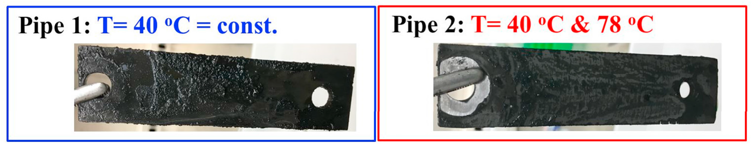

Fig.1.Thebiofilmlayeronthecoupontreatedwithheatshocks(pipe2)ismuchthinnerthanonthecouponwithconstant40°C(pipe1).

Correspondingtothelowerthicknessofthebiofilmlayerafterheatshocks,theabundanceofBacteriaaswellastheabundanceoftheSRBwereabout1000-foldlowerandthus,stronglyreduced(Fig.2a).Correspondingly,thecorrosionrateswerefivefoldlower(Fig.2b).Furthermore,thecorrosionratesalsodiffereddependingonthetreatmentofthecouponsurface.Thegroundcouponswerelessinfluencedbycorrosionthantheungroundcoupons.

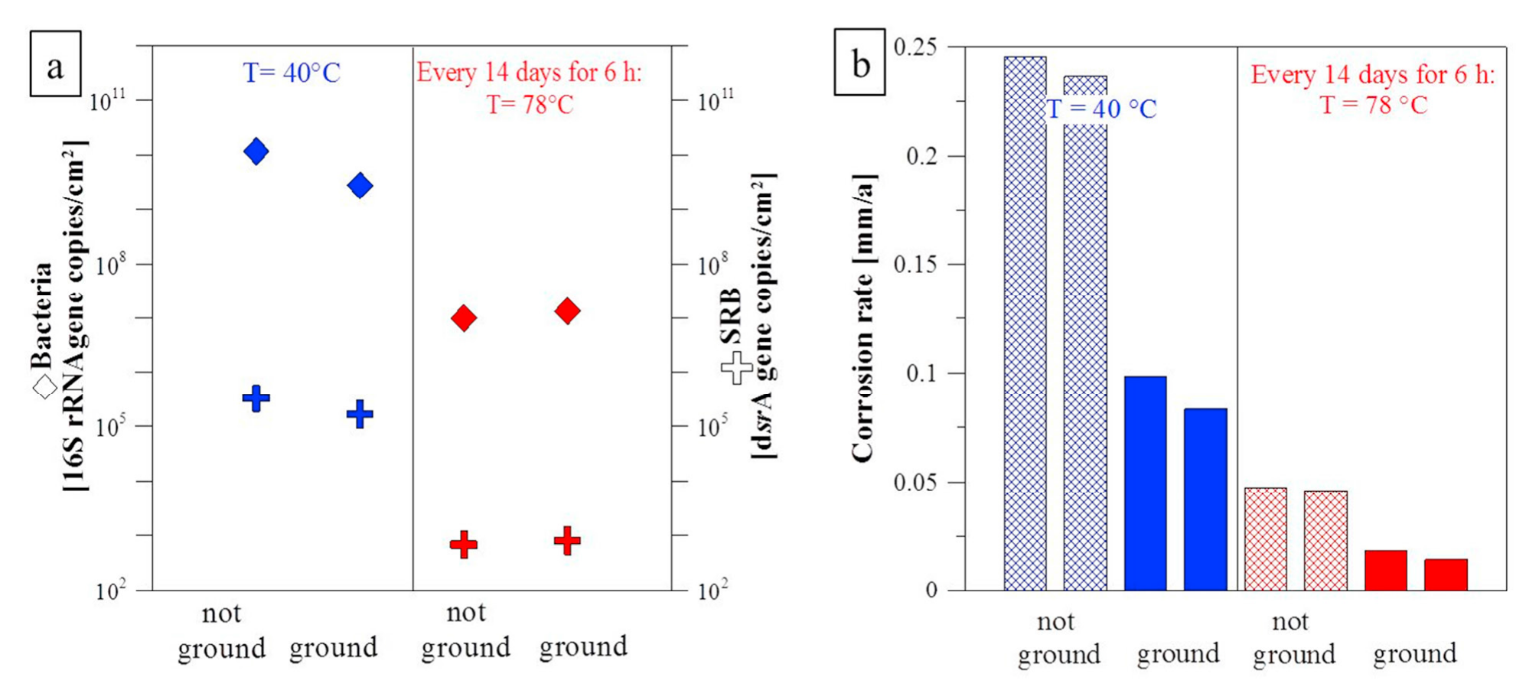

Fig.2.(a)LowerabundanceofBacteriaandSRBonthecouponswithheatshocks,(b)lowercorrosionratesofthecouponswithheatshocks.

SEMimagescombinedwithEDSanalysesshowedthatthesolidmaterialphasesonthecouponweredominatedbyironsulfidesandcalciumcarbonates(Fig.3a-d).MicroorganismsintheformofelongatedrodswerefrequentlyfoundincloserelationtoironsulfidesasshowninFig.3d.ThissuggeststhatthosemicroorganismsmightbeSRB.AccordingtoLermetal.[5]andWestphaletal[12],SRBaffiliatedtoDesulfotomaculum,Desulfohalobiumand

CandidatusDesulforudisaudaxviatordominatedinthegeothermalfluidinNeubrandenburg.AccordingtoKueverandRainey[13],Ollivieretal.[14]andJungbluthetal.[15],thoseorganismshaveanelongatedmorphology.Also,SRBweredetectedbyqPCRonthecoupons.Inthenearfuture,themicroorganismsonthecouponswillbecharacterizedindetailandmoretemperatureregimeswillbetestedinthebypasssystem.

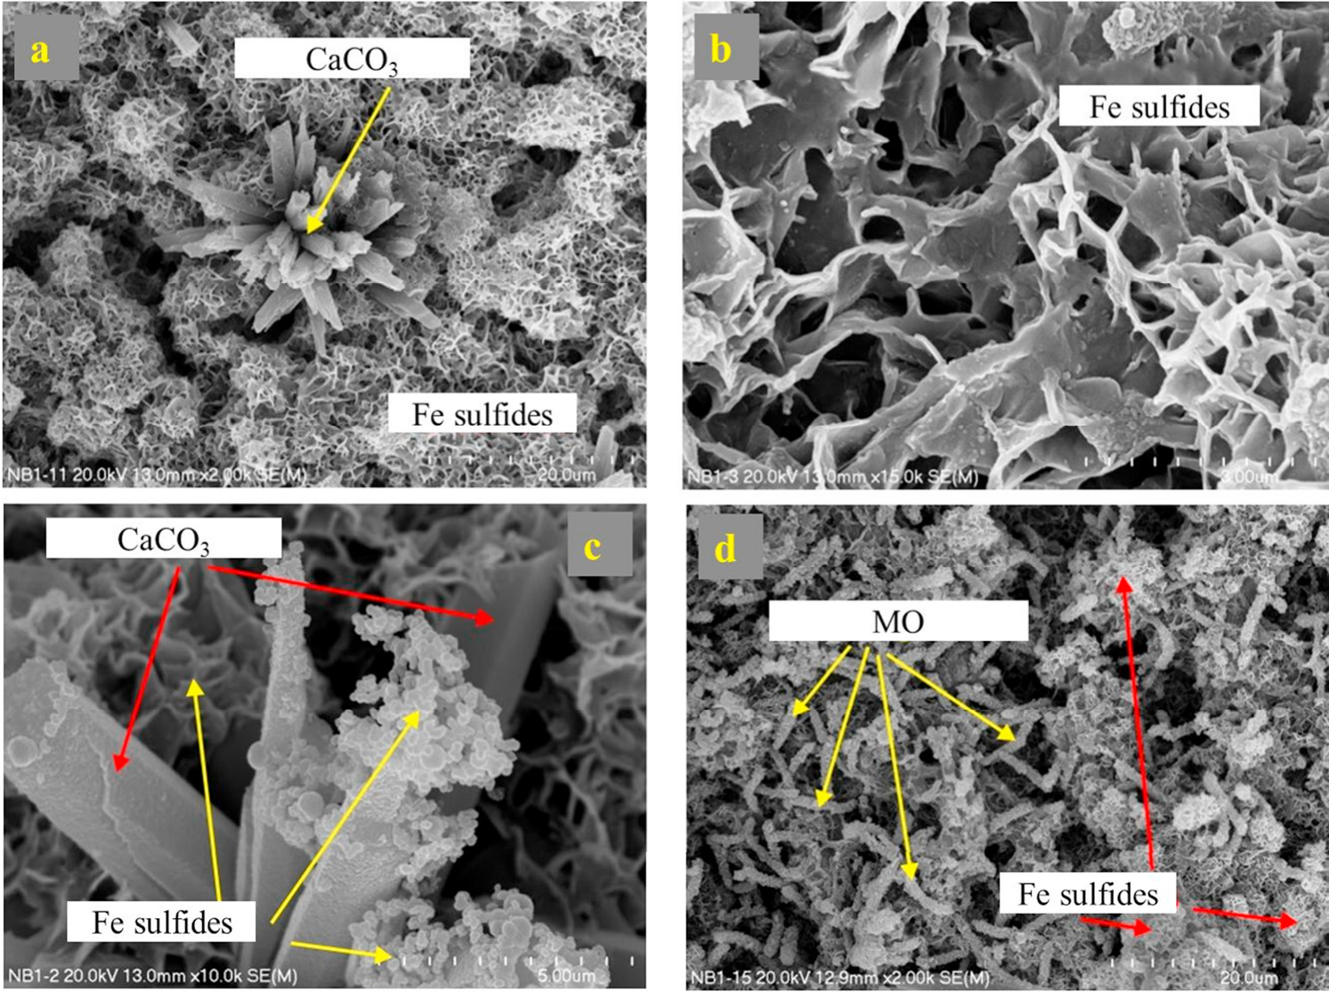

Fig.3.(a-d)SEMpicturesandEDSresultsofthebiofilmwithmicroorganisms(MO)coveredwithmineralsonthecouponswithoutheatshocksaftertheexposuretothefluidinthebypasssystemlocatedatthegeothermalstoreinNeubrandenburg.

Conclusions

Short-termheatshocksareasimple,inexpensiveandenvironmentallyfriendlyproceduretoreducecorrosionandscalingprocessestriggeredbySRB.Hereby,theheatexchangerextractslessheatthanusuallyfromtheproducedhotgeothermalfluid.Thus,thefluidflowstemporarilywithahighertemperaturethroughtheplantintotheinjectionwellinordertoexposetheattachedbiofilmsonthetechnicalcomponentsofthegeothermalplanttoaheatshock.

Acknowledgements

WethankthepublicutilitiesofthecityNeubrandenburgforprovidingaccesstothetopsidefacilityofthegeothermalheatstoreandtoallowfortheinstallationofthebypasssystemandtheconductionofexperiments.TheFederalMinistryforEconomicAffairsandEnergy(BundesministeriumfürWirtschaftundEnergie)isthankedforthefundingoftheprojectBioKS(0324029A).

References

[1]WürdemannH,WestphalA,KleyböckerA,Miethling-GraffR,TeitzS,KasinaM,SeibtA,WolfgrammM,EichingerF,LermS.(2016)
„StörungendesBetriebsgeothermischerAnlagendurchmikrobielleStoffwechselprozesseundErfolgvonGegenmaßnahmen.“Grundwasser21(2016):93–106.
[2]VenzlaffH,EnningD,SrinivasanJ,MayrhoferK,HasselA,WiddelF,StratmannM.(2014)“Acceleratedcathodicreactioninmicrobialcorrosionofironduetodirectelectronuptakebysulfate-reducingbacteria.”CorrosionScience66(2013):88-96.

[3]EnningD,GarrelfsJ.(2014)“Corrosionofironbysulfate-reducingbacteria:newviewsofanoldproblem.”AppliedandEnvironmentalMicrobiology80(2014):1226-1236.
[4]SandW.Microbiallifeingeothermalwaters.Geothermics2003;32:655-667.
[5]LermS,WestphalA,Miethling-GraffR,AlawiM,SeibtA,WolfgrammM,WürdemannH.(2013)“Thermaleffectsonmicrobialcompositionandmicrobiologicallyinducedcorrosionandmineralprecipitationaffectingoperationofageothermalplantinadeepsalineaquifer.”Extremophiles17(2013):311-327.
[6]WürdemannH,WestphalA,LermS,KleyböckerA,TeitzS,KasinaM,Miethling-GraffR,SeibtA.,WolfgrammM.(2014)“Influenceofmicrobialprocessesontheoperationalreliabilityinageothermalheatstore–resultsoflong-termmonitoringatafull-scaleplantandfirststudiesinabypasssystem.”EnergyProcedia59(2014):412-417.
[7]KabusF,WolfgrammM.(2009)“AquiferthermalenergystorageinNeubrandenburg-monitoringthroughoutthreeyearsofregularoperation.”Proc.11thInt.Conf.EnergyStorage,Stockholm,Sweden(2009):8.
[8]ObstK,WolfgrammM.(2010)„Geothermische,balneologischeundspeichergeologischePotenzialeundNutzungendestieferenUntergrundesderRegionNeubrandenburg.“Geol.Beiträge10(2010):145-174.
[9]NadkarniM,MartinF,JacquesN,HunterN.(2002)“Determinationofbacterialloadbyreal-timePCRusingabroad-range(universal)probeandprimersset.”Microbiology148(2002):257-66.
[10]WagnerM,RogerA,FlaxJ,GregoryA,StahlD,BrusseauG.(1998)“Phylogenyofdissimilatorysulfitereductasessupportsanearlyoriginofsulfaterespiration.”JournalofBacteriology180(1998):2975-2983.
[11]WilmsR,SassH,KöpkeB,CypionkaH,EngelenB.(2007)“Methaneandsulfateprofileswithinthesubsurfaceofatidalflatarereflectedbythedistributionofsulfate-reducingbacteriaandmethanogenicarchaea.”FEMSMicrobiol.Ecol.59(2007):611-621.
[12]WestphalA,LermS,Miethling-GraffR,SeibtA,WolfgrammM,WürdemannH.(2016)“EffectsofplantdowntimeonthemicrobialcommunitycompositioninthehighlysalinebrineofageothermalplantintheNorthGermanBasin.”ApplMicrobiolBiotechnol100(2016):3277-3290.
[13]KueverJ,RaineyFA.(2015)“Desulfotomaculum”inWilliamWhitman(ed)Bergey'sManualofSystematicsofArchaeaandBacteria,OnlineBergey’sManualTrust,JohnWiley&Sons.
[14]OllivierB,PatelB,Garcia,J.(2015)“Desulfohalobium”inWilliamWhitman(ed)Bergey'sManualofSystematicsofArchaeaandBacteria,OnlineBergey’sManualTrust,JohnWiley&Sons.
[15]JungbluthS,GroteJ,LinH,CowenJ,RappeM.(2013)“Microbialdiversitywithinbasementfluidsofthesediment-buriedJuandeFucaRidgeflank.”TheISMEJournal7(2013):161–172.

