
Sygnatura:PolJRadiol,2007;72(2):82-87
REVIEWARTICLE
Cephalometricimagingintheassessmentoffacial
Otrzymano:
2006.11.06
Zaakceptowano:2007.02.15
growthdirection;literaturereview
MagdalenaMiedzik1,MariaSyryńska2
1student–PostgraduateStudies,DepartmentofOrthodontics,PomeranianMedicalUniversity,Szczecin,Poland
2Head ofDepartment of Orthodontics,PomeranianMedicalUniversity,Szczecin,Poland

Author’saddress:DepartmentofOrthodontics,PomeranianMedicalUniversity,PowstancowWielkopolskich72st.,71-111Szczecin,Poland,e-mail:kizortod@pam.szczecin.pl
Summary
Theaimofthisstudywastopresentmethodsofassessmentoffacialgrowthoncephalometricimagingdescribedintheliterature.
Inthestudyarticlespublishedinforeignjournalsassessmentsoffacialgrowthweredescribed.PubMed,Medline andEbsco baseshavebeenused forfinding appropriate literature.Keywordslike:cephalometry,superimpositionmethods,craniofacialgrowthwereusedforsearching.Wechose31articleswhichdescribedthisproblem.
Craniofacialgrowthanddevelopmentisanimportantprobleminorthodonticdiagnosisandtreatment. Itmay bea supportbutalso anobstacle tothe orthodontictherapy;it canevenmakeitimpossible.Inordertodefineitoncephalometricimagingitisnecessarytoassess:craniofacialdevelopmentonreferencelandmarksofthecraniumbase;maxillarygrowth-inrelationtopointsbased onmaxilla anddevelopment ofmandible alveolar process-superimposition ofimages onthestructureslocalizedinmandible.Differentmethodsofsuperimpositiondescribedinthestudyallowassessing,moreorlessprecisely,thedirectionanddimensionofgrowthintimebetweenoneimagingandanother.
Keywords:
cephalometry•superimpositionmethods•craniofacialgrowth
PDFfile:
http://www.polradiol.com/fulltxt.php?ICID=478118
Background
In1931,twoscientists-HofratinGermanyandBroadbentintheUS-independentlygeneratedlateralteleradiographsoftheskull.Itenabledthemtoincludeinasinglepicturemajorityofstructuresimportantfororthodontics.Acepha-lometricimage(cephalograph,kephalographorlateraltele-radiographoftheskull)showsnotonlythebonystructurebutalsosofttissueprofile[2].Thetermcephalometryori-ginatesfromtwoLatinwords:“kephale”means“head”and“metrein”- “to measure”,andit signifiesmeasurement oftheextraoralandintraoralheadstructures.Cephalographshavebecomeadiagnostictoolinorthodonticsastheyallowsuccessfulmeasurementswhichpreviouslyseemedtobeinsufficientorevenimpossibletoproceed.Acephalometricimageundergoessignificantchangesalongwiththegrowthoftheexaminedperson[2].Observationofteleradiographallowsassessingthefacialskeleton,butthereisalsoanecessitytoprepareanobjectivedatawhichisabasetonumerouscephalometricanalyses.
Growthandcraniofacialdevelopmentisanextremelyimpor-tantfactorinorthodontictreatmentofchildrenandyouth.Itmaybeasupportbutalsoanobstacletothetherapy,inextremecasesitmayevenmakethetreatmentimpossible[1].Thefollowingaspectsof growthassessmentaretakenintoaccount:itsexpecteddirection,intensityandduration.Thedurationandintensitymaybedeterminedwithahighdegreeofprecisionbutdirectionisratherdifficulttopredictanditshouldbedoneverycarefully.Cephalometrybecameanessentialtoolintheinvestigationsoffacialgrowthdirec-tion.Knowledgeofanormalfacialgrowthmakesitpossibletoprepareacorrecttreatmentplan,ensuringitssuccessfulimplementationandstableresultsinyoungpatients.Theaim of thisstudy wasto describedifferent methodsin theassessmentoffacialgrowthdirectiononcephalometricima-gingbasedontheliterature.
82

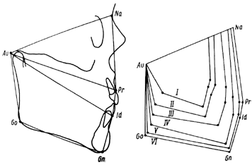
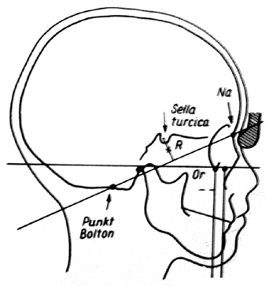
PolJRadiol,2007;72(2):82-87
Cephalometricimagingintheassessment...
In1930,Hellmanasthefirstresearcherestablishedbiolo-gicalstandardsofhumandevelopment.Hepresentedthestandards in formof profilediagrams measured from theauriculare(Au)landmarktothelandmarks:Nasion(N),prosthion(Pr),infradentale(Id),gnathion(Gn),andgonion(Go)(Fig.1)[3].
structuresreach98%oftheirfinalsizeinchildrenaged8-13.Theposteriorpartofcranialbasegrowsatanearlystageoflifeasaresultofactivityofthespheno-occipitalsuture;however,growthofitsanteriorsegmentisacon-sequence ofdevelopment of frontalsinuses, whichcausesmigrationoftheNasionlandmark(N)[13,14,15].
Anotherlong-termstudywascarriedoutbyBroadbent[2].Hismethodwastomakefourteleradiographsdocumentingconsecutivegrowthstagesofasinglepatient.Afterwardshe superimposedthem along theNasion-Bolton line. Healsodeterminedanadditionalreferencepoint-R,locatedperpendicularlymidwayfromthecentreofthesellaturci-catotheNasion-Boltonline.HesuperimposedtheimagesontheRpointandtheNasion-Boltonlineswereparallel(Fig.2)[2,4].
Inliteraturetherearemanydescriptionsofcephalometricimagesuperimpositionmethodsconcerningthecranialbase.Thefirstwasbasedontheabove-mentionedstudiesconductedbyBroadbentin1931.In1953,DeCosterdevelo-pedamethodofsuperimposingimagesalongthecribriformplateandthesphenoidboneastheybecomestableattheageof7[13,15].
Thesuperimpositionmethodwasusedforstudyingthefacialgrowthdirectionbutthelandmarksvaried[12,15,16,17].Today,authors[4,5,10,18]usecranialbaseasareferencelineandapplythebelow-mentionedresearchmethods.
Assessmentoftheskeletofacialdevelopment
Withhisstudies,Broadbentinitiatedthedevelopmentofassessment methodsforthe growth-andtreatment-rela-tedchangesinspatialskeletofacialstructures.Themethodwasbasedonsuperimpositionofcephalographsmadeinseveraltimeintervals.Inorthodontics,imagesuperimpo-sitiontechniqueisperformedinordertoevaluatethreebasicvariablesaffectingthedevelopmentofthemaxillaryalveolarprocessesandthemandibleandassessingoverallchangesinskeletofacialstructures.Forthatpurpose,itisnecessaryto superimpose the pictures based on relativelystablelandmarksontheskullsurface,withinthemaxillaandmandible.Itallowsobservationofspatialchangesinbonestructuresresultingfromthegrowthprocessandtre-atment[5].
1.SuperimpositiononthereferencepointsRprovidedthattheNasion-Boltonlinesremainparallel–asdescribedbyBroadbent.
2.SuperimpositionalongtheSella-Nasionlineisoneofthemostfrequentlyusedmethodsowingtothefactthatthelineisconsideredtobethemoststable(Fig.3)[1,12,19].
Inhisstudyofthecranialgrowth,SteinerusedtheSNlinetogetherwiththeSreferencelandmark,inordertoshowsagittalchangesofthemandible,andwiththeNreferencepoint-withrespecttothemaxilla[18].
Stabilityofreferencepointsisnecessarytoperformofadetaileddiagnosis[6,7,8,9,10,11].Changesinthefacialskeletonshouldbeobservedinreferencetolandmarkslocatedinouterstructures,suchasthecranialbase[12].Unlikefacialskeleton,thecerebralcraniumgrowsfastestinearlyperiodofhumanlifeanditreaches90%ofitsfinalsizeattheageof4-5[4].Therefore,itmaybeassu-medthatlandmarkslocalizedonitsbasismeettherequire-mentsofthesuperimpositionmethod.Inanotherresearchitwasfoundthatthecranialgrowthisfirstcompleteintheareaofanteriorcranialfossa[13],particularlybetweenthepituitaryfossaandforamencaecumwherethebony
In course ofexaminationcarried out by Björk, the S pointwasusedfordeterminingchangesinboth,theupperandlowerjawpositions[15].Lateron,theauthorobservedthatdisplacementoftheNasionlandmarkaccompaniedgrowth
Figure2.SuperimpositiononRpointandalongtheNasion-BoltonlinesaccordingtoBroadbent[2].
Figure1.Hellman’sdiagramsaccordingtoWeinberger[3].
83

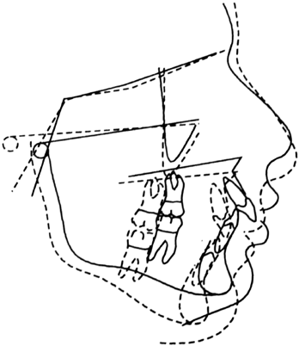
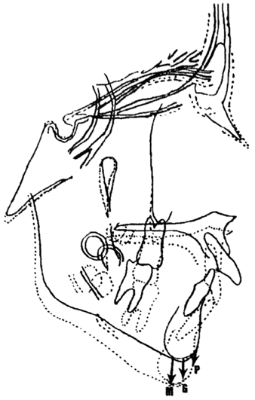
ReviewArticle
PolJRadiol,2007;72(2):82-87
Figure3.SuperimpositionalongtheSNline[19].
ofthenasofrontalsutureandmovementoftheSellapointwhichresultedfromthesellaturcica’stransformationcau-sedbygrowthofthepituitarygland.
3.Thebest-fitmethodconsistsinthesuperimpositionofcephalographsofasmanypointsaspossible,including:anteriorwallofthesellaturcica,anteriorborderofthemiddlecranialfossa,cribriformplate,cristagalliandfrontalcrests,aswellascerebralsurfaceoftheroofoftheorbitandinteriorcorticalplateofthefron-talbone[15].ReliabilityofthatmethodisconfirmedbytheresearchconductedbySakimaetal.[9]whichpro-vedstabilityoftheinteriorsurfaceofthefrontalboneandcribriformplateinchildrenolderthan6or7y.o.(Fig.4).
Figure4.Thebest-fitmethod[15].
pointS.SuperimpositionoftwoimagesalongtheSNlineandattheSpointmakespossibletoassessboththechan-ges alongthe occlusionplane (OL)and thedistance fromOLp.ThismethodincludestheexaminationofpositionsoftheU6,L6,U1,L1,A,B,andPgpoints(Fig.6).
Maxillarygrowthassessment
4.SuperimpositionalongtheBasion-NasionlinesaccordingtothemethoddevelopedbyRicketts[17].Theauthorofthatgrowth-assessmenttechniquealsousedtwolan-dmarks:theCCconstructionpointattheintersectionoftheBa-NandPt-Gnlines(thePtpointislocatedattheloweredgeofthecircularforamenanditisthehighestandmostposteriorpointontheoutlineofthepterygo-palatine fossa), and the N point. The anglebetween theBa-NandPt-Gnlinesreflectsthepositionofmandiblewithrespecttomaxilla.ByusingtheNpointasthecen-tral,itispossibletodetermineachangeinpositionofthemaxillawhichresultsfromtheApointdisplacement(Fig.5).AccordingtotheRicketts’method,superimposi-tionoftheCCpointisreferredtoaspositionIandoftheNpoint–aspositionII.HealsodevelopedpositionsIIIandIVtobediscussedbelow.
Superimpositionofcephalographsbasedonthecraniumallowsassessmentofchangesinthepositionofthemaxil-laandthemandibleinrelationtoit.Toevaluatechangesintoothstructureswithinthemaxillaandmandibleitisnecessary tosuperimpose imagesofthose bones.
Superimpositionofthemaxillarystructuresisperfor-medtoanalyzetransformationsofthealveolarproces-sesduringthegrowthperiod andresultfromorthodontictreatment[21].Björkinhisinvestigation(1955)placedtantalumimplantsinthemaxillaandmandible,whichenabledhimtocarryoutdetailed,superimposition-basedresearchandexplaindynamic,growth-relatedchan-ges.Heplacedtheimplantsinthreeanatomicalregionsofthemaxilla,namely:anteriorimplant–belowtheanteriornasalspine(ANS),lateralone–inthezygomaticprocessofthemaxillaandthethirdoneatthejunctionofhardpalateandalveolarprocessofthemaxillainthemesialdirectioncomparedtothefirstmolar.Theimplant-basedresearchexecutedbyBjörkandSkieller(1957) revealed that the anterior surface ofthe zygomatic
Pancherz[12]suggestedamethodofmodifiedsuperim-positionofimagesalongtheSNline,wherethereferen-celandmarkisSpoint.Theauthorusedocclusionline(OL-line)withaperpendicularlineOLpintersectingthe
84

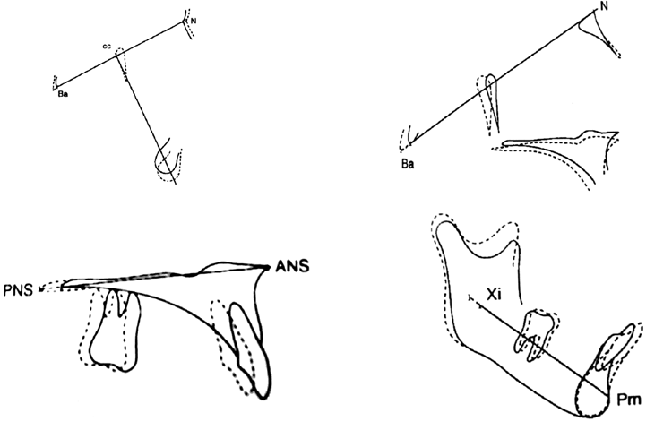
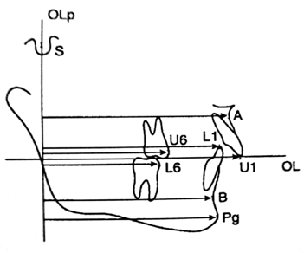
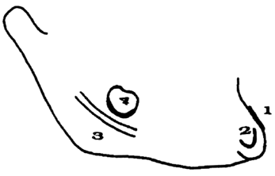
PolJRadiol,2007;72(2):82-87
Cephalometricimagingintheassessment...
Figure5.FourpositionsofcephalometricimagesuperimpositionaccordingtoRicketts[17].
Figure7.Björk’sstructures(referencelandmarksinthemandible)[21].
Mandibulargrowthassessment
Figure6.Pancherz’smethodofsuperimpositionofcephalographs[12].
Toevaluatechangesinducedbygrowthortreatmentintheareaofalveolarprocessesandteethofthemandible,thesuperimpositionmethodbasedonrelativelystablerefe-rencelandmarksisalsopossible.Thepointsontheabove-mentionedresearchcarriedoutbyBjörkusingimplants.ThelandmarksarereferredtoasBjörk’sstructures[21]andtheyinclude:thehighestanteriorborderofthementum-1,internalcorticalsurfaceof the mandibularsymphysis-2,mandibularcanal-3andloweroutlineofthethirdmolarbud(beforerootmineralization)-4(Fig.7).Björk’sstructureswererecognizedby theBritish Orthodontic Societyas recommen-dedforthemandibularsuperimpositionmethod.
processisstableinthesagittaldimension,whatallowssuperimpositionofimagesofthemaxillainthatarea.
Themostpopularmaxillarystructures’superimpositiontechniqueistousetheplaneofthehardpalateasarefe-renceline.ItleadsthroughtheANS,PNSandPTM(pte-rygomaxillaryfissure)landmarks.ThistechniquewasusedbyRicketts,withregardtohispositionIII(Fig.5),andbyNielsen[22]whofoundthatitwasimpossibletospecifyanystablereferencepointswithinthemaxillathatwouldalwaysallowanunquestionableanalysisofchangeswithinthealveolarprocessesandteethascomparedtotheimplant-basedsuperimpositionmethod.
Anothermethodofmandibularsuperimpositionisposi-tionIVsuggestedbyRicketts.Itisbasedonareference
85

PozycjaI PozycjaII

PozycjaIII PozycjaIV

ReviewArticle
PolJRadiol,2007;72(2):82-87
Table1.Abbreviationsusedinworkofreferencepointsonthecraniumthatareusedduringcephalometricanalysis;localizationdescription.
N/Na
Nasion
Themostanteriorpointofnasofrontalsutureinmid-sagittalplane
Pr
Prosthion
Thelowestandmostanteriorpointonthealveolarborderofthemaxillabetweenthecentralincisors
Themostsuperiorandmostanteriorpointofalveolarpartofmandiblelocatedinmid-sagittalplane,betweenlowercentralincisors
Id
Infradentale
Gn
Gnathion
Pointbetweenthemostanteriorandinferiorpointofchin
Go
Gonion
Pointwhereinferiormarginofthemandibularcorpusandtheposteriormarginoftheramusmeet
B/Bo
Bolton
Themostsuperiorpointofuppercurveofretrocondylarfossaofoccipitalbone
Ba
Basion
Pointlocatedmostinferiorlyontheinnerborderoftheanteriormarginoftheforamenmagnum
Roentgenpointinmedialplane,formedinplacewhereperpendicularlinesrunningfromthecentreofpituitarysellameet
S
Sella
ANS
Anteriornasalespina
Themostanteriorpointofanteriornasalspineinmid-sagittalplane
Roentgenpointformedwherethelinesofanteriorwallofandbaseofnasalspinemeetpterygopalatinefossa
PNS
Posteriornasalespina
Viewofpalatineplane,anteriorwallofmaxillaryfissure,posteriorwallofanteriorcurveofpterygoid,equalsPNS
PTM
Pterygomaxillaryfissure
Pm
Protuberancementi
Themostsuperiorpointofchinline
Pointoninferiormarginofroundforamenatthesametimebeeingapointlocatedmostanteriorlyandsuperiorlywithinpterygopalatinefossa
Pt
U6
Uppermolartip
Mesialnoduleofthe1stuppermolartooth
L6
Lowermolartip
Mesialnoduleofthe1stlowermolartooth
U1
Upperincisortip
Incisortipofthemostanteriorupperincisor
L1
Lowerincisortip
Incisortipofthemostanteriorlowerincisor
A
Subspinale
Thedeepestpointonconcavecontourofbonefrommandiblebasetotooth
B
Supramentale
Thedeepestpointofanteriorcontourofdentalpartofmandibleinmid-sagittalplane
Pog
Pogonion
Themostanteriorpointonboneoutlineofchin
Geometricalmiddleofmandibleramus(pointwherediagnonallinesofthebiggestrectangleonthemandibleramusmeet)
Xi
CC
ConstructionpointwhereBa-NandPt-Gnlinescross
Constructionpointlocatedmidwaybetweenthecentreofsella(S)andperpendiculartonasion-Bolton(N-B)line
R
linejoiningthePmlandmark(protuberantiomenti)andtheXiconstructionpointlocatedinthecentreofthemandible.
nionlandmarks,dependingonwhethertheimagesweresuperimposedonthecraniumbasepointsoronmandibularlandmarks[24].
Acomprehensivespatialchanges’assessmentprocedu-reshouldconsistof:1)superimpositionofcephalographsonthereferencelandmarksofthecraniumbaseaccordingtooneoftheabove-mentionedmethodsofshowingchan-gesinthefacialskeleton,2)superimpositionofimagesonthemaxillaallowingtoevaluatechangesinthepositionofthealveolarprocessofthemaxilla,and3)superimpo-sitionontheareaofthemandibleallowingevaluationofdevelopmentofthealveolarprocessofthemandible[23].Nevertheless,thosethreestepsprovidenofinalanswerasregardsthechangeinpositionofthemandiblewithrespecttothemaxilla.EfstratiadisandGhafariprovedthatthereweredifferencesinverticaland,toasmallerdegree,inhorizontaldisplacementofthementon,gnathionandpogo-
Theimagesuperimpositionmethodspresentedinthispaperallowamoreorlesspreciseassessmentofgrowthdirectionandrateinthetimethatelapsedbetweenthedatestheexaminations.Theyalsoshowfurthertrendswhichareparticularlyimportantforevaluationsconcer-ningthemandible.Additionallytothesuperimpositionmethod,alsoastructuralmethodisusedtoassessman-dibulargrowthtendencies.Itisbasedontheassumptionthatintensityofcertainmorphologicalfeaturesinthemandiblereflectsitsgrowthdirection.ThemethodwasdevelopedbyBjörk,whoseparatedsevenfeatureswhichmakeitpossibletoevaluatethepredictedrotationandgrowthdirectionofthemandible.Forthispurposeitisnecessarytoanalyze:
86

PolJRadiol,2007;72(2):82-87
Cephalometricimagingintheassessment...
–degreeanddirectionofthemandibularheadinclination,
Cephalometricmeasurmentsarebasedonmathematicalcalculationsbutitshouldberememberedthattheyrefertostructuresruledbybiologicallaws.Inconsequence,con-clusionsshouldbedrawncarefullyfromtheirresults.Themethodofsuperimpositionofcephalographsconstitutesavaluablesupplementtoradiographicdiagnosinginortho-donticsasitincreasesthereliabilityofforecasts.Methodsoftheassessmentoffacialgrowthdirectiononcephalo-metricimagingdescribedintheliteraturearenecessaryforplanningthetreatmentofpatientswithactivegro-wth potential.Furtherinvestigationsonaccuracy ofthesemethodsandtheiractualutilityintheorthodonticdiagno-sisneedtobecarriedout.
–shapeofthemandibularcanal,
–shapeofthelowerborderofthebodyofthemandible,
–shapeofmentalprotuberance,
–interincisialangle,
–anterior facialheightindex,
–sizeofmandibularangle[25,26,27].
References:
- GoelS,BansalM,KalraA:Apreliminaryassessmentofcephalometricorthodonticsuperimposition.EurJOrthod2004,26,217–222.
- BroadbentBH:Thefaceofthenormalchild.AngleOrthod1937,7,183–208.
- WeinbergerBW:MiloHellman–amanofscience.AmJOrthodDentofacOrthop1990,97,16A–20A.
- GhafariJ,EngelFE,LasterLL:Cephalometricsuperimpositiononthecranialbase:Areviewandcomparisonoffourmethods.Am
JOrthodDentofacOrthop1987,91,403–413.
- TrenouthMJ:Thestabilityofanatomicalandcentroidreferencepointsincephalometricanalysis.AngleOrthod1989,59,283–270.
- CookAH,SellkeTA,BeGoleE:ControloftheverticaldimensioninClassIIcorrectionusingacervicalheadgerandlowerutilityarchingrowingpatients.PartI.AmJOrthodDentofacOrthop1994,106,376–388.
- CookAH,SellkeTA,BeGoleE:Thevariabilityandreliabilityoftwomaxillaryandmandibularsuperimpositiontechniques.PartII.
AmJOrthodDentofacOrthop1994,106,463–471.
- DoppelDM,DamonWM,JoondephDR,LittleRM:Aninvestigationofmaxillarysuperimpositiontechniquesusingmetallicimplants.AmJOrthodDentofacOrthop1994,105,161–168.
- SakimaMT,PonceSakimaCG,MelsenB:Thevalidityofsuperimposingobliquecephalometricradiographstoassesstoothmovement:Animplantstudy.AmJOrthodDentofacOrthop2004,126,344–353.
- SpringateSD,JonesAG:Thevalidityoftwomethodsofmandibularsuperimposition:Acomparisonwithtantalumimplants.Am
JOrthodDentofacOrthop1998,113,263–270.
- YouQL,HäggU:Acomparisonofthreesuperimpositionmethods.EurJOrthod1999,21,717–725.
- PancherzH,HansenK:Thenasion-sellareferencelineincephalometry:amethodologicalstudy.AmJOrthod1984,86,427–434.
- SteuerI:Thecranialbaseforsuperimpositionoflateralcephalometricradiographs.AmJOrthod1972,60,493–500.
- IşeriH,SolowB:Aweragesurfaceremodelingofthemaxillarybaseandtheorbitalfloorinfemalesubjectsfrom8to25years.Animplantstudy.AmJOrthodDentofacOrthop1995,107,48–57.
- BjörkA:Predictionofmandibulargrowthrotation.AmJOrthod1969,55,585–599.
- DeCosterL.:Anewlineofreferencesforthestudyoflateralfacialcephalograms.AmJOrthod1953,39,304–312.
- RickettsRM:Afourstepmethodtodistinguishorthodonticchangesfromnaturalgrowth.JClinOrthod1975,4,218–228.
- SteinerCC:Cephalometricsinclinicalpractice.AngleOrthod1959,29,8–29.
- Lisowska-KaczorI.:OrtodontycznaocenawynikówleczeniaprogeniinapodstawieanalizycefalometrycznejmetodąHasunda-Segnera.Rozprawadoktorska,RadaWydziałuStomatologiiPomorskiejAkademiiMedycznejwSzczecinie,2004.
- AratMZ,RübendüzM,AkgülAA:Thedisplacementofcraniofacialreferencelandmarksduringpuberty:acomparisonofthreesuperimpositionmethods.AngleOrthod2003,73,374–380.
- CookPA,GravelyJF:TracingerrorwithBjörkmandibularstructures.AngleOrthod1998,58,169–178.
- NielsenIL:Maxillarysuperimposition:Acomparisonofthreemethodsforcephalometricevaluationofgrowthandtreatmentchange.AmJOrthodDentofacOrthop1989,95,422–431.
- IşeriH,SolowB:Changeinthewidthofthemandibularbodyfrom6to23yearsofage:Animplantstudy.EurJOrthod2000,22,229–238.
- EfstratiadisSS,CohenG,GhafariJ:Evaluationofdifferentialgrowthinorthodontictreatmentoutcomebyregionalcephalometricsuperimpositions.AngleOrthod1999,69,225–230.
- BremenvonJ,PancherzH:AssociationbetweenBjörk’sstructuralsignsofmandibulargrowthrotationandskeletofacialmorphology.AngleOrthod2005,75,506–509.
- GhafariJ,EfstratiadisSS:Mandibulardisplacementanddentitionalchangesduringorthodontictreatmentandgrowth.AmJOrthodDentofacOrthop1989,95,12–19.
- DibbetsJMH:Amethodforstructuralmandibularsuperimpositioning.AmJOrthodDentofacOrthop1990,976,66–73.
87

