

© Pol J Radiol 2022; 87: e369-e374
DOI: https://doi.org/10.5114/pjr.2022.118159
Received: 06.09.2021
Accepted: 11.10.2021
Published: 06.07.2022
http://www.polradiol.com
Original paper
Evaluation of the effectiveness of partial splenic endovascular
embolization in patients with refractory thrombocytopaenia
Maciej Rabczyński1,B,C,D,E,F, Monika Fenc1,C,E, Jarosław Dybko2,B,F, Jerzy Garcarek3,A,G, Marcin Miś3,B,
Maciej Guziński3,B,D
1Department of Angiology, Hypertension, and Diabetology, Wroclaw Medical University, Wroclaw, Poland
2Department of Hematology and Cellular Transplantation, Lower Silesian Oncology Center, Wroclaw, Poland
3Department of Radiology, Interventional Radiology and Neuroradiology, Wroclaw Medical University, Wroclaw, Poland
Abstract
Purpose: Partial splenic endovascular embolization (PSEE) could be an option for patients with thrombocytopaenia (TCP). We selected a group of 22 patients diagnosed with refractory TCP to undergo PSEE, and we followed them for detailed analysis.
Material and methods: Twenty-two patients aged 27-75 years (mean 46.5 ± 3.5 years) underwent PSEE, and 5 partici- pants underwent a second PSEE due to the lack of effectiveness after the first procedure. A total of 27 PSEEs were per- formed. A semi-quantitative scale was used to assess the severity of the post-embolization syndrome. The percentage of spleen parenchyma excluded from circulation was 30-70%. We used the mixture of Histoacryl N-butyl cyanoacry- late glue and Lipiodol in 10 cases, spirals in 10 cases, and polyvinyl alcohol in 7 cases, for the embolization.
Results: The mean value of platelet count (PLT) before procedure increased from 22.0 ± 15.0 to 87.7 ± 67.9 (p < 0.05) in a mean period of 194 days. In 2 cases severe post-embolization syndrome was observed. Closure less than 50% of the spleen circulation was associated with poorly expressed post-embolization symptoms. Serious complications occurred in 1 patient (3.5%). A strong positive correlation (r = 0.8, p < 0.05) was found between C-reactive protein (CRP) and the severity of post-embolization syndrome. Increased symptoms of post-embolization syndrome were also associated with a significant increase in hospitalization time – 27.0 vs. 7.2 days (r = 0.66, p < 0.05).
Conclusions: Partial endovascular embolization of the spleen (PSEE) may be a valuable therapeutic option for patients with refractory TCP. PSEE is a safe method with a low complication rate.
Key words: embolization, thrombocytopaenia, splenic artery.
cians. Treatment options are limited, and they include a few
medicament programs, but the results are often far from satisfactory. Even if, in patients with chronic TCP, the inci- dence of severe bleeding occurs relatively rarely, even with platelet (PLT) counts < 10,000/µl, it is not easy to decide when the routine prophylactic transfusion should be main- tained. Moreover, PLT transfusion performed too often can induce refractoriness to this line of therapy due to immu- nological factors [2]. Invasive therapy, like splenectomy,
Introduction
Haematological disorders such as thrombocytopaenia
(TCP) are associated with a high risk of bleeding. The co- existence of TCP can also make the treatment of a num- ber of other diseases much more difficult and complex, for example atrial fibrillation, cardiovascular complications, or continuation of tumour-related chemotherapy [1]. TCP that is resistant to treatment is a challenge for clini-
Correspondence address:
Maciej Rabczyński, Department of Angiology, Hypertension, and Diabetology, Wroclaw Medical University, 213 Borowska St., 50-529 Wrocław, Poland, phone: +48 71 733 22 00, e-mail: maciejrabczynski@gmail.com
Authors’ contribution:
A Study design ∙ B Data collection ∙ C Statistical analysis ∙ D Data interpretation ∙ E Manuscript preparation ∙ F Literature search ∙ G Funds collection
This is an Open Access journal, all articles are distributed under the terms of the Creative Commons Attribution-Noncommercial-No Derivatives 4.0 International (CC BY-NC-ND 4.0). License (https://creativecommons.org/licenses/by-nc-nd/4.0/).
e369

Maciej Rabczyński, Monika Fenc, Jarosław Dybko et al.
is an option reserved only for a small group of patients.
Partial splenic endovascular embolization (PSEE) could be a valuable, alternative option for most of the patients with TCP who do not respond well to other types of therapy. In our study we selected a group of patients diagnosed with refractory TCP, to undergo endovascular procedure, and we followed them for detailed analysis. The purpose of this study was to evaluate the effectiveness of TCP treatment with PSEE in a follow-up as an observation of PLT level
changes and to assess the safety and potential complications
after the embolization procedure.
Material and methods
In 2017-2019, PSEE was performed in a group of 22 pa-
tients aged 27-75 (mean 46.5 ± 3.5 years) due to TCP. This group included 13 men (mean age 59.15 ± 12.32 years) and 9 women (mean age 54.0 ± 13.28 years). The demographic characteristics and comorbidities in the study group are presented in Table 1. In this group, 5 participants under- went a second PSEE due to the lack of effectiveness after the first procedure. A total of 27 partial splenic emboliza- tion treatments were performed. The hospitalization time of patients with TCP was 5-35 days (mean 9.4 ± 2.12 days). The study was performed in accordance with the guidelines of the local University Ethics Committee for conducting research involving humans – decision no. KB499/2016. All subjects provided their written informed consent to participate in this study according to the Hel-
sinki Declaration.
In order to assess the severity of the post-emboliza- tion syndrome (PES), other authors graded it from 0 to 4 based on Southwest Oncology Group Toxicity Coding, where PES was recognized from grade 2 and more [3]. We decided to use the proprietary, 5-point, semi-quantitative scale. The occurrence of symptoms was assessed, and score values were assigned to the summary:
- pain symptoms – 1 point;
- sever pain requiring the use of opioid analgesics – 1 point;
- nausea, vomiting – 1 point;
- low-grade fever or fever – 1 point;
- inflammatory parameters increase (C-reactive protein [CRP], white blood cells [WBC]) – 1 point.
0-1 point: mild postembolization syndrome; 2-3 points: moderate postembolization syndrome; 4-5 points: severe postembolization syndrome.
Table 1. Demographic characteristic and comorbidities of the study group
Embolization procedure
The PSEE was performed using the Seldinger method from the inguinal approach under local anaesthesia. 1% lignocaine was used for anaesthesia. 5F access sheaths and 5F guide sheaths or catheters with an end inserted into the celiac trunk were used. The rest of the procedure involved the use of the coaxial catheter technique using microcatheters. Prolonged arteriography of the celiac trunk and its branches was performed until indirect sple- noportography was obtained. For injection, 15-20 ml low osmolar non-ionic iodine contrasts were administered at a rate of 4-5 ml/s. After the examination, the paten- cy of the vessels, the direction of blood flow, the size of the spleen, and its vascularization were assessed. In the case of qualification for PSEE, selective arteriography of the selected branch of the splenic artery was performed in order to confirm the extent of its vascularization before
TCP – thrombocytopaenia, PBC – primary biliary cholangitis, AH – arterial hypertension, AITP – autoimmune thrombocytopaenia, ITP – idiopathic thrombocytopaenic purpura, DMT2 – diabetes mellitus type 2, CVI – chronic venous insufficiency, IHD – ischaemic heart disease, AF – atrial fibrillation, CHF – chronic heart failure, AAA – abdominal aortic aneurysm, SAS – sleep apnoea syndrome, PVT – portal vein thrombosis, RA – rheumatoid arthritis
e370
© Pol J Radiol 2022; 87: e369-e374
No. Patient
Sex Age
BMI Comorbidities
1
A.M.
K
49
24.0
TCP, chronic hepatitis C
2
K.B.
K
65
25.6
TCP, PBC, AH
3

D.C.

M

39

27.2

AITP, mixed personality and behaviour disorders
4
M.B.
M
70
–
TCP, AH
5
M.S.
K
44
23.5
ITP, AH
6
A.W.
M
59
43.8
TCP, DMT2, AH, CVI
7
A.K.
M
70
25.9
TCP, CVI
8
N.B.
K
27
–
TCP
9
B.S.
K
51
22.5
ITP, AH
10

A.F.

M

75

25.4

Osteomyelofibrosis JAK2 (+), IHD, secondary anaemia, AH, DMT2
11
S.S.
K
69
–
Osteomyelofibrosis, DMT2, gout
12
L.G.
M
69
–
Paroxysmal AF, DMT2
13

L.Z.

M

72

33.0

TCP, CHF, persistent AF, AH, IHD, DMT2, AAA, SAS,
hyperuricaemia, osteoporosis
14
S.N.
M
69
27.9
TCP, AH, hyperlipidaemia
15

W.Z.

K

66

25.5

TCP, follicular thyroid carcinoma in the past
16

D.O.

K

60

22.1

Secondary TCP, hepatic cirrhosis (AIH), PVT, osteoporosis, gastropathy, hypothyroidism
17

M.R.

K

54

22.5

Splenomegaly, post- inflammatory hepatic cirrhosis (HCV), portal hypertension, PVT
18

A.Ku.

M

51

27.7

Pancytopenia, SLE, AH, iatrogenic Cushing’s syndrome
19
D.S.
M
45
20.9
Felty’s syndrome, RA
20

P.K.

M

51

–

Secondary TCP, hepatic cirrhosis, oesophageal varices
21

A.R.

M

45

30.0

Secondary TCP, hepatic cirrhosis, portal hypertension
22
A.I.
M
53
24.1
ITP

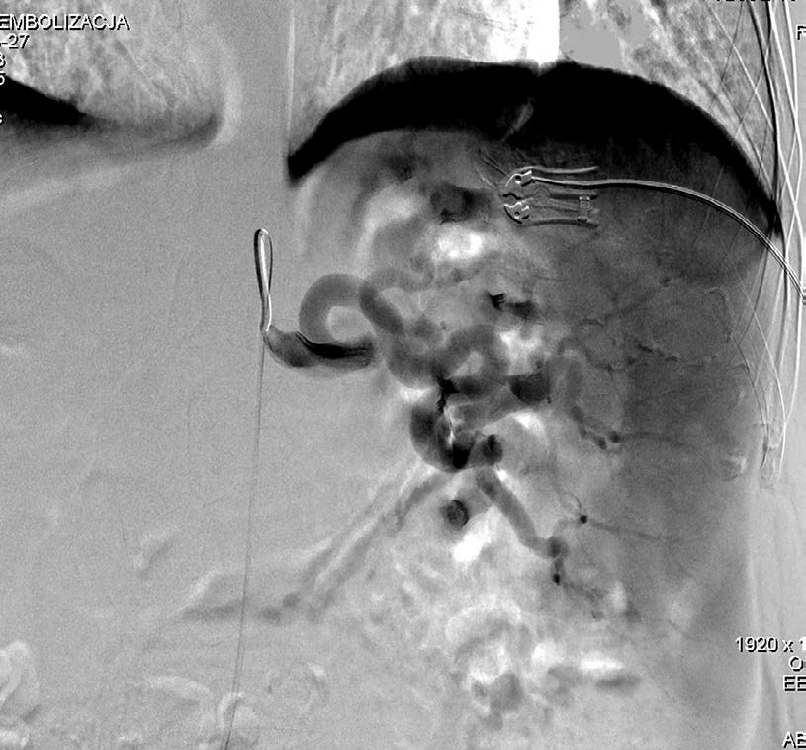
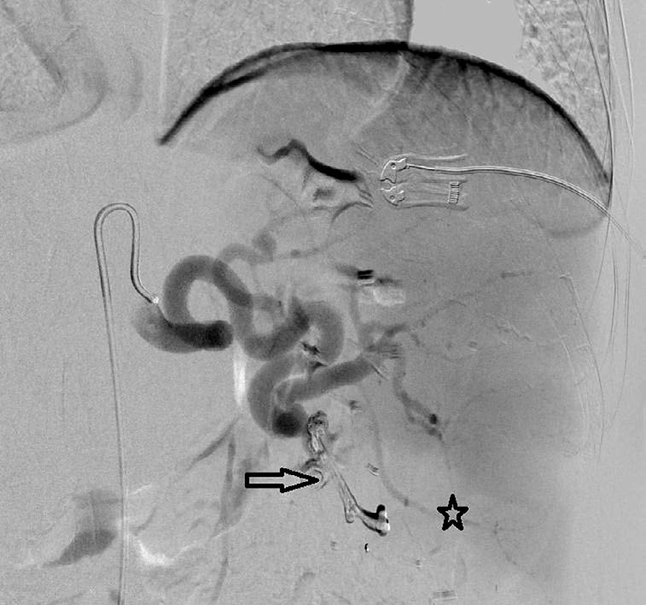
Evaluation of the effectiveness of partial splenic endovascular embolization in patients with refractory thrombocytopaenia
the final administration of the embolization material (Fig-
ures 1 and 2). The access point was normally closed with an AngioSeal (Terumo) closure.
Patients with TCP resistant to treatment were quali- fied for angiography, and at the same time, 22 patients underwent PSEE; in 5 cases PSEE was repeated. Distal embolization was performed using the coaxial catheter technique with the use of a microcatheter (Progreate, Terumo Medical Corporation, USA; Lantern, Penum- bra, USA). Embolizations were performed using selective arteriography of the branches in the splenic hilum, as- sessing the extent of their vascularization, and selecting the appropriate vessel for the procedure. The percentage of spleen parenchyma excluded from circulation was es- timated within 30-70%.
For PSEE in patients with refractory TCP, in 5 patients it was performed in 2 stages. The mixture of Histoacryl (N-butyl cyanoacrylate glue [NBCA], Braun, Germany) and Lipiodol (Guerbert, France) - 10 cases, coils (Tornado, Cook Medical, USA; Ruby, Penumbra, USA) – 10 cases, and polyvinyl alcohol – (PVA, Cook Medical, USA) – 7 cases were used for the embolization procedure, often using various embolization materials together during one treatment (Figure 1).
Only in 2 cases was severe post-embolization syndrome
observed (4-5 points). In both cases, approximately 70% of the circulation to the spleen was turned off. Closure less than 50% of the spleen circulation was associated with poorly expressed post-embolization symptoms (mild 0-1 point or moderate 2-3 points). The mean severity of the post-embo- lization syndrome in the whole group was 1.0 ± 1.2.
A strong positive correlation (r = 0.8, p < 0.05) was
found between CRP and the severity of the post-emboli- zation syndrome in patients after partial embolization of the spleen. Increased symptoms of post-embolization syn- drome were also associated with a significant increase in hospitalization time: 27.0 vs. 7.2 days (r = 0.66, p < 0.05)
(Figure 4).
The radiation absorbed by the patient during the pro- cedure in 27 endovascular procedures with TCP and sple- nomegaly ranged from 0.103 to 1.658 Gy (mean 0.19 Gy). Preoperatively, patients with TCP and splenomegaly were routinely administered amoxicillin (or ciprofloxa- cin in the case of drug allergy). The antibiotic was ad- ministered intravenously in a dose of 2.0 × 1.2 g the day before endovascular procedure, and then treatment was continued for 7-10 days depending on the persistence of the elevated CRP. The percentage of spleen parenchyma excluded from circulation was estimated within 40-70% (mean 40-50%).
Results
The results are presented in Table 2. Patients with treat-
ment-resistant TCP often requiring blood transfusions were enrolled in the study. After the procedure in out- patient control, a gradual increase in PLT was observed in a mean period of 194 days. When no satisfactory in- crease in PLT count was observed after first procedure, patients were qualified for re-embolization. The procedure was performed twice in 5 patients. The mean value of PLT before procedure increased from 22.0 ± 15 to 87.7 ± 67.9 (p < 0.05) (Figure 3). All patients became independent of platelet transfusions.
Complications
Serious complications occurred in 1 patient (3.5%) with TCP. He had a fluid reservoir in the spleen after 70% em- bolization of the spleen, requiring splenectomy.
The frequency of severe postembolization syndrome is low. In the group, after 27 embolization procedures, no features of postembolization syndrome were found in 11 patients, in 9 cases symptoms were mild, in 5 patients the symptoms were moderate, and only in 2 cases symp- toms were severe (mean 1.04 on a 5-point scale).
Figure 2. The same patient as Figure 3, N-butyl cyanoacrylate glue embo- lization of one splenic branch (black arrow) and the area of contrast deficit in part of the spleen (asterisk)
Figure 1. Selective catheter angiography of the spleen, splenomegaly and extended branches in the hilum of spleen are visible
© Pol J Radiol 2022; 87: e369-e374
e371

Maciej Rabczyński, Monika Fenc, Jarosław Dybko et al.
Table 2. List of parameters assessed in the study group
350
300
250
200
150
100
50
0
40
35
30
25
20
15
10
5
0
0
50
100
150 200 250 300 350 400 450
CRP (mg/l)
PLT in admission
PLT in control
Figure 3. Level of platelet (PLT) count before and after procedure
Figure 4. Correlation between CRP and hospitalization period
e372
© Pol J Radiol 2022; 87: e369-e374
Level of PLT
Hospitalization (days)

y
= 0.048
6x + 5.
6487

R2 =
0.4478

No. Patient PLT in admission PLT in control CRP Radiation Severity of post- Time of Volume of embolized (thousand/µl) (thousand/µl) (mg/l) (Gy) embolic syndrome hospitalization spleen (%)
1.
A.M.
33
34
94.52
0.19
2
10
50
2.
K.B.
54
20
3.14
0.443
0
8
30
3.
D.C.
12
305
202.30

4
35
70
4.
M.B.
15
44
25.71
0.269
0
6
25
5.
M.S.
9
28
29.45
1.448
1
15
20
6.
A.W.
65
38
177.62
1.107
2
6
50
7.
A.K.
24
25
8.83
0.227
1
5
25
8.
N.B.
34
48
5.29
0.258
0
7
50
9.
B.S.
64
161
0.60
0.307
0
6
60
10.
A.F.
319

90.40
0.674
2
11
60
11.
S.S.
135
94
391.91
0.103
4
27
70
12.
L.G.
70
104
131.50
0.627
1
8
50
13.
L.Z.
15
27
205.70
0.818
2
7
75
14.
S.N.
131
126
2.82
1.112
0
5
40
15.
W.Z.
1
81
3.87
0.819
1
6
60
16.
D.O.
52
121
66.52
0.372
0
7
40
17.
M.R.
28

182.99
1.658
2
19
70
18.
A.Ku.
46
53
185.38
0.642
1
9
30
19.
D.S.
242
236
59.24

1
5
20
20.
P.K.
51
53
2.00
0.416
0
5
30
21.
A.R.
43
106
2.09
0.446
0
5
25
22.
A.I.
26
59
169.40
0.275
1
9
20
23.
K.B. (II)
20
109
23.40
0.18
0
8
66
24.
A.W. (II)
86
116
5.12
1.06
1
6
40
25.
A.K. (II)
25
34
8.23
0.239
0
7
30
26.
N.B. (II)
48
35
11.64

1
6
20
27.
M.S. (II)
11

19.95

0
7
20

Evaluation of the effectiveness of partial splenic endovascular embolization in patients with refractory thrombocytopaenia
However, we should emphasize the fact that consecu-
tive PSEE intervention did not involve increased risk of complications or exposure to excessive doses of radiation. In our study the low dose of ionizing radiation in the range 0.103-1.658 Gy (0.19 Gy on average) is connected to the short time of embolization procedures and low level
of periprocedural complications.
Therefore, in accordance with the regulations, after ex- ceeding the dose of 1.0 Gy, additional diagnostic procedures should be implemented, and if the dose exceeds 3.0 Gy, specialist consultations should also be included. For this reason, strict compliance with the provisions on radiation protection of the patient is recommended, especially by less experienced operators.
The presented results were possible thanks to the use of new embolic devices and agents that limit the risk of po- tential migration and are less susceptible to recanalization. Moreover, using microprofile devices and microca- theters allows deep peripheral intervention. However, the choice of materials used during the procedure depends on
their availability and the operator’s experience.
The literature data indicate that complications after PSEE are rare, and they depend on the therapeutic method of exclusion of the circulation in the spleen (surgical or intravascular) with clear predominance of the intravas- cular method [9].
There are several limitations to our study, and they include mainly the number of patients, which was small, heterogenicity of the studied group, and different materi- als used for embolization procedures, which is why fur- ther research is needed.
Discussion
Partial endovascular embolization of the spleen (PSEE) is
a procedure performed due to many different indications, including liver cirrhosis, gastric varices, and splenomegaly. There also exist surgical indications for the intervention, and they include the patients after liver transplant who suffer from splenic artery steal syndrome (SAS) as a complication of the prior therapy [4]. Coagulation disorders in the course of liver diseases are frequently observed abnormalities. They are not only related to impairment in the process of produc- tion of coagulation factors, but also affect the level of throm- bopoietin, which exacerbates the decrease in platelet count. It is important because an additional benefit observed in the patients after the partial embolization of the spleen is the in- crease in platelet count, which minimizes the risk of bleed- ing, also in long-term follow-up [5]. However, the mecha- nisms that contribute to this rise are not fully understood.
Another indication to perform PSEE (or sometimes more invasive splenectomy) is hypersplenism-related TCP as an ef- fect of sequestration of the platelets in splenic parenchyma.
The effectiveness of PSEE in our study group with re- fractory TCP has not been assessed so far. In the literature, research focuses mostly on the problem with hypersplenic TCP as a result of other diseases, e.g. neoplasia [6,7].
Based on available literature, the prevailing opinion is that proximal embolization (involving the trunk of the splenic artery) is an effective and safe procedure [8]. From our experience, the selective embolization comprising smaller branches of the splenic artery allows us to exclude only a part of the blood circulation in the organ, which de- creases the risk of serious complications such as necrosis and its consequences. After the initial angiography, the branches chosen for embolization were those that supplied with blood to the middle and lower segments of the spleen, because the top of the organ can have extra vasculation from short gastro-omental branches.
This method of action allowed us to limit the area of splenic ischaemia, which resulted in less intense post-em- bolic syndrome during the post-operative period. A major complication was observed in only 1 case, and it concerned a patient who developed a splenic abscess after simultane- ous exclusion of more than 70% of splenic circulation.
It was proven that PSEE performed in cancer patients treated with chemotherapy is a safe intervention, and in long-term follow-up it results in increased platelet counts, allowing continuation of chemotherapy [6]. The elevation of platelets was durable and correlated with the amount of splenic parenchyma that was cut off from the blood supply. Post-embolization syndrome in the studied group of patients, if it occurred, was mild (average 1.0 on a 5-point scale). This observation can be explained by the fact that we have always tried to emphasize careful selection of the area
and location of the embolization.
On the other hand, this strategy probably caused a lack of satisfactory response for the treatment in 5 of our pa- tients and generated the need to repeat the PSEE procedure.
Conclusions
Partial endovascular embolization of the spleen (PSEE)
may be a valuable therapeutic option for patients with refractory TCP. The results show that it is a safe method with a low complication rate. Based on our experience, we suggest performing even 2 procedures of embolization of smaller amounts of splenic parenchyma over 1 procedure with occlusion of more than 70% of splenic circulation.
Despite the safety of PSEE, it is recommended that a prophylactic antibiotic therapy be introduced as a peri- procedural procedure before operation. Moreover, proce- dures in the field of radiation protection should be strictly followed because the normative doses are exceeded during most embolization procedures.
The evaluation of PSEE effectiveness in patients with TCP requires further studies on a larger group of patients.
Funding source
Supported by Wroclaw Medical University – grant No.
C.270.16.084, 2016-2019.
Conflict of interest
The authors report no conflict of interest.
© Pol J Radiol 2022; 87: e369-e374
e373

Maciej Rabczyński, Monika Fenc, Jarosław Dybko et al.
References
1.
Hill A, Elakkad A, Kuban J, et al. Durability of partial splenic
artery embolization on platelet counts for cancer patients with hypersplenism-related thrombocytopenia. Abdom Radiol (NY) 2020; 45: 2886-2894.
Wandt H, Schäfer-Eckart K, Greinacher A. Platelet transfusion in hematology, oncology and surgery. Dtsch Arztebl Int 2014; 111: 809-815.
Leung DA, Goin JE, Sickles C, et al. Determinants of postembo- lization syndrome after hepatic chemoembolization. J Vasc Interv Radiol 2001; 12: 321-326.
Saad WEA. Management of nonocclusive hepatic artery complica- tions after liver transplantation. Tech Vasc Interv Radiol 2007; 10: 221-232.
Wang Y, Zhang J, Zhang F, et al. Partial splenic artery embolization to
treat hypersplenism secondary to hepatic cirrhosis: a meta-analysis. Am Surg 2017; 83: 274-283.
6.
Luz JH, Luz PM, Marchiori E, et al. Partial splenic embolization to
permit continuation of systemic chemotherapy. Cancer Med 2016; 5: 2715-2720.
Bhatia SS, Venkat S, Echenique A, et al. Proximal splenic artery embolization in chemotherapy-induced thrombocytopenia: a ret- rospective analysis of 13 patients. J Vasc Interv Radiol 2015; 26: 1205-1211.
Mousa A, Armbruster J, Adongay J, AbuRahma AF. Splenic ar- tery embolization as a treatment option for chronic pancytopenia secondary to hypersplenism: a case report and review of literature. Vasc Endovascular Surg 2012; 46: 501-503.
Ozturk O, Eldem G, Peynircioglu B, et al. Outcomes of partial splenic
embolization in patients with massive splenomegaly due to idio- pathic portal hypertension. World J Gastroenterol 2016; 22: 9623.
7.
2.
3.
8.
4.
9.
5.
e374
© Pol J Radiol 2022; 87: e369-e374

