
Sygnatura:PolJRadiol,2007;72(1):57-64
originalarTiClE
UsefulnessofCTandMRIindiagnosticsofcranial
Otrzymano:
2006.08.11
Zaakceptowano:2006.12.11
fibrousdysplasialesions
AnnaCzarnecka,TomaszKuniej,MarekSąsiadek
DepartmentofNeuroradiology,ChairofRadiology,WroclawMedicalUniversity,Poland
Author’saddress:AnnaCzarnecka,DepartmentofNeuroradiology,Chair ofRadiology,WroclawMedical
University,M.Skłodowskiej-Curie68,50-369Wroclaw,e-mail:czanka@wp.pl
Summary
Fibrousdysplasia(FD)isadevelopmentalanomalyofunknownpathogenesisinwhichnormalboneisreplacedbyanabnormalfibroustissue.Theprocessmayaffectasinglebone(monoosticformoffibrousdysplasia)ormultiplebones(polyosticform).TheskullisthesecondmostcommonsiteofFDandcomprises25%ofcases.
ThepurposeofthisarticleistoevaluatetheusefulnessofCTandMRIindiagnosticsofcranialfibrousdysplasialesions.
Weanalyzed13CTand6MRexaminationsperformedin9femalesaged40to73years(meanage
54.7years).Fourpatientswerereferredtotheexaminationswithadiagnosisoffibrousdysplasia,3others–withasuspicionofneoplasticdiseaseand2patients-withnopreliminarydiagnosis.Clinicalsymptomsincluded:headache,deformityandasymmetryofcraniofacialregion.
Fibrousdysplasialesionswereunilateralin8patients;inonepatienttheywerebilateral.ThesphenoidandethmoidboneswerethemostcommonsinglebonesinvolvedbyFDlesions.Among9casesofFD,orbitalinvolvementwasfoundin8,nasalsinusesandcavityinvolvementin6andintracranialextensionin3patients.
CTandMRareusefulinconfirmingthediagnosisofFDandespeciallyinevaluatingtheextentofthedisease.
Background:
Material/Methods:
Results:
Conclusions:
Keywords:
fibrousdysplasia•cranial•CT•MRI
PDFfile:
http://www.polradiol.com/fulltxt.php?ICID=468407
Background
form(20–30%)whichoftenaffectsonehalfofthebody.ThelattercancoexistwithendocrinedysfunctionsandpigmentskinlesionsandinsuchcaseisdefinedastheAlbright-McCune-Sternbergsyndrome[3,4].
Inliteraturethefibrousdysplasia(FD)isreferredtoastheJaffe-Lichtensteindisease,osteitisfibrosajuvenilisoroste-itisfibrosadisseminataandrepresentsdevelopmentaldis-ordercharacterizedbyfibrocysticstructureofbonesandreplacementofosseoustissuebyfibrousandosteoidtissueofvariableconsistency.Theboneisdeformed–thickenedorthinned,duetounevendevelopmentofabnormalosse-oustissue[1,2].
TheincidenceofFDlesionsincranialandcraniofacialbonesisestimatedfor10-20%ofmonoosticcasesand50%ofpolyosticcases[5,6].
LesionsinthecourseofFDcanbeasymptomaticormanifestasbonedeformity(mostoftenvisibleincra-niofacialbones),bonepain,compressionofsoft-tissuestructuresoforbit,aswellasdisturbancesofhearingandequilibrium[7].
Thediseaseusuallybeginsinthefirsttwodecadesoflife,rarelyinadultage.Itoccursintwoforms:morefrequent-monoostic(70-80%ofcases)andlessfrequent–polyostic
57

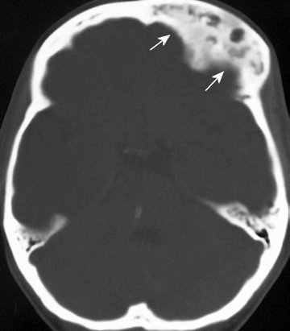
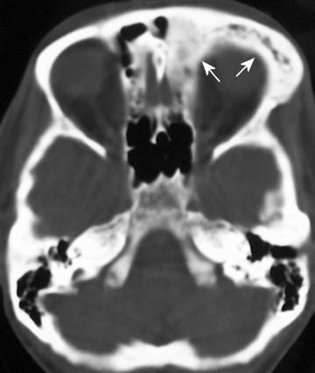
OriginalArticle
PolJRadiol,2007;72(1):57-64
Table1.Locationofthelesionsintheskull.
CTexaminationswerecarriedout using5mm thickslices(craniofacialarea) and 8mm (cerebrocranial area),in allcaseswiththeuseofboneandsoft-tissuewindows.Thescopeincludedcraniumandupperpartofcraniofacialareaincludingorbits.Insomecasesmultiplanarreconstructionsandthreedimensional(3D)CTwerealsoapplied.
LocationoftheFDlesions
Numberofpatients(n=9)
Sphenoidbone
7
Ethmoidbone
5
Maxillarybone
2
TheMRexaminationswerecarriedoutinsequencesFSE(T2-weightedimages),FE(T1-weightedimages)andFLAIRsequences,beforeandafterthecontrastmediumadminis-tration,infrontal,sagittalandtransverseplanes.
Zygomaticbone
1
Althoughtheradiographic appearanceof craniumaffect-ed by FD is well known and described, hardly anyreportsinPolishliteraturementiontheuseofcomputedtomog-raphy(CT)andmagneticresonance(MR)inthisdisease.Therefore,theaimofthisworkistodiscusstheuseofMRandCTindiagnosticsofcranialfibrousdysplasiaonthebasisoftheownmaterial.
Results
Inmostpatientsthedysplasticlesionsofbonesoccurredononesideofthebody.Onlyinonepatienttheywerebilateral.
Themostcommonlocationsoflesionsconsideringthesinglebonesweresphenoidandethmoidbones(table1)(fig.1).
Materialsandmethods
Thestudycomprised9femalepatientsaged40–73(meanage54.7).ExaminationswereperformedintheDepartmentof Radiologyof theMarciniak’sLower-SilesianSpecialistHospitalinWroclaw.Altogether13CTand6MRexamina-tionswerecarriedout.Twopatientsunderwent3CTseach,2patients–1MReach.Allinall,oneormoreCTexamina-tionswereperformedin7patientsandoneormoreMRexaminations–in5ofthem.
In8of9patientsthelesionsaffectedthestructuresoforbitbyprotrudingintoitslumen.In5casesitcausedcompres-sionontheorbitmuscles,in4–protrusionofaneyeball,andin3–compressionofopticnerve(table2)(fig.2).
Lesionswithinparanasalsinusesandnasalcavitywerefoundin6patients–forlayoutseetable3.
Fourpatientswerereferredtotheexaminationwithclini-caldiagnosisoffibrousdysplasia,threewithsuspicionofneoplasmaticprocess,while2otherpatients–withnon-definedpreliminarydiagnosis.Clinicalsymptomsobservedinpatientsincludedpain,deformityandcranio-facialasymmetry.
Protrusionintotheintracranialspacewithcompressionofcerebralstructureswasobservedin3patients(table4).
DysplasticlesionswerevisibleonCTimagesasareasofhighdensitycorrespondingwithscleroticdensityofosseous
Figure1.PatientZ.T.,43y.o.AxialCTimages.Thereisalargeareaofinhomogeneousdensityinvolvingthelowerpartofthefrontalbone,frontalsinusandethmoidcellsontheleftside(arrows).
58
A
B

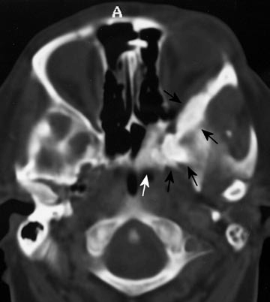
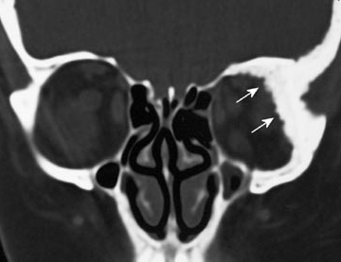
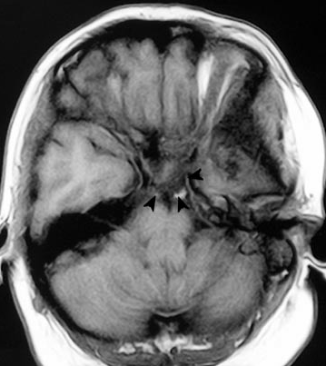
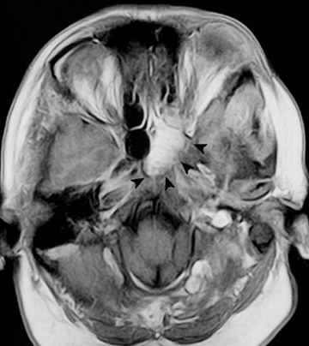
PolJRadiol,2007;72(1):57-64
UsefulnessofCTandMRIindiagnostics...
Table2.Characteristicsofthelesionsintheorbitalregion.
Typeoflesion
Numberofpatients(n=8)
Thickeningofcontoursoftheorbitalboneswithprotrusionintothelumenoforbit
8
Compressionandmodellationoforbitalmuscles
- lateralrectusmuscle
- inferiorrectusmuscle
5
4
1
Protrusionofaneyeball
4
Compressionanddisplacementofopticalnerve
3
Figure2.PatientD.B.,51y.o.Axial(A)andcoronal(B)CTimages.Thickeningandsclerosisoflateralandupperwallsoftheleftorbitandthewallsoftheleftsphenoidsinuswithprotrusionoflesionsintotheleftorbitandleftsphenoidsinus(arrows).MR,axialT1-weightedpre-(C)andpostcontrast(D)images.LesionswhichwerevisibleonCTenhancedafterintravenousinjectionofGadolinium(arrowheads).
59
C
D
B
A

OriginalArticle
PolJRadiol,2007;72(1):57-64
Table3.Lesionsinthenasalcavityandsinuses.
Table4.Intracraniallesions.
Lesionswithinsinuses
Numberofpatients(n=6)
Intracraniallesions
Numberofpatients(n=3)
Sphenoidsinus
4
compressionofbrain,including:
3
Ethmoidsinus
4
Frontallobes
2
Maxillarysinus
3
Temporallobes
1
Frontalsinus
2
etal.madeanattempttodefinethedistinctivefeaturesofFDlesionsandthePaget’sdiseaseonCTimages.AccordingtothemtheFDischaracterizedby“groundglass”lesion,asymmetryofcranialboneinfiltrationandinvolvementofparanasalsinuses.AnothersignsofFDinclude:involve-mentofthesphenoidbone,orbitandnasalcavity,presenceofsoft-tissuemass,involvementofmaxillaryboneandassociatedcysticlesionsinclivus[10].Ourmaterialcon-firmstheasymmetricallocalizationofFDlesionswithinthecranialbones,frequentinvolvementofsphenoidbone,orbitalstructuresandparanasalcavities.
Protrusionofabnormaltissueintothenasalcavity
3
tissue(fig.3,4).AlthoughonMRtheyhadlowsignalinallsequences,afterintravenouscontrastagentadministrationtheywereslightlyenhanced(fig.5).
Follow-upexaminationsof2patientsrevealedprogressionofthelesions.Bothpatientsunderwentsurgicaltreatment;diagnosisofFDinthesecaseswasconfirmedbyhisto-pathologicexamination.Thefollow-upCTandMRexami-nationsofotherpatientsshowednosignificantdifferencescomparedtothepreviousstudies.
IncasesofdifferentiationbetweenFDandneoplasticprocessestheaforementionedassessmentofsignsofbonedestructionisimportantandthe CTexamina-tionneedstobeextendedwithanexamwithcontrastmediumadministrationinordertoshowpossiblepatho-logicenhancementwithinthelesion.Kumaretal.claimthattheFDlesionsincraniofacialareatobewell-vascu-larized,canbestronglyenhancedwithcontrastmediumandcausespontaneousrecurrentbleedings[11].Inoneofourpatientsthelesionsledtobonedestructionandwereintensivelyenhancedaftercontrastmediumadministra-tion.Thepatientunderwentsurgicalprocedureduetofastprogressionofchangesandsymptomscausedbycom-pressionofintraorbitalstructures.Incaseofthatpatient,theFDdiagnosiswasconfirmedwithhistopathologicexamination.
Discussion
ConventionalradiographyisthebasicexaminationinradiologicaldiagnosticsofFDbutduetothelimitationsofthismethod(visualizationofthebonelesionsonly,limitednumberofviews)itdoesnotallowcompleteevaluationofthedysplasticlesions.
Daffneretal.emphasizethesignificanceofassessmentofFDlesionsinCTexaminationinpatientsinwhomthelesionsleadtocompressionoftheorbitalsoft-tissuestruc-turesandprotrusionoftheeyeball,whatconcernedabout35%ofFDpatientsintheirmaterial[8].Therefore,asfarasFDdiagnosticsisconcerned,assessmentinboth–boneandsofttissuewindowisobligatory.Evaluationofthebonesenablespreciseestimationoftheextentoftheprocess:bor-ders,location and size of pathologic foci as well asassess-mentofcontinuityofcorticalbonewhatcanbeconsideredasthefeaturedistinguishingfromneoplasticprocesses.Theaimofthesoft-tissuewindowexaminationistoevaluatestatewhetherthelesionsinvolveextraosseousstructures(orbits,paranasalcavities,intracranialspace)ornot.
TheMRexaminationisusuallyusedtodefinethelesionswithinthesofttissues–toevaluatetheircompressionanddisplacement causedby pathologicdysplastictissue, alsoincaseofsuspicionofotheretiologyoflesionsandtheiratypicallocation[3,5,12,13].
TheMRsignalofdysplasticlesionsisusuallyhypoin-tenseonT1andT2-weightedimages,asinthecasesweexamined.Withsuchpattern,theinterpretationofthelesionsdoesnotcauseproblems,especiallyincasesofcoexistenceofscleroticlesionsonplainfilmsorCTexami-nations.Theassessmentofetiologyofthelesionsiscompli-catedwhentheirsignaldiffersfromthementionedaboveandthelocationoflesionsisnottypicalforFD.
Thepossibilityof3Dreconstructionisanadditionaladvan-tageoftheCTexamination,whatisespeciallyusefulinplanningsurgicalprocedures.
Brownetal.mention3formsofFDcraniallesionsobservedonCTimages–lesionsofhomogenouslyhigherdensity-osteosclerotic(23%),lesionsoflowerdensity-cystic(21%)andmixed,non-homogenouslesions,theso-called“groundglass”appearance(56%)[9].InourmaterialFDlesionsinexaminedpatientswereinmostcasesthe“groundglass”type.
OnecanfindreportsonFDcasesinwhichthesignalwashypo-orisointenseonT1-weightedimagesandhypo-,iso-orhyperintenseonT2-weightedimages[5,6,14,15].Jeeetal.comparedatypicalmanifestationofFDwiththeresultofhistopathologicexaminationandfoundthatthelesionswithstrongerT2signalarebuiltofsmallernumberofbonetrabeculae,collagenandcellularelements[6].Chongetal.alsoclaimthatthehyperintensesignalofFDlesionsonT2-weightedimagescorrespondstonon-mineralizedareasandcysticlesionsfoundinCT.Theyalsosuggest
However,theaforementionedformsdonothaveacharac-teristicCTpatternandrequiredifferentiationfromotherpathologiclesionssuch as:thePaget’sdisease,inflamma-torylesionsofbonesorneoplasticprocess.Tehranzadeh
60

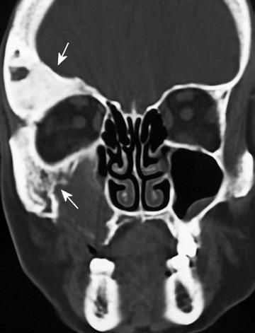
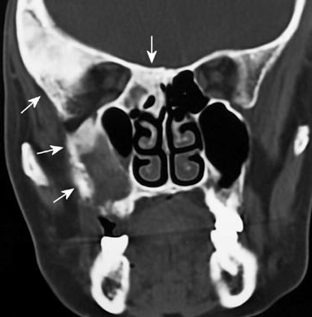
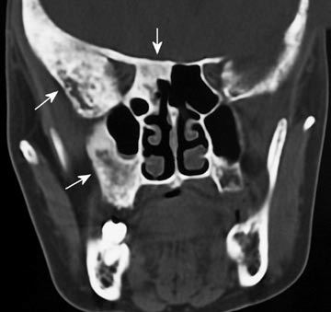
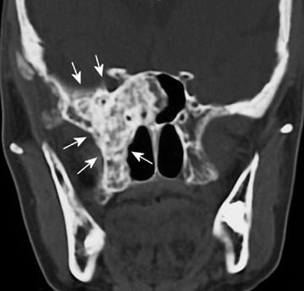
PolJRadiol,2007;72(1):57-64
UsefulnessofCTandMRIindiagnostics...
Figure3.PatientT.S.,65y.o.CTstudy.Extensivelesionsofinhomogeneousdensityontherightside,involvingmaxillaryandsphenoidsinuses,greaterwingofsphenoidbone,zygomaticboneandorbitalroofwiththeadjacentpartofthefrontalbone(arrows).
verificationofthisfindingwithfatsaturationsequenceincaseofhighersignalonT1-weightedimages,astheseregionsusuallycorrespondtobonemarrow[5].
FDlesionsofatypicalMRimageandunusuallocationcanbemisdiagnosedasinflammatoryorneoplasmaticprocess,especiallyiftheyvisiblyenhanceaftercontrastmediumadministration[17].However,Resnickemphasizesthat,unlikethescartissue,thefibroustissueinFDismetaboli-callyactiveandwell-vascularized,whatexplainswhyitisrelativelysensitivetocontrastenhancement[16].TheMRofourpatientsshowedmoderatecontrastenhancement.
ResnickemphasizesthecorrelationbetweentheFDlesionssignalintensityandtheproportionoffibroustissuetocalcifiedmatrix.Accordingtohisexperiencethehypoin-tenselesionsonT1-weightedimagesarehistopathologi-callybuiltmainlyoftherichlycalcifiedmatrix,whiletheisointenselesionscontainalotoffibroustissue.TheimageoflesionsinT2sequenceshowshighervariationofsignal.Heobservedlowersignalinwell-mineralizedlesionsandincreasedsignalinlesionsrichinfibroustissueandcysticchanges[16].
Chongetal.believethatthecertaintyofdiagnosisishighwhenthelesionsshowlowsignalonT1andT2-weightedimages,evenaftercontrastmediumadministration[5].Incaseofdif-ferent,atypicalsignalandcontrastenhancement,theverifica-tionofCTappearanceoflesionsoughttobedecisive[3,5].
61
C
D
B
A

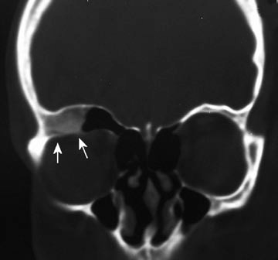
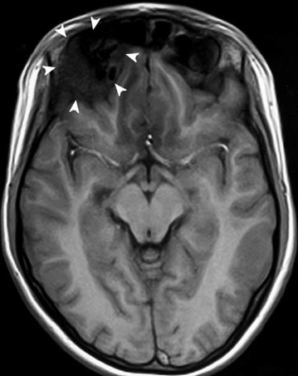
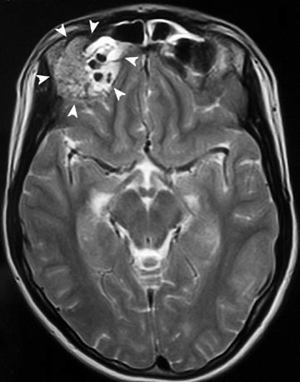
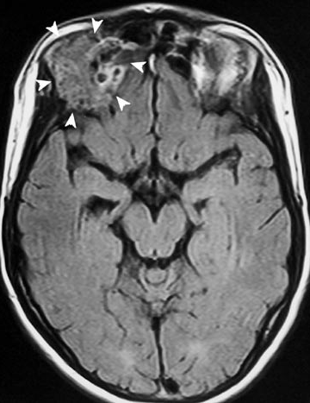
OriginalArticle
PolJRadiol,2007;72(1):57-64
Figure4.PatientM.Ż.,14y.o.CoronalCTimage(A).Thereishyperdenselesionintherightorbitalroof,involvingorbitalstructures(arrows).MR,axialT1-weighted(B),T2-weighted
(C)andFLAIR(D)images.ThelesionishypointenseonT1-weightedimagesandhasinhomogeneous,iso-tohyperintensesignalintensityonT2-weightedandFLAIRimages(arrowheads).
Sometimesitisnecessarytofollow-upthechangesandevaluatethepossibleprogressionofthedisease–insuchacasetheadvantageofMRoverplainfilmsorCTisitslackofradiationandthepossibilitytostudythesoft-tissuestruc-tures.Monitoringtheorbitallesionsisparticularlysignificantbecausethecompressionofopticalnerveleadstosightdistur-bance,whilethedisplacementofexternaleyemusclesandpro-trusionoftheeyeballcausesdisordersofitspositionandsettle-
ment,whatcanleadtodoublevisionetc.Lesionsdiagnosedtoolatecanresultinirreversibleunilateralblindness.IncasesofadvancedFDlesionswithinthecranialbonesitisnecessarytovisualizethecompression ofbrainwhichcancauseneurologi-calfocalsymptoms.Moreover,theMRshowspreciselythepro-trusion ofabnormaltissueintothenasalcavityandparanasalsinuseswhatisimportantasitcancauseairlessness,patencyandsecretionoutflowdisturbancesoftheinvolvedsinuses.
62
D
C
B
A

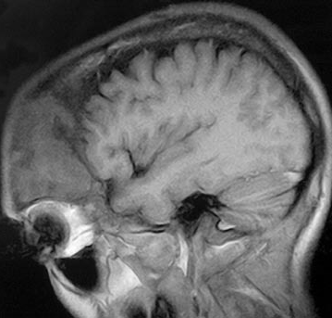
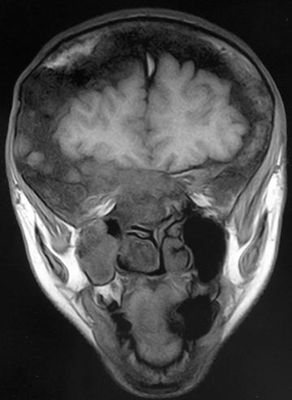
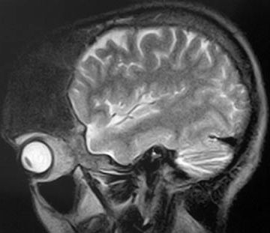
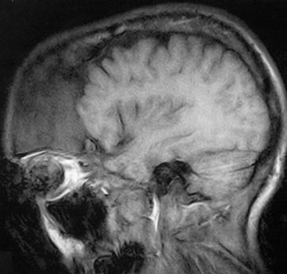
PolJRadiol,2007;72(1):57-64
UsefulnessofCTandMRIindiagnostics...
Figure5.PatientM.J.,40y.o.MR,axialT1-weightedpre(A)andpostcontrast(B)images,sagittalT2-weightedimage
(C)andcoronalcontrast-enhancedT1-weightedimage(D).Thereisahugelesioninvolvingfrontalbone,frontalsinuses,sphenoidsinus,greaterwingsofthesphenoidboneandrightmaxillarysinus.ThelesionishypointenseonT1-andT2-weightedimages.Thereisslightinhomogeneousenhancementaftercontrastmediuminjection.
ThetreatmentofFDpatientsisusuallyconservative.Surgicaltreatmentisappliedonlyincasesofincreasingdeformation,symptomaticcompressionofnervesandintracranialstructuresormalignanttransformationofthelesion[3,7].
Ourstudycorroborateshighfrequencyoforbitalstructuresbeinginvolvedwithdysplasticlesionsastheywereobservedin8of9patients.CTexaminations,especiallytheMR,enabledapreciseevaluationofthecompressionofthesoft-tissueorbitalstructuresfoundinmostofourpatients.
CTandMRplayedanimportantroleinourstudy–indiag-nosingaswellasinevaluationoftheextentoflesionsincourseofFD.Among9patientsonly4werereferredtoexaminationswithFDdiagnosis,whiletheremainingwerediagnosedonthebasisofCT,MRorbothofthem.In3casesmalignantinfiltrationwassuspectedclinicallybutimagingexaminationsallowedrulingoutsuchdiagnosis.
Moreover,CTandMRexaminationsenabledustopreciselydefinetheinvolvementofparticularcraniofacialbonesandparanasal sinuses,what canbe significantwhenplanningthe possiblereconstructionoperations. It isimportanttovisualizethecompressionofthebrainstructureswhichwasobservedin3of9patientsandtoexcludethecoexis-tenceofotherlesionswithintheintracranialspace.
63
D
C
B
A

OriginalArticle
PolJRadiol,2007;72(1):57-64
Conclusions
differentialdiagnosisinordertoexcludeotherpathologicalprocesseswhichcanoccurwithinthecraniofacialareaandclinicallycanresembletheFD(neoplasticprocess,Paget’sdisease,boneinflammation).The CTand MRoughtto beconsideredascomplementarymethodswhichplaycrucialroleinassessmentandmonitoringthelesionsaswellasinqualificationtothesurgicaltreatment.
OnthebasisofourmaterialitcanbestatedthatCTandMRstudiesprovidemuchbettervisualizationoflesionsinthecourseofFDthantheplainfilms,betterestimationoftheextentoflesionsandtheirrelationtoorbitalstruc-turesandintracranialspace.Theyarealsosignificantfor
References:
- MarchioriDM,SartorisDJ:Nowotworykości.In:MarchioriDM(ed.):Radiologiakliniczna.WydawnictwoCzelej,Lublin,1999,pp.691–694.
- RentonP:Congenitalskeletalanomalies.In:SuttonD(ed.):TextbookofRadiologyandImaging,ChurchillLivingstone,2003,pp.22–23.
- SirvanciM,KaramanK,OnatLetal:Monoosticfibrousdysplasiaoftheclivus:MRIandCTfindings.Neuroradiology,2002;44:847–850.
- DaffnerRH:FibrousDysplasia.ContemporaryDiagnosticRadiology,2002;12:1–5.
- ChongVF,KhooJB,FanYF:Fibrousdysplasiainvolvingthebaseoftheskull.AJRAmJRoentgenol,2002;178:717–720.
- JeeWH,ChoiKH,ChoeBYetal:Fibrousdysplasia:MRimagingcharacteristicswithradiopathologiccorrelation.AJRAm
JRoentgenol,1996;167:1523–1527.
- SharmaRR,MahapatraAK,PawarSJetal:Symptomaticcranialfibrousdysplasias:clinico-radiologicalanalysisinaseriesofeightoperativecaseswithfollow-upresults.JournalofClinicalNeuroscience,2002;9(4):381–390.
- DaffnerRH,KirksDR,GehweilerJAJretal:Computedtomographyoffibrousdysplasia.AJR,1982;139:943–948.
- BrownEW,MegerianCA,McKennaMJetal:Fibrousdysplasiaofthetemporalbone.AJRAmJRoentgenol,1995;164:679–682.
- TehranzadehJ,FungY,DonohueMetal:ComputedtomographyofPagetdiseaseoftheskullversusfibrousdysplasia.SkeletalRadiol,1998;27:664–672.
- KumarR,MadewellJE,LindellMMetal:Fibrouslesionsofbones.RadioGraphics,1990;10:237–256.
- LevyML,ChenTC,WeissMH:Monoosticfibrousdysplasiaoftheclivus.JNeurosurg,1991;75:800–803.
- SatoK,KubotaT,KanekoMetal:Fibrousdysplasiaoftheclivus.SurgNeurol,1993;40:522–525.
- UtzJA,KransdorfMJ,JelinekJSetal:MRappearancesoffibrousdysplasia.JComputAssistTomogr,1989;13:845–851.
- YanoM,TajimaS,TanakaYetal:Magneticresonanceimagingfindingsofcraniofacialfibrousdysplasia.AnnPlastSurg,1993;30:371–374.
- ResnickD:Tuberoussclerosis,neurofibromatosisandfibrousdysplasia.In:FeldmanD(ed.):Diagnosisofboneandjointdisorders.Saunders,Philadelphia,1995,pp.4353–4395.
- MafeeMF,CarterBL:Tumorandtumor-likelesionsoftheparanasalsinusesandnasalcavity.In:ValvassoriGE,MafeeMF,CarterBL(eds.):Imagingoftheheadandneck.Thieme,NewYork,1995,pp.302–328.
64

