
Signature:©PolJRadiol,2010;75(4):51-54
CASEREPORT
Congenitalradioulnarsynostosis–casereport
Received:2010.05.26
Accepted:2010.08.04
AnnaSiemianowicz1,WojciechWawrzynek1,KrzysztofBesler2
1DepartmentofDiagnosticImaging,DistrictHospitalofOrthopedicsandTraumaSurgery,PiekaryŚląskie,Poland
2TraumaandOrthopaedicsDepartmentforChildrenandAdolescents,DistrictHospitalofOrthopedicsandTraumaSurgery,
PiekaryŚląskie,Poland
Author’saddress:AnnaSiemianowicz,DepartmentofDiagnosticImaging,DistrictHospitalofOrthopedicsandTraumaSurgery,Bytomska62Str.,PiekaryŚląskie,Poland,e-mail:asiem@mp.pl
Summary
Congenitalradioulnarsynostosisisararemalformationoftheupperlimb,withfunctionallimitationsofthelimb.
A10-year-oldchildwithpainandrestrictedmobilityoftheelbowjointwasadmittedtothehospital.PlainfilmradiographyandCTexaminationwasperformed.Radiologicalexaminationsshowedacongenitalradioulnarsynostosis.
Thechildunderwentsurgicaltreatment–derotationalosteotomy.
Diagnosticimagingincludingcomputedtomographywiththree-dimentional(3D)reconstructions,precedingsurgeryenablesplanningofthesurgicaltreatment.
Background:
CaseReport:
Conclusions:
Keywords:
radioulnarsynostosis
PDFfile:
http://www.polradiol.com/fulltxt.php?ICID=881342
Background
andtraumahistorywasnegative.Physicalexaminationshowedadeformedandslightlyvalguselbow,aswellaslackoffullpronation.Limbinnervationandperfusionwerenormal.Thechildwasingoodgeneralhealthstate.Thepsychomotordevelopmentwasappropriateforage.Therewerenootherconcomitantmalformations.
CongenitalradioulnarsynostosiswasfirstdescribedbySandifortin1793[1,2].Theliteraturereportsonapprox.350casesofcongenitalradioulnarsynostosis[2–4].Thisisararecongenitalmalformationcausinglimitedrotationalmovementsoftheforearm,whichmayleadtodifficultieswithsomeactivitiesofdailyliving[5,6].However,thisisthemostcommoncongenitalfunctionaldisorderoftheelbowjoint. In 60–80% of cases, it is observed bilaterally[1,4].In9%ofcases,itrunsinafamily[2].In25%ofcases,thismalformationisgeneticallyconditioned[7].Congenitalradioulnarsynostosisisalsooneofmanycomponentsofmalformationsyndromesinchildrenwithchromosomalaberrations[8,9].Itiscommonlybelievedthatthismalfor-mationisconnectedwithchromosomeXaberrations[10].However,therearereportsoncasesofcongenitalradioul-narsynostosisinchromosomeYaberrations[11].
ThepreviouslyperformedX-raysshowedcongenitalradio-ulnarsynostosiswithsubluxationoftheradialhead.
Beforetheelectivesurgery,spiralCTwasperformedwithplanarand3Dreconstructions.CTconfirmedthepresenceofboneanomalyintheformofradioulnarsynostosistypeIIaccordingto ClearyandOmer classification(Figures1–4).Thesynostosisstartedatthelevelof2.5cmbelowthecoronoidprocessoftheulna,andwasvisibleforthenext4.5–5cm.A3Dreconstructionallowedforspatialvisualisa-tionoftheexistingmalformationandreciprocalanatomicalrelationswithinthebonestructures(Figures5–7).
CaseReport
A10-year-oldchildwasadmittedtoDistrictHospitalofOrthopediscandTraumaSurgery.Theboycomplainedofminorpainwithintheareaoftherightelbowjoint,mobil-itylimitations,difficultiesinwritinganddrawing.Family
Thechildwassubjectedtosurgerywhichinvolvedderota-tionalosteotomyoftheradialboneandstabilisationwithplateandscrews.Thenextstageoftreatmentinvolvedtheremovaloftheplateandscrews,andintroductionof
51

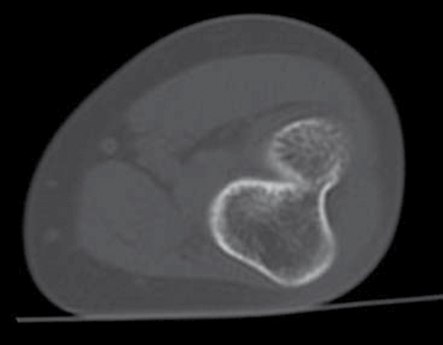
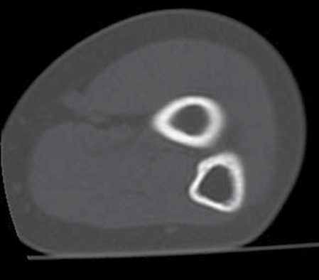
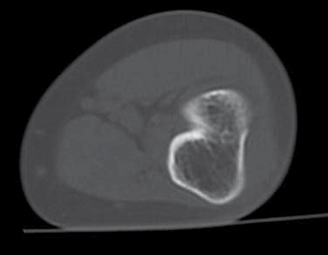
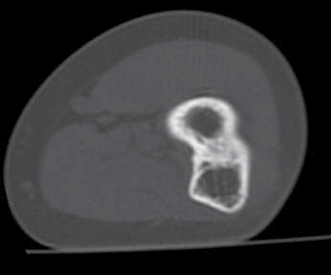
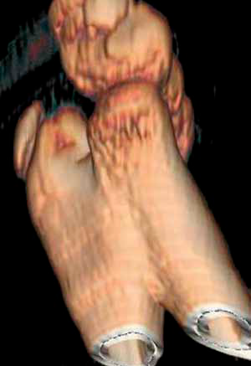
CaseReport
©PolJRadiol,2010;75(4):51-54
Figure1.CTexaminationoftheelbowjoint,bonewindow,axialplaneoftheulnarandradialboneintheupperpartoftheradioulnarsynostosis.
Figure4.CTexaminationoftheelbowjoint,bonewindow,axialplaneoftheulnarandradialbonebelowtheradioulnarsynostosis.
Figure2.CTexaminationoftheelbowjoint,bonewindow,axialplaneoftheulnarandradialboneinthecentralpartoftheradioulnarsynostosis.
Figure5.CTexaminationoftheelbowjoint,3Dreconstruction,radioulnar synostosisinpostero-inferiorview.
rehabilitation.Thesurgicalprocedureandrehabilita-tionledtoasubstantialimprovementoftheupperlimbfunction.
Figure3.CTexaminationoftheelbowjoint,bonewindow,axialplaneoftheulnarandradialboneinthelowerpartofradioulnarsynostosis.
Discussion
Congenitalradioulnarsynostosisisamalformationwhichdevelopsintheearlyfoetallife.Theelbowbeginstoappear
52

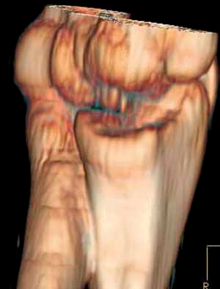
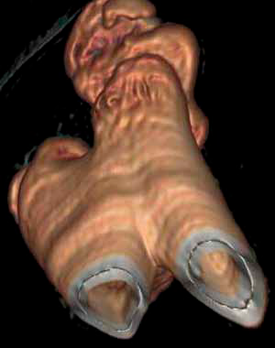
©PolJRadiol,2010;75(4):51-54
SiemianowiczAetal–Congenitalradioulnarsynostosis–casereport
Figure6.CTexaminationoftheelbowjoint,3Dreconstruction,radioulnar synostosisinpostero-inferiorview.
Figure7.CTexaminationoftheelbowjoint,3Dreconstruction,radioulnarsynostosisinantero-medialview.
onthe34–35thdayofthefoetallife,whilethehumerus,theradialbone,andtheulna–onthe37thday[4,10].Anyinflu-enceofadversefactorsinthisperiodleadstoadisturbedsegmentation,whichinturnscausesmalformation[4].Congenitalradioulnarsynostosisismostlyfoundinyoungchildren,aged2–5years[1].Inmostofthecases,theevalu-ationofthemalformationbasesonclassificationbyClearyandOmer[1,10,12].IntypeI,thereisadecreasedsizeoftheradialbone,thefusiondoesnotinvolvebones;intypeIIthereisaradioulnarsynostosis,andtheremainingbonestructuresdonotrevealanyotherchanges.IntypeIII,thereisaradioulnarsynostosis,hypoplasticheadoftheradialbone,andposteriorsubluxationoftheradialhead.IntypeIV,thereisashortradioulnarsynostosis,mushroom-shapedmalformationoftheheadoftheradialbone,andanteriorsubluxationoftheradialhead.
forearmposition.Surgeryshouldbecarriedoutinchild-hood[4].Derotationalosteotomyisoneofthepossiblemethodsofsurgicaltreatment.Inpatientsqualifiedforsurgery,it isnecessary toanalyse the resultsof diagnosticimaging:X-rayandCT.ApreoperativeCTwith3Drecon-structionswillpreciselyshowallanatomicalrelations,spatialpositionofthebonecomponents,allowingforadetailedplanningof thesurgical procedure(13).
Conclusions
Congenitalradioulnarsynostosisisararemalforma-tion,treatedconservativelyorsurgically,dependingonitsdegreeandmovementrange.Whentakingadecisiononthemethodoftreatment, itisextremelyhelpfultouse theresultsofdiagnosticsimagingproceduresandespeciallytheresultsofCTwith3Dandplanarreconstructions.CTallowsforadetailedvisualisationofthespatialrelations,whichfacilitatespreciseplanningofthesurgicalprocedure.
Dependingonthedegreeofthemalformation,thetreat-mentmaybeconservativeorsurgical[4].Qualificationforsurgerydependsonindividualfunctionallimitationsand
Refrences:
- LescaultE,MulliganJ,WilliamsG:Congenitalradioulnarsynostosisinanactivedutysoldier:casereportandliteraturereview.MilMed,2000;165(5):425–28
- FakoorM:Radioulnarsynostosisinafatherandhis5yearolddaughter.PakJMedSci,2006;22(2):191–93
- FarzanM,DaneshjouKH,MortazaviSMJetal:Congenitalradioulnarsynostosis,areportof11casesandreviewofliterature.ActaMedicaIranica,2002;40(2):126–31
- WurapaR.Radial-ulnarsynostosis.eMedicine.http://emedicine.medscape.com/article/1240467-overview(Updated:09.02.2009)
- MasukoT,KatoH,MinamiAetal:Surgicaltreatmentofacuteelbowflexioncontractureinpatientswithcongenitalproximalradioulnarsynostosis.Areportoftwocases.JBoneJointSurgAm,2004;
86-A(7):1528–33
- KaoHK,ChenHC,ChenHT:Congenitalradioulnarsynostosistreatedusingmicrovascularfreefascio-fatflap.ChangGungMedJ,2005;28(2):117–22
- YammineK,SalonA,PouliquenJC:Congeniatalradioulnarsynostisis.Studyofaseriesof37childrenandadolescents.ChirMain,1998;17(4):300–8
- ChoYG,KimDS,LeeHSetal:Acaseof49,XXXXXinwhichtheextraXchromosomeswerematernalinorigin.JClinPathol,2004;57(9):1004–6
53

CaseReport
©PolJRadiol,2010;75(4):51-54
- PeetJ,WeaverDD,VanceGH:49,XXXXY:adistinctphenotype.Threenewcasesandreview.JMedGenet,1998;35(5):420–24
- ElliottAM,KibriaL,ReedMH:Thedevelopmentalspectrumofproximalradioulnarsynostosis.SkeletalRadiol,2010;39:49–54
- SyedAA,QuintonR:Congenitalradioulnarsynostosis,azoospermiaandpseudodicentricYchromosome.FertilSteril,2008;90(2):425–26
- ClearyJE,OmerGE:Congenitalproximalradio-ulnarsynostosis.JBoneJointSurgAm,1985;67:539–45
- LandowskiJ,MaciakS,SokólskaEetal:Trójwymiarowarekonstrukcjaobrazówtomografiikomputerowej–metoda3Dwdiagnostyceukładukostno-szkieletowego.PolPrzeglRadiol,1996;61(1):55–56
54

