
Received: 4 October 2016 | Revised: 25 November 2016 | Accepted: 18 December 2016
DOI: 10.1002/ece3.2712
ORIGINAL RESEARCH

Telomere dynamics in a lizard with morph-specific reproductive
investment and self-maintenance

Nicky Rollings1 | Christopher R. Friesen1 | Joanna Sudyka2 | Camilla Whittington1 |
Mathieu Giraudeau1,3,4 | Mark Wilson5 | Mats Olsson5,6
School of Biological Sciences, University of
Sydney, Sydney, NSW, Australia
institute of Environmental
Sciences, Jagiellonian University, Kraków,
Poland
3School of Life Sciences, Arizona State
University, Tempe, AZ, USA
4Centre for Ecology and Conservation, College
of Life and Environmental Sciences, University
of Exeter, Penryn, UK
5School of Biological Sciences, The University
of Wollongong, Wollongong, Australia
6Department of Biological and Environmental
Sciences, University of Gothenburg,
Gothenburg, Sweden
Correspondence
Mats Olsson, School of Biological Sciences,
The University of Wollongong, Wollongong,
Australia.
Email: mats.olsson@bioenv.gu.se
Funding information
Australian Research Council; National Science
Foundation,
Abstract
Telomeres in human fibroblasts shorten progressively during in vitro culturing and trig-
ger replicative senescence. Furthermore, shortened telomeres can be used as bio-
markers of disease. These observations have led to the suggestion that telomere
dynamics may also be associated with viability and selection for life history variation
in non-human taxa. Model systems to examine this suggestion would particularly ben-
efit from the coexistence of multiple phenotypes within the same species with differ-
ent life history trade-offs, since those could be compared in terms of telomere
characteristics. This scenario also provokes the classic question of why one morph
does not have marginally higher fitness and replaces the others. One explanation is
that different morphs have different reproductive tactics with equal relative fitness. In
Australian painted dragons (Ctenophorus pictus), males differ in head color, the pres-
ence or absence of a gular bib, and reproductive expenditure. Red males out-compete
yellow males in dominance contests, while yellow males copulate quickly and have
higher success in sperm competition than red males. Males with bibs better defend
partners against rival matings, at the cost of loss of body condition. We show that
yellow-headed and bib-less males have longer telomeres than red, blue and bibbed
males, suggesting that telomere length is positively associated with higher investment
into self-maintenance and less reproductive expenditure.
KEYWORDS
alternative reproductive tactics, Ctenophorus pictus, painted dragon lizard, TA-65, trade-offs

1 | INTRODUCTION
Telomeres are tandem nucleotide repeats (TTAGGG in most metazo-
ans, Gomes, Shay, & Wright, 2010) found at the ends of chromosomes
(Blackburn & Gall, 1978; Hug & Lingner, 2006) that can lengthen or
shorten during an organism's life in response to stress and ageing
(Harley, Futcher, & Greider, 1990; Liu, 2014). These nucleotide repeats
are involved in several important functions, such as the triggering of
cellular, and possibly, tissue- and whole-organism senescence (von
Zglinicki, 2002). Furthermore, telomeres ensure coding DNA is not
lost when linear DNA is replicated (the end replication problem, Hug
& Lingner, 2006), prevent the accidental fusion of chromosomes by
the repair machinery of the cell (through tight binding with proteins,
Houben, Moonen, van Schooten, & Hageman, 2008), and are required
for the correct alignment and separation of chromosomes during cell
division (Lin, Smith, & Blackburn, 2004). These processes are costly
and telomeres become shorter over the life of an organism (at least in
homeotherms) due to repeated cellular replication and damage caused
by reactive oxygen species (ROS, Chen, Hales, & Ozanne, 2007), which
is often elevated during stress (Ludlow, Spangenburg, Chin, Cheng, &
This is an open access article under the terms of the Creative Commons Attribution License, which permits use, distribution and reproduction in any medium,
provided the original work is properly cited.
© 2017 The Authors. Ecology and Evolution published by John Wiley & Sons Ltd.
Ecology and Evolution. 2017;7:5163-5169. www.ecolevol.org \ 5163

Roth, 2014). Another contributing factor to the age-dependent short-
ening of telomeres may be that up-regulation of telomerase produc-
tion carries costs traded off against other self-maintenance processes.
In addition, increased testosterone levels (or reduced levels of estro-
gen) may increase telomere attrition and explain sex differences in lon-
gevity (males have shorter lives, Barrett & Richardson, 2011) because
telomere shortening may trigger cellular senescence (Valko et al.,
2007). Given the costs and benefits (sometimes substantial) of “long
telomeres,” we therefore expect that classic life history trade-offs are
mediated by, or reflected in, telomere dynamics and should vary across
morphs with different reproductive tactics.
Balanced polymorphism occurs when individuals within a pop-
ulation exhibit different phenotypes that coexist over evolutionary
time. This phenomenon has been an intriguing puzzle in evolutionary
ecology for generations (Darwin, 1871; Gross, 1996; Richman, 2000),
begging the question why does not one morph (with the marginally
higher fitness) replace the others? There are multiple mechanisms that
may maintain polymorphism, such as when heterozygous individuals
have greater fitness than their homozygous counterparts (Richman,
2000). Alternatively, the relative fitness of a morph may be frequency-
dependent, decreasing as the morph's frequency within a population
increases (Gross, 1996). An example of frequency-dependent selection
is the common side-blotched lizard (Uta stansburiana) in which orange-,
blue-, and yellow-throated males compete against each other in a clas-
sic “rock-paper-scissors” game: each morph has a fitness advantage in
competition against one morph but is out-competed by a third morph
(Sinervo & Lively, 1996). The highly dominant orange males main-
tain large territories containing many females but cannot effectively
guard these females from sneak copulations by yellow, female mimics
(Sinervo & Lively, 1996). Blue males effectively guard against the yellow
males but are displaced by orange males. As yellow males specialize
in sneaking copulations, they are likely to always face sperm compe-
tition and their sperms are under selection for long-term sperm stor-
age, which results in posthumous paternity (Zamudio & Sinervo, 2000).
Interestingly, the aggressive orange males have higher testosterone
and shorter lives than yellow sneaker males (Zamudio & Sinervo, 2000).
Phenotypic differences remarkably similar to those of the side-
blotched lizard also occur in the Australian painted dragon lizard
(Ctenophorus pictus). Males have distinct color-based strategies with
differences in somatic self-maintenance and reproductive expendi-
ture, which predicts among-morph differences in telomere attrition
without having to account for phylogenetic differences associated
with among-species comparisons of telomere dynamics (since the
morphs, largely, share the same genome). Male C. pictus are head and
gular color-polymorphic, with individuals having red, orange, yellow,
or no (“blue”) head coloration. All males have blue coloration on their
body sides. Most research has focused on the red and yellow morphs,
since orange and blue morphs have only started appearing in the pop-
ulation in 1997. The yellow coloration is carotenoid-based, while the
red is likely pteridine-based (Olsson, Healey, Wapstra et al., 2007). Red
males emerge earlier post-hibernation (Olsson, Healey, Wapstra et al.,
2007), experience a greater increase in testosterone throughout the
day than yellow males, and outcompete yellow males in dominance
ROLLINGS etal.
contests (Healey, Uller, & Olsson, 2007; Olsson, Healey, & Astheimer,
2007). Conversely, yellow males have larger testes and four times
higher reproductive success in sperm competition trials than red
males, despite much shorter copulations (Olsson, Schwartz, Uller, &
Healey, 2009). This suggests that these two morphs exhibit alterna-
tive reproductive tactics that likely result from fundamental differ-
ences in trade-offs of resources between testes, testosterone-driven
aggression, and longevity. Additionally, male dragons possess another
polymorphic feature: a yellow, probably carotenoid-based, gular bib
(Healey & Olsson, 2009). The presence of a bib identifies more short-
term reproductively successful males, producing more single paternity
clutches, at a substantially higher loss in body condition due to mate
defense than bib-less males (Olsson, Healey, Wapstra, & Uller, 2009).
Thus, polymorphisms could offer, for the first time, explanations of
intraspecific variation in telomeres among individuals that share most
of their genome but differ in reproductive tactics and expenditure. The
variation in reproduction and self-maintenance trade-offs among the
morphs is likely to stem from among-morph differences at a cellular
level, and manifest in differences in age- and growth-related telomeres.
In order to better understand the underlying role of telomeres in
the mediation of life history biology, we used a two-pronged approach.
Given their differences in reproductive expenditure, somatic main-
tenance, growth, ageing, stress, and elevated testosterone levels,
telomere dynamics are predicted to vary among morphs. We there-
fore compared telomere lengths among morphs of C. pictus. We also
attempted to directly manipulate telomere length through an increase in
telomerase activity using TA-65, a herbal supplement that is purported
to function as a telomerase activator (Bernardes de Jesus et al., 2011)
by up-regulating telomerase transcription factors which bind to the
activation domain of the telomerase gene and up-regulate transcription
(Valko et al., 2007). This manipulation unfortunately had no effect and is
reported in Appendix I to minimize the interruption of the text.

2 | METHODS
We quantified the telomere lengths of mature male painted dragons
(Ctenophorus pictus) of four different head color morphs (Figure 1).
The dragons are ideal models for this research as they are short-lived
and age rapidly (surviving ~1 year in the wild, Olsson, Healey, Wapstra
et al., 2007), making it more likely that attempts to manipulate telom-
eres will be detected (Olsson, Tobler, Healey, Perrin, & Wilson, 2012).
This work was performed under the Animal Ethics permit
2013/6050 at the University of Sydney. Mature (~9 months old) male
lizards were caught by noose or hand at Yathong Nature Reserve,
NSW, Australia (145°35'E; 32°35'S) and taken to holding facilities at
the University of Sydney in October 2014 where they were housed for
the duration of the experiments. Adult males were housed individually
in opaque plastic tubs (330 x 520 x 360 mm) with sandy substrate and
exposed to a 12-h light: 12-h dark light cycle. The males were housed
in three different rooms for logistical reasons, but morphs were ran-
domly distributed among rooms. The lizards were fed mealworms and
crickets, dusted with calcium and multivitamins, to satiation every day
5164
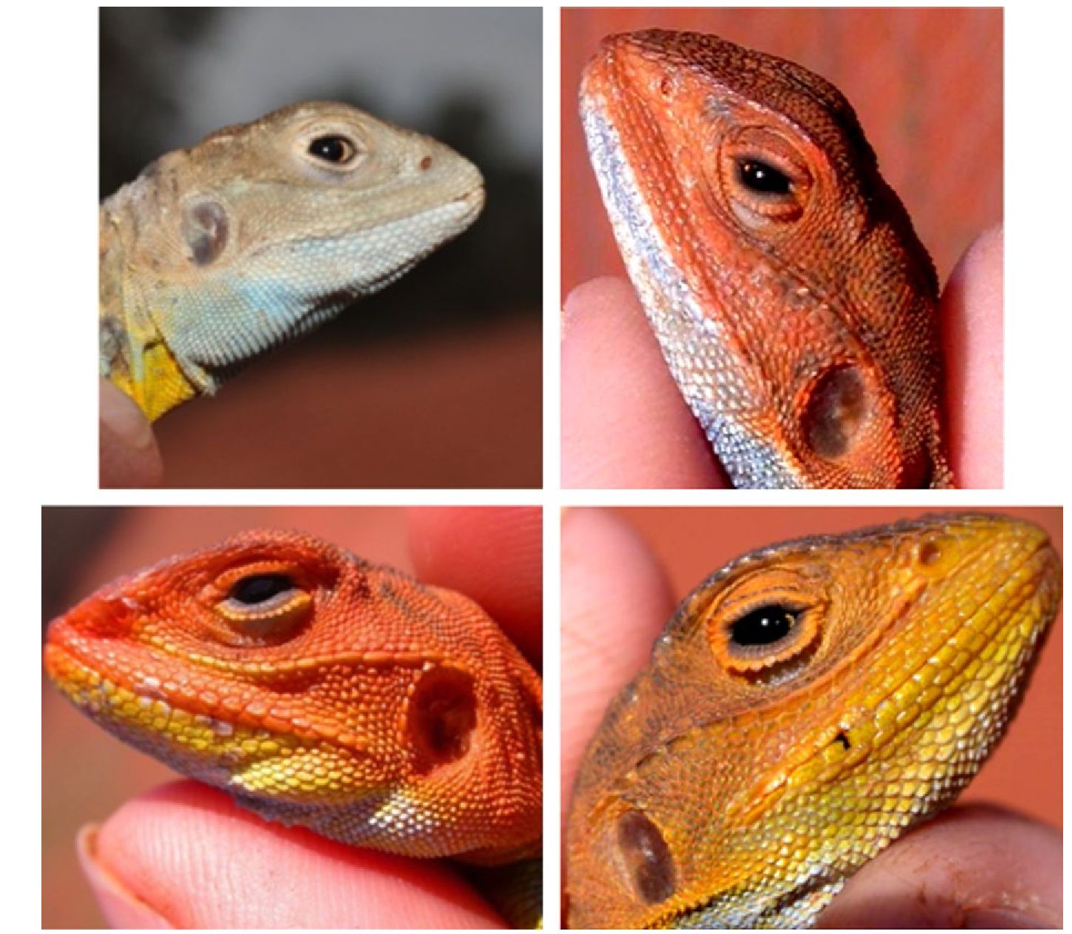

and the cages were misted with water once a day. Heat lamps and
ceramic hides were provided to allow the lizards to thermoregulate
to their preferred body temperature (36°C; M.O., unpublished data
obtained from cloacal temperature readings in the wild).

2.1 | Blood sampling
Blood (~150 |J) was sampled using a capillary tube prior to and after
the completion of the treatment by rupturing the vena angularis (in
the corner of the mouth) with the tip of a syringe. Collected blood
was mixed with heparin and centrifuged, the plasma removed and
the remaining cells resuspended with 200 |l of PBS. One milliliter of
RNAlater (Sigma Aldrich, Australia) was added and the diluted blood
cell solution for qPCR stored immediately at -80°C.

2.2 | Quantifying telomere length: qPCR
To analyze telomere length, we first purified DNA from 50 |l of the
using a DNeasy Blood and Tissue Kit (Qiagen, Australia), according to
the manufacturer's instructions. RNase A (Qiagen, Australia) was added
at the recommended concentration. The DNA concentration (ng/|l) of
each sample was measured in duplicate using a Pherastar FS (BMG,
Labtech, Germany) and aliquots diluted to 10 ng/|l using the AE buffer
provided in the DNA extraction kit. Samples were then stored at -30°C.
Telomere length was measured using real-time quantitative PCR
(qPCR) using SensiMix SYBR No-ROX Kit (Bioline, Sydney, Australia).
The telomere primers used were Telbl (5'-CGGTTTGTTTGGGTTTG
GGTTTGGGTTTGGGTTTGGGTT-3') and Telb2 (5'-GGCTTGCCTTA
CCCTTACCCTTACCCTTACCCTTACCCT-3') (Criscuolo et al., 2009).
The 18S ribosomal RNA (18S) gene (92 bp amplicon in Anolis) was
selected as the reference gene as it had previously been validated in a
reptile (Plot, Criscuolo, Zahn, & Georges, 2012). The primer sequences
used were 18S-F (5'-GAGGTGAAATTCTTGGACCGG-3') and 18S-R
(5'-CGAACCTCCGACTTTCGTTCT-3'). The melt curves produced for
both telomere and 18S after amplification by qPCR displayed a single
peak, indicating specific amplification of the DNA sequence. The qPCR
was performed in a final volume of 20 | l for both telomeres and 18S.
DNA of 10 ng was used per reaction, and the primers were used at a
concentration of 250 nM. SensiMix SYBR No-ROX Master Mix (Bioline,
Australia) of 11.25 |l was added per reaction and MgCl2 was added for
a reaction concentration of 1.7 mM. Reactions were run in triplicate
for each sample. Amplifications were carried out in a Rotor-Gene 6000
thermocycler (Qiagen, Australia) using an initial Taq activation step at
95°C for 10 min, and a total of 40 cycles of 95°C for 15 s, 60°C for
15 s and 72°C for 15 s. A melt curve was created after each run over
the temperature range of 60-95°C to ensure no non-specific product
amplification. No-template control reactions were run in triplicate for
each primer set during every qPCR run to ensure no contamination.
Standard curves were created, using the blood of a randomly selected
lizard, for both telomeres and 18S to ensure consistent rates of ampli-
fication over a wide range of DNA concentrations. The reaction was
considered consistent when a straight line with an R2 exceeding .985
could be fitted to the values obtained. Threefold serial dilutions were
created, starting at a concentration of 26.67 ng/|l down to 0.037 ng/
|l, with seven different concentrations in total (Supplemental Figure
S1) giving a linear dynamic range of 0.037-26.67 ng/|l. The efficiency
FIGURE 1 Plates of the four different
male painted dragon morphs (Ctenophorus
pictus)
ROLLINGS etal.
5165
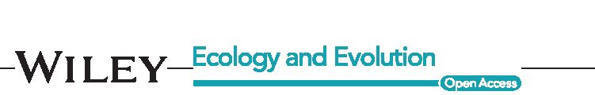
of the telomere amplification was 1.05 and the efficiency of the 18S
amplification was 0.96. All samples fell within the concentration range
generated by the standard curve. In all runs, the no-template con-
trols had a Cq value at least 10 times higher than the lowest sample
measured, indicating that contaminant DNA made up a maximum of
approximately 0.001% of the original DNA concentration. LinRegPCR
2015.2 (Ruijter et al., 2009; Tuomi, Voorbraak, Jones, & Ruijter, 2010)
was used to analyze the qPCR data. LinRegPCR calculates individual
starting concentrations based on the average efficiency of an amplicon,
the baseline fluorescence, and the threshold cycle values. The starting
concentrations of telomere (T) and control gene (S; 18S) were used
to determine the relative telomere length with the calculation T/S.
Telomeres and the control gene were assessed in separate runs. The
mean inter-assay coefficients of variation for qPCR runs for telomere
(n = 13) and 18S (n = 13) amplification were 16.73% and 38.21%,
respectively, calculated using a reference sample at 10 ng/| l that was
included in all runs. Due to the high inter-assay coefficient for the 18S
runs, we checked individual values and found an outlier which inflated
the inter-assay coefficient. When this outlier was removed, the mean
inter-assay coefficient was 23.52%. To test whether this value was
more reliable, we calculated a new mean inter-assay coefficient based
on a standard from the standard curve that was included in all runs at
a concentration of 8.89 ng/|l. Under these conditions, the mean inter-
assay coefficient was 22.30%. This suggests that the actual mean inter-
assay coefficient for 18S was approximately 23%. The mean (±SD)
intra-assay coefficients of variation for telomere and 18S runs were
14.63 ± 0.1% and 12.52 ± 0.09%, respectively. Mean (±SD) amplifi-
cation efficiencies generated by LinRegPCR across telomere and 18S
qPCR runs were 1.89 ± 0.04 and 1.98 ± 0.01, respectively. LinRegPCR
efficiency values can be compared with the efficiency obtained by a
standard curve by subtracting 1. The difference in efficiency between
the standard curve and LinRegPCR method is likely due to the manual
setting of the Cq in the standard curve method.

2.3 | Statistical analysis
For analysis of morph-specific effects on telomere length, the qPCR
data were first entered into a mixed model analysis in Proc MIXED
SAS 9.4 (SAS Institute) using telomere length in February (end date
of experiment) as the response variable, the predictor fixed factors
morph (yellow, orange, red, and blue), and bib (bibbed and not bibbed),
and with the room in which a lizard was held (numbered 1-3) as a
random factor. When “room” was not significant in a likelihood ratio
test (x2 < 1, p > .9), we performed the corresponding analysis in Proc
GLM (in order to obtain R2 values for our analyses). Telomere length in
December was used as a covariate, which controlled telomere length at
the onset of the experimental period. This also constrains the analysis
to non-interstitial telomeres, since it effectively measures the change
in telomere length (under the assumption that interstitial telomeres
do not change during the experimental period). That said, we do not
suggest that interstitial telomeres are irrelevant to viability and other
fitness effects under selection in association with telomere dynamics.
The data obtained from this experiment will be archived in Dryad.
ROLLINGS etal.

3 | RESULTS
In accordance with predictions, yellow-headed males (n = 27) had tel-
omeres that were significantly longer than both red (n = 20) and blue
males (n = 17, Table 1 and Figure 2), whereas orange-headed males
(n = 9) were intermediate between yellow and red males, as previously
demonstrated for some condition-dependent traits in this species
(Healey & Olsson, 2009). Our prediction that bibbed males (n = 24)
with more costly reproductive investments should have shorter tel-
omeres was also upheld; males without bibs (n = 52) had telomeres
1.5 times longer than those of bibbed males (Figure 3). There was
no significant interaction between head color and presence of bib.
Telomere length in February was also significantly predicted by tel-
omere length at the onset of the experiment in December (Table 1).

4 | DISCUSSION
This study provides the first evidence that individuals with different
reproductive and life history tactics of the same species have differ-
ent telomere dynamics. Red and yellow males have well-established
strategies described in our previous work, which provides context
for the morph-dependent telomere attrition. The telomeres of red
males were shorter than those of yellow males, potentially revealing
a cost associated with red males' higher levels of testosterone and
earlier reproductive activities in spring, such as territory establish-
ment. In yellow males, on the other hand, we would predict lower
testosterone-dependent metabolic rate and lower ROS levels, result-
ing in less telomere attrition. The shorter telomeres of the bibbed
males provided additional support for the hypothesis that cellular
maintenance is traded off against costs of greater, short-term repro-
ductive success (Olsson, Healey et al., 2009) and that the phenotypic
trade-off between these traits differ among morphs.
The results obtained for the orange and blue males are intrigu-
ing but, as their reproductive behavior and strategies have not been
explicitly investigated, the implications of their telomere dynamics are
less straightforward. While not significantly different, the telomere
length of the orange males was numerically intermediate to the red
and yellow males, suggesting that orange males are heterozygotes
of red and yellow alleles. Although previous research indicates that
the system of color inheritance is more complex (Olsson, Healey,
Wapstra et al., 2007), the life history strategy of orange males may
still be some intermediate to that of red and yellow males. Blue males
had the shortest telomeres and this may indicate higher levels of ROS
(perhaps as a result of lower levels of antioxidants). It is tempting to
speculate that pigments (e.g., carotenoids) are used to counter dam-
aging ROS effects, leading to the lack of head coloration observed in
blue males. However, blue males are still capable of producing bibs.
While the exact composition of the yellow bib pigment is unknown,
it may contain both carotenoids and pteridines, indicating that ROS
levels are not sufficiently high to remove all pigment-based color-
ation. Furthermore, this interpretation is further complicated by our
5166


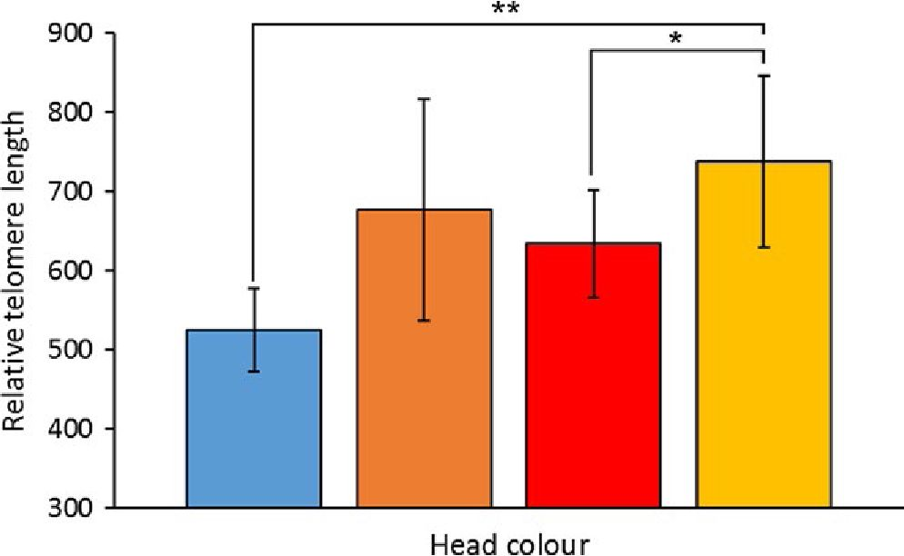
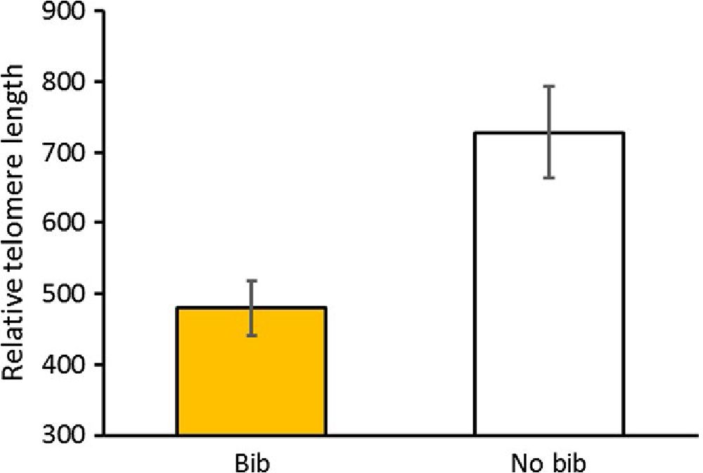
ROLLINGS et AL.
TABLE 1 GLM analysis of the interactions of telomeres in February with morph type (blue, orange, red, and yellow) and bib presence (bib
and no bib) in painted dragons, Ctenophorus pictus. Telomere length in December (TelDec) was used as a covariate
Source | df |  | Sum of squares | Mean square | F value | Pr > F
Model | 5 |  | 36.22747047 | 7.24549409 | 20.42 | <0.0001
Error | 67 |  | 23.77252953 | 0.35481387
Corrected Total | 72 |  | 60.00000000
R2 |  | Coeff Var |  | Root MSE | TelFeb Mean
.603791 |  | 6.11974E17 |  | 0.595663 | 9.7335E-17
Source | df |  | Type I SS | Mean square | F Value | Pr > F
Morph | 3 |  | 5.33457552 | 1.77819184 | 5.01 | 0.0034
Bib | 1 |  | 4.00673348 | 4.00673348 | 11.29 | 0.0013
TelDec | 1 |  | 26.88616147 | 26.88616147 | 75.78 | <0.0001
Source | df |  | Type III SS | Mean square | F Value | Pr > F
Morph | 3 |  | 3.84154096 | 1.28051365 | 3.61 | 0.0177
Bib | 1 |  | 2.52779438 | 2.52779438 | 7.12 | 0.0095
TelDec | 1 |  | 26.88616147 | 26.88616147 | 75.78 | <0.0001
Parameter | Estimate |  | Standard error | t Value | Pr > |t|
Intercept | -0.0361405961 |  | 0.15521276 | -0.23 | 0.8166
Morph BLUE | -0.5469063510 |  | 0.18497301 | -2.96 | 0.0043
Morph ORANGE | -0.0918655966 |  | 0.23245313 | -0.40 | 0.6940
Morph RED | -0.4033722194 |  | 0.17964460 | -2.25 | 0.0280
Morph YELLOW | 0.0000000000 |  | - | - | -
Bib NO | 0.4165981249 |  | 0.15607981 | 2.67 | 0.0095
Bib YES | 0.0000000000 |  | - | - | -
TelDec | 0.6868996062 |  | 0.07890948 | 8.70 | <0.0001
FIGURE 2 Mean (±SE) relative telomere lengths (RTL) of the
different morphs from blood sampled in February. RTL of yellow
males was significantly higher than red and blue males (see Table 1)
experimental demonstration that carotenoid intake has no depressing
effect on ROS levels (Olsson, Wilson, Isaksson, Uller, & Mott, 2008). In
order to understand the mechanisms behind the telomere dynamics of
these two morphs, additional studies of their life history and reproduc-
tive strategies are required.
FIGURE 3 Mean (±SE) relative telomere lengths of males with
and without bibs in blood sampled in February (at the end of the
experiment). Bibbed males had significantly shorter telomeres than
males without bibs (p = .0096)
To conclude, our results demonstrate that telomeres, polymor-
phisms, and life history strategies are strongly interlinked. We have
observed differences in telomere dynamics across not just one, but
two different types of polymorphisms within a single species, revealing
5167

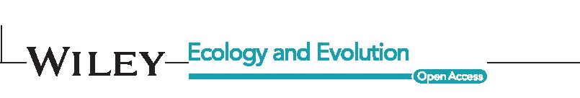
telomeres to capture the trade-offs at a cellular level caused by alter-
native reproductive tactics.
ACKNOWLEDGMENTS
We thank the Australian Research Council (MO) and the National
Science Foundation (CF) for financial support, and Ernie and Gerry
Snaith for logistic support. We thank Francois Criscuolo, Neil
Metcalfe, Pat Monaghan, Bob Montgomery and Dan Nussey for
valuable discussions.
CONFLICT OF INTEREST
The authors have no conflict of interest to declare.
REFERENCES
Anchelin, M., Alcaraz-Perez, F., Martinez, C. M., Bernabe-Garcia,
M., Mulero, V., & Cayuela, M. L. (2013). Premature aging in
telomerase-deficient zebrafish. Disease Models & Mechanisms, 6,
1101-1112.
Barrett, E. L. B., & Richardson, D. S. (2011). Sex differences in telomeres
and lifespan. Aging Cell, 10, 913-921.
Bernardes de Jesus, B., Schneeberger, K., Vera, E., Tejera, A., Harley, C. B.,
& Blasco, M. B. (2011). The telomerase activator TA-65 elongates short
telomeres and increases health span of adult/old mice without increas-
ing cancer incidence. Aging Cell, 10, 604-621.
Blackburn, E. H., & Gall, J. G. (1978). A tandemly repeated sequence at the
termini of the extrachromosomal ribosomal RNA genes in Tetrahymena.
Journal of Molecular Biology, 120, 33-53.
Chen, J.-H., Hales, C. N., & Ozanne, S. E. (2007). DNA damage, cellular se-
nescence and organismal ageing: Causal or correlative? Nucleic Acids
Research, 35, 7417-7428.
Criscuolo, F., Bize, P., Nasir, L., Metcalfe, N. B., Foote, C. G., Griffiths, K
Monaghan, P. (2009). Real-time quantitative PCR assay for measure-
ment of avian telomeres. Journal of Avian Biology, 40, 342-347.
Darwin, C. (1871). On the origin of species. New York: D. Appleton and Co..
Gomes, N. M. V., Shay, J. W., & Wright, W. E. (2010). Telomere biology in
Metazoa. FEBS Letters, 584, 3741-3751.
Gross, M. R. (1996). Alternative reproductive strategies and tactics:
Diversity within sexes. Trends in Ecology and Evoloution, 11, 92-98.
Harley, C. B., Futcher, A. B., & Greider, C. W. (1990). Telomeres shorten
during ageing of human fibroblasts. Nature, 345, 458-460.
Healey, M., & Olsson, M. (2009). Too big for his boots: Are social costs
keeping condition-dependent status signalling honest in an Australian
lizard? Austral Ecology, 34, 636-640.
Healey, M., Uller, T., & Olsson, M. (2007). Seeing red: Morph-specific con-
test success and survival rates in a colour-polymorphic agamid lizard.
Animal Behaviour, 74, 337-341.
Houben, J. M. J., Moonen, H. J., van Schooten, F. J., & Hageman, G. J.
(2008). Telomere length assessment: Biomarker of chronic oxidative
stress? Free Radical Biology and Medicine, 44, 235-246.
Hug, N., & Lingner, J. (2006). Telomere length homeostasis. Chromosoma,
115, 413-425.
Lin, J., Smith, D. L., & Blackburn, E. H. (2004). Mutant telomere sequences
lead to impaired chromosome separation and a unique checkpoint re-
sponse. Molecular Biolology Cell, 15, 1623-1634.
Liu, J. P. (2014). Molecular mechanisms of ageing and related diseases.
Clinical and Experimental Pharmacology and Physiology, 41, 445-458.
Ludlow, A. T., Spangenburg, E. E., Chin, E. R., Cheng, W. H., & Roth, S. M.
(2014). Telomeres shorten in response to oxidative stress in mouse
skeletal muscle fibers. Journal of GerontologyA-Biology, 69, 821-830.
ROLLINGS etal.
Mourkioti, F., Kustan, J., Kraft, P., Day, J. W., Zhao, M. M., Kost-Alimova, M.,
... Blau, H. M. (2013). Role of telomere dysfunction in cardiac failure
in Duchenne muscular dystrophy. Nature Cell Biology, 15, 895-U300.
Olsson, M., Healey, M., & Astheimer, L. (2007). Afternoon T: Testosterone
level is higher in red than yellow male polychromatic lizards. Physiology
and Behavior, 91, 531-534.
Olsson, M., Healey, M., Wapstra, E., Schwartz, T., Lebas, N., & Uller, T.
(2007). Mating system variation and morph fluctuations in a polymor-
phic lizard. Molecular Ecology, 16, 5307-5315.
Olsson, M., Healey, M., Wapstra, E., & Uller, T. (2009). Testing the qual-
ity of a carrier: A field experiment on lizard signalers. Evolution, 63,
695-701.
Olsson, M., Schwartz, T., Uller, T., & Healey, M. (2009). Effects of sperm
storage and male colour on probability of paternity in a polychromatic
lizard. Animal Behaviour, 77, 419-424.
Olsson, M., Tobler, M., Healey, M., Perrin, C., & Wilson, M. (2012). A signif-
icant component of ageing (DNA damage) is reflected in fading breed-
ing colors: An experimental test using innate antioxidant memetics in
painted dragon lizards. Evolution, 66, 2475-2483.
Olsson, M., Wilson, M., Isaksson, C., Uller, T., & Mott, B. (2008). Carotenoid
intake does not mediate a relationship between reactive oxygen spe-
cies and bright colouration: Experimental test in a lizard. Journal of
Experimental Biology, 211, 1257-1261.
Plot, V., Criscuolo, F., Zahn, S., & Georges, J.-Y. (2012). Telomeres, age
and reproduction in a long-lived reptile. PLoS One, 7(7), e40855.
doi:10.1371/journal.pone.0040855
Reichert, S., Bize, P., Arrive, M., Zahn, S., Massemin, S., & Criscuolo, F.
(2014). Experimental increase in telomere length leads to faster feather
regeneration. Experimental Gerontology, 52, 36-38.
Richman, A. (2000). Evolution of balanced genetic polymorphism. Molecular
Ecology, 9, 1953-1963.
Ruijter, J. M., Ramakers, C., Hoogaars, W. M. H., Karlen, Y., Bakker, O., van
den Hoff, M. J. B., & Moorman, A. F. (2009). Amplification efficiency:
Linking baseline and bias in the analysis of quantitative PCR data.
Nucleic Acids Research, 37, e45.
Sinervo, B., & Lively, C. M. (1996). The rock-paper-scissors game and the
evolution of alternative male strategies. Nature, 380, 240-243.
Tuomi, J. M., Voorbraak, F., Jones, D. L., & Ruijter, J. M. (2010). Bias in the
Cq value observed with hydrolysis probe based quantitative PCR can
be corrected with the estimated PCR efficiency value. Methods, 50,
313-322.
Valko, M., Leibfritz, D., Moncol, J., Cronin, M. T. D., Mazur, M., & Telser,
J. (2007). Free radicals and antioxidants in normal physiological func-
tions and human disease. International Journal of Biochemistry and Cell
Biology, 39, 44-84.
Zamudio, K. R., & Sinervo, B. (2000). Polygyny, mate-guarding, and posthu-
mous fertilization as alternative male mating strategies. Proceedings of
the National Academy of Sciences USA, 97, 14427-14432.
von Zglinicki, T. (2002). Oxidative stress shortens telomeres. Trends in
Biochemical Sciences, 27, 339-344.
SUPPORTING INFORMATION
Additional Supporting Information may be found online in the support-
ing information tab for this article.
How to cite this article: Rollings N, Friesen CR, Sudyka J, et al.
Telomere dynamics in a lizard with morph-specific
reproductive investment and self-maintenance. Ecol Evol.
2017;7:5163-5169. https://doi.org/10.1002/ece3.2712
5168

ROLLINGS etal.
5169

APPENDIX I
Based on the results in Reichert et al. (2014), we predicted that
TA-65 would have telomere-enhancing effects across all morphs
and that telomeres would be shorter in high-investment strategies
(thus predicting relatively shorter telomeres in red and bibbed
morphs). We therefore assessed whether TA-65 had the capacity
to alter telomere length, possibly through the amount of telomer-
ase activity and telomere length. Given its oral administration, this
would be a non-invasive, direct manipulation of telomere length
and its repercussions (Bernardes de Jesus et al., 2011; Reichert
et al., 2014).
Males were weighed to the nearest 0.01 g and snout-to-vent and
total length were measured to the nearest 1.0 mm prior to commenc-
ing the TA-65 treatment. In addition, head color and presence of a bib
were recorded and the males were randomly assigned to the TA-65
treatment (n = 41) or control (n = 35) groups. Males were treated each
weekday for 7 weeks, across January and February, with 0.7 mg of
TA-65 (T.A. Sciences, USA), dissolved in 100 |J of saline, given orally.
This dosage was selected as an increase in telomere length was
observed when zebra finches were treated with 0.5 mg per 100 |J of
water (Reichert et al., 2014). The dosage was increased by 40% to
account for the decrease in body temperature and metabolic rate
experienced by reptiles at night. The TA-65 solution was prepared
each day just prior to administration. Control males were treated iden-
tically but given only saline.
TA-65 did not significantly affect telomere length (p > .40 in all
analyses) and was backwards-eliminated from all analyses reported on
in this manuscript.
Future studies of telomere dynamics should ideally include tel-
omere manipulation experiments. Although telomerase knock-out
organisms have been a successful tool for studying telomere dynamics
(Anchelin et al., 2013; Mourkioti et al., 2013), the difficulty and cost of
generating knock-outs limit our ability to investigate telomeres in
non-model organisms. A compound that could be orally administered
would be ideal for these purposes; however, our experiments showed
no effect of TA-65 on lizard telomere length. There are a few possible
explanations for this: (1) Typical telomerase activity in painted drag-
ons may maintain telomeres at their maximum stable length for each
morph; thus, higher telomerase activity may not increase telomeres
further. (2) Previous studies have focused on endotherms and thus the
dosage chosen may not have been appropriate for an ectotherm
(although in the current experiment the bird dose (Reichert et al.,
2014) was increased by 40% to compensate for the fall in nightly body
temperature to ambient levels in an ectotherm). (3) The telomerase
activator needs to be able to bind to the activation domain of the tel-
omerase gene, and if the activation domain and telomerase activator
are not appropriately matched, binding may not occur, nullifying the
desired manipulation. Only future dose-response effects across a
wider range of concentrations will clarify the utility of this compound
for potential future telomere manipulation work in ectotherms.

