
Signature:©PolJRadiol,2010;75(1):88-91
CASEREPORT
Facialarterypseudoaneurysmandseverebleeding
Received:2009.09.28
Accepted:2010.01.06
aftertonsillectomy–endovasculartreatmentwithPVAparticleembolization
RobertJuszkat1,AleksandraKorytowska2,ZofiaŁukomska2,AnnaZarzecka1
1DepartmentofNeuroradiology,PoznańUniversityofMedicalScience,Poznań,Poland2ENTDepartment,HospitalinPoznań,Poznań,Poland

Author’saddress:RobertJuszkat,DepartmentofNeuroradiology,PoznańUniversityofMedicalScience,Poznań,Poland,e-mail:robertju@wp.pl
Summary
TonsillectomyisoneofthemostcommonproceduresperformedinENTdepartments.Themostcommoncomplicationisahaemorrhage,whichincidenceisestimatedat3–3.9%ofallprocedures.
Wepresentthecaseofa32-year-oldfemalewithseverebleeding11and23daysaftertonsillectomy.Anangiographyrevealedapseudoaneurysmofthefacialartery(FA),a5mmindiameter,attheleveloftonsillararterytakeoff.TheFAwasembolizedwith500-μmparticlesofPVA.Theprocedurewassuccessful.Thepatientdidnotexperiencefurtherbleeding.
Inrarecasespost-tonsillectomyhaemorrhagemaybecausedbythepseudoaneurysmofthefacialartery.Theendovascularembolizationofthisconditionprovedtobeavaluabletreatmentmethod.Itisasafeandpermanenttreatmentoptioninthis potentiallylife-threateningcomplication.
Background:
CaseReport:
Conclusions:
Keywords:
tonsillectomy•pseudoaneurysm•PVAembolization
PDFfile:
http://www.polradiol.com/fulltxt.php?ICID=878439
Background
aftertonsillectomywhowastreatedendovascularlywithembolizationusingPVAparticles.
Tonsillectomyisoneofthemostoftenperformedproce-duresinear-nose-throat(ENT)departments[1].Althoughmanydifferentcomplicationsmayariseafterthisproce-dure,themostcommonishaemorrhage,whichinveryrarecasesmaybefatal[2].Itsincidenceisestimatedat3–3.9%[3,4].Intraoperative(within24hoursaftertheprocedure)haemorrhageisassociatedwithoperativetechniqueandcoagulopathy.Delayedhaemorrhage(>24hafterthepro-cedure),mostlyonthe5thto7thday,isassociatedwithseparationofsloughfromthegranulatingfossa[5].Themostseverehaemorrhagesareduetoarterialdissectionsorpseudoaneurysms[5].Thelattercanbecausedbybluntor directtraumaduringdissectionortheplacing ofligationsutures[5].
CaseReport
A32-year-oldfemaleunderwenttonsillectomyduetochronicpurulenttonsillitis.Theprocedurewasperformedundergeneralanaesthesia.Theperi-andpostoperativecoursewasuneventful.Thepatientwasdischargedthefol-lowingday.Onthe11thdayaftertheprocedure,thepatientwas readmittedurgentlytothehospitaldue toashort-last-ingbutabrupthaemorrhagefromthepharynx.Shehadnosignsofbleedingonadmission.
Thepatient'shaemoglobinleveldroppedsignificantlyto6.9g/dL.Thecoagulationvalueswerewithinthenormalrange.Thepatentwastransfusedwith2unitsofpackedredbloodcellsanddischargedafter7daysingoodgeneralconditionwithnosignsofbleeding.Onthe23rddayaftertheproce-dure,thepatientexperiencedasmallbleedfromtheleftton-sillarbed.Onadmission,nomanifestationsofhaemorrhagewerenoted,however,asuggilationintheleftlinguo-tonsillar
Casesofpseudoaneurysmsaftertonsillectomy ofthelingual,facialandinternalcarotidarteryhavebeenreported[5].
Wepresentthecaseofa33-year-oldpatientwithapseu-doaneurysmofthefacialartery(FA)andseverebleeding
88

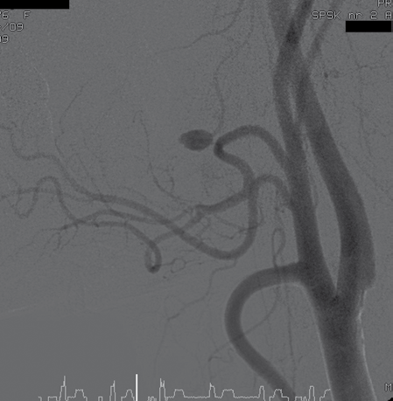
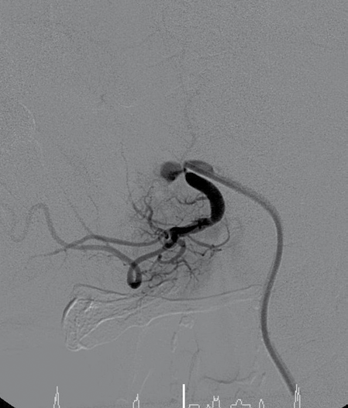
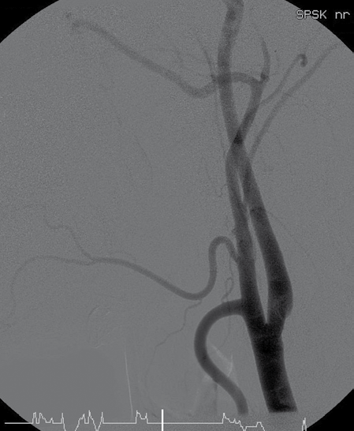
©PolJRadiol,2010;75(1):88-91
JuszkatRetal–Facialarterypseudoaneurysmandseverebleeding…
Figure2.DSA.SelectiveangiographyoftheleftcommoncarotidarteryaftercompleteembolizationofthefacialarterywithPVAparticle.
a5-mmpseudoaneurysmoftheFA,attheleveloftonsillarbranchtakeoff(Figure1A,B).EmbolizationoftheFAwasper-formedwiththeapplicationof50mgofPVAembolizationmaterialwithaparticlesizeof500μm.Theprocedurewascontinueduntilthemaintrunkwas completely closed(Figure2).Thedecisiontouse500-μmparticleswasbasedonthefactthatwewantedtoembolizethemainfacialtrunkandnotonlyitsterminalbranches.ThiswouldenablebuildingofthecollateralcirculationandpreventmucosalnecrosiscausedbytheembolizationofthefeedingvesselsfromtheFA.
Aftertheprocedure,controlDSAwasperformed.ItrevealedcompleteocclusionoftheFA.Thepostoperativecoursewasuneventful.Thepatientwasdischargedinagoodgeneralcondition.Nofurtherhaemorrhageswerenotedduringthe6-monthfollow-up.
Figure1.Digitalsubtractionangiography(DSA).Selectiveangiographyoftheleftcommoncarotidartery(A)andthefacialartery(B).Pseudoaneurysmofthefacialarteryatthelevelofthetonsillarbranchtakeoff.
Discussion
Haemorrhageisthemostcommonofallcomplicationsoftonsillectomy,withanestimatedincidenceof3–3.9%[3,4].Itsoccurrenceincreaseswithage,peakingat30–34yearswithnodifferencebetweenmalesandfemales.Theinci-denceofserioushaemorrhageincreasesintheolderagecategories[6].Delayedbleedingusuallyoccursbetweendays5 and 10postoperatively as a resultof prematuresep-arationoftheeschar,leadingtoretractionofsmallsurfacevesselsandoverlyingclotformation[7,8].
anglewasvisible.Suddenly,withoutanyprodromalsigns,severebleedingbeganfromthemouth.Thepatient'sthroatwasimmediatelyexaminedundergeneralanaesthesiaandthevesselsinthelateralwallofthepharynx,inferiortotheleftlowerpoleofthetonsil,wereelectrocauterized.Thepatientwastransfusedwithanother3unitsofpackedredbloodcells.Thepatient'sconditionimproved.Adeci-sionwasmadetoperformangiographyoftheleftexternalcarotidarterywithsubsequentembolizationofthebleedingvessel.TheangiographicexaminationwasperformedusingaHeadhunter(Balton,Warsaw,Poland)catheter,andselec-tivecatheterizationofthecommoncarotidandnextexter-nalcarotidarterywascarriedout.Theangiographyrevealed
Damagetoanarterialwallmayresultinpseudoaneurysmformationandsubsequentbleeding[9].Inthecaseofton-sillectomy,suchdamagemaybeacorollaryofdissectionorplacingsuturesduringtonsillectomy[5].Asanafter-effectofnormalarterialpressure,luminalbloodleaksout
89

A

B

CaseReport
©PolJRadiol,2010;75(1):88-91
throughthedamagedarterialwallintothesurroundingsofttissuesandformsapseudoaneurysmsacthatcommu-nicatesdirectlytothearteriallumen[9].
bloodpressureinthecarotidarterywithsubsequentleak-agefromtheaneurysm.Anewclotwouldhavemadethesevereshort-lastingbleedingstop[5].
Aberrantbloodsupplytoatonsilmayposeariskofiat-rogenicpseudoaneurysminthetonsillarbed.Thebloodsupplyofpalatinetonsilscomesfromthedescendingpala-tineartery(branchoftheinternalmaxillaryartery),theascendingpharyngealartery,thedorsallingualartery(branchofthelingualartery)andtheascendingpalatinearteryandtonsillarartery,bothoriginatingfromtheFA[2,10].ThevariablecourseoftheFAloopinghighoverthesubmandibularglandandapproachingtheposteroinfe-riortonsillarpolemakesthatareavulnerableforarterialinjury[11–13].Sporadically,theFAoreventhelingualartery mayhaveanupwardcourse andcomeclosetotheinferiortonsillarpole[13,14].
The treatment options for post-tonsillectomy haemorrhageincludesurgicalligationandendovascularembolizationofthebleedingvessels.Thefirstmethodcarriesariskofinju-rytothesuperiorlaryngealorvagusnerve,cerebrovascu-laraccidentanddiminishedvascularreserveinthearterialdistributionofthevesselsligated[13].Moreover,seriousbleedingmaynotstopafterligationoftheexternalcarotidarteryorotherarterialbranches[2,11].
EndovasculartreatmentofPTHhasthree mainadvan-tages:first,thediagnosticevaluationcanbecombinedwithdirecttherapeuticintervention;second,embolizationismoreselective;andthird,thismethodislessmutilat-ingandhaslessriskofdamagingthevagalandaccessorynerves[4].Thematerialsavailableforuseinendovasculartreatmentintheheadandneckareaincludecoils,PVApar-ticlesandgelatinsponges[2].
Inourcase,angiographydidnotrevealanaberrantcourseoftheFA,andthereforesurgicalmanipulationsintheton-sillarfossamayhavecausedtheinjurytotheFAatthelevelofthetonsillararteryorigin.Angiographyispivotalinevaluationofthetonsillarbloodsupplyanddetectionofpossibleaberrantcoursesofvessels.Itplaysaninvaluableroleinavoidingthepossibledisastrouscomplicationsofsurgicalmanipulationinthesurgicaltreatmentofbleeding.
Thethoroughevaluationoftheobtainedangiogramsoftheexternalcarotidarteryanditsbranchesisaprereq-uisiteforasuccessfulprocedure.First,thesiteofarterialinjuryisdetected.Second,itallowsforelucidatingpoten-tiallydangerousanastomosesbetweentheexternalcarotidarteryandinternalcarotidartery[2].InthecaseoftheFA,suchanastomosescanexistfromtheangulonasalarteryviathenasalarterytotheophthalmicarteryandfromtheanguloorbitalarteryviatheinferiorpalpebralarteryandnasalartery,bothtotheophthalmicartery[19].Thepos-sibleexistenceofanastomosesdeterminesthediametersoftheparticlesapplied.WeusedPVAparticlesof500μminsize.Inouropinionthisdiameterisoptimal,asitwillnotcausemucosalnecrosis,damagetoadjacentstructuresandcertainlywillnotembolizetheophthalmicarteryviatheanastomoses.However,Opatowskyetal.advisedtheuseof150μmPVAinsuchcases[2].
Thevastmajorityofcasesofpseudoaneurysmsaftertonsil-lectomyhaveconcernedthelingualartery[1,2,5,13].Singlecasesofapseudoaneurysmoftheexternalcarotidarteryhavealsobeendescribed[15,16].Toourknowledge,thisisthesecondreportedcaseofaFApseudoaneurysmsecondarytotonsillectomy[17].Inthefirstreportedcase,thepseudoaneu-rysmwascausedbydeepvesselligationinthetonsillarbed.
Repeatedepisodesofbleedingshouldbeconsideredasawarningsignofseriouspost-tonsillectomyhaemorrhage.Inthepresentedcase,thefirstbleedingepisodeoccurredonthe11thpostoperativedayandthenonday23.Nomasseswereobservedonoralinspectionatanytime.VanCruijsenproposedanexplanationfor such asequence of events.Theaneurysmdevelopsgradually,expandingwhentheperiar-terialclotdissolvesandmorebloodflowsoutsidetheves-sel[5,18].Healsosuggestedthatthesizeofthelesiontothevesselwallmightdeterminethevolumeofbloodandwhethertheaneurysmislargeenoughtobevisible.Inourcase,thelesionmayhavebeensmall,whichmighthavemadethepseudoaneurysmgrowslowly.Withoutanypro-vokingevents,lyingdowninbedmighthaveincreased
Conclusions
1.Inrarecasespost-tonsillectomyhaemorrhagemaybecausedbythepseudoaneurysmofthefacialartery.
2.Theendovascularembolizationofthisconditionprovedtobeavaluabletreatmentmethod.Itisasafeandper-manenttreatmentoptioninthispotentiallylife-threat-eningcomplication.
References:
- MenauerF,SuckfullM,StablerAetal:Pseudoaneurysmofthelingualarteryaftertonsillectomy.Ararecomplication.Laryngorhinootologie,1999;78:405–7
- OpatowskyMJ,BrowneJD,McGuirtWFJr:Endovascular
treatmentofhemorrhageaftertonsillectomyinchildren.AJNRAmJNeuroradiol,2001;22:713–16
- WeberR,KeerlR,HendusJetal:Theemergency:traumaticaneurysmintheareaofthehead-neck.Laryngorhinootologie,1993;72:86–90
- KendrickD,GibbinK:Anauditofthecomplicationsofpaediatrictonsillectomy,adenoidectomyandadenotonsillectomy.ClinOtolaryngolAlliedSc,1993;18:115–17
- vanCruijsenN,GravendeelJ,DikkersFG:Severedelayedpost-tonsillectomyhaemorrhageduetoapseudoaneurysmofthelingualartery.EurArchOtorhinolaryngol,2008;265:115–17
- AlexanderRJ,KukrejaR,FordGR:Secondarypost-tonsillectomyhaemorrhageandinformedconsent.JLaryngolOtol,2004;118:937–40
- AdamsGL,BoiesLRJr,HilgerPA:BoiesFundamentalsofOtolaryngology:Atextbookofear,nose,andthroatdiseases,6thed.WBSaunders,Philadelphia,1989
- JohnsonLB,TelluruRG,MyerCH:Complicationsofadenotonsillectomy.Laryngoscope, 2002; 112: 35–36
90

©PolJRadiol,2010;75(1):88-91
JuszkatRetal–Facialarterypseudoaneurysmandseverebleeding…
- KeelingAN,NaughtonPA,LeahyALetal:Traumaticinferiorglutealarterypseudoaneurysmandarteriovenousfistulamanagedwithemergencytranscatheterembolization.CardiovascInterventRadiol,2008;31(Suppl.2):135–39
- BochenekA,ReicherM:Anatomiaczłowieka.8thed.,Warszawa,1998;3;117
- GardnerJF:Suturesanddisastersintonsillectomy.ArchOtolaryngol,1968;88:117–21
- NathanMD,SessionsDG:Massivepost-tonsillectomyhemorrhage.SouthMedJ,1981;74:1153–56
- SimoniP,BelloJA,KentB:Pseudoaneurysmofthelingualarterysecondarytotonsillectomytreatedwithselectiveembolization.IntJPedOtorhinolaryngol, 2001;59:125–28
- Hollinshead,WH:Headandneck.In:Anatomyforsurgeons.Harper
&Row,NewYork,1968;1:448–49
- KarasDE,SawinRS,SieKC:Pseudoaneursymoftheexternalcarotidarteryaftertonsillectomy.Ararecomplication.ArchOtolaryngolHeadNeckSurg,1997;123:345–47
- PourhassanS,GrotemeyerD,FokouMetal:Extracranialcarotidarteriesaneurysmsinchildren:single-centerexperiencesin4patientsandreviewoftheliterature.JPediatrSurg,2007;42:1961–68
- WeberR,KelerR,KahleG:DerNotfall:dastraumatischeaneurysmaimkopf-hals-bereich.Laryngo-Rhino-Otol,1993;72:86–90
- DefattaRJ,VerretDJ, BauerP:Extracranial internalcarotidarterypseudoaneurysm.IntJPediatrOtorhinolaryngol,2005;69:1135–39
- LasjauniasP,BerensteinA,terBruggeK:Surgicalneuroangiography.Clinicalvascularanatomyandvariations.Vol1,2ndedn.Springer,Berlin,Heidelberg,NewYork,2001;479–629
91

