

Histochemistry and Cell Biology (2021) 155:101-116
https://doi.org/10.1007/s00418-020-01928-z
ORIGINAL PAPER

Altered vitamin D3 metabolism in the ovary and periovarian adipose
tissue of rats with letrozole-induced PCOS
Małgorzata Grzesiak1 • Gabriela Burzawa2 • Patrycja Kurowska3 • Klaudia Blaszczyk3 • Agata Szlaga4 •
Anna Blasiak4 • Andrzej Sechman2 • Agnieszka Rak3
Accepted: 1 October 2020 / Published online: 23 October 2020
© The Author(s) 2020
Abstract
Vitamin D3 (VD3) plays an important role in the ovary and its deficiency is associated with ovarian pathologies, including
polycystic ovary syndrome (PCOS). However, there is no data related to VD3 metabolism in the ovary during PCOS. Herein,
we investigated differences in the expression of VD3 receptor (VDR) and key VD3 metabolic enzymes, 1a-hydroxylase
(CYP27B1) and 24-hydroxylase (CYP24A1), in the ovary and periovarian adipose tissue (POAT) of control (proestrus and
diestrus) and PCOS induced by letrozole rats. Vdr, Cyp27b1 and Cyp24a1 mRNA expression was determined, their protein
abundance was examined and immunolocalized. Furthermore, VD3 metabolite concentrations in plasma (25OHD) and tissues
(ovary and POAT; 1,25(OH)2D3), and plasma calcium level were determined. 25OHD concentration decreased markedly in
letrozole-treated rats in comparison with controls, whereas calcium concentration did not vary among the examined groups.
The amount of 1,25(OH)2D3 decreased in both ovary and POAT of PCOS rats. In the ovary, we found decreased Cyp27b1
and increased Vdr mRNA expression in letrozole-treated and diestrus control group. Corresponding protein abundances were
down-regulated and up-regulated, respectively but only following letrozole treatment. In POAT, only Cyp27b1 transcript
level and CYP27B1 protein abundance were decreased in letrozole-treated rats. VDR was immunolocalized in healthy and
cystic follicles, while CYP27B1 and CYP24A1 were found exclusively in healthy ones. Concluding, our results provide the
first evidence of disrupted VD3 metabolism in the ovary and POAT of PCOS rats. The reduced 1,25(OH)2D3 concentration
in those tissues suggests their contribution to VD3 deficiency observed in PCOS and might implicate in PCOS pathogenesis.
Keywords CYP27B1 ■ CYP24A1 ■ Vitamin D3 receptor ■ Polycystic ovary syndrome ■ Periovarian adipose tissue

Introduction
Electronic supplementary material The online version of this
article (https://doi.org/10.1007/s00418-020-01928-z) contains
supplementary material, which is available to authorized users.
* Małgorzata Grzesiak
m.e.grzesiak@uj.edu.pl
1 Department of Endocrinology, Institute of Zoology
and Biomedical Research, Jagiellonian University
in Krakow, Gronostajowa 9, 30-387 Krakow, Poland
2 Department of Animal Physiology and Endocrinology,
University of Agriculture in Krakow, Krakow, Poland
3 Department of Physiology and Toxicology of Reproduction,
Institute of Zoology and Biomedical Research, Jagiellonian
University in Krakow, Krakow, Poland
4 Department of Neurophysiology and Chronobiology, Institute
of Zoology and Biomedical Research, Jagiellonian University
in Krakow, Krakow, Poland
It is widely accepted that vitamin D3 (VD3) regulates cal-
cium and phosphorus homeostasis to ensure bone health
(DeLuca 2004). However, due to the broad distribution of
VD3 receptor (VDR) in the organism, VD3 effects extend
to various tissues, including female reproductive organs.
Recent studies also reveal that VD3 insufficiency/deficiency
associates with many reproductive disorders, such as endo-
metriosis, uterine fibroids, premature ovarian failure, ovarian
cancer and polycystic ovarian syndrome (PCOS) (Dabrowski
et al. 2015; Muscogiuri et al. 2017).
In humans and animals, the main source of circulating
active VD3 is its endogenous synthesis in the skin upon
ultraviolet-B irradiation. In keratinocytes, 7-dehydrocho-
lesterol is converted to previtamin D3, which is metabolized
in the liver by 25-hydroxylases (e.g. CYP2R1, CYP27A1)
to 25OHD3, and further in the kidney by 1a-hydroxylase
102
Histochemistry and Cell Biology (2021) 155:101-116
(CYP27B1) to the bioactive hormone 1,25(OH)2D3. Both
1,25(OH)2D3 and 25OHD3 are inactivated by a mitochon-
drial 24-hydroxylase (CYP24A1) (Bikle 2014). To date, the
ovary has been identified as an extrarenal site of CYP27B1
expression and VDR is abundant in ovarian cells, suggest-
ing local VD3 metabolism and action within the mammalian
ovary (Herian et al. 2018; Xu et al. 2018). Indeed, there are
numerous reports of positive VD3 effects on folliculogenesis
and steroidogenesis. In details, VD3 was shown to increase
the synthesis of anti-Müllerian hormone (AMH), maintain-
ing the ovarian reserve (Irani and Merhi 2014). In addition,
Xu et al. (2018) reported a survival and development of pre-
antral and antral follicles in rhesus macaque following VD3
exposure in vitro. Moreover, VD3 was found to stimulate
progesterone and 17p-estradiol secretion by human granu-
losa cells (Parikh et al. 2010; Merhi et al. 2014). On the
other hand, hypovitaminosis D3 has been linked to several
ovarian pathologies such as PCOS (He et al. 2015).
PCOS is a common disorder affecting women of repro-
ductive age (Fauser et al. 2012). In general, two criteria,
such as oligoovulation/anovulation, hyperandrogenism and
polycystic ovaries on ultrasound, must be met for PCOS
diagnosis (Azziz et al. 2006). However, its phenotype is
accompanied by a much wider range of reproductive (ovu-
latory dysfunction, polycystic ovarian morphology, infertil-
ity), endocrine (hyperandrogenism, disturbed gonadotropins
level) and metabolic (glucose metabolism, insulin sensitiv-
ity, lipid profile) features (Fauser et al. 2012; Krul-Poel
et al. 2018). Recent clinical and experimental studies have
reported that VD3 deficiency among women contributes to
various disturbances associated with PCOS (Muscogiuri
et al. 2017). To our knowledge, low serum VD3 status causes
dysregulation in calcium metabolism that may inhibit fol-
licle maturation and ovulation in women with PCOS (Thys-
Jacobs et al. 1999). The decreased VD3 level also reduces the
activity and expression of aromatase, which impairs conver-
sion of androgens to estrogens. In turn, increased androgen
concentration blocks follicular maturation before ovulation
and leads to ovarian cyst appearance (Lorenzen et al. 2017).
Furthermore, VD3 deficiency is significantly associated with
a higher insulin resistance and a lower level of high-density
lipoproteins in PCOS patients (Krul-Poel et al. 2018). By
this time, VD3 supplementation has been shown to improve
menstrual regularity and ovulatory dysfunction as well as
decrease serum androgens level and increase insulin sensi-
tivity in women with PCOS (Karadag et al. 2018; Shojaeian
et al. 2019). However, information about local ovarian VD3
metabolism in PCOS is still lacking. In the present study, we
hypothesize that the VD3 metabolic system differs between
normal and polycystic ovaries.
This research aimed to determine whether VD3 metabolic
homeostasis is altered in the ovary and surrounding perio-
varian adipose tissue (POAT) of rats with PCOS induced by
aromatase inhibitor letrozole (Kafali et al. 2004). To meet
this goal we examined: (1) plasma 25OHD and calcium
concentrations in control and PCOS rats, (2) 1,25(OH)2D3
concentration in ovarian and POAT homogenates, (3) Vdr,
Cyp7b1 and Cyp24a1 mRNA expression, and (4) VDR,
CYP27B1 and CYP24A1 proteins abundance, and (5)
immunolocalization in the ovary and POAT obtained from
control and PCOS rats.

Materials and methods
Animals
Six-week-old female Wistar rats (mean body weight (BW)
at the beginning of the experiment 191.375 ± 7.87 g) were
purchased from Faculty of Pharmacy Jagiellonian Univer-
sity Medical College (Krakow, Poland) and Mossakowski
Medical Research Centre Polish Academy of Sciences (War-
saw, Poland). Animals were housed in controlled conditions
of temperature, humidity and light (12 h light: 12 h dark
cycle) with ad libitum availability of food and water. Rats
were allowed to acclimatize for one week before treatment.
All experimental protocols listed herein were approved by
the Local Animal Ethical Committee, Poland (permit no.
277/2019).
PCOS was induced in rats by administration of nonsteroi-
dal aromatase inhibitor letrozole (Sigma-Aldrich, St. Louis,
MO, USA) (Kafali et al. 2004; Kalamon et al. 2020). For
PCOS induction, 48 rats were randomly assigned into the
control (n = 32) and letrozole-treated (n = 16) groups. A
daily treatment regime of 21 days included oral adminis-
tration through gavage of either 2% (v/v) dimethyl sulfox-
ide (DMSO; Sigma-Aldrich) in rapeseed oil (1 ml/kg BW)
in the first group or letrozole (1 mg/kg BW) dissolved in
2% DMSO in rapeseed oil in the second group. Rats were
weighed daily for 21 consecutive days of the experiment.
After 21 days of treatment, BW, estrous cyclicity, plasma
testosterone (T) and 17p-estradiol (E2) levels as well as ovar-
ian histology were analyzed to verify the development of
PCOS.

Assessment of estrous cyclicity
Estrous cyclicity was monitored by microscope analysis of
vaginal epithelial cell smears. Smears were stained using
May-Grundwald and Giemsa procedure (Kolchem, Lodz,
Poland). Proestrus was characterized by the presence of pre-
dominantly nucleated and some cornified epithelial cells,
estrus as mostly cornified cells, metestrus as some corni-
fied epithelial cells and primarily leukocytes and diestrus as
primarily leukocytes (Marcondes et al. 2002). As a control
Histochemistry and Cell Biology (2021) 155:101-116
103
groups, animals from proestrus and diestrus phases were
chosen (n = 16 per each group) (Baravalle et al. 2006).

Blood and tissues samples
Collection of blood and tissue samples was performed
between 1:00 and 3:00 pm during proestrus and diestrus
stages of the estrous cycle of control rats and from acyclic
PCOS-induced rats. Animals were deeply anesthetized by
inhalation of 4% isoflurane in an enclosed vessel. Blood
was withdrawn through the orbital sinus in a tube and cen-
trifuged at 500 g for 15 min at room temperature. Plasma
was separated and immediately stored at - 20 °C for further
analyses. Ovaries and POAT were excised from all animals.
Separate ovary and surrounding POAT was snap-frozen in
liquid nitrogen for RNA and protein isolation, 1,25(OH)2D3
concentration measurement, as well as was fixed in formalin
(10% buffered formalin for ovaries and zinc-formalin for
POAT) for routine histology (hematoxylin-eosin staining)
and immunohistochemistry.

Antibody validation
Antibody specificity (anti-VDR, anti-CYP27B1 and anti-
CYP24A1) was determined by Western blot analysis per-
formed on lysates from rat kidney (positive control tissue
for VDR, CYP27B1 and CYP24A1) and rat heart (nega-
tive control tissue for CYP27B1 and CYP24A1) in com-
parison to lysates from rat ovary. Analyzed proteins were
shown in kidney and ovarian samples as specific bands at
approximately 48 kDa (VDR), 56 kDa (CYP27B1) and
59 kDa (CYP24A1) (Supplementary File 1). Furthermore,
the analysis of non-specific binding of secondary antibod-
ies by omission of primary antibodies was conducted (Sup-
plementary File 2). Validation of primary antibodies was
also performed by immunohistochemistry on rat kidney sec-
tions as a positive control. The incubation of sections with
respective non-immune serum (rabbit: NI01 or goat: NI02;
Calbiochem, Darmstadt, Germany) was used as a negative
control (Supplementary File 3).
According to policy of antibody validation we applied
independent antibody strategy with other antibodies against
VDR (MA1-710; Thermo Scientific, Rockford, IL, USA)
and CYP27B1 (PA5-79,128; Thermo Fisher Scientific) rec-
ognizing different region of target proteins when compared
to primary antibodies used in the present study. The expres-
sion pattern generated by two independent antibodies toward
VDR and CYP27B1 proteins yield correlated signals across
loading samples, suggesting that both antibodies recognize
the intended target (Supplementary File 4).
The anti-CYP24A1 antibody used in the present study
was specific for rat and validated on rat tissues following
manufacturer’s recommendation. It recognizes 153-514
amino acids sequence of human CYP24A1, which is homol-
ogous with rat in 86%. Furthermore, the specificity of this
antibody was confirmed by Western blot and immunohisto-
chemistry as shown in Supplementary Files 1 and 3.

Ovarian and POAT histology
Paraplast-embedded ovaries and POAT from controls and
letrozole-treated group were cut into 5 qm-thick sections
and mounted on 3'3'-aminopropyl-triethoxysaline-coated
(Sigma-Aldrich) slides. After deparaffinization and rehy-
dration, tissue sections were stained with hematoxylin QS
(Vector Laboratories, Burlingame CA, USA) and eosin Y
(Sigma-Aldrich). Next, stained slides were dehydrated,
mounted in DPX (Sigma-Aldrich) and coverslipped. Digi-
tal images were collected using an Axio Scope A1 micro-
scope with EC Epiplan-NEOFLUAR objectives (Carl Zeiss,
Jena, Germany) equipped with an Axiocam 503 color
camera (2.83 megapixel: 1936 (H) x 1460 (V); pixel size
4.54 qm x 4.54 qm) with ZEN 2.3 pro software (Carl Zeiss,
Jena, Germany).
Periovarian adipocyte size was measured according to
Benrick et al. (2017). The quantification was conducted
using ImageJ software (National Institutes of Health,
Bethesda, MD, USA) and five representative micrographs
per animal were analyzed. Following transformation to a
16-bit grayscale and setting the threshold to exclude anoma-
lies such as blood vessels, the micrographs were transformed
to black-and-white binary images and broken adipocyte
plasma membranes were mended by applying the watershed
function. Adipocytes were defined by circularity and cell
area was measured in relation to a scale bar.

T and E2 plasma concentration
T and E2 concentrations were determined in peripheral
blood plasma using commercially available enzyme-
linked immunosorbent assay kits (DRG MedTek, Warsaw,
Poland). The sensitivity of each assay was 0.083 ng/mL for
T and 9.714 pg/mL for E2, with ranges of 0-16 ng/mL, and
0-2000 pg/mL, respectively. The intra- and inter-assay coef-
ficients of variation for T were 3.28% and 6.71%, respec-
tively, and those for E2 were 2.71% and 6.72% respectively.
All analyses were performed in duplicate.

Calcium plasma concentration
Plasma calcium concentration was measured using com-
mercial colorimetric assays (Pointe Scientific, Brussels, Bel-
gium) according to the manufacturer’s protocol. Detection
limit was 1 mg/dL. The intra- and inter-assay coefficients
of variation were 1.1% and 2.0%, respectively. All analyses
were performed in duplicate.
104
Histochemistry and Cell Biology (2021) 155:101-116

25OHD plasma concentration
The concentration of total 25OHD (25OHD3 and 25OHD2)
in peripheral blood plasma was determined using a radio-
immunological commercial kit (25OH-Vitamin D total-
RIA-CT; DIAsourceImmunoAssays, Louvain-la-Neuve,
Belgium), following the manufacturer’s instruction. The
concentration of 25OHD was measured using 125I-labeled
hormone, standards and test tubes coated with an appro-
priate monoclonal antibody. Assay limit of detection was
5.67 pg/mL and the intra- and inter-assay coefficients of
variation were 5.9% and 7.4%, respectively. All analyses
were performed in duplicate.

1,25(OH)2D3 concentration in ovarian tissue
and POAT
The concentration of 1,25(OH)2D3 in homogenates of ova-
ries and POAT was determined using a radioimmunological
commercial kit (1,25(OH)2-Vitamin D-RIA-CT; DIAsour-
ceImmunoAssays, Louvain-la-Neuve, Belgium). Prior to
radioimmunoassay, fragments of ovaries and POAT from
controls as well as letrozole-treated rats were weighed,
homogenized in liquid nitrogen and dissolved in 0.1 M phos-
phate buffered saline (w/v) (PBS; pH 7.4). Following the
manufacturer’s protocol, the concentration of 1,25(OH)2D3
was measured using 125I-labeled hormone, standards and
test tubes coated with an appropriate antibody. Assay limit
of detection was 2.88 pg/mL and the intra- and inter-assay
coefficients of variation were 7.4% and 11.3%, respectively.
1,25(OH)2D3 concentration in ovaries and POAT was
expressed as ng per mg of examined tissue. All analyses
were performed in duplicate.

Quantitative real-time PCR analysis
Total cellular RNA was extracted from frozen ovarian and
POAT samples using TRI Reagent solution (Ambion, Aus-
tin, TX, USA) according to the manufacturer’s protocol. The
quality and quantity of RNA were evaluated by measuring
A260/A280 ratio using a NanoDrop™Lite Spectropho-
tometer (Thermo Scientific, Wilmington, DE, USA). Total
RNA (1 |ig) was used as a template in cDNA synthesis with
High-Capacity cDNA Reverse Transcription Kit (Applied
Biosystems, Foster City, CA, USA). The resulting cDNA
was used for quantitative PCR using TaqMan Gene Expres-
sion Master Mix (Applied Biosystems) and rat-specific
TaqMan Gene Expression Assays (Applied Biosystems)
for Vdr (Rn00690616_m1), Cyp27b1 (Rn00587137_m1)
and Cyp24a1 (Rn01423143_m1) following manufacturers’
instructions. Real-time PCR reactions were conducted in
duplicate with StepOne™ Real-Time PCR System (Applied
Biosystems) according to the recommended cycling program
(2 min at 50 °C, 10 min at 95 °C, 40 cycles of 15 s at
95 °C, and 1 min at 60 °C). Amplification of contaminat-
ing genomic DNA was checked by control experiments in
which reverse transcriptase was omitted during the reverse
transcription step. Relative mRNA quantification data were
analyzed using the real-time PCR Miner algorithm (Zhao
and Fernald 2005). The real-time PCR data obtained for Vdr,
Cyp27b1 and Cyp24a1 were normalized to endogenous con-
trol, glyceraldehyde-3-phosphate dehydrogenase (Gapdh;
assay ID: Rn01775763_g1).

Western blot analysis
Extraction and quantification of proteins as well as West-
ern blot analysis were performed as described previously
(Rak-Mardyla et al. 2013). Proteins (50 |ig/mL) were recon-
stituted directly in appropriate amounts of sample buffer,
separated by12% SDS-PAGE using Mini-Protean TGX Sys-
tem Precast Protein Gels (Bio-Rad, Hercules, CA, USA) and
then transferred to Trans-Blot Turbo Mini PVDF Transfer
membranes (Bio-Rad). The membranes were washed and
blocked in 0.02 M Tris-buffered saline containing 5% (w/v)
bovine serum albumin (BSA) and 0.1% (v/v) Tween 20 and
incubated overnight at 4 °C with primary antibodies: rabbit
polyclonal anti-VDR (dilution 1:1000; cat. no 12550, Cell
Signaling Technology, Danvers, MA, USA), goat polyclonal
anti-CYP27B1 (dilution 1:200; cat. no sc-49643, Santa Cruz
Biotechnology, Dallas, TX, USA), rabbit polyclonal anti-
CYP24A1 (dilution 1: 1000: cat. no PA5-79,127, Thermo
Fisher Scientific). Next, the membranes were washed with
TBS (Tris-buffered saline) containing 0.1% (v/v) Tween
20 and incubated for 1 h with secondary horseradish per-
oxidase-conjugated goat anti-rabbit (dilution 1:1000; Cell
Signaling Technology) or donkey anti-goat (dilution 1:1000;
Santa Cruz Biotechnology) antibodies. Each membrane was
stripped and reprobed with monoclonal mouse anti-p-actin
antibody (1: 5000; Sigma-Aldrich) followed by horseradish
peroxidase-conjugated horse anti-mouse antibody (dilution
1:1000; Cell Signaling Technology). Signals were detected
by chemiluminescence using WesternBright Quantum
(Advansta Inc., Menlo Park, CA, USA) and visualized using
the Chemidoc XRS + System (Bio-Rad). All visible bands
were densitometrically quantified and normalized to their
corresponding p -actin bands using ImageJ software with
the “Gel Analysis” functions. Semi-quantitative analysis was
performed for three separately repeated experiments.

Immunohistochemistry
Immunohistochemistry was performed as previously
described (Szoltys et al. 2010; Grzesiak et al. 2019). Briefly,
sections were deparaffinized, rehydrated and subjected to
microwave (750 W) antigen retrieval in 0.01 M (w/v) citrate
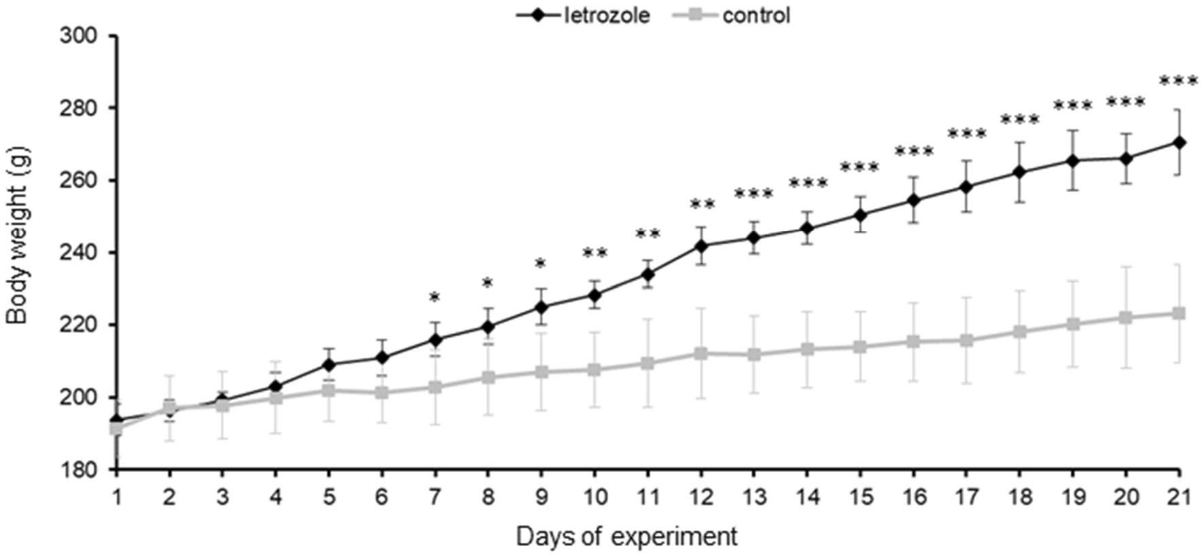

Histochemistry and Cell Biology (2021) 155:101-116
105
buffer (pH 6.0) for 12 min. Endogenous peroxidase activity
was blocked with 0.3% (v/v) H2O2 in TBS for 20 min. To
block non-specific binding sites, sections were incubated in
5% (v/v) normal rabbit or goat serum in TBS for 40 min.
Sections were then incubated overnight with primary anti-
bodies (for specification see "Western blot analysis") as
follows: anti-VDR (dilution 1:50), anti-CYP27B1 (dilution
1:50) and anti-CYP24A1 (dilution 1:300). Next, slides were
incubated with secondary biotinylated goat anti-rabbit (dilu-
tion 1:300; Vector Laboratory, Burlingame, CA, USA) or
horse anti-goat (1:300; Vector Laboratory) antibodies for
1.5 h at room temperature, and avidin-biotin-peroxidase
complex (Vectastain Elite ABC Reagent, Vector Laborato-
ries) for 40 min at room temperature. Bound antibody was
visualized with TBS containing 0.01% (v/v) H2O2, 0.05%
(w/v) 3,3'-diaminobenzidine (DAB; Sigma-Aldrich) and
0.07% (w/v) imidazole for 1 min. Negative controls were
performed by substituting the primary antibody with non-
immune rabbit (NI01; Calbiochem) or goat (NI02; Calbio-
chem) IgGs. Sections were dehydrated, cleared in xylene
and mounted in DPX (Sigma-Aldrich). Selected slides were
photographed using an Axio Scope A1 microscope and an
Axiocam503 color camera with ZEN 2.3 pro software.

Statistical analysis
Statistical analyses were performed using Statistica v.13.1
software (StatSoft, Inc, Tulsa, OK, USA). All data are pre-
sented as the overall mean ± standard error of the mean
(SEM), and differences were considered statistically sig-
nificant at the 95% confidence level.
(P < 0.05). To verify the normal distribution of data the
Shapiro-Wilk and the Lilliefors tests were applied. Data
on T and E2, 25OHD, 1,25(OH)2D3 and calcium concen-
trations were analyzed by one-way ANOVA followed by
Tukey post hoc test; BW results were analyzed by Student’s
t test. Data from real-time PCR and Western blot analyses
showed a lack of normal distribution and so the nonpara-
metric Kruskal-Wallis test was applied and the differences
between individual groups determined by post hoc Dunn’s
multiple comparison test.

Results

Effect of letrozole administration on rat BW
Letrozole-treated rats gained more weight than controls
(Fig. 1). Statistically significant differences in BW between
control and letrozole-treated rats appeared from day 7
(p < 0.05) and gradually increased over the course of the
experiment (p < 0.001).

Effect of letrozole administration on steroid
concentrations
Plasma T concentration significantly increased (p < 0.05) in
letrozole-treated rats when compared to both control groups
(Fig. 2a). Plasma E2 concentration markedly decreased
(p < 0.05) following letrozole administration in comparison
to the proestrus control group, and was similar to that in
diestrus control rats (Fig. 2b).
Fig. 1 Daily changes in body weight during the course of experiment in control (n = 16) and letrozole-treated (n = 8) rats. Values are expressed
as mean ± SEM *p < 0.05, **p < 0.01, ***p < 0.001 (Student’s t test)
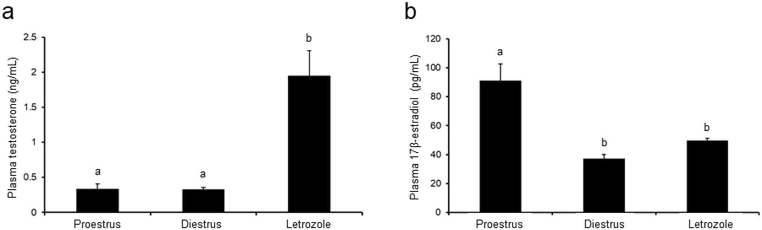
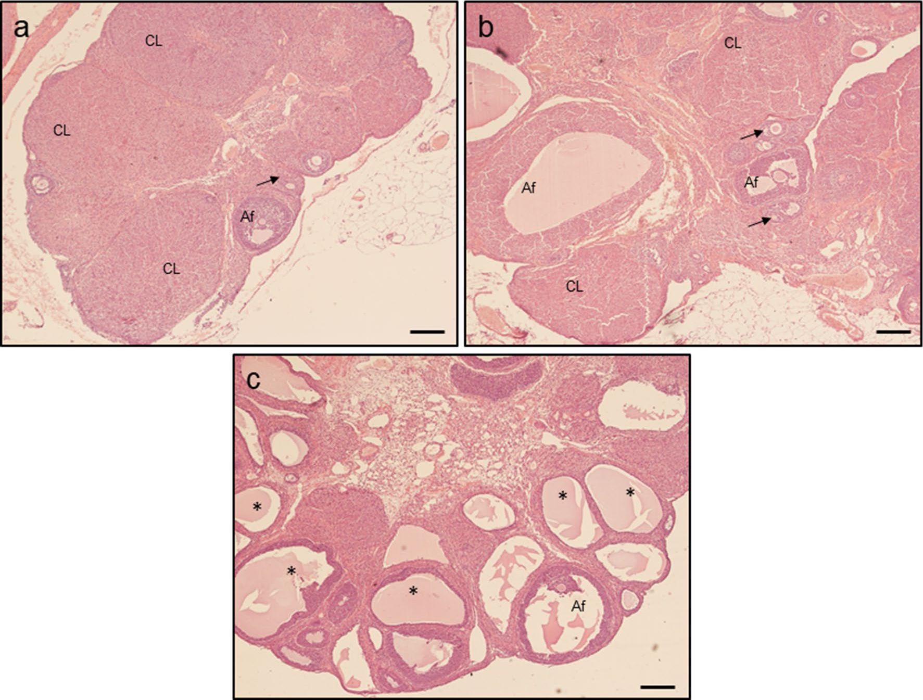
l06
Histochemistry and Cell Biology (202l) l55:l0l-ll6
Fig. 2 Plasma concentrations of testosterone and 17p-estradiol in
control (proestrus and diestrus; n = 8 per each group) and letrozole-
treated (n = 8) rats. Values are expressed as mean ± SEM. Different
letters denote statistically significant differences (p < 0.05; one-way
ANOVA followed by Tukey post hoc test)

Effect of letrozole administration on estrous
cyclicity and ovarian histology
Animals in both control groups had normal estrous cycle,
while rats treated with letrozole were acyclic. Control rats
in proestrus (Fig. 3a) and diestrus (Fig. 3b) displayed nor-
mal follicular development (preantral follicles, antral fol-
licles and corpora lutea), whereas letrozole administration
resulted in ovarian cysts and anovulation confirmed by the
lack of corpora lutea (Fig. 3c).
Fig. 3 Histology of ovaries obtained from control (a—proestrus and b - diestrus; n = 3 per each group) and letrozole-treated (c; n = 3) rats. Af
antral follicle, CL corpus luteum, asterisks - ovarian cysts; arrows - preantral follicle. Scale bars represent 200 pm
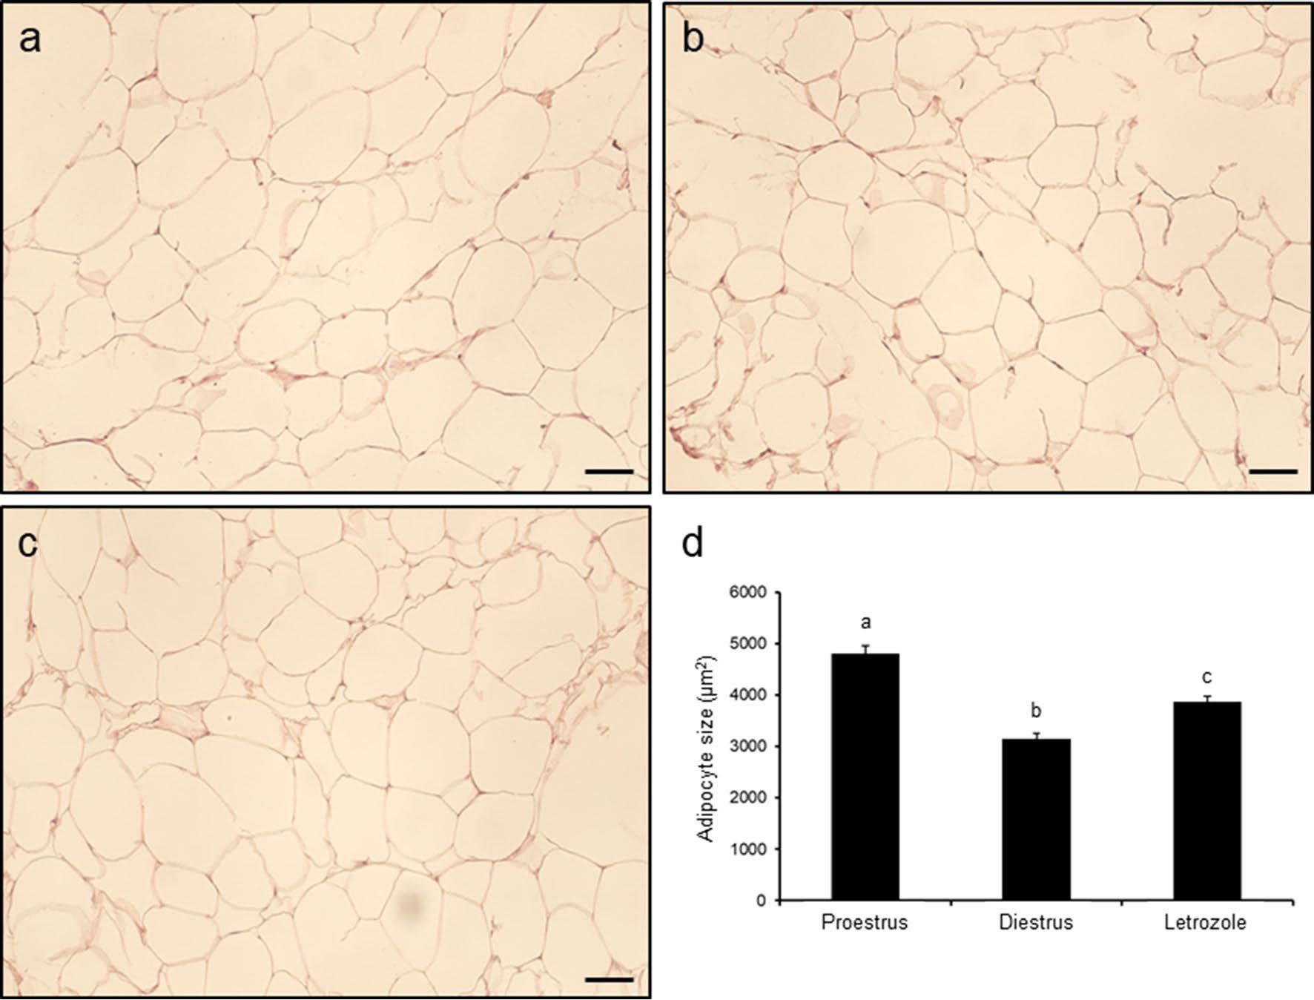

Histochemistry and Cell Biology (2021) 155:101-116
107

Effect of letrozole administration on adipocyte size
in POAT
The average size of adipocytes in POAT was greatest in
proestrus control rats (p < 0.001; Fig. 4a, d), less in the letro-
zole-treated group (p < 0.05; Fig. 4c, d) and least in diestrus
control rats (p < 0.05; Fig. 4b, d).

Effect of letrozole administration on plasma 25OHD
and calcium concentrations, and 1,25(OH)2D3 tissue
concentration
Plasma 25OHD concentration decreased markedly (p < 0.05;
Fig. 5a) in the group treated with letrozole in comparison to
both control groups, whereas calcium concentration did not
vary between the groups (p < 0.05; Fig. 5b). Neither 25OHD
nor calcium level differed between proestrus and diestrus
phases (Fig. 5a, b).
The 1,25(OH)2D3 concentration in homogenates of ovar-
ian tissue (p < 0.01; Fig. 5c) and POAT (p < 0.05; Fig. 5d)
was lower in the letrozole-treated group than in both proes-
trus and diestrus controls.

Effect of letrozole administration on Vdr, Cyp27b1
and Cyp24a1 mRNA expression in the ovary
and POAT
The expression of ovarian Vdr mRNA was greater in rats
treated with letrozole and control rats in diestrus than in the
proestrus control group (p < 0.05; Fig. 6a). Cyp27b1 mRNA
expression was lower in the ovaries of the letrozole-treated
group and diestrus control group when compared with con-
trol rats in proestrus (p < 0.05; Fig. 6Ь), whereas the expres-
sion of Cyp24a1 mRNA was unchanged (Fig. 6c).
In POAT, only Cyp27b1 mRNA expression markedly
decreased following letrozole administration in comparison
with both control groups (p < 0.05; Fig. 6e), while expres-
sion of Vdr (Fig. 6d) and Cyp24a1 (Fig. 6f) mRNAs did not
differ between control and letrozole-treated groups.
Fig. 4 Histology of periovarian adipose tissue obtained from control
(a proestrus and b - diestrus; n = 4 per each group) and letrozole-
treated (c; n = 4) rats. Chart (d) represents adipocyte size in each
examined group. Values are expressed as mean ± SEM. Different
letters denote statistically significant differences (p < 0.05; one-way
ANOVA followed by Tukey post hoc test). Scale bars represent 50 pm
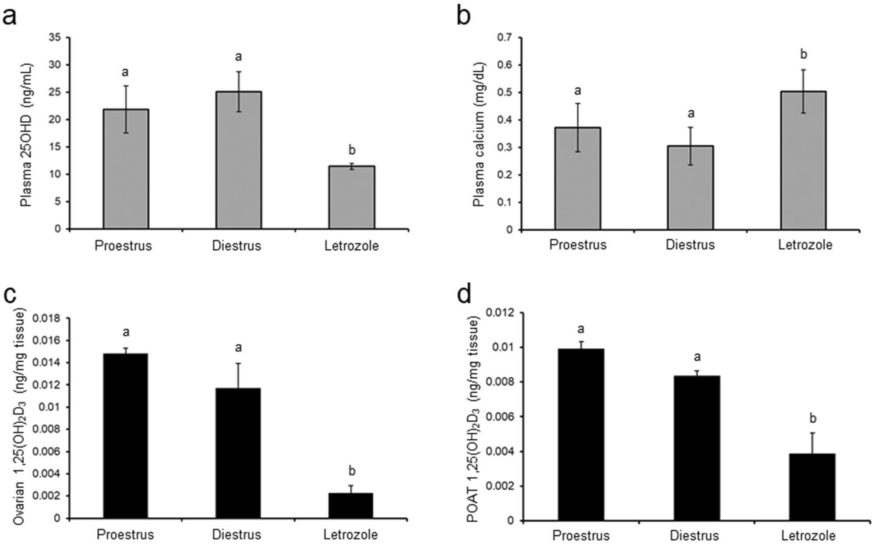

108
Histochemistry and Cell Biology (2021) 155:101-11б
Fig. S Plasma concentrations of 25OHD (a) and calcium (b), and
1,25(OH)2D3 in homogenates of ovaries (c) and periovarian adipose
tissue (POAT; d) in control (proestrus and diestrus; n = S per each
group) and letrozole-treated (n = 8) rats. Values are expressed as
mean ± SEM. Different letters denote statistically significant differ-
ences (p < 0.05; one-way ANOVA followed by Tukey post hoc test)

Effect of letrozole administration on VDR, CYP27B1
and CYP24A1 protein abundance in the ovary
and POAT
In the ovary (Fig. 7a) and POAT (Fig. 7e) of control and letro-
zole-treated rats, analyzed proteins were shown as bands at
approximately 48 kDa (VDR), 56 kDa (CYP27B1) and 59 kDa
(CYP24A1).
The ovarian VDR protein abundance significantly increased
(p< 0.05; Fig. 7b), while CYP27B1 protein markedly
decreased (p < 0.05; Fig. 7c) following letrozole administra-
tion when compared to both control groups. CYP24A1 protein
abundance was at the same level in letrozole-treated rats and
controls (Fig. 7d).
In POAT, diminished abundance of CYP27B1 protein was
only observed in rats treated with letrozole (p < 0.05; Fig. 7g),
while VDR (Fig. 7f) and CYP24A1 (Fig. 7h) protein abun-
dances were unchanged between letrozole-treated and control
groups.

Immunolocalization of VDR, CYP27B1 and CYP24A1
in the ovary and POAT
Positive nuclear VDR staining was found in both ovarian
(Fig. 8) and POAT (Fig. 9) sections from the letrozole-
treated group (Figs. 8c and 9c) as well as control in proestrus
(Fig. 8a and Fig. 9a) and diestrus (Figs. 8b and 9b). In the
control ovaries (Fig. 8a, b), VDR immunoreaction was found
in granulosa and theca cells of preantral and antral ovarian
follicles, and in luteal cells of corpora lutea. In the letrozole-
treated group (Fig. 8c), VDR was detected in cells within
the luteinized wall of follicular cysts. In POAT, VDR was
observed in the nuclei of adipocytes in all studied groups
(Fig. 9a-c).
Both metabolizing enzymes, CYP27B1 and CYP24A1,
displayed cytoplasmic localization in ovarian (Fig. 8) and
POAT (Fig. 9) sections. In the ovary, CYP27B1 (Fig. d-f)
and CYP24A1 (Fig. 8g-i) were found exclusively in the
granulosa cells of healthy follicles with a lack of positive
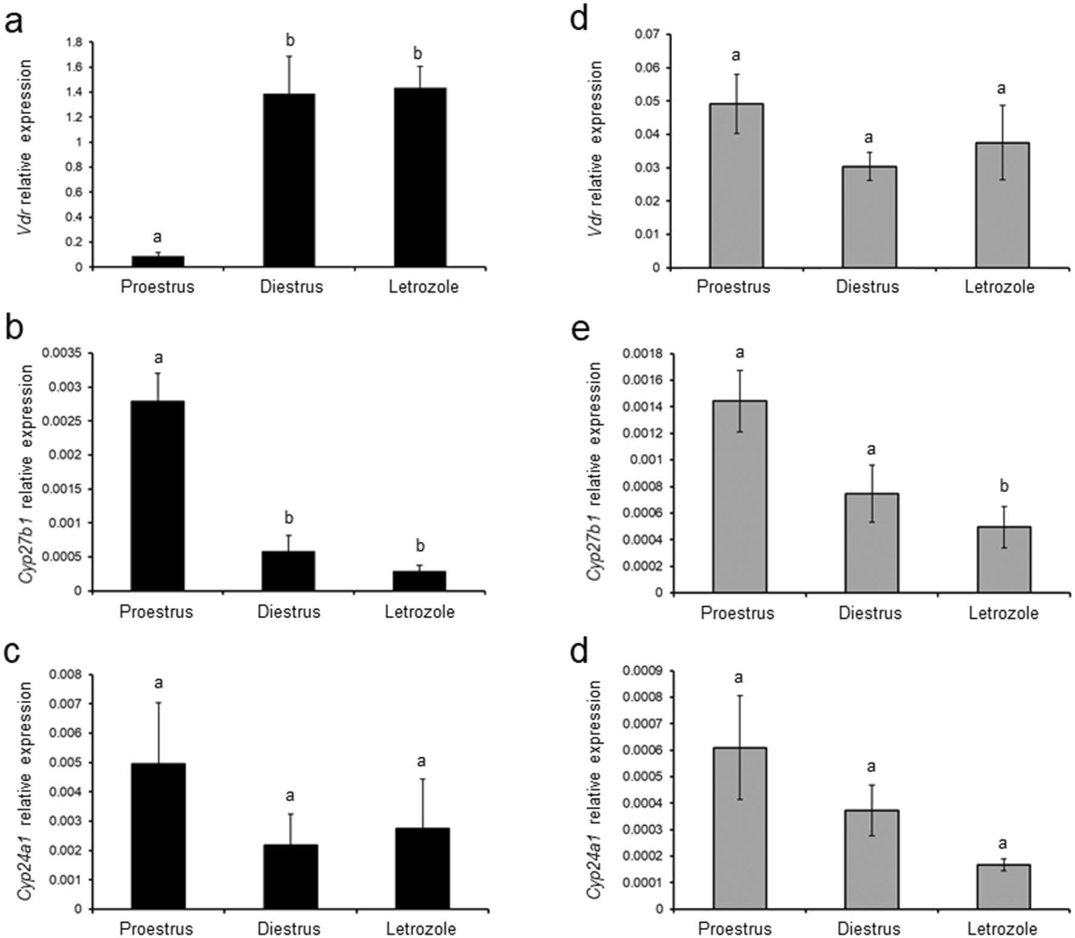
Histochemistry and Cell Biology (2021) 155:101-11б
109
Fig. б Relative expression of Vdr (a, d), Cyp27b1 (b, e) and Cyp24a1
(c, f) mRNAs in ovaries (a-c) and periovarian adipose tissue (d-f)
obtained from control (proestrus and diestrus; n = S per each group)
and letrozole-treated (n = S) rats. The mRNA expression was deter-
mined using quantitative real-time PCR and presented relative to
Gapdh as mean ± SEM. Different letters denote statistically signifi-
cant differences (p < 0.05; Kruskal-Wallis test followed by post hoc
Dunn’s multiple comparison test)
staining in follicular cysts (Fig. 8f, i). CYP27B1 (Fig. 9d-f)
and CYP24A1 (Fig. g-i) were positively localized in the
cytoplasm of adipocytes in all examined groups. Either in
ovaries (Fig. 8) or POAT (Fig. 9), CYP24A1 immunostain-
ing was weaker than CYP27B1 immunoreaction.

Discussion
Recently a growing body of evidence highlights that VD3
plays an important role in the ovary and its deficiency is
linked with several ovarian pathologies such as PCOS.
Keeping in mind the expression of CYP27B1 responsible
for active VD3 synthesis and VDR in ovarian tissue, the
question arises whether VD3 metabolism at the ovarian
level is disrupted in PCOS. Therefore, the present study
has been undertaken to examine the local VD3 metabolism
and the expression of VD3-related molecules (VDR,
CYP27B1 and CYP24A1) in ovarian tissue and POAT
of control rats (at proestrus and diestrus) and those with
PCOS induced by the aromatase inhibitor letrozole.
Herein, letrozole-treated rats exhibited key PCOS traits,
including acyclicity, anovulation confirmed by the lack of
corpora lutea, cystic ovarian morphology and increased
BW that is in agreement with previous observations on
rodents exposed to letrozole (Kafali et al. 2004; Bara-
valle et al. 2006; Mannerâs et al. 2007; Caldwell et al.
2014). Furthermore, administration of letrozole led to the
expected increase in T and decrease in E2 concentrations
in plasma, reflecting the blockage of androgen conversion
to estrogen (Baravalle et al. 2006; Mannerâs et al. 2007).
Thus, the aforementioned results indicate the successful
induction of PCOS rat model in the current study.
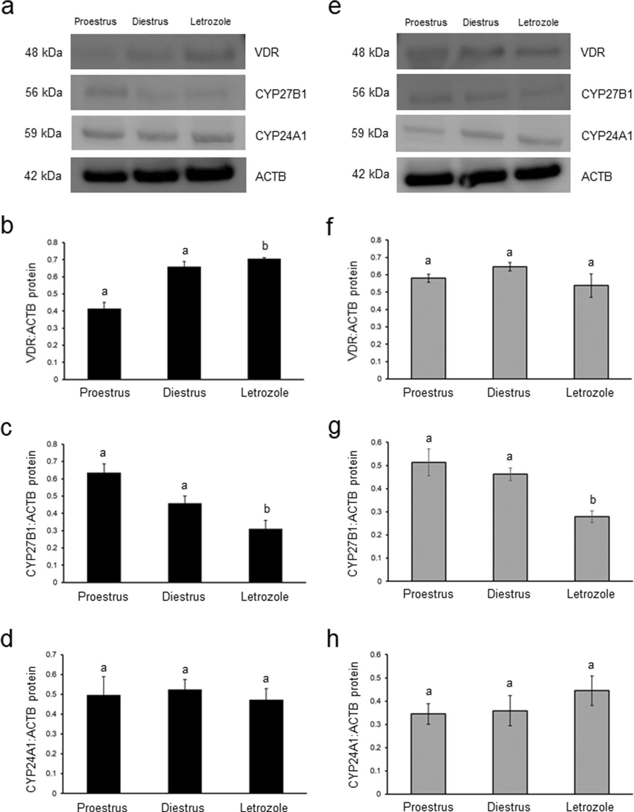
110
Histochemistry and Cell Biology (2021) 155:101-116
Fig. 7 Relative abundance of VDR (b, f), CYP27B1 (c, g) and
CYP24A1 (d, h) proteins in ovaries (b-d) and periovarian adipose
tissue (POAT; f-h) obtained from control (proestrus and diestrus;
n = 8 per each group) and letrozole-treated (n = 8) rats. Each protein
abundance was evaluated densitometrically and expressed as the
ratio relative to p-actin (ACTB) abundance (mean ± SEM). The frag-
ment of membrane with bands corresponding to predicted molecular
weights are shown (a—ovary; e— POAT). Different letters denote
statistically significant differences (p < 0.05; Kruskal-Wallis test fol-
lowed by post hoc Dunn’s multiple comparison test)
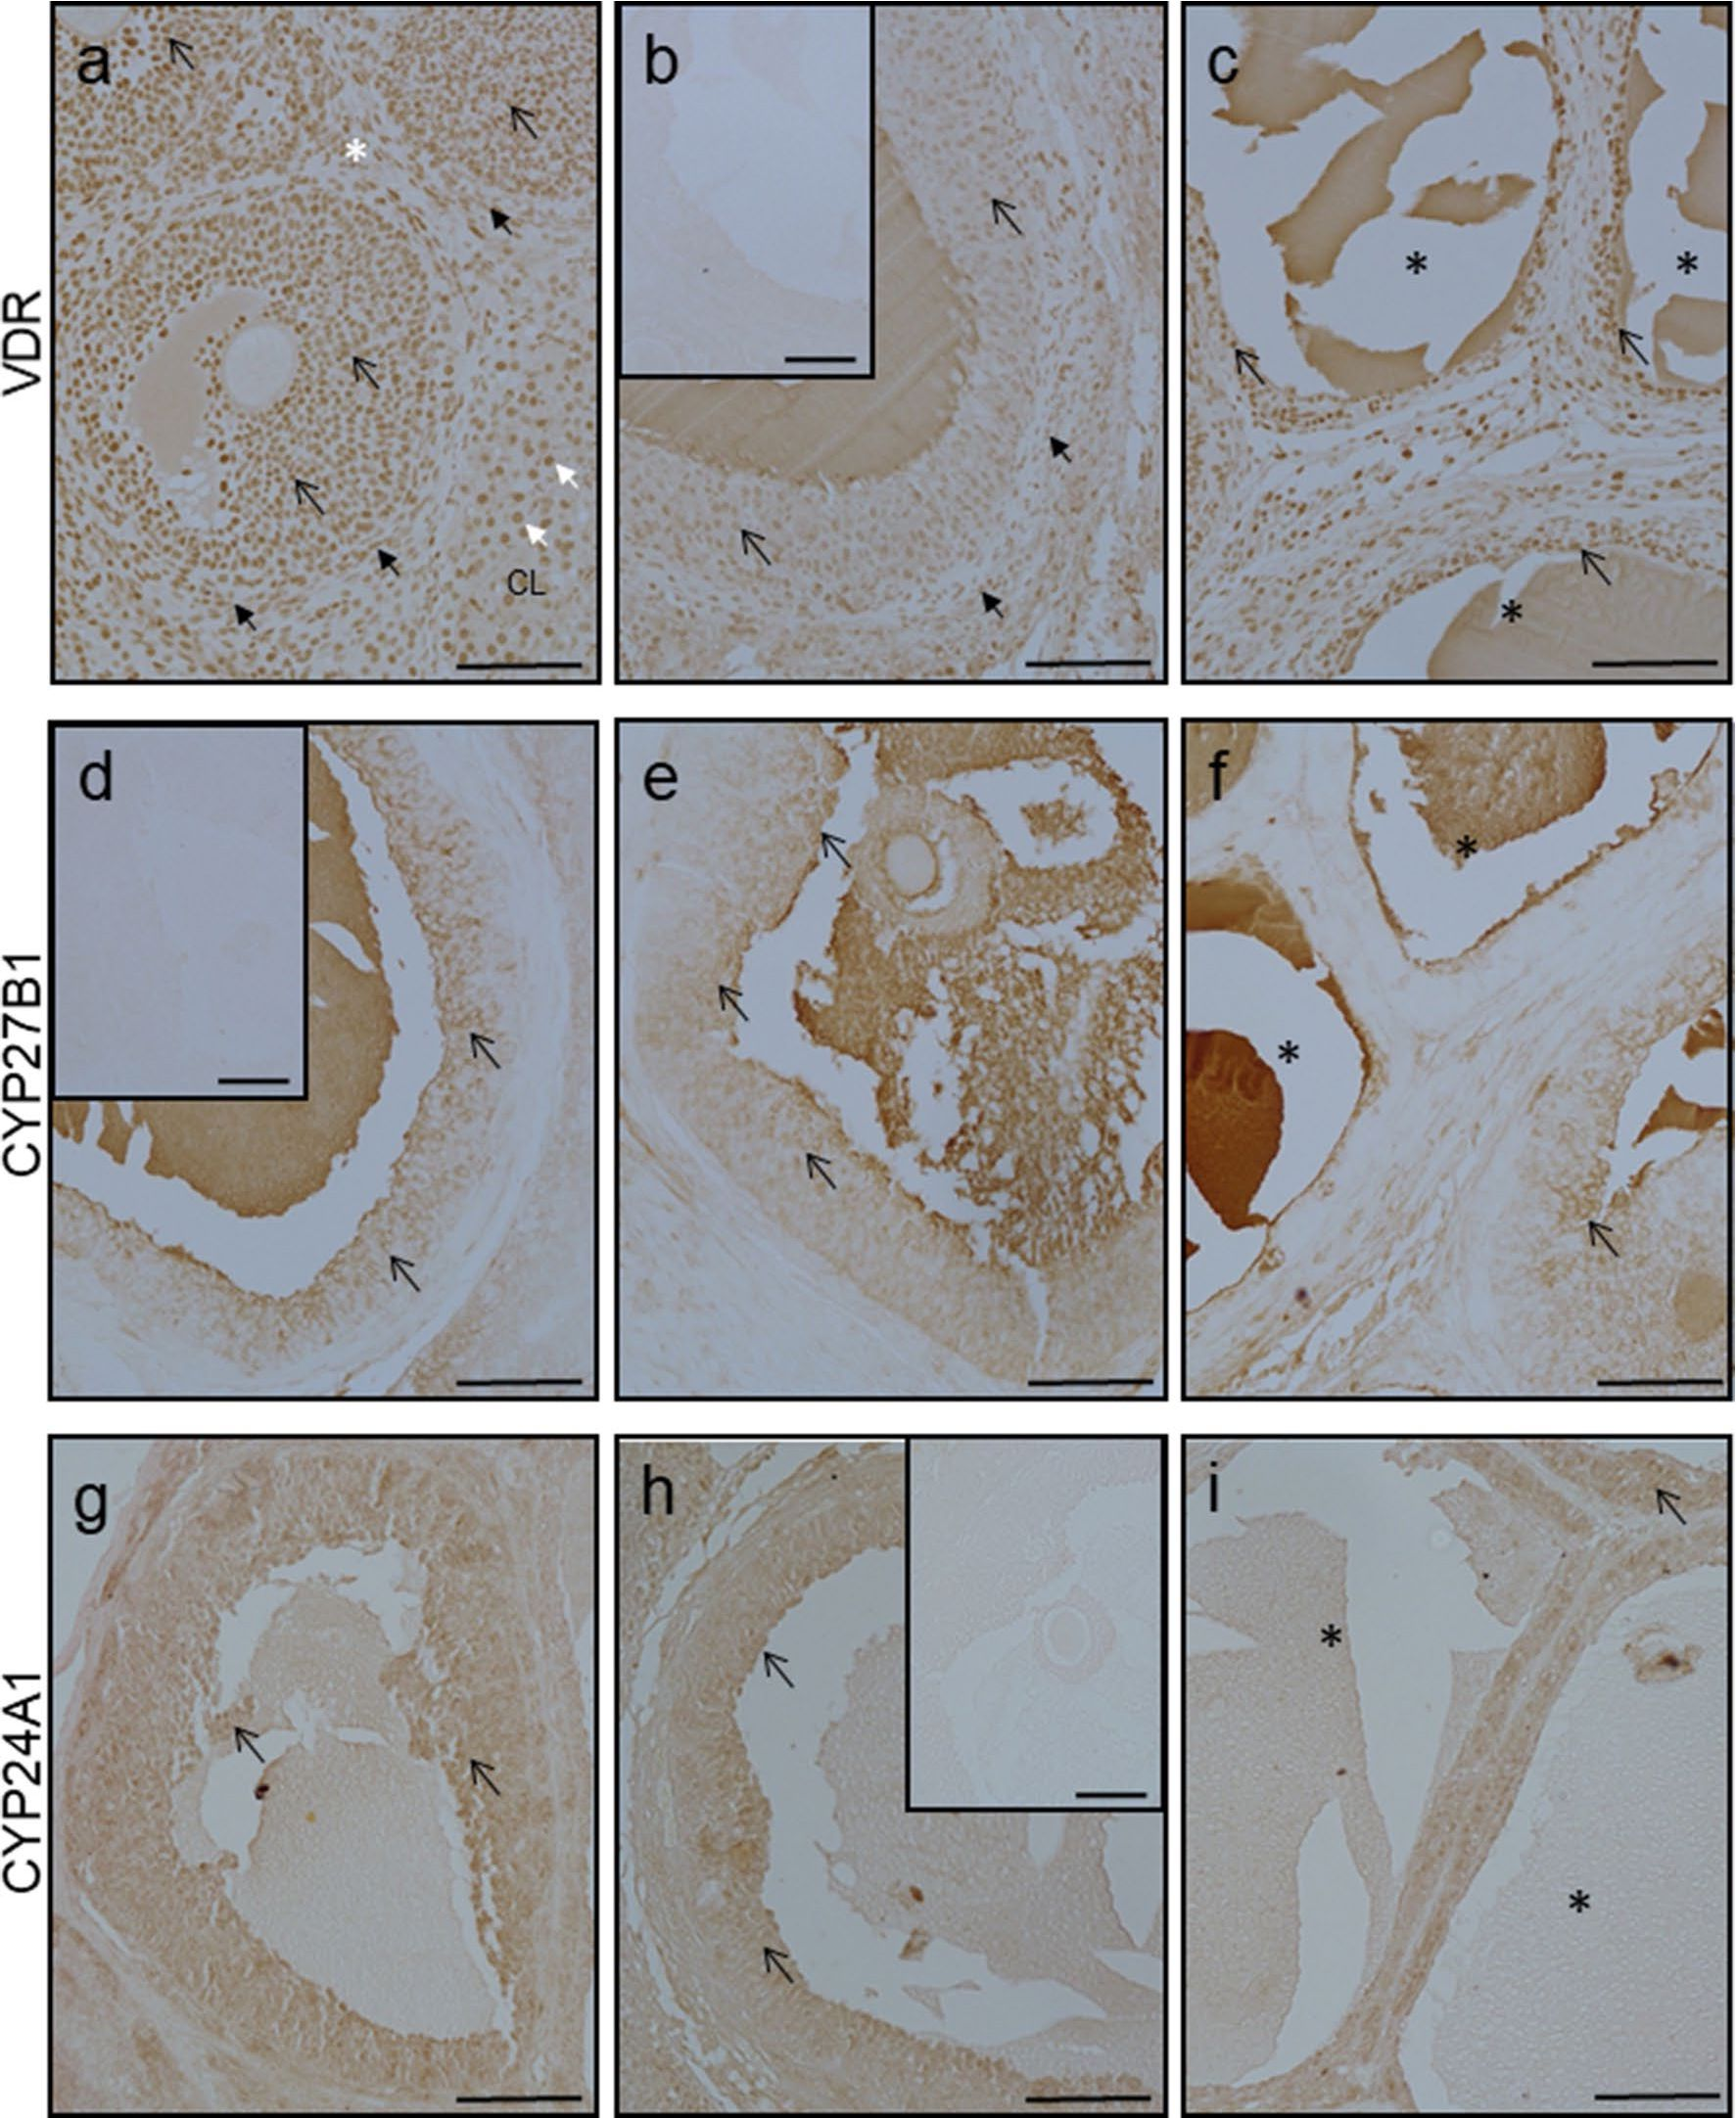
Histochemistry and Cell Biology (2021) 155:101-116
111
Fig. 8 Representative micrographs of immunohistochemical VDR,
CYP27B1 and CYP24A1 localization in ovaries obtained from con-
trol (a, d, g—proestrus and b, e, h—diestrus; n = 3 per each group)
and letrozole-treated (c, f, i; n = 3) rats. VDR expressed nuclear pat-
tern of staining (a-c), while CYP27B1 (d-f) and CYP24A1 (g-i)
were observed in the cell cytoplasm. Control sections showed no
positive staining (b inset, d inset, h inset). CL - corpus luteum; open
arrow - granulosa cells; black arrows - theca cells; white arrows -
luteal cells; asterisks - ovarian cysts. Scale bars represent 100 pm
It is proposed that VD3 deficiency correlates with the
occurrence of PCOS. Based on epidemiologic studies, its
prevalence in PCOS women is approximately 67-85% (He
et al. 2015). In accordance with those results, in PCOS rats
we observed decreased concentration of plasma 25OHD.
Although lower VD3 level is common among PCOS patients,
previous research reported a lack of statistically significant
differences in VD3 status between PCOS and non-PCOS
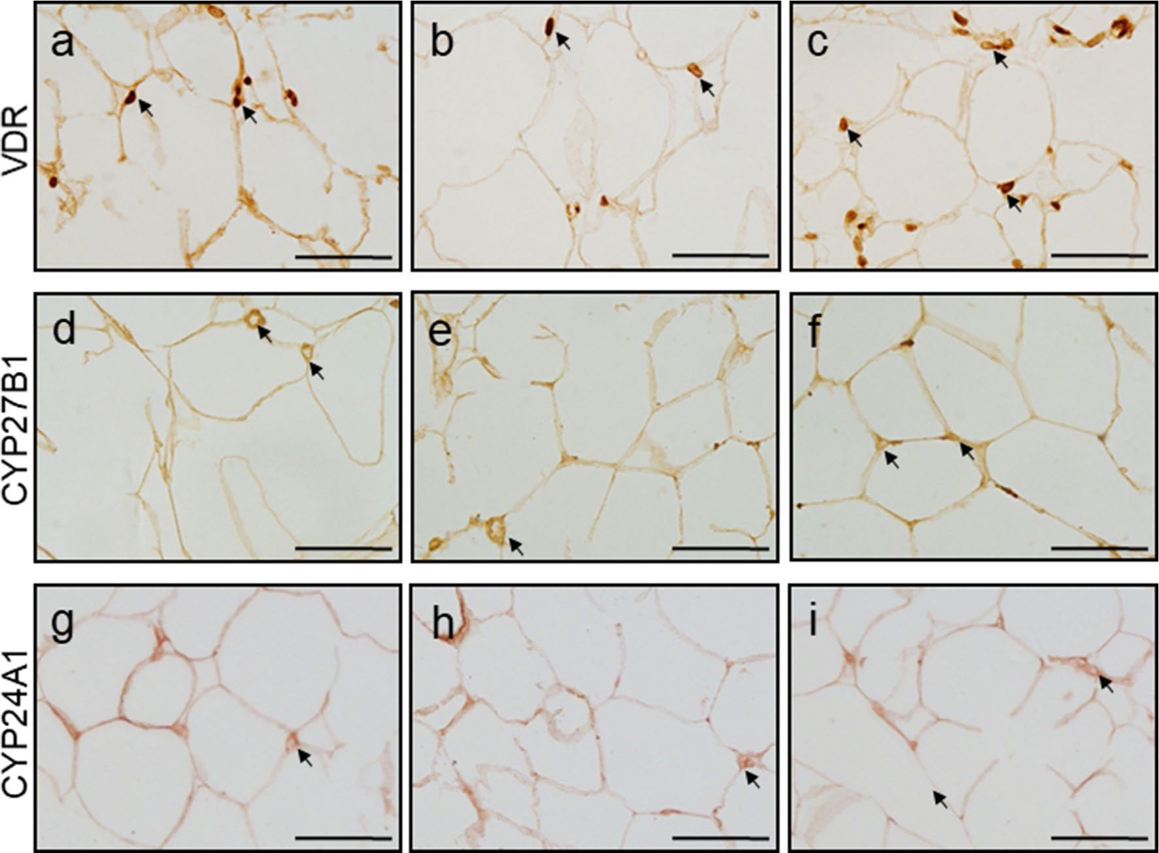
112
Histochemistry and Cell Biology (2021) 155:101-116
Fig. 9 Representative micrographs of immunohistochemical VDR,
CYP27B1 and CYP24A1 localization in periovarian adipose tissue
obtained from control (a, d, g—proestrus and b, e, h—diestrus; n = 3
per each group) and letrozole-treated (c, f, i; n = 3) rats. VDR was
observed in the nuclei of adipocytes (a-c; arrows), while CYP27B1
(d-f; arrows) and CYP24A1 (g-i; arrows) were found in adipocytes
cytoplasm. Scale bars represent 50 pm
women (Moini et al. 2015). It is noteworthy that a mark-
edly diminished 25OHD level was found in obese compared
with lean PCOS patients, suggesting that hypovitaminosis
D3 results from obesity but is independent of the presence of
PCOS (Yildizhan et al. 2009). In this context, the increased
BW of letrozole-treated rats observed here might be related
to their diminished plasma 25OHD level. It is known that
abdominal obesity contributes to the development of insu-
lin resistance in PCOS women, and a positive association
between VD3 deficiency and this metabolic disorder was
also indicated (Yildizhan et al. 2009; He et al. 2015). VD3
was shown to enhance insulin synthesis and release, increase
insulin receptor expression and inhibit the production of pro-
inflammatory cytokines that might counteract the develop-
ment of insulin resistance (Sung et al. 2012). In turn, insulin
increases ovarian androgen synthesis aggravating hyperan-
drogenism (Sam and Dunaif 2003). Thus, VD3 deficiency
might play vital role in the development of subsequent meta-
bolic and endocrine disorders in PCOS.
It is thought that VD3 deficiency in PCOS affects calcium
homeostasis, resulting in inhibition of oocyte resumption
and follicular arrest (Thys-Jacobs et al. 1999). To support
this hypothesis, several reports indicated positive effects of
VD3 and calcium supplementation on menstrual irregular-
ity and infertility in PCOS patients with low VD3 status
(Thys-Jacobs et al. 1999; Firouzabadi et al. 2012; Kadoura
et al. 2019). On the other hand, there were no differences
in calcium level between control and PCOS women (Thys-
Jacobs et al. 1999; Moini et al. 2015). In agreement with
those findings, we have observed no significant changes in
plasma calcium concentrations between PCOS rats and con-
trol groups. Thys-Jacobs et al. (1999) indicated that calcium
metabolism was disrupted in PCOS patients with VD3 defi-
ciency and hyperparathyroidism despite normal extracellular
calcium concentration. They suggested that dysregulation in
intracellular calcium signaling might affect oocyte develop-
ment and ovulation. However, further studies are needed to
confirm this.
Recent studies on humans (Masjedi et al. 2020) and on
a PCOS mouse model (Bakhshalizadeh et al. 2017, 2018)
have reported improved steroidogenesis and enzymatic
antioxidant defense in the granulosa cells isolated from
Histochemistry and Cell Biology (2021) 155:101-116
113
polycystic ovaries following VD3 treatment. This sug-
gests a critical role of VD3 in establishing proper follicu-
lar function in PCOS and that an altered VD3 metabolic
homeostasis is possible in polycystic ovaries. Disturbed
VD3 metabolism has been demonstrated in reproductive
disorders such as endometriosis (Vigano et al. 2006),
preeclampsia (Ma et al. 2012) and ovarian carcinoma
(Brozyna et al. 2015), but not in PCOS. The present study
shows for the first time a significant reduction of intrao-
varian 1,25(OH)2D3 concentration in letrozole-treated rats
when compared with controls in proestrus and diestrus.
That is probably due to diminished ovarian expression of
CYP27B1, which is responsible for the synthesis of active
VD3, at mRNA and corresponding protein levels in that
group. Furthermore, positive CYP27B1 immunostaining
was found only in the granulosa cells of healthy follicles,
but not in cystic ones. Besides indicating that the rat PCOS
ovary is a site of local VD3 synthesis, we have now demon-
strated its capacity for 1,25(OH)2D3 catabolism by reveal-
ing CYP24A1 expression and immunolocalization. In the
ovary of PCOS-induced rats, the expression of mRNA
and abundance of protein for CYP24A1 were unchanged.
Therefore, our results demonstrate that ovarian conver-
sion of the circulating 25OHD3 to active 1,25(OH)2D3 is
decreased in PCOS rat model, and this may contribute to
VD3 deficiency observed in PCOS.
It is well known that VD3 regulates ovarian function
through its cognate receptor VDR, expressed abundantly in
the mammalian ovary (Herian et al. 2018; Xu et al. 2018).
The present immunohistochemical results demonstrate
VDR distribution in granulosa and theca cells of healthy
rat ovarian follicles, consistent with Johnson et al. (1996).
In addition, VDR was detected in the luteinized wall of the
follicular cysts. Vdr mRNA expression was greater in the
ovary of letrozole-treated rats and control rats in diestrus
than in proestrus control, whereas VDR protein abundance
was increased only in the PCOS group. VDR gene is known
to be up-regulated by various hormones including parathor-
mone, retinoic acid, glucocorticoids and calcitriol due to
their action in the VDR promoter region (Pike and Meyer
2010). There are also studies on human ovarian cancer
cells (Ahonen et al. 2000) and breast cancer cells (Escaleira
et al. 1993) indicating increased VDR protein abundance
in response to dihydrotestosterone in vitro. Based on these
results, a similar mechanism might exist in PCOS under
hyperandrogenic conditions, explaining the increased ovar-
ian VDR protein level following letrozole treatment seen
here. Furthermore, androgens were shown to regulate VDR
signal transduction through suppression of VDR/retinoid
X receptor (RXR) dimerization in porcine ovarian follicles
(Herian et al. 2018). Thus, the altered response of ovarian
cells to VD3 in PCOS, independently of the VDR protein
level, cannot be excluded.
Recent research clearly demonstrates that white adipose
tissue surrounding the ovaries controls ovarian function
through paracrine interactions (Yang et al. 2018). In POAT-
deficient mice, the overall estrogens and gonadotropin lev-
els were altered with consequent disturbance to the estrous
cycle (Wang et al. 2017). Furthermore, removal of POAT
resulted in delayed antral follicle development, increased
number of atretic follicles, decreased intraovarian steroi-
dogenic enzyme expression and lipid accumulation, which
might reduce the availability of substrate for local steroid
production (Yang et al. 2018). Adipose tissue is well known
as a large endocrine tissue that can also store and metabolize
VD3 (Abbas 2017). However, information on VD3 metabo-
lism in gonadal adipose tissue is scarce. Recent data showed
hypertrophied adipocytes and enhanced inflammation in
POAT under dietary restriction of VD3 in a mouse model of
menopause (Borges et al. 2020), indicating a link between
VD3 deficiency and POAT function. Considering the role
of POAT in ovarian processes, its endocrine function and
the occurrence of hypovitaminosis D3 in PCOS women, an
examination of VD3 metabolism in gonadal adipose tissue
around polycystic ovaries appears to be required.
The expression of VD3-related molecules, including
CYP27B1 and CYP24A1, and VDR has been previously
described in adipose tissue (Abbas 2017). However, our
current research demonstrates for the first time Cyp27b1,
Cyp24a1 and Vdr mRNA expression as well as CYP27B1,
CYP24A1 and VDR protein abundance and immunolocal-
ization in rat POAT. In addition, we have found reduced
1,25(OH)2D3 concentration in POAT obtained from PCOS
rats in comparison with control groups. Accordingly, rat
POAT is a local site of VD3 metabolism. These results are
consistent with previous studies showing the production
of active VD3 by visceral and subcutaneous adipose tis-
sue (Abbas 2017). The diminished amount of 1,25(OH)2D3
in POAT of letrozole-treated rats was probably due to the
decreased Cyp27b1 mRNA expression and CYP27B1 pro-
tein abundance observed in this group. Notably, we did
not find any changes in CYP24A1 and VDR expression at
mRNA and protein level between studied groups. In adipose
tissue, CYP27B1 level is lower in obese than lean women,
whereas CYP24A1 expression does not differ between them
(Wamberg et al. 2013) explaining obesity associated VD3
deficiency. This seems to apply to VD3 deficiency in PCOS
accompanied by obesity. It is plausible that obese people
degrade more VD3 in their adipose tissue via CYP24A1
than lean ones. Thus, these data could support the hypoth-
esis of an increased catabolism of VD in obesity besides
unchanged CYP24A1 expression (Vranic et al. 2019). Obe-
sity results from the increase in adipocyte number and size
(Abbas 2017). Herein we have noted adipocyte hypertrophy
in letrozole-treated animals when compared with the con-
trol in diestrus, but not when compared with the proestrus
114
Histochemistry and Cell Biology (2021) 155:101-116
control. There are discrepancies between literature reports
on the effect of letrozole on adipocyte size in rats. One study
revealed enlargement (Manneras et al. 2007), while another
found no change (Caldwell et al. 2014). It should be stressed
that neither study was related to POAT.
In conclusion, our results provide novel evidence of dis-
rupted VD3 metabolism in the ovary and POAT of rats with
induced PCOS. The reduced 1,25(OH)2D3 concentration in
those tissues suggests that they contribute to the VD3 defi-
ciency observed in PCOS and might be implicated in PCOS
pathogenesis. Furthermore, the letrozole-induced PCOS rat
model exhibiting decreased 25OHD plasma level may be
valuable for further studies on the role of VD3 deficiency in
this reproductive disorder.
Acknowledgements The authors would like to thank Prof. Martin R.
Luck (University of Nottingham) for English language correction. The
authors are grateful to Mr. Piotr Pawlicki (Department of Endocri-
nology, Institute of Zoology and Biomedical Research, Jagiellonian
University) for technical assistance in samples collection.
Funding This work was supported by the Ministry of Sciences and
Higher Education for Jagiellonian University in Krakow, subvention
no. N18/DBS/000006.
Availability of data and material Not applicable.

Compliance with ethical standards
Conflicts of interest The authors declare that there is no conflict of
interest that could be perceived as prejudicing the impartiality of the
research reported.
Ethics approval Experimental protocols listed herein were approved by
the Local Animal Ethical Committee, Poland (Permit no. 277/2019).
Code availability Not applicable.
Consent to participate All authors approve the participation in the
manuscript.
Consent for publication All authors approve the final version of the
manuscript.
Open Access This article is licensed under a Creative Commons Attri-
bution 4.0 International License, which permits use, sharing, adapta-
tion, distribution and reproduction in any medium or format, as long
as you give appropriate credit to the original author(s) and the source,
provide a link to the Creative Commons licence, and indicate if changes
were made. The images or other third party material in this article are
included in the article’s Creative Commons licence, unless indicated
otherwise in a credit line to the material. If material is not included in
the article’s Creative Commons licence and your intended use is not
permitted by statutory regulation or exceeds the permitted use, you will
need to obtain permission directly from the copyright holder. To view a
copy of this licence, visit http://creativecommons.org/licenses/by/4.0/.

References
Abbas MA (2017) Physiological functions of vitamin D in adipose
tissue. J Steroid Biochem Mol Biol 165:369-381. https://doi.
org/10.1016/j.jsbmb.2016.08.004
Ahonen MH, Zhuang YH, Aine R, Ylikomi T, Tuohimaa P (2000)
Androgen receptor and vitamin D receptor in human ovarian
cancer: growth stimulation and inhibition by ligands. Int J Can-
cer 86:40-46. https://doi.org/10.1002/(SICI)1097-0215(20000
401)86:1%3c40::AID-IJC6%3e3.0.CO;2-E
Azziz R, Carmina E, Dewailly D, Diamanti-Kandarakis E, Escobar-
Morreale HF, Futterweit W, Janssen OE, Legro RS, Norman RJ,
Taylor AE, Witchel SF (2006) Positions statement: criteria for
defining polycystic ovary syndrome as a predominantly hyper-
androgenic syndrome: an Androgen Excess Society guideline. J
Clin Endocrinol Metab 91:4237-4245. https://doi.org/10.1210/
jc.2006-0178
Bakhshalizadeh S, Amidi F, Alleyassin A, Soleimani M, Shirazi R,
Shabani Nashtaei M (2017) Modulation of steroidogenesis by
vitamin D3 in granulosa cells of the mouse model of polycystic
ovarian syndrome. Syst Biol Reprod Med 63:150-161. https://
doi.org/10.1080/19396368.2017.1296046
Bakhshalizadeh S, Amidi F, Shirazi R, Shabani Nashtaei M (2018)
Vitamin D3 regulates steroidogenesis in granulosa cells through
AMP-activated protein kinase (AMPK) activation in a mouse
model of polycystic ovary syndrome. Cell Biochem Funct
36:183-193. https://doi.org/10.1002/cbf.3330
Baravalle C, Salvetti NR, Mira GA, Pezzone N, Ortega HH (2006)
Microscopic characterization of follicular structures in letro-
zole-induced polycystic ovarian syndrome in the rat. Arch Med
Res 27:830-839. https://doi.org/10.1016/j.arcmed.2006.04.006
Benrick A, Chanclon B, Micallef P, Wu Y, Hadi L, Shelton JM,
Stener-Victorin E, Wernstedt Asterholm I (2017) Adiponectin
protects against development of metabolic disturbances in a
PCOS mouse model. Proc Natl Acad Sci U S A 114:E7187-
E7196. https://doi.org/10.1073/pnas.1708854114
Bikle DD (2014) Vitamin D metabolism, mechanism of action,
and clinical applications. Chem Biol 21:319-329. https://doi.
org/10.1016/j .chembiol.2013. 12.016
Borges CC, Bringhenti I, Aguila MB, Mandarim-de-Lacerda CA
(2020) Vitamin D restriction enhances periovarian adipose tis-
sue inflammation in a model of menopause. Climacteric 23:99-
104. https://doi.org/10.1080/13697137.2019.1597841
Brozyna AA, Jozwicki W, Jochymski C, Slominski AT (2015)
Decreased expression of CYP27B1 correlates with the increased
aggressiveness of ovarian carcinomas. Oncol Rep 33:599-606.
https://doi.org/10.3892/or.2014.3666
Caldwell AS, Middleton LJ, Jimenez M, Desai R, McMahon AC,
Allan CM, Handelsman DJ, Walters KA (2014) Characteriza-
tion of reproductive, metabolic, and endocrine features of poly-
cystic ovary syndrome in female hyperandrogenic mouse mod-
els. Endocrinology 155:3146-3159. https://doi.org/10.1210/
en.2014-1196
Dabrowski FA, Grzechocinska B, Wielgos M (2015) The role of vita-
min D in reproductive health - a trojan horse or the golden fleece?
Nutrients 7:4139-4153. https://doi.org/10.3390/nu7064139
DeLuca HW (2004) Overview of general physiologic features and func-
tions of vitamin D. Am J Clin Nutr 80:1689-1696. https://doi.
org/10.1093/ajcn/80.6.1689S
Escaleira MT, Sonohara S, Brentani MM (1993) Sex steroids induced
up-regulation of 1,25-(OH)2 vitamin D3 receptors in T 47D breast
cancer cells. J Steroid Biochem Mol Biol 45:257-263. https://doi.
org/10.1016/0960-0760(93)90340-3
Fauser BC, Tarlatzis BC, Rebar RW, Legro RS, Balen AH, Lobo R,
Carmina E, Chang J, Yildiz BO, Laven JS, Boivin J, Petraglia
Histochemistry and Cell Biology (2021) 155:101-116
115
F, Wijeyeratne CN, Norman RJ, Dunaif A, Franks S, Wild RA,
Dumesic D, Barnhart K (2012) Consensus on women’s health
aspects of polycystic ovary syndrome (PCOS): the Amsterdam
ESHRE/ASRM-Sponsored 3rd PCOS Consensus Workshop
Group. Fertil Steril 97:28-38.e25. https://doi.org/10.1016/j.fertn
stert.2011.09.024
Firouzabadi Rd, Aflatoonian A, Modarresi S, Sekhavat L, Moham-
madTaheri S (2012) Therapeutic effects of calcium & vitamin D
supplementation in women with PCOS. Complement Ther Clin
Pract 18:85-88. https://doi.org/10.1016/)'.ctcp.2012.01.005
Grzesiak M, Waszkiewicz E, Wojtas M, Kowalik K, Franczak A (2019)
Expression of vitamin D receptor in the porcine uterus and effect
of 1,25(OH)2D3 on progesterone and estradiol-17ß secretion by
uterine tissues in vitro. Theriogenology 125:102-108. https://doi.
org/10.1016/j. ther iogenology.2018.10.026
He C, Lin Z, Robb SW, Ezeamama AE (2015) Serum vitamin D levels
and polycystic ovary syndrome: a systematic review and meta-
analysis. Nutrients 7:4555-4577. https://doi.org/10.3390/nu706
4555
Herian M, Luck MR, Grzesiak M (2018) The influence of testosterone
on the expression and function of vitamin D3 receptor (VDR)
protein in the porcine ovarian follicle. Physiol Res 67:515-519
https://doi.org/10.33549/physiolres.933762
Irani M, Merhi Z (2014) Role of vitamin D in ovarian physiology and
its implication in reproduction: a systematic review. Fertil Steril
102:460-468.e3. https://doi.org/10.1016/j.fertnstert.2014.04.046
Johnson JA, Grande JP, Roche PC, Kumar R (1996) Immunohisto-
chemical detection and distribution of the 1,25-dihydroxyvita-
min D3 receptor in rat reproductive tissues. Histochem Cell Biol
105:7—15. https://doi.org/10.1007/bf01450873
Kadoura S, Alhalabi M, Nattouf AH (2019) Effect of calcium and vita-
min d supplements as an adjuvant therapy to metformin on men-
strual cycle abnormalities, hormonal profile, and IGF-1 system
in polycystic ovary syndrome patients: a randomized, placebo-
controlled clinical trial. Adv Pharmacol Sci 2019:9680390. https
://doi.org/10.1155/2019/9680390
Kafali H, Iriadam M, Ozardali I, Demir N (2004) Letrozole-induced
polycystic ovaries in the rat: a new model for cystic ovarian dis-
ease. Arch Med Res 35:103-108. https://doi.org/10.1016/j.arcme
d.2003.10.005
Kalamon N, Błaszczyk K, Szlaga A, Billert M, Skrzypski M, Pawlicki
P, Górowska-Wójtowicz E, Kotula-Balak M, Błasiak A, Rak A
(2020) Levels of the neuropeptide phoenixin-14 and its recep-
tor GRP173 in the hypothalamus, ovary and periovarian adi-
pose tissue in rat model of polycystic ovary syndrome. Biochem
Biophys Res Commun 528:628-635. https://doi.org/10.1016/j.
bbrc.2020.05.101
Karadag C, Yoldemir T, Yavuz DG (2018) Effects of vitamin D supple-
mentation on insulin sensitivity and androgen levels in vitamin-D-
deficient polycystic ovary syndrome patients. J Obstet Gynaecol
Res 44:270-277. https://doi.org/10.1111/jog.13516
Krul-Poel YHM, Koenders PP, Steegers-Theunissen RP, Ten Boekel E,
Wee MMT, Louwers Y, Lips P, Laven JSE, Simsek S (2018) Vita-
min D and metabolic disturbances in polycystic ovary syndrome
(PCOS): A cross-sectional study. PLoS ONE 13:e0204748. https
://doi.org/10.1371/journal.pone.0204748
Lorenzen M, Boisen IM, Mortensen LJ, Lanske B, Blomberg JA,
Jensen M (2017) Reproductive endocrinology of vitamin D.
Mol Cell Endocrinol 453:103-112. https://doi.org/10.1016/j.
mce.2017.03.023
Ma R, Gu Y, Zhao S, Sun J, Groome LJ, Wang Y (2012) Expressions
of vitamin D metabolic components VDBP, CYP2R1, CYP27B1,
CYP24A1, and VDR in placentas from normal and preeclamptic
pregnancies. Am J Physiol Endocrinol Metab 303:E928-935. https
://doi.org/10.1152/ajpendo.00279.2012
Manneras L, Cajander S, Holmang A, Seleskovic Z, Lystig T, Lonn M,
Stener-Victorin E (2007) A new rat model exhibiting both ovarian
and metabolic characteristics of polycystic ovary syndrome. Endo-
crinology 148:3781-3791. https://doi.org/10.1210/en.2007-0168
Masjedi F, Keshtgar S, Zal F, Talaei-Khozani T, Sameti S, Fallahi S,
Kazeroni M (2020) Effects of vitamin D on steroidogenesis, reac-
tive oxygen species production, and enzymatic antioxidant defense
in human granulosa cells of normal and polycystic ovaries. J Ster-
oid Biochem Mol Biol 197:105521. https://doi.org/10.1016/j.
jsbmb.2019.105521
Marcondes FK, Bianchi FJ, Tanno AP (2002) Determination of the
estrous cycle phases of rats: some helpful considerations. Braz
J Biol 62:609-614. https://doi.org/10.1590/s1519-6984200200
0400008
Merhi Z, Doswell A, Krebs K, Cipolla M (2014) Vitamin D alters
genes involved in follicular development and steroidogenesis
in human cumulus granulosa cells. J Clin Endocrinol Metab
99:E1137-E1145. https://doi.org/10.1210/jc.2013-4161
Moini A, Shirzad N, Ahmadzadeh M, Hosseini R, Hosseini L, Sadat-
mahalleh SJ (2015) Comparison of 25-hydroxyvitamin D and
calcium levels between polycystic ovarian syndrome and nor-
mal women. Int J Fertil Steril 9:1-8. https://doi.org/10.22074/
ijfs.2015.4201
Muscogiuri G, Altieri B, Angelis DEC, Palomba S, Pivonello R, Colao
A, Orio F (2017) Shedding new light on female fertility: The role
of vitamin D. Rev Endocr Metab Disord 18:273-283. https://doi.
org/10.1007/s 11154-017-9407-2z
Parikh G, Varadinova M, Suwandhi P, Araki T, Rosenwaks Z, Poretsky
L, Seto-Young D (2010) Vitamin D regulates steroidogenesis and
insulin-like growth factor binding protein-1 (IGFBP-1) production
in human ovarian cells. Horm Metab Res 42:754-757. https://doi.
org/10.1055/s-0030-1262837
Pike JW, Meyer MB (2010) The vitamin D receptor: new paradigms
for the regulation of gene expression by 1,25-dihydroxyvitamin
D3. Endocrinol Metab Clin North Am 39:255-269. https ://doi.
org/10.1016/j.ecl.2010.02.007
Rak-Mardyła A, Durak M, Gregoraszczuk EL (2013) Effects of resis-
tin on porcine ovarian follicle steroidogenesis in prepubertal ani-
mals: an in vitro study. Reprod Biol Endocrinol 11:45. https://doi.
org/10.1186/1477-7827-11-45
Sam S, Dunaif A (2003) Polycystic ovary syndrome: syndrome XX?
Trends Endocrinol Metab 14:365-370. https://doi.org/10.1016/)'.
tem.2003.08.002
Shojaeian Z, Sadeghi R, Latifnejad Roudsari R (2019) Calcium and
vitamin D supplementation effects on metabolic factors, menstrual
cycles and follicular responses in women with polycystic ovary
syndrome: A systematic review and meta-analysis. Caspian J
Intern Med 10:359-369. https://doi.org/10.22088/cjim.10.4.359
Sung CC, Liao MT, Lu KC, Wu CC (2012) Role of vitamin D in insu-
lin resistance. J Biomed Biotechnol 2012:634195. https://doi.
org/10.1155/2012/634195
Szołtys M, Słomczyńska M, Knapczyk-Stwora K, Durlej M,
Lechowska A, Starowicz A (2010) Immunolocalization of andro-
gen receptor and steroidogenic enzymes in cumuli oophori of pre-
and post-ovulatory rats. Acta Histochem 112:576-582. https://doi.
org/10.1016/j.ac this.2009.06.003
Thys-Jacobs S, Donovan D, Papadopoulos A, Sarrel P, Bilezikian JP
(1999) Vitamin D and calcium dysregulation in the polycystic
ovarian syndrome. Steroids 64:430-435. https://doi.org/10.1016/
s0039-128x(99)00012-4
Vigano P, Lattuada D, Mangioni S, Ermellino L, Vignali M, Caporizzo
E, Panina-Bordignon P, Besozzi M, Di Blasio AM (2006) Cycling
and early pregnant endometrium as a site of regulated expression
of the vitamin D system. J Mol Endocrinol 36:415-424. https://
doi.org/10.1677/jme.1.01946
116
Histochemistry and Cell Biology (2021) 155:101-116
Vranic L, Mikolasevic I, Milic S (2019) Vitamin D deficiency: conse-
quence or cause of obesity? Medicina (Kaunas) 55(9):541. https
://doi.org/10.3390/medicina55090541
Wamberg L, Christiansen T, Paulsen S, Fisker S, Rask P, Rejnmark L,
Richelsen B, Pedersen SB (2013) Expression of vitamin D-metab-
olizing enzymes in human adipose tissue - the effect of obesity
and diet-induced weight loss. Int J Obes 37:651-657. https://doi.
org/10.1038/ijo.2012.112
Wang HH, Cui Q, Zhang T, Guo L, Dong MZ, Hou Y, Wang ZB,
Shen W, Ma JY, Sun QY (2017) Removal of mouse ovary fat pad
affects sex hormones, folliculogenesis and fertility. J Endocrinol
232:155-164. https://doi.org/10.1530/JOE-16-0174
Xu J, Lawson MS, Xu F, Du Y, Tkachenko OY, Bishop CV, Pejovic-
Nezhat L, Seifer DB, Hennebold JD (2018) Vitamin D3 regulates
follicular development and intrafollicular vitamin D biosynthesis
and signaling in the primate ovary. Front Physiol 9:1600. https://
doi.org/10.3389/fphys.2018.01600
Yang L, Chen L, Lu X, Tan A, Chen Y, Li Y, Peng X, Yuan S, Cai
D, Yu Y (2018) Peri-ovarian adipose tissue contributes to
intraovarian control during folliculogenesis in mice. Reproduc-
tion 156:133-144. https://doi.org/10.1530/REP-18-0120
Yildizhan R, Kurdoglu M, Adali E, Kolusari A, Yildizhan B, Sahin HG,
Kamaci M (2009) Serum 25-hydroxyvitamin D concentrations in
obese and non-obese women with polycystic ovary syndrome.
Arch Gynecol Obstet 280:559-563. https://doi.org/10.1007/s0040
4-009-0958-7
Zhao S, Fernald RD (2005) Comprehensive algorithm for quantitative
real-time polymerase chain reaction. J Comput Biol 12:1047-
1064. https://doi.org/10.1089/cmb.2005.12.1047
Publisher's Note Springer Nature remains neutral with regard to
jurisdictional claims in published maps and institutional affiliations.

