Vol. 51 (2020) Acta Physica Polonica B No 1

CONTROLLING SYSTEMATIC UNCERTAINTIES IN SEARCH FOR AN EDM IN THE STORAGE RING∗
A. Aggarwal, A. Magiera
on behalf of the JEDI Collaboration

- Smoluchowski Institute of Physics, Jagiellonian University Łojasiewicza 11, 30-348 Kraków, Poland
(Received October 1, 2019)

Spin tracking simulations for the planned experiment for measurement of EDM in storage ring for fundamental particles are very important in or- der to check how to control the systematic uncertainties. Keeping in mind the sensitivity of experiment, various effects are important to be consid- ered. One of the major factors are the interaction of particle’s magnetic dipole moment (MDM) and electric quadrupole moment (EQM) with elec- tromagnetic field gradients that can produce an effect of a similar order of magnitude as that expected for EDM. Spin tracking is done by intro- ducing realistic fields allowing to determine their gradients and extending the T-BMT equation in order to evaluate the real effect of interaction of MDM and EQM with field gradients. It is shown that the effects induced by field gradients do not affect the determination of EDM, but allow precise determination of magnitude of systematic uncertainty.

DOI:10.5506/APhysPolB.51.373

  - Introduction
According to our present understanding, the very early Universe con- tained the same amount of matter and antimatter and, if the Universe had behaved symmetrically as it developed, every particle would have been an- nihilated by one of its antiparticles. One of the greatest mysteries in the natural sciences is, therefore, why matter dominates over antimatter in the visible Universe. The breaking of the combined charge conjugation and par- ity symmetries (CP-violation, CPV) in the Standard Model (SM) of particle physics is insufficient to explain this and thus, further sources of CPV must be sought. Electric Dipole Moment (EDM) of fundamental particles larger than predicted by SM would point to new source.
∗ Presented at the 3rd Jagiellonian Symposium on Fundamental and Applied Subatomic Physics, Kraków, Poland, June 23–28, 2019.

(373)
374 A. Aggarwal, A. Magiera

Storage rings can be used to search for the EDMs of charged particles of a circulating beam [1, 2]. The main idea of such a measurement is to observe the build-up of vertical polarization induced by the EDM in a beam which at first is horizontally polarized. The JEDI Collaboration (Juelich Electric Dipole Moment Investigations) was created to carry out a long-term project for the measurement of the permanent EDM of charged particles in storage rings. Various experiments are being held at the COSY synchrotron to demonstrate the feasibility of the EDM measurement using storage rings and to perform necessary developments towards the design of a dedicated storage ring [3].
The EDM statistical sensitivity of 10−29 e cm can be achieved per year of observation. To achieve this high-level sensitivity, an unprecedented level of precision is necessary, therefore, control of systematic uncertainties with high accuracy is absolutely necessary. A novel method was proposed [4] for controlling the systematic uncertainties based on the measurement of EQM interaction of which with fields gradients induces the same effect as EDM. Since EQM value is known with good precision, its measurement with the same method as in EDM search would demonstrate control of systematic uncertainties to the required level. In [4], one of the EDM measurement methods (RF Wien filter method) was considered and an analytical solution is given for this case. However, this cannot account for all the effects present in a realistic storage ring. Therefore, the existing spin tracking codes should be extended by including the EQM interaction with field gradients, and other proposed EDM measurement methods should be analyzed.

  - BMAD simulations for Quasi-frozen Spin method
Numerical simulations were performed with BMAD software [6] devel- oped by the Cornell University. BMAD is an object-oriented, open source, subroutine library for relativistic charged-particle dynamics simulations in accelerators and storage rings. EDM effects are already present in BMAD but the detailed treatment of MDM and EQM interaction with field gradi- ents are not present. Therefore firstly, the BMAD software was modified by supplying it with full spin precession equation including MDM and EQM interaction with field gradients (see e.g. Eq. (2) in Ref. [4]). For all dipole magnets, custom field described by a standard analytic mid-plane field pro- file for a soft edge 2D dipole was defined as the BMAD custom field. Then it was necessary to modify BMAD tracking to properly treat the custom bend- ing field. With these modifications BMAD software allows one to calculate the field gradients influence on spin precession.
Controlling Systematic Uncertainties in Search for an EDM . . . 375

One on the scenarios proposed for EDM measurement is Quasi Frozen Spin method [5]. The storage ring is designed for the deuteron beam with a momentum of 1042.24 MeV/c. The symmetric lattice consist of two arc section, each with four identical bending dipoles with field of Bd = 1.5 T. Two arcs sections are separated by straight sections with static Wien filters with electric field Ew = 12 MV and corresponding magnetic field.
For EDM measurement, the symmetric Wien filter setting (the same Wien filter fields in both of the straight sections of lattice) is applied. In this case, spin continually oscillates around some average fixed direction coinciding with the momentum direction. As shown in figure 1 (a), the oscillation amplitude of spin component sz along momentum direction is very small, and only this component is responsible for behavior of vertical polarization (spin component sy ) due to EDM and EQM. The lattice could be also used for some asymmetric Wien filter settings (various fields in each straight section). Then the spin component sz could vary, e.g. recovering to initial value after one, two, . . . beam rotations in the lattice. An example for Ew = 12 MV in one straight section and Ew = 37.6 MV in the second spin variation along the lattice is shown in figure 1 (b). In this case, both spin components sx and sz vary rapidly within their limits.
− −
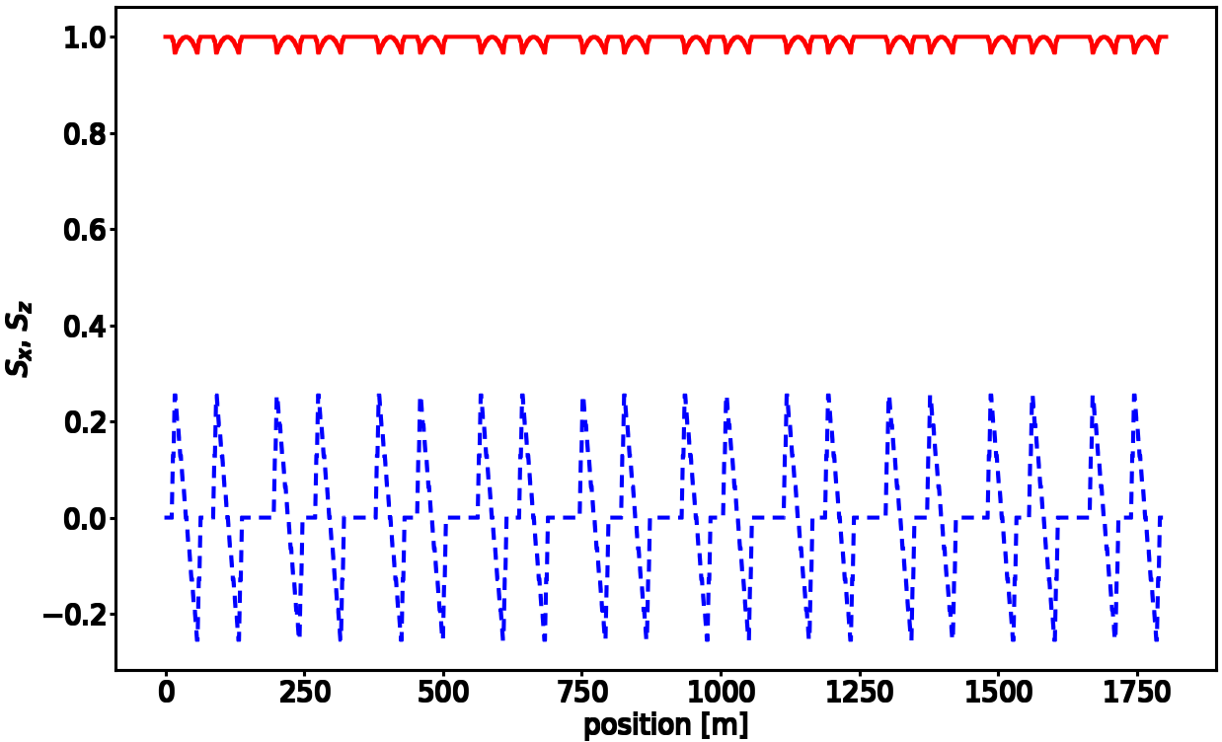
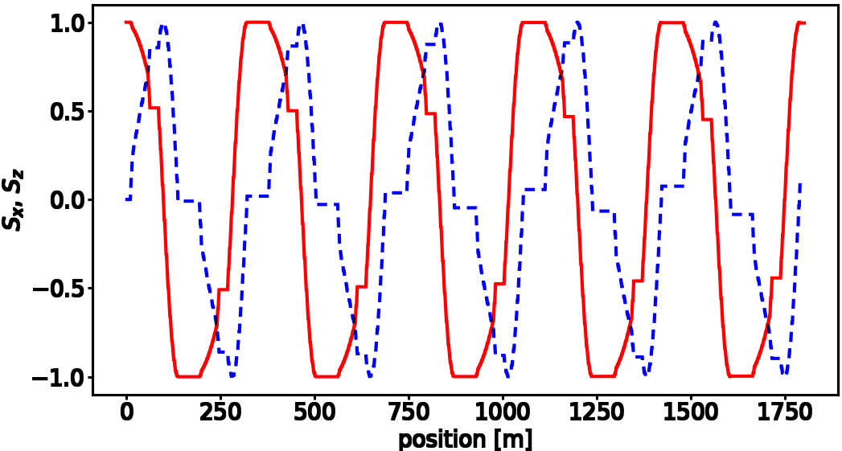
    - (b)
Fig. 1. (Color online) Spin components sx — blue dashed line and sy — red solid line for (a) symmetric field of Wien filters setting and (b) for asymmetric Wien filters fields.
For the symmetric setting it was found that for non-zero EDM, the ver- tical polarization increases linearly with time (see figure 2), while the effect of EQM interaction with field gradients averages to zero. The situation is reversed for some asymmetric Wien filter settings as shown in figure 2. For non-zero EQM value, sy spin component linearly increases with time, while EDM effect does not contribute.
376 A. Aggarwal, A. Magiera
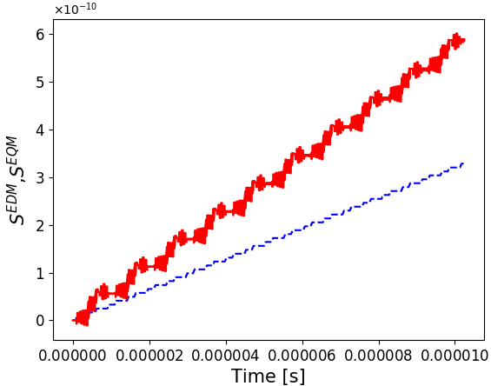
Fig. 2. (Color online) Comparison of vertical spin component for EDM effect (sym- metric field) — blue dashed line and for EQM effect (asymmetric field) — red solid line.
  - Results and conclusions
The results of [4] and of the present analysis demonstrate that MDM and EQM interaction with field gradients should be considered when analyzing the effects for very small EDM values. It was shown that these additional effects could be very useful for studying the systematic uncertainties in high precision EDM measurements. In the considered case, it was shown that for somewhat different Wien filter settings, EQM effect is by factor 1.78 larger than EDM effect for EDM value of 10−29 e cm. Therefore, reproducing EQM value within known accuracy could pin down the systematic uncertainty to 10−32 e cm. While here only consequences for one specific method of EDM measurement were considered, similar studies should be performed for other proposed methods. Hence, simulation codes should be modified with complete T-BMT equation and customized fields. Further plans are to introduce full three-dimensional customized fields [7] for all magnets.

REFERENCES
- F.J.M. Farley et al., Phys. Rev. Lett. 93, 052001 (2004).
- V. Anastassopoulos et al., Rev. Sci. Instrum. 87, 115116 (2016).
- A. Lehrach et al., Proc. of XIV Advanced Research Workshop on High Energy Spin Physics (DSPIN’11), 2011, p. 287.
- A. Magiera, Phys. Rev. Accel. Beams 20, 094001 (2017).
- Y. Senichev et al., Proc. 6th International Particle Accelerator Conference (IPAC’15), 2015, p. 213.
- https://www.classe.cornell.edu/bmad
- B.D. Muratori, J.K. Jones, A. Wolski, Phys. Rev. Accel. Beams 18, 064001 (2015).

