
International Journal of
Molecular Sciences

Article
Similarities in the General Chemical Composition
of Colon Cancer Cells and Their Microvesicles
Investigated by Spectroscopic Methods-Potential
Clinical Relevance
Joanna Depciuch 1 , Bartosz Klebowski1 , Małgorzata Stec 2, Rafał Szatanek 2,
Kazimierz Weglarczyk 2, Monika Baj-Krzyworzeka 2, Magdalena Parlinska-Wojtan ^
and Jarek Baran 2,ł
- Institute of Nuclear Physics Polish Academy of Sciences, PL-31-342 Krakow, Poland;
joanna.depciuch@ifj.edu.pl (J.D.); bartosz.klebowski@gmail.com (B.K.);
magdalena.parlinska@ifj.edu.pl (M.P.-W.)
- Department of Clinical Immunology, Institute of Pediatrics, Jagiellonian University Medical College,
PL-30-663 Krakow, Poland; malgorzata.stec@uj.edu.pl (M.S.); rafal.szatanek@uj.edu.pl (R.S.);
kazimierz.weglarczyk@uj.edu.pl (K.W.); mibaj@cyf-kr.edu.pl (M.B.-K.)
* Correspondence: mibaran@cyf-kr.edu.pl
©check for
updates
Abstract: Colon cancer constitutes 33% of all cancer cases in humans and the majority of
patients with metastatic colon cancer still have poor prognosis. An important role in cancer
development is the communication between cancer and normal cells. This may occur, among others,
through extracellular vesicles (including microvesicles) (MVs), which are being released by both types
of cells. MVs may regulate a diverse range of biological processes and are considered as useful cancer
biomarkers. Herein, we show that similarity in the general chemical composition between colon
cancer cells and their corresponding tumor-derived microvesicles (TMVs) does exist. These results
have been confirmed by spectroscopic methods for four colon cancer cell lines: HCT116, LoVo, SW480,
and SW620 differing in their aggressiveness/metastatic potential. Our results show that Raman
and Fourier Transform InfraRed (FTIR) analysis of the cell lines and their corresponding TMVs did
not differ significantly in the characterization of their chemical composition. However, hierarchical
cluster analysis of the data obtained by both of the methods revealed that only Raman spectroscopy
provides results that are in line with the molecular classification of colon cancer, thus having potential
clinical relevance.
Keywords: colon cancer; extracellular vesicles; tumor-derived microvesicles; FTIR spectroscopy;
FT-Raman spectroscopy; HCT116 cells; SW480 cells; SW620 cells; LoVo cells
1. Introduction
Colon cancer is one of the most common cancers worldwide and in the last 15 years, the number of
patients with this type of cancer has increased by 60% [1-3]. In cancer development, the communication
between cancer and normal cells plays a crucial role [4]. Recent studies have claimed that cells can
communicate with each other, among others, through the release of membrane-enclosed particles called
extracellular vesicles (EVs) [5-10]. EVs consist mainly of smaller exosomes and larger microvesicles
that can travel through the body fluids, thus conveying functional information to distant organs [11].
The release of EVs to the extracellular environment may occur either, upon the fusion of multivesicular
bodies (MVB) with the plasma membrane (exosomes) or by membrane budding (microvesicles) [12].
Int. J. Mol. Sci. 2020, 21,1826; doi:10.3390/ijms21051826
www.mdpi.com/journal/ijms
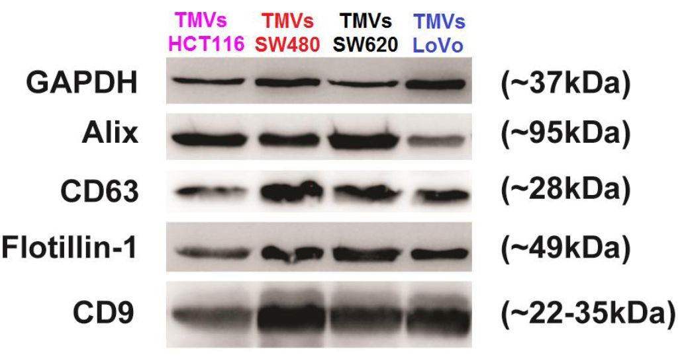
Int. J. Mol. Sci. 2020, 21,1826
2 of 18
As tumor-derived microvesicles (TMVs) are capable of transferring oncogenic proteins and nucleic
acids that modulate tire activity of recipient cells and play decisive roles in tumorigenesis, tumor
growth, progression, drug; resistance, and metastasis, there are expectations fhat they could be useful
cancer biomarkers [13-19]. Moaeover, chemically, TMVs consis t mainly of proteins and lipids, therefo re,
it is very important to know which proteins and lipids make up the; TMVs stcucture [p0]. Fotr prptein
analysis, usually the enzyme-lmked immunosorbent assays (ELISA), western blot, or mass were
performed, while for lipid composition evaluation, chromatography or mass spectroscopy were
used [2^22], These methods, however, are expensive and the data are lirmted to defining one fraction
only, (e.g., proteins, lipids, or nucleic acids).
In this study, by using Raman and FTIR spectroscopy, we determined the general chemical
composition of four colon cancer cell lmes: HCT116, LoVo, SW480, and SW620, whdch differ
in theis aggressiveness/metastatic potential [2r,2p]. In parallel, we analyzed TMVs released by
the correrponding parental cancer cells. We hypothesize th/at the chtmical composition of TMVs is
similar to the parental cells that release them, allowing [he TMVs to act as specific tumor messengers,
thus preparing the distant srgans foe metastases deve,o]tment.
- Results

2.1. Tumor-Derived Microvesicles (TMVs) Characterization
TMVs release. bp four colon aenacr ach lines HCTlló, LoVo, SW480, and SW620 were isolated
from culture supeme/en/s bp differential centriluge/ion. Cell lines differed in melignenap potentiel,
as HCT111 wrs described ea fast growing, SW480-having low metastatic ability, SW620-high metastatic
ability, end LoVo-undifferentiated [.5]. The holated TMVs were characTerized by western blot analysis
and, en shown in Figure 1-, TMVs frsm all colon cancer cell lines contained exosome and MV-associated
markers Alix, CD63, flotillin-1, and CD9 [2°].
Figure 1. Western blot analyeis of GAPDH, Alix:, CD63, Flotillin-o, CD9 expressien in TMVs collected
from HCTC16, LoVo, SW480, and SW620 cell lines. A totnl of 20 gg of the TMV protein -was used for
each- run. After SDS-PAGE separation and transfer of ths proteins ordo the polyvinylidene fluoride
membranes, the membranes were stained with mouse anti-Alix (3A9), rabbit anti-CD9 [D801A),
antiaFlotiUin-1 (D2V7J) mAbs, and rabbit polyclonal anti-CD63 Abs. As a lesading contrsl, rnbbit
anti-GAPDH Abs were used. Appropriate secondary Abs: goat anti-mouse and goat anti-rabbit
conjugated with horseradish peroxidasei followed by SuperSignal West Pica Chemiluminescence
Substrate Kit were used to visualize corresponding protein bands.
For the size distribution measurements, nanoparticle tracking analysis (NTA) was used. As shown
in Figure 2, the data indicate that a vast majority of the isolated TMVs consisted of EVs in the size range
of 120-400 nm, confirming their heterogeneous composition, which includes both exosomes and MVs.
Taken together, the size distribution and composition of protein markers support the presence of MVs,
according to the MISEV2018 guidelines ,27].
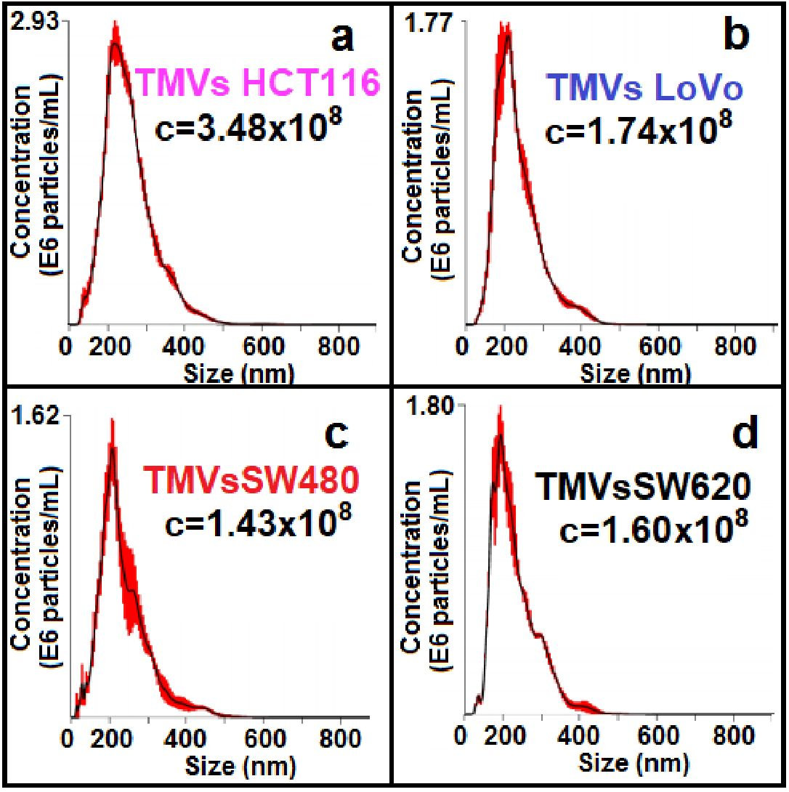
Int. J. Mol. Sci. 2020, 21,1826
3 of 18
Figure 2. Nanoparticle tracking analysis of size distribution and concentrations (number EVs/mL)
of TMVs coilected from HCT116 (a), LoVo (lb), SW480 (c), and SW620 (d) cell lines.

2.2. General Chemical Composition of the Colon Cancer Cell Lines and the Corresponding TMVs
By using two complementary spectroscopic techniques, FTIR and FT-Raman, the general chemical
composition of the four colon cancer cell lines and their corresponding TMVs was determined.
In the obtained FTIR (Figure 3) and Raman spectra (Figure 4), peaks specific for nucleic acids,
polysaccharides, proteins, lipids, water and other compounds making up the cellular and TMVs structures
were identified and described in Table 1. The quantitative (value of maximum absorbance) and qualitative
(shape of spectra, shift, or absence of maximum absorbance) differences between the respective cell lines
and their TMVs have been detected.
Comparing the respective cell lines and their TMVs, we observed similarities in the shape of
the spectra as well as in the values of maximum absorbance between the HCT116 (Figure 3a), LoVo
(Figure 3b), and SW620 (Figure 3d) cells and their corresponding TMVs in the Infrared (IR) range from
600 cm-1 to 3000 cm-1. In the case of TMVSW480 and SW480 cells (Figure 3c), differences in the maximum
absorbance values between 1500 cm-1 and 1700 cm-1 and between 2700 cm-1 and 3000 cm-1 were
noticed, however, the shape of the TMVs and cells spectra were similar. Moreover, when we compared
the FTIR spectra of the cell lines and TMVs collected from the respective cell lines, differences in
the shape of the spectra and values of maximum absorbance in the FTIR range between 3000 cm-1
and 3800 cm-1 were visible. Furthermore, the absence of peaks in the spectra of cell lines compared
to those of the corresponding TMVs were noticed. In the FTIR spectra of TMVhct116 and TMVsw480,
absence of peaks corresponding to C-O and CH3 asymmetric stretching from lipids were noticed in
comparison with the respective cell lines. The identified peaks for all the obtained spectra are presented
in detail in Table 1.
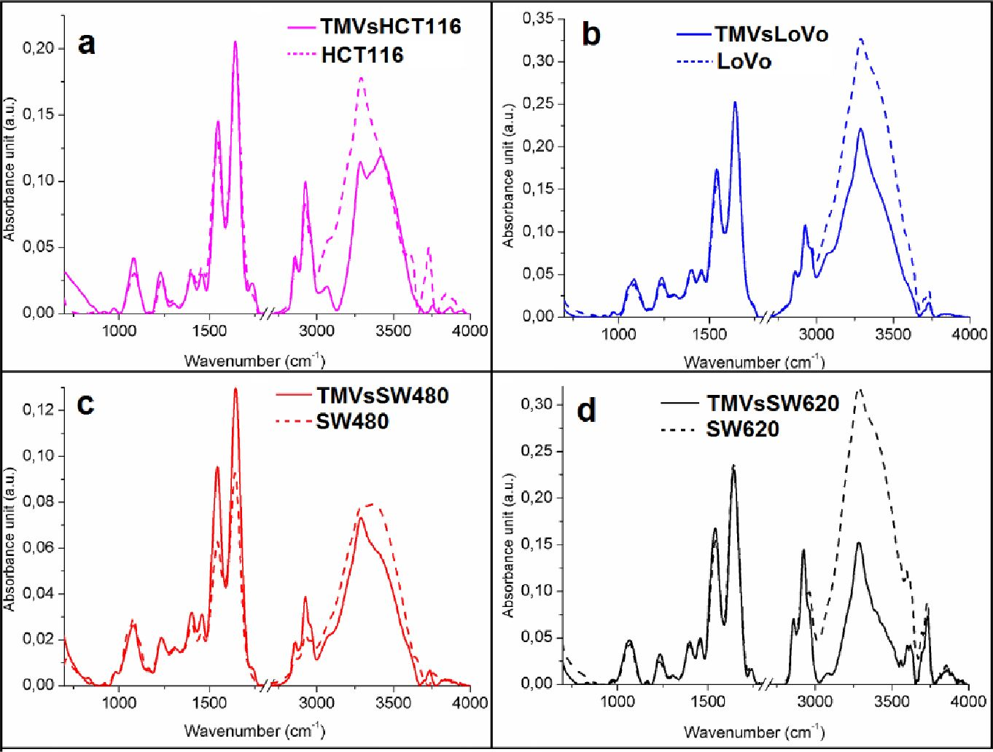
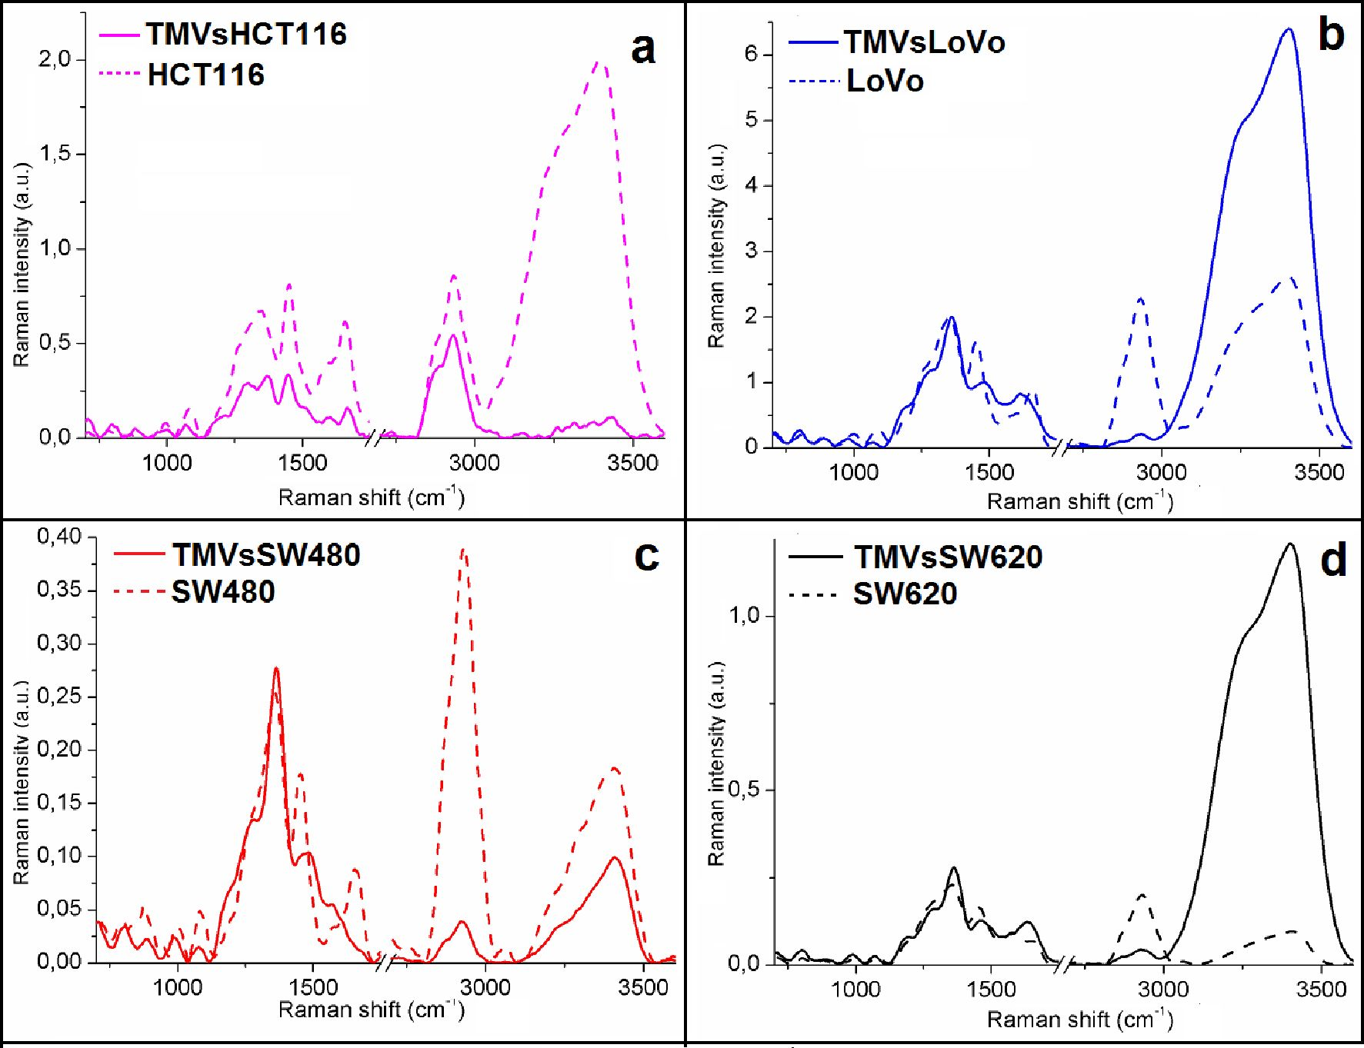
Int. J. Mol. Sci. 2020, 21,182(5
4 of 18
Figure 3. Offset FTIR spectra of: (a) HCT116; (b) LoVo; (c) SW480 and (d) SW620 cell lines (dashed
lines) and of: (a) TMVhct 116; (b) TMVloVC (c) TMVsw480 and (d) T1SW^62s\^620 (full lines).
Figure 4. Raman spectra of: (a) HCT116; (b) LoVo; (c) SW480 and (d) SW620 cell lines (dashed lines)
and of: (a) TMVhct116; (b) TMVloVo; (c) TMVsw480 and (d) TMVsw620 (full lines).
Int. J. Mol. Sci. 2020, 21,1826
5 of 18
Table 1. The Fourier Transform InfraRed (FTIR) and Raman peak positions in the analyzed cell line
and TMV samples with a description of the vibrations corresponding to the respective functional
groups [27-42].
FTIR Spectroscopy Peaks (cm 1)
HCT116 | tmvHCT116 | LoVo | TMVloVo | SW480 | TMVSW480 | SW620 | TMVSW620 | Vibrations
972 | 970 | 973 | 976 | 981 | 983 | 976 | 975 | PO3-2 group from DNA,  RNA and phospholipids [28]
1083 | 1083 | 1085 | 1081 | 1081 | 1080 | 1072 | 1067 | C-O group from glycogen [29]
1232 | 1237 | 1239 | 1238 | 1237 | 1236 | 1234 | 1238 | Amide III [30]
1302 | 1306 | 1307 | 1308 | 1309 | 1309 | 1309 | 1307 | CH2 group from protein [31,32]
1400 | 1403 | 1402 | 1404 | 1400 | 1402 | 1402 | 1401 | CH2 group from protein  and lipids [33,34]
1456 | 1457 | 1458 | 1457 | 1459 | 1458 | 1458 | 1458 | CH2 group from cholesterol [35]
1546 | 1544 | 1543 | 1547 | 1544 | 1544 | 1541 | 1542 | Amide II [32]
1643 | 1644 | 1646 | 1646 | 1646 | 1645 | 1645 | 1643 | Amide I [32]
1738 | Absent | Absent | Absent | Absent | 1731 | 1733 | 1741 | C-O group from lipids [34]
2858 | 2862 | 2861 | 2861 | 2860 | 2860 | 2860 | 2858 | Symmetric stretching vibrations  of CH2 [34]
2926 | 2923 | 2927 | 2928 | 2927 | 2926 | 2924 | 2925 | Asymmetric stretching vibrations  of CH2 [34]
3064 | Absent | 3075 | Absent | 2963 | Absent | Absent | Absent | CH3 asymmetric stretching [34]
3284 | 3290 | 3287 | 3294 | 3301 | 3284 | 3287 | 3284 | Amide A and OH group  from water [35]
Raman Spectroscopy Peaks (cm-1)
HCT116 | tmvHCT116 | LoVo | TMVloVo | SW480 | TMVSW480 | SW620 | TMVSW620 | Vibrations
1001 | 999 | 981 | 1000 | 988 | 987 | 986 | 984 | C-H in-plane bending mode  of phenylalanine [36]
1072 | 1080 | 1068 | 1083 | 1077 | 1080 | 1072 | 1072 | Glucose triglycerides, C-C (lipid)  [37,38]
Absent | Absent | Absent | Absent | 1280 | Absent | 1281 | 1284 | Amide III [39]
1301 | 1351 | 1291 | 1360 | 1362 | 1355 | 1362 | 1362 | CH3/CH2 twisting or bending  mode of lipid/collagen [40,41]
1450 | 1451 | 1481 | 1454 | 1479 | 1453 | 1461 | 1466 | Fatty acids, CH2  (lipids and proteins) [40,42]
1668 | 1658 | 1620 | 1657 | 1647 | 1654 | 1637 | 1635 | Amide I [43]
1784 | 1771 | 1761 | 1764 | 1786 | 1776 | Absent | Absent | C55O ester (lipids) [42]
Absent | Absent | Absent | 2700 | 2722 | 2728 | Absent | Absent | Stretching vibrations of CH, NH,  and OH groups [40]
2931 | 2933 | 2932 | 2931 | 2926 | 2929 | 2929 | 2926 | CH band of lipids [42]
3145 | Absent | Absent | Absent | Absent | Absent | 3124 | Absent | CH from cholesterol  and cholesterol ester [42]
The acquired Raman spectra showed differences in the intensity values as well as in the shape
of the spectra between the respective cell lines and TMVs released by them. In the spectra obtained
for the HCT116 cells, the Raman intensities in the analyzed range were higher than for their
TMVs (Figure 4a). Moreover, differences in the shape of the spectra, especially in the Raman
shift between 1250 cm-1 and 1450 cm-1 (protein functional groups range) and between 3000 cm-1
and 3500 cm-1, were noticed when we compared the TMVsHCTn6 and the HCT116 cell lines.
When comparing LoVo (Figure 4b) and SW620 (Figure 4d) cells with their TMVs, the Raman intensities
in the ranges between 800 cm-1-1400 cm-1 and 2700 cm-1-3000 cm-1 were higher for cells, while in
the ranges of 1400 cm-1-1700 cm-1 and 3000 cm-1-3500 cm-1 were higher for TMVs. In the case of
SW480 cells and their TMVs (Figure 4c), higher Raman intensities in all analyzed ranges were seen in
the spectrum of TMVSW480. Between LoVo and SW480 cells and their corresponding TMVs, we observed
differences in the shape of the spectra and peak shifts in the Raman range corresponding to protein
vibrations (1400-1700 cm-1). Moreover, in the Raman spectra of SW480 cells and TMVsw480, differences
in the shape of the spectra and peak shifts originating from DNA, phospholipids, and protein vibrations
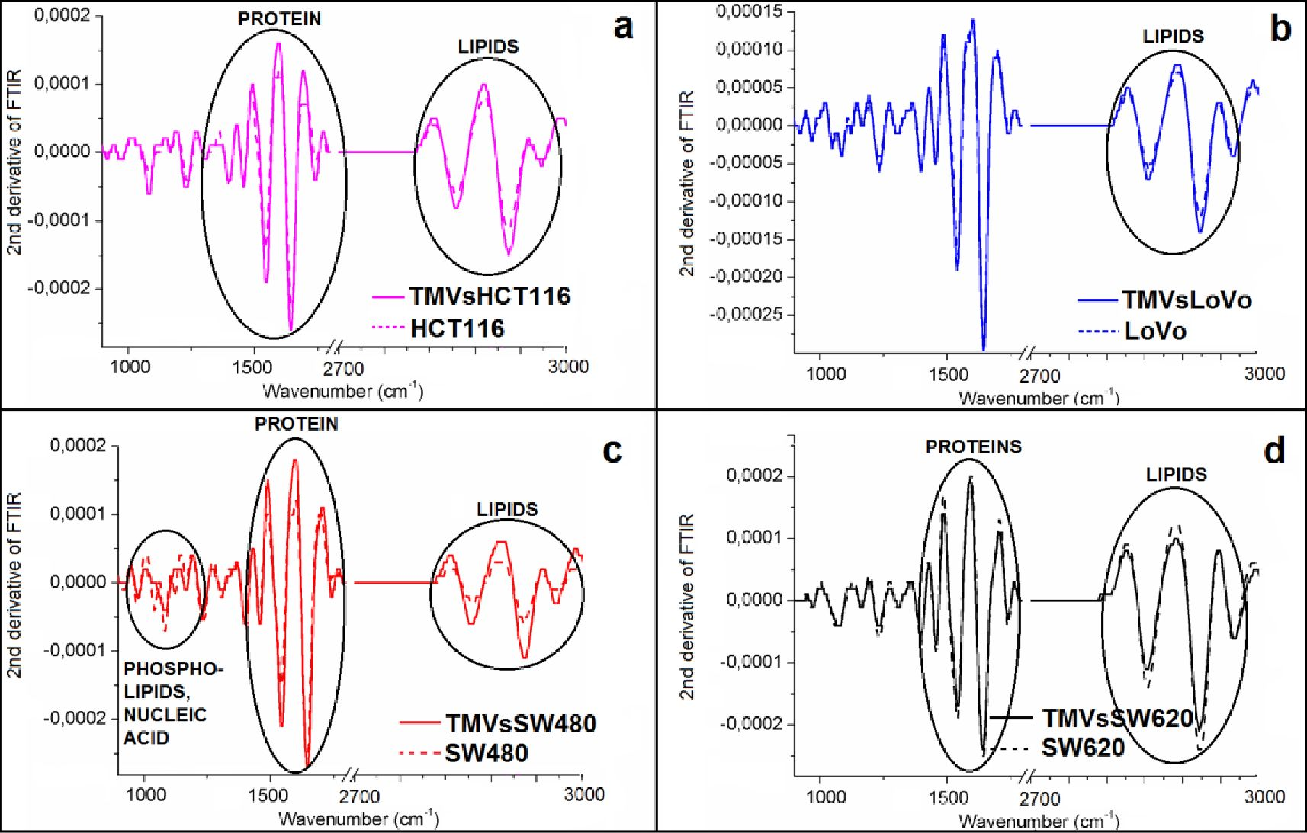
Int. J. Mol. Sci. 2020, 21, 1826
ii of 18
(800-1100 cm-1) were visible. Furthermore, in the Raman spectra of TMVhCtii6 and TMVsw620,
absence of the peak corresponding to tire C-Hgroups from cholesterol and cholesterol esOer were
noticed in comparison to their eespective cell lines. The peaks originating from thh stretching vibratiohe
of the CH, NH, and OH gsoupr were not; observed in the Raman epectrum of the LoVo cell lire in
comparison with the Raman speetrum of the TMVlovo. The identified peaks are described in detail in
Table 1 for all tihe obtained spectra.
To obtain information aeout the dihherences in the structure between cell lin es and ehe corre sponding
TMVsrelrased from them, the second derivative of the FTIR spectra was calculated (Figure S) . However,
we obtained the second derivative of the; FTIR spectta not for the entire IR range measured, but only
for the regions of nucleic acids and phospholipids (~900-1250 cm-1), proteins (-1250-1700 cm-1),
and eipid (-2700-3000 cm-1) vibrations, respectivety.
While comparing the respective cell lines and their TMVs, the most visible, however very
smatl, structural ehanges occurred in the IR region corresponding to lipid s. Changes in the protein
structure were also noticed, when the second derivatives of the FTIR spectra of the TMVshCtii6,
TMVsSW480, and TMVssW620 were compared with lhoee of their respective cell lines. Furthermore,
structural changes in the IR region corresponding to DNA and phospholipid functional group
vibrations were observed when we compared the second derivative of the FTIR spectra obtained
for the SW480 cell line and its respective TMVe. Indeed, it is well known that in the IR region
between 1700-1602 cm-1, there is a vibeation of tire (3=0 group, which participates ln the foemation
of mtramolecular and intermoleeular hydrogen bondr. In this case, the stretching vibrations of
the C=0 binds in the IR spettra are very sensitive to the formation and changes in the hydrogen
bonds between peptide groups [44,45]. Intramoleeular hydrogen bonds in the C=0 H-N group
form the a-helix conformation in proleins, wherers the intermolecular hydrogen bonds of the C=0
H-N group create ß-form or ß-sheet structures. For a-helix structures, the frequencies of the C=0
vibrational bands are in the range between 1660-1650 cm-1; for structures of the ß-form, the frequencies
are in the range between 1640-1620 cm-1, while for ß-sheet structures, it was 1670-1690 cm-1 [46].
To determine the detailed structural differences between HCT116, LoVo, SW480, and SW620 cell lines
Int. J. Mol. Sci. 2020, 21,1826
7 of 18
and their respective TMVs, we performed the analysis of the component bands, which was obtained
from the amide I FTIR region (1600-1700 cm-1). This analysis enabled the determination of the protein
secondary structure by quantifying the percentage of a-helix and ß-sheet structures.
Figure 6 shows seven component bands in HCT116, LoVo, SW480 cells, and six in the SW620
cells. In the case of the TMVs released from the SW480 and SW620 cells, respectively, the number of
component bands was the same as in the parental cells. However, in TMVhct116, one component band
less was detected than in the HCT116 cells. Moreover, when comparing LoVo cells and the TMVs
released by these cells, the TMVLoVo showed one component band less than the parental LoVo cells.
Additionally, the component band areas corresponding to the a and ß structures were different when
comparing cells with their TMVs. The peak area values, percentage, and ratio of a and ß secondary
protein structures obtained for the analyzed cell lines and their TMVs are described in Table 2.
Table 2. Value of peak areas, percentage, and ratio of a and ß secondary protein structures.
Sample | Peak Areas |  | Percentage [%] |  | a-Helix/ß-Harmonica Ratio
Sample | a-Helix | ß-Harmonica | a-Helix | ß-Harmonica | a-Helix/ß-Harmonica Ratio
HCT116 | 55.36 | 59.91 | 48.03 | 51.97 | 0.92
TMV HCT116 | 12.24 | 13.47 | 47.61 | 52.39 | 0.91
LoVo | 63.34 | 59.40 | 51.61 | 48.39 | 1.07
TMVloVo | 19.70 | 17.80 | 52.53 | 47.47 | 1.11
SW480 | 33.35 | 35.53 | 48.42 | 51.58 | 0.94
tMvSW480 | 33.99 | 34.45 | 49.67 | 50.33 | 0.99
SW620 | 40.78 | 63.42 | 39.14 | 60.86 | 0.64
tMvSW620 | 22.25 | 19.75 | 52.98 | 47.02 | 1.13
Similarity in the value of a and ß secondary protein ratio structures in tumor cell lines
and corresponding TMVs is presented. High similarities in the ratio of a-helix/ß-harmonica in
HCT116, LoVo, and SW480 cells and their corresponding TMVs have been detected. A similar trend
was also observed for the SW620 cells and corresponding TMVs, however, it was less significant.
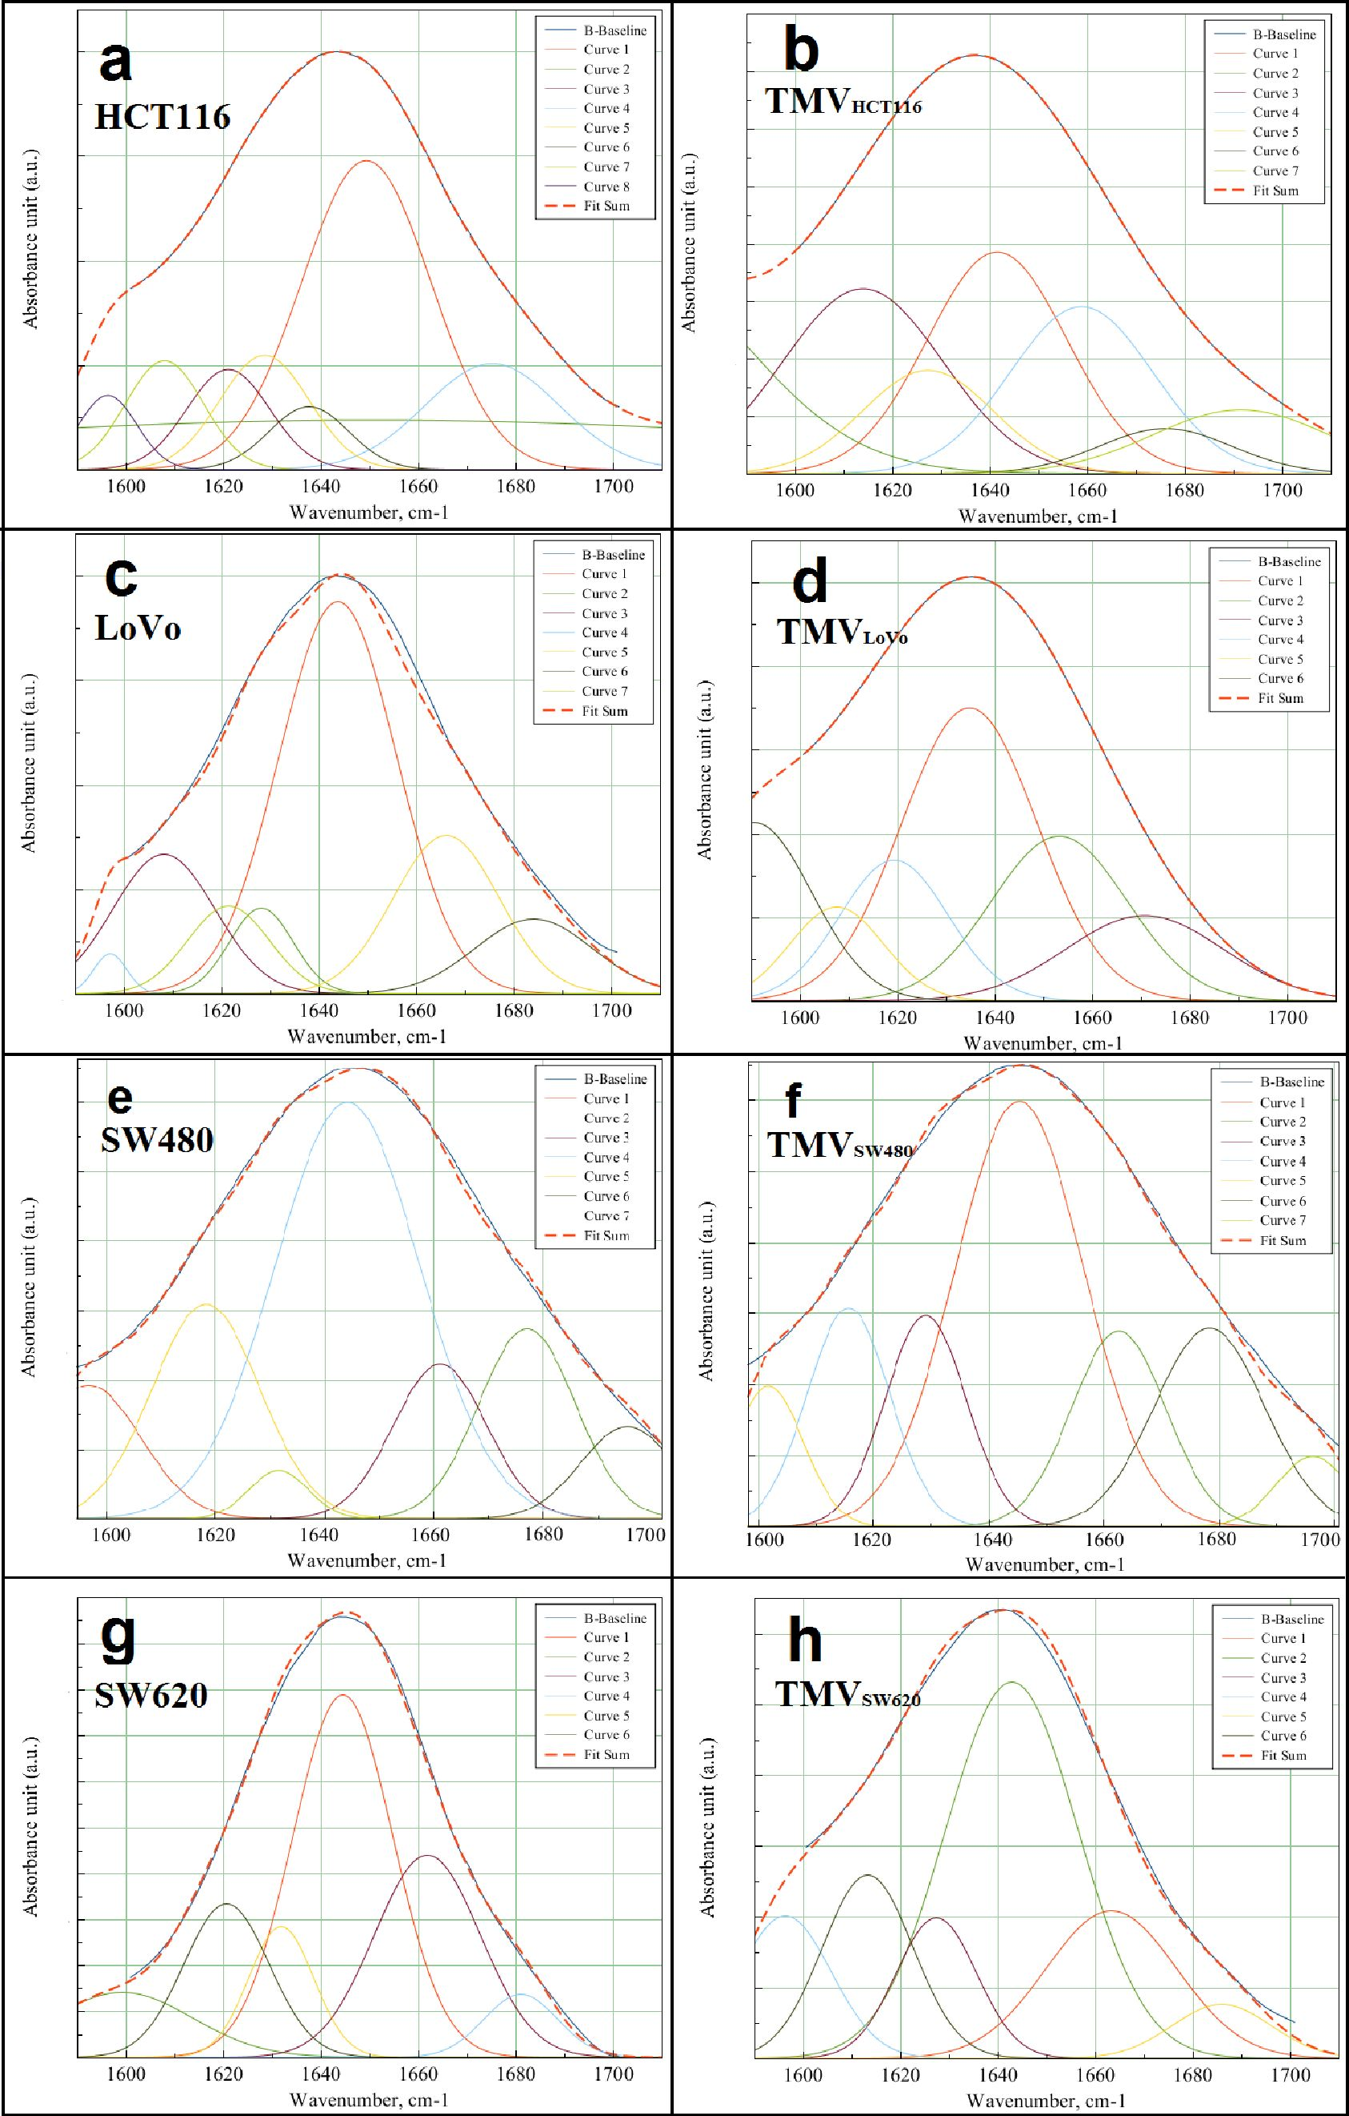
Int. J. Mol. Sci. 2020, 21,1826
8 of 18
Figure 6. Deconvolution of amide I FTIR region (1700-600 cm 1 ) obtained for cell lines: (a) HCT11 6;
(b) TMVhcT116; (c) LoVo; (d) TMVloVo; (e) SW480; (f) TMVsw480; (g) SW620 and (h) TMVsw620-
Curves 1-8 show the matched Gaussian functions and fit sum-results obtained by the matched
Gaussian functions.
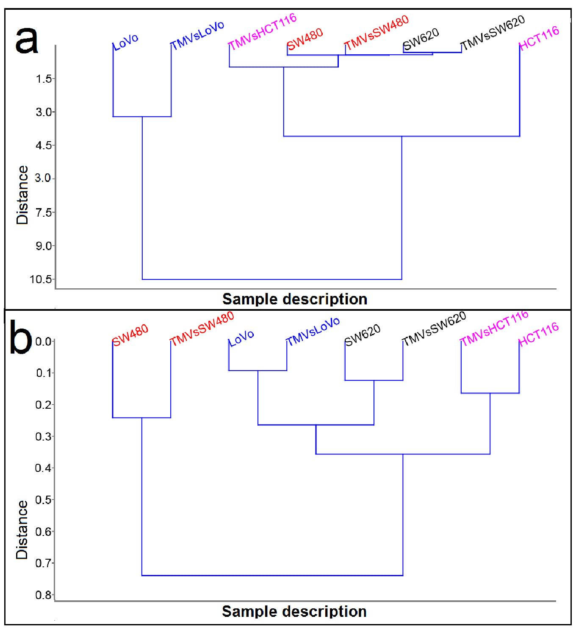
Int. J. Mol. Sci. 2020, 21,1826
9 of 18
  - Determination of Similarities Between TMVs and Cell Lines
To determine the similarities in the general chemical composition between the analyzed cell lines
and their TMVs, we performeO hierarchical cluster analysis (HCA) (Figureig.
Figure 7. Hierarchical cluster analysis (HCA) of HCT116, LoVo, SW480, and SW620 cell lines and their
corresponding, released TMVs from spectroscopy data: Raman (a) and FTIR (b).
Cluster analysis performed from the Raman (Figure 7a) and FTIR measurements (Figure 7b)
showed two main groups. However, depending on the methed, the components in these groups were
different. It is very interesting that for both Raman and FTIR spectroscopy, the TMVs were similar
to their respective ceh lines. Moreover, HCA analysis obtained from Raman data showed very high
similarities between the SW480 and SW620 cell lines and the TMVs collected from them (the lowest
value of Euclidean distance), while HCA analysis obtained from the FTIR data showed that SW620
cells and TMVSW620 were more similar to LoVo cells and TMVLoVo (Euclidean distance around 0.25).
When we compared Euclidean distance in HCA obtained for Raman and FTIR data, the lower value of
this parameter was in FTIR HCA analysis (Figure 7b), which means, that FTIR spectra of the measured
samples were more similar to each other than the Raman spectra. Moreover, the value of the Euclidean
distance (~10.5) for the LoVo cells and TMVlovo in HCA analysis for Raman suggest that the chemical
composition of these two samples was the most different to the other six samples.
To solve whether it is sufficient to detect only the differences between the studied colon cancer
cell lines and TMVs released by them, PCA was used to analyze the obtained Raman (Figure 8a)
and FTIR (Figure 8b) spectra. The Raman PCA plot showed no separation of the SW480, TMVSW480,
SW620, and TMVsw620. Consequently, it can be concluded that the SW480 and SW620 cells as well
as their corresponding TMVs are very similar to each other with respect to their chemical composition.
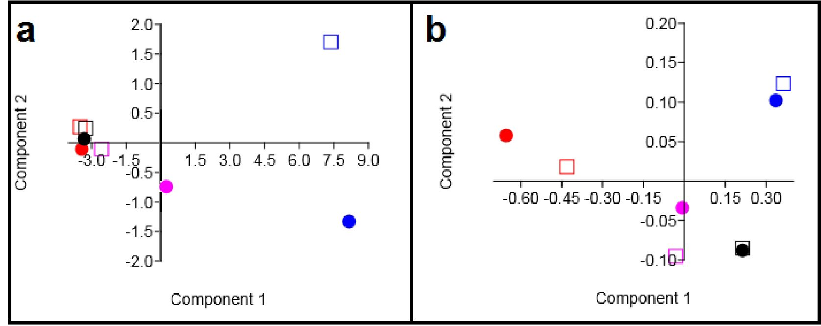
Int. J. Mol.. Sci. 2020, 21,1826
10 of 18
Moreover, PCA analysis of the Raman spectra showed that it will be very difficult: to distinguish
the HCT116 cells and the TMVs collected from this cell line. Can the other hand, PCA analysis obtained
from the FTIR spectra (Figure 8b) showed that: it ia not possible to distinguish the FTIR spectra of
all the analyzed cell lines and their corresponding TMVs. However, PCA analysis oMained from
the FTIR spectra showed that it is possible to detect chemical difference s among the HCT116, LoVo,
SW410, and SW620 cell lines as well as between the TMVs rig leased by them using; FTIR spectrosFopy.
The sensitivity of our results was between 85% and 99%, and the specificity wa s over 80% for mvee
than 9o% of cases. The respective sensitivities and epecifscitii^s for thd relevant PCA-LDA eesults ane
presented in Table a.
Table 3. Discriminant analysis results using PCA-LDA and leave-one-out cross validation to distinguish
between the obtained spectra.
Sensitivity  Specificity | HCT116 | tMv HCT116 | LoVo | TMVloVo | SW480 | TMV SW480 | SW620 | TMVSW620
HCT116 | 100% | 85% | 94% | 98% | 96% | 98% | 95% | 95%
HCT116 | 100% | 87% | 98% | 94% | 96% | 99% | 90% | 64%
tMvHCT116 | 85% | 100% | 93% | 92% | 87% | 89% | 90% | 96%
tMvHCT116 | 87% | 100% | 94% | 96% | 95% | 85% | 98% | 63%
LoVo | 94% | 93% | 100% | 89% | 92% | 93% | 93% | 98%
LoVo | 98% | 94% | 100% | 98% | 99% | 98% | 97% | 51%
TMVloVo | 98% | 92% | 89% | 100% | 96% | 97% | 85% | 99%
TMVloVo | 94% | 96% | 98% | 100% | 99% | 95% | 99% | 57%
SW480 | 96% | 87% | 92% | 96% | 100% | 96% | 96% | 98%
SW480 | 96% | 95% | 99% | 99% | 100% | 96% | 98% | 55%
tMvSW480 | 98% | 89% | 93% | 97% | 96% | 100% | 91% | 99%
tMvSW480 | 99% | 85% | 98% | 95% | 96% | 100% | 90% | 65%
SW620 | 95% | 90% | 93% | 85% | 96% | 91% | 100% | 97%
SW620 | 90% | 98% | 97% | 99% | 98% | 90% | 100% | 68%
TMVSW620 | 95% | 96% | 98% | 99% | 98% | 99% | 97% | 100%
TMVSW620 | 64% | 63% | 51% | 57% | 55% | 65% | 68% | 100%
Int. J. Mol. Sci. 2020, 21,1826
11 of 18

3. Discussion
TMVs play a crucial role in the communication between the tumor and its microenvironment,
promoting tumor progression, and metastasis formation. However, the exact mechanism involving
TMVs in these processes is still unknown. In the current study, the general chemical composition
of TMVs and their parental cells was analyzed by FTIR and Raman spectroscopy, which, to our
best knowledge, has never been done before. Moreover, the size distribution of the isolated TMVs
was measured by NTA, revealing their heterogeneous size range (120-400 nm), which showed that
the samples included both exosomes and MVs. This heterogenic composition was further confirmed
by western blot analysis and the expression of proteins characteristic for both exosomes and MVs.
The FTIR and Raman spectra of the HCT116 (Figures 3 and 4, violet spectra), LoVo (Figures 3 and 4,
blue spectra), SW480 cells (Figures 3 and 4, red spectra), and SW620 (Figures 3 and 4, black spectra)
showed similarities between the general chemical composition of the cells and the corresponding
TMVs. In addition, the a-helix to ß-harmonica ratios (Table 2) confirmed even further similarities
between the cancer cells and their TMVs. These results are of relevance as deconvolution of the amide
I region in the FTIR spectra (Figure 6) allowed us to obtain information on the secondary structure of
the whole protein. Consequently, our results showed that the TMVs released from individual cells
have very similar components of proteins, which could be useful in the identification of their molecular
subtypes. In addition, different numbers of components, in particular for SW620 cells and TMVSW620
and differences in the a-helix/ß-harmonica ratio were observed. This may be related to the type of
the tested protein in the solution, its concentration, solution pH, or solvent [47]. The solvent (water)
and pH of the solution were the same for each sample tested. Therefore, the differences in the number
of the obtained component bands or in the a-helix/ß-harmonica ratio can be interpreted as changes in
the composition of the protein fraction and its concentration.
Interestingly, in the HCA analysis (Figure 7), we found that the created similarity groups were
different when generated from the Raman or FTIR spectra. Additionally, the PCA analysis obtained
from the Raman and FTIR measurements (Figure 8) showed different possibilities for distinguishing
the TMVs and their respective cell lines. The reason could be the difference in the physical principles of
both techniques: IR requires the change of the dipole moment, whilst Raman relies on the change of bond
polarity [48,49]. On the other hand, for an IR detectable transition, the molecule must undergo dipole
moment change during vibration. So, when a molecule is symmetrical (e.g., O2), we cannot observe
any IR absorption lines since the molecule cannot change its dipole moment. It has been observed
that molecules with a strong dipole moment are typically hard to polarize [50,51]. Additionally, FTIR
spectroscopy is very sensitive to the presence of water and may induce a background in the obtained
spectra, which in turn may have an impact on the reliability of measurements. As biological samples
consist mainly of water, our results indicate that Raman spectroscopy may be a more adequate
and thus more reliable spectroscopic method for biological samples. These differences underlying
the principles of each method may consequently lead to changes in the intensity of the functional
groups measured in the same sample, depending on the method used. Consequently, when we used
Raman/FTIR spectra for the statistical analysis, we could observe differences between the results
obtained for Raman and FTIR spectroscopy (Figures 7 and 8). Moreover, FTIR spectroscopy is sensitive
to hetero-nuclear functional group vibrations and polar bonds, especially OH stretching in water.
Raman, on the other hand, is sensitive to homo-nuclear molecular bonds. For example, using Raman
spectroscopy, C-C, C=C, and C=C bonds can be distinguished. Therefore, molecules that cannot be
detected by one method can be easily detected by the other. This is another reason why we noticed
differences in the PCA and HCA analysis for Raman and FTIR spectra. This different physical
background of the measurement principle had no significant influence on the fact that Raman and FTIR
spectroscopy showed similarities in the chemical composition between cell lines and corresponding
TMVs. In the case of HCT116 cells and their corresponding TMVs, we think that the number of
functional groups, which can change polarization after laser irradiation (source of the electromagnetic
Int. J. Mol. Sci. 2020, 21,1826
12 of 18
wave in Raman spectrometer), is probably different for HCT116 cells and TMVhct116, which could
result in the observed distance between the cells and TMVs in the HCA analysis.
Moreover, in the obtained spectra, some vibration peaks were absent while the peaks corresponding
to functional groups within the measured samples have been identified. Therefore, using these two
complementary methods, a whole chemical structure of analyzed samples was obtained. Differences
in the peak-shifts as well as the absence of some peaks were observed in Figures 3 and 4 document
the differences in the chemical composition between analyzed samples.
The two isogenic colorectal cancer SW480 and SW620 cell lines were derived from the same
patient, the first originating from the primary tumor, whereas the latter was from a metastatic lesion to
the lymph node, therefore similarities between these cells and their corresponding TMVs could be
expected, as evidenced by several papers [52-55]. In this study, we observed a chemical composition
similarity between the SW480 and SW620 cell lines and TMVs collected from them (Figures 7a and 8a).
In the study by Ji et al., the authors examined the protein profiles of exosomes isolated from both
the primary (SW480) and metastatic (SW620) human colorectal tumor cells [52]. Based on their
findings, the authors concluded that the exosomes obtained from the two cell lines had 628 proteins in
common and that 313 and 168 proteins were unique for the SW480 and SW620 exosomes, respectively.
The authors also showed a selective enrichment of key metastatic factors and signal transduction
molecules in exosomes derived from the SW620 tumor cells as compared to the ones isolated from
SW480 tumor cells. The data presented in this report corroborate those from Ji's paper; however,
our study focused on the whole population of TMVs (exosomes and MVs), and not just exosomes,
which was the case in Ji's group. Moreover, the FTIR and Raman data represent the identification of
the overall functional groups present in the colorectal cancer cells (HTC116, LoVo, SW480, SW620)
and their respective TMVs, which may generate different results than protein profiling only. The recent
identification of four consensus molecular subtypes (CMS) of colon cancer with distinguishing
features has provided evidence that the expression subtypes have clinical relevance independent of
cancer stage [53,56]. According to this classification, Berg et al., in a very elegant study, analyzed
34 colorectal cancer cell lines by multi-level data integration including targeted deep sequencing,
DNA copy numbers, gene expression, microRNA (miRNA) expression, and protein expression [57].
In their study, eight cell lines were classified as CMS1-"immune", nine as CMS2-"canonical", six as
CMS3-"metabolic", and 10 as CMS4-"mesenchymal". One cell line, derived from a neuroendocrine
tumor, had a distinct gene expression profile [58]. They also used the PCA to classify the cell lines,
taking into account the PC1 from mRNA expression data to single-sample gene set enrichment
analysis (ssGSEA). Using this approach, they classified the cell lines with low PC1/high ssGSEA score
as colon-like (mainly CMS2 and CMS3 subtype, with higher levels of gastro-intestinal marker genes)
and undifferentiated (mainly CMS1 and CMS4 subtype, having higher epithelial-to-mesenchymal
transition (EMT) signature score and increased expression of TGFß induced genes). This was further
confirmed by differential mRNA, miRNA, and protein expression analysis. All of the cell lines used in
our study were classified in Berg's report as undifferentiated, and three out of four (HCT116, SW480,
and SW620) were classified as the CMS4 subtype. Only Lovo cells belonged to the CMS1 group.
This molecular classification was fully reflected by the Raman spectroscopic analysis of cancer cells
and their TMVs as performed in our study (Figure 7).
On the other hand, Pablo et al. used Raman spectroscopy to distinguish different colon cancer cell
types including SW480 and SW620. They showed that these two cell lines could be distinguished by
ratio of a: ß secondary protein structure. Furthermore, the PCA-LDA analysis showed that by using
this approach, it is possible to distinguish different types of colon cancer cell lines with an accuracy
of 92.4 ± 0.4% [59]. These results correspond with the results obtained in our work. Additionally,
in our study, a significant difference in the a:ß ratio between the SW480 and SW620 cells was observed
(Table 2). In addition, the PCA-LDA analysis showed very high probability for the distinction of
different colon cancer types (Table 3).
Int. J. Mol. Sci. 2020, 21,1826
13 of 18
To summarize, in this report, through the use of FTIR and Raman spectroscopy, we showed
that the chemical composition of TMVs is similar to the composition of the cells from which they are
released. We suggest that Raman as well as FTIR spectroscopies could find a potential application for
the first rapid chemical identification of circulating TMVs, reflecting the composition of their parental
cancer cells. It seems however, that only the data obtained from the Raman analysis were in line with
the molecular classification of colon cancer, having thus a potential clinical relevance. Further studies
involving other tumor cell lines and their respective TMVs using Raman and FTIR spectroscopies
would provide additional information on the usefulness of these methods, which could potentially
translate into the clinical setting (i.e., tumor metastasis, formation of metastatic niche).

4. Materials and Methods
  - Cell Culture
Colon cancer cell lines (LoVo, SW480, and SW620) were obtained courtesy of Prof. Caroline Dive,
Paterson Institute for Cancer Research, University of Manchester. Human colon carcinoma cell line
HCT116 was obtained from the American Type Culture Collection (ATCC, Manassas, VA, USA)
and maintained according to the ATCC's instructions. Briefly, HCT116 cells were cultured in McCoy's
5A medium (Gibco, Paisley, UK), while LoVo, SW480, and SW620 cells were cultured in Dulbecco's
Modified Eagle Medium (DMEM) with high glucose content (Corning™, Corning, NY, USA) in a 37 °C
humidified atmosphere with 5% CO2. All media were supplemented with 10% fetal bovine serum (FBS,
Biowest, Nuaille, France) and gentamicin (50 gg/mL), (PAN-Biotech, Aidenbach, Germany). The cells
were cultured by bi-weekly passages and regularly tested for Mycoplasma sp. contamination with
the PCR-ELISA kit (Roche, Mannheim, Germany), according to the manufacturers' instructions.
  - Isolation of TMVs
Supernatants from well-grown cell cultures were collected, centrifuged at 2000X g for 20 min to
remove cell debris and then centrifuged again at 50,000x g (RC28S, Sorvall, Newton, CT, USA) for 1 h
at 4 °C. Pellets were washed twice in PBS to remove FBS and finally re-suspended in serum-free medium.
Quantification of TMVs proteins was evaluated by the Bradford method (BioRad, Hercules, CA, USA).
TMVs were tested for endotoxin contamination by the Limulus test, according to the manufacturer's
instruction (Charles River Laboratories, Inc., Wilmington, MA, USA) and stored at -20 °C until use.
To simplify, TMVs were named according to their cell line of origin (e.g., TMVs released from HCT116
as TMVhct116, from LoVo-TMVLoVo, from SW480-TMVSW480, and from SW620 as TMVSW620.
  - Western Blotting
To assess the presence of different EVs markers in TMVs, the western blotting technique was
employed. TMVs were suspended in M-PER lysing buffer (Pierce, Rockford, IL, USA) containing
the protease inhibitor cocktail (Roche). The concentration of samples was measured using the Bradford
kit (Bio-Rad) as per the manufacturer's instructions. A total of 20 gg of suspended TMVs was
mixed with NuPAGE LDS Sample Buffer (4x) and NuPAGE Sample Reducing Agent (10x) (both Life
Technologies, Carlsbad, CA, USA). Samples were heated (70 °C, 10 min) and electrophoresed in 12%
polyacrylamide gel containing sodium dodecyl sulfate (SDS). Next, electrophoresed samples were
transferred onto the polyvinylidene fluoride membrane (PVDF, Bio-Rad). Then, after blocking for 1 h
at room temperature in Tris buffered saline (TBS) with 0.1% Tween-20 (Sigma, St. Louis, MO, USA)
and 1% bovine serum albumin (BSA, Sigma), the membranes were incubated overnight at 4 °C with
mouse mAb anti-Alix (3A9), rabbit mAb anti-CD9 (D801A), and anti-Flotillin-1 (D2V7J) (all from
Cell Signaling, Beverly, MA, USA) diluted 1:1000 as well as rabbit polyclonal Ab anti-CD63 (SIGMA)
diluted 1:2000. As a loading control, rabbit anti-GAPDH antibodies (Cell Signaling) diluted 1:5000 were
used. After incubation, the membranes were washed in TBS supplemented with BSA and Tween-20
and incubated for 1 h in room temperature with appropriate secondary antibody: goat anti-mouse
Int. J. Mol. Sci. 2020, 21,1826
14 of 18
and goat anti-rabbit (al secondary antibodies were used in dilution 1:2500) conjugated with horseradish
peroxidase (Santa Cruz Biotechnology). The protein bands were visualized with the SuperSignal West
Pico Chemiluminescence Substrate kit (Pierce), according to the manufacturer's protocol and analyzed
with ChemiDoc system (Bio-Rad).
  - Nanoparticle Tracking Analysis (NTA)
Average, modal size, and size distribution of the TMVs were obtained using the NAN0SIGHT
LM10-HS488FT14 Nanoparticle Characterization System (Malvern Instruments, Malvern, UK). Briefly,
1 pL of the TMV suspension was diluted 1000X in filtered (0.22 pm) PBS to obtain the total sample volume
of 1 mL. Next, approximately 700 pL of the sample was loaded manually into the measuring chamber
using an insulin-type syringe, after which the syringe was mounted onto the pump and the sample
was delivered at a constant flow rate of 80 units. Next, three one-minute videos were recorded by
the sCM0S camera for each sample and used later for analysis using the NanoSight NTA 3.0 analytical
software (Malvern Instruments).
  - Cell and TMVs Preparation for Fourier Transrorm IntraRed (FTIR) and-Raman Measurements
For FTIR and FT-Raman spectrum acquisition, cells in the concentration 108 cell/mL were
centrifuged for 5 min at 3000 rpm. Subsequently, the cells were washed three times in isotonic solution
(NaCl, 0.9%) to ensure complete removal of trypsin and culture medium. Next, dense cell suspensions
were placed onto an attenuated total reflection (ATR) crystal (FTIR spectroscopy) or CaF2 slides
(Raman spectroscopy).
  - FTIR Spectroscopy
All measurements were carried out on an EXCALIBUR FTS-3000 spectrometer (Bio-Rad,
Digilab, UK) at room temperature. All spectra were recorded by attenuated total reflection (ATR) with
a ZnSn crystal. A total of 0.5 mL of cell containing solution was deposited on the ATR ZnSn crystal.
FTIR spectra were recorded between 4000 and 500 cm-1. Each spectrum was obtained by averaging 64
scans recorded at a resolution of 4 cm-1. For statistical validation, three samples for each of the cell
lines were measured. Moreover, each sample was measured three times. Baseline correction and vector
normalization of the obtained spectra were performed using 0PUS 7.0 software (Bruker 0ptik GmbH,
Ettlingen, Germany).
  - FT-Raman Spectroscopy
FT-Raman spectra were recorded using a NicoletNXR 9650 FT-Raman spectrometer (Thermo Fisher
Scientific, USA) equipped with an Nd:YAG laser (1064 nm) and a germanium detector. Measurements
were performed in the range from 150 to 3.700 cm-1 with a laser power of 1 W. Unfocused laser beam
was used with a diameter of approximately 100 pm and a spectral resolution of 8 cm-1. Raman spectra
were processed by the 0mnic/Thermo Scientific software based on 128 scans. The obtained spectra
were normalized using vector normalization in 0PUS 7.0 software (Bruker 0ptik GmbH, Ettlingen,
Germany). Moreover, each spectrum was smoothed using the Savitzky-Golay algorithm. The number
of smoothing points was nine.
  - Deconvolution of Amide I Region (1600-1700 cm-1)
The secondary protein structure was analyzed by means of curve fitting using MagicPlot software
(Magicplot Systems, Saint Petersburg, Russia). First, the second derivative spectra were calculated based
on the ATR-FTIR spectra to determine the initial peak positioning for the curve fitting. The peaks were
fitted using a Gaussian function and the area under the curve was considered at 100%. Each component
was expressed as its percentage after fitting.
Int. J. Mol. Sci. 2020, 21,1826
15 of 18
  - Data Analysis
For all obtained spectra, vector normalization and baseline correction were applied.
These operations were performed using OPUS 7.0 software. Moreover, in each FTIR as well as Raman
spectrum, vibrations corresponding to nucleic acid, phospholipids, proteins, and lipids were analyzed.
The number of obtained data from FTIR and Raman spectra was very large, therefore, to determine
the similarity between the cancer and control cells, principal component analysis-linear discriminate
analysis (PCA-LDA) was performed. First, PCA was undertaken, which reduced the dimensionality
and the number of data variables, while maintaining as much variance as possible. Next, with
the use of the LDA method, a suitable model for grouping data based on independent variables
(wavelengths) was developed. Then, the PCA-LDA procedure was performed based on the selected
spectral regions: between 1250 cm-1-1700 cm-1 and between 2700 cm-1-3000 cm-1. PCA-LDA results
had been verified by the leave-one-sample out cross-validated method, which involves leaving all
spectra from a single sample out of the model once before assessing performance. This analysis
was done using the OriginPro 2015 software (OriginLab Co.; Northampton, MA, USA). Moreover,
to determine similarities between HCT116, LoVo, SW480, SW620 cell lines, hierarchical cluster analysis
(HCA) with Euclidean distance was performed in Past software (developed by Oyvind Hammer).
HCA analysis was done for the fingerprint region (between 800 cm-1 and 1800 cm-1) for both
the Raman and FTIR spectra of the cells and TMVs. For this purpose, 518 points from the FTIR spectra
and 259 points from the Raman spectra were analyzed using the paired group (UPGMA) algorithm.
Author Contributions: Conceptualization, J.D., M.B.-K., M.P.-W., and J.B.; Investigation and formal analysis,
J.D., R.S., and K.W.; Resources, B.K. and M.S.; Writing—original draft preparation, J.D., R.S., and M.B.-K.;
Writing—review and editing, M.P.-W., M.B.-K., and J.B.; Project administration, J.D.; Funding acquisition, J.B.
All authors have read and agreed to the published version of the manuscript.
Funding: Financial support by "Pik-Instruments" is greatly acknowledged. Publication of this article was
supported by the European Commission of the H2020-MSCA-RISE-2017 award through the CANCER project
(No. 777682) to J.B., B.K. acknowledges support of InterDokMed, project no. POWR.03.02.00-00-I013/16.
Acknowledgments: Monika Kula is acknowledged for the use of the Raman instrument located at the Polish
Academy of Sciences, The Franciszek Górski Institute of Plant Physiology. Ewa Juszyńska-Gałązka from
the Department of Soft Matter Research, Institute of Nuclear Physics Polish Academy of Sciences, is acknowledged
for her help in the FTIR measurements.
Conflicts of Interest: The authors declare no conflicts of interest.
Abbreviations
MDPI Multidisciplinary Digital Publishing Institute
DOAJ Directory of open access journals
TLA Three letter acronym
LD linear dichroism
References
- Rawla, P.; Sunkara, T.; Barsouk, A. Epidemiology of colorectal cancer: Incidence, mortality, survival, and risk
factors. Prz. Gastroenterol. 2019,14, 89-103. [CrossRef] [PubMed]
- Ewing, I.; Hurley, J.J.; Josephides, E.; Millar, A. The molecular genetics of colorectal cancer.
Frontline Gastroenterol. 2014, 5, 26-30. [CrossRef] [PubMed]
- Freddie, B.; Jacques, F.; Soerjomataram, I.; Siegel, R.L.; Torre, L.A.; Jemal, A. Global cancer statistics 2018:
GLOBOCAN estimates of incidence and mortality worldwide for 36 cancers in 185 countries. CA Cancer J.
Clin. 2018, 68, 394-424.
- Singh, A.B.; Harris, R.C. Autocrine, paracrine an juxtacrine signalling by EGFR ligands. Cell Signal. 2005,
17,1183-1193. [CrossRef] [PubMed]
- Al-Nedawi, K.; Meehan, B.; Rak, J. Microvesicles: Messengers and mediators of tumor progression. Cell Cycle
2009, 8, 2014-2018. [CrossRef]
Int. J. Mol. Sci. 2020, 21,1826
16 of 18
- Cocucci, E.; Racchetti, G.; Meldolesi, J. Shedding microveiscles: Artefacts no more. Trends Cell Biol. 2009,
19,43-51. [CrossRef]
- Gould, S.J.; Raposo, G. As we wait: Coping with an imperfect nomenclature for extracellular vesicles.
J. Extracell. Vesicles 2013, 2, 20389. [CrossRef]
- Mathivanan, S.; Ji, H.; Simpson, R.J. Exosomes: Extracellular organelles important in intracellular
communication. J. Proteomics 2010, 73,1907-1920. [CrossRef]
- Tetta, C.; Ghigo, E.; Silengo, L.; Deregibus, M.C.; Camussi, G. Extracellular vesicles as an emerging mechanism
of cell-to-cell communication. Endocrine 2013, 44,11-19. [CrossRef]
- Turturici, G.; Tinnirello, R.; Sconzo, G.; Geraci, F. Extracellular membrane vesicles as a mechanism of cell-to-cell
communication: Advantages and disadvantages. Am. J. Physiol. Cell Physiol. 2014,306, C621-C633. [CrossRef]
- Peinado, H.; Aleckowic, M.; Lavotshkin, S.; Matei, I.; Costa-Silva, B.; Moreno-Bueno, G.; Herqueta-Redono, M.;
Williams, C.; Garcia-Santos, G.; Ghajar, C.; et al. Melanoma exosomes educate bone marrow progenitor cells
toward a pro-metastatic phenotype through MET. Nat. Med. 2012,18, 883-891. [CrossRef] [PubMed]
- Bobrie, A.; Colombo, M.; Raposo, G.; Thery, C. Exosome secretion: Molecular mechanisms and roles in
immune responses. Traffic 2011,12,1659-1668. [CrossRef] [PubMed]
- Delabranche, X.; Berger, A.; Boisrame-Helms, J.; Meziani, F. Microparticles and infectious diseases. Med. Mal.
Infect. 2013, 42, 335-343. [CrossRef] [PubMed]
- Schneider, A.; Simons, M. Exosomes: Vesicular carriers for intracellular communication in neurodegenerative
disorders. Cell Tissue Res. 2013, 352, 33-47. [CrossRef] [PubMed]
- Shiromizu, T.; Kume, H.; Ishida, M.; Adachi, J.; Kano, M.; Matsubara, H.; Tomonaga, T. Quantitation of
putative colorectal cancer biomarker candidates in serum extracellular vesicles by targeted proteomics.
Sci. Rep. 2017, 7,12782.
- Gallart-Palau, X.; Serra, A.; Wong, A.S.; Sandin, S.; Lai, M.K.; Chen, C.P.; Kon, 0.L.; Sze, S.K. Extracellular
vesicles are rapidly purified from human plasma by Protein 0rganic Solvent PRecipitation (PR0SPR). Sci. Rep.
- 30,14664. [CrossRef] [PubMed]
- Baran, J.; Baj-Krzyworzeka, M.; Weglarczyk, K.; Szatanek, R.; Zembala, M.; Barbasz, J.; Czupryna, A.;
Szczepanik, A.; Zembala, M. Circulating tumour-derived microvesicles in plasma of gastric cancer patients.
Cancer Immunol. Immunother. 2010, 59, 841-850. [CrossRef]
- Hon, K.W.; Abu, N.; Ab Mutalib, N.S.; Jamal, R. Exosomes as potential biomarkers and targeted therapy in
colorectal cancer: A mini-review. Front. Pharmacol. 2017, 8, 583. [CrossRef]
- Lee, B.R.; Kim, J.H.; Choi, E.S.; Cho, J.H.; Kim, E. Effect of young exosomes injected in aged mice. Int. J.
Nanomed. 2018,13, 5335-5345. [CrossRef]
- Suchorska, W.M.; Lach, M.S. The role of exosomes in tumor progression and metastasis (review). Oncol. Rep.
- 35,1237-1244. [CrossRef]
- Luo, D.; Zhan, S.; Xia, W.; Huang, L.; Ge, W.; Wang, T. Proteomics study of serum exosomes from papillary
thyroid cancer patients. Endocr. Relat. Cancer. 2018, 25,879-891. [CrossRef] [PubMed]
- Skotland, T.; Sandvig, K.; Llorente, A. Lipids in exosomes: Current knowledge and the way forward.
Prog. Lipid Res. 2017, 66, 30-41. [CrossRef] [PubMed]
- Herzberg, G. Molecular Spectra and Molecular Structure. Part II. Infrared and Raman Spectra of Polyatomic
Molecules; D. Van Nanostrand Company: New York, NY, USA, 1945.
- Woodward, L.A. Introduction to the Theory of Molecular Vibrations & Vibrational Spectroscopy; 0xford University
Press: 0xford, UK, 1972.
- Baj-Krzyworzeka, M.; Mytar, B.; Szatanek, R.; Surmiak, M.; Weglarczyk, K.; Baran, J.; Siedlar, M. Colorectal
cancer-derived microvesicles modulate differentiation of human monocytes to macrophages. J. Trans. Med.
2016,14, 36. [CrossRef] [PubMed]
- Colombo, M.; Raposo, G.; Thery, C. Biogenesis, secretion, and intracellular interactions of exosomes and other
extracellular vesicles. Annu. Rev. Cell Dev. Biol. 2014, 30, 255-289. [CrossRef]
- Théry, C.; Witwer, K.W.; Aikawa, E.; Alcaraz, M.J.; Anderson, J.D.; Andriantsitohaina, R.; Antoniou, A.;
Arab, T.; Archer, F.; Atkin-Smith, G.K.; et al. Minimal information for studies of extracellular vesicles 2018
(MISEV2018): A position statement of the International Society for Extracellular Vesicles and update of
the MISEV2014 guidelines. J. Extracell. Vesicles 2018, 7,1535750. [CrossRef]
Int. J. Mol. Sci. 2020, 21,1826
17 of 18
- Maziak, D.E.; Do, M.T.; Shamji, F.M.; Sundaresan, S.R.; Perkins, D.G.; Wong, P.T. Fourier-transform infrare
spectroscopic study of characteristic molecular structure in cancer cells of esophagus: An explaratory study.
Cancer Detect Prev. 2007, 31, 244-253. [CrossRef]
- Krishna, C.M.; Sockalingum, G.D.; Bhat, R.A.; Venteo, L.; Kushtagi, P.; Pluot, M.; Manfait, M. FTIR and Raman
microspectroscopy of normal, benign, and malignant formalin-fixed ovarian tissues. Anal. Bioanal. Chem.
2007, 387,1649-1656. [CrossRef]
- Movasaghi, Z.; Rehman, S.; Rehman, I. Fourier transform infrared (FTIR) spectroscopy of biological tissues.
Appl. Spectrosc. Rev. 2008, 43,134-179. [CrossRef]
- Elmi, F.; Movaghar, A.F.; Alinezhad, H.; Nikbakhsh, N. Application of FT-IR spectroscopy on breast cancer
serum analysis. Spectrochim. Acta A Mol. Biomol. Spectrosc. 2017,187,87-91. [CrossRef]
- Yano, K.; Okoshima, S.; Gotou, Y.; Kumaido, K.; Moriguchi, T.; Katayama, H. Direct measurement of
human lung cancerous and noncancerous tissues by fourier transform infrared microscopy: Can an infrared
microscope be used as clinical tool? Anal. Biochem. 2000,287, 218-225. [CrossRef]
- Barth, A.; Zscherp, C. What vibrations tellu s about proteins. Q. Rev. Biophys. 2002, 35, 369-430. [CrossRef]
[PubMed]
- Wrobel, T.P.; Mateuszuk, L.; Chlopicki, S.; Malek, K.; Baranska, M. Imaging of lipids in artherosclerotic
lesion in aorta from ApoE/LDLR-/- mice by FT-IR spectroscopy an hierarchical cluster analysis. Analyst 2011,
136, 5247-5255. [CrossRef] [PubMed]
- Barth, A. Infrated spectroscopy of proteins. Biochim. Biophys. Acta 2007, 1767, 1073-1101. [CrossRef]
[PubMed]
- Chan, J.W.; Taylor, D.S.; Zwerdling, T.; Lane, S.M.; Ihara, K.; Huser, T. Micro-Raman spectroscopy detects
indiviual neoplastic and normal hematopoietic cells. Biophys. J. 2006, 90, 648-656. [CrossRef]
- Krafft, C.; Neudert, L.; Simat, T.; Salzer, R. Near infrared Raman spectra of human brain lipids. Spectrochim.
Acta A Mol. Biomol. Spectrosc. 2005, 61,1529-1535. [CrossRef]
- Silveira, L., Jr.; Sathaiah, S.; Zangaro, R.A.; Pacheco, M.T.; Chavantes, M.C.; Pasqualucci, C.A. Correlation
between near-infrared Raman spectroscopy and the histopathological analysis of artherosclerosis in human
coronary arteries. Lasers Surg. Med. 2002, 30, 290-297. [CrossRef]
- Stone, N.; Kendall, C.; Smith, J.; Crow, P.; Barr, H. Raman spectroscopy for identification of epithelial cancers.
Faraday Discuss. 2004,126,141-157. [CrossRef]
- Huang, Z.; McWilliams, A.; Lui, H.; McLean, D.I.; Lam, S.; Zeng, H. Near-infrared Raman spectroscopy for
optical diagnosis of lung cancer. Int. J. Cancer. 2003,107,1047-1052. [CrossRef]
- Huang, Z.; McWilliams, A.; Lam, S.; English, J.; McLean, D.; Lui, H.; Zeng, H. Effect of formalin fixation on
the near-infrare Raman spectroscopy of normal and cancerous human bronchial tissues. Int. J. Oncol. 2003,
23, 649-655.
- Stremersch, S.; Marro, M.; Pinchasik, B.E.; Hendrix, A.; De Smedt, S.C.; Loza-Alvarez, P.; Skirtach, A.G.;
Raemdonck, K.; Braeckmans, K. Identification of individual exosome-like vesicles by surface enhanced
Raman spectroscopy. Small 2016,12, 3292-3301. [CrossRef]
- Malini, R.; Venkatakrishna, K.; Kurien, J.; Pai, K.M.; Rao, L.; Kartha, V.B.; Krishna, C.M. Discrimination of
normal, inflammatory, premalignant, and malignant oral tissue: A Raman spectroscopy study. Biopolymers
2006, 81,179-193. [CrossRef] [PubMed]
- Skornyakov, I.V.; Tolstorozhev, G.B.; Butra, V.A. Method for Diagnosis of Malignant Neoplasm of the Breast.
Belarussian Patent No. 13242, 30 April 2010.
- Tolstorozhev, G.B.; Skornyakov, I.V.; Butra, V.A. IR spectroscopic signs of malignant neoplasms in the thyroid
gland. J. Appl. Spectrosc. 2012, 79,143-147. [CrossRef]
- Fraser, R.D.B.; MacRae, T.P. Conformations in Fibrous Proteins and Related Synthetic Polypeptides; Academic
Press: New York, NY, USA, 1973.
- Yang, H.; Yang, S.; Kong, J.; Dong, A.; Yu, S. Obtaining information about protein secondary structures in
aqueous solution using Fourier transform IR spectroscopy. Nat. Protoc. 2015,10, 382-396. [CrossRef]
- Tuschel, D. Practical group theory and Raman spectroscopy, part I: Normal vibrational modes. Spectroscopy
2014, 29,14-23.
- Steele, D. Infrared Spectroscopy: Theory, Handbook of Vibrational Spectroscopy; John Wiley & Sons, Ltd.:
Weinheim, Germany, 2016.

Int. J. Mol. Sci. 2020, 21,1826
18 of 18
- Wartewing, S. IR and Raman Spectroscopy: Fundamental Processing; Wiley-vch Verlag GmbH & Co. KGaA:
Weinheim, Germany, 2003.
- Lau, W.S. Infrared Characterization for Microelectronics; Horiba Ltd.: London, UK, 1999.
- Leibovitz, A.; Stinson, J.C.; McCombs, W.B.; McCoy, C.E.; Mazur, K.C.; Mabry, N.D. Classification of human
colorectal adenocarcinoma cell lines. Cancer Res. 1976, 36,4562-4569. [PubMed]
- Ji, H.; Greening, D.W.; Barnes, T.W.; Lim, J.W.; Tauro, B.J.; Rai, A.; Xu, R.; Adda, C.; Mathivanan, S.;
Zhao, W.; et al. Proteome profiling of exosomes derived from human primary and metastatic colorectal
cancer cells reveal differentia expression of key metastatic factors and signal transduction components.
Proteomics 2013,13,1672-1686. [CrossRef] [PubMed]
- Choi, D.S.; Choi, D.Y.; Hong, B.S.; Jang, S.C.; Kim, D.K.; Lee, J.; Kim, Y.K.; Kim, K.P.; Gho, Y.S. Quantitative
proteomics of extracellular vesicles derived from human primary and metastatic colorectal cancer cells.
J. Extracell. Vesicles 2012,1,18704. [CrossRef]
- Lobb, R.J.; Lima, L.G.; Moller, A. Exosomes: Key mediators of metastasis and pre-metastatic niche formation.
Semin. Cell Dev. Biol. 2017, 67, 3-10. [CrossRef]
- Guinney, J.; Dienstmann, R.; Wang, X.; de Reynies, A.; Schlicker, A.; Soneson, C.; Marisa, L.; Roepman, P.;
Nyamundanda, G.; Angelino, P.; et al. The consensus molecular subtypes of colorectal cancer. Nat. Med.
2015,21,1350-1356. [CrossRef]
- Berg, K.C.G.; Eide, P.W.; Eilersten, I.A.; Johannessen, B.; Bruun, J.; Danielsen, S.A.; Bjornslett, M.;
Meza-Zepeda, L.A.; Eknaes, M.; Lind, G.E.; et al. Multi-omics of 34 colorectal cancer cell lines—A resource
for biomedical studies. Mol. Cancer 2017,16,116. [CrossRef]
- Quinn, L.A.; Moore, G.E.; Morgan, R.T.; Woods, L.K. Cell lines from human colon carcinoma with unusual
cell products, double minutes, and homogeneously staning regions. Cancer Res. 1976, 39,4914-4924.
- Pablo, J.G.; Armistead, F.J.; Peyman, S.A.; Bonthron, D.; Lones, M.; Smith, S.; Evans, S.D. Biochemical
fingerprint of colorectal cancer cell lines using label-free live single-cell Raman spectroscopy, J. Raman Spectrosc.
2018,49,1323-1332. [CrossRef] [PubMed]
© 2020 by the authors. Licensee MDPI, Basel, Switzerland. This article is an open access
article distributed under the terms and conditions of the Creative Commons Attribution
(CC BY) license (http://creativecommons.org/licenses/by/4.0/).

