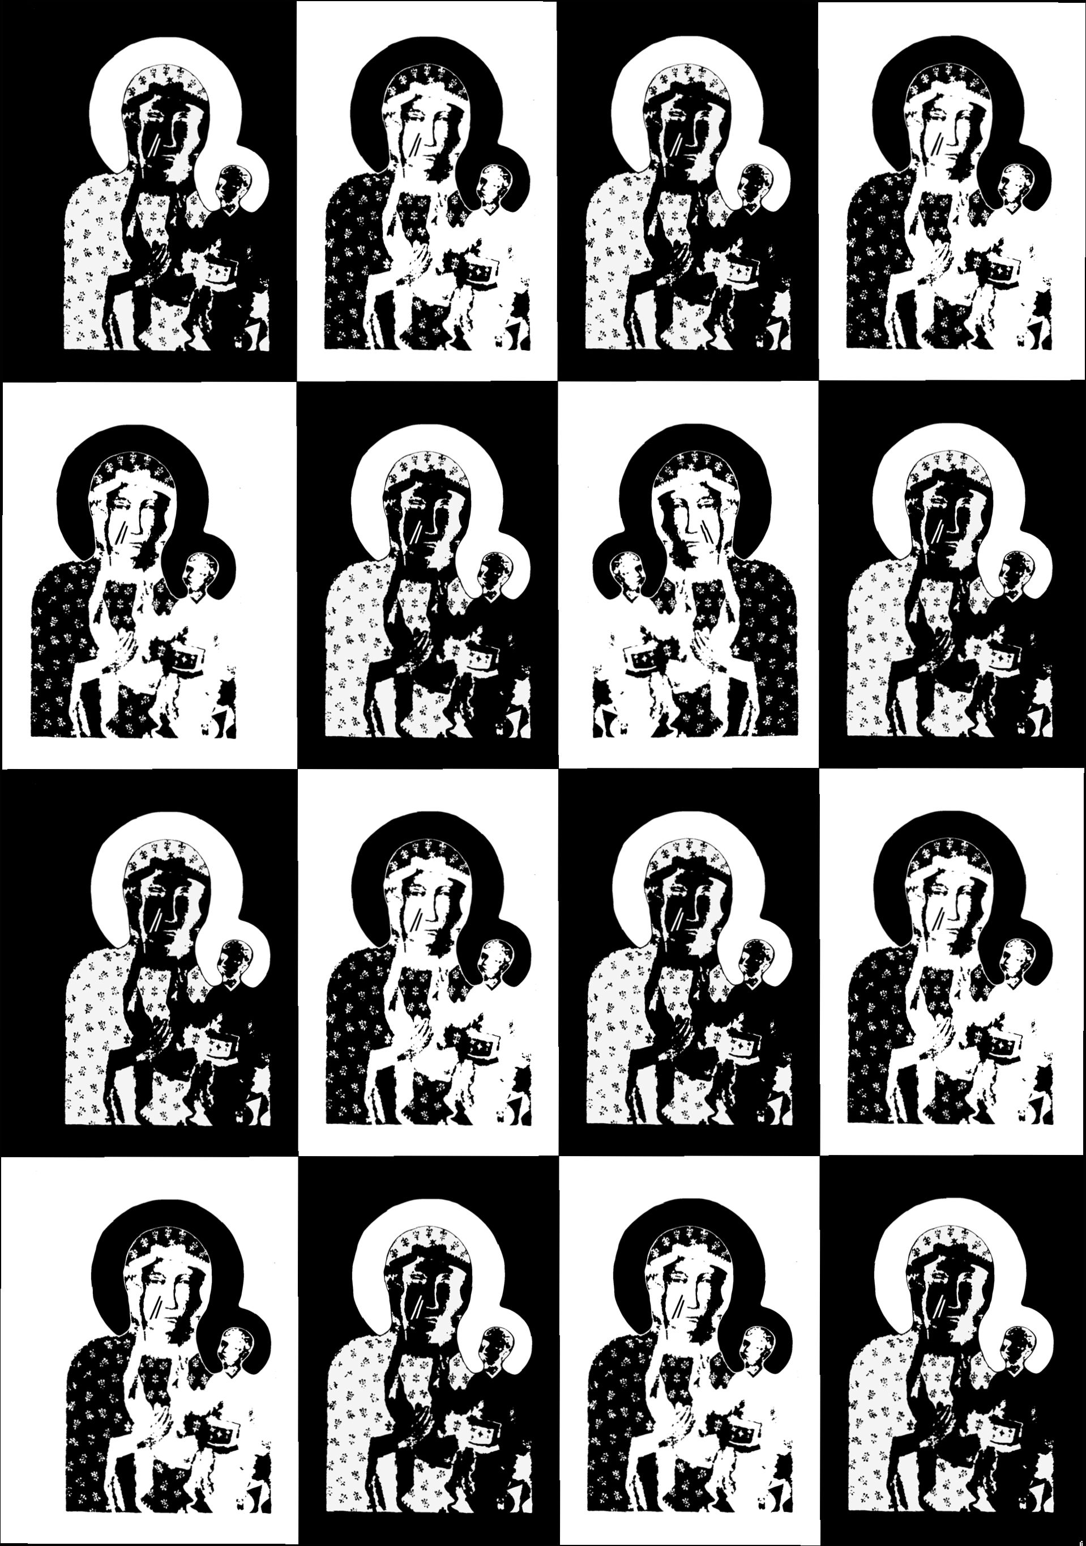

ANNA
NIEDŹWIEDŹ

THE IMAGE
AND
THE FIGURE
Our Lady of Częstochowa
in Polish Culture
and Popular Religion
jagiellonian
uníversíty
press
This book is a changed and abbreviated edition of the original Polish version:
Anna Niedźwiedź, Obraz i postać. Znaczenia wizerunku Matki Boskiej Częstochowskiej.
Kraków: Wydawnictwo Uniwersytetu Jagiellońskiego
The book was reviewed by Ewa Nowina-Sroczyńska
The publication of the book has been financed from funds donated by Katherine P. Kubala,
funds of the Faculty of History Jagiellonian University, and funds of the Institute of
Ethnology and Cultural Anthropology Jagiellonian University
TRANSLATED
Anna Niedźwiedź
Guy Torr
PROOFREADING AND EDITING OF ENGLISH TEXT
Meredith Volker
COVER DESIGN
Łukasz Dąbrowski
© Copyright by Anna Niedźwiedź & Jagiellonian University Press
First edition, Kraków 2010
All rights reserved
No part of this book may be reproduced, translated, stored in a retrieval system, or transmitted,
in any form or by any means, electronic, mechanical, photocopying, microfilming, recording,
or otherwise, without written permission from the Publisher.
ISBN 978-83-233-2900-8
I wydawnictwo]
UNIWERSYTETU
JAGIELLOŃSKIEGO
www.wuj.pl
Jagiellonian University Press
Editorial Offices: Michałowskiego St. 9/2, 31-126 Kraków
Phone: + 48 12 631 18 80, + 48 12 631 18 82, Fax: + 48 12 631 18 83
Distribution: Phone: + 48 12 631 01 97, Fax: + 48 12 631 01 98
Cell Phone: + 48 506 006 674, e-mail: sprzedaz@wuj.pl
Bank: PEKAO SA, IBAN PL80 1240 4722 1111 0000 4856 3325
To Kathy Kubala, who taught me that real friendship can cross borders.

Contents
List of illustrations IX
List of tables and appendices, Abbreviations XI
Acknowledgements XIII
Introduction 1
Chapter I
STORIES OF ORIGIN
- What is acheiropoietos? 5
- The image of Our Lady of Częstochowa as acheiropoietos 9
- The oldest legends about the image and how it came to Jasna Góra 22
- Translations of the image - variations of texts 26
- The contemporary legends of origin 30
- The great story as a contemporary etiological legend 43
Chapter II
THE WOUNDED IMAGE
- The image of Our Lady of Częstochowa as a wounded picture 49
- Changes within the oldest legends concerning the wounding
of the image 51
- The meanings attributed to the attack of 1430 54
- The contemporary tale of the wounding of the image 60
- The bleeding and weeping of images 63
- “The wounds are elongating” 66
- The symbolism of the wounds in the underground art of the 1980s 71
- The wounds in the transitory poetry of the 1980s 76
- “Wounded and Black” 83
Chapter III
QUEEN OF THE NATION
- The myth of the miraculous defense in European culture 89
- The miraculous defense of the Jasna Góra Monastery 94
- Contemporary memory of the defense 96
VIII
The Image and the Figure
- The miraculous defense and the story of the wounding 101
- The coronation of 1717 and the title of Queen 104
- The Miracle on the Vistula 112
- Miraculous defense in stories about World War II 116
- The great story as a national myth 119
- Jasna Góra - the spiritual capital of Poland 126
- Queen and Mother - a documentation of one exhibition 132
Chapter IV
THE IMAGE-FIGURE IN LIVED RELIGION
- Sensual non-differentiation 139
- “Countenance” 144
- “Mother” 150
- Mater Dolorosa 154
- Miraculous consciousness 156
- Peregrination of the image-figure 162
- “A Guest in the home” 170
- The figure without the image - the peregrination of an empty frame 174
Epilogue story 179
Appendix 180
Selected bibliography 183
Index 193

List of illustrations
- Image of Our Lady of Częstochowa (Photo: Archive of Jasna Góra, Collection of Votive
Art)
- Image of Our Lady of Częstochowa in decorative robes and crowns (Photo: Archive
of Jasna Góra, Collection of Votive Art)
- Image of Our Lady of Częstochowa at the entrance to a building, Kraków (Photo: Anna
Niedźwiedź)
- Image of Our Lady of Częstochowa - detail - face of Mary with scars (Photo: Archive
of Jasna Góra, Collection of Votive Art)
- Plastic bottles for holy water with images of Our Lady of Częstochowa or shaped like
Mary, sold near Jasna Góra Monastery (Photo: Anna Niedźwiedź)
- A small girl helping her mother to sell plastic bottles (figures of Mary) for holy water. The
Licheń sanctuary (Photo: Anna Niedźwiedź)
- “Queen of Poland we pray to you for the independence of the Fatherland” Underground
poster from the 1980s (Photo: Archive of the Foundation ‘Centrum Dokumentacji Czynu
Niepodległościowego’ and the Jagiellonian Library)
- “Our Lady pray for us” Underground envelope made in Załęże interned camp dur-
ing Martial Law (Photo: Archive of the Foundation ‘Centrum Dokumentacji Czynu
Niepodległościowego’ and the Jagiellonian Library)
- “Nowa Huta-Solidarity 1982” Underground poster from the 1980s (Photo: Archive of the
Foundation ‘Centrum Dokumentacji Czynu Niepodległościowego’ and the Jagiellonian
Library)
- “Our Lady Save Us! To the memory of the victims of the Soviet homicide” Underground
poster from the 1980s recalling the Katyń massacre (Photo: Archive of the Foundation
‘Centrum Dokumentacji Czynu Niepodległościowego’ and the Jagiellonian Library)
- “Ecce Homo of 1981” Underground poster depicting Solidarity leader Lech Wałęsa wear-
ing a small badge with the face of Our Lady of Częstochowa pinned to his jacket (Photo:
Archive of the Foundation ‘Centrum Dokumentacji Czynu Niepodległościowego’ and the
Jagiellonian Library)
- “Queen of Solidarity” “Solidarity Post” underground stamp from the 1980s (Photo:
Archive of the Foundation ‘Centrum Dokumentacji Czynu Niepodległościowego’ and the
Jagiellonian Library)
- “To the miners from “Wujek” coal mine” “Solidarity Post” underground stamp from
the 1980s (Photo: Archive of the Foundation ‘Centrum Dokumentacji Czynu Niepodległoś-
ciowego’ and the Jagiellonian Library)
- Interior of the Chapel of Our Lady of Częstochowa with the image covered with decora-
tive robes (Photo: Archive of Jasna Góra, Collection of Votive Art)
- “God, save Poland” Our Lady of Częstochowa and patriotic symbols (Photo: Archive of
the Ethnographic Museum in Kraków)
X
The Image and the Figure
- “Under Your Protection” Our Lady of Częstochowa, copy (Photo: J. Kubiena, W. Stasz-
kiewicz, Archive of the Ethnographic Museum in Kraków)
- A pilgrimage to Częstochowa, interwar period (1918-1939) (Photo: Archive of the Ethno-
graphic Museum in Kraków)
- “The Baptizing of Poland 966” “Solidarity Post” underground postcard, images of Prince
Mieszko I, Our Lady of Częstochowa and Pope John Paul II (Photo: Archive of the Foun-
dation ‘Centrum Dokumentacji Czynu Niepodległościowego’ and the Jagiellonian Li-
brary)
- “God and Fatherland” Underground print from the 1980s (Photo: Archive of the Founda-
tion ‘Centrum Dokumentacji Czynu Niepodległościowego’ and the Jagiellonian Library)
- A small badge worn by pilgrims taking part in a pilgrimage (on-foot) from Kraków to
Jasna Góra in 1989. This copy of the image of Our Lady of Częstochowa is accompanied
by a white-red Polish national flag (Photo: Anna Niedźwiedź)
- Jasna Góra Monastery (Photo: Anna Niedźwiedź)
- Pilgrims from Rozprza on their way to Częstochowa, 1961 (Photo: Jan Świderski, Archive
of the Ethnographic Museum in Kraków)
- Our Lady of Częstochowa, copy (Photo: Archive of the Ethnographic Museum in Kraków)
- Our Lady of Częstochowa, copy, oil on canvas (Photo: J. Kubiena, W. Staszkiewicz,
Archive of the Ethnographic Museum in Kraków)
- Pilgrims on their way to Częstochowa, resting inside a church at the foot of an altar
(Photo: Jan Kubiena, Archive of the Ethnographic Museum in Kraków)
- Pilgrims starting their several day long journey from Kraków to Jasna Góra, Kraków,
August 2006 (Photo: Anna Niedźwiedź)
- A stain-glass copy of Our Lady of Częstochowa inside a bakery shop. The image is sur-
rounded by Christmas decorations, Kraków (Photo: Anna Niedźwiedź)
- A sticker with a sign of a pilgrimage (on-foot) from Kraków to Jasna Góra. On Mary’s
face white and red scars are depicted (Polish national colors) (Photo: Anna Niedźwiedź)
- Image of Our Lady of Częstochowa at the entrance to a building, Kraków (Photo: Anna
Niedźwiedź)
- Image of Our Lady of Częstochowa on a building gate. Someone has decorated it with
flowers and a rosary, Kraków (Photo: Anna Niedźwiedź)
- A peregrination of the copy of the image of Our Lady of Częstochowa, Klimontów, vicin-
ity of Kraków, 2008 (Photo: Anna Niedźwiedź)
- A peregrination of the copy of the image of Our Lady of Częstochowa, Klimontów, vicin-
ity of Kraków, 2008 (Photo: Anna Niedźwiedź)
- A peregrination of the copy of the image of Our Lady of Częstochowa, Klimontów, vicin-
ity of Kraków, 2008 (Photo: Anna Niedźwiedź)
- A small peregrination of the copy of the image of Our Lady of Częstochowa, central
Poland, 2008 (Photo: Agata Banach)
- A small peregrination of the copy of the image of Our Lady of Częstochowa, central
Poland, 2008 (Photo: Agata Banach)
- A small peregrination of the copy of the image of Our Lady of Częstochowa. A woman
with a candle is taking the image to her home, Liszki near Kraków, 1985 (Photo: Jacek
Kubiena, Archive of the Ethnographic Museum in Kraków)

List of tables and appendices
Table I. The oldest legends about the image of Our Lady of Częstochowa. Based on: Naj-
starsze historie o Częstochowskim Obrazie Panny Maryi XV i XVI wiek [The old-
est stories on the image of Our Lady of Częstochowa, the fifteenth and sixteenth cen-
turies]. From manuscripts and old prints published by H. Kowalewicz, translated by
- Kowalewicz, M. Kowalewiczowa, introduction by H. Kowalewicz, Z. Rozanow
(Warszawa, 1983) p. 18
Table II. An overview of the hypotheses concerning the origins of the image of Our Lady
of Częstochowa. Based on: A. Różycka-Bryzek and J. Gadomski ‘Obraz Matki Bo-
skiej Częstochowskiej w świetle badań historii sztuki’, Studia Claromontana 5 (1984),
pp. 27-52 p. 40
Table III. Three chronological phases of the image of Our Lady of Częstochowa. Based
on: A. Różycka-Bryzek, ‘Obraz matki Boskiej Częstochowskiej. Pochodzenie i dzieje
średniowieczne’, Folia Historiae Artium 26 (1990), pp. 5-26 p. 47
Table IV. The development and changes in meanings associated with the notion of Our Lady
of Częstochowa as Queen p. 137
Appendix. Chronology of the events connected with a peregrination of the copy of the image
of Our Lady of Częstochowa in Poland p. 180

Abbreviations
DWOK - Dzieła wszystkie Oskara Kolberga [Oskar Kolberg’s Completed Works]
Material from field research is cited as:
No. - number as in the Archive of the Institute of Ethnology and Cultural Anthropology,
Jagiellonian University
int. - interview
q. - questionnaire
m. - male
f. - female
b. year - born year
In quotations from interviews all emphasis added

Acknowledgements
This book would not have been possible without help and encouragement from
many people and institutions. First of all I need to thank Katherine P. Kubala
whose friendship, trust and generosity enabled the appearance of an English ver-
sion of my original work on Our Lady of Częstochowa published in Poland. I also
would like to thank Professor Czesław Robotycki, who supervised my PhD thesis
(2003) on which this book is partially based. I feel very grateful for his inspiration
and his insight that in cultures “not everything is obvious.”
When I visited the Jasna Góra Monastery during my field and library research,
I felt very welcomed - for this I would especially like to thank Father Doctor Jan
Golonka and Father Professor Zachariasz Szczepan Jabłoński. Special thanks also
to the librarians from the Jasna Góra Library and Archive.
During my ethnographic field research and explorations I met many people
who shared their experiences - and often very private stories - connected with
the image-figure of Our Lady of Częstochowa. I am very grateful for this and
I sincerely hope that my work has stayed true to them. The text was certainly
enriched by their openness and trust. I also need to express my gratitude to the
group of students from the Institute of Ethnology and Cultural Anthropology at
the Jagiellonian Univeristy in Kraków, who helped me during the most intensive
field research in the year 2000.
For financing my field research I am grateful to the Polish Scientific Com-
mittee (research grant in 2000-2001). For financial support for this publication,
I would like to thank Katherine P. Kubala as well as Faculty of History and In-
stitute of Ethnology and Cultural Anthropology at Jagiellonian University in
Kraków, Poland.
For granting permission to use the visual material in this publication I would
like to thank the Pauline Fathers from the Jasna Góra Monastery, the photogra-
phers and employees of the Ethnographic Museum in Kraków (and its Director
Doctor Antoni Bartosz), as well as members of the Foundation “Centrum Doku-
mentacji Czynu Niepodległościowego” with its president, Adam Roliński.
Finally, I would like to express my gratitude for the excellent work performed
by Meredith Volker for carefully proofreading the English text.
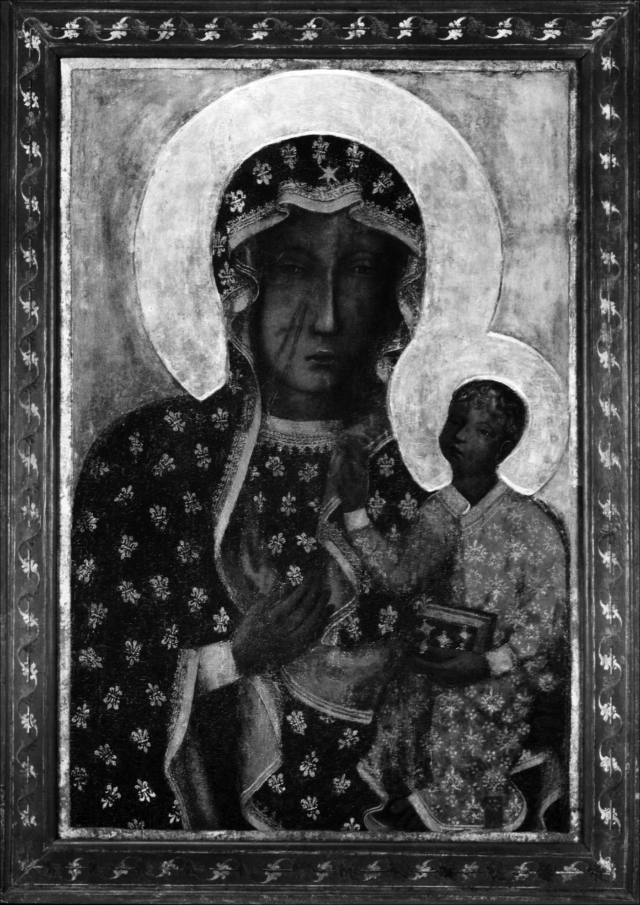
1. Image of Our Lady of Częstochowa (Photo: Archive of Jasna Góra, Collection of Votive
Art)

Introduction
The image of Our Lady of Częstochowa is the most famous and the most venerated
holy image in Poland. In contemporary Polish society the image is a kind of a cul-
tural icon, instantly recognizable and connected with popular symbolic and myth-
ological meanings.1 Characteristics of the image - the outline of the Virgin with
Child on her lap, the dark face of Mary, and the scars visible on her right cheek
- are all very well known in Poland. During the communist period (1945-1989)
the image served as one of the most popular symbols of resistance - combining
religious and national dimensions. Nowadays, countless copies of the original
image can be seen not only in churches but also on streets, above building gates,
in shops, cafeterias, in public places like offices and libraries, or in public trans-
portation as well as in private cars where drivers often hang it above the steering
wheel.
This book is an anthropological interpretation of the immense popularity of
the image of Our Lady of Częstochowa in Poland. It deals with religious, as well
as national, aspects of the cult. My main focus is on various popular beliefs, myths
and rituals connected with the image of Our Lady of Częstochowa and how these
beliefs, myths and rituals appear in popular Polish contemporary Catholicism.
The ethnographic data for the book is drawn from field research carried out in
several different parts of Poland during the years 1999-2002.2 The most important
part of the field research was based on interviews conducted by me and a group of
1 The knowledge about the symbolism of the image of Our Lady of Częstochowa is com-
mon in Poland. To a large extent this is due to a predominance of the Catholic religion. Con-
temporary official polls show that more than 90 per cent of Polish society self-identify as “Cat-
holic” or at least nominally connect themselves with the Catholic Church. However, it should
be stressed that the situation is more complicated and attitudes toward Catholicism vary even
among those counted as “Catholics.” Here, I would like to emphasize that the popular sym-
bolism of Our Lady of Częstochowa often transcends various religious attitudes and appears
not only on religious but also on cultural and social levels. That is why is seems appropriate to
apply Eric R. Wolf’s term “master symbol” - which he introduced to characterize the Mexi-
can symbolism of the Virgin of Guadalupe - to the image of Our Lady of Częstochowa in the
Polish context. See E.R. Wolf, ‘The Virgin of Guadalupe: a Mexican National Symbol’, The
Journal of American Folklore 71 (1958), pp. 34-39. See also C. de Busser and A. Niedźwiedź,
‘Mary in Poland: A Polish Master Symbol’, Moved by Mary. The Power of Pilgrimage in the
Modern World, ed. A.-K. Hermkens, W. Jansen and C. Notermans (Farnham, Burlington 2009),
pp. 87-100.
2 Partially the research was supported by the Polish Scientific Committee (grant nr
1H01H03819).
2
The Image and the Figure
students from the Institute of Ethnology and Cultural Anthropology of the Jagiel-
lonian University in the year 2000 in southern Poland. A peregrination of a copy
of the image of Our Lady of Częstochowa was happening concurrently with the
interviews.3 Additionally, one hundred written questionnaires were distributed,
completed and collected from randomly chosen people living all over Poland. In
addition to the interviews and questionnaires, I made use of participant observa-
tions during religious events involving the image of Our Lady of Częstochowa (at
the Jasna Góra Monastery, during peregrination of the copy of the image in vari-
ous parts of Poland, during pilgrimages). At the time the field research was con-
ducted, I gathered a variety of materials, such as written entries in votive books,
religious songs and poetry, popular religious magazines, devotional printouts, and
iconographical documentation; I treat these as important ethnographic sources
revealing various aspects of contemporary piety connected with the image of Our
Lady of Częstochowa.
Analyzing material from the field research, I chose to focus on four topics:
stories of the image’s origin, the symbolism of the wounds visible on Mary’s
face, the concept of the Queen of the nation, and the presence of Our Lady of
Częstochowa in lived religion. Using contemporary ethnographic research, I con-
structed each chapter recalling older, historical traces of contemporary myths and
symbols attached to Our Lady of Częstochowa. Of course my choice of topics
does not cover the whole complicated phenomenon of the cult of Our Lady of
Częstochowa. There is still more work to be done particularly with the issue of
pilgrimages done on-foot each summer to Częstochowa. These numerous pil-
grims who come from various (sometimes remote) parts of Poland create a unique
religious phenomenon in contemporary Europe.
In organizing and interpreting various fragments from my field material, I have
introduced the terms great and small stories. These terms are meant to distinguish
between decidedly collective aspects of the cult of Our Lady of Częstochowa
(great) and more individual dimension of this cult (small). While the great sto-
ry emphasizes the national dimension of Our Lady of Częstochowa and is built
around the title of the Queen of the nation, the small stories are based on very
intensive, individual religious experiences and mostly emphasize maternal and
human aspects of Mary.
Finally, I should also explain certain terms appearing in the title of the book,
namely “the image and the figure of Our Lady of Częstochowa.” The book and its
title reveal a certain duality encoded in the concept of the holy image in Chris-
tianity. The picture (material, panel, painted board, statue etc.) is seen and expe-
rienced by a religious person as the image of the holy figure, representing (i.e.
making present) this holy figure. This particular relationship - of image and figure
3 Names of interviewers: Anna Niedźwiedź, Stanisław Chruściel, Grzegorz Cichy, Szy-
mon Jadczak, Piotr Kuśmierczyk, Patrycja Kutera, Magdalena Rawłów, Agnieszka Tomana,
Arletta Wawrzyniak, Ewa Wiejaczka.
Introduction
3
- is more than just a matter of theological or philosophical dispute. As recorded in
my field research, the image-figure relation is the central issue of religious experi-
ence connected with Our Lady of Częstochowa. For my interviewees, the image
enables contact with the real holy figure i.e. Mary. This concept of the personal
dimension of venerated images and a specific relation between a viewer and an
image has been present in the broader discourse of cultural anthropology and art
history for several decades.4
As for the usage of the term “Our Lady of Częstochowa,” I should explain that
the image is also known in Poland as the image of Our Lady of Jasna Góra. Both
names are used interchangeably. The first name refers to the city (Częstochowa)
where the Pauline Monks’ monastery is located. Jasna Góra (Polish for: the
Bright Mountain) is the name of the monastery where the image is kept. In popu-
lar language, the image is also often called the Black Madonna of Jasna Góra/
Częstochowa due to the dark faces of Mary and Jesus depicted on the picture.5
The original Polish version of this book was published in 2005.6 In prepar-
ing the English version, I had to make many changes and abbreviations; several
accommodations and explanations were added and subtracted for the benefit of
non-Polish readers.
For me, as a cultural anthropologist and as a Pole, working on and writing
about contemporary Polish religiosity surrounding Our Lady of Częstochowa was
a fascinating experience. I myself came to an understanding of remote sources of
symbolism and mythical structures present in popular contemporary discourse
and perception of the image-figure of Our Lady of Częstochowa. It is my hope
that this book contains important and illuminating insights and context for Poles
and non-Poles alike and will allow a deeper understanding of the issues surround-
ing this important religious and national symbol.
4 See e.g. J. Tokarska-Bakir, Obraz osobliwy. Hermeneutyczna lektura źródeł etnograficz-
nych (Kraków, 2000). Also various works by David Morgan are definitely worth recalling in
that context. See especially D. Morgan, Visual Piety. A History and Theory of Popular Religious
Images (Berkeley, Los Angeles, London, 1998). See also D. Freedberg, Power of Images. Stud-
ies in the History and Theory of Response (Chicago and London, 1989).
5 I decided not to use the term “Black Madonna” in my writing about the image of Our
Lady of Częstochowa. In Polish the term “Black Madonna” appears mostly in devotional con-
texts and possesses a strong religious weight. For further explanation and analysis of symbolic
meanings of the term “Black Madonna” see Chapter II, Section 9 of this book.
6 A. Niedźwiedź, Obraz i postać. Znaczenia wizerunku Matki Boskiej Częstochowskiej
(Kraków, 2005).
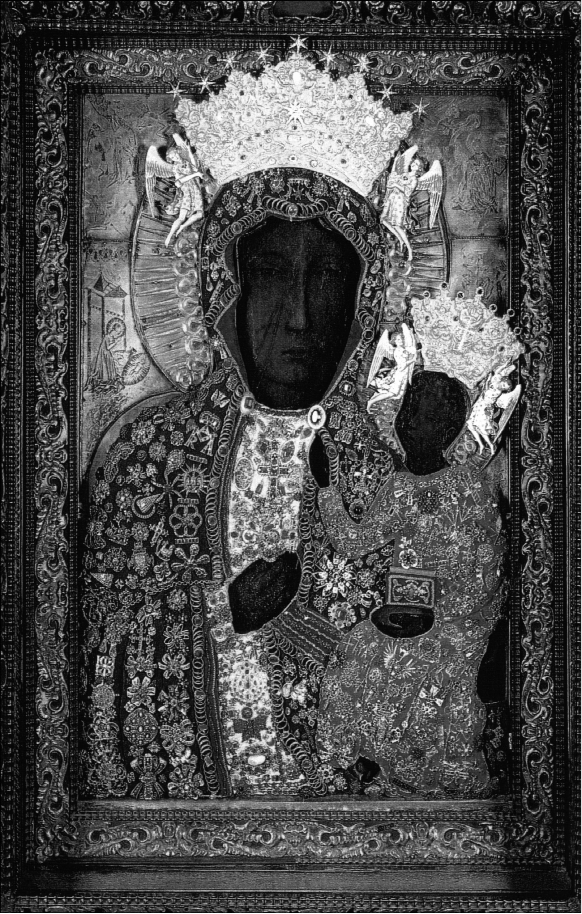
2. Image of Our Lady of Częstochowa in decorative robes and crowns (Photo: Archive
of Jasna Góra, Collection of Votive Art)

Chapter I
STORIES OF ORIGIN

1. What is acheiropoietos?
The enduring popularity of the image of Our Lady of Częstochowa among Polish
people, as well as various miraculous abilities commonly attributed by the devo-
tees to the image, are mirrored in a significant number of legends, stories and
tales about the image and its history. In this introductory Chapter, I will focus
on the legends of origin connected with the image of Our Lady of Częstochowa.
Common knowledge about the history of the image reveals very interesting and
complex links between various levels of culture: historical and present, religious
and scientific, Christian and national.
In order to synthesize this diverse discourse, and to understand the context of
the oldest themes within the Jasna Góra legend, it is worth referring to the very
beginnings of figural presentations within the purview of Christian culture. It is
also important to realize that Christian art arose within two diametrically different
attitudes towards figural art. As Ewa Kuryluk points out:
Dissenting from Judaism in a late Hellenistic world saturated with images, Christianity
is initially reluctant to embrace icons. But the existence of Jesus, a vera icon of divinity
created in Mary’s flesh, calls for representation.1
These complicated and dynamic relations between the different cult models were
inscribed in the beginnings of Christian art. They were present in the disputes
and arguments between the adherents of the cult connected with holy images and
ardent opponents of any kind of figural representation.2 The matter of the “true
image of Christ” was an integral part of the discussions and the searches of early
Christianity. It was just these quests for a “true” and “real image” of the Savior,
1 E. Kuryluk, Veronica and Her Cloth. History, Symbolism, and Structure of a "True”
Image (Cambridge MA, Oxford, 1991), p. 8.
2 See e.g. R. Knapiński, ‘Ojcowie Kościoła o znaczeniu obrazów w przekazie wiary’,
Roczniki Humanistyczne KUL. Historia Sztuki 47-4 (1999), pp. 5-22.
6
The Image and the Figure
that led to the appearance of the so-called images “not made by human hand”
(Greek acheiropoietoi)?
The first historical references to the acheiropoietoi come from the mid-sixth
century.4 Initially, these were pictures of Christ, which - according to legends -
came to earth miraculously and were regarded and worshiped as holy.5 One of the
most famous stories is connected with the image from Camuliana (a small city in
Cappadocia), where it is said that the portrait of Christ fell to earth from the sky.6
Supposedly a woman found it in a pond in her garden. The miraculous original
was said to have the power to multiply itself - it printed itself on the cloth that it
was attached to. Soon the distinction between a “true” acheiropoietos and its cop-
ies became hazy. The subsequent images printed on pieces of cloth attained the
status of an “authentic acheiropoietos” and as such were venerated. In addition,
craftsmen and artists began to produce “genuine images” of Christ based on the
image from Camuliana. In a way similar to the initial model, they were equally
ascribed with the legend of being miraculously sent from heaven.
The power connected with acheiropoietic images came from belief in their di-
vine origins. Their accreditation with direct contact with sacrum at the moment of
their creation constituted, for religious people, irrefutable evidence of their power.
Images, whose authorship was believed to be connected with the intervention of
higher powers, were considered to be not merely portraits of Christ but genuine
representations of him.
A similar group of images are the so-called sudariums (Latin “sweat cloths”)
and vera icons (Latin “true images”) depicting the face of Jesus Christ printed on
a shawl or shroud. The so-called Mandylion of Edessa, referred in sixth-century
sources, is a very intriguing example of vera icon. The image was believed to be
3 Acheiropoietos - a singular form.
4 See e.g. Kuryluk, Veronica and Her Cloth, pp. 28-29. See also: H.J. Rothemund, Ikonen-
kunst. Ein Handbuch (München, 1954), p. 9.
5 In time also other holy figures (especially the Virgin Mary) were depicted in images
known as “not made by human hand.”
6 The pattern of the legend about acheiropoietos - which fell from the sky to earth - can be
interpreted as a synthesis of earlier, mostly Greek, beliefs and rituals adopted by the Christian
imagination. In ancient Greece meteors that fell to earth were hallowed and known as diipetes
- the works of the gods that had fallen to earth. The stones that fell to earth were considered
to be amulets associated with Pallas Athena. They were called palladions and were ascribed
the power to protect certain cities and towns. Interestingly, in Byzantium, the term palladion
started to be connected with some images (often known as “not made by human hand”), which
were treated as protective objects. In the context of the image of Our Lady of Częstochowa, it
is also important to consider that this image was, for centuries, treated as a palladion - protec-
tive image - of the Jagiellonian dynasty. For more about acheiropoietos and the links with the
Greek cult of meteors see Kurylyk, Veronica and Her Cloth, pp. 30-31 and D. Freedberg, The
Power of Images. Studies in the History and Theory of Response (Chicago and London, 1989),
pp. 66-67. On the enduring story about the image “falling from the sky,” see J. Tokarska-Bakir,
Obraz osobliwy. Hermeneutyczna lektura źródeł etnograficznych. Wielkie opowieści (Kraków,
2000), pp. 319-320.
Stories of Origin
7
a “true” portray of the Savior’s face, which had been sent to Abgar, the King of
Edessa.7 The earliest known versions of the story speak of a painter called Hannan
who was to have painted a portrait of Christ, during his earthly life, proclaiming
his teachings. As time passed, however, the faithful began to see the mandylion
not as a portrait, painted by an artist, but as an imprint of Christ’s face on mate-
rial miraculously pressed on the cloth when the Savior washed his face with it.
Finally, the story of the painted portrait was transformed into the story of the
shawl “impregnated by the bloody sweat of Jesus in the garden of Gethsemane.”8
Similar representations of Christ’s face have been associated with the legendary
and apocryphal story of Veronica (her name derives from the Latin vera icon -
“true image”).
The overwhelming desire to find “a true image” of Christ has returned many
times in the history of Christianity. To this very day, the matter elicits lively reac-
tions amongst the faithful. This is borne out by the exceptional popularity and
emotional reception of the so-called Shroud of Turin. The cloth preserved in
the cathedral in Turin is - according to legends - the winding-sheet in which
Christ’s body was wrapped for burial. The imprint of the image of Christ visible
on the cloth would be, therefore, a form of acheiropoietos. However, numerous
researchers and academics have treated the story of the shroud with skepticism.
They have repeatedly emphasized that the oldest written accounts of this mysteri-
ous material date from the fourteenth century. Additionally, the current research
indicates that the shroud’s origins are in the late Middle Ages.9 Despite the con-
temporary research, the shroud, in the present day, as in years past, continues to
arouse immense emotion and adoration amongst the faithful.10 The history of the
reception of the shroud is a perfect illustration of the reverence the faithful have
for an object that they believe came into direct contact with a venerated person.
7 See R. Cormack, Painting the Soul. Icons, Death Masks, and Shrouds (London, 1997),
p. 108. Kuryluk, Veronica and Her Cloth, pp. 38-47 and Freedberg, Power of Images, pp.
207-209.
8 Kuryluk, Veronica and Her Cloth, p. 7.
9 See, for example Cormack, Painting the Soul, p. 116. Cormack also gives a survey of the
discussion and academic research conducted on the Shroud of Turin. The results of the research,
using radiocarbon dating, allowed the Shroud of Turin to be dated between the years 1260 and
1390. The question of the origin and dating of the Shroud of Turin is not, however, a matter
that has been totally resolved. In 2004, new research was published about the rear layer of the
shroud. Researchers discovered impressions of facial features on this layer of the shroud. See
W. Moskal, ‘Twarze z całunu’, Gazeta Wyborcza (15 April 2004). See also: G. Fanti, R. Mag-
giolo, ‘The double superficiality of the frontal image of the Turin Shroud’, Journal of Optics A
6-6 June (2004), pp. 491-503.
10 For instance, in Poland, the Polish translation of the famous book about the Shroud by
I. Wilson became hugely popular [see I. Wilson, Całun Turyński, transl. A. Polkowski (War-
szawa, 1985)]. There is also a copy of the Shroud of Turin - actual size - that travels around to
various places of worship, where it is displayed to the faithful. In 2003, the copy was presented
in Kraków (in the church of the Franciscan Fathers) and it was displayed and viewed by nume-
rous worshippers.
8
The Image and the Figure
An object like the shroud is especially important to believers because the contact
with the holy person has left a visual representation.
The stories of acheiropoietic images, vera icons and miraculous sudariums
are part of a fundamental mechanism determining the relationship between the
faithful and holy images. In a religious reception of Christian images, the border
between the representation (painting, portrayal) and the figure (the holy figure
e.g. Christ, Mary) is very often obliterated by the faithful. The story of origin
describes the moment of the image’s creation and defines the miraculous status of
the object. Therefore, in legendary narrations, special emphasis is placed on the
direct contact of the holy figure with his (or her) portrait. For a religious recipi-
ent of the story, the holiness of the image is based not only upon a resemblance
between image and figure but also upon ontological participation of the figure in
the image. Thanks to such an understanding, the image gains an importance close
to the status of relic.11
Significantly, at almost the same time that acheiropoietic images and vera
icons began to appear in Christian culture, another group of pictures emerged.
These pictures were attributed to Saint Luke. Among this group were images of
both Christ, as well as of the Virgin Mary with Child.12 Similar to the icons “not
made by human hand,” these images were surrounded by a particular devotion.
Legends about Saint Luke structurally resembled the stories about acheiropoietos.
And so, for example, in many legends there was a theme of the Evangelist fall-
ing asleep or leaving his work unattended during the process of painting. It was
during these times that the holy image was said to have been completed thanks to
miraculous divine intervention.13
Both the images “not made by human hand” and those ascribed to Saint Luke,
constituted answers to desires and questions that troubled the Christian religion
at a time when it was growing and spreading to more and more places. The for-
mation of dogma found its reflection, confirmation and supplementation in the
11 Some researchers emphasize that the cult of images “not made by human hand” within
the Orthodox Christian tradition, expresses the high ranking of icons equal to that of relics in
the West. See A. Różycka-Bryzek and J. Gadomski, ‘Obraz Matki Boskiej Częstochowskiej
w świetle badań historii sztuki’, Studia Claromontana 5 (1984), p. 44, footnote 48. According
to Barbara Dąb-Kalinowska, holy images (in Orthodox tradition) were ranked even higher than
relics. See. B. Dąb-Kalinowska, Ikony i obrazy (Warszawa, 2000), p. 14. On the cult of relics in
the history of Christianity see J. Kracik, Relikwie (Kraków, 2002).
12 According to the Orthodox Christian tradition, Saint Luke painted portraits of Mary
after the descent of the Holy Spirit. There are 21 icons, renowned in Orthodox tradition, that are
said to be painted by Saint Luke. See G. Kobrzeniecka-Sikorska, Ikona, kult, polityka. Rosyj-
skie ikony maryjne od drugiej połowy XVII wieku (Olsztyn, 2000), p. 6. Mieczysław Skrudlik
claims that the first reference to Saint Luke as the painter of the image of the Virgin Mary can be
found in sixth-century sources: in the letters of Theodore the Lector. See M. Skrudlik, Królowa
Korony Polskiej. Szkice z historii malarstwa i kultu Bogarodzicy w Polsce (Lwów, 1930), p. 57.
13 One of the medieval legends connected with the image of Christ (kept in the Lateran
papal complex) states that Saint Luke had started this image, however, it was completed “by
God through the hand of an angel.” See Cormack, Painting the Soul, p. 99.
Stories of Origin
9
creation and development of Christian art. “Real,” “true,” or “genuine” images
of Christ and the Virgin Mary were important arguments during many theologi-
cal discussions. During iconoclastic disputes, they were cited by the defenders of
icons, as significant proofs of the validity of the cult of holy images.14

2. The image of Our Lady of Częstochowa as acheiropoietos
Stories of “true images” and images “not made by human hand,” as well as legends
of icons painted by Saint Luke, have entered the history of European culture for
good. The themes connected with the first centuries of Christianity appeared and
reappeared both in Western culture as well as in that of the countries of Slavic-By-
zantium circles. Handed down for centuries, these legends have survived until the
current day. To date, they have been connected with many venerated images. As
Joanna Tokarska-Bakir has noted, the story concerning “beginning” and “origin”
constitutes one of the basic determinants of the holiness of an image.15 Through
“etiological legend” the religious community legitimizes the image as miraculous
by accepting it as a specific form of relic - an object endowed with the power as
well as the presence of the person.16
Many researchers of the history of religion, in examining the problem of the
popularity of holy images in Poland, have included the images within a two-fold
context - the cult of relics in Western Europe and the predominance of icons in the
Orthodox East. Some have hypothesized that the religious significance ascribed to
the holy images in traditional Polish culture results from the historical links with
the domain of Byzantium.17 At the same time, it is often noted that the cult of im-
ages within the Byzantine tradition can, to a certain degree, be compared with the
role fulfilled by the cult of relics in Western Christianity (with its Latin origins):
The function of holy images is revealed not only in their devotional and illustrative
role [...] but, first and foremost, in the concretization of mighty divine action. Christia-
nity in the West, linked this last role (the concretization of divine action) with the pos-
session of relics. In Poland, relics were less available, and under the influence of the
14 See Freedberg, Power of Images, p. 395. See also Dąb-Kalinowska, Ikony i obrazy,
p. 11.
15 Tokarska-Bakir, Obraz osobliwy, p. 281. The legend of origin is often accompanied by
stories about miracles ascribed to the image - as well as miraculous revelations of the image
status (tears appearing on the image, the bleeding of the image etc.).
16 “Etiological legend” is a term used by Joanna Tokarska-Bakir to define legends of the
origin of holy images.
17 See, for example, T.M. Trajdos, ‘Kult wizerunków maryjnych na ziemiach ruskich Ko-
rony i Litwy drugiej połowy XIV i pierwszej połowy XV w. w społecznościach katolickiej
i prawosławnej’, Studia Claromontana 5 (1984), pp. 127-147; J.J. Kopeć, Bogarodzica w kul-
turze polskiej XVI wieku (Lublin, 1997), p. 376; H. Paprocki, ‘Mariologia - wspólne źródło
prawosławia i katolicyzmu’, Kult maryjny w kościele rzymskokatolickim w Polsce i rosyjskim
kościele prawosławnym (Warszawa-Moskwa, 1989), pp. 9-16.
10
The Image and the Figure
Byzantine tradition, the concept of the concretization of divine action was connected
with images. This connection accentuated the cult and the devotional-utilitarian role
of the images similar to the model of the Orthodox icon. However, there was not the
same theological understanding of this holy representation’s significance as developed
by Orthodox Christianity.18
Anthropologists, who specialize in Polish religious images, often emphasize the
relationship between the Orthodox comprehension of the icon and the veneration
of miraculous images in popular Polish Catholicism. Sensual adoration of miracu-
lous images has been treated as one of the characteristic features of popular Polish
Catholicism both in the old traditional society and in contemporary society.19
On the other hand, it is also important to consider the historical context of the
Częstochowa image. The “new Marian cult” first gained prominence in eleventh-
century Latin Europe and reached its culmination in the fourteenth century. It
was in the fourteenth century that the image of Our Lady of Częstochowa arrived
at the Jasna Góra Monastery.20 In the religious context of the late Middle Ages,
various miraculous powers were attributed to the Virgin Mary.21 The widespread
belief in the Assumption also influenced the growth in Marian devotion. If one
believed that the body of Mary was taken to heaven, there would be no relics from
her body. Given the absence of Marian relics (besides such ridiculous examples
as the ear cerumen or breast milk), images of the Madonna obtained a high cult
ranking; particularly those whose legends indicated miraculous origins and achei-
ropoietic status. The spread of the images of the Virgin Mary, accredited to Saint
Luke, reveals a mechanism of a tradition. As Andrzej Dąbrówka writes tradition:
[...] completes the deficiency of the material grounds of the miraculous statues and
pictures through accounts of “auto-thematic” revelations or interventions, which are
supposed to be proofs that the given artifact [statue, picture] was accepted as an image
by the figure represented.22
18 Kopeć, Bogarodzica w kulturze polskiej, pp. 382-383.
19 See M. Zowczak, Biblia ludowa. Interpretacje wątków biblijnych w kulturze ludowej
(Wrocław, 2000), pp. 32-34. The author, in describing the popular cult of images, refers to the
work of Stefan Czarnowski and develops the interpretation of the concept of sensualism. See
S. Czarnowski, Kultura (Warszawa, 1938), pp. 151-186.
20 A. Dąbrówka, Teatr i sacrum w średniowieczu. Religia - cywilizacja - estetyka (Wroc-
ław, 2001), p. 139. The late medieval current of piety, known in historiography under the name
devotio moderna, was connected in East-Central Europe with devotion towards the person of
Christ and it also developed a very strongly Marian devotion. About the late medieval piety in
Poland, Bohemia and Hungary see S. Bylina, ‘Nowa dewocja, postawy wiernych i kult maryjny
w Europie Środkowej późnego średniowiecza’, Studia Claromontana 5 (1984), pp. 110-126.
21 Dąbrówka interprets this process as the equivalent of the Eliade’s theory “of the stand-
ardizing of hierophany after a period of excessive dispersion.” Dąbrówka, Teatr i sacrum,
p. 139.
22 Dąbrówka, Teatr i sacrum, p. 140.
Stories of Origin
11
The complex and varied influences are evident in the oldest legends about the im-
age of Our Lady of Częstochowa. In these narratives we find the intertwining of
threads typical of the religious culture of the Orthodox East and the Latin West.
All of the oldest versions of the legend of the image from Jasna Góra ascribe
authorship of the painting to Saint Luke the Evangelist (see Table I,point 1).23 We
are dealing, therefore, with one of the numerous miraculous images whose legend
was modeled on early medieval tradition. Yet in the oldest recorded Jasna Góra
stories, there is no appearance of the motif of Saint Luke’s falling asleep at the
easel. The work is ascribed to the Apostle himself. This is how the earliest of the
preserved narratives on the image begins:
What follows is a description of the transfer of the board of the divine Virgin Mary,
whom Saint Luke painted with his own hands. Mary, the Mother of Jesus, was taken
from this vale of misery and from this unhappy world full of sorrow and tears, from
the bonds of the body to eternal solace and to the highest location of the heavenly peak
(namely through the announcement of the glory of her soul). At this time, blessed Luke
the Evangelist was a member of her house and a loyal secretary (recording generally
and in particular the acts and deeds, signs and miracles which the Blessed Virgin Mary
related about her great beloved Son). Luke the Evangelist found the table at which the
divine Virgin would usually have sat and with great generosity offered a multitude of
requests to her only begotten Son. When Luke was asked (by certain Christians) to
paint her to the reverent memory of her beauty, preserving on this board, that is the
table, a beautiful image of this glorious Virgin in such a fashion that in the arms of her
image rested the image of Jesus Christ.24 [emphasis added]
Subsequent legendary versions, known from fifteenth- and sixteenth-century
sources, speak of the individual labor of the painter, adding however, that the
image was created “with the advice of the Holy Spirit”25 or “strengthened by
grace and led by the Holy Spirit.”26 Following the development of the Jasna Góra
legends, the acheiropoietic character of the image has, over time, become increas-
23 I quote and refer to the texts of the oldest legends about the image of Our Lady of
Częstochowa based on an edition of photocopies and translations of manuscripts and prints by
Henryk Kowalewicz. See Najstarsze historie o Częstochowskim Obrazie Panny MaryiXViXVI
wiek, ed. H. Kowalewicz, transl. H. Kowalewicz, M. Kowalewiczowa, introduction H. Kowa-
lewicz, Z. Rozanow (Warszawa, 1983). The edition consists of five texts: 1. Translatio tabulae
Beatae Mariae Virginis, quam Sanctus Lucas depinxitpropriis minibus. 2. Historia declarato-
ria (Latin version), Hie volget dy historie (German version). 3. Mikołaj Lanckoroński, Histo-
ria venerandae imaginis Beatae Mariae Virginis quae in Claro Monte in magna veneratione
habetur. 4. Piotr Rydzyński, Historia pulchra et stupendis miraculis referta imaginis Mariae,
quomodo et unde in Clarum Montem Czastochowiae et Olsztyn advenerit. 5. Mikołaj of Wilko-
wiecko, Historyja o obrazie w Częstochowie Panny Maryjej i o cudach rozmaitych tej wieleb-
nej tablice. For a detailed analysis of the contents of the legends see Table I.
24 ‘Translatio tabulae’, Najstarsze historie, p. 75. In the Latin transliteration of the text, the
introductory fragment reads: Translatio tabulae Beatae Mariae Virginis, quam Sanctus Lucas
depinxit propriis minibus... [emphasis added ], p. 66.
25 Hie Volget dy Historie’, Najstarsze historie, p. 107.
26 Lanckoroński, ‘Historia venerandae’, Najstarsze historie, p. 136.
12
The Image and the Figure
ingly exposed. In accordance with the widespread model within European culture
of the tale of Saint Luke, there appeared a thread that announces that the im-
age was created through the participation of supernatural forces - that it was not
completed by the hand of the painter but by angels or Mary herself. It, therefore,
obtained the status of an image “not made by human hand.”
The conviction about divine help - given to Saint Luke during the work
upon the Jasna Góra image - is expressed in Baroque iconography. A painting
from 1705, known as Mensa Mariana (Latin “Marian Table”), was placed on the
reverse of the miraculous image. In this painting, there is, among other things,
a scene with Saint Luke. The Apostle is working at easels and the figure of the
Virgin Mary hovers above the easels. Behind the painter’s back, angelic figures
are seen assisting in the work. Later presentations of the moment of the creation of
the Częstochowa image display the “not-human” genesis of the image even more
clearly. In eighteenth- and nineteenth-century paintings, there are multiple depic-
tions of the Apostle slumbering (or being deep in thought) during the creation of
the image. In these paintings, an angel keeps watch above the easel, giving the last
touches to the image of Our Lady of Częstochowa.27
The story continued to develop and in 1930 one of the researchers working
on the history of the cult of the image of Our Lady of Częstochowa related that:
The legend about Saint Luke, the creator of the picture of the Virgin Mary of Jasna
Góra, finds its living echo in the numerous sermons and folk tales that have simulta-
neously undergone further modifications. According to these interpretations, the Jasna
Góra picture belongs to the group of acheiropoietic images, for - as legends say - it
was created by angels while Saint Luke fell asleep exhausted by his fruitless effort.28
[emphasis added ]
Various nineteenth- and twentieth-century ethnographic sources relating to the
legends known among pilgrims to the Jasna Góra Monastery confirm a pervasive
belief about the acheiropoietic status of the image:
[The Evangelist] fell into such raptures while painting Her [the Virgin Mary’s] coun-
tenance that he was forced to interrupt the work and only upon awakening from these
raptures did he see that the work was no longer his but had been completed by angelic
hands.29
27 These paintings are still being reproduced in various devotional prints about the image
of Our Lady of Częstochowa. See, for instance, the eighteenth-century picture by an unknown
painter published in contemporary monthly Jasna Góra 8 (1984), p. 2. The same picture (il-
lustrating the legendary story about the image) was reproduced in another popular Catholic
magazine in year 2001. See Nasza Arka. Miesięcznik Rodzin Katolickich 7 (2001), p. 4; see
also: Jasna Góra 12 (1988), p. 32.
28 Skrudlik, Królowa Korony Polskiej, p. 64.
29 DWOK, vol. 23 (Kaliskie, part I), p. 230.
Stories of Origin
13
A similar version of the tale about the picture’s origin is given in numerous popu-
lar nineteenth-century folk songs from various areas of Poland:30
Holy angelic Luke
Asked God, Jesus Christ,
To paint a picture
And glory, honor God bestow.
He painted it over a long time
Twenty four years in tow
He could not paint it so
And forced he was to sleep upon it.
The holiest Virgin spoke
Till Luke awoke:
Arise, exhausted Luke
Your picture is already done.31
In another version the song says:
He could not paint it so
And forced he was to sleep upon it.
The Holiest painted it
And promised it to Częstochowa.32
In addition to emphasizing the acheiropoietic status of the image, legends of the
origin of the image of Our Lady of Częstochowa point to the importance and
uniqueness of the wooden board (panel) on which the image had been painted.
A sixteenth-century author emphasizes the direct, physical contact of the Virgin
with the board:
[...] according to the oldest tradition there was in the house of Zebedee the square
cypress wood table which was given by Saint John for the exclusive property of the
blessed Virgin Mary, at which the blessed Virgin often sat in solitary silence, enjoying
a rest, working, reading the Holy Scriptures, contemplating; in the devout contempla-
tion of her Son consumed by such sweet love that with folded fingers she lowered
with a cry that most holy head on to the board, drenching it copiously with tears.33
[emphasis added]
30 The so-called “beggars’ songs” were well-known in the nineteenth century in the coun-
tryside. They were popularized in numerous publications addressed to the faithful. They were
also sung by various beggars and wandering tramps. The lyrics of “beggars’ songs” were based
on “apocryphal texts drawn from sermons and church-fete literature.” See. T. Marcinkowska,
‘Sanktuaria maryjne w narracyjnych pieśniach ludowych’, Orędowniczko nasza. Kult Matki
Bożej w polskiej kulturze ludowej, ed. A. Spiss (Kraków, 1996), p. 59.
31 DWOK, vol. 22 (Łęczyckie), p. 168.
32 Ibid., p. 169.
33 Lanckoroński, ‘Historia venerandae’, Najstarsze historie, pp. 135-136.
14
The Image and the Figure
The board upon which the image was painted was said to have been the personal
property of the mother of Jesus Christ and - as most versions of the legend say
- of the whole Holy Family. The connection between the wooden board and the
holy persons was to be created through the sensual direct contact: the tears of
Mary soaking into the wood, the touch of the hands of the Virgin Mary as well as
those of Jesus.34 The board was marked in a permanent way:
And such was the table for the Virgin Mary of cypress wood, at which many a time she
betook of refreshments with her most beloved Son, there equally she did and discussed
the mysteries of God, which they with the touch of their the most holy hands con-
secrated.35 [emphasis added]
The legends express the conviction that, after the Assumption of Mary into heav-
en, the table top - blessed through the long standing association with the holy
figure - was the most appropriate material on which to create a memorial image of
Mary. The stories emphasize very strongly that the miraculous power of the image
results from the direct contact between the object and the holy figure.
In subsequent versions of the legend the theme concerning the origins of the
panel of the image of Our Lady of Częstochowa undergoes further development.
The most developed version of the story is bequeathed by Ambroży Szymon
Nieszporkowic’s work Morsels from the Royal Table of the Queen of Heaven
and Earth..., which constitutes a superb example of seventeenth-century Baroque
Marian devotion.36 The author, describing the beginnings of the image of Our
Lady of Częstochowa, increases the collection of miraculous circumstances that
accompanied the creation of the painting. Saint Luke was said to have painted
the image of Mary while she was still alive - before the Assumption - on a board
from the table of the Holy Family. This table had not only been the property of
the Virgin Mary for many years, but was also said to have been made by Jesus
himself, who had learned carpentry from Joseph. The nineteenth-century folk ver-
sions of the legend also repeat the motif of Jesus’ participation in the making of
the table top - the ground for the image. In the version noted by Oskar Kolberg
34 Tears, like other human secretions, in traditional Polish folk culture were connected with
special significance and ambiguity. As Piotr Kowalski has noted every secretion “combines
things already disconnected: for on the one hand when they are separated, they exist independ-
ently as separate substances, while on the other hand they still remain a fragment of the whole
- united with the entity they were an initial part of.” See P. Kowalski, Leksykon znaki świata.
Omen, przesąd, znaczenie (Warszawa-Wrocław, 1998), p. 547.
35 Mikołaj of Wilkowiecko, ‘Historyja o obrazie w Częstochowie’, Najstarsze historie,
p. 210.
36 The first edition of the text appeared in Kraków in 1681 as a Latin version (Analecta
Mensae Reginalis). In subsequent editions the text developed and evolved. Not long after the
author’s death (1703), the Pauline printing house at Jasna Góra published several new editions
of a Polish translation of the work, expanding its content (by the inclusion of, among other
things, a section about the coronation of the image in 1717). The last of the changes in the text
were completed by the 1720 edition. See A.J. Zakrzewski, W kręgu kultu maryjnego. Jasna
Góra w kulturze staropolskiej (Częstochowa, 1995), pp. 116-117.
Stories of Origin
15
(the founding father of Polish ethnography) numerous details appear that convey
to the faithful the unusual history of the cypress wood table:
When the Holy Family returned from Egypt and settled in Nazareth, Joseph, a poor
carpenter, as the legend has it, produced from cypress wood a small table, and in this
task the Infant Jesus helped. The top board of the table is the very same upon which
the miraculous image is painted. The Holy Family often fell to their knees at this table,
praying to the Father in heaven, and here they sat eating the modest fare produced by
Mary. When the Savior while on the cross directed Saint John the Evangelist to care
for his Mother who stood at the cross, the Holy Mary, entrusted to that saint, moved to
Mount Zion to the house of Zebedee, the father of Saint John, and there she took that
precious keepsake, the said cypress wood table, and there managed to reside with Her
a gathering of devout Virgins [...]. The said group of Virgins, receiving as a gift from
Mary the cypress wood table, which had served for them as an altar at which Saint
John had performed the holy mass, asked Saint Luke to paint on the altar top the image
of the Holy God-bearer and the Holy Child.37
The miraculous circumstances connected with the painting’s physical material
seem to be numerous: Jesus participated in the construction of the table; the Holy
Family not only ate but also prayed at the table, so it served as a kind of a fam-
ily altar.38 Even the place where Saint Luke painted was special and sacred: the
legend relates that it happened “in the room where the Savior established the
Most Holy Sacrament, where the Holy Spirit, in passionate languages, appealed to
those Apostles praying together with Mary.”39 Pilgrims visiting the Jasna Góra
shrine could indeed be reassured by the details of the legends about the image - its
unique material and the unusual circumstances of the creation. Such details would
reinforce the pilgrims’ belief in the miraculous powers of the image.
It is worth noting, once again, the iconographic depictions of the legend of
origin of the image of Our Lady of Częstochowa. Namely at this very same time
- when the subsequent editions of Ambroży Nieszporkowic’s treaty were pub-
lished - an interesting iconographic testimony began to emerge. The afore men-
tioned painting, known as Mensa Mariana (Latin “Marian Table”), which was
likely placed on the reverse side of the Jasna Góra image in 1705, consisted of
a set of small scenes and inscriptions which illustrated and described the legen-
dary origins of the image.40 This can be considered as an iconographic version of
37 DWOK, vol. 23 (Kaliskie, part I), pp. 229-230.
38 In traditional Polish folk culture, the table was treated as a very special and blessed piece
of furniture. It was not used on a daily basis (everyday meals were eaten on a special bench).
In peasant huts, the table stood in a “holy corner” and was known as a place of mediation with
sacrum. The table was treated as a domestic altar. For more about the symbolism of the table
in traditional Polish folk culture see Kowalski, Leksykon. Znaki świata, pp. 531-534; see also
- Kubiak and K. Kubiak, Chleb w tradycji ludowej (Warszawa, 1981).
39 DWOK, vol. 23 (Kaliskie, part I), p. 230.
40 In 1980, during restoration work upon the image, the Mensa Mariana painting was re-
moved from the rear of the miraculous image. After conservation efforts were complete, it was
transferred to the 600th Anniversary Museum at Jasna Góra. See J. Golonka, ‘Odwrocie cudow-
16
The Image and the Figure
the Jasna Góra narrative about the origins of the image. The central field of the
painting is taken up by a Latin inscription: Mensa Mariana potissima domus
Nazaraeae supellex. An accepted popular Polish translation of the inscription
does not fully convey the meanings that lie behind the Latin words. In English it
reads as follows: “The Marian table the most outstanding object from the house
in Nazareth.”41 [emphasis added] However, according to Jan Golonka, the inscrip-
tion can also be translated in the following way: “The very able board, the Marian
table, a piece of furniture from the home in Nazareth.”42 [emphasis added] Only
by a comparison of the two versions are the double meanings of the Latin word
potissima revealed. The first meaning can be explained as “the most superb, the
most important,” while the other emphasizes the power and potentiality contained
in the Marian table (“very able board”).
The versions of legends, as well as the content of the Baroque inscription, re-
veal one of the most essential dimensions of the religious emotions and practices
connected with images - the crucial importance of sensual experience. The direct
contact between the holy person and the painting is accepted as the primary deter-
minant of the miraculous nature and power of the image. The later history of the
image of Our Lady of Częstochowa - and the miracles attributed to it - are treated
as a confirmation and continuous updated reaffirmation of the object’s long ago
physical proximity to the sacrum. Due to the existence of a direct link between
the image and the person, the painting has obtained the status of a relic, compre-
hended as something more than remains or remnants “reminding one of the holy
person and his or her life.”43 In the religious perception of the image of Our Lady
of Częstochowa the concept of relics
[.] is not at all equivocal to the concept of a dead keepsake of someone who lived in
the past, and who today remains solely in the sphere of recollections. [...] Relics consti-
tute transmitters of supernatural power [...] A relic becomes a place of the virtual
(virtus - power) presence of the person, i.e. in other words the power of a concrete
person occurs in the relics. The table from the residence of Mary the God-bearer,
transformed into the Image, was to serve the Glorious Holy Mother in fulfilling Her pre-
sent tasks in a way similar to its service to Her in the temporal life.44 [emphasis added]
In this context, the image gains the status of a subject having the power of per-
sonalizing the holy figure. The image, revered as miraculous, continues to be
nego obrazu’, Najstarsze historie, pp. 55-59; see also J. Golonka, ‘Prace konserwatorskie nad
cudownym obrazem Matki Bożej Jasnogórskiej’, Studia Claromontana 5 (1984), pp. 69-85;
E. Rakoczy, ‘Mensa Mariana - malowidło z odwrocia obrazu matki Boskiej Częstochowskiej’,
Jasnogórski ołtarz Królowej Polski, ed. J. Golonka (Częstochowa, 1991), pp. 187-217.
41 Translated into Polish by P. Kosiak. As quoted in Rakoczy, ‘Mensa Mariana’, p. 192.
42 See Golonka, ‘Odwrocie cudownego obrazu’, p. 57.
43 See M. Korolko, Leksykon kultury religijnej w Polsce. Miejsca, obrzędy, wspólnoty
(zprzydatkiem literackich wypisów) (Warszawa, 1999), pp. 467-469.
44 D.T. Łukaszuk, ‘Jasnogórcy XVII wieku wiedzieli, dlaczego obrazowi należy się cześć’,
Jasna Góra 1 (1984), p. 33.
Stories of Origin
17
identified with the figure of the Virgin Mary. Joanna Tokarska-Bakir describes
this mechanism of popular religion using the term “sensual non-differentiation,”
emphasizing involvement of senses in religious experience mediated by holy im-
ages.45 Tokarska-Bakir also asserts that legends of miraculous images show the
importance of sensual experience and physical relation between the holy figure
and the image at the “times of origin.” In this sense, the legend of origin is not
merely an explanatory description, but first and foremost, the legend asserts the
miraculous status of the image and creates its religious sense.
45 Joanna Tokarska-Bakir defines this concept with reference to Stefan Czarnowski’s con-
cept of the sensualism of religious experience in traditional Polish popular (folk) Catholicism.
She also utilizes H.-G. Gadamer’s category of “non-differentiation.” According to Tokarska-
-Bakir, “sensual non-differentiation” should be considered as the fundamental part of any re-
ligious experience. See Tokarska-Bakir, Obraz osobliwy, pp. 228-230. See also Czarnowski,
Kultura, pp. 151-186 and H.-G. Gadamer, Truth and Method (London-New York, 2004), p. 134.
The oldest legends about the image of Our Lady of Częstochowa
Table I
00
Based on: Najstarsze historie o Częstochowskim Obrazie Panny Maryi XV i XVI wiek [The oldest stories on the image of Our Lady of Częstochowa, the
fifteenth and sixteenth centuries]. From manuscripts and old prints published by H. Kowalewicz, translated by H. Kowalewicz, M. Kowalewiczowa,
introduction by H. Kowalewicz, Z. Rozanow (Warszawa, 1983).
 | a) Translatio tabulae Beatae Mariae  Virginis, quam Sanctus Lucas de-  pinxit propriis minibus | b) Historia declaratoria, quo pacto  imago Virginis Mariae de Hierusa-  lem in Clarum Montem translata  fuit | c) Mikołaj Lanckoroński, Historia  venerandae imaginis Beatae Mariae  Viriginis quae in Claro Monte in  magna veneratione habetur | - Piotr Rydzyński, Historia pul-  chra et stupendis miraculis...  - Mikołaj of Wilkowiecko, History -  ja o obrazie w Częstochowie Panny  Maryjej i o cudach rozmaitych tej  wielebnej tablice
1 | After the Assumption, Saint Luke  “found the table at which the divine  Virgin would usually have sat and  with great generosity offered a multi-  tude of requests to her only begotten  Son. When Luke was asked (by certain  Christians) to paint her to the reverent  memory of her beauty, preserving on  this board, that is the table, a beauti-  ful image of this glorious Virgin in  such a fashion that in the arms of  her image rested the image of Jesus  Christ” | After the Assumption, Saint Luke  “having taken the table at which the  sweetest Virgin would sit and take  repast with her Son, with the advice  of the Holy Spirit painted the most  exact image of the single-born God  and Man, resting on the left side of the  sweet Mother Mary ” | After the Assumption, Saint Luke  - beseeched by Christians gathered  at the house of Zebedee, took the  cypress-wood board from the table at  which the Virgin Mary would sit, into  which her tears soaked and “strength-  ened by grace and led by the Holy  Spirit, with skilful art and hand” he  painted the image; Saint Luke painted  several images but the one that is at  Jasna Góra “is by right of its origin  more exquisite and more effective due  to the powers which are admirable ” | After the Assumption, Saint Luke  “destined by the Holy Spirit” painted  an image on the table; the apostles  took the picture to Jerusalem and  placed it in a church; it is said that  Saint Luke also painted other images
The Image and the Figure
2 | The transfer of the board by the Em-  peror Constantine from Jerusalem to  Constantinople; the image, placed in  one of the churches, performed many  miracles and acts of healing therefore  it was widely revered amongst people | The transfer of the board, as a result  of the miracles it performed, to Con-  stantinople by Charlemagne; further  and numerous miracles | Saint Helena transfers the image to-  gether with the Holy Cross and other  relics to Constantinople. | Charlemagne, when in Jerusalem,  asked for the image; he receives it and  transfers it to Constantinople; great  miracles in Constantinople
2a |  |  | Additional part concerning Charle-  magne and description of various rel-  ics and treasures assembled in Aachen
3 | The handing over of the image to the  Ruthenian prince, Lev, the transfer of  the board to Ruthenia, the adornment  of the image with jewels, further mira-  cles accomplished by the picture | Charlemagne fulfils the request of  Prince Lev and gives him the image;  the adornment of the image with ex-  pensive robes; the transfer of the im-  age to Bełz; cult and further miracles | Charlemagne fulfils the request of  Prince Lev and gives him the image;  the adornment of the image; hiding  the image in the Bełz Castle, acces-  sible only to Ruthenians | Charlemagne fulfils the request of  Prince Lev and gives him the image;  Lev adorns the image with jewels;  the image is placed in the fortress in  Bełz; looked after by Greek priests  (Orthodox priests), access to the im-  age exclusively for Ruthenians
4 | The taking of Ruthenia by the Polish  King Kazimierz the Great; image hid-  den in the castle at Bełz taken by the  Poles; accession to the Polish throne  by Louis of Hungary; Bełz surren-  ders to Louis; the taking of control  of the Ruthenia province by Duke  Władysław Opolczyk - discovery of  the image amongst the Bełz treasures;  display of the image in the castle’s  chamber | The taking of Ruthenia by the Polish  King Kazimierz the Great, with the  exception of five castles (including  Bełz); the accession to the Polish  throne by Louis of Hungary; the cap-  ture of the five castles by Louis; Duke  Władysław Opolczyk as a governor of  the Ruthenia province; the discov-  ery of the image amongst the Bełz  treasures; display of the image in the  castle’s chamber | The taking of Ruthenia by the Polish  King Kazimierz the Great, with the  exception of five castles (includ-  ing Bełz); accession to the Polish  throne by Louis of Hungary; Duke  Władysław Opolczyk as a governor of  the Ruthenia province; the taking of  the castles by Opolczyk; the finding of  the miraculous board; display of the  image in the castle’s chamber | The taking of Ruthenia by the Polish  King Kazimierz the Great, with the  exception of five castles (including  Bełz); accession to the Polish throne  by Louis of Hungary; the taking of the  five castles; Duke Władysław Opol-  czyk as a governor of the Ruthenia  province; the finding of the image,  display of the image in “a light and  higher place ”
Stories of Origin
5 | Siege of Bełz by the Lithuanians and  Tatars; the duke’s prayer in front of  the image; a Tatar’s arrow hits “the  right side of this venerable image [...]  with the sharp head of the arrow, such  that this arrow remained stuck in the  panel, sticking out as if it were a long  brooch pin [fibula], ” a miracle fol-  lows: a cloud of darkness engulfs the  besiegers and they are defeated | Siege of Bełz by the Lithuanians and  Tatars; a Tatar’s arrow hits the image  and “goes through the right side of the  image, ” a miracle follows: fog covers  the castle, the besiegers run away, and  those besieged burst out of the castle  and win the battle | Siege of Bełz by the Lithuanians and  Scythians; Duke Opolczyk prays  in front the image; an arrow comes  through the window and “struck in the  neck of the image, ” a miracle: retreat  of the besiegers, pursuit of them | Siege of Bełz by the Lithuanians and  Tatars; one of the besiegers “hit the  blessed image in the neck with an  arrow, ” a miracle: the blinding of the  besiegers, panic; the pursuit of the  besiegers; victory for Duke Opolczyk
6 | Transfer of the image to Poland by  Duke Władysław Opolczyk; miracle  with horses and the cart on which the  image was placed - they move on  only when the duke promises to fund  a monastery “to the greater honor and  adornment of the aforesaid board [the  image], " arrival at the hill known as  Jasna Góra, the placing of the image  in the church and the funding of the  monastery; numerous miracles | Transfer of the image to Poland by  Duke Władysław Opolczyk, miracle  with horses - they move on only when  the duke promises to fund a monastery  and settle the Pauline Order to “guard  the said board [the image] " | Transfer of the image to Poland; the  horses do not want to move; Duke  Opolczyk instructed in a dream that  he must place the image on “a Bright  [Polish Jasna] and beautifully located  Hill [Polish Góra], " transports the  image, founds a monastery, brings in  the Pauline Order | Transfer of the image to Poland; the  duke originally wanted to reach his  hometown: Opole; but on the way the  horses stopped and did not want to  move on; prayer to Our Lady “for her  to choose a place, ” the prince looks  at Jasna Góra, promises a monastery  and the horses move off; he founds  a monastery and brings in the Pauline  Order; the date of the image’s transfer  -1384
K>
O
The Image and the Figure
1 | Władysław Jagiełło as the king of Po-  land; he confirms numerous benefits  for the monastery | A note added at the end of the text:  1430 year, attack on the monastery:  “roaming Hussites plundered our  monastery of all its riches and wound-  ed the holy image, ” the marks on the  image were not able to be fixed | An attack by Hussites on Jasna Góra  Monastery; the removal of the image  irom the chapel, stripping of jewels;  “they [Hussites] smash the exposed  board into three parts, and they dis-  figure the face by cruel spitting, ” after  this act the attackers fall afflicted by  sudden death | 1430 “infidel heretics Hussites and  itinerants ” attacked the monastery;  they loot the monastery; the image is  stripped of its jewels and robes, and  placed on a cart; but the horses do not  want to move; so one of the maddened  attackers “throws the revered board  on the ground which breaks into three,  however the head of the blessed Virgin  remains intact ” in anger he draws  a sword and strikes twice “the face  (of the board) of the Blessed one, ”  a blinding of the attackers and their  sudden death
8 |  |  | King Władysław Jagiełło orders a res-  toration of the image in the capital  city of Kraków; craftsmen restore  the board, but “the scars on the face  cannot be repaired by any method, ”  a ceremonial transfer of the image  from Kraków to Jasna Góra | King Władysław Jagiełło orders  a restoration of the image in Kraków;  “painters bring about repair to the  reverend board, except for the scars/  marks on the face [of Virgin] which  [...] cannot be removed, ” ceremonial  transfer of the image ifom Kraków to  Jasna Góra
9 |  | Additional elements: prayers |  | Supplement: descriptions of miracles;  texts of prayers
Stories of Origin
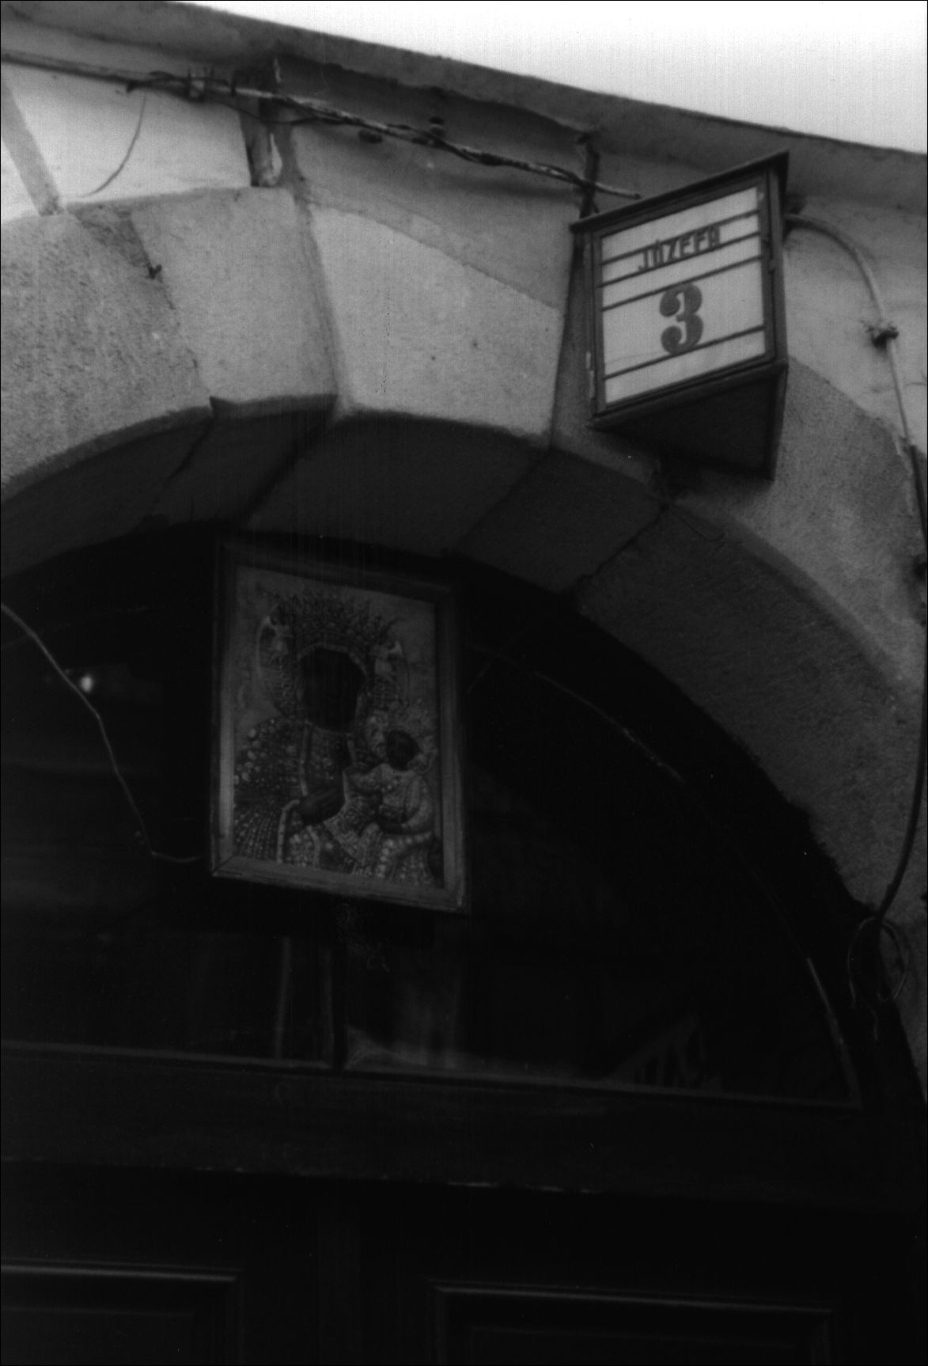
22
The Image and the Figure

3. The oldest legends about the image and how it came
to Jasna Góra
Table I is based on the work of Henryk Kowalewicz and Zofia Rozanow, who col-
lected and edited the oldest textual versions of the Jasna Góra legend. This table
shows the progressions of the origin stories according to several different sources.
It is useful to note the similarities and differences in the various sources.46
3. Image of Our Lady of Częstochowa at the entrance to a building, Kraków (Photo: Anna
Niedźwiedź)
46 See Najstarsze historie.
Stories of Origin
23

a) Translatio tabulae
The oldest known version of the Jasna Góra legend is considered to be the Latin
text entitled Translatio tabulae Beatae Mariae Virginis, quam sanctus Lucas de-
pinxit propriis manibus, which is preserved in the form of a manuscript in the
Pauline Monastery at Jasna Góra. According to what Henryk Kowalewicz and
Zofia Rozanow have ascertained, the manuscript was likely completed in 1474
(this date is seen on the last page of the codex), but it is an exact copy of an earlier
text. Kowalewicz and Rozanow assume that the original work came into being
between the year 1393 and 1430. The text mentions King Władysław Jagiełło
and his second founding and equipping of the Jasna Góra Monastery in 1393. By
contrast, it does not mention the 1430 Hussite attack on the monastery. This seems
to indicate that the work originated after 1393 but before 1430.47

b) Historia declaratoria/Hie volget dy historie
The second text of the legend is preserved in two versions: a Latin one entitled,
Historia declaratoria, quo pacto imago Virginis Mariae de Hierusalem in Clarum
Montem translata fuit, and a German version entitled, Hie volget dy historie...
The Latin text is preserved in the form of a manuscript from the end of the six-
teenth century located on the second and thrid pages of the first volume of the
Jasna Góra Liber Miraculorum. Similar to the case of Translatio tabulae., the
preserved version is a copy of an earlier text. It is difficult to determine the date
of the original. More than likely, the content of the legend concerning the paint-
ing of the image and its transfer to Jasna Góra was written before the year 1430.
After the sequence of events describing the arrival of the image to Częstochowa,
the texts of three prayers are recorded and only after these, there is a short note
about the attack of 1430. In an English translation the fragment reads as follows:
The year of our Lord 1430, on the nearest Wednesday after Palm Sunday, roaming
Hussites plundered our monastery of all its riches and wounded the holy image; these
wounds could not be fixed by any artistic means.48
It is important to emphasize that, according to the estimations of archivists, the
preserved text Historia declaratoria... is more than likely a copy of a devotional
printed work or the manuscript of a text intended for printing in the year 1514.49
This type of printing appeared in the sixteenth century in the form of poster prints
which were hung in churches, as well as during church feasts in places visited by
47 However, there is still scholarly debate about the age of legendary stories. New ar-
guments are regularly proposed by historians working on the old texts. Written versions, to
a certain extent, were based on oral tradition. For a discussion about determining the age of the
Translatio tabulae see e.g. T. Kos, Fundacja Klasztoru Jasnogórskiego w świetle nowej inter-
pretacji źródeł (Kraków, 2002), pp. 117-121 and p. 160. See also Najstarsze historie, p. 63.
48 See ‘Historia declaratoria’, Najstarsze historie, p. 99.
49 This date appears in the final part of the manuscript - at the end of one of the prayers,
before the annotation about the attack of 1430.
24
The Image and the Figure
pilgrims. Evidence to support this hypothesis comes from a preserved German
version of the Latin text: Hie volget dy historie..., which - according to the esti-
mations of historians - is a printed translation of the text Historia declaratoria...
into German.50 This is a prayer poster dated 1515, or 1516 to 1524.51 The printed
matter was discovered in 1932 by K. Piekarski in bookbinding wastepaper and was
given to the Jagiellonian Library in Kraków. Additionally, the Library’s collection
includes another - very badly damaged - copy of the print. Henryk Kowalewicz
and Zofia Rozanow posit that similar prayer posters, possibly produced by means
of the same wood-engraving decorative elements, were published in Latin (which
would have constituted the basis for the German version) as well as in Polish.52

c) Historia venerandae...
The third text is the first work not by an anonymous source - rather it was written
by the Polish magnate Mikołaj Lanckoroński. Many researchers believe that the
original dates from 1517 when the author likely personally handed the codex to
the Polish king, Zygmunt I53. Historia venerandae imaginis Beatae Mariae Vir-
ginis, quae in Claro Monte in magna veneratione habetur has been preserved to
the present day in the form of a transcript drawn up in the mid seventeenth century
by the Pauline Father, Piotr Lasota Rybicki. A copy of the work is held in the Os-
solineum Library in Wrocław. This work constitutes a special document because,
in addition to the text, it contains miniature illustrations of the legendary history
of the image. It is very probable that the miniatures placed within the preserved
version of the codex represent a more or less faithful copy of the original illustra-
tions which adorned the sixteenth-century manuscript.54 The six miniatures that
illustrate the text depict the following scenes:
- the presentation of the codex by Mikołaj Lanckoroński to King Zygmunt I;
- Saint Luke writing the beginning of the Gospel in the presence of the Vir-
gin Mary and women from Jerusalem at the house of Zebedee;
- The transfer of the table top by women from Jerusalem;
- The painting of the image by Saint Luke;
50 As Jan Pirożyński notes: “A comparison of the two accounts, the Latin and the German,
shows their almost total agreement. The German text appears to be a translation of the Latin -
maybe not literal but fairly faithful. Almost every German sentence has a Latin equivalent, the
order of events is completely preserved. Certain differences result from the fact that we are not
dealing with a literal translation, and because the structures of sentences in Latin are so differ-
ent from structures in German sentences.” J. Pirożyński, ‘Najstarszy zachowany, drukowany
przekaz legendy o obrazie Matki Boskiej Częstochowskiej’, Biuletyn Biblioteki Jagiellońskiej
1-2 (1973), p. 160.
51 Ibid., pp. 153-154.
52 See Najstarsze historie, p. 93.
53 Ibid., pp. 116-118.
54 Ibid., pp. 115-116.
Stories of Origin
25
- The transfer of the image by cart from Bełz to Jasna Góra and the miracle
with the horses;
- The attack of 1430 and the desecration of the image.
The text by Mikołaj Lanckoroński differs from other legends because of its devel-
opment of the theme concerning the Empress Helena and the Byzantine history of
the image. Due to his diplomatic duties, as well as his own interest, the author had
personally been to Constantinople - there he had enquired “about this reverend
image [...] amongst monks of the Greek order.”55 He was also acquainted with
the collections of sacral art preserved in Aachen.56 He introduced a tale about
collections in the text of Jasna Góra legend, connecting the story with figure of
Charlemagne (Table I, point 2a).

d) Historia pulchra...
The fourth text of the Jasna Góra legend also comes from the first half of the
sixteenth century. This is a printed book, published in Kraków in 1523 and en-
titled, Historia pulchra et stupendis miraculis referta Imaginis Mariae, quomodo
et unde in Clarum Montem Czastochowiae et Olsztyn advenerit. The author of
the Latin text, Piotr Rydzyński, repeated - with certain changes - the versions
of older legends. The title page is adorned by a wood engraving with a likeness
of the image. The print has been preserved in a single copy which is kept at the
Ossolineum Library in Wrocław. There is also a sixteenth-century, hand-written
copy of the print at the Cathedral Chapter Library in Gniezno.
The work is composed of two parts. The first tells of the legendary history of
the image, and ends with the tale of the attack on the monastery in 1430 and the
restoration of the image in Kraków. The second part of the work encompasses the
72 miracles ascribed to the Jasna Góra image.

e) Historyja o obrazie...
In the course of the sixteenth century, a translation of Piotr Rydzyński’s work
into Polish was produced. The translation, prepared by Mikołaj of Wilkowiecko,
appeared in print around the year 1568 under the title Historyja o obrazie
w Częstochowie Panny Maryjej i o cudach rozmaitych tej wielebnej tablice
(The History of the Image in Częstochowa of the Virgin Mary and of the various
miracles of this reverend board). One incomplete copy of this edition is preserved
55 Lanckoroński, ‘Historia venerandae’, Najstarsze historie, p. 134.
56 For details of Mikołaj Lanckoroński’s journey to Constantinople as well as to Aachen
see M. Kowalewiczowa, ‘Przyczynek do akwizgrańskiego wątku historii’, Przegląd Powszech-
ny 4 (1982), pp. 60-72. For additional information concerning Mikołaj Lanckoroński’s jour-
ney to Constantinople see also A. Różycka-Bryzek, ‘Mikołaja Lanckorońskiego pobyt w Kon-
stantynopolu w roku 1501 - nie tylko posłowanie’, Folia Historiae Artium. Seria Nowa 5-6
(1999-2000), pp. 79-92.
26
The Image and the Figure
in the Jagiellonian Library in Kraków. Similar to Rydzyński’s work, the title page
of the print is adorned with a wood-cut representation of the Jasna Góra image.
The part of the text by Mikołaj of Wilkowiecko containing the description of the
legendary history of the image is assumed to be “a Polish truncated translation of
the Latin work.”57 In this version, several fragments of the original are passed over
(for example the description of Ruthenia). The second part of the work has many
more changes mainly in the list of miracles. In the Polish version of the text, some
of the miraculous examples are left out, adding a series of new miracles which
were recorded after the appearance of the Latin print.

4. Translations of the image - variations of texts
The oldest texts presented in Table I show that the history of the image creates
a collection of sequences that aims to show the miraculous power of the image
that displayed itself during subsequent stages of its history.58 The first sequence
- describing the painting of the image by Saint Luke (see Table I, point 1) - ap-
pears in all versions of the legend. The subsequent history of the image reveals the
development, supplementation and consequence of the specific - acheiropoietic
- status of the painting.
The journey of the image from Jerusalem to Częstochowa is the most highly-
developed part of the Jasna Góra legend (see Table I, points 2-6). The image’s
journey, filled with various difficulties and adventures, ends up in Częstochowa,
and - as all the versions emphasize it - it is the image itself, which decides about
its final resting place.59
The journey of the image is performed according the legends in three stages:
- the transfer of the board from Jerusalem to Constantinople (see Table I,
point 2);
- the movement of the image to Ruthenia (see Table I, point 3);
- the transfer of the image to Poland (see Table I, point 6).
During passage the image manifests its sacral powers. Characteristically, vari-
ous Christian rulers appear in the stories as people who are able to recognize the
57 Najstarsze historie, p. 206.
58 Here I focus on the symbolic meanings of legends and how people perceive them. Ho-
wever, to certain extent I also refer to considerations that concern the credibility of legendary
facts and historical reality in these notes. The relationship of legends to historical sources and
facts are, after all, the subject of specific research and the realm of historians and archivists see
e.g. Kos, Fundacja Klasztoru Jasnogórskiego, pp. 124-147.
59 Joanna Tokarska-Bakir also draws attention to the theme of the active nature of holy
images in etiological legends. According to her the active nature of the picture “is a permanent
element of etiological legends: the holy image is not an object devoid of will. The picture wants
to fully become itself - it wants to redeem and therefore it wants to be noticed.” Tokarska-Bakir,
Obraz osobliwy, p. 352.
Stories of Origin
27
power residing in the board, as well as those who covet the image and wish to take
it with them. In this way, the subsequent owners of the image become unwitting
implementers of “God’s will.” The legends ascribe the passage of the image from
Jerusalem to Constantinople to the Emperor Constantine, to Saint Helena or to
Charlemagne (see Table I, point 2).
The second stage of the journey is the transfer of the image to Ruthenia. All
of the versions of the legend connect this fact with the figure of Prince Lev (See
Table I, point 3). It follows that the Jasna Góra legend, in accordance with the
mythical and symbolic order in the story, ignores the chronological principles of
history. Often the legendary heroes appear at times and in situations which run
contrary to the historical chronology. For example, the Ruthenian Prince Lev as
a historical figure lived in the thirteenth century (d. circa 1301) while, as Czesław
Deptuła notes, in the Jasna Góra tales the prince
[...] moves freely [...] across many centuries. For example [...] in relation to the
legend of Charlemagne’s pilgrimage to Jerusalem, it is said that the image is brought
from the Holy Land to Constantinople by Charlemagne himself and it is he [Charle-
magne], who presents it to Lev.60
The figure of Charlemagne (d. 814) as the person who donates the image to the
Ruthenian prince, appeared in the sixteenth-century versions of the legend (in
the oldest versions of the legend, this is carried out by the Emperor Constantine
- d. 337). In the sixteenth century the Polish Commonwealth was in conflict with
Muscovy. It is probable that emphasizing the Byzantine roots in the story (the
figure of Constantine) of the Jasna Góra image started to be - in those circum-
stances - inadvisable. Moreover, the author (Mikołaj Lanckoroński), as well as
the readers of his work, lived at the time of Byzantium’s collapse. The fall of
Constantinople to the Turks in 1453 - and the resulting end of the Empire - were
important events that influenced the world of politics as well as the cultural ideas
of the inhabitants of Europe.61
The final stage of the image’s journey is connected (by legends) to the Polish
Duke Władysław Opolczyk (Ladislaus of Opole) (see Table I, points 4-6). In
historical terms, the duke was undoubtedly linked with the earliest history of the
Pauline Monastery on Jasna Góra. The legal acts connected with the foundation
of the monastery, erected in 1382, are authenticated by Władysław Opolczyk’s
signature.62 It is, however, difficult to establish who, in actual fact, first invited the
Order of St Paul the First Hermit (popularly known as Paulines) from Hungary
to Częstochowa. It is also difficult to conclusively say who founded and financed
60 Cz. Deptuła, ‘Święte góry w dawniej Polsce’, Miejsca rzeczywiste. Miejsca wyobrażone.
Studia nad kategorią miejsca w przestrzeni kultury, ed. M. Kitowska-Łysiak and E.Wolicka
(Lublin, 1999), p. 238.
61 See Zakrzewski, W kręgu kultu maryjnego, p. 63.
62 See Rozanow, ‘Dzieje obrazu i fundacja Jasnej Góry’, Najstarsze historie o Często-
chowskim Obrazie Panny Maryi XVi XVI wiek, ed. H. Kowalewicz (Warszawa, 1983), pp. 6-7.
28
The Image and the Figure
the Jasna Góra Monastery. According to many researchers, the founding of Jasna
Góra was associated with King Louis of Hungary, and Duke Opolczyk merely
carrying out his will.63 Some claim, however, that the duke himself was the real
and only founder of the monastery.64
Regardless of who brought the Pauline Order to Częstochowa, there is no ref-
erence to the image of Our Lady in the oldest documents concerning the founding
of the monastery in 1382.65 More than likely, the image found its way to Jasna
Góra only in 1384 or even later.66 To date, it has not been possible to establish
what the history of the image was prior to this period. It is also unclear who pos-
sessed the image and who brought it to Częstochowa (and what means they used
to transport it).
At the same time all of the oldest legends ascribe the role of the donator of the
image to the Duke Opolczyk. More than likely Władysław Opolczyk’s connec-
tions with the Pauline Order were strong enough that the versions of the Jasna
Góra legend chronicled in monastic circles credited the duke with bringing the
image to Poland. Certain researchers even speculate that the text of the oldest
legend about the image Translatio tabulae came about upon Duke Opolczyk’s
initiative and while he was still alive, i.e. before the year 1402.67 This is borne out
by the numerous entries in the text of the manuscript praising the duke.
63 See e.g. K. Pieradzka, Fundacja klasztoru jasnogórskiego w Częstochowie w 1382 roku
(Kraków, 1939).
64 There is an ongoing discussion about the role of Duke Władysław Opolczyk in the oldest
history of the Jasna Góra Monastery. Sykstus Szanfraniec initially argued that King Louis of
Hungary was the founder of the monastery [see S. Szafraniec, ‘Jasna Góra. Studium z dziejów
kultu Matki Boskiej Czestochowskiej’, Sacrum Poloniae Millenium 4 (Rome, 1957)]. How-
ever, after further research he claimed that Duke Opolczyk originally funded the monastery
[see Rozanow, Dzieje obrazu, p. 7]. The latest research by Tadeusz Kos reveals a deep analysis
of documents concerning the oldest history of the Jasna Góra Monastery. T. Kos interprets old
texts in the legal and cultural background of the epoch. In the conclusions, he questions the
significance of Duke Opolczyk in the founding of the monastery. Kos found numerous inac-
curacies (as well as substantial ambiguities) in the documents drawn up by Duke Opolczyk’s
chancellery. He also presents mistaken interpretations (based on these inaccuracies) that are
repeated in historical works about the beginnings of the monastery in Częstochowa. See Kos,
Fundacja Klasztoru Jasnogórskiego.
65 Kos, Fundacja Klasztoru Jasnogórskiego, p. 57.
66 The date 1384 appears in the version of the legend recorded by Piotr Rydzyński. See
Najstarsze historie., p. 172. In the Polish translation of the legend (which Pauline Father
Mikołaj of Wilkowiecko completed in the late sixteenth century) a fragment reads: “[...] from
Ruthenia to Jasna Góra this reverend board was transferred in the year of our Lord 1384 - on
the Wednesday after Saint Bartholomew’s Day.” Najstarsze historie, p. 211. However, Tadeusz
Kos points out that there is no mention of the miraculous image in Duke Opolczyk’s document
dated 19 January 1385, about the changes in the monastery’s endowment. See Kos, Fundacja
Klasztoru Jasnogórskiego, p. 58. On the subject of when image arrived in the Jasna Góra Mon-
astery see also S.J. Rożej, ‘Dzieje Obrazu Matki Bożej Jasnogórskiej’, Maryja Matka Narodu
Polskiego, ed. S. Grzybek (Częstochowa, 1983), pp. 22-23.
67 A. Różycka-Bryzek, ‘Obraz Matki Boskiej Częstochowskiej. Pochodzenie i dzieje śred-
niowieczne’, FoliaHistoriae Artium 26 (1990), p. 8. According to T. Kos, the text of the legend
Stories of Origin
29
At any rate, in all legendary versions Duke Opolczyk brings the image to
Częstochowa. In all the stories it is said that, after recognizing the power of the
image, the duke desired to keep it for himself and decided to transport it from
Ruthenia to his homeland. However, in transferring the image, he unconsciously
fulfilled “God’s will,” while on the way to his Duchy the miracle with the horses
was said to have taken place.68 The descriptions of the events are similar in vari-
ous versions of the legend: the animals that are pulling the cart in which the mi-
raculous board is situated do not want to go on. The people have to interpret the
horses’ behavior and understand it as a sign sent to them by God. The miracle
takes place in various moments - either before Opolczyk’s departure from Bełz
(the version given by Translatio tabulae, Historia declaratoria and by Mikołaj
Lanckoroński; see Table I, point 6), or in the vicinity of Jasna Góra (see the works
of Piotr Rydzyński and Mikołaj of Wilkowiecko; Table I, point 6). The signifi-
cance of the legendary story about the animals being unable to move from the spot
highlights the religious and symbolic dimension of the oldest Jasna Góra legends.
The story about the travels of the image (Table I, points 2 to 6) appears in vari-
ous versions and it changes dependending upon the political and social context in
which various texts were written. However, the religious and symbolic expression
of all of the oldest legends is common and emphasizes the sacred powers con-
tained in the image. Various themes in the versions of the story were themes that
were broadly-known and popular in medieval European Christian culture - both
in the East and West. The most important themes include the story of the wound-
ing of the image as well as the story of the miraculous defense of the fortress.69 In
the oldest legends about the trials and tribulations of the Jasna Góra image, these
two stories mutually supplement each other, creating a narrative on the defense of
Bełz against Lithuanians, Tatars or Scythians (see Table I, point 5). The wounding
of the image by an arrow during the siege is interpreted as a moment of the mani-
festation of the image’s power. This leads to divine intervention, achieved through
the power of the image. This event - according to the legendary narrative - is also
the turning point leading to the transfer of the image from Bełz to Poland. Mikołaj
of Wilkowiecko relates:
was written down later, to a large extent on the basis of an orally conveyed tradition. T. Kos
recalls - quoting S. Szafraniec - that the form and layout of Translatio tabulae constitutes
a copy of the description of the transfer of the relics of Saint Paul the Hermit from Egypt to
Hungary via Constantinople and Venice. See Kos, Fundacja Klasztoru Jasnogórskiego, p. 141
and p. 160.
68 “The miracle with the horses/oxen” appears in many etiological legends of other images
considered miraculous. See e.g. Miejsca święte Rzeczpospolitej. Leksykon, ed. A. Jackowski
(Kraków, 1999).
69 Here I will only emphasize the presence of the said themes in the oldest Jasna Góra
legends. I will return to the problem in later parts of the book. I write on the subject of the story
of the wounded image in Chapter II, while in Chapter III, I analyze the miraculous defense.
30
The Image and the Figure
Having seen this power [here the reference is to the miraculous victory at Bełz] the
Duke [.] attempted to take the image [.] to the Silesian city of Opole.70
The stories about the miraculous defense of Bełz can be also interpreted as an
expression of the palladial and apotropaion dimension of the cult of the image
(i.e. the image as a powerful object protecting its owner and the place where it is
kept). This protective aspect of the image is also revealed in many other narrative
sequences of legends (e.g. it is mentioned that the Ruthenian Prince Lev wanted
to possess the image because he believed in its special power).
The designation of the Jasna Góra image as the palladium (protective image)
of the Jagiellonian dynasty undoubtedly helped and reinforced the development
of the story thread exhibiting this theme of the legend.71
It is worth noting that versions of the legend written down in the first half of
the sixteenth century, refer the story of origin and journey of the image, as well as
the historical attack on the Jasna Góra Monastery in 1430 (also included are ac-
counts of the repair of the image) (see Table I, points 7 and 8).72 In this way, they
established a new type of story about the Jasna Góra image - a story combining
the legendary history of the image with the history of Jasna Góra and events of
state significance (the repair of the image took place in Kraków - at that time the
capital of the Polish Kingdom). Over time this new - great story - about the im-
age as a symbol uniting the community, started by supplant the older legendary
narratives.

5. The contemporary legends of origin
In this section, I will present the contemporary “legends of origin” as they are
known among Polish Catholics at the beginnings of the twenty first century.
Whereas, in the previous section, the focus was on texts written in the fifteenth
and sixteenth centuries, in this part I rely on material from ethnographic field
research as well as some printed materials (brochures, Catholic newspapers etc.)
popularizing knowledge about the image among pilgrims to the Jasna Góra Mon-
astery. Specifically, I will explore how the old legends and themes - rooted in
medieval Christian culture - are represented, transformed and adopted in con-
temporary consciousness and popular religion. I will also point out that, in many
cases, a contemporary academic discourse about the origins of the image of Our
70 Mikołaj of Wilkowiecko, ‘Historyja o obrazie w Częstochowie’, Najstarsze historie,
p. 211.
71 See Zakrzewski, W kręgu kultu maryjnego, pp. 71-72.
72 The note on this subject - which is found in the document Historia declaratoria - does
not belong to the basic layer of the text. It was likely written in by a scribe who copied the text
(which had been written prior to 1430). In Chapter II I deal with the subject of the meanings of
the attack of 1430 as well as the repair of the image in Kraków.
Stories of Origin
31
Lady of Częstochowa became popularized and simplified. In this simplified form,
academic findings were incorporated into old schemas of legends of origin as well
as into a religious context.
Interpreting my field research, I focused on the answers given by interviewees
to the questions: Where did the image of Our Lady of Częstochowa come from?
How old is it? What do you know about the origin of the image? and Who painted
the image? Analyzing the answers, I distinguished five basic groups of views con-
nected with origins of the image.
I
The tradition concerning Luke’s hand in the origin of the image is present in many
answers. It is not surprising as numerous publications and guide books (designed
for pilgrims and tourists visiting Jasna Góra) present the legend about St. Luke
in a semi-fairy-tale fact form.73 The figure of Saint Luke painting the image and
a traditional version of the legend appear both in the answers received in the in-
terviews and the questionnaires (in many of these St. Luke is interchanged with
other apostles - for example John, Mark and even St. Peter. This is consistent
with the principle of interchangeability - mixing various figures within the same
category).
It is difficult to define how informants really see and understand the legend. In
many answers it seems that the story of Saint Luke being the author of the image
is not treated as being very credible. It is, however, worth noting that very often it
is cited as the only accessible source of knowledge for the individual questioned
on the subject of the image’s origins.
The image was probably painted by Luke the Evangelist on a board from the table of
the Last Supper74
- answered one of the older interviewee from a southern part of Poland. Her peer
from a small village situated in eastern Poland also revealed knowledge that was
based on an old legend:
It was Saint Luke who painted the image of the Jasna Góra Virgin on a lime board
taken from the table of the Last Supper.75
However, more often informants emphasized their distance to the version con-
cerning Saint Luke, saying that they consider it just as an old legend and a legen-
dary tradition. The following responses were obtained for the question: What do
you know about the origin of the image?
73 See e.g. J. Pach, W. Robak, J. Tomziński, Jasna Góra. Sanktuarium Matki Bożej (Jasna
Góra-Częstochowa, 1997), p. 8. See also A. Kubajak, Najsławniejsze sanktuaria Polski (Kra-
ków, 2000), p. 25.
74 No. 11/int., f., b. 1925.
75 No. 17/int., f., b. 1926.
32
The Image and the Figure
- According to legend the image was painted by Saint Luke;76
- According to legend the image was painted by Saint Mark on a lime board;77
- The image was brought by Władysław Opolczyk in the fourteenth century. Oral
accounts say that it was painted by Saint Luke;78
- According to legend the image is the work of Saint Luke the Evangelist, who
painted it after the Assumption.79
The informants admit that “in actual fact” they do not know where the image of
Our Lady of Częstochowa comes from or how old it is and who painted it. At the
same time, they freely recall the only version known to them which they term as
“legendary.”
Further analysis of the material enables one to distinguish a group of indi-
viduals who clearly differentiate between the legendary themes and the academic
hypotheses. When asked about the legend of origin they usually give answers
recalling Saint Luke:
- The image of Mary was painted by Saint Luke the Evangelist on a table top;80
- It was painted by Saint Luke on a board from the table from Nazareth.81
At the same time when asked about the origin of the image they present popular
historical knowledge on the subject and state, for instance, that the image comes
from:
[.] the fifteenth century, a copy was brought by Duke Władysław Opolczyk;82
or:
[.] from the Byzantine-Ruthenian school, since 1384 at Jasna Góra, brought for cer-
tain by Duke Opolczyk.83
II
The second group of answers shows no memory of the legendary tradition about
the origins of the image. The legends of the origin of the image are not recalled.
The interviewees do indicate, however, the fact that the image of Our Lady of
No. 22/ques., f., b. 1950.
No. 59/int., m., b. 1949.
No. 12/ques., f., b. 1940.
No. 61/ques., m., b. 1979.
No. 9/ques., f., b. 1935.
No. 21/ques., f., b. 1950.
No. 9/ques., f., b. 1935.
No. 21/ques., f., b. 1950.
76
77
78
79
80
81
82
83
Stories of Origin
33
Częstochowa “came to Poland” from some other, foreign, country. Their knowl-
edge is expressed in a reply characteristic for this group:
The image was brought from somewhere, but I don’t know from where.84
The respondents also emphasize in their statements that the image is “very old”85
and that “a very long time ago” it was brought to Częstochowa “from somewhere
far off,”86 “not from Poland,”87 and its painter was “not one of ours, not a Pole.”88
These views are summed up in one of those questioned according to whom
[.] it’s been in Poland for six hundred years for sure. I don’t know where it came from
but for sure it wasn’t painted in Poland.89
III
The third group of answers reveals an echo of the academic discussion conduct-
ed by historians, conservators and art historians since the 1930s. Contemporary
devotees seem to have synthesized academic texts and expert opinions regarding
the age and origin of the image (popularized in religious journals and magazines).
These scientific and pseudo-scientific sources, often quoted and referred to by
priests during sermons, are sometimes treated by contemporary Polish Catholics
as stories that replace the image’s old legends of origin.90 In the replies given by
interviewees one can find varied popularized scientific opinions about the genesis
of the image (compare with Table II).
Frequently opinions were expressed that pointed to the Byzantine-Ruthenian
cultural area as a place of origin of the image. Typical answers within this group
were as follows:
- The Orthodox people have icons. I suppose that the image of Our Lady of Często-
chowa could have been painted by some Orthodox painter from Constantinople,
and then made its way here in the sixteenth or seventeenth century;91
- [the image is] an icon which comes probably from the Ukraine, and was brought
by some king or other;92
84 No. 22/int., m., b. 1927.
85 No. 71/int., f., b. 1958; also e.g.: No. 86/int., f., b. 1971.
86 No. 67/int., f., b. 1954.
87 No. 34/int., m., b. 1932.
88 No. 44/int., f., b. 1937.
89 No. 74/ques., f., b. 1980.
90 There are many hypotheses concerning the time and place of creation of the image of
Our Lady of Częstochowa. I present the comparisons of the various theories on the origin and
age of the image, as well as a basic bibliography on the subject, in Table II.
91 No. 42/int., f., b. 1936.
92 No. 11/ques., f., b. 1939.
34
The Image and the Figure
- [the image] belongs to medieval forms of panel painting which have their origins
in the Orthodox Christian tradition;93
- [.] it is more than likely that the image comes from Constantinople, from there
through Ruthenia it ended up in Poland;94
- [the image] comes I think from the fourteenth century, it’s an icon brought from the
East.95
Many people claimed that the image was brought to Poland from Hungary:
- [the image was] brought by the Pauline fathers, probably from Hungary;96
- the image was brought from Hungary by some king.97
There was also a group of interviewees who recounted the so-called “Italian hy-
pothesis” concerning the origin of the image:
- [the image] was brought to Poland around the year 1380 from Italy;98
- [...] more than likely the image is from the fourteenth century - of the Italian
school;99
- [the image] was painted in the Middle Ages, probably in Italy or France;100
- It seems to me that the image comes from Italy;101
- [the image] found its way to Poland from southern Europe;102
- More than likely the Częstochowa image comes from Italy from the fourteenth
century, later through Hungary it found its way to Poland.103
IV
In the fourth group of statements, the image of Our Lady of Częstochowa is inter-
preted as first and foremost a miraculous image. The informants whose statements
93 No. 16/ques., f., b. 1948.
94 No. 3/ques., f., b. 1924.
95 No. 39/ques., m., b. 1972.
96 No. 20/ques., m., b. 1950.
97 No. 14/int., f., b. 1925.
98 No. 23/ques., f., b. 1953.
99 No. 87/ques., f., b. lack of data.
100 No. 71/ques., f., b. 1980.
101 No. 68/ques., m., b. 1980.
102 No. 51/ques., f., b. 1977.
103 No. 77/int., f., b. 1960.
Stories of Origin
35
are found in this group do not know the “traditional” versions of the Jasna Góra
legend. They are, however, convinced that the picture ended up at Jasna Góra in
an unusual way. One typical answer given in this group sounds very explicit:
The image of Our Lady of Częstochowa appeared in a miraculous way.104
Some interviewees gave more details of this “miraculous way” to Częstochowa.
Often, they recalled stories about the image of Our Lady of Częstochowa which
are known in connection with other miraculous images in Poland. In the inter-
views, for instance, there were appearances of stories about the plowing up of
the image by a farmer (this legend was originally connected with a small Marian
statute known in Poland as Our Lady of Gidle). In addition to this, there were sto-
ries of the appearance of the image on a rock or on a tree (“I don’t know where the
image of Our Lady of Częstochowa comes from - probably like other images, it
was found on a tree in a forest.”105)

V
In the fifth group, the story which included the earliest legends of the origin of the
image has been forgotten. Characteristic statements for this group were:
- The image has always been at Jasna Góra;106
- The image is six hundred years old - in the 1980s it upheld its jubilee.107
Many people admit that they are unable to say anything about the genesis of
the image - the image “simply” has “always” been in Częstochowa, and the story
about the picture has its beginnings in 1382.108 In this group of statements, one can
clearly see the domination of a new story about the image - a story within which
the fate of the picture is interpreted as “always” closely connected with Polish
lands and Polish history.
* * *
The contemporary etiological legend of the image of Our Lady of Częstochowa,
reconstructed on the basis of the material from field research, consists of a col-
lection of stories about various origins of the image, often with significant differ-
ences from earlier stories. Finally, these stories are often found in new contexts
104 No. 46/int., f., b. 1938.
105 No. 24/int., m., b. 1927.
106 No. 66/int., f., b. 1953.
107 No. 53/int., f., b. 1939.
108 The informants remember the celebrations of the six-hundredth anniversary of the Jasna
Góra Monastery and often refer to this date. In many of the statements, there appear beliefs that
the image has been at Jasna Góra “since the beginning of Poland’s existence” or “for a thousand
years” or “from Poland’s adoption of Christianity [966].”
36
The Image and the Figure
and told with varying degrees of coherence. Analysis of various versions of the
story raises questions about today’s understanding of the image: Does the image
of Our Lady of Częstochowa still hold the status of acheiropoietos? Does today’s
consciousness maintain - so fundamental in former tales - the conviction as to
the superhuman and miraculous origins of the picture? Can one still talk about the
miraculous status of the image? And if yes, in what way? And in which contexts?
What significance is borne today by former symbols? Has their “symbolism” be-
come weakened by chance? Has the so-called symbolism been stripped of its
deeper meanings? Can the religious language of the past, called upon in a contem-
porary context, still remain the language of religion? Or is it just a cultural form
of a preserved tradition?
When examining the statements (collected in field research) concerning con-
temporary imagination regarding the beginnings and oldest history of the image,
it is notable that more than once there is an emphasis on the otherness of the paint-
ing’s origin. Many interviewees expressed the conviction that the image “comes
from afar,” “not from Poland,” and that it was painted “not by one of ours, not
a Pole” (see group II). In the quoted statements, the category of the other often
appears in relation to the genesis of the image of Our Lady of Częstochowa. It
seems that in the eyes of my informants the unusual, alien, other, “not-ours,” or
mysterious origins of the image additionally predestine the object to fulfill the role
of intermediary between the world of God and that of man. The holy image - the
mediatory object itself - comes to Poland from a place referred to as “not ours,”
a different world. It is seen - from the very start - as accompanied by an aura of
mystery.
In the versions of the legend which incorporated the stories of images ap-
pearing on trees or being plowed up from the earth (see group IV), the alien and
“non-temporal” provenance of the painting is presented directly. According to
Joanna Tokarska-Bakir, images accompanied by legends of origin connected with
elements (e.g. water, earth) or nature (e.g. a tree) constitute their own version of
acheiropoietos. This author, analyzing varied etiological legends of miraculous
images, considers that:
[.] when the elements help man out in the work of creating an image then it is par
force “not made by human hand, acheiropoietos.”109
The acheiropoietic status of the image appears in a variety of contemporary
contexts, however, it is not often revealed explicitly. When analyzing various
texts which describe the image recalling the perspective of art history, I noticed
strikingly frequent descriptions of a “mystery of genesis” of the image. Below
are several characteristic examples of the various contemporary texts (academic
works as well as devotional popular texts) concerning the beginnings of the im-
age:
109 Tokarska-Bakir, Obraz osobliwy, p. 315.
Stories of Origin
37
The origin of the image of Our Lady of Częstochowa is still enveloped in mystery.
The further the investigations go, the more difficulties emerge. Besides the legend of
Saint Luke, there have been numerous academic hypotheses which place the image
within the area of Byzantium or Ruthenia, or within the Hungarian circles, or in Italy,
or in Bohemia [...];110 [emphasis added] (from a Catholic monthly magazine on reli-
gious, social and political issues)
[...] the mystery of origin, which according to the words of Walicki, appeared “at
the very threshold of the history of art that has been preserved and handed down to
us in Poland” [M. Walicki, Malarstwo polskie - gotyk, renesans, wczesny manieryzm,
Warszawa 1961, p. 14], arouses the understandable interest of art historians, historians
of cult worship etc.;111 [emphasis added] (from a scholarly journal)
As an artifact, the image does not fit into categories of a defined historical style, even
though it is an exceptional piece presenting the idea of divine maternity in strict as-
sociation with artistic form (which fascinates anyone, regardless of the degree of reli-
gious involvement). The mysterious and atypical image of Our Lady of Częstochowa
has been the subject of much research and controversial hypotheses [...] The origin
and time when it was created still remain a subject of discussion;112 [emphasis added]
(from an entry in “Encyclopedia of Catholicism”)
For centuries, having drawn the attention of the faithful, the Miraculous Image still re-
mains a mystery for art historians. The time and place of its creation has not yet been
established exactly.113 [emphasis added] (from a popular Catholic magazine)
The stylistic practice of referring to the “mystery” constitutes a common rhetori-
cal procedure expressing the powerlessness of science which is unable to answer
the questions about the image’s origins. In many cases, the use of the word “mys-
tery” implicitly connotes religious meanings which texts that aspire to be “aca-
demic” are unable to express explicitly.
The “unknown,” “not fully explained,” “mysterious” origin and history of the
image become, for the general recipient, a contemporary version of the story about
the image “not made by human hand.” On the basis of mythical thinking - the
“unexplained,” “unknown” origins constitute de facto miraculous origins.114 The
old legends symbolically described the transfiguration of the image into a specifi-
cally comprehended relic. Careful reading of contemporary texts about the image
reveals exactly the same pattern of the story. As in the description of the restora-
tion work conducted on the image of Our Lady of Częstochowa during the course
of the twentieth century:
110 ‘Z historii obrazu jasnogórskiego’, Przegląd Powszechny 4 (1982), p. 59.
111 W. Kurpik, ‘Podłoże drewniane obrazu Matki Bożej Jasnogórskiej’, Studia Claromon-
tana 5 (1984), p. 8.
112 Encyklopedia katolicka, vol. III (Lublin, 1979), pp. 853-854.
113 ‘Z dziejów Cudownego Obrazu’, Nasza Arka. Miesięcznik Rodzin Katolickich 7 (2001),
p. 4.
114 In the legends about the origins of holy images “unknown origins” are symbolically
treated as “miraculous origins.” See Tokarska-Bakir, Obraz osobliwy, p. 310.
38
The Image and the Figure
The mysterious board of the Jasna Góra image, made, according to tradition, from
a top of the table from Nazareth, belongs to that group of relics of the ranking of the
house in Loreto or the Turin Shroud and is the subject of constant research and contro-
versial statements.115 [emphasis added]
Sentences closing the report on the conservation work again recall the religious
meanings of the image:
In ending my words I will allow myself to repeat that the image of the Jasna Góra
Virgin Mary, being a relic, should be subjected to special care and any interference
in the physical substance of the image [connected with scientific research performed
on the image] must be one with an exceptionally important aim.116 [emphasis added]
In a popular guidebook published to mark the six-hundredth anniversary of the
image being at Jasna Góra the legend and history of the image is presented in the
following words:
Old legends tell that Władysław Opolczyk, governor of Ruthenia, found the ancient
image of Mary in Bełz. The said image had been painted by Saint Luke the Evangelist
on board from the table of the Holy Family. The image-relic had been received by the
Ruthenian Prince Lev [.] from Byzantine.
In the next paragraph:
The appearance of the relic brought a fundamental change of the role of the Pauline
Order [...].117 [emphasis added]
In concluding reflection on the contemporary status of the image of Our Lady
of Częstochowa, I would like to recall an iconographical example depicting the
image in a way which I found meaningful. In March 1983, during conservation
work on the image, the x-ray pictures were taken in a 1:1 scale. They were to
serve as documentation as well as the basis for further research and conservation
work on the image. However, in a short time, the prints from the x-ray became
popularized in various religious magazines. X-ray scans of the whole picture - or
details with the face of the Virgin Mary - have been published many times by the
Catholic monthly “Jasna Góra.”118 The very way the photographs were presented
was significant. In the first issue of the magazine, which appeared in November
1983, the following were placed on consecutive pages: (1) a regular black and
white photocopy of the whole image of Our Lady of Częstochowa without metal
115 Golonka, ‘Prace konserwatorskie’, p. 70.
116 Ibid., p. 85.
117 600 lat Jasnej Góry, ed. W. Krzysztoforski. Text published in the form of an occasional
print, as a commentary to the photographs commemorating the celebrations of the six-hun-
dredth anniversary of Jasna Góra.
118 See e.g. Jasna Góra 1 (1983), Jasna Góra 7 (1988). See also Jasnogórski ołtarz Królo-
wej Polski. Studium teologiczno-historyczne oraz dokumentacja obiektów zabytkowych i prac
konserwatorskich, ed. J. Golonka (Częstochowa, 1991) - the cover of the book presents a large
copy of the roentgenogram of the whole picture.
Stories of Origin
39
panels - the so-called “robes” which, on a regular basis, cover the painting exhib-
ited in the chapel; (2) a detailed photography of the image - the face of the Virgin
Mary enlarged to the dimensions of an entire page; (3) on the next page was an
even greater close-up of the face of Mary taken in infrared radiation. The series
of photographs was finished with (4) a fragment of the x-ray in a negative scope
depicting an enlarged central part of the face of the Virgin Mary. The photographs
were preceded by the heading: “When you gaze at this face.”
The composition of the photographs, presenting an increasingly closer and
detailed view of the face of the Virgin Mary (as well as the deeper painting layers
of the image), visually and symbolically express the mysterious dimension of the
image. The x-ray pictures, which were supposed to be a source of the scientific
knowledge about the origins of the image of Our Lady of Częstochowa, appeared
in a religious context as proof of the religious and miraculous status of the image.
These x-ray negative photographs of the image, published in a religious maga-
zine, in a compelling way drew a parallel with the - similarly done and often pub-
lished - x-ray negative photographs of the Shroud of Turin, the most famous of
contemporary known and adored acheiropoietic images.
40
The Image and the Figure
Table II
An overview of the hypotheses concerning the origins of the image of Our Lady of Częstochowa
Based on: A. Różycka-Bryzek and J. Gadomski, ‘Obraz Matki Boskiej Częstochowskiej
w świetle badań historii sztuki’, Studia Claromontana 5 (1984), pp. 27-52.
Hypothetical  place of origin  of the image | Details | Authors, researchers, literature
Byzantine  -Ruthenian  cultural area | The hypothesis suggests the Byzan-  tine roots of the image. It assumes  that the image reached Poland  from Ruthenia. The assumptions  are based, to a large degree, on the  contents of the oldest stories about  the Jasna Góra image, according to  which the picture was transported  from Constantinople to Ruthenia and  from there made it to Częstochowa  (see Table I).  The modern stylistic shape of the  picture is explained by the events  connected with the attack on the  monastery in 1430. The theory is  advanced that during the attack the  original Orthodox icon was almost  totally destroyed and the present  shape is the result of the work  conducted in Kraków, which de facto  meant painting the image anew. | - M. Skrudlik, Cudowny obraz Matki  Boskiej Częstochowskiej (Kraków,  1932).  The author after advancing the “Byzan-  tine hypothesis” questions it pointing to  the artistic style of the image.  - M. Walicki, Malarstwo polskie.  Gotyk, renesans, wczesny manieryzm  (Warszawa, 1961). According to the  author the restoration of the image after  1430 intensified the Byzantine features  of the initial painting.  - T. Mroczko, B. Dąb, ‘Gotyckie  Hodegetrie polskie’, Średniowiecze.  Studia o kulturze, Vol. 3 (Wrocław-  Warszawa-Kraków, 1966), pp. 18-70.  The initial image was an Orthodox  icon which could have been painted at  Mount Athos. It reached Poland from  Red Ruthenia. The image was painted  anew following its destruction in 1430  (the flowing paints of the artist noted  by Długosz are recognized as evidence  as to the image’s Byzantine origins -  the paints flowed as the initial painting  had been completed by the technique  of wax encaustics or possibly even  mosaics).  - A. Rogow, ‘Ikona Matki Boskiej  Częstochowskiej jako świadectwo  związków bizantyńsko-rusko  -polskich’, Znak 28 (1976), pp.  509-516. The image is a Byzantine  icon painted by means of encaus-  tics, probably in the twelfth century  transported to Ruthenia, at the end of  the fourteenth century transferred to  Poland. In 1430 the icon was almost  totally destroyed (the author cites  R. Kozłowski’s claim) and painted  anew.
Stories of Origin
41
Bohemia | The image could have been created  in Bohemia in the first half of the  fourteenth century. The justifications  for the hypothesis are some stylistic  similarities with works created in  this area. | K. Estreicher, ‘Madonna  Częstochowska’, Sprawozdania  z Czynności i Posiedzeń Akademii  Umiejętności w Krakowie 53-5 (1952),  pp. 249-252.
Hungary | The hypothesis claims that the im-  age could have been created in the  circles connected with the Hungarian  royal court and the Angevin dynasty.  However, the arguments advanced  to support the said assumptions are  not based on any stylistic evidence.  Some researchers, in accepting a dif-  ferent hypothesis as to the origin of  the Jasna Góra image (for instance  Italian), emphasize, however, the  possibility of the existence of links  with the Hungary. It is supposed that  the image could have been brought  from Italy to Hungary and through  the royal family sent to Poland  where it was donated to Jasna Góra  (it is important to remember that the  Pauline Order came to Poland from  Hungary). | - F. Kopera, Dzieje malarstwa w Pol-  sce, vol. 1. Średniowieczne malarstwo  w Polsce (Kraków, 1925).  - M. Walicki, Malarstwo polskie.  Gotyk, renesans, wczesny manieryzm  (Warszawa, 1961).  The author accepts the possibility of the  Hungarian origin of the image through  its late repainting.  - E. Śnieżyńska-Stolot, ‘Geneza,  styl i historia obrazu Matki Boskiej  Częstochowskiej’, Folia Historiae  Artium 9 (1973), pp. 5-43.  The author accepts the possibility of  Hungarian influences, with the assump-  tion that the original layer of the picture  was created in Italy.
Italy | This hypothesis is accepted by  a majority of researchers and appears  to be the best substantiated. The date  that is accepted for the creation of  the image is between the twelfth and  the fourteenth century. There are,  however, hypotheses which point to  earlier centuries. | - J. Fijałek, ‘Historia kultu Matki  Boskiej w Polsce średniowiecznej  w zarysie’, Przegląd Kościelny 1  (1902), pp. 409^18.  - M. Sokołowski, ‘Madonna  Zbrasławska’, Sprawozdania Komisji  do badania Historii Sztuki w Polsce 7  (1906), p. CCCLXIII.  - W. Podlacha, Historia malarstwa  polskiego, vol. 1 (Lwów, 1914)  - F. Kopera, Dzieje malarstwa w Pol-  sce, vol. 1, Średniowieczne malarstwo  w Polsce (Kraków, 1925).  - K. Pieradzka, Fundacja klasztoru  jasnogórskiego w Częstochowie  w 1382 roku (Kraków, 1939).  - B. Rothemund, Handbuch der  Ikonenkunst (München, 1966).  - J. Kębłowski, Polska sztuka gotycka  (Warszawa, 1976).
42
The Image and the Figure
- S. Tomkowicz, O obrazie Matki
Boskiej Częstochowskiej (Kraków,
1927); ‘Obraz Matki Boskiej
Częstochowskiej’, Prace Komisji
Historii Sztuki 5 (1930-1934).
The author connects the origins of
the image with the circle of Pietro
Cavallini.
- M. Skrudlik, Cudowny obraz Matki
Boskiej Częstochowskiej (Kraków,
1932).
The author rejects S. Tomkowicz’s
thesis and puts forward a hypothesis
that the image comes from the turn of
the thirteenth century and is connected
with the circle of Tuscan artists.
- R. Kozłowski, ‘Historia obrazu
jasnogórskiego w swietle badań
technologicznych i artystyczno-
-formalnych’, Roczniki Humanistyczne
KUL 20 (1972), pp. 5-46.
- E. Śnieżyńska-Stolot, ‘Geneza,
styl i historia obrazu Matki Boskiej
Częstochowskiej’, Folia Historiae
Artium 9 (1973), pp. 5-43.
The origins of the image are connected
with the artistic circle of Simone
Martini and the first quarter of the
fourteenth century.
- A. Różycka-Bryzek and
J. Gadomski, ‘Obraz Matki Boskiej
Częstochowskiej w świetle badań
historii sztuki’, Studia Claromontana 5
(1984), pp. 27-52.
The authors claim that the contem-
porary shape of the image reflects
the painting’s complicated history, in
which three painting phases have been
distinguished: the initial icon phase,
the second connected with Italian art,
and the third one, which is the result of
the restoration work carried out after
the attack on Jasna Góra Monastery in
1430 (see Table III).
Stories of Origin
43

6. The great story as a contemporary etiological legend
In a world of lived religion, stories, legends and history of an image (such as the
one at Jasna Góra) transform the picture into an object imbued with the power of
a holy figure.119 In this context, it may seem puzzling to assert that - in the con-
temporary narrative on the Jasna Góra image - the role of the etiological legend
appears to be secondary. The legend is present in the collective consciousness
only in a residual form, while its symbolic language referring to the world of
traditional imagination, within the contemporary contexts often loses its semantic
fullness and significance. It seems, however, that a new narrative has replaced
the former etiological legend. This narrative is based on a mythologized, popular
vision of Polish national history. It is important to add that this vision of history
is strictly linked to Jasna Góra - the place seen as blessed by the presence of
the image-figure of Our Lady of Częstochowa. This national narrative - which
I have termed the great story to emphasize its collective character - takes on the
semiotic role of the former etiological legend in contemporary popular Polish
Catholicism.120 The popular great story defines the most important contemporary
meanings of the image as well as the significance of the image in the context of
the six hundred year long period of “the presence of the image-figure on Polish
land.” The story describes the revealing of the miraculous powers of the image
through the centuries in the context of the history of the nation. In this story,
the presence of the figure through and in the image is emphasized very strongly.
An editorial published in the first issue of the religious monthly “Jasna Góra” is
a good example of the contemporary national narrative - great story - of the im-
age of Our Lady of Częstochowa:
Jasna Góra has always been a place where the “pulse of Poland” could be heard. It
has been a center of unity, strength and truth. It is not simply architecture, treasures,
museums, national monuments, votive offerings and the Image of the Virgin Mary
itself that make this place appropriate to inform one of “how Poland’s heart beats.”
This is achieved, first and foremost, by the Person organizing these meetings of the
nation at important moments in its history - the Mother and Queen of Poland present
here for six centuries. From this center of unity there flows out onto the whole Fat-
herland streams of religious, cultural and social powers.121 [emphasis added]
The founding of the monastery and the arrival of the image to Jasna Góra are
associated with the years 1382-1384.122 However, in the religious-national lan-
119 Here I am thinking about the above-referenced concept of relics as “transmitters of su-
pernatural power” and place of “the virtual presence of the person.” See Łukaszuk, ‘Jasnogórcy
XVII wieku’, p. 33.
120 As opposed to the small stories under which I categorize private, personal relations
connected with the image-figure of Our Lady of Częstochowa.
121 ‘Do Czytelników i Przyjaciół Jasnej Góry\ Jasna Góra 1 (1983), p. 3.
122 About the date of the image’s arrival to Jasna Góra monastery see footnote 66. Despite
the historically grounded doubts that the image was to be found in the Pauline Monastery in
44
The Image and the Figure
guage of the great story, these years define the beginning of the presence of the
figure of Our Lady of Częstochowa in Poland. Interestingly, the legendary stories
connected with the period before 1382 do not have a strong presence within the
framework of the great story. Usually, the origins of the image are recalled very
laconically, as it happens in an entry below from a concise history of the Jasna
Góra Monastery:
1384 - on the 31 August, we can find the image of the Mother of Christ in the Pauline
Church, an ancient painting which contains the mysteries of the coexistence of ele-
ments of Eastern and Western Christianity - a uniting sign.123
Another chronological history of the Jasna Góra shrine, printed and referenced
in present day popular religious magazines, contains even less reference to the
earlier history of the image:
1382 - Duke Władysław Opolczyk founds the Pauline Fathers Monastery in Częstocho-
wa; he endows the Pauline Fathers with the Miraculous Image of Our Lady.124
Despite the lack of memory (or distortion of the earlier narratives) about the
creation and transfer of the image, the contemporary version of the great story
contains an unusually strong belief that the image (figure) chose Jasna Góra as
its resting place. “Our Lady chose Poles for herself” - said one interviewee.125
A popular religious song, quoted and sung many times by my informants during
the field research, goes: “Oh Mother You chose the Polish people centuries ago.
[.] Oh Mary, you have been with us for six hundred years. From Jasna Góra you
loyally maintain your guard.”126 The choice made by the image-figure constitutes
the first episode of the great story. The later history of the image is already linked
to Poland - the headquarters of the Virgin Mary and her “Chosen Nation.” Many
interviewees eagerly expressed the principles of the great story in a few simple
formulations. Let us look at some typical statements:
- The nation is under the special care of the Virgin Mary [.] The Virgin Mary sup-
ports the nation spiritually, gives the strength;127
1382, this was the date used to calculate when the “six-hundredth anniversary of Jasna Góra”
would be. This celebration was interpreted - in the popular consciousness - as six hundred
years of the presence of the image in Poland.
123 S.Z. Jabłoński, ‘600 lat Jasnej Góry ważniejszymi wydarzeniami pisane’, Maryja Mat-
ka narodu polskiego, ed. S. Grzybek (Częstochowa, 1983), p. 9.
124 The initial fragment of a chronology in the Catholic monthly Nasza Arka 7 (2001), p. 4.
125 No. 15/int., f., b. 1925.
126 This song came into being at the beginning of the 1980s and was sung to mark the sixth
-hundred jubilee in 1982.
127 No. 24/int., m., b. 1927.
Stories of Origin
45
- The Virgin Mary looks after Poland. Without Jasna Góra who knows what the
country would look like? And besides without the image, Karol Wojtyła would not
have become pope [John Paul II];128
- Our Lady of Częstochowa fell in love with the Polish people. She takes special care
of Poland because in other countries there are a lot more disasters than in Poland,
while the Virgin Mary shows us her protection all the time;129
- Thanks to Our Lady of Częstochowa communism fell and Solidarity survived.
The pope [John Paul II] pleaded with the Virgin Mary for this [...] The image of
Częstochowa has a special meaning for Poles. The cult began a long time ago and
has been passed down from generation to generation. Every king who has prayed
to the Virgin Mary, begged for grace. [.] The image means a lot to Poles, who for
many generations have asked the image for grace, for example the Swedish Deluge
[the wars 1655-1660] was stopped thanks to the intervention of the Virgin Mary;130
- This image is so venerated because it is so important to us [Poles]. If there wasn’t
the image there wouldn’t be anything to believe in and for sure everything would
be different. Poland could have collapsed.;131
- If there wasn’t the image of Our Lady of Częstochowa in Poland then the country
would simply not be on the map. That’s why this image has such important me-
132
aning.
The great story incorporates the image-figure into the mythologized vision of the
history of the nation and ascribes to it a causative role in many historical moments
as - according to the words of my interviewees - Our Lady of Częstochowa has
manifested herself over the course of Polish history. The great story expands the
sacrum associated with the image to the place and its surroundings.133 The sacrum
of the picture blesses Jasna Góra, and further - Częstochowa, and in a wider per-
spective - the whole of Poland. In choosing Jasna Góra as the place for its loca-
tion, the image is said to have blessed the space. Jasna Góra has become a shrine
thanks to the presence of the image-figure of the Virgin Mary. When compared
to other Marian shrines, Jasna Góra is often showed as a place of Marian devo-
tion which emerged and was popularized because there was the image venerated
as holy, not due to Marian apparitions. A frequently repeated opinion states that:
Jasna Góra is the largest Marian center in the Christian world that is not associated
with apparitions of the Virgin Mary.134
128 No. 29/int., f., b. 1929.
129 No. 30/int., f., b. 1930.
130 No. 43/int., m., b. 1937.
131 No. 73/int., f., b. 1958.
132 No. 74/int., f., b. 1958.
133 Joanna Tokarska-Bakir has pointed to a similar mechanism for the “radiation of holi-
ness” that is present in the collective imagination and popular religion. See Tokarska-Bakir,
Obraz osobliwy, p. 278.
134 A. Jackowski, ‘Wstęp’, Peregrinus Cracoviensis 3 (1996), p. 9.
46
The Image and the Figure
In religious reception of the image, however, the picture represents the real figure,
- e. makes Mary really present in Jasna Góra. It seems that within the great story,
the image gains power equal to that of the holy figure. As in the old versions of
the legend, the non-differentiation between the image and the figure is present in
contemporary stories about the image. This non-differentiation is a phenomenon
that carries an essential account of the importance of the symbolic and religious
dimension of the image of Our Lady of Częstochowa, both in the culture of the
past as in that of the contemporary world of popular Polish Catholicism.
Table III
Three chronological phases of the image of Our Lady of Częstochowa
Based on: A. Różycka-Bryzek, ‘Obraz matki Boskiej Częstochowskiej. Pochodzenie i dzieje średniowieczne’, Folia Flistoriae Artium 26 (1990),
pp. 5-26.
Phase I | Iconic | The panel is connected with the oldest phase: three lime boards bound together, relief emphasized aureoles and the frame.  There is not an initial painting layer.  The picture’s layout more than likely preserves the original composition - this is indicated chiefly by the frontal depiction of the figure.  Possible places for the creation of the image: the entire area of Byzantine culture (including the area of Italy under the influence of Greek  art); the exclusion of Ruthenia - as a result of the relief aureoles. It is possible to speculate that the initial picture was created in the twelfth or  thirteenth century.
Phase II | Italian | Parts of the painting layer: the face of the Holy Virgin and Child should be included in this phase along with the layout of the figures’ clothing.  This phase is the result of the thorough renovation that the icon underwent in the first half of the fourteenth century. The renovation work was  carried out by an Italian painter connected with the so-called “Siena circle.” However, the renovation was not necessarily conducted in Italy - it  could have been carried out by an Italian artist residing, for example, at the Hungarian court of the Angevin dynasty.  An unsolved matter is whether the “Italian phase” preserved or introduced wounds (scars - visible on the right cheek of Our Lady) which  included the image into the circle of “wounded images.” There is, however, no doubt that when the Jasna Góra Monastery received the picture  the scars were already visible on the image.
Phase III | Polish | The third phase is connected with the repairs done to the image following the attack on the Jasna Góra Monastery in 1430.  According to the author (Różycka-Bryzek), despite written accounts, the panel did not break. The changes introduced after 1430 did not violate  the original composition.  Fundamental changes concerned the background as well as the aureoles - a green background was introduced and the aureoles were somewhat  lowered. The sides of the image were cut - the image was reinforced with wooden strips and a frame, upon which an ornament was painted in  the shape of a twig entwining a stick with knots. The blue clothing of the Virgin is possibly connected with this phase (the golden heraldic lilies  painted on it may also come from this time).  The image is adorned with new silver and gold revetments concealing the background and aureoles.  Despite written sources, the artistic and material structure of the image contradicts the hypothesis that proclaims that artists from Ruthenia were  called to perform the renovation work on the image.
-t.
Stories of Origin
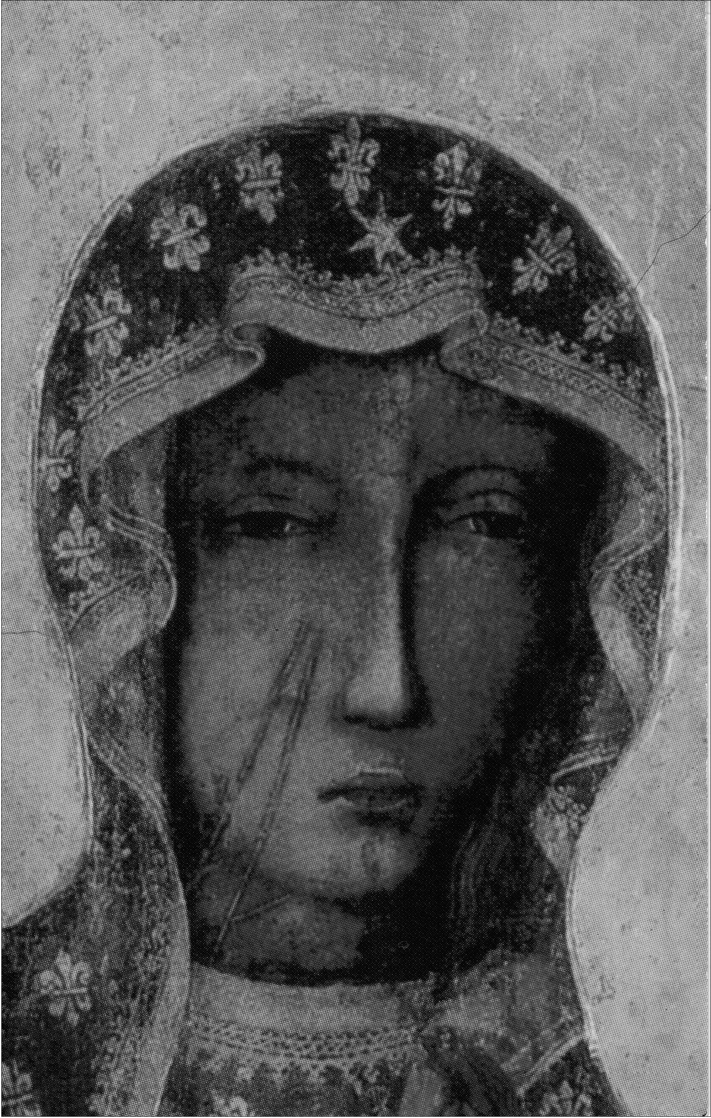
4. Image of Our Lady of Częstochowa - detail - face of Mary with scars (Photo: Archive
of Jasna Góra, Collection of Votive Art)

Chapter II
THE WOUNDED IMAGE

1. The image of Our Lady of Częstochowa as a wounded
picture
One of the most intriguing and characteristic features of the image of Our Lady of
Częstochowa are the dark lines - the scars visible on the right cheek of the Virgin.
The scarred face of Our Lady of Częstochowa is a very well known and recog-
nizable religious symbol for Polish Catholics. In the following Chapter, I will
present the historical background, as well as contemporary meanings, attached to
the scars.
A scientific discussion about the origin of the marks visible on the Jasna Góra
picture is strictly connected with research on the genesis and the oldest history of
the image and is similarly complex. The oldest written legends recount two events
which are to be linked to the appearance of the wounds visible on the picture.
The first event is the siege of Bełz, and the second is the attack on Jasna Góra in
1430 (see Table I, points 5 and 7). The stories about the events surrounding the
image’s scars fall in line with a medieval formula of tales of desecrated pictures.
These types of tales were popular in Europe and were strongly rooted especially
in the Byzantine tradition. The popularization of legends about the wounding of
images was closely connected with a period of iconoclasm.1 This debate about
1 Ewa Śnieżyńska-Stolot states that the oldest recorded story about the wounding of an
image comes from the fourth-century sermon of Athanasius the Great. This story recalls a cru-
cifix wounded by Jews. When a bloody wound appeared on the crucifix, the attackers were said
to have converted to the Christian faith. A similar story appeared within Latin writings in the
sixth-century Libri miraculorum by Gregory of Tours. In this version, a Jew wounded an image
of Christ with an arrow. The oldest known legend about the wounding of a Marian image comes
from the early seventh century. A legend known in Byzantium described an image of the Virgin
Mary wounded by a Samaritan. If we accept that the dates for the iconoclastic controversy are
the years 726-843, then we see that the legend about the wounding of a holy image was formed
much earlier and that the legend originally revolved around Judaism and its reluctance to figural
representations in art (the figures of Jews-iconoclasts). However, stories about the wounding of
images gained popularity and symbolic power in the eighth and the ninth centuries - concurrent
with iconoclasm. During the Second Council of Nicaea (787), the stories about the wounding of
50
The Image and the Figure
icons, which lasted over a century, featured several violent and emotive acts. The
icon controversy - and the acts associated with it - had a huge influence on the
formulation of the basis of the theology of icon in the Orthodox tradition. A dis-
cussion about the possibility of visual representations of the holy figures settled
in the core of theology. The existence of the image was justified through one of
the fundamental truths of faith - the belief in God’s incarnation (comprehended as
a hypostatic union of two natures - divine and human, in one person, Christ). As
so, for iconophiles, an attack on holy images started to signify denial or a lack of
understanding of the fundamental theological truths of Christianity.
During the iconoclastic period, many holy images in Byzantium were physi-
cally destroyed as a result of violent iconoclastic acts. As a response to this vio-
lence against icons, the story of a wounded image was popularized. This story,
which was propagated by icon lovers, entered the collective consciousness and
religious imagination of many Christians. The basic pattern of the story is as fol-
lows: (1) an iconoclast or unbeliever (the other), using a sharp instrument or
weapon, damages the holy image; (2) a bloody wound or a scar appears on the
panel’s surface (miraculous event); (3a) punishment falls on the profaner (blind-
ness, sudden death, paralysis); or (3b) the iconoclast - upon seeing the miracle
(blooding of the image, appearance of a wound) - suddenly realizes his mistake,
does penance, and converts.2
Stories concerning the wounding of an image appeared within Byzantium.
These stories were accompanied by actual icons with visible marks of an icon-
oclastic act (scars, wounds, drops of blood visible on pictures). The so-called
wounded icons were surrounded by a strong cult and these objects were said to
have magical powers. The congealed drops of blood, wounds and scars were treat-
ed by the faithful as explicit and sensually perceivable (visible, touchable) proof
of miracles. These features also meant that scarred images possessed the power to
represent the holy figures - not only materially but also - bodily (blood, wounds
- are connected with a living body).
It is difficult to precisely define the genesis of the wounds on some of the
scarred images preserved to this day. This is due, first and foremost, to the limited
progress achieved in research into these images, which are often extremely dif-
ficult for art historians and conservators to be reached (this is illustrated by the
example of the icons on Mount Athos). However, based on the contemporary evi-
images were quoted and considered valid arguments against the iconoclasts. See E. Śnieżyńska-
-Stolot, ‘Geneza, styl i historia obrazu Matki Boskiej Częstochowskiej’, Folia Historiae Artium
9 (1973), pp. 20-24.
2 For instance one of the versions of the legend (about the wounding of the icon from the
Iviron Monastery at Mount Athos) says that a Muslim cut the image with a sword. Seeing the
wounds appearing on the image, he was to have converted and after his death have been pro-
claimed a saint. See Śnieżyńska-Stolot, p. 23. Another version references a soldier of the icono-
clastic emperor Theophilos, who after the wounding of the image with his sword, saw blood
flowing from the picture and did penance. See T. Mroczko and B. Dąb, ‘Gotyckie Hodegetrie
polskie’, Średniowiecze. Studia o kulturze, vol. 3 (Wrocław-Warszawa-Kraków, 1966), p. 23.
The Wounded Image
51
dence, it is possible to affirm that many icons were originally created with wound
and marks. In other words, though there were cases of icons being damaged in
documented instances of iconoclastic acts, there is also evidence that artists would
regularly paint an image with wounds during the original creation of the image.
Wounded images painted, as such, received a typical legend about wounding, and
immediately acquired the renown of miracle-making images.
The image of Our Lady of Częstochowa, with the marks visible on the right
cheek of the Virgin, is classified as a wounded image. Contemporary research and
analysis into the origins of the marks has brought more questions than answers.
Anna Różycka-Bryzek and Jerzy Gadomski, assert, based on their analysis of the
paintings layers, that the marks visible on the image of Our Lady of Częstochowa
cannot be a result of iconoclastic violence; rather they seem to be a result of a con-
scious artistic act connected with - the so-called Italian phase (see Table III) - of
the image.3 However, even such an unequivocal statement is accompanied by
doubt about whether the marks should “be considered as one of the iconographic
features acquired secondarily from an Italian artist, or one of those significant
[but not preserved] features of the original composition (which the Italian artist
merely repeated).”4 Whatever the answer to this question, Różycka-Bryzek and
Gadomski decisively state that the marks visible on the image of Our Lady of
Częstochowa existed prior to the image being presented to the Pauline monks
(before 1382/1384).5 This statement is contrary to the most popular contemporary
versions of the history of Jasna Góra, as well as to various historical and legen-
dary sources which link the appearance of the wounds with the year 1430 and
the attack on Jasna Góra. However, a closer look at the preserved sources reveals
intriguing mechanisms of mythical thinking and the development of the symbol-
ism of the wounds.

2. Changes within the oldest legends concerning the wounding
of the image
As previously mentioned, the oldest legends about the image of Our Lady of
Częstochowa contain two dramatic moments connected with damage and
3 Not all researchers share this opinion. Wojciech Kurpik, who has been in charge of
conserving and caring for the image of Our Lady of Częstochowa since 1979, posits that
the damage visible on the image could not have been artistic intention. Rather, he argues it
occurred as a result of a violent act, connected either with a robbery (when the adornments co-
vering the panel were wrenched off the image) or an iconoclastic act. See W. Kurpik, ‘“Blizny”
Jasnogórskiej Madonny’, Jasna Góra 7 (1988), pp. 21-27. See also Kos, Fundacja Klasztoru,
pp. 159-160.
4 Różycka-Bryzek, ‘Obraz Matki Boskiej Częstochowskiej’, p. 12.
5 Różycka-Bryzek and Gadomski, ‘Obraz Matki Boskiej Częstochowskiej’, p. 38; also
Różycka-Bryzek, p. 17.
52
The Image and the Figure
wounding of the picture. The first is the siege of the Ruthenian castle at Bełz, and
the second is the attack on the Jasna Góra Monastery in 1430.
All of the oldest legends similarly describe the siege of Bełz (see Table I, point
5). According to legends, at the time of the siege, the castle was governed by the
Polish Duke Władysław Opolczyk (who was said to be the one who discovered
the image of “Our Lady” in the fortress). The legends describe the siege of Bełz
as a symbolic struggle between Christian defenders and pagan besiegers (Lithu-
anians, Tatars, and Scythians). According to legends, the image was wounded
when a Tatar arrow, which came through a window, stuck into the panel. This is
said to have been a turning point in the siege. At the moment of desecration, the
image revealed its miraculous powers and saved the fortress and its defenders.
Historians, who study the texts of the oldest legends regarding the origin of the
image of Our Lady of Częstochowa, have pointed out that the legendary version
of siege of the Bełz Castle distorts the historical facts drastically.6 The history of
the Bełz Castle - especially during the fourteenth century - was very dramatic and
turbulent and the fortress’s owners and occupants changed frequently. However,
in comparison to legendary versions, during the sieges of the castle (which accord-
ing to the historical sources happened in 1352 and in 1377), the roles of defenders
and besiegers of the fortress were reversed. According to historical facts, the for-
tress (both times) was defended by Lithuanians, while the Polish-Hungarian army
laid siege to the castle. What is more, during the second siege of Bełz (1377),
Duke Władysław Opolczyk was one of the attackers, accompanied by the army of
King Louis of Hungary. According to historians, during Duke Opolczyk’s govern-
ance of Ruthenia, the supposed Lithuanian/Tatar attack described in legends “in
reality never happened.”7
For the purposes of cultural anthropology, the content of the legends should
be treated - not as a reflection of reality but rather - as its interpretation and
manifestation of cultural patterns. The story about wounding of the image appears
in legends of the origin of the image of Our Lady of Częstochowa combined
with another common myth from ancient and medieval Europe: the story about
the miraculous defense of a holy town-fortress .8 Preserved versions of the legend
describe the siege of the Christian fortress (Duke Opolczyk besieged in Bełz) by
the infidels (Tatars, Lithuanians), who - when attacking the fortress - committed
an iconoclastic act (as recorded in the oldest written version of the Jasna Góra
legend):
A certain Tartar, taking up the curve of a bow and placing the sharp length of an ar-
row on it, shot forcefully into the window of a room or chamber of this castle and
wounded the right side of this venerable image, which Luke the Evangelist painted in
6 Kos, Fundacja Klasztoru, pp. 131-132.
7 Różycka-Bryzek, ‘Obraz Matki Boskiej Częstochowskiej’, p. 8.
8 I analyze the subject of the miraculous defense of a holy town-fortress in Chapter III.
There I also point out the relationship between the stories of the wounding of the image with
the stories about the miraculous defense.
The Wounded Image
53
Jerusalem, with the sharp head of the arrow, such that this arrow remained stuck in the
panel, sticking out as if it were a long brooch pin. When this most bitter wound was
dug in the above mentioned venerable picture, the Almighty... allowed a great sign to
be revealed and took the aforementioned prince of Opole out from all oppression by
freeing him from the Tartars and Lithuanians.9 [emphasis added]
Another version of the legend repeats the same sequence of events:
[.] a certain Tatar shot an arrow from his bow into the chamber, where the board of
our beloved Lady rested, and it went through the right side of the said image.10 [em-
phasis added]
Two texts, originating prior to 1430, link the marks visible on the image with the
legendary siege of Bełz. The claim that the shot hit “the right side of the image”
most likely refers to the right cheek of the Virgin Mary, where the most visible
scars are to be seen. Additionally, the description given by the author of Translatio
tabulae of the arrow “sticking out as if it were a long brooch pin” (Latin fibula) can
be interpreted as referring to the well-known shape of Mary’s scars. Anna Różycka
-Bryzek emphasizes that the Latin word fibula (used in the original text of Transla-
tio tabulae) refers to a brooch pin or clasp used to fasten garments. The researcher
compared the shape of typical medieval pins with the contour of the marks visible
on the cheek of the Virgin Mary, showing their startling resemblance.11
Therefore, the versions of the legend known prior to 1430 give a detailed ex-
planation of the genesis of the characteristic marks - wounds visible on the image
of Our Lady of Częstochowa. On the other hand, all the stories written after the
attack on the Jasna Góra Monastery explicitly connect the events of 1430 with the
wounding of the picture and the scars visible on the cheek of “Our Lady.” Mikołaj
Lanckoroński, wrote in his Historia venerandae imaginis Beatae Mariae Virginis,
that the damage to the image was done during an attack by the Hussites in 1430:
[...] they strip [the image] cruelly of its priceless treasure, they smash the exposed
board [the panel] into three parts, and they disfigure the face by cruel spitting [...].
After this event, according to Mikołaj Lanckoroński, “the scars on the face cannot
be repaired by any method.”12 Piotr Rydzyński, and after him Mikołaj of Wilkow-
iecko, gave a description which categorically links the appearance of the scars
with the attack of 1430: “One of them (the attackers) drew a sword and twice
struck the face (of the board) of the Blessed one.”13 [emphasis added] Finally, the
9 ‘Translatio tabulae’, Najstarsze historie, p. 78. The English translation quoted after
R. Maniura, Pilgrimage to Images in the Fifteenth Century. The Origins of the Cult of Our
Lady of Częstochowa (Woodbridge, 2004), p. 78.
10 ‘Hie Volget dy Historie’, Najstarsze historie, p. 108.
11 Różycka-Bryzek, ‘Obraz Matki Boskiej Częstochowskiej’, pp. 16-18.
12 Lanckoroński, ‘Historia venerandae’, Najstarsze historie, p. 141.
13 Mikołaj of Wilkowiecko, ‘Historyja o obrazie w Częstochowie’, Najstarsze historie,
p. 212. The text underlines the double strike on the image with the sword recalling the most
visible and characteristic two long scars on the cheek of Our Lady of Częstochowa.
54
The Image and the Figure
chronicler Jan Długosz in his Annales (written several dozen years after the 1430
attack) recalls a similar version of events:
[the attackers] stripped the image of our Most Praiseworthy Lady of the gold and jew-
els with which devout people had adorned it. Not satisfied with the spoils, they pierced
the image with a sword, and they broke the board to which the picture was attached.14
According to the pattern of the story of the wounding of a holy image, after com-
mitting the desecration the attackers met “justly the sword of Divine punishment”
and died. These texts show, therefore, the complete structure of the story of the
wounding, as it was known in medieval Europe and as it appeared in the earliest
versions of legends of the origin of the image of Our Lady of Częstochowa (which
described the siege of Bełz as an event connected with wounding of the image).
Newer legends adapted the structure of the story to fit into new circumstances
and historical events connected with the monastery at Jasna Góra (the new home
of the cult of the image). Interestingly, the story of the siege of Bełz castle is not
condemned to oblivion in newer legends and more recent versions of the story.
Lanckoroński writes that at the time when “Lithuanians and Scythians” were be-
sieging the fortress (Bełz)
[.] it happened that the arrow of one, shot from a bow to the chamber where the ven-
erable image stood on the altar, with accelerated flight struck in the neck of the image
and there remained stuck.15 [emphasis added]
The same course of events is recounted in another version of the legend written
in the sixteenth century:
[.] one [of the enemies attacking Bełz] strongly pulled a bow and hit the blessed im-
age in the neck with an arrow.16 [emphasis added]
And so, in newer legends, the previous version of events connected with the
wounding of the image of Our Lady of Częstochowa is not eliminated from the
story but undergoes a certain shift. The episode with the Tatar and the arrow
wounding the image is still present. However, its role is diminished, as now it is
connected with the small scratches which are visible around Mary’s neck rather
than the better-known scars on the face.

3. The meanings attributed to the attack of 1430
Even though it is historical fact that there was a violent attack on the Jasna Góra
Monastery in 1430, detailed interpretations of historical and legendary accounts
14 Quote after Rozanow, ‘Dzieje obrazu’, Najstarsze historie, p. 10.
15 Lanckoroński, ‘Historia venerandae’, Najstarsze historie, p. 140
16 Mikołaj of Wilkowiecko, ‘Historyja o obrazie w Częstochowie’, Najstarsze historie,
p. 211.
The Wounded Image
55
about the event expose various questions. The legends convey, first and foremost,
the iconoclastic and pillaging character of the fight - attributing the attack to
Hussites and connecting it with the wounding of the image.17 Among historians,
however, there are disagreements about (1) the motives of the attack; (2) who ex-
actly the attackers were; and (3) the nature of the damage sustained by the image.
Though various hypotheses and historical discussions are well represented in
the literature, my interest is in the symbolic and religious meanings attributed to
the events of the year 1430.18 Older legends as well as contemporary stories of the
Jasna Góra Monastery present the attack of 1430 as the date that wounding of the
image-figure of Our Lady of Częstochowa occurred. The religious significance of
the scars is emphasized in both older tellings and in the contemporary great story
of the image. The wounds are presented as tangible proof of the genuine presence
of sacrum in the image. The descriptions emphasize the unusual way the wounds
appeared on the image and the divine protection that the wounding apparently
triggered. Additionally, these descriptions recall typical miraculous circumstances
connected with stories of the wounding of holy images: the appearance of bloody
scars, a terrible and inescapable punishment which befalls the attackers, the pow-
erlessness of the painters reconstructing the painting and of paint flowing from the
marks during attempts to repair of the image (Table I, point 8).19 The final circum-
stance is the numerous miracles (healings, resurrecting of the dead) attributed to
the image which were said to happen after the attack (Table I,point 9).20
The restoration work was conducted on the king’s command in the capital
city of Kraków. The ceremonial return of the image to the Jasna Góra Monas-
tery in 1434 confirmed the adoption of this religious symbol by state, dynastic
and political powers. In keeping with the old Byzantine tradition - with which
King Władysław Jagiełło was likely familiar - the image started to be treated as
17 Kos, Fundacja Klasztoru, pp. 185-188.
18 There are many hypotheses and varied interpretations of the events of 1430. The most
accepted is the version that the attack was performed by iconoclastic Hussites (see Różycka-
Bryzek, ‘Obraz Matki Boskiej Częstochowskiej’). There is also a hypothesis emphasizing a po-
ssible political dimension of the attack, connected with the competition and a conflict over the
Lithuanian crown between the Polish King Władysław Jagiełło and his brother Grand Duke
Witold of Lithuania (see Rozanow, ‘Dzieje obrazu’, p. 11). The third theory describes the attack
as a robbery and looting of the monastery, whose treasures were widely known of at the time. It
is pointed out that the image was damaged during the act of ripping off of the valuable treasures
and the decorative cover (see P. Kras, Husyci wpiętnastowiecznejPolsce (Lublin, 1998), p. 189
and p. 191; Kos, Fundacja Klasztoru, pp. 185-206).
19 Some researchers point that the legendary account claiming that paint flowed out of the
image (during the restoration process in Kraków) can be interpreted as evidence pointing to
the use of a wax encaustic technique (characteristic for Orthodox icons) in the creation of the
original picture. See Mroczko, Dąb, ‘Gotyckie Hodegetrie’, p. 22.
20 One hypothesis surmises that around 1475 the unpreserved manuscript of the Jasna
Góra Miracles was written down. In this account, the first miracle could have been the story
of the attack on the monastery and the events that accompanied the attack. See Kos, Fundacja
Klasztoru, pp. 204-205.
56
The Image and the Figure
a palladion - a protective image of the Jagiellonian dynasty. We might assume
that the importance of the story about the 1430 attack and interpreting it as an act
of iconoclasm were eagerly emphasized by both Pauline monks, who wanted to
popularize the cult and fame of the scarred image, and by the Jagiellonian court of
King Władysław Jagiełło, who - as a newly baptized Christian - needed a power-
ful, religious symbol to prove his involvement with a new faith.
The image of Our Lady of Częstochowa became widely known as a wounded
picture. In subsequent centuries the motif of the wounds became a distinctive mark
for the image from Jasna Góra. The majority of the copies of the Częstochowa
picture repeated the characteristic outline of two scars21 on the right cheek of the
Virgin Mary.22 The scars became known amongst an increasingly wide circle of
people and became an essential detail of the image of Our Lady of Częstochowa.
The wounded image itself was seen as a powerful and a miraculous relic. In a re-
ligious context, the wounds announce that the image not only depicts Our Lady,
but also re-presents her. In religious perception of the image, the wounds refer to
the bodily presence of the suffering figure of the Virgin.
Over the course of the centuries, the legend about the wounding of the image
during the attack of 1430 has undergone subsequent development; absorbing and
adapting in its range a wide array of the smallest episodes. These episodes en-
forced the miraculous dimension of the event - as well as the symbolic meanings
attached to the wounds. The seventeenth-century writings - connected with the
Baroque religious renewal - show a refashioning of the story about the iconoclas-
tic attack of 1430 and about the meanings of the scars.
21 In actual fact there are more than two scars on the image of Our Lady of Częstochowa.
Yet, in common perception there are usually only two - the longest and the most visible vertical
lines on the right cheek of Our Lady. Numerous copies of the Jasna Góra image depict just those
two characteristic scars (sometimes there is a third small vertical mark).
22 A significant popularization of copies of the image of Our Lady of Częstochowa was
brought about in the seventeenth century. During the synod in Kraków in 1621, it was an-
nounced that copies of miraculous images should be as close to the originals as possible, with
the Częstochowa image considered as one of the canonical patterns. See A. Kunczyńska-Iracka,
Malarstwo ludowe kręgu częstochowskiego (Wrocław-Warszawa-Kraków, 1978), p. 17. See
also: J.S. Pasierb, ‘Matka Boska Częstochowska w kulcie i kulturze polskiej’, Maryja matka
narodu polskiego, ed. S. Grzybek (Częstochowa, 1983), pp. 319-320. A comparison of the
copies of Our Lady of Częstochowa together with an examination of pictures upon which the
motif of scars appeared has been done by D. Łuszczek, ‘Koronowane kopie obrazu Matki Bożej
Jasnogórskiej od XV do XVII wieku w Polsce’, Studia Claromontana 10 (1989), pp. 184-202.
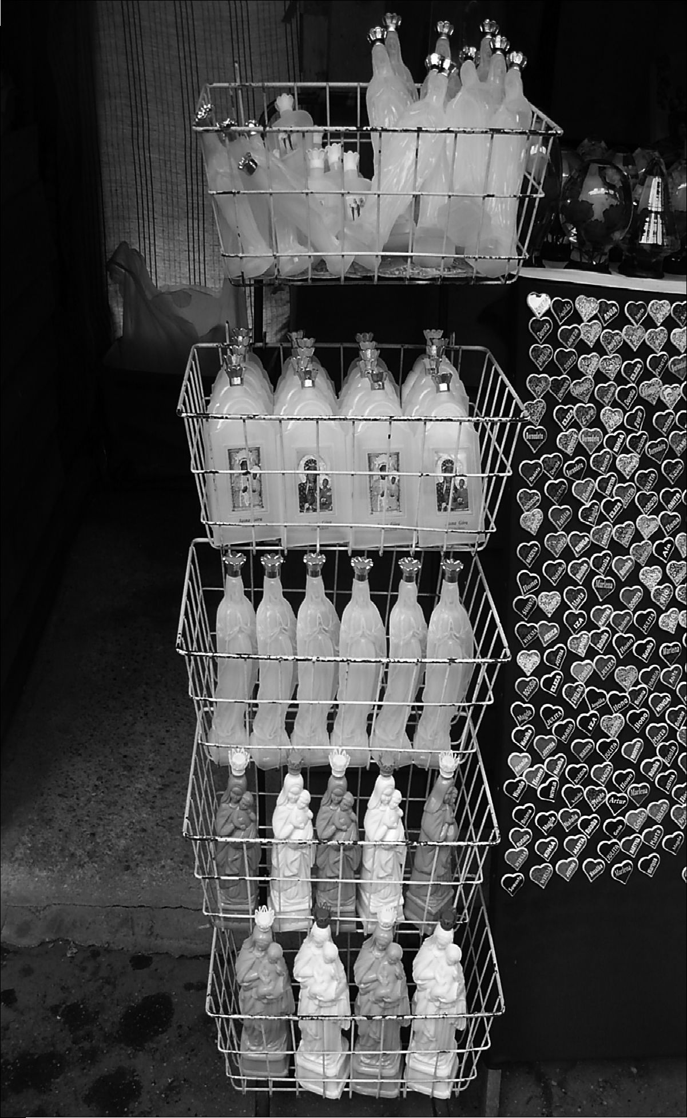
The Wounded Image
57
5. Plastic bottles for holy water with images of Our Lady of Częstochowa or shaped like
Mary, sold near Jasna Góra Monastery (Photo: Anna Niedźwiedź)
The tale about the miraculous water spring is an example of the addition of
a new element to the legend of wounds. Stories about miraculous water in vari-
ous shrines all over Europe have been well known for many years. In the Polish
-Lithuanian Commonwealth - during the post-Trent period - there was a growth
in popularity of stories which were attached to numerous Marian shrines. It is
therefore not surprising that the texts on the Jasna Góra image (newly written in
58
The Image and the Figure
the seventeenth century) recall the appearance of a miraculous spring.23 This event
is connected directly with the desecration of the image in 1430. When escaping,
the attackers were to drop the image on the ground. At this very spot, water was
said to have appeared miraculously. When Pauline monks found the image they
used the water to wash the picture. As the story says, the spring is still in the same
place. Nowadays, as years ago, numerous pilgrims go with bottles to the spring
and draw water - believing in its healing powers.24
6. A small girl helping her mother to sell plastic bottles (figures of Mary) for holy water. The
Licheń sanctuary (Photo: Anna Niedźwiedź)
The other motif incorporated into the stories about the 1430 attack is the so-
called miracle with the horses (known from earliest legends as connected with
arrival of the image to Jasna Góra). This began to appear in seventeenth-century
versions of legends that related the infamous attack. The horses, despite being
hurried and whipped, did not want to move when the attackers intended to escape
23 The story about the miraculous spring appeared in A. Gołdonowski’s work, Diva Claro-
montana published in Kraków in the year 1642. See P. Bilnik, ‘Napad “husytów” na Jasną
Górę. Fakty, konteksty - legenda’, Studia Claromontana 15 (1995), pp. 316-317.
24 The spring is located by St Barbara’s church, few hundred meters from the Jasna Góra
Monastery. On the spot pilgrims drink, wash themselves and take the water home. Nowadays,
bottled water is also offered for sale.
The Wounded Image
59
with the image on their cart. Some other versions of the story say - that the horses
would not move when the renovated image was being transferred from the capital
city of Kraków back to the Jasna Góra Monastery.25
Aside from the details added to the description of the attack, texts began to ap-
pear that analyzed the religious and symbolic meanings of the wounds. One of the
first - and most interesting - attempts to read into the symbolism of the scars was
undertaken by the Pauline Father Jan Dionizy Łobżyński in his work (published
in 1644) titled The Triumphant Transfer of the Most Wonderful Image in Poland
of the Blessed Virgin Mary to Częstochowa s Jasna Góra.... Łobżynski - when
referring to the iconoclastic act of 1430 - pays particular attention to the ques-
tion of the struggle with “heretics” (as he calls the Hussites). The concept of the
“struggle with heretics” is directly enrooted in the counter-Reformation ideology
and the nascent (at that time) mythology of Polish-Catholic nation. Interestingly,
Father Łobżyński’s arguments vastly expand the symbolic sphere attributed to
the wounds. Łobżyński claims that the marks visible on the face of Our Lady of
Częstochowa:
- were left “for us to always have fresh recollection of [Mary’s] love in front
of us;”26
- should encourage one to struggle with “heretics;”
- are a proof of the firm links between Our Lady of Częstochowa and the
nation (understood as Polish nobles);
- confirm the grace that the nation receives;
- they are a sign that the Virgin Mary is the patron saint of the Polish nation.27
Łobżynski’s text, written in the seventeenth century, illustrates the changes
that were occurring within the cult of Our Lady of Częstochowa. The text also
shows the development of the process of adapting the symbols of the wounds to
national ideology and mythology. Many of the motifs from his work left visible
traces in the great story of the image-figure. To this day, these motifs are present
in the popular discourse on the history of the picture - especially in the context
of the image’s national significance. Similar symbolism of wounds was present
in the nineteenth-century vision of Polish martyrdom and messianism, as well as
in twentieth-century texts emphasizing the national dimension of the Jasna Góra
cult.
25 See Bilnik, ‘Napad “husytów”’, pp. 316-317.
26 D.J. Łobżyński, Przenosiny triumfalne najcudowniejszego w Królestwie Polskim obrazu
Bogurodzice Panny Maryey na Iasnej Gorze Częstochowskiej abo panegiryk kościelny (Kra-
ków, 1644), p. 61.
27 Ibid., p. 64. See also Zakrzewski, W kręgu kultu maryjnego, p. 107. See also E.J. Osiad-
ły, ‘Znaczenie Jasnej Góry w religijności i kulturze polskiej według nauki O. Jana Dionizego
Łobżyńskiego (1593-1654)’, Studia Claromontana 3 (1982), pp. 104-124.
60
The Image and the Figure
There has been, however, another parallel layer of symbolism with regard to
the wounds of the image of Our Lady of Częstochowa which - in contrast to
the national layer - has been evoked in the small stories about the image-figure.
The world of the small stories has been, first and foremost, a personal world
of intimate and private religious experiences connected with the image-figure of
Our Lady of Częstochowa. The older sources as well as contemporary interviews
articulate that the suffering of “Our Lady,” expressed by the symbol of the scars,
makes her figure “more human,” more understanding and closer to the difficult
and painful human experiences of her devotees.
The changes in the meanings ascribed to the wounds from the Jasna Góra im-
age signify two fundamental layers for the reception of this symbol - national and
individual. In the further analysis of contemporary contexts, both levels of the
scars’ symbolism will be illustrated (for individual reception of the wounds see
also Chapter IV).

4. The contemporary tale of the wounding of the image
Contemporary Jasna Góra legends repeat and transform numerous motifs from
very old stories about the Częstochowa image. The genesis of the wounds vis-
ible on the face of Our Lady is explained in various ways; however, the most
popular version of the officially promoted history of the Jasna Góra Monastery is
about the appearance of the scars with the attack of 1430. A typical description,
published in a popular Catholic monthly, tells of the events under the title “With
a Sword on the Image” as follows:
[Right after the arrival of the image to Jasna Góra] the rapidly growing fame of the
image was attracting numerous pilgrims. Plentiful valuable votive offerings left by the
pilgrims were tempting to thieves and robbers. The first robbery attack on the Jasna
Góra Monastery occurred in 1430. The Miraculous Image sustained serious damage at
this time: it was thrown to the ground where it fell apart into three pieces [...].
The memory of this dramatic event is embodied in the marks made by the cutting of the
sword (or some lighter weapon) which can be clearly seen on the cheek of Our Lady
and several smaller “scars” visible on her neck. Today these marks are an integral
element of the Image, constituting a symbol of suffering. [emphasis added]
Beside a written version of the story, the authors of this popular publication
present a part of the picture from 1705 illustrating the history of the image of Our
Lady of Częstochowa (the so-called Mensa Mariana).28 The fragment illustrates
the moment when the image was donated to the Pauline monks. Below the picture
there is a description:
28 I refer to the content of this painting in Chapter I.
The Wounded Image
61
In the year 1382, Duke Władysław Opolczyk donates the miraculous image of the
Virgin Mary to the monks of the order of St Paul the First Hermit. Note that on the
illustration above there are no marks left by the sword cuts on the face of Mary -
these appeared only in 1430.29 [emphasis added]
Meanwhile, the popular imagination offers alternative versions of origins of
the wounds (despite the repetition of the 1430 attack story in sermons, brochures
and various publications dedicated to pilgrims and devotees). Field research ma-
terials show various changes and transfigurations of the story which were made
within the schema of the legend of wounding of a holy image. Surprisingly, dur-
ing my field research among dozens of interviewees, I found only one person
who referenced the highly promoted official version of the legend from popular
Catholic publications:
[.] at the time of the Hussite wars Jasna Góra was taken, the image was robbed to-
gether with the votive offerings. It was taken by the Hussites on a cart but the horses
refused to move off. In anger one of the Hussites threw the image from the cart and the
image broke into three parts. The Hussite cut the image twice. When he tried to inflict
a third cut he died suddenly.30
During some other interviews the story was slightly transformed. In some cases,
it was most likely the lack of sufficient historical knowledge about the Hussite
Revolution and the role of Hussites which influenced the narrations given by
interviewees. Instead of recalling Hussites, the interviewees mentioned “some
soldiers” or “an attacker” when describing an iconoclastic act against the image.
In a few cases Tatars, known from the legendary siege of the Ruthenian castle at
Bełz (Table I,point 5), were depicted as robbers attacking the Jasna Góra Monas-
tery and wounding the image with a sword (Table I, point 7). In further answers,
Turks, Cossacks, “pagans,” and even Christian Teutonic Knights were portrayed
as attackers and iconoclasts.31 All these figures are known in the popular vision of
Polish history as “traditional enemies” and symbolic others with whom the Polish
people fought over the course of the centuries. In contemporary popular legends
about the wounding of the image of Our Lady of Częstochowa, these various oth-
ers were adopted as playing the role of an iconoclast/profaner of this religious as
well as national symbol.
The figure of the Swedish soldier cutting the image with his sword dominates
the list of iconoclasts-others given by my informants during field research. The
29 Both quotes come from the popular Catholic monthly Nasza Arka. Miesięcznik Rodzin
Katolickich 7 (2001). A leading topic for the edition was: ‘Jasna Góra - The Spiritual Capital
of Poland.’
30 No. 59/int., m., b. 1949.
31 No. 33/int., f., b. 1932; no. 50/int., f., b. 1939; no. 66/int., f., b. 1953; no. 73/int., f., b.
1958. The Order of the Teutonic Knights of St. Mary’s Hospital in Jerusalem in the thirteenth
century created a separate state in Baltic Old Prussia. It was the cause of numerous conflicts and
wars between the thirteenth and sixteenth centuries with the Polish Kingdom, therefore the Teu-
tonic Knights in the popular vision of Polish history are seen as one of the symbolic enemies.
62
The Image and the Figure
most common contemporary story about the wounding of the image - not the of-
ficial one available in brochures and religious leaflets, but that which functions in
the collective consciousness of Polish Catholics - recalls a changed version of the
historical events connected with the year 1655 and the Swedish invasion of Po-
land. During the 1655-1660 wars, referred to as the “Swedish Deluge”, the Jasna
Góra Monastery was besieged by the Swedish army. It is historical fact that the
Swedes gave up the siege and did not enter the monastery. In any case, it would
have been impossible for the Swedes to even touch the image as it was safely hid-
den in another fortress in the Silesia region.32 Yet people easily connect elements
of the official and older legends about the wounding of the image of Our Lady of
Częstochowa with the Swedish Deluge and the defense of the monastery which
gained fame as a “miraculous defense.” Often, my informants eagerly described
their version of events connected with the wounding of the image by Swedes:
- The wounds came from the slash of a Swedish soldier, who wanted to defile the
image of Our Lady of Częstochowa. But when he hit the image, he gave up the
ghost;33
- The image was wounded by a Swedish sword. Częstochowa was miraculously
saved, but the wounds remained on the image.34
In the cited quotes the most famous military event linked to the Jasna Góra Mon-
astery and popularized in Polish national mythology (the defense of the monas-
tery in 1655) intertwines with the old legendary stories of the most intriguing
symbol connected with the image of Our Lady of Częstochowa (wounds visible
on the right cheek of “Our Lady”). Examining various versions of the story given
by numerous interviewees, one may draw the following conclusions:
- the legend of the miraculous defense of a fortress is the key structure,
around which the contemporary known story is constructed;
- in the earliest versions of the Jasna Góra legends, the theme of the mi-
raculous defense of a fortress was very closely linked with the story about
wounding of an image (the defense of Bełz and the tale of the wounding of
the image by a Tatar arrow);
- contemporary ideas repeat older structures with startling force - often how-
ever, the figures and circumstances of the events are changed in accordance
with the set of ideas in force.35
32 S.J. Rożej, ‘Dzieje Obrazu Matki Bożej Jasnogórskiej’, Maryja matka narodu polskie-
go, ed. S. Grzybek (Częstochowa, 1983), p. 29.
33 No. 11/int., f., b. 1925.
34 No. 92/int., f., b. 1929.
35 In Chapter III I analyze the legend of the miraculous defense of a sacred city-fortress in
detail. I show the continuous updating process of the identities of “besiegers” - in the contem-
porary visions they might take the shape of, for example, the Nazis or communists.
The Wounded Image
63

5. The bleeding and weeping of images
Analyzing the legends and stories about the wounds visible on the image of Our
Lady of Częstochowa, we must remember that they are religious symbol whose
meanings are enrooted in the deepest and earliest ideas concerning the cult of im-
ages in Christianity. The wounds are also undoubtedly a symbol that arouses deep
spiritual feelings in many people. In a brochure about the Jasna Góra Monastery,
distributed among pilgrims and tourists, one is confronted with a very moving
description of the Jasna Góra Chapel and image:
The walls of the Chapel of Our Lady of Częstochowa strictly define the center of the
Sanctuary. The oldest part of the building is the presbytery, dating from the times of
King Władysław Jagiełło. This is the only interior not damaged by the fires which hit
the church. The altar of the Virgin Mary is covered in ebony and silver. It was funded
in 1650 by Jerzy Ossoliński. High, overhead, hangs the national relic - the Miraculous
Image. The sad eyes of the Virgin Mary look down peacefully at the beloved faith-
ful. An inexpressible sweetness radiates from the face. The scars on the cheek burn
pilgrims, imposing thoughts about the fundamental categories of good and evil,
lightness and dark, human wisdom and foolishness.36 [emphasis added]
The outline of the wounds, visible on the face of Virgin Mary, arouses deep reli-
gious and spiritual experiences in those praying in front of the image. In the inter-
views conducted during field research, the wounds are one of the most frequently
mentioned elements of the image. The wounds are described by the interviewees as
very special, significant and deeply embedded in their memory. The wounds evoke
emotions that shape the personal bond between the faithful and the image-figure
of Our Lady of Częstochowa. Within the area of religious-symbolic language, the
scars are the most obvious and tangible motif transforming the picture into a holy
figure. The principle of non-differentiation - the mystery of the transfer between
image and figure - is achieved in the symbol of wounds and its religious under-
standing. For how could an image - understood just as a painting on canvas or
board - bleed and be wounded? The wounds - for the faithful - are irrefutable, ob-
vious proof of the personal dimension of the image of Our Lady of Częstochowa,
which imputes the status of relic onto the picture. This personal dimension is di-
rectly indicated by interviewees. When the wounds are discussed it is obvious that
the scars are not just scratches on the painted panel, but it is Mary who is wounded:
- The marks [wounds] are a mass of pain that the Virgin Mary takes unto herself;37
- The wounds signify the suffering of the Virgin Mary for human sins.38
When explaining the genesis of the wounds one interviewee described the sor-
rows of Mary in a very emotional and personal way:
36 600 lat Jasnej Góry, ed. W. Krzysztoforski.
37 No. 65/int., f., b. 1953.
38 No. 88/int., m., b. 1980.
64
The Image and the Figure
These scars are from the Virgin Mary’s tears. It is not known why the Virgin Mary
cried - no one in the world will ever know this.39
Significantly, my informant associates the wounds with the tears of Mary. Per-
haps the figure of the weeping Madonna is symbolically close to the motif of the
wounded image. Images, figures, and crucifixes which weep or bleed are one of
the most intriguing elements of popular Catholicism. As Joanna Tokarska-Bakier
relates in her interpretation of various holy images:
Images - considered by human sensus communis as miraculous - bleed, weep, sweat,
exude oils from wounds, change facially, heal, choose their place and doggedly return,
disappear and appear once again, help, protect against plagues and disasters, punish
and reward.40
The author makes a convincing argument that these stories constitute their own
popular “meditation upon the dual living-dead nature of the image;”41 in other
words, meditation upon non-differentiation between picture and the holy figure.
There are numerous records - historical and contemporary - from the Polish
territories that refer to bleeding Marian images and statutes (amongst which there
are many copies of the image of Our Lady of Częstochowa). One of the oldest
preserved copies of the Jasna Góra image is in the town of Bochnia. In 1632
(some accounts say 1637) the image was said to have cried bloody tears. In 1655,
a copy of the Częstochowa image, which normally stayed at the castle in Wiśnicz,
was moved to a church in Okulice. This was to protect the image from the Swed-
ish invasion. During its time in Okulice, the picture was said to have cried.42 In
the eighteenth century, the copy of the Częstochowa image - held in the Armenian
temple in Stanisławów - was recorded as weeping several times. This event was
interpreted in hindsight as an omen of the partitions and collapse of the Polish
Commonwealth.43
Seventeenth- and eighteenth-century accounts convey the development of
Marian emotional piety in which the Sorrowful Mother fulfils the role of a divine,
protective figure; a figure who was seen as understanding and empathetic with
human sufferings. Various iconographic representations of the Mater Dolorosa
(Our Lady of Sorrows) also show Mary with tears falling down her face.44 In Pol-
ish traditional folk culture the idea of a passion of Mary is one of the most vital
and deeply rooted elements present - not only in the nineteenth-century sources
(tales, legends, songs, iconography) - but also traceable in the contemporary Mar-
ian devotion of Polish Catholics. It is elaborated around the figure of the Virgin
39 No. 15/int., f., b. 1925.
40 Tokarska-Bakir, Obraz osobliwy, pp. 326-327.
41 Ibid., p. 327.
42 See W. Zaleski, Jasna Góra 1382-1982 (Łódź, 1982), p. 301.
43 See Z dawna Polski Tyś Królową. Przewodnik po sanktuariach maryjnych (Szymanów,
1990), pp. 212-213.
44 M. Pielas, Matka Boska Bolesna (Kraków, 2000), pp. 62-68.
The Wounded Image
65
Mary depicted as merciful, understanding of human weaknesses and, due to her
own experiences, feeling sympathy for human sufferings. This figure is seen as far
closer to human than the stern figure of Christ.45
Perhaps the most famous case of a weeping image in post-war Poland was
connected with the copy of Our Lady of Częstochowa kept at the cathedral in Lu-
blin - a city in the east part of Poland - which was recorded as weeping in 1949.
Here is an account given by one of the priests who witnessed the events in Lublin:
Around four o’clock in the afternoon the sexton ran into the vestry and stated that
something unusual was happening to the image of the Virgin Mary. I set off right away
and noticed a crowd of people staring at the picture. I looked at the image and saw
black drops emanating from the right eye, flowing down the cheek towards the scars.
The human elation, groans, tears were so forceful that I also fell to my knees and, to-
gether with the people, was moved to tears by the emotion. I personally felt that the
image was alive, the face smiling and radiating some kind of brilliance.46
One of the women who was in the cathedral at that moment described the events:
The face of the Virgin Mary turned blue and red patches appeared on it. The face was
swollen similar to a person who wishes to hold back tears in order not to explode (with
all the force) but cannot out of a great sense of pain. The face was so alive. A tear
flowed from the right eye, more or less, to the level of the length of a half of the nose.47
The so-called “Lublin miracle” rapidly gained immense fame throughout Poland.
The political situation in post-war Poland, particularly the confrontation between
the Catholic Church and a communist regime, certainly added importance to the
event.48 People from all over Poland started to visit the city of Lublin to see with
their own eyes that the image copy of Our Lady of Częstochowa cried over her
people. It was reiterated that the Virgin Mary, was aligning herself with the people
through her picture and the miracle performed, was revealing her involvement in
the history and difficult situation of the nation.49 Despite the passage of time, the
memory of the events in Lublin appeared in many interviews conducted in the
years 2000-2001:
- I remember how the Virgin Mary wept in Lublin. The Church acknowledged it
- the chemical composition of the tears was extremely similar to that of human
tears;50
- The picture of Our Lady of Częstochowa in the cathedral in Lublin started to weep.
Experts confirmed that the tears were not a secretion of the image resulting from it
45 See Zowczak, Biblia ludowa, pp. 394-415.
46 Told by Father Tadeusz Malec. Quoted after: Z dawna Polski, p. 488.
47 The relation by Franciszka Z. Quoted after: J. Kras, ‘Matka Boża Bolesna z obliczem
jasnogórskim w katedrze lubelskiej’, Jasna Góra 7 (1988), p. 36.
48 See Represje wobec uczestników wydarzeń w Katedrze Lubelskiej w 1949 roku, ed.
J. Ziółek and A. Przytuła (Lublin, 1999).
49 Kras, ‘Matka Boża Bolesna’, pp. 35-45.
50 No. 46/int., f., born 1938.
66
The Image and the Figure
being not properly impregnated but that they were human tears (they had the same
chemical composition). They were collected in an ampulla and placed in the crown
of the image.51
Many interviewees heard and repeated various versions of the story about the
weeping image. The events in Lublin - which were well known in Poland, docu-
mented, and officially recognized by the Catholic Church hierarchy - are refer-
enced in many interviews. Surprisingly though, my interviewees usually associat-
ed the story not with the year 1949, but with more recent historical circumstances.
Also, often my informants stated that it was not a copy kept in Lublin Cathe-
dral, but the real - original image of Jasna Góra which was recorded weeping. In
most cases, my informants associated the weeping of the image of Our Lady of
Częstochowa with the period of Martial Law in Poland (1981-1983) which was
definitely the most traumatic event of the last forty years of Polish history:
- It was an account in the parish that the image cried as the Soviet Army prepared
to enter Poland [as it was believed would happen in December 1981]. The Virgin
Mary’s hand ensured that there was no letting of blood and not many people died;52
- It was said that after the pacification of the “Wujek” coal mine, the image wept -
tears appeared on the cheeks of Our Lady of Częstochowa.53

6. “The wounds are elongating”
My informants made numerous references to the image of Our Lady of
Częstochowa when describing the period of Martial Law. These references show
how this religious-national symbol became very deeply involved in the memories
and discourse about the whole decade of the 1980s in Poland. Interestingly, in the
material from field research, Martial Law is described as the most traumatic, limi-
nal moment of the newest Polish history by older people as well as by younger
people (even those born after Martial Law). The “Solidarity Decade” - as it is
often called - is remembered and described during interviews about the popu-
lar meanings associated with the image-figure of Our Lady of Częstochowa.54
In contemporary Polish society it is well known and remembered that the image
51 No. 83/int., f., b. 1967 - the informant lived in Lublin in the 1980s.
52 No. 60/int., m., b. 1949.
53 No. 72/int., m., b. 1958. The “Wujek” coal mine was a strong symbol of Martial Law in
Poland. There, at the beginning of Martial Law (in December 1981), military forces attacked
miners killing nine and wounding 21.
54 N. Davies, God’s Playground. A History of Poland. In Two Volumes, vol. 2 (Oxford,
New York 2005), pp. 482-508. The 1980s in Poland can be divided into several periods:
1980-1 - the birth and growth of the Solidarity Movement; 1981-3 - Martial Law; 1984-9
- post-Martial-Law period; 1989-90 - beginning of the Third Republic and transition toward
a civil society in Poland and in other post-communist countries in East-Central Europe.
The Wounded Image
67
appeared as a very significant symbol during the Solidarity strike in Gdańsk ship-
yard in August 1980. The gates leading to the shipyard were decorated with flow-
ers, national flags, images of Our Lady and portraits of Pope John Paul II (who
was seen in Poland as the “Polish Pope” - a national hero and “savior of the na-
tion”). One copy of the image of Our Lady of Częstochowa was even called “Our
Lady of Strike.”55 The wounded face of the Black Madonna also appeared on the
famous small badge that Solidarity leader Lech Wałęsa wore on his jacket and
the painting started to be a symbol tightly connected with the Solidarity move-
ment imagery for the whole decade. During Martial Law, small badges known as
“Wałęsa’s Our Lady” were produced and worn by people (very often they were
tiny or worn under outer clothes for fear of persecution) as a symbol of resistance.
Our Lady of Częstochowa became one of the most powerful anti-communist sym-
bols in Poland.
Therefore, for my informants it seems somehow natural that during the Martial
Law period, perceived as a time of national sorrow and grief, the wounds visible
on the right cheek of Our Lady of Częstochowa turned into a symbol of national
sorrows. The wounds received their own miraculous story strictly connected with
the political events and unstable social situation of the 1980s. Numerous inform-
ants recalled rumors which were spreading in the 1980s about the unexplainable
changes which were to have occurred on the image of Our Lady of Częstochowa:
- The wounds on the image of the Virgin Mary at Jasna Góra opened and blood
flowed;56
- It was made known that a third scar had appeared on the image in Częstochowa.
I checked on my image [a small copy of the image kept by the informant at her
home] and the scratch was indeed there. The Virgin Mary also wept but I don’t
know where and why.57
The most popular story stated that the wounds on the picture had started to elon-
gate.58 The political situation in Poland, without a doubt, had a significant influ-
ence on emotions attributed to the story. This account was so widespread that
the Pauline monks (from the Jasna Góra Monastery) felt it necessary to issue an
official statement which iterated that the commission entrusted with care for the
image had not confirmed any disturbing changes on the picture.59 However, ru-
mors about the elongation of the wounds have survived in the collective memory
55 G. Boros, ‘Matka Boska Strajkowa’, Punkt. Almanach Gdańskich Środowisk Twórczych
August (1981), p. 272.
56 No. 43/int., m., b. 1937.
57 No. 71/int., f., b. 1958.
58 According to what I have found out, the rumor about the elongating wounds began to
spread during 1985 and 1986. However, in the interviews carried out in contemporary times
people tend to associate this event with the most significant and memorable moment - Martial
Law and particularly the moment of its introduction (13 December 1981).
59 See S. Rożej, ‘Rany na obliczu Matki Bożej Jasnogórskiej’ (text of the address broadca-
sted by Vatican Radio on 18 September 1986), Jasna Góra 2 (1987), pp. 9-10.
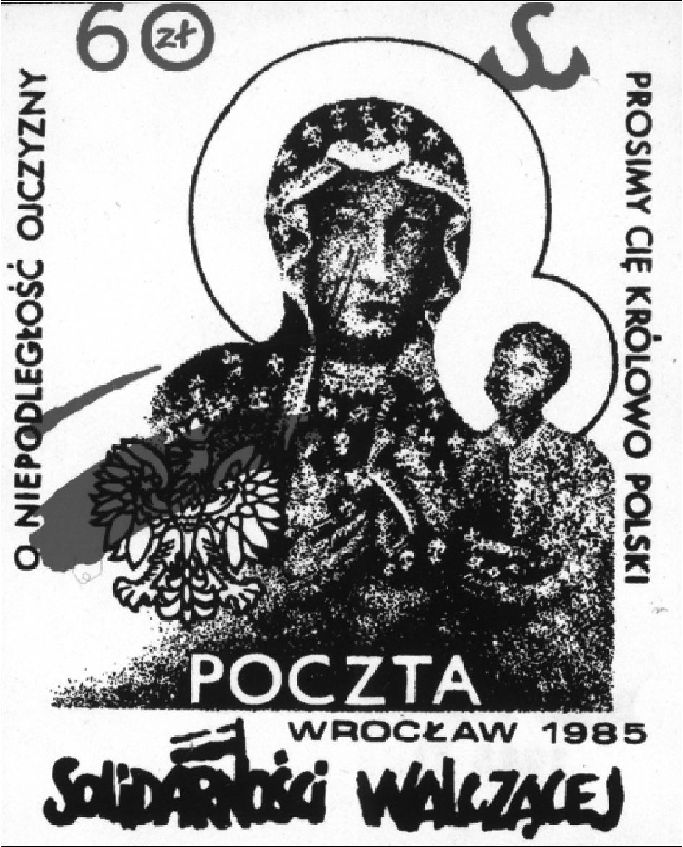
68
The Image and the Figure
to this day. The majority of informants claim that the wounds did in fact elongate.
Many - following the symbolic thinking which equates the original with its copy
- observed the same phenomenon on their pictures at home or on copies kept in
parish churches. Conveyed by word of mouth, the miracle was interpreted as con-
firmation that (as one informant said):
[...] the Virgin Mary is connected with the country - it is unexplainable but Our Lady
has always warned Poles about important and terrible events in our history.60
7. “Queen of Poland we pray to you for the independence of the Fatherland” Underground
poster from the 1980s (Photo: Archive of the Foundation ‘Centrum Dokumentacji Czynu
Niepodległościowego’ and the Jagiellonian Library)
Martial Law and the decade of the 1980s also resulted in a revival of escha-
tological themes in Polish culture. The revival of apocalyptic visions is one of
the culturally established means of collective reaction to socially important and
ground breaking events. Such a scheme of reaction has occurred in history many
times, examples of which are provided by historical records and works of lit-
erature and art. In the modern history of Poland, apocalyptic language appeared
60 No. 73/int., f., b. 1958.
The Wounded Image
69
very often in works and accounts referring to the World War II. Martial Law also
brought about a rehashing of this language and the repetition of cultural schemes
and patterns.61 The eschatological theme connected with this breakthrough situa-
tion, appearing at the same time as the theme of the elongating wounds, has been
entered permanently into the mythical universum and reappears in the statements
of the informants:
The wounds elongated - running from the nose toward the chin. If they reach the heart
then the end of the world is nigh:
“The Antichrist will rule,
Churches will be ruined,
When the end of the world approaches
Things will be tough”.62
Another interviewee also talks about the connection between the elongating scars
and the end of the world:
The wounds are still getting longer. If they reach the heart of the Virgin Mary then the
end of the world will occur. All as a result of people’s sins.63
The fundamental meanings ascribed to the elongating scars underscore the phe-
nomenon of the wounds as a symbol connected to events in the country and the
fate of the nation. This if forcibly brought home by the following statement (made
by an informant):
The wounds started to get longer during Martial Law. If they reach the heart or the
edge of the picture then there will be World War III. But apparently the wounds have
been contracting since 1989 [since the fall of communism in Poland and East-Central
Europe].64
Another informant heard two versions connected with the elongation of the
wounds on the Jasna Góra image:
If the wounds reach the heart then it will be the end of the world, while others used to
say that if they reached the heart then communism would end in Poland.65
Fulfilling the schema of the great story of the image-figure of Our Lady of
Częstochowa, a vision of national history is contained within the symbolism of
the wounds. This is a vision of a suffering nation and a nation believing in its
Mother and Queen (symbolized by the Częstochowa image of the Virgin Mary).
One of my informants explicitly expressed the linkage between the image-figure
and the nation:
61 See D. Dąbrowska, Okolicznościowa poezja polityczna w Polsce w latach 1980-1990
(Szczecin, 1998), pp. 106-124.
62 No. 25/int., f., b. 1927.
63 No. 17/int., f., b. 1926.
64 No. 74/int., f., b. 1958.
65 No. 29/int., f., b. 1929.
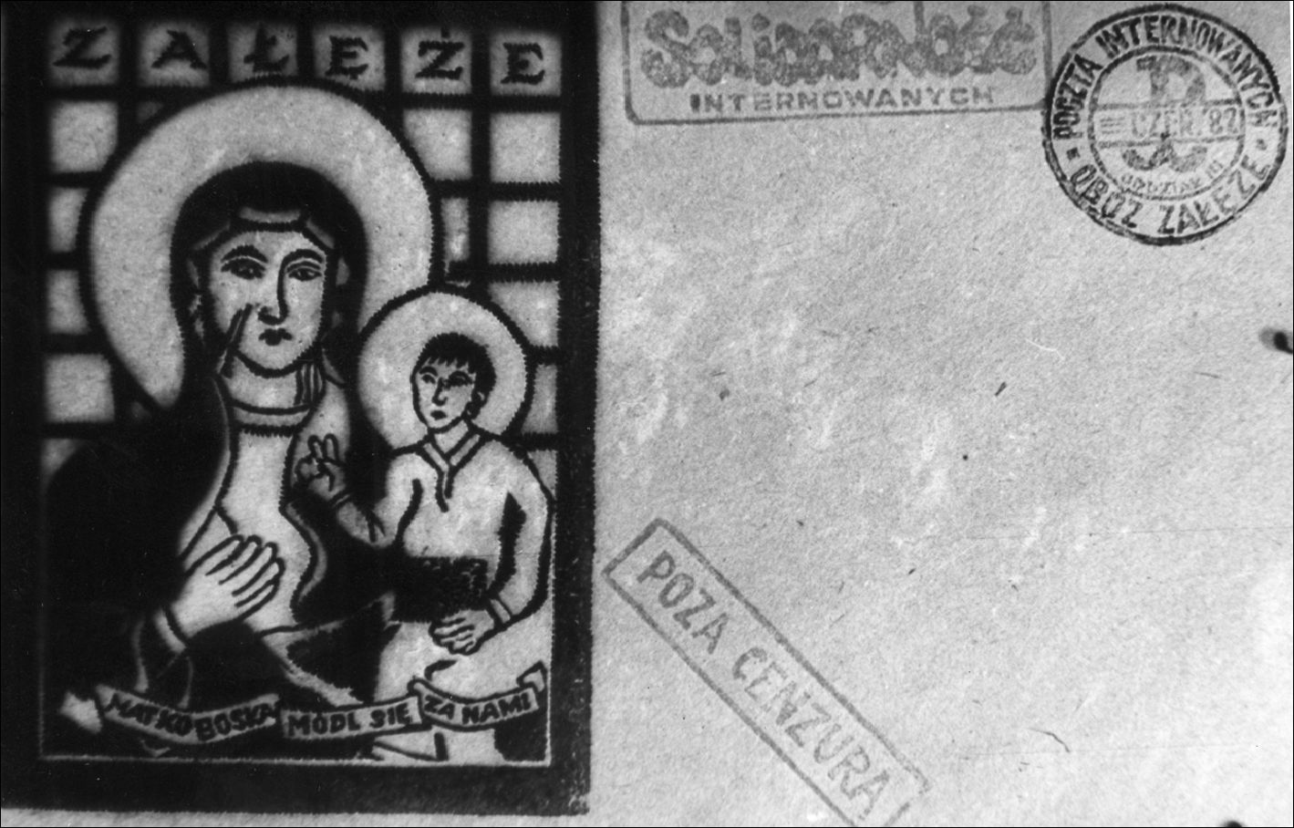
70
The Image and the Figure
The wounds are witnesses of historical events [...]. They are a specific expression of
the Madonna - her inseparability from Polish history.66
Such an interpretation of the symbol of the wounds might be traced in the Ba-
roque period when it appeared, among other things, in the work (discussed earlier)
of Łobżynski. But contemporary ideas about the wounds are also strongly based
in the nineteenth century and the period of the partitions of Poland. When the
Polish state did not exist, the wounds received a strong national dimension. Re-
searchers into the cult’s history, such as Stefan Rożej, have paid special attention
to this phenomenon:
In the period of threat to national existence - and also at a time of intensified perse-
cutions and repressions on the part of the partitioning powers - the wounds [visible on
the image of Our Lady of Częstochowa] served as the basis for arousing hope and were
the motivation for the patient suffering of adversities. They also served as a stimulus
for patriotic and religious-national feelings. In the consciousness of Poles, the wounds
were seen as connected with Our Lady of Jasna Góra (known as the Queen of Poland).67
The significance attributed to the wounds during the 1980s directly referenced
this religious-national symbolism. One may confirm this by observing the motifs
of the wounds in the spontaneously arising underground art and literature of that
decade in Poland.
- “Our Lady pray for us” Underground envelope made in Załęże interned camp dur-
ing Martial Law (Photo: Archive of the Foundation ‘Centrum Dokumentacji Czynu
Niepodległościowego’ and the Jagiellonian Library)
66 No. 72/int., m., b. 1958.
67 Rożej, Dzieje Obrazu Matki Bożej Jasnogórskiej, p. 28.
The Wounded Image
71

7. The symbolism of the wounds in the underground art of the
1980s
Independent, underground printing and art - which appeared on a huge scale in
Poland in the 1980s - was mostly connected with the Solidarity Movement and
broader opposition against the communist dictatorship. The growth of under-
ground printing - samizdat - and independent art was especially prevalent during
the Martial Law period - when the illegal production and circulation of printed
materials and artistic works created an independent, unofficial code of resistance.
The phenomenon of underground printing and art from the 1980s can be in-
terpreted on different levels and from different perspectives. As a cultural an-
thropologist, I would like to emphasize the symbolic level and point out that the
image-figure of Our Lady of Częstochowa appeared as one of the most popular
and powerful symbols of the underground national code. I believe that analyzing
the anonymous literature and independent, underground art, which were created
at the period of national liminality and suppression, can be very important in
studies of national mythologies. It will not necessarily uncover artistic values, but
rather the deeply rooted, unconscious cultural structures of the society. As Maria
Janion has pointed out:
In decisive historical moments for national existence, conditions that stimulate inno-
vative artistic work are a rarity. Literature rather refers to ideas, concepts, forms that
have already been worked out and developed, ones already consecrated. The means for
social understanding becomes, at such a time, stereotypes, art is - as probably never
before - inclined to use clichés.68
These words, addressed to literature, have their application with regard to other
art forms, as well as the world of the common imagination and collective taste.
Obviousness, simplicity, and a vulgarization of the allegory present within inde-
pendent artistic works of the 1980s constitute a reflection of the time and situ-
ation within which the works were created. An excellent and apt analysis and
evaluation of the paintings and graphic works of this period is given by Dominik
Krzysztof Łuszczek:
The didacticism of art, pushy and mass in character, the assemblage of symbols, natio-
nal and religious signs resulted in fairly disconcerting artistic effects, trivializing the
highest aims, even if the inspiration is something holy and honorable.69
This is not, in my opinion, an evaluation of the aesthetic value of the discussed
works. From the point of view of a researcher into culture, these works possess
a specific value which goes beyond an artistic one. The underground creativity
68 M. Janion, Czas formy otwartej. Tematy i media romantyczne (Warszawa, 1984), p. 134.
69 D.K. Łuszczek, Inspiracje religijne w polskim malarstwie i grafice 1981-1991 (Warsza-
wa, Częstochowa, 1998), p. 41.
72
The Image and the Figure
can be analyzed as a witness of a social experience and a spontaneous expression
of a society in a significant, historical and extreme situation.
The visual material which I will analyze is derived from two sources. The first
collection is of paintings and graphic works that were done during the so-called
Jasna Góra plein-air workshops. The first of these meetings and artistic work-
shops were organized at the Jasna Góra Monastery in September 1981 and July
1982. In December 1982, a post-workshop exhibition was opened at Jasna Góra,
entitled Painters in Homage to the Jasna Góra Lady in the Jubilee Year of 600
Years of Her Presence. The works displayed at the exhibition were inspired by
the monastery authorities and were appropriate to the set subject matter. The his-
torical and political contexts of the time influenced the artists very strongly. The
collection of pictures created during the first two Jasna Góra workshops might be
treated as reflections and expressions of the social ideas that dominated the col-
lective imagination at this important historical moment for the Polish society.70 As
emphasized by Dominik Krzysztof Łuszczek:
There were many exhibitions at this time, competitions, meetings etc. but no place, no
independent artistic event united Polish creative circles as strongly as Jasna Góra in
the years 1981-1982.71
During the Martial Law and the post-Martial Law period, churches, cloisters
and parish houses were almost the only public places in Poland where an inde-
pendent voice could speak and be heard. Many artists could not exhibit in official
(communist controlled and censored) places. These artists - even those religious-
ly indifferent - organized their exhibitions, performances of their music or theatre
shows, in churches and parish halls. Exhibitions organized by Church institutions
were reflections of social moods, in which religious elements occurred together
with patriotic ones. As Dominik Krzysztof Łuszczek argues:
Such a mass movement appeared for the first time in twentieth-century Polish art. It
arose on a large scale and with spontaneity. It possessed, as well, the stamp of a philo-
70 The Third Jasna Góra workshop took place after a long break in 1988. I had obtained the
information about the workshops directly from one of its organizers - a Pauline, Father Doctor
Jan Golonka, thanks to whose kindness I was able to use his private archives documenting the
events. The preserved documents are a proof of the special atmosphere which accompanied the
first workshops. In the preserved typescript with a plan of the workshop the organizers stress the
fact that the meeting “will not only encompass art activities, but it should create an atmosphere
allowing an understanding and experiencing the specificity of Jasna Góra, its religious, national
and artistic climate”. It was to be facilitated by various discussions and meetings accompanying
the workshops and the very fact that the artists stayed within the monastery’s walls. See. Imprezy
towarzyszące plenerowi malarskiemu ‘Jasna Góra 1981/82’, typescript, Father Jan Golonka’s
archives, Jasna Góra. See also: J. Golonka, ‘Ideowe przesłania plenerów malarskich i okolicz-
nościowych ekspozycji na Jasnej Górze - sztuka czasu nadziei’, Jasna Góra w dwudziestoleciu
pontyfikatu Jana Pawła II, ed. Z.S. Jabłoński (Jasna Góra, Częstochowa, 1999), pp. 323-332.
71 Łuszczek, Inspiracje religijne, p. 28.
The Wounded Image
73
sophical-ideological-artistic declaration, having social acceptance and the acceptance
of the Church.72
The second collection of visual materials is derived from samizdat: under-
ground production of emblems, leaflets, illegal newspapers, also prints produced
secretly, sometimes made by prisoners and those interned. These materials con-
stitute a unique record of moments, moods and images, categorizing the world of
collective imagination during a breaking moment of national history.
The iconographic documentation of the 1980s shows that the scars from the
image of Our Lady of Częstochowa started to be one of the most popular symbols
referenced in underground and independent imagery. The widespread use of this
motif reveals the vitality of the symbol, its strength and significance, and presence
in the collective consciousness. The weaving of meanings contained in the sym-
bolic unity of the Jasna Góra image, the wounds on the face of the Our Lady and
national suffering found its simple and unequivocal expression in the spontaneous
creation of iconography. One underground leaflet dated 1982 and signed Nowa
Huta (the name of the industrial district in Kraków where the Solidarity move-
ment was very strong) shows the face of Our Lady of Częstochowa on a cloth
behind a barred window. The wounds on the face of the Jasna Góra Madonna
took on the shape of a “13” - recalling the painful date (13 December 1981) when
Martial Law was declared.73
Irena Snarska, the author of an exceptionally meaningful work entitled Our
Lady, presents a silhouette of the veil of Our Lady of Częstochowa emerging from
a black, as if cracked, background. The face of Our Lady is not visible - only two
wounds emerge clearly on the right cheek. The author recalled years later the
specific situation within which the graphic work was created: “it was like a knife
incision, like delivering a deeply painful wound.”74
The combination of the contour of the scars with the colors white and red (the
colors of the Polish flag) is the most obvious graphic representation connecting
the political situation in the country with the wounds from the Jasna Góra image.
Many pictures show a silhouette imitating the Jasna Góra image on a black back-
ground, while, white and red scars are displayed on the right cheek of Mary. The
bestowing of the national colors on the wounds directly portrays the unity of the
image (the unity of the Virgin Mary) and the nation.
Besides the exposure of wounds on copies of the Jasna Góra image or the addi-
tion to the wounds of national colors, there were new solutions and iconographic
ideas. In a painting by Maciej Bieniasz entitled: Prayer (In Front of the “Wujek”
Mine)15 a sketch of the wounds from the Jasna Góra image is displayed:
72 Ibid., p. 25.
73 In some popular interpretations, the number “13” recalls also symbolically 13 May
1981 - the assassination attempt on Pope John Paul II - in popular Polish mythology the figure
of John Paul II is very strongly connected with the image-figure of Our Lady of Częstochowa.
74 Quoted after Łuszczek, Inspiracje religijne, p. 69.
75 About the events at the “Wujek” coal mine see footnote 53.
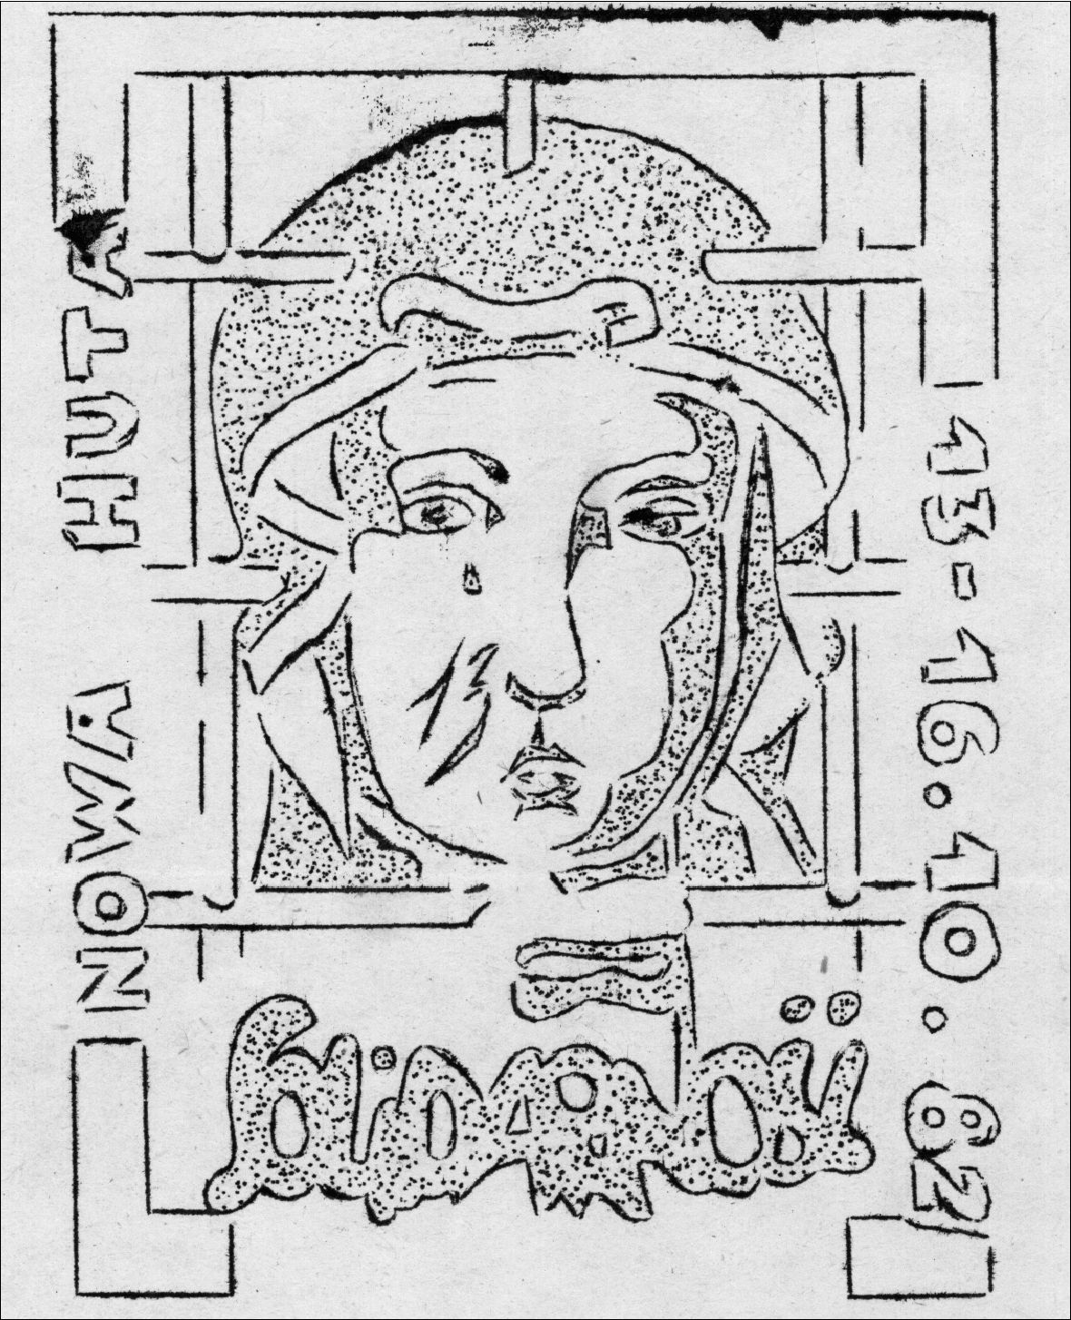
74
The Image and the Figure
- “Nowa Huta-Solidarity 1982” Underground poster from the 1980s (Photo: Archive of the
Foundation ‘Centrum Dokumentacji Czynu Niepodległościowego’ and the Jagiellonian
Library)
... on the hunched shoulders of the staggering figure of a worker. In a gesture of com-
plaint, searching for a source of solace to the pain, he returns with his suffering in the
direction of a woman standing with a child in her arm and a bundle in the other hand.
We recognize in her Mary from the Jasna Góra archetype.76
A similar iconographic pattern is recalled in Zbylut Grzywacz’s work Shade.
Bloody welts (looking like traces of flagellation) - which take on the shape of the
wounds from the Jasna Góra image - are visible on the back of a worker. Opposite
the worker stands the figure of Our Lady of Częstochowa with clearly marked
scars on her cheek. The figures of the worker and Mary are turned to face each
other, appearing to be one figure duplicated through a mirror reflection.
On yet another picture from the period of Martial Law, only the scars of Our
Lady are placed against a red background. In addition to the clearly sketched
76 D.K. Łuszczek, ‘Jasnogórska Bogurodzica w ikonografii czasu nadziei: 1981-1985’,
Jasna Góra 2 (1991), p. 36.

The Wounded Image
75
Matko í
Ocal nas
poczta iwzakgnp 2D0zf
Pamięci ofiar
sowieckiego
ludobójstwa
- “Our Lady Save Us! To the memory of the victims of the Soviet homicide” Underground
poster from the 1980s recalling the Katyń massacre (Photo: Archive of the Foundation
‘Centrum Dokumentacji Czynu Niepodległościowego’ and the Jagiellonian Library)
scars, there is a crown carried by two angels. The whole composition is entitled
Mater Dolorosa.
An examination of the underground and independent art works from the
1980s, reveals that the distinctive contours of the wounds became a separate,
independently functioning symbol. In order to interpret its significance, there is
no longer the need for the whole picture of Our Lady. There is no need even for
the face of the Madonna. The sketch of the wounds appears in new contexts and
different surroundings: on the national flag or on the back of a man who symboli-
cally depicts the Messiah - a worker - and a Pole in one figure. The wounds are
recognizable - even when referenced apart from the image - because they are so
distinctive and so frequently referenced in collective memory and imagination.
During field research, the informants repeatedly spoke openly about the col-
lective suffering and solidarity of the Polish nation and the image-figure of Our
Lady of Częstochowa. This collective suffering idea runs through the visual mod-
els present in the art of the 1980s. The interviews constitute an unusually interest-
76
The Image and the Figure
ing commentary on the iconography of Martial Law. Below are a few meaningful
statements, explaining the significance of the wounds on the Jasna Góra picture:
- Despite the attack on the image and the damage, the image is still here. It’s like
Poland - despite numerous wars, it still exists;77
- The wounds are the symbol of the suffering of Our Lady for Poland;78
- During the partitions and wars the Virgin Mary suffered along with the nation [the
informant also interpreted the significance of the wounds in this way].79

8. The wounds in the transitory poetry of the 1980s
In analyzing the world of 1980s symbols, it is impossible not to mention the un-
derground poetry and texts of popular songs that circulated among people and
were sung during illegal demonstrations. The underground literary creativity
of the period 1980-1990 possessed some characteristic features which Danuta
Dąbrowska described as “transitory occasional political poetry.”80 This creative
output is characterized by the way it circulated through Polish society. By its very
definition, this poetry enters into the range of ethnological research interests; it is
especially interesting to those who pay particular attention to the “internal mecha-
nisms of all cultures.”81 The creative output of samizdat appears to be a perfect
reflection of these internal mechanisms. An enumeration of the characteristics of
transitory occasional political poetry, confirms this hypothesis. It is worth noting
that these characteristics can also be attributed to visual materials. Some funda-
mental distinguishing features are:
- its immediateness and fluidity (reaction to actual events, collective expe-
riences);
- the predominance of political content and propaganda functions;
- the use of a generally understood semantic code, based on a collective
symbolic and mythical universum;
- its unofficial dimension - often expressing opposition in the face of the
officially promoted style of culture;
77 No. 39/int., m., b. 1935.
78 No. 61/int., f., b. 1949.
79 No. 63/int., f., b. 1952.
80 The term was introduced and analyzed by Danuta Dąbrowska. Based on her work,
I assume the accepted critical dates of the phenomena, agreeing that works connected with the
appearance of the Solidarity movement and strikes in August 1980, Martial Law (1981-1983)
and the period up to 1990 share significant common features which allow them to be described
by a single, common term of “transitory occasional political poetry.” See Dąbrowska, Okolicz-
nościowa poezja polityczna w Polsce, p. 7-29.
81 L. Stomma, ‘Etnografia - etnologia - antropologia kultury - ludoznawstwo. Czym są?
Dokąd zmierzają?’, Polska Sztuka Ludowa - Konteksty 35 (1981), p. 71.
The Wounded Image
77
- its anonymity, or if the authors were named, they had little significance;
- the adaptation of historical or popular forms and artistic patterns to inter-
pret current events.
All these features are very close to the creative output of folklore - in the tradi-
tional sense of the term. Folklore is understood as an alternative creativity, fre-
quently opposed to the official, dominant, elite group. Its functional feature serves
to unite the alternative community and distinguishes it from the official mode of
culture.82 Other features of folklore reference the above-listed characteristics of
the underground creativity. That is why the phenomenon of samizdat from the
1980s has been described as “folklore of contestation” or “political folklore.”83
The texts from the 1980s are varied in character; they recall forms, genres and
subjects that cover both folk popular genres (jokes, the burlesque) and also those
which use historical and national symbolism (hymns, prose poems, treatises). One
of the predominant codes, used by the transitory creativity of the 1980s, is the reli-
gious code8 The accumulation of religious symbols, the adaptation or paraphras-
ing of well known Church genres such as canonical prayers, litanies, as well as the
synthesis of new texts with the melodies and refrains of traditional religious songs
- all of these express the strength of this religious code. One of its fundamental
features is the combination of religious symbols with collections of symbols that
are national and patriotic in character.
This use of religious symbols - so prevalent within the 1980s - was similar
to the historical tradition of Polish culture in which the use of sacred images and
symbols in political and national contexts has been very strong; this was especial-
ly true during the nineteenth century - when Poland was partitioned and the Ro-
mantic national philosophy developed.85 The synthesis of religious and national
meanings inevitably brings to mind Polish Romantic Catholicism, which formed
a collection of patriotic sign-symbols. As Tadeusz Łepkowski argued:
Many of the nineteenth-century patriotic songs are, in fact, religious-patriotic songs
and it is difficult to say whether they are more patriotic or more religious. Sometimes
it is impossible to divide what is religious from what is patriotic. [.] And what to say
about examples of sad but lofty national institutions like the public funerals of national
martyrs [...]? Are not those rituals also religious ones?86
82 A. Jackowski, ‘Folklor kontestacji’, Polska Sztuka Ludowa - Konteksty 44 (1990), p. 11.
83 Ibid. See also W. Łysiak, ‘Oblicza folkloru - folklor polityczny’, Polska Sztuka Ludo-
wa - Konteksty 44 (1990), pp. 15-16. For the idea of political folklore in the context of social
behavior see also Cz. Robotycki, ‘Sztuka à vista. Folklor strajkowy’, Polska Sztuka Ludowa -
Konteksty 44 (1990), p. 44.
84 See Dąbrowska, Okolicznościowa poezja, pp. 124-147.
85 K.S. Evans, ‘The Argument of Images. Historical Representation in Solidarity Under-
ground Postage, 1981-87’, American Ethnologist 19 (1992), p. 757.
86 T. Łepkowski, ‘O katolicyzmie i kulcie maryjnym w społeczeństwie polskim XIX stule-
cia (Artykuł dyskusyjny)’, Studia Claromontana 7 (1987), p. 45.
78
The Image and the Figure
Reading this description written by a historian analyzing “the social-psychologi-
cal” current of the Catholic Church history in Poland, we can easily underline the
Romantic tradition of the symbolic culture of the 1980s. The situation from the
1980s can be examined as a revival of the cultural and social patterns established
in the nineteenth century. During the demonstrations of “Solidarity” which started
from holy masses “for the motherland,” as well as during the marches setting out
from churches - religious and national symbols fused. These religious-national
symbols were especially prevalent during the “institution of burials” - such as
the funeral of Cardinal Stefan Wyszyński (1981),87 and subsequently Father Jerzy
Popiełuszko (1984).88 These public events constitute a collective repetition of the
emotional and symbolic situation which developed during the partitions. In the
1980s, within the sphere connected with patriotism and freedom, Polish inde-
pendence was expressed (as in the previous century) by the use of sacral images
and tokens. The language of religion functioned as a metaphor of Polish history
and a commentary about the contemporary political situation. Danuta Dąbrowska,
who analyzed different codes of Polish underground poetry from the 1980s, com-
mented about the strength of the religious language at this period:
There were different codes used by the authors of the Martial Law period [undergro-
und] poetry. But the religious code was the most expressive. It was used to define -
very clearly - the national-solidarity community. The opposition toward the official
rules, which were connected with materialistic and atheistic ideology, could have been
expressed easily by building an alternative values system based on the Christian re-
ligion, which [as depicted in the religious code] has had a thousand year tradition in
the Polish nation.89
Occasional political poetry is a form of expression and a documentation of the
moods and convictions present in 1980s Poland. The religious and patriotic sym-
bols in art from this time are linked by collective experiences. Popularity of the
motif of the wounds of the Jasna Góra image (especially in political poetry and
folklore) confirms that this symbol was treated as an easily recognizable and com-
mon way of expressing the religious-patriotic emotions. The link between the
wounds and national suffering, which the iconography of the Martial Law period
presented through the fusion of the outline of the scars (from the Jasna Góra im-
age) with the national colors, finds its expression also in the symbolic language
of transitory poetry:
87 Cardinal Stefan Wyszyński was a primate of the Catholic Church in Poland in years
1948-81. His public funeral (May 1981) went through streets of Warsaw gathering thousands
of people.
88 Father Jerzy Popiełuszko was killed in 1984 by the Security Forces because of his po-
litical involvement and support of the Solidarity movement. His funeral turned into a huge
religious-national demonstration. In 2010 Pather Popiełuszko was beatified.
89 Dąbrowska, Okolicznościowa poezja, p. 124.
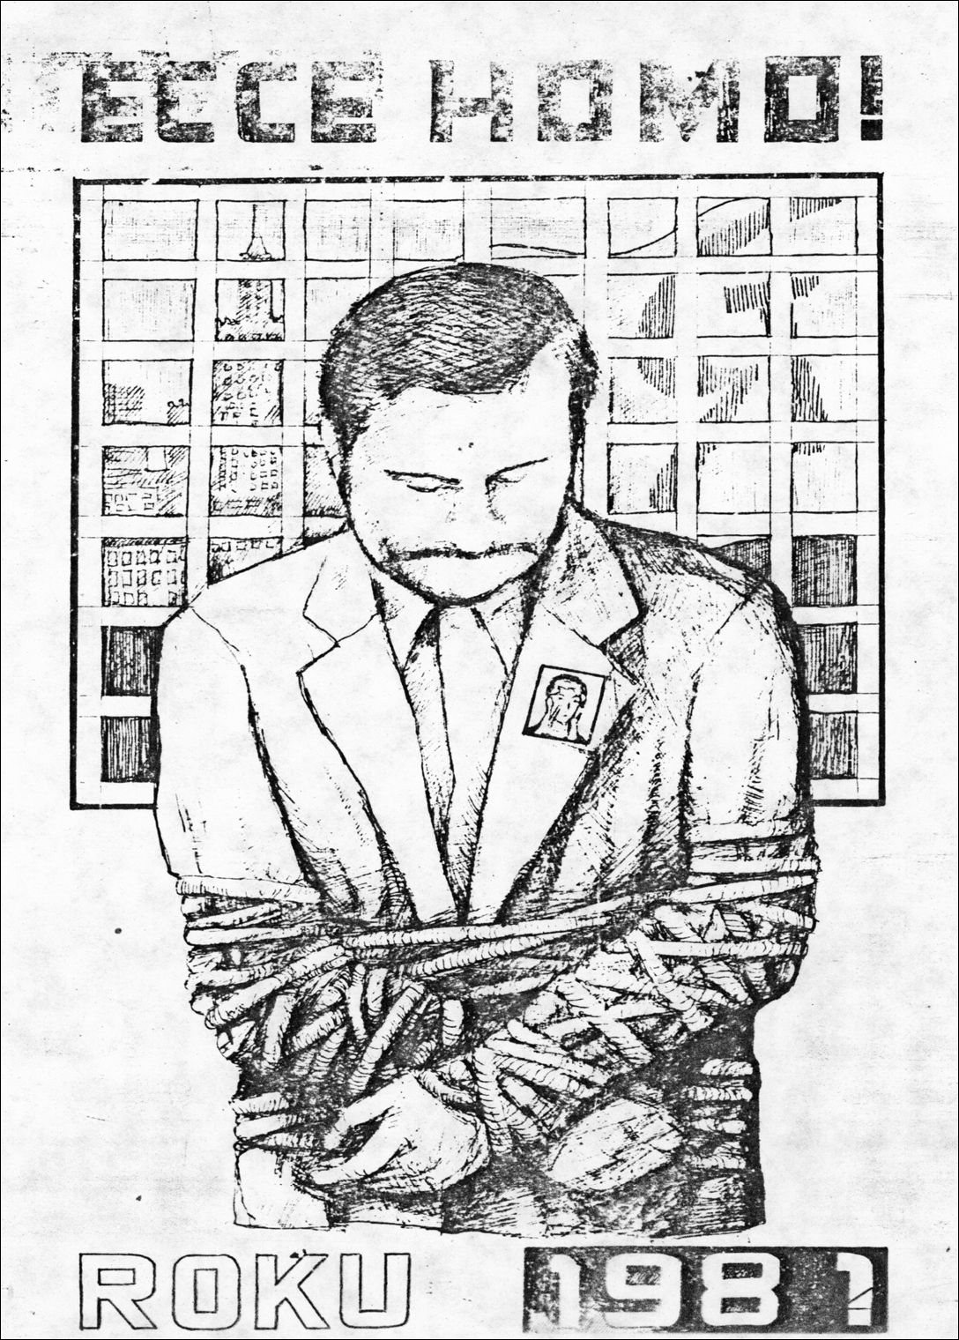
The Wounded Image
79
- “Ecce Homo of 1981” Underground poster depicting Solidarity leader Lech Wałęsa wear-
ing a small badge with the face of Our Lady of Częstochowa pinned to his jacket (Photo:
Archive of the Foundation ‘Centrum Dokumentacji Czynu Niepodległościowego’ and the
Jagiellonian Library)
Lech Wałęsa’s Prayer in Prison
Oh Blessed Virgin Mary
I no longer have that badge with the face of Częstochowa
Weeping in the snow of December.
It has penetrated right inside together with this pain
Which we have been given.
With this one blow they rammed You into the depth of the soul,
80
The Image and the Figure
There I will find you and there I will fall with the nation
Betrayed, exhausted and there in the silence I will keep vigil.90
The words of popular songs sung during masses “for the motherland” and demon-
strations conjure up the image of the wounded face of Our Lady of Częstochowa:
Oh Mother with a face black
Like that Polish soil,
Oh Mother with a face marked with scars
Like that Polish soil,
Clasp us like your son
To your heart,
Oh our escape, our defensive shield
Pray for us!91
Another popular and widely known song, written in the 1980s, underscores the
connection of the fate of the nation (and the faithful) with that of the image-figure
of Our Lady of Częstochowa:
... Oh Mother with scars on your face
A face darkened with worry
Oh Mother looking from the altars
With each century the more intense.
Oh Mother with scars on your face
Blackened from the smoke of war
Oh Mother looking from the altars
Plead for peaceful times for us ...
Oh Mother with scars on your face
Sorrowful - from insurgent ranks
Oh Mother looking from the altars
Wounded from the weapons of spies.92
The symbolism of the wounds, similar to the previously discussed, visual art calls
to mind a link between the nation and the image of the Virgin Mary. In the song
quoted above, contemporary events are interpreted through reference to historical
events: “the smoke of war” (World War II), “insurgent ranks” (the nineteenth-
and the twentieth-century national uprisings). The cyclical nature of time was
a theme that suited the transitory political poetry of the 1980s; this enters into the
logic of “spontaneous historiosophy,” in which - according to Miłowit Kuniński
- “the cyclical and linear concepts of contemporariness and the past are mixed
90 Quoted after Zielona wrona. Antologia poezji okresu stanu wojennego, ed. D. Dąbrowska
(Szczecin, 1994), p. 75. In samizdat this poem appeared anonymously in: Noc generałów. Zbiór
poezji wojennej 13 XII 1981-13.II 1982 (Oficyna Wydawnicza, 1982), p. 36.
91 See for instance: W. Jaśko, ‘X rocznica bieżanowskiego protestu głodowego’, Tygodnik
Małopolska 2 March (1995), p. 11.
92 Quoted after Jasna Góra 2 (1983), p. 64.
The Wounded Image
81
together, combining various elements: the existential and historical, the secular
and sacred.”93
Biblical history was also used (in the figure of Our Lady of Sorrows) to
connect the wound of the nation with the wound on the image of Our Lady of
Częstochowa. The Virgin Mary standing in front of the cross and weeping was
one of the most popular and the most significant figures in stories, songs, and
prayers in Polish traditional folk culture. The use of the figure of Mater Dolorosa
in transitory political poetry is the other example which depicts the combination
of the “folklore of samizdat” with the traditional folklore. In the poetry of the
Martial Law period, Our Lady of Częstochowa stands under the cross and on the
cross - as Christ - Poland is dying:
Under this cross, where torn
Poland died in the night
In the ice of the Vistula River, the snow of December
Our Lady of Częstochowa stood
Oh our Mother, Divine Mother
Plowed up, whole in care
Oh give to us
A greater faith and hope
Oh Lady of Częstochowa.94
The image of the Mourning Mother under the cross also brings to mind the Mes-
sianic vision of Polish history, which was a significant part of the nineteenth-cen-
tury national mythology. The wounds of Our Lady of Częstochowa, the wounds
of the Polish nation, and the wounds of the Messiah become one. “The Common-
wealth pierced by a spear” was sung by political prisoners in 1982 to the tune of
a patriotic song from the period of the partitions of Poland.95
In addition to the inclusion of the actual political situation in the religious
order, the personal and human dimension of the suffering is emphasized in the
usage of the religious symbol of Mater Dolorosa. Our Lady is a powerful symbol
present in Polish Catholicism. Popular religiosity accumulates universal values
connected with motherhood and, in doing so, brings public affairs into a private,
even intimate, dimension:
93 M. Kuniński, ‘Historiozofia żywiołowa a upadek komunizmu’, Czy historia może się
cofnąć?, ed. B. Łagowski (Kraków, 1993), p. 12.
94 Quoted after Zielona wrona, p. 76. In samizdat, this song was published anonymously
in: Wybór pieśni śpiewanych pod krzyżem z kwiatów w Warszawie (Warszawa, no date), p. 25.
95 “The Commonweatlh” recalls the historical name of the Polish-Lithuanian Common-
wealth (1569-1795). Nowadays the word “Commonwealth” appears in Polish language in rela-
tion to the Polish Republic. Text quoted after Zielona wrona, p. 83. The text published is based
on a hand-written letter sent from an internment camp in Strzebielinek. The text is signed with
the date: 13 June 1982.
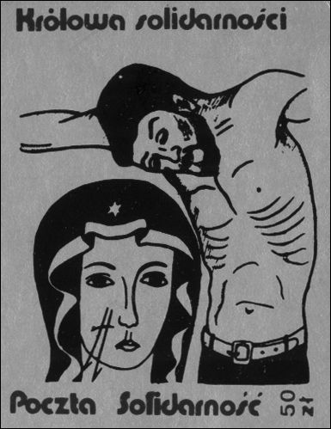
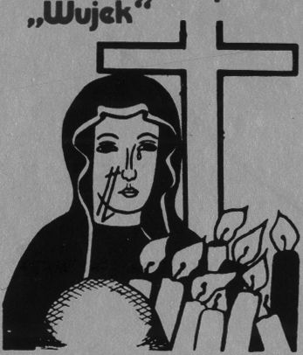
82
The Image and the Figure
Wrapped up in clothes of snow
Blackened and silent
Solidly with her people
The Mourning Mother stood
Alarmed and sleepless
Like today each Polish mother
She cuddled us to the heart.96
Analyzing the usage and popularity of the symbol of Our Lady in the transitory
political poetry and iconography of the 1980s, it is possible to point out three
contexts within which the wounded figure of the Virgin Mary is placed: biblical,
historical-national and human. The intermingling of the various semantic layers,
incorporated in the symbol of the wounds, reveals a myth-creating atmosphere.
In the context of a breakthrough situation (Martial Law and post-Martial Law
Poland) the community displayed a heightened need for self-definition - as well
as the need to interpret the changing and perilous political reality. The common
interpretation of the situation recalled three symbolically powerful references: (1)
the religious order; (2) the past (history, tradition); (3) and archetypical human
experiences embodied in the figure of the “Mourning Mother.”
- “Queen of Solidarity” “Solidarity Post” underground stamp
from the 1980s (Photo: Archive of the Foundation ‘Cen-
trum Dokumentacji Czynu Niepodległościowego’ and the
Jagiellonian Library)
Górnikom z kopalni
Poczta Jolidamo/ć
- “To the miners from “Wujek” coal mine” “Solidarity
Post” underground stamp from the 1980s (Photo: Ar-
chive of the Foundation ‘Centrum Dokumentacji Czynu
Niepodległościowego’ and the Jagiellonian Library)
96 Quoted after Zielona wrona, p. 76. In samizdat this song was published anonymously in:
Wybór pieśni śpiewanych pod krzyżem z kwiatów w Warszawie, p. 25.
The Wounded Image
83

9. “Wounded and Black”
In the songs and poems that create the political folklore of the period of break-
through, the symbolism of the wounds - one of the most distinctive elements of
the image of Our Lady of Częstochowa - intermingle with the symbolism of the
dark complexion of the figure of Our Lady. In poetry describing the introduction
of Martial Law, the Częstochowa Mother standing in the snow of December is
blackened and plowed, like the Polish soil, marked with scars. The symbolism
appears clear and obvious. The wounds and the dark face express the same senti-
ment - sorrow and suffering inscribed into the threefold mythical order (religious,
historical-national and human).
The name Black Madonna is one of the most popular references attached to
Our Lady of Częstochowa. Nowadays, it is recognized by every Pole as a syno-
nym for the Jasna Góra image-figure. The popularization of this expression is
connected with the words of a song, written at the beginning of the 1970s:97
The Black Madonna
There is a spot on this land
Where everybody would love to return
Where Her Countenance reigns
On it two wounds cut.
Oh Madonna! Oh Black Madonna!
How good it is to be Your child.
Oh Madonna! Oh Black Madonna!
Take me in your arms!
Propagated by the Catholic Church in Poland, in particular by Primate Stefan
Wyszyński, the song became a hit amongst pilgrims and was shortly to be known
and sung throughout the entire country. The words, easy to remember and appeal-
ing to the imagination, were quickly incorporated into the stock of popular lexical
expressions. One may note that people, in talking about the image and figure of
Our Lady of Częstochowa, often - consciously or unconsciously - utilize phrases
and quotes taken from the song. The clearest example is the title The Black Ma-
donna which started to function in contemporary Polish language as the most
common name of Our Lady of Częstochowa.98 Such usage can be observed not
only in the colloquial language and that of the sermons of the Catholic clergy, but
also in many publications - even academic ones - about the image of Our Lady of
Częstochowa. However, the common conviction that Our Lady of Częstochowa
is black found its critical commentary in the field of art history:
97 Korolko, Leksykon kultury religijnej w Polsce, p. 120.
98 In fact, in pre-World War II writings about the image of Our Lady of Częstochowa, I did
not encounter the name Black Madonna.
84
The Image and the Figure
Not diminishing the virtues of this term as a metaphor, it follows, however, to apply
it with a degree of reserve in all non-poetic texts - that is in various studies, mono-
graphs, reportages etc. For it is bestowed, in these cases, with an artificial meaning as
a result of the use of the word “black,” which can ring all the more so deceptively in
translations into foreign languages. For the semantics of the word become completely
unequivocal when the matter concerns a painted work, yet on the face of the Jasna
Góra Virgin one can find only a few accents justifying the term black.99
According to art historians, the complexion of the Virgin Mary’s face, in com-
bination with the gold, sparkling robes and crowns in which the image is ex-
hibited, can arouse in the spectators an impression of blackness. This feeling is
additionally intensified by the layer of darkened varnish which covers the image.
However, many scholars argue that in reality the color visible on the face of the
Virgin Mary should be defined as “dark olive”100 or “dark brown.”101 A detailed
description of the image emphasizes that generally the whole work is dark, but
“the faces of the figures retain the color of burnt ochre, in places Venetian red as
well as dark umbra.”102 Such complexions were typical of Italian artistic circles of
the thirteenth and fourteenth centuries and can be found in many works of art that
have survived to this day.103
In spite of the formal art history discussion, the Black Madonna has turned out
to be a culturally expressive phrase, confirming widespread popular theories and
feelings. This expression functions in the area of culture attaining many connota-
tions, popular interpretations and meanings. The color of Our Lady’s face has en-
tered into the circle of ideas and collective knowledge on the subject of the image.
A fair number of the explanations regarding the skin color of Our Lady of
Częstochowa (given during field research) refer to the scientific discussion about
the origins of the image (the origin of the image from Hungary, from Byzantium,
from the shores of the Mediterranean etc.) and other hypotheses (the image has
darkened with age, from the varnish, from the smoke of candles and incense, from
fire etc.). The simplest explanation is connected with the exotic, distant origin of the
person of the Virgin Mary. Many interviewees explain that the Virgin Mary on the
Częstochowa image is dark because she was (1) Jewish; (2) a black woman; and (3)
came from Asia, Africa, from the Middle East or from other ”warm countries.”104
99 W. Kurpik, ‘Dlaczego Czarna Madonna? - Rozważania na temat badań cudownego
obrazu’, Tyś wielką chlubą naszego Narodu, ed. K. Kunz (Częstochowa-Jasna Góra, 1991),
p. 423.
100 Różycka-Bryzek, Obraz Matki Boskiej, p. 11.
101 Śnieżyńska-Stolot, Geneza, styl i historia, p. 8.
102 J. Golonka, Ołtarz Jasnogórskiej Bogurodzicy. Treści ideowe oraz artystyczne kaplicy
i retabulum (Jasna Góra-Częstochowa, 1996), p. 241.
103 At the same time it must be noted, that there are images and figures which present the
Virgin Mary in dark or even black colors. These representations are venerated in various parts
of the world. See E. Begg, The Cult of the Black Virgin (London, 1996).
104 Here are some examples of answers given by the informants: “It’s possible that the pic-
ture was painted somewhere in Africa and the model was a black woman” (no. 74/ ques., f., b.
The Wounded Image
85
Yet, besides this specified collection of ideas, which can be comprehended
under the general term of rationalizing explanations, there are explanations that
carry with them an explicit, as well as implicit, symbolic meaning. In these ideas,
there are links constructed between the symbolism of wounds and the dark com-
plexion of Our Lady of Częstochowa.
The theme combining the motif of wounds with the dark complexion of Our
Lady of Częstochowa developed and evolved in transitory political poetry. These
combinations made also frequent appearances in the material from the fieldwork.
The linguistic formulations, the pattern of the story and the circle of symbols
within which the story is set, allow for a search for semantic references in ideas
known to traditional Polish folk culture.
Within traditional Polish folk culture, black is a color connected with the
sphere of death and sorrow, as well as with the idea of the other world.105 The link
of the dark complexion of Our Lady of Częstochowa with sorrow, suffering and
mourning appears in a host of the interviews. A lot of informants considered the
reason for the sorrow to be the wounds on the face of Our Lady of Częstochowa.
The interrelation between the wounds (symbolizing suffering) and the dark com-
plexion appears in many interviews. The main idea is that the Virgin Mary dark-
ened as a result of the wounds bestowed on her. The dark face of Mary is, there-
fore, a result and a reminder of the act of wounding:
- The dark image comes from sorrow and the wounds meted out - the cuts on the
face;106
- The Virgin Mary has a dark face because a Tatar injured her [.] and consequently
she is sad;107
1980); “The Virgin Mary allegedly came from a black race - but it probably isn’t true” (no. 41/
int., f., b. 1936); “The Virgin Mary was a black woman - hence the Black Madonna” (no. 42/
int., f., b. 1936); “The Virgin Mary is by origin a mulatto Jewess - born of a people with a dark
complexion” (no. 50/ int., f., b. 1939); “The dark complexion is because of the Jewish origin of
the Virgin Mary” (no. 56/ int., f., b. 1942); “The dark complexion comes from the fact that the
Madonna came from warm countries” (no. 73/ int., f., b. 1958).
105 One needs to remember that black has various connotations in culture. One can find
in them reference to “the terrifying sphere of death.” However traditional folk culture also ex-
presses “the duality of meanings for the black color” - black is “a distinguishing feature of the
other world” and refers to the initial state of chaos but also points to the beginning, emergence
of life. See Kowalski, Leksykon. Znaki świata, pp. 224-225. Ryszard Tokarski has drawn atten-
tion to the ambivalent meanings of black in linguistic stereotypes connected with the expression
“black soil.” See R. Tokarski, ‘Biała brzoza, czarna ziemia, czyli o miejscu stereotypu w opisie
języka’, Stereotyp jako przedmiot lingwistyki. Teoria, metodologia, analizy empiryczne, ed.
J. Anusiewicz, J. Bartmiński (Wrocław, 1998), p. 132.
106 No. 58/int., f., b. 1944.
107 No. 18/int., m., b. 1926.
86
The Image and the Figure
- The image was being transported by Poles on a cart. The Tatars attempted to take
it but failed. They then struck it [...]. The face of the Virgin Mary has darkened
because of this blow;108
- Some soldier attacked the picture with a sword. Blood gushed from the wounds
and covered the whole image. The picture has darkened because of the clotted
blood and has remained so to this day.109
In many interviews the “black face” of Our Lady of Częstochowa is compared to
the earth, “the Polish soil:”110
[Our Lady of Częstochowa] is as dark as the earth - is a simple reasoning - like the
earth gives off crops and its children, so the Virgin Mary is like our soil, the Holy
Mother - and Mother Earth.111
Other statements also point to the link: (1) image - figure of the Virgin Mary - (2)
wounds - (3) earth. Some of my interviewees recalled stories about the Virgin
Mary herself falling on the ground and “blackening” her face:
My mother said that the Virgin Mary was walking through the Polish lands - black and
barren lands. She tripped on a stone, fell to the ground and got her face dirty with the
soil of the Polish peasants. That’s why she beloved Poland so much.112 [a story recalled
by the interviewee as an explanation of the “black face” of Our Lady of Częstochowa]
Some others, when explaining the “blackness” of Our Lady of Częstochowa, talk
about the image itself falling on the ground - perhaps because of burial under-
ground (for instance when hidden as a result of war):
- The Swedes stole the image from Jasna Góra and took it somewhere, it fell into the
mud - the picture took on a dark complexion;113
- The Virgin Mary’s dark face is to do with the fact that the picture lay on the
ground;114
- The dark complexion comes from the long period in the earth. The image was
buried in Silesia when Częstochowa was under threat [during the Swedish wars] -
then a peasant caught his plow on the image by chance and that’s how the wounds
came about;115
108 No. 80/ int., m., b. 1963.
109 No. 39/ int., m., b. 1935.
110 Similar comparisons - the dark face of Mary to the Polish soil - were also present in
the poetry from the 1980s. See for instance the words of the song “Oh Mother with a face black
like that Polish soil” recalled in Section 8 of this Chapter.
111 No 85/int., f., b. 1969.
112 No. 17/ int., f., b. 1926.
113 No. 62/ int., f., b. 1951.
114 No. 23/ int., f., b. 1951
115 No. 34/ int., m., b. 1932.
The Wounded Image
87
- The face darkened from lying in the earth. Granny said that the picture was plowed
up from the earth with a plow by a peasant.116
The popular imagination transforms and mixes various threads emphasizing myth-
ological, symbolic and religious meanings attached to the image of Our Lady of
Częstochowa. The cultural fate of the symbol of the wounds visible on the image
of Our Lady of Częstochowa, is an example of re-interpretive mechanisms that
create the world of the collective imagination. This significant detail of the image
of Our Lady of Częstochowa evokes great and small stories, acts as a powerful
national symbol, recalls remote meanings and, just like centuries ago, emphasizes
that the wounded image, first and foremost, makes the holy figure present in front
of the eyes of the faithful.
116 No. 45/ int., f., b. 1937. The story about the image being plowed up by the peasant
appeared in some of the interviews. Evidently, the interviewees interwove the story about wo-
unds and dark face of Our Lady of Częstochowa with the legend of origin of another Marian
image venerated in Poland - a small Marian statue of Our Lady of Gidle, which is said to be
plowed out from the earth by a peasant. Sometimes my interviewees were explaining not only
the darkness of Our Lady of Częstochowa recalling this story, but also the origins of the wo-
unds: they were to appear when the peasant harmed the image with his plow, either when he
was whipping the horses which stopped suddenly when plowing (a miracle with horses which
stopped because they saw a miraculous image being plowed out from the earth) and by accident
he whipped twice through the face of the image lying on the ground - making two wounds.
- Interior of the Chapel of Our Lady of Częstochowa with the image covered with decora-
tive robes (Photo: Archive of Jasna Góra, Collection of Votive Art)

Chapter III
QUEEN OF THE NATION

1. The myth of the miraculous defense in European culture
The great story of the image of Our Lady of Częstochowa is constructed around
legends about the miraculous defense. The miraculous defense has been a very
popular myth in Poland and Europe at large. I will analyze how the legend of a mi-
raculous defense fused with the stories connected with the image-figure of Our
Lady of Częstochowa. I will also discuss how the miraculous defense fostered the
idea of the image as Queen of the nation and how Mary and the painting became
important symbols in the contemporary Polish imagination.
The topic of a miraculous defense of a fortress is one of the oldest European
mythical stories. The description of the defense of the sacred city-temple of Del-
phi in the year 480 B.C., written by Herodotus, is considered to be the prototypi-
cal story about miraculous defenses.1 According to Herodotus, even though the
defeat of Delphi seemed inevitable, a handful of men - with help from heaven
- defended the city from a large Persian army. As foretold by one of the oracle’s
priests, a violent storm hit the besiegers and the summits of Parnassus fell on
them, causing chaos and panic.
Similar stories, having spread around the ancient world and classical literature,
later infiltrated the Christian imagination. The schema of a miraculous defense
was frequently applied in Byzantine writings and descriptions of various wars be-
tween Christians and “pagans.” Perhaps the most famous “miraculous defense” in
the history of the Byzantine Empire was the defense of the holy city - Constanti-
nople - against “barbarian attackers” (Avars and Persians) in the year 626. All the
characteristic elements of the ancient story are present in the descriptions of the
defense of Constantinople: countless attackers, few defenders, heavenly help, and
a spiritual leader believing in a miracle and supporting the defenders (due to the
absence of the emperor in the city, command had been taken over by the Christian
1 F. Ziejka, ‘Cudowna obrona świątyni-miasta (z dziejów tematu)’, Roczniki Komisji Hi-
storycznoliterackiej 17 (1980), p. 44.
90
The Image and the Figure
Patriarch Sergius along with the head of the city militia). Significantly, in stories
about the miraculous defense of 626, there was a new Christian element: the de-
fense of Constantinople was described as strongly connected with the miraculous
powers of the Marian image - the icon of Our Lady of Blachernae. Prayers in
front of the icon - the palladium of the Byzantine Empire - saved the city. The
Virgin herself was said to be seen over Constantinople with a shield protecting
the fortress from projectiles. Interestingly, in the following centuries, subsequent
sieges of Constantinople (for example in 717 and 860) were also described as
“miraculous defenses” repeating the schema of the battle in 626.2
The stories about miraculous defenses were also well known in Latin me-
dieval Europe. Not only did detailed descriptions of the miraculous defense of
Constantinople become popular there, but also various events in Western Europe
started to be interpreted as miraculous defenses. These happenings were also de-
scribed using the established schema3 (for instance the defense of Chartres in 911
or the siege of Avignon in 1226).4 However, it was mostly within the Orthodox
Christian tradition that the stories about miraculous defenses became very closely
connected with the idea of a protective icon - known also as a “palladium.”5
In Orthodox Christianity, the stories about miraculous defenses were adopted as
more and more spread stories about the miraculous powers of holy and venerated
2 Subsequent victorious defenses of Byzantium and the idea of Mary protecting various
cities were mirrored in iconography. For instance, the official seal of many cities depicted the
figure of the Virgin Mary raising above the city. See E. Rakoczy, Jasnogórska Hetmanka w pol-
skiej tradycji rycersko-żołnierskiej (Warszawa, 1998), p. 22.
3 See K.S. Moisan and B. Szafraniec, Maryja orędowniczka wiernych. Ikonografia nowo-
żytnej sztuki kościelnej w Polsce (Warszawa, 1987), p. 14.
4 In both legends the defense is connected with miraculous happenings ascribed to the
Virgin Mary. See M. Gębarowicz, Mater Misericordiae, Pokrow, Pokrowa w sztuce i legendzie
środkowo-wschodniej Europy (Wrocław, 1986), p. 15. In medieval hagiographie literature,
both in the East as in the West, the motif of the patron-saint - actively participating in the battle
or shielding the town from the enemy - appeared (e.g. the story of the defense of Paris in 451
and the role of Saint Genevieve, the legend of Demetrius the defender of Thessaloniki). See
Ziejka, ‘Cudowna obrona’, p. 50.
5 The name palladion (Greek Palladion, Latin Palladium) comes from ancient Greece.
The term was used to refer to meteors that fell from the sky. The mysterious stones were used
as talismans. Hidden, they were to protect a city from danger. Palladion also signified the
sacral statue of Athena. The story of the statue has its origins in Greek mythology. According
to legends, when Athena was a child, she had a companion to play with, a girl called Pallas.
During a row Athena struck Pallas and killed her. As a sign of regret the goddess adopted the
name of her friend (Pallas-Athena). She also constructed a wooden statue of Pallas (palladion).
The sculpture was placed at the side of Zeus. When the god threw the statue out of Olympus,
the palladion landed where Troy was soon to be founded. This was considered to be a good
omen for the city to be founded on this spot. In referring to this tradition, palladion was in
ancient Greece the name of cult sculptures with representations of Pallas-Athena. The goddess
was considered to be a guardian and protector of towns and cities. See W. Kopaliński, Słownik
wyrazów obcych i zwrotów obcojęzycznych (Warszawa, 1994), p. 373 and Z. Kubiak, Mitologia
Greków i Rzymian (Warszawa, 1998), pp. 231-232.
Queen of the Nation
91
images. Prayers in front of protective icons, processions with images on fortress
ramparts were invoked as turning points of sieges and revelations of the powers
of the icons.
The legend connected with the 1169 siege of Novgorod is a significant one as
it introduces the wounding of an image into the schematic story about a miracu-
lous defense.6 According to the Novgorod legend, a few citizens - protecting the
fortress against countless enemies - brought an icon of the Virgin Mary out onto
the city walls. When the attackers sent a swarm of arrows in the direction of the
fortress, one of the arrows hit the image. At that very moment, clouds of darkness
fell - encasing the besiegers who, seeing nothing, panicked and started to kill each
other. Novgorod was saved.7
The Novgorod legend is strikingly similar to the part of the Jasna Góra story
describing the defense of Bełz Castle (see Table I, point 5). In the case of the
legendary siege of Bełz (similar to the Novgorod incident) when the attacker’s
arrow hit the image:
a cloud of darkness instantly surrounded the innumerable horde of the enemy [.] and
they could not see each other and, seized by an immense fear in their hearts, they were
forced to retreat and, in this escape, many were taken prisoner.8
Both the Novgorod and Jasna Góra narrations intermingle stories of the wounding
of an icon with stories of miraculous defenses in order to emphasize the miracu-
lous status of the image (palladium). Both stories seem to possess a very similar
structure - attackers/iconoclasts commit a sacrilege (besiege a holy city/wound
a holy icon) which triggers a punishment (death of the attackers/iconoclasts). In
both - the Novgorod and the Jasna Góra stories - emphasis was placed on the
miraculous status of the holy image.
Myths of empowering images frequently appeared in the Christian culture of
Europe. Within Catholic tradition, the battle of Lepanto in 1571 was one of the
most famous miraculous defenses, enforcing a palladial cult of a renowned Mar-
ian image. At the time of the decisive battle between the Christian fleet and the
Ottoman fleet, Pope Pius V ordered rosary processions with the intention of gain-
ing victory over the Turks. In many places in the Apennine peninsula, vigorous
prayers were undertaken. In Rome itself, it was the pope who led the procession.
A crowd of the faithful carried one of the most revered Marian images - the im-
age of Our Lady from the Santa Maria Maggiore Basilica, known as Salus Populi
Romani.9 Victory was achieved by the Christian fleet mostly because of a sudden
change in the wind. When news of the event reached Rome, the event was pro-
6 Novgorod today is a city in northwest Russia.
7 For the Novgorod legend see A. Rogow, ‘Ikona Matki Boskiej Częstochowskiej jako
świadectwo związków bizantyńsko-rusko-polskich’, Znak 28 (1976), pp. 510-511. See also
T. Mroczko and Dąb, ‘Gotyckie Hodegetrie polskie’, p. 24.
8 ‘Translatio tabulae’, Najstarsze historie, p. 78.
9 Moisan and Szafraniec, Maryja orędowniczka wiernych, p. 85.
92
The Image and the Figure
claimed a miracle ascribed to the intervention of the Virgin Mary and connected
with the picture of Our Lady from Rome.10 To commemorate the victory, the pope
instituted the feast of Our Lady of the Rosary (7 October - date of the battle)
which was also called the feast of Our Lady of Victory.11
Within the Polish-Lithuanian Commonwealth, during the seventeenth century,
there was a great renewal of interest in the medieval palladial cult of images, as
well as development of stories about miraculous defenses. In 1621, during the
battle of Khotyn [Polish Chocim]12 (between the Polish-Lithuanian forces and the
Ottoman Empire) there was conscious imitation of the 1571 procession.13 Follow-
ing the Roman tradition, during the battle, a rosary procession on the streets of
the city of Kraków, carried a Marian image (a copy of Salus Populi Romani). The
holding of the Turkish forces was attributed to the intervention of the Virgin Mary
and the image of her which was venerated in Kraków.
Soon, countless Marian shrines emerged on the Polish-Lithuanian borderlands
creating a bulwark of fortresses: each of them possessing an icon of Mary, many
of them famous as a result of miraculous defenses. For instance, in Odporyszów
the image of the Virgin Mary was to have supported the defenders three times:
in 1572 and 1654 it saved the citizens from Tatars and Cossacks, while in 1657
it brought a victory to Poles over the Swedish army.14 Twenty years later, the mi-
raculous icon of Our Lady of Pochayiv defended the monastery and the town of
Pochayiv from a Turkish advance. The divine figure was to have appeared above
the church, and to have shielded the walls of the fortress with her cloak.15 The
inhabitants of Lvov, more than once, have ascribed the defense of their city to
a revered Marian image. In 1648, when Bohdan Khmelnitsky’s (a hetman of the
Zaporozhian Cossacks) forces withdrew from the siege of the town, it was said
that “the Tatars and rebellious Cossacks felt the frightening Mary”16 protecting
the city in her icon, and gave up the battle. According to tradition, the image of
Our Lady of Tuligłowy caused a stop to the previously victorious Tatar march in
1624.17 In this same year, the Tatars reached the town of Hyżne. While the attack-
10 From that time the iconographic representation modeled on the image Salus Populi Ro-
mani started to be referred to as Our Lady of the Rosary. Ibid., pp. 85-86.
11 Ibid., p. 85. See also Rakoczy, Jasnogórska Hetmanka, p. 22.
12 Khotyn (Chocim) is today a city of the western Ukraine.
13 An analogy between the battle of Lepanto and the battle of Khotyn can be also found in
the iconographic depictions of both events. See M. Michałowska, ‘Palladium polskie. Militarne
aspekty ikonografii maryjnej XVII-XVIII w.’, Studia Claromontana 6 (1985), pp. 28-30.
14 Swedish wars were described from the Catholic perspective, similarly like wars with
Tatars and Turks, as religious wars - as Protestant Swedes were depicted as enemies of Roman
-Catholic Christianity.
15 The defense of Pochayiv took place in 1675. See Z dawna Polski Tyś Królową, pp. 99-
-101.
16 Z dawna Polski Tyś Królową, pp. 102-104. See also R. Chanas and J. Czerwiński, Lwów.
Przewodnik (Wrocław-Warszawa-Kraków, 1992), p. 72.
17 Z dawna Polski Tyś Królową, p. 150.
Queen of the Nation
93
ers were trying to burn down a temple in which a Marian image was held, an unu-
sual event occurred. The figure of Mary in the picture came to life and, raising her
hand with a scepter, threatened the attackers. Upon seeing this, the leader of the
horde died instantly, and his men fled in panic.18 In 1655, Khmelnitsky’s forces
retreated from a planned siege of Sokal. This event was interpreted as a miracle
which was achieved because of the image of Our Lady that was kept in the town.19
Legend has it that Khmelnitsky, who was standing under the walls of the town,
was unexpectedly struck blind. He regained his sight only when he gave up the
siege and repented.20
The cited stories are all reflections of the legendary prototype, within which
a Christian fortress, defended by a handful of people, is delivered miraculously
from the attack of numerous unbelievers. In a way similar to the medieval story
about the defense of Constantinople in 626, victory is connected with the pres-
ence, in a stronghold, of an image of the Blessed Virgin Mary. Most often the
defense, considered a miracle, becomes a specific moment in the development
of the cult of the given image, and the very story about the defense takes on the
role of an etiological legend of the image. The miracle of the defense constitutes
a revelation or confirmation of the power of the image. It leads to a growth in the
glory and reverence bestowed on the image and the stronghold becomes a sanctu-
ary for the revered image.
The spreading of stories of miraculous defenses (connected with venerated
icons) was also an expression of the special position of Mary. In fact, the figure of
Our Lady - since the beginning of Christianity in Poland - was treated as a special
protector, patron and mediator between people and Almighty God.21 The Baroque
period broadened this concept and tied it very firmly with a vision of a “noble
Catholic nation” defending the Christian world from “pagans,” “infidels,” the
“heathen,” and the “schismatic.” As pointed out by historian Norman Davies:
As a result of the Catholic Reformation, the Marian Cult reached new heights of in-
tensity. To some extent, the extraordinary veneration awarded to the Virgin Mary in
Poland, may be seen as the reassertion of a local ‘Old Polish’ tradition against the cen-
tralizing, Latinizing, Romanizing reforms of the Council of Trent; but it was equally
the most obvious expression of Catholic solidarity against the Protestant, Orthodox,
and Judaic challenges of the age. In the seventeenth century, more than one thousand
18 Ibid., p. 206.
19 Golonka, Ołtarz Jasnogórskiej Bogurodzicy, p. 301.
20 See T. Kukiz, Madonny Kresowe i inne obrazy sakralne z Kresów w diecezjach Polski
(poza Śląskiem), cz. I (Warszawa, 2000), p. 249.
21 The most important literary example of medieval devotion illustrating the intermediary
position of Our Lady is the anonymous song “Bogurodzica” [The Mother of God; God-bearer]
which is a masterpiece of medieval Polish poetry as well as a hymn which was sung during
important state ceremonies and events, and due to that if often called “the oldest Polish national
anthem.”
94
The Image and the Figure
Marian shrines were thriving in Poland-Lithuania, each with its miraculous icon of the
Matka Boska, ‘The Virgin Mother of God, Queen of Heaven.’22
The growing Counter Reformation movement and development of Roman
-Catholic influences over Protestant ideology within the country were not the only
factors leading to conflicts in the Polish lands. There was also a long-standing
confrontation between the Christian and Muslim worlds on south and east border
areas of the Polish-Lithuanian Commonwealth. Living in constant fear and strug-
gle with Turks and Tatars invaders led to the idea of Antemurale - the bulwark
of Christendom.23 The Polish noblemen in the borderlands perceived themselves
as defenders of Christianity and the heirs of medieval knights and crusaders. This
special vocation, to defend the Christian and Catholic faith from external enemies
surrounding it, emphasized the involvement of the figure of Our Lady (and her
images). The concept of Antemurale found its cultural and religious expression in
countless stories about miraculous defenses.

2. The miraculous defense of the Jasna Góra Monastery
The siege of the Jasna Góra Monastery in 1655 (during the war with the Swedes)
is the most famous seventeenth-century story about a miraculous defense in Po-
land. The catastrophic wars of 1655-1660 - called the “Swedish Deluge” - not
only damaged the lands of the Commonwealth to a huge extent, but also brought
about the birth of a new, powerful, collective myth about the miraculous defense
of the Jasna Góra Monastery. The defense was supposed to change the whole
course of the war and, in the end, save the Commonwealth. Historians continue to
debate issues related to the defense of the Jasna Góra Monastery. From a purely
military point of view, it is doubtful that the siege of the monastery was a decisive
moment of the war. However, the symbolic meanings of the defense could have
brought significant change in social and political moods and, in the end, it may
have turned the course of the war.
Scholars generally accept that the Pauline Prior, Father Augustyn Kordecki,
had a fundamental influence on the shaping of the popular vision of the miracu-
lous defense of Jasna Góra. In addition to leading the besieged, Father Kordecki
published his Journal of the Siege of Częstochowa (New Gigantomachy) a few
years after the siege.24 The Journal shaped convictions about the significant, key
22 N. Davis, God’s playground: a history of Poland. In Two Volumes, vol. 1 (Oxford, New
York, 2005), p. 134.
23 Ibid., p. 125.
24 A. Kordecki, Nova Gigantomachia (Kraków, 1655). The original Latin text was pub-
lished in Kraków with the date 1655. However, more than likely the author intentionally moved
the year of publication back two or three years in order to authenticate his notes. See A. Ker-
sten, Obrona Klasztoru w Jasnej Górze (Warszawa, 1964). The Polish version of the Kor-
Queen of the Nation
95
and ground-breaking role that the defense of Jasna Góra played in the outcome of
the Polish-Swedish War of 1655-1660. It also emphasized that the defense, with
significant support from Our Lady of Częstochowa herself, stopped the catastro-
phe that was threatening the whole state as well as its religion (Catholicism).
The Journal was included all the compulsory elements of the story of a mi-
raculous defense: the mighty strength of the besiegers, a small number of heroic
and deeply religious defenders (among them, in this case, the Pauline monks),
the spiritual leader would not let the spirits of the defenders fall (Prior Kordecki),
miraculous happenings (the Swedish shells missing the roofs of the monastery or
flying over it, the bullets ricocheting into the attackers, the mists enshrouding the
monastery at critical moments of the siege, finally the tale of the mysterious fe-
male figure - Our Lady - who was said to have appeared to the Swedish general).
In fact, according to the estimates of historians, there would have been far
fewer attacking soldiers surrounding the walls of Jasna Góra than the nine thou-
sand mentioned by Kordecki.25 Also, the whole course of the siege depicted by
the Jasna Góra prior most likely underwent some significant changes to better fit
the mythical pattern and describe the defenders as religious and patriotic heroes.
Some historians argue that a contradiction between the Journal and other sources
on the defense of the monastery26 implies that, in reality, the defenders (with the
prior) were engaged in serious negotiations with the Swedes.27 One may suppose
that, in reality, the course of historical events differed from those portrayed in the
Journal: however, to this day it is a “widely accepted opinion that the monks had
a heroic and uncompromising attitude.”28
Kordecki’s memoirs typically feature a blurring of the borders between reality,
fiction and legend, as well as the mixing of the order of events in the historical ac-
count with that of epos and symbolic-religious parable. The Journal should not be
considered a historical source but rather a literary and religious work in which the
style, literary imagination and religious symbolism of the epoch were revealed.29
Therefore, it is worth reading (as Andrzej J. Zakrzewski argues) “not only as
a memoir, but first and foremost as a work of literature;” it expresses a vision of
decki’s text is known under the title Pamiętnik oblężenia Częstochowy (Nowa Gigantomachia),
trans. J. Łepkowski (Warszawa, 1858). A new edition and reprint see A. Kordecki, Pamiętnik
oblężenia Częstochowy 1655 r (Nowa Gigantomachia), transl. J. Łepkowski, ed. J. Majdecki
(Częstochowa, 1991).
25 According to the sources, there were closer to eleven hundred besiegers around the Jasna
Góra Monastery. See Kersten, Obrona Klasztoru, p. 11.
26 Here the matter concerns Swedish sources found at the beginning of the twentieth centu-
ry by the Swedish historian Theodor Westrin. See Kersten, Obrona Klasztoru, p. 11.
27 It is probable that Kordecki submitted to the Swedes the act of allegiance, in exchange
for a guarantee of safety for the monastery. See J. Tazbir, ‘Wiek XVII przez okulary Sienkie-
wicza’, Zbliżenia: literatura, historia, obraz, mit..., ed. A. Kowalczykowa (Warszawa, 1998),
p. 178.
28 Kersten, Obrona Klasztoru, p. 19.
29 Ziejka, ‘Cudowna obrona’, p. 51.
96
The Image and the Figure
the world through symbols and mythical language, in which “the episode of the
Polish-Swedish wars has obtained the classification of the struggle of heretics
against the Marian cult and the very figure of Our Lady.”30
In the Journal, as well as in the Catholic writings which followed, the de-
fense of Jasna Góra in 1655 was interpreted as a sign given by Our Lady in the
context of the religious confrontation: not only did the weaker Catholic forces
receive divine support, but also the whole story revealed the immense power of
the holy image; the image revealed the weakness of “heretic convictions” (Prot-
estants - Swedes) in combating the cult of images. Therefore, we can find, in this
seventeenth-century resumption of the topic of the miraculous defense, distant
echoes of the Byzantine discourse. The legends of miraculous defenses, stories
about wounded images and palladiums constituted a form of cultural response to
the iconoclastic movement within Byzantine culture. One may suppose that the
story about the miraculous defense of Jasna Góra was treated as a symbol uniting
religious and national identities (around the venerated image of Our Lady) in the
confrontation with the others. This rang especially true in Baroque, post-Trent
culture of the Polish noblemen with their reference to the idea of the Bulwark of
Christendom. The conviction, that the defense of the monastery was miraculous
in nature (and that it was important and decisive for the outcome of the entire
war and consequently for the lot of the whole Commonwealth), became elements
that drew the faithful to Częstochowa. There is no doubt that the story about the
“miraculous defense of 1655” significantly increased the popularity of the Jasna
Góra Monastery and the cult of Marian image held there. Very soon the myth de-
veloped and the legend was joined with symbolically performed vows giving the
patronage over the country to Our Lady - Queen of the nation. Within the second
part of the seventeenth century the “Queen” title was finally tied with the image
of Our Lady of Częstochowa, which was officially confirmed by the ceremonial
coronation of the image with the papal crowns in 1717.

3. Contemporary memory of the defense
The defense of the Częstochowa monastery, against the Swedes in 1655, is very
often mentioned by interviewees and described in detail; usually in a manner re-
calling a mythical vision of the miraculous defense. The defense and the interven-
tion of Our Lady - the Queen of the nation - in the siege are seen, and interpreted,
in the context of national history; these events constitute powerful popular myths
about the Polish past. The popular contemporary vision of the events is based on
religious writings rooted in Father Kordecki’s Journal as well as on nineteenth-
century historical novels (especially on Henryk Sienkiewicz’s novel The Deluge
30 Zakrzewski, W kręgu kultu maryjnego, p. 112.
Queen of the Nation
97
which, in a colorful and adventurous way, describes the Polish-Swedish wars and
the siege of Jasna Góra and its miraculous defense).
The mythical language of the story of the miraculous defense is present in
all popular descriptions of the events which are aimed at contemporary pilgrims
to the Jasna Góra Monastery. These accounts belong more with the literary and
religious-symbolic visions than with any historical and critical analysis of the old
texts. As one popular account reads:
When the whole country was held by the Swedes, who were destroying and plundering
it, the small Jasna Góra fortress withstood the siege. It was under the command of Fat-
her Augustyn Kordecki and by only 70 monks, 160 soldiers and 20 noblemen [.] the
prior, Father Kordecki, a man of unbreakable will, was able to kindle mettle and fortify
the strength of the handful of defenders [.] The protracted siege of this holy place for
Poles released energy in the nation. The country set down to fight. The Swedes were
expelled.31
The symbolic-mythological version of the great story was remembered by
Polish bishops in their Episcopate Letter signed 25 April 1976, which was read
out, in all churches across Poland, to mark the start of preparations for the six
-hundredth anniversary of Jasna Góra:
The history of Europe remembers the century when the King of Sweden, Charles X,
intended to create a northern Protestant empire. In the year 1655 the Swedish army
crossed the borders of our country. [...] The Swedes destroyed everything that was
Polish and Catholic, so that their presence in our land was called “the deluge.” The
invaders’ conquering march was halted only at Jasna Góra Monastery. This fortress,
whose defense was commanded by the heroic prior Father Augustyn Kordecki, was
besieged by the enemy for forty days and nights [18 November - 27 December] but did
not fall. The defense of Jasna Góra was considered a miracle. It sobered up the people
and all classes who remained united with the [Catholic] Church.32
The descriptions of the defense of Jasna Góra given by my informants during
interviews, similarly referenced the symbolism of a miraculous defense. Very
often in their descriptions, historical and religious orders were mixed together.
Additionally, contemporary memory of the defense is shaped very strongly by
literature and movies. The above mentioned nineteenth-century novel The Deluge
and its well-liked film version33 are the main sources of popular knowledge about
31 600 lat Jasnej Góry, ed. W. Krzysztoforski.
32 Sześć wieków królowania Maryi w Polsce poprzez Jasnogórski Wizerunek. Episcopate
Letter signed 25 April 1976. See Tyś wielką chlubą naszego narodu, ed. K. Kunz, p. 160.
33 The first attempts at a film adaptation of Sienkiewicz’s work were undertaken in 1913.
This led to a conflict with the tsarist authorities - stemming from the scenes depicting the de-
fense of Jasna Góra as they were too Polish-patriotic in mood. In 1934 the subject returned to
the screen in Edward Puchalski’s film entitled Przeor Kordecki - obrońca Częstochowy (Prior
Korecki - the Defender of Częstochowa). The most famous and popular film adaptation of The
Deluge was directed in 1974 by Jerzy Hoffman. This film has definitely influenced mass notions
about events at the Jasna Góra Monastery in 1655. A researcher of Polish film has noted that
in Hoffman’s production, the sequence of the Jasna Góra defense is presented in a bombastic
98
The Image and the Figure
the Swedish wars. The fictional characters created by Sienkiewicz are recalled by
my informants side by side with historical figures and the novel and the film are
treated as basic sources of historical knowledge:
- The siege of Jasna Góra took place during the Swedish Deluge. It was very rea-
listically conveyed by Sienkiewicz in The Deluge. The historical facts described
there are authentic. [.] The defense was miraculous, because supernatural forces
intervened. Thanks to these three hundred Poles were able to defeat the Swedish
army of thirteen thousand;34
- The siege of Jasna Góra took place during the war with Sweden. There were as
many Swedes there as there are ants in an anthill. There at the monastery walls,
it was black with these Antichrists. It was shown in a film [here reference to the
movie based on the Sienkiewicz’s novel] [...]. Our Lady of Częstochowa did not
allow her home to be desecrated and she punished the Swedes with the plague.35
The mingling of historical, fictional, literary and religious elements seems to
be typical for contemporary memory of the defense of 1655, which constitutes an
important part of Polish national mythology. Despite the changed context, various
simplifications and easily applied modifications of the plot, the basic elements of
the story about the miraculous defense still might be found in narratives presented
by my interviewees. In the popular version of events all the traditional elements
that construct the subject of the miraculous defense of a fortress make an appear-
ance: (1) the disproportion between the forces of the Christian defenders and the
attackers (depicted as pagans, Antichrists); (2) a holy man or an exceptional hero
leading the defenders; and (3) miracles happening during the siege.
A few of the interviewees clearly illustrate the contemporary story of the de-
fense according to the constructive elements of the traditional topic:
- the disproportion between the forces of the Christian defenders and the
attackers:
- The monastery brothers were very few, and the Swedes innumerable;36
- During the Swedish attack, the point was to wrench the spirit of religion from Po-
les. The Swedes thought that if they destroyed the cult of Our Lady in Częstocho-
wa, they would take the country and break the Polish spirit. There was only a hand-
ful of defenders (among them priests) against the great number of the enemy;37
way and constitutes a reflection of collective consciousness. “It assimilates the mythology of
Jasna Góra as a shield of Polishness, it cements the charisma of the Virgin Mary as the unfail-
ing defender of the nation.” See R. Marszałek, Filmowapop-historia (Kraków, 1984), p. 180.
34 No. 59/int., m., b. 1949.
35 No. 6/int., f., b. 1920.
36 No. 61/int., f., b. 1949.
37 No. 39/int., m., b. 1935.
Queen of the Nation
99
- The monastery was besieged by Tatars and Swedes who wanted to destroy the pla-
ce of the cult of the Virgin Mary because they themselves did not venerate her. The
defenders were but a handful - that’s why the victorious defense was a miracle.38
In the cited narratives, there are numerous besiegers described as pagans - ene-
mies of religion. Interestingly the Protestant Swedes are sometimes accompanied
or even exchanged with other, typical for the Polish mythology, figures of others
(Tatars,39 Turks, one of my interviewee also mentioned that Jasna Góra was be-
sieged by the Teutonic Knights40).
- a holy man or an exceptional hero leading the defenders:
- During the siege of Jasna Góra, Father Kordecki, with his order, defended Często-
chowa from the Swedish attack. The defenders threw torches at the enemy, prayed
and walked in procession with the image of Our Lady of Częstochowa around the
walls until the enemy retired from the gates;41
- During the Swedish attack, Częstochowa was defended by only Prior Kordecki and
a handful of priests.42
The holy man - Prior Kordecki - takes command of the fortress - trusting in the
divine help of Our Lady. Interestingly, among the heroes of the defense referenced
by my interviewees was Andrzej Kmicic - the main character of Sienkiewicz’s
novel and the movie based on it. The colorful and adventurous Kmicic is very
much present in popular Polish culture and he has attained the status of a genuine
historical figure. Many interviewees pointed to Kmicic as the most representative
and remembered defender of the Jasna Góra Monastery:
- It was thanks to Kmicic, who performed penance for his old sins and gave himself
over to Mary, that the monastery was saved;43
- Kmicic came and blew up a Swedish cannon - this helped to win the battle for the
monastery.44
Franciszek Ziejka, a scholar who analyzes the history of the varied elements of
miraculous defenses, claims that Sienkiewicz’s Kmicic bears marked similarities
to the medieval mythical figure of Saint Demetrius - the patron-saint of Thes-
38 No. 56/int., f., b. 1942.
39 Interestingly, during the Polish-Swedish wars, it was actually the Polish-Lithuanian
Commonwealth which “in the struggle with the Lutheran invaders, and therefore people belon-
ging to the same Christian community, did not waver in using Tatar forces.” There were Tatars
[e.g. Muslims] units in the army forces of Poland-Lithuania. See Tazbir, ‘Wiek XVII przez
okulary Sienkiewicza’, p. 179.
40 See Chapter II, Section 4 where I discuss the story of the wounding of the image and
point to various figures of symbolic others and “traditional enemies.”
41 No. 58/int., f., b. 1944.
42 No. 22/int., m., b. 1927.
43 No. 6/int., f., b. 1920.
44 No. 88/int., m., b. 1980.
100
The Image and the Figure
saloniki.45 During numerous battles with barbarian forces threatening the town,
Saint Demetrius was to assume the role of a courageous, exceptionally brave, and
heroic knight who fought selflessly and zealously on the walls of the besieged
Thessaloniki. He also organized a daredevil foray to the enemy camp and was in-
strumental in rebuffing the attack and overcoming the enemy forces besieging the
town. Citing the parallels that occur in the construction of these two characters,
Franciszek Ziejka concludes:
It seems that our [.] Kmicic is an interesting replica - not of the patron of Thessalo-
niki, but of a type of “holy” defender; of a hero possessing divine power. Here it is not
important whether or not Sienkiewicz had read somewhere about Demetrius. He more
than likely had not. Of importance is the fact that the portrait of the defender-patron of
the town, often referenced in the tradition of the hagiographic writing of the medieval
period, was adopted by Sienkiewicz, interpreted afresh, and transformed.46
The contemporary tale of the miraculous defense fulfils, therefore, the require-
ments of structure of the traditional legend and recalls the figure of a heroic de-
fender. This figure appears in two versions - as the holy-leader of the besieged
(Prior Kordecki) or as the brave hero, the knight-defender, a replica of the medi-
eval figure of the patron-saint of a city (Andrzej Kmicic).
- miracles happening during the siege:
- A great mist fell and the Swedes could see nothing;47
- The Virgin Mary raised mountains around the monastery and the attack faltered;48
- When Jasna Góra was besieged the soldiers fired but the bullets deflected off the
walls;49
- The Virgin Mary raised the cannonballs above the monastery;50
- Mary covered the whole of Częstochowa with a cloak - in this way Our Lady of
Częstochowa saved, not only the monastery, but the whole of Poland;51
- It was the Virgin Mary who shielded the monastery with her cloak, so that the bul-
lets couldn’t hit it;52
- During the battle [for the monastery at Jasna Góra], the Virgin Mary appeared. This
helped the Poles repulse the attack.53
45 Ziejka, ‘Cudowna obrona świątyni-miasta’, p. 54.
46 Ibid.
47 No. 11/int., f., b. 1925.
48 No. 15/int., f., b. 1925.
49 No. 33/int., f., b. 1932.
50 No. 73/int., f., b. 1958. This interviewee was sure that the Jasna Góra Monastery was
besieged by Turks.
51 No. 70/int., m., b. 1957.
52 No. 11/int., f, b. 1925.
53 No. 24/int., m., b. 1927.
Queen of the Nation
101
The extraordinariness of the defense is often shown by the recollection of vari-
ous miracles present in both ancient, as well as medieval stories of miraculous
defenses. Forces of nature, unusual paranormal happenings, as well as the Virgin
Mary herself are said to come to the aid of the defenders.54

4. The miraculous defense and the story of the wounding
Beliefs in the miracles accompanying the defense of Jasna Góra relate directly to
the image of Our Lady of Częstochowa. Many informants have no doubts that it
was the presence of the image that brought victory for the defenders:
- The Swedes wanted to destroy Jasna Góra - “the heart of faith.” [.] They said that
“Once we’ve got rid of the image we’ll manage with the rest.” But thanks to the
powers of the image, events turned out differently;55
- During the Swedish Deluge, Częstochowa was a besieged fortress, the last point of
resistance. But the image of the Virgin Mary foiled the Swedish plan;56
- They [the Swedes] fired at the image during the attack on Częstochowa, but the
bullets, in a miraculous way, deflected off it.57
Usually my informants do not realize that during the siege of the Jasna Góra Mon-
astery the image was not held there. Before the siege started, it had been trans-
ferred to the Pauline monastery in Silesia58. Even the fundamental source as to the
mythical history of the siege, Kordecki’s Journal, does not mention the presence
of the image at Jasna Góra. In finishing his Journal, Kordecki even mentions that,
during the siege, the miraculous image “was placed in a safe place because of the
threat from the enemy side”59 and, following the withdrawal of the Swedes, the
painting was brought back to the Jasna Góra Chapel. One may find, however, in
the whole text of the Journal, a formulated reference to faith in the power of the
54 Franciszek Ziejka notes that in the topic of the miraculous defense of a fortress “the
motif of help being provided for the besieged by nature was embedded in the idea from the very
beginning. So at Delphi the heavens intervene, sending (at the critical moment) a mighty and
unexpected storm and the stone blocks falling from the slopes of Parnassus bring death to the
attackers. So it was at Constantinople, where during the decisive assault [.] a sudden mighty
storm broke from the land and the sea, destroying thousands of barbarian ships and boats.”
Ziejka, ‘Cudowna obrona świątyni-miasta’, p. 56.
55 No. 60/int., m., b. 1949.
56 No. 42/int., f., b. 1936.
57 No. 35/int., f., b. 1934. The informant, in speaking about the miraculous defense of Jasna
Góra, describes the besiegers at “Turks.” She also gives a description of the wounding of the
image by Turks.
58 See Kersten, Obrona Klasztoru, p. 7. The image was taken from Jasna Góra probably
on 17 November 1655 and brought back on 16 April 1656. See Golonka, Ołtarz Jasnogórskiej
Bogurodzicy, p.86.
59 Kordecki, Pamiętnik oblężenia Częstochowy, p. 107.
102
The Image and the Figure
image and the constantly ascertained conviction that Our Lady herself asked for
heavenly intervention, for the “place had been left in her special care.”60 Even
though there has never been a word that speaks directly about the presence of the
image at Jasna Góra, in Kordecki’s depiction, the Swedes surrounding the mon-
astery are described as raising their hands against a holy place. Furthermore, the
war is described as a religious war with emphasis on iconoclastic and anti-Marian
elements supposedly propagated by Lutherans.61 The full Latin title of the Kor-
decki’s Journal describes the siege of Jasna Góra Monastery as a “New Gigan-
tomachy conveyed by Swedes and heretics against the holy image of the Mother
of God depicted by St. Luke and held at the Jasna Góra Monastery by monks of
St Paul the First Hermit Order.” [emphasis added]. Also, descriptions of the de-
fense and the attack on the monastery symbolically recall the image of Our Lady:
It seemed as if hell itself had opened its jaws against the Holy Image, for as day
broke, the artillery launched such terrible fire (from the north and south) that during
that single day three hundred and forty cannonballs were shot [.].62 [emphasis added]
Kordecki also described an episode in which the Swedish general, after retreating
from the siege of the Jasna Góra Monastery, entered a church in the city of Pi-
otrków, where he saw a copy of the image of Our Lady of Częstochowa. He gazed
at the image, recognizing the features of the mysterious female figure which had
appeared to him during the siege of Jasna Góra. The meaning of the scene is obvi-
ous - the image-figure of Our Lady of Częstochowa is indicated as being the real
defender of the monastery.
Although the image was not actually at the Jasna Góra Monastery during the
siege, this did not harm the conviction that it was the image’s power, and the in-
tervention of the Virgin Mary represented through it, that had produced victory.63
Soon, the absence of the revered image during the siege was forgotten. The popu-
lar story, following the pattern of the topic of a miraculous defense of a fortress,
incorporated the image-palladium into the main plot. Already, in the second half
of the seventeenth century, the iconography of the siege of Jasna Góra (graphics,
prints and devotional images) depicted a scene with Prior Kordecki genuflecting
and praying in front of the image of Our Lady of Częstochowa inside the monas-
60 Ibid., p. 24.
61 Kordecki’s work needs to be interpreted in the context of the Counter-Reformation
(Catholic Reformation) when the very struggle with Protestant Swedes was comprehended as
a war of a religious significance. See Tazbir, ‘Wiek XVII przez okulary Sienkiewicza’, p. 179.
62 Kordecki, Pamiętnik oblężenia Częstochowy, p. 58.
63 In the seventeenth-century sources there was a belief that - as long as the image of the
Virgin Mary stayed at Jasna Góra - the Swedes would be unable to lay siege, even though they
supposedly tried to. Only when the image was transferred to Silesia did the siege begin. See
J. Sikorski, Jasna Góra 1655 (Warszawa, 1994), p. 51. For seventeenth-century authors like
Kordecki or Nieszporkowic it was clear that if the image was not moved from the monastery
“the enemy would not approach the walls of Jasna Góra at all.” See Łukaszuk, ‘Jasnogórcy
XVII wieku’, p. 31.
Queen of the Nation
103
tery. In the background, there is usually a window through which one can see the
attackers besieging Jasna Góra.
Also literary works quickly incorporated the image into the story of the siege.
And, when in the nineteenth century Sienkiewicz wrote his novel The Deluge,
he revealed no doubts as to the presence of the miraculous image at the Jasna
Góra Monastery during the siege. The second volume of The Deluge is filled with
scenes played out in front of the image of Our Lady of Częstochowa. It is clear
that it was the image itself and its presence that brought about the miraculous
course of events at the monastery walls. In the novel’s narrative, Prior Kordecki
often makes his way to the Chapel of the Holy Image to give over himself to the
protection of Our Lady of Częstochowa.64
Based on material from field research, it seems that it is commonly accepted
(among Polish Catholics) that the image was present in the monastery for the
entire duration of the siege of 1655.65 To my interviewees, it seems obvious that:
the fact that the monastery was not taken can only be explained by the presence of the
image of Our Lady of Częstochowa. It was a miracle.66
Some of my informants gave detailed descriptions of prayers in front of the image
and other devotional practices:
During the defense, there was a procession with the image walked around the walls.
The procession was not hit by the Swedish cannonballs.67
The conviction that the image was present at the Jasna Góra Monastery during the
siege follows the established course of the story of the miraculous defense, there-
fore its popularity among my interviewees is not surprising. There is, however,
another element attached to the story of the miraculous defense which involves
the image itself. Numerous informants (when describing the siege and discussing
the origins of the scars visible on the right cheek of Our Lady of Częstochowa)
linked the appearance of the wounds with the Swedish siege of the monastery.
The popularity of this conviction is startling, and, it seems to occur regardless
of the age, education or religious attitudes of the informants. This conviction is
all the more unusual since it is impossible to find in any popular publications
or devotional works any linkage between the two events. Even the version of
the history of Jasna Góra published in Pauline sources speaks clearly about the
1430 attack on the monastery, when the holy picture was said to be profaned (see
Chapter II and scholarly discussion about possible dates and circumstances of the
64 H. Sienkiewicz, Potop, vol. II (Warszawa, 1968). See, for example, the description of
the collective praying before the image on pages: 245-246.
65 Only a few interviewees expressed a supposition that, during the siege, the image was
not at the monastery. The overwhelming majority claim that - during the siege of 1655 - the
image was at Jasna Góra.
66 No. 12/int., f., b. 1924.
67 No. 3/int., m., b. 1918.
104
The Image and the Figure
appearance of the scars). The miraculous defense of Jasna Góra in 1655 appears
as a separate happening, absolutely unconnected with the wounding of the image.
Surprisingly, at the same time the popular oral version of the Jasna Góra story
combines both of these facts (the wounding and the defense) very eagerly. In the
materials from field research the story was recalled frequently:
- The image was wounded by a Swedish sword. Częstochowa was miraculously
saved, but the wounds remained on the image;68
- The wounds were given to the picture by Swedes when the monastery was besie-
ged by them;69
- The image was wounded with a saber by a Swede during the defense of Częstocho-
wa.70
In analyzing the scheme of the popular scenario of events, we can explain the
mechanisms governing the world of the collective imagination. In the old legend
about the Jasna Góra image’s miraculous defense of Belz Castle, there was a close
connection with the story about the wounding of the picture by a Tatar arrow. At
the moment when the image was wounded, a mist fell, which aided in bringing
victory to the defenders. A similar pattern occurred in other medieval accounts
and legends about other holy images (for example, see the story of the Novgorod
icon): the story of the miraculous defense was combined with that of the wound-
ing of the holy image in many medieval sources. The contemporary oral and pop-
ular version of the Jasna Góra legend is significantly different from the officially
accepted and propagated stories. Though the popular version remains clearly at
odds with the state of academic research, it depicts the enduring elements and
structures of the collective consciousness and mythical thinking.
When the story about the wounding is synthesized with the story about the
defense, a joint symbolic narrative about the miraculous power of the holy image
is created. Both legendary-historical threads - today as in the past - create a com-
positional and dramaturgical narrative entity which emphasizes and expresses the
religious and national meanings of the image-figure of Our Lady of Częstochowa.

5. The coronation of 1717 and the title of Queen
[the Polish] King Jan Kazimierz, feeling grateful [for victory over Swedes] on 1 April
1656, at a ceremonial taking of vows at the Lvov Cathedral, dedicated the country to
68 No. 92/int., f., b. 1929.
69 No. 31/int., f., b. 1931.
70 No. 23/ques., f., b. 1953.
See also Chapter II, Section 4. Conviction that the image of Our Lady of Częstochowa was
wounded by Swedes predominates in the interviews conducted. Also the author’s individual
talks constantly confirm that this conviction is widespread among Polish people.
Queen of the Nation
105
the authority of the Virgin Mary, electing Her the Patron and Queen of the state. From
that moment onwards, the Most Holy Virgin Mary has ruled over Catholic Poland and
Jasna Góra has been the symbol of national and religious freedom.71
This fragment is an announcement on the website of the Jasna Góra Monastery.
Official documents of the Catholic Church in Poland, and the popular vision of
national history directly connect the 1656 vows in Lvov Cathedral with the mi-
raculous defense of the Jasna Góra Monastery in 1655. One of the official letters
of the Polish Catholic Episcopate states that:
On 1 April 1656 King Jan Kazimierz, at the Lvov Cathedral announced in a ceremonial
oath, the Great Mother of God-Man to be the Queen of Poland. It was obvious that
the throne of the Polish Queen was to be at Jasna Góra.72 [emphasis added]
It is a historical fact that King Jan Kazimierz made his oath in Lvov, before
the altar of the Virgin Mary at the Domagalicz Chapel. He proclaimed the choice
of the Most Holy Virgin Mary as the Queen of the Polish Crown. The content of
the Lvov vows do not, however, refer to the figure of Our Lady of Częstochowa.
What is more, the vows were made in front of a different Marian image. “In the
text of Jan Kazimierz’s vows, there is no mention of any Marian shrine. There is
simply a proclamation of Our Lady as a patron-saint of the Kingdom.”73 However,
in the course of subsequent years, the text of the vows became connected very
strictly with the image-figure of Our Lady of Częstochowa.74
Popularization of the story of the miraculous defense of Jasna Góra under-
scored the power of the image of Our Lady of Częstochowa as a palladium. Ac-
cording to the story, the image, which saved the whole country, played a crucial
role in the process of connecting the idea of Mary - the patron and Queen of the
Commonwealth - with the image-figure of Our Lady of Częstochowa. The coro-
nation of the image of Our Lady of Częstochowa with papal crowns on 8 Septem-
ber 1717 was a pinnacle moment, designating the patron-saint of the Common-
wealth - Our Lady of Częstochowa - as its Queen.
The actual course of the coronation service was exceptionally grand. As a his-
torian of the Marian cult evaluates, “the coronation ceremony, in its very con-
ception, was contrived to be an event national in status, one of importance for
religious as well as political considerations.”75 This is borne out by the documents
enumerating the invited guests and describing the ceremony, which extended to
71 ‘Z dziejów sanktuarium’. A fragment from the Jasna Góra shrine official website [http://
www.jasnagora.pl/] Archived in January 2002.
72 ‘Sześć wieków królowania Maryi w Polsce poprzez jasnogórski wizerunek’, p. 160.
73 Zakrzewski, W kręgu kultu maryjnego, p. 90.
74 Many researchers have drawn attention to the relatively quick transfer of meanings con-
nected with the Lvov vows on the Częstochowa picture. See Golonka, Ołtarz Jasnogórskiej
Bogurodzicy, p. 281 and U. Borkowska, ‘Królowie polscy a Jasna Góra od czasów Jana Ka-
zimierza do końca Rzeczypospolitej Obojga Narodów’, Studia Claromontana 6 (1985), p. 67.
75 Zakrzewski, W kręgu kultu maryjnego, p. 92.
106
The Image and the Figure
an entire octave (eight day feast) and was played out in a huge company. The au-
dience included two hundred thousand pilgrims (derived from the gentry classes
as well as the plebeian).76 The texts of the sermons - as well as accounts and re-
ports - appeared shortly after the ceremony in the form of numerous publications
popularizing the event and cult of Our Lady of Częstochowa as Queen. It is safe to
assume that the widespread development of the cult of Our Lady of Częstochowa
as Queen was initiated in the year 1717.
New cult forms grew out of the coronation. The prayer to the “Queen of the
Polish Crown” was attached to the Polish version of the Litany of Loreto. It was
during this time that the custom of covering and uncovering the picture to the
accompaniment of the so-called royal fanfare (intrada) was introduced.77 To sym-
bolically emphasize the royal title associated with the image, the décor of the
chapel was changed as was the shape of the altar.78 On the anniversary of the
coronation, the Brotherhood of the Most Holy Virgin Mary of Jasna Góra and
the Finding of the Holy Cross was founded. The Brotherhood was soon to be
renamed The Brotherhood of the Coronation of the Most Holy Virgin Mary of
Jasna Góra. The Brotherhood was to play a significant role in the development
of the Marian cult.79
The idea of Mary reigning over the Polish people - widely propagated in 1717
- fostered a religiosity within which the history of Poland and the Marian cult
were closely intertwined. At this time there was:
[...] a shift of emphasis, from the theological and dogmatic elements of the Marian
cult, to a highlighting of a particular role of the image from Jasna Góra. The image
became strongly associated with national characteristics and traits integrating society
around religious unity, and to a lesser degree, state unity.80
76 See W. Kęder, ‘Jasna Góra wobec przemian politycznych w Rzeczypospolitej w latach
1661-1813’, Studia Claromontana 13 (1993), p. 137.
11 A. Zyskowska, Historia Obrazu Jasnogórskiego, typescript, Pauline Library at Jasna
Góra Monastery, pp. 90-91. See also J.S. Płatek, ‘Przy dźwiękach jasnogórskich fanfar.’, Tyś
wielką chlubą, ed. K. Kunz, pp. 457-467.
78 The ideological content of the Jasna Góra altar and its changes have been analyzed
particularly by Father Jan Golonka. He has drawn attention to the fact that the altar in the Jasna
Góra Chapel fulfils various functions - it is not only an altar but also a reliquary constructed for
a concrete picture. Therefore, its symbolism contains meanings ascribed to the image-figure of
Our Lady of Częstochowa revered as the Queen of Poland. See Golonka, Ołtarz Jasnogórskiej
Bogurodzicy.
79 S.J. Rożej, ‘Bractwo Najświętszej Marii Panny Jasnogórskiej i Znalezienia Krzyża
Świętego na Jasnej Górze w XVIII i XIX wieku’, Studia Claromontana 1 (1981), pp. 143-156.
80 Zakrzewski, W kręgu kultu maryjnego, p. 95. Zakrzewski presents four fundamental
components of the Jasna Góra topos formed in the eighteenth century: (1) the legendary his-
tory of the image; (2) the connection between the Polish state and the figure of Our Lady of
Częstochowa - her role in maintaining the integrity of the Commonwealth’s borders; (3) the
image of a caring mother - stories of miraculous interventions; (4) the emphasis on the national
context of the Marian cult.
Queen of the Nation
107
The figure of Mary as the Queen of the Polish Crown was adopted and pop-
ularized in the context of the political system of a “Noble Democracy” in the
Polish-Lithuanian Commonwealth. The noblemen (The Nobility, Polish szlachta)
- who enjoyed the privilege of electing the king - conferred the inalienable title
of Queen of the Polish Crown on the Virgin Mary. It was understood as a collec-
tive sanctioning of the Queen’s will, who had herself taken the Commonwealth
to be her Kingdom. The durability of the Queen’s authority was contrasted with
the temporal authority of freely elected kings (whose election was a privilege
of noblemen). Within the ideological current supporting the political idea of the
Noble Democracy, it was proclaimed that the unique system, one unknown in
other European countries, was itself the element which had resulted in the choice
of the Commonwealth to be the “Kingdom of Mary.”81 The concept of “the No-
blemen’s Nation of the Queen Virgin Mary” consequently confirmed the idea of
the privileged position of the noblemen (on whom the king was dependent) and
the ^’Nobility’s freedom” (Polish wolność szlachecka known also as “Golden
Freedom,” Polish złota wolność)?2 The nobles were depicted as servants of the
Divine Queen, who was mightier than the actual “earthly” kings. According to
the idea of the Bulwark of Christendom, in exchange for guarding the borders of
Christianity, the nobles compelled their Queen to act as an extraterrestrial shield
(image-palladium) defending the state, as well as the political system, that was
beneficial for them:83
We are dealing here with the transference of noble notions of royal authority onto the
Virgin Mary: in this meaning one may talk of political-state currents within the cult of
Mary, Queen of the Polish Crown.84
81 We can find such a notion on the subject of union between the “noble nation” (e.g. noble-
men nation) and the Virgin Mary in many Baroque works connected with Jasna Góra, including
J. Łobżyński Przenosiny triumfalne najcudowniejszego w Królestwie Polskim obrazu Bogu-
rodzice Panny Maryey na Iasnej Gorze Częstochowskiey abo panegiryk kościelny (Kraków,
1644). I refer to this work in Chapter II, recalling the interpretation of wounds on the image
of Our Lady of Częstochowa. This work is considered to be the “summary of the cult of Our
Lady of Częstochowa developing in the first half of the seventeenth century.” See Zakrzewski,
ibid., pp. 105-106.
82 See J. Tazbir, Kultura szlachecka w Polsce: rozkwit - upadek - relikty (Poznań, 1998),
pp. 112-113. See also: Słowniksarmatyzmu, ed. A. Borowski (Kraków, 2001), pp. 95-96.
83 A.J. Zakrzewski, ‘Od “świątyni zakonnej” do “sanktuarium narodowego” (Kulturowe
znaczenia i funkcje Jasnej Góry w kulturze narodowej Polaków)’, Obraz świątyni w kulturze
i literaturze europejskiej, vol. II, p. 1 (Częstochowa, 2001), ed. L. Rożek, p. 84.
84 E. Jabłońska-Deptuła, ‘Boś Ty jest wolność. Kult Matki Boskiej Częstochowskiej -
Królowej Polski w okresie niewoli narodowej’, Więź 10 (1982), p. 4. The author also empha-
sizes that in the case of Lithuania it was cult of the image of Our Lady of the Gate of Dawn in
Vilnius which accumulated similar aspects.
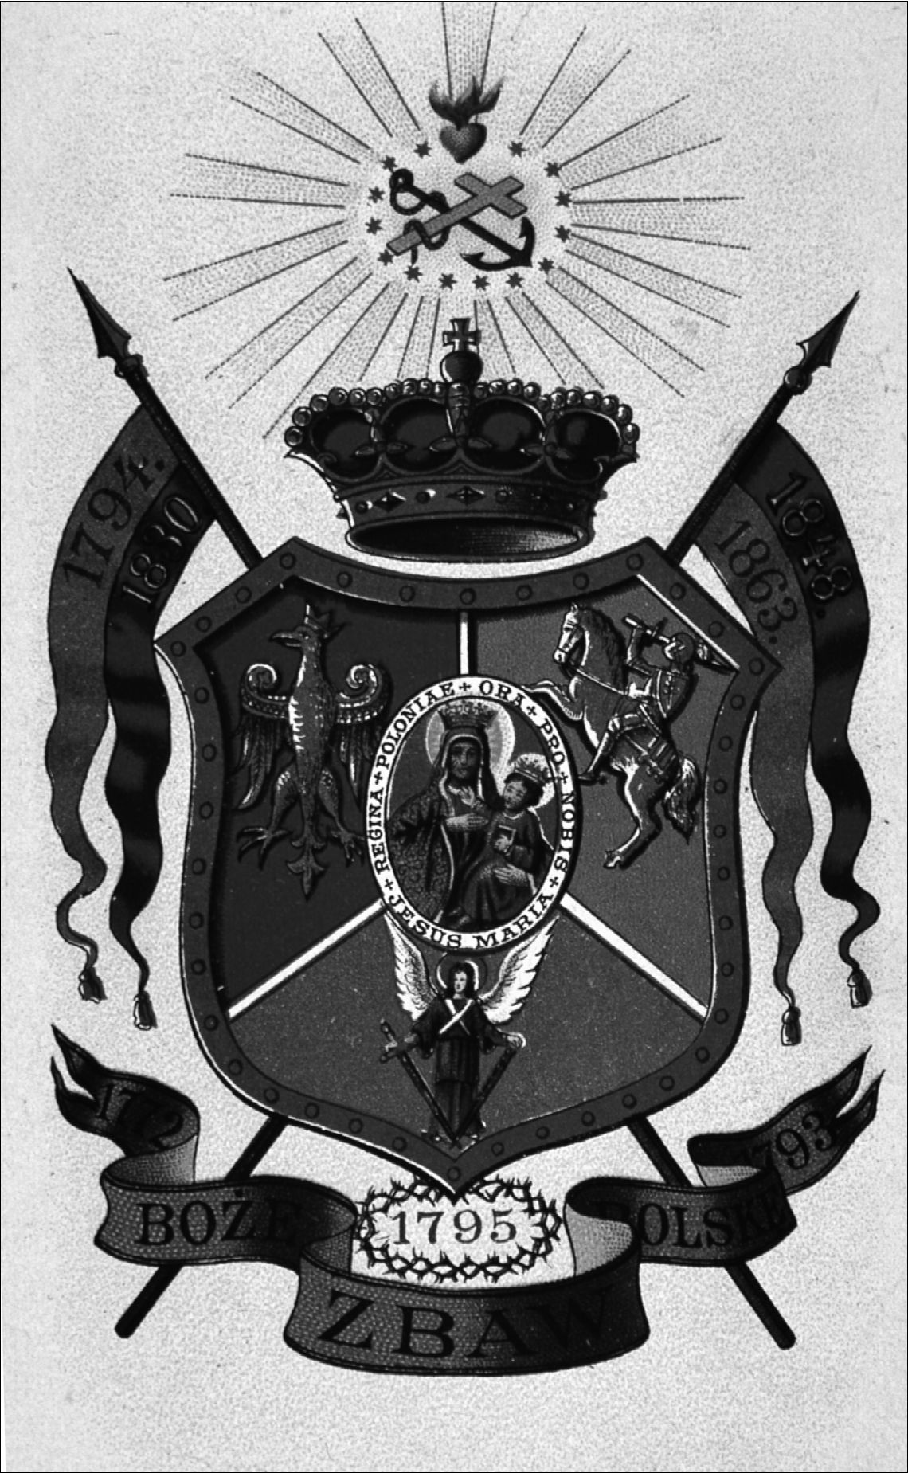
108
The Image and the Figure
- “God, save Poland” Our Lady of Częstochowa and patriotic symbols (Photo: Archive of
the Ethnographic Museum in Kraków)
Queen of the Nation
109
The interpretation of the notion of the “reign of the Virgin Mary” was to shortly
undergo a further transformation. This was to be influenced by the dramatically
changing political situation of the state. The period of the partitions of Poland
(1772 - the First Partition, 1793 - the Second Partition, 1795 - the Third Partition
- which lasted until 1918) confirmed the position of Our Lady of Częstochowa as
an independent ruler who was stronger than the earthly rulers. In the period when
the official Polish state did not exist, and the Polish lands were ruled by three
neighboring empires (Russia, Prussia, and Austria), the ideological power of na-
tional mythology developed and religious symbols were one of the most important
means of building new national identity. The figure of the Queen of Poland was
all the more clearly incorporated in the struggle for matters of the nation, lending
religious authority to armed acts directed against secular authority. The figure of
the Queen defending her kingdom appears in many works of poetry, as well as in
the patriotic songs from this time. The songs emphasized that soldiers themselves
were not merely defenders of national sovereignty, but also “Knights of Mary.”
The following song was sung as the anthem of Bar Confederates (1768-1772) and
during any other national uprisings in the course of the next century:
On the orderlies for the needs of the Fatherland,
Knightly without anyone’s call,
Good natured they endure and pick up scars
In matters of nation and of Our Mary
Glory to You, Oh Lady, who rules in heaven.
We made a timeless alliance with You!
So keep your shield always in readiness,
With that which they swore loyalty eternally
Glory to You Lady, Patron of this earth,
This, our poor Commonwealth of today!
And guard over your servants,
That let your blood in abundant quantities
Remember, Oh Lady, the Polish Crown,
That you took once under your protection.
After all you are Polish, Mary, Queen,
Whom God gave Częstochowa as the throne.85
The loss of Polish independence cemented the link between the national and re-
ligious. The cult of Our Lady of Częstochowa as the Queen of Poland became
increasingly widespread and acquired clear patriotic traits. This was illustrated by
the size and nature of the celebrations to mark the one-hundredth anniversary of
the coronation of the image (in 1817 at Jasna Góra).86 In 1820, pilgrims going on
foot from Warsaw to Jasna Góra brought a crown as a votive offering to the im-
age. The tsarist authorities interpreted this as an expression of opposition towards
85 Ibid., pp. 6-7.
86 Z. Bania and S. Kobielus, Jasna Góra (Warszawa, 1983), p. 88.
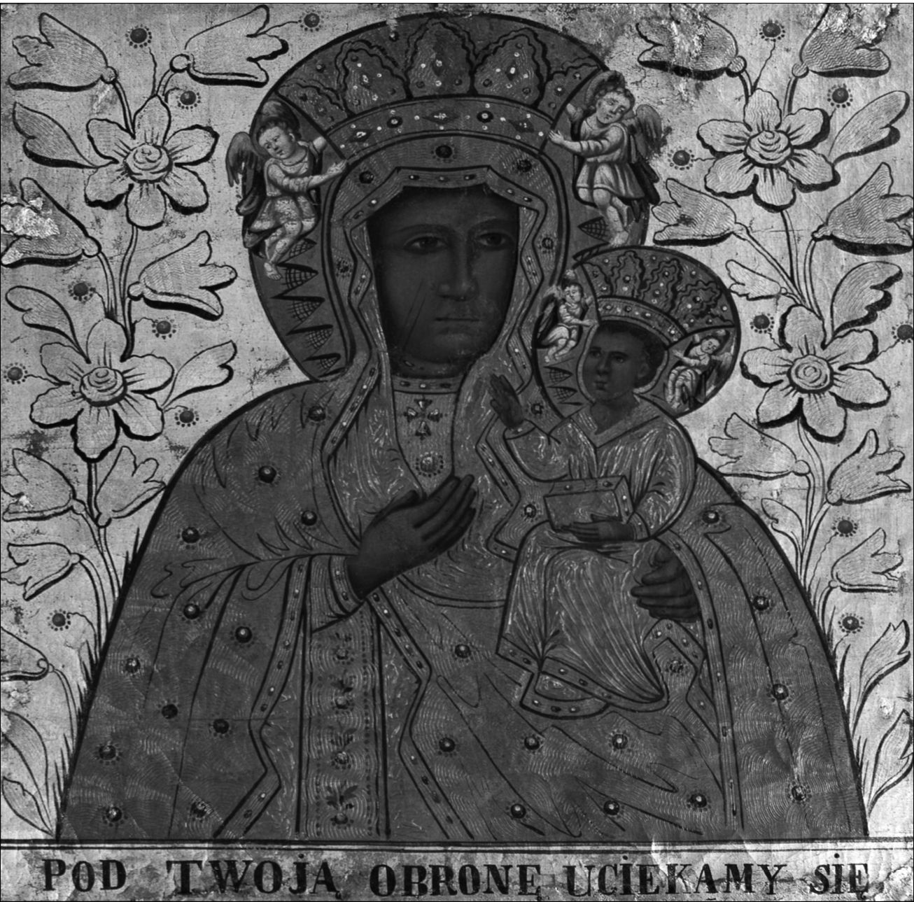
110
The Image and the Figure
the partition governments. Investigations were undertaken which led to the clos-
ing of a part of the border crossings with other partitioned parts of the old Polish
-Lithuanian Commonwealth.87 The decision was justified by “the lack of devout
intentions on the part of some pilgrims.”88 By the 1850s, with the development of
the Romantic concept of history, the significance of Częstochowa as a “national
sanctuary” started to increase.89
- “Under Your Protection” Our Lady of Częstochowa, copy (Photo: J. Kubiena, W. Stasz-
kiewicz, Archive of the Ethnographic Museum in Kraków)
87 Since 1813 (after the Napoleon Wars) Częstochowa and the Jasna Góra Monastery were
within the Russian partition.
88 Z.S. Jabłoński, Pielgrzymowania na Jasną Górę w czasie i przestrzeni. Wybór rozpraw
i artykułów (Częstochowa, 2000), pp. 197-198.
89 Zakrzewski, ‘Od “świątyni zakonnej”’, pp. 89-90.
Queen of the Nation
111
The pinnacle of this ideology of combining the political with religious dimen-
sions came to fruition during the January Uprising (1863-1864). One scholar re-
ferred to this as “the decisive sealing of Polishness with Catholicism.”90 The cult of
Mary expanded - as she became widely accepted as the Queen of Poland and the
Queen of the Poles (a Queen who cared for her Kingdom). The National Govern-
ment created during the uprising, again proclaimed the Virgin Mary as the Queen
of Poland. At this time, there were projects to incorporate an effigy of the Jasna
Góra image as the future national emblem.91 During the January Uprising, the im-
age of Our Lady of Częstochowa - treated as a national symbol - was one of the
most popular tokens placed on banners, frequently printed in the independent press
and on patriotic leaflets.92 This was a time when national motifs were connected
very closely with religious ones and these motifs appeared in various customs
of public life.93 The funerals of national heroes, masses for the homeland during
which mourning attire was worn, patriotic jewelry (upon which religious motifs
appeared - including the picture of Our Lady of Częstochowa) - all of these collec-
tive gestures constituted a manifestation uniting religious and national meanings.
“The Marian cult acquired a dimension, in Poland, unobserved in other countries,
not merely advocating but almost identified with freedom.”94 Częstochowa, next
to Kraków with its royal castle of Wawel, was the main destination for so-called
national pilgrims, who described Jasna Góra as not only a religious, but also a na-
tional sanctuary for Poles.95 Those exiled to Siberia took with them copies of the
Jasna Góra image. Historical accounts and popular stories told of how those who
were exiled, walked toward their destination laboriously carrying heavy images of
Our Lady of Częstochowa.96 In the second half of the nineteenth century, numer-
ous literary works appeared about the history of Jasna Góra, and with them the
vision of Jasna Góra as a national sanctuary entered into common parlance. There
were also popular historical works presenting a vision of Poland’s past through
the story of the history of the image of Our Lady of Częstochowa - the Queen of
Poland.97 In the popular vision of the nation and its history, the title of “Queen”
started to be perceived as obviously connected with the image-figure of Our Lady
of Częstochowa, one existing since mythical national “beginnings.”
90 E. Jabłońska-Deptuła, Kościół - Religia - Patriotyzm. (Polska 1764-1864) (Warszawa,
1985), p. 58.
91 One of the emblems designed for the future country depicted an eagle with the image of
Our Lady of Częstochowa placed on its breast. See J.S. Pasierb, ‘Znaczenia wizerunku Matki
Boskiej Jasnogórskiej’, Studia Claromontana 5 (1984), p. 107.
92 E. Rakoczy, ‘Matka Boża Częstochowska w tradycji rycersko-żołnierskiej’, Studia Cla-
romontana 16 (1996), p. 20.
93 See T. Łepkowski, ‘O katolicyzmie i kulcie maryjnym w społeczeństwie polskim XIX
stulecia’, p. 45.
94 Jabłońska-Deptuła, Kościół - Religia - Patriotyzm, p. 75.
95 See F. Ziejka, ‘Pisarze czasów narodowej niewoli na jasnogórskim szlaku pielgrzymko-
wym’, Peregrinus Cracoviensis 3 (1996), pp. 97-117.
96 See Rakoczy, ‘Matka Boża Częstochowska’, p. 19.
97 Zakrzewski, ‘Od “świątyni zakonnej”’, p. 90.
112
The Image and the Figure

6. The Miracle on the Vistula
When examining popular devotional works on the history of Częstochowa (as
well as when analyzing the results of the ethnographic field research) it is worth
noting that the miraculous defense of Jasna Góra has functioned as a form of
mythical structure called upon to describe subsequent historical situations. The
ancient and medieval subject of the miraculous defense was renewed, referenced,
and repeated in the face of various historical events ascribed to the Queen of the
nation. It became itself a matrix structuring collective notions of popular Polish
mythology. Subsequent historical events in Polish history have often been inter-
preted through the lens of the story of the miraculous defense. Popular calendars
of the Jasna Góra Monastery present a series of events which repeat the vision
of the miraculous defense. We can find amongst them the defense of the Jasna
Góra Monastery at the time of the Bar Confederation (1771), the siege in 1809
by Austrian troops,98 and finally, the most famous twentieth-century “miraculous
defense” - the so-called Miracle on the Vistula. Surprisingly, the “Miracle on the
Vistula,” from a military and geographic point of view, was not at all connected
with the Jasna Góra Monastery - or even the Częstochowa area. The name is as-
sociated with the battle on the outskirts of Warsaw (12-25 August 1920) during
the Polish-Bolshevik war. The unexpected victory over the Bolsheviks turned out
to be the turning point of the whole war and, soon, was acclaimed as a maneuver
which stopped the “Red Menace”99 - saving not only the freshly recreated in-
dependent Polish state, but also Western European countries from the spread of
bolshevism. Again, in the story of the Miracle on the Vistula, the idea of Poland as
the Bulwark of Christendom reappeared. The religious dimension attached to the
Battle of Warsaw is not surprising though. Immediately after the battle, the story
about miraculous defense emerged; linking the victory with the figure of Our
Lady - Queen of Poland, who was said to have protected and led Polish troops.
Contemporary, popular narrations incorporate the Miracle on the Vistula
into the great story about the image of Our Lady of Częstochowa. Let us look at
a typical description of the events of 1920, published in a contemporary popular
Catholic monthly, and highlight the elements that one can find in other stories of
miraculous defenses:100
(1)
- the disproportion between the forces of the fighting sides (“It did not seem
humanly possible for the Poles to overcome the enemy”);
98 See Rakoczy, Jasnogórska Hetmanka, p. 25.
99 A.J. Prażmowska, A History of Poland (Hampshire, New York, 2004), p. 165.
100 Nasza Arka. Miesięcznik Rodzin Katolickich 7 (2001), p. 9. All quotations in brackets
are taken from this issue.
Queen of the Nation
113
- the attackers depicted as enemies of the Christian world (the Bolsheviks,
atheists);
(2)
- the charismatic and spiritual figure of the leader (the Polish general “Józef
Haller was in prayer contact with the Jasna Góra sanctuary during the en-
tire battle. He firmly believed in divine help”);
- the figure of a brave hero, the knight-defender (“A young catechist Father
Ignacy Skorupka displayed courage - especially during the battle. With
a cross in his hand he would stand at the head of a unit of young Warsaw
soldiers”);101
(3)
- the intervention of divine forces (“Nobody doubts that the Most Holy Vir-
gin Mary listened to the pleas of the nation and turned events around”);
- the victory was ascribed to Our Lady of Częstochowa; for it was before
a copy of her image that the novena was performed in besieged Warsaw
and, at the very same time, the prayers were performed at the Jasna Góra
Monastery;
- the turning point in the battle coincided with a Marian feast day (“Was it
not highly significant that the turning point of the Battle of Warsaw [...]
took place on the Feast of the Assumption of Mary [15 August]?”).
Right after the signing of the treaty ending the Polish-Bolshevik war (1921),
numerous symbolic elements appeared which were meant to connect the Miracle
on the Vistula with the image-figure of our Lady of Częstochowa, Queen of Po-
land. As expressions of gratitude for the 1920 victory, various votive offerings
were donated to the Jasna Góra Monastery. Popular iconography depicting the
Miracle on the Vistula, directly referenced the Baroque prototype - presenting
the siege of the Jasna Góra Monastery in 1655. The typical iconographic sche-
ma on the Miracle on the Vistula - established in the interwar period - presents
a battlefield on the outskirts of Warsaw with an image or figure of Our Lady of
Częstochowa rising above it (sometimes covering the city or Polish soldiers with
her cloak).102 Half-legendary stories were circulated about the various happenings
and miraculous dimensions of the battle.
101 The figure of Father Skorupka often mirrors the role of Father Kordecki - the spiritual
leader of those fighting. In a popular book about Jasna Góra for children we can find a direct
comparison: “The young twenty six-year-old catechist Father Ignacy Skorupka, like a second
Father Kordecki, aroused faith in the help of Mary” [emphasis added]. See E. Hanter, Tutaj
bije serce Narodu (Ząbki, 2001), p. 54.
102 See e.g. illustrations nr. 78 and 79 in Rakoczy, Jasnogórska Hetmanka, pp. 166-167.
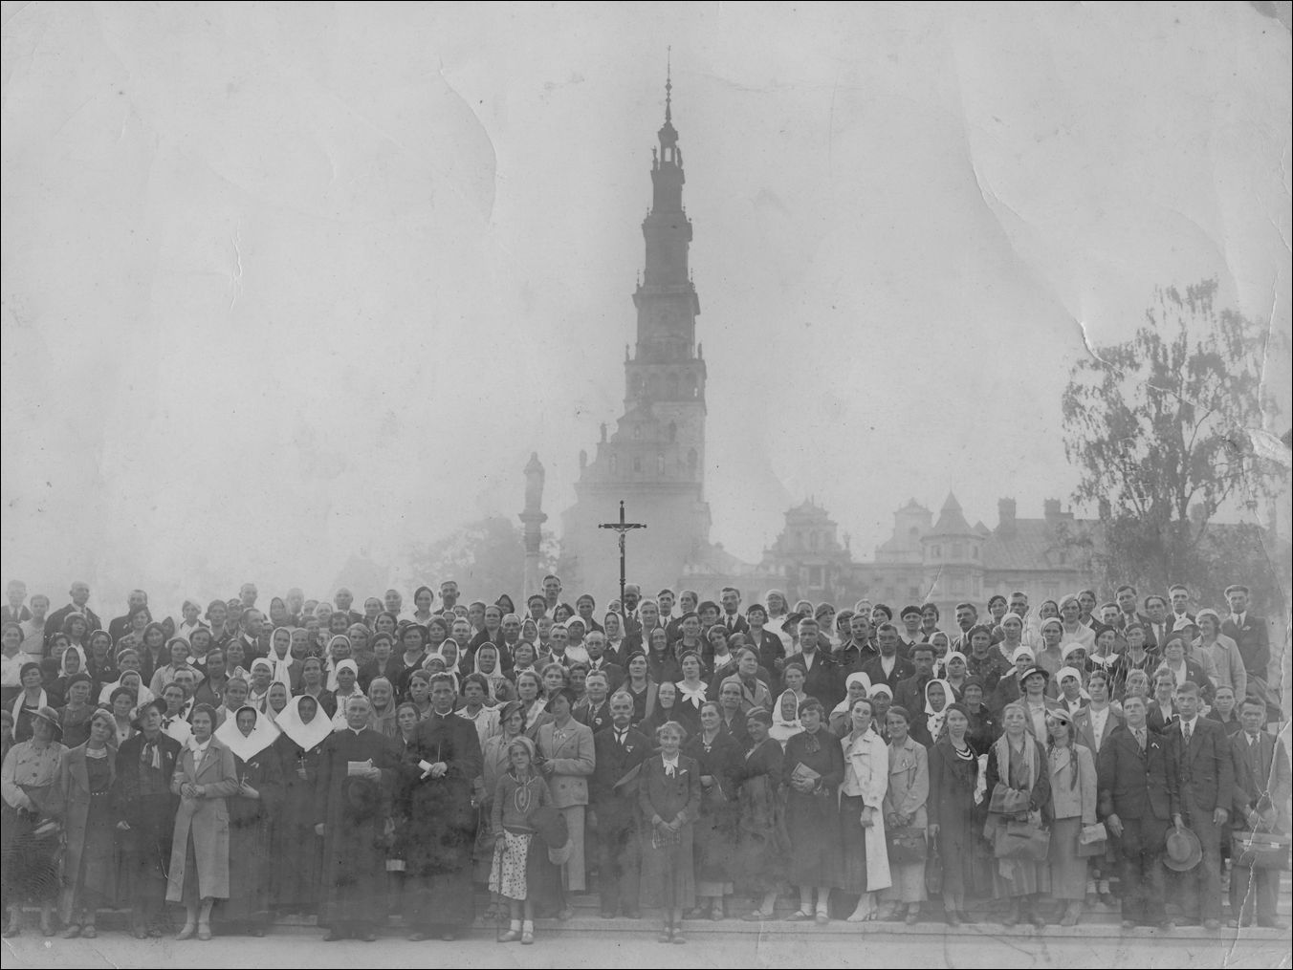
114
The Image and the Figure
17. A pilgrimage to Częstochowa, interwar period (1918-1939) (Photo: Archive of the Ethno-
graphic Museum in Kraków)
During my field research, many interviewees discussed their understanding
of the Battle of Warsaw. Definitely, the Miracle on the Vistula is very strongly
present in the contemporary vision of the Polish past. Descriptions of the battle
also reference the schema of a miraculous defense. Though it needs to be noted
that, in the statements given by the interviewees, there is a lack of clarity about
whether or not the figure of the Virgin Mary that appeared above the Vistula (and
Warsaw) was exactly that of Our Lady of Częstochowa (or another one). Some
interviewees were even confident that “it was not Our Lady of Częstochowa.”
However, the overwhelming majority point to the role of Jasna Góra and the im-
age of Our Lady of Częstochowa as being influential in achieving a final victory.
The Miracle on the Vistula is recalled as a kind of repetition of the miraculous
defense of the Jasna Góra Monastery during the Swedish wars:
- The history of Poland has twice been linked to the image of Our Lady of Często-
chowa. Once during the Swedish attack on Jasna Góra, and the second time during
the Miracle on the Vistula;103
- The miraculous defense was the defense of the monastery from the Swedes [...]
and also the Miracle on the Vistula.104
103 No. 24/int., m., b. 1927.
104 No. 70/int., m., b. 1957.
Queen of the Nation
115
Comments about the Battle of Warsaw given by my interviewees recall typical ex-
amples of miracles ascribed to the miraculous defense. In many cases the image-
figure of Our Lady of Częstochowa is directly connected with the battle:
- During the Miracle on the Vistula, a handful of soldiers went into attack and were
victorious thanks to the power of the image [of Our Lady of Częstochowa];105
- During the time of the Miracle on the Vistula, the Russians saw the image of Our
Lady of Częstochowa over Warsaw. When they fired at it the bullets bounced back
or carried on further without damaging it;106
- I knew a man who took part in the Polish-Bolshevik war and was fighting during
the Miracle on the Vistula. He said that it was a difficult situation when both armies
met near Warsaw. At a critical moment, an image of the Virgin Mary appeared to
both armies in the sky. No sooner had it appeared than the Bolshevik army started
a quick retreat;107
- Even the Russians were frightened of the might of Our Lady of Częstochowa. I’ve
heard from my mother that during the Miracle on the Vistula, Our Lady of Często-
chowa punished the Russians with a plague.108
The story about the Miracle on the Vistula was both decisive and symbolic for
the Polish nation. Popularized during the interwar period, the story disappeared
from the official version in communist controlled (post World War II) Poland.109
It was present, however, in verbal accounts, and, subsequently, in unofficial writ-
ten materials (samizdat). The very form by which the narration was transmitted
gave it the status of a contemporary, popular, apocryphal text. This process of
transmission fostered the creation of folklore surrounding the story. After 1989
(the end of communism in Poland), the story was, again, returned to the realm of
official culture. Aside from historical and academic contexts, the story has found
widespread welcome in the world of cultural symbolism; here, the group of fun-
damental meanings ascribed to it is based on the subject matter copied from the
miraculous defense. In post-communist Poland, 15 August is celebrated as a holi-
day - on one level, it is an officially recognized Day of the Assumption of Mary,
on the second level, it is celebrated as the “Day of the Polish Army” commemorat-
ing the Battle of Warsaw.
105 No. 60/int., m., b. 1949.
106 No. 78/int., m., b. 1960.
107 No. 48/int., m., b. 1938.
108 No. 17/int., f., b. 1926.
109 The Polish-Bolshevik war was not to appear in history books during the communist pe-
riod in Poland (1945-1989) and state censorship treated it as a forbidden part of Polish history.
116
The Image and the Figure

7. Miraculous defense in stories about World War II
The topic of a miraculous defense connected with the image of Our Lady of
Częstochowa and the Jasna Góra Monastery is rooted in Polish popular con-
sciousness. The miraculous defense seems to be eagerly adopted as a reproduc-
ible schema through which various historical events are interpreted. During my
field research, plenty of my interviewees connected the concept of the miraculous
defense of Częstochowa with various events during the World War II and the Nazi
occupation of Poland (1939-45). One of my younger informants even expressed
a conviction that, due to the presence of the miraculous image: “Jasna Góra is the
only fortress that no one has ever taken - not even the Nazis.”110
Reviewing the interviews and various stories recalled by the interviewees,
I found a consistent thread describing a miraculous defense of Częstochowa in
September 1939 - during the Nazi invasion of Poland, which began a five-year
long occupation. One woman gave a very interesting description of events which
she named as a miraculous defense of Jasna Góra:
A German pilot was to bomb the monastery at Jasna Góra but he couldn’t find it. Three
times he tried, and could never find it because he got lost in space. And after all this,
the pilot converted, even though he was a German.111
Searching for any further information about the “miraculous defense in Septem-
ber 1939,” I found out that, in devotional publications connected with Jasna Góra
from the 1980s, there were published accounts about an unsuccessful Nazi bomb-
ing raid on the Jasna Góra Monastery in September 1939. In 1984 the “Jasna
Góra” monthly published a letter received from a person who wrote down the
recollections of his deceased neighbor. The recollections of Stanisław Biegalski
are based on his discussions with two German witnesses whom he met during the
Nazi occupation. The first one - a German landlord of Biegalski in the village of
Pavelvitz - was said to have been employed in the air force technical services at
the airport. According to Biegalski, in September 1939 this person confessed to
him:
Your Madonna, yesterday and today, performed a great miracle and did not allow Her
headquarters in Częstochowa to be bombed. Yesterday, a flight of planes was sent to
bomb Her church. The pilots returned and said that they had received bad draft maps
- where the target was marked, there was a large lake and it was there they dropped
their bombs. The command said that it was sabotage and the pilots were placed under
provost guard. In the afternoon of the same day, a second flight was dispatched, but
this one also failed because they saw a huge forest where the target was supposed to
have been. And even though they dropped their bombs there, they shared the fate of
their colleagues. On 2 September 1939 a third flight was sent, but composed of only
110 No. 88/int., m., b. 1980.
111 No. 76/int., f., b. 1959.
Queen of the Nation
117
SS officers, volunteers to boot. None of them returned to base. What happened to them,
no one knows at present.112
There was also an eyewitness in the account of the event - a participant in the
third air raid. During the course of the German occupation, Biegalski was to have
bumped into the crippled former air force lieutenant, who related the following
story to him:
While I was a lieutenant in the air force (SS formation), I volunteered on 2 September
1939 for a flight to bomb the church with the image of the Schwarze Madonna in Czę-
stochowa. They demanded volunteers because the previous two flights had, as a result
of sabotage or desertion, failed to accomplish the task. We decided to do it whatever
the cost, for that was the order of our SS commander. Immediately after taking off,
the flight was going normally, when - half way into the route - our rudders started to
act on their own. I noticed that everyone was flying in different directions, not keeping
to the target. I landed in Czechoslovakia in a potato field, having run out of fuel. What
happened to my colleagues I can’t tell. I know that I will be a cripple to the end of my
days because you’re not to fight God. My being crippled is, for me, a miracle of my
regained faith.113
The memoirs of Stanisław Biegalski were published in “Jasna Góra” monthly un-
der the title: “A Description of the Miraculous Defense of Jasna Góra on 1 and 2
September 1939.” These recollections evoked a great response, as more and more
people started sending letters with their personal memories and accounts recalling
miraculous events connected with the beginning of the World War II. In one of
the published letters, the figure of the crippled air force officer reappeared, a sup-
posed participant in the air raids on Jasna Góra. During forced labor in Germany,
the author of the letter met two air force officers who spoke thus about a colleague
of theirs:
[.] he flew with the aim of bombing the Monastery. He did not achieve the task be-
cause he did not manage to get to the indicated place and was forced to drop his bombs
in a field because he was not allowed to land with live bombs. After he had landed
[.] the pilot claimed that he had lost the use of his legs. Although they [the German
officers] were atheists, they themselves admitted that it had been a miracle that the
Monastery had not been reached and bombed.114
As established by Janusz Zbudniewek, in his study of Jasna Góra during the
Nazi occupation, it is very probable that, on 1 September 1939, a squadron of
planes was to have taken off from the airport in Pavelvitz near Breslau (present
day Wrocław) and headed toward Częstochowa. It is also probable that, during
the war (or right after it concluded), the story about the two, unsuccessful attempts
112 K. Hektor, ‘Opis Cudownej Obrony Jasnej Góry w dniu 1 i 2 września 1939 r.’, Jasna
Góra 2 (1984), pp. 59-60.
113 Ibid., p. 60.
114 T. Binkowski, ‘List w sprawie Cudownej Obrony Jasnej Góry w 1939 r.’, Jasna Góra
2 (1985), p. 64.
118
The Image and the Figure
to find the monastery (as well as the third flight that resulted in a crash landing)
was circulating among the inhabitants of Pavelvitz, who were to remember a crip-
pled German lieutenant.115 However, researchers have not been able to confirm
the authenticity of any details, or find proof that, in September 1939, the Nazis
really attempted to bombard the monastery at Jasna Góra. As noted by Janusz
Zbudniewek:
The authenticity of these accounts has been impossible to verify (although I have devo-
ted a lot of time to this matter) and it is unlikely that they will be verified in the future.
The accounts remain at odds with other versions, also oral, that feature the German
command ordering its men to spare Jasna Góra upon entering the borders of Często-
chowa.116
Possibly the “confusing accounts of the alleged witnesses”117 are worth treating
not as a historical source, but as testimony to the durability and repeatability of
cultural models in situations that are critical for society. Knowing the history of
the mythical subject of the miraculous defense, as well as its weaving into various
events associated with Jasna Góra, one may note that the story of the unsuccess-
ful German raid acquires the dimension of a story depicting the utilization of the
traditional topic about a miraculous defense in subsequent dramatic and decisive
historical situations. This story has appeared, in a spontaneous way, and has taken
on various versions, for example, on the day the Germans took Częstochowa there
were already rumors spreading around the town that, at high noon, a German
plane had flown over the monastery, dropping two bombs. However, before the
bombs hit their target, they were said to have exploded in mid air, causing no harm
whatsoever.118
Those of my informants who, in their accounts, associated the idea of a mi-
raculous defense with September 1939, follow the mythical pattern of the story:
- During World War II, a pilot of the Luftwaffe was to bomb Częstochowa. But he
mistook the direction. This pilot was very seasoned in his trade and this was the
first time he had experienced something like that;119
- A German pilot was given the order to bomb Jasna Góra. But he didn’t manage it
because the trigger mechanism jammed, and it only released when he was flying
115 See J. Zbudniewek, Jasna Góra w latach okupacji hitlerowskiej (Jasna Góra-Często-
chowa, 1991), p. 56.
116 Ibid.
117 J. Zbudniewek, ‘Jasna Góra w okresie okupacji hitlerowskiej’, Studia Claromontana 1
(1981), p. 304.
118 More than likely, a bomb did actually explode on 3 September 1939 in the environs of
the monastery, damaging the southern part of the basilica. It is difficult, however, to ascertain
the authenticity of the version about the air raid, particularly that the Germans at this time were
already located in the city of Częstochowa and the monastery. See Zbudniewek, Jasna Góra
w latach okupacji hitlerowskiej, pp. 56-57.
119 No. 49/int., m., b. 1939.
Queen of the Nation
119
over meadows where he dropped his bombs. During another attempt, mist appea-
red over the monastery;120
- Hitler gave the order to destroy Jasna Góra. The best planes were chosen for the
task, the greatest flying aces, and the most dangerous criminals. The planes set
off. The bombs were prepared for release. But when they arrived, as it seemed to
them that they were over the monastery, mist enveloped them from all sides. The
Nazis couldn’t believe it, but they had to go back. They didn’t give up after the one
attempt. Hitler was livid that such a small town, a handful of monks, some kind
of image had broken his might. The raids were repeated twice more. Also without
result. In the end, the leader of the Reich gave up and, for the remainder of the war,
did not attack the monastery.121
In the cited accounts, there are many of the obligatory elements of the story about
a miraculous defense of a fortress: the holy place is attacked by a stronger and
devilish enemy; from the human point of view, there should be no problem in de-
stroying the monastery, but Jasna Góra is saved due to various unexplainable hap-
penings (miracles). Also the figure of the crippled German officer calls to mind
the old thread of the punished and converted iconoclast-attacker, so often incor-
porated in the old stories and present in the Jasna Góra topos.
In addition to detailed stories about the miraculous defense of the monastery
in September 1939, many of my interviewees emphasize that Jasna Góra survived
World War II miraculously. Even though they are often unable to explain the roots
of their conviction, their statements might be also treated as proof of the popular-
ity and importance of the image-figure of Our Lady of Częstochowa in the context
of the common vision of the past and national history.

8. The great story as a national myth
In post war Poland, the Catholic Church emphasized its connection with the tra-
ditional symbolism of Jasna Góra and very strongly enforced the image of the
monastery as a “spiritual center of the nation” and a “religious fortress” in a “del-
uge of communism.” Within a situation of fierce confrontation with the state, the
Catholic Church in Poland introduced the immense, precisely planned program of
“mass religious events.”122 In this program, the idea was to connect the mythical
vision of the history of the Polish nation with popular devotion dedicated to Mary,
the Mother of God and Queen of Poland. The image of Our Lady of Częstochowa
appeared to be a central symbol of the religious renewal initiated by the Church.
120 No. 59/int., m., b. 1949.
121 No. 17/int., f., b. 1926.
122 The most glaring manifestation of the tense Catholic Church-state relations of the time
was the arrest of Primate S. Wyszyński, who was interned from 25 September 1953 to 26 Octo-
ber 1956. On the subject of the various initiatives of S. Wyszyński connected with the image of
Our Lady of Częstochowa see e.g. M.P. Romaniuk, Prymas Wyszyński (Gniezno, 2001).
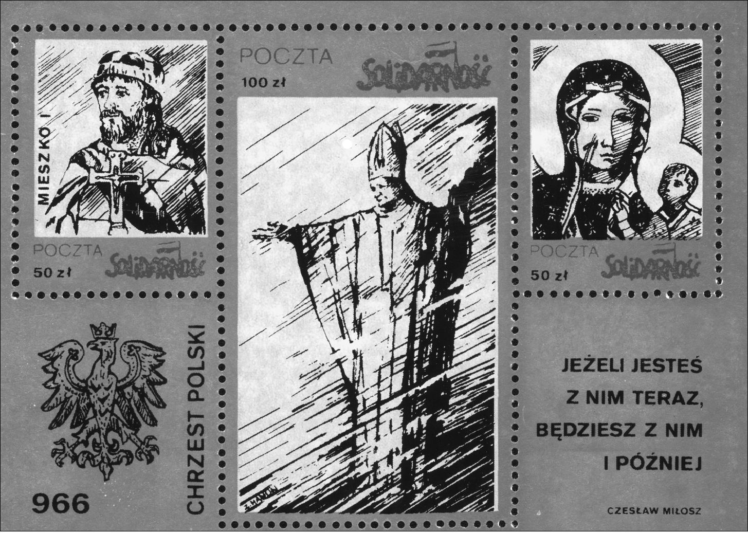
120
The Image and the Figure
18. “The Baptizing of Poland 966” “Solidarity Post” underground postcard, images of Prince
Mieszko I, Our Lady of Częstochowa and Pope John Paul II (Photo: Archive of the Foun-
dation ‘Centrum Dokumentacji Czynu Niepodległościowego’ and the Jagiellonian Li-
brary)
The program of “mass religious events” (supported by Cardinal Wyszyński)
spanned many years, starting from 1956 and a public ceremonial renewal of “King
Jan Kazimierz’s vows” and a repeated “recognition of the Virgin Mary as the
Queen of the Polish Nation” on the three-hundredth anniversary of the event.123
The climactic moment, chosen by Wyszyński to add even more levels of national-
religious symbolism, was the year 1966. It was announced by the Episcopate that
this marked the “Polish millennium.” It had been one thousand years since the
year 966 when the Polish Prince Mieszko I decided to accept Christianity from
Rome. This date has been treated as the symbolic beginning of Christianity in
Poland, as well as the date that Polish statehood began. Huge religious events con-
nected with the “Polish millennium” overshadowed the official state celebrations
of the “one thousand years of Polish statehood.” This showed that the mythical
religious-symbolic vision of Polish history, combined with Marian devotion (as
well as the most popular Marian shrine and image) could attract crowds and deep
emotions even during an atmosphere of terror and repression.
123 For the text of vows see S. Wyszyński, Na drogach zawierzenia (Warszawa, 1996),
pp. 18-22
Queen of the Nation
121
A program of reinforcing popular religiosity and “preparing the nation” for
the millennial year 1966 was strongly promoted by Wyszyński. The year 1957
marked the start of one of the most intriguing and widespread religious rituals
connected directly with the image of Our Lady of Częstochowa. A special copy
of the original image was prepared, blessed and dedicated to travel around all of
Poland, “visiting” every single parish church. The whole ritual was called a per-
egrination of the copy of the image of Our Lady (see Chronology of a peregrina-
tion on page 180) and was often heralded as a “visit of the Queen of Poland” or
a “wandering of the Mother of God through the Polish land.”124 At the most criti-
cal moment, when the state authorities stopped the peregrination and “arrested”
the picture, the power and popularity of myths and beliefs creating the great na-
tional story of the Jasna Góra image was revealed.125 Shortly after the authorities
ordered a cessation to the ritual of the wandering image, the general of the Pauline
Order gave a sermon at Jasna Góra. This sermon referred to the significance of the
image-figure in a historical-mythical manner, referencing the vision of a miracu-
lous defense and the title of “Queen:”
When the Protestant Swedes wanted to take the Polish Kingdom into their rule, it was
at Jasna Góra that their might was broken. The Virgin Mary saved our faith, and the
awakened nation finally regained its freedom. Jasna Góra was bequeathed the title -
Jasna Góra of Victory. The king elected Mary Queen of Poland.126
After the image was stopped, the Pauline Order decided to continue the per-
egrination without the image. Empty frames, symbolizing the missing image,
were sent out. The first service was conducted with the empty frames of the
image in the Katowice Cathedral in the Silesia region. Over the entrance to the
cathedral, a huge banner read: “Silesia in honor of the Queen of Poland.”127 There
was a great deal of rhetoric and symbolism referring to the regal and national
dimensions of the image during the peregrination of the empty frames. In 1966,
when the third ceremonial coronation of the image of Our Lady of Częstochowa
took place, the symbolism was further enhanced.128 Within the framework of the
celebrations of a thousand years of Polish Christianity, Primate Stefan Wyszyński
decorated the image with millennial crowns, which were specially made for this
124 S. Grzybek, ‘Teologiczne podstawy peregrynacji Matki Bożej Częstochowskiej’, Ma-
ryja Matka Narodu Polskiego, ed. S. Grzybek (Częstochowa, 1983), p. 282.
125 In Chapter IV I describe the peregrination, analyzing its religious dimension.
126 A fragment of the sermon given by Father J. Tomziński on 8 September 1966. See
A. Szypuła, Peregrynacja obrazu Matki Bożej Częstochowskiej w diecezji przemyskiej w latach
stanu wojennego 1982-1983 (Przemyśl, 1996), p. 21.
127 Ibid.
128 The first coronation of the image was connected with the described celebrations of
1717. In 1909 the crowns from the image of Our Lady of Częstochowa were stolen. In 1910 the
image received new crowns. The ceremony performed in 1966 with “millennial crowns” was
therefore the third coronation of the image.
122
The Image and the Figure
occasion. The picture was also decorated with new millennial robes.129 Yet again
Our Lady of Częstochowa was recognized symbolically as the Queen of Poland.
An emphasis was placed on her particular contribution to the history of the nation.
The very fact that the celebrations of one thousand years of Polish Christianity
were linked with Jasna Góra (and the inclusion of the image-figure of the Queen
of Poland in the celebrations) is evidence of the particular form of collective na-
tional tradition. The celebration could just as easily have been in Gniezno, where
Prince Mieszko I was supposedly baptized in 966, or in Warsaw, the official capi-
tal of Poland. One may assume that Our Lady of Częstochowa is viewed as having
been “always,” “from the beginning of the Polish statehood” the Queen of “her
chosen nation,” while the story of many centuries of history is confirmation of the
regal title.
Actually, King Jan Kazimierz and the Lvov vows are mentioned often, in the
interviews, as the moment when the title of Queen of Poland was bestowed. There
is a repetition of the formula that “the king crowned the image Queen of Poland”
or “he chose the Virgin Mary to be Queen.” There is also, however, a simultane-
ous conviction that, in reality, Our Lady of Częstochowa has “always” been the
ruler and special guardian of Poles, with the actual moment of the official bestow-
ing of the regal title being shifted to a time of mythical antiquity.130 As mentioned
in Chapter I, in this context the great story appears as a contemporary version of
the etiological legend of the holy image:
- The Virgin Mary has always been the Queen of Poland. For us Poles this means
that she has us under her special protection;131
- The Virgin Mary has had the title of Queen of Poland from time immemorial,
from the time Christianity was adopted. It is connected with some ancient Christian
king;132
- Poles were told that Our Lady of Częstochowa was the Queen of Poland at the
dawn of time. It’s always said that some Kazimierz crowned the Virgin Mary
Queen;133
- The term Queen of Poland is known from litanies. The title results from the Poles’
faith. Once someone deserving and famous obtained crowns for the Virgin Mary.
The Virgin Mary has had these crowns for a long time. [.] One hears from child-
129 Zyskowska, Historia Obrazu Jasnogórskiego, p. 88.
130 Even in the stories in which the Lvov vows are recalled, we are often dealing with the
category of mythical past - the informants are unable, on the whole, to locate this event within
historical time, while the very figure of the king takes on the form of a figure undefined histori-
cally. Jan Kazimierz is therefore referred to as “some old Christian king,” “some Kazimierz or
other” or appears interchangeably with other well known Polish rulers - Kazimierz the Great,
Władysław Jagiełło, Jan Sobieski.
131 No. 12/int., f., b. 1924.
132 No. 24/int., m., b. 1927.
133 No. 14/int., f., b. 1925.
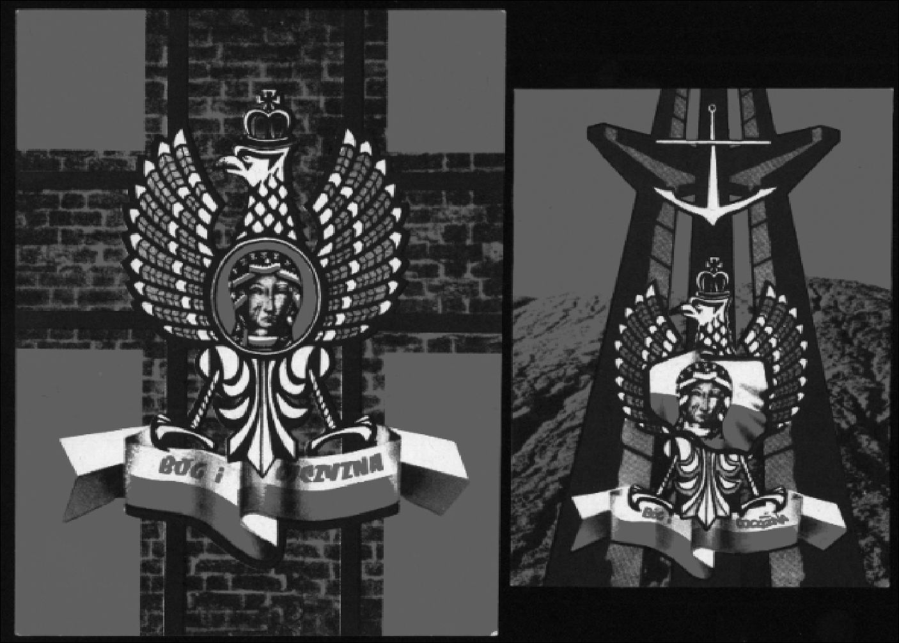
Queen of the Nation
123
hood that she is the Queen of the Polish Crown, which is why she is revered. She
is the Polish patron;134
- The Virgin Mary has been the Queen of Poland for centuries. Just like in the song:
‘Of old you are the Queen of Poland.. .,’135
- Our Lady of Częstochowa has always been the Queen of Poland, it’s always been
said so. She protects us.136
19. “God and Fatherland” Underground print from the 1980s (Photo: Archive of the Founda-
tion ‘Centrum Dokumentacji Czynu Niepodległościowego’ and the Jagiellonian Library)
The story developing around the notion of the Queen of Poland in the popular
vision references, first and foremost, the figure of the Virgin Mary as guardian
and protector. In mythical discourse about Polish popular Catholicism, the Polish
nation appears as specially chosen. The image, in accordance with the content of
former etiological legends, chose Jasna Góra for itself as a resting place. Here
it displayed its power, performing miracles on many occasions. As a result, the
Polish nation is enveloped in care. Many of the interviewees speak of the Virgin
Mary’s choice of Poland:
134 No. 7/int., f., b. 1920.
135 No. 64/int., f., b. 1952.
136 No. 65/int., f., b. 1953.
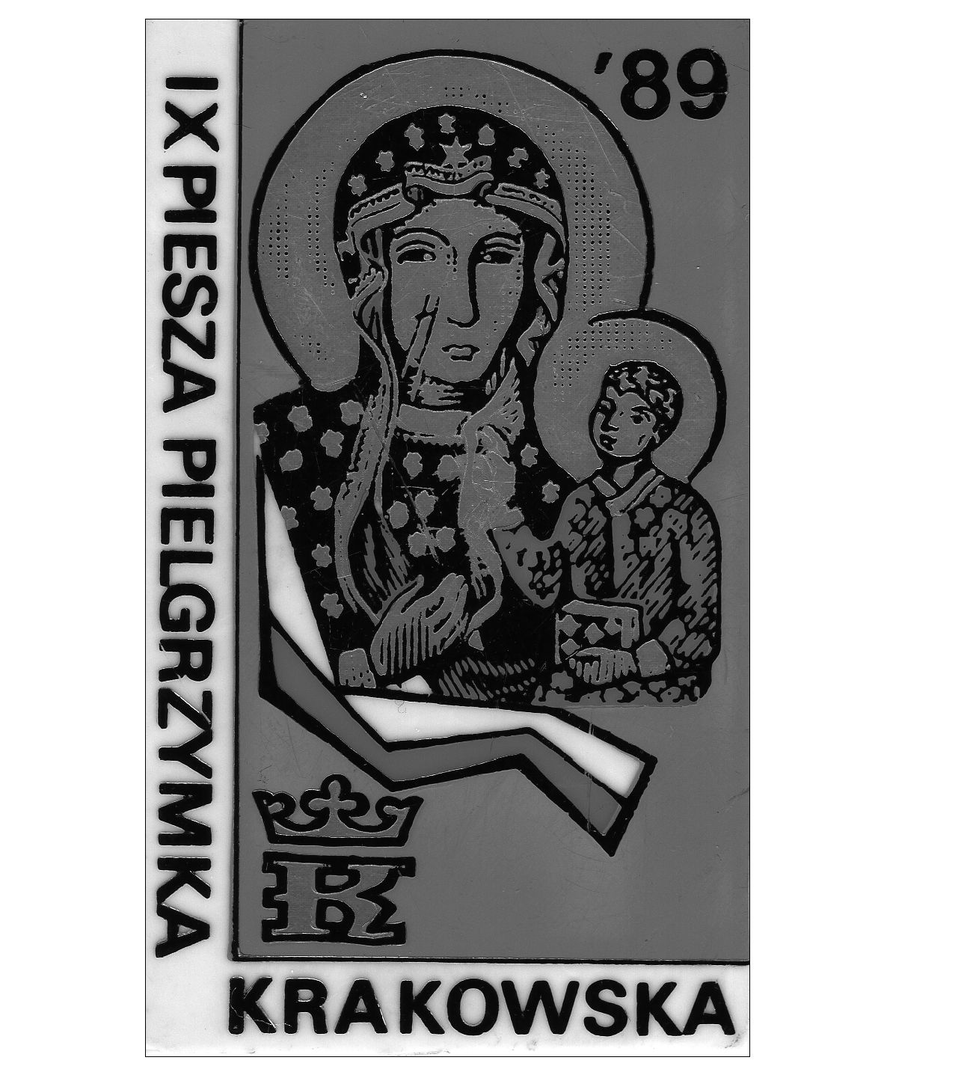
124
The Image and the Figure
- Only the Virgin Mary deserves the title of Queen of Poland [...]. The Virgin Mary
is strength, and we are nothing. There are many religious Catholics in Poland and
She herself chose Poles. And having made such a choice, so it had to be till the end
of the world;137
- The title Queen of Poland is derived from the fact that the Virgin Mary loved Po-
land and Poles in particular. She promised to protect them from misfortunes;138
- So many things have happened in Poland which prove that Poland is a chosen
country and touched by the protection of Our Lady of Częstochowa [...]. As a fa-
mily, we pray in family matters as if to the Mother, while in matters of state, then
we pray to the Queen of the nation.139

There is a strong conviction that the Virgin Mary extends special protection over
Poland; this belief is connected with the motif of Poland as a chosen nation.
20. A small badge worn by pilgrims taking part in a pilgrimage (on-foot) from Kraków to
Jasna Góra in 1989. This copy of the image of Our Lady of Częstochowa is accompanied
by a white-red Polish national flag (Photo: Anna Niedźwiedź)
137 No. 15/int., f., b. 1925.
138 No. 55/int., f., b. 1941.
139 No. 68/int., m., b. 1954.
Queen of the Nation
125
In the assembled interviews, there is often a belief that the Queen of Poland
has actively involved herself in the most recent history of the country and of
the world. She is credited with the choice of a Pole for pope (the late Pope John
Paul II) as well as for the collapse of communism in the countries of East-Central
and Eastern Europe. Both recent and ancient history are interpreted as an ex-
pression of the providential vigil conducted by the image-figure of Our Lady of
Częstochowa - Queen of Poland. Here is how the informants depict the vision of
Our Lady of Częstochowa - the nation’s guardian:
- The Virgin Mary helped Poland, she helps and will continue to help [...]. In the
whole world, there is no Virgin Mary like the one in Poland. Mary likes Poland in
a special way;140
- The Polish nation is under the special care of the Virgin Mary. Which is why
her image [at Częstochowa] is so revered;141
- The Virgin Mary is known as the Queen of Poland because she protects Poland
from evil;142
- For us Poles [the fact that the Virgin Mary is the Queen of Poland] means that she
has us under her special care;143
- We thank her for her aid in every difficult situation, for she has cast her cloak over
Poland. Recently the Pope announced Her to be the Queen of Poland;144
- When foreigners attacked Poland, Poles always turned to the help of Our Lady
of Częstochowa as Queen.145
The image of Our Lady of Częstochowa is linked with a mythologized vision of
national history, in which the past of Poland and Poles is presented in the form of
a coherent sequence of events.
The great story of the image-figure of Our Lady of Częstochowa has features
of a mythical self-description of one’s own past, particular for the category of
tradition. It is worth remembering that tradition is, first and foremost, an attitude
in relation to one’s own past, which, as Czesław Robotycki writes:
bestows meaning to elements from the past. It [tradition] petrifies the past, bestowing
a sense of continuity. It combines phenomena that are, chronologically and logically,
varied into a single joint timeless category of “former.” This category seems to exist
outside a sense of time and logic. Tradition presents different phenomena of the world
and man as a continuous and intentional whole. It gives meaning to activities and
durability to values. It creates visions of the human world in which accumulation oc-
No. 17/int., f., b. 1926.
No. 24/int., m., b. 1927.
No. 9/int., f., b. 1923.
No. 12/int., f., b. 1924.
No. 63/int., f., b. 1952.
No. 14/int., f., b. 1925.
140
141
142
143
144
145
126
The Image and the Figure
curs. That which existed and has passed will survive in values. The past may be saved
despite the passing nature of events.146
The great story of the image is, therefore, a fundamental part of national tra-
dition and defines the values associated with the image-figure of Our Lady of
Częstochowa underscoring the religious-patriotic semantic. In addition to its role
in the nation’s past, the great story of the image simultaneously provides an on-
going interpretation of the present. Society often interprets the world of current
events using a mythical examination of the past. Current happenings, on the one
hand, provide new annotations to the pages of a mythical vision of history; on the
other hand - they are interpreted as an incessant repetition “of that which was.”147

9. Jasna Góra - the spiritual capital of Poland
Our Lady of Częstochowa is seen in popular discourse as the Queen of Poland,
therefore the place where the image is kept (and where the figure is believed to
reside) is described as a special place - a national “spiritual capital” which exists
outside the official state capital. The phrase “spiritual capital” became so popu-
lar and recognizable in the Polish language that it frequently appears in popular
publications as well as in academic works. Very often the symbol of a “spiritual
capital” further reveals the mythical order of the great narrative of the image. As
Zofia Rozanow writes:
Three capitals can be cited during the thousand-year history of the Polish state: Gnie-
zno, Kraków and Warsaw - three consecutive centers of monarchical authority. At the
end of the fourteenth century, when - through the marriage of the Angevin Queen of
Poland [Jadwiga] to a Lithuanian duke [Władysław Jagiełło] - a new dynasty took
over the administration of the Polish kingdom, the creation of the nation’s spiritual
capital occurred. This was to be not a monarchical but a monastic seat, the Pauline
monastery at Jasna Góra in Częstochowa founded in 1382.148 [emphasis added]
The notion of Jasna Góra as a place of special importance for Poles is con-
nected, first and foremost, with the period of the non-existence of the Polish state.
During the partitions Jasna Góra attracted national pilgrims who went there not
only for the sacral character of the place, but also because of patriotic motifs.149
Here national relics, votive offerings and banners commemorating the victories of
the past were gathered and viewed by visitors.
146 Cz. Robotycki, ‘Historia i tradycja - dwie kategorie opisu przeszłości’, Prace Etnogra-
ficzne ZNUJ 29 (1992), p.18.
147 See e.g. the notion of “spontaneous historiosophy” described by Kuniński. Kuniński,
‘Historiozofia żywiołowa a upadek komunizmu’, pp. 9-25.
148 Rozanow, Dzieje obrazu, p. 6.
149 See Ziejka, ‘Pisarze czasów narodowej niewoli’, pp. 97-117.
Queen of the Nation
127
During the course of the nineteenth century, Jasna Góra’s status as the domi-
nant Marian sanctuary (attracting Poles) increased dramatically. The shrine’s
popularity was directly connected with the growth and popularization of the cult
of the Virgin Mary, Queen of Poland, seen in opposition to the unrecognized,
foreign, temporal partition authorities. A historian of the nineteenth century has
described that at this time:
Polish Catholicism became increasingly Częstochowian. The people believed that
Mary - together with God - rules the world. The most popular place among pilgrims
was Jasna Góra. It was considered the spiritual capital of Poland and the seat of
Mary’s temporal stay as the Queen of Poland, while the Marian cult took on a national
dimension. Mystical unity replaced the absence of state unity.150 [emphasis added]
The political and historical circumstances of the nineteenth century appeared
to influence the development and re-creation of the Baroque Sarmatian cult of
the Virgin Mary as a Queen. During the eighteenth century, the Sarmatian ideol-
ogy - parallel with the political system of a noble democracy and free election
of kings - influenced the creation of the cult of the Virgin Mary - Queen. She
was seen by Polish nobles in opposition to the temporal king’s power. In the sub-
sequent century, the figure of the Queen was seen as a ruler who was supposed
to be stronger than the partitioning powers. The notion of Jasna Góra as a place
of exceptional importance for Poles was shaped simultaneously. The Jasna Góra
Monastery started to be seen as the actual seat of the Queen of Poland. It gained
the title of an alternative capital in relation to the worldly temporal which were,
de facto, the seats of the partitioning powers.
The notion of Jasna Góra as a national sanctuary, as well as the spiritual cap-
ital, is still present in the contemporary story of the image. The confrontation
between Warsaw (the seat of unrecognized and hostile temporal authority) and
Częstochowa (the spiritual capital of Poland) was very popular during the period
of communism (1945-1989). The mass religious ceremonies organized at Jasna
Góra and, the symbolism used by the Catholic Church, developed the mythical
great story about the image and the vision of Częstochowa as the seat of the
“real Queen of Poland.” “Theology of the Jasna Góra sanctuary” was created and
popularized by such influential figures of Polish Catholicism as Cardinal Stefan
Wyszyński and Cardinal Karol Wojtyła (later known as Pope John Paul II).151 In
popular, colloquial and contemporary Polish, the expression “spiritual capital of
Poland” often appears as a synonym for the Jasna Góra Monastery. In common
explanations given during field research, aside from the mythical vision of the his-
150 A. Chwalba, Historia Polski 1795-1918 (Kraków, 2000), pp. 123-124.
151 See e.g. J. Pach, ‘Jasnogórski obraz i sanktuarium w nauczaniu kardynała Stefana
Wyszyńskiego’, Studia Claromontana 5 (1984), pp. 86-101. See also R.J. Abramek, ‘’’Jasno-
górska” mariologia kardynała Karola Wojtyły papieża Jana Pawła II’, Studia Claromontana 1
(1981), pp. 7-39 and J.A. Nalaskowski, ‘Jana Pawła II teologia jasnogórskiego sanktuarium’,
Jasna Góra w dwudziestoleciu pontyfikatu Jana Pawła II, ed. Z.S. Jabłoński (Jasna Góra-Czę-
stochowa, 1999), pp. 65-81.
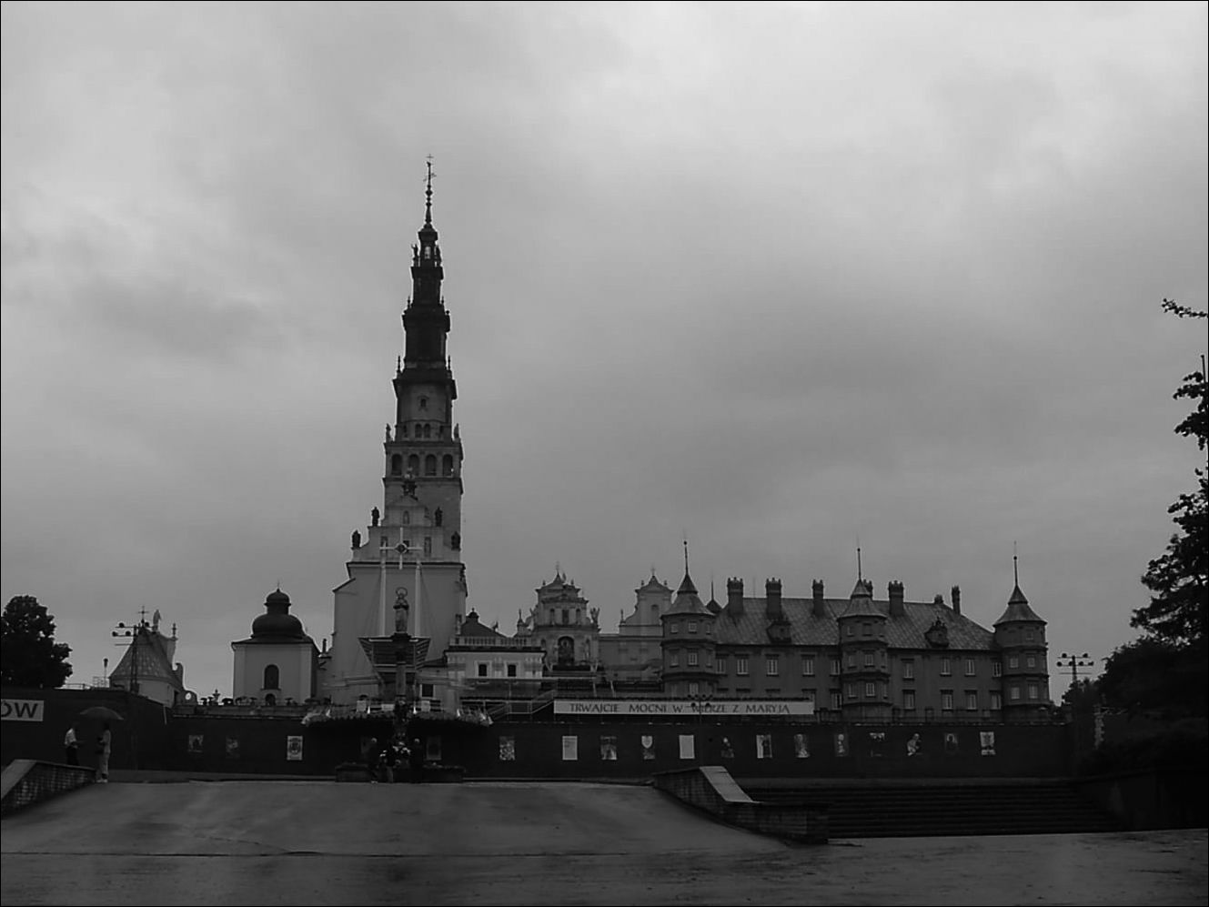
128
The Image and the Figure
21. Jasna Góra Monastery (Photo: Anna Niedźwiedź)
tory of the nation, there was also the idea of the image as a representation of a holy
figure. Our Lady, in the religious perception of the image, is really present at
Jasna Góra through her image. She is there, so - as in the order of the great story -
she is seen as the Queen - her court and capital are situated at the monastery. The
following expressions, my interviewees used when describing the image-figure,
illuminate the religious-national perception of Our Lady of Częstochowa:
- The Queen of Poland lives in Częstochowa;152
- Mary is the Queen of Poland, and every queen must have her capital. Therefore,
Częstochowa is the spiritual capital;153
- Częstochowa has earned the name of the spiritual capital of Poland because there
are no other better places where the Virgin Mary could have her palace;154
- Warsaw is the temporal capital, while Jasna Góra is the spiritual one. People pray
here and obtain miracles. The Virgin Mary in the frame has so many votive of-
ferings - people promise things to her for wishes fulfilled;155
152 No. 61/int., f., b. 1949.
153 No. 52/int., m., b. 1939.
154 No. 73/int., f., b. 1958.
155 No. 9/int., f., b. 1923.
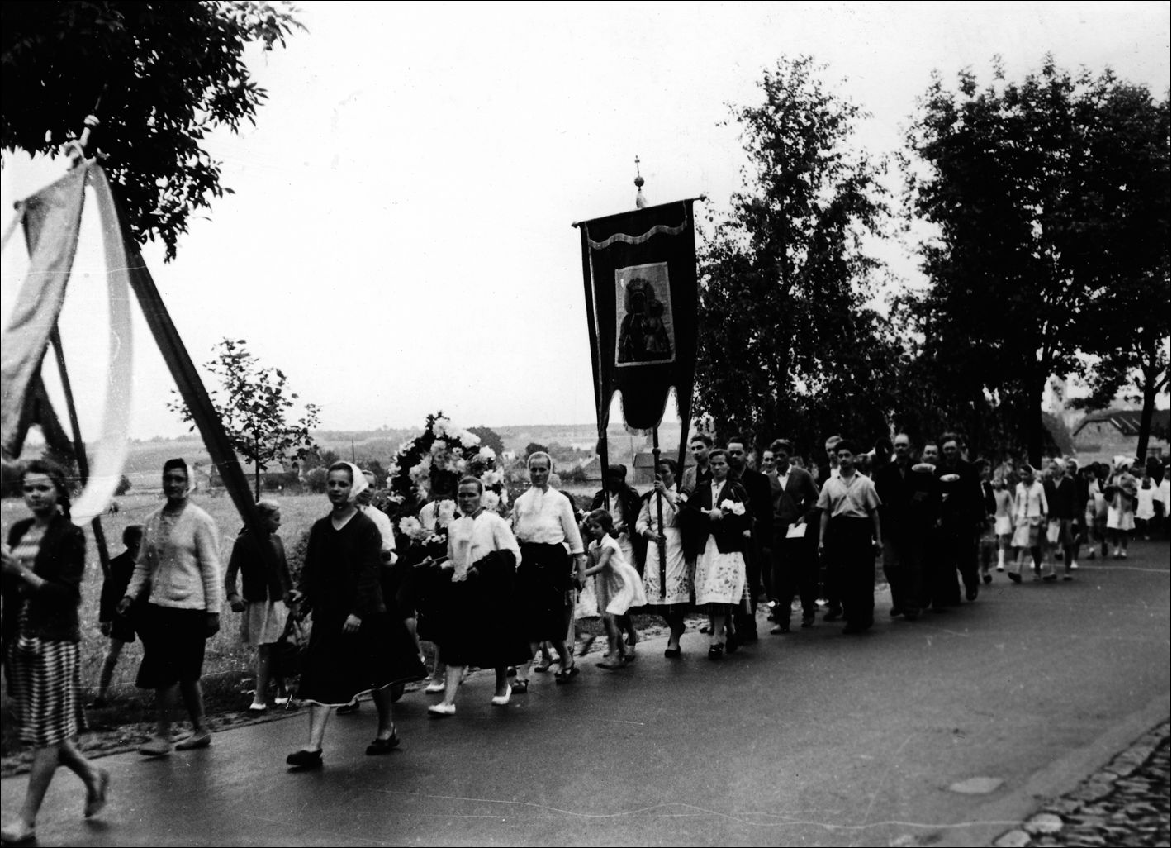
Queen of the Nation
129
- The term “spiritual capital of Poland” refers to Częstochowa - this is connected
with the fact that it is here that the picture of Our Lady of Częstochowa is loca-
ted.156
The fieldwork materials reveal that Jasna Góra, described as the spiritual capital of
Poland, is seen primarily as a miraculous place, the oldest and most exceptional.
Within the interviews, there is repetition of tales about the immense number of
miracles, acts of healings and grace carried out at Jasna Góra (“the largest number
of miracles occur there”). The informants also expressed their conviction that Ja-
sna Góra is “the oldest sanctuary in Poland,” “the biggest,” and that the image
kept here “is the oldest in Poland” and that the largest number of pilgrims assemble
there. Various opinions emphasize the significance of the Jasna Góra Monastery in
Poland. One interviewee stated, for example, the belief that “Jasna Góra is located
at the very center of Poland.”157 That it is a special place - “like heaven.” People
experience lofty and extraordinary things there. The informants, when recalling
their times at Jasna Góra, speak of the exceptional sensations, as well as a sense
of being associated with a great and miraculous power. All those descriptions per-
fectly suit an anthropological category of a sacred and liminal space.
22. Pilgrims from Rozprza on their way to Częstochowa, 1961 (Photo: Jan Świderski, Archive
of the Ethnographic Museum in Kraków)
- No. 81/int., f., b. 1964.
- No. 42/int., f., b. 1936.
130
The Image and the Figure
The capital, central, miraculous dimension of Jasna Góra is directly connected
with the recognition of the royal majesty of the image-figure of Our Lady of
Częstochowa. Tales about the pilgrimages of kings and national heroes to Jasna
Góra become, in the collective tradition, confirmation of the primacy of the Virgin
Mary’s authority over Poland. Earthly sovereigns come and go, power changes
hands, but the image-figure of Our Lady of Częstochowa was, and always will be,
marked by regal status. Therefore, representatives of temporal authority should
recognize the precedence of Our Lady of Częstochowa’s authority:
- Many times hetmans and other military leaders confirmed Our Lady of Często-
chowa’s power as greater than theirs;158
- Various kings, leaders and commanders have always come to Jasna Góra and here
have prayed for victory;159
- The history of Poland is closely connected with the history of the image, because
in the past commanders setting off for wars placed themselves under the protection
of Our Lady of Czestochowa;160
- This title [Queen of Poland ] means that the Virgin Mary is important for Poles.
That she is, the equivalent of the kings, who only enjoyed respect, while the Virgin
Mary, as Queen, was (and still is) revered.161
Public confirmation of popular notions is borne out by the various, ostentatious
displays made by politicians who have come to Jasna Góra. They repeat and mim-
ic the gestures of the former rulers of the Polish Commonwealth (whose acts are
present in the collective memory).162 They often speak explicitly of their connec-
tion with tradition. Here is the text of a prayer given during a pilgrimage made by
members of the Polish Parliament on 2 February 1992:
So like King Jan Kazimierz years ago, in desiring to save the Fatherland, he chose
You for his states as Queen. So we, senators and deputies of the Polish Republic, stand
before You so that the fate of Poland can be entrusted to You, and through You to the
Most Holy Heart of Jesus.163
Regardless of the motives that drive politicians to visit Jasna Góra, it is impor-
tant to note the fact that there is a socially endorsed and accepted custom of mak-
ing a pilgrimage to Częstochowa. It is difficult to evaluate whether this behavior
remains within the sphere of gesture, political games, or constitutes a calculat-
158 No. 63/int., f., b. 1952.
159 No. 39/int., m., b. 1935.
160 No. 43/int., m., b. 1937.
161 No. 41/int., f., b. 1936.
162 Note that politicians undertook official pilgrimages to Jasna Góra during the inter-war
period, for example in 1923 on the anniversary of the Miracle on the Vistula, President Sta-
nisław Wojciechowski went there. Also President Ignacy Mościcki (1926-1939) twice made
a pilgrimage to Częstochowa .
163 See Jasna Góra 3 (1992), pp. 25-26.

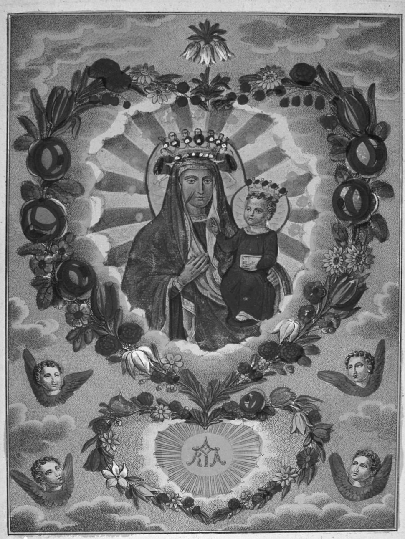
Queen of the Nation
131
ed public display. However, an ethnologist can note that the collection of signs
used by various politicians journeying to Jasna Góra in post-communist Poland,
brings to mind the ideas that created the great story about the image-figure of the
Virgin Mary. The ostentatious visits of politicians to Jasna Góra become part of
the collection of socially accepted forms of behavior as they repeat the mythical
model and reinforce the religious-patriotic meaning of the image of Our Lady of
Częstochowa.
QJuatz N.P. M&xyi
C ZESTOCHOWSKIEY
" ». t*~.r i/. «JJcvrï&tiV’àÂvlÿ/
23. Our Lady of Częstochowa, copy (Photo: Archive of the Ethnographic Museum in Kraków)
132
The Image and the Figure

10. Queen and Mother - a documentation of one exhibition
As I have mentioned previously, the national dimension of the image and the title
of Queen of Poland connected with it were very strongly emphasized within pop-
ular Polish Catholicism during the communist period. The strength of the Queen
symbol, similarly to earlier times, was supported by the construction of an op-
position between non-recognized temporal authorities and extraordinary spiritual
power.
In searching for various aspects documenting the cult of Our Lady of
Częstochowa within the national context during the period of the 1980s, I have
focused on an exhibition organized by the Ethnographic Museum in Kraków. The
exhibition entitled “Our Lady of Częstochowa in Folk and Popular Art” presented
numerous copies of the image of Our Lady of Częstochowa, and an especially
big collection of the nineteenth-century panel paintings which were mostly pro-
duced in the workshops of Częstochowa and distributed among pious peasants
in different parts of the Polish lands. The exhibition which opened in Kraków in
October 1982 (later it was shown also in Wrocław and Warsaw) immediately was
interpreted by its visitors as an event coinciding with the religious celebrations
of six-hundred years of the Jasna Góra Monastery. One of the contributors to the
exhibition recalls the specific feeling of this time - when there was both Martial
Law and the grand celebration of the Jasna Góra anniversary (promoted by the
Catholic Church in Poland). Despite the fact that the exhibition
[...] did not reference the jubilee in its title [...] it was interpreted and understood by
the public as an event connected with the six-hundredth anniversary of the cult of the
image of the Virgin Mary revered at Jasna Góra in Częstochowa.
Further on the curator notes that
[...] the exhibition was not typical for various reasons: it displayed a phenomenon that
was religious in character but also possessing an exceptional emotive weight for the
Polish nation in times of difficulty, crisis and war [Martial Law]; it aroused hope and
raised the spirits of people oppressed by various difficulties.164
In point of fact, the opening of the exhibition was nine months after the introduc-
tion of Martial Law in Poland (called in Polish stan wojenny i.e. “state of war”).
The exhibition constituted a forum for spontaneous reactions and demonstrations
of resistance toward the actual political situation within the country. The pre-
served fragments of the Book of Comments and Visitors to the Exhibition (which
can be found in the Archive of the Ethnographic Museum in Kraków) reveal the
very emotional reception of the exhibition.165 What is more, the Book illustrates
164 A. Jacher-Tyszkowa, ‘Wystawa dla narodu polskiego’, Jasna Góra 3 (1984), pp. 24-25.
165 At the Archive of the Ethnographic Museum in Kraków I was able to find the Book
of Comments and Visitors to the Exhibition from Wrocław. The quotes from the Book I cite
with the annotation [Wr.]. The remaining quotes which come from the Kraków exhibition [Kr.]
Queen of the Nation
133
that, for many people, their visit to the museum appeared to be a deeply reli-
gious experience. Many entries are composed in the form of prayer invocations
dedicated to Our Lady of Częstochowa - Queen and Mother of the Polish nation.
The Book is closer in content to a typical Devotional Votive Book placed in front
of a holy image (a common custom in Polish Catholic churches), than a Book of
Comments placed at the entrance to a museum exhibition. Here are some of the
strikingly devotional entries left by visitors to the museum:
- Oh Mary, our Mother, Oh Mother of our tormented nation
Do not leave us! [Kraków];
- Oh Mary, Queen of Poland
I am with you, I remember and keep vigil [Wrocław];
- We escape to Your Protection
Oh Holy Divine Mother [Wr.];
- Oh Mary - save our Fatherland [Wr.];
- Oh Mother! Pray for us - Poles! [Wr.];
- Oh Mother dearest of Częstochowa, keep vigil over the Polish nation, so that no
harm befalls our Beloved Homeland. You know what I ask of You, for victory and
for all those interned to be freed [Wr.]
- I thank you, oh Mary, for protection and ask for it to continue. Take the Homeland
into your protection, my family and all those who escape to you. With thanks for
the grace [Wr.];
- Oh Częstochowa Mother! Have our town, our Homeland and all of Your children
in your care. Our hope lies in You. Let Your memory live for the centuries to come
[...]. Congratulations to the organizers of the exhibition [Wr.].
In many of the entries the invocation to the Virgin Mary is directly interwoven
with thanks addressed to the curators of the exhibition and comments on it:
- God bless the Organizers!
Oh Mother of kings and lesser mortals
Save the Nation and the Homeland [Wr.];
I quote from A. Jacher-Tyszkowa, ‘Wystawa dla narodu polskiego (2.)’, Jasna Góra 6 (1984),
pp. 55-62, as well as after A. Jackowski, ‘Wpisy do “Księgi wystawy”’, Polska Sztuka Ludowa
3 (1984), pp. 155-156. It might be interesting to add that the state censor did not allow certain
fragments of the Book to be published in the monthly Jasna Góra due to their political charac-
ter (those parts were omitted when printed and signed as “censured”). Quoting all the entries,
I keep the capitalization that was present in the original entries. I also try to follow the graphic
layout of the entries. In most cases I decided to omit signatures (often illegible) and exact dates
left by the visitors. All emphasis added.
134
The Image and the Figure
- The exhibition of Our Lady of Częstochowa is superb, we have gone round with
our hearts touched, may there be many more. Oh Mary save our Homeland! [Wr.];
- Oh, Our Lady of Częstochowa, take us Poles into your care!
Let God reward all the organizers of this beautiful exhibition [Wr.];
- God bless the organizers!
Oh Mother, oh Queen of Poland
Take care of the whole Nation [Wr.];
- Oh Divine Virgin, oh Holy Maid
Let God honestly Repay You
Through the Intercession of the Most Holy Mother
To Whom the Exhibition is Devoted
We celebrate the Ceremonious Celebration of the 600-year Jubilee
Of the Holy Jasna Góra Image we Adore
So amongst the Nations as You Yourself Said
Enraptured by Religious Exhibits
One should say Holy, although maybe Ancient
But in the Soul of a Pole and the Heart Deeply Hidden
I Respectfully Lay on this Route
Great Words of Recognition to the Organizers
And the Dear Staff of the Ethnographical Museum [Wr.].
Often direct reference to the figure of Our Lady of Częstochowa is developed into
a longer, complex utterance which recalls personal reflection on the meanings of
the image of Our Lady of Częstochowa:
- The nation manifests what beats in its heart. I give thanks that I could participate at
least for a moment in this National Experience thanks to this marvelous exhibition.
Oh Mary, Queen of Poland - pray for us! [Kr.];
- An exposition rich in content, depth of historical thought - highly inspiring - of
matters of the Lady of Jasna Góra, in order for us to become one great family really
loving each other [Wr.];
- “Under Your protection, we run, oh Holy Divine Mother,” Our Lady of Jasna Góra,
revered for centuries by your ever loyal Polish Nation. As with generations past,
save us from every need. Protect the young generations from the gangrene of de-
pravity. Be always the bulwark of the Pole for all time and the champion of the
Son. The exhibition is truly beautiful. It makes so visible the succession of Polish
generations making pilgrimages through the centuries of history. God bless the
organizers [Wr.];
- The collection is most beautiful, meaningful and delightful. It arouses admiration
of both painting and real history. Thank you for the organization and assembly of
Queen of the Nation
135
such numerous exhibits. One can see in them the beauty of the figure, the suffering,
the pain and hope for a better tomorrow. Oh Mary Queen of Poland Pray for us
[Wr.];
- God bless the organizers and creators for such a marvelous display of art, for
a beautiful exhibition, and let there be more. Oh Mother, have in your care our Ho-
meland and ask for grace with God, so that the Holy Father John Paul II can come
to your six-hundredth anniversary [Wr.].
The personal dimension of the image, the reminder of the figure of Our Lady of
Częstochowa, the often iterated conviction as to her actual and direct presence
at the exhibition can be found in the following entries which recall the notion of
non-differentiation:
- I am placing real flowers at the feet of Our Lady of Częstochowa in Her picture
a copy of the image [Wr.];
- We liked the exhibition of Our Lady of Częstochowa very much, our hearts were
touched immensely. Oh Mary, give us your hand! [Wr.];
- I was there, I saw and was moved by Your sight which remains in my mind [Wr.];
- Oh Mother! How good it is to meet You here in so many artistic manifestations.
How we need frequent meetings with You who, now as ever, will always be with
us [Kr.];
- It is good that in a jubilee year the Virgin Mary has made it also to a museum [Wr.];
- Welcome Queen of Poland to Wrocław! “There is a spot on this land, where eve-
rybody would love to return. Where Her Countenance reigns, on it two wounds
cut...” [Wr].
- Oh Most Holy Queen of Poland and of the World on the throne of Częstochowa
Present at the exhibition in Wrocław. Send us the grace of salvation [Wr.];
- Farewell, OH MOTHER. [Wr.].
In reading through the entries to the Book, it is easy to see that the reaction to the
exhibition was extremely emotional and infused with religious dimensions. There
is a religious-patriotic tone which dominated the entries, while the documentary
and academic value of the exhibition is treated as secondary:
- Here not only can one admire the beauty of folk art but one can pray and leave
with the hope in one’s heart that Mary, despite the suffering and pain, will rescue
Poland from the enemies of the Country and the Church. “Victory will come via
Mary.” I would really like to thank the organizers, and God bless them for a fanta-
stic experience [Wr.];
- Unique beauty - the marvelous radiance of the exhibition and not only that but
- one can just look and look and at the same time pray. This is inspired by the
beauty of the Most Holy Virgin Mary [Wr.];
136
The Image and the Figure
- I find myself leaving the exhibition with a joyous feeling as if I was at the entran-
ce to heaven. “Come and help us, oh Merciful Lady.” God bless You! [Kr.];
- The exhibition deepens one’s Love for Our Lady of Częstochowa [Wr.];
- In visiting this exhibition, the thought comes to mind: as if we were not viewing it
as a work of art, but saw within it a manifestation of the deeply-rooted faith of the
Polish Nation [Wr.].
It seems that the exhibition became more than an exposition of the cult of the
Virgin Mary. For many of those who attended, it was an exhibition to honor the
Virgin Mary:
- We thank you most sincerely for the organization of such a beautiful exhibition to
honor the Virgin Mary Queen of Poland [Wr.];
- Thank you for organizing and making available such a wonderful exhibition to the
honor of the Virgin Mary [Wr.];
- God has truly blessed us - that in these difficult times such a wonderful exhibition
has been allowed to be organized to honor our miraculous Queen of the heaven
and earth [Wr.].
* * *
The documentation relating to the exhibition illustrates an intertwining of the
great-national story about the image with that of the private small stories. In the
entries from the Book, the relationship to the national past is linked with a per-
sonal religious dimension. In addition to the figure of the Queen, there is the no-
tion of the Mother. Next to the patriotic meanings and that of the great national
story, there are also small private narratives - based on the personal and religious
relations between believers and the image-figure of Our Lady of Częstochowa.
National mythology and the great story about the image blends with private and
popular piety.
Queen of the Nation
137
Table IV
The development and changes in meanings associated with the notion of Our Lady of
Częstochowa as Queen.
The image of Our Lady of Częstochowa | The palladium of kings and the defensive shield of the  state
The figure of Our Lady of Częstochowa | Patron and defender of the state
The figure of the Queen of the Polish  Crown | The ruler of the noble nation. She is stronger than the  temporal earthly kings
The figure of the Queen of Poland | The ruler of the nation alternative to earthly authority.  Her reign sanctions struggle with earthly authority
The figure of the Queen - Guardian of  Poles and the Mother of the nation | The guardian and ruler of Poles, interfering in the  course of history. She spreads her protection over her  beloved nation
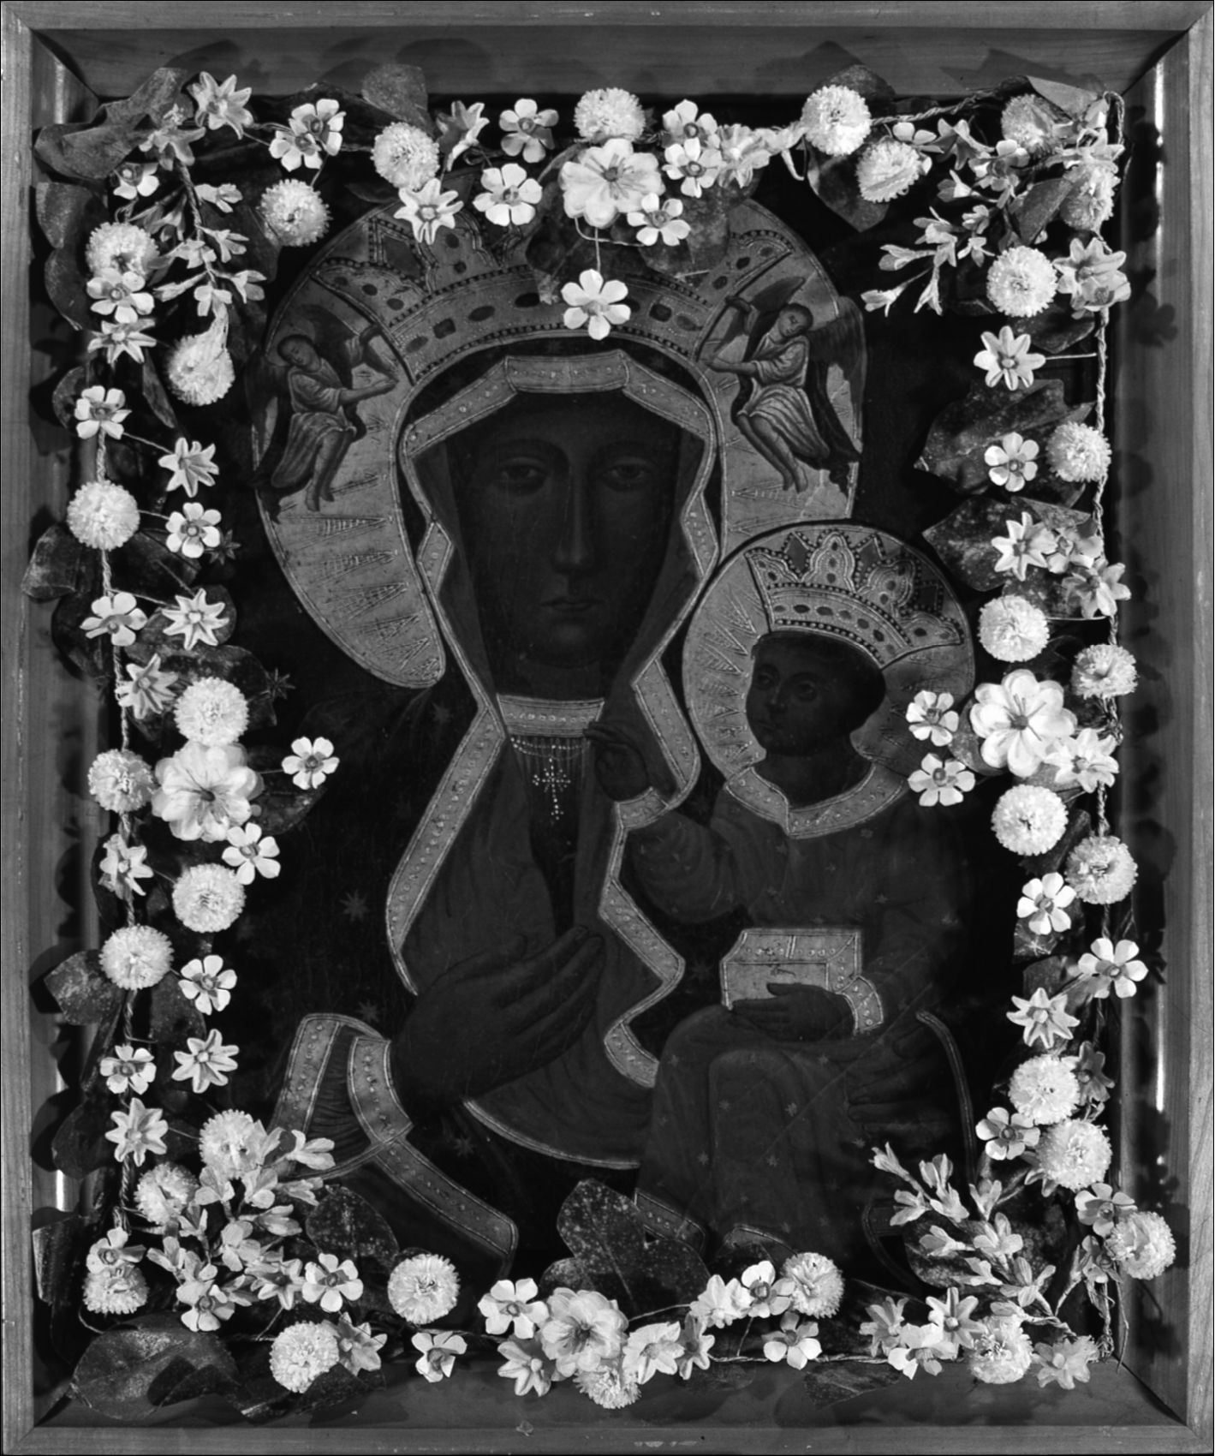
- Our Lady of Częstochowa, copy, oil on canvas (Photo: J. Kubiena, W. Staszkiewicz,
Archive of the Ethnographic Museum in Kraków)

Chapter IV
THE IMAGE-FIGURE IN LIVED RELIGION

1. Sensual non-differentiation
In this closing Chapter, I will discuss typical features of the religious experience
connected with the image-figure of Our Lady of Częstochowa in contemporary
Polish popular Catholicism. Of special interest are various forms of private reli-
gious devotion connected with the image - as well as the feelings and emotions
that the image evokes in its devotees. Here I will focus more on small stories -
stories of lives, private and family experiences - rather than on the national public
discourse of the great story which dominated the previous parts of this book. My
main interest here is discovering how the image-figure is lived in today’s Poland
by contemporary Catholics.
Before analyzing several case studies and examples of personal experiences of
the image, it is worth reviewing the discourse about the notion “popular religion”
within the context of Polish anthropology and ethnology. The concept of “popular
religion” has been analyzed and discussed by various disciplines. It has appeared
not only in strictly anthropological works but also in religious studies, sociology,
history, theology - as well as in public and journalistic discourse. The use of the
term by various disciplines and in various contexts additionally blurred its mean-
ings. As one of the researchers pointed out, the term “popular religion” is term
which is “one of the most unclear both with regard to content as well as scope
and range.”1 Additionally, in Polish linguistic tradition, the term itself has been
problematic since various terms have been used to describe “popular religion.”
The most popular terms are those that refer to the idea of religion rooted in the tra-
ditional piety of the Polish historical peasantry: “folk religion,” “folk religiosity,”
“folk piety” (religia ludowa, religijność ludowa, pobożność ludowa). This very
terminology is strictly connected with the notion of “popular culture” (which in
Polish anthropological tradition has been often named “folk culture” (kultura lu-
dowa) with references to ethnographical analysis of the traditional culture of peas-
antry). Critical discourse about the usage of the terms connected with traditional
1 W. Piwowarski, ‘Wprowadzenie’, Religijność ludowa. Ciągłość i zmiana, ed. W. Piwo-
warski (Wrocław, 1983), p. 6.
140
The Image and the Figure
ethnography (in the context of analyzing contemporary societies) brought about
the appearance of a new term within the Polish ethnology: “culture of a folk-type”
(kultura typu ludowego).2 This term enabled researchers to define the typical fea-
tures of contemporary popular culture - while emphasizing structural similarities
with the historically described “folk culture.” Following this discourse, the term
“religion/religiosity of a folk-type” started to be used in Polish anthropology to
describe a phenomenon usually known in English as “popular religion.”
When describing “religion of a folk-type” a few characteristic features are
generally referenced: the social dimension of religious phenomena; the adapta-
tion of religious dogma to local traditions and everyday reality; the spontaneous,
impulsive organization of society around religious ideas, convictions and sym-
bols; the religious and mythical interpretation of reality; the ritualization of cult
forms and behaviors; and the sensual experience of sacrum (through images and
other material objects, bodily experiences and practices: e.g. pilgrimages, fast-
ing). Even though the term “religion of a folk-type” recalls the ethnographical
studies of traditional “folk culture,” this term embraces a much broader reality.
“Folk culture” appears as a term based on a case study of a historical social group
which enables one to describe characteristic behaviors also appearing in contem-
porary societies.
Following the Polish ethnological tradition, I will emphasize the character-
istic features of “religion of a folk-type” in the context of private religious ex-
perience connected with the image-figure of Our Lady of Częstochowa. I will,
however, use here the term “popular religion” - as well as the term used by Rob-
ert Orsi “lived religion.” These terms are meant to emphasize that (especially
in this closing Chapter, describing small stories about the image-figure of Our
Lady of Częstochowa) - my focus is on religion understood as “relationships
between heaven and earth,” as Orsi wrote, “with the specific forms that these
relationships take in particular times and places.”3 The image-figure of Our Lady
of Częstochowa appears as a kind of a heavenly intercessor - one who can be
lived and experienced by people on earth. The dual perception of Our Lady of
Częstochowa seen and experienced as both: the image and the figure is one of the
most fascinating elements present in popular Polish Catholicism. It is an example
of sensual non-differentiation which appears in the contact with the material ob-
ject (picture) perceived as holy.
2 See e.g. L. Stomma, Antropologia kultury wsi polskiej XIX wieku (Warszawa, 1986),
p. 147 and Cz. Robotycki, Etnografia wobec kultury współczesnej (Kraków, 1992), pp. 12-17.
3 R. Orsi, Between Heaven and Earth. The Religious Worlds People Make and the Scho-
lars who Study Them (Princeton and Oxford, 2005), p. 2.
The Image-Figure in Lived Religion
141
- Pilgrims on their way to Częstochowa, resting inside a church at the foot of an altar
(Photo: Jan Kubiena, Archive of the Ethnographic Museum in Kraków)
142
The Image and the Figure
Such a relation to and with the image-figure can be counted as one of the char-
acteristic features of popular religion (religion of a folk-type) in which experience
of sacrum is sensual and mediated through material objects. Polish sociologist,
folklorist and historian Stefan Czarnowski, in his famous article about “a religious
culture” of the Polish peasantry (published in the 1930s), emphasized that the sen-
sual experience of sacrum has been crucial in Polish Catholicism and in the cult
of images. Czarnowski wrote that holy images “are, for our people, something
more than mere pictures. They are symbols in the most literal meaning of the word
i.e. objects taking part in the nature of the imagined figure and summarizing this
figure.”4 Joanna Tokarska-Bakir, referring to Stefan Czarnowski’s work, addition-
ally emphasizes the crucial role of the sensual non-differentiation in religious expe-
rience connected with holy images. She claims that the sensual non-differentiation
which enables the “adhesion of image and referent, names and individuals, text and
its meanings is not a secondary phenomenon in relation to religious experience,
rather it fundamentally establishes and enables it.”5 [emphasis added]
In previous chapters of this book, I have often highlighted the presence of the
image-figure relation in etiological legends and in the great story of Our Lady
of Częstochowa. Here, I will focus on the contemporary small, private stories of
the image of Our Lady of Częstochowa, which are reflections of deeply-rooted
religious experiences and feelings which express the symbolic character of the
picture. The statements gathered during the field research show the religious sen-
sitivity which appears when a believer has contact with the image-figure of Our
Lady of Częstochowa. Expressions used by many of my interviewees show that
they have no doubt that in meeting with the image, they are in fact taking part in
a meeting with the genuine, actually present figure of Our Lady of Częstochowa:
- Our Lady of Częstochowa looks at a man as if she wanted to say something to
him;6
- The eyes of the Virgin Mary are particularly important in the image. When a man
looks into the image he sees that the Virgin Mary is extremely solicitous. You can
read the pain that people cause in these eyes;7
- During peregrination one could talk one to one with the image, present one’s
own problems. It was such a personal meeting with the Virgin Mary;8
- I have heard from people that the countenance of Our Lady of Częstochowa is
sometimes sad and that then the Virgin Mary almost does not look people in the
eye (this means danger) while at other times it (her face) is more cheerful;9
4 Czarnowski, Kultura, p. 171.
5 Tokarska-Bakir, Obraz osobliwy, p. 230.
6 No. 33/int., f., b. 1932.
7 No. 40/int., f., b. 1935.
8 No. 39/int., m., b. 1935. I discuss the peregrination in further parts of this Chapter. Here,
the interviewee describes the so-called small peregrination during which the copy of the image
of Our Lady of Częstochowa was visiting his home
9 No. 14/int., f., b. 1925.
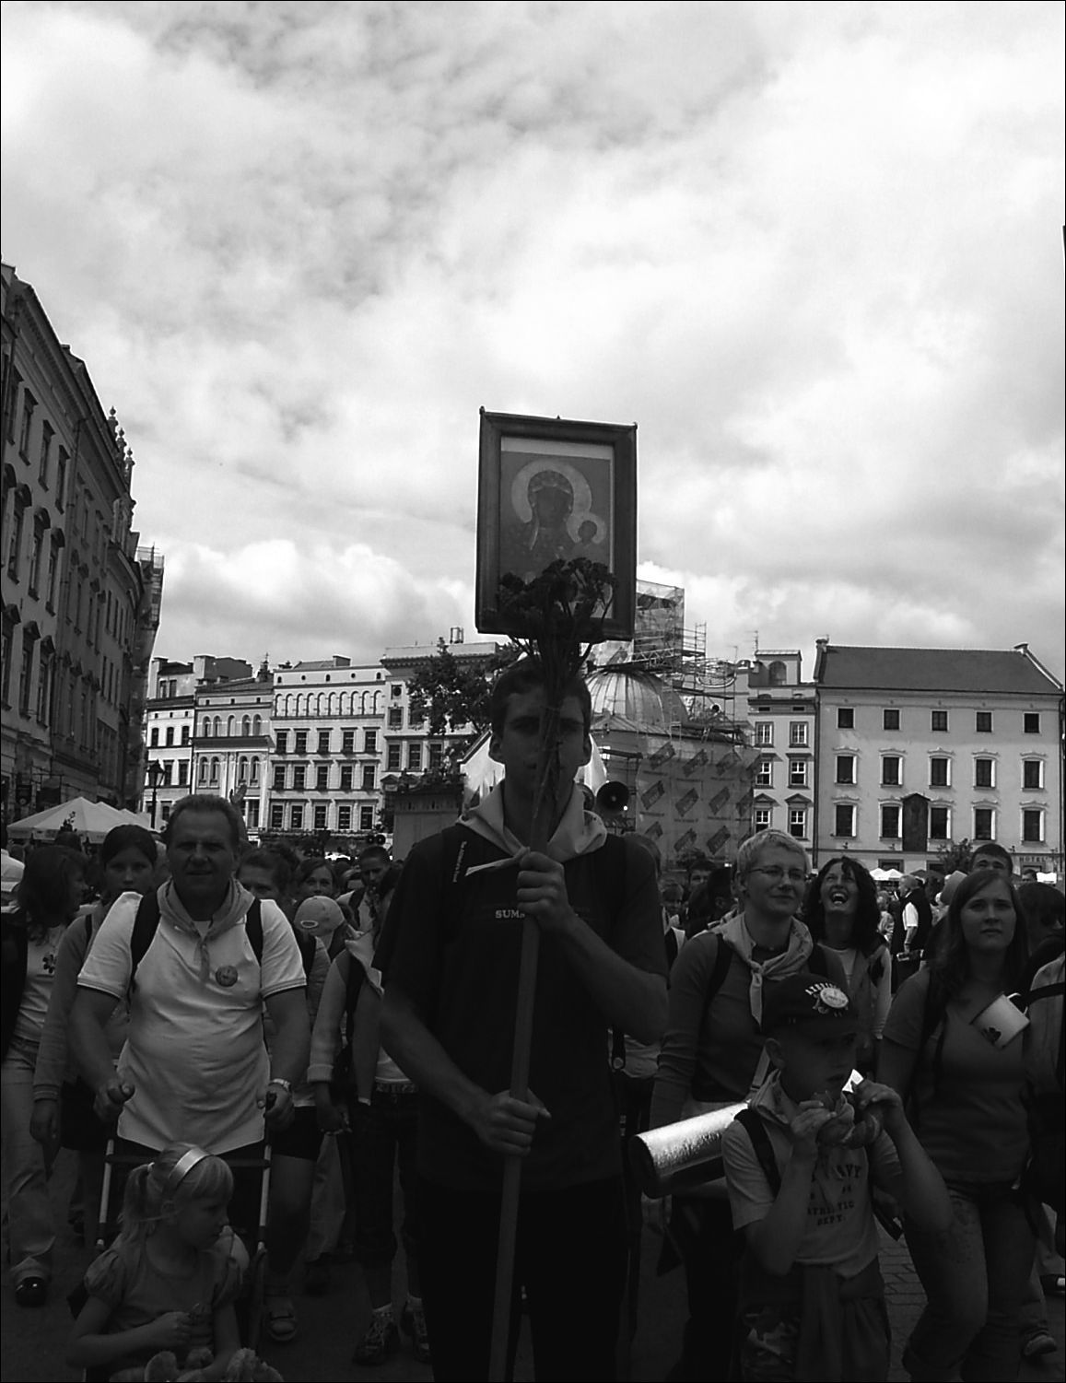
The Image-Figure in Lived Religion
143
- If you look at the image, your attention is drawn by the Virgin Mary’s face - it is
sad, turned as if wanting to say something.10
There were many other statements collected during the field research which
emphasize the personal dimension of the experience of the image of Our Lady of
Częstochowa. Usually, in statements given by my informants, the interchange-
ability of the image-figure seems to be something that is considered obvious,
natural and beyond doubt. It constitutes the basis for a praying contact with the
image - since it appears to be evident to believers that a prayer recited before
the picture is “in reality” a prayer to the Virgin Mary. As recalled many times by
my interviewees, the figure of the Virgin Mary (portrayed in the image) comes
alive - becomes real, endowed with personal features: it sees, it wants to talk,
and sometimes it even says things and gives signs. In a religious situation, the
personal dimension of the image becomes dominant.
26. Pilgrims starting their several day long journey from Kraków to Jasna Góra, Kraków,
August 2006 (Photo: Anna Niedźwiedź)
10 No. 58/int., f., b. 1944.
144
The Image and the Figure

2. “Countenance”
From the point of view of iconographic tradition, the image of Our Lady of
Częstochowa represents the type of the Hodegetria icon (from Greek Hodegetria:
“She who shows the way”):
The Virgin Hodegetria, “showing the way,” presents the Christological dogma and
shows her Son: He, Who is the Way. She holds the blessing Infant in her left arm, while
with the right hand she points at the Savior.11
Popular religiosity has often interpreted the image of Our Lady of Częstochowa
while omitting its principal Christological dimension. Within popular reception,
the image of Our Lady of Częstochowa becomes, first and foremost, a repre-
sentation of the Virgin Mary alone. In interviews collected during field research,
the face of Mary is mentioned frequently as the most dominating element of the
image (also mentioned are her eyes, the wounds, and the sorrow painted on the
face of the Virgin). It seems that theological (Christological) content connected
with the Hodegetria iconic type is not recognized in the popular perception of
the image. This is illustrated by the broad popularization of copies of the image
of Our Lady of Częstochowa in which only a fragment of the picture - the face
of Mary herself - is shown. Very often, the presentation of the head of the Virgin
Mary from the Jasna Góra image constitutes a synonym for the whole image.12
The Marian-centric perception of the image is confirmed in numerous interviews.
When interviewees describe image of Our Lady of Częstochowa, they often recall
only a face-countenance of the Virgin Mary:
- Jasna Góra is the spiritual capital of Poland, because it is there that the miraculo-
us countenance of the Virgin Mary resides;13
- Yes, I’ve got a copy of the Częstochowa image at home [says one of the infor-
mants, pointing to an oil-painted picture of the face of Our Lady of Częstochowa
on plywood];14
- It is the very face of the Virgin Mary that draws one’s attention the most, and not
Jesus or the other details;15
- It is the face of Mary itself that moves one the most (and the wounds upon it).16
11 P. Evdokimov, Sztuka ikony. Teologia piękna, transl. M. Żurowska (Warszawa, 1999),
p. 218.
12 Despite the fact that many theologians condemn such a presentation of the image of Our
Lady of Częstochowa, one can point to many examples of the spreading of the picture of the
head itself also by the hierarchy of the Catholic Church (also e.g. by the late Pope John Paul II,
who possessed an image like that in his private chapel at the Vatican).
13 No. 21/int., f., b. 1927.
14 No. 35/int., f., b. 1934.
15 No. 69/int., f., b. 1955.
16 No. 19/int., f., b. 1926.

The Image-Figure in Lived Religion
145
r: .-
> O'*.ľ.
Wm*?'.
-ßT-i
■»-
It'
FF
1 *< ~r~ j , a
‘«r f V Í
ti -1 ' r *( d \ I
V
v O’
^ - #
V'.-. = •■/ ' C
j■ ’r»■)- A- , /ŕ- .
n..: h .■ ■
v
> ; - f . ' a r- •
*K 1 ■ ' *■:' ■ ■ *
'4' * ! *
27. A stain-glass copy of Our Lady of Częstochowa inside a bakery shop. The image is sur-
rounded by Christmas decorations, Kraków (Photo: Anna Niedźwiedź)
Many of the interviewees showed me their copies of the image of Our Lady of
Częstochowa - depicting just a fragment with the face of Virgin Mary (with-
out crowns and ceremonial robes). These images are very popular, and often de-
scribed as “closer” to the people. The fragment images are also described as much
more “moving” than the whole picture.17
The popularization of the images composed exclusively of the head of Our Lady
of Częstochowa was, to a large degree, the work of Cardinal Stefan Wyszyński.
He himself expressed personal Marian piety (associated in particular with the
image of Our Lady of Częstochowa). He eagerly promoted and popularized the
images depicting just the face of the Virgin Mary (without any votive offerings or
jewels). In many historical photographs, we can see Cardinal Stefan Wyszyński
himself with just such a picture of the head of the Virgin Mary. These photographs
are striking because they are composed as portraits of Wyszyński with the figure
of Our Lady. The image of Our Lady of Częstochowa (showing only the face of
17 See e.g. the confession of one of the participants of a pilgrimage (on foot) from Kraków
-Skałka to Jasna Góra. A. Niezabitowska, ‘Którędy z Jasnej Góry do Matki Boskiej Często-
chowskiej’, Jasna Góra 2 (1984), p. 29.
146
The Image and the Figure
Mary) is not hanging somewhere in the background - it appears, for instance,
being held by Wyszyński on his lap, and even being embraced by him. There are
also pictures of the face of Mary being touched by the cardinal’s hand - treated as
a real person posing for a photograph.18 Wyszyński often publicly expressed his
deep devotion and piety directed to Our Lady of Częstochowa. He liked to use the
word “countenance” which was to describe the picture of Jasna Góra.19 The word
“countenance” soon started to be treated as an expression synonymously used
with the term “image of Our Lady of Częstochowa” which often appeared in in-
terviews collected during field research. The role of Wyszyński in the populariza-
tion of Marian-centered copies of the image of Our Lady of Częstochowa is also
preserved in a popular name: “the primate’s image of Our Lady of Częstochowa”
(as a description of image with a face of Mary alone).20 Also religious-national
iconography, especially the iconography of Martial Law and the whole decade of
the 1980s, eagerly adopted the fragmentary image of Our Lady of Częstochowa
with the head of Mary and with the scars clearly visible on her cheek.21 The popu-
larity of the image was consolidated in the 1980s in particular.
The growing popularity of the “primate’s images” received very critical com-
mentary from a group of theologians. These people pointed out the inappropri-
ateness (in terms of dogma) of presenting only a fragment of the image of Our
Lady of Częstochowa. The theologians believed that the actual significance of
the original picture was lost in this abbreviated form. In statements of criticism,
the fragmentary depictions of the image of Our Lady of Częstochowa are even
described as a “mutilation” or “painfully wounding” of the holy image. They are
further referred to as an example of “a depressing image of our Polish Mariology
and Marian piety.”22
Regardless of the controversy, fragmentary copies of the image are well rec-
ognized and appreciated by numbers of Polish Catholics (who are usually not
conscious of the theological debate behind the “primate’s Mary”). For a prevail-
18 See e.g. ‘Jasna Góra’ 5 (1984). For a similar photograph see also S. Wyszyński, Wszyst-
ko postawiłem na Maryję (Warszawa, 1998), photo insert from p. 288.
19 Pach, ‘Jasnogórski obraz i sanktuarium w nauczaniu kardynała Stefana Wyszyńskiego’,
p. 90.
20 See e.g. Niezabitowska, ‘Którędy z Jasnej Góry do Matki Boskiej Częstochowskiej’,
p. 29.
21 In the 1980s, pilgrims visiting Rome presented many images like this to the Pope John
Paul II. A rich collection of “heads” of Our Lady of Częstochowa can be found in the Center
for the Documentation of the Pontificate of John Paul II at the Polish House in Rome. For a de-
tailed iconographie description of these representations see H. Kupiszewska, ‘Wizerunki Matki
Bożej Jasnogórskiej wśród darów dla Ojca Świętego w Ośrodku Dokumentacji Pontyfikatu
Jana Pawła II’, Jasna Góra w dwudziestoleciu Jana Pawła II, ed. Z.S. Jabłoński (Jasna Góra-
-Częstochowa, 1999), pp. 338-339. For the iconography of Martial Law see D.K. Łuszczek,
Inspiracje religijne w polskim malarstwie i grafice 1981-1991.
22 See S. Budzik, Maryja w tajemnicy Chrystusa i Kościoła (Tarnów, 1995). The quotes
come from the book by J. Kudasiewicz, Matka Odkupiciela (Kielce, 1992). I quote from
S. Budzik, p. 163.
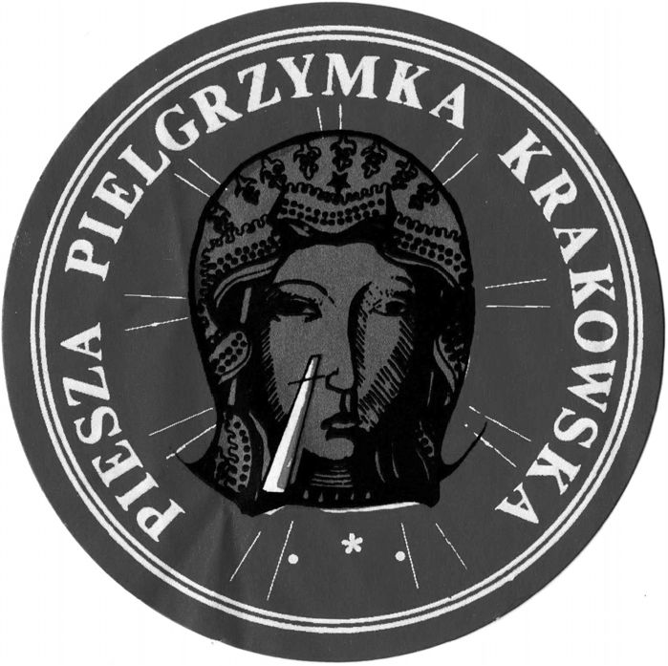
The Image-Figure in Lived Religion
147
ing number of my informants, the Częstochowian image of Virgin Hodegetria is
seen as an image of the Virgin Mary, and then only secondarily (if at all) as a rep-
resentation of the Virgin Mary with Christ. In mainstream, popular, contemporary
devotion of Polish Catholics, the image of Our Lady of Częstochowa is, first and
foremost, a Marian image.23
28. A sticker with a sign of a pilgrimage (on-foot) from Kraków to Jasna Góra. On Mary’s
face white and red scars are depicted (Polish national colors) (Photo: Anna Niedźwiedź)
In accordance with sensual non-differentiation, the figure of the Virgin Mary is
seen by the believers as a real, live person. Characteristically, it is Mary - not the
baby Christ - who my interviewees describe as a living figure in front of whom
people genuflect, kneel, cry and pray. In a religious context, a contemplation of the
image of Our Lady of Częstochowa appears to be a meeting with the Virgin Mary
herself. Many informants speak about the deeply emotional relationship that links
them with the image-figure of Our Lady of Częstochowa. Mary is described as
a confidant and guardian of the people. It seems that the figure of the Virgin Mary
is far closer to man, far more human than the figure of Jesus. It was not unusual for
my interviewees to state, for example, “The Virgin Mary is like a mother to us. We
prefer to pray to her more often than we do to Jesus.”24 The maternal dimension of
Virgin Mary constantly returns in the interviews, questionnaires and documenta-
23 The propagation of the reception of the Jasna Góra picture as an image of Mary can
be included within the current of Marian devotion. As has been noted by researchers into the
Marian cult, the Virgin Mary was revered in the Middle Ages first and foremost as Theotokos
- the Mother of God (God-bearer); while, in later periods (particularly strongly marked at the
beginnings of the nineteenth century) increasing emphasis was connected with the figure of
Mary herself, who started to function autonomously. See V. Turner and E. Turner, Image and
Pilgrimage in Christian Culture. Anthropological Perspectives (New York, 1978), p. 203.
24 No. 73/int., f., b. 1958.
148
The Image and the Figure
tion of the contemporary forms of the cult connected with the image of Our Lady
of Częstochowa. Here are some answers given by the informants in response to
a question about the role of Our Lady of Częstochowa and the significance of the
Jasna Góra image in their private and family life:
- The Virgin Mary is my holy Mother. She talks to her son on my behalf. She asks
her son on my behalf. I didn’t have a real mother - she died when I was four. She
[Our Lady] is my mummy;25
- Our Lady of Częstochowa is like a mother to me. That picture has a special power
to move one - through its suffering;26
- The image hangs in my bedroom and every day, in the evening, I say a prayer be-
fore it. I then address Our Lady of Częstochowa with the trust of a child;27
- Mary is the Mother, the Guardian who helps me in life, in ups and downs. I pray to
her like to a Mother - in simple words, from myself or “Under Your Protection.”
She is my Mother Consoler;28
- For Poles, Our Lady of Częstochowa has turned out to be a true mother. For many
people - even those who do not believe in her;29
- Our Lady of Częstochowa is, in life, like a real mother. I pray to her when there are
problems, I have only to ask her and I have what I’ve asked for. [.] I, along with
my wife, have given my whole family to the protection of the Virgin Mary;30
- The Virgin Mary is as just a much our mother as she is the mother of Christ. She is
very close to me. She can intercede with her son on behalf of the children left here
on earth;31
- I treat Our Lady of Częstochowa like a mother. I have experienced an awful lot of
real help from her [the informant, in a later part of the interview, revealed that she
has (several times) participated in on foot pilgrimages to Częstochowa - praying
for various family matters which have been positively resolved].32
One of my interlocutors, when asked about the role of Virgin Mary in her life,
was deeply moved and confessed that she prays very often to Our Lady in front
of images of Our Lady of Częstochowa (as well as images of Our Lady of Licheń
25 No. 10/int., f., b.1924.
26 No. 87/int., f., b. 1977.
27 No. 59/int., m., b. 1949.
28 No. 11/int., f., b. 1925. “Under Your Protection” is the opening sentence of the popular
prayer dedicated to Our Lady of Częstochowa.
29 No. 63/int., f., b. 1952.
30 No. 24/int., m., b. 1927.
31 No. 46/int., f., b. 1938.
32 No. 55/int., f., b. 1941.
The Image-Figure in Lived Religion
149
which she keeps at her home).33 In her private story, the rise in Marian piety was
linked to her son’s accident and the operations he has undergone for several years.
As she recalls:
Each of my son’s four operations was actually linked with some feast day of the Virgin
Mary. Recently, when there was supposed to be an operation, there wasn’t a feast day
in April. But I happened to find out that an image of Our Lady of Częstochowa was to
visit the hospital [during peregrination], because the Virgin Mary has my son under
her special protection. When I see the image [of Our Lady of Częstochowa] I see so-
mething more than just an image - I see the Virgin Mary herself.34
This confession that the devotee “sees something more than just an image” gives
insight into the structure of religious experience in the context of the image of
Our Lady of Częstochowa in contemporary popular Polish Catholicism. The sen-
sual experience of perceiving the image through various senses (sight, but also
touch, as well as other senses, involved in the “experience of image”) leads - in
a religious context - toward non-differentiation. Within the religious experience -
based on sensual non-differentiation - through material presentation (picture) the
real person (figure of Our Lady) is revealed and encountered.
Individuals, when talking about their experiences of contact with the image
-figure of the Virgin Mary, often display a large degree of self-reflection. It is
through this self-reflection that the symbolic and religious dimension of the ex-
perience is visible. Here is how one of those questioned told of an experience in
front of an image of the Virgin Mary at a sanctuary in Tuchów:35
I was in Tuchów because of my son [the informant’s son was very ill and died shortly
thereafter]. I prayed intensively to the Virgin Mary. I walked on my knees from the
door. I don’t know whether it was because of the candles or overtiredness from slee-
pless nights but when they drew back the covers on the image, I saw how the Virgin
Mary rippled, as if she was talking to me, she moved.36
This extremely personal account, told with tears in the interviewee’s eyes, illus-
trates the depth of spiritual experiences felt by believers when in contact with
a holy image-figure of the Virgin Mary. Emotion, ecstasy, agitation, the feeling of
meeting with something unusual, something great and sacred - are experiences
and feelings recalled by many interviewees (in front of Marian images in various
shrines or in private homes).37
33 Licheń is a Marian shrine in central Poland, which has been very strongly promoted and
popular within the last twenty years.
34 No. 71/int., f., b. 1958. The mentioned visit of the image was connected with the pere-
grination of the copy of Our Lady of Częstochowa - which I describe further in the following
parts of this Chapter.
35 Tuchów is a middle-sized Marian shrine in the southeast part of Poland.
36 No. 93/int., f., b. 1932.
37 Within the experiences described by informants, we can find elements of sacrum as indi-
cated by Rudolf Otto. See R. Otto, Das Heilige. Über das Irrationale in der Idee des Göttlichen
und sein Verhältnis zum Rationalem (München, 1963).
150
The Image and the Figure
This account and the presence of similar statements in many other interviews
are presented to stress the importance and strength of private devotion connected
with the image-figure of Mary in Polish Catholicism. I believe that national and
social dimensions of the great story of the image of Our Lady of Częstochowa
cannot be fully understood without the realization that Mary is present in the per-
sonal experiences of believers. Many interviews reveal that through the image of
Our Lady of Częstochowa - and its religious experience - Mary ‘is lived’ on an
everyday basis and she is encountered by many.
- “Mother”
The power of Marian experience is connected not only with its personal dimen-
sion but also with the fact that the person represented and met through the im-
age appears to be a figure of a mother. The figure of Mary as mother, both of
mankind and of individuals, dominates contemporary piety and popular religion
associated with the image of Our Lady of Częstochowa. The sources of just such
a constructed relation between a believer and the image are present in the various
layers creating the world of contemporary Polish popular Catholicism. To a cer-
tain degree the doctrinal layer, and the general Christian context, is mirrored in
popular religion.
The fundamental Marian dogma is the dogma of Ephesus of 431 on Theotokos
(Greek the God-bearer). At the Council of Ephesus, Mary was defined as the God-
bearer - the Mother of God. Over the course of the subsequent centuries, Marian
dogmas have been added to Roman Catholic tradition, developing the Mariologi-
cal current within theology.38 Besides the four main dogmas (Mary, the Mother
of God; the Immaculate Conception; the Assumption; and the Perpetual Virginity
of Mary), there are many Mariological directives and resolutions which possess
a ranking lower than that of “dogma.” Among these directives and resolutions, the
title Mother holds an extremely important place in relation to the figure of Mary.
The term Mother emphasizes “the spiritual maternity of Mary” who “for centuries
has been not only revered as the Mother of Christ and the Mother of God, but -
first and foremost - as the Mother of all believers who intercedes with her Son on
their behalf.”39
38 There is extensive literature on the subject of the dogmatic agreements (as well as dif-
ferences in thought on Marian devotion) within various Christian traditions. See e.g. Teksty
o Matce Bożej. Prawosławie, vol. 1 (Niepokalanów, 1991). See also S. Budzik, Maryja w ta-
jemnicy Chrystusa i Kościoła and Gratia plena. Studia teologiczne o Bogurodzicy, ed. B. Przy-
bylski (Poznań, 1965).
39 Budzik, Maryja w tajemnicy Chrystusa i Kościoła, p. 131.
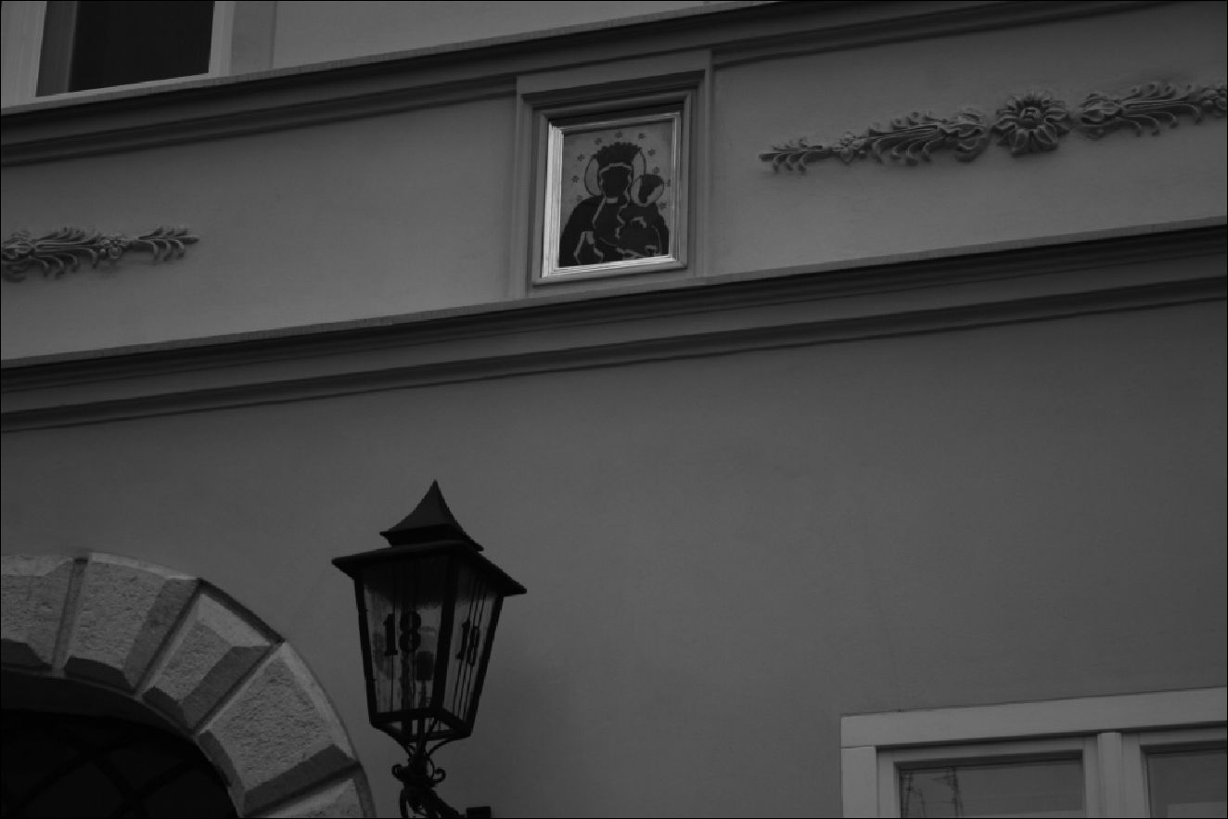
The Image-Figure in Lived Religion
151
29. Image of Our Lady of Częstochowa at the entrance to a building, Kraków (Photo: Anna
Niedźwiedź)
The fundamental statement regarding Mary’s “spiritual maternity” is the frag-
ment of the Gospel according to John describing the scene at the foot of the cross
(John 19.25-27). The spiritual meaning of this scene and a recognition, in the
figure of John standing under the cross as the symbol of the whole Church, was
carried out relatively late - probably in the ninth century. The maternity of Mary,
in the course of the twentieth century, has been extended to the all of humankind.
This is evidenced by the numerous statements of twentieth-century popes.40 Simi-
larly significant is the usage of the term Mother of the living in the new Catechism
of the Catholic Church.41 The Eighth Chapter of the Dogmatic Constitution on
the Church passed during the Second Vatican Council is considered to be the
most important document shaping contemporary Roman-Catholic Mariology.42 In
Point III of the Eighth Chapter, there is a mention of the maternal union between
Mary and the Church, where the figure of the Virgin Mary is defined, on the one
40 See A. Perz, ‘Magisterium Kościoła o Matce Słowa Wcielonego’, Gratia plena. Studia
teologiczne o Bogurodzicy (Poznań, 1965), p. 156.
41 See Maryja w Katechizmie Kościoła Katolickiego, ed. S.C. Napiórkowski and B. Ko-
chaniewicz (Kraków, 1996).
42 On the subject of the contents of the Eighth Chapter of Lumen Gentium and the resulting
theologicial significance of Jasna Góra and the Częstochowa image see J. Nalaskowski, ‘Jas-
nogórska posługa Słowa Bożego w świetle VIII rozdziału “Lumen Gentium” część 1’, Studia
Claromontana 3 (1982), pp. 9-29 and ‘Jasnogórska posługa Słowa Bożego w świetle VIII
rozdziału “Lumen Gentium” część 2’, Studia Claromontana 4 (1983), pp. 32-50.
152
The Image and the Figure
hand, as a prototype, while on the other she is referred to as Advocate, Auxiliatrix,
Adjutrix and Mediatrix.43
When re-interpreted by common sense and lived religion, the ideas of Ad-
vocate, Helper and Mediator shape collective and individual Polish Marian pi-
ety. The maternal dimension of the image-figure of Our Lady of Częstochowa,
dominates popular Marian devotion and is recalled by my interviewees; they refer
to her not so much in the context of the theological idea of Mother of God (The-
otokos) but mostly in the context of Mary described as the mother of mankind
and, even more, the mother of people in a concrete sense. When talking about
Mary, many informants spontaneously and emotionally express their feelings -
calling her “my mother” or even “my mater” and “my mummy.” The figure of
the mother dominates various prayers and devotional texts. The votive entries left
by pilgrims visiting Jasna Góra often begin from emotive and personal phrases
directly geared towards the figure of Mary: “I am coming to you Mother...;” “Oh
Mater of Częstochowa;” “Oh Most Beloved Mother.;” “I thank you most sin-
cerely, Oh my Mother.;”44 “Mommy, thank you for this that I could again look
into your eyes;” “Oh Jasna Góra Mother, oh dearest of Mothers!...;” “Oh Dearest
Mother!...;” “Oh Mother!”45 [emphasis added, capitalization as in original] The
image is interpreted by the faithful as the figure of a close, understanding, sup-
porting and tender mother.
I should stress that the specificity of the Polish language additionally empha-
sizes the maternal dimension of Mary. Polish equivalents of the English terms
Our Lady (Polish Nasza Pani) or Virgin Mary (Polish Panna Maria or Dziewica
Maryja) are much less common than the Polish expressions “Matka Boska” and
“Matka Boża” which can be translated as “Mother of God” but also as “Divine
Mother” or “Holy Mother,” which might be seen as stressing the holiness of Mary
herself. It is also very difficult not to lose something in the translation of various
diminutive forms of the word “mother” used by my informants and present in
various ethnographic sources connected with the image-figure of Our Lady of
Częstochowa (Polish mateńka, matuchna, mamusia).
The maternal aspect of the figure of Mary consequently goes beyond the
sphere of pure dogma and relates, presumably to deeper strata. The very concept
mother is closely connected with the biological and natural aspect of man’s life
and belongs to the basic categories shaping human notions of the world.46 The
43 Lumen Gentium, Chapter 8, point III/62 See Budzik, Maryja w tajemnicy Chrystusa
i Kościoła, p. 59.
44 The entries left at the Jasna Góra Chapel in August 1983. See H.R. and R.A., ‘Tajemnica
spotkań z Jasnogórską Matką - wotami pisana’, Jasna Góra 1 (1984), pp. 15-23.
45 The entries left at the Jasna Góra Chapel between January 1976 and May 1977. See
M. Królik, Nieustanna Nowenna do Matki Bożej Jasnogórskiej, a typescript in the Library of
the Pauline Fathers at the Jasna Góra Monastery.
46 For the symbolic meanings of the maternal figure in various cultural and religious tradi-
tions see G. van der Leeuw, Fenomenologia religii, pp. 82-91. For meanings of the word moth-
er in traditional contexts and contemporary colloquial Polish see. J. Bartmiński, ‘Podstawy
The Image-Figure in Lived Religion
153
particular closeness, tender and emotional character of the relation, the sense of
limitless protection and help on the part of the Virgin Mary conveys meanings of
the mother-child relationship.
Many researchers, when analyzing the maternal dimension of the lived Mar-
ian devotion of Polish Catholics, have suggested that the cult of Mary adopted
some earlier elements of pre-Christian beliefs. These scholars theorize that beliefs
surrounding Mary are linked to an undefined goddess of nature and fertility, or
mother earth.47 It is difficult today to categorically prove the validity of such a hy-
pothesis. However, in the traditional folk cultures of all Slavic people, there was
an idea of mother as a universal female figure. This figure was closely connected
with the concept of nature and linked with the fertility of the earth. The very fig-
ure of the Virgin Mary, in traditional folk cultures described by ethnographers in
the nineteenth and early twentieth centuries, was similarly understood as being
closely connected with nature. There are plenty ethnographic sources showing
examples that identify Our Lady with mother earth.
Within Eastern Slavic traditions, the concept of identifying Mary with earth in
beliefs and rituals was recorded as recently as the twentieth century (for instance
in the vows on the earth which was identified with Our Lady).48 In the 1930s,
Gerardus van der Leeuw stated, in his Phenomenology of Religion, that the Rus-
sian peasants “do not differentiate the holy Russian soil from the Virgin Mary -
Mother of God.”49 Additionally, the Polish authors of Dictionary of Stereotypes
and Folk Symbols (which is based on rich ethnographical material), advanced the
hypothesis that “(in Europe) the archaic cult of the earth as a Mother Goddess has
seen its continuation in the popular Marian cult.” The authors suggest that, while
in Russian Orthodoxy “the cult of the God-bearer has been imposed on the im-
age of the mother earth, in Poland this cult has developed within popular Marian
piety.”50
Interestingly, references to Mary as mother earth appeared in interviews con-
ducted during field research about Our Lady of Częstochowa. As discussed in
Chapter II, some of my interviewees - when describing the dark face of Mary -
recalled the “black Polish soil” and mother earth. It is possible that contemporary
references to the image of Our Lady of Częstochowa reveal deeper cultural traces
which have connected Mary with the concept of nature and fertility.
lingwistycznych badań nad stereotypem - na przykładzie stereotypu matki’, Język a Kultura
12 (1998), pp. 63-83.
47 See e.g. J. Kłoczowski, ‘Sens społeczny polskiej maryjności’, Więź 7 (1982), p. 5.
48 I am here referring to information presented by Anna Engelking who recalls Uspienski’s
work ‘Mitologicheski aspekt russkoi ekspressivnoi frazeologii’, Studia Slavica Hungarorum
29 (1983), pp. 52-54. See A. Engelking, Klątwa. Rzecz o ludowej magii słowa (Wrocław,
- , pp. 130-131, footnote 70.
49 G. van der Leeuw, Fenomenologia religii, p. 87.
50 Słownik stereotypów i symboli ludowych, vol. I, part. 2, ed. J. Bartmiński (Lublin, 1999),
p. 18.
154
The Image and the Figure
In an article published in 1984, the ethnologist Jacek Grąbczewski presented
Polish ethnographic and folkloristic sources from the nineteenth and twentieth
centuries in which Our Lady appears as a figure closely connected with the entire
world of nature.51 In the traditional culture of the Polish peasantry at the end of the
nineteenth century, Mary was seen as a “floral figure” - a patron of various plants
(herbs, trees, and flowers) as well as a “lunar figure” connected symbolically with
the moon. At the same time, however, she was the “Intercessor” and “the Helper”.
As summed up by Grąbczewski, those two Christian titles (the Intercessor, the
Helper)
contain and combine traits typical for the figure of the “Mother.” The Intercessor and
the Helper - this is every mother, whose work is to care, help, defend, love, but also to
punish. Floral and lunar themes [...] confirm the features of the image of the “Mother.”
The symbolic dimension of these accounts [ethnographic accounts recalling the floral
and lunar themes] fully conveys what is characteristic for the image of a woman - the
giver of life - a mother.52
The lively Marian devotion in Poland, which categorizes the image-figure
of Our Lady of Częstochowa as a maternal relation, expresses an archetype of
mother deeply rooted in Polish culture. The cult of the image-figure of Our Lady
of Częstochowa has dimensions related to theology and dogma as well as connec-
tions with old beliefs (most likely with pre-Christian roots). These older beliefs
are typical in traditional folk cultures where there is a universal concept of mother
as a powerful fertile female figure and a source of life identified with nature.53

4. Mater Dolorosa
The concept of the Sorrowful Mother intensifies the emotional relation between
devotees and the image-figure of Our Lady of Częstochowa. For many of my in-
terviewees, the “image of Our Lady of Częstochowa is sad.” As previously men-
tioned, the dark face of Our Lady as well as the scars (wounds) visible on her face
are recalled not only as characteristic and unique elements of the picture but also
as signs of sorrow:
- It is the sorrowful countenance of the Virgin Mary that attracts attention most in the
picture - that moves the conscience;54
51 See J. Grąbczewski, ‘Postać Matki Boskiej w ludowych przekazach językowych’, Pol-
ska Sztuka Ludowa 3 (1984), pp. 158-160.
52 Ibid., pp. 164.
53 Ewa Rosa gives many examples from traditional folk culture where the Virgin Mary
appears on the one hand as the Mother of the Savior, while on the other as the Mother of the
people and an individual man. See E. Rosa, ‘Typy Madonny w literaturze ludowej’, Literatura
Ludowa 3 (1986), pp. 19-55.
54 No. 20/int., f., b. 1927.
The Image-Figure in Lived Religion
155
- The Virgin Mary is sad - therefore the picture is dark [...]. It is the sorrowful, soli-
citous face of the Virgin Mary that (of all the parts of the image) most draws one’s
attention.55
On the one hand, Our Lady of Częstochowa is recalled as the Queen of a suffering
nation and one who empathizes with this nation (see Chapter III). On the other
hand, suffering and sorrow are strongly connected with the figure of Mother. Our
Lady of Częstochowa is seen as a Sorrowful Mother (Mater Dolorosa) and this
image evokes emotional responses of believers:
- Kneeling at Jasna Góra, before the image, I gaze into the eyes of the Virgin Mary.
They appear sad and then I am moved;56
- Sorrow looks out of the eyes of Our Lady of Częstochowa;57
- When I look into the picture, I can see that the Virgin Mary is extremely solicitous.
In those eyes one can see the pain that people cause [.] the Most Holy Mother is
very sad - she worries about people - for her this is a constant ordeal;58
- Our Lady of Częstochowa has a sad expression on her face - this is the most
striking element of the image. This comes from reflection on the evil present in the
world;59
- The sad face of the Virgin Mary in the picture draws one in. She worries because
the world is evil.60
The Virgin Mary’s suffering appears in various contexts. From a certain point
of view, the figure is categorized based on holiness and divinity. The Virgin Mary
suffers for the sins of the world, and the wounds visible on the image acquire
a ranking comparable to those of Christ.61 The wound on the image made by
a sword, in the symbolic dimension of popular religion, becomes an echo of the
Christ’s wounds inflicted by a spear during the crucifixion. In such a way the
Passion of Mary is inscribed into the history of mankind.62 From other perspec-
tives, Mater Dolorosa is a woman - a mother in sorrow experiencing the death
of her son. Her suffering achieves, first and foremost, a human dimension. My
interviewees frequently emphasized this human aspect of Marian suffering. Many
interviewees claimed that people have a close relationship and understanding with
55 No. 24/int., m., b. 1927.
56 No. 61/int., f., b. 1949.
57 No. 38/int., m., b. 1935.
58 No. 40/int., f., b. 1935.
59 No. 41/int., f., b. 1936.
60 No. 64/int., f., b. 1952.
61 Those ideas present in contemporary popular Polish Catholicism seem to reflect con-
cepts appearing in some currents of Catholic theology where the idea of the Fifth Marian dogma
of Co-redemption is promoted.
62 The idea connecting the wounds visible on the image of Our Lady of Częstochowa with
the wounds of Christ appeared in Baroque writings connected with the Jasna Góra Monastery.
156
The Image and the Figure
the Virgin Mary because of the shared experience of sorrow and suffering. Mary
is capable of understanding and empathizing with the worries of ordinary people
- she shares their experiences and troubles. Those who pray in front of Mary are
often moved by the sorrow “looking out from the eyes of Mary.” People feel that
the sorrow arouses trust.
It is possible to trace the characteristics of old traditional Polish folk religios-
ity in the contemporary popular cult of Our Lady of Częstochowa as a Sorrowful
Mother. In traditional folk culture, both aspects of Marian Passion - divine and
human - were present.63 Ethnographers have ascertained that the figure of Sor-
rowful Mother developed as one of the most popular figures in traditional peas-
ant culture. The Sorrowful Mother was also present in folkloristic texts as well
as in popular iconography.64 The image of a suffering mother, full of pain and
regret, spoke to the peasant imagination and mentality in a vivid way. The Virgin
Mary suffered because of the loss of her only son - this strongly identifies her
as human. This mourning and suffering allowed the Virgin Mary to be close to
humanity and to see her burden on the same level as the burden of the human lot.
At the same time, in old folklore, similarly as in today’s popular religion, Mary’s
suffering gained a symbolic dimension. Mary’s suffering was seen as similar and
complementary to the suffering of Christ for the sins of humanity. As Magdalena
Zowczak has noted, the Marian Passion can be interpreted as a popular form of
meditation on the theological idea of the “participation of Mary in redemption
through suffering that she shared with Christ.”65 These elements, analyzed in the
context of traditional piety of Polish peasants, reappear in the contemporary re-
ligiosity dedicated to the image of Our Lady of Częstochowa.

5. Miraculous consciousness
For my interviewees, there are no doubts that the image of Our Lady of
Częstochowa is holy and miraculous. This is taken for granted. Often my inter-
locutors were using expressions like “Miraculous Image” and “Holy Image” as
equivalents for the name “image of Our Lady of Częstochowa.” The image is per-
ceived as being filled with unusual power. Contact with it arouses deep experienc-
es and is often connected with the sensation of the intensive presence of sacrum.66
The picture’s holiness is said to be confirmed by numerous miracles. The story of
63 For the ‘Passion of Mary’ see M. Zowczak, Biblia ludowa. Interpretacje wątków biblij-
nych w kulturze ludowej (Wrocław, 2000), pp. 394-414.
64 See Zowczak, ibid. See also Rosa, ‘Typy Madonny w literaturze ludowej’, p. 20 and
p. 29-32.
65 See Zowczak, ibid., p. 415.
66 Many researchers have drawn attention to the identification of the concept of holiness
with the idea of miraculousness within the popular religion. A historian of the cult of the image
of our Lady of Częstochowa notes that within traditional Polish culture this was a widespread
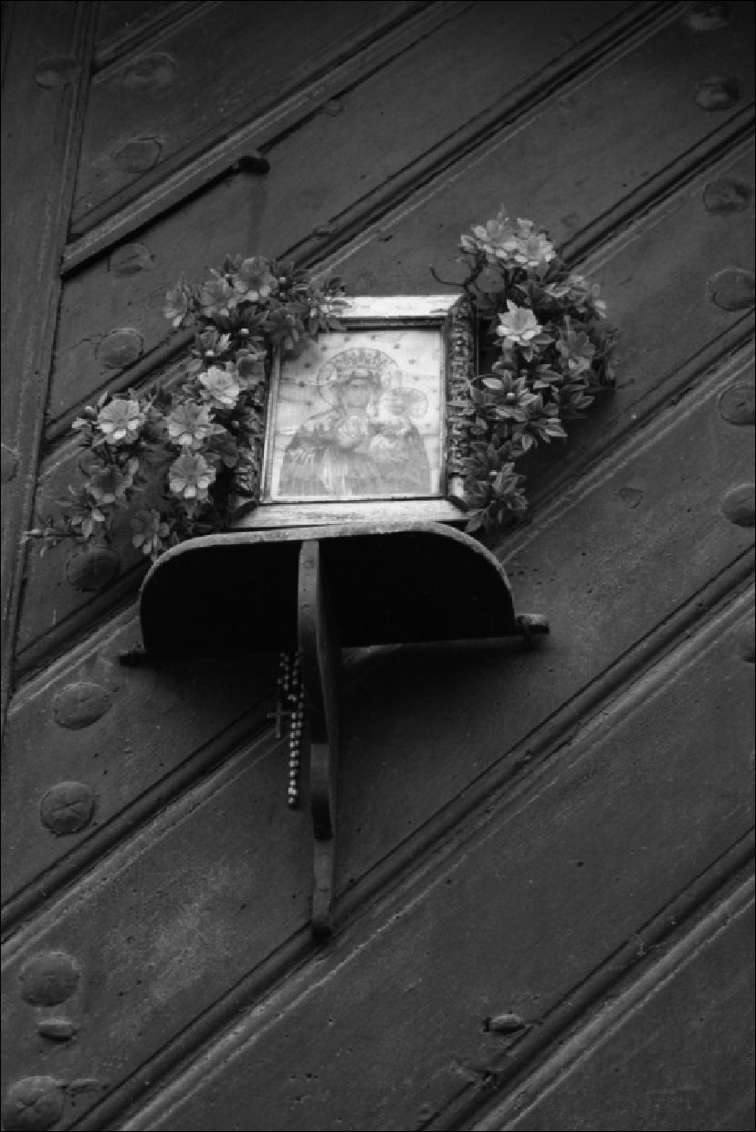
The Image-Figure in Lived Religion I57
the miraculous power of the image of Our Lady of Częstochowa is extraordinar-
ily alive in contemporary Polish culture, and it is frequently mentioned by my
interviewees. Its present-day form constitutes a continuation of earlier beliefs and
piety connected with the image.
30. Image of Our Lady of Częstochowa on a building gate. Someone has decorated it with
flowers and a rosary, Kraków (Photo: Anna Niedźwiedź)
The oldest documents and written accounts connected with the Jasna Góra
shrine ascribed miraculous power to the image. These sources give numerous
accounts of healings and miracles. Literary versions of the oldest legends of the
Częstochowa image, which were written in the fourteenth and fifteenth centuries
(see Table I) give information about the miracles and healings attributed to “that
revered board.” All of the oldest legends emphasize that the unusual miraculous
power of the image manifested itself from the very start. The image “performed
miracles” in Jerusalem, then in Constantinople, in Ruthenia and finally at Jasna
phenomenon. See A.J. Zakrzewski, W kręgu kultu maryjnego. Jasna Góra w kulturze staropol-
skiej (Częstochowa, 1995), p. 85.
158
The Image and the Figure
Góra. According to Translatio tabulae, when the image was brought to the capital
city of Byzantium:
Thanks to the intercession and various requests of the divinely blessed Virgin on be-
half of the sinners and disabled, God the Father and the majesty of the entire Trinity,
and with benevolence literally flowing, generously granted mercy to these disabled,
showing an immense variety of signs by means of this board [the image]. All of the
people saw it [the miracles]; but especially those who were blighted with disability - as
a result of various diseases - came there the most often, and, being cured, they revered
it [the image].67
Shortly afterwards when the board was transferred to Ruthenia:
[...] everyone, generally speaking the throngs of pilgrims, saw that the blind had their
sight completely restored. They returned to their former health and had excellent clar-
ity. And the lame - with punctured and cavernous legs, feet twisted from the shin
- were set straight and strong, made healthy by the power of a perfect cure [...] the
inconvenience and painfulness of other illnesses were abundantly rewarded to all those
ailing through the generously flowing patronage of signs and miracles.68
In the subsequent versions of the legend, there is an increase in the quantity of
information and the details of the miraculous events. The successive stories ex-
press - over and over again - the conviction that the image had unusual sacral
power. The versions of the legend presented by Piotr Rydzyński and Mikołaj of
Wilkowiecko place great import on the miraculous healings carried out by the
image at Jasna Góra. In the list of the miracles placed after the text of the leg-
end (Table I, point 9) various unusual events are recalled: healings, unexpected
liberations from prison, savings of lives, and even returning life (resurrecting).
Individual examples are described in detail, along with the names of the individu-
als touched by miracles. Sometimes the authors even give the date of the event
in order to strengthen the credibility of the account. The growth in quantity of
miraculous stories, and the clear development of miraculous motifs in the oldest
legends about the image, expressed the need for repeated confirmations of the
sacral powers of the picture. The stories about miracles also portray the develop-
ment of the Jasna Góra cult centre, whose fame as a miraculous place drew more
and more pilgrims.
Books of miracles and lists of miracles have, for centuries, been the most
popular expressions of belief in the miraculous power of the image. Today, thou-
sands of pilgrims leave written entries in the “Votive offerings books” left in front
of various Marian images. At Jasna Góra, in the Chapel of Our Lady, people write
their requests on small pieces of paper - strongly believing in the possibility of
a miraculous intervention. They also leave their written gratitude, as well as vari-
ous votive offerings commemorating the miraculous experiences. Notable votive
offerings include an impressive collection of crutches hanging on one wall of the
67 ‘Translatio tabulae’, Najstarsze historie, p. 75.
68 Ibid., p. 76.
The Image-Figure in Lived Religion
159
Chapel of Our Lady of Częstochowa. The “miraculous consciousness”69 - the
expectation and readiness to experience miraculous happenings via the sacred
image - is one of the most typical and common features of piety addressed to Our
Lady of Częstochowa.70 Jasna Góra is famous for the miracles and healings that
take place there. The miraculous story expresses belief in the great power of the
image. In many of the statements given during the field research, the accounts of
Jasna Góra miracles and healings are pervasive:
- Numerous miracles are associated with Jasna Góra. Throngs of people come here
from abroad. Votive offerings are found here and it is because of the image that he-
aling takes place [.] A prayer to Our Lady of Częstochowa has immense power;71
- Our Lady of Częstochowa is miraculous - she helps people and listens to their
requests. [.] I myself have experienced healing thanks to her;72
- Everyone goes to Częstochowa to pray. There are miracles there. The Virgin Mary
is famous for them;73
- The largest number of miracles, healings and grace is at Jasna Góra. More than in
other Marian shrines;74
- I knew a woman - extremely religious. She lived alone and had a paralyzed hand.
She often went to Częstochowa - on pilgrimages - and she rubbed her sick hand
on the image of Our Lady. And the hand got better.75
In answer to the question as to whether the expression the spiritual capital of Po-
land was known, one of the informants explains:
The features that make Częstochowa the spiritual capital of Poland is its universali-
ty, the power of the grace of the Virgin Mary flowing from it. People believe in the
immense power of prayer in this place. Evidence of belief is the numerous votive
offerings made by believers.76
Subsequent interviewees develop the story about the miracles:
- The image is miraculous, because when I visited Jasna Góra, I saw the artificial
limbs, the crutches of those who have been cured. [.] The image is revered becau-
se there have been many cases of healing, miracles;77
69 ‘Miraculous consciousness’ and ‘miraculous sensitivity’ are the terms proposed by
Jacek Olędzki. See J. Olędzki, ‘Świadomość mirakularna’, Polska Sztuka Ludowa. Konteksty
3 (1989), pp. 147-158. See also A. Hemka and J. Olędzki, ‘Wrażliwość mirakularna’, Polska
Sztuka Ludowa. Konteksty 1 (1990), pp. 8-14.
70 See e.g. Zakrzewski, W kręgu kultu maryjnego, p. 31.
71 No. 13/int., f., b. 1925.
72 No. 16/int., f., b. 1925.
73 No. 28/int., f., b. 1929.
74 No. 30/int., f., b. 1930.
75 No. 47/int., f., b. 1938.
76 No. 48/int., m., b. 1938.
77 No. 60/int., m., b. 1949.
160
The Image and the Figure
- A friend of my sister was an organist at Jasna Góra. She witnessed many healings
that took place there;78
- Many people owe miraculous healings and cures to Our Lady of Częstochowa.
People derive strength from the miracles;79
- There [on Jasna Góra] favors that are asked for by people are fulfilled;80
- Jasna Góra is exceptional. Miracles happen there, cures and healings. There was
a miraculous defense. People also convert there;81
- The image is so revered because it has performed many miracles and given a lot of
grace.82
The accounts of personal experiences which believers attach to contact with the
image of Our Lady of Częstochowa confirm the sense of miraculousness. The
majority of people with whom interviews were conducted admitted that they had
personally experienced the miraculous power of the image-figure of Our Lady
of Częstochowa. Many people, in very private conversations, which took place
between the ethnographer and the informant, recalled their own experiences of
miracles.
There is a typical set of miraculous motifs that are often present at various
Marian shrines. The material gathered during field research showed that these
motifs are definitely present in stories about Jasna Góra. The greatest number of
miraculous stories concern healing experienced by interviewees themselves or in
their closest family circles. There are also frequent mentions of the relief from
physical pain and bodily suffering experienced as a result of fervent prayer.83 The
second group of miraculous events are the stories about salvation during the war
(World War II and Nazi occupation - which is still present in the memory of the
people of Poland), or about the Virgin Mary’s help during the post-war Stalinist
repressions and during the communist period.84 Another common theme is a per-
son praying for the religious conversion of a family member. Many people believe
that their relatives converted because of a family member’s prayer at Jasna Góra.
There are many stories about sinners taking Holy Communion, or confessing and
repenting sins before death (frequently the sinner was an alcoholic, an atheist,
78 No. 49/int., m., b. 1939.
79 No. 62/int., f., b. 1951.
80 No. 69/int., f., b. 1955.
81 No. 79/int., f., b. 1961.
82 No. 90/int., m., b. 1982.
83 I decided not to recall exact stories about miracles as they were told to me and the stu-
dents conducting the field research. Often the stories were very personal and there is no need for
a recollection of exact quotations. Yet, in order to illustrate the scale of the phenomenon I attach
footnotes with exemplary numbers of the interviews where the account of the said events oc-
curred. The tales about healing can be found in the following interviews: Nos. 5, 16, 19, 20, 27,
32, 33, 44, 47, 49, 52, 54, 63, 71, 85; relief from pain: 31, 42.
84 See e.g. interviews Nos.: 3, 24, 27, 30, 45, 47, 82.
The Image-Figure in Lived Religion
161
a communist).85 The final group of miracles include women who ascribe the suc-
cessful conception or birth of a child to the Virgin Mary.86
There are also numerous interviewees who admit that they experience the mi-
raculous power of the image of Our Lady of Częstochowa on a daily basis. Trust
in the Virgin Mary and prayers to her for help are supposed to be an effective,
certain and verified remedies for various worries and needs. The informants often
repeat that because they pray in front of the image, they have experienced graces
and that many of their requests have been heard. They ascribe this to the power
contained in the image and the intercession of the Virgin Mary.87 In their state-
ments, they reveal the image-figure relation and the non-differentiation shaping
a religious experience of the image. The ascribing of personal traits to a revered
image, especially when it is done spontaneously, is a fundamental element of the
miraculous consciousness connected with the image of Our Lady of Częstochowa.
Mary - seen as a loving and caring mother (intercessor and helper) - is perceived
as a powerful source of miracles that happen through the image representing her.
In referring to the ethnographic material gathered during the field research
I should add a certain personal remark concerning the circumstances in which
stories of miracles were recalled by the interviewees. I have to admit that namely
for me (and this was shared by research assistants who also conducted interviews)
people were surprisingly open, and they answered extremely intimate questions
on the subject of their private religious experiences. They willingly spoke about
the image of Our Lady of Częstochowa, particularly about their personal piety
and feelings. While the informants showed abashment in relation to questions on
the subject of the history of the image or Polish history, the part of the question-
naire connected with private piety and personal relations to the image aroused
a willingness to confide. One could note that the people really did have “some-
thing to say” on this subject, that the experience of the image-figure of Our Lady
of Częstochowa was, for them, important. More than once, I was taken aback by
the ease and openness with which informants switched to personal confessions.
We researchers often witnessed the interviewee being moved to tears by what
he or she wanted to say on the subject of the significance of the image-figure of
Our Lady of Częstochowa. Such moments made it clear that the small stories (on
matters of private miracles and acts of grace experienced by people) were, in real-
ity, stories about something great - about the experiencing of an unusual power
which repeatedly influenced the informant’s entire life. Therefore, in writing this
Chapter (about contemporary piety connected with the image-figure of Our Lady
of Częstochowa) I constantly return to the fundamental relationship between the
believer and the image-figure, and admit that the sacral and spiritual character
of this relation is a core issue here. The stories about private miracles that are
often present in popular religion reveal the experience of sacrum that constitutes
85 See e.g. interviews Nos.: 28, 47, 58.
86 See e.g. interviews Nos.: 15, 51.
87 See e.g. interviews Nos.: 7, 9, 11, 18, 24, 25, 27, 31, 35, 41, 55, 56, 68, 69, 78, 92.
162
The Image and the Figure
an expression of faith in the unusual, miraculous causative power contained in
the image of the Virgin Mary. The countless stories of miracles, which multi-
plied throughout the centuries, influence and shape the experience of the image in
popular religion. Stories of these miracles also bring to mind the archaic concept
of sacrum as the source of all possible forms of efficiency.88

6. Peregrination of the image-figure
In focusing on the contemporary experience of the image-figure of Our Lady of
Częstochowa, it is impossible not to mention the ritual of the peregrination (or
travelling) of a copy of the image. The ritual, initiated by the Polish Catholic
Church hierarchy in the days of communism, has gained enormous popularity
with Polish Catholics. It has also resulted in the spontaneous creation of new cult
forms, as well as the reminder and reinstatement of the former symbolic meanings
of the image-figure of Our Lady of Częstochowa. The practice continues to this
day (see Chronology of a peregrination on page 180).
As mentioned in the Chapter III, the concept of peregrination of a copy of
the image of Our Lady of Częstochowa was proposed by Stefan Wyszyński, Pri-
mate of the Polish Catholic Church for the period 1948-1981.89 Peregrination
was involved in a program of mass religious events connected with preparations
for celebrations of the “Polish millennium” in 1966. In October 1956, when Car-
dinal Wyszyński was released from internment, the painter Leonard Torwirt was
commissioned to make an exact copy of the image of Our Lady of Częstochowa.
When the image-copy was ready, Wyszyński took the picture to Rome in a special
railway carriage compartment (which was decorated and transformed into a sort
of chapel). In Rome, the image was blessed by Pope Pius XII and then returned to
Poland - where it was to visit all the parish churches in the country.
88 R. Caillois, Człowiek i sacrum, trans. A. Tatarkiewicz and A. Burska (Warszawa, 1995),
pp. 22-24.
89 Perhaps the most famous peregrination in the Catholic Church tradition is that of the
statue of Our Lady of Fatima. In Polish tradition, there are historical sources describing similar
rituals involving the image of Our Lady of Chełm in the seventeenth century. The taking of
icons from house to house is known and practiced in Eastern Orthodox Christianity. There is
still a tradition alive, to this day, of carrying an icon of the Virgin Mary on Easter Monday in
the Orthodox villages of Cyprus with blessings for the individual families. There is also an
account that comes from the Russian territories that during the cholera epidemic in Kazan in
1654, a Marian icon was ceremoniously carried around the houses. See Kobrzeniecka-Sikorska,
Ikona, kult, polityka, p. 75. For the history of peregrination see Królowa Polski nawiedza swój
kraj... Kronika Nawiedzenia Kopii Cudownego Obrazu Matki Bożej Jasnogórskiej w parafiach,
vol. I. p. 8, a typescript in the Library of the Pauline Fathers at the Jasna Góra Monastery. See
also: J. Cimek, ‘Nawiedzenie obrazu Matki Bożej Częstochowskiej w rodzinach na przykładzie
parafii Gorzków w diecezji lubelskiej’, Studia Claromontana 7 (1987), pp. 100-101.
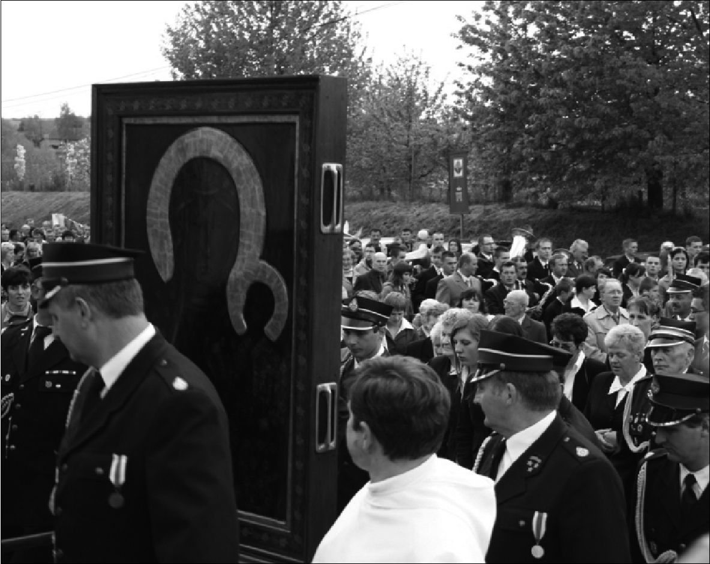
The Image-Figure in Lived Religion
163
31. A peregrination of the copy of the image of Our Lady of Częstochowa, Klimontów,
vicinity of Kraków, 2008 (Photo: Anna Niedźwiedź)
The ceremonious start of the peregrination was announced on 26 August 1957
at Jasna Góra Monastery:
At 10.30, the Pauline Fathers took the Miraculous Image from the altar and transferred
it to the basilica’s presbytery, where the copy (brought from Rome) was waiting. The
Primate [.] moved the copy closer - touching the original image with it. The original
image returned to its former place over the altar, while the Primate handed over the
copy to the deans of all the dioceses who, in turn, carried it in a procession around the
monastery ramparts.90
The description of the same ceremony, which is preserved in the Library of the
Pauline Fathers, gives an even stronger impression of the significance attributed
to the ceremonial beginning of the peregrination and the touching of two images
(original and a copy). The whole description is in a very religious tone, and written
in the present tense - emphasizing the significance of all details of the ceremony:
At 10.30 the Pauline Fathers take the Miraculous Image from the altar. Its route is
a short one this year: only as far as the Basilica’s presbytery. There, a copy of the
Image awaits [...]. The Miraculous Image is taken down. It is held by the Cardinal
Primate. And it seems that the Queen of Poland has left the altar in order to show him
joy because of his return [from internment] and to offer thanks for his suffering and
90 See S.C. Napiórkowski, Matka Naszego Pana (problemy - poszukiwania - perspektywy)
(Tarnów, 1992), p. 119.
164
The Image and the Figure
courage. [.] And now the Queen of Poland is welcoming him. The Cardinal is already
in the Basilica. He is leaning the two Images toward each other. The copy is touching
the Miraculous Image.91
The sacral power of the copy was believed to be drawn directly from the original
miraculous image - at the moment of the touching of the two images together.
From that moment onward, the copy started to be treated as a “real copy” - equiv-
alent to the original. The ceremony and gesture of touching of the two pictures
together, as noted by the chronicler, bring to mind the practices - known in tradi-
tional cultures - where touch is connected with the transfer of power. In the sen-
sual experience of religious images, touch appears in various rituals that devotees
perform. It is believed that touching the picture can bring healing and transfer the
miraculous power of the image to their bodies.
In the case of the image of Our Lady of Częstochowa, which is kept at a high
altar preventing pilgrims from direct access, other substitutes and “transformers”
mediating the direct touch of the image have become popular. For instance, among
pilgrims to Częstochowa small, paper printed copies of the image circulate with
a tiny piece of cloth attached to them. The inscription announces that the cloth
is “the veil rubbed against the miraculous image of Our Lady of Częstochowa.”
Peregrination of the “real copy” of the original image was also intended to bring
the power of the revered image closer to the faithful.
During the peregrination, the image-copy was to spend one twenty-four hour
period in each parish church. This period was preceded by retreat and a special
service, preparing people for the ceremony. The twenty-four hour period during
which the picture was located in a given church also had a strictly defined drama-
turgy which was identical for all parishes. After the welcoming ceremony at the
borders of the village or town, the image was taken out from the car-chapel and
brought to the local church on people’s arms in a procession. In the church, a serv-
ice was held and various prayers (including an all night vigil) were performed in
front of the image.
As a result of the peregrination, new cult practices connected with the im-
age of Our Lady of Częstochowa emerged. Up until this time, the image of the
Virgin Mary had been connected with a concrete place, a shrine at the Jasna Góra
Monastery. It was possible to make a pilgrimage to the place, and it was possible
to become the owner of a copy of the miraculous image. In the context of the
peregrination of a copy of the Jasna Góra image, a new custom was introduced;
a new feast day - a heretofore unknown feast day. It was also connected with the
huge growth in popularity of the cult of the Jasna Góra image as well as of Marian
piety and devotion.
Soon, the ritual of peregrination gained immense popularity. The clergy, not-
ing the response amongst believers to the idea of peregrination, popularized it
all the more willingly. In many regions, there have been local peregrinations of
91 Królowa Polski nawiedza swój kraj, pp. 6-7.
The Image-Figure in Lived Religion
165
figures or images revered in local communities. In 1985, just five years after the
completion of the parish peregrination of the copy of the image of Our Lady of
Częstochowa, a second peregrination of the image-copy was initiated. This per-
egrination is still in progress.
Parallel to the so-called great (parish) peregrination, there were small peregri-
nations of smaller copies of the image of Our Lady of Częstochowa to individual
families. In 1965, small copies of the miraculous image were blessed at Jasna
Góra and given to all dioceses in Poland. The small peregrination involved the
passing of a copy of the image from house to house, and from flat to flat. These
small peregrinations were conducted for a second time in Polish parishes in 1978
(they constituted an element of the preparations for the six-hundredth anniversary
of the Jasna Góra shrine) and have been frequently repeated in various parts of
Poland.
During peregrination, one of the most striking things was that people treated
the image as a person. Non-differentiation, so characteristic for popular reception
of holy images, was often also visible on an official level. Theological descrip-
tions of peregrination emphasized that the wandering of the copy of the image of
Our Lady of Częstochowa brings to mind the Biblical scene of the visitation of the
Virgin Mary to Elizabeth.92 In official Church statements, the name peregrination
appears to be interchangeable with the name visitation. Both emphasize a per-
sonal dimension of the image (which also predominates in the official liturgical
rite connected with the peregrination).
The personal dimension of the image in the context ofperegrination is present
in almost all of Cardinal Wyszyński’s statements on the subject. Mariologist
Stanisław Celestyn Napiórkowski noted that Cardinal Wyszyński constantly
treated the image (and its copy) as a person. Napiórkowski has conducted a great
deal of research into the question of peregrination in Catholic doctrine. This au-
thor has analyzed, in detail, Wyszyński’s recorded statements on the subject of
interest and has determined three basic depictions of the question of the personal
presence of the Virgin Mary during peregrination.93 Napiórkowski showed that
Wyszyński’s statements on peregrination have been widely propagated. One can
see traces of Wyszyński’s influence in the statements and popular beliefs of people
taking part in peregrination. Wyszyński’s discourse on peregrination can actually
be treated as an expression of typical popular piety, based on a mechanism of non-
differentiation, and directed to the image-figure of Our Lady of Częstochowa.
Stanisław Celestyn Napiórkowski pointed out three basic groups of statements
made by Wyszyński on the subject of the personal dimension of the image and
peregrination:
92 See S. Grzybek, ‘Teologiczne podstawy peregrynacji Matki Bożej Częstochowskiej’,
Maryja Matka Narodu Polskiego, pp. 282-290.
93 S.C. Napiórkowski, Matka Naszego Pana, pp. 118-140.
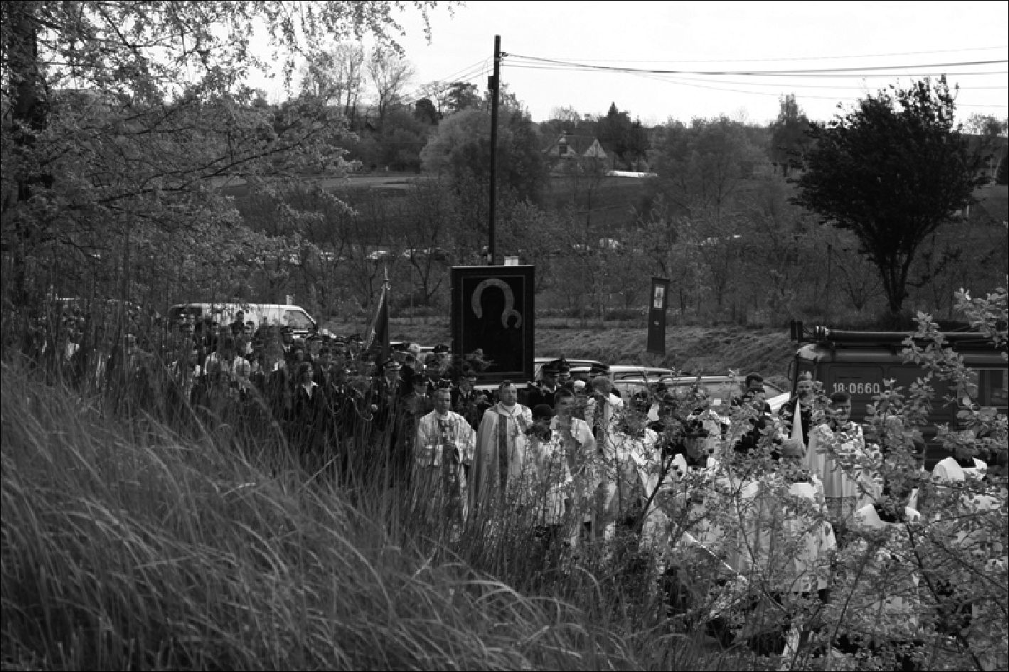
166
The Image and the Figure
32. A peregrination of the copy of the image of Our Lady of Częstochowa, Klimontów,
vicinity of Kraków, 2008 (Photo: Anna Niedźwiedź)
1)
Statements in which there is formal recollection of the presence of the Virgin
Mary in the image (copy). For example, in prayers - the prayer is directed not
towards the image, but to the figure:
In being physically turned towards the image, we speak to the person. It is, however,
impossible to construct convincing arguments for the thesis that the praying Primate
locates the Addressee of his prayer in the image. One may understand this as the adop-
tion of religious convention in our cultural circle.94
2)
Statements which reveal not only a formal but a substantive, “intensive, powerful,
condensed, exceptional, active, and dynamic presence of Mary in the Jasna Góra
image and its copy.”95
94 Ibid., p. 123.
95 Ibid.
The Image-Figure in Lived Religion
167
3)
Statements in which the question of peregrination (and the presence of the Virgin
Mary in the image-copy) is entered into a broad historical and ecclesiological vi-
sion.
The first group of statements can be considered as a natural way of reciting
a prayer before a revered image. In the third group, dominates a metaphorical
depiction of the phenomenon ofperegrination and its inclusion within a mytholo-
gized vision of history and the great story of the image. The second group of
statements is perhaps the most interesting group. In this group, there is a blur-
ring of the border between the image and the figure (according the concept of
non-differentiation). In Wyszyński’s statements (categorized in this group) the
material and the personal dimensions of the image of Our Lady of Częstochowa
intertwine and interweave. During the ceremonial service at the beginning of the
peregrination in 1957 Wyszyński carried out a characteristic transition from im-
age to person. The image and figure became interchangeable:
A moment ago, we saw how the priests carried the [...] picture of the Jasna Góra
Mother around the ramparts [.] Look once again towards Your Most Holy Mother
who soon will be carried by priests and people of God from temple to temple, from
cathedral to cathedral, from diocese to diocese, out of the will of the Episcopate and
with its [the Episcopate’s] blessing it [the picture] is to gladden the whole Homeland
with its visitation and all of You.96 [emphasis added]
Wyszyński’s sermons often contain a personal treatment of the picture. The image
becomes a place of intense presence of the Virgin Mary. For instance, Wyszyński
addresses “the Mother who, through the eyes of Our Lady of Jasna Góra, looks
out from your image” [sermon given on 9 May 1962; emphasis added].97 The
image-figure is also bestowed with its own will: “The visitation of our parishes
by the Virgin Mary Queen of Poland is her answer to the Vows of the Nation.”98
[emphasis added]
In 1956, Wyszyński wrote a letter to the organizers of national celebrations
[“Jasna Góra National Vows”] at the Jasna Góra Monastery. Wyszyński wrote the
letter, while interned, to give his advice. He encouraged the organizers to show the
original image of Our Lady of Częstochowa to all the pilgrims gathering on a big
meadow at the foot of the monastery. In the letter, Wyszyński wrote not so much
about the image but about the person of Our Lady:
I consent to the request [about presenting the original image during the open-air servi-
ce in front of the monastery] with enthusiasm so that the Most Holy Mother can look
at the hundreds of thousands of pilgrims gathering at the foot of Jasna Góra. When you
carry the image up the steps to the altar, stop for a moment at the balustrade - so that
96 As quoted by Napiórkowski, ibid., p. 124.
97 See Pach, Jasnogórski obraz i sanktuarium, p. 90.
98 See Królowa Polski nawiedza swój kraj, p. 5.
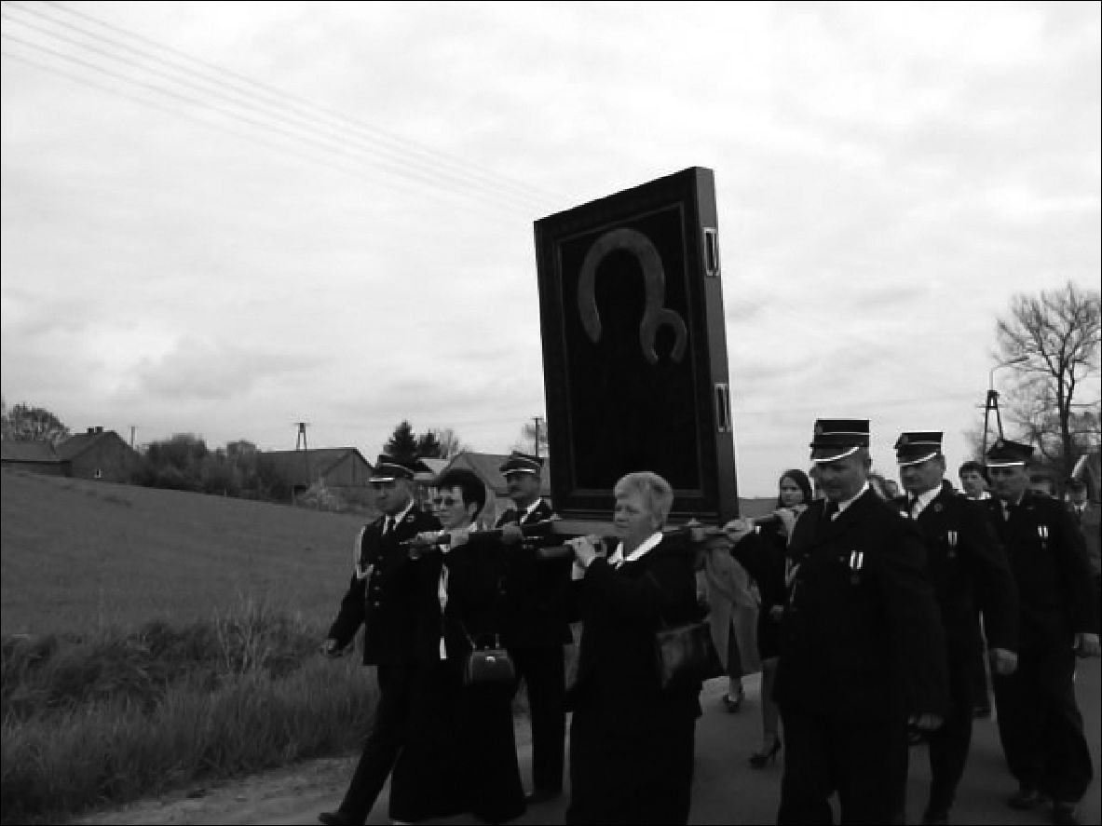
168
The Image and the Figure
all the people can (in the bright sunshine) fully view the Mother of the Sun of Justice
[a letter to General Father A. Wrzalik, 3 August 1956; emphasis added].99
Later, when he learned about huge success of the celebrations which attracted
many pilgrims, Wyszyński noted his reflections on the “Jasna Góra National
Vows” performed according his suggestions. He especially noted the moment the
miraculous image was taken from the chapel:
The Queen came out, the Virgin Helper, onto the Jasna Góra Ramparts [...]. She re-
ceived the prayers, offerings, and the renewal of the vows of the Polish Nation. She
smiled with the grace of a bright sky and returned to her Altar.” [emphasis added]
These statements illustrate that, for Wyszyński, the figure of Our Lady is present
through and in the image. As if the person of the Virgin Mary participated in the
image.
33. A peregrination of the copy of the image of Our Lady of Częstochowa, Klimontów,
vicinity of Kraków, 2008 (Photo: Anna Niedźwiedź)
Non-differentiation, the absence of a border between the image and the fig-
ure, seems to dominate contemporary popular piety connected with the image of
Our Lady of Częstochowa. The rituals surrounding the peregrination of copies of
the Jasna Góra image strengthened the mechanisms of non-differentiation in the
religious perception of the image. Various words of prayers, requests and descrip-
99 See J. Tomziński, ‘Jasnogórska Maryja w życiu i służbie kpp. Kardynała Stefana Wy-
szyńskiego’, Studia Claromontana 2 (1981), p. 14.
The Image-Figure in Lived Religion
169
tions of peregrination referred to it not as an image (that is being carried from
parish to parish) but the Virgin Mary herself visiting her country. On one of the
numerous websites devoted to the peregrination of the copy of the image of Our
Lady of Częstochowa, one may find the following formulations describing the
beginning of the peregrination in 1957:
On 26 August [1957] the Virgin Mary commences her pilgrimage, which will last
for almost a quarter of a century, right up to 12 October 1980. During this time Mary
will visit all the parishes in Poland [...]. She will begin her wanderings around the
country from the capital of Poland - Warsaw and then move through the dioceses
[...].100 [emphasis added]
A similar record of experiences (based on non-differentiation) is conveyed by
children from a southern part of Poland in a school chronicle they were keeping.101
Below are examples of typical fragments from the entries describing the peregri-
nation of the image in the children’s parish: “Oh Lady of Jasna Góra, we are really
happy that you were with us;” “an Amazing Guest” came to us;” “And when the
Virgin Mary had left, I started to feel very sad.” [emphasis added]
In the songs sung at the beginning and end of the peregrination at a small town
in southeastern Poland, similar phrases were repeated: “We welcome You Lady
of Częstochowa [...] Wherever your feet touch the earth [...] Let adoration and
eternal praise resound for You Oh Mother and Queen from a thousand hearts;”
“You are leaving us Oh Most Holy Lady in the golden frame of the image.”102
[emphasis added]
Non-differentiation between the image and the person also dominates descrip-
tions of the peregrination given by the interviewees during field research. It seems
that religious people experience the peregrination as an actual visit of the Virgin
Mary herself. In remembering the recent peregrination of the image in her par-
ish, an old woman declares: “I am really pleased that I have lived long enough to
witness this moment. I feel chosen that I had a chance, once more before death, to
see the Lady of Jasna Góra.”103 On the subject of the approaching peregrination
to the parish, another informant said that “it is a huge experience. As if the most
important guest was coming. All the windows in the houses have been decorated
for the occasion.”104 Another interviewee emphasizes that “It’s as if Mary herself
had come.”105
100 http://arka.ids.bielsko.pl
101 The quotes come from Kroniki nawiedzenia [Peregrination chronicle, 12-13 October
1999] in the village of Jawornik, Małopolska voivodship. I collected the quotes during the exhi-
bition ‘The Polish Landscape’ organized in June 2000 in St Jadwiga Parish Church in Kraków.
102 Powitanie obrazu, Pożegnanie obrazu - the texts of songs which I found on leaflets distri-
buted during the peregrination in Odporyszów, Tarnów district in May 2001.
103 No. 17/int., f., b. 1926.
104 No. 24/int., m., b. 1927.
105 No. 58/int., f., b. 1944.
170
The Image and the Figure

7. “A Guest in the home”
The personal dimension of the image can especially be found in recollections of
the small domestic peregrination. During this peregrination, a copy (smaller than
the original picture) was passed from house to house. The image generally stayed
with each family for one twenty-four hour period. The domestic peregrination
has remained in people’s memory as a major happening. Even though many years
have passed since the event, the informants often recalled the feelings associated
with the domestic peregrination.106
The relationship between devotees and the image-figure of Our Lady of
Częstochowa during the small peregrination is richly illustrated by the documen-
tation of the small peregrination that took place in 1965 in one of the parishes
in the Lublin area.107 My own interviews with people who remembered a per-
egrination at their homes provides additional context. Before the transfer of the
image, the house (or apartment) and surroundings were prepared for the celebra-
tion. The interior was cleaned and adorned. A place for the image was also pre-
pared. A wooden platform was placed on a table or in a window, around which
flowers were arranged - potted plants and freshly cut flowers. When the image
was brought in (from the previous house or from the parish church) a cushion
with a rosary was placed before the image. The image itself - a photograph of
the Jasna Góra picture - was decorated. Flowers were inserted around the frame
(real as well as plastic flowers) the quantity of which increased as the wanderings
continued. The image was also adorned with colorful sashes. The material of the
sashes was embroidered on the reverse and embossed with various inscriptions
(for example the letter M for Mary). Votive offerings (medallions, chains, crosses,
jewelry) were hung on the image’s wooden frame. These objects accompanied the
image in its wanderings.
The transfer of the image to another family took place in the afternoon. A large
group of people would gather for the occasion - relatives and neighbors would
join the residents. The head of the household would kiss the image as a farewell
and hand it over to the next householder who would also kiss the picture as a sign
of welcome. Then he would take the image and, accompanied by those present,
would carry it into his house. Often the transfer of the image took on the form
of a spontaneous procession, during which candles were lit, and the image was
adorned with sashes and flowers, and songs were sung. After the arrival at a new
home the image was placed on the platform. In the evening, the rosary was said
and songs were sung, after which everyone returned to their homes. The next day
people again met to pray, and in the afternoon a celebratory bearing farewell to
the image took place and it was entrusted to the next household.
106 As I have already mentioned the small peregrination took place in most parishes twice:
in the 1960s and 1970s. During the field research, people often confused the dates of the pere-
grinations when recalling former events.
107 See Cimek, ‘Nawiedzenie obrazu’, pp. 100-120.
The Image-Figure in Lived Religion
171
- A small peregrination of the copy of the image of Our Lady of Częstochowa, central
Poland, 2008 (Photo: Agata Banach)
The domestic peregrination brought about a deep sense of experience (and
various spontaneous reactions) which conveyed the specific relationship to the
image of Our Lady of Częstochowa. During the field research, people often re-
called events that had occurred several years before:
In the 1960s the image was at home. I really did cry that we had lived to see this mo-
ment. Because it was the first time the image had been in the house. We kept vigil all
night. Even though there are images in the house, this is different - a different expe-
rience. Such a guest in the house. the family unites and can pray together.108
In another, already cited statement an informant admits that while the image was
in the house “one could be in solitude with the image and talk one to one, present
one’s problems. It was a really personal meeting with the Virgin Mary.”109 Sim-
ilar views are expressed by other interviewees. Here are some of the recollections
of the peregrinations that were assembled during the field research:
- When the image was at home it was a special visit of a great guest, who would
listen to your sorrows and to whom you could tell your problems;110
- The domestic peregrination was an important event. When the image was in the
house the neighbors came to visit;111
108 No. 51/int., f., b. 1939.
109 No. 39/int., m., b. 1935.
110 No. 60/int., m., b. 1949.
111 No. 65/int., f., b. 1953.
172
The Image and the Figure
- The image twice went from house to house. The family received the image and
prayed jointly and kept vigil. In the given house, neighbors also gathered (bringing
their own chairs);112
- Peregrination means that the Virgin Mary keeps vigil like a mother who wishes to
visit every house, parish, family. She is received like a long awaited guest;113
- The image went round twice - in the church and around the villages. It is simply
impossible to express that feeling. It is even better than being in Częstochowa,
because the Virgin Mary visits every corner, every house, and every parish.114
The receiving of the image by each family, the recitation of prayers, and the sing-
ing of songs was similar in each place (in keeping with the recommendations of
priests and the liturgical schemes proposed by the Church). It is important to note,
however, that though this new form of devotion to Our Lady of Częstochowa was
initiated by the Church hierarchy, it fell on fertile ground and met with an enthu-
siastic response from a significant portion of the faithful. People were happy to
participate in the peregrination and they experienced the visitation of a copy of
Our Lady of Częstochowa in their own homes in an exceptionally emotional and
deeply-felt way.
Although the peregrination was initiated by (and was under the protection
of) the clergy, the various devotional practices and paraliturgical forms of behav-
iors surrounding the visitation were spontaneous in character. In addition to the
recommended prayers, which were widely propagated in various prayer books
and liturgical handbooks, during the peregrination people composed their own
prayers and prayed in their own words. Many individuals who had never been
to church for a service during the year, regularly and willingly participated in the
domestic peregrination. This illustrates the unofficial and spontaneous nature of
participant experiences.
In the texts of the prayers and songs, the image wandering from house to house
is a Guest-Figure, who is ceremoniously and cheerfully welcomed and, later, seen
off with genuine and heartfelt sorrow. Often, during the presence of the image in
a given home, a celebratory supper was organized. Families gathered around the
image of Our Lady of Częstochowa for commemorative photographs. Aside from
participating in the peregrination in one’s own house, there was a keen need to
visit neighbors and relatives when the image was residing in their households.
In the recollections, written-down prayers, and the songs evoked, the personal
dimension of the image is evident. The copy wandering from house to house was
not simply a photograph of the miraculous picture, but a real figure present in the
house: the Queen and Mother. The prayers contain various themes and motifs
which we are able to treat as expressions of Marian popular piety. Amongst the
most characteristic features of popular piety are: the personal treatment of the
112 No. 21/int., f., b. 1927.
113 No. 69/int., f., b. 1955.
114 No. 26/int., f., b. 1928.
The Image-Figure in Lived Religion I73
image (frequently emphasized by me), as being the figure of the Mother or the
figure of the Queen, the motifs of the Consoler, Helper as well as the motif of the
wandering of the Virgin Mary - so characteristic for devotion connected with the
peregrination.
- A small peregrination of the copy of the image of Our Lady of Częstochowa, central
Poland, 2008 (Photo: Agata Banach)
Within the texts that remain after the peregrination, the figure of Our Lady
of Częstochowa enters, into the existing tradition of popular texts that talk of the
wandering of the Virgin Mary around the world:
Oh Divine Mother, you are in Częstochowa.
And desired to be with us in Gorzków [.]
Now, Oh Mother, you travel the world,
And have those babes in your care.115
115 The text of a prayer noted during a small peregrination in the Gorzków parish. See
Cimek, ‘Nawiedzenie obrazu’, p. 117.
174
The Image and the Figure
The next prayer also recalls the poetics of folk tales about the Virgin Mary wan-
dering the earth and visiting poor abodes:
Mary wanders the roads of Poland
She visits all the cottages.
So the old and young
Fathers, children and mothers gather.116

8. The figure without the image - the peregrination of an empty
frame
One of the most dramatic manifestation of the non-differentiation of the image-
figure occurred when the Communist authorities attempted to stop the great per-
egrination of the copy of the image of Our Lady of Częstochowa. This meant,
within the social, spontaneous reception of events, that the Virgin Mary herself
had been arrested. During this episode, a copy of the image of Our Lady of
Częstochowa was held three different times by the security forces.117
On 6 June 1966, after the end of the service in Lublin, the image was ap-
prehended. The car transporting the image - on the orders of the communist au-
thorities - was covered with a tarpaulin and taken to Jasna Góra. Despite the
harassment from the communist security service, the Pauline Fathers, in conjunc-
tion with the Church authorities, decided to send the picture, in accordance with
previous plans, to Frombork for the next of the planned celebrations. On 20 June
1966, when the image was being transported from Frombork to Warsaw, the car
was again stopped by militiamen. The militiamen took the picture to St. John’s
Cathedral in Warsaw where it was kept and not allowed to be sent back on the
peregrination route. According to the plans for September 1966, the peregrina-
tion was to start in Katowice in the Silesia region. Church officials organized
a secret transportation of the image from Warsaw to Silesia. This was in direct
violation of the wishes of the state authorities This time militiamen forced the car
- with the image inside - back to Jasna Góra. State officials warned the monastery
authorities about the illegality of transporting the image beyond the gates of the
monastery.
The copy of the miraculous picture remained in Jasna Góra for almost five
years (until 18 June 1972). During this period preceding June of 1972, however,
there was no break in the peregrination. In subsequent churches and locations,
an unusual symbol appeared - an empty frame (with a candle and a lectionary
book) - which were carried in processions. People prayed before the empty frame
in exactly the same way as they would to the copy of Our Lady of Częstochowa.
116 Ibid., p. 119.
117 Szypuła, Peregrynacja obrazu Matki Bożej, pp. 17-22.
The Image-Figure in Lived Religion
175
The research conducted in 2000 indicated that many informants have vivid
memories from this time period.118 Statements which were made in 2000, refer-
ence the events of over thirty years ago. Yet the recollections of experiences and
circumstances that accompanied the peregrination are still strong; even people
who were, at that time, only a few years old talk about the peregrination of an
empty frame. During the interviews on this subject, individuals who were not
even born then recall how they had heard about the peregrination of the frame
from parents and grandparents. The presence of these cases within the collective
memory may give evidence that the peregrination of the image without an image
constituted an unusually meaningful sign, which aroused a great sense of experi-
ence amongst those who participated. The symbol of the image of Our Lady of
Częstochowa had, once again, illustrated the unity of patriotic-national themes
within the world of popular religion. The image itself and the figure took part in
a direct political conflict. According to the sensual non-differentiation, the hold-
ing of the image by the Communist authorities was seen as the arrest of the Virgin
Mary:
- People really experienced it deeply [theperegrination of the empty frame - ]. They
cried secretly because they were afraid of the communists. Only they were capable
of imprisoning the Virgin Mary;119
- When Mary was imprisoned, Poles were sad and suffered;120
- I remember the peregrination of the frame of the Częstochowa image. People re-
ally felt for the arrest of the Queen. The mood that reigned at the time of the
imprisonment was similar to a funeral mood. Sorrow reigned;121
- In 1966 just the frame visited the parish [...] the Secret Police had, at that time,
arrested the Virgin Mary;122
- Only the frame moved around as the Virgin Mary had been arrested. There was
a ban. The frame was a sign of protest by Poles that they did not agree with this
ban.123
Even when the figure is not directly recalled in the statements, the usage of the
formulation about arresting the image implies association with a person. For one
cannot talk about the arrest of an object. Arresting brings to mind a person who
has been taken into official custody.
118 The majority of the interviews were conducted in the Tarnów diocese in 2000. Pere-
grination without the image took place in the Tarnów diocese between December 1968 and
March 1970.
119 No. 11/int., f., b. 1925.
120 No. 52/int., m., b. 1939.
121 No. 30/int., f., b. 1930.
122 No. 46/int., f., b. 1938.
123 No. 71/int., f., b. 1958.
176
The Image and the Figure
Analyzing field research material many questions appear. Is it possible to ap-
ply the notion of non-differentiation to the peregrination of the image without the
image? Why did people pray to an empty frame, hang votive offerings on it, deco-
rate it with flowers and maintain the ceremony connected with the peregrination
of the image-figure of Our Lady of Częstochowa? The behavior and statements
of the informants point to the conviction as to the actual presence of the image-
figure:
- When I was a child, the image of Our Lady of Częstochowa was blocked. But it
travelled on with the frame itself. The communists lost out immensely on this
detention, because the empty frame caused greater agitation and the significance of
this empty frame was all the greater;124
- I remember processions with the empty frame. Everyone acted as if the image had
not in fact been removed. Everyone saw it and all were sorrowful.125
The picture was not there and at the same time - it was. The reception of the per-
egrination of the frame revealed the face of popular religion in which symbolic
thinking attained a creative dimension, and the “archaic ontology” based on the
“existence-proof” concept of truth underwent a sort of reversion.126 In the experi-
ence of the peregrination of the image without the image the equation: existence
equals truth was changed into the function: truth equals existence. The “archaic
ontology” in a creative and paradoxical way transformed the situation. The frame
and the candle became powerful symbols - in the social reception of events -
making the image-figure present:
- The picture always overcomes aliens. It spiritually triumphed when, in 1966, the
empty frame with a lit candle wandered;127
- In the 1980s, only the frame travelled around. And if they had arrested the frame,
then the candle symbolizing the image would have carried on the journey.128
Theologians have pondered the phenomenon of praying to an empty frame.129
How was it possible that people gathered before a frame which did not hold the
revered image? Could the person of the Virgin Mary really be made present in the
symbol of the frame, the candle and the Gospel? Is she present at all in the image
itself?
124 No. 70/int., m., b. 1957.
125 No. 43/int., m., b. 1937.
126 As discussed by JoannaTokarska-Bakir in “archaic ontology” the concept of truth was
different than the so-called “classical concept of truth.” In popular religion (which is based on
elements of “archaic ontology”) what exists (what is perceived as existing) is real and truth. See
Tokarska-Bakir, Obraz osobliwy, pp. 31-31 and pp. 365-373.
127 No. 72/int., m., b. 1958.
128 No. 63/int., f., b. 1952.
129 See Napiórkowski, Matka Naszego Pana, pp. 118-140.
The Image-Figure in Lived Religion
177
It is difficult for an ethnologist to delve into theological considerations. All
the more so when theologians themselves clash over interpretative positions and
varied concepts of religiousness.130 A researcher into culture may, however, note
the experiences of those who participated in the celebrations and who remember
them. Of course the basic dimension for this experience is religious in character.
However, we must at the same time, realize that the peregrination of the image
of Our Lady of Częstochowa, particularly the peregrination of the image without
an image, relates to the great national story about the image. It also shows that
the religious dimension becomes a manifestation of political and patriotic convic-
tions. The small-private story blends with the great story, and the way of thinking
and perception of reality (specifically for popular religion), creates an examina-
tion of the world which is perceived in the sphere of mythology and national-
patriotic tradition. During the peregrination there were several occurrences of
“making a religious ritual a national ritual.” This is something characteristic for
popular Polish Catholicism.131
* * *
The small story about the picture of Our Lady of Częstochowa interprets the
image within the context of personal religious experience. Non-differentiation
between the image and the figure, plays a fundamental role in the religious experi-
ence of the image. The notion of Mary as Mother is the dominating figure around
which the religious imagination shapes the relationship: believer - image - figure.
One of the most important experiences connected with the image is the miracu-
lous consciousness.
Finally, the image of Our Lady of Częstochowa (and the events surrounding
the peregrination of the image), show the complementary relationship of contem-
porary Polish popular Catholicism with the sphere of national-patriotic notions.
130 Ibid. See also R.J. Abramek, ‘Kult Bogarodzicy w nawiedzającym obrazie’, Jasnogór-
ska Bogurodzica w drodze, ed. S.J. Rożej (Jasna Góra-Częstochowa, 1996), pp. 109-127.
131 Sroczyńska, Fenomen religijności ludowej w Polsce, pp. 268-269.
- A small peregrination of the copy of the image of Our Lady of Częstochowa. A woman
with a candle is taking the image to her home, Liszki near Kraków, 1985 (Photo: Jacek
Kubiena, Archive of the Ethnographic Museum in Kraków)

Epilogue story
The cult of Mary and piety connected with Marian images are phenomena lived
by Catholics all over the world. The figure of Mary today, as in previous centu-
ries, attracts and accumulates various meanings fulfilling personal and collective
needs of people. In the case of Poland, national and private stories surrounding
the image of Our Lady of Częstochowa describe Mary as Queen and as Mother.
Our Lady of Częstochowa as a “master symbol” shapes rituals, behaviors, and (to
a huge extent) myths connected with contemporary Polish popular Catholicism.
As pointed out in many places in this book, the power of this cultural icon has
been especially revealed in breakthrough, liminal situations when the society and
individuals search for symbolic dimensions in their lives.
As I was preparing an English version of this book to be published, the Polish
state and society experienced a politically shaking event. On Saturday morning,
10 April 2010, a plane with 96 top Polish officials - including the President of the
Polish Republic Lech Kaczyński and his wife - crashed near the Smoleńsk Air-
port in Russia killing all on board. This tragic crash was immediately perceived
in Poland in very symbolic terms. On the level of “spontaneous historiosophy,” it
was interpreted in the context of the popular vision of “dramatic Polish history.”1
Knowing the symbolic dimension of Our Lady, I was not surprised when the im-
age-figure of Our Lady of Częstochowa began to play a role in national mourning.
Three weeks after the fatal crash, a representative of the Jasna Góra Monastery
officially announced that a tiny part of the crashed airplane had been delivered to
the monastery and it would appear as a votive offering on the newly embellished
metal robes (which adorn the image of Our Lady of Częstochowa) to “reveal our
deep concern and care for the Fatherland.”2
The image-figure of Our Lady of Częstochowa has again shown itself in myth-
ical discourse as a powerful and lasting symbol. It continues to adapt to new situ-
ations and circumstances. Great and small stories are still told and experienced
in front of the image at the Jasna Góra Chapel, as well as in front of its countless
copies visible on streets and in many Polish homes.
1 The fatal crash happened when the Polish delegation was going to take part in a ceremo-
ny commemorating the seventieth-anniversary of the massacre of Polish Army officers secretly
executed in 1940 by the Soviets. This fact added a symbolic historical dimension to the popular
interpretations and symbolism of the event.
2 See M. Jankowska, Fragment samolotu prezydenta będzie na obrazie Matki Boskiej na
Jasnej Górze, www.gazeta.pl, material archived on 30 April 2010.

APPENDIX

Chronology of the events connected with
a peregrination of the copy of the image of Our Lady
of Częstochowa in Poland
1953-1956 - internment of the Cardinal Stefan Wyszyński - Primate of the Catholic
Church in Poland (released in October 1956)
26 August 1956 - ‘ ‘Jasna Góra National Vows” performed during the absence of the
Primate Cardinal Stefan Wyszyński; celebrations followed suggestions written by
S. Wyszyński; the original image of Our Lady of Częstochowa was taken from the
chapel and showed to the crowd of one million pilgrims gathered around the Jasna
Góra Monastery
April 1957 - the copy of the image of Our Lady of Częstochowa meant for a peregrina-
tion is completed
May 1957 - S. Wyszyński takes the copy of the image to Vatican to be blessed by Pope
Pius XII
26 August 1957 - the beginning of the peregrination of the copy of the image of Our Lady
of Częstochowa; opening celebrations performed at Jasna Góra
- - beginning of the so-called “small peregrinations” (smaller copies of the image of
Our Lady of Częstochowa were to visit private homes and families)
- - “Millennium year” - one-thousandth anniversary of Christianity in Poland (known
as “the Baptizing of Poland”); regular parish peregrination is suspended during this
year to emphasize the importance of the image-copy “visiting” all bishopric-capitals in
Poland (peregrination to the bishopric capitals)
3 May 1966 - ‘ Millennium year” celebrations at Jasna Góra; the image-copy “visits” the
monastery
Appendix
181
6 June 1966 - first attempt by the communist authorities to stop the image-copy during the
peregrination to the bishopric capitals in “Millennium year”
20 June 1966 - the image-copy stopped by communist security service during the peregri-
nation to the bishopric capitals and transported to the Warsaw Cathedral; the Church
did not receive permission to move the image from the Cathedral and continue the
peregrination in other places
2 September 1966 - Church authorities attempt to take the image from the Warsaw Ca-
thedral for a scheduled peregrination in Katowice; the car with the image is stopped
again by security service and transported to the Jasna Góra Monastery. The monastery
authorities are warned by the state officials about the illegality of transporting the im-
age beyond the gates of the monastery; militiamen, appointed by the state, are posted
to check all cars leaving the monastery grounds
- September 1966 - the peregrination in Katowice continues as scheduled; an empty
frame with a candle and a lectionary book represents the “arrested” image
Till 18 June 1972 - the image-copy is kept at the Jasna Góra Monastery; the peregrina-
tion continues in parishes as originally scheduled; an empty frame with a candle and
a lectionary book continues to represent the image
18 June 1972 - after the “stealing” of the image from the Jasna Góra Monastery by a priest
(Józef Wójcik) the image-copy appears during the peregrination in Radom. Since then
the peregrination has proceeded without disturbance
1980 - the conclusion of the first peregrination
1982-1983 - the Church organizes additional peregrinations, sending the image-copy for
a one-week period to each diocese in Poland; this is connected with celebrations of the
600th year of the Jasna Góra Monastery. The events possess strong social and political
dimensions as they are organized during Martial Law
- May 1985 - the second peregrination to all parishes in Poland begins
May 2010 - as of completion of this work, the second peregrination is on-going

Selected bibliography
Abramek R.J., ‘Jasnogórska” mariologia kardynała Karola Wojtyły papieża Jana Pawła
II’, Studia Claromontana 1 (1981), pp. 7-39
‘Aneks: Kult Bogarodzicy w nawiedzającym obrazie’, Jasnogórska Bogurodzica
w drodze, ed. S.J. Rożej (Jasna Góra-Częstochowa, 1996), pp. 109-127
Bania, Z. and S. Kobielus, Jasna Góra (Warszawa, 1983)
Bartmiński J., ‘Podstawy lingwistycznych badań nad stereotypem - na przykładzie stere-
otypu matki, Język a kultura 12 (1998), pp. 63-83
Begg E., The Cult of the Black Virgin (London, 1996)
Bilnik P., ‘Napad “husytów” na Jasną Górę. Fakty, konteksty - legenda’, Studia Claro-
montana 15 (1995), pp. 277-323
Borkowska U., ‘Jasna Góra w pobożności królów polskich’, Studia Claromontana 4
- , pp. 126-146
Budzik S., Maryja w tajemnicy Chrystusa i Kościoła (Tarnów, 1995)
de Busser, C. and A. Niedźwiedź, ‘Mary in Poland: A Polish Master Symbol’, Moved by
Mary. The Power of Pilgrimage in the Modern World, ed. A.-K. Hermkens, W. Jansen,
C. Notermans (Farnham, Burlington, 2009), pp. 87-100
Bylina S., ‘Nowa dewocja, postawy wiernych i kult maryjny w Europie Środkowej
późnego średniowiecza’, Studia Claromontana 5 (1984), pp. 110-126
Caillois R., Człowiek i sacrum, transl. A. Tatarkiewicz, E. Burska (Warszawa, 1995)
Chwalba A., Historia Polski 1795-1918 (Kraków, 2000)
Cimek J., ‘Nawiedzenie obrazu Matki Bożej Częstochowskiej w rodzinach na przykładzie
parafii Gorzków w diecezji lubelskiej’, Studia Claromontana 7 (1987), pp. 100-120
Cormack R., Painting the Soul. Icons, Death Masks and Shrouds (London, 1997)
Czarnowski S., Kultura (Warszawa, 1938)
184
Selected bibliography
Davies N., Gods Playground. A History of Poland. In Two Volumes (Oxford, New York
2005)
Dąb-Kalinowska B., Ikony i obrazy (Warszawa, 2000)
Dąbrowska D., Okolicznościowa poezja polityczna w Polsce w latach 1980-1990
(Szczecin, 1998)
Dąbrówka A., Teatr i sacrum w średniowieczu. Religia - cywilizacja - estetyka (Wrocław,
2001)
Deptuła Cz., ‘Święte góry w dawnej Polsce. Impresja z pogranicza średniowiecza i re-
nesansu’, Miejsca rzeczywiste. Miejsca wyobrażone. Studia nad kategorią miejsca
w przestrzeni kultury, eds. M. Kitowska-Łysiak and E. Wolicka (Lublin, 1999), pp.
215-244
Engelking A., Klątwa. Rzecz o ludowej magii słowa (Wrocław, 2000)
Estreicher K., ‘Madonna Częstochowska’, Sprawozdania z Czynności i Posiedzeń
Akademii Umiejętności w Krakowie 53-5 (1952), pp. 249-252
Evans K.S., ‘The Argument of Images. Historical Representation in Solidarity Under-
ground Postage, 1981-87’, American Ethnologist 19 (1992), pp. 749-767
Evdokimov P., Prawosławie, transl. J. Klinger (Warszawa, 1964)
Sztuka ikony. Teologia piękna, transl. M. Żurowska (Warszawa, 1999)
Fijałek J., ‘Królowa Korony Polskiej. Historya kultu Matki Boskiej w Polsce
średniowiecznej w zarysie’, Przegląd Kościelny 1 (1902), pp. 409-418
Freedberg D., The Power of Images. Studies in the History and Theory of Response (Chi-
cago and London, 1989)
H.-G. Gadamer, Truth and Method (London-New York, 2004)
Gębarowicz M., Mater Misericordiae, Pokrow, Pokrowa w sztuce i legendzie środkowo-
wschodniej Europy (Wrocław-Warszawa-Kraków, 1986)
Golonka J., ‘Odwrocie cudownego obrazu’, Najstarsze historie o Częstochowskim Obra-
zie Panny MaryiXViXVI wiek, ed. H. Kowalewicz (Warszawa, 1983), pp. 55-59
‘Prace konserwatorskie nad cudownym obrazem Matki Bożej Jasnogórskiej’, Stu-
dia Claromontana 5 (1984), pp. 69-85
Ołtarz Jasnogórskiej Bogurodzicy. Treści ideowe oraz artystyczne kaplicy i retabu-
lum (Jasna Góra-Częstochowa, 1996)
‘Ideowe przesłania plenerów malarskich i okolicznościowych ekspozycji na Jasnej
Górze - sztuka czasu nadziei’, Jasna Góra w dwudziestoleciu pontyfikatu Jana Pawła
II, ed. Z.S. Jabłoński (Jasna Góra-Częstochowa, 1999), pp. 323-332
Selected bibliography
185
Grąbczewski J., ‘Postać Matki Boskiej w ludowych przekazach językowych’, Polska Sztu-
ka Ludowa 3 (1984), pp. 157-166
Grzybek S., ‘Teologiczne podstawy peregrynacji Matki Bożej Częstochowskiej’, Maryja
Matka Narodu Polskiego, ed. S. Grzybek (Częstochowa, 1983), pp. 282-290
Hemka, A. and Olędzki J., ‘Wrażliwość mirakularna’, Polska Sztuka Ludowa. Konteksty
1 (1990), pp. 8-14
Jabłońska-Deptuła E., ‘Boś Ty jest wolność. Kult Matki Boskiej Częstochowskiej -
Królowej Polski w okresie niewoli narodowej’, Więź 10 (1982), pp. 3-18
Kościół - Religia - Patriotyzm (Polska 1764-1864) (Warszawa, 1985)
Jabłoński Z. S., ‘600 lat Jasnej Góry ważniejszymi wydarzeniami pisane’, Maryja Matka
narodu polskiego, ed. S. Grzybek (Częstochowa, 1983), pp. 9-21
Pielgrzymowania na Jasną Górę w czasie i przestrzeni. Wybór rozpraw i artykułów
(Częstochowa, 2000)
Jacher-Tyszkowa A., ‘Wystawa dla narodu polskiego’, Jasna Góra 3 (1984), pp. 24-25
‘Wystawa dla narodu polskiego (2.)’, Jasna Góra 6 (1984), pp. 55-62
Jackowski Aleksander, ‘Wpisy do “Księgi wystawy”’, Polska Sztuka Ludowa 3 (1984),
pp.155-156
‘Folklor kontestacji’, Polska Sztuka Ludowa 2 (1984), pp. 10-14
Jackowski Antoni, ‘Wstęp’, Peregrinus Cracoviensis 3 (1996), pp. 9-13
Janion M., Czas formy otwartej. Tematy i media romantyczne (Warszawa, 1984)
Kersten A., Obrona Klasztoru w Jasnej Górze (Warszawa, 1964)
Kębłowski J., Polska sztuka gotycka (Warszawa, 1976)
Kęder W., ‘Jasna Góra wobec przemian politycznych w Rzeczypospolitej w latach 1661
-1813’, Studia Claromontana 13 (1993), pp. 7-206
Kłoczowski J., ‘Sens społeczny polskiej maryjności’, Więź 7 (1982), pp. 3-13
Knapiński R., ‘Ojcowie Kościoła o znaczeniu obrazów w przekazie wiary’, Roczniki Hu-
manistyczne KUL. Historia Sztuki 47-4 (1999), pp. 5-22
Kobrzeniecka-Sikorska G., Ikona, kult, polityka. Rosyjskie ikony maryjne od drugiej
połowy XVII wieku (Olsztyn, 2000)
Kolberg O., Dzieła wszystkie Oskara Kolberga (Poznań, 1961-)
Kopaliński W., Słownik wyrazów obcych i zwrotów obcojęzycznych (Warszawa, 1994)
I86 Selected bibliography
Kopeć J.J., Bogarodzica w kulturze polskiej XVI wieku (Lublin, 1997)
Kopera F., Dzieje malarstwa w Polsce, vol. 1: Średniowieczne malarstwo w Polsce
(Kraków, 1925)
Kordecki A., Pamiętnik oblężenia Częstochowy 1655 r (Nowa Gigantomachia), transl.
J. Łepkowski, ed. J. Majdecki (Częstochowa, 1991) [edition based on 1858 print]
Korolko M., Leksykon kultury religijnej w Polsce. Miejsca, obrzędy, wspólnoty (zprzydat-
kiem literackich wypisów) (Warszawa, 1999)
Kos T., Fundacja Klasztoru Jasnogórskiego w świetle nowej interpretacji źródeł (Kraków,
2002)
Kowalewiczowa M., ‘Przyczynek do akwizgrańskiego wątku historii’, Przegląd Po-
wszechny 4 (1982), pp. 60-72
Kowalski P., Leksykon znaki świata. Omen, przesąd, znaczenie (Warszawa-Wrocław,
1998)
Kozłowski R., ‘Historia obrazu jasnogórskiego w świetle badań technologicznych i arty-
styczno-formalnych’, Roczniki Humanistyczne KUL 20 (1972), pp. 5-46
Kracik J., Relikwie (Kraków, 2002)
Kras P., Husyci wpiętnastowiecznej Polsce (Lublin, 1998)
Kubajak A., Najsławniejsze sanktuaria Polski (Kraków, 2000)
Kubiak, I. and K. Kubiak, Chleb w tradycji ludowej (Warszawa, 1981)
Kubiak Z., Mitologia Greków i Rzymian (Warszawa, 1998)
Kukiz T., Madonny Kresowe i inne obrazy sakralne z Kresów w diecezjach Polski (poza
Śląskiem), vol. I (Warszawa, 2000)
Kunczyńska-Iracka A., Malarstwo ludowe kręgu częstochowskiego (Wrocław-Warszawa
-Kraków-Gdańsk, 1978)
Kuniński M., ‘Historiozofia żywiołowa a upadek komunizmu’, Czy historia może się
cofnąć?, ed. B. Łagowski (Kraków, 1993), pp. 9-25
Kurpik W., ‘Podłoże drewniane obrazu Matki Bożej Jasnogórskiej’, Studia Claromontana
5 (1984), pp. 8-13
‘“Blizny” Jasnogórskiej Madonny’, Jasna Góra 7 (1988), pp. 21-27
Selected bibliography
187
‘Dlaczego Czarna Madonna? - Rozważania na temat badań cudownego obrazu’,
Tyś wielką chlubą naszego Narodu, ed. K. Kunz (Częstochowa-Jasna Góra, 1991), pp.
423-428
Kuryluk E., Veronica and Her Cloth. History, Symbolism, and Structure of a “True” Image
(Cambridge MA, Oxford, 1991)
Leeuw van der G., Fenomenologia religii, transl. J. Prokopiuk (Warszawa, 1997)
Łepkowski T., ‘O katolicyzmie i kulcie maryjnym w społeczeństwie polskim XIX stulecia
(Artykuł dyskusyjny)’, Studia Claromontana 7 (1987), pp. 40-49
Łobżyński D.J., Przenosiny triumfalne najcudowniejszego w Królestwie Polskim obrazu
Bogurodzice Panny Maryey na Iasney Gorze Częstochowskiey abopanegirykkościelny
(Kraków, 1644)
Łukaszuk T.D., ‘Jasnogórcy XVII wieku wiedzieli, dlaczego obrazowi należy się cześć’,
Jasna Góra 1 (1984), pp. 30-34
Łuszczek D., ‘Koronowane kopie obrazu Matki Bożej Jasnogórskiej od XV do XVII
wieku w Polsce’, Studia Claromontana 10 (1989), pp. 184-202
‘Jasnogórska Bogurodzica w ikonografii czasu nadziei 1981-1985’, Jasna Góra 2
(1991), pp. 35-41
Inspiracje religijne w polskim malarstwie i grafice 1981-1991 (Warszawa-Czę-
stochowa, 1998)
Łysiak W., ‘Oblicza folkloru - folklor polityczny’, Polska Sztuka Ludowa 2 (1990), pp.
16-19
Maniura R., Pilgrimage to Images in the Fifteenth Century. The Origins of the Cult of Our
Lady of Częstochowa (Woodbridge, 2004)
Marcinkowska T., ‘Sanktuaria maryjne w narracyjnych pieśniach ludowych’, Orędowniczko
nasza. Kult Matki Bożej w polskiej kulturze ludowej, ed. A. Spiss (Kraków, 1996), pp.
59-67
Marszałek R., Filmowa pop-historia (Kraków, 1984)
Maryja w Katechizmie Kościoła Katolickiego, ed. S.C. Napiórkowski and B. Kochanie-
wicz (Kraków, 1996)
Michałowska M., ‘Palladium polskie. Militarne aspekty ikonografii maryjnej XVII-XVIII
w.’, Studia Claromontana 6 (1985), pp. 25-46
Miejsca święte Rzeczypospolitej. Leksykon, ed. A. Jackowski (Kraków, 1999)
188
Selected bibliography
Moisan, K.S. and Szafraniec B., Maryja Orędowniczka Wiernych, Ikonografia nowożytnej
sztuki kościelnej w Polsce (Warszawa, 1987)
Morgan D., Visual Piety. A History and Theory of Popular Religious Images (Berkeley,
Los Angeles-London, 1998)
Mroczko, T. and Dąb B., ‘Gotyckie Hodegetrie polskie’, Średniowiecze. Studia o kulturze,
vol. 3 (Wrocław-Warszawa-Kraków, 1966), pp. 18-70
Najstarsze historie o Częstochowskim Obrazie Panny Maryi XV i XVI wiek, ed. H. Kow-
alewicz, transl. H. Kowalewicz, M. Kowalewiczowa, introduction H. Kowalewicz,
Z. Rozanow (Warszawa, 1983)
Nalaskowski J.A., ‘Jana Pawła II teologia jasnogórskiego sanktuarium’, Jasna Góra
w dwudziestoleciu pontyfikatu Jana Pawła II, ed. Z.S. Jabłoński (Jasna Góra-Czę-
stochowa, 1999), pp. 65-81
Napiórkowski S.C., Matka Naszego Pana (problemy - poszukiwania - perspektywy)
(Tarnów, 1992)
Olędzki J., ‘Świadomość mirakularna’, Polska Sztuka Ludowa. Konteksty 3 (1989),
pp.147-157
Orsi R., Between Heaven and Earth. The Religious Worlds People Make and the Scholars
who Study Them (Princeton and Oxford, 2005)
Osiadły E.J. ‘Znaczenie Jasnej Góry w religijności i kulturze polskiej według nauki O. Jana
Dionizego Łobżyńskiego (1593-1654)’, Studia Claromontana 3 (1982), pp. 104-124
Otto R., Das Heilige. Über das Irrationale in der Idee des Göttlichen und sein Verhältnis
zum Rationalem (München, 1963)
Pach J., ‘Jasnogórski obraz i sanktuarium w nauczaniu kardynała Stefana Wyszyńskiego’,
Studia Claromontana 5 (1984), pp. 86-100
Pach J., Robak, W. and J. Tomziński, Jasna Góra. Sanktuarium Matki Bożej (Jasna Góra
-Częstochowa, 1997)
Paprocki H., ‘Mariologia - wspólne źródło prawosławia i katolicyzmu’, Kult maryjny
w kościele rzymskokatolickim w Polsce i rosyjskim kościele prawosławnym (Warszawa
-Moskwa, 1989), pp. 9-16
Pasierb J.S., ‘Matka Boska Częstochowska w kulcie i kulturze polskiej’, Maryja matka
narodu polskiego, ed. S. Grzybek (Częstochowa, 1983), pp. 313-324
‘Znaczenia wizerunku Matki Boskiej Jasnogórskiej’, Studia Claromontana 5
- , pp. 102-109
Selected bibliography
189
Perz A., ‘Magisterium Kościoła o Matce Słowa Wcielonego’, Gratia plena. Studia teolo-
giczne o Bogurodzicy, ed. B. Przybylski (Poznań, 1965), pp. 129-162
Pielas M., Matka Boska Bolesna (Kraków, 2000)
Pieradzka K., Fundacja klasztoru jasnogórskiego w Częstochowie w 1382 r (Kraków,
1939)
Pirożyński J., ‘Najstarszy zachowany, drukowany przekaz legendy o obrazie Matki Bo-
skiej Częstochowskiej’, Biuletyn Biblioteki Jagiellońskiej 1-2 (1973), pp. 151-166
Piwowarski W., ‘Wprowadzenie’, Religijność ludowa. Ciągłość i zmiana, ed. W. Piwowar-
ski (Wrocław, 1983), pp. 5-19
Płatek J., ‘Przy dźwiękach jasnogórskich fanfar...’ Tyś wielką chlubą naszego Narodu, ed.
K. Kunz (Częstochowa-Jasna Góra, 1991), pp. 457-464
Podlacha W., Historia malarstwa polskiego, vol. 1 (Lwów, 1914)
Prażmowska A.J., A history of Poland (Hampshire, New York, 2004)
Rakoczy E., ‘“Mensa Mariana” - malowidło z odwrocia obrazu Matki Boskiej
Częstochowskiej’, Jasnogórski ołtarz Królowej Polski. Studium teologiczno-historycz-
ne oraz dokumentacja obiektów zabytkowych i prac konserwatorskich, ed. J. Golonka
(Częstochowa, 1991), pp. 187-217
‘Matka Boża Częstochowska w tradycji rycersko-żołnierskiej’, Studia Claromon-
tana 16 (1996), pp. 5-30
Jasnogórska Hetmanka w polskiej tradycji rycersko-żołnierskiej (Warszawa, 1998)
Robotycki Cz., ‘Sztuka à vista. Folklor strajkowy’, Polska Sztuka Ludowa 2 (1990),
pp.44-49
Etnografia wobec kultury współczesnej (Kraków, 1992)
‘Historia i tradycja - dwie kategorie opisu przeszłości’, Prace Etnograficzne ZNUJ
29 (1992), pp. 15-20
Rogow A., ‘Ikona Matki Boskiej Częstochowskiej jako świadectwo związków bizantyńsko
-rusko-polskich’, Znak 28 (1976), pp. 509-516
Romaniuk M.P. , Prymas Wyszyński: biografia i wybrane źródła (Gniezno, 2001)
Rosa E., ‘Typy Madonny w literaturze ludowej’, Literatura Ludowa 3 (1986), pp. 19-56
Rothemund H.J., Ikonenkunst. Ein Handbuch (München, 1954)
Rozanow Z., ‘Dzieje obrazu i fundacja Jasnej Góry’, Najstarsze historie o Częstochowskim
Obrazie Panny MaryiXViXVI wiek, ed. H. Kowalewicz (Warszawa, 1983), pp. 6-44
190
Selected bibliography
Rożej S. ‘Bractwo Najświętszej Marii Panny Jasnogórskiej i Znalezienia Krzyża Świętego
na Jasnej Górze w XVIII i XIX wieku’, Studia Claromontana 1 (1981), pp. 143-156
‘Dzieje Obrazu Matki Bożej Jasnogórskiej’, Maryja Matka narodu polskiego, ed.
S. Grzybek (Częstochowa, 1983), pp. 22-61
Jasnogórska Bogurodzica w drodze (Jasna Góra-Częstochowa, 1996)
Różycka-Bryzek, A. and Gadomski J., ‘Obraz Matki Boskiej Częstochowskiej w świetle
badań historii sztuki’, Studia Claromontana 5 (1984), pp. 27-52
Różycka-Bryzek A., ‘Obraz Matki Boskiej Częstochowskiej. Pochodzenie i dzieje
średniowieczne’, Folia Historiae Artium 26 (1990), pp. 5-26
‘Mikołaja Lanckorońskiego pobyt w Konstantynopolu w roku 1501 - nie tylko
posłowanie’, Folia Historiae Artium. Seria Nowa 5-6 (1999-2000), pp. 79-92
Skrudlik M., Królowa Korony Polskiej. Szkice z historii malarstwa i kultu Bogarodzicy
w Polsce (Lwów, 1930)
Cudowny obraz Matki Boskiej Częstochowskiej (Kraków, 1932)
Słownik sarmatyzmu: idee, pojęcia, symbole, ed. A. Borowski (Kraków, 2001)
Słownik stereotypów i symboli ludowych. Kosmos: ziemia, woda, podziemie, vol. 1, part 2,
ed. J. Bartmiński (Lublin, 1999)
Sroczyńska M., ‘Fenomen religijności ludowej w Polsce - ciągłość i przeobrażenia’,
Kościół i religijność Polaków 1945-1999, eds. W. Zdaniewicz, T. Zembrzuski
(Warszawa, 2000), pp. 253-270
L. Stomma, Antropologia kultury wsi polskiej XIX wieku (Warszawa, 1986)
Szafraniec S., Jasna Góra. Studium z dziejów kultu Matki Boskiej Częstochowskiej (Rome,
1957)
Szypuła A., Peregrynacja obrazu Matki Bożej Częstochowskiej w diecezji przemyskiej
w latach stanu wojennego 1982-1983 (Przemyśl, 1996)
Śnieżyńska-Stolot E., ‘Geneza, styl i historia obrazu Matki Boskiej Częstochowskiej’,
Folia Historiae Artium 9 (1973), pp. 5-43
Tazbir J., Kultura szlachecka w Polsce: rozkwit - upadek - relikty (Poznań, 1998)
‘Wiek XVII przez okulary Sienkiewicza’, Zbliżenia: literatura, historia, obraz,
mit..., ed. A. Kowalczykowa (Warszawa, 1998), pp. 163-181
J. Tokarska-Bakir, Obraz osobliwy. Hermeneutyczna lektura źródeł etnograficznych. Wiel-
kie opowieści (Kraków, 2000)
Tokarski R., ‘Biała brzoza, czarna ziemia, czyli o miejscu stereotypu w opisie języka’,
Języka a kultura 12 (1998), pp. 124-134
Selected bibliography
191
Tomkowicz S., O obrazie Matki Boskiej Częstochowskiej (Kraków, 1927)
Tomziński J., ‘Jasnogórska Maryja w życiu i służbie ks. Kardynała Stefana Wyszyńskiego,
Prymasa Polski’, Studia Claromontana 2 (1981), pp. 5-45
Trajdos T.M., ‘Kult wizerunków maryjnych na ziemiach ruskich Korony i Litwy drugiej
połowy XIV i pierwszej połowy XV w. w społecznościach katolickiej i prawosławnej’,
Sudia Claromontana 5 (1984), pp. 127-147
Turner, V. and E. Turner, Image and Pilgrimage in Christian Culture. Anthropological
Perspectives (New York, 1978)
Walicki M., Malarstwo polskie. Gotyk, renesans, wczesny manieryzm (Warszawa, 1961)
Wolf E. R., ‘The Virgin of Guadalupe: a Mexican National Symbol’, The Journal of Amer-
ican Folklore 71 (1958), pp. 34-39
Wyszyński S., Na drogach zawierzenia (Warszawa, 1996)
Wszystko postawiłem na Maryję (Warszawa, 1998)
Zakrzewski A.J., W kręgu kultu maryjnego. Jasna Góra w kulturze staropolskiej
(Częstochowa, 1995)
‘Od “świątyni zakonnej” do “sanktuarium narodowego”. (Kulturowe znaczenia
i funkcje Jasnej Góry w kulturze narodowej Polaków’, Obraz świątyni w kulturze
i literaturze europejskiej, vol. II, part 1, ed. L. Rożek (Częstochowa, 2001), pp. 81-90
Zaleski W., Jasna Góra 1382-1982 (Łódź, 1982)
Zbudniewek J., ‘Jasna Góra w okresie okupacji hitlerowskiej’, Studia Claromontana 1
(1981), pp. 300-374
Jasna Góra w latach okupacji hitlerowskiej (Jasna Góra-Częstochowa, 1991)
Z dawna Polski Tyś Królową. Przewodnik po sanktuariach maryjnych (Szymanów, 1990)
Ziejka F., ‘Cudowna obrona świątyni-miasta (Z dziejów tematu)’, Rocznik Komisji Histo-
rycznoliterackiej 17 (1980), pp. 41-61
‘Pisarze czasów narodowej niewoli na jasnogórskim szlaku pielgrzymkowym’,
Peregrinus Cracoviensis 3 (1996), pp. 97-117
Zielona wrona. Antologia poezji okresu stanu wojennego, ed. D. Dąbrowska (Szczecin,
1994)
Zowczak M., Biblia ludowa. Interpretacje wątków biblijnych w kulturze ludowej (Wrocław,
2000)

Index
Abgar, King of Edessa 7
acheiropoietic images (acheiropoietoi) 5-9, 11,
12, 26, 36, 39
apotropaion 30
Antemurale. See bulwark of Christendom
anti-communist symbols 67
apocalyptic language 68, 69
arresting of image 174, 175
Assumption, of Mary 10, 14, 18, 32, 113, 115
Battle of Warsaw 112-115
Baroque: 12, 16, 70, 93; devotion 14, 56, 127
Bełz, castle: 19, 20, 25, 29, 30, 52; in legend 25,
38, 49, 52, 53, 54, 61, 62, 91, 104
Bieniasz, Maciej 73
Black Madonna: 83; and art history 84; meanings
in Polish language 3, 83; song 83
bleeding of images 63-66, 50
Breslau. See Wrocław
bulwark of Christendom 94, 107
Byzantine-Ruthenian circle/area 33, 40
Byzantine tradition 49, 55
Byzantium 9, 27, 37, 47, 50, 84, 89, 158
Camuliana, image from 6
Chapel of Our Lady. See Jasna Góra Chapel
Charlemagne 19, 25, 27
chosen nation, Poles as 44, 123, 124
Christian art 5, 9
communism, in Poland 1, 45, 65, 69, 72, 115
Constantine, Emperor 19, 27
Constantinople 19, 25, 26, 27, 34, 40, 89, 90, 93,
157
copy, of the image: sacral power of copy 6, 68,
164, 174
coronation, of images 104-106
Cossacks 61, 92
Counter Reformation (Catholic Reformation) 59,
93, 94
Christ: image of 6, 7, 11, 18, 50. See also Edessa
crowns of Mary 105, 109; millennial 121
Czarnowski, Stefan 142
Częstochowa, city 3, 26, 27, 28, 29, 33, 35, 40, 45.
See also Our Lady of Częstochowa
Dąbrowska, Danuta 76, 78
Dąbrówka, Andrzej 10
Davies, Norman 93
Demetrius, Saint 100
Deptuła, Czesław 27
devotional practices 10, 106
Długosz, Jan 40, 54
dogma, Marian 150
Edessa, image of Christ (mandylion) 6, 7
Ephesus, Council of 150
eschatological themes 68, 69
etiological legend. See legend of origin
figural art 5
folk culture 64, 85, 140, 153
folk religion 139
folklore: political 77, 78, 83; of contestation 77
folk-type religion (religion of a folk-type) 139
Gadomski, Jerzy 40-42, 51
great story 2, 30, 43-46, 59, 69, 87, 89, 112, 119
-126, 131, 136, 150, 177, 179
Gdańsk, strike in shipyard 67
Golonka, Jan 16
Grąbczewski, Jacek 154
Grzywacz, Zbylut 74
Helena, Saint, Empress 19, 25, 27
Herodotus 89
History: mythologized vision of 45, 78, 127
Hodegetria 144, 147
holy water/spring 57, 58
194
Index
Hussites, in Jasna Góra legends 21, 23, 53, 55, 59,
61
iconoclasm 9, 49, 50
iconoclast, figure of 50, 61, 91
icons: in Orthodox Church 9, 10, 50, 51, 90, 91.
See also Our Lady of Częstochowa
image of Our Lady of Częstochowa. See Our Lady
of Częstochowa
image-figure relation 2-3, 8, 10, 14, 16, 43, 46, 50,
56, 63, 64, 140, 149
incarnation 50
Jan Kazimierz, King 104, 105, 120, 122, 130
Janion, Maria 71
Jasna Góra Chapel 63, 101, 106, 158, 179
Jasna Góra Monastery 10, 20, 21, 23, 27, 28, 30,
43, 44, 47, 52, 53, 54, 59, 60, 62, 67, 72, 102,
179; national dimension of 129-130
Jerusalem 18, 24, 26, 27, 52
John Paul II, Pope 45, 67, 125, 127
Kaczyński, Lech, President 179
Kazimierz the Great, King 19
Khmelnitsky, Bohdan, Hetman 92, 93
Kolberg, Oskar 14
Kordecki, Augustyn, Prior 94-96, 97, 99, 100,
101, 102
Kowalewicz, Henryk 18-26
Kraków 21, 24, 25, 26, 30, 40, 55, 59, 73, 92, 126,
132
Kuniński, Miłowit 80
Kuryluk, Ewa 5
Lanckoroński, Mikołaj 18, 24, 25, 27, 29, 53
Latin West (Latin Europe) 9, 10, 11
Leeuw, Gerardus van der 153
legend: about miraculous defense. See miraculous
defense; about Saint Luke. See Luke; about
wounding of images 29, 49, 50, 51-52, 54, 55,
60; and iconography 12, 15-16, 24-25, 60;
and Jasna Góra 11, 13, 14, 15, 17, 18-30, 43;
of origin 5, 8, 9, 13, 15, 18-30, 31, 43
Lepanto, battle of 91
Lev, Prince19, 27 30, 38
Lithuanians 52, 54
lived religion 43, 139
Lublin: 174; miracle in 65-66
Luis of Hungary, King 19, 28, 52
Luke, Saint (as a painter of holy images) 8-15, 18,
24, 26, 30, 31, 32, 37, 52
Lvov 92, 104, 105. See also vows
Łepkowski, Tadeusz 77
Łobżyński, Jan Dionizy 59, 70
Łuszczek, Dominik Krzysztof 71, 72
Marian Passion 64, 156
Marian piety/devotion/cult 10, 14, 45, 64, 106,
111, 120, 145, 146, 154
Mariology 146, 151
Martial Law (1981-1983) 66-83, 132
Mary, Mother of Jesus 11, 14, 15, 16, 18, 65. See
also Our Lady of Częstochowa
master symbol 179
Mater Dolorosa 64, 75, 81, 154-156
material object 7-8, 50
Mensa Mariana (painting) 12, 15-16, 60
Middle Ages 7, 10
Mikołaj, of Wilkowiecko 18, 25, 26, 29, 53, 158
millennium, celebration of 120, 180
Miracle in Lublin. See Lublin
Miracle, on the Vistula. See Battle of Warsaw
miracles: and images 6, 14, 19, 20, 25, 26, 50, 55,
158; with horses 20, 25, 29, 58
miraculous consciousness 156-162
miraculous defense: and Swedish Deluge 62,
94-96; as European topic 29, 89-94; in Jasna
Góra legends 29, 30, 52, 62, 94-104
miraculous sensitivity. See miraculous coscious-
ness
miraculous water spring. See holy water
Mother: archetype 153; Mary as Mother 2, 43, 69,
119, 137, 147, 150-154, 173
Mother of God. See Theotokos
mystery, rhetoric of 36-39
national mythology 59, 62, 69, 71, 77, 81, 110,
111,119, 123,125
national narrative 43, 59. See also great story
national symbol 59, 61, 66, 67, 70, 71, 73, 77, 78,
87, 111
national philosophy, Romanticism 110, 111
national pilgrims 111, 126
national shrine (sanctuary) 110, 111, 127
Napiórkowski, Stanisław Celestyn 165
Nazi occupation, of Poland (1939-1945) 116
Nieszporkowic, Ambroży Szymon 14, 15
Index
195
noble democracy 107, 127
non-differentiation 17, 46, 63, 64, 135, 139-143,
147, 149, 168, 169, 176, 177
Novgorod 91, 104
oath. See vows
occasional political poetry. See transitory poetry
Order of St Paul the Hermit. See Paulines
Orsi, Robert 140
Orthodox Church/Christianity/East 11, 34, 50, 90;
in Russia (Russian Orthodoxy) 153; other fig-
ure of 36, 50, 61, 96, 99
Our Lady: term 3, 152
Our Lady of Częstochowa: and art history 33,
36-38, 40-42, 47, 51; history 14, 28, 30, 33,
34, 37, 43; icon/image 1, 14, 15, 16, 26, 40,
43, 47; myths and legends 5, 11, 12, 18-25,
36, 56; and religious practices 58, 63. See also
peregrination.
palladium (palladion) 30, 55, 90, 91, 102, 105,
107, 137
passion of Mary. See Marian Passion
Paulines/Pauline Monks/Pauline Order 3, 20, 27,
28, 38, 41, 44, 51, 56, 58, 60, 61, 67, 163
partitions, of Poland 70, 77, 81, 109
peregrination 2, 121, 162-169, 180-181; small
peregrination 165, 170-173; peregrination
of an empty frame 174-177
Pius V, Pope 91
Pius XII, Pope 162, 180
Polish-Bolshevik war 112
Polish-Lithuanian Commonwealth 57, 92, 94, 110
popular Catholicism, in Poland 1, 10, 30, 43, 46,
64, 123, 140, 149, 177
popular religion/religiosity 17, 30, 81, 139, 144
Popiełuszko, Jerzy, Father, Blessed 78
post-Trent period 57
pre-Christian beliefs 153
Protestant(s) 93, 94, 97
Queen of Poland, Mary as 2, 43, 69, 70, 89-137,
173
relics: and images 8, 9, 16, 37, 38, 56, 63; Mar-
ian 10
religious experience 2, 3, 16, 60, 63, 139, 160
-161, 171
representation, image as 2, 5, 6, 7, 8, 46, 50, 56
resistance, symbols of 1, 67
robes of Mary 39, 122, 179
Robotycki, Czesław 125
Romantic Catholicism, in Poland 77
Rome 91, 92, 121
Rozanow, Zofia 18-26, 126
Rożej, Stefan 70
Różycka-Bryzek, Anna 40^2, 47, 51, 53
Ruthenia 19, 26, 27, 29, 34, 37, 38, 40, 47, 52, 157,
158
Rydzyński, Piotr 18, 25, 26, 29, 53, 158
sacrum, experience of 140, 142
samizdat 71, 73, 76, 115
Salus Populi Romani, image 91, 92
scars of Mary: as separate symbol 75; elongation
of 67-70; in contemporary stories 60-62, 67,
83; in old legends 49-55; symbolical mean-
ings 49, 50, 51, 54-62, 63, 67, 71-87. See also
wounded pictures
sensual experience: of religious images 10, 16, 17,
50, 149
sensual non-differentiation. See non-differentia-
tion
shrines, Marian 45, 57, 92. See also national shrine
Shroud of Turin 7, 38, 39
Sienkiewicz, Henryk 96, 99, 100, 103
small story 2, 60, 87, 136, 139, 142, 161, 177, 179
Snarska, Irena 73
Solidarity: movement 45, 67, 71, 73, 78; Decade
66
songs, words of 13, 44, 80, 81, 83, 109
Sorrowful Mother. See Mater Dolorosa
spiritual capital 126-131
spiritual maternity 151
spontaneous historiosophy 80, 179
story of origin. See legend of origin
sudarium 6, 8
Swedes, figures of 62, 86, 96, 100, 101, 102, 121
Swedish Deluge 45, 62, 94, 96, 98
Tatars 92, 94; as others 52, 99; in Jasna Góra leg-
ends 20, 29, 52, 53, 54, 61,62, 85, 86
Theology: of icon 50; of Jasna Góra sanctuary 127
Theotokos 150, 152
Tokarska-Bakir, Joanna 9, 17, 36, 64
Torwirt, Leonard 162
Tradition, mechanism of 125
transitory poetry 76, 78, 80, 82, 85
196
Index
true image, of Christ 5
Turks 61, 91, 99
underground art 70, 71, 76
vera icon 5, 6, 7, 8
Veronica, story of 7
visual representation. See representation
votive books 133, 158
votive offerings 109, 126, 170, 179
vows: in Lvov 105, 122; national 167, 168, 180
Wałęsa, Lech 67, 79
Warsaw 109, 113, 126, 127, 132, 174, 181. See
also Battle of Warsaw
Wawel (castle and cathedral) 111
weeping/crying of images 63-66, 67
Władysław Jagiełło, King 21, 23, 55, 56, 126
Władysław Opolczyk, Duke 19, 20, 27, 28, 29, 32,
38, 44, 52, 61
Wojtyła, Karol. See John Paul II, Pope
World War II 69, 80, 116; and miraculous defense
116-119
wounded pictures (images): image of Our Lady of
Częstochowa 49-87
wounds of Mary. See scars of Mary
Wrocław (Breslau) 24, 25, 117, 132
“Wujek,” coal mine 66, 73
Wyszyński, Stefan, Cardinal, Primate 78, 83, 120,
121, 145, 146, 165, 167, 180
Zakrzewski, Andrzej J. 95
Zbudniewek, Janusz 117, 118
Ziejka, Franciszek 99, 100
Zowczak, Magdalena 156
Zygmunt I, King 24

EDITOR IN CHIEF
Mirosław Ruszkiewicz
PROOFREADER
Jerzy Hrycyk
TYPESETTER
Wojciech Wojewoda
Jagiellonian University Press
Editorial Offices: Michałowskiego St. 9/2, 31-126 Kraków
Phone: + 48 12 631 18 80, + 48 12 631 18 82, Fax: + 48 12 631 18 83

