ARCHIVES OF METALLURGY AND MATERIALS
Volume 53 2008 Issue 1
P. OZGA*, Z. ŚWIĄTEK*, M. MICHALEC**, B. ONDERKA*, J. BONARSKI*
PHASE STRUCTURE AND TEXTURE OF ELECTRODEPOSITED InSn ALLOYS ON COPPER SUBSTRATE
STRUKTURA FAZOWA ORAZ TEKSTURA OSADZONYCH ELEKTROLITYCZNIE STOPÓW InSn NA PODŁOŻU MIEDZIANYM
The In-Sn alloys are interesting as the materials used in the lead-free interconnection technology and as the replacement
materials for toxic cadmium layers. This work investigated the indium-tin layers electrodeposited from the complex citrate
solutions. The citrate electrolytic baths are especially attractive as the non-toxic baths for the electrodeposition of alloys. The
depositions were conducted in various hydrodynamic conditions by means of the rotating disc electrode technique (RDE). It was
observed that the applied potential, hydrodynamic conditions, pH, composition of solution and additional organic compounds
have a strong effect on the chemical composition, the phase structure and the texture of the electrodeposited layers. The phase
equilibria in the Cu-In-Sn ternary system were calculated and the isopleths of the phase diagram were presented. The X-ray
structural investigations of the thermal stability of the deposits on the copper substrate were carried out in the temperature
range from 25 to 400° C.
Keywords'. Lead-free alloys, InSn alloy, electrodeposition, phase structure, texture, citrate bath, Cu-In-Sn phase diagram
Stopy In-Sn są interesujące jako materiały dla technologii połączeń bezołowiowych oraz jako materiały zastępujące
toksyczne warstwy kadmowe. W pracy badano warstwy indowo-cynowe osadzone z kompleksowych roztworów cytrynianowych.
Kąpiele cytrynianowe są szczególnie atrakcyjne jako nietoksyczne kąpiele dla elektrolitycznego osadzania stopów. Osadzanie
prowadzono w różnych warunkach hydrodynamicznych przy zastosowaniu wirującej elektrody dyskowej (WED). Stosowany
potencjał, warunki hydrodynamiczne, pH, skład roztworu i dodatki składników organicznych miały silny wpływ na skład
chemiczny, strukturę fazową i teksturę osadzonych warstw. Obliczono równowagi fazowe w układzie Cu-In-Sn i przedstawiono
izoplety diagramu fazowego. W zakresie 25 do 400° C przeprowadzono badania termicznej stabilności osadów na podkładzie
miedzianym przy zastosowaniu strukturalnej analizy rentgenowskiej.

1. Introduction
The In-Sn alloys are especially interesting as the ma-
terials used for the lead-free interconnection technology
(diffusion soldering) [1,2] and as the replacement materi-
als for toxic cadmium layers (high corrosive resistance,
similar to the cadmium layers) [3]. The electrodeposi-
tion technique has significant advantages to the other
methods of deposition of InSn layers, which are: (i) the
low temperature of the deposition, (ii) the relatively low
losses of metals (indium is expensive) (iii) the accurate
control of the thickness of the layer. Citrate electrolytes
are attractive as non-toxic baths for the electrodeposition
of metals, alloys and semiconductor materials [4, 5, 6],
Citrates form complexes with In(III) and Sn(II). On this
account, citrate baths can be prepared for electrodeposi-
tion of binary In-Sn alloys. The kind of electrolyte can
have a great influence on the properties and the phase
composition of the electrodeposited layers [5]; hence,
the analysis of the phase structure, the thermal stability
of the deposits on the copper substrate and the texture of
the electrodeposited InSn alloys can be very important
for the application of these layers in diffusion soldering
or in anticorrosive coating.

2. Experimental procedure
The electrolysis was carried out in 100 ml and 500
ml cell with rotating disk electrode (RDE) to ensure con-
stant and controlled hydrodynamic conditions. The tem-
perature of electrolytes was maintained at 20°C±0.2°C.
Redestillated water was used for the preparation of the
solutions, from which gases had been removed by boil-
ing. The preparation of the solution and the experiments
* INSTITUTE OF METALLURGY AND MATERIALS SCIENCE OF THE POLISH ACADEMY OF SCIENCES, 30-059 KRAKÓW (CRACOW) REYMONTA 25, POLAND
** FACULTY OF CHEMISTRY, JAGIELLON1AN UNIVERSITY, INGARDENA 3, 30-060 KRAKÓW (CRACOW) POLAND
308
on the solutions were performed in argon atmosphere
(Argon 5.0, Air Products). The system was supplied by
a PAR 273A EG&G potentiostat-galvanostat. Polycrys-
talline copper disks (0.071 cm2 - in partial polarization
measurements and 2.73 cm2 - in the preparation of the
samples for the X-ray structural and texture analysis) ro-
tating at 0 - 68 rad/s were applied as the cathode. The
copper electrodes were chemically polished with the use
of a mixture of concentrated nitric, acetic and phospho-
ric acids (1:1:1) in the ambient temperature. A Sn rod
(5cm2) was used as the anode. The cathode potentials
were referred to a saturated calomel electrode (SCE)
and were corrected for ohmic drop (Cl method). The
potential scan rate was v = 2 mV/s in potentiodynamic
experiments. The chemical composition and the mass of
the deposits were determined by the EDS analysis with
the use of the LINK-ISIS system attached to the Philips
XL 30 Scanning Electron Microscope. The analysis was
carried out within the scanned area of about 1 mm2.
The tin coatings on the copper substrate were used as
the standards for the determination of the absolute mass
of the coatings in a similar way to the one in the earli-
er works [7, 8]. The mass of the coating was used for
the calculation of the current efficiency and the partial
polarization curves. The useful linear range was found
to be from 0 to about 50 pg Sn at 28 kV accelerating
voltage. This linearity was the basis for the assumption
that in the case of the In-Sn coatings, the correlation
between the relative intensities of (ISn + Iin )/(Icu + Isn +
Iin) and the mass of In-Sn deposit would be analogous
to that of the Sn standards Isn/(Isn + Icu)-
The X-ray diffractometry, with the use of the Philips
diffractometer type X’Pert PRO in the Bragg-Brentano
geometry, was used to identify the phase composition in
the deposits of different In concentrations. CuKa radia-
tion (wavelength X = 0.154184 nm) diffracted by sample
was selected by means of a graphite monochromator.
The scanning voltage of the X-ray tube was 40 kV, the
current was 25 mA, the exposure time was 10 s and the
measured angle, 20, was from 25° to 95°. The scanning
step was 0.02°. The high temperature X-ray diffraction
studies were carried out using the reaction chamber type
XRK 900 (Anton Paar). The sample was heated from
25°C up to 400°C in air with the step of 25°C. The mea-
sured angle, 20, was from 26° to 48° with the scanning
step of 0.02°. The lattice parameters were determined
by means of the Philips X’Pert Plus software for all the
detected peaks.
The texture measurements were performed with the
application of the Philips X’Pert system, equipped with
the texture goniometer ATC-3. The filtered X-ray radia-
tion CoKa (wavelength X = 0.179026 nm) was used. The
incomplete pole figures were registered by means of the
Schulz back-reflection technique [9], for the following
ranges of the radial (a) and azimuthal (|3) angles: a =
0° to 75° and (3 = 0° to 360°, with steps Aa = 5° and
A|3 = 5°, respectively.

3. Results and discussion

3.1. Optimal citrate baths compositions and
electrolysis conditions for the electrodeposition of
In-Sn alloys
The initial investigations of the electrodeposition
of the In-Sn alloy were conducted in the citrate bath
described by Zorkina et al. [10], These investigations
showed the lack of stability of this bath. The precipi-
tates of hydroxides and insoluble citrates were present
in the solution after several hours. Hence, in our investi-
gations, the optimal citrate bath composition was deter-
mined on the basis of thermodynamic analysis of the
In(III)-Sn(II)-Cit system (where Cit denote Cc,H4074)
and on the basis of the polarization experiments. The
VCS (Villars - Cruise - Smith) algorithm was used in
the calculations of the equilibrium concentrations [11].
Citrate baths for In(III)-Sn(II)-Cit (where Cit denote
C6H4O“4) are not stable for a pH lower than about 2.4,
as the formation of the citrate complexes as dominate
species of Sn(II) starts above a pH of about 2. Below
pH 2.4, precipitates of Sn(OH)2 and citrate polymers
[Sn^Cit0],, are possible. On that account, the citrate
baths have limited stability. The current efficiency of
indium electrodeposition diminishes with the increase
of pH above 2.6; hence, the optimal pH range for the
electrodeposition of the In-Sn alloys is between 2.4 and
2.6. The decay of the current efficiency of the indium
electrodeposition on the cathode above pH 2.6 is con-
nected with the formation in the solutions of the predom-
inant electrochemically non-active indium citrate com-
plexes with a high negative charge: [In(HCit)2]~3 and
[InifOHXCitLL4. The baths at pH 2.5 were also well
buffered by the citrate ions; hence the little change in
the concentration of the solution component, not causing
any great changes in the properties of the electrolytes.
A strong influence of the anions was stated. The elec-
trodepositon process was activated by the presence of
chloride ions in the bath. On the partial polarization
curves of indium, strong maxima were observed of the
potential from -690 to -800 mV vs SCE, where also
observed were the maximal contents of indium in the
In-Sn alloys. The optimal potential ranges for the alloy
electrodeposition were found in the range from -705
to -750 mV vs SCE, where the content of indium in
the alloy was constant. The composition of the alloys
depends on the concentration of the citrate ions in solu-
309
TABLE 1
The chemical composition of the optimal citrate electrolytes for the electrodeposition of In-Sn alloys
No | The electrolyte composition [mol/dm3] |  |  |  |  | pH
No | u  c | SnClr H20 | NH4CI | PEG 3000 | Citrate  (H4Cit + Na3HCit) | pH
1 | 0.07 | 0.02 | 0.8 | 0.0001 | 0.09 | 2.5
2 | 0.09 | 0.02 | 0.8 | 0.0001 | 0.11 | 2.5
3 | 0.11 | 0.02 | 0.8 | 0.0001 | 0.13 | 2.5
4 | 0.13 | 0.02 | 0.8 | 0.0001 | 0.15 | 2.5
tion. The increase of the ratio of the citrate concentration
to the sum concentrations of the metals (i.e. In(III) and
Sn(II)) higher than 1 led to the decreases of the indium
content in the alloys, while the decreases of this ratio to
below 1 led to the instability of the solution (formation
of hydroxides precipitates). Hence, the optimal citrate
concentration is close to the sum concentrations of in-
dium(III) and tin(II) in the solution. A positive effect of
the polyethylene glycol with the average molecular mass
3000 (PEG-3000) on the quality of the deposits was stat-
ed. The baths containing antioxidants (ascorbic acid and
pyrogallol) had a limited stability for about 1 week. The
chemical compositions of the optimal electrolytes are
given in Table 1. The indium content in the In-Sn alloy
increases with the increase of the indium(III) concentra-
tion in the electrolytic bath from 48 at.% in the deposit
obtained from the solution ‘1’ (Tab. 1) to 60 at.% in
the deposits obtained from the solution 3 (rotation rate
of disc electrode 14 rad/s). A strong influence of the
hydrodynamic condition was also stated. The analysis of
the polarization curves indicates that the limitations of
the partial tin currents by the mass transport of Sn(II)
species to the cathode can explain the strong effect of
the hydrodynamic conditions on the composition of the
In-Sn alloy. The increase of the rotation rate of the disc
electrode led to the increase of the tin content in the
alloys. For example, the increase of the rotation rate of
the disc electrode from 0 rad/s (non-stirred solution) to
68 rad/s led to the increase of the tin content in the
alloys by about 100% (from 34 to 67.5 at.%) for the
electrodepositon made from the solution 4.

3.2. Thermodynamic properties of phases in
Cu-In-Sn system
The electrodeposited alloys may differ considerably
in their phase constitution in comparison with the alloys
of the same chemical composition but obtained by ther-
mal methods [12], In the case of the electrodeposited
alloys, the metastable phases are often present in the de-
posits or, for that matter, the phases which have different
compositions for the solubility limits [5, 12]. Hence, for
the electrodeposited alloys, the phase structure may differ
from the phase structure for the equilibrium conditions.
In the case of soldering processes, the creation of phases
as a result of the reaction of the In-Sn alloy layer with
the copper substrate takes place. On this account, the
analysis of the phase diagram in the Cu-In-Sn system
can be very helpful.
Observations of the phase equilibria in the Cu-In-Sn
system have been carried out, among others, by:
- Koster i in. [13] (isothermal sections and, so called,
isopleths - vertical sections) - with the use of DTA
and metallographic methods
- Liu i in. [14] (8 isothermal sections and 7 vertical
sections within the temperature range form 110 to
900°C and the composition range from 10 to 70%
mas. Cu) - metallographic methods, XRD and DSC.
A range from the Cu-In system to the Cu-Sn system
of the homogeneity of the 77 phase was detected and
the presence of a new ternary Cu2ln3Sn phase at the
temperature of 110°C was stated.
The results of the Liu i in. [14] investigations show
a very high solubility of indium in the e(Cu3Sn) and
S(Cu4iSnn) phases of the Cu-Sn system and a high sol-
ubility of tin in the y and 6(Cu7ln3) phases of the Cu-In
system.
On the basis of the literature data and the own data,
Liu i in. [14] conducted a critical analysis of the da-
ta and the thermodynamic modelling of the equilibria
in the Cu-In-Sn system, by means of the CALPHAD
method (Calculation of Phase Diagram) [15]. The list
of solid phases in the ternary Cu-In-Sn system have been
collected in Table 2.
For the determination of the vertical sections (iso-
pleths) of the phase diagram presented in this paper
(Figure 1-3), the model parameters from the COST531
(ver.2.0) data base were applied, after minor corrections.
The phase diagrams were calculated with the use of the
PANDAT (ver. 7) software.
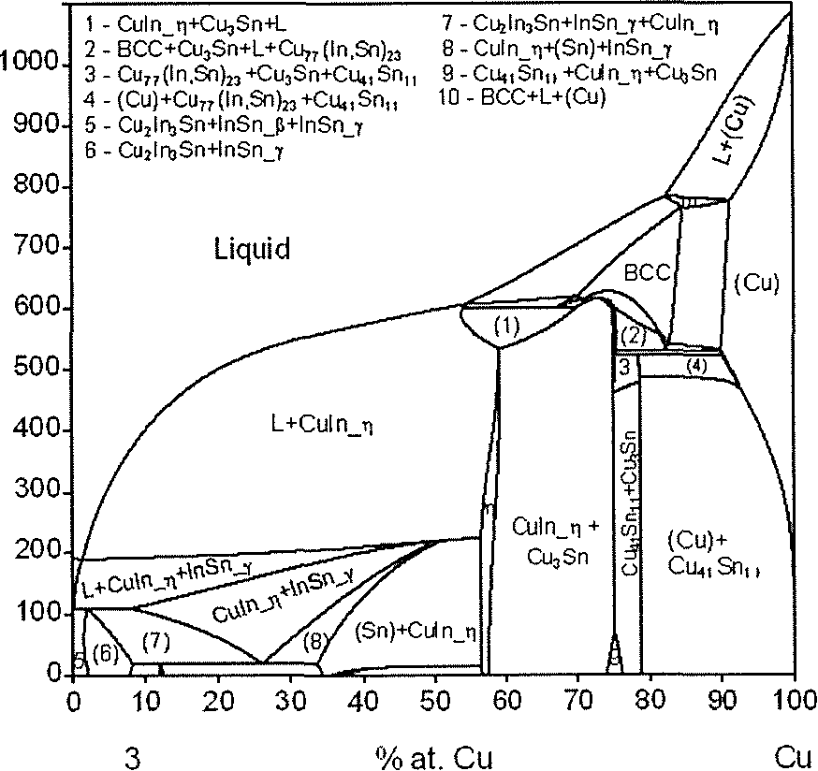
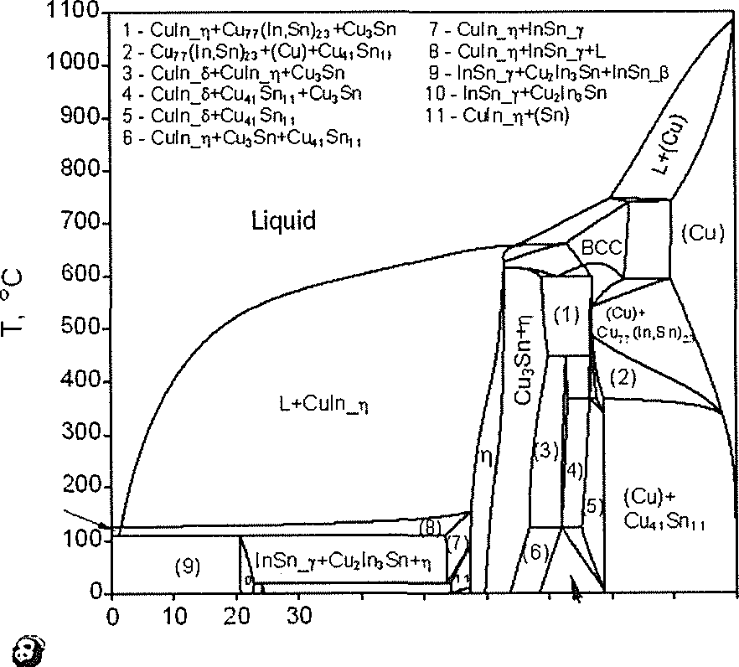
310
TABLE 2
Solid phases in the ternary Cu-In-Sn system
Phase  The denotations  used in  ternary system* | Phase  The denotations  used in  binary system | Prototype  (Structure)1101 | Model
Cu2ln3Sn | - | Cu2ln3Sn | (Cu)o.333(In)o.5(Sn)o.l67
Cu77(In,Sn)23,  Cuio(ln,Sn)3  (  Cu10Sn3 | - | CuioSn3 | (Cu)o.77(In,Sn)o.23
(Cu)  (FCC) | (Cu)/FCC | Cu (Al) | (Cu,In,Sn)
P  (BCC) | P  (Cu-In) | W (A2) | (Cu,In,Sn)
pSn  (Sn) | PSn | PSn (A5) | (Cu,In,Sn)
(In) | (In) | In (A6) | (Cu,In,Sn)
h  Cuín T)  Cu6(Sn,In)5,  Cu(InSn) t) | r](Cu-In) | NiAs (B8,) | (Cu)o.545(Cu,In,Sn)o.i22(In,Sn)o.333
Cuín t]’  Cu2(In,Sn) | t)’ (Cu-In) | Ni2In (B82) | Cuo.64Ino.36
e  Cu3Sn,Cu3(In,Sn) | e(Cu-Sn) | Cu3Sn | Cuo.75(InSn)o.25
6  Cu4iSnn, Cu4¡(In,Sn)ii  CuSn 6 | 8(Cu-Sn) | Cu4iSnu | Cuo.788(In,Sn)o.212
Culn_8  Cu7(In,Sn)3 | 8(Cu-In) | Cu7In3 | Cuo.7(In,Sn)o.3
Cuín y | Y(Cu-In) | InMn3 | Ca654(Cu,In)0.i i5(In,Sn)o.231
InSn y | Y(In-Sn) |  | (In,Sn)
InSn p | P(In-Sn) | In (A6) | (In,Sn)
Cunln9,0  Cuín | 0(Cu-In) | AlCu | Cuo.55Ino.45
* denotations used in this and other papers
1100
® ln:Sn=1:
L+lnSn_Y
ln:Sn=1:1
40 50 60
% at. Cu
70 ^ 80 90 100
Cu4iSn,,+Cuin_Ti
Fig. 1. The T-X section of the phase diagram for the Cu-In-Sn system
calculated for the In:Sn ratio 1:3
Fig. 2. The T-X section of the phase diagram for the Cu-In-Sn system
calculated for the In:Sn ratio 1:1
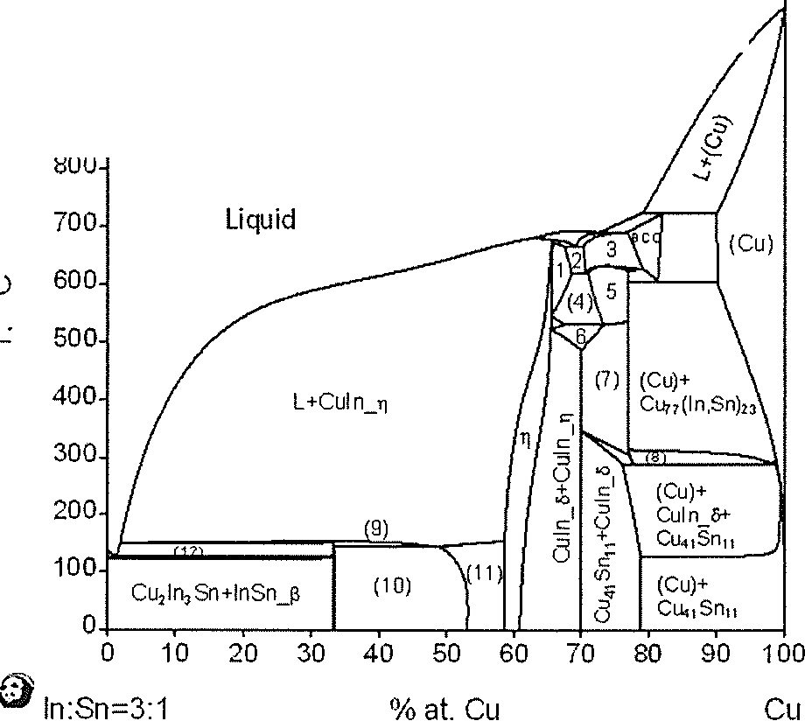
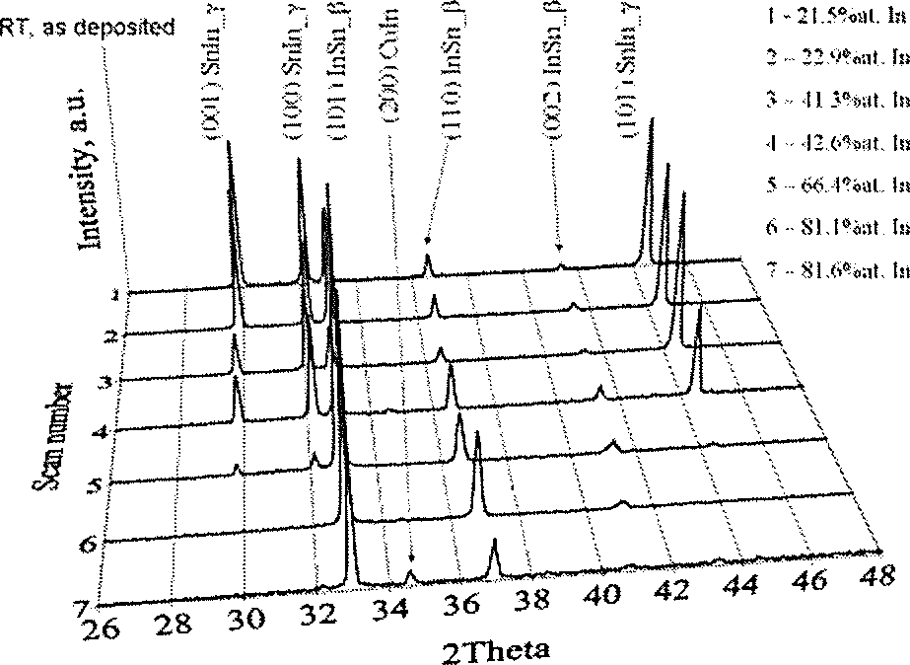
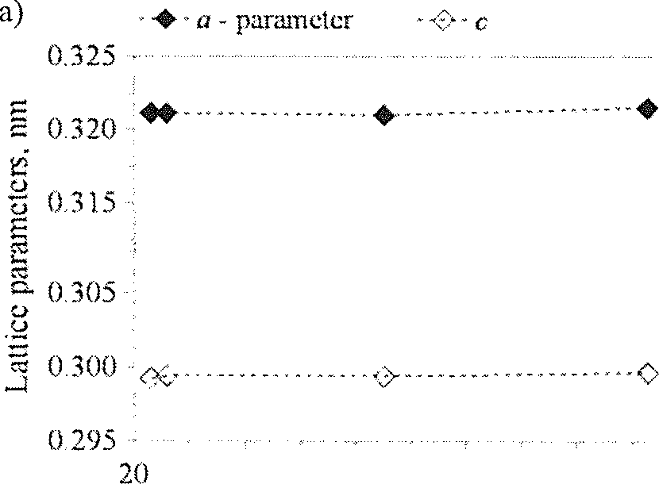
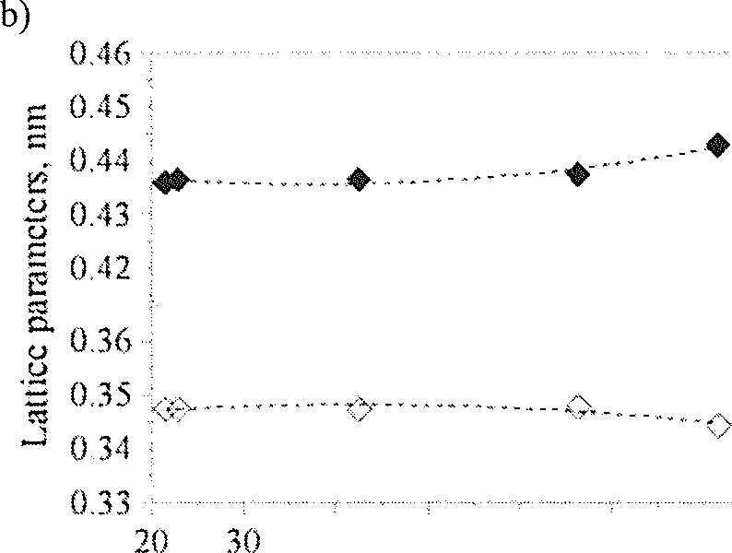
311
1100
- - Cuin_-q+Culn_y 7-Culn_5+Cu77(ln,Sn)}3
- - Cii n_f + CuIn_ri+BCC 8 - (CiO+Cu*] Srin +Cu7?(ln,Sn)23 ^
- - BCC+Culn_y 9 - L+Culn_ri+Cu2lf>)Sn
- - CJn_7+Cu!n_t|+Cu7?(ln,Sn)23 10 - Culn_ri+Cu2ln3Sn+(ln)
- - Cu7?(ln.Sn)23+Cu!n_T 11 - Culn_ri+(ln)
- - Ciin_ti+Cu7?(ln,Sn)23+Ciin_6 12- L+Cujln3Sn
Fig. 3. The T-X section of the phase diagram for the Cu-In-Sn system
calculated for the In:Sn ratio 3:1

3.3. X-ray structural investigations

3.3.1. Structure of deposited alloys
Figure 4 presents the results of X-ray structural in-
vestigations on the Sn-In deposits within the concen-
tration range of indium from 21.5 to 81.6 at% In and
temperature 25°C. From the analysis of the X-ray diffrac-
tion patterns it is evident that electrodeposited Sn-In al-
loys exhibit two phases: the InSn_y phase with a simple
hexagonal structure and the InSn_|3 phase, with a tetrag-
onal one. It can be seen that the p-phase exists in the
whole composition range and the y-phase - up to the
deposit containing 66.4%at. In. The deposits with 21.5
and 22.9% at. In contain the p-phase out of the equilib-
rium limit. Simultaneously, some distinct changes in the
peak intensities of the diffraction patterns of the y phase
were identified. A decreasing fraction of the y phase,
and an increasing fraction of the P one, accompanied by
an increasing In content in the deposits, was observed.
Additionally, along with the increasing In content in the
deposits, a shift of the diffraction peaks took place. It can
be explained by the changes in the lattice parameters of
both phases. The replacement of Sn by In in the hexago-
nal cell leads to a gradual increase in the cell parameters
a and c. The evolution of the lattice parameters of the
y-phase against the In content in the deposits is shown
in Fig. 5a. In the case of the p-phase, substitution of
tin by indium atoms with a greater atomic radius (rsn
= 0.172 nm, r\n = 0.200 nm) leads to a faster decrease
in the cell parameter a and increase in c (Fig. 5b). For
the deposit with the highest In content (81.6% at. In)
the phase composition changes, beside the dominating
P-phase, a small amount of a Culn (Database ICCD, PDF
No 00-035-1150, [16]) one, with a monoclinic structure
is observed.
Fig. 4. The X-ray diffraction patterns of the coatings against
indium content in the deposits
parameter
O a - parameter
♦ e - parameter
30 40 50
at.% In in deposits
40 50 60 70
at.% In in deposits
Fig. 5. The variation of the lattice parameters of the hexagonal y-phase (a) and the tetragonal P-phase
(b) versus the indium content in the deposits
90
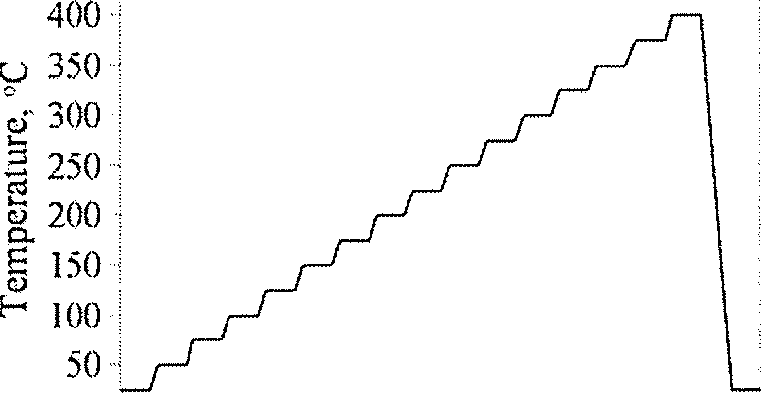
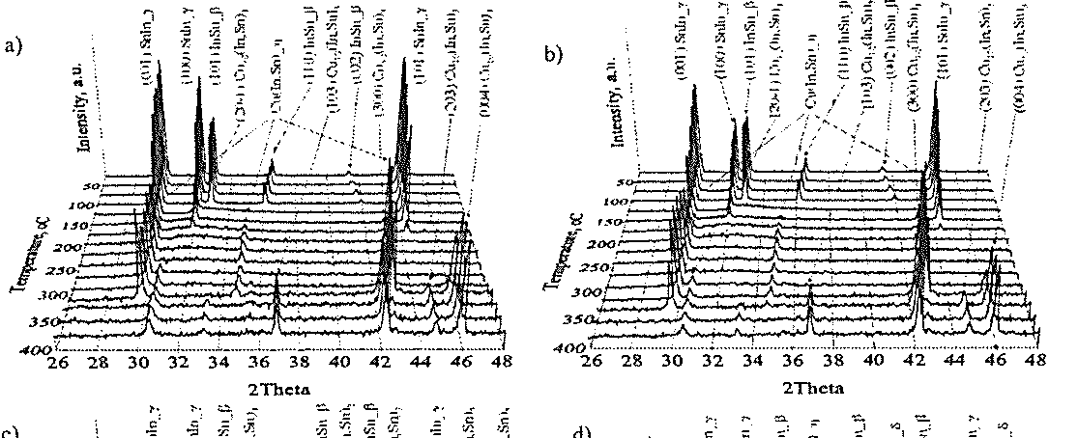
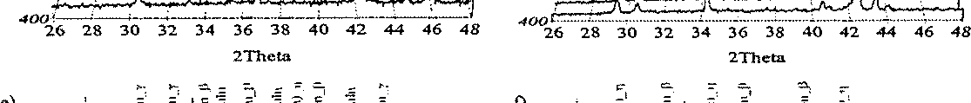
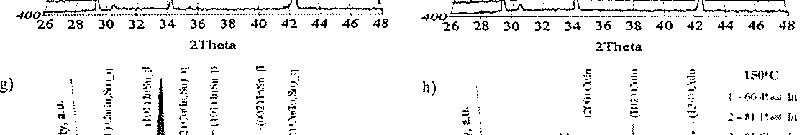
312

3.3.2. Thermal stability
The X-ray structural investigations of thermal stabil-
ity of deposits were carried out in the temperature range
25 to 400°C according to heating curve visible in Fig. 6.
The X-ray diffraction patterns of the coatings against the
temperature are shown in Fig. 7. From results obtained,
it can be seen that the y-phase exists in the deposits up
to 175°C but from 150°C - only for the deposits with a
low indium content (up to 22.9% at. In, see Fig. 7a-b).
Simultaneously, for the deposits with a greater In con-
tent, only the monoclinic Culn phase(Database ICCD,
PDF No 00-035-1150, [16], phase not present in phase
diagram) was observed (Fig. 7h). The diffraction peaks
of the (4-phase are observed only up to temperature of
125°C, but only in the case of the deposits with a higher
indium percentage (from 41.3% at. In, see Fig. 7c-g).
The variation of the lattice parameters of both phases
dominated in this temperature range versus the indium
content in the deposits and the temperature is presented
in Fig. 8.
450 | ■
°0 25 50 75 100 125 150 175 200
Time, min
Fig. 6. The heating curve used in the thermal stability investigations
Fig. 7. The recorded X-ray diffraction patterns versus the temperature of the InSn deposits within the concentration range of indium from
21.5 to 81.6% at In (a - 21.5% at. In, b - 22.9% at. In, c - 41.3% at. In, d - 42.6% at. In, e - 66.4% at. In, f- 81.1% at. In, g - 81.6% at.
In, h - the phase composition of the deposits with a high In concentration at 150°C)
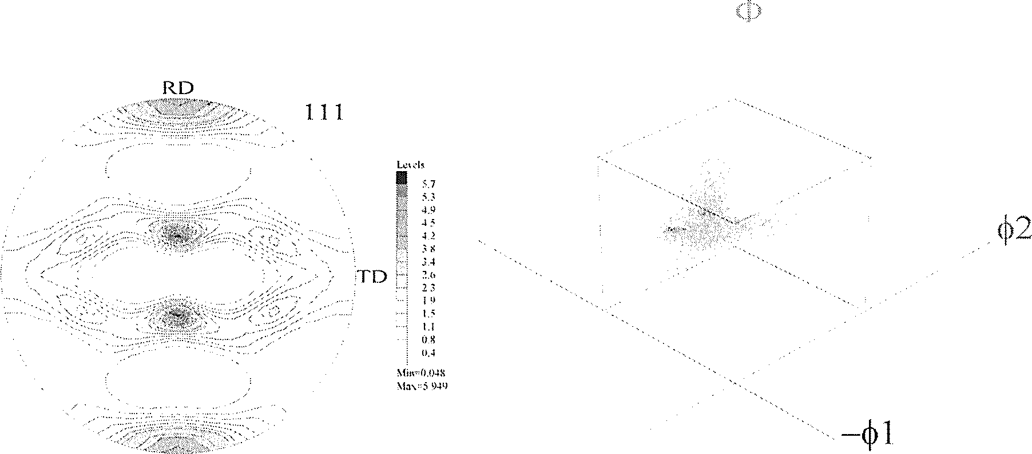
313
a)
21,5%at. In 22.9%at. In 42.6%at. In 66 yl°/oat In
% a ♦ a I a A a
O c O c □ c Ac
0.325
I 0.320
<D
U 0.315
e
cd
c3
^ 0.305
<D
U
a 0.300
0.295
b)
0.45
| 0.44
| 0.43
I 0.42 H
Sa
ex
g 0.36
0.34
■ * | * 0 | fj # ^ | +
 | 0 0 | 0 O © | &
0 25 | 50 75 | 100 125 150 | 175 2C
 | Temperature, °C
21.5%at. In | 22.9%at. In 42.6%at. In 66.4%at. In |  | 81.6%at. In
• c | ♦ c | Me A c | V c
O a | O a | fl a A a | V a
T | V | T ▼ | T
 | 4 | A ^ | A
 |  | 9 § | M
B | Q | a § | s
V | V | V V | V
25 50 75 100
Temperature, °C
125 150
Fig. 8. The variation of the lattice parameters of the hexagonal
Y-phase (a) and the tetragonal (5-phase (b) versus the indium content
in the deposits and the temperature
Along with the increasing the temperature, instead
of the Culn phase a new Cu(In,Sn)_p phase with struc-
ture type Cu2ln crystallizes. At the same time, a shift of
the diffraction peaks take place what can be explained
by the growth of lattice parameters of the Cu(In,Sn) jp
phase. At 300°C, for the deposits with a low indium con-
tent (21.5% at. In) a new Cu-In-Sn phase: Cuio(In,Sn)3
with a hexagonal structure type CujoSn3, crystallizes.
It should be noted that the diffraction patterns of this
high-temperature phase do not vary up to 400° C.
An increase of the indium content in deposits results
in a modification of the phase composition. For 42.6% at.
In (Fig. 7d), beside the indium oxide, a triclinic CuIn_S
(Cuy(In,Sn)3) type Cu?In3 is observed. For the deposits
with higher indium percentage, from 42.6% at. In (see
Fig. 7e-g), the hexagonal Cu(In,Sn)_r] phase type Cu2ln
is still dominated.

3.4. Effect of Electrodeposition Conditions on the
Crystallographic Texture of Indium Tin Alloys
Deposits
The sets of incomplete pole figures (100),(001) for
InSn_y (hexagonal structure) and (101), (110) for InSn_[3
phase (tetragonal structure) were registered. A similar
set of incomplete pole figures (111), (100) and {110}
was also registered for the copper substrate. In order to
calculate the orientation distribution function (ODF) and
the complete pole figures (i.e. for the range of the polar
angle from 0° to 90°) the ADC method was used [17]
The numerical analysis was performed with the use of
the software package LaboTex [18].
Fig. 9. The pole figure {111) and the ODF of a copper substrate (cathode)
314
RD
101
TD
Min-0
\la\-2 ‘>57
Fig. 10. The pole figure (101) and the ODF (axial symmetry) of the deposit (phase InSn_|3). A stirred solution (ai - 14 rad/s)
RD
101
■i'd ¡;;;
©.

-(,1
Fig. 11. The pole figure (101) and the ODF of the deposit (phase InSnJ3). A non-stirred solution (a> = 0 rad/s)
The texture of the copper substrate is typical for
rolling copper. The pole figure {111} and the ODF for
the copper substrate (cathode) are presented in Fig. 9.
The hydrodynamic conditions have a strong effect on
the texture of the In-Sn deposits. The axial texture of
the deposits was formed in stirred solutions in both the
InSn y and InSn p phases. The dominating texture com-
ponents in the InSn_y phase were the fibers (120}||ND,
{301 }|jND and {212}||ND, while for the InSn_|3 phase,
the fiber {101 }||ND was found. An example of the pole
figure (101) and the ODF for the phase InSn y of the
deposit in a stirred solution is presented in Fig. 10. The
deposits obtained from the non-stirred solutions during
the electrodeposition have a non-axial texture. The dom-
inating texture components in the InSn_y phase were
{103}< -3 - 91 > and the fiber {301}||ND, while in the
InSnJ3 phase, the dominating one was {231 }< 1 - 11 >.
An example of the pole figure (101) and the ODF for
the phase InSnp of the deposit in a non-stirred solution
is presented in Fig. 11.

4. Conclusion
- It was provided that the In-Sn alloys can be obtained
by electrodeposition from stable citrate solutions.
- The analysis of thermodynamic models of citrate sys-
tems and the results of electrochemical activity of
the citrate complexes make it possible to indicate
a very narrow range of pH - from 2.4 to 2.6 - of
the solution as optimal for the electrodeposition of
indium-tin alloys. Also stated was a positive influ-
315
ence of the presence of chloride ions as well as PEG
3000, in the solution.
® The plateaus of the maximal content of indium in the
In-Sn alloys were obtained in the range from -705
to -750 mV vs SCE. A strong influence of the hy-
drodynamic condition on the contents of indium in
the alloys was stated. A lowered rotation rate of the
disk electrode raises the indium content in the alloy.
® The electrodeposited Sn-In alloys exhibit two phases:
the InSnjy phase, with a simple hexagonal structure,
and the InSnJ3 phase, with a tetragonal one. The
deposits contain also the (3-phase out of the equi-
librium limit. A small amount of the Culn phase,
with a monoclinic structure, is observed, beside the
dominated (3-phase, for the deposit with the highest
In content (81.6% at. In).
- y-phase exists in the deposits up to 175°C, but from
150°C - only for the deposits with a low indium con-
tent, while, for the deposits with a greater In content,
only the monoclinic Culn phase was observed. The
diffraction peaks of the (3-phase are observed only up
to the temperature of 125°C. At a higher temperature,
also observed were the Cu(In,Sn)_q , Cuio(In,Sn)3
and Cu7(In,Sn)3 phases, as well as some oxides.
- The hydrodynamic conditions have strong influence
on the texture of the In-Sn deposits. The axial texture
of deposits was formed in stirred solutions.
Acknowledgements
This work was supported by grant from MNISW (Poland) : 3
T08A 04527.
REFERENCES
- S. Sommadossi, W. Gust, EJ Mitt erne i-
j e r, “Characterization of the Reaction Process in
Diffusion-Soldered Cu/In-48 at.% Sn/Cu Joints”, Mat.
Chem. Phys., 77, (2003) 924.
- J. W o j e w o d a, P. Z i § b a, B. O n d e r k a, R. F i 1 -
i p e k, P. R o m a n o w, “Growth Kinetics of the In-
termetallics Formed in Diffusion Soldered Interconnec-
tions”, Arch.Metall.Mat. 51, (2006) 345.
- E. W. B r o o m a n, “Corrosion Behaviour of Envi-
ronmentally Acceptable Alternatives to Cadmium and
Chromium Coatings: Cadmium”, Met.Finishing, April,
(2000) 42.
- E. Beltowska-Lehman, P. Ozga, “Effect of
complex formation on the diffusion coefficient of Cu(II)
in citrate solution containing Ni(II) and Mo(VI)”, Elec-
trochim. Acta, 43 (1998) 617.
- E. Beltowska-Lehman, P. Ozga, Z.
S w i a t e k, C. L u p i, “Influence of structural factor
on corrosion rate of functional Zn-Ni coatings”, Cryst.
Eng., 5 (2002) 335.
- E. Beltowska-Lehman, P. Ozga, “Electrode-
position of ZnTe thin films”, Arch.Metall.Mat., 50
- 319.
- P. Ozga, “Electrodeposition of Sn-Ag and Sn-Ag-Cu
alloys from the thiourea solutions”, Arch.Metall.Mat. 3
- 413.
- P. O z g a, E. B i e 1 a n s k a, “Determination of corro-
sion rate of Zn and Zn-Ni layers by the EDS technique”,
Mat. Chem.Phys., 81, 562-565 (2003).
- L. G. S c h u 1 z, “A Direct Method of Determining Pre-
ferred Orientation of a Flat Reflection Sample Using a
Geiger Counter X-Ray Spectrometer”, J. Apply. Phys.,
20, (1949) 1030.
- O. V. Z o r k i n a, Y. P. P e r e 1 y g i n, “Electrodeposi-
tion of tin-indium alloy from citrate electrolyte”, Russian
Journal of Applied Chemistry , 72 (1999) 1476.
- W. R. S m i t h, R. W. Missen, “Chemical Reactions
Equilibrium Analysis : Theory and Algorithms”, John
Wiley & Sons, Toronto (1982).
- P. L. C a v a 11 o 11 i, L. Nobili, A. Vicen-
z o, “Phase structure of electrodeposited alloys”, Elec-
trochimica Acta 50 (2005) 4557.
- W. K o s t e r, T. G o d e c k e, D. H e i n e, Z. Metal-
lkde. 63, 802 (1972).
- X. J. L i u, H. S. L i u, I. O h n u m a, R. Kainu-
ma, K. Ishida, S. Itabashi, K. Kameda,
K. Yamaguchi, “Experimental Determination and
Thermodynamic Calculation of the Phase Equilibria in
the Cu-In-Sn System”, J.Electronic Mater., 30, (2001)
1093.
- H. L. Lukas, S. G. Fries, B. Sund-
m a n, “Computational Thermodynamics, The Calphad
Method”, Cambridge University Press, 2007 (ISBN
978-0-521-868811-2).
- V. Simic, J. M a r i n ko v i c, Less-Common. Met.,
72, 133 (1980).
- K. P a w 1 i k, “Determination of the Orientation Distri-
bution Function from Pole Figures in Arbitrarily Defined
Cells”. Phys. Stat. Sol. (b) 134, (1986) 477.
- K. P a w 1 i k, P. Ozga, “LaboTex: The Texture Anal-
ysis Software”, Göttinger Arbeiten zur Geologie und
Paläontologie, SB4, 146-147 (1999).
Received: 3 December 2007.

