Acta Geologica Polonica, Vol. 62 (2012), No. 2, pp. 205-215
DOI: 10.2478/v10263-012-0010-2
VERSITA

The miniature echinoid trace fossil Bichordites kuzunensis
isp. nov. from early Oligocene prodelta sediments of the
Mezardere Formation, Gokęeada Island, NW Turkey
HURIYE DEMIRCAN¹ AND ALFRED UCHMAN²
¹ Department of Geological Research, General Directorate of Mineral Research and Exploration (MTA),
06520, Ankara, Turkey. E-mail: asmin68@yahoo.com.tr
² Institute of Geological Sciences, Jagiellonian University, Oleandry 2a; PL-30-063 Kraków, Poland.
E-mail: alfred.uchman@uj.edu.pl
ABSTRACT:
Demircan, H. and Uchman, A. 2012. The miniature echinoid trace fossil Bichordites kuzunensis isp. nov. from early
Oligocene prodelta sediments of the Mezardere Formation, Gokęeada Island, northwest Turkey. Acta Geologica
Polonica, 62 (2), 205-215. Warszawa.
The pascichnial trace fossil Bichordites kuzunensis isp. nov. occurs as an epichnial complex structure in early
Oligocene prodelta sediments of the Thrace Basin in Gokęeada Island, northwest Turkey. It displays characteris-
tics of irregular echinoid burrows such as overall shape and a double meniscate filling with a chevron dorsal su-
ture, in addition to the feature typical of the so far monospecific Bichordites Plaziat and Mahmoudi, 1988, that is
a single central core around a single drainage tube. Its miniature size can be related to the small size of the trace-
maker (ontogenic feature) or to its dwarfism in a stressed deltaic environment (palaeoecological feature). Its oc-
currence indicates a period of fully marine conditions during accumulation of the deltaic sediments of the
Mezardere Formation.
Key words: Bichordites kuzunensis; Ichnology; Ichnotaxonomy; New taxa; Pascichnia;
Prodelta; Oligocene; Thrace Basin; Turkey.
INTRODUCTION
Burrowing irregular echinoids are important com-
ponents of ecosystems since the Jurassic (e.g. Kier
1982), and spread out from shelf to the deep sea envi-
ronments since the Tithonian (Tchoumatchenco and
Uchman 2001). So far, four ichnogenera are related to
them, in particular Scolicia de Quatrefages, 1849, Bi-
chordites Plaziat and Mahmoudi, 1988, Ereipichnus
Monaco et al., 2005, and Cardioichnus Smith and
Crimes, 1983. The first three are locomotion and feed-
ing traces (pascichnia), and the last one is a resting
trace (cubichnion). Bichordites was so far a monospe-
cific ichnogenus, with B. monastiriensis Plaziat and
Mahmoudi, 1988, being its only ichnospecies. Detailed
morphological analysis of a small irregular echinoid
trace fossil allowed the establishment of a new ich-
nospecies of Bichordites. The trace was found in
prodelta sediments of the Mezardere Formation (lower
Oligocene) in Gokçeada Island, northwest Turkey (Text-
fig. 1). Its palaeoenvironmental setting is unusual for this
ichnogenus, because B. monastiriensis is known mostly
from shoreface clastics. The description and interpre-
tation of this burrow is the main aim of this paper.
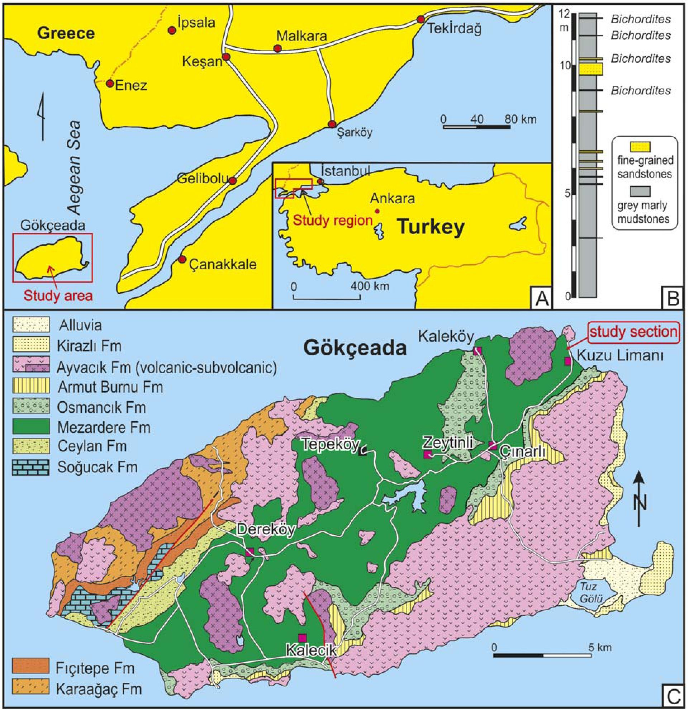
206
HURIYE DEMIRCAN AND ALFRED UCHMAN

Text-fig. 1. Location maps. A - The study region and its location in Turkey. B - log of the studied section. C - Geological map of Gok9eada Island (based on Temel
and Qift?i 2002). Location of the studied section indicated
GEOLOGICAL SETTING
The succession of the Thrace Basin in northwest
Turkey is up to 9000 m thick. In Gokfeada Island
(Text-fig. 1A, C), it reaches a thickness of 2000 m.
and is composed of Eocene-Miocene deep-sea to
shallow-marine and non-marine, mostly clastic sed-
iments, which are intruded and partly covered by
Late Oligocene and Late Miocene volcanics (e.g.
Turgut et al. 1983; Turgut and Eseller 1999). The
Yenimuhacir Group (upper Eocene to Oligocene),
formed by the Mezardere, Osmancik and Dani^ment
formations, is composed mostly of deltaic sediments
(Siyako 2006; Siyako and Huvaz 2007). The Mezardere
and Osmancik formations are recognised in Gökfeada
Island.
The Mezardere Formation (Gök$en 1967; Saner
1985; Sümengen et al. 1987) was named earlier the
Mezardere Shale (Ünal 1967) or the Muhacir Forma-
tion (Lebküchner 1974). It is 500-2500 m thick and
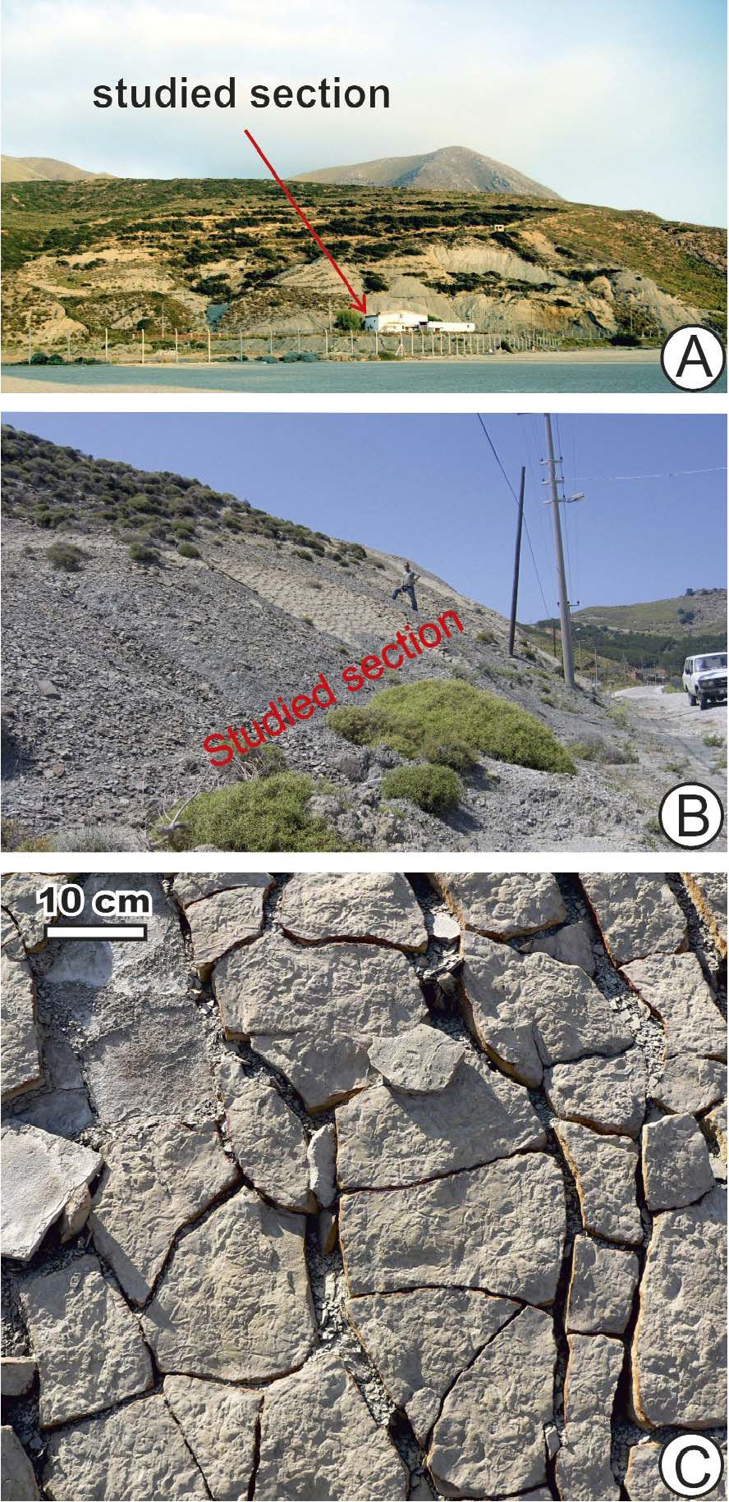
207
NEW ECHINOID TRACE FOSSIL FROM EARLY OLIGOCENE
composed mostly of mudstones, siltstones and thin- or
medium-bedded, poorly sorted sandstones that are im-
portant source rocks for gas (Karahanoglu et al. 1995;
Ho^gormez and Yalfin 2005). The Mezardere Forma-
tion overlies sandy flysch deposits of the Ke§an For-
mation (middle-upper Eocene) or shaley-sandy flysch
deposits with tuffites of the Ceylan Formation (upper
Eocene), and is overlain by delta front sediments with
coals, limestones and volcanics of the Osmancik For-
mation (Siyako 2006).
In Gokfeada Island, the Mezardere Formation
(Temel and Qiftfi 2002; Kesgin and Varol 2003; au-
thors’ own unpublished observations) is 400-900 m
thick. It is composed mostly of thinly-bedded light-
grey calcareous mudstones and siltstones, which dis-
play shale fissility, fine parallel lamination or rarely
ripple lamination. Locally, carbonate concretions are
present. The fine-grained sediments are intercalated
with isolated thin beds of very fine- or fine-grained,
slightly muscovitic sandstones, which display parallel
lamination in the lower part and ripple lamination in
the upper part, or only ripple lamination. Fine car-
bonized plant detritus is dispersed in the sandstones.
The palynomorphs indicate a late Eocene-early
Oligocene age (Ediger and Alihan 1989; Bati et al.
1993, 2002). An early Oligocene age is also docu-
mented by dinocysts (Temel and Ciftici 2002). In
many parts of the island, the Mezardere Formation is
intruded by volcanic rocks.
The deposits of the Mezardere Formation are gene-
rally interpreted as representing a deltaic environment,
from delta front to prodelta (Temel and Qiftfi 2002), or
to prodelta only (Siyako and Huvaz 2007). In Gokfeada
Island, the Mezardere Formation is dominated by the
prodelta facies, with a 50-80 m water depth estimated by
basin modelling (Ho^gormez and Yalfin 2005). Locally,
sandstones of distal or even proximal mouth bars are
present.
A12 m thick succession, dated as early Oligocene,
was measured in the upper part of the Mezardere For-
mation (Text-fig. 1B). It crops out in scarps and small
gorges along the road running NW of Kuzulimani har-
bour (Text-fig. 2A; GPS co-ordinates: N40°13.732’;
E025°56.719’; ±5 m). Bluish-grey marly mudstones
are sporadically intercalated with thin, rarely medium-
and thick-bedded sandstones. The presence of sand-
stone beds suggests an upper prodelta setting influ-
enced by mouth bars.
The studied trace fossil occurs in four beds (Text-
fig. 1B), which are, from bottom to top, 3.5, 7, 2.5, and
4 cm thick. The lowest bed is fine-grained, parallel
laminated in the lower part and ripple laminated in the
upper part. Its lower surface is even, and its upper sur-
face (Text-fig. 2B) is uneven and strongly bioturbated.
This bed contains rare muscovite flakes and dispersed
fine plant detritus. The other beds are similarly com-
posed.
The deltaic sediments of the Mezardere Formation
in the Thrace Basin are still poorly studied ichnologi-
cally. Only the hunting fish trace Osculichnus labialis
Demircan and Uchman, 2010, and associated Lockeia
and Planolites, have been recognized near Malkara in
the northwest part of Turkey (Demircan and Uchman
2010).

Text-fig. 2. The studied section of the Mezardere Formation. A - view from
Kuzulimani harbour, with position ofmeasured section indicated (Text-fig. 1B).
B -view ofthe section. C - upper, strongly bioturbated surface ofthe first bed
with Bichordites in the measured section (Text-fig. 1B)
208
HURIYE DEMIRCAN AND ALFRED UCHMAN
DESCRIPTION OF THE TRACE FOSSIL
Bichordites Plaziat and Mahmoudi, 1988
TYPE ICHNOSPECIES: Bichordites monastiriensis
Plaziat and Mahmoudi, 1988.
EMENDED DIAGNOSIS: Predominantly horizontal,
cylindrical or subcylindrical, straight to winding, un-
branched, meniscate, complex burrow with a central
bilobate core.
DISCUSSION: The original diagnosis was slightly
modified by Uchman (1995) to: “Predominantly hor-
izontal, cylindrical, straight to winding, unbranched
meniscate composite burrow, slightly concave along
the base and the top, and with central core. At least the
upper part of the burrow contains a double row of
menisci. The core is preferentially preserved; it is
heart-shaped to ovoid in cross-section, tapers locally
and is interrupted. A longitudinal median shallow
groove along the top of the core locally passes into an
indistinct crest. Locally, the core is covered with ex-
ternal irregular constrictions or transverse striae.” This
diagnosis applies only to Bichordites monastiriensis.
Therefore, the diagnosis of the ichnogenus is emended
in order to include the morphological features in com-
mon of B. monastiriensis and of the new ichnospecies
described herein.
A double row of menisci in the upper part of bur-
rows was also described in the ichnogenus Laminites
Ghent and Henderson, 1966, and it is a characteristic
feature of both Scolicia and Bichordites. The main
difference between the two ichnogenera is the presence
of structures related to the single drainage tube in Bi-
chordites (the central core) and to the double drainage
tube in Scolicia (Uchman 1995; Asgaard and Bromley
2007 and references therein).
Bichordites is produced by irregular echinoids with
a single drainage tube that belong to the Echino-
cardium group (Plaziat and Mahmoudi 1988) of the
family Echinocardiidae (Asgaard and Bromley 2007),
and to spatangoid echinoids of the family Maretiidae
(Gibert and Goldring 2007; Bernardi et al. 2010). It is
known from the Oligocene (Bernardi et al. 2010) to
Pleistocene (e.g. Nara 2004), and its Recent finds are
referred to as the “Echinocardium burrows” (e.g.
Bromley et al. 1995).
Bichordites kuzunensis isp. nov.
(Text-figs 3A-F, 4A-D)
DERIVATION OF NAME: Latinized Turkish kuzun -
a small goat, which is a common animal on the island,
and in reference to Kuzulimani, which is the main har-
bour of Gokfeada Island and near the section studied.
MATERIAL: Thirty-two slabs housed in the Museum
of Natural History of the General Directorate of Min-
eral Research and Exploration in Ankara (institutional
abbreviation Tr, specimens Tr1K-2008-Tr32K-2008).
Four slabs are housed in the Museum of Geology in the
Institute of Geological Sciences, Jagiellonian Univer-
sity, Cracow (specimens INGUJ224P1-4).
TYPES: Holotype - Tr4A-K-2008 (Text- fig. 3B);
paratype - Tr4B-K-2008 (Text-fig. 3F).
DIAGNOSIS: Subcylindrical Bichordites with basal
keel-like shape and mantle.
DISCUSSION: In well preserved specimens, the
mantle can show a corrugated surface, the central
core can contain an internal tube, and the contact be-
tween the two rows of menisci can display a chevron
pattern.
DESCRIPTION: A horizontal, winding or rarely
almost straight epichnial burrow, the lower part of
which is keel-like (obtuse triangle) in cross section
(Text-figs 4E, 5). Its upper part is semi-elliptical or
almost flat. The burrow is 6-11 mm wide (mean =
7.9 mm; n = 21). The lower side of the burrow was
observed only from the interior. The morphology of
the internal part varies depending on the level of the
trace sectioned by the bedding surface (Text-figs 3,
4). In many specimens, a central core is observed in
the middle part of the burrow. It is 3-5.5 mm wide,
slightly bilobate or almost flat. The lobes of the
central core are separated by a thin, indistinct fur-
row (Text-figs 3A, D, F, 4B). The surface of the
core is covered with transverse ribs (8-12 ribs per
1 cm), which locally show a low amplitude chevron
pattern along the furrow. Kinks of the chevrons are
unidirectional along the central core. Locally, where
the central core is deeply eroded, a central, smooth
tunnel (1.1-1.5 mm in diameter) is present within
the core (Text-figs 3A, D, 4D). The burrow fill on
both sides of the central core display a meniscate
fill (Text-fig. 4B, E). The menisci extend from the
transverse ribs of the central core. They run as arcs
and join the burrow margins tangentially (Text-fig.
3D). The concavity of the arcs is unidirectional,
consistent with the direction of the chevron kinks of
the central core ribs. The burrow fill above the cen-
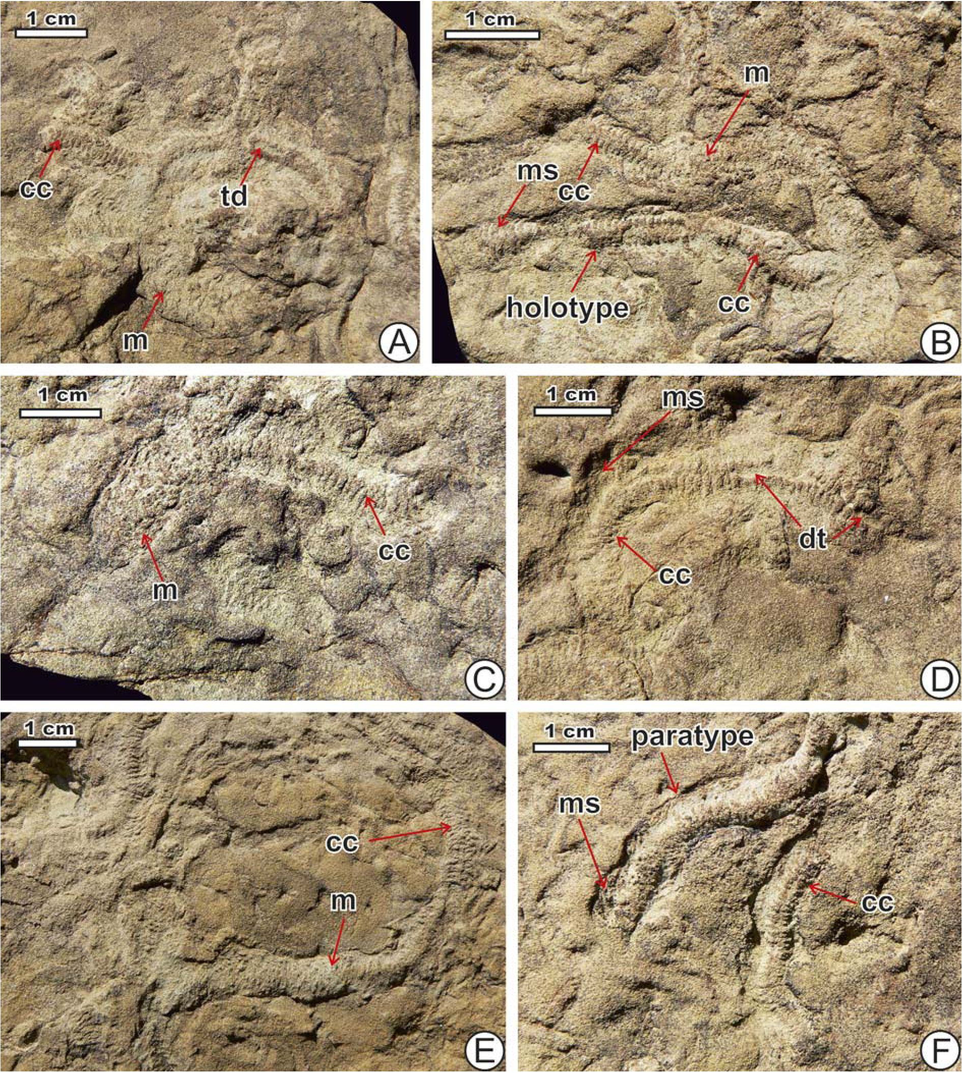
209
NEW ECHINOID TRACE FOSSIL FROM EARLY OLIGOCENE
tral core contains two rows of menisci, which form
continuous arcs, without distinct chevrons. In the
upper part of the burrow, the two rows of menisci
join along the middle part of the burrow and form
a chevron suture (Text-fig. 4D). The suture is about
3 mm wide and is herein called the dorsal suture. At
least the upper surface of more complete burrows
shows an external mantle, which is a blanket about
1 mm thick (Text-fig. 3A-C, E). The surface of
the mantle is corrugated. The corrugations are
formed mainly by irregular mounds, up to 1 mm
wide.

Text-fig. 3. Bichordites kuzunensis isp. nov., its types and morphological variability. All specimens are epichnia in fine-grained sandstones. Mezardere Formation (lower
Oligocene), Gokfeada Island. Morphological elements: cc - central core; m - mantle; ms - menisci, td - true drainage tube. A - specimen Tr4A-K-2008. B - specimen
Tr4A-K-2008 with the holotype. C - specimen Tr4-K-2008. D - specimen Tr4-K-2008. E - specimen Tr4-K-2008. F -specimen Tr4B-K-2008 with the paratype
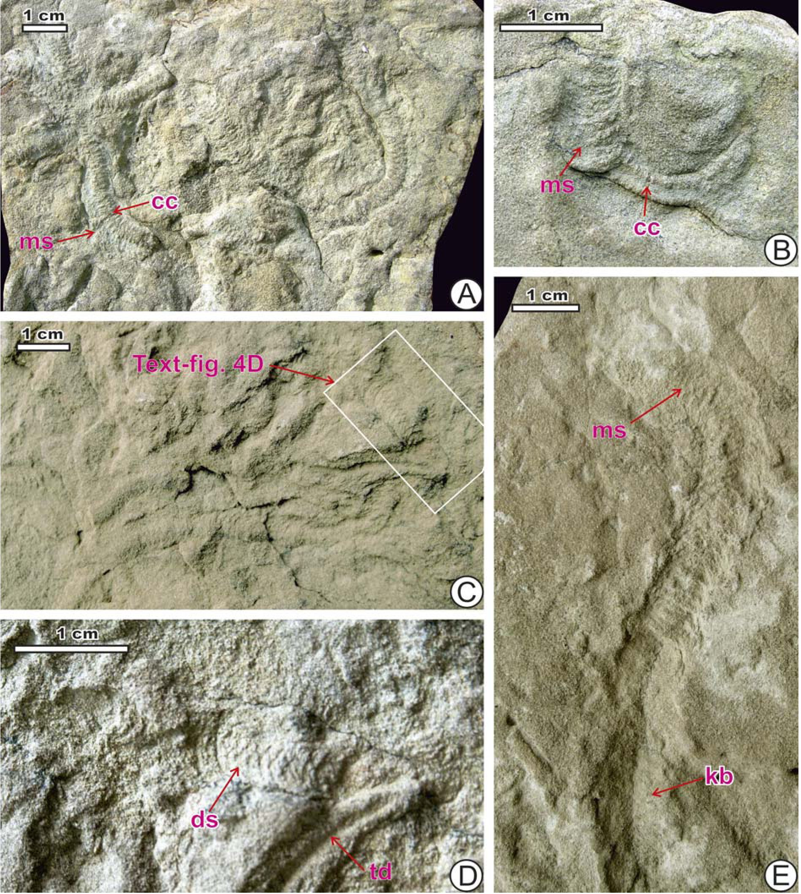
210
HURIYE demircanand Alfred uchman

Text-fig. 4. Bichordites kuzunensis isp. nov., other specimens. All specimens are epichnia in fine-grained sandstones. Mezardere Formation (lower Oligocene), Gök9eada
Island. Morphological elements: cc - central core; ds - dorsal suture; kb - keel-like base; td - true drainage tube. A - specimen Tr1-K-2008. B - specimen Tr1A-K-2008.
C - specimen Tr1B-K-2008. D - Detail of C. E - specimen Tr1C-K-2008
DISCUSSION

Interpretation of the burrow
Detailed analysis of the morphological variants of
Bichordites kuzunensis isp. nov., which are here con-
sidered as preservational variants, enabled the re-
construction of a three-dimensional burrow model
(Text-fig. 5). The preservational variants display tran-
sitions between each other, these being particularly
visible where the burrow changes its depth slightly
relative to the bedding surface. The reconstructed
burrow is compared with ichnotaxa of similar mor-
phology.
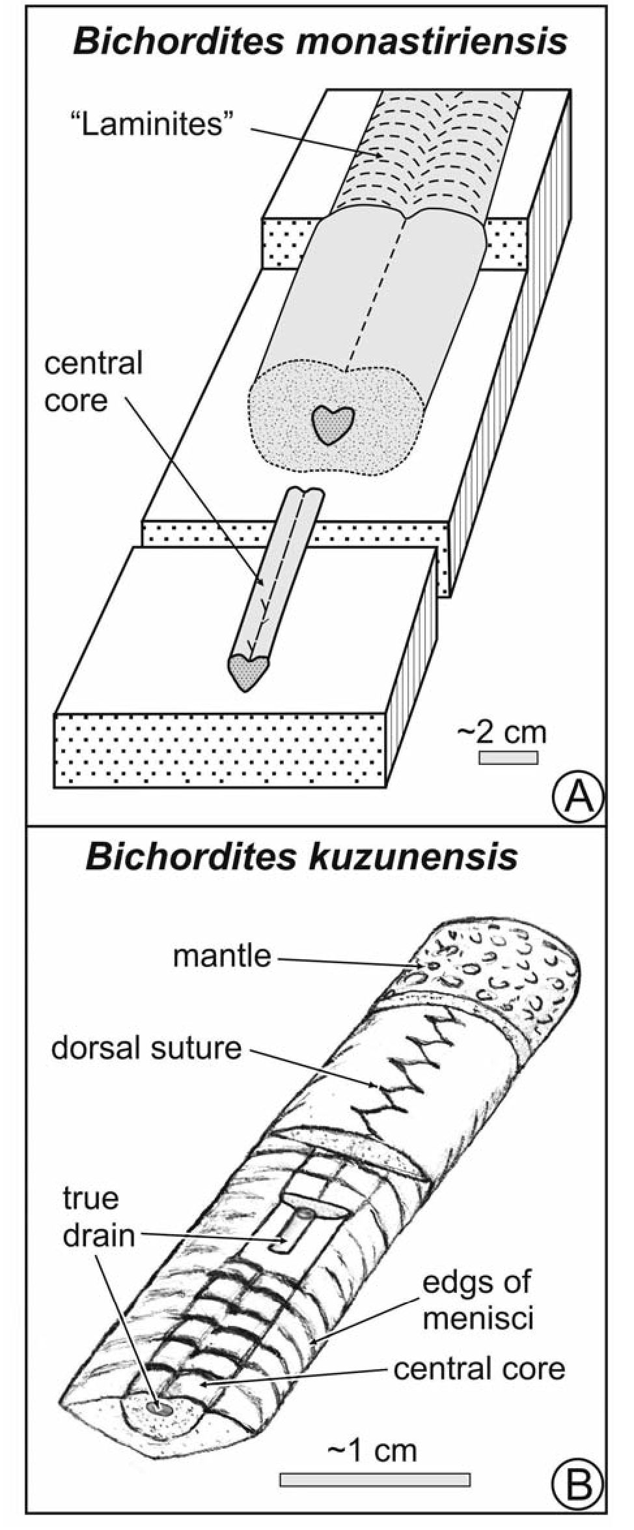
211
NEW ECHINOID TRACE FOSSIL FROM EARLY OLIGOCENE
In its winding course, transverse ribbing and
meniscate fill, the trace fossil under discussion is sim-
ilar to Psammichnites plummeri (Fenton and Fenton.
1937), formerly Olivellitesplummeri Fenton and Fen-
Text-fig. 5. Models of Bichordites. A - Bichordites monastiriensis (adapted
from Uchman, 1995). B - Bichordites kuzunensis isp. nov.
ton, 1937, which is a Palaeozoic trace fossil common
in shallow marine clastic deposits (see Mangano et al.
2002 for review). However, P plummeri displays a
characteristic straight dorsal ridge or groove, which is
absent in B. kuzunensis.
The combination of a complex meniscate fill, ex-
hibiting a double row of menisci and the dorsal suture,
together are features of irregular echinoid burrows;
specifically, the single central core is diagnostic of Bi-
chordites (Plaziat and Mahmoudi 1988; Uchman 1995).
The keel-like lower part of the burrow, as well as the
occurrence of a mantle, differentiates B. kuzunensis
from B. monastiriensis (Text-fig. 5). Moreover, B.
kuzunensis is much smaller (11 mm in the widest spec-
imen) than B. monastiriensis, which is commonly 15 to
50 mm wide. The dorsal suture results from the contact
between two rows of menisci at the upper surface of the
burrow and should be considered as a diagnostic fea-
ture of echinoid burrows. It is present in Scolicia (Text-
fig. 6) and Bichordites (Uchman 1995), being a part of
the “Laminites” preservational aspect of these ichno-
genera. Laminites Ghent and Henderson, 1966, which
is characterized by double arcs of menisci, is considered
to be a preservational variant of either Scolicia or Bi-
chordites (Uchman 1995).
The tube within the central core is interpreted as the
true drainage tube of the burrowing echinoid (see Nara
2004). The central core is a better cemented zone
along the drainage tube than the surrounding material.
The better cementation was induced probably by the
high amount of mucus secreted by the echinoids,
which resulted in an enhanced chemical gradient that
could have favoured microbial activity. Due to the
better cementation, it is preferentially preserved and is
a conspicuous morphological element on weathered
bedding surfaces. The ribs on the central core are
edges of menisci adhering to the core. The mantle and
its surface corrugations resulted from spine move-
ment while the echinoid burrowed.
The keel-like lower side of the burrow can be re-
lated to a keel-like shape of the lower side of the test
that is present in some irregular echinoids. For in-
stance, many species of Brissopsis Agassiz (known
since the Eocene), Echinocardium Gray (known since
the Miocene) or Maretia Gray (known since the Mid-
dle Eocene) show this feature (Smith and Kroh 2012).
The latter two genera are considered as the producers
of Bichordites monastiriensis (see discussion of the
ichnogenus). The recent Maretiaplanulata (Lamarck)
shows a very flat test (Smith and Kroh 2012), sug-
gesting that a similar, rather flat-tested echinoid, could
have been a producer of Bichordites kuzunensis, tak-
ing its small vertical extent into account.

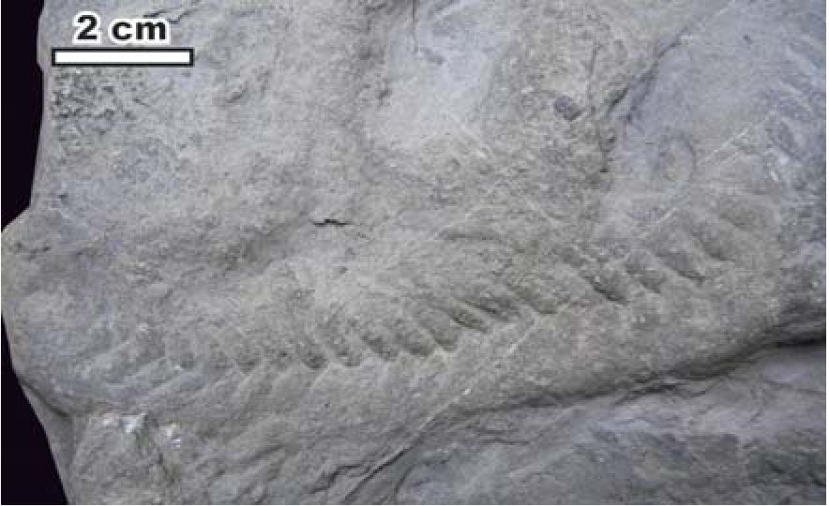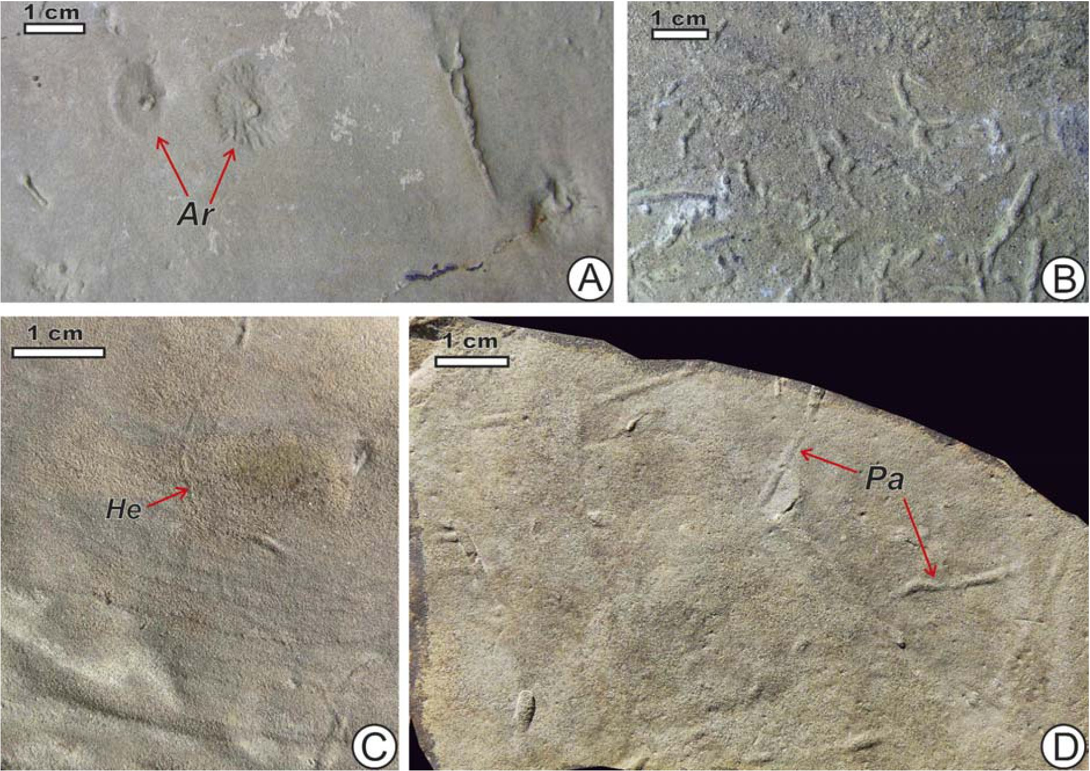
212
HURIYE DEMIRCAN AND ALFRED UCHMAN

Text-fig. 6. Dorsal suture in Scolicia, epichnion in a turbiditic sandstone-mudstone
bed, Beloveza Beds (Eocene), Lipnica Wielka, Poland (specimen TFUJ 1358
from the Ksi^zkiewiecz collection, originally described as Subphyllochorda.
epichnial form, in Ksi^zkiewicz 1977, pl. 15, fig. 4; Museum of Geology.
Institute of Geological Sciences, Jagiellonian University, Cracow)

Associated trace fossils and environmental aspects
The beds with Bichordites kuzunensis also contain
Planolites isp., which is an endichnial, epichnial and
hypichnial, simple, tubular burrow, 1.2-2 mm in di-
ameter (Text-fig. 2C). Additional trace fossils occur in
other beds in the nearby outcrops. They include tortu-
ous tubes of endichnial Planolites montanus Richter
(Text-fig. 7B) and simple, almost straight, lined tubes
of Palaeophycus tubularis Hall (Text-fig. 7D), both of
which are common. Thin, winding Helminthoidich-
nites tenuis Fitch (Text-fig. 7C) and probably U-shaped
vertical burrows visible as pairs of small epichnial
depressions (determined as lArenicolites isp.; Text-fig.
7A), are rare.
The diversity of the trace fossil assemblage in the
succession is very low. This is a common character-
istic feature of deltaic sediments, as this environment
is characterized by a high sedimentation rate, inflow
of turbid waters and fluctuating salinity, which are the
main stress factors limiting trace fossil diversity (e.g.
Gingras et al. 1998; Buatois and Mangano 2011).
Under such conditions, many tracemakers, especially
stenohaline and filter-feeding organisms, do not occur.
Echinoid burrows are very rare in deltaic facies. In
their review of the ichnology of nine deltaic forma-
tions, MacEachern et al. (2005) reported rare Scolicia
occurring in one Cretaceous distal delta front sedi-
ment. Scolicia is more common in upper shoreface de-

Text-fig. 7. Trace fossils associated with Bichordites kuzunensis in the same exposure; all are hypichnia on fine-grained sandstone bed. Mezardere Formation (lower
Oligocene), Gök?eada Island. A - ?Arenicolites isp. (Ar), specimen Tr2-K-2008. B - Planolites montanus, specimen Tr3-K-2008. C - Helminthoidichnites tenuis (He).
specimen Tr3A-K-2008. D - Palaeophycus tubularis, specimen Tr3B-K-2008
213
NEW ECHINOID TRACE FOSSIL FROM EARLY OLIGOCENE
posits of a Miocene wave-dominated delta in
Venezuela (Buatois et al. 2008). Chen (2005) reported
it from Oligocene deltaic sediments of Taiwan, where
it occurs in tempestite sandstone beds; however, judg-
ing from the photograph (fig. 10C), this trace fossil
may belong to Bichordites because of its distinct sin-
gle axial element (lcentral core). Bichordites monas-
tiriensis occurs abundantly in Pleistocene delta front
sands of southern Italy (D’Alessandro and Uchman
2007). It was also found in the proximity of an
Oligocene coarse-grained delta at Valsugana in north-
east Italy (Bernardi et al. 2010). Ayranci and Dasht-
gard (2011) reported incipient Scolicia and Bi-
chordites from the recent Fraser River delta front in
British Columbia, western Canada.
Echinoids as stenohaline organisms (Bromley and
Asgaard 1975; Buatois et al. 2005) are especially sen-
sitive to lowered or fluctuating salinity. However,
some of them, e.g. Brissopsis lyrifera (Forbes) from
the western part of the Danish Straits (Pearson et al.
1985; Josefson and Hansen 2004; Zettler et al. 2000)
can tolerate slightly brackish or polyhaline waters
(Anonymous 2012). A small-sized echinoid burrow
(10-15 mm wide), referred to Scolicia and attributed
to Brissopsis lyrifera, was reported from Holocene
sediments of the southwest Baltic Sea (Virtasalo 2011),
a basin subject to salinity fluctuations during the
Holocene and now a brackish sea. Uchman (1995)
described Scolicia strozzii (Savi and Meneghini), form
A, from the Laga Formation (Apennines), which is
only 4-12 mm wide, the small size probably resulting
from environmental stress due to a high sedimentation
rate and the late Miocene (Messinian) salinity crisis.
Thus, the occurrence of echinoid burrows in environ-
ments stressed by lowered or fluctuating salinity is pos-
sible, albeit generally rare. Alternatively, the size of
burrowing echinoids has been reported to reflect ben-
thic food quality; the higher the nutritious value of the
food the larger the animals grow (Kroncke 2006; Wet-
zel 2008).
Bichordites kuzunensis isp. nov. is distinctly
smaller than B. monastiriensis and other echinoid bur-
rows. The small size of the B. kuzunensis producer can
be either an ontogenetic feature or an effect of
dwarfism caused by environmental stress. It is known
that dwarfism is common in brackish environments
(Kinne 1971), which are expected in the proximity of
deltas. Nevertheless, it can be concluded that the oc-
currence of Bichordites kuzunensis isp. nov. marks an
interval of fully-marine or nearly fully-marine condi-
tions during sedimentation of the Mezardere Forma-
tion. Irregular echinoids invaded the prodelta sea floor,
which was probably at the range of their habitat.
CONCLUSIONS
A new trace fossil preserved as an epichnial, com-
plex meniscate, winding structure, with a central core,
dorsal suture and a mantle, occurs in early Oligocene
prodelta sediments of the Thrace Basin in Gokfeada Is-
land, northwest Turkey.
The trace fossil is interpreted as an irregular echi-
noid burrow and is ascribed to the ichnogenus Bi-
chordites and referred to a new ichnospecies, B.
kuzunensis.
Its occurrence in the deltaic sediments of the
Mezardere Formations indicates a period of normal- or
nearly normal-marine but otherwise stressing condi-
tions, as implied by the small burrow size.

Acknowledgements
The field research was supported by the General Direc-
torate ofMineral Research and Exploration (MTA) in Ankara
within the framework of grant 2008-08-16-01-b of the Nat-
ural History Museum General Directorate of Mineral Re-
search and Exploration Ankara, Turkey. Additional support
was provided by the Jagiellonian University (DS funds).
Dirk Knaust (Stavanger), Paolo Monaco (Perugia) and An-
dreas Wetzel (Basel), the journal referees, offered useful
comments, which improved the final version of this paper.
REFERENCES
Anonymous, 2012. BIOTIC - Biological Traits Information
Catalogue [http://www.marlin.ac.uk/biotic/browse.php?
sp=4376; 14.01.2012],
Asgaard, U. and Bromley, R.G. 2007. Co-occurrence of
schizastrid echinoids and the trace fossil Scolicia, Pleis-
tocene, Greece: Facts, myths, and fascicoles. In: R.G.
Bromley, L.A. Buatois, M.G., Mangano, J.F Genise.
and R.N. Melchor (Eds), Sediment-organism interac-
tions: A multifaceted ichnology. Society of Economic Pa-
leontologists and Mineralogists (Society for Sedimentary
Geology) Special Publications, 88, 87-95.
Ayranci, H. and Dashtgard, S.E. 2011. Animal-sediment inter-
actions and trace assemblages on the asymmetrical Fraser
River delta front and prodelta, British Columbia, Canada.
AAPG Annual Conference and Exhibition, Making the
Next Giant Leap in Geosciences, April 10-13, 2011, Hous-
ton, Texas, USA [http://www.searchanddiscovery.com/ab-
stracts/html/2011/annual/abstracts/Ayranci.html.
12.01.2012],
Bati, Z, Erk, S. and Ak9a, N. 1993. Trakya Havzasi Tersiyer
birimlerinin palinomorf, foraminifer ve nannoplankton
214
HURIYE DEMIRCAN AND ALFRED UCHMAN
biyostratigrafisi. TPAO Araçtirma Dairesi Arçivi, teknik
rapor, 1947, 92 s. Turkish Petroleum Corporation,
Ankara. [Unpublished report]
Bati, Z, Aliçan, C., Ediger, V.§., Teymur, S., Akça, N., San-
cay, H., Ertug, K., Kirici, S., Erenler, M., and Aköz, Ö.
2002. Kuzey Trakya Havzasi’ nin Palinomorf,
Foraminifer ve Nannoplankton Biyostratigrafisi, Türkiye
Stratigrafi Komitesi Çaliçtayi (Trakya Bölgesi’nin
Litostratigrafi Adlamalari) Özleri. In: Türkiye Strati-
grafi Komitesi 2. Çaliçtayi Trakya Bölgesinin Litostrati-
grafi Adlamalari 30/31-Mayis-2002. MTA Genel Müdür-
lügü, Ankara. Bildiri Özleri Kitabi, Ankara, p. 14.
Bernardi, M., Boschele, S., Ferretti, P. and Avanzini, M.
2010. Echinoid burrow Bichordites monastiriensis from
the Oligocene of NE Italy. Acta Palaeontologica
Polonica, 55, 479-486.
Bromley, R.G. and Asgaard, U. 1975. Sediment structures
produced by a spatangoid echinoid: a problem of preser-
vation. Bulletin of the Geological Society of Denmark.
24, 261-281.
Bromley, R.G., Jensen, M. and Asgaard, U. 1995, Spatangoid
echinoids: deep-tier trace fossils and chemosymbiosis:
Neues Jahrbuch für Geologie und Paläontologie, Ab-
handlungen, 195, 25-35.
Buatois, L.A., Gingras, M.K., MacEachern, J., Mangano,
M.G., Zonneveld, J.-P., Pemberton, S.G., Netto, R.G. and
Martin, A. 2005. Colonization of brackish-water systems
through time: evidence from the trace-fossil record.
Palaios, 20, 321-347.
Buatois, L.A. and Mangano, M.G. 2011. Ichnology: Organ-
isms-Substrate Interactions in Space and Time, pp. 1-
358. Cambridge University Press; Cambridge.
Buatois, L.A., Santiago, N., Parra, K. and Steel, R. 2008. Ani-
mal-substrate interactions in an Early Miocene wave-
dominated tropical delta: delineating environmental stress
and depositional dynamics (Tacata Field, eastern Vene-
zuela). Journal of Sedimentary Research, 78, 458-479.
Chen, W.S. 2005. Characteristic trace fossils from shoreface
to offshore environments of an Oligocene succession,
northeastern Taiwan. Tao, 16, 1097-1120.
D’Alessandro, A. and Uchman, A. 2007. Bichordites and Bi-
chordites-Rosselia ichnoassemblages from the Lower
Pleistocene Tursi Sandstone (southern Italy). In: R.G.
Bromley, L.A. Buatois, M.G., Mangano, J.F Genise,
and R.N. Melchor (Eds), Sediment-organism inter-
actions: A multifaceted ichnology. Society of Economic
Paleontologists and Mineralogists (Society for Sedi-
mentary Geology) Special Publications, 88, 213-221.
Demircan, H. and Uchman, A. 2010. Kiss of death of a
hunting fish: trace fossil Osculichnus labialis igen. et isp.
nov. from late Eocene - early Oligocene prodelta sedi-
ments of the Mezardere Formation, Thrace Basin, NW
Turkey. Acta Geologica Polonica, 60, 29-38.
Ediger, V.§. and Alihan, C. 1989. Tertiary fungal and algal pa-
lynomorph biostratigraphy of the northern Thrace basin,
Turkey. Review of Palaeobotany and Palynology, 58,
139-161.
Fenton, C.L. and Fenton, M.A. 1937. Olivellites, a Pennsyl-
vanian snail burrow. American Midland Naturalist, 18,
452-453
Ghent, H.D. and Henderson, R.A. 1966. Petrology, sedi-
mentation, and paleontology of Middle Miocene graded
sandstones and mudstone, Kaiti Beach, Gisborne. Trans-
action of the Royal Society of New Zealand, Geology, 4,
147-169.
Gibert, J.M., de and Goldring, R. 2008. Spatangoid-pro-
duced ichnofabrics (Bateig Limestone, Miocene, Spain)
and the preservation of spatangoid trace fossils. Palaeo-
geography, Palaeoclimatology, Palaeoecology, 270,
299-310.
Gingras, M.K., MacEachern, J.A. and Pemberton, S.G. 1998.
A comparative analysis of the ichnology of wave- and
river-dominated allomembers of the Upper Cretaceous
Dunvegan Formation. Bulletin of Canadian Petroleum
Geology, 46, 51-73.
Gok9en, L.S. 1967. Ke§an bolgesinde Eosen-Oligosen sedi-
mantasyonu, Guneybati Turkiye Trakyasi. Maden Tetkik
Arama Dergisi, 69, 1-10.
Ho§gormez, H. and Yal9in, M.N. 2005. Gas-source rock
correlation in Thrace basin, Turkey. Marine and Petro-
leum Geology, 22, 901-916.
Josefson, A.B. and Hansen, J.L.S., 2004. Species richness of
benthic macrofauna in Danish estuaries and coastal areas.
Global Ecology and Biogeography, 13, 273-288.
Karahanoglu, N., Eder, A. and Illeez, A. I. 1995. Mathemat-
ical approach to hydrocarbon generation history and
source rock potential in the Thrace Basin, Turkey. Ma-
rine and Petroleum Geology, 12, 587-596.
Kesgin, Y. and Varol, B. 2003. Gok9eada ve Bozcaada’ nin
Tersiyer jeolojisi. Maden Tetkik ve Arama Dergisi, 126,
49-67.
Kier, P.M. 1982. Rapid evolution of echinoides. Palaeon-
tology, 25, 1-9.
Kinne, O. 1971. Salinity: 3. Animals: 1. Invertebrates. In: O.
Kinne (Ed.), Marine Ecology: A Comprehensive, Inte-
grated Treatise on Life in Oceans And Coastal Waters: 1.
Environmental Factors: pp. 821-995. Wiley-Inter-
science; London.
Kroncke, I. 2006. Structure and function of macrofaunal
communities influenced by hydrodynamically controlled
food availability in the Wadden Sea, the open North
Sea, and the deep-sea. A synopsis. Senckenbergiana
maritima, 36, 123-164.
Ksiqzkiewicz, M. 1977. Trace fossils in the Flysch of the
Polish Carpathians. Palaeontologia Polonica, 36, 1-
208.
215
NEW ECHINOID TRACE FOSSIL FROM EARLY OLIGOCENE
Lebküchner, R.F. 1974. Orta Trakya Oligosen’ inin jeolojisi
hakkinda. Maden Tetkik Arama Dergisi, 83, 1-29.
MacEachern, J.A., Bann, K.L., Bhattacharya, J.P. and Howell,
C.D., Jr. 2005. Ichnology ofdeltas: organism responses to
the dynamic interplay ofrivers, waves, storms and tides. In:
L. Giosan, and J.P. Bhattacharya (Eds), River deltas -
concepts, models, and examples. Society of Economic Pa-
leontologists and Mineralogists (Society for Sedimentary
Geology) Special Publications, 83, 49-85.
Mangano, G.M., Buatois, L.A. and Rindsberg, A.K. 2002.
Carboniferous Psammichnites: A systematic re-evalua-
tion, taphonomy and autecology. Ichnos, 9, 1-22.
Monaco, P., Gianetti, A., Caracuel, J.E. and Yébenis, A.
2005. Lower Cretaceous (Albian) shell-armoured and as-
sociated echinoid trace fossils from the Sacaras Forma-
tion, Sierra Gelada area, southeast Spain. Lethaia, 38,
333-344.
Nara, M. 2004, Trace fossil Bichordites monastiriensis in
Pleistocene shallow marine deposits of the Boso Penin-
sula, central Japan, and its palaeoenvironmental signifi-
cance. Journal of the Geological Society of Japan, 110,
545-551. [In Japanese with English abstract]
Pearson, T.H., Josefson, A.B. and Rosenberg, R. 1985. Pe-
tersen’s benthic stations revisited. I. Is the Kattegatt be-
coming eutrophic? Journal of Experimental Marine Bio-
logy and Ecology, 92, 157-206.
Plaziat, J.-C. and Mahmoudi, M. 1988. Trace fossils attrib-
uted to burrowing echinoids: a revision including new
ichnogenus and ichnospecies. Geobios, 21, 209-233.
Quatrefages, de, M.A. 1849. Note sur la Scoliciaprisca (A.
de Q.) annélide fossile de la Craie. Annales des Sciences
Naturalles, 3 série, Zoologie, 12, 265-266.
Saner, S. 1985. Saros körfezi ve dolayinin çôkelme istifleri
ve tektonik yerleçimi, Kuzeydogu Ege denizi, Türkiye.
Türkiye Jeoloji Kurumu Bülteni, 28, 1-10.
Siyako, M. 2006. Thrace Basin Tertiary rock units. In: M.
Üzer (Ed.), Trakya Bölgesi Litostratigrafi Birimleri
[Lithostratigraphic Units of the Thrace Region], pp. 43-
83. Maden Tetkik ve Arama Genel Müdürlügü, Ankara.
[In Turkish]
Siyako, M. and Huvaz, O. 2007. Eocene stratigraphic evo-
lution of the Thrace Basin, Turkey. Sedimentary Geo-
logy, 198, 75-91.
Smith, A. B. and Crimes, T. P. 1983. Trace fossils formed by
heart urchins - a study of Scolicia and related traces.
Lethaia, 16, 79-92.
Smith, A.B. and Kroh A. 2012. The Echinoid Directory.
The Natural History Museum [http://www.nhm.ac.uk/re-
search-curation/research/projects/echinoid-directory/in-
dex.html; 14.01.2012]
Sümengen, M., Terlemez, L, §entürk, K., Karaköse, C.,
Erkan, N.E., Ünay, E., Gürbüz, M. and Atalay, Z. 1987.
Gelibolu Yarimadasi ve Güneybati Trakya Tersiyer
havzasmm stratigrafisi, sedimantolojisi ve tektonigi:
MTA genel Müdürlügü. Jeoloji Etüdler Dairesi, yayim-
lanmami? teknik rapor, 2121, 1-337. [Unpublished]
Tchoumatchenco, P. and Uchman, A. 2001. The oldest deep-
sea Ophiomorpha and Scolicia and associated trace fos-
sils from the Upper Jurassic - Lower Cretaceous deep-
water turbidite deposits of SW Bulgaria. Palaeo-
geography, Palaeoclimatology, Palaeoecology, 169, 85-
99.
Temel, R.Ö. and ^iftgi, N.B. 2002. Stratigraphy and depo-
sitional environments of the Tertiary sedimentary units
in Gelibolu peninsula and islands of Gök9eada and
Bozcaada (Northern Aegean region, Turkey). TAPG-
Turkish Association of Petroleum Geologists Bulletin,
14, 17-40.
Turgut, S. and Eseller, G. 1999. Sequence stratigraphy, tec-
tonics and depositional history in eastern Thrace Basin,
NW Turkey. Marine and Petroleum Geology, 17, 61-
100.
Turgut, S., Siyako, M. and Dilki, A. 1983. Geology and hy-
drocarbon potential of the Thrace Basin. Turkish Geo-
logical Congress Bulletin, 4, 35-46.
Uchman, A. 1995. Taxonomy and palaeoecology of flysch
trace fossils: The Marnoso-arenacea Formation and as-
sociated facies (Miocene, Northern Apennines, Italy).
Beringeria, 15, 3-115.
Ünal, O.T. 1967. Geology of Thrace and oil potential. TPO
Arama Grubu Ar§vi (yayimlanmamif) rapor, 391, 1-80.
TPO, Ankara. [In Turkish, unpublished report of the
Turkish Petroleum Company]
Virtasalo, J.J., Bonsdorff, E., Moros, M., Kabel, K., Koti-
lainen, A.T., Ryabchuk, D., Kallonen, A. and Hämäläi-
nen, K. 2011. Ichnological trends along an open-water
transect across a large marginal-marine epicontinental
basin, the modern Baltic Sea. Sedimentary Geology,
241, 40-51.
Wetzel, A. 2008. Recent bioturbation in the deep South
China Sea: A uniformitarian ichnologic approach.
Palaios, 23, 601-615.
Zettler, M.L., Bönsch, R. and Gosselck, F. 2000. Verbrei-
tung des Makrozoobenthos in der Mecklenburger Bucht
(südliche Ostsee) - rezent und im historischem Vergleich.
Meereswissenschaftliche Berichte, 42, 1-144.
Manuscript submitted: 31th January 2012
Revised version accepted: 10th May 2012

