



J Therm Anal Calorim (2016) 126:1313–1322 DOI 10.1007/s10973-016-5614-4
Influence of thermal treatment conditions on efficiency of PFA/
MCM-48 composite and CMK-1 carbon replica in adsorption of volatile organiccompounds
KamilMachowski¹•PiotrNatkan´ski¹•AnnaBiałas¹•PiotrKus´trowski¹
Received: 26 February 2016 / Accepted: 6 June 2016 / Published online: 18 June 2016
©The Author(s) 2016. This article is published with open access at Springerlink.com
Abstract The mechanism of thermal degradation of poly(furfuryl alcohol) (PFA) deposited on theMCM-48 mesoporous silica was studied. The behaviour of the thinPFA film homogeneously dispersed on the silica surface (the material with the real PFA/MCM-48 mass ratioof 0.06) was compared to that of the 3D structure of PFA completely filling the MCM-48 channels (the material with the real PFA/MCM-48 mass ratio of 1.02). The progress of decomposition was controlled by thermogravimetry accompanied by infrared spectroscopy providing informa- tion on the composition of gaseous products evolvedduring the sample degradation. The thermal treatment ofPFA/ MCM-48 composites at various temperatures in the range of 523–1323 K enabled us to synthesize two series of PFA- derived carbon adsorbents: (1) containing the degraded PFA film supported on the mesoporous silica and (2) CMK-1 type carbon replicas, which were obtained by leaching of SiO₂from the PFA/MCM-48 composite after the previous pyrolysis. The structural and textural proper- ties of these materials were determined by powder X-ray diffraction, DRIFT spectroscopy and low-temperature nitrogen adsorption. Furthermore, the samples were tested as adsorbents of different volatile organic compounds (VOCs). The PFA/MCM-48 materials showed the high adsorption capacity only in the removal of polar molecules, whereas CMK-1 was effective in the elimination of linear alkanes and aromatic VOCsas well.
Keywords MCM-48 silica·Nanoreplication·Ordered
mesoporous carbons·Poly(furfuryl alcohol)·Adsorption·
Volatile organic compounds
Introduction
A significantly increasing concentration of volatile organic compounds (VOCs), including saturated and unsaturated aliphatic hydrocarbons, aromatic hydrocarbons as well as their derivatives, in the atmosphere is a serious environ- mental problem [1,2]. These compounds are recognized to be responsible for changes in global climate, the formation of smog, many human health problems as well as the decay of plants and animals. Therefore, useful methods of elim- ination of organic pollutants emitted from anthropogenic sources, such as transport, chemical and petrochemical industries or waste utilization plants, have been intensively developed. Among them, adsorption processes using suit- able adsorbents—usually activated carbons (ACs) [3–5]— show a high removal efficiency and many other advantages.
Lignocellulosic biomass, coal and used polymers (e.g. poly(acrylonitrile), poly(vinyl chloride), poly(ethylene terephthalate)) are widely used for the production of ACs [6–11]. However, the polymer-derived ACs usually exhibit superior structural characteristics (i.e. uniform composi- tion, high carbon yield and low ash content) compared to the ACs prepared from the natural feedstock [12,13]. During the production of ACs, carbonization of a raw material, performed in the temperature range of 600–900°C under an inert atmosphere, is often followed by physical activation (for example, treatment with steam or CO₂) and/or chemical activation (for example, reaction with KOH, ZnCl₂or H₃PO₄), resulting in a developmentof
&Piotr Kus´trowskikustrows@chemia.uj.edu.pl
1
Department of Chemical Technology, Faculty of Chemistry,JagiellonianUniversity,Ingardena3,30-060Krako´w,Poland
13

1314
K. Machowski et al.
surface area and pore volume of formed ACs as well
as
[33,46]. From this point of view, the presentation of PFA as another carbon precursor, which results in a simplified route of production of CMK-1 replica with different sur- face composition, seems to be interesting. On the other hand, we have optimized the thermal treatment conditions in a wide temperature range from 250°C to 1050°C showing their influence on the adsorption efficiency of the differently pyrolysed samples in the elimination of two polar (butan-2-one and propan-2-ol) and two non-polar (n- heptane and toluene) adsorbates. Such study, which evi- dences a possibility of using of PFA-derived OMCs with the controlled structure and surface composition, has not been presented in the literature yet.
changes in their surface composition [14–20]. A majority of ACs is microporous solids with very narrow channels, which can cause diffusion limitations restricting an access to inner adsorption centres and making ACs unregenerable [21–24].
Ordered mesoporous carbons (OMCs) show specific surface areas comparable to those of ACs, but their sig- nificantly wider pores enable migration of large organic molecules to the inner surface [25,26]. OMCs are usually synthesized using: (1) soft-templating method with poly- merization of a carbon precursor on micelles formed by a surfactant [27,28] or (2) hard-templating method, whichinvolves deposition of a carbon precursor inside pores of a rigid template [29–35]. The deposited carbon precursor issubsequently carbonized, and the soft or hard template is eliminated at elevated temperatures. The formed OMCscan be further activated using the same methods as men- tioned above for ACs [36,37]. The high surface area and specific surface composition cause OMCs to be active in adsorption of both small organic molecules (i.e. ethanol, toluene,n-hexane [38]) and larger ones (i.e. dibenzothio- phene [39], aniline, fuchsine [40],orthophenanthroline,
2,2⁰-bipyridine[41]).
An alternative approach to obtain carbon materials containing surface functional groups characteristic of ACs is deposition of thermally activated polymer film on a high surface area support (e.g. mesoporous silica) [42]. For this purpose, polyacrylonitrile (PAN) and poly(furfuryl alco- hol) (PFA) have been mainly used due to their high carbon content and thermal stability [43–45]. The highest adsorption capacity in the elimination of ketones from thegas phase was achieved for mesoporous silica decorated with small amounts of PFA pyrolysed at 250°C. It was revealed that such carbonization conditions favour the formation of surfacec-diketone moieties, which induce keto-enol tautomerization of ketone molecules and interact with them via hydrogen bonds [45].
In the presented work, we compare two series of PFA- derived carbon-containing materials: (1) mesoporous silica MCM-48 decorated with a film of thermally degraded PFA and (2) CMK-1 carbon replica produced by a complete filling of mesopores in MCM-48 with PFA, subsequent carbonization and etching of SiO₂(Fig.1). The mechanism of thermal decomposition as well as changes in structural and textural properties of materials, which occur during thermal degradation of polymeric precursor supported on the MCM-48 surface under an inert atmosphere, is studied. The CMK-1 materials, described earlier in the literature, were usually synthesized by the introduction of sucrose (as the carbon precursor) into the channels of MCM-48 mesoporous silica through impregnation in the presence of sulphuric acid catalyst followed by mild carbonization
Experimental
Synthesis
MCM-48
In order to obtain the MCM-48 silica support, 32 mL of cetyltrimethylammonium chloride (25 mass % in H₂O,
Aldrich)210 mL
aqueous
was mixed with 134 mL of distilled water, of methanol (Sigma-Aldrich) and 60 mL of ammonia solution (25 %, PolishChemicals
Reagents) at room temperature under vigorous stirring. Then, 18 mL of tetraethyl orthosilicate (98 %, Aldrich) was added dropwise. The final mixture was agitated for 2 h. Subsequently, the white precipitate was filtered, washed with distilled water and dried at 80°Covernight. Toremovethetemplate,thedriedmaterialwascalcinedinairat550°Cfor6h(ataheatingrateof1°Cmin⁻¹).
PFA/MCM-48 composites
The PFAx/MCM-48 composite materials, wherex=0.10 and 1.25 indicate the intended poly(furfuryl alcohol)/ MCM-48 mass ratios, were synthesized as follows: 1.0 g of freshly calcined support was placed in a round-bottomflask and suspended in 100 mL of distilled water.Afterwards,
0.8 mL (for PFA0.10/MCM-48) or 10.2 mL (for PFA1.25/ MCM-48) of furfuryl alcohol (FA, 98 %, Acros Organics) was added and the mixture was stirred at room temperature for 30 min. Subsequently, the proper volume of HCl (35 %, Polish Chemical Reagents), being an acid catalyst of polycondensation, was introduced at the HCl/FA molar ratio of 6.0. The polycondensation process was performed under a reflux condenser at 100°C for 6 h. The obtained composite was filtered, washed with distilled water and dried at 80°C overnight. Finally, the PFAx/MCM-48 precursors were thermally activated for 4 h (heating rate of1°Cmin⁻¹)inatubularfurnaceinflowingN₂
13

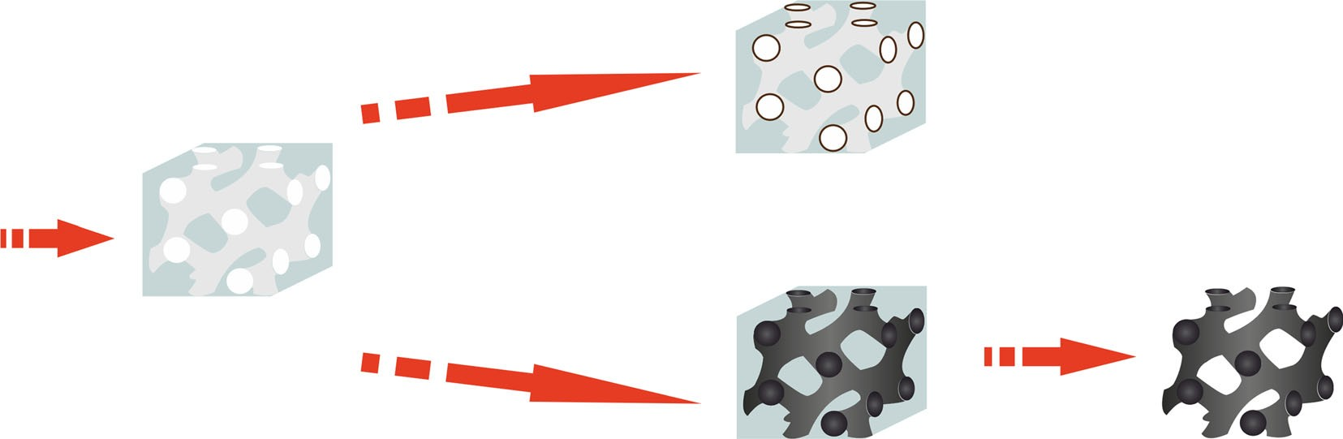
Influence of thermal treatment conditions on efficiency of PFA/MCM-48 composite and CMK-1…
1315
+furfuryl alcohol(FA);FA:MCM–48 mass ratio = 0.10
+HCl (polycondensation catalyst)
carbonisation, 4 h, 250–1050 °C
silica source: tetraethyl orthosilicate surfactant:
cetyltrimethylammonium chloride
pH controling agent: NH3solvents: H2O, MeOH
PFA0.10/MCM–48
composite with polymer film depositedon the SiO2surface
Calcination
8 h, 550 °C
+furfuryl alcohol(FA);FA:MCM–48 mass ratio = 1.25
+HCl (polycondensation catalyst)
MCM–48
mesoporoussilica
silica leaching
2 × 24 h
1 M NaOH
carbonisation, 4 h, 250–1050 °C
PFA1.25/MCM–48
composite with the SiO2pores completelyfilled with polymer
CMK–1
Fig. 1 Synthesis routes used to prepare the PFA-based adsorbents for the VOCs elimination
(40mLmin⁻¹)attemperature250–1050°C.
from
the
range
of
nitrogen (77 K) was used to determine textural parameters of the studied materials. The adsorption–desorption iso- therms were collected in an ASAP 2020 instrument (Mi- cromeritics). Samples were initially outgassed at 250°C for12h.TheobtaineddatawereanalysedusingtheBET
CMK-1 carbon replica
In order to leach silica from the thermally treated PFA1.25/ MCM-48 composites and to obtain corresponding CMK-1 carbon replicas, these samples were soaked twice in 1 MNaOH(30mLg⁻¹)for24h.Afterthat,theresultingcarbon replicas were washed five times with water, oncewith ethanol and dried at room temperature overnight.
(surface area,
SBET)
and single point (total pore volume,
V_{total}) models. Moreover, the NLDFT (in the case of the MCM-48 silica and the PFAx/MCM-48 composites) and QSDFT theory (in the case of the carbon replicas) were used for the calculation of mesopore volume (V_{meso}) and pore size distribution. DRIFT spectra were collected in a Nicolet 6700 (Thermo Scientific) FTIR spectrometer for samples diluted with KBr (4 mass %). Two hundred scans were taken using a liquid nitrogen-cooled MCT-A detectorfrom650to4000cm⁻¹atresolutionof4cm⁻¹.
Characterization
The thermal decomposition of the PFAx/MCM-48 com-positeswasstudiedinaTAInstrumentsSDTQ600ther-mogravimeter equipped with a TG/FTIR interface (ThermoScientific)connectedon-linewithaNicolet6700FTIR spectrometer. Ca. 10 mg of a sample was placed in a corundumcrucibleandoutgassedintheflowofnitrogen(20mLmin⁻¹)atroomtemperaturefor1h.Then,thetemperaturewasincreasedto1100°Cataheatingrateof
20°Cmin⁻¹.Thecompositionofgasesevolvedduringthe
thermaltreatmentwasanalysedbycollectingFTIRspectrainthewavenumberrangeof650–4000cm⁻¹atresolution of4cm⁻¹andtimeintervalof3s.AdditionalTGmea-surementsweretakenwithoutusingoftheFTIRdeviceinflowingair(100mLmin⁻¹)insteadofN₂todeterminethecontent of PFA in the synthesizedcomposites.
Elemental analysis was performed using a Flash 2000 (Thermo Scientific) CHN analyser. Powder X-ray diffrac- tion patterns (XRD) were taken using a Bruker D2 Phaser diffractometer equipped with a Cu Karadiation
(k=1.54184A˚).Thediffractogramswererecordedinthe
2h range of 0.5°–8.0°with a step of 0.02°and a count time of 1 s at each point. Low-temperature adsorption of
Adsorption capacity
Ca. 100 mg of a sample was weighted in a stainless steel reactor.Theadsorbentwasheatedupto250°CinflowingN₂(40mLmin⁻¹)andkeptatthistemperaturefor15min.Afterwards,theovenwascooleddowntoatemperature,at which the relative vapour pressure of selected adsorbate (butan-2-one,propan-2-ol,n-heptaneortoluene)was0.25,andtheflowofcarriergas(N₂,40mLmin⁻¹),saturatedwith the VOCs vapour, was passed by the adsorbent bed until a flame ionization detector (FID) signal reached a plateau.Afterthat,thesystemwaspurgedwithpurecarrier gas in order to remove the physically adsorbed forms ofVOC. Subsequently, temperature-programmed desorption(TPD)wasperformedbyheatingupto250°Catarateof
15°Cmin⁻¹intheflowofnitrogen(40mLmin⁻¹).
Finally, the sample was weighted in order to determine the exact mass of the run sample. The adsorption capacities were calculated from the TPD profiles after their integration.
13

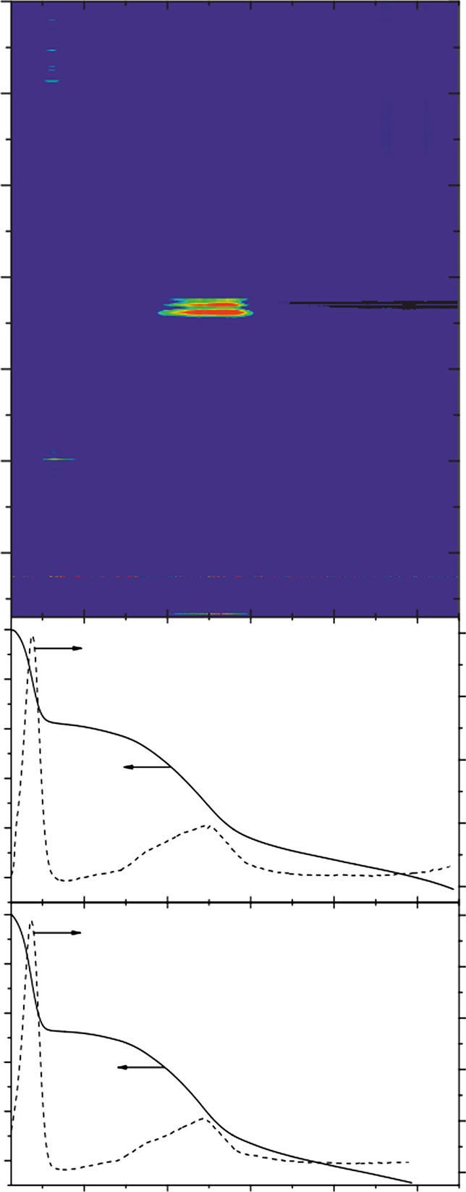
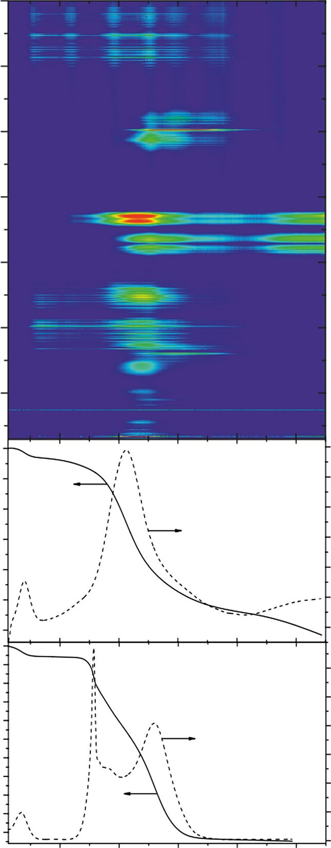
1316
K. Machowski et al.
PFA0.10/MCM–48
PFA1.25/MCM–48
4000
4000
N2flow
N2flow
3500
3500
3000
3000
2500
2500
2000
2000
1500
1500
1000
1000
100
100

95
0.12
0.08
N2flow
N2flow
0.10
98
0.06
0.08
90
96
0.06
0.04
85
94
0.04

0.02

0.00
80
0.02
92
75
90
100
0.00
0.10
70
100
95
90
85
80
75
70
65
60
55
50
AIR flow
AIR flow
0.30

0.25

0.20

0.15

0.10
98
0.08
96
0.06
94
0.04
92
0.02
0.05

0.00
90
0.00
200
400
600
800
1000
473
673
873
1073
1273
Temperature/°C
Temperature/°C
Fig. 2
TG and DTG curves as well as FTIR maps of gaseous products formed during thermal decomposition of PFA0.10/MCM-48 (left) and
PFA1.25/MCM-48 (right) composites in flowing N₂and air
Results and discussion
The percentage mass loss observed during the TGmeasurements for the PFA0.10/MCM-48 sample is almost the same at both oxidizing and inert atmosphere (Fig.2). This effect can suggest that even in flowing N₂, the content of oxygen, related to its presence on the composite surface in the form of adsorbed and deposited species, is enough to combust entirely the polymer film. Figure2shows that the process of PFA oxidation occurs in the temperature range of 290–590°C with the maximum at about 500°C, which corresponds to the CO₂emission manifested by the appearance of two IR bands observed at 2310 and
Mechanism of decomposition of PFA deposited in various amounts in pore system of MCM-48
Thermogravimetric and elemental analyses revealed
the
amount of introduced PFA and the content of carbon in the synthesized PFA0.10/MCM-48 and PFA1.25/MCM-48 composites.ThePFA/MCM-48massratiosof0.06and1.02, respectively,determinedbyTG,arelowerthantheintended values due to the incomplete deposition of furfuryl alcohol onthesilicasurfacecausedbytheformationofwater-soluble oligomers [44,45]. The carbon contents in the studied materials are 1.7 and 29.4 %, respectively, and perfectly correspond to the calculated PFA/MCM-48 massratios.
2350cm⁻¹[47].ThisfindingobviouslyPFA film is very temperature-sensitive, temperature activation (below 290°C) against any significant damage.
shows that the and only low- can protect it
13
Wavenumber/cm–1
Mass/%
Mass/%
Deriv.Mass/%K–1
Deriv.Mass/%K–1
Wavenumber/cm–1
Mass/%
Mass/%
Deriv.Mass/%K–1
Deriv.Mass/%K–1

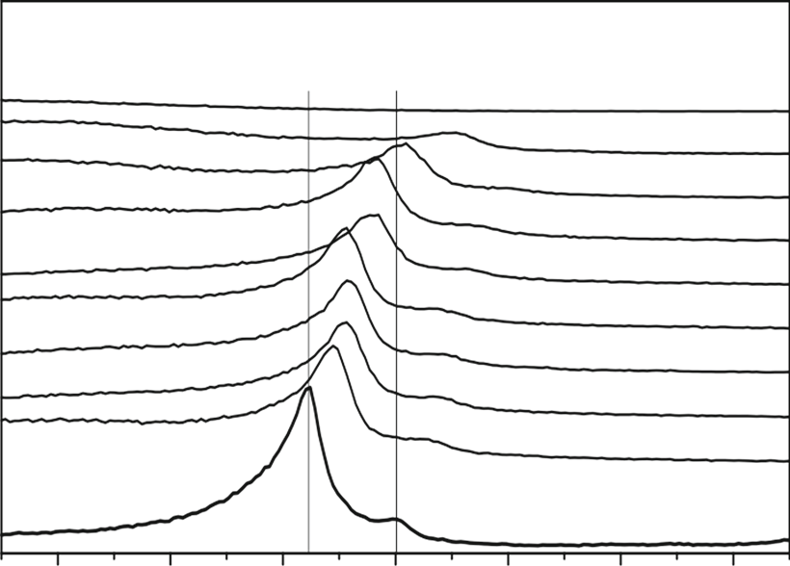
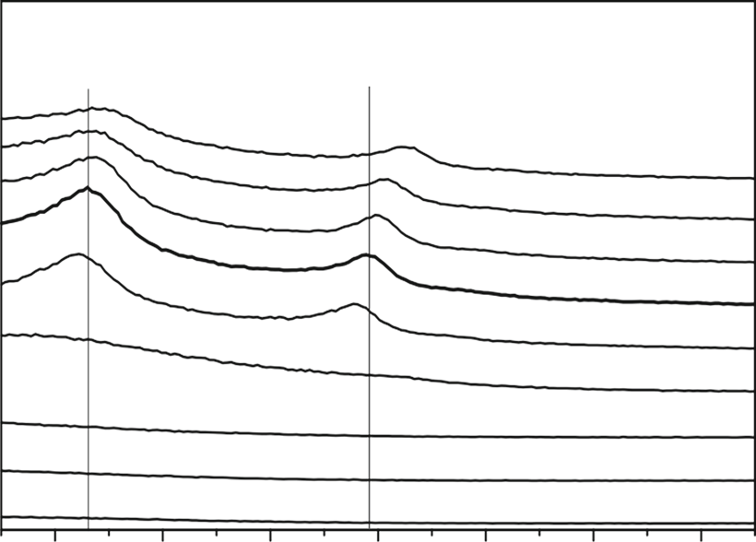
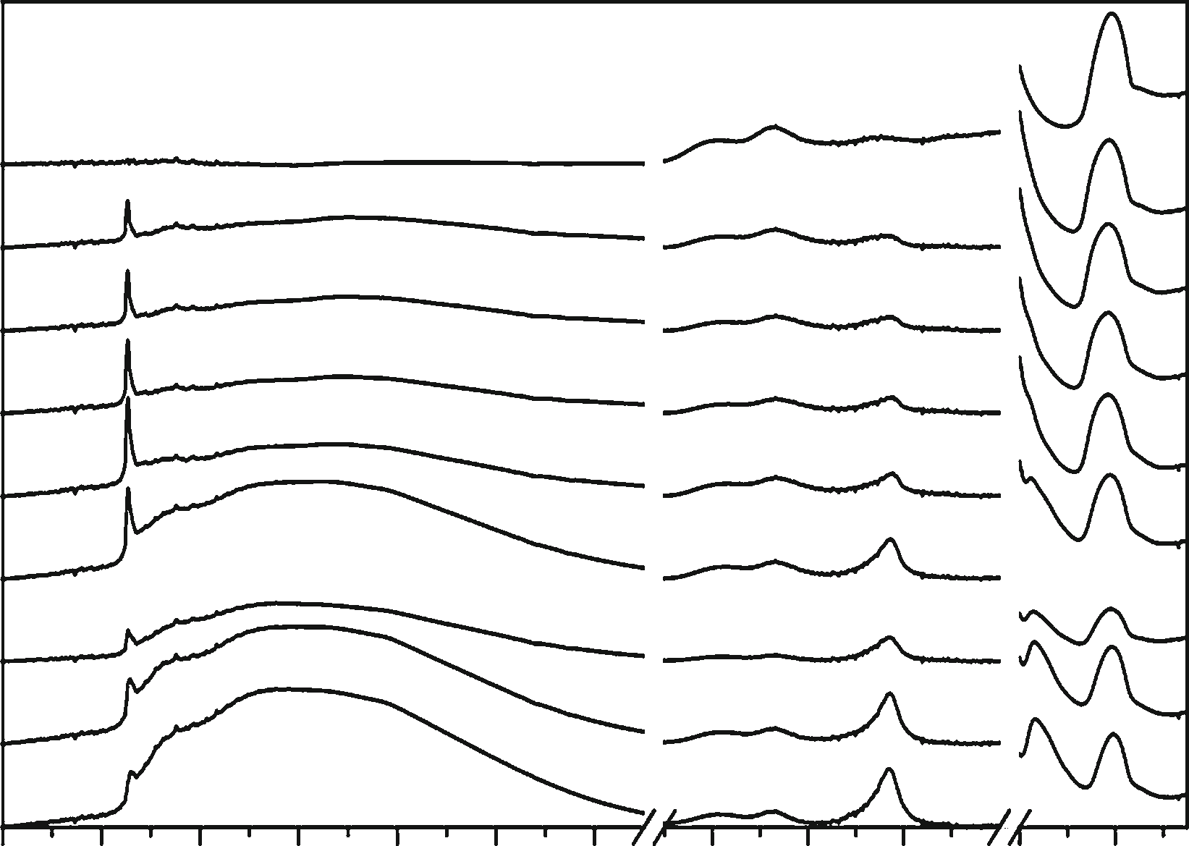
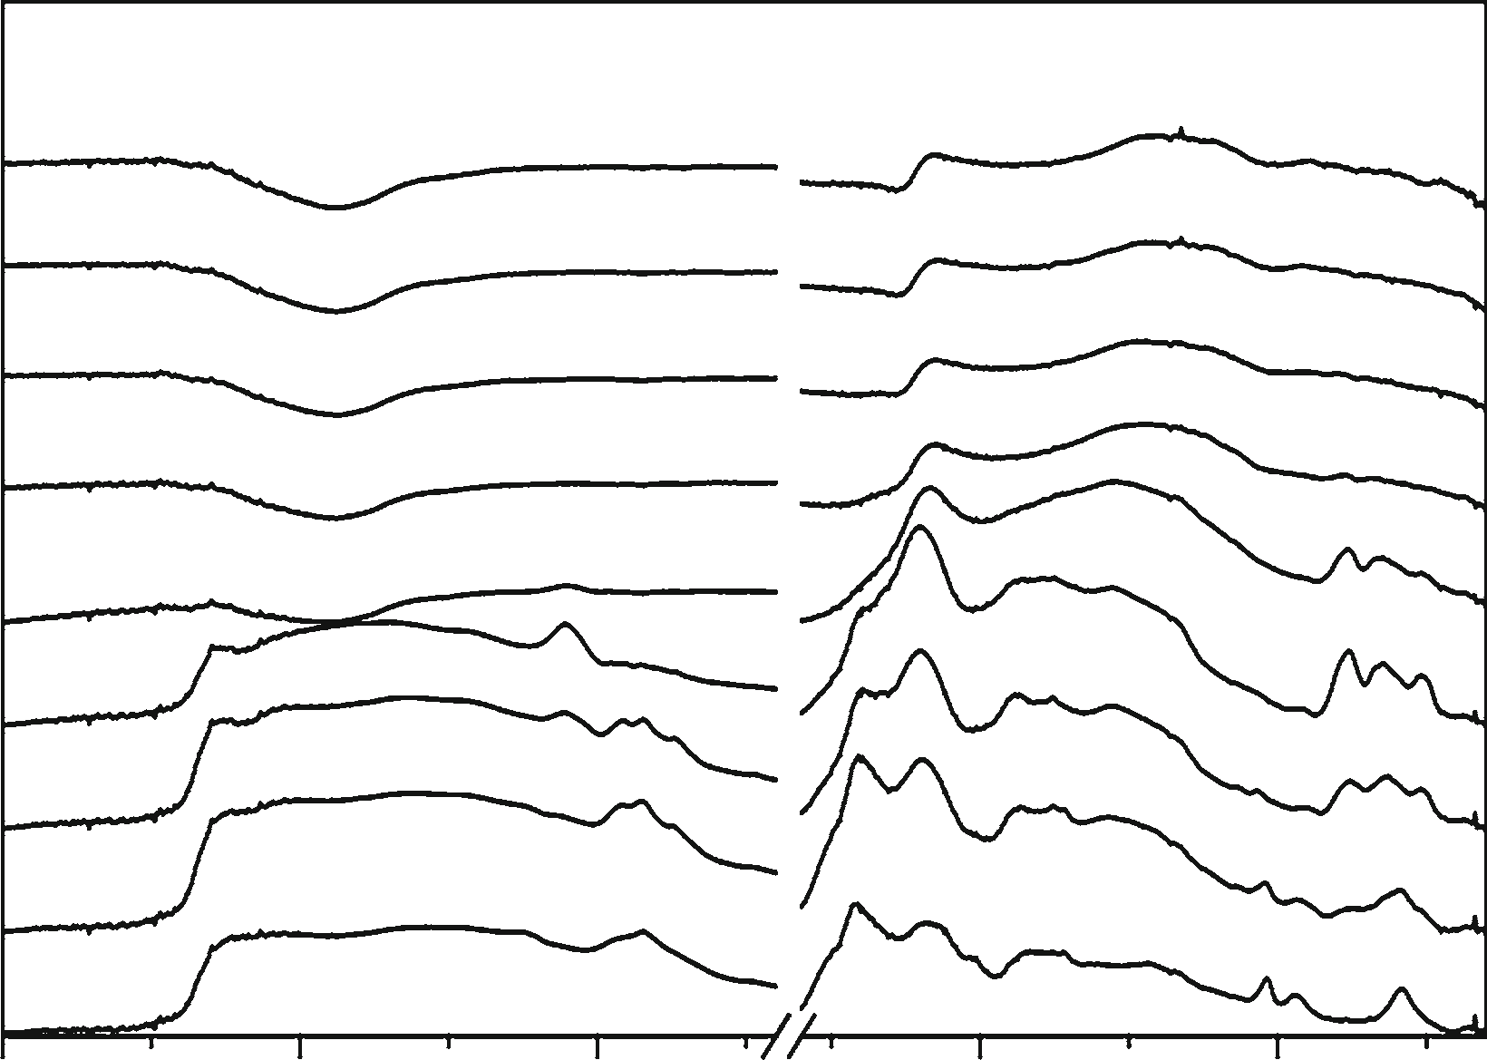
Influence of thermal treatment conditions on efficiency of PFA/MCM-48 composite and CMK-1…
1317
(a)
(b)
PFA0.10/MCM–48
CMK–1
1050
950
850
750
650
550
450
350
250
1050
950
850
750
650
550
450
350
250
4.5
MCM–48
4.5
1.5
2.0
2.5
3.0
2θ/°
3.5
4.0
1.5
2.0
2.5
3.0
2θ/°
3.5
4.0
Fig. 3 XRD patterns of PFA0.10/MCM-48 composites (a) and CMK-1 carbon replicas (b) after the thermal treatment at the chosen temperature from the range of 250–1050°C
(a)
PFA0.10/MCM–48
1050
950
850
750
650
550
450
350
250
4000 380036003400 32003000 2800 200018001600 1000 800
Wavenumber/cm–1
(b)
CMK–1
1050
950
850
750

650
550
450
350
250
4000
3500 3000
1500
1000
Wavenumber/cm–1
Fig. 4 DRIFT spectra of PFA0.10/MCM-48 composites (a) and CMK-1 carbon replicas (b) after the thermal treatment at the chosen temperaturefromtherangeof250–1050°C
On the contrary, in the case of the PFA1.25/MCM-48 sample, the mass loss measured under the inert atmosphere is three times lower than in the presence of oxygen. This confirms another mechanism of thermal decomposition of PFA deposited in the SiO₂pores, which occurs in the flowing N₂. The polymer degradation, with emission ofCO₂(2310and2350cm⁻¹),CO(2110and2170cm⁻¹)
andsimplecarbonylcompounds(1220and1740cm⁻¹)detached from the ends of polymer chain [48], intensifiesatabout 300°C. The presence of carbonyl compounds is observed in the exhaust gases up to 650°C, while the bands attributed to CO and CO₂are detected even at the higher temperatures. Furthermore, the IR bands at1304
and3015cm⁻¹,whichappearinthetemperaturerangeof420–815°C, can be assigned to the production of gaseous
methane during the PFA decomposition [49,50]. At the temperatures higher than 815°C, the hydrogen content in the degraded polymer is probably too low to form CH₄molecules. It should therefore be assumed that above 815°C, the PFA1.25/MCM-48 material undergoes only graphitization as well as combustion by the traces of oxygen present in thepurging gas.
Structural and textural properties of PFA-derived adsorbents
PFA0.10/MCM-48 composites
As previously reported [51], the structure of MCM-48 silica is thermally stable up to about 550°C.Nevertheless,
13
Absorbance
Counts
(211)
(220)
Absorbance
Counts
(110)
(211)

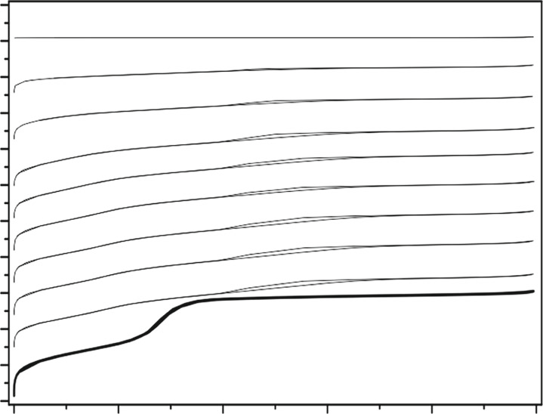
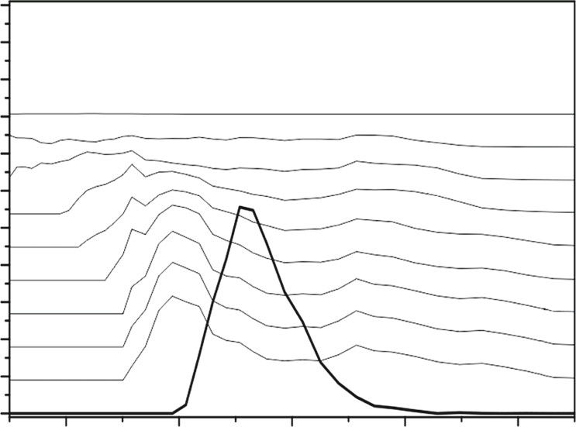
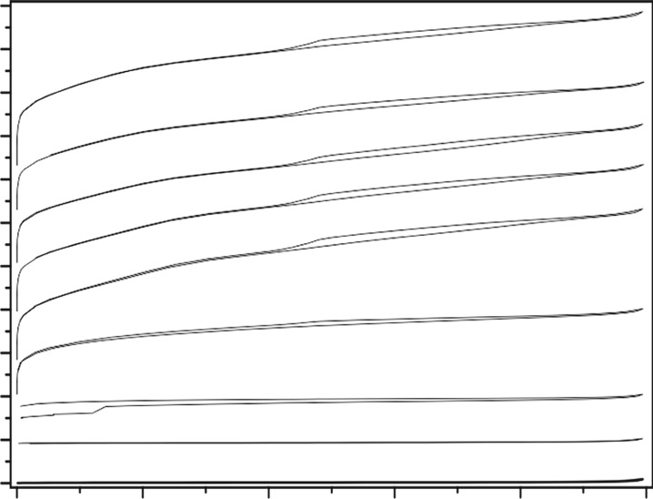
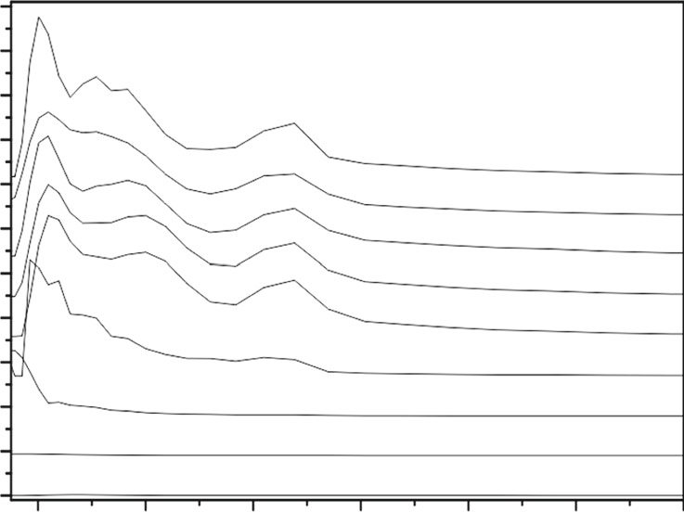
1318
K. Machowski et al.
2200
2000
1800
1600
1400
1200
1000
800
600
400
200
0
2.2
2.0
1.8
1.6
1.4
1.2
1.0
0.8
0.6
0.4
0.2
0.0
PFA0.10/MCM–48
+2020
PFA0.10/MCM–48
1050
950
850
750
650
550
450
350
250
MCM–48
+1700
1050
950
850
750
650
550
450
350
250
MCM–48
6
+1.62

+1.44

+1.26
+1.08
+0.90

+0.72
+0.54
+1435
+1165

+985
+805

+625

+445

+270
+0.36

+0.18
0.0
0.2
0.4
0.6
0.8
1.0
2
3
4
Pore size/nm
5
p/p0
2200
2000
1800
1600
1400
1200
1000
800
600
400
200
0
2.2
2.0
1.8
1.6
1.4
1.2
1.0
0.8
0.6
0.4
0.2
0.0
CMK–1
CMK–1
1050
950
850
750
650
+1435
1050
950
850
750
650
550
450
350
250
7
+1.44
+1210
+1.26
+1.08

+0.90
+985
+755
550
+535
+0.72
+360
450
350
250
+0.54
+0.36

+0.18
+270
+185
0.0
0.2
0.4
0.6
0.8
1.0
1
2
3
4
Pore size/nm
5
6
p/p0
Fig. 5
Low-temperature nitrogen adsorption–desorption isotherms and pore size distributions for PFA0.10/MCM-48 composites and CMK-1
carbon replicas after the thermal treatment at the chosen temperature from the range of 250–1050°C
we studied the changes in the structural properties of PFA0.10/MCM-48 in the temperature range of 250– 1050°C using the XRD method (Fig.3a). Both pristine MCM-48 and PFA0.10/MCM-48 composites pyrolysed at relatively low temperatures exhibit the (211) and(220)
diffraction lines, which are typical of the cubicIa3dme- sostructure. The introduction of PFA followed by the thermal treatment results in the shift of (211) reflection towards higher angles. Thea₀lattice parameter calculated
CH and –CH₂stretching vibrations (2850, 2920 and2970cm⁻¹)inPFAdepositedontheMCM-48surface.Moreover, the decrease in the intensity of wide band at3200–3550cm⁻¹,correspondingtotheSi–OH–PFAinteractions, connected with the increase in the intensity ofsharpbandat3745cm⁻¹relatedtothevibrationsoffreesilanols, is observed. All these changes confirm the removal of PFA film covering the MCM-48 surface, observed by the TG analysis during the thermal treatment at the inert atmosphere (Fig.2). It is not surprising that after heating at 1050°C, no bands characteristic of the vibrationsofsilanolsanddegradedPFAarefound.
The nitrogen adsorption isotherms and pore size distri- bution (Fig.5) as well as determined textural parameters (Table1) reveal that after the deposition of PFA in the pore system of MCM-48, the BET surface area as well as
according to the formula ofa₀=6^{1/2}.
d211
changes the
value from 8.3 nm for the pristine MCM-48 silica to
8.0 nm for PFA0.10/MCM-48 activated at 250°C. A fur- ther increase in temperature causes a gradual lowering ofa₀value, finally to 7.1 nm for 850°C and 6.6 nm for 950°C. The observed effect is explained by the shrinkage of material structure. After activation at the highest tem- perature, no reflection is present in the XRD pattern, sug- gestingthecompletedestructionoftheporousstructureof
MCM-48.
The DRIFT spectra collected for the thermally activated PFA0.10/MCM-48 composite are compiled in Fig.4a. It is clear that the increase in temperature results in the disap- pearance of the weak IR bands, attributed to the aliphatic –
mesopore decrease, increases. composite
and total pore volume of the silica support and simultaneously, the micropore volume The pore structure of the PFA0.10/MCM-48 is entirely stable up to 550°C. Abovethis
temperature, the material begins to be transformed into an amorphous, non-porous solid. This effect is the most dis- tinct in the case of the sample carbonized at 1050°C,
13
Volume adsorbed STP/cm3g–1
Volume adsorbed STP/cm3g–1
dV/dD/cm3g–1nm–1
dV/dD/cm3g–1nm–1

Influence of thermal treatment conditions on efficiency of PFA/MCM-48 composite and CMK-1…
1319
Table 1 Textural parameters of MCM-48 mesoporous support as well as PFA0.10/MCM-48 composites and CMK-1 carbon replicas after the thermal treatment at the chosen temperature from the range of 250–1050°C
Sa/m2g-1
Vb
/cm³g⁻¹
Vc
/cm³g⁻¹
Vd
/cm³g⁻¹
Sample
BET
micro
meso
total
MCM-48 PFA0.10/MCM-48_523 PFA0.10/MCM-48_623 PFA0.10/MCM-48_723 PFA0.10/MCM-48_823 PFA0.10/MCM-48_923PFA0.10/MCM-48_1023 PFA0.10/MCM-48_1123 PFA0.10/MCM-48_1223 PFA0.10/MCM-48_1323CMK-1_523
CMK-1_623 CMK-1_723 CMK-1_823 CMK-1_923CMK-1_1023 CMK-1_1123 CMK-1_1223
CMK-1_1323
1187
999
1010
1026
1044
982
857
626
380
7
11
20
432
1124
1563
1531
1442
1490
1748
0.009
0.149
0.154
0.137
0.169
0.159
0.151
0.126
0.078
0.002
0.001
0.002
0.085
0.294
0.142
0.160
0.198
0.266
0.342
0.882
0.627
0.635
0.616
0.593
0.571
0.509
0.330
0.173
0.004
0.012
0.017
0.029
0.190
0.567
0.547
0.512
0.420
0.467
0.943
0.675
0.684
0.662
0.640
0.612
0.547
0.400
0.254
0.011
0.029
0.040
0.217
0.688
1.124
1.094
1.035
0.987
1.143
a
S_{BET}= surface area (BET)
V_{micro}= micropore volume (t-plot)
V_{meso}=mesopore volume (equilibrium NLDFT for the samples containing MCM-48, QSDFT for the CMK-1-type carbons)
I_{total}=total pore volume (single point)
b
c
d
which has the BET surface area and the total pore volumeabout 98–99 % lower than that pyrolysed at 250°C.
Figure4b shows the DRIFT spectra of the PFA1.25/ MCM-48materialaftercarbonizationatdifferenttemper- atures and the SiO₂leaching. The IR bands related to thepresenceofpartiallydegradedPFAat3400cm⁻¹(–OHstretching),3115cm⁻¹(–CHinaromaticrings),2960, 2920and2860cm⁻¹(aliphatic–CHand–CH₂stretchingvibrations),1710cm⁻¹(C=Ostretchingvibrations),1600cm⁻¹(aromaticC=C),1500cm⁻¹(furanringvibra-tions),1430cm⁻¹(asymmetricbendingCH₂vibrations),1355cm⁻¹(–CHfuranringdeformation),1020cm⁻¹(asymmetric and symmetric=C–O–C=vibrations in2-substitutedfuranring)and795cm⁻¹(thevibrationsofC–C bonds in 2,5-disubstituted furan rings forming the polymer chain) are clearly observed up to 550°C. The furtherraisingtemperatureresultsinthedisappearanceof these features due to the complete carbonization of PFA precursor. No new bands are distinguished in theDRIFT spectra,becausetheblackmaterialischaracterizedbyhigh infraredabsorbance.
The results of low-temperature N₂adsorption of nitro- gen (Fig.5; Table1) confirm the evolution of CMK-1 structure with the carbonization temperature. It is obvious that the rigid framework is formed after carbonization at
CMK-1 carbon replicas
The XRD patterns of CMK-1 carbon replicas carbonized at temperatures below 650°C (Fig.3b) reveal that these materials have no ordered mesoporous structure. Probably, so low carbonization temperatures do not provide the for- mation of rigid carbon backbone, which would be stable after the leaching of SiO₂template. However, the thermal treatment of PFA1.25/MCM-48 at 650°C or higher temperature followed by the silica removal leads to the appearance of (110) and (211) diffraction lines char- acteristic of the cubicI4₁32mesostructure. As in the case of the PFA0.10/MCM-48 composite, the increase in the activation temperature causes a slight shift of reflections to higher angles in the final CMK-1 replicas (thea₀lattice parameter, calculated according to the formulaof
a₀=2^{1/2}·d₁₁₀, changes its value from 7.8 nm for 650°C
to 7.3 nm for 1050°C). The CMK-1 sample obtained by carbonization at 750°C shows certainly the most ordered structure.
13

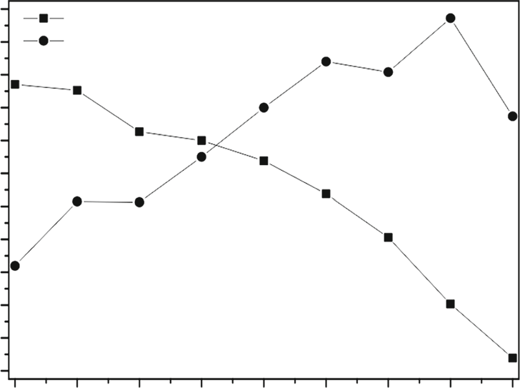
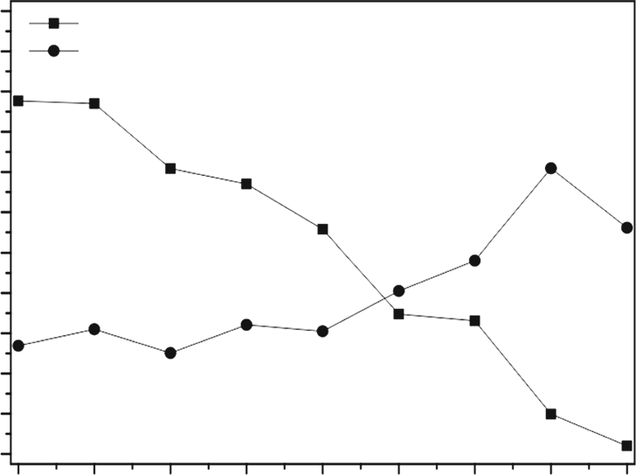
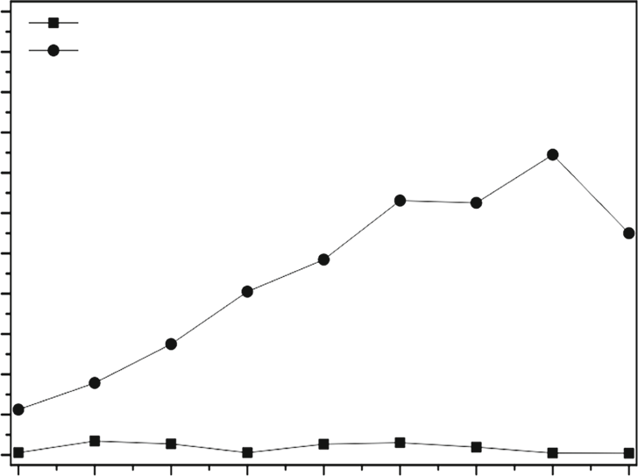
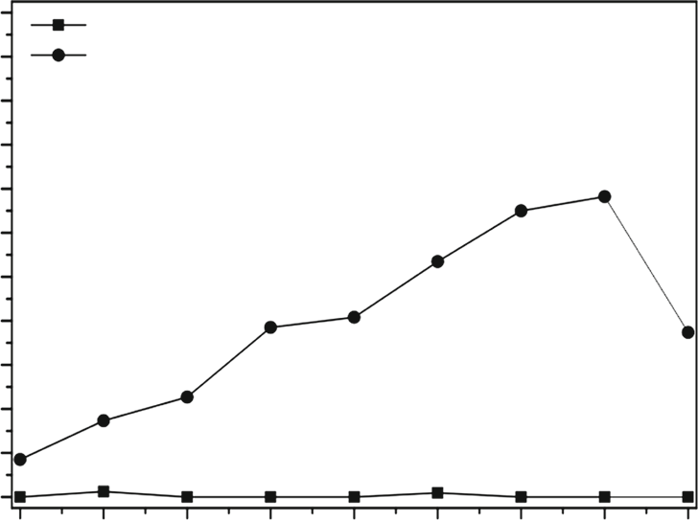
1320
K. Machowski et al.
(a)
(b)
2.2
2.0
1.8
1.6
1.4
1.2
1.0
0.8
0.6
0.4
0.2
0.0
2.2
2.0
1.8
1.6
1.4
1.2
1.0
0.8
0.6
0.4
0.2
0.0
PFA0.10/MCM–48CMK–1
PFA0.10/MCM–48CMK–1
250
350 450
550
650 750 850 950
1050
250
350 450 550 650 750 850 950 1050
Temperature of thermal treatment/°C
Temperature of thermal treatment/°C
(c)
(d)
2.2
2.0
1.8
1.6
1.4
1.2
1.0
0.8
0.6
0.4
0.2
0.0
2.2
2.0
1.8
1.6
1.4
1.2
1.0
0.8
0.6
0.4
0.2
0.0
PFA0.10/MCM–48CMK–1
PFA0.10/MCM–48CMK–1
250
350 450
550 650 750 850 950
1050
250
350 450 550 650 750 850 950 1050
Temperature of thermal treatment/°C
Temperature of thermal treatment/°C
Fig. 6
Adsorption capacity (mmol of VOCs per 1 g of an adsorbent)
replicas after the thermal treatment at the chosen temperature from the range of 250–1050°C
of butan-2-one (a), propan-2-ol (b),n-heptane (c) and toluene (d) measured for PFA0.10/MCM-48 composites and CMK-1 carbon
temperature of 650°C or even higher. This effect is manifested by a significant increase in the BET surface area as well as the mesopore volume. The CMK-1 porous structure is stable even at the highest carbonization tem- perature of 1050°C when the carbon shrinkage and decomposition of surface functional groups are highly intensified. The comparison of textural properties for this sample to data collected for PFA0.10/MCM-48 pyrolysed at the same temperature reveals that the presence of PFA entirely filling the mesopores of silica protects it against structuraldecomposition.
which is mainly related to the progressive polymer decomposition and the elimination of surface carbonyl moieties responsible for the enhanced efficiency in the adsorption process. The high polarity of pristine silica as well as the PFA modifier causes the studied composite materials to have negligible adsorption capacity in the removal of non-polar molecules of linear alkanes and aromatic compounds (n-heptane and toluene).
On the other hand, the adsorption capacity of CMK-1 carbon replicas increases with the carbonization tempera- ture. There are at least two important reasons, whichexplain that fact. Firstly, the carbon materials obtained from the PFA1.25/MCM-48 composite pyrolysed at lower temperatures do not maintain the structure of template and their textural parameters are rather poor influencing thelow surface concentration of adsorption centres. Secondly, the surface composition of carbon after the leaching of silica template is completely different than that of the PFA/ MCM-48 composites. The diffusion limitations during thermal treatment of MCM-48 with the poresystem
Adsorption capacity of PFA/MCM-48 and CMK-1 pyrolysed at different temperatures
As shown in Fig.6, the thermally treated PFA0.1/MCM-48 composites thermally activated at low temperatures are effective in adsorption of polar VOCs (butan-2-one and propan-2-ol). Increasing thermal treatment temperature leads to a gradual lowering of the adsorption capacity,
13
Sorption capacity/mmolMEKg–1
Sorption capacity/mmolMEKg–1
Sorption capacity/mmolMEKg–1
Sorption capacity/mmolMEKg–1

Influence of thermal treatment conditions on efficiency of PFA/MCM-48 composite and CMK-1…
1321
References
completely filled with PFA substantially change the mech- anism of polymer degradation. In the consequence, the CMK-1 carbon replicas obtained from the PFA1.25/MCM-48 composite carbonized at higher temperatures exhibit theaffinity to both polar and non-polar adsorbates. It is most likely that the oxygen moieties co-exist with graphitic domains favouring the adsorption of various VOCs mole- cules. The highest adsorption capacity is achieved for the CMK-1 material carbonized at 950°C, in which thecontent of these species is balanced. The higher pyrolysis tempera-turecouldeffectivelyremovetheoxygen-containinggroups, and too much graphitic domainsappeared.
- Chew T-L, Ahmad AL, Bhatia S. Ordered mesoporous silica (OMS) as an adsorbent and membrane for separation of carbon dioxide(CO₂).AdvColloidInterfaceSci.2010;153:43–57.
- Khan FI, Ghosal AK. Removal of volatile organic compounds frompollutedair.JLossPrevProcessInd.2000;13:527–45.
- DerbyshireF,JagtoyenM,AndrewsR,RaoA,Mart´ın-Gullo´nI,Grulke E. Carbon materials in environmental applications. Mar- cel Decker;2001.
- Gallego E, Roca FJ, Perales JF, Guardino X. Experimental evaluation of VOC removal efficiency of a coconut shell acti- vated carbon filter for indoor air quality enhancement. Build Environ.2013;67:14–25.
- Sidheswaran MA, Destaillats H, Sullivan DP, Cohn S, Fisk WJ.Energy efficient indoor VOC air cleaning with activated carbon fiber (ACF) filters. Build Environ.2012;47:357–67.
- Bansal RC, Donet BJ, Stoeckli F. Active carbon. Marcel Dekker; 1988.
- Ryu ZY, Rong HQ, Zheng JT, Wang MZ, Zhang BJ. Microstructure and chemical analysis of PAN-based activated carbon fibers prepared by different activation methods. Carbon. 2002;40:1144–7.
- Park SJ, Jung WY. Preparation and structural characterization of activated carbons based on polymeric resin. J Colloid Interface Sci.2002;250:196–200.
- San Miguel G, Fowler GD, Sollars CJ. A study of the charac- teristicsofactivatedcarbonsproducedbysteamandcarbon
Conclusions
The mechanism of degradation of PFA deposited on the surface of MCM-48 mesoporous silica is strongly influ- enced by the content of polymer in the PFA/MCM-48 composite. Even in flowing nitrogen, the thin film of PFA (PFA0.10/MCM-48) is completely oxidized in the tem- perature range of 290–590°C due to the presence of oxi- dizing species on the composite surface. On the other hand, the 3D structure of PFA located in the MCM-48 channels (PFA1.25/MCM-48) has a relatively large amount of bulk, which remains unattainable for the oxidizing agents. Itallows to obtain the stable carbon structure with varying number of oxygen-containing surface functionalities and degree of graphitization.
It was observed that both PFA/MCM-48 composites and PFA-derived CMK-1 carbon replicas exhibit the cubic structure with an extremely expanded surface area andporosity. These features, controlled by the choice of con- ditions used during the thermal treatment, cause these materials to be very efficient adsorbents of VOCs. How- ever, the surface composition and polarity affect theadsorption selectivity. The PFA/MCM-48 compositesshow the high adsorption capacity only in the removal of polar molecules, whereas CMK-1 carbons are also effective intheeliminationoflinearalkanesandaromaticVOCs.
dioxide
activation
of
waste
tyre
rubber.
Carbon.
2003;41:1009–16.
- Skodras G, Diamantopouiou I, Zabaniotou A, Stavropoulos G, Sakellaropoulos GP. Enhanced mercury adsorption in activated carbons from biomass materials and waste tires. Fuel Process Technol.2007;88:749–58.
- Long C, Lu JD, Li AM, Hu DB, Liu FQ, Zhang QX. Adsorption of naphthalene onto the carbon adsorbent from waste ion exchange resin: equilibrium and kinetic characteristics. J Hazard Mater.2008;150:656–61.
- Hayashi J, Yamamoto K, Horikawa T, Muroyama K, Gomes VG. Preparation and characterization of high-specific-surface-area activated carbons from K₂CO₃-treated waste polyurethane. J Colloid Interface Sci.2005;281:437–43.
- Va´zquez-SantosMB,Castro-Mun˜izA,Mart´ınez-AlonsoA,Tasco´nJMD.Poroustextureevolutioninactivatedcarbonfibers
prepared from poly (p-phenylene benzobisoxazole) by carbon
dioxide
activation.
Microporous
Mesoporous
Mater.
2008;116:622–6.
- Cagnon B, Xavier P, Guillot A, Stoeckli F, Chambat G. Contri- butions of hemicellulose, cellulose and lignin to the mass and the porous properties of chars and steam activated carbons from various lignocellulosic precursors. Bioresource Technol. 2009;100:292–8.
- Sun K, Jiang JC. Preparation and characterization of activated carbon from rubber-seed shell by physical activation with steam. Biomass Bioenergy.2010;34:539–44.
- Daud WMAW, Ali WSW, Sulaiman MZ. Effect of activation temperature on pore development in activated carbon produced frompalmshell.JChemTechnolBiotechnol.2003;78:1–5.
- Shawabkeh RA, Aslam Z, Hussien IA. Thermochemical treat- ment of fly ash for synthesis of mesoporous activated carbon. J Therm Anal Calorim.2015;122:1191–201.
- Tsai WT, Chang CY, Lee SL. A low cost adsorbent from agri- cultural waste corn cob by zinc chloride activation. Bioresource Technol.1998;64:211–7.
Acknowledgements This work was supported by the Polish National Science Centre under the grant no. 2013/11/B/ST5/01550 and by the European Regional Development Fund in the framework of thePolish Innovation Economy Operational Program (contract no. POIG.02.01.00-12-023/08), which financed the purchase of research equipment.
Open Access This article is distributed under the terms of the Creative Commons Attribution 4.0 International License (http://creativecommons.org/licenses/by/4.0/), which permits unrestricted use, distribution, and reproduction in any medium, provided you give appropriate credit to the original author(s) and the source, provide a link to the Creative Commons license, and indicate if changes were made.
13

1322
K. Machowski et al.
- Go´rkaJ,ZawislakA,ChomaJ,JaroniecM.KOHactivationofmesoporous carbons obtained by soft-templating. Carbon.2008;46:1159–74.
- de Souza LKC, Wickramaratne NP, Ello AS, Costa MJF,da Costa CEF, Jaroniec M. Enhancement of CO₂adsorption onphenolic resin-based mesoporous carbons by KOH activation. Carbon.2013;65:334–40.
- Saini VK, Andrade M, Pinto ML, Carvalho AP, Pires J. How theadsorption properties get changed when going from SBA-15 toits CMK-3carbonreplica.SepPurifTechnol.2010;75:366–76.
- Nejad NF, Shams E, Amini MK, Bennett JC. Ordered meso- porous carbon CMK-5 as a potential sorbent for fuel desulfur- ization: application to the removal of dibenzothiophene andcomparison with CMK-3. Microporous Mesoporous Mater. 2013;168:239–46.
- Wu Z, Meng Y, Zhao D. Nanocasting fabrication ofordered mesoporous phenol–formaldehyde resins with various structuresand their adsorption performances for basic organic compounds. Microporous Mesoporous Mater.2010;128:165–79.
- Anbia M, Alvand M. Fast and efficient removal oforthophenanthrolineand2,2⁰2,2⁰-bipyridinefromaqueoussolu-tions by adsorption on modified nanoporous carbon. Sci Iran C. 2012;19:1573–9.
- Glover TG, Dunne KI, Davis RJ, LeVan MD. Carbon–silicacomposite adsorbent: characterization and adsorption of light gases. Microporous Mesoporous Mater.2008;111:1–11.
- JanusR,Kus´trowskiP,DudekB,PiwowarskaZ,KochanowskiA, Michalik M, Cool P. Removal of methyl–ethyl ketone vapour onpolyacrylonitrile-derived carbon/mesoporous silica nanocompos- ite adsorbents. Microporous Mesoporous Mater.2011;145:65–73.
- Janus R, Wach A,Kus´trowskiP, Dudek B, Drozdek M, Silvestre- AlberoAM,Rodr´ıguez-ReinosoF,CoolP.Investigationonthe
low-temperature transformations of poly(furfuryl alcohol) deposited on MCM-41. Langmuir. 2013;29:3045–53.
- Machowski K,Kus´trowskiP, Dudek B, Michalik M.Elimination
of ketone vapors by adsorption on spherical MCM-41 and MCM-48 silicas decorated with thermally activated poly(furfuryl alco- hol). Mater Chem Phys. 2015;165:253–60.
- RyooR, Joo SH, Kruk M, Jaroniec M. Ordered mesoporous carbons. Adv Mater.2001;13:677–81.
- MartinPE, Barker EF. The infrared absorption spectrum of car- bon dioxide. Phys Rev.1932;41:291–303.
- Guigo N, Mija A, Zavaglia R, Vincent L, Sbirrazzuoli N. New insights on the thermal degradation pathways of neat poly(fur-furyl alcohol) and poly(furfuryl alcohol)/SiO₂hybrid materials. Polym Degrad Stabil.2009;94:908–13.
- Nelson RC, Plyler EK, Benedict WS. Absorption spectra ofmethane in the near infrared. J Res Natl Bur Stand. 1948;41:615–21.
- Burket CL, Rajagopalan R, Marencic AP, Dronvajjala K, FoleyHC. Genesis of porosity in polyfurfuryl alcohol derived nano- porous carbon. Carbon.2006;44:2957–63.
- Cassiers K, Linssen T, Mathieu M, Benjelloun M, Schrijnemak-ers K, Van Der Voort P, Cool P, Vansant EF. A detailed study of thermal, hydrothermal, and mechanical stabilities of a wide range of surfactant assembled mesoporous silicas. Chem Mater. 2002;14:2317–24.
- Gupta VK, Suhas PJM. Application of low-cost adsorbents for dyeremoval—areview.JEnvironManage.2009;90:2313–42.
- Crini G. Non-conventional low-cost adsorbents for dye removal: a review. Bioresour Technol.2006;97:1061–85.
- Al-Othman ZA, Ali R, Naushad M. Hexavalent chromium removal from aqueous medium by activated carbon prepared from peanut shell: adsorption kinetics, equilibrium and thermo- dynamic studies. Chem Eng J.2012;184:238–47.
- ZhongZY,YangQ,LiXM,LuoK,LiuY,ZengGM.Preparation of peanut hull-based activated carbon by microwave-induced phosphoric acid activation and its application in Remazol Bril- liantBlueRadsorption.IndCropProd.2012;37:178–85.
- Liu F, Guo Z, Zheng S, Xu Z. Adsorption of tannic acid and phenol on mesoporous carbon activated by CO₂. Chem Eng J. 2012;183:244–52.
- Fu K, Yue Q, Gao B, Sun Y, Zhu L. Preparation,characterization
and application of lignin-based activated liquor lignin by steam activation. 2013;228:1074–82.
carbon from black Chem Eng J.
- ZhangJ,JinL,ZhuS,HuH.Preparationofmesoporousactivated carbons from coal liquefaction residue for methane decomposi- tion. J Nat Gas Chem.2012;21:759–66.
- Bedia J, Rosas JM,Rodrı´ıguez-MirasolJ, Cordero T. Pd sup- ported on mesoporous activated carbons with high oxidation resistance as catalysts for toluene oxidation. Appl Catal B Env- iron.2010;94:8–18.
- Choma J, Jedynak K, Marszewski M, Jaroniec M. Polymer- templated mesoporous carbons synthesized in presence of nickel nanoparticles, nickel oxide nanoparticles, and nickel nitrate. Appl Surf Sci.2012;258:3763–70.
- Wickramaratne NP, Jaroniec M. Phenolic resin-basedcarbons with ultra-large mesopores prepared in the presence of poly(- ethylene oxide)–poly(butylene oxide)–poly(ethylene oxide)tri- block copolymer and trimethyl benzene. Carbon.2013;51:45–51.
- Shi ZG, Feng YQ, Xu L, Da SL, Zhang M. A template method to control the shape and porosity of carbon materials. Carbon. 2004;42:1677–82.
- FierroCM,Go´rkaJ,ZazoJA,RodriguezJJ,LudwinowiczJ,Jaroniec M. Colloidal templating synthesis and adsorption char- acteristics of microporous–mesoporous carbons from Kraft lig- nin. Carbon.2013;62:233–9.
- Karandikar P, Patil KR, Mitra A, Kakade B, Chandwadkar AJ. Synthesis and characterization of mesoporous carbon through inexpensive mesoporous silica as template. Microporous Meso- porous Mater.2007;98:189–99.
- Seredych M, Bandosz TJ. Surface properties of porous carbons obtained from polystyrene-based polymers within inorganic templates: role of polymer chemistry and inorganic template pore structure. Microporous Mesoporous Mater.2007;100:45–54.
- Ryoo R, Joo SH, Jun S. Synthesis of highly ordered carbon molecular sieves via template-mediated structural transformation. J Phys Chem B.1999;37:7743–6.
- Ryoo R, Joo SH. Nanostructured carbon materials synthesized from mesoporous silica crystals by replication. Stud Surf Sci Catal.2004;148:241–60.
- Jun S, Joo SH, Ryoo R, Kruk M, Jaroniec M, Liu Z, Ohsuna T, Teresaki O. Synthesis of new, nanoporous carbon with hexago- nallyorderedmesostructure.JAmChemSoc.2000;122:10712–3.
13

