

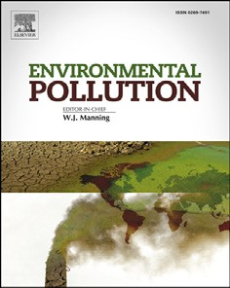
Environmental Pollution 265 (2020) 114882
Usefulness of bee bread and capped brood for the assessment of monocyclic aromatic hydrocarbon levels in the environment*
Katarzyna Zie˛ ba ª, Elz_ bieta Szostak ª, Krystyna Czekon'ska ^{b}, Paweł Mi'skowiec ª, Agnieszka Moos-Matysik ª, Anna Nyczyk-Malinowska ^{c}, Hajnalka Szentgyo€rgyi ^{d,} *, ¹
a Faculty of Chemistry, Jagiellonian University, Gronostajowa 2, Krako'w, 30-387, Poland
b Faculty of Animal Science, University of Agriculture in Krako'w, al. 29 Listopada 56, Krako'w, 31-425, Poland
c Faculty of Materials Science and Ceramics, University of Science and Technology, ul. Akademicka 2, Krako'w, 30-059, Poland
d Faculty of Biotechnology and Horticulture, University of Agriculture in Krako'w, al. 29 Listopada 56, Krako'w, 31-425, Poland
a r t
i c l e i n f o
a b s t r a c t
Article history:
Received 8 January 2020 Received in revised form 25 May 2020
Accepted 25 May 2020
Available online 2 June 2020
Monitoring airborne pollutants, like aromatic hydrocarbons, are raising more and more concerns recently. Various sampling techniques and methods are known to collect, measure, and analyse envi- ronmental pollution levels based on honey bee bodies or bee product samples. Although honey bees are studied in detail and sampling methods are becoming more and more sophisticated biological samples may signiﬁcantly differ in pollutant accumulation, showing a wide range of pollution levels even in the same site and environment. We have compared the pollution levels of honey bee capped brood and bee bread (pollen collected by honey bees and deposited in the hive) originating from four sites during two years of study and twelve honey bee families near various pollution sources emitting monocyclic aro- matic hydrocarbons (BTEX) to the environment. Our result showed, that the environmental monitoring of BTEX can be based on sampling honey bees, and bee bread in particular. However, we found a sig- niﬁcant difference in the uptake of these pollutants regarding sample type. Pollen collected as a food source revealed consistently higher levels of BTEX than bee brood, as well as some other differences in pollution levels between samples and between seasons, as opposed to capped brood. Based on our re- sults, we suggest that for measuring and monitoring of BTEX pollution in the environment the use of bee bread is a valuable source of information.
© 2020 The Authors. Published by Elsevier Ltd. This is an open access article under the CC BY license
(http://creativecommons.org/licenses/by/4.0/).
1. Introduction
sources. Various aquatic and terrestrial organisms are used for such monitoring purposes, as are honey bees (Apis mellifera) (Bromenshenk et al., 1985; Bargan'ska et al., 2015). The honey bee as a species has been managed for thousands of years throughout human history, and due to its economic and agricultural impor- tance is nowadays widespread and abundant on almost all conti- nents. Honey bees’ worldwide distribution allows scientists to use them in various ecosystems for environmental monitoring. The bees themselves, as well as their products d honey or pollen d can be used to monitor the environment for the distribution of various pollutants: heavy metals (Bromenshenk et al., 1991; Conti and Botre', 2001; Satta et al., 2012), essential metals (Dz_ ugan et al., 2017) radioactive substances (Haarmann, 1997), non-organic sub- stances (Ponikvar et al., 2005), pesticides (Chauzat et al., 2006), organic contaminants like polychlorinated biphenyls (Anderson and Wojtas, 1986), and, lately, aromatic hydrocarbons (Dobrinas et al., 2008; Perugini et al., 2009). Various sampling techniques and methods are known to collect, measure, and analyse pollution
Anthropogenic pollution
of the environment is a growing
problem globally, and has been since the Industrial Revolution.
Direct measurement of environmental pollutants can show how contaminated the soil, air, or water is, but to assess how this contamination can affect the ecosystem requires a somewhat different approach. Animal- or plant-derived samples can indicate the uptake of pollutants from anthropogenic environmental
* This paper has been recommended for acceptance by Christian Sonne.
* Corresponding author.
E-mail addresses: kzieba@chemia.uj.edu.pl (K. Zie˛ ba), elzbieta.szostak@uj.edu.pl (E. Szostak), krystyna.czekonska@urk.edu.pl (K. Czekon'ska), miskowie@chemia.uj. edu.pl (P. Mi'skowiec), agnieszka.moos@uj.edu.pl (A. Moos-Matysik), nyczyk@agh. edu.pl (A. Nyczyk-Malinowska), hajnalka.szentgyorgyi@uj.edu.pl (H. Szentgyo€rgyi).
1 Present address: Faculty of Biology, Jagiellonian University, ul. Gronostajowa 3,
Krako'w 30e387, Poland.
https://doi.org/10.1016/j.envpol.2020.114882
0269-7491/© 2020 The Authors. Published by Elsevier Ltd. This is an open access article under the CC BY license (http://creativecommons.org/licenses/by/4.0/).
Contents lists available at ScienceDirect

Environmental Pollution

journal homepage: www.elsevier.com/locate/envpol

2
K. Zie˛ba et al. / Environmental Pollution 265 (2020) 114882
levels based on bee bodies, body parts, or bee product samples. Although honey bees are studied in detail and sampling methods are becoming more and more sophisticated (Bargan'ska et al., 2015), biological samples may signiﬁcantly differ in pollutant accumula- tion, showing a wide range of pollution levels even in the same site and environment. Especially honey was well studied due to its importance as a bee product. It was found, that variation in trace element content in honey is ﬁrst of all due to botanical origin rather than environmental exposition to pollution (Bogdanov 2006; Bogdanov et al., 2007), however also apiculture practices and honey processing should be considered when analysing metal content of honey samples (Pohl, 2009).
Honey bees feed on honey d which is made from ﬂoral nectar or honeydew (sap excreted by aphids living on plant sap) collected by the bees d and on pollen, also collected by worker bees from ﬂower anthers. Floral nectar is a substance produced by the nec- taries; due to the structure of ﬂowers it is less exposed to airborne pollution and is the least polluted bee product (Formicki et al., 2013; Joveti'c et al., 2018; Matin et al., 2016). Nectar can also evaporate from the ﬂower in high temperatures or be washed out during heavy rains, which means that the plant must constantly renew it until the ﬂower is pollinated. For this reason, honey is usually less exposed to airborne pollutants (often travelling on PM present in the air, eg. heavy metals), and contains lower levels of such pollution than honeydew or pollen, which can be exposed to airborne pollutants for longer periods of time (Maragou et al., 2017). In addition, the high viscosity of honeydew and pollen causes them to accumulate larger amounts of pollution. Nectar and pollen can be contaminated not only by the deposition of atmo- spheric pollution on plants, but also by plants’ uptake of pollutants like radionuclides or heavy metals from the soil (Bunzl et al., 1988; Ismael et al., 2019; Silva et al., 2012).
The presence of pollutants in honey can therefore vary based on the ﬂower’s ability (its shape or environmental conditions during ﬂowering) to collect these airborne pollutants, and on the plants’ ability to uptake and excrete pollutants into the produced nectar (Bunzl et al., 1988). These differences can be quite signiﬁcant. For example, the level of heavy metal pollution can differ by a factor of one hundred depending on the type of sampled honey, usually reaching higher levels in honeydew than in monoﬂoral honeys (Dz_ ugan et al., 2017). A similar tendency was found when comparing radionucleotide levels in various nectar honeys and honey from honeydew (Bari~si'c et al., 1999). Monoﬂoral honeys can also differ in the level of pollutants, e.g. due to differences in ﬂower structure and shape, such as open or closed ﬂowers or ﬂowers standing upright or hanging down. The fresh nectar collected by bees is also mechanically ﬁltered by the proventriculus before reaching the crop (the nectar-collecting organ of bees) and particles 100 mm or larger are caught between the stylets of the mouthparts and are not ingested (Peng and Marston, 1986). In honey, the composition of minerals or pollutants besides the raw material from which honey was produced (botanical origin) may also depend on the climatic conditions and geographical area (Bogdanov, 2006; Bogdanov et al., 2007) and was found to be a poor bioindicator of heavy metal pollution in the environment (Conti et al., 2018; Pohl, 2009; Satta et al., 2012), but also honey pro- cessing itself can cause additional contamination of collected honey (Pohl, 2009). Nevertheless, there are studies suggesting, that honey samples can indicate of the sampled honey’s geographical and botanical origins, as well as types, source, and degree of contami- nation (Solayman et al., 2015). Yet, having in mind the large effect of botanical and climatic conditions on pollutant uptake by honey, it is the least reliable bee product for monitoring purposes.
Pollen is usually found to be more contaminated due to its being
exposed to airborne pollution longer than the continuously pro- duced nectar, and because pollen is highly lipophilic, containing 4%e8% lipids, but in some cases as much as 22.4% (Szcze˛ sna, 2006). Honey, on the other hand, contains water, sugars, amino acids, organic acids, minerals, and other relatively hydrophilic constitu- ents (da Silva et al., 2016). Similarly to pollen, propolis (resinous exudates gathered mainly from buds, but also from leaves, branches, and barks and mixed with the secretion of bees’ mandibular gland) also contains more contaminants (Matin et al., 2016) and various microelements than does honey (Maragou et al., 2017). However, collecting propolis from the hive is a more time-consuming and complicated procedure than collecting pollen, as the latter can be collected by using readily available pollen traps or by simply taking samples straight from a comb ﬁlled with bee bread (pollen gathered and slightly fermented for storage in cells). Therefore, bee bread can be an easily accessible bee product to be used for environmental monitoring.
For the last more than 50 years numerous studies have showed
that measuring pollutant level in adult honey bees can also serve for monitoring purposes (Bromenshenk et al., 1985; Crane, 1984; Conti and Botre', 2001; Wallwork-Barber et al., 1982). Most studies use adult honey bee bodies to monitor the environment for pol- lutants ﬁrst of all. The level of pollution in bee bodies was found to be signiﬁcantly different between environments and to correspond to the varying level of pollution (Bargan'ska et al., 2015). Heavy metal concentration in the body of adult bees was, for example, almost one hundred times larger in bees living in areas with a higher probability of pollution (Bromenshenk et al., 1985). The area of foraging activity associated with honey bee colonies can gener- ally extend over a 10-km radius (Visscher and Seeley, 1982) around the colony; however, in the natural environment bees will ﬂy up to approximately 1.7 km (Waddington et al., 1994), while in an urban environment it is usually about 1.2 km (Garbuzov et al., 2015). These differences in foraging distance are usually due to differences in food source availability: the more diverse and rich the actual food source around the colony is, the shorter distance a bee will ﬂy while foraging (Schneider and McNally, 1993; Beekman and Ratnieks, 2000). Nevertheless, colonies even in the same place can differ in their actual foraging area, foraging activity, distance covered, and even in preferred food sources (both for nectar and pollen). These differences between colonies can affect the amount of pollution found in the collected pollen and in bee bodies.
Bees of various age may also differ in the levels of contamination found in their body or tissues. After hatching from its egg, a bee larva is fed a high-protein diet based on pollen and royal jelly (a secretion of nursing bee glands) which is necessary for its devel- opment. Depending on its future caste, the bee larva is fed continuously for 5e8 days by the nursing bees; after consuming all the food it is provided with, it will produce a cocoon, go through metamorphosis, and ﬁnish its development. During its ﬁrst few days of life after eclosion, a young bee will clean the brood cells, build up its protein level by consuming more and more pollen, and feed the older larvae. Later, when its hypopharyngeal glands are fully developed, it will also feed the younger larvae royal jelly (Haydak, 1963). During the last two phases, the nursing bee may be exposed to relatively high levels of contamination present in the pollen and nectar from which it produces royal jelly for the larvae and covers its own energetic and metabolic needs for survival. Later, when hive bees turn into foragers, their diet changes: they reduce their fat bodies and consume mostly honey instead of pollen (Haydak, 1963).
Monitoring airborne pollutants, like aromatic hydrocarbons, are
raising more and more concerns recently. Although in the last few years the emission of air pollutants in Europe has followed a
K. Zie˛ba et al. / Environmental Pollution 265 (2020) 114882
3
downward trend, in Poland PM2.5 and PM10 levels continue to be among the highest rates in the EU. Reports of the World Health Organization (WHO) indicate that more than half of the 50 smog- affected European cities are located in southern Poland (WHO, 2016), a region which is both highly urbanised and industrialised. The city of Krako'w is ranked 11th among them. Several factors can be the source of such high concentrations of air pollution in the capital of the Lesser Poland Voivodship. The most important one is called “low emission” (emission from sources located at a height of up to 40 m) and results from the combustion of solid fuels (e.g. low quality coal) and rubbish in heating furnaces (Burchart-Korol et al., 2016; Dziku'c and Adamczyk, 2015). Another factor affecting the quality of the air in Krako'w is pollution due to vehicular trafﬁc, in particular car exhaust fumes (Dziku'c et al., 2017). The data from 2016 presented in the TomTom Trafﬁc Index report indicate that Krako'w ranks 8th in the most congested cities in Europe, and its position in this ranking is rising. In addition, as indicated by the Statistical Yearbook of Poland (GUS, 2018), one in ﬁve cars regis- tered in Poland is over 15 years old with an inefﬁcient or worn-out catalytic converter. The air quality in Krako'w is also strongly inﬂuenced by the location of the city in the Vistula River valley, and its dense urban development signiﬁcantly limits the movement of air masses, making it impossible to disperse persistent pollution over a large area (Oleniacz et al., 2016). In the vicinity of Krako'w, there are other signiﬁcantly polluted areas. Stretching westward from Krako'w is the Katowice industrial region, with a number of coal and ore mines, smelters, and other heavy industrial activities. One of the closest industrial sites is just outside the city of Olkusz, 30 km northwest of Krako'w: the zinc smelter ZGH “Bolesław" in Bukowno. It pollutes the environment both with the by-products of previous mining activities, stored in ore heaps, and with air pollution from combustion processes and other technological processes during the production of various forms of zinc from metalliferous ores.
In our study, we described the aromatic hydrocarbon pollution levels of honey bee capped brood (larvae after ﬁnishing feeding and being in the cocoon in a closed, capped cell and later changing into pupa) and bee bread in hives (pollen collected by and prepared for storage and larval feeding by bees) located on sites with different sources of air pollution (mostly urban or mostly industrial) in southern Poland d in the city of Krako'w and around the city of Olkusz. The aim of our study was to test how high the uptake in bee bread and capped brood is and how reliable single bee bread or capped brood samples are for monitoring urban and industrial areas for aromatic hydrocarbon pollution. So far, only a few studies were conducted for monitoring of polycyclic aromatic hydocarbons (PAHs) with use of either adult honey bees (Perugini et al., 2009) or additionally also honey bees products (Lambert et al., 2012; Kargar et al., 2017).
We have chosen capped brood instead of adult bees, based on the growth and life cycle of honeybees. One can except high levels of contamination in bee bodies during the last phase of larval development (Haydak, 1963). The pollution level is mostly depen- dent on the level of contamination of pollen, the protein source for developing larvae, therefore, capped brood may serve as a better indicator of environmental pollution levels than adult forager bees feeding mostly on nectar. Bee bread stored in the hive may also have higher pollution levels than pollen. Pollen is transported by forager bees to the hive, where it is deposited and processed for storage possibly gathering also additional pollution from the for- agers bee’s body during deposition. Therefore bee bread may give a better picture of the total environmental pollution in the area surrounding the hive.
2. Materials and methods
Samples of bee bread (further called pollen) and capped brood were collected on two urban-type sites in the city of Krako'w (sites K1 and K2, further called urban sites) and on two industrial sites near and in the city of Olkusz (sites O1 and O2, further called in- dustrial sites). Site K1 (50o 03039.400N 19o52017.000E) was located in the vicinity of the Wolski Forest in the outskirts of Krako'w, 4 km from the city centre, the Main Market Square, in a predominantly residential area with detached houses, meadows, and woodland, but within a few hundred metres of a public road with heavy trafﬁc. Site K2 (50o 03040.900N 19o55048.100E) was located in the old city centre of Krako'w, a few hundred metres from the Main Square, in the Monastery of Minor Capuchin Friar. Considering the average ﬂight range of honeybees, which in an urban environment can reach about 1.2 km (Garbuzov et al., 2015), the possible foraging areas of the sampled bee colonies from sites K1 and K2 did not overlap, as shown in Fig. 1, but both were located inside the city area. Site O1 (50o17003.600 N 19o26057.500E) was located in the village of Bukowno, which neighbours the city of Olkusz, less than two km from the ZGH “Bolesław" zinc smelter and the ore heaps located just outside of the city of Olkusz. Site O2 (50o18014.600N 19o32034.700E) was located at a distance of about 3 km from Olkusz’s city centre, in an area of detached houses neighbouring a woodland and lying approximately 4 km from the smelter and the ore heaps. Both sites, O1 and O2, were located approximately 3 km from na- tional road No. 94, which experiences heavy trafﬁc. The locations of all sample sites are presented in the maps in Fig. 1.
The pollution of atmosphere with benzene in the Lesser Poland Voivodship was monitored in 2018 and the mean concentration did not exceed 3 mg/m3. Speciﬁcally for Krako'w the pollution levels with benzene for this period based on 3 sampling points were: min.
2.1 mg/m³ max. 2.8 mg/m³ and mean 2.32 mg/m³ in 2018. no such
data is available for the city or the surroundings of Olkusz.
At each site, capped brood and pollen were collected from three stationary hives owned by local beekeepers. Two pieces of comb were cut out for testing, each with a surface area of at least
15 cm x 15 cm (or more when necessary) d one containing stored
bee pollen and the other capped brood. Samples were collected in two seasons: 2017 and 2018. In each season, all colonies were sampled twice, in the spring (the end of April or May, depending on the weather) and in the summer (June). The pieces of comb were placed in airtight polyethylene bags and kept cool in portable cooling boxes, transported back to the laboratory, where they were
kept frozen at -20 oC until analysis.
Prior to the analysis of volatile organic compounds (BTEX), the
samples were defrosted and homogenised to obtain the most ho-
mogenous mass, and then weighed in amounts of 0.4 g. The sam- ples were not dried before the analysis, due to possible losses of volatile organic compounds during drying. Three weights were made from a sample from a given hive. BTEX hydrocarbon con- centrations (benzene, toluene, ethylbenzene, and p-xylene) were analysed using the GC/MS technique with a headspace injector and n-buthylbenzene as an internal standard. The analyses were per- formed with a Hewlett Packard 6890 chromatograph equipped with Hewlett Packard headspace model HP7694E and Agilent 5HS
30 m x 0.25 mm x 0.25 mm capillary column. The fused silica 30 m
capillary column containing 10% of phenyl groups ran at a constant pressure. Helium was used as a carrier gas at a ﬂow rate of 1.0 ml/ min. The following conditions were used: an initial temperature of 55 o C, an equilibration time of 3 min, a temperature gradient of 15 oC/min, and a ﬁnal temperature of 120 oC kept for 3 min. Vial pressure was 50 psi, vial pressurizing time lasted 0.3 min and Vial
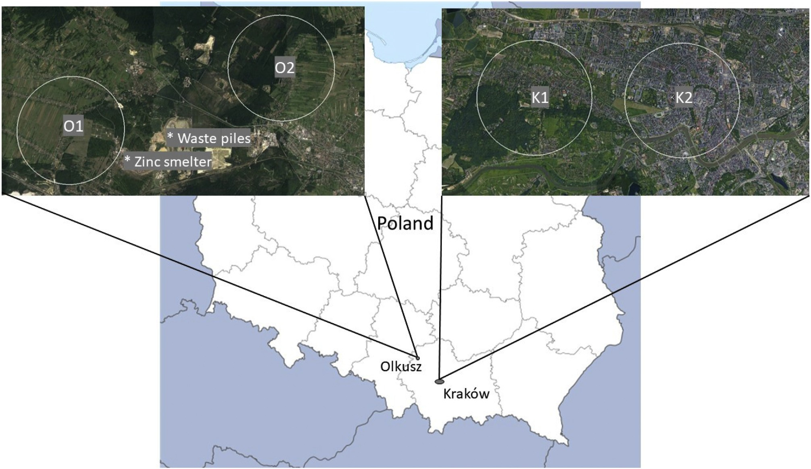
4
K. Zie˛ba et al. / Environmental Pollution 265 (2020) 114882
Fig. 1. Map of sampling sites in the city of Krako'w (urban sites) and near the Olkusz industrial area (industrial sites) in Poland. Circles showing the mean ﬂying distance of honeybees from their colony, while O1, O2, K1 and K2 showing the location of the colonies (three per site) and the location of the “Bolesław” Zinc Smelter and waste piles near Olkusz.
sampling time 0.33 min. The temperatures of the ion source and the quadrupole were 230 o C and 150 o C, respectively. Detection was conducted using electron impact ionization at 70 eV in selected ion monitoring (SIM) mode at an m/z of 78, 91, 106, 106, and 134 amu for selective detection and quantiﬁcation of benzene, toluene, ethylbenzene, p-xylene, and n-butylbenzene, respectively.
Unfortunately, no certiﬁed reference materials are available for honey bees and pollen or bee bread therefore we used the following hydrocarbon standards: benzene, toluene, ethylbenzene, p-xylene. Their LOD values were the following: benzene 0.243 ng/g and 0.6967 ng/g, toluene 0.189 ng/g and 0.866 ng/g, ethylbenzene
0.170 ng/g and 0.943 ng/g and p-xylene 0.766 ng/g and 0.420 ng/g for capped brood and pollen, respectively. Their LOQ values were the following: benzene 0.810 ng/g and 2.322 ng/g, toluene 0.631 ng/g and 2.885 ng/g, ethylbenzene 0.566 ng/g and 3.14 ng/g and p-xylene 2.553 ng/g and 1.399 ng/g for honeybees and bee bread, respectively. Hydrocarbon concentrations in standard solu- tions 1e6 were in the range of 0.167e0.850 mg/ml (hydrocarbon dissolved in methanol). The concentration of solution No. 7 was about 5 times higher than solution No. 6. Solution No. 7 was pre- pared to check whether the straightness of the calibration curve
was 2 min 14 samples of capped brood and 14 samples of pollen (0.4 g each) were prepared in glass vials. Then, each of the seven calibration solutions was dosed to two bee samples and two pollen samples in an amount of 50 ml. The amounts of individual hydro- carbons added to the samples equalled from 8.4 to 212.6 ng, which, based on 1 g of capped brood or pollen, gives values from 21 to 532 ng.
The weight of 0.4 g was the maximum mass of capped brood that could be obtained for one measurement from the average slice obtained for testing. Obtaining a smaller amount of sample would result in less volatile compounds evaporated to a larger volume of the headspace phase in the vial, and thus smaller peak areas and greater uncertainty in the results obtained. Despite weighing the same capped brood and pollen weight (0.4000 ± 0.0010 g) each time, these weights differ in volume, and thus the volume of the headspace phase in the vial (and the concentration of volatile substances in this phase) is different for each weighting. The addition of an internal standard to the weighing each time and taking into account its peak area in the calculations allows to eliminate differences in the peak areas resulting from unequal volumes of the supra-surface phase.
Therefore, in addition to calibration solutions, 43 ng of internal
standard (n-butylbenzene) in the form of a 50 mL methanol solution was added to the capped brood and pollen weights, and the vial prepared in this way was sealed and subjected to chromatographic analysis.
Linearity range for each hydrocarbon, for capped brood and pollen was 0.5 mg/g. Accuracy (and precision given as standard deviation) of actual value was 137.33 (±35.78)% and 126.76
(±20.71)% for benzene, 140.05 (±27.34) % and 149.07 (±39.42) % for
toluene, 101.27 (±12.48) % and 112.53 (±15.26) % for ethylbenzene and 107.61 (±14.33) % and 117.79 (±17.50) % for p-xylene for capped
(y ¼ ax þ b) was maintained at much higher concentrations.
Calibration of the chromatographic system for the analysis of
monocyclic aromatic hydrocarbons was performed not for pure
standard solutions, but for weights of capped brood and pollen with the addition of these solutions. This treatment was aimed at eliminating the inﬂuence of interference effects of matrix compo- nents on the course of the calibration curve.
Capped brood and pollen used for calibration were obtained from an apiary located outside Krako'w. They were packed into sealed bags immediately after being removed from the patch. After packing, the material was homogenised. The homogenization time
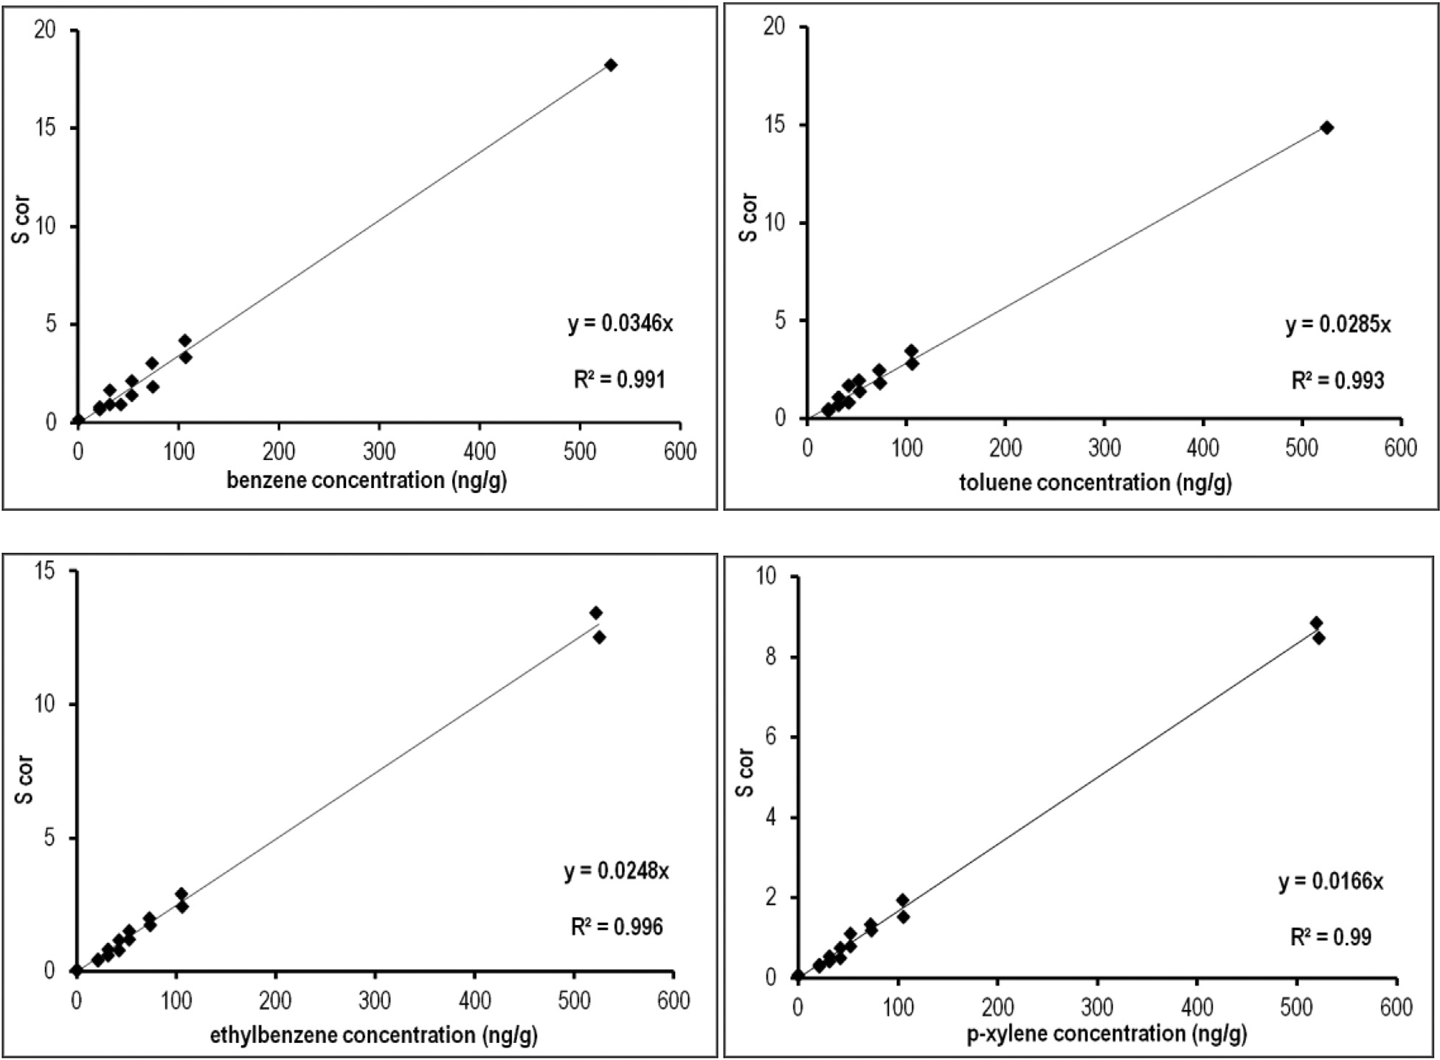
K. Zie˛ba et al. / Environmental Pollution 265 (2020) 114882
5
brood and pollen, respectively.
For the calculation of hydrocarbon concentrations in real sam-
used for paired comparison. All calculations were done using Sta- tistica 13 (Dell Statistica, 2016).
ples, calibration curve equations in the form y ¼ ax were used. The
calibration curves were plotted as the S_{cor} (corrected area) depen- dence on c (hydrocarbon content per gram of capped brood or pollen). S_{cor} was calculated as the quotient of the peak area char- acteristic of a given hydrocarbon and the peak area of the internal standard (n-butylbenzene) (Fig. 2).
For each colony, the level of pollen and capped brood pollution were counted based on a maximum of three repeated measure- ments per sample. We calculated the coefﬁcients of variance be- tween colonies from the same site at the same time in the season and in the same year. Then, we compared these values to the co- efﬁcient of variance between sites of the same type and from the same year using a t-test. The possible correlation between pollen and capped brood samples originating from the same families at the same time were compared using Spearman’s correlation, which is less sensitive to possible strong outliers.
Next, the mean values for all families per site were counted to assess pollution levels for each site. Due to the non-normal distri- bution of the data, non-parametric tests were used for further analysis. For comparison of pollen and capped brood contamination levels between years and site types, mean values counted for each site were used (to weigh against unequal colony number on some sites) and analysed using ManneWhitney’s U test. To compare pollen and capped brood contamination from the same family and to assess possible seasonal differences between sites, a t-test was
3. Results
We collected 43 pollen samples and 46 samples of capped brood from 12 hives, during the two years and during two different sea- sons (Table 1A and B). The level of mean BTEX pollution was generally higher in the pollen (mean ± SE: 29.2 ± 2.15 mg/kg) than
in the capped brood (17.3 ± 1.22 mg/kg)(t ¼ 21, df ¼ 16, p ¼ 0.015,
although in some cases in 2017, due to high ethylbenzene levels in some samples, this trend was reversed (Table 1A). An analysis based on the mean pollution levels calculated for each colony showed that the contamination of bee bread and capped brood with BTEX on urban and industrial sites were similar (bee bread:
U ¼ 30, p ¼ 0.878; capped brood: U ¼ 29, p ¼ 0.798) (Fig. 3).
However, some differences between the study years were found. The pollution levels found in the bee bread were higher in 2018
than in 2017 (U ¼ 6.0, p ¼ 0.005), but not in capped brood (U ¼ 30.0,
p ¼ 0.878) (Fig. 4). The mean BTEX contamination of bee bread
samples between spring (mean ± SE: 27.0 ± 2.95 mg/kg) and sum-
mer (31.4 ± 3.11 mg/kg) sampling were similar (t ¼ -1.23, df ¼ 19,
p ¼ 0.234) and the contamination of capped brood samples were
the same between seasons (spring mean ± SE: 16.8 ± 1.46 mg/kg and
summer 17.8 ± 1.99 mg/kg) (t ¼ -0.35, df ¼ 21, p ¼ 0.729).
Detailed analysis of the four measured components of BTEX
contamination did not show any signiﬁcant difference between the
Fig. 2. Calibration curves of four hydrocarbons (benzene, toluene, ethylbenzyne and - xylene). The S_{cor} (corrected area) dependence on c (hydrocarbon content per gram of capped brood or bee bread). S_{cor} was calculated as the quotient of the peak area characteristic of a given hydrocarbon and the peak area of the internal standard (n-butylbenzene).
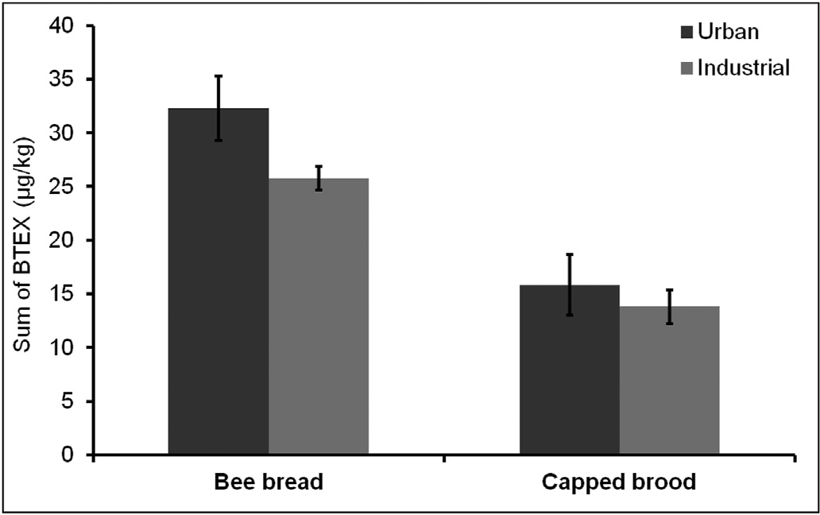
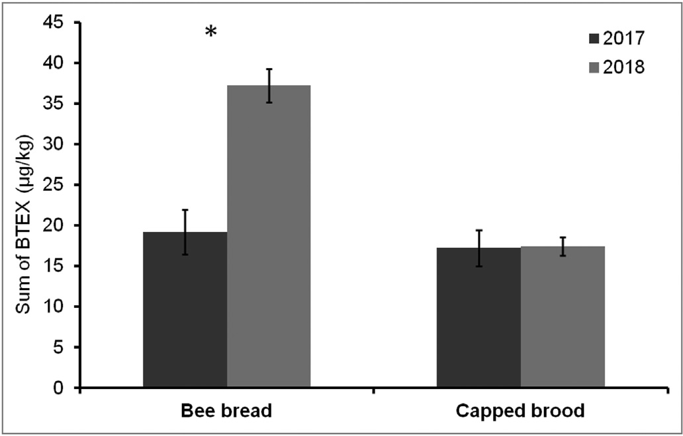
6
K. Zie˛ba et al. / Environmental Pollution 265 (2020) 114882
Table 1
Mean pollution (±SD) levels with BTEX on two industrial and two urban sites measured twice during the season: during spring and during the summer in bee bread stored by bees and in capped brood and in two consecutive seasons: 2017 (A) and 2018 (B).
A)
Urban sites
K1 spring Bee bread
K1 summer Bee bread
K2 spring Bee bread
K2 summer Bee bread
Capped brood
Capped brood
Capped brood
Capped brood
Benzene toluene ethylbenzene p-xylene
Sum of all pollutants (BTEX)
Proportion of BTEX in capped brood compared to pollen
0.4 ± 0.02
3.2 ± 0.28
0.4 ± 0.03
5.1 ± 0.17
9.0 ± 0.49
116.0%
0.1 ± 0.05
2.5 ± 0.84
3.6 ± 1.39
4.2 ± 1.27
10.5 ± 3.52
0.7 ± 0.23
14.4 ± 1.42
1.1 ± 0.13
23.5 ± 4.23
39.8 ± 5.7
63.0%
0.1 ± 0.07
6.1 ± 2.31
5.3 ± 2.55
13.5 ± 5.47
25.1 ± 10.3
1.6 ± 0.8
6.1 ± 2.21
0.8 ± 0.3
12.3 ± 10.29
20.8 ± 12.29
112.2%
0.2 ± 0.09
5.5 ± 0.91
9.0 ± 1.13
8.4 ± 0.78
23.1 ± 2.85
0.3 ± 0.16
6.6 ± 2.48
0.4 ± 0.15
10.0 ± 3.73
17.3 ± 6.42
91.5%
0.1 ± 0.00
3.9 ± 0.71
3.2 ± 0.4
8.6 ± 1.09
15.8 ± 2.1
Industrial sites
O1 spring Bee bread
O1 summer Bee bread
O2 spring Bee bread
O2 summer Bee bread
Capped brood
Capped brood
Capped brood
Capped brood
benzene toluene ethylbenzene p-xylene
Sum of all pollutants (BTEX)
Proportion of BTEX in pupa compared to pollen
0.3 ± 0.00
4.0 ± 0.00
0.3 ± 0.00
4.3 ± 0.00
8.9 ± 0.00
177.1%
0.2 ± 0.01
4.0 ± 0.4
5.6 ± 2.86
5.9 ± 1.34
15.7 ± 4.58
0.2 ± 0.07
6.5 ± 0.8
0.5 ± 0.09
7.8 ± 0.34
14.9 ± 1.3
220.8%
0.6 ± 0.3
12.3 ± 6.51
9.0 ± 0.77
11 ± 3.14
32.9 ± 10.62
0.7 ± 0.08
9.3 ± 1.2
0.5 ± 0.41
11.0 ± 1.39
21.4 ± 2.69
37.4%
0.3 ± 0.04
6.2 ± 0.63
e
1.6 ± 2.76
8.0 ± 2.23
0.2 ± 0.1
2.3 ± 0.57
e
2.4 ± 3.36
4.9 ± 2.69
31.7%
e
0.5 ± 0.03
e
1.1 ± 0.45
1.5 ± 0.48
B)
Urban sites
K1 spring Bee bread
K1 summer Bee bread
K2 spring Bee bread
K2 summer Bee bread
Capped brood
Capped brood
Capped brood
Capped brood
benzene toluene ethylbenzene p-xylene Sum of BTEX
Proportion of BTEX in pupa compared to pollen
7.5 ± 4.00
24 ± 2.67
1.8 ± 2.39
4.3 ± 6.59
37.6 ± 15.41
38.0%
2.3 ± 1.64
12.0 ± 4.29
e e
14.3 ± 5.93
9 ± 4.17
26.9 ± 2.53
4.2 ± 1.72
7.0 ± 2.79
47.1 ± 1.23
28.2%
1.2 ± 0.35
9.2 ± 2.12
1.3 ± 0.35
1.5 ± 0.51
13.3 ± 3.32
3.4 ± 1.08
21.8 ± 4.38
3.1 ± 1.47
6.1 ± 2.79
34.3 ± 9.22
59.3%
1.4 ± 0.15
12.3 ± 1.16
2.0 ± 0.27
4.7 ± 0.64
20.4 ± 2.1
9.2 ± 4.52
29.4 ± 7.9
2.6 ± 0.38
1.0 ± 1.7
42.1 ± 11.31
42.4%
1.6 ± 0.26
11.9 ± 1.11
1.8 ± 0.31
2.5 ± 0.28
17.8 ± 1.72
Industrial sites
O1 spring Bee bread
O1 summer Bee bread
O2 spring Bee bread
O2 summer Bee bread
Capped brood
Capped brood
Capped brood
Capped brood
benzene toluene ethylbenzene p-xylene Sum of BTEX
Proportion of BTEX in pupa compared to pollen
10.1 ± 9.89
16.3 ± 2.74
2.8 ± 0.94
4.7 ± 0.81
34.0 ± 13.8
80.1%
12.1 ± 1.36
10.6 ± 1.52
1.8 ± 0.32
2.8 ± 0.56
27.2 ± 3.7
6.9 ± 1.46
18.3 ± 3.79
3.8 ± 0.53
4.5 ± 1.85
33.5 ± 4.59
43.6%
1.3 ± 0.28
10.2 ± 1.68
1.4 ± 0.33
1.7 ± 0.58
14.6 ± 2.83
6.0 ± 3.13
17.2 ± 7.25
3.1 ± 1.32
5.5 ± 2.77
31.8 ± 14.45
46.1%
2.2 ± 0.6
9.5 ± 2.43
1.2 ± 0.15
1.8 ± 0.09
14.7 ± 3.27
7.1 ± 2.5
22.0 ± 2.32
3.9 ± 1.4
4.1 ± 1.04
37.1 ± 4.57
43.8%
1.5 ± 0.33
12.0 ± 2.43
1.5 ± 0.55
1.2 ± 0.96
16.2 ± 4.2
Fig. 3. Mean (±SE) BTEX (sum of benzene, toluene, ethylbenzyne and p-xylene) levels (mg/kg) in samples of bee bread and capped brood, collected on urban and industrial sites in Poland.
Fig. 4. Mean (±SE) BTEX (sum of benzene, toluene, ethylbenzyne and p-xylene) levels (mg/kg) in samples of bee bread and capped brood collected in Poland during two sampling seasons.
two types of sites, either in bee bread or in capped brood samples (Table 2A). The highest levels in both bee bread and capped brood was of toluene, while the lowest were ethylbenzene in bee bread and benzene in capped brood (Fig. 5a and b). There was also no signiﬁcant difference between the spring and summer samples of
the bee bread and the capped brood, except for toluene levels in the bee bread. The summer samples had signiﬁcantly higher toluene levels in the bee bread (Table 2B).
The benzene (r(40) ¼ 0.423, p ¼ 0.005), toluene (r(40) ¼ 0.604,
p < 0.001), and p-xylene (r(40) ¼ 0.561, p < 0.001) levels in the

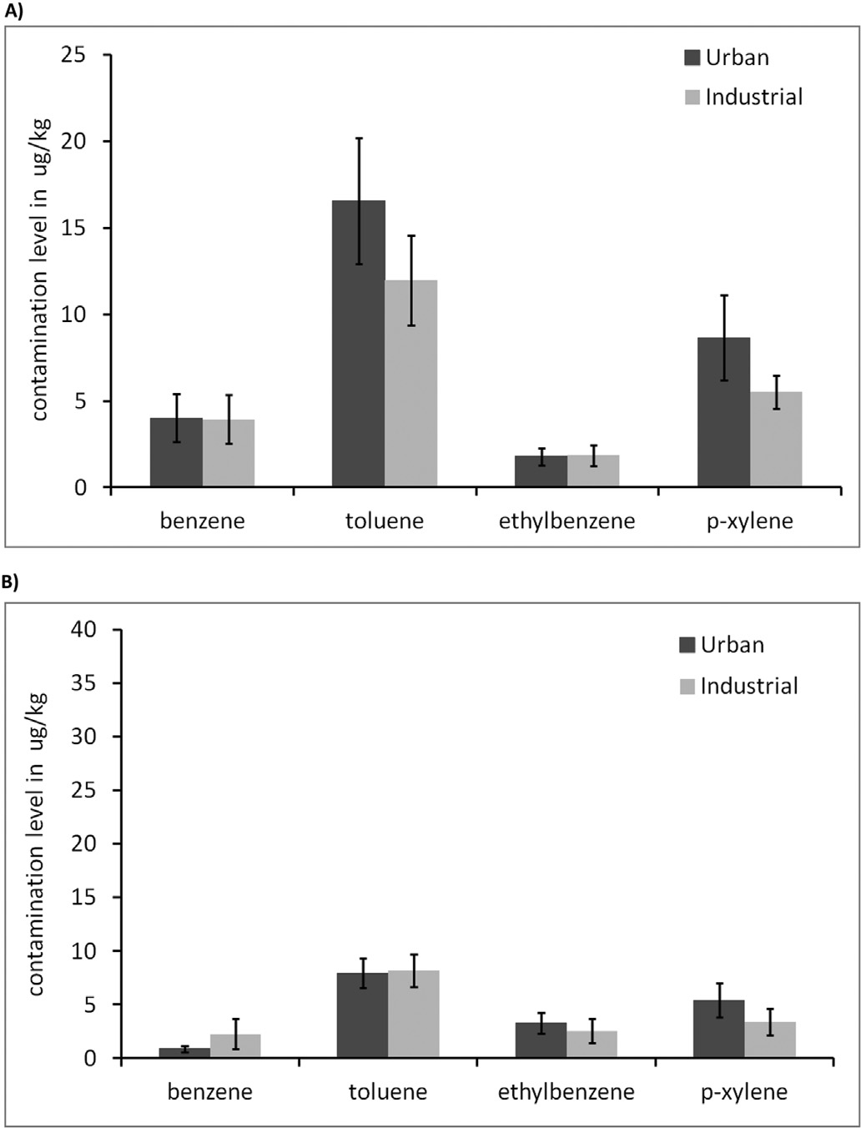
K. Zie˛ba et al. / Environmental Pollution 265 (2020) 114882
7
Table 2
Statistical comparison of the level of BTEX pollutants found in bee bread and capped brood samples between urban and industrial sites (A) and between spring and summer samples (B). * indicates statistically signiﬁcant difference.
A)
Bee bread
Capped brood
U
df
p
U
df
p
Benzene Toluene Ethylbenzene P-xylen
74.0
77.0
70.0
79.0
8
8
8
8
0.574
0.382
0.878
0.279
27.0
29.0
22.0
23.0
8
8
8
8
0.645
0.798
0.328
0.382
B)
Bee bread
Capped brood
Z
df
p
Z
df
p
Benzene Toluene Ethylbenzene P-xylen
1.94
46.0
79.0
97.0
20
20
19
20
0.232
0.028*
0.520
0.765
1.94
118.0
92.0
87.0
22
22
20
22
0.072
0.783
0.627
0.200
samples ranged between 9.6% and 41.5% (Table 3B). No signiﬁcant difference was found between the coefﬁcients of variance for the
bee bread and capped brood samples (t ¼ -0.46, df ¼ 15, p ¼ 0.652).
We also calculated the coefﬁcient of variance between sites and found similar or somewhat higher values as the coefﬁcient of variance between colonies at the same site (Table 3). For bee bread, the range was between 6.9% and 76.6% (Table 3A), while for capped brood it was 12.7%e71.6% (Table 3B).
4. Discussion
Our results show that the environmental monitoring of BTEX can be based on sampling honey bee capped brood, and bee bread in particular. However, there is a signiﬁcant difference in the uptake of these pollutants regarding sample type. Bee bread collected as a food source revealed consistently higher levels of BTEX than cap- ped brood (Fig. 3), as well as differences between years, as opposed to capped brood.
Honey bees in urban areas collect pollen from 0.5 to 1.2 km around the hive (Garbuzov et al., 2015). However, this 0.8e4.5 km² area in the case of urban honey bees may not be covered uniformly by foragers of each family. Bees learn the location of a food source from each other, so each colony might forage on different areas of this larger potential zone. Such foraging differences can result in varying pollution uptake depending on where in the surrounding area and on which ﬂowers bees of a certain colony mostly forage. These differences are quite visible when comparing the coefﬁcient of variance between colonies from the same site. Both bee bread and capped brood samples showed a wide variance, suggesting that the families studied indeed used different food sources, even when located on the same sites (Table 1). Actually, the coefﬁcient of variance between colonies from the same site and the coefﬁcient of variance between mean pollution levels of the four various sites are similar. The wide variance of pollution levels measured at the same site but in different hives shows clearly that monitoring should be based on more than one colony (Table 3). A minimum of three colonies, like in our study, or optimally more, should be used to achieve an accurate mean pollution level per site. This is even more true if only small differences are expected in pollution levels be- tween sites, like in our example. Various studies used so far different number of colonies for biomonitoring purposes. Some based their results on a single colony per site, others used more, usually at least three colonies per site.
Honey bee larvae are fed primarily royal jelly with a growing
addition of pollen over time. Pollen (both in the form of royal jelly
Fig. 5. Mean (±SE) benzene, toluene, ethylbenzyne and p-xylene levels (mg/kg) in samples of bee bread (a) and capped brood (b) collected in Poland on urban and in- dustrial sites.
capped brood corresponded positively to the pollution levels found in bee bread, while ethylbenzene showed a somewhat weaker and
negative correlation (r(40) ¼ - 0.350, p ¼ 0.023) between the two
sample types (Fig. 6).
The coefﬁcients of variance between the samples from the same site and the same season were compared, and we found that in the case of bee bread these values ranged between 2.6% and 59.2% per site (Table 3A), while in the case of the bee capped brood the

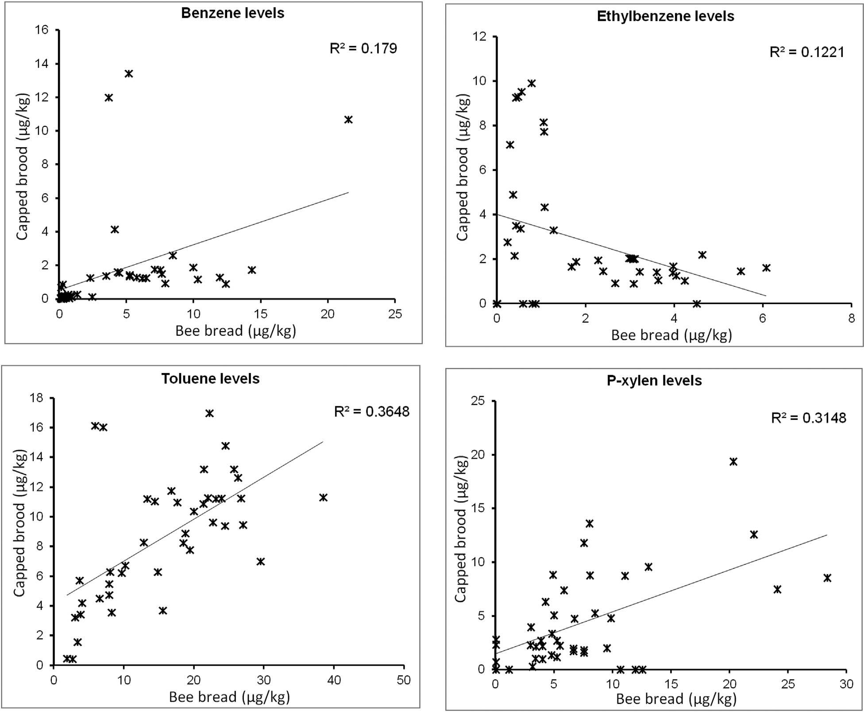
8
K. Zie˛ba et al. / Environmental Pollution 265 (2020) 114882
Fig. 6. Correlation of BTEX pollution levels (benzene, toluene, ethylbenzene, p-xylene) between capped brood and bee bread originating from the same colonies.
and as bee bread) is the larvae’s source of the proteins necessary for development. Lower pollution levels found in honey bee capped brood are a natural phenomenon and corresponds to the results of Lambert et al. (2012) who also found lower levels of PAHs in honey bee bodies, than in pollen samples on the same sites. In addition to protein (from pollen) bees also need carbohydrates, lipids, min- erals, and water for their development, which are found mostly in the honey produced from ﬂower nectar. Honey made from ﬂower nectar is a less polluted food source (Formicki et al., 2013; Joveti'c et al., 2018), so feeding the larvae both honey and pollen can explain the lower, more diluted pollution levels in the capped brood’s bodies.
Lower pollution levels in capped brood were not followed by lower variance levels, as one might expect. Pollution levels tend to present a left-skewed lognormal distribution, causing lower vari- ance in the case of lower mean values, due to the skewness of data. Therefore, one can assume that bee bread d with its higher mean pollution values and similar variance between samples from the same site d actually shows a more accurate picture of pollution than the less-polluted capped brood.
Bee bread pollution levels may also more accurately correspond to environmental pollution level than capped brood. The BTEX levels found in capped brood which were fed the bee bread present in the hive and analysed for pollution did not correspond fully to
the levels found in the bee bread. While in the bee bread samples, substantially more BTEX was found in 2018 in the capped brood, such increased levels of BTEX pollution did not appear in that year of our study; moreover, the capped brood actually showed similar levels on both site types and through both years, regardless of changes in bee bread pollution. There are two possible explana- tions: either there is a mechanism controlling some of the BTEX pollution levels in the capped brood or the nursing bees were choosing less-polluted bee bread to feed to the larvae. In both cases, monitoring of BTEX pollution in the capped brood may result in a false, reduced picture of overall pollution, due to the controlled or selective uptake of pollutants. This could explain why in our sam- ples the levels of three out of four pollutants (benzene, toluene, and p-xylen), nevertheless, correlated between the bee bread and capped brood samples, while one (ethylbenzene) did not, and actually showed a negative correlation. Assuming possible differ- ences in pollution levels at different time-points, there is also a possibility that in some cases the bee bread samples taken from the hive were not fresh and therefore represented a different time- frame for pollution than the larvae, which are usually fed fresh bee bread. Such a scenario could also cause not only discrepancies be- tween the pollution levels found in the capped brood and bee bread samples, but higher pollution levels in the capped brood than in the bee bread taken from the same colony at the same time. Such a
K. Zie˛ba et al. / Environmental Pollution 265 (2020) 114882
9
Table 3
Coefﬁcient of variance of BTEX pollution levels between colonies on the same sites and between sites in bee bread (A) and capped brood samples (B).
A)
Year
Area
Season
Site
Colonies with bee bread samples
Coefﬁcient of variance between colonies
Sites with bee bread samples
Coefﬁcient of variance between sites
2017
2017
2017
2017
2017
2017
2017
2017
2018
2018
2018
2018
2018
2018
2018
2018
Urban Urban Industrial Industrial Urban Urban Industrial Industrial Urban Urban Industrial Industrial Urban Urban Industrial Industrial
Spring Spring Spring Spring Summer Summer Summer Summer Spring Spring Spring Spring Summer Summer Summer Summer
K1 K2 O1 O2 K1 K2 O1 O2 K1 K2 O1 O2 K1 K2 O1 O2
2
3
1
3
3
3
3
2
3
3
3
3
3
3
3
3
5.4
59.2
12.6
14.3
37.1
8.7
55.2
41.0
26.8
40.6
45.4
2.6
26.9
13.7
12.3
3
46.7
4
76.6
4
6.9
4
14.9
B)
Year
Area
Season
Site
Colonies with capped brood samples
Coefﬁcient of variance per colony
Colonies with capped brood samples
Coefﬁcient of variance per colony
2017
2017
2017
2017
2017
2017
2017
2017
2018
2018
2018
2018
2018
2018
2018
2018
Urban Urban Industrial Industrial Urban Urban Industrial Industrial Urban Urban Industrial Industrial Urban Urban Industrial Industrial
Spring Spring Spring Spring Summer Summer Summer Summer Spring Spring Spring Spring Summer Summer Summer Summer
K1 K2 O1 O2 K1 K2 O1 O2 K1 K2 O1 O2 K1 K2 O1 O2
3
3
3
3
3
3
3
2
3
3
3
3
3
3
3
3
33.6
12.3
29.2
27.8
41.1
13.3
32.3
31.0
41.5
10.3
13.6
22.3
24.9
9.6
19.4
25.9
4
46.5
4
71.6
4
31.7
4
12.7
situation also occurred in our study at site O1, during both the spring and the summer sampling, and in the case of the spring samples from K1 and K2 in 2017 (Table 1). In the case of the O1 and K1 spring samples, in some of the colonies the amount of bee bread was actually too scarce to run the analysis; therefore, the results obtained from the bee bread are based on one or two colonies. This could also mean that the nursing bees in these colonies were forced to use all d probably leftover, older d bee bread in the hive to feed the sampled capped brood during open brood phase. As a result, they could have fed them bee bread which was more polluted, as it would have been collected earlier in the season when household heating was still causing more air pollution on these sites. Although in our case it might cause a discrepancy, yet sampling bee bread on marked combs (combs added at known dates and their ﬁlling up controlled) can allow for sampling pollutants for longer periods of time. Additionally bee bread sampling will not deprive the colony of fresh pollen completely, like in case of using pollen traps.
Based on our results, we suggest that for measuring and
monitoring of BTEX pollution the use of bee bread is a better source of information about environmental pollution levels than capped brood. Bee bread usually has a higher level of pollution than capped brood, which allows for more accurate analysis, and it is also easier to extract from the cell than capped brood. Bee larvae may also be fed selectively or may possess a mechanism which controls the uptake of BTEX from food. It is also important to remember that honey bee families d even if they are located in the same place d can prefer certain areas and pollen sources (ﬂowers). Therefore,
sampling should be based on a minimum of three, but ideally even more, bee families in order to have a better coverage of the tested area.
Declaration of competing interest
The authors declare that they have no known competing ﬁnancial interests or personal relationships that could have appeared to inﬂuence the work reported in this paper.
CRediT authorship contribution statement
Katarzyna Zie˛ ba: Methodology, Formal analysis, Investigation, Writing - original draft. Elz_ bieta Szostak: Formal analysis, Writing
- original draft. Krystyna Czekon'ska: Methodology, Investigation, Writing - original draft. Paweł Mi'skowiec: Methodology, Formal analysis, Investigation, Writing - original draft. Agnieszka Moos- Matysik: Formal analysis, Investigation, Writing - original draft. Anna Nyczyk-Malinowska: Investigation, Writing - original draft. Hajnalka Szentgyo€rgyi: Conceptualization, Methodology, Formal analysis, Investigation, Writing - original draft, Funding acquisition, Supervision.
Acknowledgements
This work was supported by the Polish National Science Centre, grant number: UMO-2016/21/B/NZ9/01163.

10
K. Zie˛ba et al. / Environmental Pollution 265 (2020) 114882
Appendix A. Supplementary data
s11252-014-0403-y.
GUS, 2018. Statistical Yearbook of the Republic of Poland Warsaw 2018. https://stat. gov.pl/obszary-tematyczne/roczniki-statystyczne/roczniki-statystyczne/ rocznik-statystyczny-rzeczypospolitej-polskiej-2018,2,18.html).
Haarmann, T.K., 1997. Honey bees as indicators of radionuclide contamination: exploring colony variability and temporal contaminant accumulation. J. Apicult. Res. 36 (2), 77e87. https://doi.org/10.1080/00218839.1997.11100933.
Haydak, M.H., 1963. Age of nurse bees and brood rearing. J. Apicult. Res. 2, 101e103 org/10.1080/00218839.1963.11100067.
Ismael, M.A., Elyamine, A.M., Moussa, M.G., Cai, M., Zhaoab, X., Hu, Ch., 2019. Cadmium in plants: uptake, toxicity, and its interactions with selenium fertil- izers. Metallomics 11, 255e277. https://doi.org/10.1039/c8mt00247a.
Joveti'c, M.S., Red~zepovi'c, A.S., Nedi'c, N.M., Vojt, D., ÐurCi'c, S.Z., Br~ceski, I.D., Milojkovi'c-Opsenica, D.M., 2018. Urban honey e the aspects of its safety. Arh. Hig. Rada. Toksikol. 69, 264e274. https://doi.org/10.2478/aiht-2018-69-3126.
Kargar, N., Matin, G., Matin, A.A., Buyukisik, H.B., 2017. Biomonitoring, status and source risk assessment of polycyclic aromatic hydrocarbons (PAHs) using honeybees, pine tree leaves, and propolis. Chemosphere 186, 140e150. https:// doi.org/10.1016/j.chemosphere.2017.07.127.
Lambert, O., Veyrand, B., Duran, D., Marchand, P., Le Bizec, B., Piroux, M., Puyo, S., Thorin, C., Delbac, F., Pouliquen, H., 2012. Polycyclic aromatic hydrocarbons: bees, honey and pollen as sentinels for environmental chemical. Chemosphere 86 (1), 98, 104contaminantsdoi.org/10.1016/j.chemosphere.2011.09.025.
Maragou, N.C., Pavlidis, G., Karasali, H., Hatjina, F., 2017. Major and minor element levels in Greek apicultural products. Global Nest J. 19 (3), 423e429. https:// doi.org/10.30955/gnj.002227.
Matin, G., Kargar, N., Buyukisik, H.B., 2016. Bio-monitoring of cadmium, lead, arsenic and mercury in industrial districts of Izmir, Turkey by using honey bees, propolis and pine tree leaves. Ecol. Eng. 90, 331e335. https://doi.org/10.1016/ j.ecoleng.2016.01.035.
Oleniacz, R., Bogacki, M., Szulecka, A., Rzeszutek, M., Mazur, M., 2016. Assessing the impact of wind speed and mixing-layer height on air quality in Krakow (Poland) in the years 2014e2015. J. Civ. Eng. Environ. Architect. 33, 315e342. https:// doi.org/10.7862/rb.2016.168, 63 (2/II/16).
Peng, Y.-S., Marston, J.M., 1986. Filtering mechanism of the honey bee proventric- ulus. Physiol. Entomol. 11 (4), 433e439. https://doi.org/10.1111/j.1365- 3032.1986.tb00434.x.
Perugini, M., Di Seraﬁno, G., Giacomelli, A., Medrzycki, P., Sabatini, A.G., Oddo, L.P., Marinelli, E., Amorena, M., 2009. Monitoring of polycyclic aromatic hydrocar- bons in bees (Apis mellifera) and honey in urban areas and wildlife reserves. J. Agric. Food Chem. 57, 7440e7444. https://doi.org/10.1021/jf9011054.
Pohl, P., 2009. Determination of metal content in honey by atomic absorption and emission spectrometries. Trends Anal. Chem. 28 (1), 117e128. https://doi.org/ 10.1016/j.trac.2008.09.015.
Ponikvar, M., S~najder, J., Sedej, B., 2005. Honey as a bioindicator for environmental
pollution with SO2. Apidologie 36, 403e409. https://doi.org/10.1051/apido: 2005027.
Satta, A., Verdinelli, M., Ruiu, L., Buffa, F., Salis, S., Sassu, A., Floris, I., 2012. Combi- nation of beehive matrices analysis and ant biodiversity to study heavy metal pollution impact in a post-mining area (Sardinia, Italy). Environ. Sci. Pollut. Control Ser. 19, 3977e3988. https://doi.org/10.1007/s11356-012-0921-1.
Schneider, Stanley S., McNally, Linda C., et al., 1993. Spatial foraging patterns and colony energy status in the African honey bee,Apis mellifera scutellata. J. Insect Behav. 6, 195e210. https://doi.org/10.1007/BF01051504.
Silva, A.S., Araújo, S.B., Souza, D.C., Santos, F.A., Silva, E., 2012. Study of the Cu, Mn, Pb and Zn dynamics in soil, plants and bee pollen from the region of Teresina (PI), Brazil. An Acad. Bras Cie^ncias 84 (4), 881e889.
Solayman, Md, Islam, A.M.D., Pau, S., Ali, Y. Md., Khalil, I. Md., Alam, N., Gan, S.G., 2015. Physicochemical properties, minerals, trace elements, and heavy metals in honey of different origins: a comprehensive review. Compr. Rev. Food Sci. Food Saf. 15 (1), 219e233. https://doi.org/10.1111/1541-4337.12182.
Szcze˛ sna, T., 2006. Long-chain fatty acids composition of honeybee collected pollen.
J. Apicult. Sci. 50, 65e79.
Visscher, P.K., Seeley, T.D., 1982. Foraging Strategy of Honeybee Colonies in a Temperate Deciduous Forest. Ecology 63 (6), 1790e1801. https://doi.org/ 10.2307/194012.
Waddington, K.D., Herbert, T.J., Visscher, P.K., Richter, M.R., 1994. Comparisons of forager distributions from matched honey bee colonies in suburban environ- ments. Behav. Ecol. Sociobiol. 35, 423e429 org/10.1007/BF00165845.
Wallwork-Barber, M.K., Ferenbaugh, R.W., Gladney, E.S., 1982. The use of honeybees as monitors of environmental pollution. Am. Bee J. 122, 770e772.
WHO Releases Country Estimates on Air Pollution Exposure and Health Impact, 2016. World Health Organization, Geneva. http://www.who.int/mediacentre/ news/releases/2016/air-pollution-estimates/en/. (Accessed 23 December 2016).
Supplementary data to this article can be found online at https://doi.org/10.1016/j.envpol.2020.114882.
References
Anderson, J.F., Wojtas, M.A., 1986. Honey bees (Hymenoptera: Apidae) contami- nated with pesticides and polychlorinated biphenyls. JEE (J. Econ. Entomol.) 79, 1200e1205. https://doi.org/10.1093/jee/79.5.1200.
Bargan'ska, Z_ ., S'lebioda, M., Namie'snik, J., 2015. Honey bees and their products:
bioindicators of environmental contamination. Crit. Rev. Environ. Sci. Technol. 46 (3), 235e248. https://doi.org/10.1080/10643389.2015.1078220.
Bari~si'c, D., Verta~cnik, A., Bromenshenk, J.J., Kezi'c, N., Luli'c, S., Hus, M., Petar
Kraljevi'c, P., S~impraga, M., Seletkovi'c, Z., 1999. Radionuclides and selected el- ements in soil and honey from Gorski Kotar, Croatia. Apidologie 30 (4),
277e287 org/10.1051/apido:19990403.
Beekman, Madeleine, Ratnieks, F.L.W., et al., 2000. Long-range foraging by the honey-bee, Apis mellifera L. Funct. Ecol. 14 (4), 490e496. https://doi.org/ 10.1046/j.1365-2435.2000.00443.x.
Bogdanov, S., 2006. Contaminants of bee products. Apidologie 38 (1), 1e18. https:// doi.org/10.1051/apido:2005043.
Bogdanov, S., Haldimann, M., Luginbühl, W., Gallmann, P., 2007. Minerals in honey: environmental, geographical and botanical aspects. J. Apicult. Res. 46 (4), 269e275. https://doi.org/10.1080/00218839.2007.11101407.
Bromenshenk, J.J., Carlson, S.T., Simpson, J.C., Thomas, J.M., 1985. Pollution moni- toring of puget sound with honeybees. Science 227, 632e634. https://doi.org/ 10.1126/science.227.4687.632.
Bromenshenk, J.J., Gudatis, J.L., Carlson, S.R., Thomas, J.M., Simmons, M.A., 1991. Population dynamics of honey bee nucleus colonies exposed to industrial pollutants. Apidologie 22, 359e369. https://doi.org/10.1051/apido:19910401.
Bunzl, K., Kracke, W., Vorwohl, G., 1988. Transfer of Chernobyl-derived 134 C s, l37 C s, 131 1 , and 103 R u from ﬂowers to honey, and 103 R u from ﬂowers to honey and pollen. J. Environ. Radioact. 6, 261e269.
Burchart-Korol, D., Korol, J., Czaplicka-Kolarz, K., 2016. Life cycle assessment of heat production from underground coal gasiﬁcation. Int. J. Life Cycle Assess. 21 (10), 1391e1403 org/10.1007/s11367-016-1102-0.
Chauzat, M.-P., Faucon, J.-P., Martel, A.-C., Lachaize, J., Cougoule, N., Aubert, M., 2006. A survey of pesticide residues in pollen loads collected by honey bees in France. J. Econ. Entomol. 99 (2), 253e262. https://doi.org/10.1093/jee/99.2.253. Conti, M.E., Botre', F., 2001. Honeybees and their products as potential bioindicators of heavy metals contamination. Environ. Monit. Assess. 69, 267e282 doi.org/
10.1023/A:1010719107006.
Conti, M.E., Canepari, S., Finoia, M.G., Mele, G., Astolﬁ, M.L., 2018. Characterization of Italian multiﬂoral honeys on the basis of their mineral content and some typical quality parameters. J. Food Compos. Anal. 74, 102e113. https://doi.org/10.1016/ j.jfca.2018.09.002.
Crane, E., 1984. Bees, honey and pollen as indicators of metals in the environment.
Bee World 65 (1), 47e49.
da Silva, P.M., Gauche, C., Gonzaga, L.V., Costa, A.C.O., Fett, R., 2016. Honey: chemical composition, stability and authenticity. Food Chem. 196, 309e323, 10.1016/j. foodchem.2015.09.051.
Dell Inc, 2016. Dell Statistica (Data Analysis Software System). software.dell.com version 13.
Dobrinas, S., Birghila, S., Coatu, V., 2008. Assessment of polycyclic aromatic hy- drocarbons in honey and propolis produced from various ﬂowering trees and plants in Romania. J. Food Compos. Anal. 21, 71e77 doi.org/10.1016/ j.jfca.2007.07.003.
Dziku'c, M., Adamczyk, J., 2015. The ecological and economic aspects of a low emission limitation: a case study for Poland. Int. J. Life Cycle Assess. 20 (2), 217e225. https://doi.org/10.1007/s11367-014-0819-x.
Dziku'c, M., Adamczyk, J., Piwowar, A., 2017. Problems associated with the emissions
limitations from road transport in the Lubuskie Province (Poland). Atmos. En- viron. 160, 1e8 doi.org/10.1016/j.atmosenv.2017.04.011.
Dz_ ugan, M., Zaguła, G., Wesołowska, M., Sowa, P., Puchalski, Cz., 2017. Levels of toxic
and essential metals in varietal honeys from Podkarpacie. J. Elementol. 22 (3), 1039e1048. https://doi.org/10.5601/jelem.2016.21.4.1298.
Formicki, G., Gren', A., Stawarz, R., Zy'sk, B., Gał, A., 2013. Metal content in honey, propolis, wax, and bee pollen and implications for metal pollution monitoring. Pol. J. Environ. Stud. 22 (1), 99e106, 2013.
Garbuzov, M., Schürch, R., Ratnieks, F.L.W., 2015. Eating locally: dance decoding demonstrates that urban honey bees in Brighton, UK, forage mainly in the surrounding urban area. Urban Ecosyst. 18, 411e418. https://doi.org/10.1007/

