Evol Ecol (2014) 28:131-140
DOI 10.1007/s10682-013-9664-9
ORIGINAL PAPER

Species size affects hatching response to different
temperature regimes in a rotifer cryptic species complex

Aleksandra Walczyńska • Manuel Serra
Received: 6 June 2013/Accepted: 25 June 2013/Published online: 5 July 2013
© The Author(s) 2013. This article is published with open access at Springerlink.com
Abstract The strategy of decreasing size with increasing temperature known as
Bergmann’s rule operates at geographic scale and in spite of extensive studies still presents
a puzzle to researches. The aim of this work was to verify whether patterns of diapausing
egg hatching of closely related species are consistent with the expectations from Berg-
mann’s rule. In a laboratory study of the cryptic species complex of the rotifer Brachionus
plicatilis, the response to temperature (17.5, 22.5, and 25.0 °C) of diapausing eggs col-
lected in a pond where the three tested species coexist was assessed by (1) the number of
hatchlings emerging or (2) the time needed to hatch. Our results show that the response to
temperature from the sediment egg bank is species-dependent. In line with Bergmann’s
rule, an association was observed between the hatching response to temperature and
organism size. The biggest species increased its proportion in the hatchlings as temperature
decreased, and vice versa. The intermediate size species showed an intermediate pattern.
Nevertheless, temperature showed a general positive effect on hatching success. Time
needed to hatch suggests a signature of Bergmann’s rule, but other factors seem to be
affecting this parameter. This is the first study to demonstrate differences in the thermal
dependence of diapausing egg hatching among closely related species with different body
sizes, and it supports that Bergmann’s rule can be applied to diapause, an important phase
in many invertebrate lifecycles.
Keywords Adaptation • Bergmann’s rule • Body size • Cryptic species • Egg bank •
Resting eggs
A. Walczyńska (&)
Institute of Environmental Sciences, Jagiellońiań University, Gronostajowa 7, 30-387 Krakow, Poland
e-mail: aleksandra.walczynska@uj.edu.pl
M. Serra
Institute Cavanilles for Biodiversity and Evolutionary Biology, University of Valencia,
A.O. 2085, 46071 Valencia, Spain
^ Springer
132
Evol Ecol (2014) 28:131-140

Introduction
Related taxa usually vary in adult size. This variation can be driven by a number of internal
and external factors, one of which is temperature. Bergmann (1847, cited in Watt et al.
2010) was the first to observe temperature-related differences in the body size of related
species, though initially his rule applied only to vertebrates at different latitudes. The so-
called ‘extended Bergmann’s rule’ describes genetic differences between closely related
species of all living organisms, leading to slower growth and larger size at high latitudes
(i.e., low mean temperature) than closer to the equator. The adaptive role of this universal
phenomenon has not been unequivocally established, and the rationale for such an adap-
tation is poorly understood (Angilletta 2008).
Closely related species coexisting in the same environment could be used to shed new
light on the adaptive significance of body size (Angilletta and Dunham 2003), as they have
similar morphology and ecology. The cryptic species complex Brachionus plicatilis rotifer
offers such a model. A cryptic species complex is a set of biological species not distin-
guished earlier due to their morphological similarity. Previously thought to be a single
cosmopolitan eurioic species (Walker 1981), the B. plicatilis complex apparently contains
at least 14 species (Suatoni 2003). Three of them co-occur in small ponds on the Medi-
terranean coast of Spain (Gomez et al. 1995; Ortells et al. 2003). In order from largest to
smallest, they are B. plicatilis (Müller) sensu stricto, B. ibericus and B. rotundiformis
(Tschugunoff) (Gomez et al. 1995; Ciros-Perez et al. 2001a; Lapesa et al. 2004; Fig. 1).
Their morphology (Gomez et al. 1995; Ciros-Perez et al. 2001a), reproduction (Carmona
et al. 1995; Gomez et al. 1997) and ecological specialization (Gomez et al. 1995, 1997;
Ciros-Perez et al. 2001b; Lapesa et al. 2002; Montero-Pau et al. 2011; Montero-Pau and
Serra 2011) have been described in detail. Brachionus is a group of cyclically partheno-
genetic rotifers which are seasonally active in the water column of lakes and ponds. These
organisms sexually produce diapausing eggs that remain in the sediment and can survive
adverse conditions. When good conditions resume, a fraction of these eggs hatches, pro-
ducing clones via parthenogenetic proliferation. Partial hatching is regarded as a bet-
hedging strategy, the by-product being huge banks of diapausing eggs (Garcia-Roger
2006a), similar to seed banks, where the eggs can remain viable for decades. B. plicatilis,
B. ibericus and B. rotundiformis are involved in seasonal succession with partially over-
lapping temporal distributions. B. plicatilis tends to occur in the water column in winter,
B. ibericus is present in spring and B. rotundiformis in spring and summer (Gomez et al.
1995). Being filtering feeders that consume microalgae, they compete. Laboratory studies
have shown that competition can result in exclusion or coexistence, depending on con-
ditions (Ciros-Perez et al. 2001b).
Production of diapausing eggs, essential for survival of the genotype during adverse
periods, is regarded as an interannual fitness measure (Serra and King 2001). The
expenditure of resources on diapausing egg production is huge: egg bank size is estimated
at billions of eggs even in a small pond (Garcia-Roger 2006a). An important fitness
component of the rotifer life cycle is related to diapausing egg hatching. Hatching at the
wrong time means a smaller chance to compete and proliferate. For instance, during the
increase of lake temperature from winter to summer, early hatching would incur the risk of
exposure to lethally low temperature, and late hatching would mean wasting proliferation
time in a competitive scenario. Hence, the theoretical expectation is that the hatching
response to temperature is correlated with the optimal temperature for a given species, the
eggs being programmed to hatch at the optimal temperature for the adults. Therefore, from
Bergmann’s rule, the expectation is a hatching response to temperature dependent upon
^ Springer
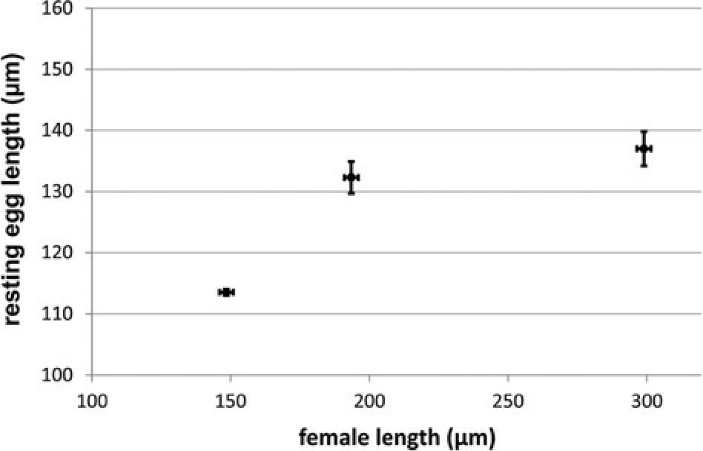
Evol Ecol (2014) 28:131-140
133
Fig. 1 Mean resting egg size related to mean female size for three species of the B. plicatilis cryptic species
complex (mean ± SE; data from Ciros-Perez et al. 2001a)
species body size, with a tendency for large body size animals to have high egg hatching
rates at low temperature. Additionally, it is also arguable that, if large size has a relative
physiological advantage at low temperature, it might affect the egg developmental per-
formance, with large eggs being more efficiently developed at low temperature if com-
pared to small eggs. Adult body size and egg size are commonly correlated, as found in the
three Brachionus species specified above (Fig. 1). These two arguments, based respec-
tively on the optimum for the adult and on egg development efficiency, work in the same
direction. Nevertheless, temperature accelerates metabolic rates and embryonic develop-
ment in ectotherms, so that a general trend to increased hatching rates with temperature
might be also expected. Thus, the question arises whether Bergmann’s rule has implica-
tions for leaving diapause, or if the general effect of temperature on metabolic rates is the
dominant effect.
Previous evidence suggests that rotifers hatch within certain species-specific tempera-
ture ranges corresponding to their thermal preference ranges (Pourriot and Snell 1983); the
temperatures that support adults are similar to those that promote hatching, though there
are exceptions (Cephalodella hoodi: Bell and Weithoff 2003, cited in Schroder 2005).
Within-species studies showed that hatchling fitness may increase with diapausing egg size
(Brachionus calyciflorus: Kirk 1997; Liu and Niu 2010; Synchaeta pectinata: Kirk 1997),
but that diapausing egg size did not influence the hatching pattern at two different tem-
peratures (B. calyciflorus Pallas: Liu and Niu 2010). Moreover, egg size and body size
were negatively related to temperature at intraspecific level in B. calyciflorus (Sun and Niu
2012).
Using the opportunity offered by a rotifer cryptic species complex—i.e., their mor-
phological similarity except in size, the aim of this study was to verify whether for the
three rotifer species the pattern of hatching from the sediment egg bank is associated with
species size in a manner predicted by the extended Bergmann’s rule. The response could be
manifested in the number of hatchlings at a particular temperature, or the time needed to
hatch. We are interested in showing that the developmental acceleration expected at higher
temperature does not neutralize completely the expectations from Bergmann’s rule. Thus,
the tested hypotheses are that, as the body size of the species increases, temperature has (1)
an increasingly negative effect on the proportion of hatchlings relative to those of other
species, and (2) an increasingly negative effect on the time of hatching.
^ Springer
134
Evol Ecol (2014) 28:131-140

Materials and methods
We used the egg bank from sediments taken from Torreblanca Poza Sur pond
(40°08.715'N, 0°10.059'E) in this study. This pond was the only one in the area where all
three Brachionus species were recorded in the egg bank (Garcia-Roger et al. 2008). We
used the sediment sample taken from the field in July 2007 and thereafter kept at 4 °C in
the dark until the experiments began in February 2012. Such long storage ensured com-
pletion of the obligatory period of diapause; for about one month, diapausing eggs do not
respond to hatching induction conditions (Hagiwara and Hino 1989). We exposed the eggs
to hatching conditions following the protocol of Garcia-Roger et al. (2008). We transferred
sediment aliquots (15 ± 0.5 g wet weight) to twelve 45-ml centrifuge tubes and separated
lightweight material, which included diapausing eggs, by sucrose flotation technique (Onbe
1978; Gomez and Carvalho 2000), by which each sample was resuspended in sucrose
solution (1:1 sucrose: water) and centrifuged (12.6g for 5 min). We washed the supernatant
thoroughly with diluted artificial seawater (Instant Ocean®, Aquarium Systems, Sarrebourg
Cedex, France) at 6 ppt salinity through 30-pm Nytal mesh which retained the diapausing
eggs, and kept the eggs in this washing solution to proceed to the hatching bioassay. We
selected 6 ppt salinity because previously it was found to be best for induction of diapa-
using egg hatching in the B. plicatilis species complex from Poza Sur pond (Garcia-Roger
et al. 2008). We repeated the procedure of resuspension in sucrose solution, centrifugation
and washing the eggs for the remaining organic material of each aliquot. We transferred
the material collected from an aliquot to Petri dishes to induce diapausing egg hatching.
One sample was accidently poured out, so we divided the 11 remaining Petri dishes among
three temperature regimes: 17.5 °C (four replicates), 22.5 °C (three replicates) and 25.0 °C
(four replicates). We kept constant illumination in each chamber (c. 75 pmol quan-
ta m-2 s-1) to induce hatching. We assigned the location of Petri dishes in the rack
randomly and changed it daily. Starting from the next day, we were checking all the Petri
dishes daily for hatching and removed the hatchlings. We monitored hatching in the Petri
dishes until day 14, when only one hatchling was recorded in all the samples. Then we
switched the temperature regimes of the Petri dishes in the low- and high-temperature
treatments, and divided two samples from the mid-temperature treatment (the third was
accidently poured out on the fourth day of observations) between low and high temperature
regimes. We continued checking for hatched individuals daily for another 9 days. We
made the final check 3 weeks after switching the regimes. However, this switch worked
only as a test of the method we applied and these observations were not analyzed
statistically.
To reliably identify the species of the hatchlings found in the Petri dishes, we singly
transferred the removed hatchlings to a well in 24-well plates and fed them with culture
medium containing the microalga Tetraselmis suecica. After parthenogenetic proliferation,
we fixed all clonal cultures founded from the hatchlings with Lugol’s solution. First, we
identified the cultured species as ‘Large’ (B. plicatilis) or ‘Small’ (B. ibericus or rotund-
iformis) morphotypes according to the description given by Ciros-Perez et al. (2001a), or as
a non-Brachionus species. To differentiate B. ibericus from B. rotundiformis, we examined
each ‘Small’ morphotype under a microscope (Olympus SZX7, SZX9) and identified it by
spine morphology (Ciros-Perez et al. 2001a). We identified other rotifers as bdelloids, or to
species if monogononts, using Koste’s (1978) key.
We calculated all statistics in this study with SPSS (IBM SPSS Statistics) 19.0. We
analyzed hatching counts in a generalized linear model (GLM) with a factorial design
(factors: species and temperature), assuming a Poisson distribution of data and using log as
^ Springer
Evol Ecol (2014) 28:131-140
135
link function (Nelder and Wedderburn 1972). In this design the effect of temperature on
hatchling counts is affected by the loss of a Petri dish and is not reliable, but the ‘spe-
cies x temperature’ interaction is the relevant effect to test a species-dependent response
to temperature (H1), and this effect is not affected by the replicate loss. It made no
difference for statistical analyses of factor interaction, as the statistical analysis corrects for
different counts in each main factor.
Survival analysis can be used to analyze the fate (e.g., death, hatching) of cases (e.g.,
individuals, eggs) followed through time. We used Cox regression to test for a species-
dependent effect of temperature on hatching time. The dependent variable was the time (in
days) from the start of the experiment, and the event was hatching. Both temperature and
species were categorical variables. We standardized the first day of hatching by assigning 1
to the day the first hatchling appeared for each replicate independently. For this analysis,
we grouped hatching times for each treatment and species combination regardless of the
replicate. Cox regression is not affected by the loss of a replicate because it focuses on the
average behavior at each temperature.

Results
A total of 525 hatchlings, most of them belonging to B. rotundiformis (Fig. 2) were
obtained and used to found clones and then classified. Another 113 clones were lost before
identification. In the replicate lost at 22.5 °C, we observed one B. plicatilis and seven
B. rotundiformis hatchlings before the day it was lost (day 4 of observations). We included
these data in the analysis. More than 80 % hatchings occurred in the first 5 days of
incubation. Temperature increased dramatically the propensity to hatch. Hatchlings per
sediment gram were 1.28 at 17.5 °C, 2.10 at 22.5 °C and 5.23 at 25 °C.
The GLM analysis of hatching counts integrated over time shows that both effects
(temperature and species) and their interaction are highly significant (Table 1). The species
effect may reflect trivial differences in species abundance in the diapausing egg bank, and
temperature effect is affected by the amount of tested sediment (i.e., replicate loss). The
prediction that a ‘species x temperature’ interaction occurs was confirmed by GLM. The
smallest species provided higher number of hatchlings regardless incubation temperature,
but meaningfully the biggest species decreased its proportion in the total hatchlings with
the incubation temperature (Fig. 3). Species percentages responded to temperature with
slopes 2.1 for the smallest species (B. rotundiformis), 0.49 for the intermediate species
(B. ibericus) and 2.6 for the biggest species (B. plicatilis), so that the slope is higher as the
rotifer is smaller.
Cox regression revealed a significant effect of the interaction between species and
temperature on the timing of hatching (Table 2; Fig. 2). However, average hatching time at
different temperature showed a complex species-dependent pattern (Fig. 4). B. rotundi-
formis had delayed hatching if compared to the other species, but hatched faster as
incubation temperature increased. According to Fig. 2, during the first two days of
hatching, B. plicatilis was more abundant than B. rotundiformis at 17.5 °C, but the opposite
was observed at the higher temperatures.
After switching the cultures to different temperature treatments, we found no Brachi-
onus individuals of the cultures switched from 22.5 or 25.0 °C at 17.5 °C. At 25.0 °C, we
noted one B. ibericus, two B. plicatilis and 24 B. rotundiformis. Three clones were lost
before identification. Apart from Brachionus, 11 other rotifers hatched in the course of the
experiment: four bdelloids (at all three temperatures), one Lecane hastata (25.0 °C) and
^ Springer

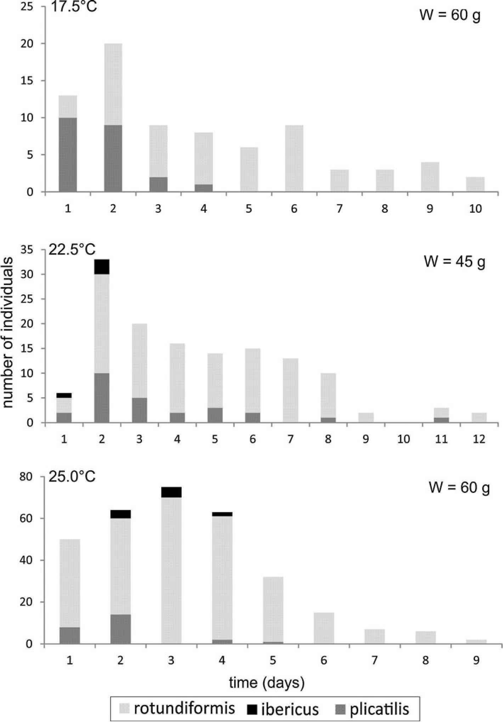
136
Evol Ecol (2014) 28:131-140
Fig. 2 Number of individuals of the three Brachionus species hatched from the sediment egg bank on
consecutive days of the experiment under three temperature regimes. The first day was standardized to the
day the first hatchling appeared, for each replicate independently. The numbers of individuals were then
summed for all replicates of a temperature treatment. W—total wet weight of sediment used to extract
resting eggs
1 Springer
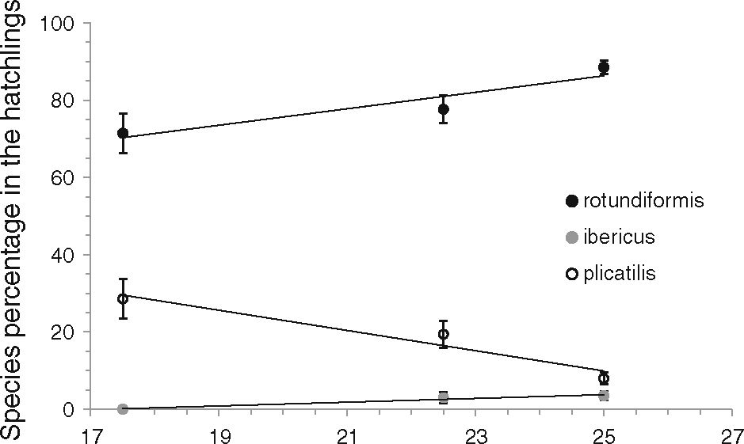
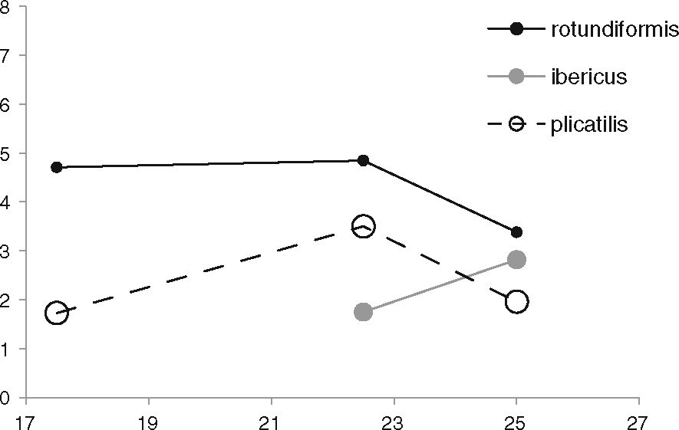
Evol Ecol (2014) 28:131-140
137
Table 1 GLM analysis of
effect of temperature on
hatching species
Factor | Wald  Chi-square | df | P
Intercept | 281.4 | 1 | <0.001
Temperature | 24.2 | 2 | <0.001
Species | 69.5 | 2 | <0.001
Temperature x species | 24.8 | 3 | <0.001
Fig. 3 Species percentage in the
hatchings observed at the
experimental temperatures for
diapausing egg incubation. Lines
were fitted using the least square
method. Vertical bars indicate
standard error estimations based
on a binomial distribution
Incubation temperature (oC)
Table 2 Cox regression analy-
sis of effect of temperature on
timing of species hatching
Factor | Wald  Chi-square | df | P
Temperature | 29.9 | 2 | <0.001
Species | 17.7 | 2 | <0.001
Temperature x species | 17.1 | 3 | 0.001
Fig. 4 Average incubation time
for hatching
U)
c
o
>
(C
~o
0)
U)
(C
0)
3
Incubation temperature (oC)
five Lecane inermis (one at 25.0 °C before the switch, one at 17.5 °C after the switch, and
three at 25.0 °C after the switch). One individual, probably Lecane, died before founding a
clone.
Ô Springer
138
Evol Ecol (2014) 28:131-140

Discussion
Our results show clearly that the response to temperature of hatching from the sediment
egg bank is species-dependent. This is an important finding, reported here for cryptic
rotifer species for the first time. Moreover, the results given in Fig. 3, when combined with
species body size, show an association between the diapause egg hatching response to
temperature and organism size. The biggest species increased its proportion in the
hatchlings as temperature decreased. The intermediate size species B. ibericus showed an
intermediate pattern, although based on a low number of hatchlings. Besides this species
differences, an underlying general effect of temperature on the number of hatchings seems
likely, as temperature increased dramatically this number. This general tendency could be
partially due the dominance of the smallest species in the hatchlings. However, the three
species tended to respond positively to temperature, but with different intensity. In sum-
mary, our results suggest that temperature favors hatching, presumably by accelerating
embryonic development, but that the species size is correlated to the proportions of
hatching in a way consistent with Bergmann’s rule.
Comparing only three species is somewhat limited. Nevertheless, the number of systems
where three cryptic, sympatric species can be compared is also limited. We suggest that our
experimental system, which compares species with very similar ecology, is particularly
appropriate to isolate a body size effect. The response of the intermediate size species
showed in Fig. 3 reinforces our conclusion of the implication of Bergmann’ rule in this
system.
Contrarily to the hatching proportions, the timing of hatching showed a more complex
pattern, and the average incubation time to hatching did not confirm completely Berg-
mann’s rule. The exception is that B. plicatilis had shorter average time to hatching at 25
than at 22.5 °C (Fig. 4), while the expectation was an increase steeper than in
B. ibericus, the intermediate size species. Since the early-hatched eggs start early clonal
proliferation, they are expected to contribute more to the populations than the late
hatched eggs. Given the high growth rates these rotifers have during the parthenogenetic
proliferation phase, starting early may provide a high advantage. Therefore, it is relevant
to know what happens in the first days of hatching. If the analysis is restricted to the
biggest and the smallest species, since B. ibericus contribute with few hatchlings, we see
that the expectation for Bergmann’s rules holds because B. plicatilis, the largest, was
three times more abundant than B. rotundiformis at 17.5 °C, but at the higher temper-
atures B. rotundiformis, the smallest, was twice (22.5) and five times (25.0 °C) more
abundant than B. plicatilis.
Potentially, hatchability might be affected by many factors, for example by salinity
(Kim and Hagiwara 2011a) or by age of mother (Kim and Hagiwara 2011b). However, our
results show temperature acts differentially on the egg bank of each species, so that
temperature effect is not masked by other factors. Moreover, we intentionally did not
control for factors during egg formation because we wanted to know the response in eggs
collected in the wild, from natural populations. The temperature-associated proportions of
hatching in the three Brachionus species are mostly in accordance with the thermal
preferences of adults (Gomez et al. 1995): of the three, B. plicatilis, the ‘‘winter’’ species,
is best adapted to low temperature and lives at 10.0 °C; the bigger of the ‘‘summer’’
species, B. ibericus, can live at 15.0 °C; the smallest ‘‘summer’’ species, B. rotundiformis,
prefers higher temperatures (Gomez et al. 1997).
The low number of B. ibericus that hatched in the course of the experiment is in agreement
with previous research. In a study of hatching from Poza Sur sediments, Garcia-Roger
^ Springer
Evol Ecol (2014) 28:131-140
139
(2006a) found that B. plicatilis, B. rotundiformis and B. ibericus contributed 44.7, 42.6 and
12.7 % respectively. The shares of B. plicatilis to B. ibericus were similar to those in the
present study, while the share of B. rotundiformis hatchlings was lower. That difference
may be due to the lower temperature they used, 20 °C, which in light of our study appears
suboptimal.
The unidentified clones should not affect the general pattern found, because the share of
each species among them was most probably random. Moreover, the number of clones that
were not identified because they did not proliferate increased with the day of observation,
meaning that individuals hatching after some critical time were not viable. Garcia-Roger
(2006b), however, found that 99.4 % of hatchlings survived to maturity. The discrepancy
between survival rates might be due to long storage of the sediment under laboratory
conditions in our study.
This study demonstrated that size is adaptive for temperature in the B. plicatilis cryptic
species complex. The study focused on egg size, a good proxy for adult size at interspecific
level (Pourriot and Snell 1983; our Fig. 1); it is justified to infer that what is actually
adaptive for temperature is the adult size of a species. Nevertheless, temperature is asso-
ciated in nature with other ecologically relevant factors, and low-temperature species are
expected to be adapted at a suit of factors. For instance, B. plicatilis seems to be adapted to
environmental fluctuations (Carmona et al. 1995) and it is likely more eurioic than the
other species studied here. Besides Bergmann’s rule at work, this could explain partially
our results, as B. plicatilis seems to be less temperature-specialized. The short times
needed for their diapausing eggs to hatch, despite the large size of these eggs, are also
consistent with an opportunistic strategy, expectable to evolve in a fluctuating scenario.
In summary, by studying a set of sympatric, cryptic species, we showed the applicability
of Bergmann’s rule to life-history traits associated to diapause, although our results suggest
that additional selective factors might have modeled those traits.
Acknowledgments We are grateful to Maria Jose Carmona, Carmen Gabaldon, Eduardo Garcia-Roger and
Javier Montero-Pau for advice and assistance at all stages of the study and two anonymous referees for valuable
comments on previous versions of the manuscript. We thank Eduardo Garcia-Roger for identifying non-
Brachionus species and M. Jacobs for editing the text. The study was funded by the Foundation for Polish Science
(POMOST/2011-3/12) and the Spanish Ministry of Economy and Competitiveness (CGL2009-07364).
Open Access This article is distributed under the terms of the Creative Commons Attribution License
which permits any use, distribution, and reproduction in any medium, provided the original author(s) and the
source are credited.

References
Angilletta MJ Jr (2008) Thermal adaptation: a theoretical and empirical synthesis. Oxford University Press,
Oxford
Angilletta MJ Jr, Dunham AE (2003) The temperature-size rule in ectotherms: simple evolutionary
explanations may not be general. Am Nat 162:332-342
Bell EM, Weithoff G (2003) Benthic recruitment of Zooplankton in an acidic lake. J Exp Mar Biol Ecol
285(286):205-219
Bergmann C (1847) Über die Verhältnisse der warmeokonomie der thiere zuihrer grosse. Gott Stud
1:595-708
Carmona MJ, Gomez A, Serra M (1995) Mictic pattern of the Brachionus plicatilis Müller 1786 in small
ponds. Hydrobiologia 313(314):365-371
Ciros-Perez J, Gomez A, Serra M (2001a) On the taxonomy of three sympatric sibling species of the
Brachionus plicatilis (Rotifera) complex from Spain, with the description of B. ibericus n. sp.
J Plankton Res 23:1311-1328
Ô Springer
140
Evol Ecol (2014) 28:131-140
Ciros-Perez J, Carmona MJ, Serra M (2001b) Resource competition between sympatric sibling rotifer
species. Limnol Oceanogr 46:1511-1523
García-Roger EM (2006a) Análisis demográfico de bancos de huevos diapausicos de rotíferos. PhD dis-
sertation, Institute Cavanilles, University of Valencia, Valencia, Spain
García-Roger EM (2006b) Hatching and viability of rotifer diapausing eggs collected from pond sediments.
Fresh Biol 51:1351-1358
García-Roger EM, Armengol-Díaz X, Carmona MJ, Serra M (2008) Assessing rotifer diapausing egg bank
diversity and abundance in brackish temporary environments: an ex situ sediment incubation approach.
Fund Appl Limnol 173:79-88
Gomez A, Carvalho GR (2000) Sex, parthenogenesis and the genetic structure of rotifers: microsatellite
analysis of contemporary and resting egg bank populations. Mol Ecol 9:203-214
Gomez A, Temprano M, Serra M (1995) Ecological genetics of a cyclical parthenogen in temporary
habitats. J Evol Biol 8:601-622
Gomez A, Carmona MJ, Serra M (1997) Ecological factors affecting gene flow in the Brachionus plicatilis
complex (Rotifera). Oecologia 111:350-356
Hagiwara A, Hino A (1989) Effect of incubation and preservation on resting egg hatching and mixis in the
derived clones of the rotifer Brachionus plicatilis. Hydrobiologia 186/187:415-421
Kim HJ, Hagiwara A (2011a) Effect of salinity during resting egg formation and hatching on descendent
reproduction in the rotifer Brachionus rotundiformis Tschugunoff. J Plankton Res 33:1033-1042
Kim HJ, Hagiwara A (2011b) Effect of female aging on the morphology and hatchability of resting eggs in
the rotifer Brachionus plicatilis Müller. Hydrobiologia 662:107-111
Kirk KL (1997) Egg size, offspring quality and food level in planktonic rotifers. Fresh Biol 37:515-521
Koste W (1978) Rotatoria. Die Rädertiere Mitteleuropas. (Oberordnung Monogononta.). Gebrüder Bornt-
raeger, Stuttgart
Lapesa S, Snell TW, Fields DM, Serra M (2002) Predatory interactions between a cyclopoid copepod and
three sibling rotifer species. Fresh Biol 47:1685-1695
Lapesa S, Snell TW, Fields DM, Serra M (2004) Selective feeding on Arctodiaptomus salinus (Copepoda,
Calanoida) on co-occurring sibling rotifer species. Fresh Biol 49:1053-1061
Liu W, Niu CJ (2010) Polymorphism in resting egg size and hatching strategy in the rotifer Brachionus
calyciflorus Pallas. Zool Sci 27:330-337
Montero-Pau J, Serra M (2011) Life-cycle switching and coexistence of species with no niche differenti-
ation. PLoS ONE 6:e20314
Montero-Pau J, Ramos-Rodriguez E, Serra M, Gomez A (2011) Long-term coexistence of rotifer cryptic
species. PLoS ONE 6:e21530
Nelder JA, Wedderburn RWM (1972) Generalized linear models. J R Stat Soc A 135:370-384
Onbe T (1978) Sugar flotation method for sorting the resting eggs of marine cladocerans and copepods from
sea-bottom sediment. Bull Jpn Soc Sci Fish 44:1411
Ortells R, Gomez A, Serra M (2003) Coexistence of cryptic rotifer species: ecological and genetic char-
acterisation of Brachionus plicatilis. Fresh Biol 48:2194-2202
Pourriot R, Snell TW (1983) Resting eggs in rotifers. Hydrobiologia 104:213-224
Schroder T (2005) Diapause in monogonont rotifers. Hydrobiologia 546:291-306
Serra M, King CE (2001) Optimal rates of bisexual reproduction in cyclical parthenogens with density-
dependent growth. J Evol Biol 12:263-271
Suatoni EM (2003) Patterns of speciation in the Rotifer species complex, Brachionus plicatilis. PhD dis-
sertation. Yale University, New Haven, CT
Sun D, Niu C (2012) Adaptive significance of temperature induced egg size plasticity in a planktonic rotifer,
Brachionus calyciflorus. J Plankton Res 34:864-873
Walker KF (1981) A synopsis of ecological information on the saline lake rotifer Brachionus plicatilis
Müller 1786. Hydrobiologia 81:159-167
Watt C, Mitchell S, Salewski V (2010) Bergmann’s rule: a concept cluster? Oikos 119:89-100
1 Springer

