GBE

Constraint and Adaptation in newt Toll-Like Receptor Genes
Wiesław Babik*, Katarzyna Dudek, Anna Fijarczyk, Maciej Pabijan, Michał Stuglik, Rafał Szkotak, and
Piotr Zielinski
Institute of Environmental Sciences, Jagiellonian University, Krakow, Poland
Corresponding author: E-mail: wieslaw.babik@uj.edu.pl.
Accepted: November 26, 2014
Data deposition: This project has been deposited at GenBank under the accessions KP180430-KP181615.

Abstract
Acute die-offs of amphibian populations worldwide have been linked to the emergence of viral and fungal diseases. Inter and
intraspecific immunogenetic differences may influence the outcome of infection. Toll-like receptors (TLRs) are an essential component
of innate immunity and also prime acquired defenses. We report the first comprehensive assessment of TLR gene variation for urodele
amphibians. The Lissotriton newt TLR repertoire includes representatives of 13 families and is compositionally most similar to that of
theanuran Xenopus. Both ancient and recent gene duplications have occurred in urodeles, bringing the total number of TLR genes to
at least 21. Purifying selection has predominated the evolution of newt TLRs in both long (~70 Ma) and medium (~ 18 Ma) timescales.
However, we find evidence for both purifying and positive selection acting on TLRs in two recently diverged (2-5 Ma) allopatric
evolutionary lineages (Lissotriton montandoni and L. vulgaris graecus). Overall, both forms of selection have been stronger in L. v.
graecus, while constraint on most TLR genes in L. montandoni appears relaxed. The differences in selection regimes are unlikely to be
biased by demographic effects because these were controlled by means of a historical demographic model derived from an inde-
pendent data set of 62 loci. We infer that TLR genes undergo distinct trajectories of adaptive evolution in closely related amphibian
lineages, highlight the potential of TLRs to capture the signatures of different assemblages of pathogenic microorganisms, and
suggest differences between lineages in the relative roles of innate and acquired immunity.
Key words: amphibia, Approximate Bayesian Computation, Lissotriton, positive selection, Toll-like receptors.

Introduction
Plant and invertebrate genes involved in detection of patho-
gens tend to evolve rapidly. They are characterized by per-
vasive positive selection in Drosophila (Sackton et al. 2007)
and by high gene turnover in multilocus families coupled
with transient balancing selection in plants (Tiffin and
Moeller 2006; Boller and He 2009). The need for high ge-
netic diversity of innate sensors may have been reduced in
vertebrates by transferring the role of the pathogen-specific
response to the molecules of the adaptive immune system
(Wlasiuk et al. 2009; Wlasiuk and Nachman 2010). However,
as evidenced by the diversity of the vertebrate innate
immune system (Akira et al. 2006; Hansen et al. 2011;
Kawai and Akira 2011), rapid recognition of conserved mo-
lecular patterns associated with pathogens is still essential.
Toll-like receptors (TLRs) are pattern recognition receptors
that sense conserved pathogen associated molecular patterns
(PAMPs; Akira et al. 2006; Kawai and Akira 2010). TLRs are of
paramount importance for the innate immune response and
also provide a crucial link between innate and adaptive
immune systems (Iwasaki and Medzhitov 2010; Kawai and
Akira 2010). Vertebrates usually have a limited number of
TLRs specialized in recognition of various PAMPs (Palti 2011;
Keestra et al. 2013). These TLR genes form several families
(Roach et al. 2005; Temperley et al. 2008) and representatives
of most families appear indispensable for an effective immune
response (Medzhitov 2001; Takeda et al. 2003).
Evolutionary rates in various TLR families have been re-
ported as similar and slow (Roach et al. 2005; Temperley
et al. 2008). Within the molecules, the extracellular part, con-
sisting of multiple leucine-rich repeats (LRR), is involved in
pathogen recognition and evolves faster than the intracellular
Toll/interleukin-1 receptor (TIR) domain responsible for intra-
cellular signaling (Mikami et al. 2012). However, the image of
a static, functionally conserved and slowly evolving TLR may
be oversimplified as suggested by interspecific differences in
ligand recognition (Werling et al. 2009; Palti 2011) and by
major differences in TLR repertoires among vertebrate
groups (Roach et al. 2005; Temperley et al. 2008).
Moreover, observations of multiple instances of recurrent
© The Author(s) 2014. Published by Oxford University Press on behalf of the Society for Molecular Biology and Evolution.
This is an Open Access article distributed under the terms of the Creative Commons Attribution License (http://creativecommons.org/licenses/by/4.0/), which permits unrestricted reuse,
distribution, and reproduction in any medium, provided the original work is properly cited.
Genome Biol. Evol. 7(1):81-95. doi:10.1093/gbe/evu266 Advance Access publication December 4, 2014
81
Downloaded from https://academic.oup.eom/gbe/article-abstract/7/1/81/599895 by Jagiellonian University user on 05 April 2019
Babiketal.
GBE
and episodic positive selection occurring in various taxonomic
groups on relatively short timescales (Wlasiuk et al. 2009;
Wlasiuk and Nachman 2010; Alcaide and Edwards 2011;
Tschirren et al. 2011) are inconsistent with slowly evolving
and strongly conserved TLR genes. Associations between
TLR polymorphism and susceptibility to infection have been
demonstrated in rodent (Tschirren et al. 2013) and human
(Netea et al. 2012) populations, again suggesting that epi-
sodes of positive selection in TLR genes may be prompted
by changes in PAMP or in the composition of pathogen com-
munities. Thus, TLR genes are substantially conserved, but ep-
isodic positive as well as transient balancing selection are not
uncommon and variation segregating in populations may be
of adaptive significance (Tschirren et al. 2012, 2013).
A detailed study of TLR polymorphism in human
populations revealed variable levels of constraint, abundant
polymorphism and recent positive selection at some loci
(Ferrer-Admetlla et al. 2008; Barreiro et al. 2009; Mukherjee
et al. 2009, 2014; Wlasiuk and Nachman 2010). The most
constrained human TLRs are 03, 07, 08, and 09 which act
as sensors of pathogen nucleic acids (NAs). Barreiro et al.
(2009) suggested that less constrained TLRs, in which mis-
sense or even nonsense mutations are tolerated, may be
promising targets of transient positive/balancing selection be-
cause polymorphisms segregating in populations for longer
periods of time should be available for selection if environmen-
tal conditions or pathogen pressure change. They also hypoth-
esized that changes in pathogen pressure may render some
innate immune receptor genes temporarily redundant. Such
fluctuations in selection regimes could potentially explain the
loss of certain TLR genes observed during vertebrate evolution
and may also facilitate the evolution of altered ligand
specificity.
Empirical evaluations of TLR polymorphism within and di-
vergence between closely related species have been per-
formed only in a handful of mammals and birds (Palermo
et al. 2009; Downing et al. 2010; Grueber et al. 2012;
Tschirren et al. 2012). The most comprehensive analyses in-
clude studies of humans (Barreiro et al. 2009) and apes
(Wlasiuk and Nachman 2010; Quach et al. 2013), which dem-
onstrated substantial interspecific differences in the strength
of purifying selection acting on TLRs. Similar information is
currently lacking for other vertebrate groups and for TLR
genes absent in amniotes.
The only amphibians for which TLRs have been character-
ized so far are clawed frogs of the genus Xenopus. These
anurans exhibit a TLR repertoire somewhat intermediate to
that of fish and terrestrial vertebrates (Ishii et al. 2007). No
data on the TLRs of urodele amphibians, a group which di-
verged from anurans about 300 Ma (Roelants et al. 2007),
have been reported so far. This is unfortunate as amphibians
are in a catastrophic decline partly attributed to emerging in-
fectious diseases (Cheng et al. 2011; Fisher et al. 2012).
Resistance to the most important of these diseases,
chytridiomycosis, is contingent both on genetic differences
among species (Woodhams et al. 2007) and variation within
species (Savage and Zamudio 2011). TLRs, by providing a link
between the innate and acquired branches of the immune
system, may be particularly relevant to understanding the fac-
tors that affect susceptibility to chytridiomycosis (Richmond
et al. 2009). Moreover, TLRs have been shown to mediate
antifungal immunity in other vertebrates (Roeder et al.
2004; Luther and Ebel 2006). Given the acute need for com-
prehensive information on amphibian immunogenetics, we
characterize the TLR repertoire and variation in urodeles
with a main focus on newts of the genus Lissotriton. We
use transcriptome sequences combined with high-throughput
amplicon sequencing to identify, characterize, and assess poly-
morphism in newt TLR genes. We then identify selection pres-
sures acting on the urodele TLR repertoire at long-term,
medium-term, and recent evolutionary time scales.
Specifically, we address the following questions: 1) what is
the repertoire of TLR genes in urodeles and how does it com-
pare to that of other vertebrate groups? 2) what is the extent
of selective constraint of individual TLR genes in urodeles? Are
there differences in constraint between amphibians and mam-
mals, especially in NA-sensing and nonNA-sensing genes? 3) is
there evidence of recent positive selection or polymorphisms
of adaptive significance segregating in TLR genes in distinct
evolutionary lineages of Lissotriton newts? 4) do overall pat-
terns of selection on TLRs differ between lineages when con-
trolling for historical demography?

Materials and Methods
Identification of the TLR Repertoire in the newt
Transcriptome
Transcripts of TLR genes were identified in transcriptome as-
sembled from liver and spleen mRNA of 14 newts. Liver tran-
scriptomes of six Lissotriton montandoni and six L. vulgaris and
spleen transcriptomes of two L. vulgaris were sequenced.
Sequencing libraries were prepared using the TruSeq RNA
kit starting from total RNA and sequenced with HiSeq2000
(Illumina). In total 471 million pairs (on average 33.6 ± [SD] 9.6
million per sample) of 100 bp reads were used for assembly
with Trinity (Grabherr et al. 2011). A database of TLR protein
sequences compiled from a diverse set of vertebrate species
was used to identify TLR transcripts (using BLASTx algorithm)
in the assembled transcriptome. The two Lissotriton species
are closely related; due to ongoing hybridization and incom-
plete lineage sorting, they share a large number of polymor-
phisms, and in most gene trees the species are not reciprocally
monophyletic (Zielinski et al. 2013; Pabijan M, Zielinski P,
Babik W, unpublished data). Therefore we did not attempt
to reconstruct TLR transcripts for each species; instead we
used the assembled contig as a representative L. montan-
doni/vulgaris TLR-coding sequence for comparisons with
82 Genome Biol. Evol. 7(1):81-95. doi:10.1093/gbe/evu266 Advance Access publication December 4, 2014
Downloaded from https://academic.oup.eom/gbe/article-abstract/7/1/81/599895 by Jagiellonian University user on 05 April 2019
Constraint and Adaptation in TLR Genes
GBE
other vertebrates. We did not analyze noncoding parts of the
transcripts but took advantage of this information to design
primers for an assessment of TLR polymorphism.
Transcripts of a number of TLR genes were identified in the
newt transcriptome. Some of them were highly divergent
from TLRs of other vertebrates. A phylogeny of vertebrate
TLR proteins including those inferred from newt transcripts
was used to assign newt genes to TLR families. This phylogeny
included all major vertebrate TLR families, with several repre-
sentatives from each to facilitate alignment. We searched the
transcriptome derived from multiple tissues of the red-spotted
newt (Notophthalmus viridescens) (Abdullayev et al. 2013) for
orthologs of Lissotriton TLR genes and included them in the
phylogenetic analysis if complete open reading frames (ORFs)
could be identified. Alignment was done with MAFFT (Katoh
et al. 2002) using the L-INS-i strategy and the BLOSUM45
substitution matrix. The best fitting model of amino acid sub-
stitution, the WGA model including rate variation among sites
and a nonzero proportion of invariable sites (WGA + G +1 + F),
was selected in ProtTest 3.3 (Darriba et al. 2011). Phylogenetic
trees were constructed with the neighbor-joining method
with 1,000 bootstrap replicates from a matrix of Jones-
Taylor-Thornton distances in MEGA5 (Tamura et al. 2011)
and using model-based Bayesian inference in MrBayes 3.2.2
(Ronquist and Huelsenbeck 2003). The Bayesian analysis was
run for 106 steps with trees sampled every 200 steps and the
first 25% of sampled trees discarded as burn-in; two analyses
run in parallel, each consisting of one cold and three heated
chains, converged on the same posterior distribution as evi-
denced by the standard deviation (SD) of split frequencies less
than 0.01. An additional phylogenetic analysis was performed
for the TLR05 family, which includes members lacking TIR and
transmembrane domains; these genes in fish encode a soluble
TLR05S form (Tsujita et al. 2004; Palti 2011). Alignment,
model selection (also resulting in the WGA + G + I + F model)
and phylogenetic analyses were performed as described
above. Protein domains were identified using SMART
(Letunic et al. 2012).
The selection landscape has been reported to differ be-
tween "cell surface" versus "endosomal" (Barreiro et al.
- or "viral" versus "nonviral" (Wlasiuk and Nachman
- TLRs. To test this hypothesis in newts, we had to
modify the criteria of classification because not all newt TLRs
could be unambiguously assigned to defined classes: protein
(profilin) sensing TLR12 localizes into the endosomal compart-
ment (Yarovinsky 2014), endosomal TLR13 senses bacterial
rRNA (Oldenburg et al. 2012) while dsRNA-sensing TLR22 is
present on the cell surface (Matsuo et al. 2008). As the core of
the hypothesis is the difference in patterns of selection be-
tween NA sensing and other TLRs, we classify newt TLRs
into two groups according to their ligands: NA-sensing (NA:
TLR03, 07, 08, 09, 13, 21, 22) or nonNA-sensing TLRs
(nonNA: TLR01, 02, 05, 05L, 12, 14) (Palti 2011; Oldenburg
et al. 2012; Keestra et al. 2013; Koblansky et al. 2013; Pietretti
and Wiegertjes 2014; Rauta et al. 2014). The ligand forTLR14
remains unknown, but this gene falls into the TLR01/02 family
and therefore was tentatively classified as nonNA. The TLR19
ligand is also unknown, but this gene is so divergent from
other TLR families that we did not assign NA/nonNA status.
TLR Expression in Liver and Spleen
TLRs were identified from deep-sequenced transcriptomes of
two organs: liver and spleen. Although only two spleen tran-
scriptomes were available, it was nevertheless possible to
meaningfully compare the level of expression of various TLRs
between organs. Analysis was performed using a pipeline dis-
tributed within the Trinity package. First, it uses RSEM (Li and
Dewey 2011) to calculate transcript abundance based on
reads mapped to TLRs with Bowtie (Langmead et al. 2009).
Next, differentially expressed genes were identified with
edgeR (Robinson et al. 2010), a Bioconductor package
(Gentleman et al. 2004), with trimmed mean of M-values
normalization, which accounts for differences between sam-
ples in the number of reads. We used a 10~3 false discovery
rate and 4-fold change threshold to identify tissue-biased
genes.
Polymorphism and Divergence of newt TLR Genes
Examination of TLR polymorphism and divergence within and
between closely related species was facilitated by the genomic
structure of the vertebrate TLR genes: in most genes the entire
or an overwhelming majority of the coding region is com-
posed of a single exon. We could therefore design primers
for amplification of TLR genes from genomic DNA in over-
lapping 800-1,000 bp fragments (supplementary table S1
and fig. S1, Supplementary Material online). Each polymerase
chain reaction (PCR) was performed in 15 ml and contained
7.5 ml of HotStarTaq PCR Master Mix (Qiagen), 1.0 mM of each
primer and 50-100 ng of genomic DNA. The following PCR
protocol was used: 95°C/15min, 35 x (94°C/30s, 55°C/30s,
72°C/60 s), 72°C/10 min. Amplified fragments were pooled in
an equimolar fashion. For each newt, a fragment library was
prepared using the Nextera XT kit (Illumina) according to the
manufacturer's protocol. Indexed libraries were sequenced on
a MiSeq (Illumina), producing 2 x 150 bp reads. Mapping of
reads to reference, single nucleotide polymorphism-calling
and physical reconstruction of haplotypes were done as de-
scribed in Zielinski et al. (2014), resulting in phase-resolved
haplotypes (alleles) for most heterozygous individuals. In
some cases certain positions could not be physically phased;
these were phased computationally using PHASE (Stephens
et al. 2001; Stephens and Donnelly 2003); physically phased
alleles and homozygous individuals were provided as known
haplotypes.
To test the mode of natural selection operating on newt
TLR genes, we performed analyses of polymorphism and di-
vergence using two complementary sampling schemes
Genome Biol. Evol. 7(1):81-95. doi:10.1093/gbe/evu266 Advance Access publication December 4, 2014
83
Downloaded from https://academic.oup.eom/gbe/article-abstract/7/1/81/599895 by Jagiellonian University user on 05 April 2019
Babik et al.
GBE
(supplementary fig. S2, Supplementary Material online). A
single L. helveticus individual was used as an outgroup. In
the first scheme 16 L. montandoni and L. vulgaris individuals
were selected, representative of genetic diversity of both spe-
cies (Babik et al. 2005; Nadachowska and Babik 2009;
Nadachowska-Brzyska et al. 2012). This species-wide data
set was useful for some selection tests such as the
McDonald-Kreitman (MK) test, because high overall variation
increases power. Due to strong genetic structure in Lissotriton,
this sampling strategy was not well suited for neutrality tests
based on site-frequency spectra (Stadler et al. 2009).
Therefore we also used a population sampling strategy, involv-
ing two genetically distinct groups which we consider as re-
gional populations: 1) L. vulgaris graecus from Albania, Greece
and Macedonia and 2) L. montandoni from the southern part
of its range. Genetic variation within these regional popula-
tions is substantial but differentiation between demes is lim-
ited (Pabijan et al. forthcoming; Zielinski et al. 2013). Newts
form discrete demes corresponding to breeding ponds, such
demes undergo extinction and recolonization, and thus the
regional population can be considered a metapopulation
(Marsh and Trenham 2001; Smith and Green 2005). It has
been shown (Wakeley 1999, 2004; Wakeley and Aliacar
2001) that if one gene copy per locus is sampled per deme,
the ancestral process producing such sample is identical to the
unstructured coalescent process, if time is rescaled appropri-
ately. We approximated this optimal strategy by sampling
multiple localities, with one individual sampled per locality.
For the species-wide data set we sequenced almost entire
coding sequences of TLR genes (on average 2.4kb per
gene); for the population data set we focused on the more
variable external domain (~1.5 kb).
Basic measures of polymorphism and divergence including
the number of segregating sites (S), number of alleles, overall
(p), synonymous (pS) and nonsynonymous (pN) nucleotide di-
versities, Tajima's D and Fay and Wu's H were calculated in
DnaSP 5.1 (Librado and Rozas 2009) and mstatspop
(http://bioinformatics.cragenomica.es/numgenomics/people/-
sebas/software/software.html, last accessed December 20,
2014). For completeness, we report values of D and H for
synonymous, nonsynonymous and all sites combined, but
test significance only for synonymous and nonsynonymous
sites. Statistical significance of D and H was tested by com-
paring the observed values to the null distributions obtained
through 100,000 coalescent simulations in ms (Hudson 2002)
under an appropriate demographic model (supplementary
tables S2 and S3, Supplementary Material online). The demo-
graphic model was selected and its parameters estimated
using sequences of 62 markers located in 30-untranslated re-
gions (UTR) of transcripts (Zielinski et al. 2014) within the
Approximate Bayesian Computation (ABC) framework; details
are given in supplementary material, Supplementary Material
online. The null distributions of D and H for each TLR were
obtained using synonymous and nonsynonymous mutation
rates estimated by comparison with L. helveticus which di-
verged approximately 18.4 Ma (Pabijan et al. forthcoming)
and a single recombination rate estimated in the ABC analysis
(supplementary table S3, Supplementary Material online).
Modes and Strength of Natural Selection Acting on newt
TLR Genes
The maximum-likelihood estimate of the ratio of nonsynon-
ymous to synonymous divergence between TLR sequences of
L. vulgaris/L. montandoni and Notophthalmus was calculated
in PAML 4.7 (Yang 2007). The effects of nonsynonymous
substitutions were predicted using PROVEAN (Choi et al.
2012). SNiPRE (Eilertson et al. 2012), an MK-like method uti-
lizing information from multiple genes to detect selection was
used to estimate the measure of constraint f (the proportion of
nonlethal nonsynonymous mutations). This analysis was done
using species-wide data set. The standard MK test was calcu-
lated using DnaSP on both species-wide and population
data sets.
The Hudson-Kreitman Aguade (HKA) test assesses hetero-
geneity of the ratio of intraspecific polymorphism to interspe-
cific divergence; significant heterogeneity indicates that some
of the investigated genes have been affected by differential
selection. Because HKA is known to be sensitive to population
structure (Ingvarsson 2004), we applied this test only to the
population data set. The multilocus HKA test was calculated in
the program HKA (https://bio.cst.temple.edu/~hey/software/
software.htm); significance was assessed with 10,000 coales-
cent simulations. Because the HKA test was significant in both
lineages, we used the maximum-likelihood version of the test
(Wright and Charlesworth 2004) to determine which genes
are under selection. Likelihood-ratio tests were used to com-
pare the null neutral model to models in which a particular
gene is affected by selection. Tests were done in the program
MLHKA (http://wright.eeb.utoronto.ca/programs/) with chain
length of 200,000 steps.
The distribution of selection coefficients within the TLR
genes was investigated using a population genetics-phyloge-
netics approach implemented in the program gammamap
(Wilson et al. 2011). This method is embedded in a Bayesian
framework and models evolution of codons to explain both
observed intraspecific polymorphism and interspecific diver-
gence. A sliding window approach is used to model variation
in selection pressures along genes and infer the posterior
probability of positive selection for each codon. The analysis
was performed on sequence data from L. montandoni and
L. v. graecus, and a single outgroup (L. helveticus) sequence.
Prior distributions on all model parameters were chosen as in
Wilson et al. (2011). We assumed lineage-specific priors for
the distribution of fitness effects (DFE), sliding window
smoothing parameter (p), branch length (T), and transi-
tion:transversion ratio (k). An uninformative, symmetric
Dirichelet prior was applied on DFE, where 12 fitness classes
84 Genome Biol. Evol. 7(1):81-95. doi:10.1093/gbe/evu266 Advance Access publication December 4, 2014
Downloaded from https://academic.oup.com/gbe/article-abstract/7/1/81/599895 by Jagiellonian University user on 05 April 2019
Constraint and Adaptation in TLR Genes
GBE
ranging from effectively inviable to beneficial (g = -500,
-100, -50, -10, -5, -1, 0, 1, 5, 10, 50, 100) are equally
likely. We employed a uniform prior on p within interval (0,1),
and improper log-uniform priors on k and T. The population-
scaled mutation parameter 0 was assigned a separate log-
normal prior distribution for each lineage and each gene
with hyperparameters mean m and SD ct. The mean m was
given an improper uniform prior and SD ct was given a log-
normal prior with mean 0 and SD 2. The posterior distributions
of selection coefficients for each codon (g) together with all
other parameters were estimated jointly in six separate
MCMC runs, each 3,000,000 steps long, with values recorded
every 50 steps. Mixing conditions for each parameter were
adjusted beforehand. We removed the first 300,000 steps as
burn-in and compared chains for convergence. The final esti-
mates were obtained by merging values from all chains
together.

Results
TLR Repertoire and Expression in newts
Sixteen TLR genes were identified in the Lissotriton transcrip-
tome (fig. 1). In most cases assignment to TLR families was
straightforward. However, the classification of two genes
(TLR12 and TLR19) should be regarded as tentative because
of high sequence divergence from other vertebrate genes
(fig. 1). Representatives of all major vertebrate TLR families
except TLR04 were found in the Lissotriton transcriptome.
The TLR repertoire is similar to that of Xenopus. Notable dif-
ferences include the lack of divergent TLR14 paralogs, and the
presence of TLR19 which has so far been detected only in fish.
Xenopus has only four genes in the TLR11 (sensu Roach et al.
2005) family, whereas Lissotriton has six (fig. 1). TLR09 and
TLR22 underwent duplication in urodeles before the diver-
gence of Lissotriton and Notophthalmus approximately
70 Ma. Full-length ORFs of 11 and partial ORFs of four appar-
ent orthologs were identified in the Notophthalmus transcrip-
tome, making TLR12 the only TLR gene not detected in the
available Notophthalmus assembly (table 1). A short gene
from the TLR05 family (TLR05L), lacking the transmembrane
and TIR domains, is present in the newt transcriptome.
Phylogenetic analysis demonstrated that it is not orthologous
to the teleost soluble TLR05S (supplementary fig. S3,
Supplementary Material online).
Domain structure of newt TLR proteins is generally similar
to that of Xenopus (fig. 2). Remarkably, neither newt nor frog
has a SMART-identifiable transmembrane domain in TLR07.
Newts do not have a transmembrane domain in TLR22, a
feature shared with fugu TLR22 and 23 proteins but not
with Xenopus TLR22. The presence of three transmembrane
domains (fig. 2) is a unique feature of newt TLR12.
All TLR genes were expressed in both liver and spleen al-
though expression level differed widely across genes and
organs; the differences spanned almost three orders of mag-
nitude (supplementary fig. S4, Supplementary Material
online). Significant differences between organs were detected
for five TLR genes: 05, 05L, and 22A had higher expression in
liver, whereas TLR12 and 19 had higher expression in spleen
(supplementary fig. S4, Supplementary Material online).
Variation and the Nature of Selection Acting on TLR in
Lissotriton newts
The presence of more than two expressed variants per indi-
vidual and high within-individual variation indicate that five
genes (TLR05, 08 12, 14, and 19) have recently been dupli-
cated in the Lissotriton lineage (data not shown). The dupli-
cated copies did not assemble into separate contigs,
presumably because of high sequence similarity. We were
thus unable to sort out the paralogs and we do not present
an analysis of polymorphism for these genes, but use the as-
sembled transcript sequences to assess long-term evolutionary
constraint.
The extent of constraint was estimated at three evolution-
ary scales: 1) long-term, by calculating Lissotriton-
Notophthalmus dN/dS, 2) medium-term, by using L.
montandoni/vulgaris polymorphism data in relation to
divergence from L. helveticus, and 3) recent, by employing
population genetic and phylogenetic methods in two regional
newt populations and controlling for the effects of historical
demography. The dN/dS ranged from 0.22 to 0.52, with
TLR13 (for which <60% coding sequence was available for
dN/dS calculation) a clear outlier at 0.71 (table 1). No differ-
ence in dN/dS was detected between the NA and nonNATLRs
(Welch t-test, t10 5 = 0.4022, P = 0.70, TLR13 excluded). At a
medium-term evolutionary scale the range of constraint
(f, proportion of nonlethal nonsynonymous mutations as cal-
culated by SNiPRE) was relatively narrow (table 2) and did not
differ between the NA and nonNA TLRs (t4.9= 1.2246,
P=0.28). A positive correlation between dN/dS and f indicates
that the overall constraint has been similar across the time-
scales (r =0.765, t8 = 3.3605, P =0.0099).
Below, we present analyses of polymorphism and diver-
gence based both on species-wide and population data sets
(for L. montandoni and L. v. graecus). TLR genes exhibited
comparable variation in the species-wide data set and their
average p was about 0.8 of that for 62 30-UTRs (table 2 and
supplementary fig. S5, Supplementary Material online). No
differences in nucleotide diversity between the NA and
nonNA TLRs were detected (t3 063 = 0.1 13, P = 0.917).
The MK test did not detect adaptive evolution for any TLR in
the species-wide data set (table 2), but in population data sets
significant results were obtained for TLR05L in L. montandoni
(P = 0.035) and TLR09B in L. v. graecus (P =0.006), indicating
that either power was increased in relation to the species-wide
data set or that selection pressures have varied in the history of
the two evolutionary lineages. The multilocus HKA test was
Genome Biol. Evol. 7(1):81-95. doi:10.1093/gbe/evu266 Advance Access publication December 4, 2014
85
Downloaded from https://academic.oup.eom/gbe/article-abstract/7/1/81/599895 by Jagiellonian University user on 05 April 2019
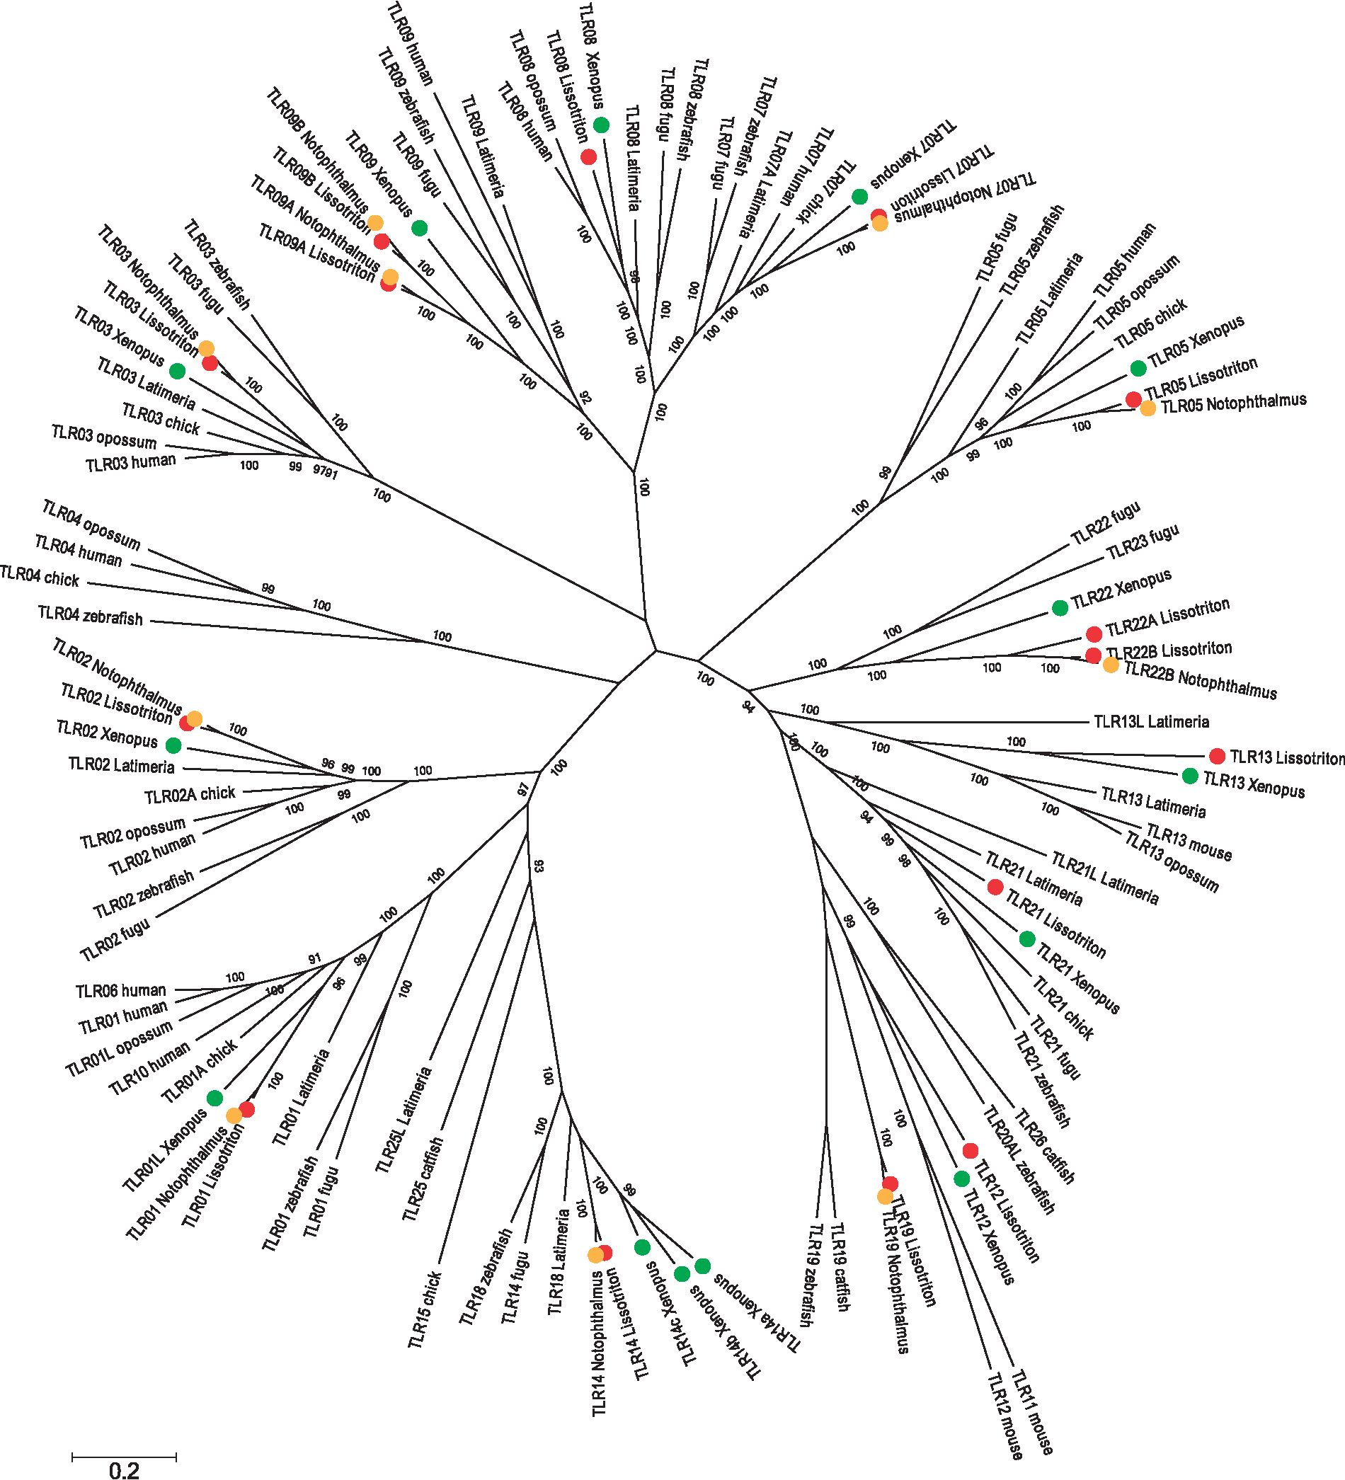
Babiketal.
GBE
Fig. 1.—A Bayesian tree showing the relationships among vertebrate TLRs. Amphibian TLRs are color coded by species.
significant in both lineages (L. montandoni P < 0.0001, L. v.
graecus P=0.007). In individual tests two genes exhibited an
excess of divergence: TLR05L in L. montandoni (P=0.006) and
TLR21 in L. v. graecus (P=0.001) and one gene, TLR07,
showed a marginally significant excess of polymorphism
(P=0.04) in L. v. graecus (table 3).
The distribution of selection coefficients for 11 TLR genes as
estimated by the population genetics-phylogenetics
gammamap method differed substantially between L. mon-
tandoni and L. v. graecus, although the 95% credible intervals
estimated for each fitness class were wide in both species (fig.
3). The proportion of strongly constrained codons
(-500 < g <-5) was higher in L. v. graecus than in L. mon-
tandoni (86% vs. 68%). The frequencies of neutral and ben-
eficial mutations in L. montandoni exceeded those in L. v.
graecus, with the starkest contrast among neutral and
86 Genome Biol. Evol. 7(1):81-95. doi:10.1093/gbe/evu266 Advance Access publication December 4, 2014
Downloaded from https://academic.oup.eom/gbe/article-abstract/7/1/81/599895 by Jagiellonian University user on 05 April 2019
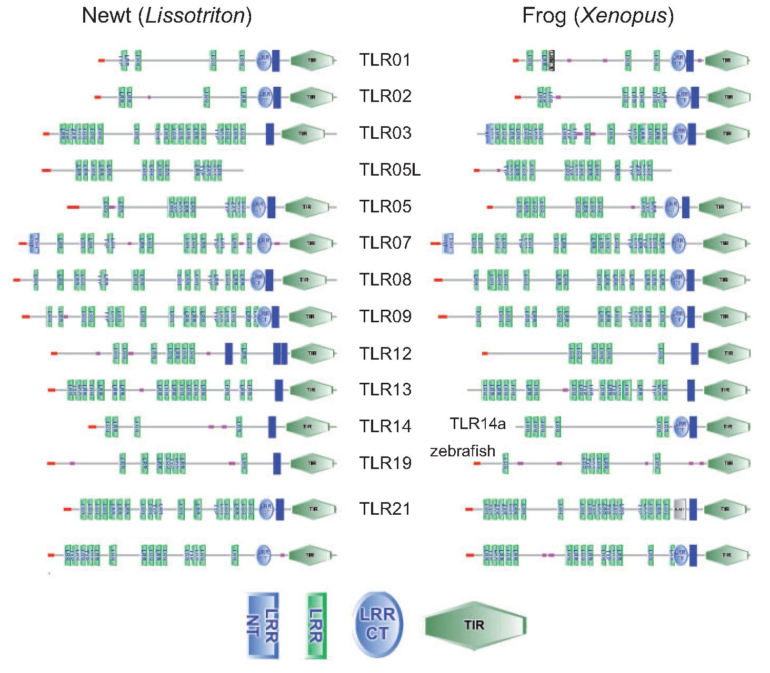
Constraint and Adaptation in TLR Genes
GBE
Table 1
Synonymous and Nonsynonymous Divergence between
Notophthalmus and Lissotriton TLR Genes
Gene | ncodons | cds | dN | dS | dN/dS
TLR01 | 786 | 1.00 | 0.056 | 0.142 | 0.39
TLR02 | 799 | 1.00 | 0.069 | 0.184 | 0.37
TLR03 | 901 | 1.00 | 0.057 | 0.186 | 0.31
TLR05 | 888 | 1.00 | 0.089 | 0.170 | 0.52
TLR05L | 664 | 1.00 | 0.064 | 0.162 | 0.40
TLR07 | 1,041 | 0.99 | 0.048 | 0.211 | 0.22
TLR08 | 534 | 0.50 | 0.076 | 0.169 | 0.45
TLR09A | 1,038 | 1.00 | 0.056 | 0.154 | 0.37
TLR09B | 1,034 | 1.00 | 0.079 | 0.147 | 0.54
TLR12 | 0 | 0.00 | — | — | —
TLR13 | 566 | 0.59 | 0.114 | 0.160 | 0.71
TLR14 | 819 | 1.00 | 0.050 | 0.167 | 0.30
TLR19 | 955 | 1.00 | 0.084 | 0.204 | 0.41
TLR21 | 707 | 0.73 | 0.083 | 0.316 | 0.26
TLR22A | 871 | 0.91 | 0.067 | 0.146 | 0.46
TLR22B | 956 | 1.00 | 0.059 | 0.151 | 0.39
Note.—ncodons, the length of the Lissotriton-Nothophthalmus alignment in
codons; cds, proportion of the coding sequence covered by alignment; dN, max-
imum likelihood (ML) estimate of nonsynonymous divergence; dS, ML estimate of
synonymous divergence.
nearly neutral mutations (-1 < g < 1, 24% vs. 9%). Despite
overall constraint, adaptive evolution may have occurred at
individual codons. Following Quach et al. (2013), we consid-
ered codons as evolving under positive selection if the propor-
tion of simulated positive gamma values (g > 0) exceeded
0.75. In total 33 codons under positive selection were inferred
in L. v. graecus, compared with only 15 in L. montandoni
(supplementary table S4, Supplementary Material online).
Overall, the number of positively selected codons per gene
was low, ranging from zero in TLR01 in both lineages to 8
in TLR09B in L. v. graecus and only four were predicted to have
a radical effect on protein function (supplementary table S4,
Supplementary Material online). In five genes (TLR02, 09A,
09B, 21, 22B) positively selected codons were detected in
both lineages. In addition, positive selection was inferred in
four genes (TLR03, 07, 13, 22A) only in L. v. graecus, and in
one gene (TLR05L) in L. montandoni. Remarkably, only a single
codon was identified as positively selected in both lineages
(codon 294 of TLR21, in which a nonsynonymous polymor-
phism shared with the outgroup species segregates in both
lineages). Nonsense mutations segregated at appreciable fre-
quencies in TLR09B in L. montandoni, the more common of
TLR22
Fig. 2.—Comparison of the domain structure between newt and frog TLRs. TLR19 is absent in Xenopus and zebrafish structure is provided instead;
abbreviations of protein domains: LRR NT, Leucine-rich repeat, N-terminal; LRR, Leucine-rich repeat; LRR CT, LRR C-terminal.
Genome Biol. Evol. 7(1):81-95. doi:10.1093/gbe/evu266 Advance Access publication December 4, 2014
87
Downloaded from https://academic.oup.eom/gbe/article-abstract/7/1/81/599895 by Jagiellonian University user on 05 April 2019
Babiketal.
GBE
Table 2
Polymorphism in 11 TLR Genes in a Species-Wide Sample of Lissotriton montandoni/vulgaris, Data for 62 UTR Are Also Shown
Gene | 2N | nsites | cds | n alleles | S | n | N  n | nS | NI | MK P-val | f Lo95 | f | f Hi95
TLR01 | 32 | 2,358 | 1.00 | 25 | 160 | 0.0146 | 0.0105 | 0.0293 | 0.93 | 1.000 | 0.23 | 0.28 | 0.35
TLR02 | 32 | 2,313 | 0.96 | 21 | 87 | 0.0090 | 0.0066 | 0.0174 | 0.74 | 0.451 | 0.23 | 0.30 | 0.41
TLR03 | 32 | 1,776 | 0.66 | 26 | 132 | 0.0136 | 0.0074 | 0.0351 | 0.46 | 0.086 | 0.17 | 0.22 | 0.27
TLR05L | 32 | 1,782 | 0.89 | 24 | 146 | 0.0117 | 0.0068 | 0.0271 | 0.28 | 0.063 | 0.19 | 0.25 | 0.30
TLR07 | 32 | 3,045 | 0.97 | 27 | 171 | 0.0109 | 0.0044 | 0.0331 | 0.69 | 0.348 | 0.16 | 0.21 | 0.25
TLR09A | 32 | 3,090 | 0.99 | 23 | 118 | 0.0080 | 0.0047 | 0.0194 | 0.96 | 1.000 | 0.20 | 0.26 | 0.34
TLR09B | 30 | 2,083 | 0.67 | 19 | 119 | 0.0121 | 0.0089 | 0.023 | 0.40 | 0.075 | 0.25 | 0.31 | 0.40
TLR13 | 32 | 2,502 | 0.88 | 26 | 181 | 0.0100 | 0.0067 | 0.0209 | 1.68 | 0.303 | 0.22 | 0.27 | 0.33
TLR21 | 32 | 2,841 | 0.98 | 26 | 215 | 0.0141 | 0.0077 | 0.0347 | 0.99 | 1.000 | 0.18 | 0.23 | 0.28
TLR22A | 32 | 2,787 | 0.98 | 23 | 149 | 0.0097 | 0.0054 | 0.0242 | 0.95 | 1.000 | 0.20 | 0.25 | 0.30
TLR22B | 32 | 2,026 | 0.71 | 26 | 145 | 0.0141 | 0.0084 | 0.0334 | 1.12 | 1.000 | 0.22 | 0.28 | 0.36
TLR average | 32 | 2,418 | 0.88 | 24.2 | 147.5 | 0.0116 | 0.0070 | 0.0271 | 0.83 |  |  | 0.26
62 UTR average | 32 | 499 |  | 17.7 | 37.8 | 0.0146
Note.—2N, number of gene copies sampled; nsites, the length of alignment; cds, proportion of the coding sequence covered by alignment; S, number of segregating
sites; p, overall nucleotide diversity; pn, nucleotide diversity at nonsynonymous sites; ps nucleotide diversity at synonymous sites; NI, neutrality index; MK P-val, McDonald and
Kreitman Fisher's exact test P-value (Lissotriton helveticus was used as an outgroup); f Lo95, lower credible limit for constraint calculated in SNiPRE; f, estimate of constraint; f
Hi 95%, upper credible limit for constraint.
Table 3
Polymorphism in 11 TLR Genes in Population-Level Samples of Two Evolutionary Lineages: Lissotriton montandoni (Lm, 38 gene copies sampled)
and L. vulgaris graecus (Lvg, 34 gene copies sampled), Data for 62 UTR Are Also Shown
Gene | nsites | cds | n | alleles |  | S |  | n |  | "S |  | "N
Gene | nsites | cds | Lm | Lvg | Lm | Lvg | Lm | Lvg | Lm | Lvg | Lm | Lvg
TLR01 | 1,626 | 0.69 | 13 | 18 | 65 | 39 | 0.0112 | 0.0047 | 0.0220 | 0.0113 | 0.0081 | 0.0028
TLR02 | 1,656 | 0.69 | 10 | 12 | 23 | 35 | 0.0024 | 0.0031 | 0.0074 | 0.0047 | 0.0009 | 0.0027
TLR03 | 1,620 | 0.60 | 17 | 19 | 65 | 47 | 0.0097 | 0.0037 | 0.0289 | 0.0079 | 0.0041 | 0.0025
TLR05L | 1,463 | 0.73 | 5 | 18 | 5 | 41 | 0.0008 | 0.0051 | 0.0019 | 0.0139 | 0.0004 | 0.0024
TLR07 | 1,527 | 0.49 | 22 | 17 | 44 | 58 | 0.0067 | 0.0065 | 0.0143 | 0.0195 | 0.0045 | 0.0026
TLR09A | 1,683 | 0.54 | 7 | 14 | 27 | 39 | 0.0056 | 0.0048 | 0.0097 | 0.0112 | 0.0034 | 0.0029
TLR09B | 1,452 | 0.47 | 14 | 16 | 15 | 26 | 0.0017 | 0.0046 | 0.0029 | 0.0105 | 0.0013 | 0.0028
TLR13 | 1,479 | 0.52 | 16 | 14 | 46 | 48 | 0.0092 | 0.0047 | 0.0168 | 0.0067 | 0.0068 | 0.0040
TLR21 | 1,611 | 0.55 | 25 | 11 | 82 | 15 | 0.0124 | 0.0017 | 0.0283 | 0.0033 | 0.0074 | 0.0015
TLR22A | 1,723 | 0.60 | 9 | 16 | 47 | 47 | 0.0095 | 0.0041 | 0.0221 | 0.0130 | 0.0058 | 0.0015
TLR22B | 1,387 | 0.48 | 18 | 18 | 53 | 43 | 0.0095 | 0.0070 | 0.0219 | 0.0151 | 0.0058 | 0.0047
TLR average | 1,566 | 0.58 | 14.2 | 15.7 | 42.9 | 39.8 | 0.0071 | 0.0045 | 0.0160 | 0.0106 | 0.0044 | 0.0028
62 UTR average | 499 |  | 7 | 9.5 |  |  | 0.0044 | 0.0052
Note.—nsites, the length of alignment; cds, proportion of the coding sequence covered by alignment; S, number of segregating sites; p, overall nucleotide diversity; pn,
nucleotide diversity at nonsynonymous sites; ps nucleotide diversity at synonymous sites.
these mutations produced a stop codon in position 48, indi-
cating that the respective allele does not encode a functional
protein.
In the population data sets TLR nucleotide diversity tended
to be higher in L. montandoni (pmon = 0.0072, pgre = 0.0045,
t1261 =2.027, P =0.064), whereas for 62 30-UTRs it was
similar in both lineages (pmon = 0.0044, pgre = 0.0052,
t1219= 1.079, P =0.283) (table 3 and fig. 4). Tajima's D in
TLR genes was significantly higher in L. montandoni
(Dmon = 0.20, Dgre = -0.96, t^.28 = -3.82 7, P = 0.0012),
whereas no differences were detected in UTRs
(Dmon = —0.95, Dgre= —0.92, T120.9 = 0.175, P =0.086)
(table 4 and fig. 4). In each lineage Tajima's D values at syn-
onymous and nonsynonymous sites of most genes were
remarkably similar and in most cases did not depart from ex-
pectations under the inferred demographic model (supple-
mentary tables S2 and S3, Supplementary Material online;
table 4 and fig. 4). The few significant D values indicated an
excess of high frequency variants (table 4). Significantly neg-
ative Fay and Wu's H, signaling an excess of high-frequency
derived alleles consistent with an incomplete selective sweep
was detected in one L. montandoni gene (TLR22B, only syn-
onymous sites), whereas three (TLR03, 07, 13) L. v. graecus
genes exhibited this pattern (table 4). The same three genes
88 Genome Biol. Evol. 7(1):81-95. doi:10.1093/gbe/evu266 Advance Access publication December 4, 2014
Downloaded from https://academic.oup.eom/gbe/article-abstract/7/1/81/599895 by Jagiellonian University user on 05 April 2019
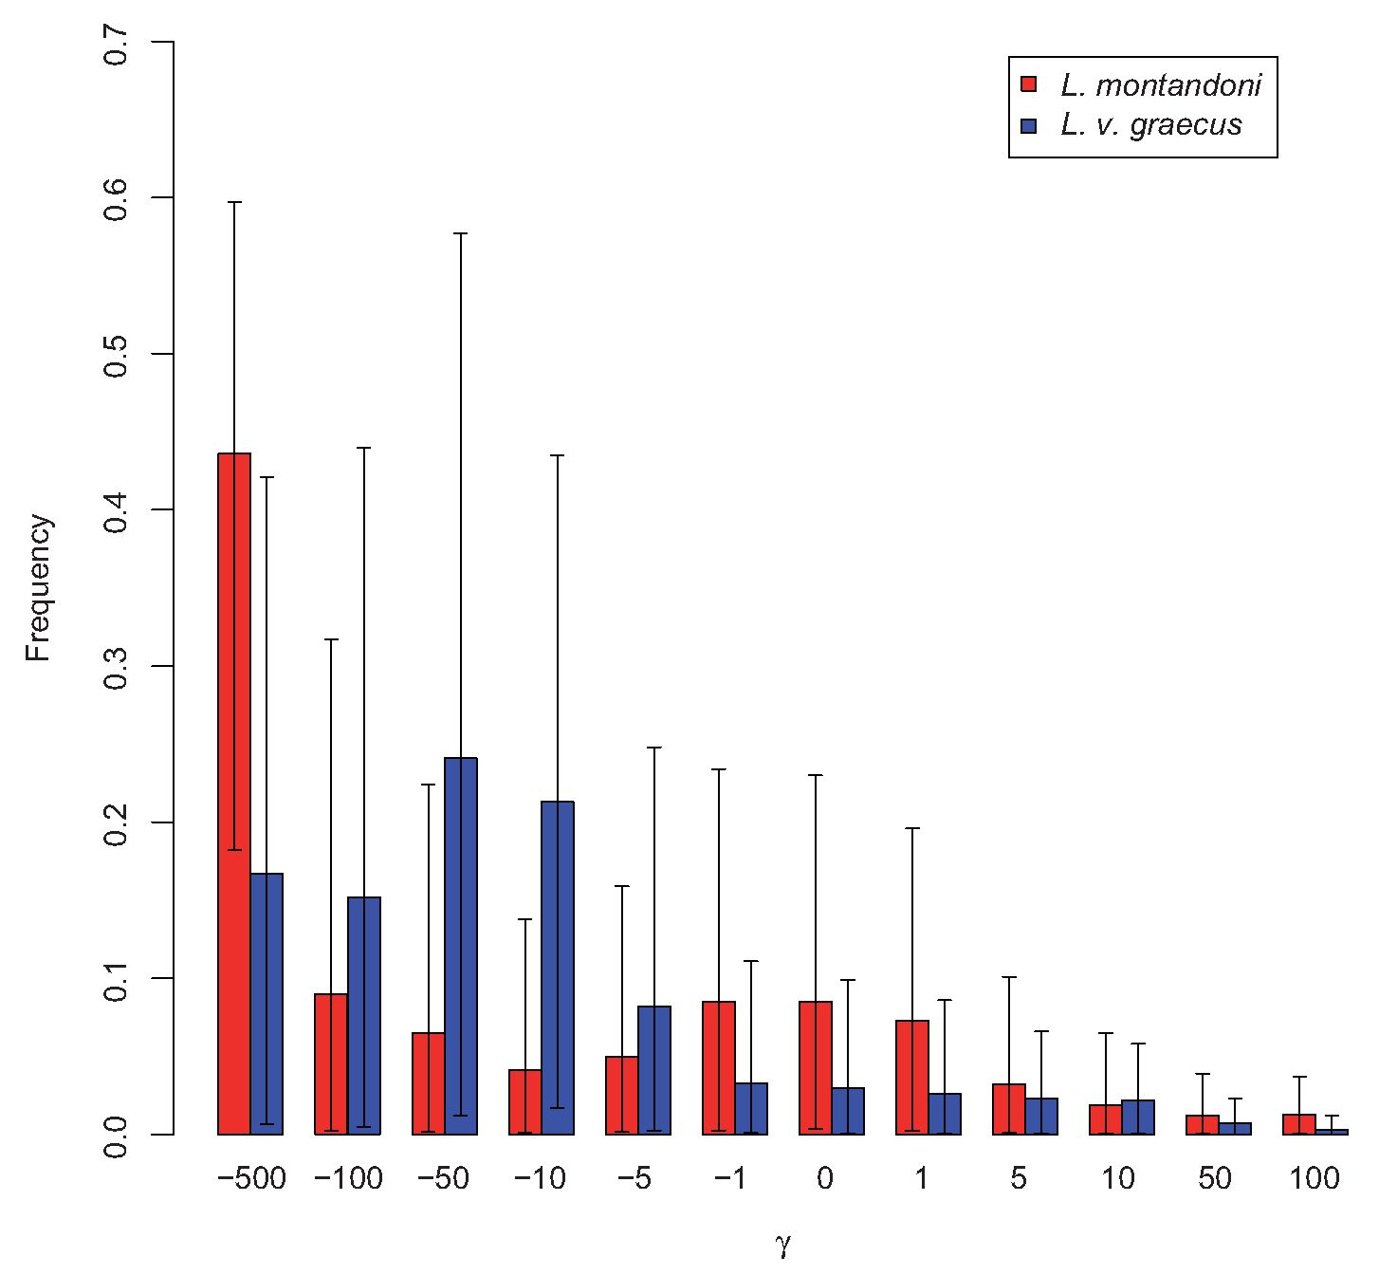
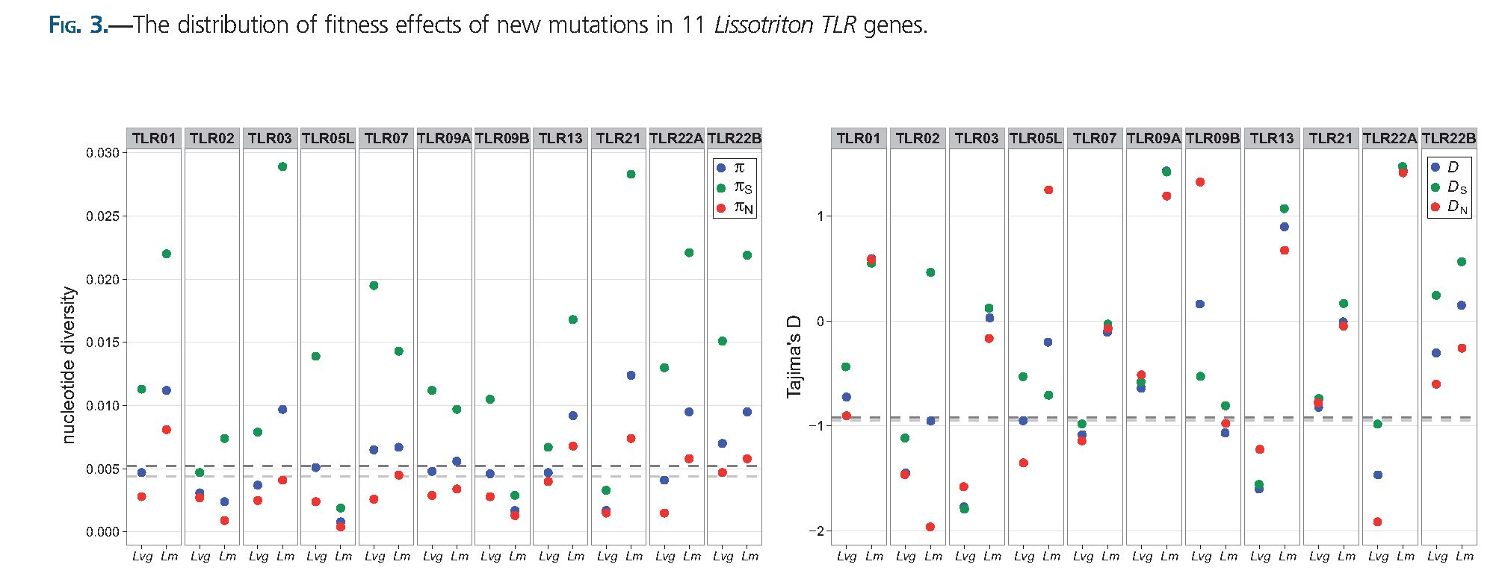
Constraint and Adaptation in TLR Genes
GBE
Fig. 4.—Nucleotide diversity and Tajima's D in population data sets; Lm, Lissotriton montandoni, Lvg, L. vulgarisgraecus; p, overall, ps, synonymous and
pn, nonsynonymous nucleotide diversity; D, overall, Ds, synonymous and Dn, nonsynonymous Tajima's D.
were identified by the gammamap method as targets of pos-
itive selection in L. v. graecus.

Discussion
This work is the first analysis of the repertoire and evolutionary
dynamics of TLR genes in urodele amphibians and one of the
few studies employing population genetic methods to
understand processes shaping variation in these genes,
while controlling for nonequilibrium demography. Overall,
we found that amid substantial evolutionary conservation ep-
isodes of lineage-specific adaptation have involved individual
codons of some TLR genes, potentially providing a more effi-
cient response to pathogen assault that may vary in space
and time. Available data from several systems indicate that
Genome Biol. Evol. 7(1):81-95. doi:10.1093/gbe/evu266 Advance Access publication December 4, 2014
89
Downloaded from https://academic.oup.eom/gbe/article-abstract/7/1/81/599895 by Jagiellonian University user on 05 April 2019
Babiketal.
GBE
Table 4
Results of Neutrality Tests and Values of Tajima's D and Fay and Wu's H Statistics in Lissotriton montandoni (Lm, 38 gene copies sampled) and
L. vulgaris graecus (Lvg, 34 gene copies sampled)
 | MK P-val |  | HKA P-val |  | D |  | Ds |  |  | dn |  | H |  | Hs | Hn
 | Lm | Lvg | Lm | Lvg | Lm | Lvg | Lm | Lvg | Lm | Lvg | Lm | Lvg | Lm | Lvg | Lm | Lvg
TLR01 | 0.806 | 0.644 | 0.273 | 0.968 | 0.57 | -0.74 | 0.52 | -0.45 | 0.57 | -0.94 | 0.75 | -0.98 | -0.11 | -2.50 | 1.05 | 1.63
TLR02 | 1.000 | 0.621 | 0.108 | 0.695 | -0.93 | -1.41 | 0.50 | -1.08 | -1.93 | -1.45 | -6.15 | -4.03 | -3.25 | -1.46 | -2.95 - | 3.72
TLR03 | 0.264 | 0.824 | 0.471 | 0.752 | 0.00 | -1.79 | 0.10 | -1.77 | -0.19 | -1.63 | 4.14 | -16.66 | 3.49 | -11.46* | 0.55 - | 5.14
TLR05L | 0.035 | 0.170 | 0.006 | 0.359 | -0.16 | -0.94 | -0.72 | -0.52 | 1.25 | -1.34 | 0.66 | 0.19 | 0.32 | -0.55 | 0.24 | 0.74
TLR07 | 0.139 | 0.741 | 0.152 | 0.041 | -0.06 | -1.07 | 0.00 | -0.99 | -0.10 | -1.10 | 2.13 | -6.45 | 0.11 | -3.08 | 1.97 - | 3.26*
TLR09A | 0.435 | 1.000 | 0.165 | 0.735 | 1.38 | -0.61 | 1.39* | -0.60 | 1.18 | -0.56 | -4.38 | 2.44 | -1.46 | 0.02 | -1.88 | 1.98
TLR09B | 0.112 | 0.006 | 0.115 | 0.305 | -1.06 | 0.15 | -0.84 | -0.53 | -1.01 | 1.29* | 0.84 | -1.81 | -0.20 | -1.54 | 0.76 - | 0.33
TLR13 | 0.361 | 0.576 | 0.206 | 0.234 | 0.85 | -1.63 | 1.04 | -1.58 | 0.63 | -1.20 | 3.20 | -11.04 | 1.01 | -5.43* | 2.19 - | 5.28*
TLR21 | 0.843 | 0.452 | 0.594 | 0.001 | 0.01 | -0.83 | 0.12 | -0.76 | -0.07 | -0.74 | -5.17 | -1.78 | -1.21 | -0.93 | -2.20 | 1.13
TLR22A | 0.818 | 0.198 | 0.685 | 0.743 | 1.43 | -1.45 | 1.43* | -1.01 | 1.37* -1.92 |  | 1.91 | -7.97 | 0.94 | -3.30 | 0.99 - | 4.04
TLR22B | 0.723 | 1.000 | 0.140 | 0.123 | 0.15 | -0.26 | 0.58 | 0.25 | -0.25 | -0.62 | -7.10 | -0.65 | -4.23* | 2.95 | -0.89 | 0.23
TLR average |  |  |  |  | 0.20 | -0.96 | 0.37 | -0.82 | 0.13 | -0.93 | -0.83 | -4.43 | -0.42 | -2.48 | -0.01 - | 1.46
Note.—MK P-val, McDonald and Kreitman Fisher's exact test P-value; HKA P-val, maximum-likelihood HKA test P-value; D, Tajima's D value for all sites; Ds, Tajima's D
value for synonymous sites; DN Tajima's D value for nonsynonymous sites; H, Fay and Wu's H value for all sites; Hs, Fay and Wu's H value for synonymous sites; HN, Fay and
Wu's H value for nonsynonymous sites; *, P< 0.01; P-values are provided only for Ds, DN, Hs, and HN, for D two-sided, for H one-sided.
lineage-specific bouts of adaptive evolution may dominate the
dynamics of vertebrate TLRs (Tschirren et al. 2011, 2012;
Quach et al. 2013; Grueber et al. 2014). Thus, although adap-
tive changes in TLR genes may be subtle in comparison to
other components of the immune system (Piertney and
Oliver 2006; Downing et al. 2010; Quintana-Murci and
Clark 2013), these genes should be incorporated into research
aiming to understand associations between genetic variation
and susceptibility to pathogens in natural populations
(Tschirren et al. 2013).
The Evolution of the Urodele TLR Repertoire
Substantial differences in the composition of the TLR family
occur between fish and amniotes (Roach et al. 2005;
Temperley et al. 2008; Palti 2011). Amphibians have been
suggested to possess an intermediate TLR repertoire which
may reflect their association with both aquatic and terrestrial
environments (Ishii et al. 2007; Oshiumi et al. 2008). The data
so far have been restricted to Xenopus (Ishii et al. 2007). Our
study shows that TLR composition in urodeles and anurans is
broadly similar. The only major family present in newts but
absent in Xenopus is TLR19, otherwise found only in some fish
(Palti 2011), and newts express representatives of all families
present in Xenopus. No TLR04 orthologs have been found in
the newt transcriptome, leaving TLR04 the only major verte-
brate TLR family not detected in urodeles. TLR04 plays a crucial
role in the mammalian response against diverse microbes, es-
pecially gram-negative bacteria (Akira et al. 2006). In fish
TLR04 is functionally different from the mammalian counter-
part and present only in some species (Palti 2011; Kanwal
et al. 2014). The presence of TLR04 in Xenopus has been
controversial (Roach et al. 2005; Ishii et al. 2007), but TLR04
genes derived from automated prediction are present in the
most recent versions of the Xenopus laevis and Xenopus tro-
picalis genome assemblies (http://www.xenbase.org/). TLR04
has also been reported in the transcriptome of another
anuran, Bombina maxima (Zhao et al. 2014), and, based on
indirect data, also in frogs (Nikolaeva et al. 2012). Thus the
evidence regarding the presence and nature of amphibian
TLR04 is somewhat equivocal. A short amphibian gene from
the TLR05 family lacking the TIR domain (TLR05L) is not ortho-
logous to the teleost soluble TLR05S (Munoz et al. 2013), but
is unique to some tetrapods, being found in turtles (supple-
mentary fig. S3, Supplementary Material online) and the anole
lizard (Munoz et al. 2013). It is currently unknown whether
TLR05L binds flagellin and modulates a flagellin-mediated
immune response, as has been demonstrated for teleost
TLR05S (Munoz et al. 2013). The expression of newt TLR05L
was much higher in liver than in spleen, similar to that of fish
TLR05S.
Lineage-specific duplications have occurred in anurans and
urodeles, leading to differences in the composition of several
TLR families between the amphibian orders. At least 16 TLR
genes are expressed in newts, four of them result from dupli-
cations (TLR09A-09B and TLR22A-22B) predating the diver-
gence of Lissotriton and Notophthalmus at approximately
70 Ma (Roelants et al. 2007). Duplications have also been
common in the more recent history of the Lissotriton TLR
genes, as evidenced by closely related paralogs in five of
them, which brings the total number of TLR genes to at
least 21. Due to high sequence similarity, examination of var-
iation in these TLR genes would require a separate study em-
ploying dedicated methods. Such studies are desirable as they
90 Genome Biol. Evol. 7(1):81-95. doi:10.1093/gbe/evu266 Advance Access publication December 4, 2014
Downloaded from https://academic.oup.eom/gbe/article-abstract/7/1/81/599895 by Jagiellonian University user on 05 April 2019
Constraint and Adaptation in TLR Genes
GBE
may shed light on the fates of TLR paralogs immediately fol-
lowing duplication: whether both copies are commonly main-
tained by selection or if one typically undergoes
pseudogenization. Gene duplication and to a lesser extent,
gene conversion among paralogs within families, feature
prominently in the evolution of vertebrate TLR genes.
Mammals and birds differ in this respect from fish. Although
in the former duplication and gene conversion are restricted
mainly to the TLR01 family (Huang et al. 2011), in the latter
duplications are common, particularly in fish-specific TLRs, re-
sulting in multigene families sometimes composed of many
similar paralogs (Star et al. 2011; Sundaram et al. 2012;
Quiniou et al. 2013; Pietretti et al. 2014). Duplications in
fish seem lineage-specific and short lived, as their patchy phy-
logenetic distribution suggests. The data from newts reveal a
similar pattern with recent duplications in four of five major
TLR families. The propensity for retention of duplicated TLR
copies may be related to the efficiency of other components
of the immune system as has been suggested in the case of
extreme duplications of TLR in the Atlantic cod, a fish species
which lacks a functional major histocompatibility complex
(MHC) class II pathway (Star et al. 2011; Sundaram et al.
2012).
Constraint and Lineage-Specific Adaptation in newt TLR
Genes
Urodele TLR genes are substantially constrained at the long-
term evolutionary scale, and the extent of constraint in indi-
vidual genes is similar to that reported for birds (Alcaide and
Edwards 2011; Grueber et al. 2014). Thus purifying selection
has predominated the evolution of urodele TLR genes, simi-
larly as in other vertebrates (Roach et al. 2005; Mikami et al.
2012). However, several studies found signatures of recurrent
or episodic positive selection affecting a relatively minor (<1-
5%) fraction of codons in birds and mammals (Wlasiuk et al.
2009; Wlasiuk and Nachman 2010; Alcaide and Edwards
2011; Areal et al. 2011; Grueber et al. 2014). With data
from only two species, we did not have enough power to
test for individual codons under positive selection, but flag
this as a priority for future studies with more data.
We used the extensive data on polymorphism and diver-
gence of TLR genes to test for selection in the more recent
evolutionary history of Lissotriton newts, that is, since the
origin of the L. vulgaris lineage at approximately 18 Ma
(Pabijan et al. forthcoming). At this scale constraint remains
strong; no differences were detected between NA-sensing
and nonNA-sensing TLR genes. Stronger purifying selection
in the former versus more positive selection and less constraint
in the latter were reported in primates and birds (Barreiro et al.
2009; Wlasiuk and Nachman 2010; Huang et al. 2011).
Conservation of NA-sensing TLRs has been ascribed to func-
tional constraint, that is, proteins encoded by these genes
must recognize motives and types of foreign NA without
triggering autoimmune reactions. This may well be true for
specific clades, but a broader analysis of mammal TLR did not
confirm differences in the rate of adaptive evolution between
viral and nonviral TLR genes (Areal et al. 2011). Likewise, we
did not find this pattern in newts.
Our results suggest substantial differences in selection re-
gimes between the two closely related lineages L. montandoni
and L. v. graecus; their divergence has been estimated at ap-
proximately 7 Ma (supplementary table S3, Supplementary
Material online). Natural selection operating on TLR genes
has been stronger in L. v. graecus and, interestingly, both pu-
rifying and positive selection seem more prominent in this
lineage compared with L. montandoni in which selection ap-
pears somewhat relaxed. Despite the overwhelming signal of
purifying selection, positive selection was detected by at least
one method in 9 of 11 genes in L. v. graecus, but only in 6 L.
montandoni genes. Also over twice as many codons evolved
adaptively in the former lineage compared with the latter.
Recent positive selection in L. v. graecus is emphasized by
concomitant signals of incomplete sweeps in the Fay and
Wu test and positive selection inferred by the gammamap
method in three genes. Qualitatively similar differences in
overall TLR selection landscapes have been reported between
humans and other great apes and attributed to differences in
demographic history (Quach et al. 2013). It is unlikely that our
inference of selection has been severely distorted by demo-
graphic factors in newts because effective population sizes
and demographic histories of both lineages were similar as
estimated from an independent data set using ABC modeling.
Therefore the strength of selection may signify differences
between lineages in the overall importance of TLRs for an
effective immune response. Because MHC class II variation is
lower in L. v. graecus compared with L. montandoni
(Nadachowska-Brzyska et al. 2012), it is tempting to speculate
that the innate components of the L. v. graecus immune
system may be relatively more important in fighting pathogen
assault. Interestingly, a recent study reported drastic differ-
ences between species of the genus Lissotriton in susceptibility
to an emerging urodele fungal pathogen Batrachochytrium
salamandrivorans (Martel et al. 2014) which may suggest sub-
stantial interspecific immunogenetic differences.
The strongest and most consistent signatures of positive
selection were observed in TLR05L of L. montandoni. This
gene exhibits an excess of fixed replacement substitutions,
an excess of divergence, and two codons with fixed substitu-
tions identified by gammamap as targets of positive selection.
Although direct evidence is lacking, it is likely that TLR05L
modulates, together with TLR05, a flagellin-mediated
immune response (see above). TLR05 is a common target of
positive selection (Wlasiuk et al. 2009) that may be driven by
coevolution with bacteria which, in some bacterial species,
leads to variation in flagellin sequences resulting in the evasion
of recognition by hosts (Andersen-Nissen et al. 2005). Thus
positive selection in L. montandoni TLR05L may reflect
Genome Biol. Evol. 7(1):81-95. doi:10.1093/gbe/evu266 Advance Access publication December 4, 2014
91
Downloaded from https://academic.oup.eom/gbe/article-abstract/7/1/81/599895 by Jagiellonian University user on 05 April 2019
Babiketal.
GBE
adaptation to changing pathogen pressure. In this context it
would be interesting to investigate TLR05 variation and test
for recent selection in this gene which we were unable to do
because of the presence of closely related paralogs.
The MK test and gammamap detected signatures of pos-
itive selection acting on TLR09B in L. v. graecus. TLR09 senses
mainly unmethylated CpG-rich bacterial DNA and DNA:RNA
hybrids (Bauer et al. 2001; Yeh et al. 2013; Rigby et al. 2014).
Although TLR09 is generally strongly constrained in mammals,
a few codons under positive selection have been reported
(Wlasiuk and Nachman 2010; Areal et al. 2011) and adaptive
evolution of this gene may be more frequent in fish (Chen
et al. 2008; Zhu et al. 2013). The importance of TLR09 in fish
antibacterial immunity is suggested by two observations. First,
in zebrafish two distantly related proteins, TLR09 and TLR21,
mediate CpG oligonucleotide activity, but have different rec-
ognition profiles (Yeh et al. 2013). Second, the only species in
which TLR09 duplication has been reported so far is cod,
which lacks MHC class II signaling but has five TLR09 paralogs;
expansion of the TLR09 family may reflect its importance for
antibacterial immunity in this species (Star et al. 2011). In con-
trast to birds and mammals with either TLR09 or TLR21, am-
phibians have both receptors, thus the role of these receptors
in antibacterial response may be similar to that offish. Because
CpG DNA from various bacteria differ in their potential to
activate TLR09 (Bauer et al. 2001), coevolution between
host TLR and bacterial pathogens appears likely. The two uro-
dele TLR09 paralogs have been maintained by selection for at
least tens of millions of years, so possibly these genes special-
ized in recognition of various bacterial DNA PAMPs. Contrary
to the situation observed in L. v. graecus, relaxation of selec-
tion and some functional redundancy of L. montandoni
TLR09B is suggested by the relatively high frequency
(~15%) of a nonsense (premature stop codon) mutation.
Patterns consistent with recent positive selection were also
detected in TLR21 of L. v. graecus: an excess of divergence,
low variation, and six replacement substitutions fixed by se-
lection as inferred by gammamap. Again, relaxation of selec-
tion in L. montandoni is more likely: TLR21 is the most variable
of all TLR genes and nonsynonymous polymorphisms are still
segregating in all codons identified as positively selected by
gammamap. Hence, L. v. graecus and L. montandoni likely
differ in the response to bacterial DNA mediated by TLR09
and TLR21 and such differences may reflect variable selection
pressure exerted by pathogens on TLR genes in closely related
evolutionary lineages.

Conclusions
In this study, we characterized urodele TLR genes which
encode a crucial component of the innate immune system
and provide a link to adaptive immunity. The TLR repertoires
of two major amphibian groups, urodeles and anurans, are
broadly similar and intermediate between those of fish and
amniotes. Gene duplications feature prominently in the evo-
lution of urodele TLR. Both old duplications, apparently main-
tained by long-term selection and very recent duplications are
present. TLR genes examined for polymorphism and diver-
gence in Lissotriton newts exhibit a comparable degree of
conservation and evolutionary constraint. However, the rate
and targets of adaptive evolution differ substantially between
two recently diverged Lissotriton lineages. These differences
were not an artifact of nonequilibrium demography because
demographic effects were accounted for through ABC model-
ing using an independent data set of 62 loci. Short-term se-
lective pressures thus vary both between closely related
lineages and among TLR genes, and may indicate differences
in the relative roles of innate and acquired immunity. TLR
variation may play an important role in the response to chang-
ing pathogen pressure, and these genes are a promising
target for studies aiming to link genetic variation to pathogen
susceptibility in amphibians, a vertebrate group severely
threatened by emerging infectious diseases.

Supplementary Material
Supplementary material, tables S1-S4, and figures S1-S5 are
available at Genome Biology and Evolution online (http://
www.gbe.oxfordjournals.org/).

Acknowledgments
The authors thank D. Cogalniceanu, S-D. Covaciu-Marcov,
and M. Liana for help in sampling and K. Nadachowska-
Brzyska for help in sampling and with ABC modeling. This
work was supported by the Polish National Science Center
[UMO-2012/04/A/NZ8/00662 to W.B.] and by Jagiellonian
University [DS/WBiNoZ/INoS/762/13]. P.Z. was supported by
EU resources under the European Social Fund: Creating
English interdisciplinary graduate program in the area of
ecology and enhancing the teaching potential of the
academic staff at the Institute of Environmental Sciences
of the Jagiellonian University. The study was performed
with the financial support of the Foundation for Polish
Science.

Literature Cited
Abdullayev I, Kirkham M, Bjorklund AK, Simon A, Sandberg R. 2013. A
reference transcriptome and inferred proteome for the salamander
Notophthalmus viridescens. Exp Cell Res. 319:1187-1197.
Akira S, Uematsu S, Takeuchi O. 2006. Pathogen recognition and innate
immunity. Cell 124:783-801.
Alcaide M, Edwards SV. 2011. Molecular evolution of the toll-like receptor
multigene family in birds. Mol Biol Evol. 28:1703-1715.
Andersen-Nissen E, et al. 2005. Evasion of Toll-like receptor 5 by flagel-
lated bacteria. Proc Natl Acad Sci USA. 102:9247-9252.
Areal H, Abrantes J, Esteves PJ. 2011. Signatures of positive
selection in Toll-like receptor (TLR) genes in mammals. BMC Evol
Biol. 11:368.
92 Genome Biol. Evol. 7(1):81-95. doi:10.1093/gbe/evu266 Advance Access publication December 4, 2014
Downloaded from https://academic.oup.eom/gbe/article-abstract/7/1/81/599895 by Jagiellonian University user on 05 April 2019
Constraint and Adaptation in TLR Genes
GBE
Babik W, et al. 2005. Phylogeography of two European newt species—
discordance between mtDNA and morphology. Mol Ecol. 14:
2475-2491.
Barreiro LB, et al. 2009. Evolutionary dynamics of human toll-like receptors
and their different contributions to host defense. PLoS Genet. 5:
e1000562.
Bauer S, et al. 2001. Human TLR9 confers responsiveness to bacterial DNA
via species-specific CpG motif recognition. Proc Natl Acad Sci USA.
98:9237-9242.
Boller T, He SY. 2009. Innate immunity in plants: an arms race between
pattern recognition receptors in plants and effectors in microbial path-
ogens. Science 324:742-743.
Chen JSC, Wang TY, Tzeng TD, Wang CY, Wang D. 2008. Evidence for
positive selection in the TLR9 gene of teleosts. Fish Shellfish Immunol.
24:234-242.
Cheng TL, Rovito SM, Wake DB, Vredenburg VT. 2011. Coincident mass
extirpation of neotropical amphibians with the emergence of the in-
fectious fungal pathogen Batrachochytrium dendrobatidis. Proc Natl
Acad Sci USA. 108:9502-9507.
Choi Y, Sims GE, Murphy S, Miller JR, Chan AP. 2012. Predicting
the functional effect of amino acid substitutions and indels. PLoS
One 7:e46688.
Darriba D, Taboada GL, Doallo R, Posada D. 2011. ProtTest 3: fast selec-
tion of best-fit models of protein evolution. Bioinformatics 27:
1164-1165.
Downing T, Lloyd AT, O'Farrelly C, Bradley DG. 2010. The differential
evolutionary dynamics of avian cytokine and TLR gene classes.
J Immunol. 184:6993-7000.
Eilertson KE, Booth JG, Bustamante CD. 2012. SnIPRE: selection inference
using a poisson random effects model. PLoS Comput Biol. 8:
e1002806.
Ferrer-Admetlla A, et al. 2008. Balancing selection is the main force shap-
ing the evolution of innate immunity genes. J Immunol. 181:
1315-1322.
Fisher MC, et al. 2012. Emerging fungal threats to animal, plant and
ecosystem health. Nature 484:186-194.
Gentleman RC, et al. 2004. Bioconductor: open software develop-
ment for computational biology and bioinformatics. Genome Biol. 5:
R80.
Grabherr MG, et al. 2011. Full-length transcriptome assembly from
RNA-Seq data without a reference genome. Nat Biotechnol. 29:
644-652.
Grueber CE, Wallis GP, Jamieson IG. 2014. Episodic positive selection in
the evolution of avian toll-like receptor innate immunity genes. PLoS
One 9:e89632.
Grueber CE, Wallis GP, King TM, Jamieson IG. 2012. Variation at innate
immunity Toll-like receptor genes in a bottlenecked population of a
New Zealand robin. PLoS One 7:e45011.
Hansen JD, Vojtech LN, Laing KJ. 2011. Sensing disease and danger: a
survey of vertebrate PRRs and their origins. Dev Comp Immunol 35:
886-897.
Huang Y, et al. 2011. Molecular evolution of the vertebrate TLR1 gene
family—a complex history of gene duplication, gene conversion, pos-
itive selection and co-evolution. BMC Evol Biol. 11:149.
Hudson RR. 2002. Generating samples under a Wright-Fisher neutral
model of genetic variation. Bioinformatics 18:337-338.
Ingvarsson PK. 2004. Population subdivision and the Hudson-Kreitman-
Aguade test: testing for deviations from the neutral model in organelle
genomes. Genet Res. 83:31-39.
Ishii A, Kawasaki M, Matsumoto M, Tochinai S, Seya T. 2007. Phylogenetic
and expression analysis of amphibian Xenopus Toll-like receptors.
Immunogenetics 59:281-293.
Iwasaki A, Medzhitov R. 2010. Regulation of adaptive immunity by the
innate immune system. Science 327:291-295.
Kanwal Z, Wiegertjes GF, Veneman WJ, Meijer AH, Spaink HP. 2014.
Comparative studies of Toll-like receptor signalling using zebrafish.
Dev Comp Immunol. 46:35-52.
Katoh K, Misawa K, Kuma KI, Miyata T. 2002. MAFFT: a novel method for
rapid multiple sequence alignment based on fast Fourier transform.
Nucleic Acids Res. 30:3059-3066.
Kawai T, Akira S. 2010. The role of pattern-recognition receptors in in-
nate immunity: update on toll-like receptors. Nat Immunol. 11:
373-384.
Kawai T, Akira S. 2011. Toll-like receptors and their crosstalk with
other innate receptors in infection and immunity. Immunity 34:
637-650.
Keestra AM, de Zoete MR, Bouwman LI, Vaezirad MM, Van Putten JPM.
2013. Unique features of chicken Toll-like receptors. Dev Comp
Immunol. 41:316-323.
Koblansky AA, et al. 2013. Recognition of profilin by Toll-like receptor 12 is
critical for host resistance to Toxoplasma gondii. Immunity 38:
119-130.
Langmead B, Trapnell C, Pop M, Salzberg SL. 2009. Ultrafast and memory-
efficient alignment of short DNA sequences to the human genome.
Genome Biol. 10:R25.
Letunic I, Doerks T, Bork P. 2012. SMART 7: recent updates to the protein
domain annotation resource. Nucleic Acids Res. 40:D302-D305.
Li B, Dewey CN. 2011. RSEM: accurate transcript quantification from
RNA-Seq data with or without a reference genome. BMC
Bioinformatics 12:323.
Librado P, Rozas J. 2009. DnaSP v5: a software for comprehensive analysis
of DNA polymorphism data. Bioinformatics 25:1451-1452.
Luther K, Ebel F. 2006. Toll-like receptors: recent advances, open ques-
tions and implications for aspergillosis control. Med Mycol. 44:
219-227.
Marsh DM,Trenham PC. 2001. Metapopulation dynamics and amphibian
conservation. Cons Biol. 15:40-49.
Martel A, et al. 2014. Recent introduction of a chytrid fungus endangers
Western Palearctic salamanders. Science 346:630-631.
Matsuo A, et al. 2008. Teleost TLR22 recognizes RNA duplex to
induce IFN and protect cells from birnaviruses. J Immunol 181:
3474-3485.
Medzhitov R. 2001. Toll-like receptors and innate immunity. Nat Rev
Immunol. 1:135-145.
Mikami T, Miyashita H, Takatsuka S, Kuroki Y, Matsushima N. 2012.
Molecular evolution of vertebrate Toll-like receptors: evolutionary
rate difference between their leucine-rich repeats and their TIR
domains. Gene 503:235-243.
Mukherjee S, Ganguli D, Majumder PP. 2014. Global footprints of purify-
ing selection on toll-like receptor genes primarily associated with
response to bacterial infections in humans. Genome Biol Evol. 6:
551-558.
Mukherjee S, Sarkar-Roy N, Wagener DK, Majumder PP. 2009. Signatures
of natural selection are not uniform across genes of innate immune
system, but purifying selection is the dominant signature. Proc Natl
Acad Sci USA. 106:7073-7078.
Munoz I, Sepulcre MP, Meseguer J, Mulero V. 2013. Molecular cloning,
phylogenetic analysis and functional characterization of soluble toll-
like receptor 5 in gilthead seabream, Sparus aurata. Fish Shellfish
Immunol. 35:36-45.
Nadachowska K, Babik W. 2009. Divergence in the face of gene flow: the
case of two newts (Amphibia: Salamandridae). Mol Biol Evol. 26:
829-841.
Nadachowska-Brzyska K, Zielinski P, Radwan J, Babik W. 2012.
Interspecific hybridization increases MHC class II diversity in two
sister species of newts. Mol Ecol. 21:887-906.
Netea MG, Wijmenga C, O'Neill LAJ. 2012. Genetic variation in Toll-like
receptors and disease susceptibility. Nat Immunol. 13:535-542.
Genome Biol. Evol. 7(1):81-95. doi:10.1093/gbe/evu266 Advance Access publication December 4, 2014
93
Downloaded from https://academic.oup.com/gbe/article-abstract/7/1/81/599895 by Jagiellonian University user on 05 April 2019
Babiketal.
GBE
Nikolaeva S, et al. 2012. Frog urinary bladder epithelial cells express TLR4
and respond to bacterial LPS by increase of iNOS expression and
L-arginine uptake. Am J Physiol Regul Integr Comp Physiol. 303:
R1042-R1052.
Oldenburg M, et al. 2012. TLR13 recognizes bacterial 23S rRNA devoid
of erythromycin resistance—forming modification. Science 337:
1111-1115.
Oshiumi H, Matsuo A, Matsumoto M, Seya T. 2008. Pan-vertebrate toll-
like receptors during evolution. Curr Genomics. 9:488-493.
Pabijan M, et al. Forthcoming. The dissection of a Pleistocene refugium:
phylogeography of the smooth newt, Lissotriton vulgaris, in the
Balkans. J Biogeogr. Advance Access published November 27, 2014,
doi: 10.1111/jbi.12449.
Palermo S, et al. 2009. Toll-like receptor 4 genetic diversity among pig
populations. Anim Genet. 40:289-299.
Palti Y. 2011. Toll-like receptors in bony fish: from genomics to function.
Dev Comp Immunol. 35:1263-1272.
Piertney SB, Oliver MK. 2006. The evolutionary ecology of the major his-
tocompatibility complex. Heredity 96:7-21.
Pietretti D, et al. 2014. Identification and functional characterization
of nonmammalian Toll-like receptor 20. Immunogenetics 66:
123-141.
Pietretti D, Wiegertjes GF. 2014. Ligand specificities of Toll-like receptors in
fish: indications from infection studies. Dev Comp Immunol. 43:
205-222.
Quach H, et al. 2013. Different selective pressures shape the evolution of
toll-like receptors in human and African great ape populations. Hum
Mol Genet. 22:4829-4840.
Quiniou SMA, Boudinot P, Bengten E. 2013. Comprehensive survey
and genomic characterization of Toll-like receptors (TLRs) in channel
catfish, Ictalurus punctatus: Identification of novel fish TLRs.
Immunogenetics 65:511-530.
Quintana-Murci L, Clark AG. 2013. Population genetic tools for
dissecting innate immunity in humans. Nat Rev Immunol. 13:280-293.
Rauta PR, Samanta M, Dash HR, Nayak B, Das S. 2014. Toll-like receptors
(TLRs) in aquatic animals: signaling pathways, expressions and immune
responses. Immunol Lett. 158:14-24.
Richmond JQ, Savage AE, Zamudio KR, Rosenblum EB. 2009. Toward
immunogenetic studies of amphibian chytridiomycosis: linking innate
and acquired immunity. Bioscience 59:311-320.
Rigby RE, et al. 2014. RNA:DNA hybrids are a novel molecular pattern
sensed by TLR9. EMBO J. 33:542-558.
Roach JC, et al. 2005. The evolution of vertebrate Toll-like receptors. Proc
Natl Acad Sci USA. 102:9577-9582.
Robinson MD, McCarthy DJ, Smyth GK. 2010. edgeR: a Bioconductor
package for differential expression analysis of digital gene expression
data. Bioinformatics 26:139-140.
Roeder A, et al. 2004. Toll-like receptors as key mediators in innate anti-
fungal immunity. Med Mycol. 42:485-498.
Roelants K, et al. 2007. Global patterns of diversification in the history of
modern amphibians. Proc Natl Acad Sci U S A. 104:887-892.
Ronquist F, Huelsenbeck JP. 2003. MrBayes 3: Bayesian phylogenetic in-
ference under mixed models. Bioinformatics 19:1572-1574.
Sackton TB, et al. 2007. Dynamic evolution of the innate immune system
in Drosophila. Nat Genet. 39:1461-1468.
Savage AE, Zamudio KR. 2011. MHC genotypes associate with resistance
to a frog-killing fungus. Proc Natl Acad Sci U S A. 108:16705-16710.
Smith MA, Green DM. 2005. Dispersal and the metapopulation paradigm
in amphibian ecology and conservation: are all amphibian populations
metapopulations? Ecography 28:110-128.
Stadler T, Haubold B, Merino C, Stephan W, Pfaffelhuber P. 2009.
The impact of sampling schemes on the site frequency spec-
trum in nonequilibrium subdivided populations. Genetics 182:
205-216.
Star B, et al. 2011. The genome sequence of Atlantic cod reveals a unique
immune system. Nature 477:207-210.
Stephens M, Donnelly P. 2003. A comparison of Bayesian methods for
haplotype reconstruction from population genotype data. Am J Hum
Genet. 73:1162-1169.
Stephens M, Smith NJ, Donnelly P. 2001. A new statistical method for
haplotype reconstruction from population data. Am J Hum Genet. 68:
978-989.
Sundaram AY, Kiron V, Dopazo J, Fernandes JM. 2012. Diversification of
the expanded teleost-specific toll-like receptor family in Atlantic cod,
Gadus morhua. BMC Evol Biol. 12:256.
Takeda K, Kaisho T, Akira S. 2003. Toll-like receptors. Annu Rev Immunol.
21:335-376.
Tamura K, et al. 2011. MEGA5: molecular evolutionary genetics analysis
using maximum likelihood, evolutionary distance, and maximum par-
simony methods. Mol Biol Evol. 28:2731-2739.
Temperley ND, Berlin S, Paton IR, Griffin DK, Burt DW. 2008. Evolution of
the chicken Toll-like receptor gene family: a story of gene gain and
gene loss. BMC Genomics 9:62.
Tiffin P, Moeller DA. 2006. Molecular evolution of plant immune system
genes. Trends Genet. 22:662-670.
Tschirren B, Andersson M, Scherman K, Westerdahl H, Raberg L. 2012.
Contrasting patterns of diversity and population differentiation at the
innate immunity gene toll-like receptor 2 (TLR2) in two sympatric
rodent species. Evolution 66:720-731.
Tschirren B, et al. 2013. Polymorphisms at the innate immune receptor
TLR2 are associated with Borrelia infection in a wild rodent population.
Proc R Soc B Biol Sci. 280:20130364.
Tschirren B, Raberg L, Westerdahl H. 2011. Signatures of selection
acting on the innate immunity gene Toll-like receptor 2
(TLR2) during the evolutionary history of rodents. J Evol Biol. 24:
1232-1240.
Tsujita T, et al. 2004. Sensing bacterial flagellin by membrane and soluble
orthologs of toll-like receptor 5 in rainbow trout (Onchorhynchus
mikiss). J Biol Chem. 279:48588-48597.
Wakeley J. 1999. Nonequilibrium migration in human history. Genetics
153:1863-1871.
Wakeley J. 2004. Metapopulation models for historical inference. Mol
Ecol. 13:865-875.
Wakeley J, Aliacar N. 2001. Gene genealogies in a metapopulation.
Genetics 159:893-905.
Werling D, Jann OC, Offord V, Glass EJ, Coffey TJ. 2009. Variation matters:
TLR structure and species-specific pathogen recognition. Trends
Immunol. 30:124-130.
Wilson DJ, Hernandez RD, Andolfatto P, Przeworski M. 2011. A popula-
tion genetics-phylogenetics approach to inferring natural selection in
coding sequences. PLoS Genet. 7:e1002395.
Wlasiuk G, Khan S, Switzer WM, Nachman MW. 2009. A history of re-
current positive selection at the toll-like receptor 5 in primates. Mol Biol
Evol. 26:937-949.
Wlasiuk G, Nachman MW. 2010. Adaptation and constraint at toll-like
receptors in primates. Mol Biol Evol. 27:2172-2186.
Woodhams DC, et al. 2007. Resistance to chytridiomycosis varies among
amphibian species and is correlated with skin peptide defenses. Anim
Cons. 10:409-417.
Wright SI, Charlesworth B. 2004. The HKA test revisited: a maximum-
likelihood-ratio test of the standard neutral model. Genetics 168:
1071-1076.
Yang ZH. 2007. PAML 4: phylogenetic analysis by maximum likelihood.
Mol Biol Evol. 24:1586-1591.
Yarovinsky F. 2014. Innate immunity to Toxoplasma gondii infection. Nat
Rev Immunol. 14:109-121.
Yeh DW, et al. 2013. Toll-like receptor 9 and 21 have different
ligand recognition profiles and cooperatively mediate activity of
94 Genome Biol. Evol. 7(1):81-95. doi:10.1093/gbe/evu266 Advance Access publication December 4, 2014
Downloaded from https://academic.oup.eom/gbe/article-abstract/7/1/81/599895 by Jagiellonian University user on 05 April 2019
Constraint and Adaptation in TLR Genes
GBE
CpG-oligodeoxynucleotides in zebrafish. Proc Natl Acad Sci USA.
110:20711-20716.
Zhao F, et al. 2014. Comprehensive transcriptome profiling and functional
analysis of the frog (Bombina maxima) immune system. DNA Res. 21:
1-13.
Zhu Z, Sun Y, Wang R, Xu T. 2013. Evolutionary analysis of TLR9 genes
reveals the positive selection of extant teleosts in Perciformes. Fish
Shellfish Immunol. 35:448-457.
Zielinski P, et al. 2013. No evidence for nuclear Introgresslon despite com-
plete mtDNA replacement in the Carpathian newt (Lissotriton mon-
tandoni). Mol Ecol. 22:1884-1903.
Zielinski P, StuglikMT, Dudek K, Konczal M, BabikW. 2014. Development,
validation and high-throughput analysis of sequence markers in non-
model species. Mol Ecol Res. 14:352-360.
Associate editor: Belinda Chang
Genome Biol. Evol. 7(1):81-95. doi:10.1093/gbe/evu266 Advance Access publication December 4, 2014
95
Downloaded from https://academic.oup.eom/gbe/article-abstract/7/1/81/599895 by Jagiellonian University user on 05 April 2019

