Protoplasma (2012) 249:663-670
DOI 10.1007/s00709-011-0306-1
ORIGINAL ARTICLE

Actin cytoskeleton in the extra-ovular embryo
sac of Utricularia nelumbifolia (Lentibulariaceae)

Bartosz Jan Płachno • Piotr Świątek
Received: 30 March 2011 /Accepted: 10 July 2011 /Published online: 24 July 2011
© The Author(s) 2011. This article is published with open access at Springerlink.com
Abstract The actin cytoskeleton in the mature female
gametophyte of angiosperms has been examined in only
a few dicot and monocot species. The main purposes of
this study were to identify how the actin cytoskeleton is
arranged in the mature extra-ovular embryo sac in
Utricularia nelumbifolia (Lentibulariaceae). We found that
the extra-ovular part of the central cell has a well-
developed actin cytoskeleton: actin microfilaments formed
of long strands which run longitudinally or transversally to
the long axis of the embryo sac. The exerted part of the
central cell, which is exposed to the environment of the
ovary chamber, is highly vacuolated and in the thin
peripheral cytoplasm possesses a complicated network of
actin microfilaments. The epidermal cells of the placenta
that are in contact with the extra-ovular part of the embryo
sac are crushed. The ultrastructure data of these cells are
presented. We detected the accumulation of the actin
cytoskeleton between the micropylar parts of the synergids
Handling Editor: Peter Nick
Electronic supplementary material The online version of this article
(doi:10.1007/s00709-011-0306-1) contains supplementary material,
which is available to authorized users.
B. J. Płachno (*)
Department of Plant Cytology and Embryology,
Jagiellonian University,
Grodzka 52,
31-044 Cracow, Poland
e-mail: bartosz.plachno@uj.edu.pl
P. Świątek
Department of Animal Histology and Embryology,
University of Silesia,
Bankowa 9,
40-007 Katowice, Poland
and the extra-ovular part of central cell. This actin
accumulation is unusual because in typical angiosperms
the micropylar parts of the synergids form the apex of the
female gametophyte.
Keywords Actin microfilaments. Female gametophyte.
Embryo sac . Egg apparatus . Central cell.
Lentibulariaceae. Carnivorous plants

Abbreviations
ASB Actin-stabilizing buffer
DAPI 4',6-Diamidino-2-phenylindole dihydrochloride
ES Embryo sac
AF Actin microfilaments
PBS Phosphate-buffered saline
SEM Scanning electron microscope

Introduction
In seed plants, there is a cross dialogue between two
generations: the female gametophyte (embryo sac, ES) and
maternal sporophyte (Ingram 2010; Bencivenga et al.
2011). Ovular tissues provide nutrients to the female
gametophyte and also participate in the guidance of the
pollen tube (Shimizu and Okada 2000; Chudzik et al. 2005;
Palanivelu et al. 2003; Chae and Lord 2011). In most
angiosperms, the female gametophyte remains in the ovule
surrounded by sporophyte tissue; however, in a few genera,
the female gametophyte grows outside the ovule, where it is
partially exposed and may establish contact with other
sporophyte tissue, e.g., in Philadelphus, Thesium, Galium,
Utricularia, and some members of the Scrophulariaceae
family (Maheshwari 1950). In Philadelphus, Thesium,
Ö Springer
664
B.J. Płachno, P. Świątek
Galium, Torenia, and some species of Lindernia not only
part of the central cell is extra-ovular but also the egg
apparatus itself (Krishna Iyengar 1941; Maheshwari
1950; Higashiyama et al. 2006). In these genera, the egg
apparatus occupies the micropylar-apical position in the
embryo sac. In the above-mentioned genera, the most
famous is the genus Torenia because studies of the extra-
ovular egg apparatus in this genus (especially Torenia
fournieri) confirmed the fact that the synergids are
responsible for the attraction of pollen tubes in angio-
sperms (Higashiyama et al. 1998, 2001, 2003). These
studies also provided new data about the process of
fertilization (Higashiyama et al. 1997; Yuan et al. 2002)
and about the symplastic communication between the
central cell and the egg apparatus (Han et al. 2000). It is
worth noting the genus Utricularia in any discussion of
the extra-ovular embryo sac. With some exceptions, a
common characteristic in Utricularia species is that only
the central cell grows outside, while the egg apparatus
occurs in the part of the central cell which remains in the
ovule (Płachno 2011). Therefore, this Utricularia feature
is different from the model species T. fournieri in the egg
apparatus position. In T. fournieri, the egg apparatus is
exposed. The occurrence of the partially exposed embryo
sac in Torenia also allows the actin cytoskeleton in living
female gametophytes of this species to be studied (Huang
et al. 1999; Yuan et al. 2002). According to Yuan et al.
(2002), the actin cytoskeleton in Torenia undergoes
dramatic changes that correlate with nuclear migration
within the central cell and the primary endosperm.
However, in Utricularia, which possesses another type of
exposed embryo sac, there is a lack of data about its actin
cytoskeleton. In Utricularia, the central cell forms the
haustorium which interacts with placental tissue (Khan
1954; Farooq and Siddiqui 1964; Płachno and Świątek
2008). This haustorium in some Utricularia species
(subgenus Utricularia, section Utricularia) is the “pre-
lude” for producing, after fertilization, a special placenta-
endosperm syncytium (which possesses both maternal and
paternal genetic material) (Khan 1954; Płachno and
Świątek 2011). This syncytium has a well-developed actin
cytoskeleton (Płachno et al. 2011). Moreover, it seems that
Utricularia quelchii synergids have a simpler structure
compared to related Genlisea and some other angiosperms
(Płachno 2011). Therefore, identifying how the actin
cytoskeleton is arranged in the egg apparatus of Utricu-
laria appeared to be worth investigating.
The main purpose of this study was to identify how the
actin cytoskeleton is arranged in the mature extra-ovular
embryo sac in Utricularia nelumbifolia (before pollination
and fertilization). The results of fluorescent light microsco-
py were correlated with those of transmission and scanning
electron microscopy.

Material and methods
Material
The flowers of a Brazilian species of U. nelumbifolia
Gardner (section Iperua, Taylor 1989) were obtained from
the greenhouse collection of the Botanic Garden of the
Jagiellonian University in Kraków, Poland.
Immunofluorescence of cytoskeleton
For the visualization of actin microfilaments (AF), pla-
centas with ovules were fixed in a mixture of 4%
formaldehyde (freshly prepared from paraformaldehyde)
and 0.25% glutaraldehyde in an actin-stabilizing buffer
(ASB; 50 mM piperazine-N,N-bis(2-ethanesulfonic acid),
10 mM ethylene glycol-bis(/3-aminoethyl ether) N,N,N,N
tetraacetic acid, and 1 mM MgCl₂, pH 6.8), overnight at 4°C.
All chemicals were obtained from Sigma (Germany)
unless otherwise indicated. After fixation and three
washes in an ASB, they were dehydrated in a graded
ethanol series. The material was then infiltrated with
Steedmans’ Wax. Then 5-10-^.m sections were taken
from the embedded ovaries and adhered to poly-L-
lysine-coated microscope slides. The sections were dried
overnight, dewaxed in ethanol, rehydrated in an ethanol-
phosphate-buffered saline (PBS) series, and rinsed in
PBS. After 10 min in methanol at -20°C, they were
washed in PBS. Tissue sections were preincubated in 5%
bovine serum albumin in PBS for 45 min, washed in
PBS, and then incubated in a monoclonal antibody
against actin (clone C4, ICN) overnight at 4°C. The
sections were then washed in PBS and incubated for 4 h
in a secondary Alexa 488-conjugated anti-mouse anti-
body (Molecular Probes). The slides were rinsed in PBS
and the nuclei were stained by 4 ,6-diamidino-2-phenylindole
dihydrochloride (DAPI; 5 ^.g/1 ml, Sigma). The slides
were then mounted in an anti-fading solution Citifluor
AF1 (Agar). In the control experiments, conducted in a
similar manner but omitting the first antibody, no actin
staining was detected (control is presented as Supple-
mentary material). Fluorescence was examined using
Nikon Eclipse E800 and Olympus BX60 epifluorescence
microscopes. More than 100 ovules were examined. The
quality of fixation was checked using the differential
interference contrast microscopy technique. The quality of
preservation of the AF varied between the embryo sacs.
The embryo sacs with collapsed cells in which serious
apparent osmotic damage was observed were not included
in the description of the actin cytoskeleton arrangements.
However, the embryo sacs in which slight plasmolysis
occurred, but the actin cytoskeleton appeared intact, were
included in the study.
Springer

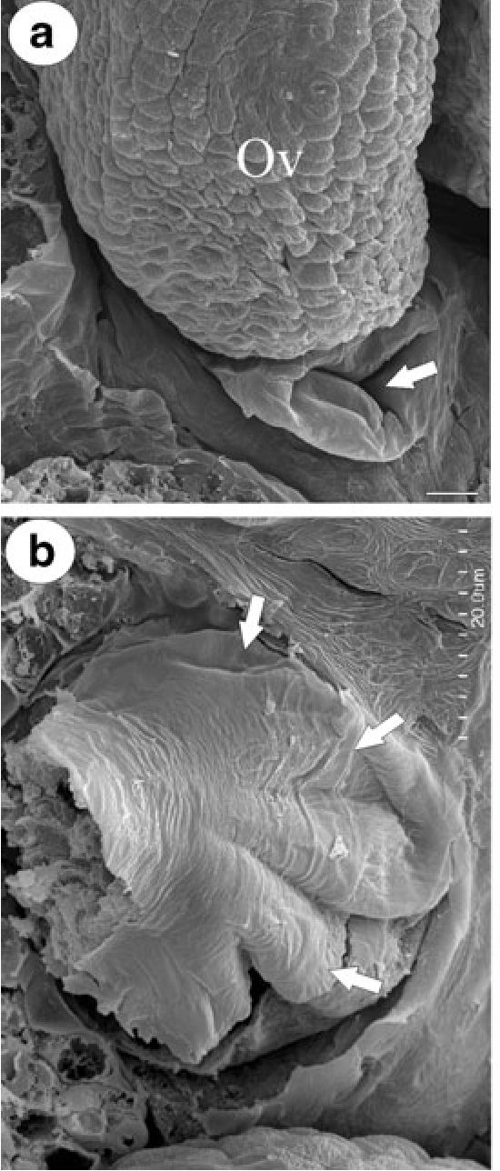
Actin cytoskeleton in embryo sac of Utricularia
665
Light and electron microscopy
For electron microscopy, placentas with ovules were
isolated from ovaries and fixed in a mixture of 2.5%
formaldehyde and 2.5% glutaraldehyde in a 0.05-M
cacodylate buffer (pH 7.0) for 2 days then washed in a
cacodylate buffer, postfixed in 1% OsO4 in a cacodylate
buffer for 24 h at 4°C, rinsed in the same buffer, treated
with 1% uranyl acetate in distilled water for 1 h, dehydrated
with acetone, and then embedded in Epoxy Embedding
Medium Kit (Fluka). Semithin sections (0.8-1,5 |rm thick)
were cut using a Leica ultracut UCT ultramicrotome,
stained with methylene blue and examined under an
Olympus BX60 microscope equipped with a DP12 digital
camera and AnaliSIS 3.2 (Soft Imaging System) software.
Ultrathin sections (70 nm) were cut using a Leica ultracut
UCT ultramicrotome. After contrasting with uranyl acetate
and lead citrate, the sections were examined using a Hitachi
H500 electron microscope. The procedure for preparing
samples for Scanning electron microscope (SEM) was as
described earlier (Płachno and Świątek 2009, 2010). The
dried tissues were sputter-coated with gold and viewed
using a HITACHI S-4700 microscope (Scanning Microscopy
Laboratory of Biological and Geological Sciences,
Jagiellonian University).

Results
Like the majority of angiosperm taxa, U. nelumbifolia has a
so-called Polygonum-type female gametophyte. In U.
nelumbifolia, the mature central cell can be divided into
three parts: extra-ovular, central (where the secondary
nucleus occurs) and the chalazal. The micropylar part of
the central cell of the mature embryo sac projects out
beyond the edges of the integument and grows outside the
ovule (Fig. 1a, b). The embryo sac is exposed to the
environment of the ovary chamber (Fig. 1a, b); however,
the extra-ovular part of the central cell also penetrates the
placenta tissue (Fig. 1c). This haustorial part of the central
cell which penetrates the placenta has contact with a special
spherical group of cells that have a thicker cell wall
(“nutritive tissue”) which differentiates in close proximity
to the ovule base at an early stage of the development of the
female gametophyte (Fig. 1c). In the micropylar part and
the extra-ovular part of the central cell, AF form long
strands which run longitudinally and transversally to the
long axis of the embryo sac (Fig. 2a). The exposed part of
the central cell, which is in contact with the environment of
the ovary chamber, is highly vacuolated (Fig. 2b). A
complicated network of AF is clearly visible in the thin
peripheral cytoplasm of the exposed part of the central cell
H
Cc
In
A
Ep
Ra
HEs
Ep
Nt
Fig. 1 The morphology and
anatomy of the ovule and
embryo sac of U. nelumbifolia;
a SEM micrograph of the ovule
(Ov) and extra-ovular part of the
central cell (arrow). Bar=
11 urn. b SEM micrograph of
the extra-ovular part of the
central cell (arrows), the ovule
was removed for better visuali-
zation of the central cell.
Bar=200 um. c A longitudinal
section through the ovule,
embryo sac, and part of the
placenta showing the arrange-
ment of actin in different types
of cells (actin by antibody
immunolabeling—green). Note
the haustorial part of the embryo
sac which penetrates the pla-
centa tissue (HEs) and long AF
strands which run longitudinally
to the long ES axis (small
arrows); raphe (Ra), placenta
(P), integument (In), placenta
epidermis (Ep), central cell (Cc),
hypostase (H), nutritive tissue
(Nt), the extra-ovular part of the
central cell (arrow). Bar =10 um

Ô Springer
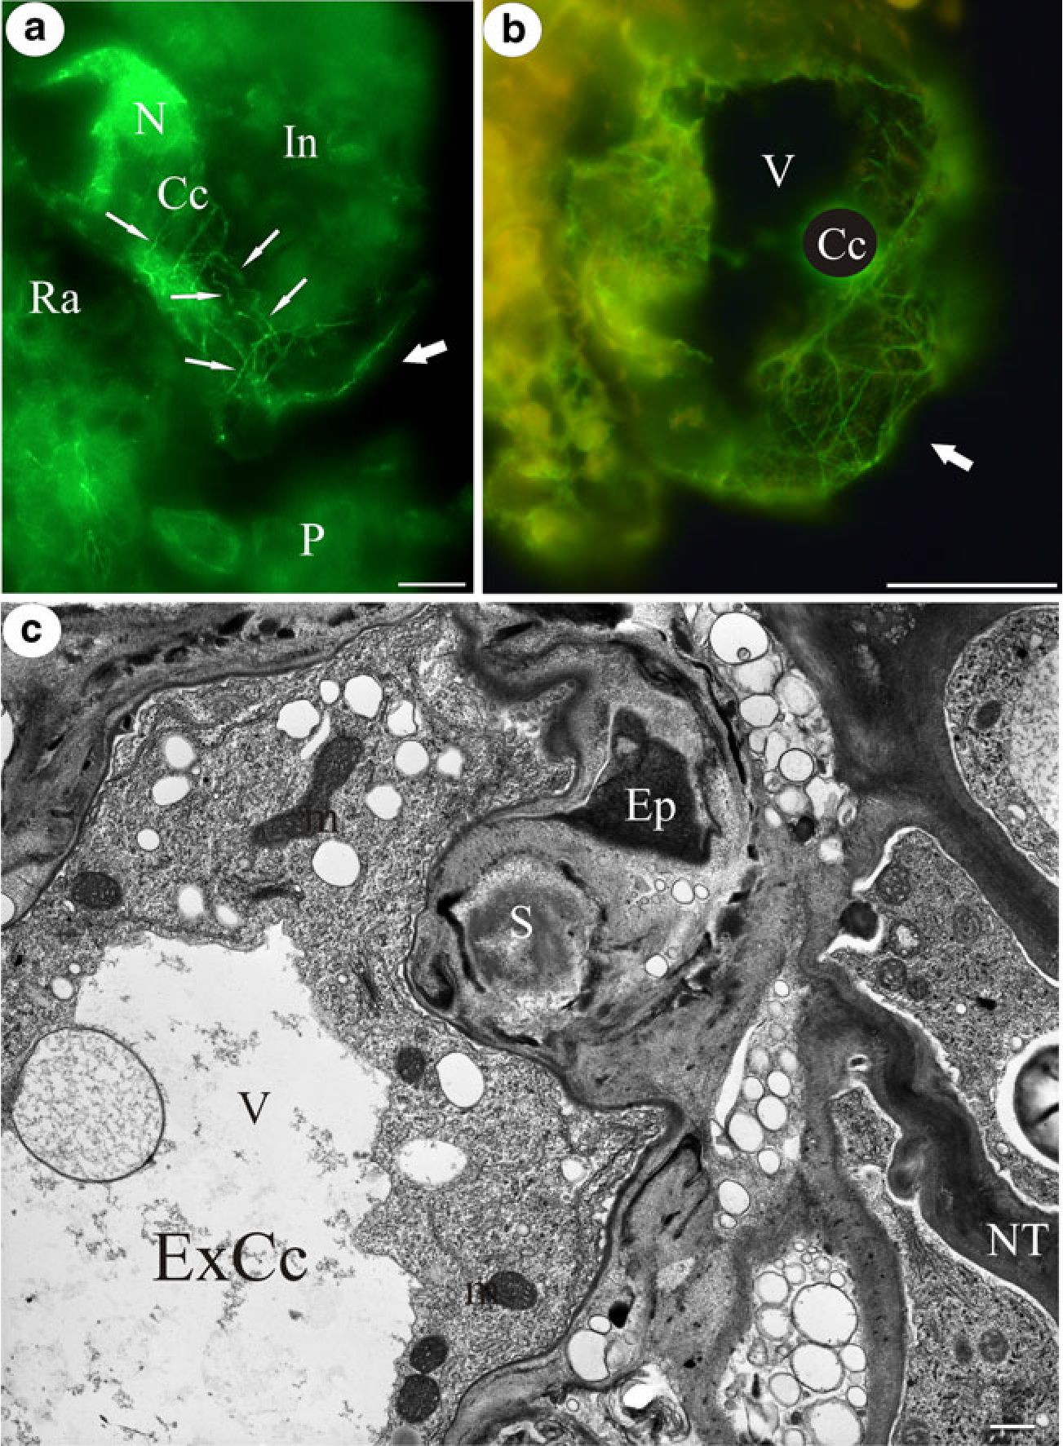
666
B.J. Plachno, P. Swiqtek
Fig. 2 The actin cytoskeleton
and ultrastructure of the extra-
ovular part of the embryo sac; a
a longitudinal section showing
the arrangement of actin in the
central cell of the embryo sac.
Note long AF strands which run
longitudinally or transversally
(small arrows); raphe (Ra),
placenta (P), secondary nucleus
(N), integument (In), central cell
(Cc), extra-ovular part of the
central cell (arrow). Bar=
22 p,m. b A transverse section
showing the complicated actin
network in the extra-ovular part
of the central cell (Cc), the
arrow points to the part of the
central cell that is exposed to the
environment of the ovary cham-
ber; vacuole (V). Bar=20 p,m. c
Electron micrograph showing
the contact of the extra-ovular
part of the central cell (ExCc)
with the epidermis (Ep) and
nutritive tissue (NT) of the
placenta; mitochondrion (m),
vacuole (V), starch grain (S).
Bar=0.8 p,m

(Fig. 2b). The epidermal cells of the placenta that are in
contact with the extra-ovular part of the embryo sac are
crushed (Fig. 2c). In contrast to the other epidermal cells,
positive signals were not observed after DAPI staining (not
shown), nor were they observed in these cells after actin
staining (Fig. 3a). The cell walls of these cells are partially
dissolved (Fig. 2c). Thus, the extra-ovular part of the
embryo sac should be considered as haustorial. In the
central part of the central cell, near the secondary nucleus,
bundles of microfilaments run in cytoplasmic strands
(Fig. 3a) forming radial or random arrays. The chalazal
part of the central cell has a cortical actin cytoskeleton in
the shape of long AF arranged according to the long axis of
the ES (not shown). In the synergids, AF are present
throughout the cytoplasm but are concentrated at the
micropylar pole (Fig. 3a) in a transverse orientation. It
should be stressed that near the micropylar part of the
synergids in the central cell, there are thick bundles of AF
oriented longitudinally. These bundles form an actin
cylinder between the synergids and the extra-ovular part
of the central cell (Fig. 3b). Actin microfilaments occur
around the nuclei of the synergids and also along
cytoplasmic transvacuolar strands (not shown). Our obser-
vations of the actin cytoskeleton are consistent with
ultrastructural data (Fig. 4a, b), e.g., a concentration of
AF was detected at the micropylar synergid pole where
most of the cytoplasm, nucleus, and filiform apparatuses
are located (Fig. 4a). Plasmodesmata between the synergids
and the central cell occur here (not shown). In addition, the
part of central cell which borders the micropylar part of the
synergids has cytoplasm filled with mitochondria, profiles
of endoplasmic reticulum, dictyosomes, and numerous
small vesicles (Fig. 4a). An egg cell is situated below the
synergids (Fig. 4b). The egg nucleus and the majority of the
Springer
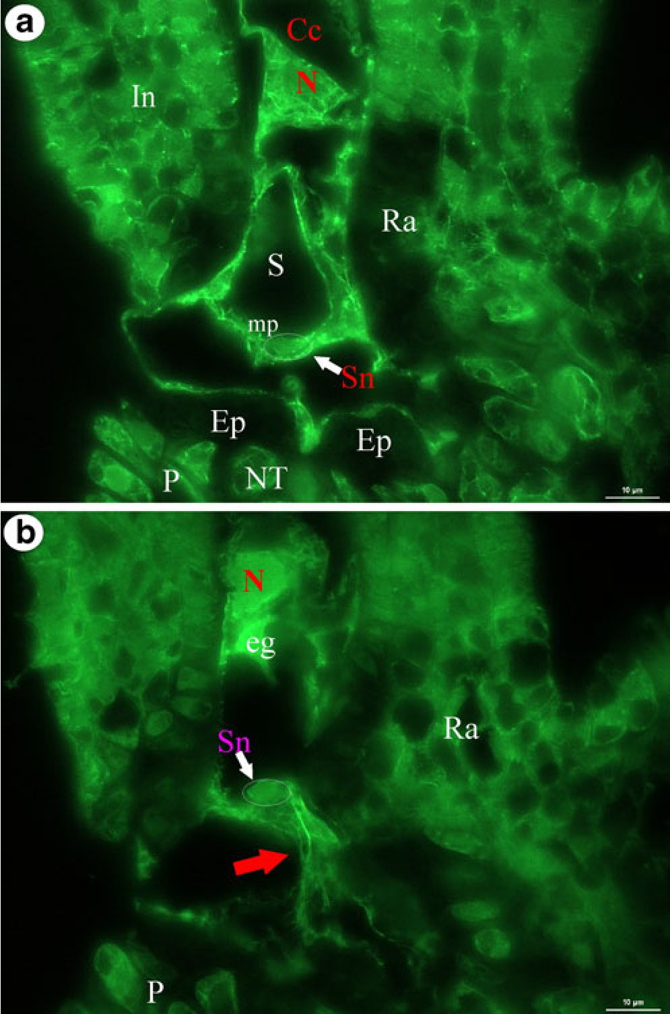
Actin cytoskeleton in embryo sac of Utricularia
667

Fig. 3 Visualization of the actin cytoskeleton in the egg apparatus and
the central cell; a, b Longitudinal sections through the central and extra-
ovular part of the embryo sac; note the AF strands in the micropylar
part of the synergid (mp) near the synergid nucleus. Also, note the
strong accumulation of actin microfilaments near the micropylar part of
the synergids (red arrow). No positive signal of actin was observed in
the crushed placenta epidermal cells (Ep); synergid nucleus (Sn),
synergid (S), secondary nucleus (N), egg cell (eg), central cell (Cc),
placenta (P), raphe (Ra), integument (In), nutritive tissue (NT). Bar=
10 pm
egg cytoplasm with mitochondria and plastids are located in
the chalazal region of the cell (Fig. 4b). A few actin
microfilaments were randomly oriented near the nucleus in
the chalazal part of the egg cell (Fig. 4c). It should be noted
that we observed only a diffuse actin network in many egg
cells (Fig. 3b).

Discussion
The actin cytoskeleton in the female gametophyte of
angiosperms has been examined in only a few dicot and
monocot species (e.g., Webb and Gunning 1994; Huang et al.
1993, 1999; Huang and Russell 1994; Huang and Sheridan
1998; Yuan et al. 2002; Ye et al. 2002; Bednara 2003). None
of these species develops such a well-developed haustorial
central cell which penetrates placenta tissues, as the
Utricularia species do. Thus, the enormous haustorial,
extra-ovular part of the central cell, which has a complicated
network of actin microfilaments, is unique to Utricularia.
The question is why does Utricularia develop this extra-
ovular part of the central cell. In the Utricularia ovule, the
funiculus lacks vascular tissue, so some Utricularia species
have another pathway for the transport of metabolites
(mainly species from the section Utricularia, Khan 1954;
Płachno and Świątek 2008, 2009) directly from the placental
nutritive tissue to the embryo sac. In addition, the influence
of the extra-ovular part of the central cell on the sporophytic
cells of the placenta has been observed in the case of U.
nelumbifolia (section Iperua). It appears that this highly
vacuolated extra-ovular part of the central cell of U.
nelumbifolia squashes the epidermal cells of the placenta
by physical pressure. This study indicated that, in the above-
mentioned epidermal cells, there was protoplast disintegra-
tion and that there was also a partial dissolution of cell walls.
Synergids are essential for attracting pollen tubes and for the
fertilization process of angiosperms (Huang and Russell
1992; Higashiyama et al. 2001; Okuda et al. 2009), but it has
only recently been found that the central cell also has its own
role in attracting pollen tubes (Marton et al. 2005; Chen et al.
2007). It was proposed that signals from the micropylar part
of the central cell could diffuse readily to the micropyle or
that the signals produced by the central cell may be
transported via the egg apparatus cells (Dresselhaus 2006;
Chen et al. 2007; Liu et al. 2010). In U. nelumbifolia, the
enlargement of the central cell increases the absorptive
surface of the embryo sac; in addition, it may also help in
signal transduction for the attraction of pollen tubes.
However, further studies are necessary to determine this.
In U. nelumbifolia, the actin cytoskeleton of the central
and chalazal parts of the central cell have an arrangement
very similar to other plants where F-actin is distributed in
the cortical and perinuclear region and also along the
transvacuolar strands (Plumbago Huang et al. 1993; Zea,
Torenia Huang et al. 1999; Arabidopsis Webb and Gunning
1994) or along the amyloplasts when the central cell is rich
in starch (Arabidopsis Webb and Gunning 1994). Yuan et al.
(2002), using living Torenia embryo sacs and microinjec-
tion experiments, showed that in the central cell, AF form a
very dynamic system that is dependent on the phases of the
development of the flower (time of anthesis) and pollina-
tion. These authors found thick bundles of AF which
connected the secondary nucleus to the micropylar, cortical
cytoplasm near the egg apparatus. A similar actin cylinder
was found in the central cell of Galanthus nivalis (Bednara
2003). According to Yuan et al. (2002), actin in the central
cell not only participates in cytoplasm streaming and
Ö Springer
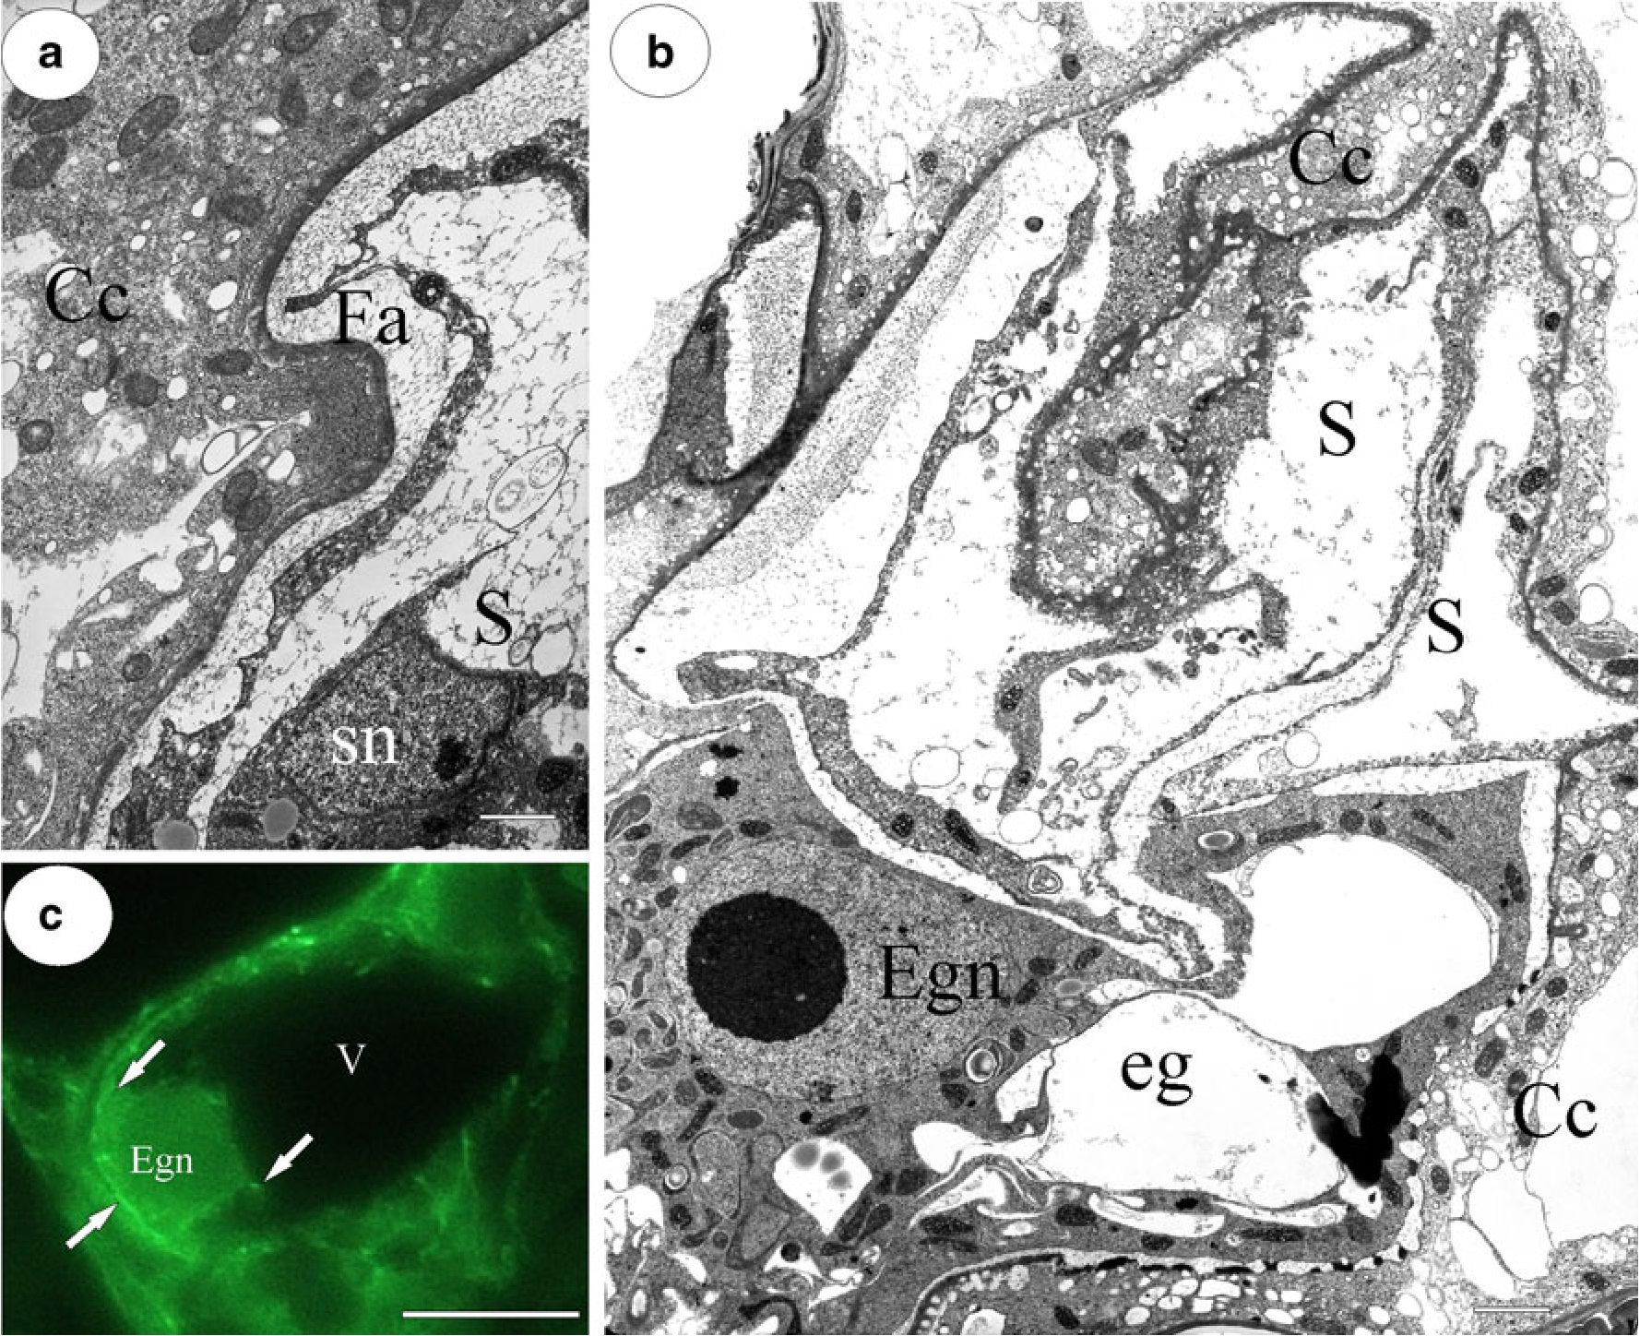
668
B.J. Plachno, P. Swiqtek

Fig. 4 Ultrastructure of the egg apparatus of U. nelumbifolia and an
immunostaining of the actin microfilaments in the egg cell; a contact
between the micropylar part of the synergid and the central cell;
synergid (S), synergid nucleus (sn), central cell (Cc), filiform
apparatus (Fa). Bar =1 pm. b Ultrastructure of the egg apparatus,
egg nucleus (Egn), egg cell (eg), central cell (Cc), synergid (S). Bar=
1.3 pm. c Poor actin cytoskeleton in egg cell: actin microfilaments
(arrows), egg nucleus (Egn), vacuole of the egg cell (V). Bar =10 pm
organelle movements but also in the migration of the
secondary nucleus to the region of the egg apparatus. As
was mentioned above, in Torenia and Galanthus, the actin
cylinder which connects the central cell and the egg
apparatus was observed (Yuan et al. 2002; Bednara 2003).
An actin cylinder-like structure was also observed in this
study, however in a different location: between the
micropylar parts of the synergids and the extra-ovular part
of the central cell. This accumulation of actin cytoskeleton
may participate in the transport of signals between the
cytoplasm of the central cell and the synergids, especially
since there are plasmodesmata which connect the micropylar
parts of the synergids with the central cell. However, this
should be experimentally proven.
Generally, in angiosperm synergids, actin microfilaments
are mostly aligned longitudinally with the long cell axis
(Arabidopsis Webb and Gunning 1994; Torenia Fu et al.
2000). In contrast, the actin microfilaments in U. nelumbi-
folia were aligned transversely with the long cell axis; this
is probably connected with their simpler synergid structure
as compared to other angiosperms (Plachno 2011) and with
the orientation and structure of the filiform apparatus in this
genus. In Torenia, dense actin filaments are located near the
region of the filiform apparatus. Later, after the degenera-
tion, actin forms a cap near the filiform apparatus (Fu et al.
2000). Similarly to Torenia, AF have also been detected in
this region in Utricularia synergids.
The four following actin arrangements have been
described for plant egg cells: (1) AF in the chalazal pole,
(2) a cortical arrangement, (3) AF in cytoplasmic strands,
and (4) a random arrangement (Webb and Gunning 1994;
Huang et al. 1993, 1999; Huang and Russell 1994; Bednara
2003). Similar to other angiosperms, the AF concentrate at
the chalazal pole of the egg cell in U. nelumbifolia. The
poor AF cytoskeleton in the Utricularia egg may be
connected to the inactive physiological stage (resting phase)
of the egg cell of angiosperms or actin signals may simply
label globular actin.
Springer
Actin cytoskeleton in embryo sac of Utricularia
669

Conclusions
This study has shown that the U. nelumbifolia embryo sac
has some unusual characteristics in AF arrangement
comparison with typical angiosperms: The extra-ovular
part of the central cell has a well-developed actin
cytoskeleton—actin microfilaments formed of long strands
run longitudinally and transversally to the long axis of the
embryo sac. The exerted part of the central cell, which is
exposed to the environment of the ovary chamber, is highly
vacuolated, and in the thin peripheral cytoplasm, a
complicated network of actin microfilaments was present.
The accumulation of the actin cytoskeleton between the
micropylar parts of the synergids and the extra-ovular part
of the central cell is unusual because in typical angiosperms
the micropylar parts of the synergids form the apex of the
female gametophyte.
Acknowledgments This paper is dedicated to Professor Romana
Izmaiłow (Department of Plant Cytology and Embryology, Institute of
Botany, Jagjellonian University) for her great contribution to research on
plant embryology. This study was funded by grant NN304 002536 from the
Polish Ministry of Science and Higher Education. We cordially thank the
director of the Botanic Garden of the Jagiellonian University, Prof. Bogdan
Zemanek, for permission to use plants from the Garden collections and also
gardener, Lucyna Kurleto, who conscientiously cares for the collection of
carnivorous plants in the Garden. We also especially thank both Dr.
Małgorzata Kozieradzka-Kiszkurno and M.Sc. Małgorzata Ignatowska
(University of Gdańsk) for their expert technical help. The comments to the
manuscript of Prof.Ewa Kurczyńska are kindly acknowledged.
Conflict of interest statement The authors declare that they have no
conflict of interest.
Open Access This article is distributed under the terms of the
Creative Commons Attribution Noncommercial License which per-
mits any noncommercial use, distribution, and reproduction in any
medium, provided the original author(s) and source are credited.

References
Bednara J (2003) Rola szkieletu cytoplazmatycznego w rozmnażaniu
roślin. (Role of cytoskeleton in plants reproduction.). Kosmos
52:469-479
Bencivenga S, Colombo L, Masiero S (2011) Cross talk between the
sporophyte and the megagametophyte during ovule development.
Sex Plant Reprod 24. doi:10.1007/s00497-011-0162-3
Chae K, Lord EM (2011) Pollen tube growth and guidance: roles of
small, secreted proteins. Ann Bot. doi:10.1093/aob/mcr015
Chen Y-H, Li H-J, Shi D-Q, Yuan L, Liu J, Sreenivasan R, Baskar R,
Grossniklaus U, Yang W-C (2007) The central cell plays a critical role
in pollen tube guidance in Arabidopsis. Plant Cell 19:3563-3577
Chudzik B, Zarzyka B, Śnieżko R (2005) Immunodetection of
arabinogalactan proteins in different types of plant ovules. Acta
Biol Cracov Ser Bot 47:139-146
Dresselhaus T (2006) Cell-cell communication during double fertil-
ization. Curr Opin Plant Biol 9:41-47
Farooq M, Siddiqui SA (1964) The embryology of Utricularia
stellaris Linn. f. Sci Cult 30:394-395
Fu Y, Yuen M, Huang BQ, Yang HY, Zee SY, O’Brien TP (2000) Changes
in actin organization in the living egg apparatus of Torenia fournieri
during fertilization. Sex Plant Reprod 12:315-322
Han YH, Huang BQ, Zee SY, Yuan M (2000) Symplastic communi-
cation between the central cell and the egg apparatus cells in the
embryo sac of Torenia fournieri Lind. before and during
fertilization. Planta 211:158-162
Higashiyama T, Kuroiwa H, Kawano S, Kuroiwa T (1997) Kinetics of
double fertilization in Torenia fournieri based on direct observa-
tions of the naked embryo sac. Planta 203:101-110
Higashiyama T, Kuroiwa H, Kawano S, Kuroiwa T (1998) Guidance
in vitro of the pollen tube to the naked embryo sac of Torenia
fournieri. Plant Cell 10:2019-2031
Higashiyama T, Yabe S, Sasaki N, Nishimura Y, Miyagishima S,
Kuroiwa H, Kuroiwa T (2001) Pollen tube attraction by the
synergid cell. Science 293:1480-1483
Higashiyama T, Kuroiwa H, Kuroiwa T (2003) Pollen tube guidance:
beacons from the female gametophyte. Curr Opin Plant Biol 6:36-41
Higashiyama T, tnatsugi R, Sakamoto S, Sasaki N, Mori T, Kuroiwa
H, Nakada T, Nozaki H, Kuroiwa T, Nakano A (2006) Species
preferentiality of the pollen tube attractant derived from the
synergid cell of Torenia fournieri. Plant Physiol 142:481-491
Huang BQ, Russell SD (1992) Female germ unit: organization,
isolation, and function. Int Rev Cytol 140:233-293
Huang BQ, Russell SD (1994) Fertilization in Nicotiana tabacum:
cytoskeletal modifications in the embryo sac during synergid
degeneration. Planta 194:200-214
Huang BQ, Sheridan FW (1998) Actin coronas in normal and
indeterminate gametophyte 1 embryo sacs of maize. Sex Plant
Reprod 11:257-264
Huang BQ, Pierson ES, Russell SD, Tiezzi A, Cresti M (1993) Cytoskeletal
organisation and modification during pollen tube arrival, gamete
delivery and fertilisation in Plumbago zeylanica. Zygote 1:143-154
Huang BQ, Fu Y, Zee SY, Hepler PK (1999) Three-dimensional
organization and dynamic changes of the actin cytoskeleton in
embryo sacs of Zea mays and Torenia fournieri. Protoplasma
209:105-119
Ingram GC (2010) Family life at close quarters: communication and
constraint in angiosperm seed development. Protoplasma
247:195-214
Khan R (1954) A contribution to the embryology of Utricularia
flexuosa Vahl. Phytomorphol 4:80-117
Krishna Iyengar CV (1941) Development of embryo-sac and
endosperm haustoria in Torenia cordifolia Roxb., and T. hirsuta
Benth. Proc Nat Inst Sci India 7:61-71
Liu Y, Yan Z, Chen N, Di X, Huang J, Guo G (2010) Development and
function of central cell in angiosperm female gametophyte.
Genesis 48:466-478
Maheshwari P (1950) An introduction to the embryology of
angiosperms. McGraw-Hill, New York
Marton ML, Cordts S, Broadhvest J, Dresselhaus T (2005) Micropylar
pollen tube guidance by egg apparatus 1 of maize. Science
307:573-576
Okuda S, Tsutsui H, Shiina K, Sprunck S, Takeuchi H, Yui R,
Kasahara RD, Hamamura Y, Mizukami A, Susaki D et al (2009)
Defensin-like polypeptide LUREs are pollen tube attractants
secreted from synergid cells. Nature 458:357-361
Palanivelu R, Brass L, Edlund AF, Preuss D (2003) Pollen tube
growth and guidance is regulated by POP2, an Arabidopsis gene
that controls GABA levels. Cell 114:47-59
Plachno BJ (2011) Female germ unit in Genlisea and Utricularia, with
remarks about the evolution of the extra-ovular female gameto-
phyte in members of Lentibulariaceae. Protoplasma 248:391-
404. doi: 10.1007/s00709-010-0185-x
Ô Springer
670
B.J. Płachno, P. Świątek
Płachno BJ, Świątek P (2008) Cytoarchitecture of Utricularia
nutritive tissue. Protoplasma 234:25-32
Płachno BJ, Świątek P (2009) Functional anatomy of the ovule in
Genlisea with remarks on ovule evolution in Lentibulariaceae.
Protoplasma 236:39-48
Płachno BJ, Świątek P (2010) Unusual embryo structure in viviparous
Utricularia nelumbifolia, with remarks on embryo evolution in
genus Utricularia. Protoplasma 239:69-80. doi:10.1007/s00709-
009-0084-1
Płachno BJ, Świątek P (2011) Syncytia in plants: cell fusion in endosperm-
placental syncytium formation in Utricularia (Lentibulariaceae).
Protoplasma 248:425-435. doi:10.1007/s00709-010-0173-1
Płachno BJ, Świątek P, Kozieradzka-Kiszkurno M (2011) The F-actin
cytoskeleton in syncytia from non-clonal progenitor cells.
Protoplasma 248:623-629. doi:10.1007/s00709-010-0209-6
Shimizu KK, Okada K (2000) Attractive and repulsive interactions
between female and male gametophytes in Arabidopsis pollen
tube guidance. Development 127:4511-4518
Taylor P (1989) The genus Utricularia—a taxonomic monograph.
Kew B 14:1-735
Webb MC, Gunning BES (1994) Embryo sac development in
Arabidopsis thaliana. II. The cytoskeleton during megasporo-
genesis. Sex Plant Reprod 7:153-163
Ye XL, Yeung EC, Zee SY (2002) Sperm movement during double
fertilization of a flowering plant, Phaius tankervilliae. Planta
215:60-66
Yuan Ming Fu, Ying WF, Bing-Quan H, Zee S-Y, Hepler PK (2002)
Fertilization in Torenia fournieri: actin organization and nuclear
behavior in the central cell and primary endosperm. Science in
China 45:211-22412
Springer

