


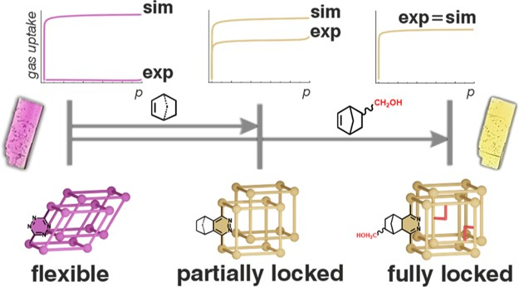




pubs.acs.org/cm
Turning Flexibility into Rigidity: Stepwise Locking of Interpenetrating Networks in a MOF Crystal through Click Reaction
Damian Jędrzejowski, Marzena Pander, Wojciech Nitek, Wojciech Bury,* and Dariusz Matoga*
Cite This: Chem. Mater. 2021, 33, 7509−7517
Read Online
ACCESS
*sı
Metrics & More
Article Recommendations
Supporting Information
ABSTRACT: Post-synthetic modiﬁcations of metal−organic frameworks (MOFs) enable synthesis of materials with enhanced performance characteristics or those inaccessible by direct synthetic routes. In this work, for the ﬁrst time, we utilize inverse-electron demand Diels−Alder (iEDDA) modiﬁcation to control the structural ﬂexibility and porosity of an open framework material. We selected a series of dienophiles with increasing bulkiness including ethyl vinyl ether (eve), cyclohexene (chx), norbornene (nor), and 5- norbornene-2-methanol (noh) to modify a tetrazine-based linker (3,6-dipyridyl-1,2,4,5- tetrazine, dpt) incorporated in a unique doubly interpenetrated 3D hybrid MOF−HOF
porous material (HOF, hydrogen-bonded organic framework), {[Cd₂(coh)₂(dpt)₂]·
guests}_{n} (JUK-20). Each subnetwork in JUK-20 is built of 2D coordination layers stacked by strong complementary CO··· H−N hydrogen bonds between carbohydrazide dibenzoate linkers (coh). By using the [4 + 2] click reactions of JUK-20, which proceed in a prominent single-crystal-to-single-crystal manner, we obtained a series of JUK-20-dienophile MOFs. The modiﬁcations lead to a stepwise decrease in structural ﬂexibility of the JUK-20 platform until the highest rigidity and stability is reached for JUK- 20-noh. Consequently, the adsorption capacity in the JUK-20-dienophile series increases, as revealed collectively by single-crystal
X-ray diﬀraction, physisorption isotherms (N₂,
CO₂, and MeOH), and grand canonical Monte Carlo simulations. Our work
demonstrates that post-synthetic iEDDA modiﬁcation is a versatile and eﬃcient tool for systematic functionalization of open framework materials under mild conditions.
■
INTRODUCTION
approach, numerous studies have shown classical nucleophilic substitution^{31,32} or substitution in a carbonyl group;^{33,34} however, these reactions typically require chemically stable structures that are resistant to highly corrosive reagents, for example, acyl chlorides or acid anhydrides. Alternatively, to avoid framework degradation, a number of CPSMs have been carried out under mild conditions using Schiﬀ base condensations,^{35,36} reactions between amines and isocya- nates,^{37,38} or azide−alkyne click reactions.^{30,39} On the other hand, these reactions suﬀer from limitations such as low conversion, products prone to hydrolysis, and necessity to use extra additives or catalysts. Therefore, searching for new post- synthetic irreversible modiﬁcations, which can proceed eﬃciently under mild conditions, is of high importance.
By drawing inspiration from bioorthogonal chemistry⁴⁰⁻⁴³ that occurs in living cells, cycloaddition reactions have been applied as mild CPSM of MOFs.³⁹ The most common is Huisgen 1,3-dipolar cycloaddition between organic azides and
Among various classes of advanced functional materials, metal−organic frameworks (MOFs) stand out by virtue of
their unique building units,¹ switchable porosity,² and high crystallinity.³ Large surface areas, tunable pore size, and chemical environment oﬀer a rich landscape for exploring adsorption phenomena and related applications such as gas storage,⁴ separation,⁵ catalysis,⁶ and sensing.⁷ From the diversity of metal nodes, organic ligands, and guest molecules emerge a variety of properties whose control can be achieved by taking advantage of the structural ﬂexibility of MOFs. This dynamic behavior of coordination networks can be triggered by external stimuli such as inclusion/removal of guest molecules, pressure, or temperature⁸⁻¹⁰ and is governed by two major factors, that is, ﬂexibility of coordination bonds involved in the node-linker interactions and free rotations or bending of structural fragments of the linkers. For inter- penetrated systems, additional degrees of freedom must be taken into consideration, arising from separation of individual subnetworks. All these structural features can be collectively manifested as inter- or intraframework movements. Signiﬁcant changes in ﬂexibility and adsorption properties of a given MOF
2]46−48
alkynes,^{44,45} whereas the variants [2 +
and [4 + 2],
ions,11−13
platform have been observed for various metal
linkers,¹⁴⁻¹⁶ or their substituents.¹⁷⁻²¹ These changes can be
realized by rational selection of secondary building units,^{11,18,22} post-assembly linker/metal exchange,^{23,24} or by covalent post- synthetic modiﬁcation (CPSM) of linkers.²⁵⁻³⁰ Within the last
© 2021 The Authors. Published by American Chemical Society
https://doi.org/10.1021/acs.chemmater.1c02451
Chem. Mater. 2021, 33, 7509−7517
7509
Downloaded via UNIWERSYTETU JAGIELLONSKIEGO on November 3, 2021 at 10:09:50 (UTC). See https://pubs.acs.org/sharingguidelines for options on how to legitimately share published articles.

Article
Received: July 15, 2021
Revised: August 24, 2021
Published: September 7, 2021

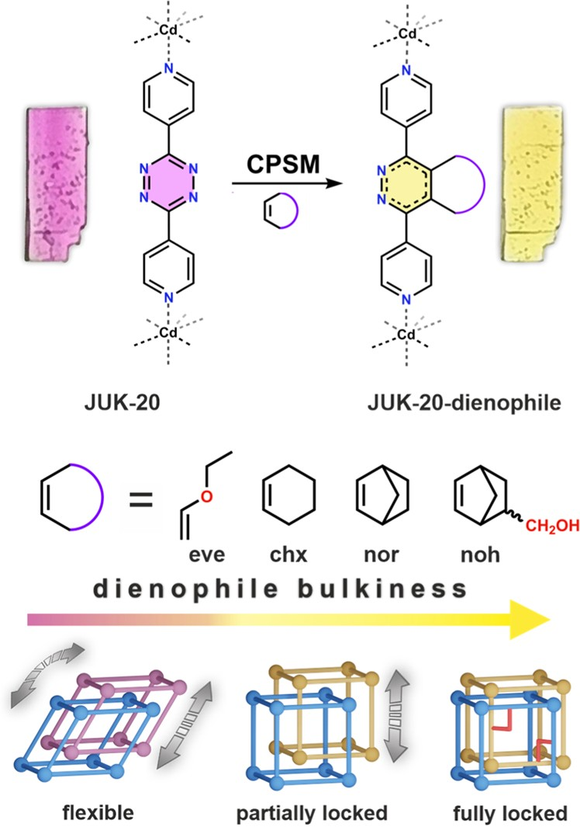
Chemistry of Materials
pubs.acs.org/cm
Article
including the Diels−Alder reaction,⁴⁹⁻⁵² have been rarely employed. The main reason for that is the scarcity of reactive linkers and reversibility of the reactions. The classic variant of the Diels−Alder reaction requires the presence of electron- donor substituents in a diene and electron-acceptor sub- stituents in a dienophile. The major limitations of this approach are high activation energies and the need to use catalysts. An alternative variant of this process called the inverse electron-demand Diels−Alder (iEDDA) reaction reverses the electron requirement between dienes and dienophiles, which broadly expands the library of useful
canonical Monte Carlo (GCMC) simulations. Our work demonstrates that post-synthetic iEDDA modiﬁcation is an astonishingly versatile and eﬃcient tool for systematic functionalization of open framework materials under mild
conditions.
■
EXPERIMENTAL SECTION
Materials. All reagents and solvents, unless otherwise noted, were
purchased from commercial sources and used without further
puriﬁcation. 3,6-Di(pyridin-4-yl)-1,2,4,5-tetrazine (dpt) was synthe- sized by a literature method with a slight modiﬁcation.⁶⁰ Bis(4- formylbenzoic acid) carbohydrazone (coh) was synthesized by condensation of carbohydrazide with 4-formylbenzoic acid. (Bicyclo[2.2.1]hept-5-en-2-yl)methanol (noh) was synthesized by a literature method.⁶¹ Each derivative of the dpt ligand (i.e., dpt-eve, dpt-chx, dpt-nor, dpt-noh) was synthesized by iEDDA reaction with a corresponding dienophile (see the Supporting Information for details).
MOF Syntheses. Single crystals of JUK-20 were obtained by a slow diﬀusion method. Bulk samples were prepared in closed vials using N,N-dimethylformamide (DMF)/methanol (MeOH) mixtures at 80 °C. The iEDDA reactions of JUK-20 with all dienophiles were conducted by using solids suspended in DMF. The reaction conditions were established by monitoring UV−vis and nuclear magnetic resonance (NMR) spectra of the products. Additional control syntheses involving the pre-assembly modiﬁed dpt linkers (dpt-eve, dpt-chx, dpt-nor, dpt-noh) did not lead to JUK-20- dienophile products (see the Supporting Information for details).
Physisorption Measurements and GCMC Simulations. The sorption measurements for N₂, CO₂, and methanol were performed at 77, 195, and 293 K, respectively. The virtual porosity of the JUK-20-x materials (collective notation for JUK-20 and JUK-20-dienophile series) was analyzed using Zeo++ calculations⁶² of the framework models based on the crystal structures (Supporting Information, Table S4). The adsorption isotherms for dinitrogen (77 K), carbon dioxide (195 K), and methanol (293 K) in JUK-20-x materials were calculated by GCMC simulations using the RASPA2 software.⁶³ The models used, simulation, and experimental details are described in the
reactants.42,43,53,54
To date, there are only a handful of
literature reports where iEDDA has been reported as CPSM
of a coordination polymer.⁵⁵⁻⁵⁹ The tetrazine-based click reaction in MOFs was initially shown for materials containing an oleﬁn-tagged benzenedicarboxylate linker,⁵⁵ and more recently, it was used to obtain a superhydrophobic MOF material⁵⁷ or to increase CO₂ adsorption capacity.⁵⁹
Herein, we demonstrate precise control of the number of possible degrees of freedom in a doubly interpenetrated framework by using iEDDA reaction. As a model system, we designed a new MOF platform (JUK-20), which contains an immobilized 1,2,4,5-tetrazine entity and enables a series of post-synthetic iEDDA modiﬁcations that occur in a unique single-crystal-to-single-crystal (SCSC) manner (Figure 1). Our
Supporting Information.
■
RESULTS AND DISCUSSION
Synthesis and Structure of JUK-20. Solvothermal
reaction of Cd(NO₃)₂·6H₂O, coh, and dpt in DMF/MeOH (9:1 v/v) carried out at 80 °C for 72 h resulted in the
formation of {[Cd₂(coh)₂(dpt)₂]·6DMF·5H₂O}_{n} (JUK-20). The phase purity of bulk JUK-20 was conﬁrmed by comparison of its experimental powder X-ray diﬀraction (PXRD) pattern with that calculated from single crystal diﬀraction data (Supporting Information, Figure S1). Single crystals suitable for SC-XRD measurements were obtained by a slow diﬀusion method (see the Supporting Information for details). JUK-20 crystallizes in the triclinic space group (P1̅) and forms a hybrid MOF−HOF three-dimensional (3D) material (HOF, hydrogen-bonded organic framework). In the structure of JUK-20, the coh anions act as μ₃-κ²,κ²,κ¹ linkers joining bimetallic cadmium clusters, whereas the μ₂-dpt ligands act as double pillars and complete the coordination sphere of each metal ion, resulting in the formation of 2D coordination
Figure 1. Post-synthetic covalent iEDDA-type modiﬁcations (CPSM) of JUK-20 with dienophiles of increasing bulkiness occurring in an SCSC manner (top). Schematic diagram illustrating control of structural ﬂexibility through CPSM (bottom).
approach allowed for a systematic incorporation of structural fragments with increasing bulkiness and diﬀerent polarities into the pores of JUK-20, which was fully conﬁrmed by SCXRD studies after the iEDDA modiﬁcations. The structural ﬂexibility of the parent and daughter materials was thoroughly examined by adsorption of diﬀerent adsorbates (N₂, CO₂, and MeOH) with varying polarity. Furthermore, the experimental struc- ture−sorption relationship was supported by the grand
layers of sql topology. Importantly, these layers are stacked
together by strong complementary CO···H−N hydrogen bonds between coh linkers, forming a 3D hybrid network (Figure 2a). The structure of JUK-20 consists of two such 3D networks that interpenetrate each other. The relative position of interpenetrating networks is inﬂuenced by weak C−H···N interactions and hydrogen bonds with guest solvent molecules (DMF). The as-synthesized JUK-20 contains open one-

https://doi.org/10.1021/acs.chemmater.1c02451
Chem. Mater. 2021, 33, 7509−7517
7510

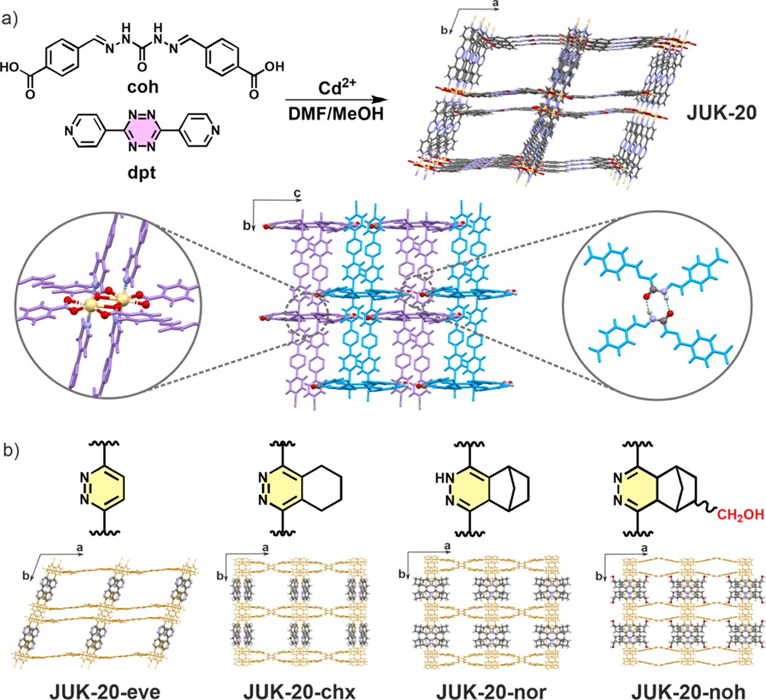
Chemistry of Materials
pubs.acs.org/cm
Article
Figure 2. (a) Synthetic scheme leading to microporous JUK-20 (top); structural features of JUK-20 (bottom): Cd₂ clusters as nodes (left inset), two interpenetrating hybrid 3D networks (shown as purple and blue), each built of coordination layers stacked by strong hydrogen bonds (right inset). (b) Crystal structures of JUK-20-dienophile MOFs with respective tetrazine-derived linkers after iEDDA reactions.
dimensional diamond-shaped channels with large apertures of
10.4 × 17.3 Å propagating along the [001] direction (Figure 2a). The accessible probe-occupiable pore volume of JUK-20 calculated using the Zeo++ software⁶² with a probe radius of
1.86 Å amounts to 45.6%.
Structural features of JUK-20 are corroborated by vibra- tional spectroscopy. The infrared (IR) spectrum of JUK-20 shows characteristic absorption bands corresponding to coh and dpt ligands (Supporting Information, Figure S1). Apart from symmetric and asymmetric vibrations of carboxylates (1394 and 1535 cm⁻¹, respectively), the presence of 3463,
ethyl-vinyl ether (eve), cyclohexene (chx), norbornene (nor), and (norbornenyl)methanol (noh), which diﬀer by the presence of electron-donor groups (eve, noh) and angular stress (nor, noh). The dienophiles can be arranged in increasing order of reaction rates (chx < eve < nor < noh), which strongly correlates with the inﬂuence of electron-donor groups and angular stress. The reactions were completed at RT from within several minutes (for noh) to several hours (for chx). The products were identiﬁed and quantiﬁed by TLC and NMR spectroscopy. Importantly, direct synthetic approaches toward JUK-20-dienophile materials were also explored. dpt- eve, dpt-nor, and dpt-noh were utilized in a series of experiments in diﬀerent solvents at various concentrations and temperatures. Despite numerous eﬀorts, no pure crystalline phases of JUK-20-dienophile MOFs were obtained due to the poor solubility of the modiﬁed ligands.
The iEDDA reactions were carried out on single crystals and
polycrystalline samples of JUK-20 immersed in DMF. The reaction progress was monitored visually by observation of dinitrogen gas evolution and a distinct color change from pink to pale yellow (Figure 1 and Supporting Information, Movie S1). The complete conversion was also conﬁrmed by solid- state UV−vis−NIR reﬂectance spectroscopy; full conversion led to a complete disappearance of the band at 537 nm (Supporting Information, Figure S6). The relative rates for the reactions of JUK-20 with various dienophiles were the same as for the dpt itself; however, due to heterogeneity of the process and diﬀusion inside the crystals, each reaction time was ﬁve to ten times longer than for the ligand.
Structural Studies of the JUK-20-Dienophile Series. The samples after post-synthetic modiﬁcations with dien- ophiles were examined by complementary techniques. The IR spectra after iEDDA reactions show only slight changes in the

https://doi.org/10.1021/acs.chemmater.1c02451
Chem. Mater. 2021, 33, 7509−7517
1668, and 1606 cm⁻¹ bands is attributed, respectively, to the
amide N−H, CO, and NC groups of the coh acylhydrazone. A signiﬁcant blue shift of the amide N−H band as compared to the free coh ligand (3222 cm⁻¹) supports the formation of strong hydrogen bonds between the N−H group and the carbonyl oxygen atom. Thermogravimetric analysis of the as-synthesized JUK-20 demonstrates removal of DMF and H₂O molecules upon heating to ca. 200 °C (weight loss, 27.6%), and the material is thermally stable up to ca. 250
°C (Supporting Information, Figure S1). The desolvation leads to a partial amorphization of JUK-20, and its crystallinity is fully recovered upon resolvation (Supporting Information, Figure S2).
Systematic iEDDA Approach to JUK-20-Dienophile MOFs. We hypothesized that the 1,2,4,5-tetrazine as a well- known diene for iEDDA reactions⁶⁴ could be a suitable moiety for stepwise introducing of various bulky and anchoring groups into a MOF by proper selection of the dienophiles used for post-synthetic modiﬁcation. Initially, several iEDDA reactions with various dienophiles were carried out using the dpt ligand itself as a reactant (see the Supporting Information for details). Selected dienophiles for the reaction (Figure 2b) included
7511

Chemistry of Materials
pubs.acs.org/cm
Article
1390−1410 cm⁻¹ range, attributed to the reduced amount of aromatic N−N bonds in the 1,2,4,5-tetrazine moiety, and the appearance of a relatively weak absorption band near 3340 cm⁻¹, from the O−H bond in the noh dienophile (Supporting Information, Figure S7). Desolvated samples of the modiﬁed
inside the main pore (60% site occupancy for B isomer, Table
1) due to its involvement in hydrogen bonds with the OH group of the noh dienophile (Figure 2b). Whereas the shape of the main pore changes signiﬁcantly from rhomboidal to rectangular upon cycloaddition of bulky dienophiles (chx, nor, and noh), the accessible pore volumes remain practically constant (within 0.03 cm3/g for eve and chx) or decrease by
0.10 cm3/g for nor and by 0.15 cm3/g for noh, which is a
result of repositioning of the coh linker. More importantly, however, the bulky dienophile with a polar substituent (noh) provides additional rigidity and stabilization of the framework through strong hydrogen bonding (O−H···O; d(O···O) = 2.82 Å) between adjacent subnetworks. In summary, the least bulky eve dienophile does not cause any signiﬁcant structural changes of JUK-20, and the framework ﬂexibility may arise from either intralayer tilting or interlayer displacements. As the bulkiness of dienophiles increases (chx and nor), the tilt angle becomes ﬁxed at 90° and only 1 degree of freedom remains. Finally, introduction of the bulkiest noh dienophile leads to a fully locked rigid structure of JUK-20-noh.
The susceptibility of undergoing structural changes in JUK- 20-x materials before and after modiﬁcation was further investigated by variable-temperature PXRD (VT-PXRD). In Figure 3a, the selected VT-PXRD patterns are shown in a range of 30−300 °C for the JUK-20-x series. With increasing temperature, the triclinic JUK-20 and JUK-20-eve materials undergo phase transitions which are conﬁrmed by the appearance of the high-intensity diﬀraction peaks at higher 2θ angles. In contrast, no visible diﬀerences in VT-PXRD patterns can be observed for the rest of JUK-20-dienophile materials, hence proving their more rigid nature.
Modulation of Porosity and Flexibility of JUK-20. The structural changes of JUK-20 upon iEDDA reactions, including the shape of the main [001] channel and interlayer bonding, prompted us to explore the adsorption properties of the JUK- 20-dienophile series. To estimate the expected virtual porosity of the JUK-20-x materials, GCMC calculations were performed based on the structural models of the desolvated frameworks. Structural models for JUK-20-chx, JUK-20-nor, and JUK-20-noh were constructed using the single crystal data including both A and B isomeric frameworks (vide supra, and Supporting Information, Figure S17). The calculated dini- trogen adsorption isotherms are presented in Figure 3b and show that all materials are expected to be porous. Having in hand the simulation data, we performed N₂ adsorption measurements at 77 K on the desolvated MOF powders (Figure 3b). Interestingly, for JUK-20-x materials, the comparison of experimental physisorption results with simulations of virtual porosity spreads from a complete disagreement to a perfect match. The largest discrepancies between simulations and measurements were observed for JUK-20 and JUK-20-eve, with the simulated N₂ uptakes of
353 and 340 cm³/g, respectively. Based on experimental results, JUK-20 and JUK-20-eve are almost non-porous toward dinitrogen, whereas for JUK-20-chx, JUK-20-nor, and JUK-20-noh, we observed signiﬁcant experimental N₂ uptakes of 230, 266, and 284 cm3/g, respectively. Surprisingly, the calculated nitrogen adsorption isotherms for JUK-20-nor and JUK-20-noh are in exceptionally good agreement with the experimental data, that is, the N₂ uptake values of 295 and 278 cm³/g were obtained, respectively. We ascribe these discrep- ancies between experiment and simulations to framework ﬂexibility in case of JUK-20 and JUK-20-eve. To further
https://doi.org/10.1021/acs.chemmater.1c02451
Chem. Mater. 2021, 33, 7509−7517
1H
JUK-20 were also subjected to elemental (CHN) and
NMR analyses; the latter were carried out after digestion of the samples in a deuterated sulfuric acid/dimethylsulfoxide-d₆ mixture (Supporting Information, Figure S9). Here, three types of products including 1,2-diazine, 1,4-dihydro-1,2-diazine
or 4,5-dihydro-1,2-diazine moieties were identiﬁed dependent on the bulkiness of the dienophile and its leaving group (see the Supporting Information for details). The formation of the three products can be rationalized in terms of the commonly accepted cycloaddition mechanism of dienophiles to the 1,2,4,5-tetrazine moiety (Supporting Information, Figures S10−S11). It is worth noting that 4,5-dihydro-1,2-diazine has rarely been reported in the literature as the iEDDA product so far due to its spontaneous oxidation to an aromatic system, and only in the case of a tetrasubstituted dienophile, this product was reported.^{65,66}
All post-synthetic iEDDA reactions of JUK-20 occurred in an SCSC manner and the structures of the products were determined based on SC-XRD (Figure 2b). PXRD patterns for each sample revealed retention of the bulk crystallinity with only slight shifts of the peak positions (Supporting Information, Figure S6). The modiﬁcation with the eve dienophile leads to the replacement of two nitrogen atoms in a tetrazine ring by carbon atoms. A similar modiﬁcation may be carried out using 2,5-norbornadiene or any other ethylene derivative with a good leaving group. From the network perspective, such a modiﬁcation is structurally insigniﬁcant and causes only slight changes in the unit cell parameters and the accessible pore volumes (V_{P}) (Table 1). A systematic increase
Table 1. Selected Geometrical Parameters for JUK-20-x Series Including Structural Disorder
JUK-20 JUK-20-eve
JUK-20-chx-A JUK-20-chx-B JUK-20-nor-A JUK-20-nor-B JUK-20-noh-A JUK-20-noh-B
70.324
69.545
90
90
90
90
90
90
n/a n/a 0.67
0.33
0.75
0.25
0.40
0.60
0.50
0.48
0.47
0.43
0.40
0.38
0.40
0.35
aCalculated with Zeo++ using a probe radius of 1.86 Å
in dienophile bulkiness by incorporating a steric
hindrance
(chx, nor, and noh) and additionally a hydrogen-bonding
group (noh) led to the crystal symmetry change from triclinic to monoclinic (Figure 2b) and introduced disorder at the coh ligand, which occupied two alternative positions, leading to isomers A (higher pore volume) and B (lower pore volume). Solvent-accessible pore volumes were calculated assuming that the coh ligand occupies only one position in each structure (Table 1 and Supporting Information, Table S4). In JUK-20- chx and JUK-20−nor, the predominant position of the coh linker (67 and 75% site occupancies for A isomers, Table 1) is directed outside the main [001] pore, whereas in JUK-20-noh, in contrast, this linker occupies mostly the position directed
7512
site occupancy of coh pore volumeª material γ/deg linker /cm3·g−1

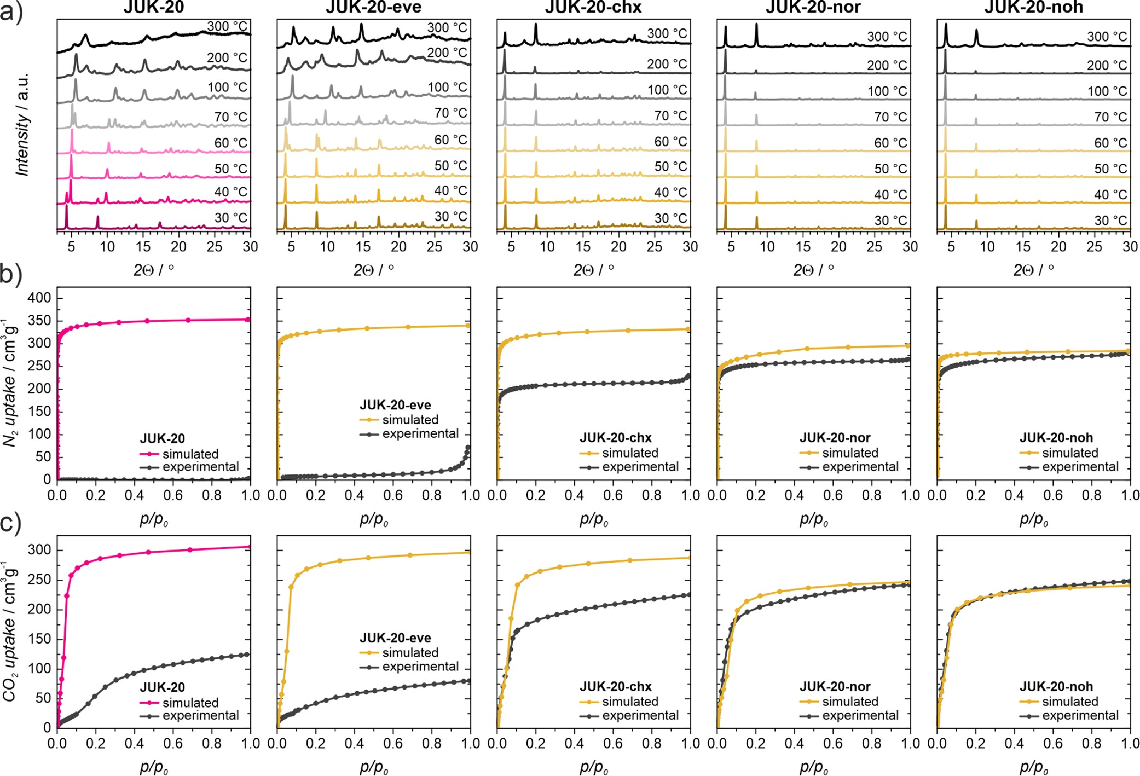
Chemistry of Materials
pubs.acs.org/cm
Article
Figure 3. (a) VT-PXRD patterns of the JUK-20-x series before and after iEDDA reaction. (b) Nitrogen sorption isotherms (simulated and experimental) measured at 77 K for the JUK-20-x series. (c) Carbon dioxide sorption isotherms (simulated and experimental) measured at 195 K for the JUK-20-x series. For JUK-20-chx, -nor, and -noh, only the simulated isotherms for the A framework isomers (with higher porosity) are presented.
explore the adsorption properties of the JUK-20-x series toward other adsorbates, the CO₂ isotherms were collected at 195 K (Figure 3c) and at 293 K (for JUK-20 and JUK-20-noh, Supporting Information, Figure S15). In contrast to the N₂ physisorption experiments, the porosity toward CO₂ in all JUK-20-x materials was observed. Although we noticed
does not completely prevent possible interframework displace- ments.
Finally, to further challenge the porosity in the studied JUK- 20-x systems, we also performed methanol adsorption experiments at 293 K (Supporting Information, Figure S16). The total uptake of MeOH for all the studied materials exceeded 200 cm³/g at the saturation point, reaching more than 80% of the calculated adsorption capacity for each material. For the most ﬂexible structures, JUK-20 and JUK-20- eve, we observed a signiﬁcant improvement as compared to N₂ and CO₂ sorption of the methanol-induced structure opening
signiﬁcant CO uptake for both JUK-20 (125 cm³/g) and
2
JUK-20-eve (80 cm3/g) materials, the obtained values represent only 41 and 27% of the estimated porosities based on GCMC simulations, respectively. These results clearly demonstrate that both structures are porous; however, an
eﬃciency, which resulted in the maximum CH₃OH uptakes of
234 (simulated269 cm³/g) and 218 cm³/g (simulated260 cm³/g), respectively. These results are in good agreement with the simulated MeOH sorption data for those materials in their crystallographic form (Supporting Information, Figure S20). A
adsorbate with a smaller kinetic diameter than that of N is
2
required due to the pore constraints. The CO₂ isotherms of the JUK-20-chx, JUK-20-nor, and JUK-20-noh materials, where more bulky dienophiles were introduced, show much higher CO₂ uptakes of 225, 242, and 248 cm³/g, respectively. On
narrow hysteresis observed in the CO and MeOH isotherms
2
comparison of the experimental CO sorption isotherms with
2
for JUK-20-nor and JUK-20-noh supports structural rigidity of these frameworks in contrast to the remaining JUK-20-x frameworks, where signiﬁcant hysteresis was observed. The lack of hysteresis in the rigidiﬁed MOFs supports the hypothesis that the structural ﬂexibility of the parent MOF has been altered.
Possible Sorption Mechanism in JUK-20-x Materials. Despite the similar total amount of the adsorbed MeOH in all JUK-20-x materials, the measured adsorption isotherms

https://doi.org/10.1021/acs.chemmater.1c02451
Chem. Mater. 2021, 33, 7509−7517
the isotherms obtained from GCMC simulations (Figure 3c), we noticed particularly good agreement between the simulations and the experiment for JUK-20-nor and JUK- 20-noh, whereas for JUK-20-chx, a signiﬁcant discrepancy is observed (the simulated CO₂ uptake amounts to 287 cm³/g). We attribute this mismatch to a possible internetwork displacement in the doubly interpenetrated system of JUK- 20-chx because the chx backbone with a moderate bulkiness
7513

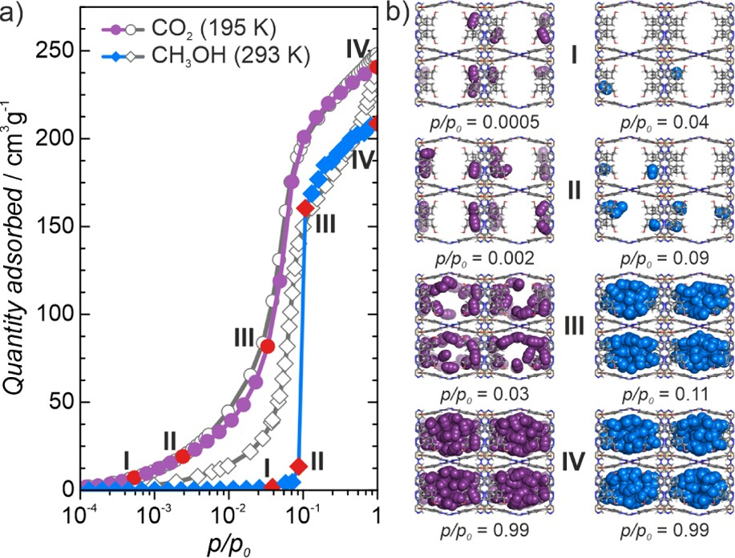
Chemistry of Materials
pubs.acs.org/cm
Article
(Supporting Information, Figure S16) represent diﬀerent shapes originating from alternative adsorption mechanisms in these frameworks. The MeOH adsorption isotherm for JUK- 20-chx exhibits intermediate behavior, which places this framework in the middle of the rigidity scale in the series of JUK-20-x materials. Based on the comparison of experimental and simulated adsorption data, we conclude that the most rigid structure is JUK-20-noh, which can be treated as a benchmark for mechanistic considerations. Therefore, for this material, we performed a more detailed analysis of snapshots for each adsorption step for CO₂ and MeOH. The snapshots taken at four sorption steps (I−IV, Figure 4) evidently demonstrate a
co-workers⁶⁷ in which they show that minimizing framework ﬂexibility is an important factor in achieving the globally optimized capacity of an MOF. This work also supports our conclusions that structural ﬂexibility is the cause of low N₂ and CO₂ uptakes for JUK-20 and JUK-20-eve. Apart from the inﬂuence on sorption properties, rigidifying MOFs has also been shown in a number of cases to lead to improved light
emission properties.^{68,69}
■
CONCLUSIONS
In summary, we have demonstrated that irreversible post- synthetic covalent modiﬁcation can be utilized for control of ﬂexibility and porosity in an open framework material. By using a unique doubly interpenetrated 3D hybrid MOF-HOF porous material with a tetrazine entity as a model system, we have performed a series of iEDDA reactions with dienophiles of increasing bulkiness and polarity. This systematic approach allowed to introduce various side groups into cavities of the material, which gradually reduced the number of its possible
internal motions. The fully locked rigid structure, JUK-20-noh, was obtained for the dienophile with a polar anchoring group, capable of strong interaction with pore walls of the adjacent subnetwork. For JUK-20-noh, theoretical and experimental adsorption data showed remarkable agreement, whereas for the remaining materials, distinctive discrepancies between theory and experiment were observed and rationalized by their varying degrees of ﬂexibility.
Finally, we envisage the generality of the iEEDA approach and believe that such irreversible click reactions may be used for ﬁne-tuning of structural features and introducing desired functionalities into porous materials under mild conditions. The remaining aromatic nitrogen atoms after CPSM could be used as binding sites for electron-accepting species and the rigidiﬁed frameworks could demonstrate the potential for novel
Figure 4. Comparison of simulated and experimental CO₂ (195 K) and MeOH (293 K) adsorption results for JUK-20-noh: (a) calculated isotherms (closed symbols) and experimental (open symbols) and (b) adsorption snapshots of CO₂ (left) and MeOH (right) adsorbates taken at selected pressures.
gas sorption or sensing properties.
■
continuous pore ﬁlling mechanism for rigid JUK-20-noh. The ﬁrst two snapshots (I and II) clearly show initial adsorption sites for CO₂ molecules, which are located inside baskets formed by the norbornene moieties. In the case of MeOH adsorption, a much steeper isotherm shape was observed for simulated and experimental data (Figure 4).
Moreover, the snapshots taken at four adsorption points for the simulated MeOH isotherm at 293 K demonstrate a slightly diﬀerent sorption mechanism as compared to CO₂. In this case, at lower pressures of the MeOH vapor (steps I and II, Figure 4), only the norbornene baskets (initial sorption sites) are occupied by MeOH molecules. However, at p/p₀ = 0.1, a rapid capillary condensation occurs until complete pore ﬁlling with MeOH molecules as shown by a steep increase of the isotherm. Similar behavior was observed for the experimental isotherm, which supports the rigidity of the framework under adsorption conditions. For other materials in the JUK-20-x series, various deviations between simulated and experimental isotherms are present as shown in Supporting Information, Figure S20. A similar isotherm trace as for JUK-20-noh was obtained for JUK-20-nor, which can be explained by similar rigidity of the MOF framework. For more ﬂexible systems, namely, JUK-20 and JUK-20-eve, these discrepancies are more pronounced; the shapes of experimental isotherms suggest continuous opening of the structures without capillary condensation inside large pores.
The importance of increasing the rigidity of MOFs with respect to gas sorption ﬁnds support in the paper by Smit and
ASSOCIATED CONTENT
Supporting Information
*sı
The Supporting Information is available free of charge at https://pubs.acs.org/doi/10.1021/acs.chemmater.1c02451.
Details of synthetic procedures, sample handling, physical measurements, computational studies; addi- tional IR, PXRD, TGA, UV−vis, NMR and adsorption data, crystal structure drawings (PDF).
NMR spectra for the coh ligand (ZIP).
CCDC 2065038−2065042 as the supplementary crystallographic data for JUK-20, JUK-20-chx, JUK- 20-nor, JUK-20-noh, and JUK-20-eve. CCDC 2065043−2065045 as the supplementary crystallo- graphic data for dpt-eve, dpt-nor, and dpt-noh (ZIP)
Additional edited JUK-20-nor structure. The sets of atomic coordinates and charges of all JUK-20-x framework models used for GCMC simulations (ZIP)
iEDDA reaction on a single crystal of JUK-20 (MP4)
■
AUTHOR INFORMATION
Corresponding Authors
Wojciech Bury − Faculty of Chemistry, University of Wrocław, 50-383 Wrocław, Poland; orcid.org/0000-0002-8207- 1384; Email: wojciech.bury@uwr.edu.pl

https://doi.org/10.1021/acs.chemmater.1c02451
Chem. Mater. 2021, 33, 7509−7517
7514

Chemistry of Materials
pubs.acs.org/cm
Article
Dariusz Matoga − Faculty of Chemistry, Jagiellonian University, 30-387 Kraków, Poland; orcid.org/0000- 0002-0064-5541; Email: dariusz.matoga@uj.edu.pl
Authors
Damian Jędrzejowski − Faculty of Chemistry, Jagiellonian University, 30-387 Kraków, Poland; orcid.org/0000- 0003-1426-2477
Marzena Pander − Faculty of Chemistry, University of Wrocław, 50-383 Wrocław, Poland; orcid.org/0000- 0003-1681-1353
Wojciech Nitek − Faculty of Chemistry, Jagiellonian University, 30-387 Kraków, Poland
Complete contact information is available at: https://pubs.acs.org/10.1021/acs.chemmater.1c02451
- Bavykina, A.; Kolobov, N.; Khan, I. S.; Bau, J. A.; Ramirez, A.; Gascon, J. Metal−Organic Frameworks in Heterogeneous Catalysis: Recent Progress, New Trends, and Future Perspectives. Chem. Rev. 2020, 120, 8468−8535.
- Li, H.-Y.; Zhao, S.-N.; Zang, S.-Q.; Li, J. Functional Metal−
Organic Frameworks as Effective Sensors of Gases and Volatile Compounds. Chem. Soc. Rev. 2020, 49, 6364−6401.
- Vervoorts, P.; Keupp, J.; Schneemann, A.; Hobday, C. L.;
Daisenberger, D.; Fischer, R. A.; Schmid, R.; Kieslich, G. Configura- tional Entropy Driven High-Pressure Behaviour of a Flexible Metal− Organic Framework (MOF). Angew. Chem., Int. Ed. 2021, 60, 787− 793.
- Chanut, N.; Ghoufi, A.; Coulet, M.-V.; Bourrelly, S.; Kuchta, B.; Maurin, G.; Llewellyn, P. L. Tailoring the Separation Properties of Flexible Metal-Organic Frameworks Using Mechanical Pressure. Nat. Commun. 2020, 11, 1216.
- Tan, K.; Jensen, S.; Wang, H.; Feng, L.; Wei, K.; Zhou, H. C.;
Li, J.; Thonhauser, T. Thermally Activated Adsorption in Metal− Organic Frameworks with a Temperature-Tunable Diffusion Barrier Layer. Angew. Chem., Int. Ed. 2020, 59, 18468−18472.
- Sadakiyo, M.; Yamada, T.; Kato, K.; Takata, M.; Kitagawa, H. A
Significant Change in Selective Adsorption Behaviour for Ethanol by Flexibility Control through the Type of Central Metals in a Metal− Organic Framework. Chem. Sci. 2016, 7, 1349−1356.
- Schneemann, A.; Vervoorts, P.; Hante, I.; Tu, M.;
Wannapaiboon, S.; Sternemann, C.; Paulus, M.; Wieland, D. C. F.; Henke, S.; Fischer, R. A. Different Breathing Mechanisms in Flexible Pillared-Layered Metal−Organic Frameworks: Impact of the Metal Center. Chem. Mater. 2018, 30, 1667−1676.
- Schneemann, A.; Rudolf, R.; Baxter, S. J.; Vervoorts, P.; Hante,
- ; Khaletskaya, K.; Henke, S.; Kieslich, G.; Fischer, R. A. Flexibility Control in Alkyl Ether-Functionalized Pillared-Layered MOFs by a Cu/Zn Mixed Metal Approach. Dalton Trans. 2019, 48, 6564−6570.
  - Cao, L.-H.; Liu, X.; Tang, X.-H.; Liu, J.; Xu, X.-Q.; Zang, S.-Q.;
Ma, Y.-M. A Fivefold Linker Length Reduction in an Interpenetrated Metal−Organic Framework via Sequential Solvent-Assisted Linker Exchange. Chem. Commun. 2019, 55, 12671−12674.
  - Razavi, S. A. A.; Morsali, A. Ultrasonic-Assisted Linker
Notes
The authors declare no competing ﬁnancial interest.
■
ACKNOWLEDGMENTS
We gratefully acknowledge the support of the National Science Centre (NCN), Poland; grants no: 2019/35/B/ST5/01067 (D.M., W.N., and D.J.) and 2014/14/E/ST5/00652 (M.P. and
W.B). D.J. additionally thanks the Polish Ministry of Science and Higher Education for a doctoral scholarship within the Diamond Grant funding scheme (grant no. 0170/DIA/2019/ 48). Calculations have been carried out using resources provided by the Wroclaw Centre for Networking and Supercomputing (http://wcss.pl), grant no. 454.
■
ABBREVIATIONS
chx, cyclohexene; CPSM, covalent post-synthetic modiﬁcation;
DMF, N,N′-dimethylformamide; dpt, 3,6-dipyridyl-1,2,4,5- tetrazine; eve, ethyl-vinyl ether; exp, experimental; GCMC, grand canonical Monte Carlo; H₂coh, bis(4-formylbenzoic acid) carbohydrazone; HOF, hydrogen-bonded organic frame- work; iEDDA, inverse-electron demand Diels−Alder (reac- tion); JUK-20, {[Cd₂(coh)₂(dpt)₂]·guests}_{n}; JUK-20-dieno- phile, JUK-20 modiﬁed by a dienophile; JUK-20-x, entire JUK- 20 platform; MeOH, methanol; MOF, metal−organic frame- work; NMR, nuclear magnetic resonance; noh, 5-norbornene- 2-methanol; nor, norbornene; RT, room temperature; SBU, secondary building unit; sim, simulated; SCSC, single-crystal- to-single-crystal; SC-XRD, single-crystal X-ray diﬀraction;
TLC, thin-layer chromatography; VT-PXRD, variable-temper-
Exchange (USALE): A Novel Post-Synthesis Method for Controlling
the Functionality, Porosity, and Morphology of MOFs. Chem.Eur. J.
2019, 25, 10876−10885.
- Wu, W.; Su, J.; Jia, M.; Li, Z.; Liu, G.; Li, W. Vapor-Phase Linker Exchange of Metal-Organic Frameworks. Sci. Adv. 2020, 6, No. eaax7270.
- Bon, V.; Pallmann, J.; Eisbein, E.; Hoffmann, H. C.; Senkovska, I.; Schwedler, I.; Schneemann, A.; Henke, S.; Wallacher, D.; Fischer,
R. A.; Seifert, G.; Brunner, E.; Kaskel, S. Characteristics of Flexibility in Metal-Organic Framework Solid Solutions of Composition [Zn2(BME-Bdc)x(DB-Bdc)2−xdabco]n: In Situ Powder X-Ray Diffraction, in Situ NMR Spectroscopy, and Molecular Dynamics Simulations. Microporous Mesoporous Mater. 2015, 216, 64−74.
- Henke, S.; Schneemann, A.; Wütscher, A.; Fischer, R. A.
Directing the Breathing Behavior of Pillared-Layered Metal−Organic Frameworks via a Systematic Library of Functionalized Linkers Bearing Flexible Substituents. J. Am. Chem. Soc. 2012, 134, 9464− 9474.
- Chen, T.-H.; Schneemann, A.; Fischer, R. A.; Cohen, S. M. Metal−Organic Frameworks Constructed from Crown Ether-Based 1,4-Benzenedicarboxylic Acid Derivatives. Dalton Trans. 2016, 45, 3063−3069.
- Handke, M.; Weber, H.; Lange, M.; Möllmer, J.; Lincke, J.;
Gläser, R.; Staudt, R.; Krautscheid, H. Network Flexibility: Control of Gate Opening in an Isostructural Series of Ag-MOFs by Linker Substitution. Inorg. Chem. 2014, 53, 7599−7607.
- Henke, S.; Schneemann, A.; Kapoor, S.; Winter, R.; Fischer, R.
A. Zinc-1,4-Benzenedicarboxylate-Bipyridine Frameworks − Linker Functionalization Impacts Network Topology during Solvothermal Synthesis. J. Mater. Chem. 2011, 22, 909−918.

https://doi.org/10.1021/acs.chemmater.1c02451
Chem. Mater. 2021, 33, 7509−7517
ature powder X-ray diﬀraction
■
REFERENCES
(1) Furukawa, H.; Cordova, K. E.; O’Keeffe, M.; Yaghi, O. M. The
Chemistry and Applications of Metal-Organic Frameworks. Science
2013, 341, 1230444.
- Evans, J. D.; Bon, V.; Senkovska, I.; Lee, H.-C.; Kaskel, S. Four- Dimensional Metal-Organic Frameworks. Nat. Commun. 2020, 11, 2690.
- Feng, L.; Wang, K.-Y.; Day, G. S.; Ryder, M. R.; Zhou, H.-C. Destruction of Metal-Organic Frameworks: Positive and Negative Aspects of Stability and Lability. Chem. Rev. 2020, 120, 13087−13133.
- Mason, J. A.; Veenstra, M.; Long, J. R. Evaluating Metal− Organic Frameworks for Natural Gas Storage. Chem. Sci. 2014, 5, 32− 51.
- Li, H.; Wang, K.; Sun, Y.; Lollar, C. T.; Li, J.; Zhou, H.-C. Recent Advances in Gas Storage and Separation Using Metal− Organic Frameworks. Mater. Today 2018, 21, 108−121.
7515

Chemistry of Materials
pubs.acs.org/cm
Article
- Nam, D.-H.; Shekhah, O.; Lee, G.; Mallick, A.; Jiang, H.; Li, F.; Chen, B.; Wicks, J.; Eddaoudi, M.; Sargent, E. H. Intermediate Binding Control Using Metal−Organic Frameworks Enhances Electrochemical CO₂ Reduction. J. Am. Chem. Soc. 2020, 142, 21513−21521.
- Deria, P.; Mondloch, J. E.; Karagiaridi, O.; Bury, W.; Hupp, J. T.; Farha, O. K. Beyond Post-Synthesis Modification: Evolution of Metal−Organic Frameworks via Building Block Replacement. Chem. Soc. Rev. 2014, 43, 5896−5912.
- Karagiaridi, O.; Bury, W.; Mondloch, J. E.; Hupp, J. T.; Farha,
O. K. Solvent-Assisted Linker Exchange: An Alternative to the De Novo Synthesis of Unattainable Metal−Organic Frameworks. Angew. Chem., Int. Ed. 2014, 53, 4530−4540.
- Cohen, S. M. Postsynthetic Methods for the Functionalization of Metal−Organic Frameworks. Chem. Rev. 2012, 112, 970−1000.
- Canivet, J.; Aguado, S.; Bergeret, G.; Farrusseng, D. Amino Acid Functionalized Metal−Organic Frameworks by a Soft Coupling−Deprotection Sequence. Chem. Commun. 2011, 47, 11650−11652.
- Kandiah, M.; Usseglio, S.; Svelle, S.; Olsbye, U.; Lillerud, K. P.; Tilset, M. Post-Synthetic Modification of the Metal−Organic Framework Compound UiO-66. J. Mater. Chem. 2010, 20, 9848− 9851.
- Fracaroli, A. M.; Siman, P.; Nagib, D. A.; Suzuki, M.; Furukawa, H.; Toste, F. D.; Yaghi, O. M. Seven Post-Synthetic Covalent Reactions in Tandem Leading to Enzyme-like Complexity within Metal−Organic Framework Crystals. J. Am. Chem. Soc. 2016, 138, 8352−8355.
- Kutzscher, C.; Nickerl, G.; Senkovska, I.; Bon, V.; Kaskel, S. Proline Functionalized UiO-67 and UiO-68 Type Metal−Organic Frameworks Showing Reversed Diastereoselectivity in Aldol Addition Reactions. Chem. Mater. 2016, 28, 2573−2580.
- Gadzikwa, T.; Farha, O. K.; Malliakas, C. D.; Kanatzidis, M. G.;
Hupp, J. T.; Nguyen, S. T. Selective Bifunctional Modification of a Non-Catenated Metal−Organic Framework Material via “Click” Chemistry. J. Am. Chem. Soc. 2009, 131, 13613−13615.
- Liu, T.; Che, J. X.; Hu, Y. Z.; Dong, X. W.; Liu, X. Y.; Che, C.
M. Alkenyl/Thiol-Derived Metal−Organic Frameworks (MOFs) by
- Jewett, J. C.; Bertozzi, C. R. Cu-Free Click Cycloaddition Reactions in Chemical Biology. Chem. Soc. Rev. 2010, 39, 1272.
- Blackman, M. L.; Royzen, M.; Fox, J. M. Tetrazine Ligation:
Fast Bioconjugation Based on Inverse-Electron-Demand Diels-Alder Reactivity. J. Am. Chem. Soc. 2008, 130, 13518−13519.
- Devaraj, N. K.; Weissleder, R.; Hilderbrand, S. A. Tetrazine-
Based Cycloadditions: Application to Pretargeted Live Cell Imaging.
Bioconjugate Chem. 2008, 19, 2297−2299.
- Goto, Y.; Sato, H.; Shinkai, S.; Sada, K. “Clickable” Metal− Organic Framework. J. Am. Chem. Soc. 2008, 130, 14354−14355.
- Jiang, H.-L.; Feng, D.; Liu, T.-F.; Li, J.-R.; Zhou, H.-C. Pore
Surface Engineering with Controlled Loadings of Functional Groups via Click Chemistry in Highly Stable Metal−Organic Frameworks. J. Am. Chem. Soc. 2012, 134, 14690−14693.
- Hazra, A.; Bonakala, S.; Bejagam, K. K.; Balasubramanian, S.;
Maji, T. K. Host−Guest [2+2] Cycloaddition Reaction: Postsynthetic
Modulation of CO₂ Selectivity and Magnetic Properties in a Bimodal
Metal−Organic Framework. Chem.Eur. J. 2016, 22, 7792−7799.
- Park, I.-H.; Chanthapally, A.; Lee, H.-H.; Quah, H. S.; Lee, S. S.; Vittal, J. J. Solid-State Conversion of a MOF to a Metal-Organo Polymeric Framework (MOPF) via [2+2] Cycloaddition Reaction. Chem. Commun. 2014, 50, 3665−3667.
- Medishetty, R.; Koh, L. L.; Kole, G. K.; Vittal, J. J. Solid-State
Structural Transformations from 2D Interdigitated Layers to 3D Interpenetrated Structures. Angew. Chem., Int. Ed. 2011, 50, 10949−
10952.
- Nayab, S.; Trouillet, V.; Gliemann, H.; Hurrle, S.; Weidler, P. G.; Rashid Tariq, S.; Goldmann, A. S.; Barner-Kowollik, C.; Yameen,
B. Chemically Reprogrammable Metal Organic Frameworks (MOFs) Based on Diels−Alder Chemistry. Chem. Commun. 2017, 53, 11461− 11464.
- Nayab, S.; Trouillet, V.; Gliemann, H.; Weidler, P. G.; Azeem, I.; Tariq, S. R.; Goldmann, A. S.; Barner-Kowollik, C.; Yameen, B. Reversible Diels−Alder and Michael Addition Reactions Enable the Facile Postsynthetic Modification of Metal−Organic Frameworks. Inorg. Chem. 2021, 60, 4397−4409.
- Peng, H.; Raya, J.; Richard, F.; Baaziz, W.; Ersen, O.; Ciesielski,
A.; Samorì, P. Synthesis of Robust MOFs@COFs Porous Hybrid Materials via an Aza-Diels−Alder Reaction: Towards High-Perform- ance Supercapacitor Materials. Angew. Chem., Int. Ed. 2020, 59, 19602−19609.
(52) Roy, P.; Schaate, A.; Behrens, P.; Godt, A. Post-Synthetic
Means of Postsynthetic Modification for Effective Mercury
Adsorption. Chem.Eur. J. 2014, 20, 14090−14095.
(32) Britt, D.; Lee, C.; Uribe-Romo, F. J.; Furukawa, H.; Yaghi, O.
M. Ring-Opening Reactions within Porous Metal−Organic Frame- works. Inorg. Chem. 2010, 49, 6387−6389.
- Nguyen, J. G.; Cohen, S. M. Moisture-Resistant and Superhydrophobic Metal−Organic Frameworks Obtained via Post- synthetic Modification. J. Am. Chem. Soc. 2010, 132, 4560−4561.
- Wang, Z.; Cohen, S. M. Modulating Metal−Organic Frame- works To Breathe: A Postsynthetic Covalent Modification Approach. J. Am. Chem. Soc. 2009, 131, 16675−16677.
- Dalapati, R.; Biswas, S. Post-Synthetic Modification of a Metal-
Organic Framework with Fluorescent-Tag for Dual Naked-Eye Sensing in Aqueous Medium. Sens. Actuators, B 2017, 239, 759−767.
- Huang, A.; Caro, J. Covalent Post-Functionalization of Zeolitic
Imidazolate Framework ZIF-90 Membrane for Enhanced Hydrogen Selectivity. Angew. Chem., Int. Ed. 2011, 50, 4979−4982.
- Dugan, E.; Wang, Z.; Okamura, M.; Medina, A.; Cohen, S. M.
Covalent Modification of a Metal−Organic Framework with Isocyanates: Probing Substrate Scope and Reactivity. Chem. Commun. 2008, 29, 3366−3368.
- Garibay, S. J.; Wang, Z.; Tanabe, K. K.; Cohen, S. M. Postsynthetic Modification: A Versatile Approach toward Multifunc- tional Metal-Organic Frameworks. Inorg. Chem. 2009, 48, 7341− 7349.
- Li, P.-Z.; Wang, X.-J.; Zhao, Y. Click Chemistry as a Versatile Reaction for Construction and Modification of Metal-Organic Frameworks. Coord. Chem. Rev. 2019, 380, 484−518.
- Sletten, E. M.; Bertozzi, C. R. Bioorthogonal Chemistry: Fishing for Selectivity in a Sea of Functionality. Angew. Chem., Int. Ed. 2009, 48, 6974−6998.
Modification of Zr-Metal−Organic Frameworks through Cyclo-
addition Reactions. Chem.Eur. J. 2012, 18, 6979−6985.
- Pałasz, A. Recent Advances in Inverse-Electron-Demand Hetero-Diels−Alder Reactions of 1-Oxa-1,3-Butadienes. Top. Curr. Chem. 2016, 374, 1−37.
- Prokhorov, A. M.; Kozhevnikov, D. N. Reactions of Triazines and Tetrazines with Dienophiles (Review). Chem. Heterocycl. Compd. 2012, 48, 1153−1176.
- Chen, C.; Allen, C. A.; Cohen, S. M. Tandem Postsynthetic
Modification of Metal−Organic Frameworks Using an Inverse- Electron-Demand Diels−Alder Reaction. Inorg. Chem. 2011, 50, 10534−10536.
- Clements, J. E.; Price, J. R.; Neville, S. M.; Kepert, C. J. Perturbation of Spin Crossover Behavior by Covalent Post-Synthetic Modification of a Porous Metal−Organic Framework. Angew. Chem., Int. Ed. 2014, 53, 10164−10168.
- Feng, L.; Lo, S.-H.; Tan, K.; Li, B.-H.; Yuan, S.; Lin, Y.-F.; Lin,
C.-H.; Wang, S.-L.; Lu, K.-L.; Zhou, H.-C. An Encapsulation- Rearrangement Strategy to Integrate Superhydrophobicity into Mesoporous Metal-Organic Frameworks. Matter 2020, 2, 988−999.
- Vinu, M.; Sivasankar, K.; Prabu, S.; Han, J.-L.; Lin, C.-H.; Yang,
C.-C.; Demel, J. Tetrazine-Based Metal-Organic Frameworks as Scaffolds for Post-Synthetic Modification by the Click Reaction. Eur. J. Inorg. Chem. 2020, 2020, 461−466.
- Zhang, Y.-J.; Nie, H.-X.; Yu, M.-H.; Chang, Z. Post-Synthetic
Modification of Tetrazine Functionalized Porous MOF for CO₂

https://doi.org/10.1021/acs.chemmater.1c02451
Chem. Mater. 2021, 33, 7509−7517
7516

Chemistry of Materials
pubs.acs.org/cm
Article
Sorption Performances Modulation. J. Solid State Chem. 2021, 300, 122257.
- Bakkali, H.; Marie, C.; Ly, A.; Thobie-Gautier, C.; Graton, J.; Pipelier, M.; Sengmany, S.; Léonel, E.; Nédélec, J.-Y.; Evain, M.; Dubreuil, D. Functionalized 2,5-Dipyridinylpyrroles by Electro- chemical Reduction of 3,6-Dipyridinylpyridazine Precursors. Eur. J. Org. Chem. 2008, 2008, 2156−2166.
- Mammadbayli, E. H.; Hajiyeva, G. E.; Ibrahimli, S. I.; Jafarova,
N. A. Mannich Bases from Bicyclo[2.2.1]Hept-5-En-2-Ylmethanol, Secondary Amines and Formaldehyde. Russ. J. Gen. Chem. 2018, 88, 2204−2208.
- Willems, T. F.; Rycroft, C. H.; Kazi, M.; Meza, J. C.; Haranczyk, M. Algorithms and Tools for High-Throughput Geometry-Based Analysis of Crystalline Porous Materials. Micro- porous Mesoporous Mater. 2012, 149, 134−141.
- Dubbeldam, D.; Calero, S.; Ellis, D. E.; Snurr, R. Q. RASPA:
Molecular Simulation Software for Adsorption and Diffusion in Flexible Nanoporous Materials. Mol. Simul. 2016, 42, 81−101.
- Boger, D. L. Diels-Alder Reactions of Heterocyclic Aza Dienes. Scope and Applications. Chem. Rev. 1986, 86, 781−793.
- Hartmann, K.-P.; Heuschmann, M. Steric Effects on the Regioselectivity in Two-Step Diels−Alder Reactions of 1,2,4,5- Tetrazines with 2-Cyclopropylidene-4,5-Dihydro-1,3-Dimethyl-Imida- zolidine. Tetrahedron 2000, 56, 4213−4218.
- Mathew, T.; Tonne, J.; Sedelmeier, G.; Grund, C.; Keller, M.;
Hunkler, D.; Knothe, L.; Prinzbach, H. [6+6]Photocycloadditions in Face-to-Face Benzo/Pyridazino Substrates − En Route to Azapago- danes. Eur. J. Org. Chem. 2007, 2007, 2133−2146.
- Witman, M.; Ling, S.; Jawahery, S.; Boyd, P. G.; Haranczyk, M.; Slater, B.; Smit, B. The Influence of Intrinsic Framework Flexibility on Adsorption in Nanoporous Materials. J. Am. Chem. Soc. 2017, 139, 5547−5557.
- Bauer, C. A.; Timofeeva, T. V.; Settersten, T. B.; Patterson, B. D.; Liu, V. H.; Simmons, B. A.; Allendorf, M. D. Influence of Connectivity and Porosity on Ligand-Based Luminescence in Zinc Metal−Organic Frameworks. J. Am. Chem. Soc. 2007, 129, 7136− 7144.
- Cui, Y.; Yue, Y.; Qian, G.; Chen, B. Luminescent Functional Metal−Organic Frameworks. Chem. Rev. 2012, 112, 1126−1162.
7517
https://doi.org/10.1021/acs.chemmater.1c02451
Chem. Mater. 2021, 33, 7509−7517

