MEDICINALCHEMISTRY RESEARCH
Med Chem Res (2015) 24:115–123 DOI 10.1007/s00044-014-1074-1
Interaction of methotrexate, an anticancer agent, withcopper(II)
ions: coordination pattern, DNA-cleaving properties and cytotoxic studies
Justyna Nagaj•Paulina Kołkowska•Aleksandra Bykowska•
Urszula K. Komarnicka•Agnieszka Kyzioł•
Małgorzata Jez_owska-Bojczuk
Received: 14 February 2014 / Accepted: 7 June 2014 / Published online: 4 July 2014
©The Author(s) 2014. This article is published with open access at Springerlink.com
Abstract The acid–base properties and the Cu(II) bind- ing processes of methotrexate (MTX) were characterizedby selected spectroscopic techniques and potentiometric measurements. The pH titration data showed thatMTX behaves as a triprotic ligand. The deprotonation constants were determined for a-COOH and c-COOH groups and (N1)H?from the pteridine ring. Taking all the obtained results into consideration, a coordination pattern was pro- posed. The DNA-cleaving activity and reactive oxygen species (ROS) generation were investigated for both MTX and the Cu(II)–MTX system. The complex displayed a promising nuclease activity toward plasmid DNA in the presence of hydrogen peroxide. Interestingly, the induction of ROS, such as hydroxyl radicals, superoxide anions or singlet oxygen, was excluded and a different mechanism of DNA degradation was proposed. As MTX is now com- monly used in anticancer therapy i.e. against lung cancer, basic cell-based studies were carried out to establish if its Cu(II) complex exhibits higher cytotoxic properties than the ligand alone. Activities of both compounds were also tested against colon carcinoma. Moreover, the determined values of IC₅₀were confronted with the cytotoxic activity ofcisplatin.
Keywords Methotrexate·Copper(II) complexes·
Plasmid DNA damage·Cytotoxic studies
Introduction
Methotrexate (MTX, (2S)-2-[(4-{[(2,4-diaminopteridin-6-yl)methyl](methyl)amino}benzoyl)amino]pentanedioic acid)is a folic acid antagonist and it has a therapeutic effect on many types of cancer cells. It is currently widely used as a major chemotherapeutic agent for human malignancies, such as acute lymphoblastic leukemia, lymphoma, osteo- sarcoma, and also breast, lung, head, and neck cancers (Yoonet al.,2010). In the body, MTX is taken up by cells and tissues and then immediately metabolized to polyglu- tamate derivatives. Polyglutamates block the synthesis of purines and pyrimidines by inhibiting dihydrofolate reductase and several other folate-dependent enzymes.This blocking results in the disruption of DNA biosynthesis and is the basis of MTX chemotherapeutic action (Chibberet al.,2012). Tumor cells require about tenfold higher concentration of thymidine triphospate than healthy cells, and therefore they are more sensitive to the effects of antifolates (Navarro-Peranet al.,2005).
MTX is a methylated derivative of folic acid (Fig.1). Its structure consists of a pteridine ring and dimethyl-p- aminobenzoic acid residue linked with glutamic acid. The coordination properties of this compound are not well characterized. Metal complexes of pteridines are rare since it is a highly p electron-deficient heterocyclic system (Kaimet al.,1999). On the other hand, the binding properties of glutamic acid, which forms ther- modynamically stable complexes with a number of metal ions, are well characterized (Sajadi,2010; Naiket al.,2012).
Electronic supplementary material The online version of this article (doi:10.1007/s00044-014-1074-1) contains supplementary material, which is available to authorizedusers.
J. Nagaj·P. Kołkowska·A. Bykowska·
U. K. Komarnicka·M. Jez_owska-Bojczuk (&)
Faculty of Chemistry, University of Wrocław, F. Joliot-Curie 14, 50-383 Wrocław, Poland
e-mail:malgorzata.jezowska-bojczuk@chem.uni.wroc.pl
A. Kyzioł
Faculty of Chemistry, Jagiellonian University, R. Ingardena 3,30-060Krako´w,Poland
13
ORIGINAL RESEARCH

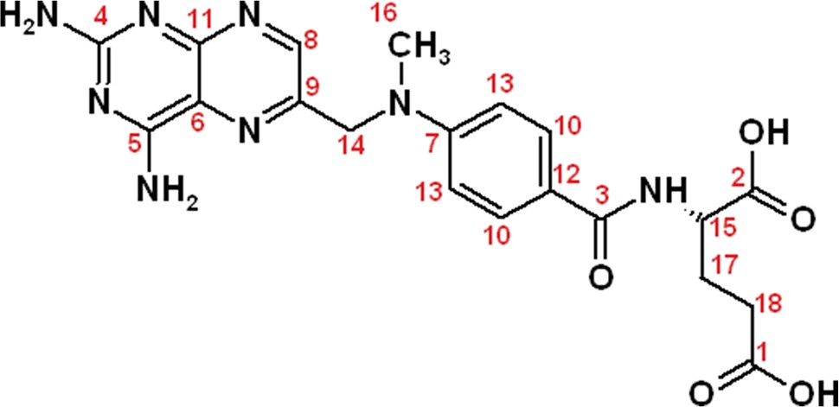
116
Med Chem Res (2015) 24:115–123
ratios of 1:1 and 1:4 were used. These data were analyzed using the SUPERQUAD program (Gans1983). Standarddeviations(rvalues)quotedwerecomputedbySUPER-QUAD and refer to randomerrors.
Nuclear magnetic resonance (NMR)
1H NMR and¹³C NMR measurements were performed on a Bruker AMX-500 instrument (¹H: 500 MHz). TSP (tri-methylsilyl propanoic acid) was used as an internal stan- dard. Samples were prepared in 500llD₂O (99.95 %) and the final concentration was 10 mM and 40 mM for proton and carbon spectra, respectively. NMR spectra were recorded for MTX and Cu(II)–MTX system at pD(pH measured by electrode uncorrected for the isotopic effect)value7.5,whichafterappropriatecorrection(Kre˛z_elandBal,2004) is equal to 7.4. Measurements were made for solutions at five different Cu(II)–MTX molar ratios 1:50075:500. The pD of samples was adjusted by adding smallvolumes of concentrated DNO₃orNaOD.
Fig. 1 The molecular formula of MTX with atom numeration schemeusedfor¹³CNMRspectraanalysis
Copper is an important metal ion and an essential con- stituent of our biological enzyme systems. It is proven that both in inflammatory conditions and during neoplastic diseases copper plasma concentration rises from 15 lM/L in normal to 22–26 lM/L in cancerous cells (Zowczaket al.,2001). Hence, it is possible that chemotherapeutic drugs have an opportunity to interact with endogenous copper. Therefore, the aim of this work was to: (1) inves- tigate the coordination properties of MTX toward Cu(II) ions, (2) verify the ability of this complex to generate ROS and DNA damage, and (3) establish the potential cytotoxic effect of the Cu(II)–MTX complex against two cancer cell lines.
Infrared spectroscopy (IR)
The room temperature infrared powder spectrawere recorded using Bruker IFS-66 FT spectrometer. The scan-ningrangewas4,000–400cm⁻¹andtheresolutionwas2cm⁻¹.SpectraofMTXaloneandtheCu(II)–MTXcomplex were registered in a transmission mode as KBrpellets.
Experimental
DNA strand break analysis
Materials
The ability of Cu(II)–MTX complex to induce single- and/ or double-strand breaks in the absence or presence of H₂O₂was tested with the pUC18 plasmid on 1 % agarose gels containing ethidium bromide. The buffered samples (phosphate buffer, pH 7.4) contained combinations ofDNA (25 lg/mL) and the components of investigated systems (metal ion and/or antibiotic, H₂O₂). Concentrations of eachsubstance are given in figure captions. The metal to ligand molar ratio 1:1 was used according to the complexes stoichiometry based on the potentiometric calculations. After 1 h of incubation at 37°C in the dark, the reaction mixtures were mixed with 4 mL of loading buffer (bro- mophenol blue in 30 % glycerol) and loaded on 1 % aga- rose gels containing ethidium bromide (Sigma-Aldrich), in TBE buffer (90 mM Tris–borate, pH 8.0; 20 mM EDTA). Gel electrophoresis was done at a constant voltage of 4 V/cm for 60 min. As a control for double-strand breaks, reference plasmid samples were linearized withEcoRI endonuclease. The gels were photographed and processed with a Digital Imaging System (Syngen Biotech, Wroclaw, Poland).
Methotrexate, CuCl₂96H₂O, TSP-d₄(trimethylsilyl pro- pionate), D₂O, DNO₃, NaOD, and pUC18 plasmid DNA were obtained from Sigma-Aldrich Co, Germany. NaOH, HCl, and ethylene glycol were purchased from Merck KGaA, Germany. Calibration buffers at pH values 4.01and
9.21 was received from Mettler-Toledo GmbH, Germany.
Potentiometric measurements
Potentiometric titrations of MTX and its complexes with Cu(II) in aqueous solution in the presence of 0.1 M KCl were performed at 298 K under argon atmosphere using pH-metric titrations (Metrohm, 905 Titrando). The CO₂free NaOH solution was used as a titrant. The sampleswere titratedinthepHregion2.0–10.5usingatotalvolumeof
1.5 mL. Changes in pH were monitored with acombined glass–Ag/AgClelectrode(Metrohm,Biotrode)calibrated daily by HCl titrations (Irvinget al.,1967). Ligand con-centrationwas5910⁻⁴M,andmetaltoligandmolar
13

Med Chem Res (2015) 24:115–123
117
Reactive oxygen species (ROS) generation measurements
200lLof tested samples: CuCl₂, MTX, Cu(II)–MTX, and cisplatin for 4 h at 37°C under conditions of 5 % CO₂. Then, solutions were removed, cells were washed withPBS (phosphate buffered saline, IMMUNIQ, Poland) and fresh relevant medium was added. Cells were incubated for 24 h at standard conditions and then cytotoxicity was estimated once more. Whereas, in the second approach cells were incubated with various concentrations of testedsamples diluted in DMEM containing 1 % FBS for 24 h in standard conditions. After that time surviving fraction was deter-mined by MTT assay.
The ROS generation measurements were carried out with NDMA (N,N-dimethyl-4-nitrosoaniline) and NBT (nitro- tetrazolium blue chloride), a scavenger molecules com- monly used in studies of hydroxyl radicals and superoxide anion generation, respectively. The experiments were fol- lowed at 25°C on a Cary 60 spectrophotometer. The solutions of NDMA and NBT at final concentrations 20lMwere added to the samples containing 50lMCu(II), MTX and Cu(II)–MTX, in the presence of 50lMH₂O₂, at pH 7.4 (0.2 M phosphate buffer). The generation of singlet oxygen was tested by gel electrophoresis in conditions described above(‘‘DNAstrand breakanalysis’’section) with an extra addition of NaN₃(singletoxygen
MTT assay
Briefly, a solution of 3–(4,5–dimethylthiazo1–2–y1)–2,5– diphenyltetrazolium bromide (MTT, Sigma) was prepared at 5 mg/mL in PBS and was diluted 1:10 in DMEMwithout FBS. 200lLof this solution was added to each well. After 4 h of incubation at 37°C in a humidifiedincubator with 5 % CO₂, the medium/MTT mixtures were removed, and the formazan crystals formed by the mito- chondrial dehydrogenase activity of vital cells were dis- solved in 100lLof DMSO:CH₃OH dilution (1:1). The absorbance of soluble product was read with a microplate reader (Infinite 200 M PRO NanoQuant, Tecan, Switzer-land) at 565nm.
scavenger (Franco 40 mM.
et
al.,
2007))
at
final
concentration
Cytotoxic assay
Cell lines and culture conditions
CT26 cell line (mouse colon carcinoma,
morphology:
fibroblast, ATCC: CRL–2638) and A549 cell line (human lung adenocarcinoma, morphology: epithelial, ATCC: CCL–185) were obtained from professor Luis G. Arnaut group (Chemistry Department, University of Coimbra, Portugal). Cells were cultured in flasks in Dulbecco’s Modified Eagle Medium (DMEM) without phenol red, with 10 % fetal bovine serum (FBS) and with 1 % strep- tomycin/penicillin at 37°C and 5 % CO₂in a humidified atmosphere. Cells were passaged at preconfluent densities, using a solution containing 0.05 % trypsin and 0.5mM
Data analysis
Cell viability was calculated using cells treated with DMEM containing 1 % FBS as control. Cell surviving fraction (%) was calculated using the formula: S/S₀(%)=[abs_{565nm}of treated cells/abs_{565nm}of untreated cells (control)]9100. Each experiment was done in triplicate and was repeated at least twice. The inhibitoryconcentration (IC) values were calculated from a dose– response curve. IC₅₀values were determined from the fittingcurvebycalculatingtheconcentrationofagentthat reduced the surviving fraction of treated cells by 50 %, compared to control cells. IC₅₀data are expressed as mean values±standard deviation (SD) and they are the average of two independent experiments, done intriplicate.
EDTA. All the cell culture IMMUNIQ (Poland).
fluids
were
purchased
from
Cytotoxicity study
ThecytotoxicactivityinvitrowasevaluatedbytheMTT assay.Theassaywascarriedoutaccordingtothewell- known protocol (Slateret al.,1963). For thescreeningexperiments, exponentially growing cells wereharvestedandplatedin96–wellplatesataconcentrationof1910⁴cells/well. After 24 h of incubation at 37°C underhumidified5%CO₂allowingcellattachment,thecellsinthewellsweretreatedwithtestedcompoundsatvarious concentrationsintherangefrom1to100lM.Thecom-poundswerepredissolvedinphosphatebuffer(pH7.4)anddilutedintherespectivemediumwith1%FBS.
Two different protocols of cytotoxicity evaluation were performed. In the first approach cells were treated with
Fluorescence microscopy
Viable and dead cells were detected by staining with AO (5 mg/L) and PI (5 mg/L) for 20 min and examined using fluorescence- inverted microscope (Olympus IX51, Japan) with an excitation filter of 470/20 nm. Photographs of the cells after treatment with the tested compounds were taken under magnification20.009.
13

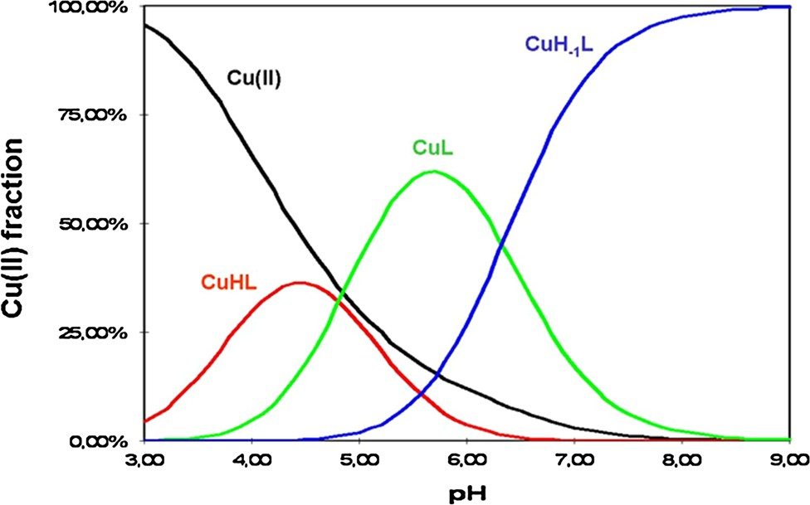
118
Med Chem Res (2015) 24:115–123
Table 1 Potentiometric complexes
parameters for MTX
and
its
Cu(II)
Logbª
pK^{b}
Ligand/complex
a
H₃L H₂L HL CuHL
CuL CuH₋₁L
13.10 (4)
10.21 (3) 5.65 (3) 8.82 (6) 4.01 (3)
-2.32(3)
2.89
4.56
5.65
– 4.81
6.33
a
nH??L^{m-}$H_{n}L,statisticalerrorsonthelastdigitsofstability
constant are given in parentheses. Overall stability constant (b)
expressedbyequationb_{HnL}=[H_{n}L^{(m–n)-}]/[H?][L^{m-}]describesareaction
Fig. 2 Species distribution diagram for the Cu(II)–MTX system
b
Deprotonation constant (pKa) expressed by equation pKa=logb
(HnL(m–n)-)-logb(Hn-1L(m–n?1)-)
starts at pH 3.0 with the appearance of a CuHL form, as shown in the distribution diagram (Fig.2). Considering theacid–base properties of the ligand, it is clear that in the presence of copper(II) ion the MTX molecule simulta- neously loses two protons. The groups with the lowest pK_{a}values are the a-carboxyl and c-carboxyl ones. It can be assumed that the Cu(II) ion binds to the oxygen atomsfrom both of them. With the rise of pH, the species distribution diagramrevealstheoccurrenceofanewCuLformwhich
reaches the maximum concentration at pH*5.8. In that
pH range deprotonation of (N1)H?nitrogen takes place probably without its participation in the binding process.Thelastspecies,CuH₋₁L,isformedduetotheforceddissociationofamidemoietycausedbymetalionbinding to this fragment of the studiedmolecule.
These assumptions are supported by the NMR and IR results. Using NMR spectroscopy we could verify the type of donor atoms bound to the metal ion in solution. As in a number of other instances (Bertini and Pierattelli,2004; Otting,2010), also in this case the coordination of the paramagnetic cation causes a significant decrease of the intensity or even disappearance of the signals derived from the neighboring carbon atoms. Thus, the interaction ofMTX with small amounts of Cu(II) solution (M:L 1:500) also results in vanishing of both carboxylic carbons and C_{a}signals from glutamyl residue (Fig.3). The remaining peaks from glutamic carbon atoms and theneighboring
Results and discussion
The acid–base chemistry of methotrexate
MTX molecule contains a 2,4-diaminopteridine ring andN,N-dimethyl-p-aminobenzoic acid residue linked with glutamic acid by a peptide bond (Fig.1). It exists in water solution in a fully protonated form as a H₃L ligand. The acid–base properties of the moieties, which can be depro- tonated with a rise of pH value, were determined using potentiometric measurements (Table1). The first two obtained pK_{a}values: 2.89 and 4.56 correspond to the deprotonation of carboxylic groups from glutamic acid, a-COOH and c-COOH, respectively (Poe,1973,1977; Melounet al.,2010). The highest value of pK_{a}=5.65 corresponds to the deprotonation process of the heterocy- clic nitrogen (N1)H?from the pteridine ring. The resulting pK_{a}values are quite consistent with the literature data. They have been first determined by Poe (1973) using potentiometric and spectrophotometric titrations, as 3.36, 4.70, and 5.71,respectively.
Investigation of the Cu(II)–methotrexate coordination mode
In order to obtain insight into the binding mode ofMTX, thecomplexformationprocesseswerestudiedbypotenti- ometry, IR, and NMR spectroscopic techniques. These methods all together enabled verification of the type of donoratomsboundtoCu(II)ionsanddeterminationofthe stabilityconstants(Table1).IntheinvestigatedpHrange threemonomericcomplexesareformed:CuHL,CuL,andCuH₋₁L.Stabilityconstantsforbis-ligandcomplexescouldnotbeestablishedwithcertainty,thereforetheywere excluded from the accepted model. The bindingprocess
CC=O
have a lower intensity. These findings support the
modelofcoordination{a-COO⁻,c-COO⁻,and
Namide}
deduced above (Fig.4). The chemical shift values of MTX carbon atoms are collected in Table2.
Interestingly, the intensity of all¹³C NMR signals from the pteridine ring also slightly decreases. The participation of this part of the molecule in the binding process does not fit the expected model. There could be one explanation for this phenomenon connected with the stacking interaction. The self-association of heterocyclic aromatic compounds
13

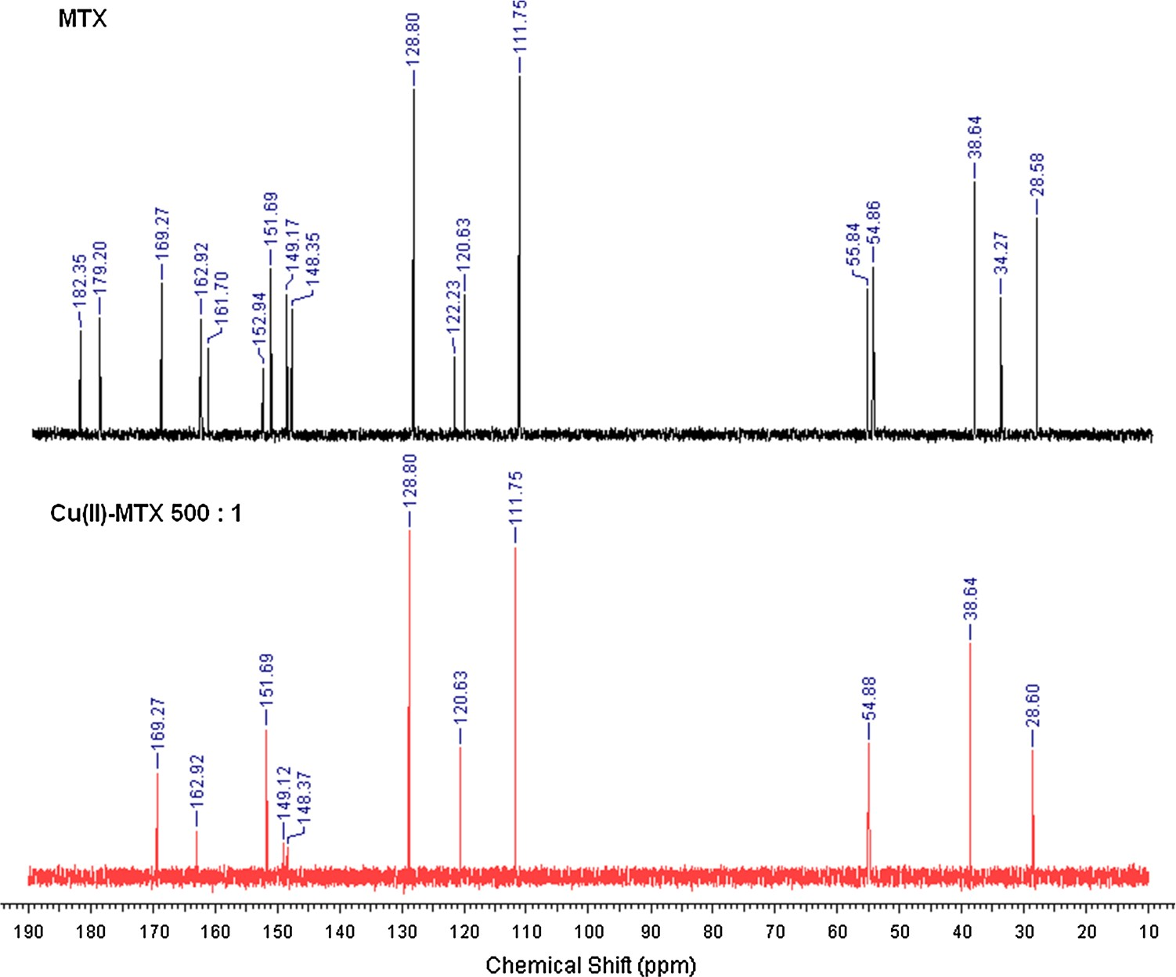
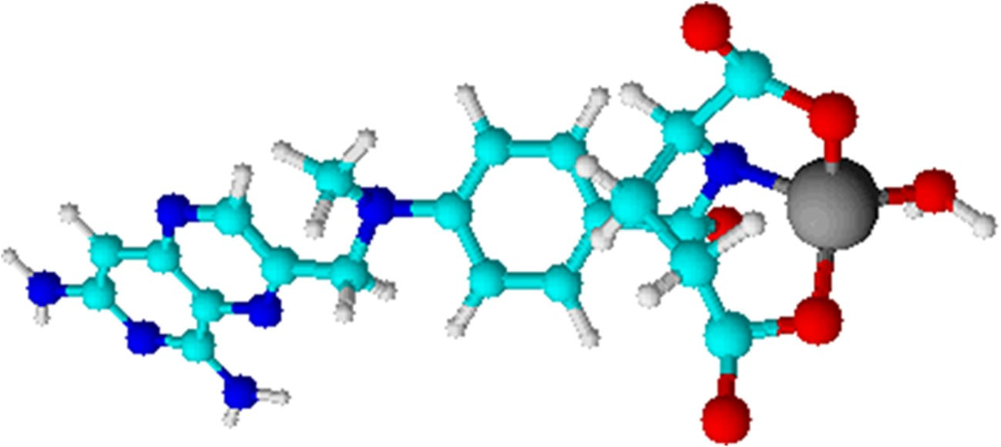
Med Chem Res (2015) 24:115–123
119
Fig. 3¹³CNMR spectra of MTX and Cu(II)–MTX
solutions at pH 7.4
Fig. 4 The model of Cu(II)– MTX complex existing at pH7.5
has been observed for purines and pyrimidines, structurally related to MTX (Sigel and Griesser,2005; Mitchell and Sigel,1978; Dungeret al.,1998). Therefore, this process can be expected in the studied case. MTX is known to aggregate, depending on the concentration and pH. How- ever, the investigation of folates showed that these com- pounds do not form higher oligomers than dimers (Poe,1973). According to this knowledge, at the neutral pH an MTX dimer consists of two molecules in a fully ‘‘stretched out’’ configuration. Consequently, both pteridine andp-aminobenzoate rings may participate in stacking inter- actions in a head-to-tail arrangement (Poe,1973). This circumstance would be very helpful in the explanation of
shifts are very sensitive to the environment. Looking at the proposed dimer structure, it is clearly seen that the pteri- dine ring is localized exactly above thep-aminobenzoate ring linked with glutamic acid (Fig.5). Therefore, binding of copper(II) ions to carboxyl groups and amide nitrogen reduces the intensity of the signals of both the adjacent carbon atoms and pteridinic atoms.
The results obtained from FTIR experiments also sup- port the proposed coordination mode. When comparing the solid state spectra of MTX and the Cu(II)–MTX system (Fig. S1), the most pronounced changes were recorded intherangeofasymmetricstretchingvibrationsofCOO⁻groups(1700–1600cm⁻¹).Thesebandsarenotvisibleinthe complex spectrum. Returning to the analysis ofthe ligand data, it is supposed that MTX exists in azwitterionic
13C
the disappearance of
NMR signals from pteridine
moiety in the course of the present research. Chemical
13

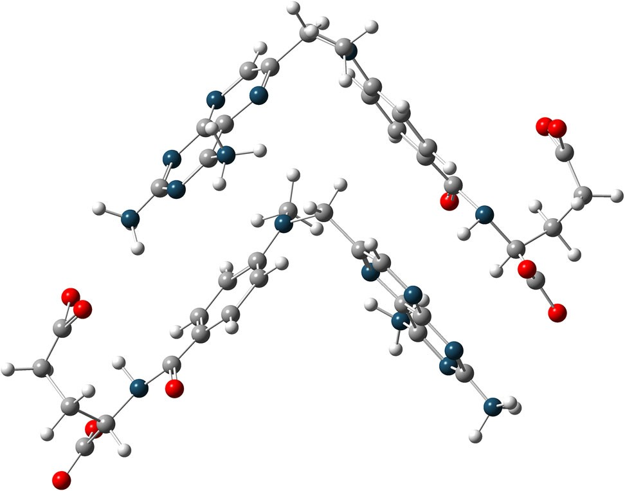
120
Med Chem Res (2015) 24:115–123
The¹³C NMR chemical shifts for MTX solution at pH 7.4
analyzed by an agarose-gel electrophoresis method. The cleavage activity was determined by measuring the con- version of supercoiled plasmid DNA (form I) to open-cir- cular DNA (form II) or linear DNA (form III). The initial experiments show that the studied drug neither alone (Fig.6, lanes 3, 9) nor in the presence of hydrogen per- oxide (lanes 6, 12) is able to damage the DNA, regardless of the ligand concentration. Although Cu(II) ionsalone (lanes 2, 8) and complexed (lanes 4, 10) yield some increase in the open-circular form II, significant changes in the plasmid structure are observed in the presence of H₂O₂(lanes 5, 7, 11, 13). The obtained results demonstrate that complex-H₂O₂(lanes 11 and 13) is the most efficient in plasmid degradation. As shown in Fig.7, the Cu(II)–MTX- H₂O₂system causes the cleavage of supercoiled DNA to its open-circular (II) and linear (III) form in a wide concen- tration range (from 5lMto 1 mM). Moreover, these effects are accompanied by cutting the plasmid into shorter polynucleotide fragments, which is particularly evident on lanes 7 and 9. The quantity of the form II is in these cases negligible and streaks are the most visible. At a twicelower concentration of hydrogen peroxide, the plasmid destruc- tion process isidentical.
In order to gain some insight into the mechanism by which the complex-H₂O₂system induces DNA cleavage, the ability to generate ROS was investigated. Most of the studied Cu(II) complexes have caused single- and double- strand DNA scissions by the oxidative mechanism in the presence of endogenous amounts of hydrogen peroxide (Suntharalingamet al.,2012; de Hooget al.,2007;Devereuxet al.,2007; Szczepaniket al.,2002;Jez_owska- Bojczuket al.,2002). It has often been evident that the presence of an antibiotic enhanced the oxidative activity of Cu(II) ions, and the resulting complex exhibited much higher potency toward ROS induction (Gaggelliet al.,2010; Balenciet al.,2009). The hydroxyl radicalsdetection is performed by monitoring the NDMA characteristic band at 440 nm on the electronic spectra. Generation of the˙OH radicals causes the decrease in the intensity of this band and can be measured in a time-dependent mode. The˙OH induction by the complex-H₂O₂system was investigated in the conditions of gel electrophoresis experiments (50lMconcentration of both the complex and H₂O₂). However, only a slight decrease of the NDMA band was observed. The ability to generate superoxide anion by the complex-H₂O₂system was also examined by performing a similar test with another reporter molecule-NBT. Likewise, the investigated system failed to induce this type of radicals. The next experiment was carried out using gelelectro- phoresis by adding sodium azide (singlet oxygen scaven- ger) to the reaction mixture. This procedure did not cause theinhibitionofthecleavagereactioneither.
Table 2
d [ppm]
d [ppm]
Carbon
Carbon
C1C2C3C4C5C6C7C8C9
C10C11C12C13C14C15C16C17C18
182.3
179.2
169.3
162.9
161.7
152.9
151.7
149.2
148.3
128.8
122.2
120.6
111.7
55.8
54.9
38.6
34.3
28.6
Assignments
were made
on
the basis of Spectrum
Database of
Organic Compounds
Fig. 5 Proposed structure for MTX dimer on the basis of crystal data
form with a positive charge at two pteridine amino groups and a negative charge at carboxylate anions. An absorptionbandabove1700cm⁻¹characteristicfortheCOOHgroupwas not observed. However, there is a band in the range of1690–1640cm⁻¹whichcorrespondstotheasymmetricstretchingvibrationoftheCOO⁻moieties.Simulta-neously, the band originating from the amino group vibrations does not appear. Instead, overlapped bands can be seen derived from the stretch vibration of carboxylate anions and asymmetric deformation of –NH₃?. Such zwitterionic structure can facilitate the coordination of positive copper ion to the negative carboxylates.
DNA damage and ROS generation by the Cu(II)–MTX system
In order to investigate the nuclease activity of the cop- per(II) complexes with MTX, pUC18 plasmid was used as the DNA substrate, and the resulting products were
13

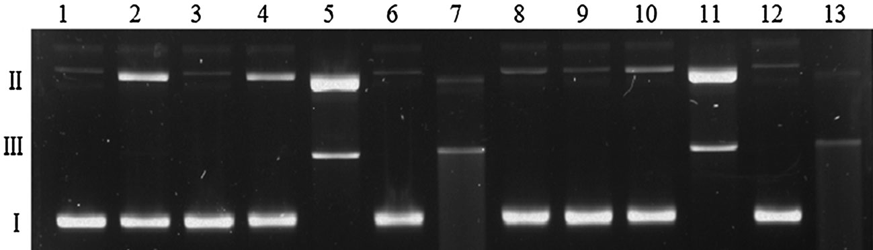
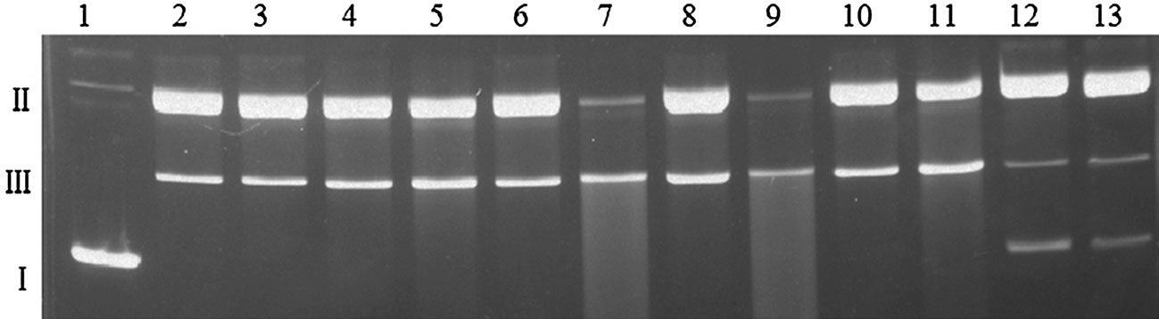
Med Chem Res (2015) 24:115–123
121
Fig.6AgarosegelelectrophoresisofpUC18plasmidcleavagebyMTX, CuCl₂, and Cu(II)–MTX (1:1).Lane 1—untreated plasmid,lane2—100lMCuCl₂,lane3—100lMMTX,lane4—100lMCu(II)–MTX,lane 5—100lMCuCl₂?50lMH₂O₂,lane 6— 100lMMTX?50lMH₂O₂,lane 7—100lMCu(II)–
MTX?50lMH₂O₂,lane 8—50lMCuCl₂,lane 9—50lM
MTX,
lane
10—50lM Cu(II)–MTX,
lane
11—50 lM
Cu(II)?50lMH₂O₂,lane12—50lMMTX?50lMH₂O₂,lane13—50lMCu(II)–MTX?50lMH₂O₂
Fig.7AgarosegelelectrophoresisofpUC18plasmidcleavagebyCu(II)–MTX(1:1)inthepresenceof50lMH₂O₂.Lane1—untreatedplasmid;Even lanes:?CuCl₂in concentrations: 1 mM, 500 lM,
100 lM, 50 lM, 25 lM, 5 lM;Odd lanes:?Cu(II)–MTX at the same, appropriate concentrations
Taken together, the obtained results suggest that the single- and double-stranded DNA cleavage mediated by complex-H₂O₂, does not occur by an oxidative mechanism. On the other hand, the same reactions performed without hydrogen peroxide do not result in plasmid degradation (Fig.6, lanes 4, 10). This led us to propose that most probably the active species is copper-oxene or copper- coordinated hydroxyl radical (Sigmanet al.,1991; Baronet al.,1936). The reactive species remain tightly bound to copper(II), thus preventing them from being deactivated by radical scavengers. A copper-oxene or a resonance hybrid of a copper(II)-hydroxyl radical species generates a deoxyribose-centered radical by C-1 hydrogen abstraction (Sigmanet al.,1991; Baronet al.,1936), and is probablyresponsibleforplasmidDNAcleavageinthestudiedcase.
Table 3 IC₅₀values for MTX, CuCl₂, Cu(II)–MTX, and cisplatin against CT26 and A549 cell lines after 4 and 24 h of incubation
IC values [lM]ª
50
4 h
24 h
CT26
A549
CT26
A549
MTX
CuCl₂Cu(II)–MTX
Cisplatin
258±78
360±52
135±17
2200±20
348±32
459±32
151±12
3150±450
460±23
423±32
1022±172
4990±670
485±12
481±11
188±52
3850±430
IC₅₀=concentration of drug required to inhibit growth of 50 % of thecancercells(Strohfeldtetal.,2008)
a
Data are mean±SD of three replicates each
relationship between the optical absorbance of dissolved formazan into a colored solution and the number of viable cell.
The IC₅₀values were derived from dose–response curves and are summarized in Table3. Cytotoxic study in vitro revealed that Cu(II)–MTX exhibits considerable toxicity toward both tested cell lines. The IC₅₀values obtained for the complex were in most cases lower than those for MTX and CuCl₂. Generally, the greatest effect was observed on both cell lines after 4 h of incubation with thetestedsamples(Table3).Whileafter24htheimpact
In vitro cytotoxic studies
The anticancer activity of MTX, CuCl₂, Cu(II)–MTX, and cisplatin against two selected cell lines: mouse colon car- cinoma (CT26) and human lung adenocarcinoma (A549) were investigated. The evaluation of the cytotoxic activity of the compounds was carried out by the MTT assay, based on the ability of mitochondrial dehydrogenases in the viable cells to cleave the tetrazolium rings of MTT and to form dark blue membrane-impermeable crystals of for- mazan.Thesurvivingfractionwasdeterminedbythe
13

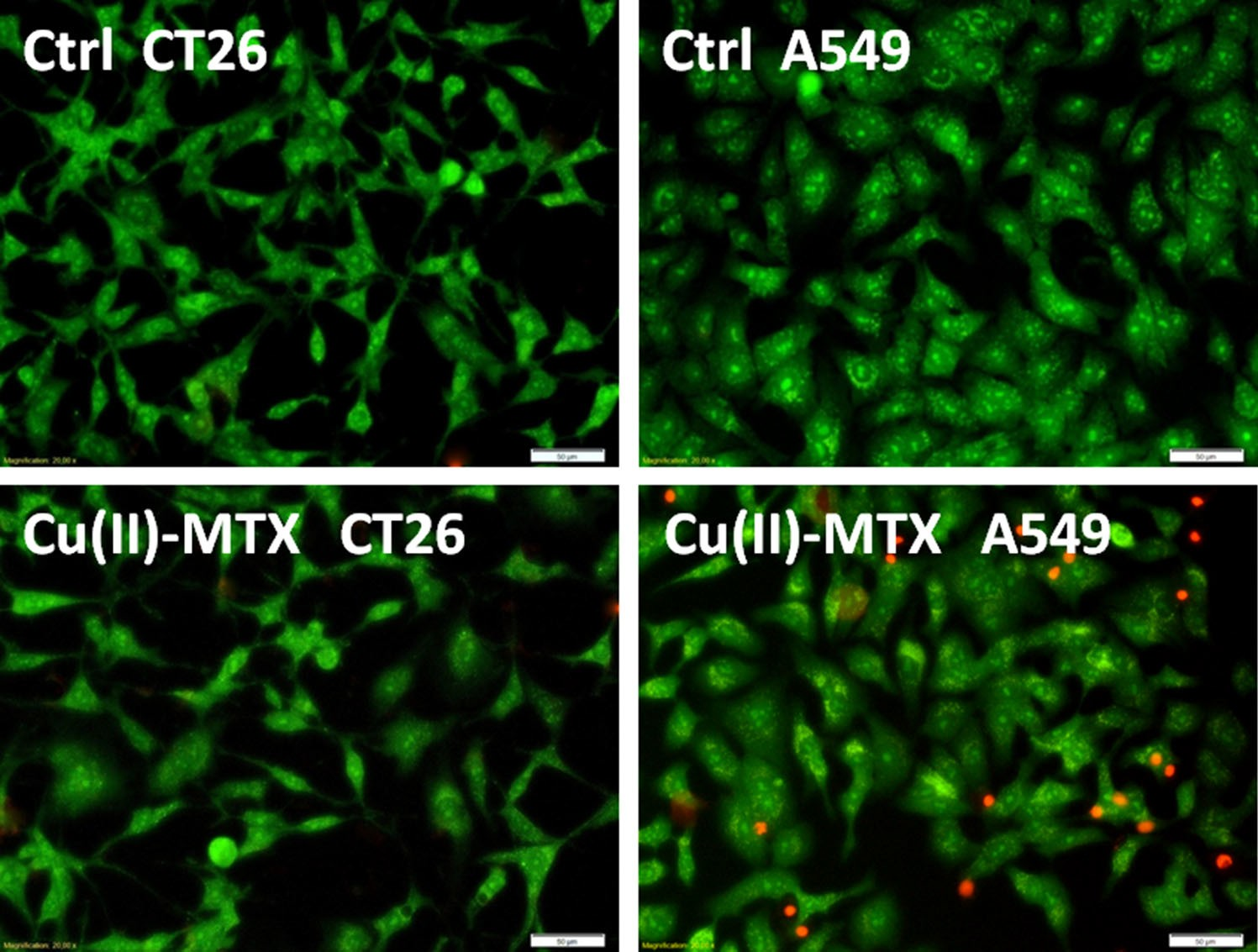
122
Med Chem Res (2015) 24:115–123
Fig. 8 The selected photos (magnification 920.00,bar
50 lm) of CT26 and A549cells after treated with the tested compounds(0.05mM)for24h. Thegreen cellswith normal morphology are viable ones (AO?), whileround red cellsare dead(PI?)
of the complex on A549 line was similar (IC₅₀: 188 lM), in the case of CT26 line the cytotoxic effect was dramat- ically lower (IC₅₀: 1022 lM). These results indicate that A459 line is more sensitive for Cu(II)–MTX than CT26 cell line. It is noteworthy that all the tested compounds showed a significantly better anticancer activity than cis- platin (Table3). Selected photographs of CT26 and A549 cell lines treated with the tested compounds are provided in Fig.8. Cell viability was examined by counting the dead and alive cells stained with two fluorescent dyes. Accord- ingly, green cells with normal nuclei were treated as viable cells (AO?), while the red ones as dead (PI?). As can be noticed, Cu(II)–MTX caused a significant reduction onlyin the surviving fraction of A549 cell line (after 24 h of incubation time). This means that the investigated complex may exhibit selective biological activity toward only spe- cific tumors. These studies indicate that Cu(II)–MTXexhibits biological activity toward specific cell lines and the cytotoxicity level is time dependent. Theobtained
in vitro studies were performed. In the presence of hydrogen peroxide the Cu(II)–MTX system displays nuclease activity, almost completely cleaving DNA. Most probably, the responsibility for the plasmid degradation processes may be attributed to the copper-oxene or copper- coordinated hydroxyl radical. Investigations of the anti- cancer activity showed that the complex generally displays higher cytotoxicity in vitro than the ligand and metal ion separately and is more selective against A459 cell line. As MTX is used in the treatment of lung cancer, our investi- gations demonstrated that complexation of MTX by Cu(II) ions results in its higher cytotoxicity. Moreover, in com- parison to cisplatin, the Cu(II)–MTX system shows supe- rior anti-tumor effects. MTX interacts with copper(II) ions forming complexes which display high DNA-cleaving propensity and promising cytotoxicity. The results pre- sented herein can be helpful in the search for newcytostatic substances.
Acknowledgments The research was supported by the Wroclaw Research Center EIT? under the Project ‘‘Biotechnologies and advanced medical technologies – BioMed’’ (POIG 01.01.02-02-003/ 08-00) financed from the European Regional Development Fund(Operational Programme Innovative Economy, 1.1.2). The cytotoxic investigations were carried out with the equipment purchased, thanks to the financial support of the European Regional Development Fund in the framework of the Polish Innovation Economy Operational Program (Contract No. POIG.02.01.00-12-023/08).
results are preliminary needed to understand cytotoxicity.
and the
further investigations are
molecular
mechanism
of
Conclusions
It was demonstrated that
MTX interacts with Cu(II) ions
Conflict of interest The authors declare that they have no conflict ofinterest.
and in aqueous solution it forms three monomeric com- plexes in a wide pH range. Moreover, basic biological
13

Med Chem Res (2015) 24:115–123
123
Open Access This article is distributed under the terms of the Creative Commons Attribution License which permits any use, dis-tribution, and reproduction in any medium, provided the original author(s) and the sourceare credited.
Kaim W, Schwederski B, Heilmann O, Hornung FM (1999) Coordination compounds of pteridine, alloxazine and flavin ligands: structures and properties. Coord Chem Rev 182: 323–342
Kre˛z_elA,BalW(2004)AformulaforcorrelatingpKavaluesdetermined in D₂O and H₂O. J Inorg Biochem 98:161–166
Meloun M, Ferencikova Z, Vrana A (2010) The thermodynamic dissociation constants of methotrexate by the nonlinear regres-sion and factor analysis of multiwavelength spectrophotometric pH-titration data. Cent Eur J Chem 8:494–507
Mitchell PR, Sigel H (1978) A proton nuclear-magnetic-resonancestudy of self-stacking in purine and pyrimidine nucleosides andnucleotides. Eur J Biochem 88:149–154
Naik KBK, Raju S, Kumar BA, Rao GN (2012) Chemical speciation of binary complexes of Pb(II), Cd(II) and Hg(II) with_{L}-glutamicacid in dioxan–water mixtures. Chem Spec Bioavailab 24:241–247
Otting G (2010) Protein NMR using paramagnetic ions. Annu RevBiophys 39:387–405
Navarro-Peran E, Cabezas-Herrera JF, Garcia-Canvos F, DurrantMC,Thorneley RNF, Rodriguez-Lopez JN (2005) The antifolateactivityofteacatechins.CancerRes65:2059–2064
Poe M (1973) Proton magnetic resonance studies of folate, dihydro-folate, and methotrexate: evidence from pH and concentration studies for dimerization. J Biol Chem 248:7025–7032
Poe M (1977) Acidic dissociation constants of folic acid, dihydrofolicacid, and methotrexate. J Biol Chem 252:3724–3728
Sajadi SAA (2010) Metal ion binding properties of_{L}-Glutamic Acidand L-Aspartic Acid, a comparative investigation. Nat Sci 2: 85–90
SigelH,GriesserR(2005)Nucleoside5⁰-triphosphates:self-associ-ation, acid–base, and metal ion-binding properties in solution. Chem Soc Rev34:875–900
Sigman DS, Kuwabara MD, Chen CB, Bruice TW (1991) Nucleaseactivity of 1,10-phenanthroline-copper in study of protein-DNA interactions. Methods Enzymol 208:414–433
Slater TF, Sawyer B, Strauli UD (1963) Studies on succinate-tetrazolium reducase systems. III. Points of coupling of four different tetrazolium salts. Biochim Biophys Acta 77:383–393
Strohfeldt K, Tacke M (2008) Bioorganometallic fulvene-derivedtitanocene anti-cancer drugs. Chem Soc Rev 37:1174–1187 Suntharalingam K, Hunt DJ, Duarte AA, White AJP, Mann DJ, Vilar
R (2012) A tri-copper(II) complex displaying DNA-cleavingproperties and antiproliferative activity against cancer cells. Chem Eur J 18:15133–15141
SzczepanikW,KaczmarekP,SobczakJ,BalW,GatnerK,Jez_owska- Bojczuk M (2002) Copper(II) binding by kanamycin A andhydrogen peroxide activation by resulting complexes. NewJChem26:1507–1514
Yoon SA, Choi JR, Kim JO, Shin JY, Zhang X, Kang JH (2010) Influence of reduced folate carrier and dihydrofolate reductasegenes on methotrexate-induced cytotoxicity. Cancer Res Treat42:163–171
Zowczak M, Iskra M, Torlinski L, Cofta S (2001) Analysis of serum copper and zinc concentrations in cancer patients. Biol Trace Elem Res 82:1–8
References
Balenci D, Bonechi G, D’Amelio N, Gaggelli E, Gaggelli N, MolteniE,ValensinG,SzczepanikW,DziubaM,S´wie˛cickiG,Jez_owska-BojczukM(2009)Structuralfeaturesandoxidative
stress towards plasmid DNA of apramycin copper complex. Dalton Trans 7:1123–1130
Baron ESG, DeMeio RH, Klemperer F (1936) Studies on biological oxidations: V. Copper and hemochromogens as catalysts for the oxidation of ascorbic acid. The mechanism of theoxidation. J Biol Chem112:625–640
Bertini I, Pierattelli R (2004) Copper(II) proteins are amenable for NMR investigations. Pure Appl Chem 76:321–333
Chibber S, Hassan I, Farhan M, Naseem I (2012) Light-mediated interaction of methotrexate with transition metal Cu(II). Med Chem Res 21:2379–2387
de Hoog P, Boldron C, Gamez P, Sliedregt-Bol K, Roland I, Pitie M, Kiss R, Meunier B, Reedijk J (2007) New approach for the preparation of efficient DNA-cleaving agents: ditopic copper– platinum complexes based on 3-clip-phen and cisplatin. J Med Chem 50:3148–3152
Devereux M, Shea DO, Kellett A, McCann M, Walsh M, Egan D, Deegan C, Kedziora K, Rosair G, Muller-Bunz H (2007) Synthesis, X-ray crystal structures and biomimetic and antican- cer activities of novel copper(II) benzoate complexes incorpo-rating2-(4⁰-thiazolyl)benzimidazole(thiabendazole),2-(2-pyridyl)benzimidazole and 1,10-phenanthroline as chelating nitrogen donor ligands. J Inorg Biochem 101:881–892
Dunger A, Limbach HH, Weisz K (1998) NMR studies on the self- association of uridine and uridine analogues. Chem Eur J 4:621–628
Franco R, Panayiotidis MI, Cidlowski JA (2007) Glutathione depletion is necessary for apoptosis in lymphoid cells indepen- dent of reactive oxygen species formation. J Biol Chem 282:30452–30465
GaggelliE,GaggelliN,MolteniE,ValensinG,BalenciD,Wron´ska
M,SzczepanikW,NagajJ,SkałaJ,Jez_owska-BojczukM(2010)Coordination pattern, solution structure and DNA damage studies of the copper(II) complex with the unusual aminoglyco- sideantibiotichygromycinB.DaltonTrans39:9830–9837
Gans P (1983) Superquad: a new computer program fordetermination of stability constants of complexes by potentiometric titration. Inorg Chim Acta79:219–220
Irving HM, Miles MG, Pettit LD (1967) A study of some problems in determining the stoicheiometric proton dissociation constants of complexes by potentiometric titrations using a glass electrode. Anal Chim Acta 38:475–488
Jez_owska-BojczukM,SzczepanikW,Les´niakW,CiesiołkaJ,Wrzesin´skiJ,BalW(2002)DNAandRNAdamagebyCu(II)-amikacin complex. Eur J Biochem269:5547–5556
13

