


Article

Prediction of Air Temperature in the Polish Western
Carpathian Mountains with the ALADIN-HIRLAM
Numerical Weather Prediction System
Piotr Sekula 1,2 * , Anita Bokwa 3 , Bogdan Bochenek 2 and Miroslaw Zimnoch ©
- Faculty of Physics and Applied Computer Science, AGH-University of Science and Technology,
30-059 Krakow, Poland; zimnoch@agh.edu.pl
- Institute of Meteorology and Water Management, National Research Institute, IMGW-PIB Branch of Krakow,
30-215 Krakow, Poland; bogdan.bochenek@imgw.pl
- Institute of Geography and Spatial Management, Jagiellonian University, 30-387 Krakow, Poland;
anita.bokwa@uj.edu.pl
* Correspondence: piotr.sekula@fis.agh.edu.pl
1. Introduction
Increasing knowledge about physical atmospheric processes contributes to improvement of the
numerical models used for weather forecasting. Tests of new model configurations show that weather
prediction for regions with complex topography constitutes a challenging task for the development
of numerical weather forecasting (NWF) systems. One internationally coordinated activity is the
Transport and Exchange Processes in the Atmosphere over Mountains Experiment (TEAMx) [1].
Regions with highly complex relief are important, not only because of the impact on weather formation,
but also the occurrence of processes like katabatic flows and strong temperature inversions caused by
stable stratification of the air volume within the valleys. Those processes have a significant impact
on air quality, as they stimulate an increased concentration of air pollutants and the formation of
smog episodes.
The Aire Limitee Adaptation Dynamique Developpement International (ALADIN) High
Resolution Limited Area Model (HIRLAM) system is a numerical weather prediction (NWP) system
Atmosphere 2019,10,186; doi:10.3390/atmos10040186
www.mdpi.com/journal/atmosphere
Received: 5 January 2019; Accepted: 2 April 2019; Published: 5 April 2019
Abstract: Prediction of spatial and temporal variability of air temperature in areas with complex
topography is still a challenge for numerical weather prediction models. Simulation of atmosphere
over complex terrain requires dense and accurate horizontal and vertical grids. In this study,
verification results of three configurations of the Aire Limitee Adaptation Dynamique Developpement
International High-Resolution Limited Area Model (ALADIN-HIRLAM) numerical weather
prediction (NWP) system, using two different horizontal and vertical resolutions and applied to
the Polish Western Carpathian Mountains, are presented. One model of the ALADIN-HIRLAM
NWP system is tested in two horizontal and vertical resolutions. Predicted air temperatures are
compared with observations from stations located in different orographies. A comparison of model
results with observations was conducted for three cold season intervals in 2017 and 2018. Statistical
validation of model output demonstrates better model representativeness for stations located on
hill and mountain tops compared to locations in valley bottoms. A comparison of results for two
topography representations (2 x 2 km and 1 x 1 km) showed no statistically significant differences
of root mean square error (RMSE) and bias between model results and observations.
Keywords: ALADIN-HIRLAM numerical weather prediction system; variability of air temperature;
Polish Western Carpathian Mountains
Atmosphere 2019,10,186
2 of 27
developed by the international ALADIN and HIRLAM consortiums for operational weather forecasting
and research purposes [2,3]. The ALADIN-HIRLAM NWP system is based on a code that is shared
with the Integrated Forecast System (IFS) global model developed by the European Centre for
Medium-Range Weather Forecasts (ECMWF) and the Action de Recherche Petite Echelle Grande
Echelle (ARPEGE) global numerical weather prediction model used for operational weather forecasting
at Meteo-France. The system provides a multitude of high-resolution limited-area model (LAM)
configurations. Several configurations in the ALADIN consortium are precisely validated and prepared
to be used for operational weather forecasting at the 16 partner institutes. These configurations are
called the ALADIN canonical model configurations (CMCs). Currently there are three canonical model
configurations: the ALADIN baseline CMC, the Application of Research to Operations at Mesoscale
(AROME) CMC, and the ALADIN-AROME (ALARO) CMC. The HIRLAM consortium prepared its
own model configuration of AROME, named the HIRLAM ALADIN Regional/Mesoscale Operational
NWP in Europe AROME (HARMONIE-AROME), which is used for operational short-range weather
forecasts in 10 countries in Europe.
Reliable weather forecasting for such regions may require models of subkilometer spatial
resolution. Meteo France is running the AROME operational model with a resolution of 1.3 km [4].
The first results of the preoperational high-resolution AROME model (named AROME Airport)
were presented by Hagelin et al. [5]. A rapidly updated forecast was run with 500 m resolution for
nowcasting over Paris Charles de Gaulle Airport (CDG) to increase the safety of airport operations.
The results of AROME Airport were compared with the operational configuration of the AROME model
using the forecasts from AROME Airport starting every hour. The forecasts from AROME Airport
delivered improved data compared to the operational version, in particular for wind speed for runs
from all forecast hours. ALADIN and HIRLAM consortium members are testing new configurations
of sub-km models. For example, the Danish Meteorological Institute, which belongs to the HIRLAM
consortium, presented some promising results of the HARMONIE-AROME model with a resolution of
750 m [6]. Changing the resolution of the numerical weather forecast model to the regional scale (i.e., a
few hundred meters) is necessary for its verification. Tests of verification of the high-resolution model
were presented by Amodei et al. [7]. A regional Brier probability score was used to compare the results
from the high-resolution model with those from the low-resolution model in terms of the forecast of
rainfall and wind gusts, with application of the observations from surface stations. The method was
based on a comparison of the frequency from the forecast with observed events in the neighborhood
of each measurement point. High-resolution forecasts of small-scale events are usually correct, but
forecasts of these events can be slightly shifted in space and time from observations. Forecasts of
events shifted in space and time are penalized twice, because of false alarm and nondetection, which is
called double penalty. The adopted strategy reduced the impact of the double penalty, greatly affecting
the high-resolution model compared with models at lower resolution.
Poland is one of the European countries with relatively poor air quality, especially during the cold
part of the year [8]. Most affected are areas with complex topography where the natural dispersion
conditions are often very poor, due to the local weather phenomena mentioned above, especially
thermal inversions. The Polish Western Carpathian Mountains represent such a region and were
chosen as the study area. The aim of the paper was to evaluate the performance of the operational
AROME model in the study region and to verify the hypothesis that in mountain areas, the increased
resolution in the ALADIN-HIRLAM NWP system would significantly improve the accuracy of air
temperature forecasts (at the level of 2 m above the ground). The AROME model is used by the Polish
Institute of Meteorology and Water Management, National Research Institute (IMWM-NRI). Three
configurations of the nonoperational ALADIN-HIRLAM NWP system (AROME 1 km x 1 km, ALARO
nonhydrostatic (NH) 1 km x 1 km, and HARMONIE-AROME 2 km x 2 km) were used for verification
of the above hypothesis. The verification of model forecast results was achieved by comparison with
measurements from 19 meteorological stations located in the Western Carpathian Mountains.
Atmosphere 2019,10,186
3 of 27
The present study consists of four sections. The first section includes a presentation of the
context of the issue and a formulation of the research aim. Section 2 contains a brief description of
the analyzed region, data and methods used for forecast verification, descriptions of the ALADIN
consortium and ALADIN-HIRLAM NWP system, and the representativeness of stations in the model
domains. Section 3 shows the results obtained with the AROME CMC operational model and a
comparison of the results from different configurations of ALADIN consortium models. Section 4
contains the conclusions.
- Data and Methodology

2.1. Study Area
The Polish Western Carpathian Mts. are the northernmost and westernmost parts of the
Carpathians, a mountain range located in eight European countries: Austria, the Czech Republic,
Hungary, Poland, Romania, Serbia, Slovakia, and Ukraine. The Polish part covers about 6% of the area
of the country (1.96 million hectares) and extends from the Moravian Gate (marked as A in Figure 1a)
in the west to the Ukrainian Carpathians (beyond the range of Figure 1) in the east, and from the
chain of basins in the north (located in the Carpathian Foredeep; B) to the Slovakian Carpathians
in the south (C). The altitude varies from 200 to 300 m a.s.l. In the Carpathian Foothills (D) to over
2000 m a.s.l. In the highest range of the whole Carpathians, the Tatra Mts., (E) with the highest peak
being Gerlach (2655 m a.s.l., located in Slovakia; the highest Polish peak of the Tatra Mts. is Rysy,
2499 m a.s.l.). The Tatra Mts. are the only part of the Carpathians with typical alpine, high mountain
landscape. Farther to the north is the main part of the Polish Western Carpathians, the Beskidy Mts.
(divided further into several ranges), with altitudes exceeding 1000 m a.s.l., and the highest peak,
Babia Góra Mt., at 1725 m a.s.l., is located in the Beskid Żywiecki Mts. (F). A characteristic feature of
the Beskidy Mts.' relief is the presence of deeply incised valleys, as relative heights reach 400-700 m.
The mountain peaks are most often forested and not favorable for settlement. Therefore, human
activity is concentrated in the valleys. It is the opposite in the Carpathian Foothills, which extend along
the Beskidy Mts. from west to east. They consist of hills with relatively wide and flat hilltops where
settlements and transportation infrastructure are located, while the valleys are left unused and often
forested. The climatic conditions are very diverse due to the large differences in altitude and complex
relief. Mean annual air temperature in the period 1951-2006 varied from 8.0 °C in Kraków (northern
border of the foothills) to 5.3 °C in Żakopane (foot of the Tatra Mts.) and -0.6 °C at Kasprowy Wierch
Mt. (a peak in the Tatra Mts. at 1987 m a.s.l.). Mean annual precipitation sums varied from 667 mm
in Kraków to 1115 mm in Żakopane and 1754 mm at Kasprowy Wierch Mt. [9,10]. Vertical climatic
zones are best developed in the Tatra Mts., from a forest zone at the foot of the mountain up to bare
rock zone at the highest peaks, but the climatic zonality is also well seen in most of the Beskidy Mt.
ranges [11]. Particular weather features of the Polish Western Carpathians include foehn winds [12],
air temperature inversions, and the highest mean annual number of days with thunderstorms (up to 34
days in the Tatra Mts.) compared to other regions of Poland [13,14]. The Carpathian valleys show large
spatial diversity of local climate, forming a sequence of temperature-humidity vertical zones [15].
Table 1. Meteorological stations/measurement points used in the study. JU, Jagiellonian University;
IMWM-NRI, Institute of Meteorology and Water Management, National Research Institute.
No. | Name | Latitude | Longitude | Altitude (m a.s.l.) | Manager of  the Station | Land Form
1 | Wandy Bridge | 50.053 | 20.049 | 197 | JU | Valley bottom
2 | Jeziorzany | 49.996 | 19.775 | 211 | JU | Valley bottom
3 | Garlica Murowana | 50.142 | 19.931 | 270 | JU | Hill top
4 | Kocmyrzów | 50.143 | 20.132 | 299 | JU | Hill top
5 | Choragwica | 49.959 | 20.083 | 436 | JU | Hill top
6 | Balice | 50.083 | 19.8 | 237 | IMWM-NRI | Valley bottom
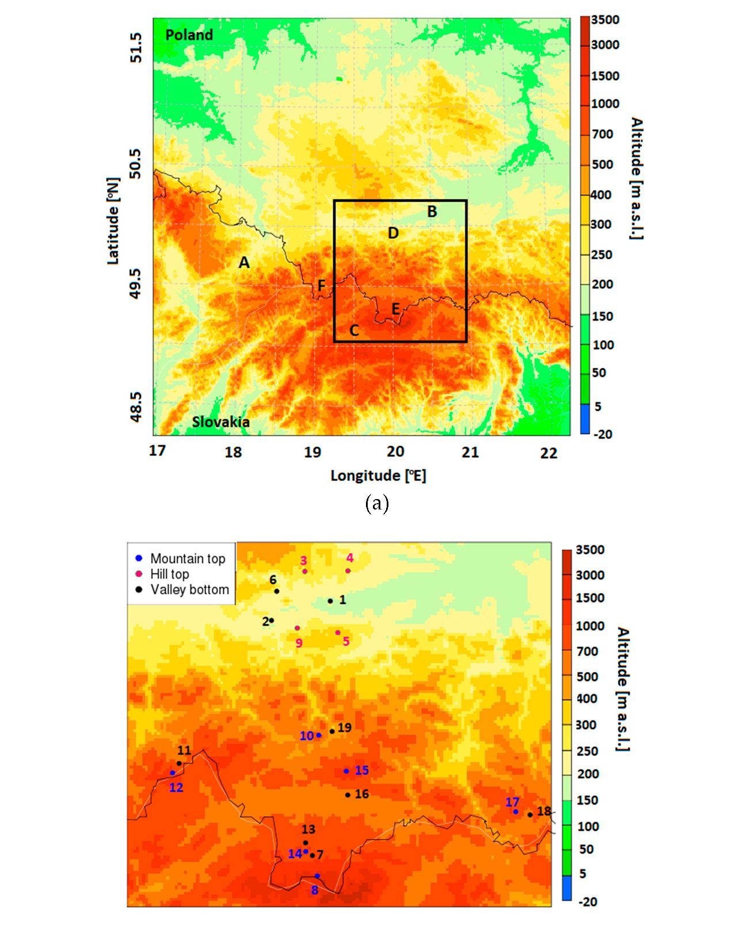
Atmosphere 2019,10,186
4 of 27
Table 1. Cont.
No. | Name | Latitude | Longitude | Altitude (m a.s.l.) | Manager of  the Station | Land Form
7 | Zakopane | 49.294 | 19.96 | 855 | IMWM-NRI | Val.ey bottom
8 | Kasprowy Wierch | 49.233 | 19.982 | 1991 | IMWM-NRI | Mountain top
9 | Libertow | 49.973 | 19.895 | 314 | IMWM-NRI | Hill top
10 | Luboń Wielki | 49.653 | 19.992 | 1022 | IMWM-NRI | Mountain top
11 | Korbielów | 49.569 | 19.348 | 650 | IMW M-NRI | Valley bottom
12 | Pilsko | 49.541 | 19.318 | 1270 | IMWM-NRI | Mountain top
13 | Nowe Bystre | 49.332 | 19.929 | 800 | IMW M-NRI | Valley bottom
14 | Gubałówka | 49.306 | 19.93 | 1173 | IMWM-NRI | Mountain top
15 | Turbacz | 49.545 | 20.118 | 1240 | IMWM-NRI | Mountain top
16 | o puszna | 49.474 | 20.124 | 568 | IMW M-NRI | Valley bottom
17 | Jaworzyna Krynicka | 49.418 | 20.895 | 1172 | IMWM-NRI | Mountain top
18 | Krynica | 49.408 | 20.961 | 585 | IMW M-NRI | Valley bottom
19 | Mszana Dolna | 49.664 | 20.054 | 440 | IMW M-NRI | Valley bottom
(b)
Figure 1. (a) .Altitude (m a.s.l.) within the domain of ALARO-NH and AROME CMC 1 km models
with 1 km x 1 km resolution and (b) locations of meteorological stations/measurement points on
the background of orography map for 1 km x 1 km domain of AROME CMC 1 km and ALARO NH
models. Analyzed area is marked with a black frame. Explanation of the letters in Fig. 1a can be found
in the text of the Section 2.1. Numbers in fig. Hr as in Table 1.
Atmosphere 2019,10,186
5 of 27
  - Measurement Data
The study was focused on the cold part of the year (September to April), when heating season
takes place. This is linked to the fact that the vertical lapse rate in that part of the year is often decisive
for air pollution dispersion, due to the formation of air temperature inversions. Therefore, the study
concentrated on the air temperature spatial distribution in the area with diversified relief, where air
pollution problems are the greatest, and the application of data from the stations located in the valleys
and at the hilltops. The air temperature data from the measurements were available for two uneven
periods: 1 January to 3 April 2017 and 1 September 2017 to 30 April 2018. In order to eliminate the
effects of various sample sizes, studies on the variability of air temperature (at 2 m above the ground)
for the Polish Western Carpathian Mts. were carried out for three intervals: winter/spring, 1 January
to 30 April 2017 and 1 January to 30 April 2018, and autumn/winter, 1 September to 31 December 2017.
Additionally, the division of subperiods was linked to the fact that for each subperiod, the number of
stations from which data were available was different, and merging the data into one sample would
eliminate 6 stations from the 19 studied.
Air temperature measurements from 19 meteorological stations or measurement points were used
to verify the model forecast. The stations/measurement points are located in both concave and convex
land forms (i.e., in valleys and at the tops of hills or mountains) so as to represent the diversity of local
climate generated by the complex relief, as described in Section 2. From 19 stations/measurement
points mentioned, 13 were owned and maintained by the IMWM-NRI (10 automatic stations and 3
synoptic stations). Five measurement points were located in the vicinity of Kraków and belonged to
Jagiellonian University (JU). Basic information about the stations/measurement points is presented in
Table 1. Measurement points 1-4 and 6 were located outside the Carpathians but very close to their
northern border and, therefore, they were included in the analysis. Figure 1b presents the locations of
meteorological stations/measurement points used in the study.
Air temperature measurements at the IMWM-NRI stations were realized following the standards
of the World Meteorological Organization (WMO). Measurements of air temperature at the points
administered by JU were realized in accordance with WMO guidelines [16], and the technical details
can be found in Bokwa et al. [17]. The stations/measurement points were divided into two groups:
(1) representing valley bottoms (Nos. 1, 2, 6, 7,11,13, 16,18, and 19), and (2) representing hill and
mountain tops (Nos. 3, 4, 5,8, 9,10,12,14,15, and 17). Further analysis was conducted separately for
those two groups in order to study the performance of the modeled air temperature forecast in relation
to local environmental conditions. The stations/measurement points represented the main types of
relief of the Polish Western Carpathians: high mountains (8); areas at the foot of high mountains (7,14);
mountain tops in the Beskidy Mts. (10, 12, 15, and 17); valley bottoms in the Beskidy Mts. (11, 13,
16,18, and 19); hill tops in the Carpathian Foothills (5, 9); and valley bottoms in the basins along the
northern border of the Carpathians (1, 2, and 6). Measurement points 3 and 4 represented convex
landforms comparable to 5 and 9 but were located north of the Carpathian Foredeep and belonged to
the area upland of Central Poland.
  - Model Configurations
The first model configuration of the ALADIN system was ALADIN, running from 1998 to 2013.
After the 2013 model, ALADIN was replaced with ALARO and AROME configurations. Currently,
AROME CMC and ALARO CMC are used operationally in IMWM-NRI, together with the CY40T1
ALARO CMC hydrostatic model, with a horizontal resolution of 4 x 4 km. The latter is run with
a 16-point-wide coupling zone and a 3 h coupling with ARPEGE CY42. There are four operational
forecasts per day starting at 00:00,06:00,12:00, and 18:00 UTC with respective forecast ranges of 66, 66,
66, and 60 h. The model has been validated by the ALADIN team at IMWM-NRI [18].
The ARPEGE global model has been used operationally at Meteo-France since 1992. The horizontal
resolution ranges from 7.5 km over Europe to 36 km over other areas, and the model uses 105 vertical
levels, the lowest level at a height of 10 m up to the highest, defined by pressure equal to 0.1 hPa.
Atmosphere 2019,10,186
6 of 27
The model uses an incremental 4D-Var data assimilation system, which runs every 6 h followed
by 6 h forecasts. "The control variables are vorticity and unbalanced variables for divergence,
temperature, surface pressure and humidity. The background error variances are derived from
a data assimilation ensemble and are updated at every cycle" [19]. During the analyzed time a
change was made in the ARPEGE configuration. The surface scheme was changed from Interaction
Sol-Biosphere-Atmosphere (ISBA) to Surface externalisee (SURFEX) in December 2017, which could
have an influence on forecasting.
Forecast results of ALARO CMC are used to prepare lateral boundary coupling for the
nonhydrostatic model CY40T1 AROME CMC (AROME CMC 2 km) with a horizontal resolution
of 2 x 2 km and 60 vertical levels. AROME CMC 2 km is run four times per day with 30 h forecast.
The location of the lowest model level is at 10 m above ground level, and the model top is located at 65
km above ground level. Detailed information concerning the height of the lowest model levels up to
3 km altitude for two resolutions, 60 and 105, are included in Appendix A.
In the present study, three models were tested: AROME CMC with two horizontal and vertical
resolutions, HARMONIE-AROME, and ALARO nonhydrostatic (ALARO NH), which together
provided four options for further analysis (Table 2). In the case of the ALARO NH model,
lateral/boundary conditions were taken from ARPEGE with a horizontal resolution of 15.2 x 15.2 km.
For other configurations, lateral/boundary conditions were taken from ALARO 4 x 4 km.
Table 2. Configurations of models used in the study. AROME, Application of Research to
Operations at Mesoscale; CMC, canonical model configuration; HARMONIE, Limitee Adaptation
Dynamique Developpement International (ALADIN) High-Resolution Limited Area Model (HIRLAM)
Regional/Mesoscale Operational Numerical Weather Prediction (NWP) in Europe AROME; ALARO
NH, ALADIN-AROME nonhydrostatic.
Model Name | Horizontal  Resolution | Number of  Vertical Levels | Lateral/Boundary  Conditions | Dimension  of Domain | Time Step (s) | Length of  Forecast
AROME CMC 2 km  (operational model) | 2 km x 2 km | 60 | ALARO CMC  4 km x 4 km | 810 x 810 | 51.42 | 30 h
HARMONIE-AROME | 2 km x 2 km | 60 | ALARO CMC  4 km x 4 km | 810 x 810 | 75 | 30 h
AROME CMC 1 km | 1 km x 1 km | 105 | ALARO CMC  4 km x 4 km | 389 x 389 | 30 | 18 h
ALARO NH | 1 km x 1 km | 105 | ARPEGE  15.2 km x 15.2 km | 389 x 389 | 30 | 18 h
Due to ongoing work on the assimilation of surface data in the ALARO model in the ALADIN
Poland group, data assimilation was not used in this research, and models were run in dynamical
adaptation mode. HARMONIE-AROME and AROME CMC 2 km had the same domain, with a
horizontal resolution of 2 x 2 km and 60 vertical levels. The length of the forecast for the AROME
CMC 2 km and HARMONIE-AROME models was 30 h. The size of the model domain for AROME
CMC (AROME CMC 1 km) and ALARO NH with a resolution of 1 x 1 km was significantly smaller
than the domain of AROME CMC 2 km. The definitions of horizontal and vertical grids for AROME
CMC 2 km and HARMONIE-AROME were the same. The horizontal and vertical grids of AROME
CMC 1 km and ALARO NH were determined by the same method. Due to the longer calculation time
for the forecast for models with 1 x 1 km resolution and 105 vertical levels, the forecast length was
18 h. The two resolution domains tested in the present study are shown in Figure 1.
In the present study, initial/boundary data from 12:00 UTC for each forecast day were used.
AROME CMC 2 km was run operationally in IMWM-NRI, and AROME CMC 1 km, ALARO NH,
and HARMONIE-AROME were launched in the trial version. Verification of forecast results for the
AROME CMC 2 km model was performed for forecasts between the 6th and 29th hour (i.e., from
18:00 to 17:00 UTC) each day from 1 January to 30 April 2017 and 1 September 2017 to 30 April 2018.
Comparisons of observations with forecast results of HARMONIE-AROME, ALARO NH, and AROME
CMC 1 km were made for the shorter period of 1 January to 16 February 2017. That period was chosen
Atmosphere 2019,10,186
7 of 27
for tests because of the occurrence of low air temperatures at 2 m a.g.l. measured at all mentioned
stations (below -20 °C).
The length of forecast for HARMONIE-AROME was 30 h, including 6-h spin-up. Verification of
forecast results was performed for 24-h periods (i.e., from 18:00 to 17:00 UTC) for the period 1 January
to 16 February 2017. Due to problems with the availability of lateral/boundary archive files, it was not
possible to obtain predictions for all days representing the above period. Comparisons of observations
with two limited-area AROME CMC 2 km and HARMONIE-AROME models were made for 39 of the
47 days.
The range of forecasts for 2 km-scale AROME CMC 1 km and ALARO NH models was 18 h.
Comparisons of observations with kilometer-scale models were made for the common time period
(from the 6th to 18th forecast hour). The verification period for the three models was from 1 January to
16 February 2017 (data for AROME CMC 1 km and ALARO NH were available for 31 of the 47 days).
The first 6 h of model forecast represented model spin-up, therefore they were omitted from
all analyses.
HARMONIE-AROME is a configuration of AROME prepared by the HIRLAM consortium.
The main differences between the models concern the dynamics and turbulence. HARMONIE-AROME
uses the same nonhydrostatic dynamical [20] core as AROME, based on the fully compressible
Euler equations. The differences in the dynamics between AROME and HARMONIE-AROME are
connected to the use of the Stable Extrapolation Two-Time-Level Scheme (SETTLS) used for numerical
integration [21] and application of vertical nesting through Davies relaxation to assure stability of the
integrations. Additionally, HARMONIE-AROME, contrary to AROME, uses the Stable Extrapolation
Two-Time-Level Scheme (HARATU) turbulence scheme, while representation of the turbulence in
AROME is based on prognostic turbulent kinetic energy (TKE) combined with a diagnostic mixing
length [22,23]. The HARATU scheme also uses a prognostic equation for turbulent kinetic energy
(TKE) and numerical implementation of TKE equations on "half" model levels ("full" model levels in
AROME).
The diagnostic temperature at 2 m in AROME was calculated using a prognostic surface boundary
layer scheme [24].
To describe the microphysics, AROME and HARMONIE-AROME models use the three-class ice
parameterization (ICE3) package, and the difference between the parameterization of microphysics
for the models is that HARMONIE, to improve model performance under cold conditions, uses
the option "OCND2" [25] and the Kogan autoconversion scheme. The radiation schemes used in
AROME and HARMONIE-AROME are almost the same; one difference is in shortwave radiation
parameterization, where the cloud liquid optical properties scheme is used [26,27]. The shortwave
radiation scheme (Morcrette radiation scheme from ECMWF) contains six spectral intervals (0.185-0.25,
0.25-0.44, 0.44-0.69, 0.69-1.1, 1.1-2.38, and 2.38-4.00 pm). The longwave Rapid Radiative Transfer
Model (RRTM) radiation scheme is divided by 16 spectral bands between 3.33 and 1000 pm.
ALARO NH uses the same nonhydrostatic dynamic core as AROME and HARMONIE-AROME;
some differences between these models are in surface, turbulence, convection, microphysics, and
radiation scheme. Parameterization of processes occurring in the surface in ALARO is through the
ISBA surface scheme. Because ALARO is provided for use in mesoscale resolution for parameterization
of moist deep convection, the Modular Multiscale Microphysics and Transport (3MT) scheme is
used [28]. Parameterization of clouds is provided by the cloud system resolving model (CSRM).
The CRSM scheme relies on convective drafts that are fully resolved by the model dynamics, and all
the condensation is computed by the cloud scheme. The microphysics scheme in ALARO works with
six species: dry air, water vapor, suspended liquid and ice cloud water, rain, and snow. A comparison
of the models' assumptions and features is presented in Table 3.

Atmosphere 2019,10,186
8 of 27
Table 3. Physics schemes used in tests of ALADIN HIRLAM system.
Parameterization
Scheme
Model Name
AROME CMC [2]
HARMONIE-AROME CMC [3]
ALARO Nonhydrostatic (ALARO NH) [2]
Dynamics
Turbulence
Radiation
Microphysics
Shallow convection
Deep convection
Clouds
Surface scheme
Nonhydrostatic ALADIN [20]
Prognostic turbulent kinetic energy (TKE)
combined with diagnostic nixing
length [22,23]
Longwave Rapid Radiative Transfer Model
(RRTM) radiation scheme, Morcrette
shortwave radiation scheme from European
Centre for Medium-Range Weather
Forecasts (ECMWF)
Three-class parameterization (ICE3)
Pergaud, J., Masson, V., Malardel, S., and
Couvreux, F., 2009 (PMMC09) [30]
Statistical cloud scheme
SURFEX [27]
Non-hydrostatic ALADIN, Stable
Extrapolation Two-Time-Level
Scheme (SETTLS) [20,21]
HARMONIE
with Regional Atmospheric
Climate Model (RACMO) Turbulence
(HARATU) [3]
Longwave RRTM radiation scheme,
Morcrette shortwave radiation
scheme from ECMWF, liquid optical
properties scheme [26]
Three-class ice parameterization
(ICE3) with option "OCND2" [25],
and Kogan autoconversion scheme
PMMC09
Statistical cloud scheme
SURFEX [27]
Nonhydrostatic ALADIN [20]
Third Order moments Unified
Condensation And N-dependent Solver
(TOUCANS)
Actif Calcul de RAyonnement et NEBulosite
(ACRANEB2)
Lopez [29]
TOUCANS
Modular Multiscale Microphysics and
Transport (3MT) [28]
Cloud system resolving model (CSRM)
Interaction Sol-Biosphere-Atmosphere (ISBA)

2.4. Representation of Meteorological Stations/Measurement Points in Model Domains
One of the main problems in weather forecasting for areas with variable topography is achieving
the best possible reconstruction of analyzed landforms in the model. Therefore, the representation
of meteorological stations/measurement points in model grids was thoroughly analyzed in order
to determine for each station the model grid point that would be the closest to the real location of a
station, in both horizontal and vertical coordinates.
    - Domain of AROME Canonical Model Configuration (CMC) 2 km and HARMONIE-AROME
Model grid points representing meteorological stations were determined in a few steps. First,
for each station, the model grid point located closest to the station was assigned. However, good
representation in the horizontal dimension was not always accompanied by good agreement in altitude.
In particular, the altitude of more than half of the model grid points chosen was significantly different
(by over 100 m) from the altitude of matching stations/points. Therefore, in the second step, for each
such point, neighboring model grid points up to a distance of two nodes along the axis of the ordinate
and the abscissa were found, and their altitudes were compared with the corresponding station/point
altitude. The final choice of a grid point representing a particular station in the model was based on an
analysis of surrounding landforms. The grid point had to represent the same landform as the station
(i.e., a hill/mountain top or valley bottom). In the last step, it was verified whether the correction
of grid points positively influenced the reliability of the forecast. Forecast results for AROME CMC
2 km were compared with measurements for the period February to March 2018, and the values of
root mean square error (RMSE) and bias of air temperature at 2 m showed improvement in four cases
(stations/points 8, 9, 12, and 15) out of seven tested. Therefore, only for those four stations/points were
corrected grid points chosen. Table 4 shows the final grid points set for domains with two resolutions,
2 x 2 km and 1 x 1 km, and Figure 1b presents the locations of meteorological stations against the
background of an orography map of AROME CMC 2 km. Table 4 also has information about the
horizontal distance between selected grid points and stations. Mean values of horizontal distance
between selected grid points and stations were comparable, 1.66 km for grids with 2 x 2 km resolution
and 1.96 km for grids with 1 x 1 km resolution. Maximum horizontal distance was measured for
synoptic station Kasprowy Wierch, and large differences were caused by a complex topography of high
mountains in the analyzed region and maximum reduction of the vertical height difference between
grid points and the station. The minimum horizontal distance was 0.17 km and 0.09 km for grids with
2 x 2 km and 1 x 1 km resolution, respectively.
Atmosphere 2019,10,186
9 of 27
Table 4. Comparison of altitudes of meteorological stations/measurement points used in the
study and horizontal distances between grid points and stations for AROME CMC 2 km and
HARMONIE-AROME (both with 2 km x 2 km resolution) and for AROME CMC 1 km and ALARO
NH (with 1 km x 1 km resolution).
Station  No. | Station/Point | Grid with 2 km X 2 km Resolution |  |  | Grid with 1 km X 1 km Resolution
Station  No. | Altitude  (m a.s.l.) | Grid Point  Altitude  (m a.s.l.) | Height  Difference  (Real- Model) | Horizontal  Distance between  Grid Point and  Station (km) | Grid Point  Altitude  (m a.s.l.) | Height  Difference  (Real-Model) | Horizontal  Distance between  Grid Point and  Station (km)
1 | 197 | 195 | 2 | 1.67 | 192 | 5 | 0.09
2 | 211 | 215 | -4 | 1.62 | 221 | -10 | 0.87
3 | 270 | 279 | -9 | 0.85 | 271 | -1 | 2.64
4 | 299 | 273 | 26 | 1.60 | 296 | 3 | 0.98
5 | 436 | 351 | 85 | 2.16 | 384 | 52 | 3.82
6 | 237 | 260 | -23 | 1.32 | 243 | -6 | 0.49
7 | 855 | 00  00 | -26 | 0.71 | 855 | 0 | 1.83
8 | 1991 | 1852 | 139 | 6.288 | 2005 | -14 | 3.91
9 | 314 | 301 | 13 | 2.22 | 315 | -1 | 3.85
10 | 1022 | 716 | 306 | 1.42 | 880 | 142 | 0.64
11 | 650 | 730 | -80 | 0.17 | 656 | -6 | 0.24
12 | 1270 | 1268 | 2 | 3.05 | 1277 | -7 | 2.89
13 | 800 | 945 | -145 | 0.35 | 802 | -2 | 3.62
14 | 1123 | 995 | 128 | 0.87 | 1117 | 6 | 2.95
15 | 1240 | 1147 | 93 | 3.32 | 1235 | 5 | 0.78
16 | 568 | 604 | -36 | 0.57 | 566 | 2 | 1.92
17 | 1112 | 970 | 142 | 0.61 | 1032 | 80 | 3.25
18 | 585 | 658 | -73 | 1.55 | 584 | 1 | 0.71
19 | 440 | 409 | 31 | 1.18 | 446 | -6 | 1.76
Data in bold signifies stations/points with corrected locations of grid points.
The mean value of absolute height difference for the model domain with 2 x 2 km resolution was
72 ± 74 m. The maximum height difference was computed for station 10 (306 m). The lowest height
difference was 2 m for stations 1 and 12.
    - Domain of AROME CMC 1 km and ALARO Nonhydrostatic (NH) Models
The same procedure as described for the model with 2 x 2 km resolution was repeated for the
- x 1 km resolution domain, but the threshold of height difference above which the correction was
performed was 10 m. First, grid points for altitude correction were checked at the horizontal distance
of one node, then the grid points at the distance of two nodes, until the reduction of altitude difference
was below the threshold. Table 4 presents altitudes of the meteorological stations/measurement
points used in the study and corresponding model grid points for the 1 x 1 km domain. The range of
absolute height difference for the model domain with 1 x 1 km resolution was significantly smaller;
the maximum difference of height was 142 m for station 10 (the difference in height for the grid with
- x 2 km resolution was 306 m). The minimum difference in height for points in the grid to real
altitude was in the range of ±1 m (for station 7, the difference was close to 0 m). The mean value of
absolute height difference for all stations for the model domain with 1 x 1 km resolution was 18 ±
35 m.
  - Forecast Evaluation
The analyzed period includes three shorter time intervals: winter/spring, 1 January to
30 April 2017 and 1 January to 30 April 2018; and autumn/winter, 1 September to 31 December
2017. Measurement data of air temperature at 2 m a.g.l. from all stations with a time resolution of
1 h were compared with model forecasts run periodically at 12:00 UTC. The observation database
contained gaps for the analyzed periods, therefore the length of the analyzed data was shorter than
the length of analyzed time intervals; stations with gaps of more than 50% of data were omitted from
the analysis. Information about analyzed periods and number of stations used in the comparison are
included in Table 5.
Atmosphere 2019,10,186
10 of 27
Table 5. Number of stations used in analyses for particular subperiods and data coverage.
Analyzed Period | Data Coverage (%) | Number of Stations
1 January to 30 April 2017 | 93.8 | 15
1 September to 31 December  2017 | 79.4 | 19
1 January to 30 April 2018 | 64.8 | 17
Due to the significant differences in daily temperature ranges between stations located in the
valley bottoms and tops, stations were divided into two groups. The value of root mean square
error (RMSE), difference (bias), and forecast accuracy were determined on the basis of differences
between observation and forecast for each hour and separately for minimum and maximum daily
air temperature. Forecast accuracy was calculated for three temperature difference ranges: ±1, ±2,
and ±5 °C. The accuracy for a given range specified what percentage of forecast hours were different
between forecast and observation below a specified range. In order to make a multifaceted assessment
of the quality of the simulation, the results of model verification were graphically presented using
a Taylor diagram [31]. This chart allowed us to show three measures commonly used for quality
assessment: standard deviation, Pearson's correlation coefficient, and centered pattern RMS difference.
Additionally, for all tested models, predicted vertical temperature gradients were examined
for all verified time periods. The value of the vertical temperature gradient determined the state of
atmospheric stability, which in turn affected the possibility of smog episodes occurring. Ten pairs of
neighboring stations were created to calculate vertical temperature gradients. Detailed information
of station pairs for model grids with 1 x 1 km and 2 x 2 km horizontal resolution are presented in
Table 6.
Table 6. Station pairs used for vertical temperature gradient analysis.
Pair No. | Number of  Top Stations | Number of  Valley Stations | Real Altitude  Difference (m) | Altitude Difference  in Model Domain  with 2 km X 2 km  Resolution (m) | Altitude Difference  in Model Domain  with 1 km X 1 km  Resolution (m)
1 | 12 | 11 | 620 | 538 | 621
2 | 14 | 13 | 323 | 50 | 315
3 | 8 | 7 | 1136 | 971 | 1150
4 | 9 | 6 | 77 | 41 | 72
5 | 10 | 19 | 582 | 307 | 434
6 | 15 | 16 | 672 | 543 | 669
7 | 17 | 18 | 527 | 312 | 448
8 | 5 | 1 | 239 | 156 | 192
9 | 4 | 1 | 102 | 78 | 104
10 | 3 | 2 | 59 | 64 | 50
The representation of difference in altitude between station pairs in the model domain with 1
x 1 km horizontal resolution was significantly better than that for the model domain with 2 x 2 km
resolution (RMSE value for both domains was 55 m for kilometric resolution and 160 m for higher
resolution).
The model performance was also presented as air temperature courses, with 1 h time resolution,
separately for the Kasprowy Wierch Mt. (representing hilltops) and Zakopane (representing valleys),
for all three subperiods. Both stations were chosen to represent relief variability of the study area
because of the large altitude difference between the stations, limited anthropogenic impact on the
natural environment, and relatively small differences between actual and model station altitudes.
Additionally, as shown in Tables 7-9, statistical parameters for both stations were close to the mean
values for the whole study area.
Atmosphere 2019,10,186 11 of 27
Table 7. Verification of air temperature forecast for the period 1 January to 30 April 2017.
Station No. | RMSE  Value (0C) | Bias  Value (0C) | Accuracy of Forecast (%)  ±1 0C ±2 0C ±5 0C |  |  | Max. Daily Temperature  Bias (0C) RMSE (0C) |  | Min. Daily Temperature  Bias (°C) RMSE (°C)
Hill and mountain tops
3 | 2.70 | 0.73 | 41.5 | 69.6 | 92.4 | -0.63 | 2.33 | 2.42 | 3.72
8 | 1.94 | 0.90 | 29.9 | 69.9 | 99.4 | 0.19 | 1.93 | 1.32 | 2.08
9 | 1.87 | 0.27 | 45.5 | 74.3 | 98.2 | -0.19 | 2.04 | 0.80 | 1.86
12 | 1.61 | 0.21 | 50.8 | 78.8 | 99.5 | -0.31 | 1.68 | 0.61 | 1.52
14 | 2.12 | 0.00 | 42.1 | 70.2 | 97.5 | -0.41 | 1.98 | 0.36 | 1.78
15 | 1.86 | 1.13 | 35.9 | 73.5 | 98.7 | 0.55 | 1.55 | 1.58 | 2.07
17 | 1.93 | 1.14 | 33.0 | 70.5 | 99.3 | 0.74 | 1.70 | 1.40 | 1.86
Mean value | 2.00 ± 0.31 | 0.63 ± 0.43 | 39.8 ± 6.7 | 72.4 ± 3.1 | 97.8 ± 2.3 | -0.01 ± 0.48 | 1.89 ± 0.25 | 1.22 ± 0.64 | 2.13 ± 0.67
Valley bottoms
2 | 2.66 | 0.57 | 38.7 | 65.9 | 93.1 | -0.74 | 2.34 | 2.41 | 3.64
6 | 2.36 | 0.86 | 41.3 | 71.1 | 94.3 | 0.47 | 2.16 | 1.93 | 3.04
7 | 2.44 | 1.09 | 45.3 | 68.0 | 93.3 | 0.15 | 1.75 | 2.41 | 3.45
11 | 2.08 | 0.08 | 41.2 | 73.4 | 97.4 | -0.85 | 1.99 | 1.23 | 2.45
13 | 2.23 | 0.58 | 41.7 | 67.4 | 96.2 | -0.83 | 1.94 | 2.07 | 3.07
16 | 4.08 | 1.67 | 36.1 | 60.0 | 86.0 | 0.29 | 2.63 | 3.77 | 5.92
18 | 2.74 | 0.95 | 42.6 | 67.9 | 92.2 | 0.01 | 2.19 | 2.27 | 3.79
19 | 2.81 | 1.30 | 40.2 | 66.6 | 91.9 | 0.57 | 2.18 | 2.42 | 3.80
Mean value | 2.68 ± 0.58 | 0.89 ± 0.46 | 40.9 ± 2.5 | 67.5 ± 3.7 | 93.0 ± 3.2 | -0.12 ± 0.56 | 2.15 ± 0.25 | 2.31 ± 0.67 | 3.64 ± 0.96
Data in bold signifies stations/points with highest and lowest RMSE value in each group.
Table 8. Verification of air temperature forecast for period 1 September to 31 December 2017.
Station No. | RMSE  Value (0C) | Bias  Value (0C) | Accuracy of Forecast (%)  ±1 0C ±2 0C ±5 0C |  |  | Max. Daily Temperature  Bias (0C) RMSE (0C) |  | Min. Daily Temperature  Bias (0C) RMSE (0C)
Hill and mountain tops
3 | 1.67 | -0.28 | 48.4 | 77.3 | 99.7 | -1.26 | 2.05 | 0.87 | 1.97
4 | 1.59 | -0.84 | 51.0 | 81.0 | 99.7 | - 1.41 | 2.08 | -0.43 | 1.25
5 | 1.41 | -0.22 | 64.0 | 87.9 | 99.2 | -1.41 | 2.43 | 0.36 | 1.20
8 | 1.62 | 0.66 | 46.2 | 83.3 | 99.0 | -0.16 | 2.27 | 1.32 | 1.88
9 | 1.36 | -0.59 | 57.3 | 86.5 | 100.0 | -1.10 | 1.86 | -0.08 | 1.15
10 | 2.14 | 1.54 | 22.2 | 57.3 | 99.4 | 1.28 | 2.04 | 1.70 | 2.08
12 | 1.30 | -0.17 | 67.0 | 88.6 | 99.6 | -0.54 | 1.43 | 0.40 | 1.11
14 | 1.77 | -0.20 | 57.2 | 81.8 | 97.7 | -0.46 | 1.79 | 0.18 | 1.56
15 | 1.31 | 0.67 | 56.6 | 88.3 | 99.9 | 0.29 | 1.28 | 0.93 | 1.38
17 | 1.42 | 0.90 | 47.7 | 86.4 | 99.9 | 0.56 | 1.28 | 1.15 | 1.69
Mean value | 1.55 ± 0.24 | 0.19 ± 0.68 | 52.1 ± 11.8 | 82.3 ± 8.8 | 99.4 ± 0.6 | -0.42 ± 0.87 | 1.85 ± 0.38 | 0.64 ± 0.63 | 1.53 ± 0.34
Valley bottoms
1 | 1.55 | -0.65 | 52.2 | 80.8 | 99.7 | -1.03 | 1.91 | -0.13 | 1.46
2 | 1.69 | -0.40 | 46.1 | 78.4 | 99.7 | - 1.46 | 2.14 | 0.56 | 1.69
6 | 1.54 | -0.22 | 52.0 | 81.4 | 99.7 | -0.38 | 1.45 | 0.42 | 1.76
7 | 2.00 | 0.66 | 50.6 | 74.9 | 97.7 | -0.22 | 1.38 | 2.04 | 2.89
11 | 1.61 | -0.69 | 42.7 | 77.7 | 99.9 | -1.37 | 1.85 | 0.44 | 1.71
13 | 1.81 | -0.14 | 41.3 | 76.4 | 98.8 | -1.08 | 1.67 | 1.11 | 2.22
16 | 2.17 | 0.40 | 45.4 | 72.6 | 96.3 | -0.66 | 1.67 | 1.63 | 2.91
18 | 1.56 | -0.19 | 52.2 | 81.6 | 99.8 | -0.77 | 1.68 | 0.88 | 1.95
19 | 2.08 | 0.22 | 53.4 | 82.1 | 98.4 | -0.44 | 1.62 | 1.45 | 3.36
Mean value | 1.78 ± 0.23 | -0.11 ±  0.43 | 48.4 ± 4.3 | 78.4 ± 3.2 | 98.9 ± 1.2 | -0.82 ± 0.41 | 1.71 ± 0.22 | 0.93 ± 0.65 | 2.22 ± 0.63
Data in bold signifies stations/points with highest and lowest RMSE value in each group.
 | Table 9. Verification of air temperature forecast for the period 1 January to 30 April 2018.
Station No. | RMSE  Value (0C) | Bias  Value (0C) | Accuracy of Forecast (%)  ±1 0C ±2 0C ±5 0C |  |  | Max. Daily Temperature  Bias (0C) RMSE (0C) |  | Min. Daily Temperature  Bias (0C) RMSE (0C)
 |  |  |  | Hill and mountain tops
4 | 1.62 | -0.03 | 46.8 | 79.4 | 99.5 | -0.88 | 2.05 | 0.65 | 1.52
5 | 1.84 | 0.66 | 45.3 | 73.2 | 99.1 | -0.22 | 2.26 | 1.29 | 1.86
8 | 1.91 | 1.23 | 33.5 | 70.1 | 99.4 | 0.36 | 1.70 | 1.99 | 2.44
9 | 1.58 | 0.14 | 47.0 | 80.9 | 99.8 | -0.42 | 1.69 | 0.75 | 1.64
10 | 2.85 | 2.30 | 15.4 | 39.6 | 94.1 | 1.68 | 2.45 | 2.44 | 2.83
12 | 1.56 | 0.49 | 52.2 | 81.3 | 99.6 | -0.02 | 1.78 | 0.85 | 1.61
14 | 1.99 | 0.98 | 39.3 | 68.6 | 98.9 | 0.62 | 2.14 | 1.34 | 1.93
15 | 2.01 | 1.34 | 35.4 | 68.2 | 99.1 | 0.54 | 1.75 | 1.91 | 2.30
17 | 2.05 | 1.50 | 35.4 | 64.8 | 99.0 | 0.86 | 1.89 | 1.80 | 2.21
Mean value | 1.93 ± 0.37 | 0.96 ± 0.69 | 38.9 ± 10.3 | 69.6 ± 12 | 98.7 ± 1.7 | 0.28 ± 0.72 | 1.97 ± 0.26 | 1.45 ± 0.59 | 2.04 ± 0.41
Atmosphere 2019,10,186
12 of 27
Table 9. Cont.
Station No. | RMSE  Value (°C) | Bias  Value (°C) | Accuracy of Forecast (%)  ±1 °C ±2 °C ±5 °C |  |  | Max. Daily Temperature  Bias (°C) RMSE (°C) |  | Min. Daily Temperature  Bias (°C) RMSE (°C)
Valley bottoms
1 | 1.69 | 0.28 | 46.0 | 78.2 | 99.3 | 0.00 | 1.57 | 0.79 | 1.89
2 | 1.97 | 0.45 | 42.4 | 74.7 | 98.1 | -0.68 | 1.89 | 2.04 | 2.96
6 | 1.69 | 0.49 | 45.6 | 76.4 | 99.4 | 0.35 | 1.66 | 1.24 | 2.06
7 | 2.44 | 1.39 | 36.0 | 63.3 | 95.0 | 0.40 | 1.91 | 2.73 | 3.51
11 | 1.93 | 0.09 | 40.4 | 71.0 | 98.4 | -0.41 | 1.85 | 1.09 | 2.40
13 | 2.22 | 0.94 | 37.7 | 66.3 | 96.3 | -0.24 | 1.86 | 2.36 | 3.20
16 | 3.05 | 1.42 | 32.8 | 63.3 | 91.5 | 0.29 | 1.85 | 3.29 | 4.90
19 | 2.58 | 1.24 | 37.7 | 61.8 | 94.0 | 0.67 | 2.01 | 2.57 | 3.83
Mean value | 2.20±0.44 | 0.79±0.49 | 39.8±4.4 | 69.4±6.1 | 96.5±2.6 | 0.05±0.43 | 1.83±0.13 | 2.01±0.83 | 3.09±0.94
Data in bold signifies stations/points with highest and lowest RSME value in each group.

3. Results
Our comparison of air temperature forecasts with observations consisted of (i) results of
verification of AROME CMC 2 km for three time intervals: winter/spring, 1 January to 30 April
2017 and 1 January to 30 April 2018; and autumn/winter, 1 September to 31 December 2017
(Section 3.1); (ii) a comparison of observations with two limited-area models: AROME CMC 2 km
and HARMONIE-AROME, both with resolution of 2 x 2 km, for verification period 1 January to
16 February 2017 (data for 39 days were available) (Section 3.2); and (iii) a comparison of observations
with two kilometric scale models, AROME CMC 1 km and ALARO NH, and operational model
AROME CMC 2 km. As models differed with length of forecast, only common time periods (6th to
18th forecast hour) were used for verification. The verification period for the two kilometric scale
models was 1 January to 16 February 2017, and data for 31 days were available.
  - Evaluation of AROME 2 km
During all three subperiods, following the classification of Niedźwiedź [32], atmospheric
circulation conditions can be considered as close to the average pattern. That pattern can be
characteriźed with conditions that are controlled mainly by the atmospheric circulation. As shown
by Ustrnul [33], in the study area during the cold part of the year, the differences between standard
autumn (September to November) and winter (December to February) were negligible, on average.
Advection of air masses from the west prevailed, linked to the activity of both cyclonic and anticyclonic
centers of atmospheric pressure. During the standard spring (March to May), no synoptic situation
type was prevalent (i.e., all types had similar frequency). However, a typical feature for Central Europe
is high variability of the circulation patterns from year to year.
    - Winter/Spring Period, 1 January to 30 April 2017
For the first analyzed period, stations 1 (Wandy Bridge), 4 (Kocmyrzów), 5 (Chorągwica), and 10
(Lubon Wielki) were not included in the analysis because of their significant data gaps.
Results of the comparison representing the first winter/spring period are presented in Table 7.
Values of RMSE and bias for the analyzed period, daily values of air temperature extremes, and
forecasting accuracy for three ranges of temperature differences were presented separately for stations
located in valley bottoms and tops. Mean values of most statistical indicators showed that the forecast
of air temperature was better for mountain/hill tops than for valley bottoms. One exception was
accuracy with a difference range of ±1 °C, for which the parameters for both groups were comparable
(tops, 39.8 ± 6.7 %; valleys, 40.9 ± 2.5 %). Forecast accuracy for ranges ±2 °C and ±5 °C was higher
for mountain/hill tops.
Lower forecast accuracy for valley stations (ranges ±2 ° C and ±5 °C) was probably caused by
underestimation of minimal temperatures in the valleys predicted by the model compared to the
mountain/hill tops.
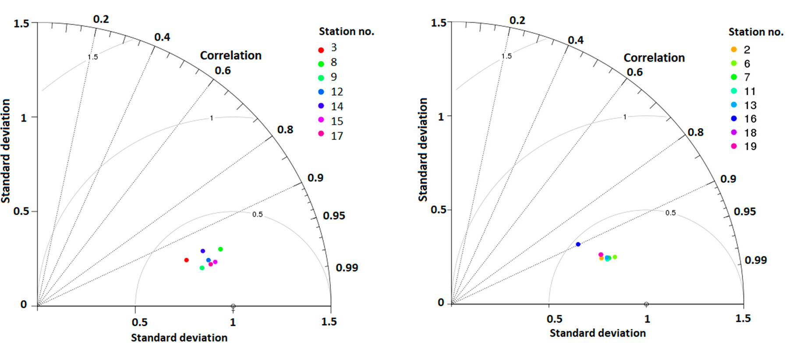
Atmosphere 2019,10,186
13 of 27
This study points out that RMSE value in some cases is not a sufficient indicator to assess forecast
quality. The station with the highest RMSE value (No. 3) had better accuracy in the range ±1 °C
compared to selected stations with lower RMSE. Compatibility of diurnal temperature range from the
model and from the measurements for stations located at the tops was better than that for stations in
the valleys, which was caused by better compatibility of forecast minimum air temperature. Mean
values of RMSE minimum daily temperature for stations located at the tops were significantly lower
than those for stations in valleys. The difference between RMSE values for minimum and maximum
daily air temperature for six out of eight analyzed stations (2, 7,13,16,18, and 19) was greater than
one. The maximum difference between RMSE values for minimum and maximum daily temperatures
was measured for station 16 (difference of 3.29 °C). The minimum difference between RMSE values
for minimum and maximum daily observations was 0.16 °C for mountain station 17. Differences in
mean RMSEand bias values for maximum daily air temperature between stations located at topsand
in valleys were smalL Contrary to top stations, the RMSE values for minimum daily, aie temperature
for all valley stations were higher than the values for maximum daily air tempetature. The RMSE
vaiues for minimum dai ly air tempe rature for three mountain stations were lower than the valaes for
maximum daily air temperature.
Additional information is provided by tha Taylor diagram presented in Figure 2 . Points
representing forecast compliance for valley stations were less rpread out than °oinas corresponding to
forecast erroes far sfati ons located of the tops. Thir indicated that the °orecasts for -valley stotfons for all
mea surement points were similar, with the exception of station 16, for which the foracast error was
much larger. The large spread of psints corresponding to stations located atthe tops indicated their
large diversity.
(o)
(b)
Figure 2. Tnylor diagram for forecast air tempeeature for (a) mountain and hill peeks and (b) valley
bottoms for the period 1 January to 3 0 April 2017.
Time seeiee of air tempeeature for the valley station at Zakopane and the station at the top of
Kasprowy Wierch are presented in F iguues 3 and 4.
Based on surface preesure charts prepared by IMWM-NRI, two high-preesure system periods
on 7-9 and 27-31 Januaiy 2017 ovee the anaiyzed area were sepaiated. An analysis of those peeiods
indicated highee e eror of numerical weather predsction for v alley stations comprred to hill/mountain
top srations. The minimum temperature values for those periods were overestimated by as much as
10 ° C, which affeeted the RMSE vaiue representing tha whafe annlyzed period.
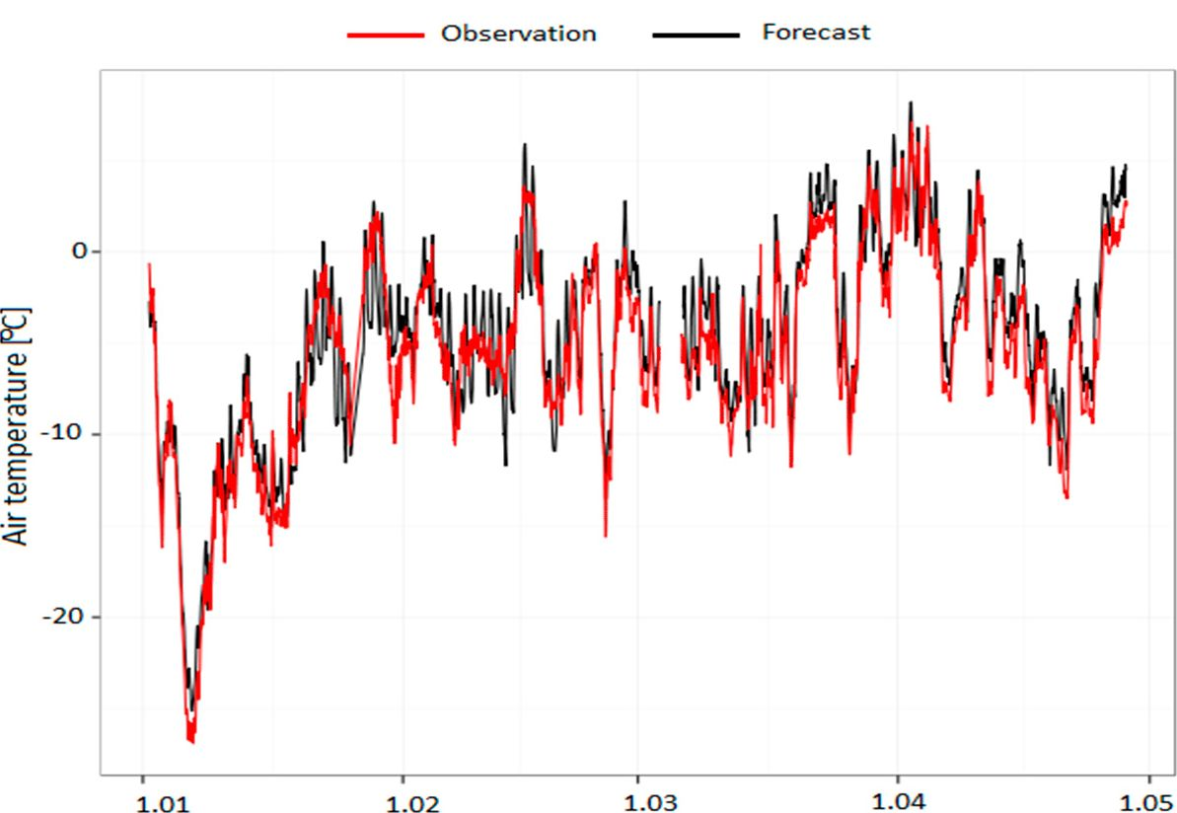
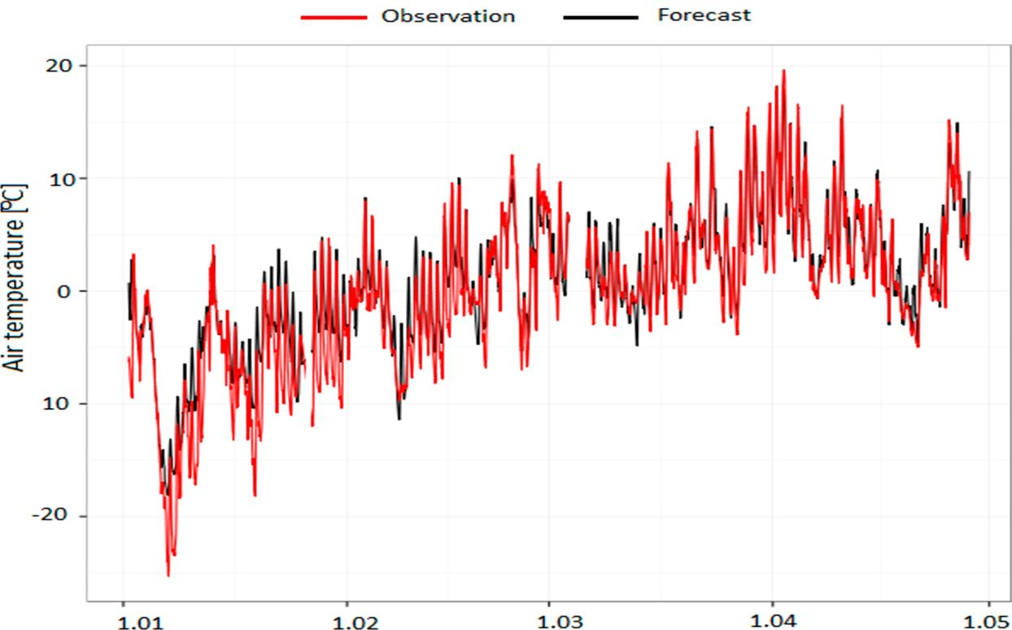
Atmosphere 2019,10,186
14 of 27
Figure 3. Measured and modeled values of air temperature (2 m above the ground) at Kasprowy
Wierch station for the period 1 January to 30 April 2017 for AROME CMC 2 km.
Figure 4. Measured and modeled values of air temperature (2 m above the ground) at Zakopane station
for the period 1 January to 30 April 2017 for AROME CMC 2 Ion.
- Autumn/Winter Period, 1 September to 31 December 2017
In the second analyzed period, observation data from all stations were used for verification.
Results of the comparison representing the autumn/wintar period are presented in Table 8.
The analyzed period differed significantly from t2e first winter/spring period. Mean values of all
sSatistical indicators pointed out betSer compatibility of the forecast tor autumn/winter. Mean values
of forecast accuracy for fhree ranges between a group ofvalleys anS tops were comparable. Analyzing
values of RMSE and bias separately for hillemountain tops and valley bottoms, we can conclude that
tliers wan no statis tically significant diffesence befween the above parameters characterizing both
groups. MOean values of RMSE and bias for1 extreme daily air temperatuee Sor stations located at valleys
and tops showed that forecest compliance for- the maxfmum temperature wascomparable for both
groups. Mora significane difSerences were seen for- daily, minimum air aemperature: the average RMSE
value for stations located at the teps was lower than the value for stations in valleys. The difference
between RMSE values for minimum and maximum daily air temperature for three valley stations
(7,16, and 19) was greater than 1 °C. During the previous analyzed period, the difference inRMSE
value for extreme daily, temperatures was also higher fos the stations mentioned above.
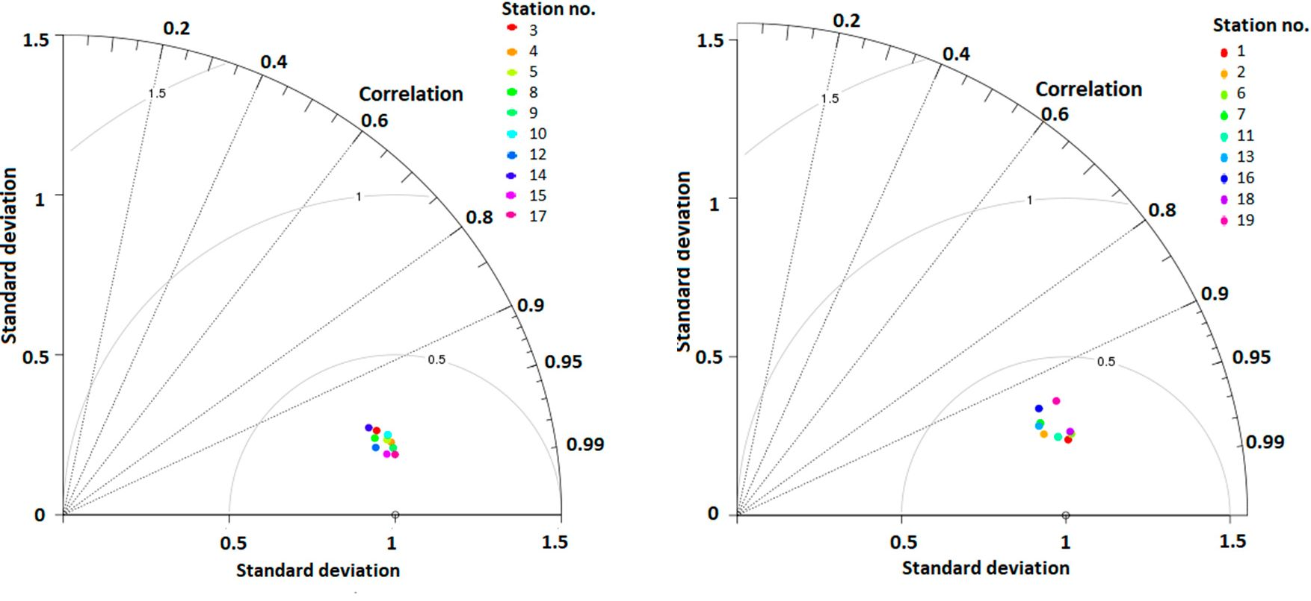
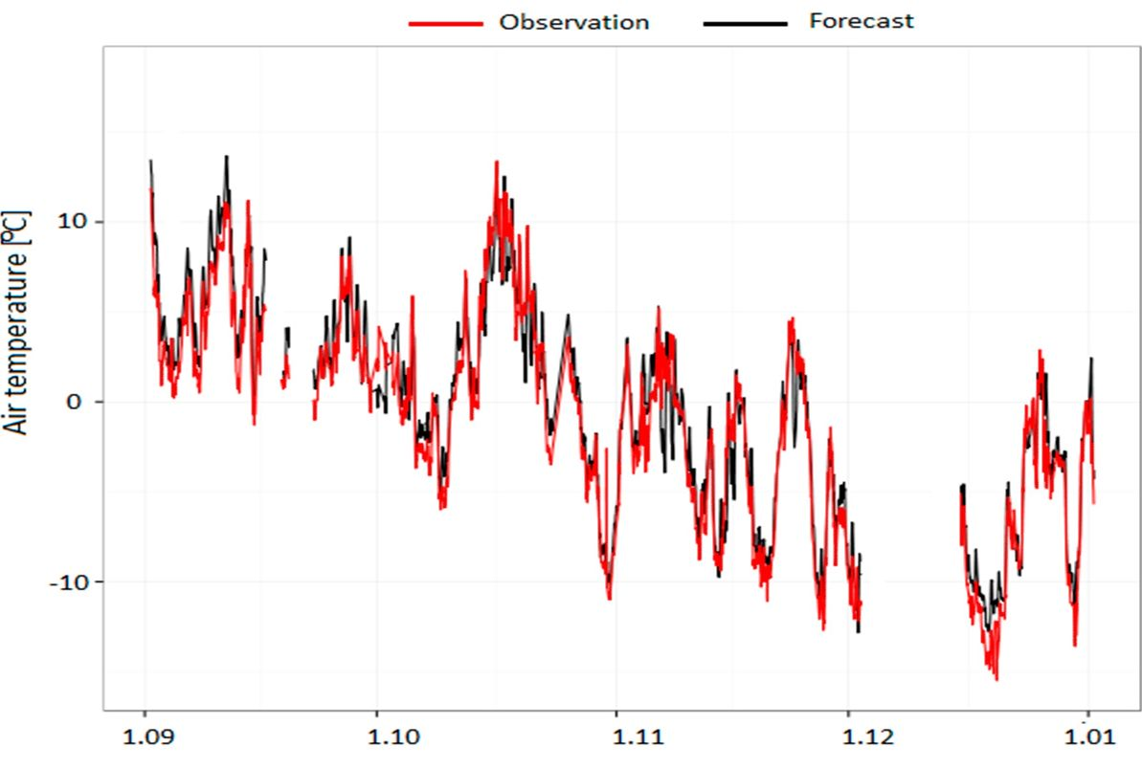
Atmosphere 2019,10,186
15 of 27
Taylor diagrams in Figure 5 for two groups of stations also showed that the quality of air
temperature forecast was comparable for all stations. Points representing forecast compliance for
stations located at tops were less spread out than points corresponding to forecast error for stations
located in valley bottoms. The highest RMSE value for points at top stations was measured for station
10 (Lubon Wielki). The forecast for station 10 also had the lowest accuracy in the range ±1 °C compared
to all stations.
(a) (b)
Figure 5. Taylor diagram for forecast air temperature for (a) mountain and hill peaks and (b) valley
bottoms for the period 1 September to 31 December 2017.
Figures 6 and 7 present time series of air temperature for valley station Zakopane and the station
at the top of Kasprowy Wierch.
Figure 6. Measured and modeled vafuer oO air temperafure (2 m abovs the ground) at Kaspeowy
Wierch station for the period 01 Septembef to 31 December 2017 for AROME (EMC 2 Ism.
While the diurnal amplitude and synoptic variability of temperature calculated for mountain top
stations followed the observations, at the valley station in Zakopane, for two periods (middle of October
and second part of November) corresponding to high-pressure system situations, the minimum diurnal
temperatures forecast was overestimated compared to the observations.
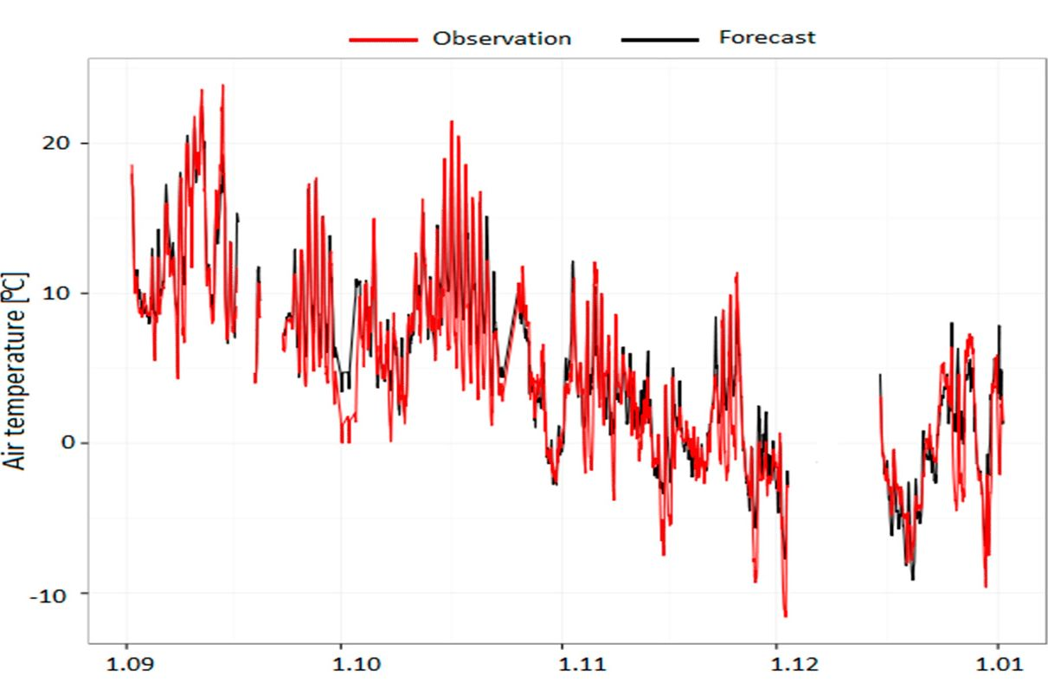
Atmosphere 2019,10,186
16 of 27
Figure 7. Measured and modeled "values of air temperature (2 m above the ground) at Zakopane station
for the period 01 September to 31 December 2017 for AROME CMC 2 km.
- Winter/Spring Period, 1 January to 30 April 2018
For the last analyzed period, stations 2 and 181 were not included in the analysis because they had
significant data gaps. Results of the comparison for stadions located in various landforms representing;
the socood winter/spring period are presentad in Table 9. Mean RMSE values for all periods and
extreme daily values and forecast accuracy for stations located in valleys and at tops were comparable
with the values forthe first analyzed winter/spring; period. The forecast error for the autumn/winter
period was significantly lower than for both winter/spring periods. The difference in RMSE values
for minimum and maximum daily temperature for five of eight valley stations was greater than
1 °C (stations 2, 7, 13, 16, and 19). Stations mentioned above in the first analyzed period also had
a difference in RMSE values greater than 1 ° C. The maximum difference of RMSE values for daily
extreme temperatures was measured for station 16 (difference of 3.04 °C). Lower RMSE values for
minimum daily temperature than for maximum daily temperature for five mountain stations pointed
out better compatibility of forecasted minimum than maximum daily temperature for these stations
(4, 5,9,12, and 14).
Taylor diagrams presented in Figure 8 point out that the forecast results are better for
mountain/hill top than valley stations.
Figures 9 and 10 present time series of modeled and measured values of air temperature at 2 m
a.g.l. for the stations in Zakopane and at Kasprowy Wierch Mt. As in the previous winter/spring
season, the minimum temperatures for valley stations were often overestimated, which was noticeable
in the temperature course for the Zakopane station.
In the period between the end of February and the beginning of March 2018, the southern part of
Poland was under the influence of Arctic air. The air mass was transformed into a continental one.
In parallel, there was an inflow of Arctic air from the east of the continent. At most of the analyzed
stations, very low minimum temperatures were measured. The difference between forecast and
measured minimum air temperatures for valley stations was as high as 10 °C. Differences between
observed and forecast minimum temperatures for stations located at the tops were smaller than for
stations in valley bottoms. The analysis of the forecast cloudiness observed for the synoptic stations at
Kraków and Zakopane did not show major differences that would significantly affect the reduction of
outgoing longwave radiation.
The comparison of all three subperiods presented above showed relatively good agreement
between the model data and measurements and a general similarity between the periods distinguished.
However, there were some differences in the statistical parameters for stations representing different
landforms. For hilltop stations, mean RMSE values for all periods and for minimum daily air
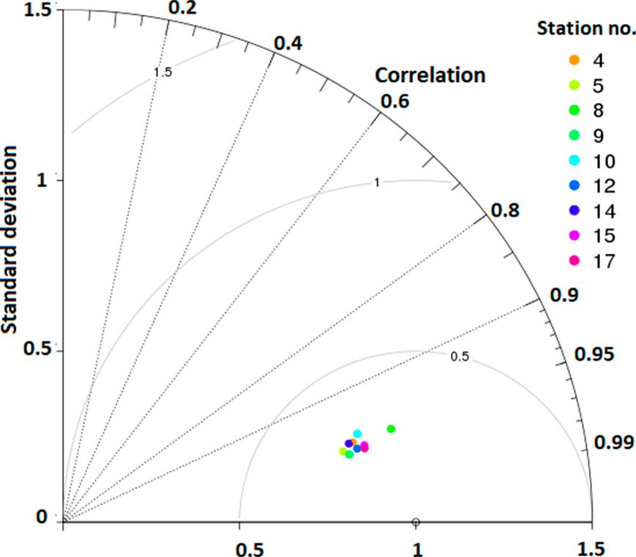
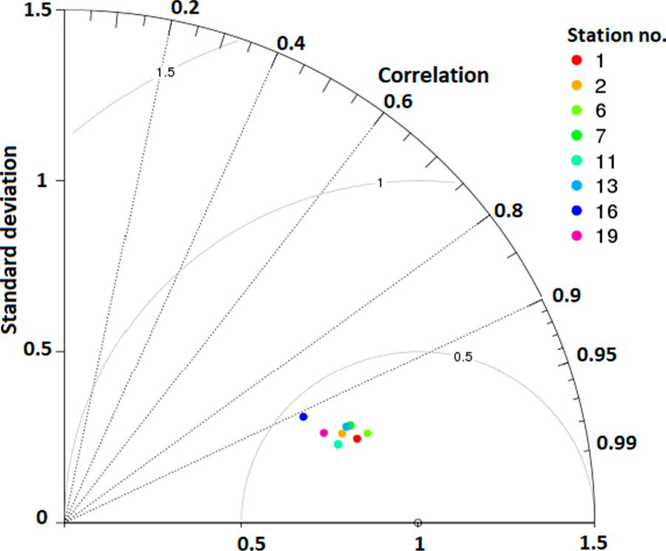
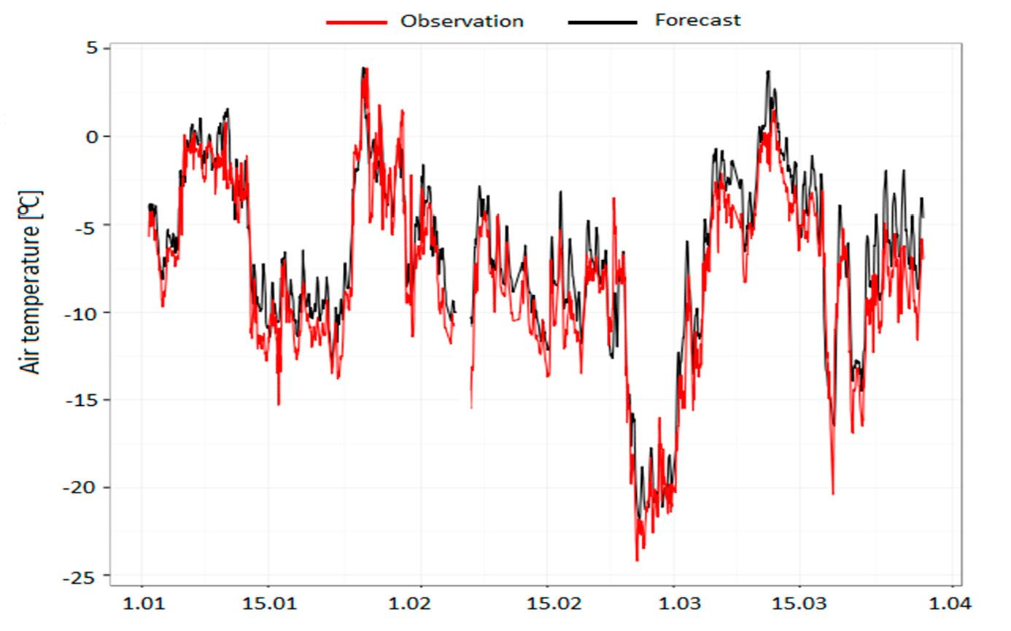
Atmosphere 2019,10,186
17 of 27
temperature showed better agreement between forecast and observations than -valley stations. As those
features can be found for all three periods, it can be assumed that they were typical for the study
area. The largest problem with air temperature prediction in the valleys was related to the influence
of high-pressure systems, which was shown using cases of synoptic conditions; a more thorough
statistical analysis was not possiblebec ause the; acailabla sample was too amall.
Standard deviation
Standard deviation
(a)
(b)
Figure 8. Taylor diagram for forecast air temperature for (a) mountain and hill peaks and (lb) valley
bottoms for the period 1 January to 30 April 2018.
Figure 9. Measured and modeled values of air temperature (2 m above the ground) at Kasprowy
Wietch station for the period 1 January to 30 Apeil 2018 for AROME CMC 2 km.
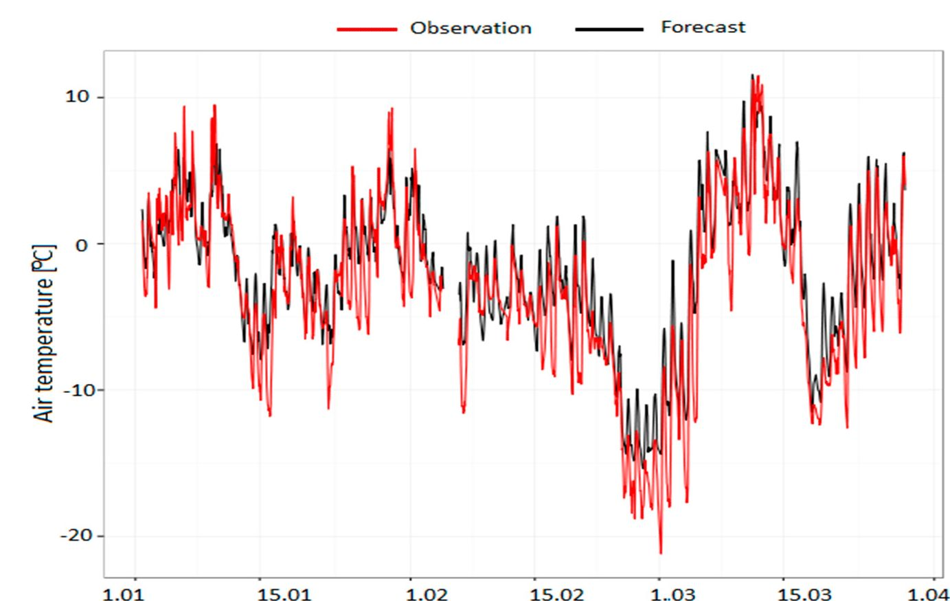
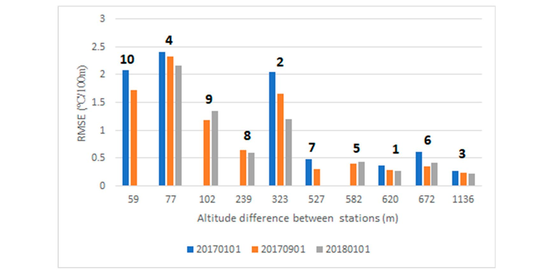
Atmosphere 2019,10,186
18 of 27
Figure 10. Measured and modeled values of air temperature (2 m above the ground) at Zakopane
station for the period 1 January to 850 April 2018 for AROME CMC 2 km.
- Temperature Gradient Analysis for AROME 2 km
The RMSE values of temperature gradient calculated based on differences between pairs of
neighboring stations wore analyzed. Since some stations were not included in the analysir for
individual time periods (lack of data), some; station pairs were also excluded. For the period t January
to 30 April 2017, stations pairs 5, 8, and 91 were excluded, and for 1 January to 30 April 2018, stations 7
and S0 wore excluded. RMSE values for predicted temperature gradeents are presented in Figurell.
Figures 11 and 12 show the numbers of station pairs used for temperature gradient analysis.
Figure 11. RMSE values for predicted temperature gradients for three analyzed periods.
Obtained RMSE values of temperature gradients were in the range between 0.3 and 2.5 oC/100 m.
Tire highest RMSE values were observed for pairs with the least altitude difference (Figure 11). The bias
between observed and predicted gecdienfs by the model had a similar pattern (Figure 12).
It was also noticeable that tire temperature gradient predicted by the model was underesfimated
for most of the station pairs (negative bias -values). A possible explanation for such an effect can tie
uncertainty of station altitude reproduced in the model domain. We can conclude that the prediction
of temperature gradient based on station pairs having altitude differences greater than 500 m was
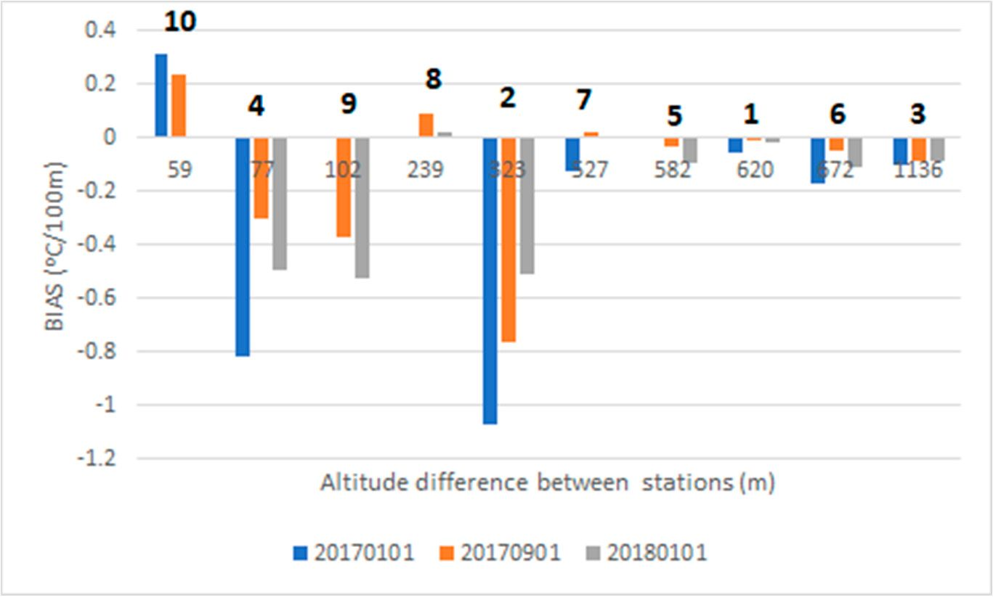
Atmosphere 2019,10,186
19 of 27
fairly accurate (RMSE < 0.5 oC/100 m, bias < 0.1 oC/100 m), thus the possibility of a smog episode can
be reliably predicted by the model using such station pairs.
Figure 12. Bias values for predicted temperature gradients for three analyzed periods.
- Comparison of Observations with AROME CMC 2 km and HARMONIE-AROME
In order to improve the quality of numerical prediction for areas with a large diversity of relief,
HARMONIE-AROME mode l tests were performed.
A comparison of observations with two models was performed for the period 1 January to 16
February 2017, which can be evaluated as representative for winter time. According to the calendar
of T. NiedZwied0 [33], on 15 days (32% of the days ire that period) there were synoptic situations
with advection from the west, but no longer periods with the same situation. The advection direction
changed every few days. There was a period of a few days with anticyclonic-type atmospheric
circulotion and no advection, and a smog episade oocurred at that time (26-29 January 12017). On
18 days of the period, p olar maritime air masses came into the study area, while on 22 days there were
polar continental air masses. The period 1 January to 16 February 2017 presented typical conditions of
the transitional climate cat Central Europ e, with large variability of the synoptic situotion and frequent
changes io advection conOitions, which was the reason fon irepuent changes in weather conditions.
Both models had lhe same size domain and resolution (2 x 12 km). The verified period was
relatively short, therefore only bias and RMSE values were calculated 0or stations. Data for stations
1, 4, and 5 load many gaps and, therefore, were not tncluded in the analysis. A comparison of
observations with models is presented in Table 10. Tie analysis of RMSE and biao valuer for the
remaining statians, assuming n significance level of 5%f, indicated that the differences between ihe
models was statistically insignificant. Stations with tits highest and lowest RMSE in both groups
(valley bottoms and hill and mountain tops) were the same for both models. The test for the winter
psieroioo,di,fiooriHi ARMONIE-AROME pointed out that differences in dynamics and turbulence scheme had
no significant impact on improvement of the forecost air temperature at a height of 2 m obove ground
level compared to the results of AROME CMC 2 Ion.
Air temperatures from selected ntations -were used to compare air temperature gradients between
pairs of ground stations. For the period 1 January to 16 Fobruary 12017, station pairs 8 and 9 were
excluded because they had s amah amount of data. A comparison of RMSE valuer for predicted
temperatuie gradienti between two models (HARMONIE-AROME and AROME CMC 12 km) presented
in Figure 13 pointed out that forecast accuracy for both models was similor.
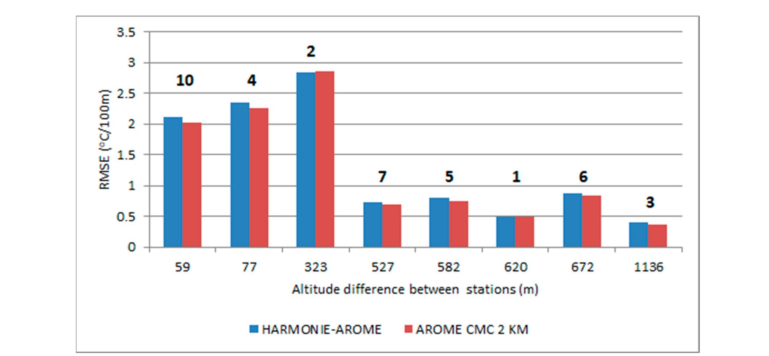
Atmosphere 2019,10,186
20 of 27
Table 10. Comparison of observations with HARMONIE-AROME model and AROME CMC 2 km
operational model.
Station No. | AROME CMC 2 km |  | HARMONIE-AROME
Station No. | RMSE (°C) | Bias (°C) | RMSE (°C) | Bias (°C)
Hill and mountain tops
3 | 3.65 | 2.10 | 3.78 | 2.41.80
8 | 3.39 | 2.19 | 3.-41 | 2.30
9 | 2.22 | 1.31 | 2.33 | 1.58
10 | 2.94 | 1.62 | 3.02 | 1.778.81
12 | 1.96 | 0.16 | 1.88 | -0.06
14 | 2.53 | -0.22 | 2.47 | -0.15
15 | 2.08 | 1.07 | 2.02 | 0.98
17 | 2.11 | 1.1-4 | 2.28 | 1.201.82
Mean value | 2.61±0.60 | 1.17=10.80 | 2.64±8.64 | 1.25±0.91
Valley bottoms
2 | 3.52 | 1.90 | 3.62 | 2.248.. 8
6 | 2.17 | 0.40 | 2.11 | 0.14
7 | 3.15 | 1.87 | 3.27 | 2.18
11 | 2.66 | 1.13 | 2.64 | 1.23
13 | 2.97 | 1.82 | 2.97 | 1.90
16 | 5.92 | 3.82 | 6.07 | 4.10
18 | 3.79 | 2.3e | 3.98 | 2.62
19 | 4.06 | 2.84 | 4.26 | 13.15
Mean value | 3.53 ± 1.07 | 2.02 ± 0.9 7 | 3.62 ± 1.13 | 2.20 ± 1.12
Data in bold signifies stations/points with highest and lowest RMSE value in each group.
Figure 13. RMSE values for predicted temperature gradients for HARMONIE-AROME and AROME
CMC 2 km.
Bias values for predicted temperature gradients shown in Figure 14 were also comparable between
HARMONIE-AROME and AROME CMC 2 km. A significantly higher value for station pair no. 2 was
caused by high underestimation of altitude difference between stations (difference in model domain
was 50 m, while real altitude difference was 323 m).
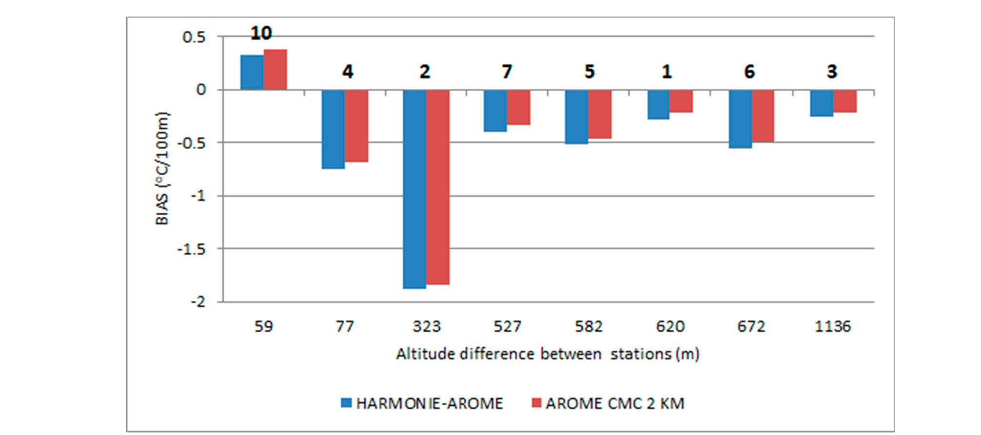
Atmosphere 2019,10,186
21 of 27
Figure 14. Bias values for predicted temperature gradients for HARMONIE-AROME and AROME
CMC 2 km.
- Comparison of Observation with Kilometric Scale Models AROME CMC1 km, ALARO NH, and
AROME CMC 2 1cm
The previously described test compared the performance of two kilometric scale mo dels to the
operational AROME CMC 2 Ion moder used by the Polish group of ALADIN for routine forecast
calculation for the analyzed area. If we incsease the model resolution and number of vertical levels,
we can expect that local dynamic processrs like kaiabatic flow and temperature inversion in the valleys
will be better reproduced try the model because? of better topography representation, and the denser
computational grid can 2etter reproduce small-scale phenomena. For the short winter period, tests of
AROME CMC 1 km and ALARO NH (both with 105 vertical levels) were run.
Below are presented the rerults of the comparison of the AROME CIVIC 21cm operationcl model
and the two kilometric scale model s, AROME CMC and ALARO NH for the period c January to
16 February 210)? 7. Data for stations 1, 4, and 5 wore not included in the analysis because of many
gaps. Tabe 11 presents tire RMSE values and bias error o. forecast. RMSE values for all ctations were
very similar. Despite the fact that AROME CMC 1 km had more vertical levelr and better horizontal
resolution, differences between the AROMECMC 2 km operational model and the new version were
insignificanl. Analyzing RMSE values and bias error separately for hill/.mountain tops and valley
bottoms, we can conc lude that differences between models were within the limits of single stsndard
deviation of mean value. The lowest RMSE value for hill/mountain stations was obtained in AROME
CMC 1 km, while better forecasting for stations in valley bottoms was obtained by ALARO NH.
Table 11. Comparison of ALARO NH and AROME CMC 1 km kilometric scale models and AROME
CMC 2 km operational model.
Station No. | ALARO NH |  | AROME CMC 1 km |  | AROME CMC 2 km
Station No. | RMSE (°C) | Bias (°C) | RMSE (°C) | Bias (°C) | RMSE (°C) | Bias (°C)
Hill and mountain tops
3 | 3.31 | 1.81 | 3.89 | 2.24 | 3.92 | 2.31
8 | 2.94 | 1.52 | 3.71 | 2.63 | 3.53 | 2.28
9 | 1.91 | 0.05 | 1.87 | 0.86 | 1.97 | 1.02
10 | 2.57 | -0.41 | 1.92 | 0.46 | 2.41 | 0.89
12 | 2.46 | -0.99 | 1.55 | 0.07 | 1.85 | -0.35
14 | 3.55 | -1.95 | 2.65 | -1.33 | 2.53 | -0.84
15 | 1.99 | -0.34 | 1.74 | 0.22 | 1.72 | 0.65
17 | 2.02 | 0.01 | 1.57 | 0.49 | 1.68 | 0.72
Mean value | 2.60 ± 0.58 | 0.04 ± 1.16 | 2.36 ± 0.89 | 0.70 ± 1.17 | 2.45 ± 0.80 | 0.83 ± 1.03
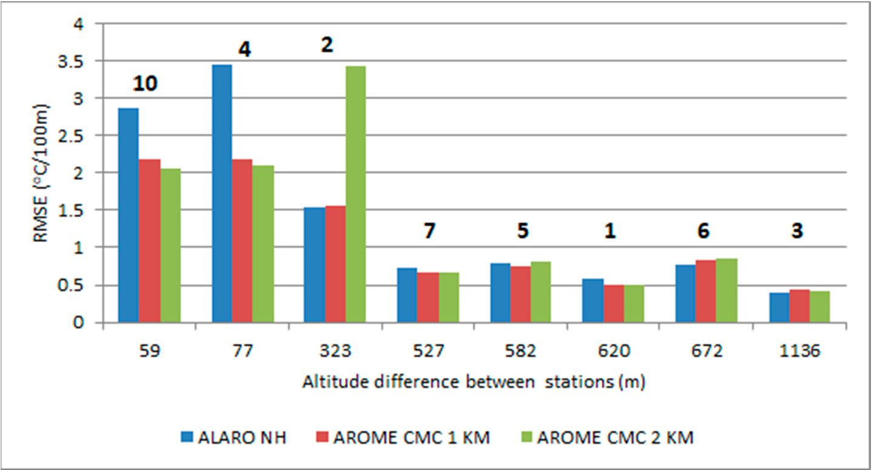
Atmosphere 2019,10,186
22 of 27
Table 11. Cont.
Station No. | ALARO NH |  | AROME CMC 1 km |  | AROMECMC2km
Station No. | RMSE (°C) | Bias (°C) | RMSE (°C) | Bias (°C) | RMSE (°C) | Bias (°C)
Valley bottoms
2 | 3.19 | 1.60 | 3.82 | 2.05 | 3.84 | 2.13
6 | 2.73 | -1.21 | 2.09 | -1.00 | 2.03 | -0.25
7 | 2.59 | 1.32 | 2.66 | 1.11 | 2.97 | 1.50
11 | 2.48 | 0.54 | 3.04 | 1.76 | 2.61 | 1.09
13 | 2.67 | 1.40 | 3.40 | 2.61 | 2.97 | 1.93
16 | 4.71 | 2.38 | 5.71 | 3.37 | 5.95 | 1o 13...581 1 1.
18 | 3.34 | 1.66 | 3.40 | 1.71 | 3.48 | 1.78
19 | 3.38 | 1.54 | 4.28 | 2.62 | 4.19 | 2.73
Mean value | 3.14 ± 0.68 | 1.15 ± 1.01 | 3.55 ± 1.03 | 1.78 ± 1.24 | 3.50 ± 1.13 | 1.81 ± 1.06
Data in bold signifies stations/points with highest and lowest RMSE value in each group.
Observations of air temperature from selected stations we/e us/d for verification of temperature
gradients; stations pairs 8 and 9 were excluded because they had a small amount of data. Figure 15,
containing plots of RMSE values for predicted temperature gradients, pointed out that for altitude
difference greater than 500 m, the differences between kilometric scale models and the model with a
bigger resolution were small. There was significantly better forecast compliance for kilometric scale models
compar/p with AROME CMC 2 km for sltation pair No. 2, which wos caused by bettee representation
of alti tude difference indie moeel domain. Pred ictad air temperatuoe gradients for pairs with altitude
differences less than 100 m were similar for AROME CMC 2 km and AROME CMC 1 km.
Figure 15. RMSE values for predicted temperature gr/dients for two kilometric scale resolution modele
(AROMO CMC 1 km and ALARO NH) and operational AROME CMC2 km as reference.
Figure 16 presents bias values for predicted temperature gradients for three model configurations.
Bias for pairs with altitude difference greater than 500 m were comparable, and were slightly
underestimated up to -0.6 oC/100 m.
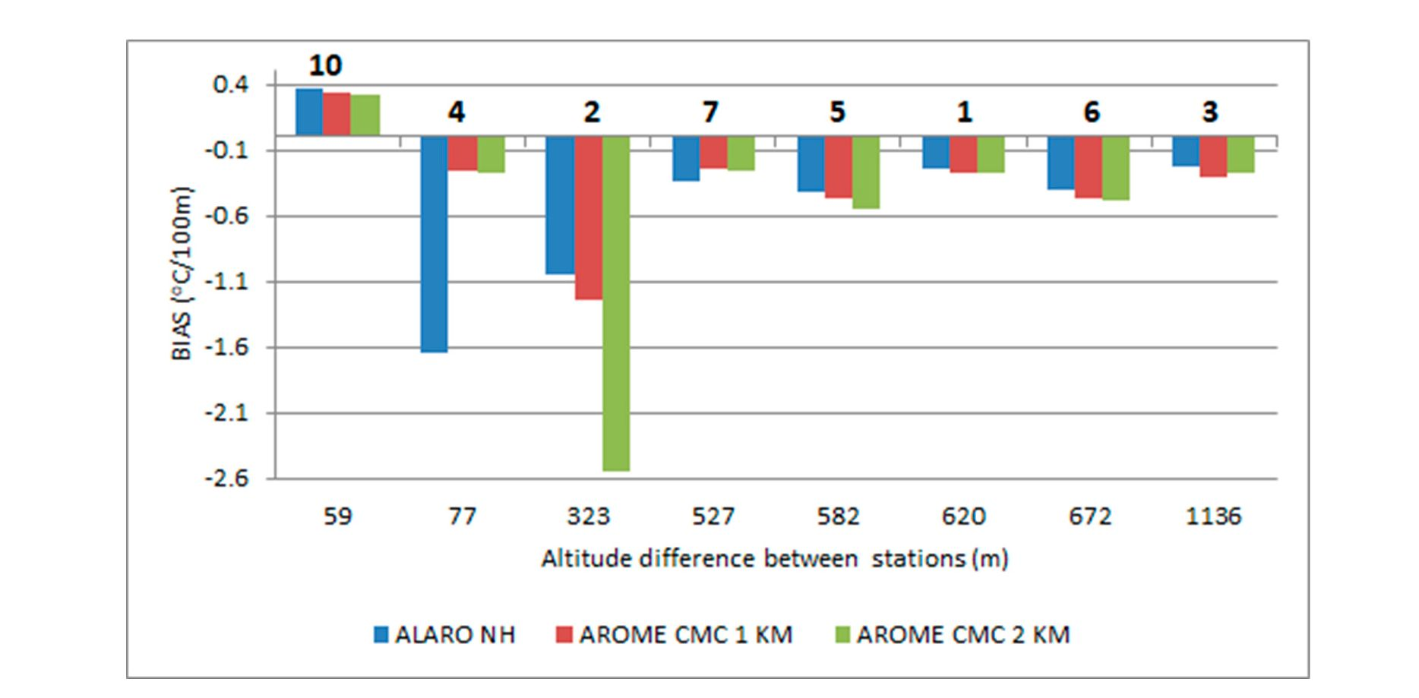
Atmosphere 2019,10,186
23 of 27
Figure 16. Bias values for predicted temperature gradients for two kilometric scale resolution models
(AROME CMC 1 km and ALARO NH) and operational AROME CMC 2 km as reference.

4. Conclusions
One of the aims of this paper was to evaluate the performance of the operational AROME CMC
2 km model, used by IMWM-NRI in the region of the Polish Western Carpathian Mts. The analysis
of the results for three time periods (two winter/spring and one autumn/winter) indicates much
better compatibility of forecasts for AROME CMC 2 km for hilltop stations than for valley ones. Bigger
forecast error is caused by overestimation of the minimum temperatures, particularly visible for
stations located in the valley bottoms. The largest differences between fsrecast and observed minimum
temperatures for stations invalleys occurred when the analyzed area was under the influence oC stroes
high-pressure systems. During such synoptic situations, cold air pools often form in the vafl ey bottoms
as a re sult of atmospheric calm or very weak winds and katabatic flow s. "Therefore, air temperature
reaches much lower values than in areas located at a similar altitude but in cn open, flat environmeet.
Significant overestimation of the minimum temprrature for stations in the valleys indicates errors in
the prediction of thefmal stratification of atmosphere inside she valleys. The air ternperature forecast
of AROME CMC 2 km for stations at the tops is better than the forecasts for stations in the valleys.
Particularly large differencea in forecast error between ctafions in the valleys and those at the tops occ ur
in the winter season. Despite the problems with forecasting; minimum temperatures ie fhe valleys,
it has been demonstrated that based on temperafure gradients calculated on the bcsis of strtton pairs
having an altitude difference greater than 500 m, it is possible to reliably predict thermal inversions
leading to the formation of smog episodes inthe valleys.
The second aim of the paper was to verify the hypothesis that in mountain areas, the increased
resolution of the ALADIN-HIRLAM NWP system would significantly improve the accurecy of the air
temperature forecast at 2 m above the ground. A comparison of the results of the AROME CMC 2 km
operational mo del wish the HARMONIE-AROME mrdel, which uses other tu rbu lence and dynamics,
showed no signiffcant improvemeot inforecasO air temperature for stations al the tops and in the
nalleyst A comparison of the results ot tha AROME CMC 2 km operating model with a resolution of 1
x 1 km end more vertical levels (1015) did no, show eignificant improvement in forecast temperature
as well. One po ssible reason could be that there were still not enough verticaf level s repreaenting air
masses in the valleys. It can be improved by redistributing the lowesf model levels its future studfes.
Aacurafe representatior of the vertical profsles of atmosphere is strongly dependent on the amount
and location os vertical levele. Plow ever, previous studies pofnted out: that a more importan t iacfor
for properly forecasting the spatial variability of air temperature in areas with variable topography is
horizontal resolution rather than vertical [34,35]
Atmosphere 2019,10,186
24 of 27
Further works should be aimed at comparing other meteorological parameters affecting thermal
stratification in valleys and conducting a deeper analysis of modelling systems to identify the
parameters and physical processes affecting the quality of thermal stratification forecasts for areas
with complex topography. Analysis of forecasted temperature gradients calculated using pairs
of hilltop/valley stations points out that for pairs with an altitude difference greater than 500 m,
the temperature gradient prediction is significantly better (RMSE < 0.5 oC/100 m, bias <0.1 oC/100 m)
compared to pairs with a smaller altitude difference.
Author Contributions: The experiment was conceptualized by P.S., A.B., B.B., and M.Z.; Methodology, A.B.,
B.B., and M.Z.; software, P.S., B.B.; validation, P.S.; formal analysis, P.S., A.B., and M.Z.; investigation, P.S., B.B.,
and M.Z.; resources, all coauthors; data curation, P.S., A.B., and B.B.; writing—original draft preparation, all
coauthors; writing—review and editing, all coauthors; visualization, P.S.; supervision, A.B., B.B., and M.Z.; project
administration, P.S.
Funding: This research was partly funded by the EU Project POWR.03.02.00-00-I004/16 (PS) and Ministry of
Science and Higher Education subsidy, project no. 16.16.220.842-B02. This research has been partly supported by
IMWM-NRI, grant number DS.-M10/2018.
Acknowledgments: We are grateful to both anonymous reviewers for their detailed and constructive comments
on the content of the manuscript. The comments allowed us to improve significantly the overall quality of
the manuscript.
Conflicts of Interest: The authors declare no conflict of interest.

Appendix A
Table A1. Height of lowest model levels up to 3 km altitude for 60 and 105 vertical levels used
in forecast.
105 Vertical Levels |  | 60 Vertical Levels
Number of Vertical  Level | Height of Vertical Level  (km a.g.l.) | Number of  Vertical Level | Height of Vertical Level  (km a.g.l.)
1 | 0.009 | 1 | 0.01
2 | 0.029 | 2 | 0.035
3 | 0.051 | 3 | 0.072
4 | 0.075 | 4 | 0.124
5 | 0.1 | 5 | 0.196
6 | 0.129 | 6 | 0.289
7 | 0.16 | 7 | 0.405
8 | 0.194 | 8 | 0.546
9 | 0.232 | 9 | 0.714
10 | 0.273 | 10 | 0.91
11 | 0.318 | 11 | 1.134
12 | 0.367 | 12 | 1.387
13 | 0.42 | 13 | 1.67
14 | 0.479 | 14 | 1.983
15 | 0.542 | 15 | 2.327
16 | 0.611 | 16 | 2.701
17 | 0.686 | 17 | 3.105
18 | 0.767
19 | 0.855
20 | 0.951
21 | 1.054
22 | 1.166
23 | 1.285
24 | 1.414
25 | 1.552
26 | 1.7
27 | 1.857
Atmosphere 2019,10,186
25 of 27
Table A1. Cont.
105 Vertical Levels |  | 60 Vertical Levels
Number of | Height of Vertical Level | Number of | Height of Vertical Level
Vertical Level | (km a.g.l.) | Vertical Level | (km a.g.l.)
28 | 2.025
29 | 2.202
30 | 2.39
31 | 2.588
32 | 2.796
33 | 3.014
References
- Serafin, S.; Adler, B.; Cuxart, J.; Wekker, S.; Gohm, A.; Grisogono, B.; Kalthoff, N.; Kirshbaum, D.; Rotach, M.;
Schmidli, J.; et al. Exchange Processes in the Atmospheric Boundary Layer Over Mountainous Terrain.
Atmosphere 2018, 9, 102. Available online: https://www.mdpi.com/2073-4433/9/3/102 (accessed on
15 March 2019). [CrossRef]
- Termonia, P.; Fischer, C.; Bazile, E.; Bouyssel, F.; Brozkova, R.; Benard, P.; Bochenek, B.; Degrauwe, D.;
Derkova, M.; Khatib, R.; et al. The ALADIN System and its Canonical Model Configurations of cycles
CY40T1 and CY41T1. Geosci. Model Dev. 2018,11, 257-281. Available online: https://www.geosci-model-
dev.net/11/257/2018/gmd-11-257-2018.pdf (accessed on 15 March 2019). [CrossRef]
- Bengtsson, L.; Andrae, U.; Aspelien, T.; Batrak, Y.; Calvo, J.; Rooy, W.; Gleeson, E.; Hansen-Sass, B.;
Homleid, M.; Hortal, M.; et al. The HARMONIE-AROME Model Configuration in the ALADIN-HIRLAM
NWP System. AMS 2017, 145, 1919. Available online: https://journals.ametsoc.org/doi/full/10.1175/
MWR-D-16-0417.1 (accessed on 15 March 2019). [CrossRef]
- Brousseau, P.; Seity, Y.; Ricard, D.; Leger, J. Improvement of the forecast of convective activity from the
AROME-France system. Q. J. R. Meteorol. Soc. 2016, 142,2231-2243. Available online: https://rmets.
onlinelibrary.wiley.com/doi/abs/10.1002/qj.2822 (accessed on 15 March 2019). [CrossRef]
- Hagelin, S.; Auger, L.; Brovelli, P.; Dupont, O. Nowcasting with the AROME Model: First Results from the
High-Resolution AROME Airport. AMS 2014, 29, 773-787. Available online: https://journals.ametsoc.org/
doi/full/10.1175/WAF-D-13-00083.1 (accessed on 15 March 2019). [CrossRef]
- Yang, X. Configuration of sub-km Harmonie-nowcasting ensemble, Geophysical Research Abstracts.
In Proceedings of the EGU General Assembly, EGU 2018, Vienna, Austria, 4-13 April 2018; EGU2018-16337.
Available online: https://meetingorganizer.copernicus.org/EGU2018/EGU2018-16337.pdf (accessed on
15 March 2019).
- Amodei, M.; Sanchez, I.; Stein, J. Verification of the French operational high-resolution model AROME
with the regional Brier probability score. Meteorol. Appl. 2015, 22, 731-745. Available online: https:
//rmets.onlinelibrary.wiley.com/doi/10.1002/met.1510 (accessed on 15 March 2019). [CrossRef]
- Czarnecka, M.; Nidzgorska-Lencewicz, J. Impact of weather conditions on winter and summer air quality.
Int. Agrophys. 2011, 25, 7-12. Available online: http://www.old.international-agrophysics.org/en/issues.
html?stan=detail&vol=25&numer=1&paper=900&i=2 (accessed on 15 March 2019).
- Bokwa, A.; Wypych, A.; Ustrnul, Z. Climate Changes in the Vertical Zones of the Polish Carpathians in
the Last 50 Years. In The Carpathians: Integrating Nature and Society Towards Sustainability, Environmental
Science and Engineering; Kozak, J., Ed.; Springer-Verlag: Heidelberg/Berlin, Germany, 2013; pp. 89-110.
Available online: https://link.springer.com/chapter/10.1007/978-3-642-12725-0_8 (accessed on 15 March
2019).
- Wypych, A.; Ustrnul, Z.; Schmatz, D.R. Long-term variability of air temperature and precipitation conditions
in the Polish Carpathians. J. Mt. Sci. 2018,15, 237-253. Available online: https://link.springer.com/article/
10.1007/s11629-017-4374-3 (accessed on 15 March 2019). [CrossRef]
- Hess, M. Pietra klimatyczne w polskich Karpatach Zachodnich. Zesz. Nauk. UJ Pr. Geogr. 1965,105,11.
- Ustrnul, Z. Influence of foehn winds on air-temperature and humidity in the Polish Carpathians. Theor. Appl.
Climatol. 1992,45, 43-47. Available online: https://link.springer.com/article/10.1007/BF00865992 (accessed on
15 March 2019). [CrossRef]
Atmosphere 2019,10,186
26 of 27
- Dąbrowska, K.; Guzik, M. Atlas of the Tatra Mountains—Abiotic Nature; Tatrzański Park Narodowy: Zakopane,
Poland, 2015.
- Ustrnul, Z.; Wypych, A.; Henek, E.; Czekierda, D.; Walawender, J.; Kubacka, D.; Pyrc, R.; Czernecki, B.
Meteorlogical Hazard Atlas of Poland; Instytut Meteorologii i Gospodarki Wodnej & Wydawnictwo Attyka:
Kraków, Poland, 2014.
- Niedzwiedz, T. Temperatura i wilgotnosc powietrza w warunkach rzezby pogórskiej Karpat (na przykładzie
doliny Raby koło Gaika-Brzezowej). Zesz. Nauk. UJ Pr. Geogr. 1973, 32, 7-88.
- Oke, T.R. Initial Guidance to Obtain Representative Meteorological Observations at Urban Sites; WMO Report No.
81, WMO/TD No. 1250; WMO: Geneva, Switzerland, 2004; Available online: https://library.wmo.int/pmb_
ged/wmo-td_1250.pdf (accessed on 15 March 2019).
- Bokwa, A.; Hajto, M.J.; Walawender, J.P.; Szymanowski, M. Influence of diversified relief on the urban
heat island in the city of Kraków, Poland. Theor. Appl. Climatol. 2015, 122, 365-382. Available online:
https://link.springer.com/article/10.1007/s00704-015-1577-9 (accessed on 15 March 2019). [CrossRef]
- Szczech-Gajewska, M.; Bochenek, B.; Kolonko, M.; Jerczynski, M.; Woyciechowska, J.; Sekula, P. ALADIN
in Poland. In Proceedings of the 39th EWGLAM and 24rd SRNWP Meeting, Reading, UK, 2-5 October
2017; Available online: http://smwp.met.hu/Annual_Meetmgs/2017/download/monday/posters/poster-
EWGLAM2017.pdf (accessed on 15 March 2019).
- Chambon, P.; Meunier, L.; Guillaume, F.; Piriou, J.; Roca, R.; Mahfouf, J. Investigating the impact of the
water-vapour sounding observations from SAPHIR on board Megha-Tropiques for the ARPEGE global
model. Q. J. R. Meteorol. Soc. 2015,141,1769-1779. Available online: https://rmets.onlinelibrary.wiley.com/
doi/full/10.1002/qj.2478 (accessed on 15 March 2019). [CrossRef]
- Benard, P.; Vivoda, J.; Masek, J.; Smohkova, P.; Yessad, K.; Smith, C.; Brozkova, R.; Geleyn, J.-F. Dynamical
kernel of the Aladin-NH spectral limited-area model: Revised formulation and sensitivity experiments. Q. J.
R. Meteor. Soc. 2010,136,155-169. Available online: https://rmets.onlinelibrary.wiley.com/doi/abs/10.
1002/qj.522 (accessed on 15 March 2019). [CrossRef]
- Hortal, M. The development and testing of a new two-timelevel semi-Lagrangian scheme (SETTLS) in
the ECMWF forecast model. Q. J. R. Meteor. Soc. 2002, 128, 1671-1687. Available online: https://rmets.
onlinelibrary.wiley.com/doi/10.1002/qj.200212858314 (accessed on 15 March 2019). [CrossRef]
- Cuxart, J.; Bougeault, P.; Redelsberger, J.-L. A turbulence scheme allowing for mesoscale and large-eddy
simulations. Q. J. R. Meteor. Soc. 2000,126,1-30. Available online: https://rmets.onlinelibrary.wiley.com/
doi/10.1002/qj.49712656202 (accessed on 15 March 2019). [CrossRef]
- Bougeault, P.; Lacarrere, P. Parameterization of orography induced turbulence in a meso-beta-scale model.
Mon. Weather Rev. 1989,117, pp. 1870-1888. Available online: https://journals.ametsoc.org/doi/abs/10.
1175/1520-0493%281989%29117%3C1872%3APOOITI%3E2.0.CO%3B2 (accessed on 15 March 2019).
- Masson, V.; Seity, Y. Including atmospheric layers in vegetation and urban offline surface schemes.
J. Appl. Meteorol. Climatol. 2009, 48,1377-1397. Available online: https://journals.ametsoc.org/doi/10.1175/
2009JAMC1866.1 (accessed on 15 March 2019). [CrossRef]
- Müller, M.; Homleid, M.; Ivarsson, K.I.; Koltzow, M.A.; Lindskog, M.; Midtbo, K.H.; Andrae, U.; Aspelien, T.;
Berggren, L.; Bj0rge, D. AROME-MetCoOp: A Nordic convective-scale operational weather prediction
model. Weather Forecast. 2017, 32,609-627. Available online: https://journals.ametsoc.org/doi/full/10.
1175/WAF-D-16-0099.1 (accessed on 15 March 2019). [CrossRef]
- Nielsen, K.P.; Gleeson, E.; Rontu, L. Radiation sensitivity tests of the HARMONIE 37h1 NWP model.
Geosci. Model Dev. 2014, 7,1433-1449. Available online: https://www.geosci-model-dev.net/7/1433/2014/gmd-7-
1433-2014.html (accessed on 15 March 2019). [CrossRef]
- Masson, V.; Le Moigne, P.; Martin, E.; Faroux, S.; Alias, A.; Alkama, R.; Belamari, S.; Barbu, A.; Boone, A.;
Bouyssel, F.; et al. The SURFEXv7.2 land and ocean surface platform for coupled or offline simulation of
earth surface variables and fluxes. Geosci. Model Dev. 2013, 6,929-960. Available online: https://www.
geosci-model-dev.net/6/929/2013/ (accessed on 15 March 2019). [CrossRef]
- Gerard, L.; Piriou, J.-M.; Brozkova, R.; Geleyn, J.-F.; Banciu, D. Cloud and precipitation parameterization in a
meso-gammascale operational weather prediction model. Mon. Weather Rev. 2009,137,3960-3977. Available online:
https://joumals.ametsoc.org/doi/full/10.1175/2009MWR2750.1 (accessed on 15 March 2019). [CrossRef]
- Lopez, P. Implementation and validation of a new prognostic large-scale cloud and precipitation scheme
for climate and data assimilation purposes. Q. J. R. Meteor. Soc. 2002, 128, 229-257. Available online:

Atmosphere 2019,10,186
27 of 27
https://rmets.onlinelibrary.wiley.com/doi/pdf/10.1256/00359000260498879 (accessed on 25 March 2019).
[CrossRef]
- Pergaud, J.; Masson, V.; Malardel, S.; Couvreux, F. A parameterization of dry thermals and shallow cumuli
for mesoscale numerical weather prediction. Bound.-Lay. Meteorol. 2009, 132, 83-106. Available online:
https://www.umr-cnrm.fr/IMG/pdf/pergaud_etal_2009.pdf (accessed on 15 March 2019). [CrossRef]
- Taylor, K.E. Summarizing multiple aspects of model performance in a single diagram. J. Geophys. Res. 2001,
106, 7183-7192. Available online: https://agupubs.onlinelibrary.wiley.com/doi/abs/10.1029/2000JD900719
(accessed on 15 March 2019). [CrossRef]
- NiedZwiedZ, T. Kalendarz Typów Cyrkulacji Atmosfery Dla Polski południowej [Calendar of Atmospheric Circulation
Types for Southern Poland]; Silesia University, Chair of Climatology: Sosnowiec, Poland, 2018; a computer
file; Available online: http://www.kk.wnoz.us.edu.pl/nauka/kalendarz-typow-cyrkulacji/ (accessed on
15 March 2019).
- Ustrnul, Z. Warunki Cyrkulacyjne [Atmospheric Circulation Conditions]. In Klimat Krakowa w XX w.
[Climate of Kraków in the 20th Century]; Matuszko, D., Ed.; Institute of Geography and Spatial Management,
Jagiellonian University: Kraków, Poland, 2007; pp. 21-40, (in Polish with English summary); ISBN
978-83-88424-28-1. Available online: https://denali.geo.uj.edu.pl/publikacje.php?id=000112 (accessed on
25 March 2019).
- Billings, B.; Grubisic', V.; Borys, R. Maintenance of a Mountain Valley Cold Pool: A Numerical Study. AMS
2006,134, 2266-2278. Available online: https://joumals.ametsoc.org/doi/10.1175/MWR3180.! (accessed on
15 March 2019). [CrossRef]
- Chen, Y.; Ludwig, F.; Street, R. Stably Stratified Flows near a Notched Transverse Ridge across the Salt Lake
Valley. AMS 2004, 43,1308-1328. Available online: https://journals.ametsoc.org/doi/pdf/10.1175/1520-
0450%282004%29043%3C1308%3ASSFNAN%3E2.0.C0%3B2 (accessed on 15 March 2019). [CrossRef]
© 2019 by the authors. Licensee MDPI, Basel, Switzerland. This article is an open access
article distributed under the terms and conditions of the Creative Commons Attribution
(CC BY) license (http://creativecommons.org/licenses/by/4.0/).

