






sustainability

Article
Application of Natural Carbon Isotopes for Emission Source Apportionment of Carbonaceous Particulate Matter in Urban Atmosphere: A Case Study from Krakow, Southern Poland

Miroslaw Zimnoch 1 , Lucyna Samek 1 , Leszek Furman 1, Katarzyna Styszko 2 , Alicja Skiba 1, Zbigniew Gorczyca 1 , Michal Galkowski 1,3 , Kazimierz Rozanski 1 and Ewa Konduracka 4,*
- Faculty of Physics and Applied Computer Science, AGH-University of Science and Technology, Al. Mickiewicza 30, 30-059 Kraków, Poland; zimnoch@agh.edu.pl (M.Z.); Lucyna.Samek@fis.agh.edu.pl (L.S.); Leszek.Furman@fis.agh.edu.pl (L.F.); alicja.skiba@fis.agh.edu.pl (A.S.);
zbigniew.gorczyca@fis.agh.edu.pl (Z.G.); mgalkow@bgc-jena.mpg.de (M.G.); rozanski@agh.edu.pl (K.R.)
- Faculty of Energy and Fuels, AGH-University of Science and Technology, Al. Mickiewicza 30, 30-059 Kraków, Poland; styszko@agh.edu.pl
- Max Planck Institute for Biogeochemistry in Jena, Hans-Knöll Str. 10, 07745 Jena, Germany
- Department of Coronary Disease and Heart Failure, Jagiellonian University Medical College, John Paul II Hospital, ul. Pra˛dnicka 80, 31-202 Kraków, Poland
* Correspondence: ekonduracka@interia.eu; Tel.: +48-501-520-617

Received: 15 June 2020; Accepted: 14 July 2020; Published: 17 July 2020
check for

updates

Abstract: Successful mitigation of air pollution in large cities requires information about the structure of emission sources and their contribution to total atmospheric load. The presented research demonstrates a possibility of application of isotope tracers for the estimation of contribution of different sources to the carbonaceous fraction of PM2.5 (Particulate Matter containing fraction below
2.5 µm) collected in the urban atmosphere of Krakow, Poland during the summer and winter seasons.
Isotope mass balance approach was used to perform source apportionment analysis for those two seasons. The analysis showed that the dominant source of the carbonaceous fraction of PM2.5 in Krakow is coal burning during the winter season and biogenic emissions during the summer season. Sensitivity analysis revealed that the uncertainty of the percentage contribution of different sources to the overall carbon load of the analyzed PM2.5 fraction is in order of a few percent.
Keywords: particulate matter; natural carbon isotopes; air quality; emission sources

Introduction
Recently, an increased interest in issues related to air pollution has been observed. This is due to growing public awareness of the impact of air quality on human health. There are a number of studies presenting the negative impact of air pollution on human health [1–3]. Krakow is one of the Polish cities affected by poor air quality, and at the same time, it is a pioneering city in Poland undertaking diverse actions to improve it. Despite the radical decisions made recently by the City Council, such as the introduction of a total ban on combustion of solid fuels in the city [4], and replacement of most public transport fleet with electric, hybrid, or Euro-6 compliant vehicles, periods of increased concentrations of particulate matter (PM) pollutants in the city atmosphere exceeding daily limit value for the PM10 fraction of 50 µg/m3 [5] are still observed. There is an ongoing discussion concerning possible reasons for such a situation. One of the key questions having no unequivocal answer to date is related to the

Sustainability 2020, 12, 5777; doi:10.3390/su12145777 www.mdpi.com/journal/sustainability

role of various emission sources in the observed PM load of the urban atmosphere in Krakow and its temporal variability.
Krakow, the second largest city located in Southern Poland having the population close to one million inhabitants belongs to one of the most polluted cities in Europe [2]. Frequent smog episodes occurring mainly during the winter season are stimulated by two factors. The first one is associated with emission from household stoves distributed within the city and in the surrounding villages and traffic emissions generated by car fleet containing a significant number of aged diesel-powered vehicles fulfilling the emission standards below Euro-4. The second factor is connected with the location of the city within the Vistula river valley and surrounded by upland and hilly terrain. Such location is stimulating frequent temperature inversions and reduces the wind speed within the city, hereby enhancing the accumulation of the pollutants inside the planetary boundary layer (PBL).
There are a number of approaches aimed at source apportionment based on the statistical analysis of the chemical and elemental composition of PM [6,7] or application of isotope tracers for identifying emission sources. For instance, Garbariene et al [8] applied 13C and 14C isotopes to identify coal, biomass, and liquid fossil fuel derived submicron aerosol emissions in the region of Vilnius city (Lithuania). Another application of carbon isotopes for Xi’an region in China done by Ni et al. [9] demonstrated a possibility of characterizing the origin of both carbon fractions, organic carbon (OC), and elemental carbon (EC). The authors used the Bayesian Markov chain Monte Carlo (MCMC) scheme to further constrain EC sources into biomass burning, liquid fossil fuel combustion, and coal combustion. Application of carbon isotopes to characterize industrial PM10 source in the Turow open-pit mine, southwest Poland, presented by Kosztowniak et al. [10] confirmed the usefulness of the method as a tool for calculating the percentage contribution of possible sources of OC and EC in atmospheric particles.
We present here an example of the application of natural carbon isotopes to identify and determine the share of different emission sources of carbonaceous particulate matter to the observed air pollution load in Krakow atmosphere. The analysis is based on two sets of PM samples (PM2.5 fraction) collected in the summer 2017 and winter 2018 seasons, in the location close to the city center. In each of these periods, a set of daily averaged PM samples was collected, and the carbon isotopic composition of the carbonaceous fraction was analyzed. The obtained isotope results were used to calculate the contribution of various emission sources using isotope-mass balance approach and the assumed values of the isotope signatures of individual sources. As the isotope signatures of different carbon sources serve as prescribed parameters in the calculations, careful selection of those values is required, based on local information on emission sources existing in the studied area. A detailed discussion of possible ranges of those parameters presented in the literature and values selected in this study is presented in the Materials and Methods Section.

Materials and Methods
The sampling location of PM2.5 fraction was placed within Akademia Górniczo-Hutnicza (AGH) University of Science and Technology campus with the distance of ca. 1 km west from the city center. The samples were collected on a daily basis using low-volume LV-3 air sampler with flow rate of
2.3 m3/h. Sampling took place during the summer 2017 and winter 2018 seasons on 47 mm diameter quartz filters. Each campaign lasted approximately 50 days. The filter samples, after determination of PM2.5 concentration using gravimetric method, were aggregated into sets representing approximately weekly periods, to obtain a sufficient amount of carbon necessary to perform the isotopic analyses. Detailed information concerning aggregation periods and corresponding average PM2.5 concentration for both seasons are presented in Table 1.
In the next step, the total carbon (TC) contained in the aggregated samples was converted to CO2 in quartz-sealed tubes using the procedure described by Major et al. 2012 [11]. A standardized portion of filters cut into small pieces, with the addition of CuO (source of oxygen for combustion) and Cu (capture of oxygen traces after conversion), were placed inside pre-baked quartz combustion

tubes, which were evacuated and flame-sealed. Next, combustion tubes were placed in the oven for 3 h at 950 ◦C. Finally, the CO2 obtained from conversion of total carbon present in the sample was cryogenically purified and analyzed for δ13C using isotope ratio mass spectrometry (IRMS) and the fossil fuel fraction (FF) was determined using analyses of radiocarbon (14C/12C isotope ratio) using accelerator mass spectrometry. The 14C/12C isotope ratios are usually expressed as per cent of modern carbon, which is defined as 95% of the specific activity of internationally accepted standard NBS Oxalic Acid (Ox1) in the year 1950. IRMS analysis were done in Environmental Physics Stable Isotope Laboratory on Finnigan Delta-S mass spectrometer, while radiocarbon content was determined after sample graphitization in Poznan Radiocarbon Laboratory on 1.5 SDH-Pelletron Model ‘Compact Carbon AMS’ according to the procedure described by Czernik and Goslar 2001 [12]. The obtained carbon isotope data were then used to calculate the contribution of various emission sources using the following isotope-mass balance equations:

1 = cbio + ccoal + ctra f f (1)
1·δ13Catm = cbio·δ13Cbio + ccoal·δ13Ccoal + ctra f f ·δ13Ctra f f (2) 1·FFatm = cbio·FFbio + ccoal·FFcoal + ctra f f ·FFtra f f (3)
where:
cbio—biogenic contribution to carbonaceous fraction of PM2.5; ccoal—carbonaceous fraction of PM2.5 originating from coal combustion; ctraff—carbonaceous fraction of PM2.5 originating from traffic emissions; δ13Catm—13C isotopic composition of the measured PM2.5 sample; FFatm—fossil fuel fraction in the total carbon present in measured sample;
δ13Cbio, coal, traff—13C isotopic signature of biogenic, coal burning-related and traffic-related sources;
FFbio, coal, traff—fossil fuel fraction in biogenic, coal burning-related and traffic-related sources.

Table 1. List of samples along with aggregation periods and related average PM2.5 concentrations.

Code | Summer Campaign | PM2.5 (µg/m3) | Code | Winter Campaign | PM2.5 (µg/m3)
L1 | 05.06–12.06.2017 | 16.3 | Z1 | 03.01–10.01.2018 | 34.3
L2 | 13.06–21.06.2017 | 19.2 | Z2 | 11.01–21.02.2018 | 34.8
L3 | 22.06–29.06.2017 | 17.0 | Z3 | 22.01–28.01.2018 | 86.2
L4 | 30.06–07.07.2017 | 18.9 | Z4 | 29.01–05.02.2018 | 31.1
L5 | 08/07–15.07.2017 | 20.9 | Z5 | 06.02–14.02.2018 | 59.3
L6 | 16.07–23.07.2017 | 18.4 | Z6 | 15.02–21.02.2018 | 45.3

For successful calculation of contributions of three carbon source categories (biogenic, coal-burning, and traffic-related), the isotopic signatures of those sources had to be assumed. Stable carbon isotope composition (13C/12C) of PM samples reported in the literature for those source categories vary in a wide range. δ13C value reported for traffic-related sources has the range between −28.3 and −24.5%0. 13C isotope signatures of non-vehicle anthropogenic emissions range from −27.4 to −23.3%0, whereas δ13C values of PM originating from biomass burning (C3 plants) range from −34.7 to −25.4%0 [13]. For the purpose of these calculations, we adopted values determined during previous studies in Krakow and its region. δ13C value of biogenic source (δ13Cbio) equal to (−26 ± 2)%0 and 14C content (FFbio) of (110 ± 5)% of modern carbon. The biogenic source represented in the study region mainly by C3 plants is a complex reservoir consisting of at least two components related to biomass burning (wood and wood products being active mainly during the winter season) and volatile organic carbon (VOC) emissions by living plants (active mainly during the summer season). Assumed radiocarbon content higher than modern level is reflecting bomb-derived 14C fraction still present in biomass samples (wood). Coal-burning component contains carbon originating from hard coal being 14C-free carbon

reservoir (FFcoal = 100%). δ13C of Polish hard coals ((δ13Ccoal) is well defined and varies in a relatively narrow range (−23.3%0 to −24.5%0) [14]. Traffic emission source comprises particles generated during liquid fuel combustion (mainly in Diesel engines) and carbonaceous particles associated with wearing of tires and asphalt pavement. While asphalt and petroleum fuels have 14C-free fossil origin, modern carbon contribution is present in the form of biofuels and natural rubber admixtures in fuels and tires, respectively. In this study based on values reported in the literature [15,16] we adopted δ13C of traffic component ((δ13Ctraff) equal to −(30 ± 1)%0 and fossil contribution (FFtraff) (90 ± 10)%. The reservoir of carbon in PM2.5 samples may also contain carbon devoid of 14C, which is associated with the presence of mineral dust in atmospheric aerosols. This carbon is mostly in the form of carbonates (Ca or Mg). Based on previous studies [17], we assessed that the correction for the presence of mineral fraction is less than the uncertainty of balance calculation, thus no corrections were applied.
Assessment of the possible influence of long-range transport of PM (footprints) for Krakow has been performed for both sampling periods using 96 h back trajectories calculated with hourly resolution. Each frequency plot was created based on ca. 1200 individual trajectories. The trajectories were calculated with the use of a Hybrid Single-Particle Lagrangian Integrated Trajectory model (Hysplit 4, revision 983) [18]. The model was run in the back-trajectory mode providing information on the origins of the air masses arriving at the measurement site. The length of 96 h was assumed based on the recommendation in Hysplit FAQ, as the most appropriate for a statistical regional analysis like frequency of clustering.

Results
The summary of PM2.5 concentration and carbon isotope composition measurements (δ13C and fossil component FF calculated based on 14C analysis) of aggregated samples representing the summer and winter seasons are presented in Figure 1.
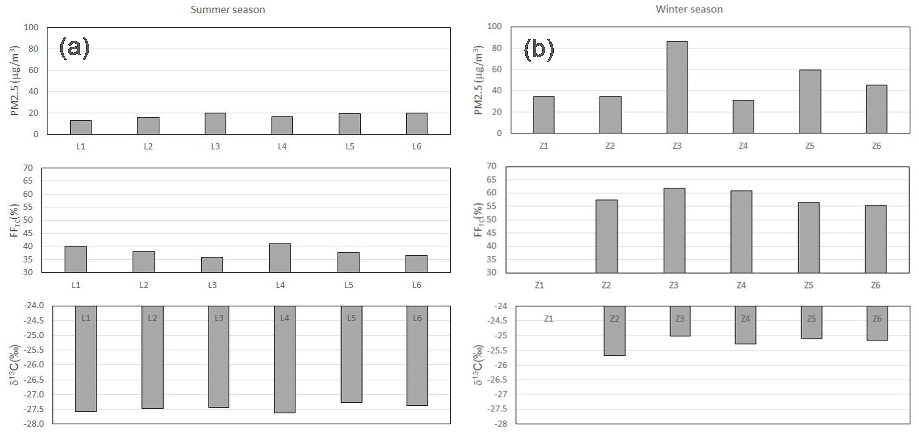
Figure 1. Summary of PM2.5 concentration determined by gravimetric method and carbon isotope composition of weekly aggregated PM2.5 samples collected in Krakow and representing summer 2017
  - and winter 2018 (b) seasons (cf. Table 1). Shown are fossil-fuel fractions (FFTC) derived from measurements of 14C/12C isotope ratios and 13C/12C isotope ratios expressed as per mill deviation from
the internationally accepted standard (VPDB). Isotope data for Z1 sample are missing due to technical problems during sample preparation.
The weekly mean PM2.5 concentration values for samples collected during the summer season fluctuated in a narrow range between 16 and 21 µg/m3, which corresponds to good air quality observed during the whole sampling period, often observed at this time of year in Krakow. The fossil contribution

to the total carbon reservoir in PM is in the range of 36% to 41%. The remaining fraction of the total carbon contains modern carbon originating from biogenic and traffic emissions (wearing of tires and biofuels contribution). The measured values of δ13C (−27.3−−27.6%0) are characteristic for a mixture of biogenic and traffic-related emissions in this region.
For the winter season, much higher variability of weekly mean PM fraction was observed, with maximum PM2.5 values reaching 87 µg/m3 (max. daily value of 160 µg/m3), which in turn, corresponds to typical smog situations in the city. The samples collected during winter 2018 represent different periods corresponding to both better air quality conditions (Z1, Z2, and Z4), typical smog situations (Z3, Z5) and intermediate air quality conditions (Z6). The fossil component shows a much higher contribution of 14C-free carbon (55−62%) with the highest values corresponding to smog situations. This confirms the hypothesis pointing to coal-burning as the most important source of PM during winter smog events in Krakow. Values of δ13C (−25.0−−25.7%0) are also confirming coal burning as the main source.
Calculated footprints (areas of influence) representing the summer and winter seasons reveal substantial differences (Figure 2). While during the summer season, westerly air mass transport dominates, the winter footprint map reveals almost isotropic circulation patterns. Comparison of surface areas for the regions on both maps with the highest percentage of trajectories frequency (>5%) leads to the conclusion that residence times of air masses over land during the winter season are longer, favoring the accumulation of PM emitted from the surface. There is a lack of trajectories indicating long-range transport of Saharan dust, potentially loading the aerosols sampled in Krakow with higher levels of the mineral fraction. This fact justifies the omission of the mineral component in the isotope-mass balance calculations.
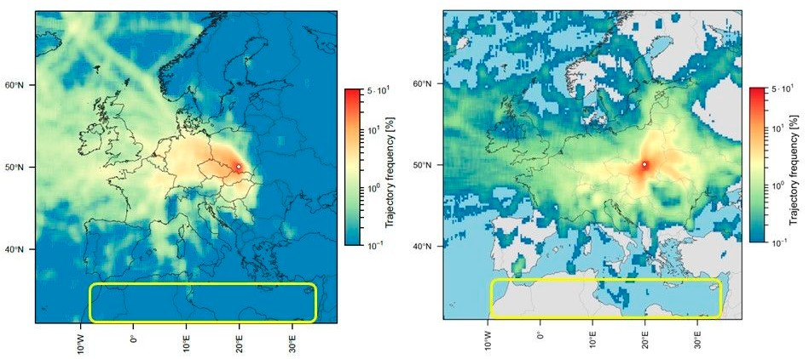
Figure 2. Area of influence (footprint) maps representing long-range aerosol transport to the location where PM samples analyzed in this study were collected (summer season: left-hand panel; winter season: right-hand panel). The white circle indicates the location of Krakow. Saharan region (northern Africa) is marked with a yellow rectangle.

Discussion
Carbon isotope-mass balance calculations applied to PM samples collected in Krakow allowed a deeper insight into the origin of carbon present in those samples and apportionment of potential emission sources contributing to this reservoir: (i) Hard coal combustion, (ii) biogenic emissions (including biomass combustion), and (iii) traffic-related emissions. The calculated percentage contributions for two analyzed periods are presented in Figure 3.

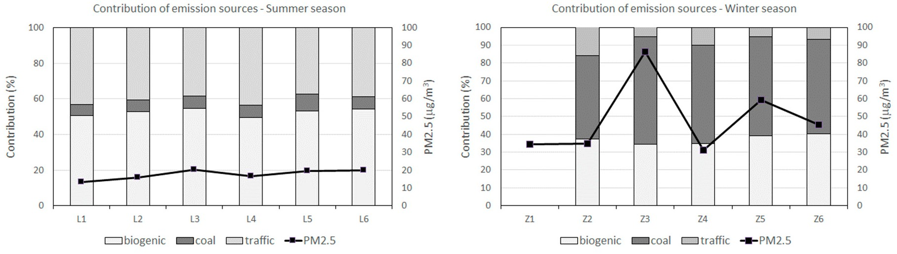
Figure 3. Calculated percentage contribution of three main emission sources of carbonaceous aerosols in Krakow (bars) and associated PM2.5 concentration (squares) measured in weekly aggregated samples collected in Krakow during the summer and winter seasons (left-hand column and right-hand column, respectively).

As seen in Figure 3, the temporal variability of calculated percentage contributions for the summer season is very small. Maximum differences are in order of 5%. This is consistent with the low and stable concentration of PM2.5 controlled by generally higher wind speed and strong vertical convective mixing within PBL during summer. Contribution of carbonaceous aerosols originating from coal-burning to the total PM2.5 load is small, in the order of a few percent. Biogenic emissions dominate the carbon balance. The second strongest source of carbonaceous aerosols during summer is related to traffic. The most important component of biogenic emissions is presumably linked to emissions of Volatile Organic Carbon (VOCs) by living plants and burning of biomass.
The winter carbon balance points to coal burning as a dominant source of carbonaceous aerosols. The second important source of carbon is linked to biogenic emissions (biomass burning, mainly wood and wood products). The samples collected during smog episodes (Z3, Z5) indicate the highest contribution of coal burning to the carbon balance, in agreement with expectations. Coal-burning source dominating during smog periods reduces the relative contribution of traffic component.
The analysis of seasonally averaged results (Figure 4) shows that contribution of carbon emission sources related to hard coal burning during summer reaches only 7.2% and is probably mainly related to industrial sources. Traffic-related emissions account for 40.3%, while biogenic emissions account for 52.3%. Such a high proportion of biogenic carbon is most likely linked to the activity of the biosphere (VOCs), acting as precursors of secondary organic aerosols. The relative contribution of analyzed emission sources is changing dramatically during the winter period. Dominating source of the carbonaceous fraction of PM2.5 in winter is coal burning (54.3%). The second largest source is linked to biogenic emissions resulting from biomass burning (wood and wood products). Traffic-related emissions account only for ca. 8.6% of the total carbon emissions.
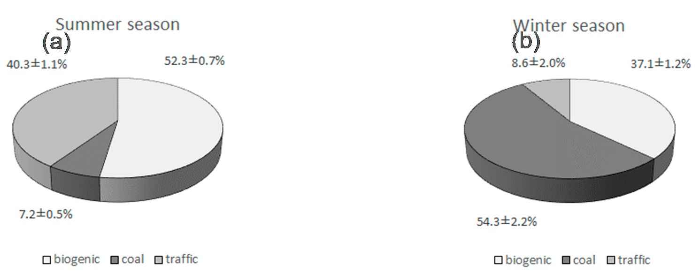
Figure 4. Seasonally averaged percentage contribution of assumed three main emission sources of carbonaceous aerosols in Krakow representing summer 2017 (a) and winter 2018 (b) seasons.

The sensitivity analysis applied to carbon sources identified in the analyzed samples of PM2.5 has been performed in order to assess uncertainties associated with the contribution of those sources to the carbon reservoir present in PM samples, as well as to identify model input parameters (isotopic signatures of the sources) most strongly affecting the budget calculations. It is clearly seen from Figure 5 that fossil-fuel component defined on the basis of radiocarbon analyses has a negligible impact on the source apportionment resulting from isotope-mass balance calculations.
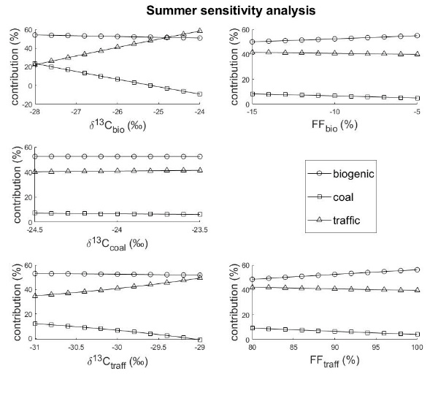
(a)
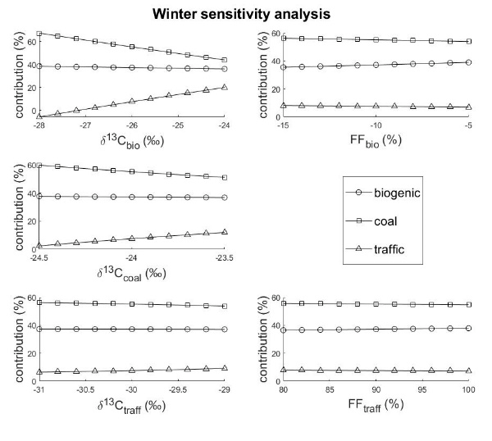
(b)
Figure 5. Sensitivity analysis of source apportionment calculations done separately for the summer (a) and winter (b) season.

The maximum influence parameter defined as the ratio of calculated component change to the unit change of a given parameter is less than 0.5% of the calculated contribution per percent of FF share for both seasons. It means that assuming the maximum estimated uncertainty of the radiocarbon signature leads to maximum uncertainty of the calculated budget component less than 10%. In the case of 13C isotope composition, the isotopic signature of the biogenic source has the highest influence reaching the maximum value of 10%/%0. Assuming uncertainty of δ13C value equals 0.5%0, it transfers to ca.5% uncertainty of the derived component of the balance. Another factor significantly influencing the apportionment of carbon sources during the summer season is δ13C value of traffic-related component. The maximum influence parameter associated with this factor is equal ca. 5%/%0. To summarize, the sensitivity analysis showed that the uncertainty of the estimated carbon balance components for winter and summer seasons in Krakow is in the order of a few percent.

Conclusions
It has been demonstrated that the application of carbon isotope tracers for apportionment of the carbonaceous fraction of airborne PM allows determining the contribution of three main emission sources of carbon with error margin in the order of a few percent. A key element of this apportionment is the proper estimation of carbon isotope signatures of the respective sources, which often depend on the geographical location of the examined site or region. The study presented here has shown that during the winter season, coal combustion is a dominant source of carbonaceous aerosols in Krakow, while during summer, the main contribution to the carbon balance comes from biogenic emissions and traffic.
Author Contributions: Conceptualization, M.Z., M.G., K.R. and E.K.; methodology, M.Z., L.S., K.S., Z.G., M.G. and K.R.; software, M.Z. and M.G.; formal analysis, L.S., L.F., K.S., A.S. and Z.G.; investigation, M.Z. and K.R.; data curation, M.Z., L.S., K.S. and M.G.; writing—original draft preparation, M.Z., K.R. and E.K.; writing—review and editing, M.Z., K.R. and E.K.; visualization, M.Z. and M.G.; supervision, M.Z. and K.R.; project administration, E.K.; funding acquisition, E.K. All authors have read and agreed to the published version of the manuscript.
Funding: This research was funded by National Science Center, grant number DEC-2016/21/B/NZ7/01747” and subsidy from the Ministry of Science and Higher Education, grant number 16.16.220.842 B02.
Acknowledgments: The authors would like to acknowledge technical staff of the Stable Isotope Laboratory of the Faculty of Physics and Applied Computer Science, AGH University of Science and Technology in Krakow for their assistance in sample preparation and δ13C analyses.
Conflicts of Interest: The authors declare no conflict of interest. The funders had no role in the design of the study; in the collection, analyses, or interpretation of data; in the writing of the manuscript, or in the decision to publish the results.

References
- Shiraiwa, M.; Ueda, K.; Pozzer, A.; Lammel, G.; Kampf, C.J.; Fushimi, A.; Enami, S.; Arangio, A.M.; Frohlich-Nowoisky, J.; Fujitani, Y.; et al. Aerosol Health Effects from Molecular to Global Scales. Environ. Sci. Technol. 2017, 51, 13545–13567. [CrossRef] [PubMed]
- Ahmed, C.M.S.; Jiang, H.H.; Chen, J.Y.; Lin, Y.H. Traffic-Related Particulate Matter and Cardiometabolic Syndrome: A Review. Atmosphere 2018, 9, 16. [CrossRef]
- Pardo, M.; Li, C.L.; He, Q.F.; Levin-Zaidman, S.; Tsoory, M.; Yu, Q.Q.; Wang, X.M.; Rudich, Y. Mechanisms of lung toxicity induced by biomass burning aerosols. Part. Fibre Toxicol. 2020, 17, 15. [CrossRef] [PubMed]
- Council, L.P.V.l.g. Resolution on the Introduction of Restrictions on the Operation of Installations in which Fuel is Burned in the Municipality of Krakow (in Polish); Voivodeship Local Parliament: Warsaw, Poland, 2016.
- European Environment Agency. Air Quality in Europe; European Environment Agency: Copenhagen, Denmark, 2019.
- Samek, L.; Stegowski, Z.; Styszko, K.; Furman, L.; Zimnoch, M.; Skiba, A.; Kistler, M.; Kasper-Giebl, A.; Rozanski, K.; Konduracka, E. Seasonal variations of chemical composition of PM2.5 fraction in the urban area of Krakow, Poland: PMF source attribution. Air Qual. Atmos. Health 2020, 13, 89–96. [CrossRef]

- Elser, M.; Huang, R.J.; Wolf, R.; Slowik, J.G.; Wang, Q.Y.; Canonaco, F.; Li, G.H.; Bozzetti, C.; Daellenbach, K.R.; Huang, Y.; et al. New insights into PM2.5 chemical composition and sources in two major cities in China during extreme haze events using aerosol mass spectrometry. Atmos. Chem. Phys. 2016, 16, 3207–3225. [CrossRef]
- Garbariene, I.; Sapolaite, J.; Garbaras, A.; Ezerinskis, Z.; Pocevicius, M.; Krikscikas, L.; Plukis, A.; Remeikis, V. Origin Identification of Carbonaceous Aerosol Particles by Carbon Isotope Ratio Analysis. Aerosol Air Qual. Res. 2016, 16, 1356–1365. [CrossRef]
- Ni, H.Y.; Huang, R.J.; Cao, J.J.; Liu, W.G.; Zhang, T.; Wang, M.; Meijer, H.A.J.; Dusek, U. Source apportionment of carbonaceous aerosols in Xi’an, China: Insights from a full year of measurements of radiocarbon and the stable isotope C-13. Atmos. Chem. Phys. 2018, 18, 16363–16383. [CrossRef]
- Kosztowniak, E.; Ciezka, M.; Zwozdziak, A.; Gorka, M. OC/EC from PM10 in the vicinity of Turow lignite open-pit mine (SW Poland): Carbon isotopic approach. Atmos. Pollut. Res. 2016, 7, 40–48. [CrossRef]
- Major, I.; Furu, E.; J Janovics, R.; Hajdas, I.; Kertész, Z.; Molnár, M. Method development for the 14C measurement of atmospheric aerosols. Acta Phys. Debrecina 2012, XLVI, 83–95.
- Czernik, J.; Goslar, T. Preparation of graphite targets in the Gliwice radiocarbon Laboratory for AMS C-14 dating. Radiocarbon 2001, 43, 283–291. [CrossRef]
- Aguilera, J.; Whigham, L.D. Using the C-13/C-12 carbon isotope ratio to characterise the emission sources of airborne particulate matter: A review of literature. Isot. Environ. Health Stud. 2018, 54, 573–587. [CrossRef] [PubMed]
- Lewan, M.D.; Kotarba, M.J. Thermal-maturity limit for primary thermogenic-gas generation from humic coals as determined by hydrous pyrolysis. Aapg Bull. 2014, 98, 2581–2610. [CrossRef]
- Widory, D. Combustibles, fuels and their combustion products: A view through carbon isotopes.
Combust. Theory Model. 2006, 10, 831–841. [CrossRef]
- Zimnoch, M. Stable isotope composition of carbon dioxide emitted from anthropogenic sources in the Krakow region, Southern Poland. Nukleonika 2009, 54, 291–295.
- Zimnoch, M.; Morawski, F.; Kuc, T.; Samek, L.; Bartyzel, J.; Gorczyca, Z.; Skiba, A.; Rozanski, K. Summer–winter contrast in carbon isotope and elemental composition of total suspended particulate matter in the urban atmosphere of Krakow, Southern Poland. Nukleonika 2020, 65, 181–191.
- Stein, A.F.; Draxler, R.R.; Rolph, G.D.; Stunder, B.J.B.; Cohen, M.D.; Ngan, F. Noaa’s Hysplit Atmospheric Transport and Dispersion Modeling System. Bull. Am. Meteorol. Soc. 2015, 96, 2059–2077. [CrossRef]

© 2020 by the authors. Licensee MDPI, Basel, Switzerland. This article is an open access article distributed under the terms and conditions of the Creative Commons Attribution (CC BY) license (http://creativecommons.org/licenses/by/4.0/).

