RESEARCH ARTICLE

Regularization and grouping -omics data by
GCA method: A transcriptomic case
Monika PiwowanD'1*, Kinga A. Kocemba-Pilarczyk2, Piotr Piwowar3
- Department of Bioinformatics and Telemedicine, Jagiellonian University-Medical College, Krakow, Poland,
- Chair of Medical Biochemistry, Jagiellonian University Medical College, Krakow, Poland, 3 AGH University
of Science and Technology, Faculty of Electrical Engineering, Automatics, Computer Science and Biomedical
Engineering, Department of Measurements and Electronic, Krakow, Poland
* mpiwowar@cm-uj.krakow.pl

H)
Check for
updates
OPEN ACCESS
Citation: Piwowar M, Kocemba-Pilarczyk KA,
Piwowar P (2018) Regularization and grouping
-omics data by GCA method: A transcriptomic
case. PLoS ONE 13(11): e0206608. https://doi.org/
10.1371/joumal.pone.0206608
Editor: Y-h. Taguchi, Chuo University, JAPAN
Received: April 5,2018
Accepted: October 16,2018
Published: November 1,2018
Copyright: © 2018 Piwowar et al. This is an open
access article distributed under the terms of the
Creative Commons Attribution License, which
permits unrestricted use, distribution, and
reproduction in any medium, provided the original
author and source are credited.
Data Availability Statement: All transcriptomics
files are available from the GEO database https://
www.ncbi.nlm.nih.gov/gds/ (accession number
GSE2658).
Funding: The Jagiellonian University Medical
College sponsored the preparation of the
manuscript as part of the grant number: K/ZDS/
006364 to MP. The funder had no role in study
design, data collection and analysis, decision to
publish, or preparation of the manuscript.
Competing interests: The authors have declared
that no competing interests exist.

Abstract
The paper presents the application of Grade Correspondence Analysis (GCA) and Grade
Correspondence Cluster Analysis (GCCA) for ordering and grouping -omics datasets, using
transcriptomic data as an example. Based on gene expression data describing 256 patients
with Multiple Myeloma it was shown that the GCA method could be used to find regularities
in the analyzed collections and to create characteristic gene expression profiles for individ-
ual groups of patients. GCA iteratively permutes rows and columns to maximize the tau-
Kendall or rho-Spearman coefficients, which makes it possible to arrange rows and columns
in such a way that the most similar ones remain in each other’s neighbourhood. In this way,
the GCA algorithm highlights regularities in the data matrix. The ranked data can then be
grouped using the GCCA method, and after that aggregated in clusters, providing a repre-
sentation that is easier to analyze-especially in the case of large sets of gene expression
profiles. Regularization of transcriptomic data, which is presented in this manuscript, has
enabled division of the data set into column clusters (representing genes) and row clusters
(representing patients). Subsequently, rows were aggregated (based on medians) to visual-
ise the gene expression profiles for patients with Multiple Myeloma in each collection. The
presented analysis became the starting point for characterisation of differentiated genes
and biochemical processes in which they are involved. GCA analysis may provide an alter-
native analytical method to support differentiation and analysis of gene expression profiles
characterising individual groups of patients.

Introduction
Modern high-throughput methods produce large volumes of -omics data. Efficient processing
of such data, in conjunction with other available biomedical datasets, is one of the main chal-
lenges facing modern biostatisticians and bioinformatics experts [1]. To extract information
from such datasets, multidimensional analysis is commonly applied. Classical statistical meth-
ods are adapted to process large volumes of data, or data may be preprocessed-with the use of
biological knowledge-as a preliminary step in statistical processing pipelines [2] [3] [4]. It is
PLOS ONE | https://doi.ora/10.1371/iournal.pone.0206608 November 1, 2018
1/14

Regularisation and grouping data by GCA method
also becoming more and more common to adopt an integrative approach based on specialied
databases, with various configurations of analytical methods facilitating simple and efficient
extraction of relevant information using custom analysis platforms [5] [6]. Nevertheless, in
spite of the dynamic evolution of data analytics, the capabilities of existing IT frameworks lag
behind the sheer volume of data sets produced by modern research tools.
This manuscript presents the Grade Correspondence Analysis (GCA) application, which is
custom-tailored for transcriptomics data and addresses the aforementioned challenges. GCA
exemplifies the rapidly expanding field referred to as data mining and constitutes an essential
step towards the integration of statistics, data exploration, taxonomy and measurement theory,
with continuous and discrete data treated in a similar manner [7]. The GCA process involves
identifying regularities and dependencies between variables and observations and helps define
data clusters in predictive analysis problems. Regularity metrics are used to subdivide each
dataset into clusters, based on different monotonic models than in the source matrix. Grade
analysis methods can be applied to search for trends (hidden structure), groups and outliers.
GCA analysis has so far been successfully used in (a) identifying concentrations of vital ele-
ments (calcium, magnesium, zinc, iron and copper) and two toxic elements (lead and cad-
mium) in hair tissue (over 20 thousand subjects); (b) analysis of parliamentary election results
in selected electoral circuits [8], and (c) processing of images where pixels are described by
selected variables [9].
GCA may also constitute a valuable exploratory and analytical tool for -omics data, facilitat-
ing proper data classification and therefore increasing the accuracy of decisions related to, e.g.
custom therapies for patients with specific transcriptomic profiles.
This paper discusses the results of GCA and Grade Correspondence-Cluster Analysis car-
ried out on gene expression datasets obtained from Multiple Myeloma patients. The analysis
resulted in a reduction in the dimensionality of input data while enabling patient records to be
assigned to regular layers and uniform, well-ordered clusters. The outcome was a set of distinct
patient groups and gene clusters with characteristic levels of expression, providing input for
further analysis of biochemical pathways. The Multiple Myeloma example, presented here as a
case study, shows how to isolate groups of patients (rows) and sets of genes (columns) from a
large transcriptomics dataset to characterise patients with specific genetic profiles.

Materials and methods

Data analysis scheme
Data analysis workflow consists of the following stages (Fig 1):
- Data preprocessing. The data used for analysis must be subjected to quality analysis and nor-
malisation to remove outliers and to allow comparison of samples.
- Statistical analysis (GCA and GCCA). The normalised data is sorted and grouped according
to GCA and GCCA methodology, respectively.
- Functional analysis. The grouped data allows the analysis of a narrower number of data (in
groups) regarding their e.g. function in biological processes.
- Biological Interpretation.
- The most important stage of the analysis is the interpretation of the results, supported by the
results obtained from the app assessing the function that the products of the analysed genes
meet.
PLOSONE | https://doi.org/10.1371/joumal.pone.0206608 November 1, 2018
2/14

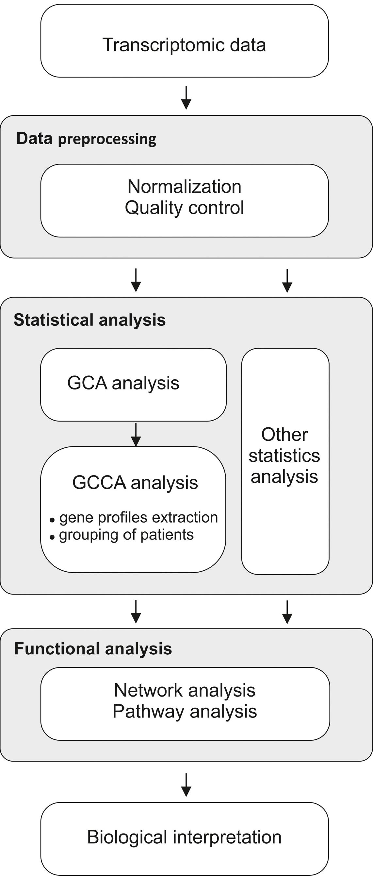
Regularisation and grouping data by GCA method
PLOSONE | https://doi.org/10.1371/journal.pone.0206608 November 1, 2018
3/14

Regularisation and grouping data by GCA method
Fig 1. Data analysis workflow.
https://doi.ora/1Q.1371/journal.pone.Q2Q66Q8.aQQ1
The individual steps of the workflow are described below.
Microarray data. Gene expression data used in the study was publicly available and
deposited at the NIH Gene Expression Omnibus (GEO) National Center for Biotechnology
Information. The accession number of the source of data: GSE2658. The data concerned the
U133 Plus 2.0 Affymetrix oligonucleotide microarray data from 256 newly diagnosed MM
patients undergoing total therapy 2 (TT2), provided by the Donna D. And Donald M. Lambert
Laboratory of Myeloma Genetics, the University of Arkansas for Medical Sciences, Little Rock,
AR, USA [10]. The data set of 559 myeloma patients (GSE2658) is composed of a patient
enrolled in two different therapies, total therapy 2 (TT2) and total therapy 3 (TT3). The micro-
array analysis was performed on malignant plasma cells at diagnosis of the disease and in con-
sequence the gene expression profile analysed in the manuscript is not influenced by any kind
of therapy. Thus, there is no difference in the expression profile between TT2 and TT3 group
at starting point but the differences are expected once the treatment has been completed. Tak-
ing into consideration that the relation between particular expression profile and the clinical
parameters as overall survival and progression free survival needs to be analysed separately for
TT2 and TT3 group, the one of two groups, exactly the TT2, has been selected for analysis.
Pre-processing data. For background correction and normalisation of gene expression
data the limma library [11] for the R, environment was used [12] [13]. To reduce the variability
of log-ratios for low-intensity spots the ’normexp’ background correction method was used,
while to preserve comparability of distributions across samples the ‘quantile’ normalisation
method was applied.
Statistical analysis: Grade Correspondence Analysis (GCA) and Grade Correspon-
dence-Cluster Analysis (GCCA). Data analysis proceeded with the use of the Grade Corre-
spondence Analysis algorithm (GCA), which seeks regularities in data matrices and identifies
correspondences between their rows and/or columns [14].
The GCA algorithm accepts a data matrix consisting of n rows (patients), each of which
comprises k normalized nonnegative values (columns) which correspond to individual genes.
This input is transformed into a matrix with dimensions n*k which can be formally treated as
a probability matrix Pn»k = [p^] for a two-dimensional distribution. Quantification of measure
(3) yields, for each unit square, a nonnegative function called grade density. Subsequently,
GCA iteratively permutates rows and columns in order to maximize either Kendall’s tau or
Spearman’s rho, arranging them in such a way as to ensure that similar rows and/or columns
are proximate to each other. For the bigger n*k tables permutations randomly rows and col-
umns and reorders them to achieve a local maximum of the tau-Kendall (tau) or rho-Spear-
man (rho) coefficients is time-consuming and computationally demanding. In that cases, to
reach a global maximum of tau or rho within a reasonable time, simulations are used, e.g.
Monte Carlo. In effect, GCA uncovers regularities and monotonicity present in the input
matrix, revealing hidden trends.
When the data structure is irregular and contains no strong monotonic dependencies, out-
lier detection may be applied to single out disruptive elements and subsequently identify regu-
lar subsets referred to as layers.
The subsequent phase, called Grade Correspondence-Cluster Analysis (GCCA), involves
decomposition of each regular data layer produced by GCA into more uniform subsets. At this
point, segmentation becomes bidirectional and yields segments consisting of successive, adja-
cent cases (rows or records) as well as variables (columns). The number of clusters is arbitrarily
defined. Clusters are formed by variance coefficients, maximising the variance between each
PLOSONE | https://doi.org/10.1371/journal.pone.0206608 November 1, 2018
4/14


Regularisation and grouping data by GCA method
pair of groups, i.e. between objects formed by aggregating all elements which comprise each
cluster. The target number of clusters is determined by commonly used scree plots.
The data can be graphically represented as a heatmap.
Grade Correspondence-Cluster Analysis also enables a reduction in data volume by aggre-
gating adjacent rows and columns within each cluster, or by singling out representative cases
for each cluster.
Grade analysis is based on the so-called grade transformation [14] defined for the cumula-
tive distribution function F of a random variable X as follows (I):
F*(u, x)
1
u — F(x-)
F(x-) - F(x-) '
if F(x-) < u,
if F(x-) < u < F(x-
if F(x-) > u
(1)
0
u e [0,1], x e R
Where F(x+) is the right-handed limit while G(x-) is the left-handed limit of F at point x.
The grade transformation is, therefore, the only transformation of a random function
through F which is independent of distribution type. It results in a uniform distribution over
the unit range, i.e. F*(u) = u; u belongs to [0,1].
Assuming that the cumulative distribution function H(x,y) describes the joint distribution
of the random vector H(X,Y); F(x) and G(y) are distribution functions which correspond to
edge distributions X and Y; while F*(u,x) and G(v,y) are their corresponding grade transfor-
mations; the grade transformation of the cumulative distribution function H(2), given as
H*(u v) = Ur2 F*(u; v)G*(v; y)dH(x; y); (2)
u, v e [0,1], x, y e R
Maps H onto an unambiguous two-dimensional copula H* referred to as the grade distri-
bution (X,Y). Wherever the edge distribution functions F and G remain continuous this cop-
ula coincides with Sklar’s copula. [15].
The edge distributions for copulas are monotonous over the [0,1] range. The grade distribu-
tion is continuous; the grade density of vector (X,Y) is defined as the distribution density of its
corresponding column. Coefficients which result from applying the aforementioned transfor-
mation to vector parameters are also referred to as grade coefficients.
When the distribution of (X,Y) is discrete, with a probability matrix Pn*k
Pn*k = (Pij), i = 1, 2,... n, j = 1, 2,... k
grade density can be defined as follows (3):
h*(u, v)= ppp., (u, v) e Rij, Rij = ft- 1, S) * [j 1, T) (3)
Where Sj = pk+ +pk, Tj = p.x+ +p.j, S0 = T0 = 0, i = 1,... n, j = 1,... k
P: = S1kPi,j Pj = S1nPi,j
is the density of the two-dimensional distribution with monotonous edges, uniform over each
rectangular region Rij which belongs to the unit square.
PLOSONE | https://doi.org/10.1371/joumal.pone.0206608 November 1, 2018
5/14


Regularisation and grouping data by GCA method
When X and Yare independent, p^ = p^p.j, grade density becomes equal to 1. Accordingly,
grade density at point (u,v) may be interpreted as the measure of local overrepresentation of
the distribution corresponding to pair (X,Y) with respect to the independent distribution
(sharing the same edge values). Charting the grade density for the unit square, using color-
coded values, results in the so-called overrepresentation map. Overrepresentation may adopt
any nonnegative value; however, values from the [0,1) range are sometimes referred to as
underrepresentation.
An important example of a parameter which is invariant to the (X,Y) grade transformation
is the grade correlation coefficient, also known as Spearman’s rho: it directly maps to the grade
distribution correlation coefficient (Spearman’s correlation coefficient for the copula) while
retaining its value. Spearman’s rho is one of the nonparametric measures of a monotonic rela-
tionship between random variables.
For probability matrix Pn»k this coefficient is given by (4):
p*(P**k) = (s,_ 1 + Si - i)(j! + t i)py (4)
j=i i=i
Where p^, p,j, Sj and Tj are defined as above.
Another measure of the monotonic relationship between random variables which is invari-
ant to the grade transformation is Kendall’s tau coefficient, which, for an arbitrary probability
matrix Pn*k, can be expressed as (5):
t(Pn*k) = £ X0 X0(pljp’s - PrjPis) (5)
r=2 i=1 s=2 j=1
Both rho (6) and tau (7) may also be expressed as measures ofvariance of rows (or col-
umns) in probability matrix Pn*k in the following manner [7]:
_ n r-1
P*(Pn*k) = ^ J2(Sr + Sr-1 ~ Si + Si- 1)Pi*Pr*ar(r : i) (6)
r=2 i=1
_ ,, r—1
(PnJ = 2^ J2P>*Pr*ar(r : 0 (7)
r=2 i=1
Where ar(r:i) is the value of the vector variance coefficient:
P^,p^-,...,prn) and (^pi2,... ,
Pr* PrJ \Pi* Pi* Pi,
and is defined as (8):

k X\ (PuPrs - PrjPis)
ar(r : i) = ££ p "W
s=2 j=1 rr*F i*
Monotonic regularity is expressed by the so-called regularity index [16] (9):
t
max(p) /r\\

reg = p (9)
tabs(P)
PLOSONE | https://doi.org/10.1371/journal.pone.0206608 November 1, 2018
6/14

Regularisation and grouping data by GCA method
Where tau max is the peak value of t over all possible permutations of rows and columns
from Pn*k, while tau abs (10) is defined as:
^ n r-1 ^ k s-1
tabs(Pn*k) = ^ J2\P>)Prs ~ PrjPis\ (10)
r=2 i=1 s=2 j=1
and describes the total variance for all columns and rows in Pn.k
This measure is also invariant to cupola transformation.
The basic tool of grade analysis is the GCA (Grade Correspondence Analysis) algorithm,
which attempts to maximise regularity within a data matrix and also identify the strongest cor-
relations between its rows and columns.
Functional analysis. To analyse and visualise the gene terms for large clusters of genes in
a functionally grouped network the ClueGo (Cytoscape plug-in) was used [17]. The ClueGo
improve biological interpretation of large lists of UP and DOWN regulated genes. It has imple-
mented enrichment tests based on the hypergeometric distribution with Benjamini-Hochberg
correction for multiple testing.
Comparision of GCA versus CUR and random results. The GCA results were compared
with an additional way of analysis of gene expression and discriminant gene selection which
was the CUR-based matrix decompositions method implemented in the rCUR package [18].
Based on the CUR methodology [19], 10% the probes being the of the whole dataset were iden-
tified (k = 4) (rCUR results). Then this subset was sorted by the GCA method and clustered
for 6 clusters in a similar way to the whole original dataset. The rCUR results were compared
to the original data. The GCA results were also compared with the randomly selected probes
divided into six clusters.

Results and discussion

Grade Correspondence Analysis (GCA) results
By maximising the Rho gradation correlation, the GCA algorithms “sorts” the rows and col-
umns of the input matrix. As a result, regular distribution of gene expression profiles (columns
representing probes) for individual patients (rows) is obtained (Fig 2). This ordering is such
that the “trend structure” shows up as darker shading running from the top left to the bottom
right corner, concentrating at these opposite corners. It reveals dependencies whose strength is
measured by global differentiation (peak value of the “rho” coefficient for the input dataset).
The overrepresentation map is composed of 256 horizontal rows where each row represents a
patient. 54 677 columns correspond to 54 677 variables (genes).
The value range is represented by shading. Darker areas mean “higher than expected” val-
ues in the expression matrix. In the presented case, the overrepresentation map obtained after
using the GCA algorithm indicates a higher number of transcripts genes (columns) in areas
marked by intense shading, and a lower number of transcripts in relation to the expected value
in lightly shaded areas (Fig 2B). It can be seen that in some patients the expression of certain
genes is stronger than in other patients.

Grade Correspondence-Cluster analysis (GCCA)
To distinguish groups of patients, with the most extreme differences in gene expression pro-
files, cluster analysis was performed using the GCCA method. The group of patients was
divided into six clusters. Similarly, in the case of genes, to differentiate groups of genes with a
similar level of expression, they were also divided into six clusters (Fig 3A).
PLOSONE | https://doi.org/10.1371/journal.pone.0206608 November 1, 2018
7/14
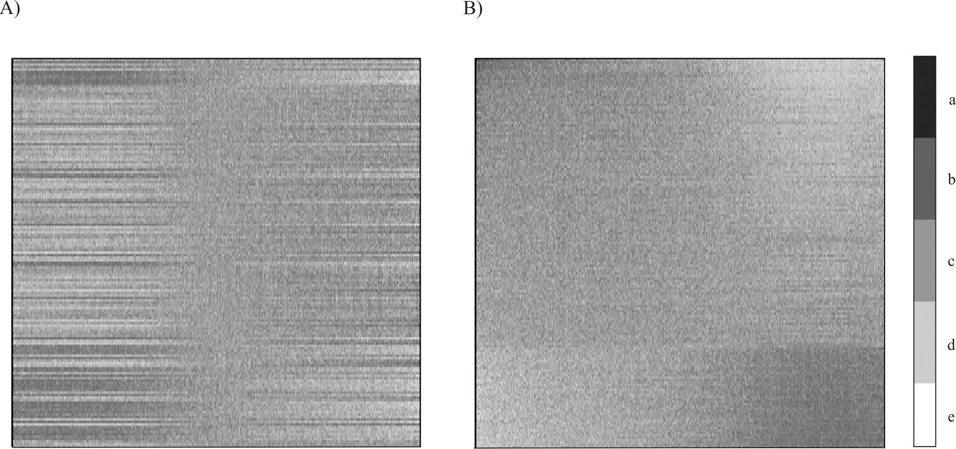
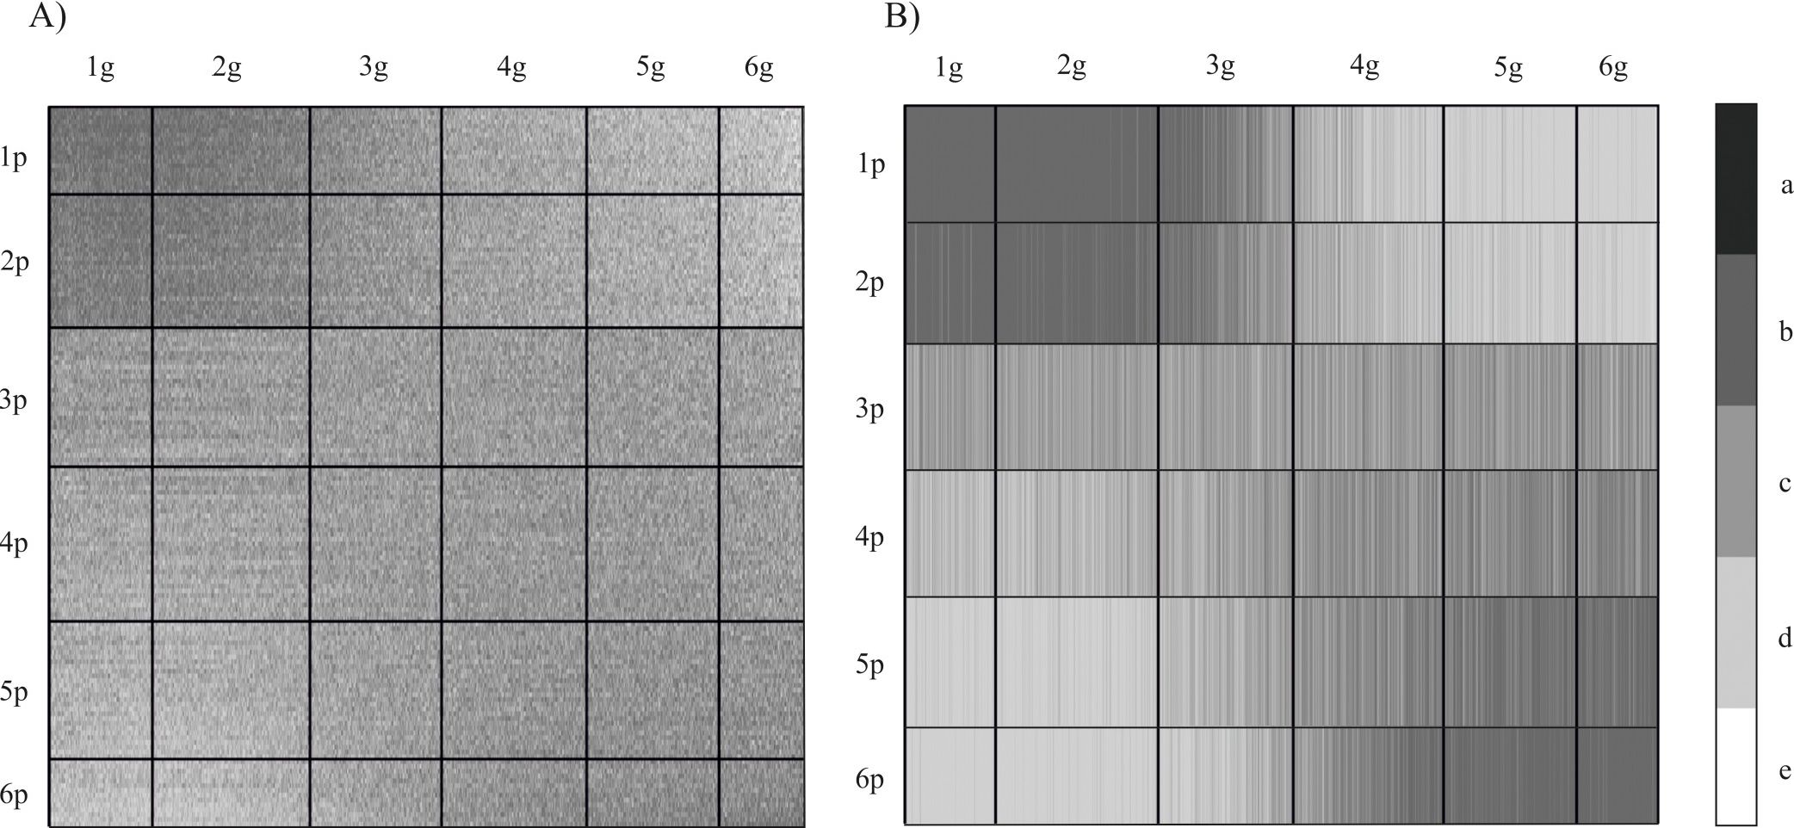
Regularisation and grouping data by GCA method
Fig 2. Gene expression maps for 54 677 probes in columns (genes) and 256 patients (rows). A) raw data distribution, before applying GCA; B)
overrepresentation map revealing the dominant trend after GCA has been applied. Specific values are represented by shades of grey (with darker shades
corresponding to greater values). The lighter the shading (d,e), the closer the value is to 0; the darker the shading (a,b), the greater the ratio; c-ideal
representation.
https://doi.org/10.1371/journal.pone.0206608.g002
The data presented in Fig 3A is divided into six cluster groups, both horizontally (rows)
and vertically (columns). These variable clusters are a permutation of the 54 677 columns rep-
resenting genes (probes) and 256 rows previously ordered by GCA. As clusters are formed by
Fig 3. Overrepresentation maps of gene expression after GCCA A) clustering previously ordered data in rows and columns on six groups B) aggregation
data in row clusters by median; bold vertical bars separate gene clusters (1p-6p); bold horizontal lines separate patient clusters (1g-6g). The lighter the
shading (d,e), the closer the value is to 0; the darker the shading (a,b), the greater the ratio c-ideal representation.
https://doi.org/10.1371/journal.pone.0206608.g003
PLOSONE | https://doi.org/10.1371/journal.pone.0206608 November 1, 2018
8/14
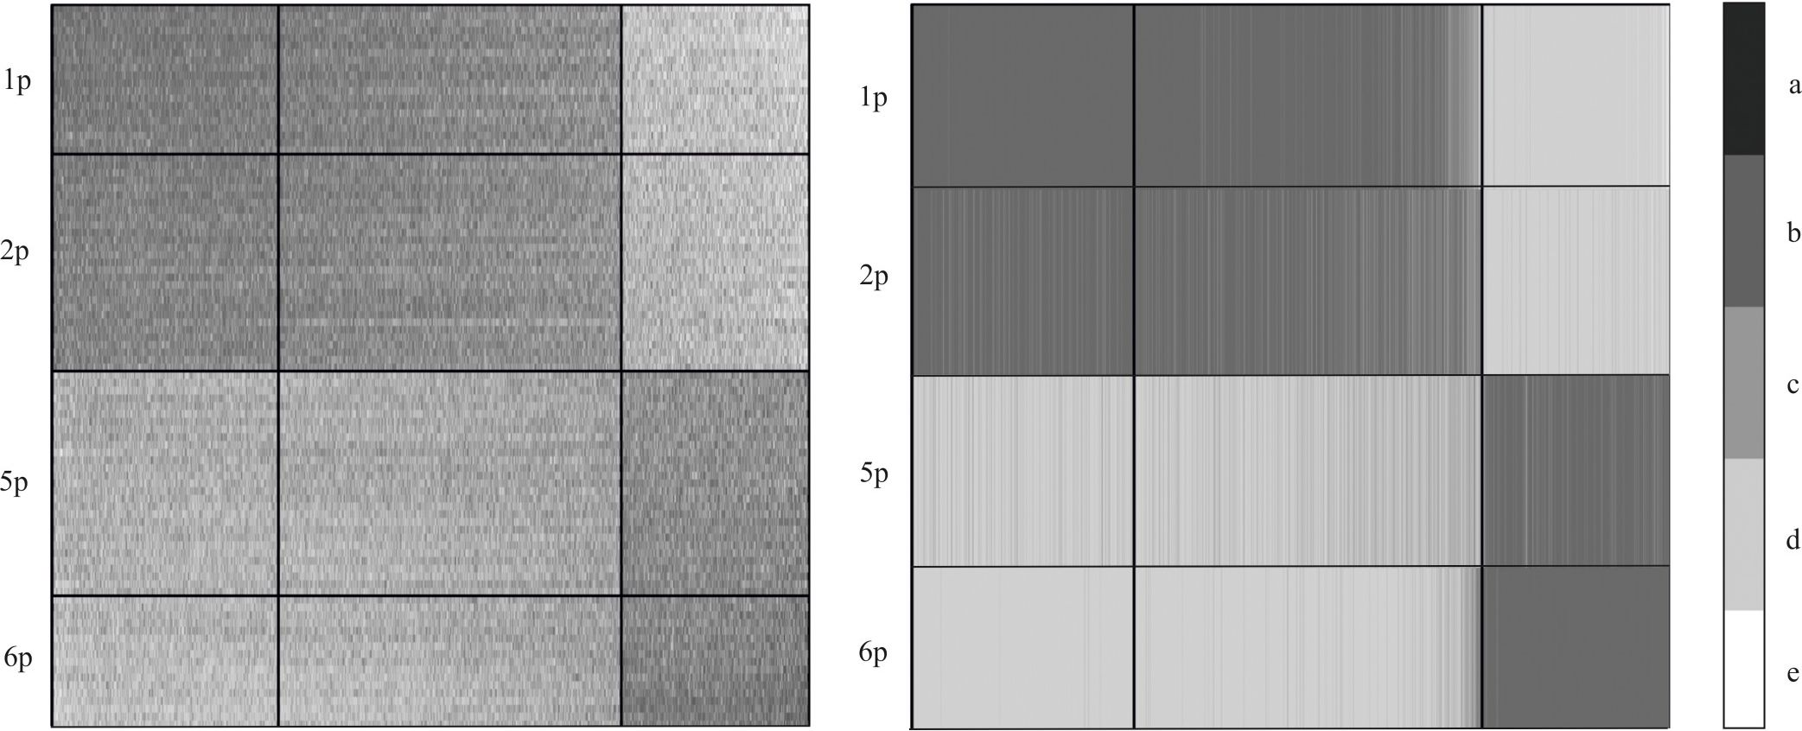

Regularisation and grouping data by GCA method
computing variance coefficients and maximizing the variance between each pair of clusters,
the resulting width of each cluster may vary.
In the next step, a median value was calculated for each cluster (Fig 3B). This approach
increases the readability of the obtained result. Our focus then shifted to those representations
for which the observed differences were the largest, i.e. they contained the level of the most dif-
ferentiating genes expression. Visualization of data after GCCA revealed groups of patients
(rows) whose expression profiles significantly differed from the expected values, i.e. they were
significantly higher or lower (clusters 1/2 and 5/6 respectively). The clusters of genes (in col-
umns) reveal genes whose expression was either higher or lower (clusters 1/2 and 6 respec-
tively) depending on the group of patients (Fig 3B). Hence, the further analysis focused on
patient clusters 1, 2 and 5, 6, while the central rows 3 and 4 were omitted (Fig 4). Gene clusters
3, 4 and 5 (columns) were similarly omitted, leaving only the strongly differentiated clusters 1,
2 and 6 (Fig 4).
Properties of over- or underexpressed genes. Gene expression among patients with Mul-
tiple Myeloma is not very diverse (expression profiles are similar). However, the results of
GCA sorting allowed us to distinguish two groups of patients with slightly different profiles:
the group represented by clusters 1 and 2, and another group consisting of clusters 5 and 6
(Fig 4).
To present quantitative differences in the level of gene expression in the selected groups of
patients, differential analysis of genes was performed. We calculated the relative difference in
the expression of individual genes in clusters 1 and 2 compared to clusters 5 and 6. Genes for
which the difference factor was lower than 1.3 were omitted in the further analysis under the
assumption that they do not have a qualitative impact on the phenotype of the analysed
patients. Consequently, we focused on those genes whose expression was the most diverse (dif-
fering by a factor of at least 1.3). In the following step, we analysed the processes in which
those genes are involved. For the underexpressed genes, statistically significant involvement
(p<0.05) was reported for the following processes (Fig 5A):
• regulation of systemic arterial blood pressure by renin-angiotensin
'g 2g 6g lg 2g 6g
Fig 4. Overrepresentation map showing the most diverse clusters of genes (columns- 1g, 2g and 6g) and patients (rows aggregated by median- 1p,
2p, 5p and 6p). The lighter the shading (d,e), the closer the value is to 0; the darker the shading (a,b), the greater the ratio c-ideal representation.
https://doi.ora/10.1371/journal.pone.0206608.a004
PLOSONE | https://doi.org/10.1371/joumal.pone.0206608 November 1, 2018
9/14
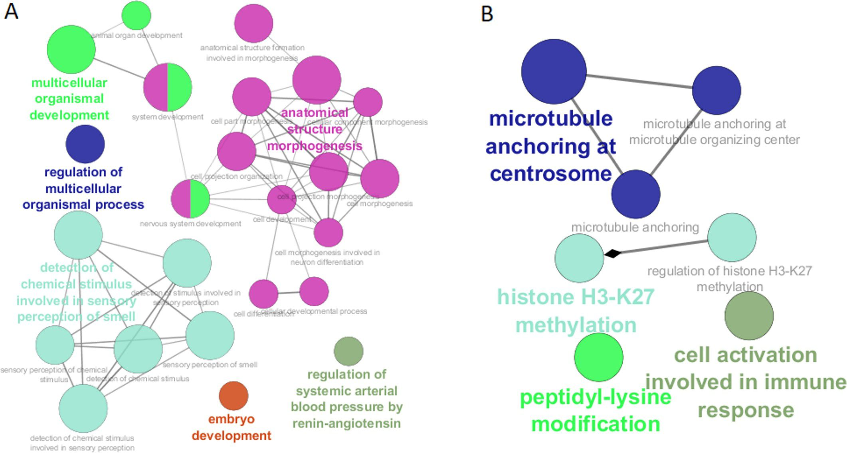
Regularisation and grouping data by GCA method
Fig 5. Biological processes affected by gene expression differences between both study groups of patients. A) underexpressed genes; B) overexpressed
genes.
https://doi.org/10.1371/journal.pone.0206608.a005
- embryo development
- morphogenesis of anatomical structures
- detection of chemical stimulus involved in sensory perception of smell
- multicellular organismal development
- regulation of the multicellular organismal process
In contrast, overexpressed genes were found to participate in the following processes (Fig
5B):
- microtubule anchoring at the centrosome
- histone H3-K27 methylation
- cell activation involved in immune response
- peptidyl-lysine modification
It is important to note that the processes in which differentiated genes are involved may be
important for the progression of multiple myeloma. For example, genes whose protein prod-
ucts are associated with embryonic development undergo incorrect regulation during the
development of myeloma, thus contributing to the progression of this cancer [20]. Particularly
noteworthy is the renin-angiotensin system, which in classical terms is responsible for pressure
regulation [21]. However, recent studies indicate that deregulation of the renin-angiotensin
system is observed in some diseases, including cancer [22]. Changes in the expression of genes
PLOSONE | https://doi.org/10.1371/journal.pone.0206608 November 1, 2018
10/14

Regularisation and grouping data by GCA method
related to the renin-angiotensin system are observed in parental tumour cells, which indicate
their importance in the process of carcinogenesis [23]. Among the overexpressed genes, a group
associated with the centrosome was demonstrated. This may be important for the prognosis for
multiple myeloma since previous studies have shown that the expression of genes associated
with centrosomes is an independent predictor of myeloma patients [24]. The lysine 27 methyla-
tion process in histone 3 is a modification associated with gene repression and plays a key role
in regulation that ensures a balance between differentiation and proliferation [25]. Accordingly,
any aberrations associated with methylation of lysine 27 in histone 3 may translate into func-
tional changes of myeloma cells, leading to the progression of this cancer. Based on these few
examples, it can be seen that the processes which involve the differentiated genes are important
in the development of myeloma, and that this knowledge may lead to therapies which target
intensified or inhibited processes for specific groups of patients, as appropriate.
Comparison of GCA versus CUR matrix decompositions and random results. To eval-
uate the GCA method described in the manuscript, the results obtained by the GCA method
were compared with the alternative method, i.e. CUR decomposition matrix and with a ran-
dom data set. For this purpose, based on the CUR methodology, a subset of samples (genes)
being representants of the original set was generated (k = 4). A random subset of samples
(genes) was independently generated.
The subsets were grouped by the GCA method on six clusters (similarly to the original set)
and then compared the overlapping samples (genes) in clusters.
The results were in the range of 72% -86% of compatibility of samples in clusters depending
on the cluster for GCA and rCUR results. GCA results in comparison to CUR results for clus-
ters 1 and 6 (from UP and DOWN regulated genes) showed compliance at the level of nearly
82% (Fig 6). In the case of the comparison of GCA results with the randomly selected samples
(genes), compatibility was in the range of 43%-52%. For Cluster 1 and 6, the result was 52.9%
compatibility and 47.1% non-compatibility (Fig 6).
Without penetrating the biological interpretation of the obtained results it was carried out
analyzes on various data sets. Similar results of the method’s effectiveness were obtained. In
the case of data from the GDS2771 (Large airway epithelial cancer from suspect lung cancer)
experiment, that the sorting of cancer data for GCA vs rCUR gives nearly 86% similar results
while the case of GCA vs randomly "sorted" received compliance level: 46%. Based on a set
derived from the GDS4337 (Type 2 diabetic and hyperglycemic pancreatic islets) experiment,
narrowing the analysis to non-diabetic patients, the similarity of the obtained results: GCA vs
rCUR -> 84%; GCA vs random -> 51%

Conclusion
The Grade Correspondence Analysis method is an example of such an approach to an analysis
of gene expression, which includes all probes and treats them independently. In gene expres-
sion microarray studies, hundreds of thousands of probe expressions are measured for a large
number of samples. Not every probe for a particular gene gives a proportional result. Some
probes show that a given gene has a higher expression, other lower. In a typical research meth-
odology, the result for individual genes is the averaging of results obtained for all probes of a
given gene. The publication of studies with dissimilar or contradictory results has raised con-
cerns about the reliability of this way of analysis.
The Grade Correspondence Analysis is a method that can be overcome this problem. Itis
an exploratory method which reveals hidden information by sorting all probes and all patients.
By computing overrepresentation coefficients, the presented method can reveal the degree of
discordance between the expected and observed values, assuming that the distribution remains
PLOSONE | https://doi.org/10.1371/journal.pone.0206608 November 1, 2018
11/14
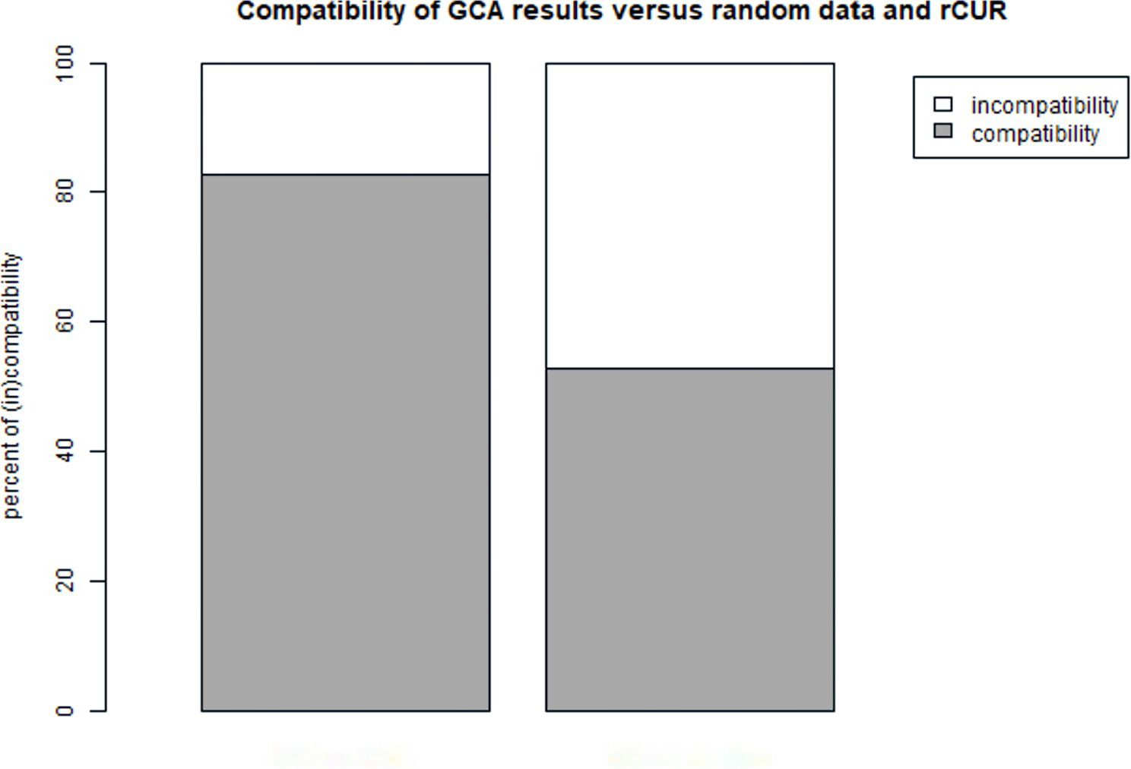

Régularisation and grouping data by GCA method
GCAvsrCUR GCA vs random
Fig 6. Comparison of GCA versus CUR matrix decompositions and random results.
https://doi.org/10.1371/journal.pone.0206608.g006
perfectly proportional. The ordering of columns may be thought of as a representation of their
relative “importance” for the structure of the data. Edge cases (located on either side of the
sorted matrix) are more strongly indicative of the observed trends than items in the middle.
Based on the Multiple Myeloma example it was shown how to distinguish groups of patients
and sets of probes (being representatives of genes), to identify particularly interesting patients
and genes that can be used as a starting point for further studies.
GCA and GCCA can be used as an alternative to popular data grouping methods [26] [27],
e.g. gene expression profiles. Processing data with the GCA algorithm may provide an impor-
tant step in the analysis of various biological processes. GCA results integrated with another
biological data (e.g. biochemical pathways, protein interactions, gene signatures) [28] [29] [26]
may constitute a valuable tool in the analysis of the interesting processes. The Grade Corre-
spondence Analysis may be used to regularize and sort matrices including large -omics arrays
(not only transcriptomics data).
In the case of large data resources (including large -omics arrays), to maintain a maximum
amount of information, GCA method used to regularize and sort matrices seems to be a useful
tool for analysis.

Author Contributions
Conceptualization: Monika Piwowar.
Data curation: Kinga A. Kocemba-Pilarczyk.
Formal analysis: Monika Piwowar, Piotr Piwowar.
Investigation: Monika Piwowar.
Methodology: Monika Piwowar.
Validation: Kinga A. Kocemba-Pilarczyk, Piotr Piwowar.
PLOSONE | https://doi.org/10.1371/iournal.pone.0206608 November 1, 2018
12/14
Régularisation and grouping data by GCA method
Writing - original draft: Monika Piwowar, Kinga A. Kocemba-Pilarczyk.

References
- Binder H, Blettner M. Big data in medical science—a biostatistical view. Dtsch Arztebl Int. 2015; 112:
137-42. https://doi.org/10.3238/arztebl.2015.0137 PMID: 25797506
- Piwowar M, Jurkowski W. ONION: Functional Approach for Integration of Lipidomics and Transcrip-
tomics Data. PLoS One. 2015; 10: e0128854. https://doi.org/10.1371/journal.pone.0128854 PMID:
26053255
- Bellazzi R, DiomidousM, Sarkar IN, Takabayashi K, Ziegler A, McCray AT. Data analysis and data min-
ing: current issues in biomedical informatics. Methods Inf Med. NIH Public Access; 2011; 50: 536-44.
https://doi.org/10.3414/ME11-06-0002 PMID: 22146916
- Cruz-Cano R, Lee M-LT. Fast regularized canonical correlation analysis. Comput Stat Data Anal. Else-
vier; 2014; 70: 88-100. Available: http://econpapers.repec.org/RePEc:eee:csdana:v:70:y:2014:i:c:
p:88-100
- Munoz-Torres PM, Rokć F, Beluzic R, Grbesa I, VugrekO. msBiodat analysis tool, big data analysis for
high-throughput experiments. BioData Min. 2016; 9: 26. https://doi.org/10.1186/s13040-016-0104-6
PMID: 27547241
- Waller T, GubałaT, Sarapata K, Piwowar M, Jurkowski W. DNA microarray integromics analysis plat-
form. BioData Min. 2015; 8: 18. https://doi.org/10.1186/s13040-015-0052-6 PMID: 26110022
- Kowalczyk T, Pleszczyńska E, Ruland F. Grade models and methods for data analysis: with applica-
tions for the analysis of data population. Springer; 2004.
- Szczesny W, KowalczykT, Wolińska-Welcz A, Wiech M, Dunicz-Sokołowska, Aldona Grabowska G,
Pleszyńska E. Models and methods of grade data analysis: recent developments [Internet]. Institute of
Computer Science. Polish Academy of Science; 2012. Available: https://www.ksiegarnia-ekonomiczna.
com.pl/modules.php?name=Sklep&plik=lista&nazwa=opis&nr katal=9788363159023&hthost=
1&store id=2
- GrzegorekM. An s-layered Grade Decomposition of Images. Springer, Heidelberg; 2013. pp. 451-
460. https://doi.org/10.1007/978-3-319-00969-8 44
- Hanamura I, Huang Y, Zhan F, Barlogie B, Shaughnessy J. Prognostic value of Cyclin D2 mRNA
expression in newly diagnosed multiple myeloma treated with high-dose chemotherapy and tandem
autologous stem cell transplantations. Leukemia. 2006; 20:1288-1290. https://doi.org/10.1038/sj.leu.
2404253 PMID: 16688228
- Ritchie ME, Phipson B, Wu D, Hu Y, LawCW, Shi W, et al. limma powers differential expression analy-
ses for RNA-sequencing and microarray studies. Nucleic Acids Res. 2015; 43: e47-e47. https://doi.org/
10.1093/nar/gkv007 PMID: 25605792
- Gentleman RC, Carey VJ, Bates DM, Bolstad B, Dettling M, Dudoit S, et al. Bioconductor: open soft-
ware development for computational biology and bioinformatics. Genome Biol. BioMed Central; 2004;
5: R80. https://doi.org/10.1186/gb-2004-5-10-r80 PMID: 15461798
- R Development Core Team. R: a language and environment for statistical computing [Internet]. 2011
[cited 24 Nov 2017]. Available: http://www.r-project.org/
- Szczesny W. On the performance of a discriminant function. J Classif. Springer-Verlag; 1991; 8: 201-
215. https://doi.org/10.1007/BF02616239
- Niewiadomska-bugaj M, Kowalczyk T. Kendall‘s t, Spearman ‘ s p and Gini correlation as functions of
smoothed cdf ‘ s. 2005; 125-137.
- Kowalczyk T. Link between grade measures of dependence and of separability in pairs of conditional
distributions. Stat Probab Lett. 2000; 46: 371-379.
- Bindea G, Mlecnik B, Hackl H, Charoentong P, Tosolini M, Kirilovsky A, et al. ClueGO: a Cytoscape
plug-in to decipher functionally grouped gene ontology and pathway annotation networks. Bioinformat-
ics. Oxford University Press; 2009; 25:1091-3. https://doi.org/10.1093/bioinformatics/btp101 PMID:
19237447
- Bodor A, Csabai I, Mahoney MW, Solymosi N. rCUR: an R package for CUR matrix decomposition.
BMC Bioinformatics. 2012; 13: 103. https://doi.org/10.1186/1471-2105-13-103 PMID: 22594948
- Mahoney MW, Drineas P. CUR matrix decompositions for improved data analysis. Proc Natl Acad Sci
USA. National Academy of Sciences; 2009; 106: 697-702. https://doi.org/10.1073/pnas.0803205106
PMID: 19139392
- Blotta S, Jakubikova J, CalimeriT, RoccaroAM, Amodio N, Azab AK, etal. Canonical and noncanonical
Hedgehog pathway in the pathogenesis of multiple myeloma. Blood. 2012; 120: 5002-5013. https://doi.
org/10.1182/blood-2011 -07-368142 PMID: 22821765
PLOS ONE | https://doi.ora/10.1371/iournal.pone.0206608 November 1, 2018
13/14

Regularisation and grouping data by GCA method
- Hall JE. Control of blood pressure by the renin-angiotensin-aldosterone system. Clin Cardiol. 1991; 14:
IV6-21; discussion IV51-5. Available: http://www.ncbi.nlm.nih.gov/pubmed/1893644 PMID: 1893644
- Pinter M, Jain RK. Targeting the renin-angiotensin system to improve cancer treatment: Implications for
immunotherapy. SciTransl Med. 2017; 9: eaan5616. https://doi.org/10.1126/scitranslmed.aan5616
PMID: 28978752
- Ram RS, Brasch HD, Dunne JC, Davis PF, Tan ST, ItinteangT. Cancer Stem Cells in Moderately Differ-
entiated Lip Squamous Cell Carcinoma Express Components of the Renin-Angiotensin System. Front
Surg. 2017; 4: 30. https://doi.org/10.3389/fsurg.2017.00030 PMID: 28634582
- Kryukov F, Nemec P, Radova L, Kryukova E, Okubote S, Minarik J, et al. Centrosome associated
genes pattern for risk sub-stratification in multiple myeloma. J Transl Med. 2016; 14:150. https://doi.
org/10.1186/s12967-016-0906-9 PMID: 27234807
- Ezponda T, Licht JD. Molecular Pathways: Deregulation of Histone H3 Lysine 27 Methylation in Cancer
—Different Paths, Same Destination. Clin Cancer Res. 2014; 20: 5001-5008. https://doi.org/10.1158/
1078-0432.CCR-13-2499 PMID: 24987060
- Zhan F, Huang Y, Colla S, Stewart JP, Hanamura I, Gupta S, etal. The molecular classification of multi-
ple myeloma. Blood. American Society of Hematology; 2006; 108: 2020-8. https://doi.org/10.1182/
blood-2005-11-013458 PMID: 16728703
- Radich JP, Dai H, MaoM, OehlerV, SchelterJ, DrukerB, etal. Gene expression changes associated
with progression and response in chronic myeloid leukemia. Proc Natl Acad Sci USA. National Acad-
emy of Sciences; 2006; 103: 2794-9. https://doi.org/10.1073/pnas.0510423103 PMID: 16477019
- Chen L, Wang S, Zhou Y, WuX, Entin I, Epstein J, etal. Identification of early growth response protein
1 (EGR-1) as a novel target for JUN-induced apoptosisin multiple myeloma. Blood. 2010; 115: 61-70.
https://doi.org/10.1182/blood-2009-03-210526 PMID: 19837979
- Zhan F, Barlogie B, Arzoumanian V, Huang Y, Williams DR, Hollmig K, et al. Gene-expression signature
of benign monoclonal gammopathy evident in multiple myeloma is linked to good prognosis. Blood.
2007; 109: 1692-1700. https://doi.org/10.1182/blood-2006-07-037077 PMID: 17023574
PLOSONE | https://doi.org/10.1371/journal.pone.0206608 November 1, 2018
14/14

