Tridentate hydrazido-hydrazones vanadium complexes. Synthesis, properties and biological activity
Janusz Szklarzewicza,*, Anna Jurowskaa, Maciej Hodorowicza, Dariusz Matogaa, Ryszard Grybośa,
Barbara Filipekb, Jacek Sapab, Monika Głuch-Lutwinb, Barbara Mordylb, Grzegorz Kazekb
a Jagiellonian University, Faculty of Chemistry, Gronostajowa 2, 30-387 Kraków, Poland
b Jagiellonian University Medical College, Pharmacy, Medyczna 9, 30-001 Kraków, Poland
Article history: Received 7 December 2018 Received in revised form 12 March 2019
Accepted 2 April 2019
Available online 2 April 2019
Abstract
Nine new vanadium complexes, with tridentate Schiff base ligand based on 3,5-di-tert-butyl-
-2-hydroxybenzaldehyde and different hydrazides, are described and characterized. The X-ray crystal structure of complex 8 shows distorted octahedral geometry of vanadium, with ONO ligand in equatorial position. The tridentate Schiff base ligand forms six membered and five-
-membered chelate rings at the V(V) acceptor center, with the corresponding bite angles being 82.97(9)˚ and 74.48(9)˚. The molecules are gathered by means of intermolecular O-HN hy- drogen bond and layered by ππ interactions involving the pyridine and phenolate rings. Such interactions expand the structure along the crystallographic a axis. The complexes were cha- racterized by the elemental analyses, IR, UV-Vis, EPR spectroscopy, cyclic voltammetry, ther- mogravimetry and magnetic susceptibility measurements. The stabilization role of co-ligands is discussed. The cytotoxicity versus HepG2 hepatocytes and inhibition of human recombinant PTP1B was studied.
Keywords: vanadium, complex, Schiff base, structure, hydrazides, biological activity
Introduction
Adverse and toxic effects of vanadium compounds have been observed in numerous preclinical, animal models during studies of pharmacological activity of vanadium compounds, mainly in antidiabetic and antitumor activity tests [14]. Numerous side and toxic effects of vanadium compounds affect most of the systems and organs of the body. This includes the respiratory, digestive and cardiovascular system as well as blood, brain, liver and kid- neys. Vanadium also exhibit reproductive toxicity, influence on developmental processes and have potential to exert teratogenic and carcinogenic activity [15-17]. Several studies on preclinical animal models have provided strong evidence that the toxicity of vanadium compounds is related to several factors including species, dose, route and duration of administration as well as to the nature of the compound [18,19]. Organic vanadium com- pounds were recognised as much safer than inorganic vanadium salts [20] and antidiabetic potency and efficacy as well as tox- icity may be modified by reasonable ligand binding of vanadyl ions [21]. The possibility of modulating the biological effects of vanadium (minimizing toxic effects and preserving the phar- macological activity) by modification the structure of organic
ligands has been demonstrated by number of studies [22-24].
Schiff bases are an important class of ligands both in the medic- inal and pharmaceutical fields. The coordination to vanadium spread the applications to such a biological activity as antibacte- rial, anti-inflammatory, antiviral, antifungal, anticancer and an- tipyretic properties [1-7]. One of the significant role of vanadium was found recently as decreasing the resistance to oncolytic im- munotherapy [8]. On the other hand, chemistry and properties of vanadium complexes with Schiff bases allowed us to study the possible coordination modes of vanadium, stability of its oxida- tion states, role of co-ligands and the stability in solution [9,10]. It has been also shown that vanadium compounds are potent inhibitors of phosphatases, especially protein tyrosine phos- phatases such as PTP1B, TCPTP, PTP-MEG2, SHP-1, SHP-2,
LAR [11-13]. This leads to the modulation of various cellular functions and may be the basis for the therapeutic use of va- nadium compounds in metabolic, neoplastic, inflammatory, neurodegenerative and other diseases. The beneficial effects of vanadium compounds have been observed in studies using cells (including cancer) and in animal studies demonstrating the potential therapeutic efficacy of this group of phosphatase
inhibitors.
*Corresponding author: szklarze@chemia.uj.edu.pl, tel: 48-12-686-2504, fax: 48-12-686-2750
www.stijournal.pl
Sci, Tech. Innov 2019; 4 (1), 9-20

10
Science, Technology and Innovation
Original Research
Materials and Methods
resazurin-based reagent that functions as a cell viability indi- cator by using the reducing power of living cells (mitochondrial enzymes activity) to quantitatively measure the proliferation of cells. Human hepatocytes HepG2 seeded 18-24 hours before ex- periments in 96-well microplate (1x103 in 100 µl DMEM with 10% FBS) were incubated with tested compounds at 37°C and 5% CO2. After 24 hours incubation, 10 μl of PrestoBlue reagent was added to each microplate well and microplate was mixed on orbital shaker. Plates were incubated for 20 minutes and the fluorescence intensity at 560 nm excitation and 590 nm emis- sion was determined using multi-mode microplate reader PO- LARstar Omega (BMG Labtech, Germany). The results were
normalized to the control (cells with solvent only), wherein the intensity of fluorescence was taken as 100%.
Statistical analysis was performed by analysis of variance fol- lowed by the Tukey test for post hoc comparisons using Graph-
Pad Prism 6.0 software (GraphPad Software, USA).
[VO(acac)2], VOSO4aq, 1,10-phenanthroline (phen),
maltol,
acetone, benzhydrazide, nicotinic hydrazide, phenylacetic hy- drazide, 4-chlorobenzhydrazide, 2-hydroxybenzhydrazide, 3-hydroxy-2-naphthoic acid hydrazide, and 3,5-di-tert-bu- tyl-2-hydroxybenzaldehyde (bald) were of analytical grade (Aldrich) and were used as supplied. Ethanol (98%) of phar- maceutical grade was from Polmos and used as supplied. All other solvents were of analytical grade and were used as sup- plied. BaSO4 was of spectroscopic grade (Japan). Bu4NPF6 was synthesized from Bu4NBr and KPF6 by a standard method and recrystallized from acetone [25]. Microanalysis of carbon, hy- drogen and nitrogen were performed using Elementar Vario MI- CRO Cube elemental analyzer. IR spectra were recorded on a Bruker EQUINOX 55 FT-IR spectrophotometer in KBr pellets. The electronic absorption spectra were recorded with Shimad- zu UV-3600 UV-Vis-NIR spectrophotometer equipped with a CPS-240 temperature controller. Diffuse reflectance spectra were measured in BaSO4 pellets with BaSO4 as a reference on Shimadzu 2101PC equipped with an ISR-260 integrating sphere attachment. The magnetic susceptibility measurements were performed on a SHERWOOD SCIENTIFIC magnetic suscep- tibility balance. EPR spectra were recorded on a BRUKER ELEXSYS 500 using 9.419 GHz microwave frequency. Cyclic voltammetry measurements were carried out in DMSO with [Bu4N]PF6 (0.1 M) as the supporting electrolyte, using Pt work- ing and counter and Ag/AgCl as reference electrodes on an AU- TOLAB/PGSTAT 128 N Potentiostat/Galvanostat. E1/2 values were calculated from the average anodic and cathodic peak po- tentials, E1/2 = 0.5(Ea + Ec). The redox potentials were calibrated versus ferrocene (0.440 V versus SHE), which was used as an internal potential standard for measurements in organic solvents to avoid the influence of a liquid junction potential; the final val- ues are reported versus the standard hydrogen electrode (SHE). Assessment of pharmacological activity included in vitro evaluation of PTP1B inhibition by an enzyme-based assay [26]. For determination the ability of tested compounds to inhibition of human recombinant PTP1B previously described method was used [26]. To the solution of the tested compounds on black 384- well microplate wells (PerkinElmer) an equal volume of a test solution of phosphatase 50 ng mL−1 PTP1B (1.5 U ml-1) was added in a reaction buﬀer: 25 mM of 3-(N-morpholino)pro- panesulfonic acid (MOPS), 50 mM NaCl, 1 mM dithiothreitol (DTT) and 0.05% Tween-20, pH 7.0. After 10 minutes, a solution of phosphate 6,8-difluoro-4-methyl (DiFMUP) was added until its final concentration was 0.1 mM. After 20 minutes of incuba- tion at room temperature, the fluorescence intensity (excitation 355 and emission 560 nm) was measured on a multifunctional
plate reader POLARstar Omega (BMG Labtech, Germany). Cytotoxicity assay was performed using PrestoBlue Cell
Viability Reagent (ThermoFisher Scientific), a cell permeable
Synthesis
In Table 1 the ligand notation is shown.
Table 1. Schiff base ligands, formed in situ in reaction between 3,5-di-tert-butyl-2-hydroxybenzaldehyde (bald) and respective hydrazide, notation
Ligand notation
hydrazide
L1
L2 L3
benzhydrazide
2-hydroxybenzhydrazide phenylacetic hydrazide
4-chlorobenzhydrazide
3-hydroxy-2-naphtoic acid hydrazide nicotinic hydrazide
L
L L
4
5
6
[VO(L1)(maltol)]·H2O, 1
The bald (0.351 g, 1.5 mmol) and the benzhydrazide (0.204 g,
1.5 mmol) were dissolved in 33 ml of EtOH under Ar. The mix- ture was refluxed for 10 minutes under argon, next VOSO4aq (0.333 g, 1.5 mmol) was added and mixture was refluxed for 15 minutes. The solution becomes slowly dark. Then 10% from total 0.189 g (1.5 mmol) of maltol was added. After 5 minutes of reflux rest of the maltol was added. The solution becomes dark red. The reflux was then removed and 10% of solvent was evaporated under Ar. At this stage, formation of crystals was observed. The mixture was left for cooling. The formed dark red crystals were filtered off, washed with EtOH and water and dried in air. Yield: 0.540 g, 64 %. MW = 560.51. Anal. Cal- cd. for C28H33N2O7V: C, 60.00; H, 5.93; N, 5.00 %. Found: C, 60.46; H, 5.72; N, 4.95 %. The complex is diamagnetic. FT-IR (KBr, cm-1): 3452 (w,br), 2963 (s), 2863 (w), 1622 (s), 1606 (s), 1591 (s), 1537 (m), 1515 (w), 1493 (w), 1462 (w), 1432 (m), 1349 (s), 1263 (vs), 1202 (s), 930 (m), 849 (m), 696 (s), 651 (w), 591 (w), 544 (w), 612 (s), 476 (m), [V=O] 978 (s). UV-Vis (DMSO):
Sci, Tech. Innov 2019; 4 (1), 9-20
www.stijournal.pl

11
J. Szklarzewicz et al. | Tridentate hydrazido-hydrazones vanadium complexes. Synthesis, properties and biological activity
285, 340, 464 nm, (MeCN) : 285, 340, 460 nm, (MeOH): 272,
326, 400 nm.
(KBr, cm-1): 3470 (w,br), 2951 (vs), 2874 (w), 1650 (vs), 1609 (vs),
1559 (s), 1546 (s), 1528 (s), 1462 (m), 1434 (s), 1391 (m), 1361 (s),
1371 (m), 1266 (s), 1247 (vs), 1205 (m), 1172 (s), 1027 (w), 926
(w), 913 (w), 848 (s), 811 (w), 758 (m), 729 (s), 645 (w), 624 (m),
593 (s), 568 (m), 488 (w), [V=O] 982 (vs). UV-Vis (DMSO): 324,
515 nm, (MeCN) : 253, 277, 507 nm, (EtOH): 272, 324, 511 nm.
[{VO(L2)(EtO)}{V(L2)(EtO)2}(µ-O)], 2
The complex was synthesized by us in 2010 by different method than that described in the literature [27]. The synthesis of the complex was under patent procedure and we could not published the results before 2017. The bald (0.352 g, 1.5 mmol), 2-hydrox- ybenzhydrazide (0.228 g, 1.5 mmol) and EtOH (30 ml) were refluxed for 15 minutes (yellow solution was observed). Then VOSO4aq (0.333 g, 1.5 mmol) was added and mixture was re- fluxed for additional 90 minutes. The solution turned to dark yellow-brown and formation of yellow-brown precipitation was observed. The crystals were filtered off, washed with cold EtOH and dried in air. Yield: 0.554 g, 73 %. MW = 1002.98. Anal. Calcd. for C50H68N4O11V2: C, 59.88; H, 6.83; N, 5.59 %. Found:
C, 60.08; H, 6.68; N, 5.67 %. The complex is diamagnetic. FT-
IR (KBr, cm-1): 3380 (w,br), 2965 (vs), 2862 (w), 1625 (vs), 1558
(m), 1523 (w), 1490 (m), 1463 (w), 1385 (w), 1361 (s), 1309 (w),
1272 (m), 1252 (vs), 1181 (m), 1091 (m), 1055 (s), 920 (m), 903
(m), 853 (m), 753 (s), 730 (m), 690 (w), 637 (m), 621 (m), 566 (w),
468 (w), [V=O] 993 (m), 957 (vs). UV-Vis (DMSO): 340, 416 nm,
(MeCN) : 277, 342, 460 nm, (EtOH): 270, 338, 415 nm.
[VO(L4)(phen)]·2H2O, 5
The bald (0.352 g, 1.5 mmol) and the 4-chlorobenzhydrazide (0.254 g, 1.5 mmol) and EtOH (50 ml) were refluxed for 10 min- utes under Ar. Then [VO(acac)2] (0.394 g, 1.5 mmol) was added. The immediate change of solution colour to dark green and then brown was observed. The mixture was refluxed for 20 minutes and 1,10-phenanthroline (0.276 g, 1.5 mmol), in 10 ml of EtOH, was added. The solution turns to blooded-red. The solution was left for crystallization. The formed crystals were filtered off, washed with EtOH and dried in air. Yield: 0,183 g, 18 %. MW =
668.08. Anal. Calcd. for C34H37ClN4O5V: C, 61.13; H, 5.58; N,
8.39 %. Found: C, 60.67; H, 5.24; N, 7.50 %. The complex is par- amagnetic, µ = 1.48 µB. FT-IR (KBr, cm-1): 3465 (s,br), 2945 (vs), 2863 (w), 1646 (w), 1608 (vs), 1585 (s), 1519 (s), 1490 (s), 1464 (w), 1428 (s), 1386 (m), 1364 (s), 1273 (w), 1252 (m), 1197 (w), 1169 (m), 1142 (w), 1089 (m), 1016 (w), 913 (w), 845 (s), 781 (w), 726 (s), 643 (w), 588 (w), 554 (w), 456 (w), [V=O] 966 (s). UV-Vis (DMSO): 331, 418 nm, (MeCN) : 263, 332, 421 nm, (EtOH): 230,
265, 333, 429 nm.
[VO(L2)2]·EtOH, 3
The bald (0.541 g, 2.3 mmol), 2-hydroxybenzhydrazide (0.351 g,
2.3 mmol) and EtOH (30 ml) were refluxed under Ar for 15 min- utes. Then VOSO4aq (0.513 g, 2.3 mmol) was added and reflux was continued for next 30 minutes. The dark green-brown prod- uct was started to precipitate. The solution was evaporated to ca 10 ml under argon and left for cooling. The precipitate was fil- tered off under argon, washed with deareated acetone and dried under argon. Yield: 0.300 g, 31 %. MW = 845.92. Anal. Calcd. for C46H58N4O8V: C, 65.31; H, 6.91; N, 6.62 %. Found: C, 65.29; H, 6.90; N, 6.41 %. The complex is paramagnetic, µ = 1.34 µB. FT-IR (KBr, cm-1): 3458 (w,br), 2963 (vs), 2869 (w), 1623 (vs), 1589 (vs), 1535 (vs), 1487 (s), 1464 (m), 1426 (w), 1388 (m), 1363 (s), 1304 (w), 1251 (vs), 1180 (m), 1159 (m), 1030 (w), 914 (w), 829 (m), 783 (m), 750 (s), 725 (m), 661 (m), 615 (m), 563 (m), 476 (w), [V=O] 954 (w). UV-Vis (DMSO): 301, 370 nm, (MeCN) : 284, 300, 363 nm, (EtOH): 274, 303, 371 nm.
[VO(L5)(EtO)], 6
The bald (0.352 g, 1.5 mmol) and the 3-hydroxy-2-naphthoic acid hydrazide (0.303 g, 1.5 mmol) were dissolved in 80 ml of EtOH under Ar flow on a magnetic stirrer. The mixture was refluxed for 35 minutes with constant stirring and the temperature was raised to 100 oC. Then VOSO4aq (0.333 g, 1.5 mmol) and 15 ml of EtOH were added and the mixture was refluxed for 180 minutes. After that, the volume of the reaction mixture was concentrated to final volume of ca. 20 ml and cooled to the room temperature. The black powder started to precipitate from dark brown solu- tion. The precipitate was filtered off, washed with ethanol and dried in air. Yield: 0.614 g, 77 %. MW = 528.51. Anal. Calcd. for C28H33N2O5V: C, 63.63; H, 6.29; N, 5.30 %. Found: C, 63.85; H,
6.23; N, 5.32 %. The complex is diamagnetic. FT-IR (KBr, cm-1):
3465 (w,br), 2963 (vs), 2863 (w), 1642 (s), 1602 (s), 1575 (m), 1554
(s), 1523 (vs), 1470 (s), 1431 (w), 1390 (w), 1363 (m), 1342 (m),
1301 (s), 1270 (w), 1242 (m), 1215 (m), 1181 (m), 1147 (m), 1091
(m), 1053 (vs), 997 (vs), 929 (m), 904 (m), 873 (m), 854 (m), 756
(m), 747 (m), 707 (w), 656 (w), 642 (m), 619 (m), 569 (w), 552 (w), 473 (w), [V=O] 951 (w). UV-Vis (DMSO): 334, 423 nm, (MeCN)
: 226, 261, 326, 415 nm, (EtOH): 226, 269, 318, 417 nm.
[VO(L3)(bald)], 4
The bald (0.353 g, 1.5 mmol) and the phenylacetic hydrazide (0.227 g, 1.5 mmol) in 50 ml of EtOH were refluxed for 10 min- utes under Ar. Then [VO(acac)2] (0.398, 1.5 mmol) was added and mixture was refluxed for 38 minutes giving very dark yellow transparent solution. This was then evaporated to ca. 20 ml and left aside for crystallization. The next day black powder product was filtered off. Yield: 0.170 g, 34 %. MW = 665.76. Anal. Cal- cd. for C38H50N2O5V: C, C, 68.55; H, 7.57; N, 4.21 % Found: C,
68.35; H, 7.39; N, 4.38 %. The complex is diamagnetic. FT-IR
[VO(L6)H2O], 7
a) The bald (0.469 g, 2.0 mmol) and the nicotinic hydrazide (0.274 g, 2.0 mmol) in 40 ml of EtOH were refluxed for 15
www.stijournal.pl
Sci, Tech. Innov 2019; 4 (1), 9-20

12
Science, Technology and Innovation
Original Research
minutes under Ar. Then the VOSO4aq (0.442 g, 2.9 mmol) was added. The reflux was continued for 25 minutes under Ar. The red compound was filtered off, washed several times with ethanol and dried in air. Yield: 0.134 g, 15 %. MW = 436.4. Anal. Calcd for C21H27N3O4V: C, 57.80; H, 6.24; N, 9.63 %.
Found: C, 57.28; H, 5.84; N, 9.53 %. The complex is paramag-
netic, µ = 1.20 µB.
b) The bald (0.703 g, 3.0 mmol) and the nicotinic hydrazide (0.411 g, 3.0 mmol) in 50 ml of EtOH were refluxed for 14 minutes under Ar. Then the [VO(acac)2] (0.795 g, 3.0 mmol) was added. The reflux was continued for 48 minutes under Ar. The brown compound was filtered off, washed several
times with ethanol and dried in room temperature. Yield:
1536 (vs), 1464 (m), 1429 (vs), 1388 (w), 1363 (s), 1311 (w), 1284
(w), 1249 (w), 1232 (w), 1199 (w), 1174 (s), 1106 (w), 1027 (s), 845
(s), 784 (w), 770 (w), 727 (vs), 644 (w), 624 (w), 580 (m), 545 (w),
481 (w), [V=O] 962 (s). UV-Vis (DMSO): 334, 428 nm, (MeCN)
: 226, 287, 342, 442 nm, (EtOH): 226, 268, 337, 445 nm.
[VO(L2)(maltol)], 10 and [VO(L3)(bpy)]·MeOH, 11
The syntheses and physicochemical characterization of the 10 and 11 complexes were described and discussed in [28]. In this paper we present the pharmacological activity of these com- pounds.
Crystallographic data collection and structure
refinement
0.262 g, 20%. MW = 436.4. Anal. Calc. for C H N O V: C,
21 27 3 4
57.80; H, 6.24; N, 9.63 %. Found: C, 57.22; H, 5.72; N, 10.02
%. The complex is paramagnetic, µ = 1.20 µB. FT-IR (KBr,
cm-1): 3435 (w,br), 2951 (vs), 2863 (w), 1615 (vs), 1533 (s), 1482
(w), 1463 (w), 1433 (m), 1388 (w), 1362 (s), 1299 (w), 1274
(w), 1251 (m), 1198 (m), 1177 (m), 1060 (w), 922 (w), 880 (s),
838 (w), 779 (w), 756 (w), 725 (m), 695 (w), 549 (w), 480 (w),
[V=O] 998 (w). UV-Vis (DMSO): 332, 420 nm, (EtOH) : 259,
337, 457 nm.
Crystal data, data collection and structure refinement details are summarized in Table 2. Positions of all of non-hydrogen at- oms were determined by direct methods using SHELXT2017 [29]. All non-hydrogen atoms were refined anisotropically using weighted full-matrix least-squares on F2. Refinement and fur- ther calculations were carried out using SHELXL2017 [30]. All hydrogen atoms joined to carbon atoms were positioned with an idealized geometries and refined using a riding model with Uiso(H) fixed at 1.5 Ueq of C for methyl groups and 1.2 Ueq of C
for other groups.
[VO(L6)(EtO)(EtOH)], 8
The bald (0.469 g, 2.0 mmol) and the nicotinic hydrazide (0.274 g, 2.0 mmol) in 60 ml of EtOH were refluxed for 15 minutes under Ar. Then the VOSO4aq (0.442 g, 2.9 mmol) was added. The reflux was continued for 90 minutes under Ar. The mixture was left for crystallization. After one day the brown crystals precipitated and crystals were filtered off, washed several times with ethanol and dried in room temperature Yield: 0.400 g, 39%. MW = 509.5. Anal. Calcd for C25H36N3O5V: C, 58.93; H, 7.12;
N, 8.25 %. Found: C, 58.40; H, 6.97; N, 8.16 %. The complex is
diamagnetic. FT-IR (KBr, cm-1): 3435 (w,br), 3104 (w,br), 2963
(vs), 2856 (m), 1610 (vs), 1583 (m), 1555 (s), 1518 (s), 1466 (w),
1434 (s), 1407 (m), 1379 (s), 1362 (s), 1348 (s), 1273 (m), 1251 (m),
1209 (w), 1181 (m), 1149 (w), 1088 (s), 1052 (vs), 915 (s), 876 (w),
848 (m), 770 (w), 755 (w), 720 (m), 702 (w), 644 (m), 620 (w), 593
(m), 563 (m) 480 (w), [V=O] 976 (vs). UV-Vis (DMSO): 331, 422
nm, (MeCN) : 241, 330, 417 nm, (EtOH): 333, 419 nm.
Results and Discussion
The Schiff base formed in situ in EtOH solution reacts with the appropriate vanadium substrate, yielding the complexes 1-9. We used two different V(IV) sources – [VO(acac)2] or VOSO4aq and it was found that the product formula does not depend on substrate, as shown in synthesis of 7. But in some cases, the sol- ubility of VOSO4 is low in EtOH, resulting in formation of un- dissolved substrate, which can contaminates the product. Thus the time of reflux had to be carefully controlled. As the ligand Ln (n = 1-6) is tridentate, the complex needs a co-ligand to fill the coordination sphere. When additional co-ligand is not add- ed, vanadium coordinates or solvent molecule (as in case of 2, 6-8) or ligand Ln (complex 3) or its components (complex 4). The coordination of solvent molecule results in redox instability of the product and the oxidation to V(V) in most cases is observed (complexes 2, 6, 8). Also maltol as co-ligand does not stabilize the +4 oxidation state (complex 1). When phen was used (com- plexes 5 and 9), the complexes are fairly stable in air and can be kept in air for long period (within 9 years after preparation only a small decrease in magnetic moment is observed).
[VO(L6)(phen)]⋅5H2O, 9
The bald (0.351 g, 1.5 mmol) and the nicotinic hydrazide (0.206 g, 1.5 mmol) in 40 ml EtOH were refluxed for 10 minutes under Ar. Then the VOSO4aq (0.253 g, 1.4 mmol) in 5 ml of H2O was added. The reflux was continued for 10 minutes under Ar. The 1,10-phenanthroline (0.270 g, 1.5 mmol) was added. The solution was evaporated and the brown compound was obtained. Yield: 0.796 g, 77 %. MW = 688.67. Anal. Calcd. for C33H43N5O8V: C,
57.55; H, 6.29; N, 10.17 %. Found: C, 57.76; H, 5.51; N, 9.86 %.
The complex is paramagnetic, µ = 1.34 µB. FT-IR (KBr, cm-1): 3441 (w,br), 3064 (w), 2951 (vs), 2869 (w), 1683 (m), 1607 (vs),
1. Crystal structure
A single crystal X-ray study reveals that the asymmetric part of the unit cell of the complex, [VO(L6)(EtO)(EtOH)] (8), where L6 = N’-[(E)-(2-hydroxy-3,5-ditertbuthylphenyl)metylidene] pyridine-3-carbohydrazide consists of one crystallographical-
Sci, Tech. Innov 2019; 4 (1), 9-20
www.stijournal.pl

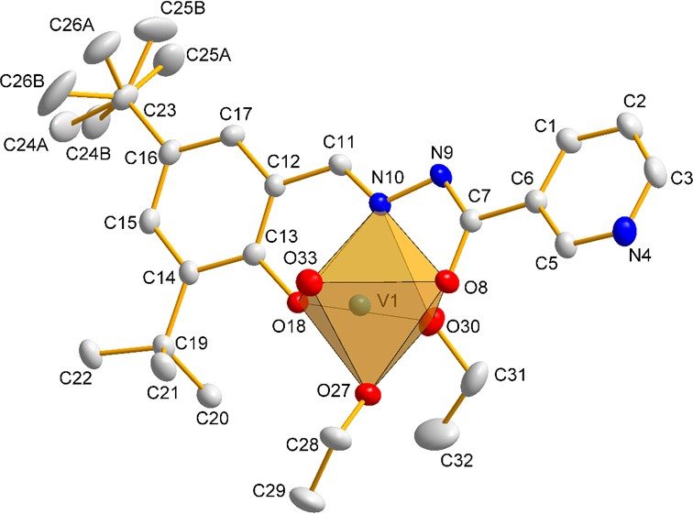
J. Szklarzewicz et al. | Tridentate hydrazido-hydrazones vanadium complexes. Synthesis, properties and biological activity 13
Table 2. Experimental details for complex 8.
Crystal data Chemical formula Mr
Crystal system, space group
Temperature (K)
a, b, c
b (°)
V (Å3) Z
Radiattion type
µ (mm-1)
Crystal size (mm) Data collection Diffractometer Absorption correction Tmin, Tmax
No. of measured, independent and
observed [I >2σ(I)] reflections
Rint
(sin θ/λ)max (Å-1)
Refinement
R[F2 >2σ(F2)], wR(F2), S
No. of reflections No. of parameters No. of restraints H-atom treatment
Δ ρmax, Δ ρmin (e Å-3)
[VO(C21H25N3O2)(C2H5O)(C2H5OH)] 509.51
Monoclinic, P21
293(2)
8.459(2), 15.091(4), 10.552(3)
93.204(1)
1344.91(6)
2
Mo Kα 0.406
0.46 x 0.23 x 0.04
Nonius Kappa CCD
Semi-empirical from equivalents 0.8356, 0.984
23447, 6092, 5571
0.0492
0.649
0.0371, 0.0908, 1.026
6092
346
2
H atoms treated by a mixture of independent and constrained refinement 0.386 -0.258
ly independent VV ion surrounded by oxo ligand, one L6 ligand
molecule, one ethoxy ligand (EtO-) and one ethanol molecule.
The asymmetric unit of the complex with the adopted atomic numbering scheme is shown in Fig. 1. The crystallographic data
and detailed information on the structure solution and refine-
ment for 8 are given in Table 2. Selected bond distances and bond angles are listed in Table 3.
Figure 1. A view of the coordination environment of the VV atom in 8. H atoms have been omitted for clarity. Displacement ellipsoids are drawn at the 30% probability level. The figure was prepared using DIAMOND [31]
www.stijournal.pl
Sci, Tech. Innov 2019; 4 (1), 9-20

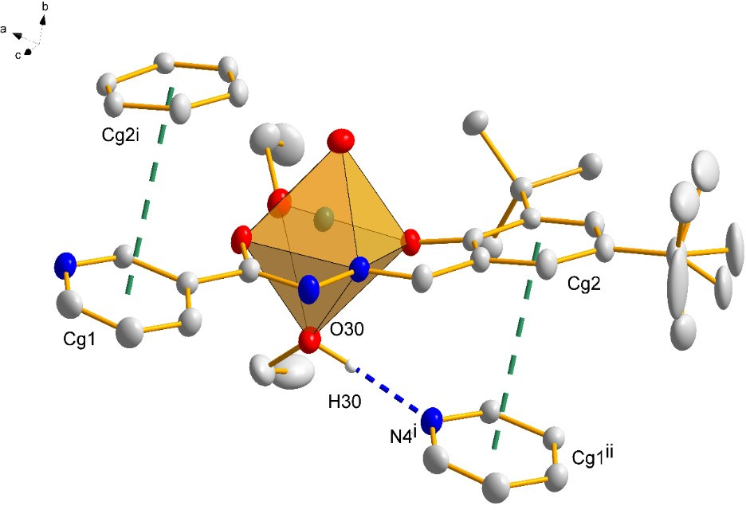
14
Science, Technology and Innovation
Original Research
together by typical hydrogen and two π⋅⋅⋅π interactions (Fig. 2), which are summarized in Tables 4 and 5, respectively. All these interactions are responsible for the self-assembly of the complex
molecules and stabilization of the 3D structure.
Table 3. Selected bond lengths [Å] and angles [°] for 8.
V1-O33 V1-O27 V1-O18 V1-O8 V1-N10 V1-O30 C7-N9 C7-O8 N9-N10 N10-C11
O33-V1-O27 O33-V1-O18 O27-V1-O18 O33-V1-O8 O27-V1-O8 O18-V1-O8 O33-V1-N10 O27-V1-N10 O18-V1-N10 O8-V1-N10 O33-V1-O30 O27-V1-O30 O18-V1-O30 O8-V1-O30
N10-V1-O30
1.589(2)
1.776(2)
1.845(2)
1.956(2)
2.113(2)
2.336(2)
1.300(4)
1.302(4)
1.399(3)
1.285(4)
103.20(12)
97.89(11)
101.32(9)
100.02(11)
95.38(10)
151.97(10)
93.85(11)
161.56(11)
82.97(9)
74.49(9)
171.31(11)
85.40(10)
78.93(9)
80.16(9) 77.78(9)
Figure 2. The 3D supramolecular network of 8 formed through O-H⋅⋅⋅N and π⋅⋅⋅π interactions. [Symmetry codes: (i) x - 1, y, z; (ii) x + 1, y, z]. The figure was prepared using DIAMOND [31]
Table 4. Hydrogen-bond geometry (Å, °)
D-H...A
d(D-H)
d(H...A)
d(D...A)
<(DHA)
O30-H30⋅⋅⋅N4i
0.94(3)
1.90(3)
2.834(4)
169(5)
Symmetry codes: (i) x - 1, y, z
Table 5. π⋅⋅⋅π interaction geometry in 8 (Å). Cg1: N(4)-C(3)-C(2)-C(1)-C(6)-C(5),
Cg2: C(12)-C(13)-C(14)-C(15)-C(16)-C(17)
In the structure surroundings of the central VV form a distort- ed octahedral O5N conformation. The equatorial plane defined by atoms O18, O8 and N10 of the fully deprotonated tridentate hydrazone ligand (L6) and O27 of ethoxy group (r.m.s. = 0.0183 Å). The oxo O33 atom and atom O30 of the ethanol molecule occupy the apical sites of the octahedron with a trans angle of 171.3(1)˚. The central vanadium atom is above the basal plane by
0.301 (1) Å and is directed towards the oxo O33 atom. As a con- sequence, the O33 ligand is significantly closer to the VV cation than the other groups, and for the complex the V–Ooxo distance is equal to 1.589(2) Å, which is in agreement with data for oth- er pentacoordinate oxovanadium(V) compounds [32-34]. In the complex the four V–O bond lengths are unequal, with the V=O bond being the shortest and the V–O30 = 2.336(2) Å (enolate) bond the longest. The magnitude, 2.113(2) Å, of the V1-N10 bond indicates a low affinity between the imine N atom and the central atom in neutral oxidovanadium(V) complexes. The V–O bond lengths follow the order: V–O33oxo > V–O27ethoxo > V– O18phenoxo > V–O8alkoxo > O30enolate. These data indicate
stronger binding of the alkoxo group compared to the enolate oxygen atoms. Analysis of the crystal structure of 8 at the su-
pramolecular level reveals that the complex molecules are held
Cg⋅⋅⋅Cg
Slippage
Cg1⋅⋅⋅Cg2i
Cg2⋅⋅⋅Cg1ii
3.9850(1)
3.9850(1)
1.787
1.477
Symmetry codes: (i) x - 1, y, z; (ii) x + 1, y, z
2. UV-Vis spectra
The UV-Vis spectral data are collected in Synthesis for each complex. As the solubility of the complexes is poor, only inter ligand transitions are observed, the less energetic one is con- nected with the formation of imine group within Schiff base. The more interesting thus are the spectra in solid state, in which, due to the technique used, the low intensity d-d transitions can be also observed. The reflectance spectra, after Kubelka-Munk transformation, are presented separately for diamagnetic (Fig.
3) and paramagnetic (Fig. 4) complexes. The presented spectra are very similar to that in solution, for paramagnetic complexes the d-d bands are better visible, as in solution these forbidden transitions have a very low intensity, compared to allowed CT
ones.
Sci, Tech. Innov 2019; 4 (1), 9-20
www.stijournal.pl

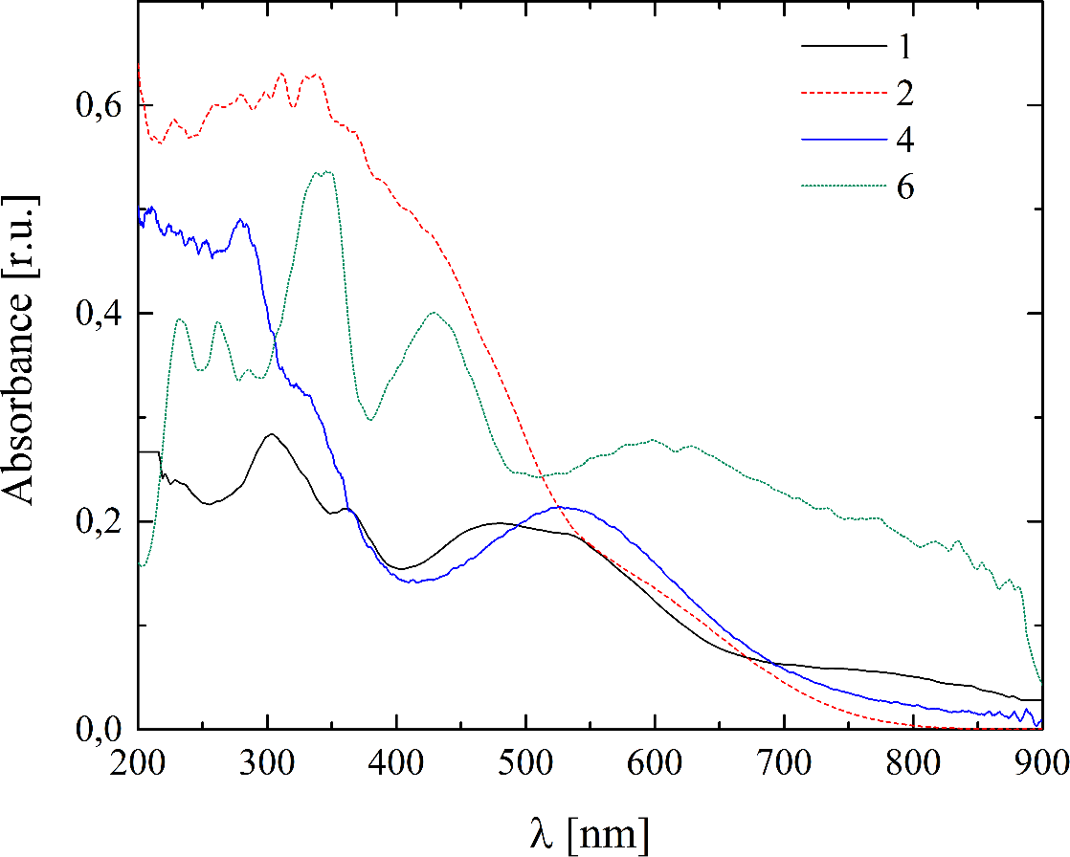
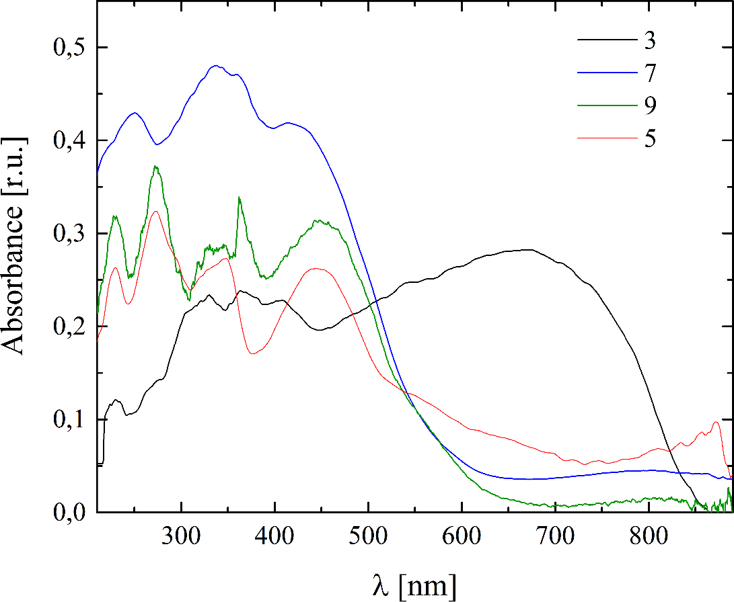
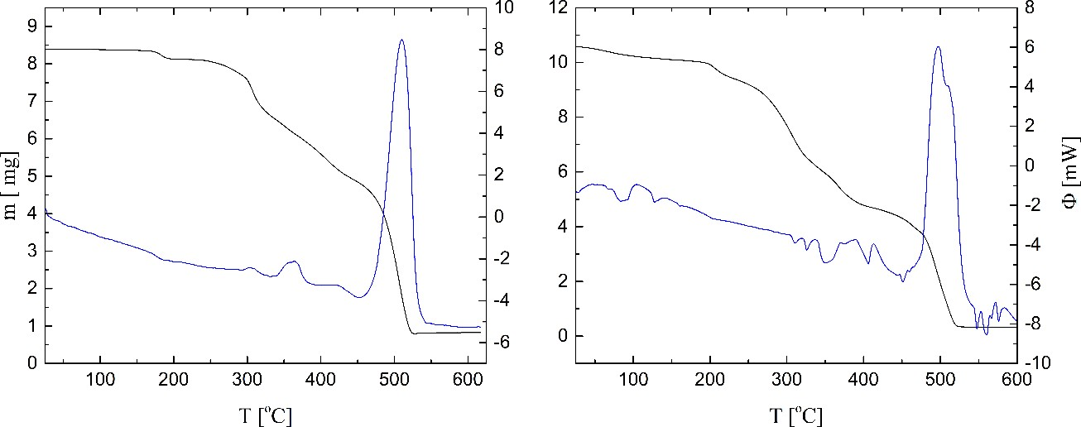
J. Szklarzewicz et al. | Tridentate hydrazido-hydrazones vanadium complexes. Synthesis, properties and biological activity 15
3. Magnetic measurements
To find the exact oxidation state of vanadium, the magnetic susceptibility measurements were performed using a magnetic Ewan’s balance. The calculated magnetic moments are present- ed in the Experimental part. Complexes 1, 2, 4, 6 and 8 were diamagnetic, while the magnetic moment of complexes 3, 5, 7 and 9 indicate on V(IV) with d1 configuration. The EPR spectra of complexes, were measured both at room and at liquid nitro- gen temperature for solid samples and are in agreement with the magnetic susceptibility data. The EPR spectra at room tem- perature show g parameter equal to 1.978 (3), typical for vana- dium(IV). The absence of hyperfine structure indicates on V-V interaction in condensed phase, both at room and at liquid nitro- gen temperature.
Figure 3. Reflectance spectra (after Kubelka-Munk transformation) of diamagnetic complexes 1, 2, 4 and 6. BaSO4 as internal white standard
4. Thermogravimetry
Thermal decomposition processes for complexes 3 and 9 are pre-
sented in Fig. 5, while numerical data are collected in Table 6.
The decomposition of complex 3 starts early, the final mass loss is 90.17 %, calculated for EtOH and ligand release is 92.09, these both values fit quite well including oxidation processes and formation of V2O5 as a final product. For complex 9 several, not well resolved, decomposition processes can be seen in Fig. 5. The raft estimations gave in Table 6 show that water is released in two separated steps and then phen ligand is released. As the plateaus are not well reached (see Fig. 5) the mass loss can only be estimated (basing on SDTA plots). The next step is two-step decomposition of ligand L, probably, as indicated in Table 6, first hydrazide and then in second step aldehyde part of the li- gand are released. Such a stepwise decomposition of Schiff base ligand was observed earlier by us [9,10,26]. The total mass loss is 96.90 %, calculated 93.03 %.
Figure 4. Reflectance spectra (after Kubelka-Munk transformation) of paramagnetic complexes 3, 5, 7 and 9. BaSO4 as internal white standard
Figure 5. TG (left axis) and SDTA (right axis) curves for 3 (left) and 9 (right). Scan speed 10o / min, air
www.stijournal.pl
Sci, Tech. Innov 2019; 4 (1), 9-20

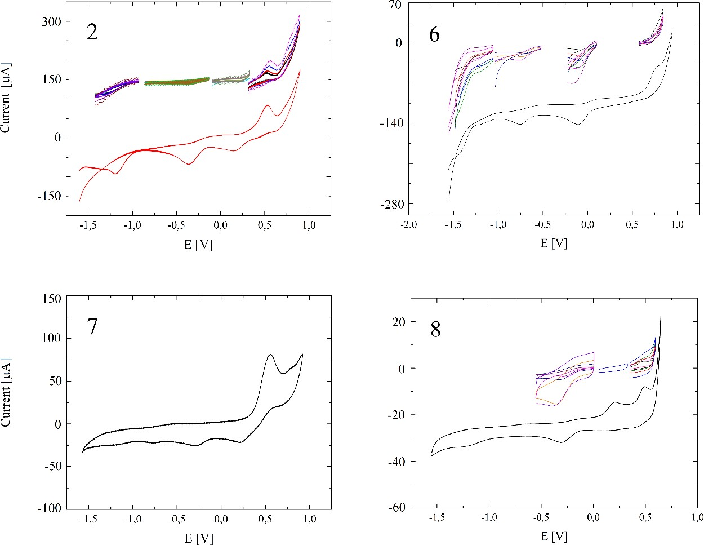
16
Science, Technology and Innovation
Original Research
Table 6. The TG and SDTA data for complexes 3 and 9. Scan speed 10o /min.
Complex
m [mg]
Tmax [oC] (SDTA)
Δmexp [%]
Δmcalc [%]
Attributed to
3
8.3938
8.1229
184 (endo)
304 (exo) 358sh (exo) 363 (exo) 419sh (exo) 510 (exo)
3.23
0.8251
86.94
92.09
2L + EtOH
9
10.5750
85 (endo)
127 (endo)
10.0699
4.78
5.23
2H2O
9.3849
6.1648
311 (endo)
326 (endo)
349 (endo)
406 (endo)
497 (exo) 510sh (exo)
6.48
30.45
7.84
26.17
3H2O
phen
4.6887
13.96
19,91
L(hydrazide)a
0.3272
41.24
33,88
L(aldehyde)b
* – rest of the peaks, shown in Fig. 5 were not listed, a Δm calculated for release of hydrazide part of the ligand, b Δm calculated for release of the aldehyde from the ligand.
are observed for complexes with bidentate co-ligands (1, 3, 4 and 5), as exemplified in Fig. 7. This behavior was found earlier by us for complexes with phen as a co-ligand, the E1/2 = -1.31 V for 5 (with Ea/Ec peak separation of 110 mV at scan speed 100 mV/s). Similar behavior shows the complex 1 with maltol as a co-ligand with E1/2 = -0.116 V and Ea/Ec peak separation of 73 mV (at scan speed 100 mV/s), indicating on one electron
5. Cyclic voltammetry
Cyclic voltammograms for selected complexes are presented in Figs. 6 and 7. In general the presented data indicate on irre- versible processes connected with the vanadium oxidation (at positive potentials), this is a typical behavior for vanadyl com- pounds. The reversible redox processes at negative potentials
Figure 6. Cyclic voltammograms of complexes 2, 6, 7 and 8 in DMSO. Pt working and counting, Ag/AgCl as reference electrodes.
Potentials versus SHE. 0.1M Bu4NPF6, scan speed (full curve) 100 mV/s, insets scan speeds from 20–1000 mV/s
Sci, Tech. Innov 2019; 4 (1), 9-20
www.stijournal.pl

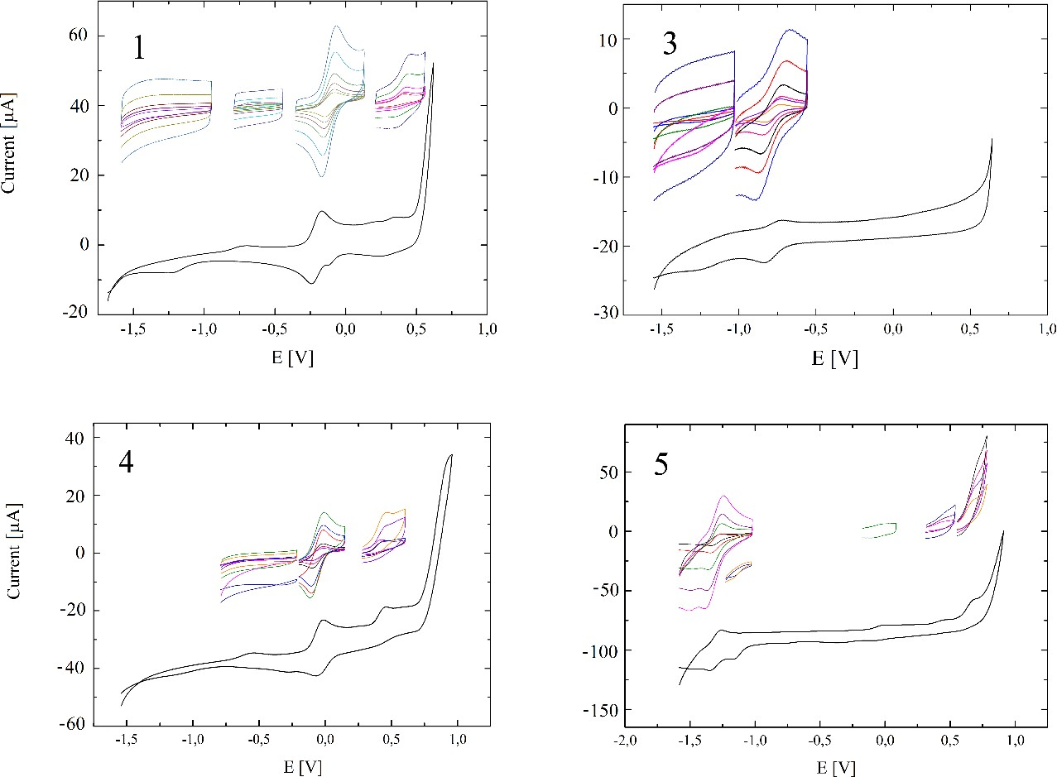
Tridentate hydrazido-hydrazones vanadium complexes. Synthesis, properties and biological activity 17
J. Szklarzewicz et al.
|
Figure 7. Cyclic voltammograms of complexes 1, 3, 4 and 5 in DMSO. Pt working and counting, Ag/AgCl as reference electrodes.
Potentials versus SHE. 0.1M Bu4NPF6, scan speed (full curve) 100 mV/s, insets scan speeds from 20–1000 mV/s.
process. The independence of E1/2, Ea and Ec on scan speed and symmetry of peaks support the reversibility of the redox pro- cess. The electrochemical reversibility observed for complexes 3 and 4 are directly connected with bidentate co-ligand (bald for 4, and bidentate L2 ligand in 3). The E1/2 = -0.782 V (Ea/Ec peak separation 130 mV) for 3 and E1/2 = -0.059 V (Ea/Ec peak separation 94 mV) at scan speed 100 mV/s. For 4 the reversi- ble process is connected with coordination of bald, much lower potential observed for 3 with the L2 ligand indicates that the hydrazide part (different in 3 and 4) stabilizes the aldehyde part of Schiff base. In case of ligand L2 (in complex 3) aromatic ring of hydrazide stabilizes the aldehyde part, while when aliphatic separator between aromatic ring and hydrazide part (as in li- gand L3) is present, such a stabilization is not observed, and in
4 redox processes are less energetic.
through digestion system (with pH as low as 2.0) and transfer to the cell. Due to the almost insolubility in water of synthesized complexes, we were forced to use DMSO as a solvent in the mix- ture with water. DMSO is very popular in medicine as it helps in transfer of many substances through biological membranes. However, in in vitro studies, the main medium for cells is water (as solvents for all biological buffers and media). We firstly stud- ied the stability of the complexes in pure DMSO, by measuring the UV-Vis spectra versus time. We have found, that the solu- tions of all 1-9 complexes are stable in DMSO. In DMSO-H2O (20 µl + 3ml, respectively) mixtures at native pH complexes are fairly stable and only small decomposition is observed (less than
10% of decomposition after 90 min). At pH = 2.00 complexes 5 and 7 are stable, while others undergoes slow decomposition, still over 50% of initial complex amount remains after 90 min- utes. All these facts indicate, that all studied complexes are sta- ble enough to survive the conditions present in human digestion system. The sample spectra changes for complex 6 are presented
in Fig. 8.
6. Complex stability in solution
The admission of vanadium complexes in in vitro and in vivo
studies complicates theirs solubility, stability on transfer
www.stijournal.pl
Sci, Tech. Innov 2019; 4 (1), 9-20

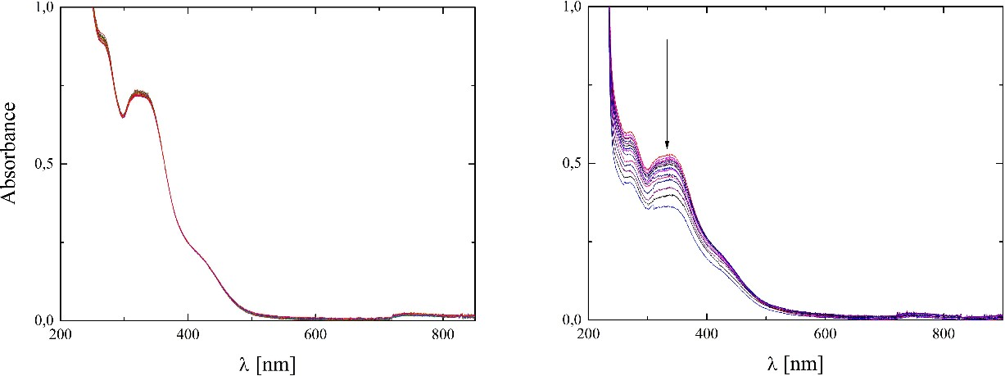
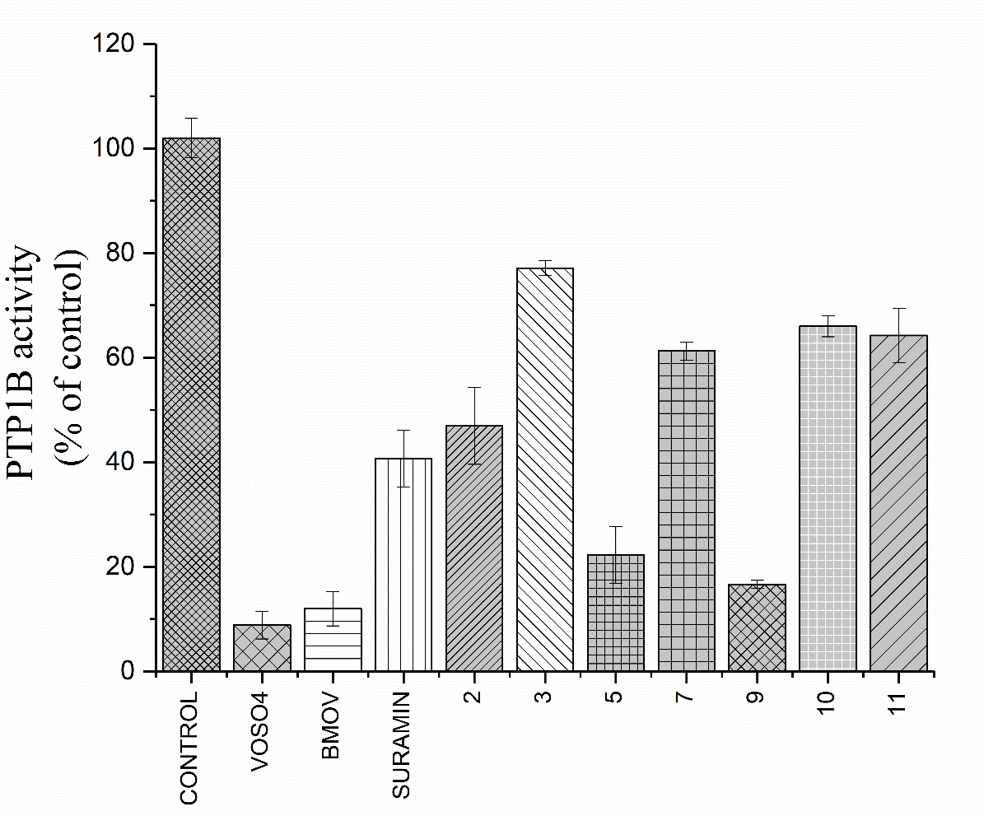
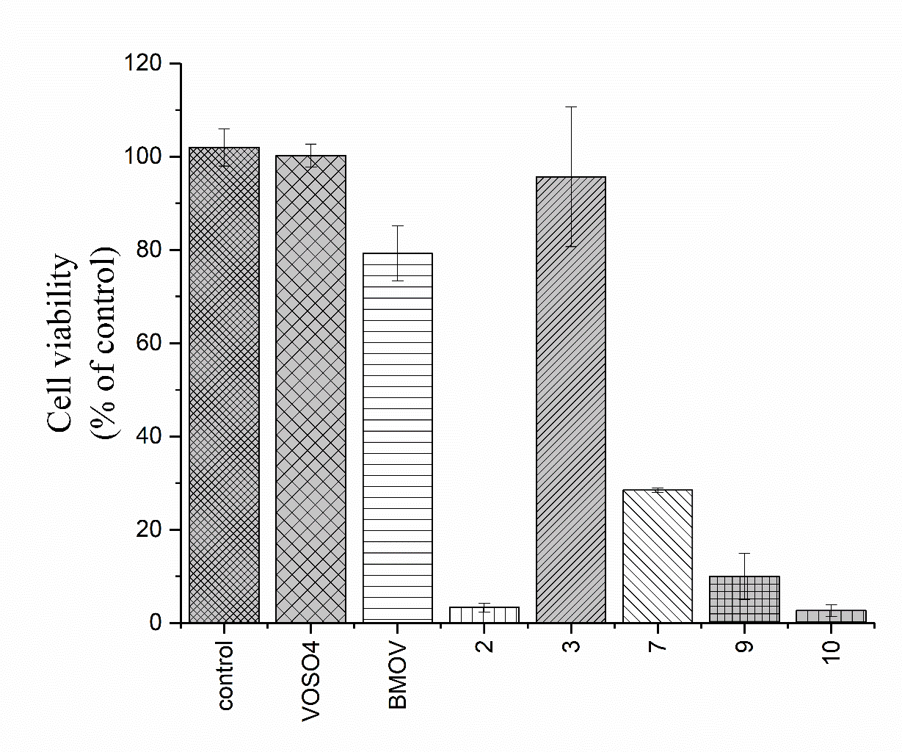
18
Science, Technology and Innovation
Original Research
Figure 8. UV-Vis spectra of complex 6 in DMSO-H2O mixture (20 µl + 3 ml respectively) mixture at native pH (left) and
at pH = 2.00 (right). T = 37 oC, d = 1 cm, 15 spectra measured in 340 s intervals. The arrow shows direction of changes in spectra
significant cytotoxicity compared to control and to VOSO4 or
BMOV, while all other complexes possesses high cytotoxicity.
Biological activity of selected complexes
All tested complexes (2, 3, 5, 7, 9-11) as well as comparative compounds (VOSO4, BMOV and suramin) were shown the in- hibitory effect on human recombinant PTP1B at 100 μM con- centration (P≤.001) as shown in Fig. 9. All complex showed a weaker degree of inhibition both to the inorganic vanadium ref- erence compound and to the organic vanadium complex BMOV [bis(maltolato)oxovanadium(IV)] whose pharmacological activ- ity has been extensively studied and which has been in phase III clinical trials. The compounds 5 and 9 have been shown a signif- icantly more potent PTP1B inhibition ability than the other test- ed compounds and over twice higher inhibition than suramin.
The very important part in application of compounds is their cytotoxicity. The cytotoxicity of tested compounds on HepG2 hepatocytes is presented in Fig. 10. The results were normalized to the control (cells with solvent only), wherein the intensity of
fluorescence was taken as 100%. The complex 3 does not show
Figure 10. Cytotoxicity of tested compounds on HepG2 hepatocytes. Error bars: +/− SD. Statistically significant differences in comparison to control:
*** p = 0.0001 (for 2, 7, 9 and 10)
Conclusions
Nine new complexes of vanadium with ONO donating Schiff hydrazido-hydrazones are described and characterized. All complexes contain the V=O group. The bidentate co-ligands not only stabilize the V(IV) oxidation state, but also stabilize com- plexes in solution, even at pH 2.00. The stabilization at low pH is very important in vanadium applications as pharmaceuticals. In contrary to bidentate ligands, as in BMOV, coordination of tridentate ligand results in strong dependence of biological ac- tivity (cytotoxicity and inhibition of human PTP1B) on type of ligand used. This, together with complex stability, indicates that ONO ligand is not released during migration to the cells and the biological activity depends on ONO ligand composition and not
only on presence of VO2+ anions. Further studies are in progress.
Figure 9. Inhibition of human PTP1B. Error bars: +/− SD. Statistically significant differences in comparison to control: *** p = 0.0001 (for VOSO4, BMOV, suramin, 2, 5, 7, 9, 10, 11), *p = 0.01 (for 3)
Sci, Tech. Innov 2019; 4 (1), 9-20
www.stijournal.pl

J. Szklarzewicz et al. | Tridentate hydrazido-hydrazones vanadium complexes. Synthesis, properties and biological activity 19
Acknowledgments
- Lu L, Zhu M. Protein tyrosine phosphatase inhibition by me- tals and metal complexes. Antioxidants and Redox Signaling. 2014; 20:2210-2224.
- Thompson KH, Orvig C. Vanadium in diabetes: 100 years from Phase 0 to Phase I. Journal of Inorganic Biochemistry. 2006; 100:1925-1935.
- Domingo JL, Gomez M, Sanchez DJ, Llobet JM, Keen CL. Toxicology of vanadium compounds in diabetic rats: the ac- tion of chelating agents on vanadium accumulation. Molecu- lar and Cellular Biochemistry. 1995; 153:233–240.
- Domingo JL. Vanadium and tungsten derivatives as anti- diabetic agents. Biological Trace Element Research. 2002; 88:97–112.
- Gruzewska K, Michno A, Pawelczyk T, Bielarczyk H. Essen- tiality and toxicity of vanadium supplements in health and pathology. Journal of Physiology and Pharmacology. 2014; 65:603-611.
- Evangelou AM. Vanadium in cancer treatment. Critical Re- views in Oncology/Hematology. 2002; 42:249-265.
- Llobet JM, Domingo JL. Acute toxicity of vanadium compo- unds in rats and mice. Toxicology Letters. 1984; 23:227-231.
- Srivastava AK. Anti-diabetic and toxic effects of vanadium compounds. Molecular and Cellular Biochemistry. 2000; 206:177-182.
- Reul BA, Amin SS, Buchet JP, Ongemba LN, Crans DC, Bri- chard SM. Br. Effects of vanadium complexes with organic ligands on glucose metabolism: a comparison study in diabe- tic rats. British Journal of Pharmacology. 1999; 126:467-477.
- Fujimoto S, Fujii K, Yasui H, Matsushita R, Takada J, Sakurai
H. Long-term acting and orally active vanadyl-methylpicoli- nate complex with hypoglycemic activity in streptozotocin-
-induced diabetic rats. Journal of Clinical Biochemistry and
Nutrition. 1997; 23:113–129.
This work was partly financed by the European Regional De- velopment Fund under the Innovative Economy Programme 2007–2013 (WND POIG.01.03.01-174/09). The complexes are
protected by the patent P.401493.
References
- Rehder D. Implications of vanadium in technical applications and pharmaceutical issues. Inorganica Chimica Acta. 2017; 455:378-389.
- Azza AA. Synthesis and spectroscopic studies on ternary bis-
-Schiff-base complexes having oxygen and/or nitrogen do- nors. Journal of Coordination Chemistry. 2006; 59:157-176.
- Pessoa JC, Etcheverry S, Gambino D. Vanadium compounds in medicine. Coordination Chemistry Review. 2015; 301- 302:24-48.
- Dhar DN, Taploo CL. Schiff-bases and their applications. Jo- urnal of Scientific and Industrial Research. 1982; 41:501-506.
- Jia Y, Li J. Molecular Assembly of Schiff Base Interactions: Construction and Application. Chemical Review. 2015; 115:1597-1621.
- Przybylski P, Huczynski A, Pyta K, Brzezinski B, Bartl F. Biological properties of Schiff bases and azo derivatives of phenols. Current Organic Chemistry. 2009; 13:124-148.
- Ebrahimipour SY, Sheikhshoaie I, Kautz AC, Ameri M, Pas- ban-Alibadi F, Rudbari HA, Bruno G, Janiak Ch. Mono-and dioxido-vanadium (V) complexes of a tridentate ONO Schiff base ligand: Synthesis, spectral characterization, X-ray cry- stal structure, and anticancer activity. Polyhedron. 2015; 93:99-105.
- Zamarin D. Vanadium: A Panacea for Resistance to Oncolytic Immunotherapy? Molecular Therapy. 2018; 26:9-12.
- Zabierowski P, Szklarzewicz J, Gryboś R, Modryl B, Nitek
W. Assemblies of salen-type oxidovanadium (IV) complexes: substituent effects and in vitro protein tyrosine phosphatase inhibition. Dalton Transactions. 2014; 43:17044-17053.
- Gryboś R, Szklarzewicz J, Jurowska A, Hodorowicz M. Properties, structure and stability of V (IV) hydrazide Schiff base ligand complex. Journal of Molecular Structure. 2018;1171:880-887.
- Ma L, Lu L, Zhu M, Wang Q, Gao F, Yuan C, Wu Y, Xing S, Fu X, Mei Y, Gao X. Dinuclear copper complexes of organic claw: potent inhibition of protein tyrosine phosphatases. Jo- urnal of Inorganic Biochemistry. 2011; 105:1138-1147.
- Wang Q, Zhu M, Lu L, Yuan C, Xing S, Fu X. Potent in- hibition of protein tyrosine phosphatases by quinquedentate binuclear copper complexes: synthesis, characterization and biological activities. Dalton Transactions. 2011; 40:12926-
12934.
23.
Halevas E, Tsave O, Yavropoulou MP, Hatzidimitriou A, Yovos JG, Psycharis V, Gabriel C, Salifoglou A. Design, syn- thesis and characterization of novel binary V (V)-Schiff base materials linked with insulin-mimetic vanadium-induced differentiation of 3T3-L1 fibroblasts to adipocytes. Struc- ture–function correlations at the molecular level. Journal of
Inorganic Biochemistry. 2015; 147:99-115.
- Sugiyama H, Matsugo S, Misu H, Takamura T, Kaneko S, Ka- natani Y, Kaido M, Mihara C, Abeywardana N, Sakai A, Sato K, Miyashita Y, Kanamori K. Regulation of the physiological effects of peroxidovanadium (V) complexes by the electronic nature of ligands. Journal of Inorganic Biochemistry. 2013; 121:66-76.
- Dümmling S, Eichhorn E, Schneider S, Speiser B, Würde M. Recycling of the Supporting Electrolyte Tetra(n-butyl)ammo- nium Hexafluorophosphate from Used Electrolyte Solutions. Current Separations. 1996; 5:53-56.
- Gryboś R, Paciorek P, Szklarzewicz J, Matoga D, Zabierow-
ski P, Kazek G. Novel vanadyl complexes of acetoacetanilide:
www.stijournal.pl
Sci, Tech. Innov 2019; 4 (1), 9-20

20
Science, Technology and Innovation
Original Research
Synthesis, characterization and inhibition of proteintyrosine phosphatase. Polyhedron. 2013;49:100-104.
- Sutradhar M, Martins LM, Carabineiro SA, Guedes da Silva MFC, Buijnsters JG, Figueiredo JL, Pombeiro AJL. Oxido- vanadium (V) Complexes Anchored on Carbon Materials as Catalysts for the Oxidation of 1-Phenylethanol. Chem.Cat. Chem. 2016;8:2254-2266.
- Szklarzewicz J, Jurowska A, Hodorowicz M, Gryboś R, Ma- toga D. Role of co-ligand and solvent on properties of V(IV) oxido complexes with ONO Schiff bases. Journal of Molecu- lar Structure. 2019; 1180:839-848.
- Sheldrick GM. SHELXT – Integrated space-group and cry- stal-structure determination. Acta Crystallographica Section A Foundations and Advances. 2015; 71:3-8.
- Sheldrick GM. Crystal structure refinement with SHELXL.
- Brandenburg K, Putz H. DIAMOND. Crystal Impact GbR, Bonn, Germany. 2005.
- Tsiamis C, Voulgaropoulos B, Charistos D, Voutsas GP, Ka- vounis C. Ligand reactivity, substituent effects and solvent in- teractions in the spectra and structure of some oxovanadium
(V) chelates with Schiff bases. Proof for dimeric species. Po- lyhedron. 2000; 19:2003-2010.
- Diamantis AA, Frederiksen JM, Salam MA, Snow MR, Tie- kink ERT. Structures of 2 Vanadium (V) Complexes With Tridentate Ligands. Australian Journal of Chemistry. 1986; 39:1081-1088.
- Wang W, Wang X, Liu HX, Tan MY. Synthesis, characteri- zation and crystal structure of an oxovanadium (V) complex with the Schiff base N-benzoylacetone-M-chlorobenzoylhy-
drazone. Journal of Coordination Chemistry 1995; 36:49-55.
Acta Crystallographica
2015; 71:3-8.
Section
C
Structural
Chemistry.
Sci, Tech. Innov 2019; 4 (1), 9-20
www.stijournal.pl

