



Mol Biotechnol (2016) 58:605–618 DOI 10.1007/s12033-016-9960-z
Engineeredb-LactoglobulinProducedinE.coli:Purification, Biophysical and StructuralCharacterisation
Joanna I. Loch¹•Piotr Bonarek²•Magdalena Tworzydło²•Agnieszka Polit²•
BarbaraHawro¹•AnetaŁach¹•ErykLudwin¹•KrzysztofLewin´ski¹
Published online: 5 July 2016
©The Author(s) 2016. This article is published with open access at Springerlink.com
Abstract Functional recombinant bovine b-lactoglobulin has been produced by expression inE. coliusing an engineered protein gene and purified to homogeneity by applying a new protocol. Mutations L1A/I2S introduced into the protein sequence greatly facilitate in vivo cleavage of the N-terminal methionine, allowing correctly folded and soluble protein suitable for biochemical, biophysical and structural studies to be obtained. The use of gel fil- tration on Sephadex G75 at the last purification step enablesproteinwithoutendogenousligandtobeobtained.
Keywords b-Lactoglobulin·Escherichia coli·Protein
engineering·Protein stability·Ligand binding·
N-terminal methionine
Abbreviations
BlgB
Natural bovine b-lactoglobulin isoform B
Recombinant b-lactoglobulin isoform B
Recombinant b-lactoglobulin isoform B with N-terminal L1A/I2S substitutions
sBlgB purified by protocol #1 sBlgB purified by protocol #2 pETDuet-1 carrying rBlgB sequence
pETDuet-1 carrying sBlgB sequence
rBlgB
sBlgB
The
physicochemical
properties
of
recombinant
b-lactoglobulin such as CD spectra, ligand binding (n,K_{a}, DH,TDS, DG), chemical and thermal stability (DG_{D},C_{mid}) and crystal structure confirmed that the protein obtained is almost identical to the natural one. The substitutions of N-terminal residues did not influence the binding proper- ties of the recombinant protein so that the lactoglobulin produced and purified according to our protocol is a goodcandidate for further engineering and potential use in pharmacology and medicine.
sBlgB#1 sBlgB#2
pETDuet-1/DsbC/
BlgB
pETDuet-1/DsbC/L1A/I2S-BlgB
Introduction
Bovineb-lactoglobulin(BlgB)isasmallprotein(18.3kDa) belonging to the lipocalin family. Due to BlgB ability to bind different classes of bioactive compounds, its applica- tionasanutrientsnanotransporterordrugcarrieriscurrently an object of intensive studies [1–5]. Most of them are per- formed with commercially available natural lactoglobulin, but the use of recombinant protein seems to be a better alternative. The expression of correctly folded BlgB was successful for an extended period but only in eukaryotic systems: insect [6], yeast (P. pastoris[6],S. cerevisiae[8]) and transgenic mice [9]. More recent studies showed that BlgBcanbeproducedandsecretedbyLactobacilluscasei
[10] while attempts to express b-lactoglobulin inE. coli

Electronic supplementary material The online version of this article (doi:10.1007/s12033-016-9960-z) contains supplementary material, which is available to authorized users.
&
KrzysztofLewin´skilewinski@chemia.uj.edu.pl
1
Biocrystallography Group, Department of Crystal Chemistry and Crystal Physics, Faculty of Chemistry, JagiellonianUniversity,Ingardena3,30-060Krako´w,Poland
Department of Physical Biochemistry, Faculty of Biochemistry, Biophysics and Biotechnology, JagiellonianUniversity,Gronostajowa7,30-387Krako´w,Poland
2
13
ORIGINAL PAPER

606
Mol Biotechnol (2016) 58:605–618
have continued to fail due to incorrect protein folding. The expression systems used for lactoglobulin production were reviewed in details by Ariyaratne et al. [11].
The strategy for successful expression of b-lactoglobu- lin inE. coliwas discovered by Ponniah et al. [12], who produced soluble and correctly folded BlgB inOrigami Bcells. Folding of recombinant protein in the bacteria cyto- plasm was possible due to its co-expression with DsbC (E. colicytoplasmic disulphide bond isomerase), which facilitates disulphide bridges formation in the reducing environment of bacterialcytoplasm.
Potential utilisation in medicine of small proteins belonging to the lipocalin family has recently intensified their studies [13]. Such research has been aimed at pro-ducing engineered proteins that can specifically recognise receptors or bind desired low molecular weight ligands[14]. An increased affinity to selected molecular targets is achieved by introducing mutations into the binding site region. In modified lipocalins, substituted residues interact specifically with ligands and change the binding pocket plasticity [15].
The process of protein engineering requires an expres- sion system which allows obtaining high yields of pure and biologically active protein molecules. Engineered lipoca- lins, calledAnticalins, are usually produced in prokaryotic expression systems; however, due to the presence of disulphide bonds in their structure, during expression they are directed to the periplasmic space (e.g. by N-terminalOmpAsignal peptide), in which efficient S–S bridge for- mation occurs. Anticalins also may have affinity tag at the C-terminus to facilitate protein purification [16], but itoften needs to be removed in vitro before structural and other studies. This experimental strategy, however, gener- ates additional steps in the protein purification protocol.
As other proteins from lipocalin family, BlgB can be re-engineered to gain specificity of binding selected bioactive ligands, and this requires heterologous protein production in the appropriate expression system. Such system should be not expensive and enable to produce the correctly folded protein in high amounts needed for medical and structural studies. In this context, strategy for BlgB production inE. coliwith co-expression of the DsbC isomerase [12] seems to be especially valuable. We have repeated this procedure (protocol #1), but we have found that obtained BlgB has physicochemical properties different than natural lactoglobulin isolated from bovine milk. Detailed studies, presented below, revealed the presence of uncleaved N-terminal methionine and endogenous fatty acid tightly bound in the binding pocket which significantly influenced properties of the recombi- nant protein and affected binding of pharmaceutical agents.
Here, we present a modification of expression and purification protocol (protocol #2) which allows producing inOrigami B(DE3) cells fully functional BlgB. To com- pare properties of recombinant lactoglobulin produced using different protocols, we used a range of techniques. Secondary and tertiary structure in solution was inspected by CD spectra. Thermal and chemical denaturation moni- tored by CD spectra changes was used to determine protein stability. The thermodynamic parameters of model ligand binding have been measured using isothermal titration calorimetry. Origins of different properties observed for proteins produced with the use of different protocols were explained on the basis of MS and crystal structures.
Materials and Methods
Materials
All chemicals used for protein purification and crystal- lization, e.g. phosphate and Tris–HCl buffer ingredients, salts: NaCl, (NH₄)₂SO₄, HCl, tri-sodium citrate in analyt- ical grade, were purchased fromIDALIA(Poland) orAvantor Performance Materials Poland S.A.
Antibiotics (ampicillin sodium salt, kanamycin mono- sulphate tetracycline chloride) and LB broth Miller (Bio-Shop) were purchased fromLabEmpire. Agar and IPTG were purchased fromA&A Biotechnology(Poland). Nat- ural (milk) b-lactoglobulin isoform B used as a reference in spectroscopic and calorimetric studies was purchased fromSigma-Aldrich.
Construction of Expression Vector and Mutagenesis
Genes coding bovine b-lactoglobulin isoform B (BlgB,UNP: P02754) and bacterial disulphide bond isomerase DsbC (DsbC,UNP: P0AEG6) were chemically synthesised and optimised for the expression inE. coliby GeneArt (Germany). In both cases, the short sequences responsible for the extracellular localisation of proteins were omitted. The expression vector was generated according to Ponniah et al. [12]:DsbCwas cloned into MCS I whileBlgBwas introduced into MCS II of the pETDuet-1 vector (Invitro-gen) usingNcoI/HindIIIandNdeI/KpnIset of endonucle- ases. The use of theNcoIrestriction site eliminated the presence of His-tag at the N-end of DsbC and duplicated TAA codon at the end ofBlgBpreventing the formation of S-tag at the C-end of rBlgB. Before transformation, the modified vector pETDuet-1/DsbC/BlgBwas sequenced to prove that no frameshift or mutation took place during the cloning procedure.
13

Mol Biotechnol (2016) 58:605–618
607
Initial amino acids in b-lactoglobulin were modified byQuikChangemethod. A pair of complementary mutagenicprimers(FOR:5⁰GGAGATATACATATGGCCTCAGTTACCCAGACCATG3⁰andREV:5⁰CATGGTCTGGGTAAC
TGAGGCCATATGTATATCTCC3⁰)wasappliedtoreplace codons for Leu1 and Ile2 with Ala and Ser during PCR. pETDuet-1/DsbC/BlgBvector served as a matrix for this reaction. In the next step, the methylated matrix was digested withDpnIrestriction enzyme and newly synthe- sised DNA (pETDuet-1/DsbC/L1A/I2S-BlgB) was used to transformE. coliDH5a competent cells. The presence of the desired mutation in obtained colonies was confirmedbysequencing.
fractions were analysed by SDS-PAGE, and those con- taining b-lactoglobulin were pooled and dialysed overnight to 50 mM phosphate buffer pH 7.5.
After dialysis, lactoglobulin concentration was esti-
(e=17600M⁻¹cm⁻¹
mated by measurement of
A280
[17]). The protein solution was diluted to concentration
*1 mg/ml with phosphate buffer, and then, 0.1 M HCl was added dropwise with continuous stirring, to achieve a pH of 2.6. Solid NaCl was added to 7 % (w/v) to precip- itate first protein fraction. Precipitated proteins were removed by centrifugation at 15,0009g, and the super- natant containing b-lactoglobulin was recovered. Solid NaCl was added to reach a concentration of 30 % (w/v), and proteins precipitated at this step (containing predomi- nately rBlgB or sBlgB, Fig.2) were harvested by cen- trifugation at 15,0009g. The pellet was re-suspended in a small volume of 50 mM phosphate buffer pH 7.5 and dialysed overnight at 4°C. Protein purity and homogeneity were checked by SDS-PAGE and size exclusion chro- matography atSuperdex75 10/300 GL(GE Healthcare) (Fig.2).
Chemical, N-terminal protein sequencing by the Edman method (Procise 491 Sequencer, Applied Biosystems,BioCentrum, Poland) of first five amino acids was per- formed for rBlgB being a product of pETDuet-1/DsbC/BlgBexpression. Prior to sequencing, protein was deformylated using the protocol described by Hirano et al.
[18] (Fig. S1).
The molecular weight of lactoglobulin (rBlgB and sBlgB) was determined using mass spectrometry (MS). Mass spectra were recorded with the use of an MALDI- TOF/TOF mass spectrometer (ultrafleXtreme, BrukerDaltonics) equipped with smartbeamTM laser operated at 1 kHz repetition rate. Spectra acquisition and pre-pro- cessing were performed withflexControlandflexAnalysissoftware, both fromBruker. Spectra were registered withinm/zrange of 5000–20,000 in a linear positive mode with 25 kV acceleration voltage. Multiple charge state analysis (MCSA) [19] was employed for the determination of pro- tein mass weight. 2,5-Dihydroxyacetophenone (DHAP) was used as a matrix, while Protein Calibration Standard I(Bruker) was exploited for calibration of the TOFanalyser.
Expression
CompetentE. coli Origami B(DE3) (Novagen) cells were transformed with pETDuet-1/DsbC/BlgBor pETDuet-1/
DsbC/L1A/I2S-BlgBLB–agarose plates 15 lg/mlkanamycin
vector and grown overnight in containing 100 lg/ml ampicillin, and 12.5 lg/ml tetracycline.Single
colonies were transferred to 5 ml of LB medium containing the same antibiotics and grown overnight at 37°C. Next day, liquid culture was increased to 50 ml and incubated overnight at 37°C. Fifty ml of overnight culture was added to 1.2 L of LB media supplemented with the same antibi- otics, and cultures were incubated for 3–6 h at 37°C
applying constant stirring 100 rpm, until
OD600
reached
0.5–0.7 (pETDuet-1/DsbC/BlgB) or 1.0–1.2 (pETDuet-1/DsbC/L1A/I2S-BlgBvector). When OD₆₀₀reached desired value,proteinexpressionwasinducedbyaddingIPTGtoits final concentration 500lM.After induction, the tempera- turewasdecreasedto25°Candcultureswereincubatedfor 3–4 h (pETDuet-1/DsbC/BlgBvector) or overnight (pET- Duet-1/DsbC/L1A/I2S-BlgBvector), with constant stirring 200 rpm. After this time, cells were harvested by centrifu-gationat5000rpmandfrozenat-80°C.
Purification Protocol #1
The described below purification protocol was applied to rBlgB (product of pETDuet-1/DsbC/BlgB) and sBlgB (product of pETDuet-1/DsbC/L1A/I2S-BlgB). This purifi- cation protocol follows the procedure described by [12] with some modifications. Cell pellet (approximately 4–5 g) were re-suspended in 20 ml of 50 mM phosphate buffer (pH 6.5) containing PMSF. Cells were disrupted by soni- cation (395 min) and centrifuged at 15,0009g. Clarified cell lysate was loaded on chromatography XK 16/20 col- umn (GE Healthcare) packed withFractogel EMD TMAE
(S) resin (Merck Millipore), equilibrated previously with the 50 mM phosphate buffer pH 6.5. Proteins were eluted using a linear gradient of 2 M NaCl (Fig.1). Collected
Purification Protocol #2
This protocol was applied only to L1A/I2S-substituted variant(sBlgB).Theinitialstepsofproteinpurificationwere the same as in protocol #1, but after ion-exchange chro- matographyatFractogelEMDTMAE(S),insteadofsalting out by NaCl, the second chromatography step was applied. Fractions containing lactoglobulin, eluted from an anion- exchange resin, were analysed by SDS-PAGE, and those containing the highest content of L1A/I2S were pooledand
13

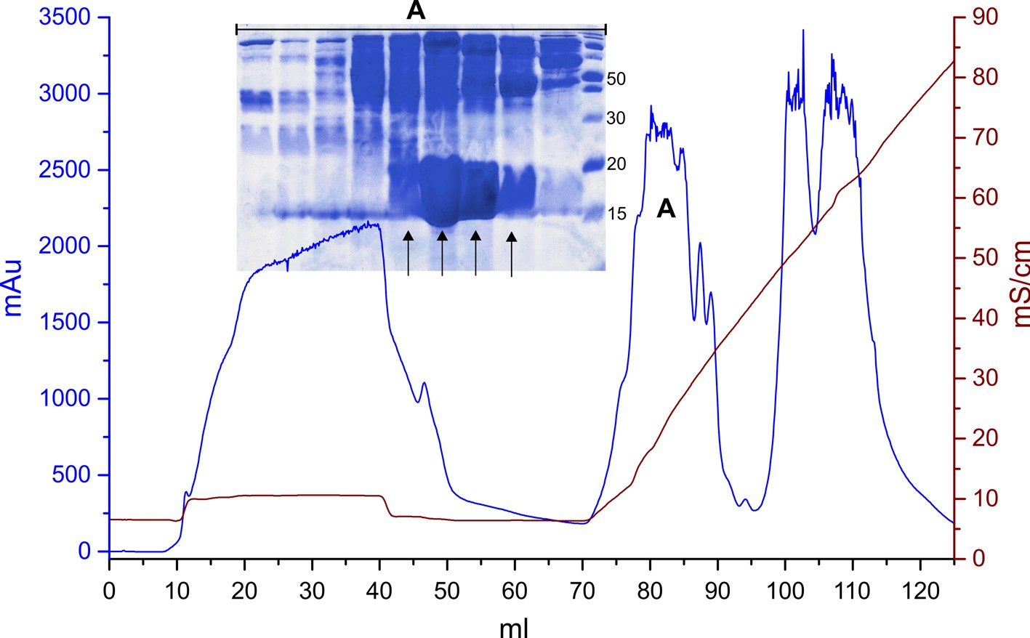
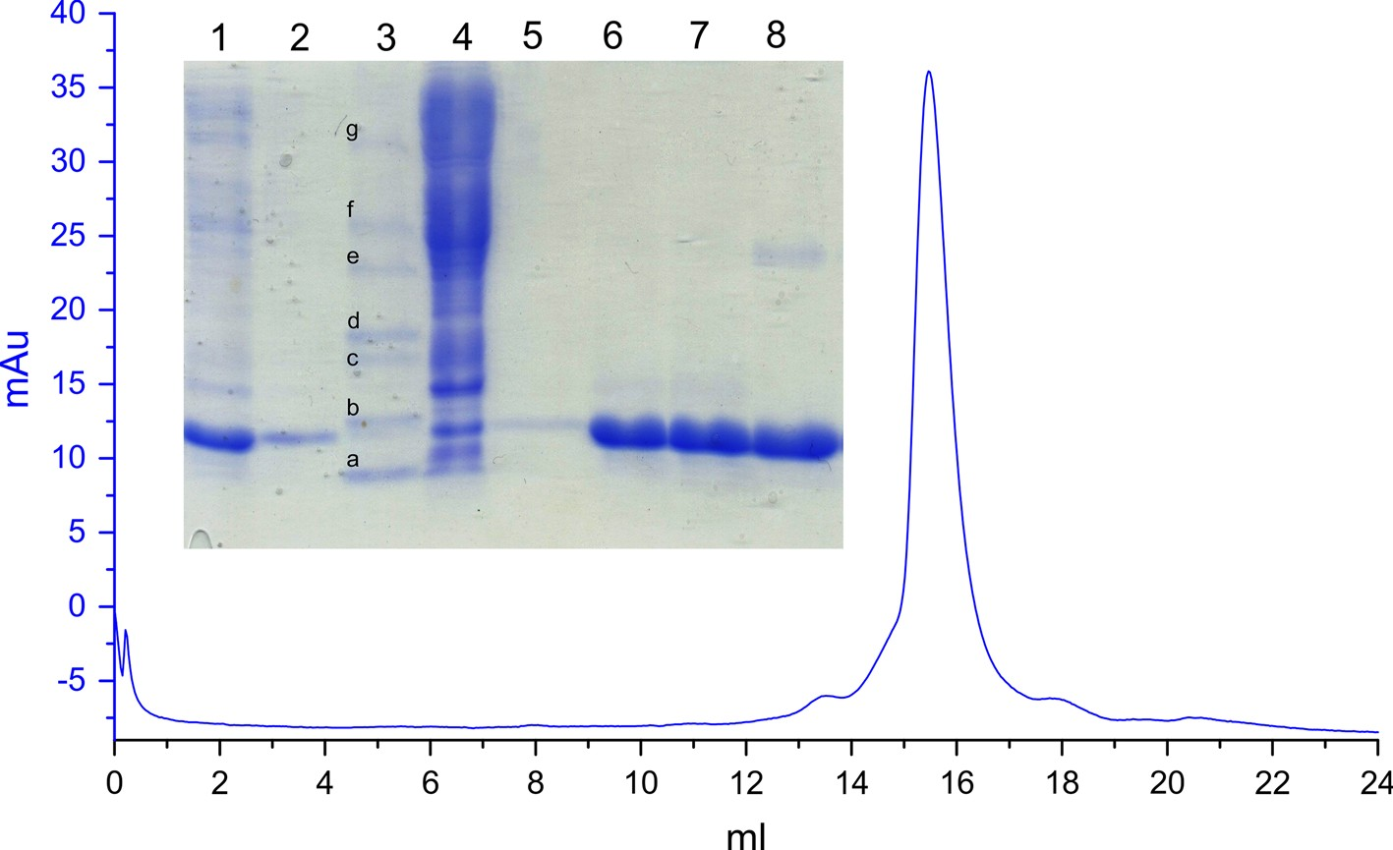
608
Mol Biotechnol (2016) 58:605–618
Fig. 1 Initial step of lactoglobulin purification onFractogel TMAE(S) (the example of sBlgB). Proteins were eluted using 0–50 % gradient of 2 M NaCl in 50 mM phosphate pH 6.5. sBlgB was eluted in peak A (fractions marked byarrowson SDS- PAGE gel)
Fig. 2 SDS-PAGE analysis of rBlgB purification:Line 1pooled fractions collected in anion-exchange chromatography,line 2super- natant after salting out by 7 % (w/v) NaCl,line 3marker (a14.2 kDa,b20.1 kDa,c24 kDa,d29 kDa,e36 kDa,f45 kDa,g66 kDa),line4pellet after salting out by 7 % (w/v) NaCl,line 5pellet aftersalting
out by 30 % (w/v) NaCl re-suspended in phosphate buffer (diluted rBlgB),line 6, 7concentrated rBlgB (15 and 20 mg/ml),line 8natural b-lactoglobulin purchased from Sigma-Aldrich (20 mg/ml). Size exclusion chromatography onSuperdex200 10/300 GLperformed forrBlgB#1(correspondstolines6and7ongel)
loaded on XK 16/20 column (GE Healthcare)
packed by
measurements, buffer containing 20 mM acetate, 20 mM phosphate, 20 mM Tris and 20 mM borate was used and the pH was adjusted to the desired value by adding HCl orNaOH. Each sample was prepared at least a half-hour beforemeasurement.
The protein concentrations 10–15lMand the 200lmpathlengthwereusedforfar-UVmeasurements,whilethe protein concentrations 50lMand the 5 mm path length were used for near-UV measurements. Three scanning acquisitions were accumulated and averaged to yieldthe
Sephadex G75(Pharmacia). Proteins were eluted using 50 mM phosphate buffer pH 6.5 (Fig.3). Eluted fractions were analysed by SDS-PAGE (insertin Fig.3).
Circular Dichroism
CD spectra of rBlgB and sBlgB were recorded at 20°C on a JASCO J-710 spectropolarimeter using 50 mM phos- phate buffer pH 6.5 or 7.5. In the case of pH-dependent
13

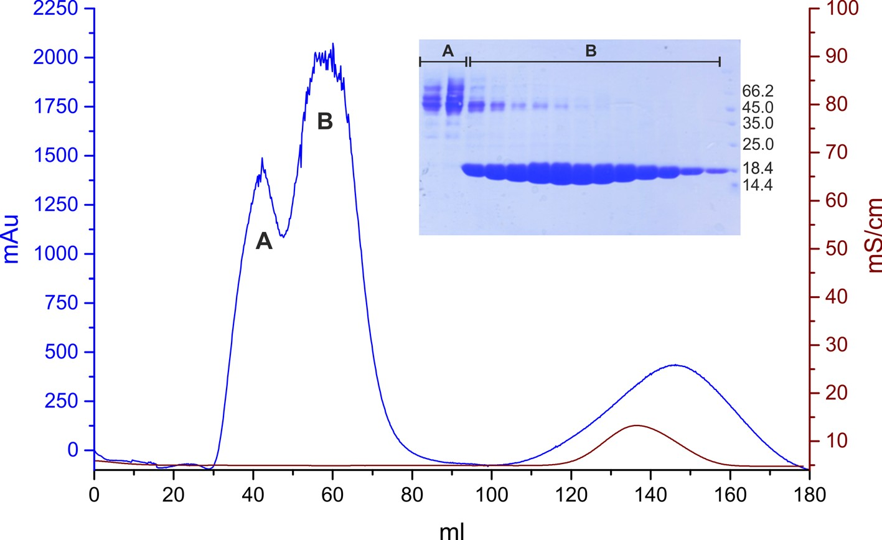
Mol Biotechnol (2016) 58:605–618
609
Fig. 3 Purification of sBlgB#2 onSephadex G75. Fractions
Bcontained almost pure L1A/ I2S-BlgB
final spectrum. CD spectra were corrected for the buffer baseline. The ellipticity was converted to a difference in extinction coefficients. The spectra were normalised to the peptide bonds concentration for far-UV and the protein concentration for near-UV.
The secondary structure composition was estimated using CDPro spectra deconvolution software developed bySreerama and Woody [20]. The best fits were obtained
50 mM phosphate buffer pH 6.5 at room temperature. The samples were prepared 1 day before experiment by mixing a stock solution of the protein with 10 M urea solution in the same buffer to a final concentration of 5lMsBlgB#2 and incubated overnight at room temperature. Global analysis of data in triplicates was conducted usingOriginsoftware assuming a two-state mechanism according to methods described in [21].
using CONTINLL algorithmspectrums data set.
and
the
SDP42
reference
Isothermal Titration Calorimetry
Thermal Denaturation
All ITC experiments, both for recombinant proteins and milk lactoglobulin used as a reference, were carried out at 25°C using a VP-ITC instrument (MicroCal, Northamp- ton, MA, USA). SDS binding experiments were performed according to methods described in our previous paper [22] using 50 mM phosphate buffer pH 6.5 or 50 mM Tris–HCl buffer pH 7.5. Data analysis was performed usingMicroCal Originscientific plotting software according to the model of the single set of identical independent sites. Standard deviations of determined parameters were calcu- lated from at least two titration runs. In the case of data without typical sigmoidal dependence of heats versus reagents molar ratio, fixed value of enthalpy equalto
-31.07kJ/molwasused[22].
Equilibrium thermal unfolding of the sBlgB#2 was moni- tored by CD on aJASCO J-710spectropolarimeter using 1-mm path length quartz thermostated cuvette sealed witha Teflon stopper to avoid evaporation during thermal unfolding. The measurements were taken at 50 mM phos- phate buffer pH 6.5. The temperature of the cuvette in the sample beam was controlled by Julabo circulating water bath. A signal at 200 nm was recorded as a function of temperatureoverarangeof20–95°C.Theheatingratein
the experiments was 1.0°C per minute. The raw temper-
ature scans were processed using a first-order Savitzky– Golay algorithm ofOriginsoftware (version 9.1.0) with a window of 20 points to determine the first-orderderivativesandT_{m}valuesasameanvalueofthreeindependentruns.
Crystallization
ChemicalDenaturation
Recombinant lactoglobulin was crystallised using vapour diffusion method in hanging drop set-up. Small (*0.1–0.2 mm), poorly diffracting crystals of rBlgB appeared only in drops formed by mixing 1–2llof protein (concentrationbetween12.5and25mg/ml)and1–2llof
Urea-induced unfolding of the protein was monitored by CD on a JASCO J-710 spectropolarimeter using 1-mmpath length quartz cuvette. A signal at 220 nm was recordedin
13

610
Mol Biotechnol (2016) 58:605–618
1.8–3.0 M (NH₄)₂SO₄solution in 0.2 M Tris–HCl buffer pH from 7.8 to 8.8. Larger crystals (*0.4 mm) suitable for data collection were obtained in drops containing 1llof
Table 1
Statistic of data collection and structure refinement
rBlgB
sBlgB#1
sBlgB#2
PDB
Endogenous ligand Space group
Unitcell[A˚]
5K06
Yes P6₄22
a= 106.65
b= 106.65
c= 59.31
9.98–2.50
(2.54–2.50)
99.6 (100)
19.7 (20.4)
0.073 (0.228)
64.7 (16.1)
6058 (1043)
21.3
32.4
0.012
1.676
5HTD
Yes P3₂21
a= 53.49
b= 53.49
c= 111.04
13.75–2.50
(2.62–2.50)
98.9 (98.8)
2.8 (2.3)
0.072 (0.348)
8.4 (1.8)
5367 (1293)
20.1
27.2
0.007
1.116
5HTE
No C222₁
a= 54.85
b= 79.09
c= 65.70
13.79–2.40
(2.49–2.40)
97.4 (97.8)
2.5 (1.8)
0.047 (0.616)
13.7 (2.0)
4456 (1187)
21.1
30.3
0.010
1.465
1.34 M sodium citrate in 0.1 M Tris pH 7.5 and 1ll
of
protein (30 mg/ml) for sBlgB#1 or 1llof 2.3 M (NH₄)₂₋SO₄in 0.5 M Tris–HCl pH 8.5 for sBlgB#2.
Data Collection, Structure Solution and Refinement
Resolutionrange[A˚]
X-ray diffraction data for rBlgB crystal were collected at MAX-LAB synchrotron facility at I911-3 beamline(1.00A˚).Crystalswerewashedincryoprotectant(20%
v/v glycerol) and immediately transferred to nitrogen cryostream (100 K). Data were recorded on CCD MAR 165 detector and processed using XDS [23] and HKL2000 [24].
Diffraction data for sBlgB crystals were collected atSuperNovadiffractometer (Rigaku Oxford Diffraction)usingCuKaradiation(1.54A˚)generatedbymicrofocus
radiation source (0.8 mA and 50 kV). Data were collected at 120 K using 20 % v/v glycerol as a cryoprotectant and recorded on 135-mm Atlas CCD detector. Data were pro- cessed usingCrysalis^{Pro}(Rigaku Oxford Diffraction) andScala[25] formCCP4package [26].
Structures of rBlgB, sBlgB#1 and sBlgB#2 were solvedby molecular replacement withPhaser[27] using bovine b-lactoglobulin structure 1BSY or 1B8E as a starting model. Structures were refined byRefmac5[28], while Fourier maps were investigated usingCoot[29]. Statistics of data collection and structure refinement are summarised in Table1. Structures were deposited in Protein Data Bank (PDB) as entries: 5K06, 5HTD, 5HTE.
Completeness [%]
Redundancy
R
merge
I/rI
Reflections (test set)
R[%]
R_{free}[%]
rmsdbonds[A˚]rmsd angles [°]
Ramachandran statistics
Favoured [%]
Allowed [%] Outliers [%]
93
4
2
95
5
0
90
10
0
Folding of Recombinant Bovine b-Lactoglobulin Produced inOrigami B(DE3)
The correctness of recombinant lactoglobulin (rBlgB and sBlgB) folding was routinely verified by CD spectra in the far and near-UV range (Fig.4). The position of extremesdid not depend on the sample, while amplitudes strongly depended on the type of the protein and purification pro- tocol indicating a more dynamic structure of all recombi-nant proteins in comparison with milk b-lactoglobulin. Despite these differences, the quantitative analysis of spectra usingCDProsoftware gave for all analysed recombinant proteins contents of the secondary structures being in agreement with that calculated from crystallo- graphic data (Table S1). The best compliance tosignal observed for milk protein at the near-UV range was for sBlgB#2. The amplitude of both troughs at about 286 and 293 nm and their ratio are close to measured earlier [30,31].
Results
Expression inOrigami B(DE3) and Purification of Recombinant b-Lactoglobulin
The optimal expression time maximising the amount of soluble protein produced inOrigamicells was 3–4 h for rBlgB and 18–20 h (overnight) for sBlgB at room tem- perature. To monitor expression level, samples of cell culture were collected and analysed by SDS-PAGE. Inspection of gels (Fig. S2) clearly showed that bandshaving a molecular weight about 24 kDa (DsbC) and 18 kDa (BlgB) appeared 1 h after induction and their intensity increased withtime.
The typical yield of soluble protein (purity B90 %, Fig.3) obtained from 4 to 5 g wet cells produced in 1 L culture medium was about 15–20 mg of rBlgB or sBlgB (protocol#1)andabout30–40mgofsBlgB(protocol#2).
Ligand Binding by Recombinant Bovine
b-Lactoglobulin Produced inE. coli
Because SDS binding to lactoglobulin is well characterised in the literature [22,32], to verify the ability of the recombinant protein (rBlgB, sBlgB#1 and sBlgB#2) to
13

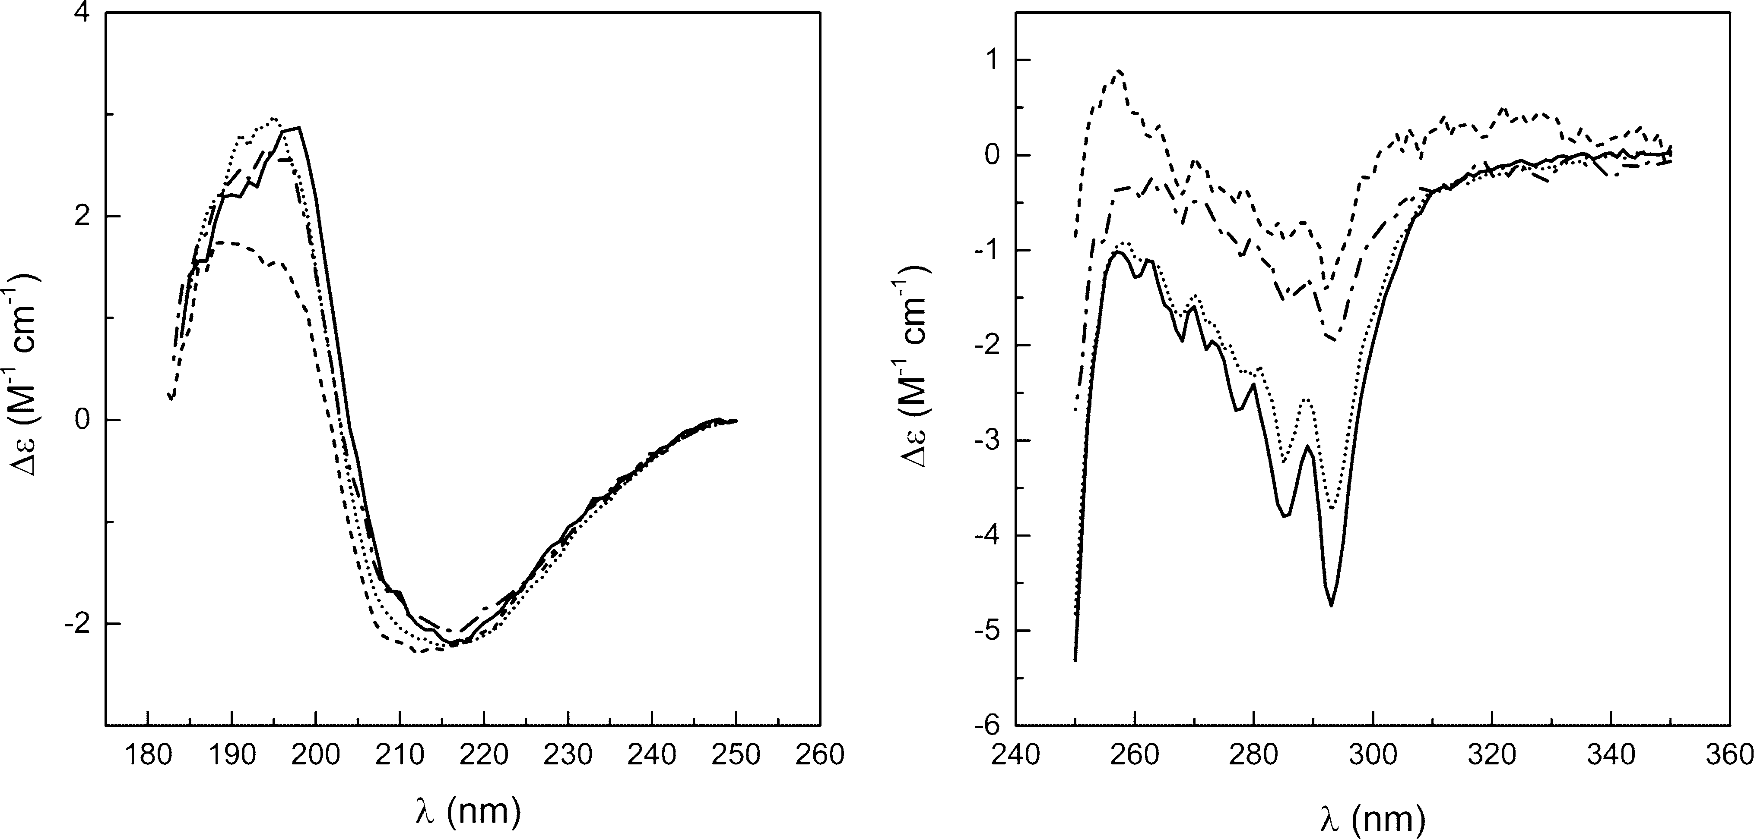
Mol Biotechnol (2016) 58:605–618
611
Fig. 4 Far-UV (left panel) and near-UV (right panel) CD spectra of BlgB (solid line, from [27]), rBlgB (dash-dot line), sBlgB#1 (dashed line) and sBlgB#2 (dotted line) in 0.05 M phosphate buffer pH 7.5, 20°C. Dewas normalised by peptide bonds or protein concentration
bind ligands, we selected it as a model ligand. Observed initial heat release (Fig.5) was consistent with effect measured for BlgB isolated from milk [22,32,33]. The binding constantK_{a}and thermodynamic parameters ofSDS binding are presented in Table2. The stoichiometry for rBlgB and sBlgB#1 was in the range from 0.15 to 0.4,while for sBlgB purified by protocol #2 stoichiometry wasabove0.8.
presence of the uncleaved N-terminal methionine Met0. Fourier maps also showed unexpected elongated density in the hydrophobic pocket of b-barrel. 10–16-carbon long fatty acids were modelled, and the best fit has been observed for 14-carbon myristic acid (MYR) (Fig.6). As the rBlgB was crystallised without the addition of potential ligands, it must have an endogenic origin.
Crystal Structure of sBlgB Purified by Protocol #1
Crystal Structure of rBlgB Purified by Protocol #1
The space group P3₂21 and unit cell parameters of sBlgB crystals correspond very well to the trigonal form ofnatural bovine b-lactoglobulin. The crystal structure was in agreement with MS results, indicating that N-terminal methionine has been successfully cleaved(determined
m.w. was 18,211.7±5 Da, while the calculated was 18,213.05 Da). The electron density is well visible for almost entire protein chain; the exception is flexible loop GH. Electron density maps confirmed that disulphide bridges, between residues Cys66–Cys160 and Cys106– Cys119, are correctly formed, so the applied system of BlgB co-expression with DsbC works efficiently for lac- toglobulin sequence carrying mutation L1A/I2S.
Similarly to previous structure, electron density maps revealed the presence of a ligand in the b-barrel, even though no ligand was added to protein solution and crys- tallization drops (Fig.6). The electron density in the binding pocket was similar to that observed in the struc- tures of lactoglobulin–fatty acid complexes, and it has been interpreted as a myristic acid [22,34]. Superposition of sBlgB structure with BlgB-MYR complex (PDB: 3UEV)
Crystals of rBlgB obtained from ammonium sulphatepoorlydiffractX-rays,anddatacollectionrequiredtheuseofsynchrotronradiation.TheunitcellsymmetryP6₄22 was not observed previously for b-lactoglobulin. Theasymmetricunitcontainsoneproteinchain(Fig.6).With theexceptionofGHloopwhichisdisordered,theelectrondensityiswelldefinedforentireproteinchainandshowsthat disulphide bridges are correctly formed. Thedensity also allowed to resolve two alternative conformations of N-terminal part of the polypeptide chain located oncrys- tallographictwofoldaxis.Additionalelectrondensity,notobserved previously in structures of bovine milk lac-toglobulin,wasfoundnearN-terminalfragmentofproteinmolecules. Mass spectrometry revealed thatmolecular weight[M?H]?ofrBlgBwas18,409.8(±5)Da,about
128.6 Da more than calculated from its sequence usingCompute pI/MwfromExpasyserver. This difference cor- responds within experimental error to the mass of methionine (132 Da). Chemical sequencing (see‘‘Purifi-cation Protocol#1’’section and Fig. S1) confirmed the
13

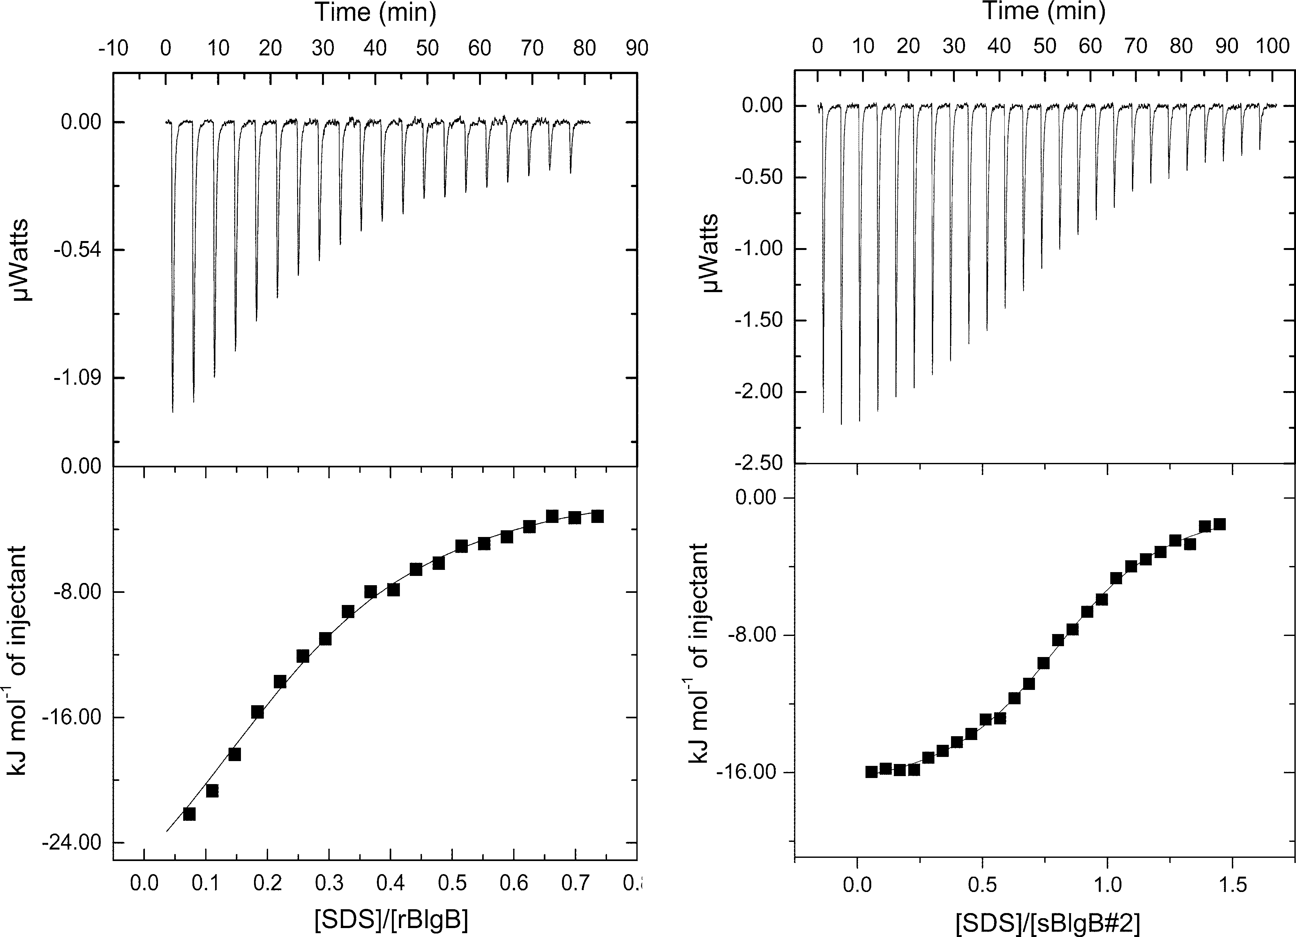
612
Mol Biotechnol (2016) 58:605–618
Fig. 5
Calorimetric isotherms of SDS binding to rBlgB (left panel)
500lMfor rBlgB and 37 and 100lMfor sBlgB#2. Thesolid linerepresents the best fit of experimental data to the one site bindingmodel.Afixedvalueofenthalpy(-31.07kJ/mol)wasusedincaseofrBlgB
and sBlgB#2 (right panel). The experiments were performed at 25°C
in 50 mM Tris–HCl buffer pH 7.5 and 50 mM phosphate buffer pH 6.5, respectively. The protein and ligand concentrations were 28 and
Table 2 Thermodynamic parameters of SDS binding
Ligand binding

K_{a}(910⁵M⁻¹)
n
DG(kJ/mol)
DH(kJ/mol)
TDS(kJ/mol)
rBlgBªsBlgB#1ªsBlgB#2^{b}
Milk BlgB^{b}
-31.07^{c}
-31.07^{c}
-17.6±0.2
-20.3±0.1
0.17–0.41
0.19–0.38
0.82–0.84
1.01–1.05
5.3±1.5
1.6±0.7
4.2±0.2
3.6±0.6
-32.6±0.7
-29.5±0.9
-32.1±0.1
-31.7±0.5
n.d.
n.d.
14.54±0.1
11.45±0.2
a
50 mM Tris–HCl, pH 7.5
50 mM phosphate, pH 6.5
A constant value taken from [22]
b
c
revealed almost the same position of ligand in both struc- tures (Fig.6c).
observedseveraltimesfornatural,unligandedprotein[35,36].Theelectron densityiswell definedexceptfor flexibleloopsCD andGHanddisorderedC-terminalfragment 155–162. Contrarytoproteinpurifiedbyprotocol#1,thereisnoevidenceofanyligandboundinthebindingsite(Fig.6d).SuperpositionofsBlgB#2andthree natural b-lactoglobulin structuresofthesamespace group symmetry gave r.m.s.d. valuesforC_{a}inthe
range0.39–0.47A˚(Fig.7a,b).
Crystal Structure and Properties of sBlgB Purified by Protocol #2
The crystals obtained using recombinant sBlgB purified by protocol #2 had space group symmetry C222₁, the same as
13

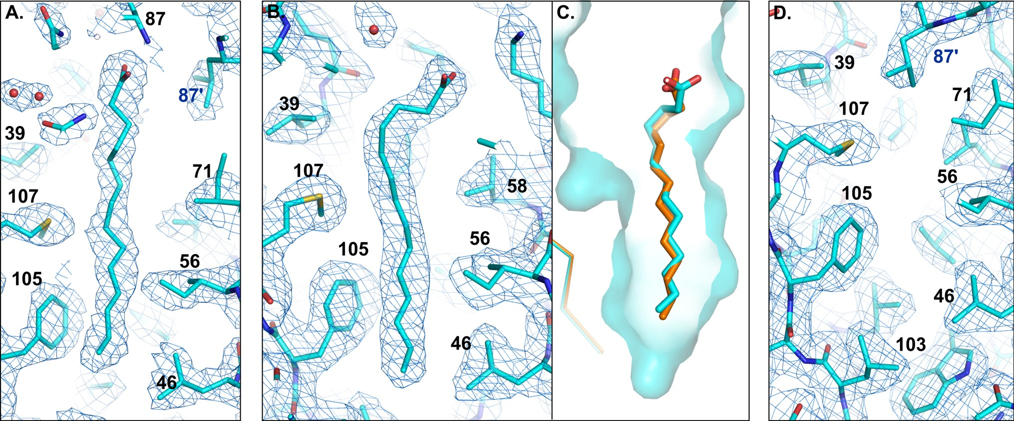
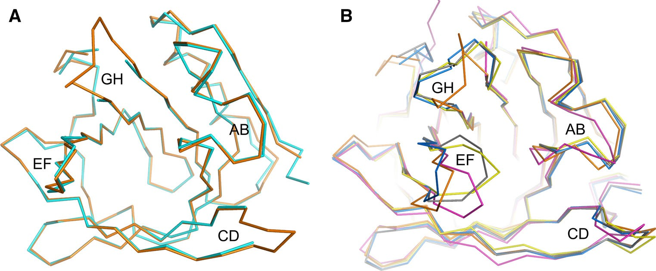
Mol Biotechnol (2016) 58:605–618
613
Fig.6 Electron density map around endogenous ligand bound inb-barrelofarBlgB(1.2r)andbsBlgB#1(1.0r).cThepositionofligandinsBlgB#1(cyan)andinmilklactoglobulincomplexwith
myristicacid(orange,PDB:3UEV).dElectrondensitymap(1.0r)around residues in empty b-barrel in sBlgB#2 (Color figure online)
ITC experiments performed using SDS as a model ligand provided binding parameters (Table2) being in good agreement with parameters obtained by us in refer- ence experiments with milk Blg in the same conditions and others[33].
To further characterise sBlgB#2 protein, we also per- formed thermal and chemical denaturation experiments.The results of urea-induced denaturation presented in Table3show that the stability of a recombinant protein islower than of milk protein by about 11.5 kJ/mol, but theirC_{mid}values are similar. Also, the thermal denaturation of the protein analysed as the temperature dependence of the CD signal derivative measured at 200 nm indicates lower stability of sBlgB#2 in comparison with milk protein. TheT_{m}value decreased from 79.4±1.4°C for milk proteinto
72.8±0.4°CforsBlgB#2.AstoragestabilityofsBlgB#2
was monitored by measurements of CD spectra. We did not
observe any change in a term of 2 weeks at room tem- perature and at 4°C (Fig. S3).
Because it is known that pH strongly modifies the Blg properties, especially its ability to bind ligands [37–39], CD signal versus pH was measured for sBlgB#2 and nat- ural BlgB isolated from milk and no significant differences have been found (Fig.S4).
Discussion
Expression of b-Lactoglobulin inE. coli
Although recombinant bovine lactoglobulin has been suc- cessfully produced in eukaryotic expression systems
(Pichia pastoris)
[7], the production of correctly folded
protein in bacteria was unsuccessful until 2010. The
Fig. 7 a Superposition of sBlgB#2 structure (cyan, C222₁) and natural lactoglobulin (orange, PDB: 1B8E, C222₁). b Superposition of lactoglobulin structures: rBlgB (chain C:magenta), PDB: 1BSY (blue), PDB:3BLG
(grey), PDB: 1B8E (orange), PDB: 1BEB (yellow) (Color figure online)
13

614
Mol Biotechnol (2016) 58:605–618
Table 3 Thermodynamic parameters of protein chemical unfolding for protein concentration in range from 0.1 to 0.73 mg/ml
Experimental conditions
Chemical denaturation parameters

pH
Ionic strength (mM)
DG_{D}(kJ/mol)
m(kJ/mol M)
C_{mid}(M)
Ref.
Recombinant sBlgB#2
6.5
50
16.2±2.4
3.9±0.6
4.18
This work
Natural (milk) BlgB
6.5
7.0
6.2
6.85
8.3
50
50
10
10
10
27.7±5.4
25.0±1.5
12.1±5.5
27.8
20.5±4.6
6.5±1.3
6.5±0.35
3.77±1.26
6.4
5.02±0.85
4.26
3.8
3.2±0.8
4.35
3.9±0.4
This work [47]
[21]
[48]
[21]
breakthrough was made by Ponniah et al. [12] who found that BlgB must be co-expressed inE. coli Origamicells together with bacterial disulphide bond isomerase (DsbC). We used this expression system and purification protocol without any major modifications to produce recombinant lactoglobulin in our laboratory. However, we have noticed that obtained protein (rBlgB) had properties different than protein isolated from milk.
The ITC experiments gaveK_{a}values of SDS binding to rBlgB in agreement with values obtained using milk pro- tein in the same conditions [22,33], but the binding stoi- chiometry in the range 0.17–0.41 was much lower than expected. This result could be explained by partially incorrect folding of the protein or by the occupation of the binding pocket by endogenous ligand. The second hypothesis has been confirmed by the crystal structure of rBlgB which showed the presence of endogenous aliphatic ligand bound inside the b-barrel (Fig.6a).
Mass spectrometry revealed that molecular weight [M?H]?of rBlgB was higher than the expected value by
128.59 Da indicating the possible presence of uncleaved N-terminal methionine. The chemical sequencing of rBlgB unambiguously confirmed this hypothesis (Fig. S1). The uncleaved N-terminal Met is sometimes observed in recombinant proteins, and its impact on protein properties and stability can be positive, insignificant or negative. Uncleaved N-terminal methionine was found e.g. in recombinant hen egg white lysozyme produced inE. coli.In this case, it was found that protein with additional Met had lower refolding rate and solubility in comparison with wild-type protein [40]. The N-terminal methionine present in recombinant rubredoxin fromPyrococcus furiosushad a moderate effect on protein thermal stability and structure [41]. Crystal structure of recombinant rubredoxin showed that extra methionine has changed only the hydrogen bond pattern in its close neighbourhood [41].
The positive effect of the N-terminal Met on protein stability was observed in recombinant ribonuclease A (RNase A) [42]. Enzyme containing uncleaved N-terminal Met had enzymatic activity close to that of bovine RNase
A, while its transition midpoint for thermal unfolding was
1.5°C higher than that of natural bovine RNase A [42]. Contrary, N-terminal methionine, which was detected in recombinant goat a-lactalbumin expressed inEscherichiacoli, remarkably decreased the stability of the protein and increased its apparent net negative charge. It also affected the packing of a-lactalbumin molecules in the crystalline phase and altered crystal symmetry [43].
Likewise, in rBlgB uncleaved starting methionine neg- atively influenced properties of protein, affecting not only binding stoichiometry but also crystallization conditions and intermolecular interactions in the crystalline phase. The crystallization trials showed that rBlgB could be crystallised only from the high concentration ofammonium sulphate (2.8–3.0 M) and such conditions produced small, poorly diffracting crystals with morphology and symmetry substantiallydifferentthanobservedfornaturalprotein.
The origins of such differences have become understood later, after careful analysis of crystal structure. They arethe effect of partial disorder around N-terminus fragments with uncleaved Met, which also affects positions of other resi- dues. Superposition of rBlgB and known structures of milk lactoglobulin (1BSY, 1BEB and 3NQ3) revealed that N-terminal parts of the protein chain and AB loophave
positionshiftedbyabout2–5A˚incomparisonwithits
location in trigonal structures.
Hirel et al. [44] have found that in bacteria cells, the catalytic efficiency of N-terminal methionine excision by MAP (_{L}-methionine amino peptidase) depends on the nat- ure of the second amino acid in the polypeptide chain. Efficiency of MAP decreases when the side chain length of the penultimate amino acid increases. This dependence is related to the structure of the enzyme active site in which each subsite is able to accommodate side chain with specified dimensions [44,45]. The rate of N-terminal Met processing is the highest for residues possessing short side chains (Gly, Ala, Pro, Ser, Thr, Val) while the sequence of BlgB starts with relatively large leucine and isoleucine. To eliminate N-terminal Met, we have engineered two muta- tions (L1A/I2S), which were designed according to more
13

Mol Biotechnol (2016) 58:605–618
615
recent findings by Frottin et al. [45]. They observed that most efficient cleavage of N-terminal Met occurs when an N-terminal sequence is Met–X–Y, where X is Gly, Ala, Pro, Ser and Y is Gly, Ala, Trp, Met or Ser. We have decided to replace Leu1 by Ala, which is thenonpolar residue with shorter side chain, so such substitution in contrast to Gly, Pro or Ser should not affect the protein properties significantly. In the second position, Ile hasbeen replaced by Ser, to avoid residue with large side chain(Trp, Met) and duplicationof residues (Ala).
The presence of additional Met at N-terminus was not reported by Ponniah et al. [12] who checked only CD and NMR spectra of recombinant lactoglobulin. These tech- niques are also not sensitive enough to show the differ- ences, especially when the core of protein made of b-barrel is correctly folded. Interestingly, the presence of uncleaved Met was also not recognised by Crowther et al. [46] who expressed recombinant caprine b-lactoglobulin using the same DsbC-co-expression system. The recombinant goat protein was crystallised, and structure was solved with ultra-high resolution (PDB: 4TLJ). But careful investiga- tion of electron density maps that are available for this structure onElectron Density Serverrevealed an extra electron density near N-terminus in which methionine canideally be fitted, as predicted.
overnight dialysis procedures, but the efficiency of purifi- cation is relatively low. For these reasons, we have decided to modify this protocol. In the protocol #2, instead of two salting out and dialysis steps, we have used the size exclusion chromatography on Sephadex G75 at pH 6.5. Such replacement allowed us to obtain the recombinant L1A/I2S BlgB variant with the unblocked binding site (sBlgB#2). The protocol #2 also eliminates the need of strong acidification of protein solution to pH 2.6 whichwas necessary to precipitateE. coliproteins (Fig.2). Instead, in protocol #2, bacterial proteins were separated from lac- toglobulin in gel filtration step, because most of them have molecularmasseshigherthanlactoglobulin(Fig.3).
The observation that protocol #2 allows obtaining a protein with empty b-barrel indicates that ligand was trapped in the BlgB b-barrel in the purification process rather than during expression inE. coli. Binding of fatty acid might occur e.g. at cell lysis step or later, at low-pH salting out. Another possibility is that in the acidic envi- ronment most of the lactoglobulin molecules, especially those that were not stabilised by a fatty acid, have been denaturated. Only a small fraction of lactoglobulin mole- cules with a bound ligand was stable enough to remain soluble. Such hypothesis would also explain low efficiency of lactoglobulin purification by protocol #1.
Purification Protocols of Recombinant
b-Lactoglobulin
Binding Properties and Stability of sBlgB#2
As ITC showed it, sBlgB#2 can bind model ligand (SDS) with the stoichiometry 0.8 (Table2). The value of the stoichiometry lower than 1.0 is in agreement with our previous data [22,34] and was also observed in other experiments [29]. The binding constantK_{a}is in good agreement with reference data obtained from milk protein [22,33]. The values of the enthalpy and entropy changes determined for sBlgB#2 are higher by about 3 kJ/mol but compensate, giving DGalmost the same as observed for milk protein (Table2). These data show that recombinant protein, despite substitutions L1A/I2S introduced at N-terminus, has binding properties comparable to natural b-lactoglobulin isolated from milk.
The chemical stability of sBlgB#2 determined by urea- induced denaturation (Fig.8) can be described by the two- state model and is lower than measured by us for com- mercially available milk protein (Table3). Survey of results reported by other authors [21,47,48] shows con- siderable discrepancies, both negative and positive, in theC_{mid}values even for data determined spectroscopically at similar experimental conditions and analysed with the use of the same model of denaturation (Table3). It indicates that not only experimental conditions but also protein ori- gin might influence obtained values, and such finding suggests that lower than expected value ofchemical
The new lactoglobulin variant carrying substitutions L1A/ I2S at N-terminus (sBlgB) has been produced and puri- fied by two different protocols. The sBlgB purified by protocol #1, based on the method proposed by Ponniah et al. [12], had spectroscopic properties corresponding very well to milk protein (Fig.4) and crystallised in the con- ditions typical for natural protein. However, ITC tests were constantly showing a very low stoichiometry of SDS binding, with the values similar to the observed for rBlgB (Table2). These results indicated that the binding site of sBlgB#1 was probably occupied by endogenous ligand. This hypothesis was verified by the crystal structure, which confirmed the presence of the endogenous ligand in the b-barrel. Elongated electron density observed in the bind- ing site was interpreted as 14-carbon myristic acid. How- ever, its origin is unknown. It might be either fatty acid present in cytoplasm and bound during expression or fatty acid from disrupted cell membranes which has bound during purification. The second possibility seems to be the most probable because the modification of a purification protocol allowed to obtain the sBlgB with empty b-barrel (Fig.6d).
Purification of L1A/I2S BlgB variant by protocol #1 requires one chromatography step and two time-consuming
13

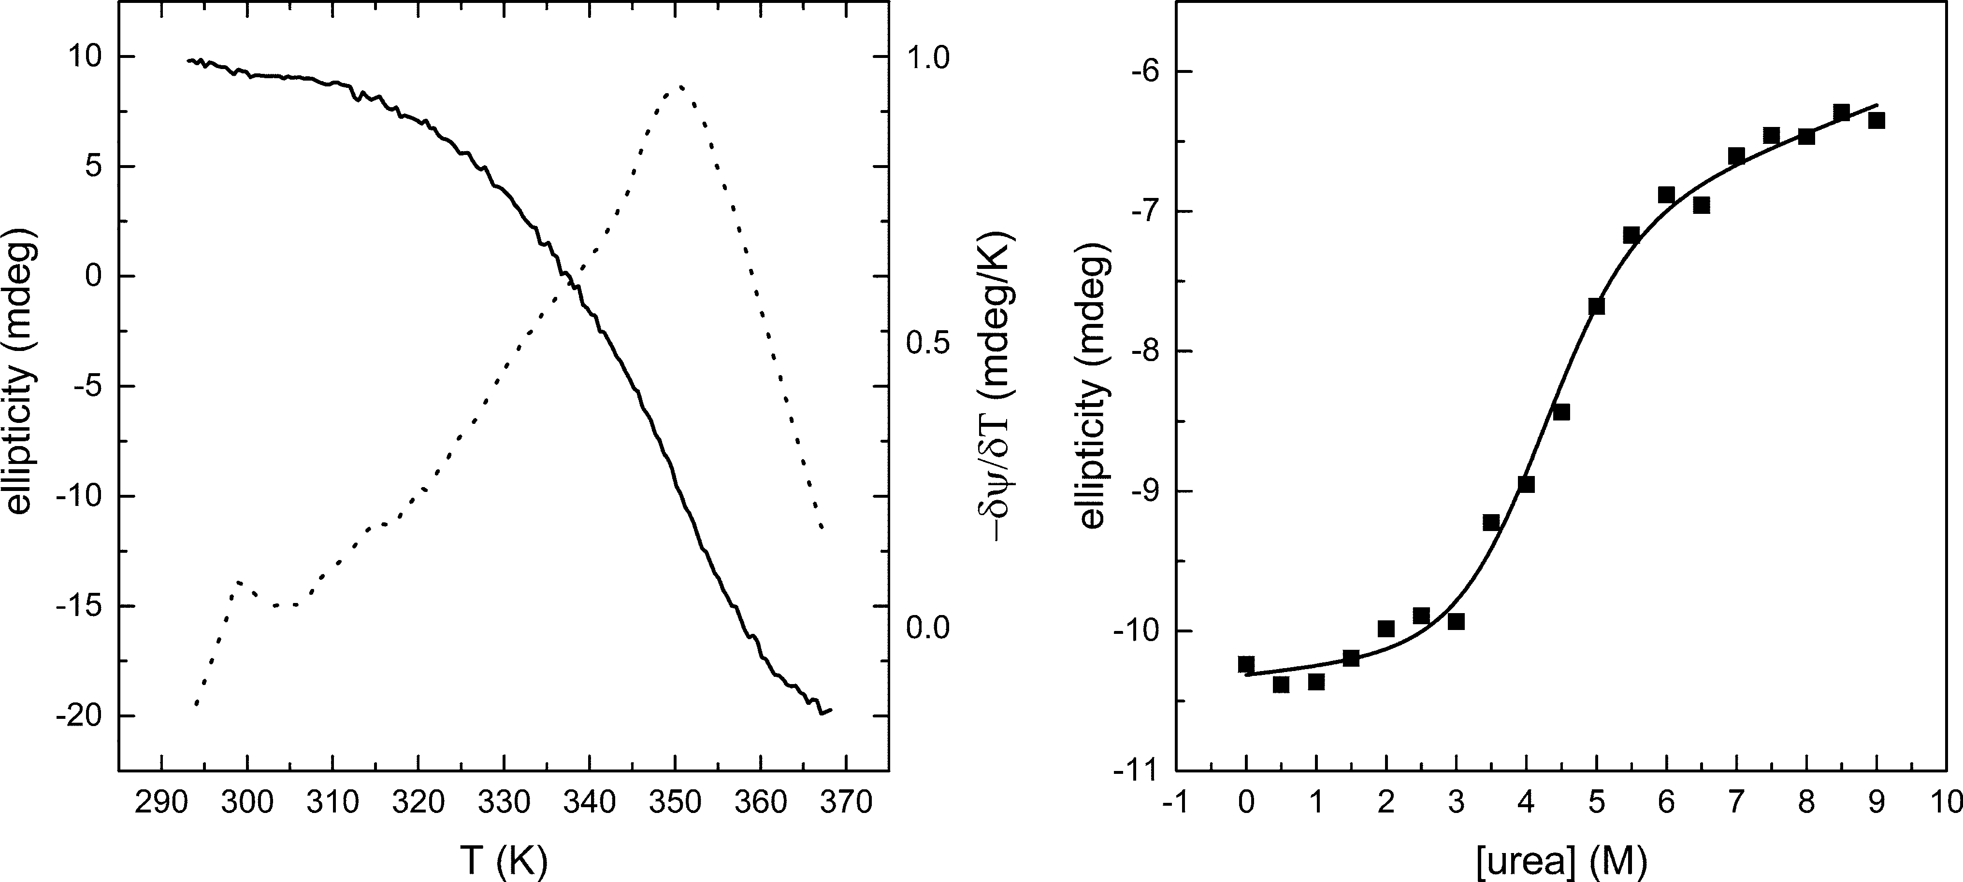
616
Mol Biotechnol (2016) 58:605–618
Fig. 8
Unfolding of sBlgB#2 studied by circular dichroism spec-
derivative (dotted line).Right panelurea concentration induced unfolding of 10lMprotein reported at 220 nm. Thesolid linerepresents the best fit of the data to the two-state model of denaturation
troscopy. The experiments were performed at 20°C in phosphate
buffer at concentration 0.05 M and pH 6.5.Left panelthe thermal unfolding of 12lMprotein reported at 200 nm (solid line) and its
stability of sBlgB#2 cannot be interpreted as the negative attribute of recombinant protein.
Similar ambiguous observation concerns lactoglobulin thermal denaturation parameters (Fig.8). DeterminedT_{m}value has pointed lower thermal stability of sBlgB#2 in comparison with milk protein. On the other hand, the thermal stability of milk lactoglobulin determined previ- ously spectroscopically at similar experimental conditions variesintherange68–80.1°C[49].
Our studies also show that the CD signal dependence on
pH for sBlgB#2 was in agreement with the one recorded for milk protein (Fig S4). We have limited our investiga- tions to one method and pH range from 4 to 10, in which only two conformational transitions of lactoglobulin could be analysed: so-called N-to-Q transition [50] and Tanford transition [37]. High similarity of signals from both pro- teins and their consistency with data measured earlier [38] indicate in sBlgB#2 and milk protein the same nature ofthe conformationalchanges.
that substitutions of N-terminal residues did not influencestability and binding properties of the protein significantly.Therefore, it can be concluded that sBlgB#2 is a goodsubstitute for natural lactoglobulin which can be used in thebiochemical, biophysical, food and nanomaterials studies.It is also an excellent starting model for further engineeringwhich would change its binding affinity towards selectedligands. New, engineered lactoglobulin with mutations inregion of the binding pocket can potentially have an
application in medicine.
Acknowledgments This study was supported by the Polish National Science Centre, Grant Number: 2012/05/B/ST5/00278. The research was carried out with equipment purchased thanks to the financial support of the European Regional Development Fund within the framework of the Polish Innovation Economy Operational Pro- gramme (Contract No. POIG.02.01.00-12-023/08). We would also like to thank Dr. Marta Gawin for performing the mass spectrometry experiments.
Open Access This article is distributed under the terms of the Creative Commons Attribution 4.0 International License (http://creativecommons.org/licenses/by/4.0/), which permits unrestricted use, distribution, and reproduction in any medium, provided you give appropriate credit to the original author(s) and the source, provide a link to the Creative Commons license, and indicate if changes weremade.
Conclusions
High similarity of L1A/I2S BlgB purified by protocol #2 to natural protein has been confirmed by CD spectra, calori-metric studies, crystallization conditions and crystal structure. Because thermodynamic parameters of ligand binding are sensitive to pH, ionic strength and temperature, both sBlgB and milk protein used as a reference were investigated in the same conditions. All results confirmed
References
1. Izadi, Z., Divsalar, A., Saboury, A. A., & Lindsay, S. (2016). b-lactoglobulin–pectin nanoparticle-based oral drug delivery system for potential treatment of colon cancer.Chemical Biology& Drug Design,. doi:10.1111/cbdd.12748.
13

Mol Biotechnol (2016) 58:605–618
617
- Ali,A., Mekhloufi, G., Huang, N., & Agnely, F. (2016). b-lac- toglobulin stabilized nanemulsions—Formulation and processfactors affecting droplet size and nanoemulsion stability.Inter-national Journal of Pharmaceutics, 500(1–2), 291–304. doi:10.1016/j.ijpharm.2016.01.035.
- Rastegari, B., Karbalaei-Heidari, H. R., Yousefi, R., Zeinali, S., & Nabavizadeh, M. (2016). Interaction of prodigiosin with HSAand b-Lg: Spectroscopic and molecular docking studies.Bioor-ganic & Medicinal Chemistry, 24(7), 1504–1512. doi:10.1016/j.bmc.2016.02.020.
- Wilde, S. C., Keppler, J. K., Palani, K., & Schwarz, K. (2016). b- Lactoglobulin as nanotransporter—Part I: Binding of organosul-fur compounds.Food Chemistry, 197(Pt A), 1015–1021. doi:10.1016/j.foodchem.2015.11.010.
- Teng, Z., Luo, Y., Li, Y., & Wang, Q. (2016). Cationic beta- lactoglobulin nanoparticles as a bioavailability enhancer: Effectof surface properties and size on the transport and deliveryin vitro.Food Chemistry, 204, 391–399. doi:10.1016/j.foodchem.2016.02.139.
- Mizumachi, K., Kurisaki, J., Tsuji, N. M. (1993). High-level expression of recombinant bovine ß-lactoglobulin in insect cells.In S. Kaminogawa, A. Ametani, & S. Hachimura (Eds.),Animalcell technology: Basic and applied aspects(pp. 115–121). Dor- drecht: Springer.doi:10.1007/978-94-011-2044-9.
- Kim,T. R., Goto, Y., Hirota, N., Kuwata, K., Denton, H., Wu, S. Y., et al. (1997). High-level expression of bovine beta-lac- toglobulin inPichia pastorisand characterization of its physicalproperties.Protein Engineering,10(11), 1339–1345. Retrieved fromhttp://www.ncbi.nlm.nih.gov/pubmed/9514124.
- Totsuka, M., Katakura, Y., Shimizu, M., Kumagai, I., Miura, K.,& Kaminogawa, S. (1990). Expression and secretion of bovine beta-lactoglobulin inSaccharomyces cerevisiae.Agricultural andBiological Chemistry,54(12), 3111–3116. Retrieved fromhttp://www.ncbi.nlm.nih.gov/pubmed/1368635.
- Hyttinen,J.M.,Korhonen,V.P.,Hiltunen,M.O.,Myo¨ha¨nen,S.,
- Gebauer, M., & Skerra, A. (2012). Anticalins small engineered binding proteins based on the lipocalin scaffold.Methods inEnzymology, 503, 157–188. doi:10.1016/B978-0-12-396962-0.00007-0.
- Collini, M., D’Alfonso, L., Molinari, H., Ragona, L., Catalano, M., & Baldini, G. (2003). Competitive binding of fatty acids and the fluorescent probe 1-8-anilinonaphthalene sulfonate to bovine beta-lactoglobulin.Protein Science: A Publication of the ProteinSociety, 12(8), 1596–1603.doi:10.1110/ps.0304403.
- Hirano, H., Komatsu, S., Kajiwara, H., Takagi, Y., &Tsunasawa,
S. (1993). Microsequence analysis of the N-terminally blocked proteins immobilized on polyvinylidene difluoride membrane by Western blotting.Electrophoresis, 14(1), 839–846. doi:10.1002/elps.11501401134.
- Resemann, A., Paape, R., & Suckau, D. (2012). Precise MW determination of intact proteins by multiple charge state analysis of MALDI generated ions. Bruker Daltonics GmbH, Bremen, Germany, Application Note #MT-112.
- Sreerama, N., & Woody, R. W. (2000). Estimation of protein secondary structure from circular dichroism spectra: Comparison of CONTIN, SELCON, and CDSSTR methods with an expanded reference set.Analytical Biochemistry, 287(2), 252–260. doi:10.1006/abio.2000.4880.
- D’Alfonso, L., Collini, M., & Baldini, G. (2002). Does b-Lac- toglobulin Denaturation Occur via an Intermediate State?Bio-chemistry, 41(1), 326–333.doi:10.1021/bi0115028.
- Loch,J.I.,Bonarek,P.,Polit,A.,Swia˛tek,S´.,Dziedzicka-Wa-sylewska,M.,&Lewin´ski,K.(2013).Thedifferencesinbinding
12-carbon aliphatic ligands by bovine b-lactoglobulin isoform A and B studied by isothermal titration calorimetry and X-ray crystallography.Journal of Molecular Recognition: JMR, 26(8), 357–367. doi:10.1002/jmr.2280.
- Kabsch, W. (2010). Integration, scaling, space-group assignment and post-refinement.Acta Crystallographica. Section D, Biolog-ical Crystallography, 66(Pt 2), 133–144. doi:10.1107/S0907444909047374.
- Otwinowski, Z., & Minor, W. (1997).Processing of X-raydiffraction data collected in oscillation mode. Methods in enzy-mology(Vol. 276). Harvard: Elsevier. doi:10.1016/S0076-6879(97)76066-X.
- Evans, P. (2006). Scaling and assessment of data quality.ActaCrystallographica. Section D, Biological Crystallography, 62(Pt 1), 72–82.doi:10.1107/S0907444905036693.
- Winn, M. D., Ballard, C. C., Cowtan, K. D., Dodson, E. J., Emsley, P., Evans, P. R., et al. (2011). Overview of the CCP4 suite and current developments.Acta Crystallographica. Sec-tion D, Biological crystallography, 67(Pt 4), 235–242. doi:10.1107/S0907444910045749.
- McCoy, A. J., Grosse-Kunstleve, R. W., Adams, P. D., Winn, M. D., Storoni, L. C., & Read, R. J. (2007). Phaser crystallographicsoftware.Journal of Applied Crystallography, 40(Pt 4), 658–674.doi:10.1107/S0021889807021206.
- Murshudov,G.N.,Skuba´k,P.,Lebedev,A.A.,Pannu,N.S.,Steiner, R. A., Nicholls, R. A., et al. (2011). REFMAC5 for the refinement of macromolecular crystal structures.Acta crystallo-graphica. Section D, Biological crystallography, 67(Pt 4), 355–367.doi:10.1107/S0907444911001314.
- Emsley, P., Lohkamp, B., Scott, W. G., & Cowtan, K. (2010). Features and development of Coot.Acta Crystallographica.Section D, Biological Crystallography, 66(Pt 4), 486–501.doi:10.1107/S0907444910007493.
- Manderson, G. A., Creamer, L. K., & Hardman, M. J. (1999). Effect of heat treatment on the circular dichroism spectra of bovine beta-lactoglobulin A, B, and C.Journal of Agriculturaland Food Chemistry, 47(11), 4557–4567. doi:10.1021/jf981291m.
&
Ja¨nne,J.(1998).High-levelexpressionofbovinebeta-lac-
toglobulin gene in transgenic mice.Journal of Biotechnology,61(3), 191–198. Retrieved fromhttp://www.ncbi.nlm.nih.gov/pubmed/9684337.
- Hazebrouck,S.,Pothelune,L.,Azevedo,V.,Corthier,G.,Wal,J.- M., & Langella, P. (2007). Efficient production and secretion of bovine beta-lactoglobulin byLactobacillus casei.Microbial CellFactories, 6, 12.doi:10.1186/1475-2859-6-12.
- Ariyaratne, K. A. N. S., Brown, R., Dasgupta, A., de Jonge, J., Jameson, G. B., Loo, T. S., et al. (2002). Expression of bovine b- lactoglobulin as a fusion protein inEscherichia coli: A tool for investigating how structure affects function.International DairyJournal, 12(4), 311–318.doi:10.1016/S0958-6946(02)00027-4.
- Ponniah,K.,Loo,T.S.,Edwards,P.J.B.,Pascal,S.M.,Jameson,
G. B., & Norris, G. E. (2010). The production of soluble and correctly folded recombinant bovine beta-lactoglobulin variants A and B inEscherichia colifor NMR studies.Protein Expressionand Purification, 70(2), 283–289.doi:10.1016/j.pep.2009.12.006.
- Richter, A., Eggenstein, E., & Skerra, A. (2014). Anticalins: Exploiting a non-Ig scaffold with hypervariable loops forthe engineering of binding proteins.FEBS Letters, 588(2), 213–218. doi:10.1016/j.febslet.2013.11.006.
- Gebauer, M., Schiefner, A., Matschiner, G., & Skerra, A. (2013). Combinatorial design of an Anticalin directed against the extra- domain b for the specific targeting of oncofetal fibronectin.Journal of Molecular Biology, 425(4), 780–802. doi:10.1016/j.jmb.2012.12.004.
- Skerra, A. (2008). Alternative binding proteins: Anticalins— harnessing the structural plasticity of the lipocalin ligand pocket to engineer novel binding activities.The FEBS Journal, 275(11), 2677–2683.doi:10.1111/j.1742-4658.2008.06439.x.
13

618
Mol Biotechnol (2016) 58:605–618
- Loch,J.I.,Bonarek,P.,Polit,A.,S´wia˛tek,S.,Czub,M.,Lud-wikowska,M.,&Lewin´ski,K.(2015).Conformationalvari-ability of goat b-lactoglobulin: Crystallographic and thermodynamic studies.International Journal of BiologicalMacromolecules, 72, 1283–1291. doi:10.1016/j.ijbiomac.2014.10.031.
- Gutie´rrez-Magdaleno,G.,Bello,M.,Portillo-Te´llez,M.C.,Rodr´ıguez-Romero,A.,&Garc´ıa-Herna´ndez,E.(2013).Ligandbinding and self-association cooperativity of b-lactoglobulin.Journal of Molecular Recognition, 26(2), 67–75. doi:10.1002/jmr.2249.
- Bello,M.,delPortillo-Te´llez,M.,&Garc´ıa-Herna´ndez,C.E.
(2011). Energetics of ligand recognition and self-association ofbovine b-lactoglobulin: Differences between variants A and B.Biochemistry, 50(1), 151–161. doi:10.1021/bi1016155.
- Loch,J. I., Polit, A., Bonarek, P., Olszewska, D., Kurpiewska,K.,Dziedzicka-Wasylewska,M.,&Lewin´ski,K.(2012).Structuraland thermodynamic studies of binding saturated fatty acidsto
- Bau, R., Rees, D. C., Kurtz, D. M, Jr., Scott, R. A., Huang, H., Adams, M. W. W., & Eidsness, M. K. (1998). Crystal structureofrubredoxinfromPyrococcusfuriosusat0.95A˚resolution,and
the structures of N-terminal methionine and formylmethionine variants of Pf Rd. Contributions of N-terminal interactions to thermostability.Journal of Biological Inorganic Chemistry, 3(5), 484–493. doi:10.1007/s007750050258.
- Schultz, D. A., & Baldwin, R. L. (1992). Cis proline mutants of ribonuclease A. I. Thermal stability.Protein Science: A Publi-cation of the Protein Society, 1(7), 910–916. doi:10.1002/pro.5560010709.
- Chaudhuri, T. K., Horii, K., Yoda, T., Arai, M., Nagata, S., Terada, T. P., & Kumagai, I. (1999). Effect of the extra n-ter- minal methionine residue on the stability and folding of recom- binant alpha-lactalbumin expressed inEscherichia coli.Journalof Molecular Biology, 285(3), 1179–1194. doi:10.1006/jmbi.1998.2362.
- Hirel,P.H.,Schmitter,M.J.,Dessen,P.,Fayat,G.,&Blanquet,
S. (1989). Extent of N-terminal methionine excision fromEscherichia coliproteins is governed by the side-chain length of the penultimate amino acid. InProceedings of the NationalAcademy of Sciences of the United States of America,86(21), 8247–8251. Retrieved fromhttp://www.pubmedcentral.nih.gov/articlerender.fcgi?artid=298257&tool=pmcentrez&rendertype=abstract.
- Frottin,F., Martinez, A., Peynot, P., Mitra, S., Holz, R. C., Giglione, C., & Meinnel, T. (2006). The proteomics of N-ter-minal methionine cleavage.Molecular & Cellular Proteomics:MCP, 5(12), 2336–2349.doi:10.1074/mcp.M600225-MCP200.
- Crowther,J.M.,Lasse´,M.,Suzuki,H.,Kessans,S.A.,Loo,T.S.,Norris, G. E., et al. (2014). Ultra-high resolution crystal structureof recombinant caprine b-lactoglobulin.FEBS Letters, 588(21), 3816–3822.doi:10.1016/j.febslet.2014.09.010.
- Galani, D., & Owusu Apenten, R. K. (1999). Beta-lactoglobulindenaturation by dissociation-coupled unfolding.Food ResearchInternational, 32(2), 93–100.doi:10.1016/S0963-9969(99)00067-8.
- Kella, N. K. D., & Kinsella, J. E. (1988). Structural stability of b-lactoglobulin in the presence of kosmotropic salts A kinetic and thermodynamic study.International Journal of Peptide andProtein Research, 32(5), 396–405.doi:10.1111/j.1399-3011.1988.tb01274.x.
- Busti, P., Gatti, C. A., & Delorenzi, N. J. (2005). Thermalunfolding of bovine b-lactoglobulin studied by UV spectroscopyand fluorescence quenching.Food Research International, 38(5), 543–550.doi:10.1016/j.foodres.2004.11.007.
- Timasheff, S. N., Mescanti, L., Basch, J. J., & Townend,R. (1966). Conformational transitions of bovine beta-lactoglobulins A, B, and C.The Journal of Biological Chemistry, 241(11), 2496–2501.
bovine b-lactoglobulin.International
Journal of Biological
doi:10.1016/j.ijbiomac.
Macromolecules,
2012.03.002.
35. Oliveira, K. M.,
50(4), 1095–1102.
Valente-Mesquita, V. L., Botelho, M. M.,
Sawyer, L., Ferreira, S. T., & Polikarpov, I. (2001). Crystal structures of bovine beta-lactoglobulin in the orthorhombic space group C222(1). Structural differences between genetic variants A and B and features of the Tanford transition.European JournalofBiochemistry/FEBS, 268(2),477–483.
- Vijayalakshmi, L., Krishna, R., Sankaranarayanan, R., & Vija- yan, M. (2008). An asymmetric dimer of beta-lactoglobulin in a low humidity crystal form—Structural changes that accompany partial dehydration and protein action.Proteins, 71(1), 241–249. doi:10.1002/prot.21695.
- Tanford, C., Bunville, L. G., & Nozaki, Y. (1959). The reversible transformation of b-lactoglobulin at pH 7.5 1.Journal oftheAmerican Chemical Society, 81(15), 4032–4036. doi:10.1021/ja01524a054.
- Taulier, N., & Chalikian, T. V. (2001). Characterization of pH- induced transitions of beta-lactoglobulin: Ultrasonic, densimetric, and spectroscopic studies.Journal of Molecular Biology, 314(4), 873–889.doi:10.1006/jmbi.2001.5188.
- Sakurai, K., & Goto, Y. (2007). Principal component analysis of the pH-dependent conformational transitions of bovine beta-lac- toglobulin monitored by heteronuclear NMR.Proceedings of theNational Academy of Sciences of the United States of America, 104(39), 15346–15351.doi:10.1073/pnas.0702112104.
- Mine, S., Ueda, T., Hashimoto, Y., & Imoto, T. (1997). Improvement of the refolding yield and solubility of hen egg- white lysozyme by altering the Met residue attached to its N-terminus to Ser.Protein engineering,10(11), 1333–1338. Retrieved fromhttp://www.ncbi.nlm.nih.gov/pubmed/9514123.
13

