
XIV International Conference on Topics in Astroparticle and Underground Physics (TAUP 2015) IOP Publishing
Journal of Physics: Conference Series 718 (2016) 042062 doi:10.1088/1742-6596/718/4/042062

The DarkSide-50 outer detectors
S Westerdalec P Agnes", L Agostino6, I F M Albuquerquec,d,
T Alexander6,7, A K Alton-, K Arisakah, H O Back6i, B Baldinf,
K Bieryf, G Bonfini7, M Bossak, B Bottino1m, A Brigatti",
J Brodskyc, F Budanoop, S Bussinoop, M Cadedduqr, L Cadonati6,
M Cadoniqr, F Calapricec, N Cancis j, A Candela7, H Caoc,
M Cariellom, M Carlini7, S Catalanotti*", P Cavalcantev j,
A Chepurnovw, A G Cocco", G Covone*", D D’Angeloxn,
M D’Incecco7, S Davinik’7, S De Cecco6, M De Deo7,
M De Vincenziop, A Derbiny, A Devotoqr, F Di Eusanioc,
G Di Pietro7", E Edkinsz, A Empls, A Fanh, G Fiorillo"*,
K Fomenko"", G Foster6,7, D Franco", F Gabriele-7', C Galbiati6,7,
C Giganti6, A M Goretti7, F Granato*’66, L Grandicc, M Gromovw,
M Guandd, Y Guardincerri7, B R Hackettz, K R Herner7,
E V Hungerfords, Aldo Ianni66’7, Andrea Iannic, I Jamesop,
C Jollet77, K Keeter--, C L Kendziora7, V Kobychevhh, G Kohc,
D Korablev““, G Korgas’j, A KubankinM, X Lic, M Lissiar,
P Lombardi", S Luitz77, Y Madd, I N Machulinfcfc’H, A, Mandaranok’7,
S M Mariop, J Maricicz, L Marini1,m, C J Martoff66, A Meregagliaff,
P D Meyersc, T Miletic66, R Milincicz, D Montanarif, A Monte6,
M Montuschi7, M E Monzani77, P Mosteiroc, B J Mount-",
- N Muratovay, P Musicom, J Napolitano66 M Orsini7, F Orticammnra,
L Pagani1,m, M Pallavicini1,m, E Pantic00, S Parmeggiano",
K Pelczarpp, N Pellicciammnra, S Perasso", A Pocar6’c, S Pordesf,
D A Pugachevfcfc,H, H Qianc, K Randle6, G Ranucci", A Razeto7’6,
B Reinholdz, A L Renshawh’s, A Romanimm’nn, B Rossiu’6, N Rossi7,
S D Rountreev, D Sablone7, P Saggese", R Saldanha66, W Sands6,
S Sangiorgio", C Savaresek’7, E Segretorr, D A Semenovy, E Shields6,
P N Singhs, M DSkorokhvatovfcfc,H, O Smirnov"", A Sotnikov"",
C Stanford6, Y Suvorovh’7’fcfc, R Tartaglia7, J Tatarowicz66,
G Testeram, A Tonazzo", P Trinchese*, E V Unzhakovy,
A Vishneva"", B Vogelaarv, M Wada6, S Walker*’-", H Wangh,
- Wangdd’h ss, A W Watson66, J Wilhelmi66, M M Wojcikpp, X Xiang6,
J Xu6, C Yangdd, J Yoof, S Zavatarellim, A Zec6, W Zhongdd, C Zhu6,
and G Zuzelpp
The DarkSide Collaboration
a APC, Universite Paris Diderot, CNRS/IN2P3, CEA/Irfu, Obs de Paris, Sorbonne Paris
Cite, 75205 Paris, France
b LPNHE Paris, Universite Pierre et Marie Curie, Universite Paris Diderot, CNRS/IN2P3,
Paris 75252, France
c Department of Physics, Princeton University, Princeton, NJ 08544, USA
Content from this work may be used under the terms of the Creative Commons Attribution 3.0 licence. Any further distribution
of this work must maintain attribution to the author(s) and the title of the work, journal citation and DOI.
Published under licence by IOP Publishing Ltd 1
XIV International Conference on Topics in Astroparticle and Underground Physics (TAUP 2015) IOP Publishing
Journal of Physics: Conference Series 718 (2016) 042062 doi:10.1088/1742-6596/718/4/042062
d Instituto de Flsica, Universitade de Sao Paulo, Sao Paulo 05508-090, Brazil
e Amherst Center for Fundamental Interactions and Department of Physics, University of
Massachusetts, Amherst, MA 01003, USA
f Fermi National Accelerator Laboratory, Batavia, IL 60510, USA
9 Department of Physics, Augustana University, Sioux Falls, SD 57197, USA
h Department of Physics and Astronomy, University of California, Los Angeles, CA 90095,
USA
1 Pacific Northwest National Laboratory, Richland, WA 99354, USA
j Laboratori Nazionali del Gran Sasso, Assergi AQ 67010, Italy
k Gran Sasso Science Institute, L’Aquila 67100, Italy
1 Department of Physics, Universita degli Studi, Genova 16146, Italy
m Istituto Nazionale di Fisica Nucleare, Sezione di Genova, Genova 16146, Italy
n Istituto Nazionale di Fisica Nucleare, Sezione di Milano, Milano 20133, Italy
- Istituto Nazionale di Fisica Nucleare, Sezione di Roma Tre, Roma 00146, Italy
p Department of Physics and Mathematics, Universita degli Studi Roma Tre, Roma 00146,
Italy
q Department of Physics, Universita degli Studi, Cagliari 09042, Italy
r Istituto Nazionale di Fisica Nucleare, Sezione di Cagliari, Cagliari 09042, Italy
s Department of Physics, University of Houston, Houston, TX 77204, USA
- Istituto Nazionale di Fisica Nucleare, Sezione di Napoli, Napoli 80126, Italy
u Department of Physics, Universita degli Studi Federico II, Napoli 80126, Italy
v Department of Physics, Virginia Tech, Blacksburg, VA 24061, USA
w Skobeltsyn Institute of Nuclear Physics, Lomonosov Moscow State University, Moscow
119991, Russia
x Department of Physics, Universita degli Studi, Milano 20133, Italy
y St. Petersburg Nuclear Physics Institute NRC Kurchatov Institute, Gatchina 188350, Russia
z Department of Physics and Astronomy, University of Hawai’i, Honolulu, HI 96822, HI
aa Joint Institute for Nuclear Research, Dubna 141980, Russia
bb Department of Physics, Temple University, Philadelphia, PA 19122, USA
cc Kavli Institute, Enrico Fermi Institute and Dept. of Physics, University of Chicago,
Chicago, IL 60637, USA
dd Institute for High Energy Physics, Beijing 100049, China
ee Laboratorio Subterraneo de Canfranc, Canfranc Estación E-22880, Spain
IPHC,19 Universite de Strasbourg, CNRS/IN2P3, Strasbourg 67037, France
99 School of Natural Sciences, Black Hills State University, Spearfish, SD 57799, USA
hh Institute for National Research, National Academy of Sciences of Ukraine, Kiev 03680,
Ukraine
Radiation Physics Laboratory, Belgorod National Research University, Belgorod 308007,
Russia
SLAC National Accelerator Laboratory, Menlo Park, CA 94025, USA
kk National Research Centre Kurchatov Institute, Moscow 123182, Russia
11 National Research Nuclear University MEPhI, Moscow 115409, Russia
mm Department of Chemistry, Biology and Biotechnology, Universita degli Studi, Perugia
06123, Italy
nn Istituto Nazionale di Fisica Nucleare, Sezione di Perugia, Perugia 06123, Italy
oo Department of Physics, University of California, Davis, CA 95616, USA
pp Smoluchowski Institute of Physics, Jagiellonian University, Krakow 30059, Poland
qq Lawrence Livermore National Laboratory, Livermore, CA 94550, USA
rr Institute of Physics Gleb Wataghin Universidade Estadual de Campinas, Sao Paulo
13083-859, Brazil
ss School of Physics, University of Chinese Academy of Sciences, Beijing 100049, China
E-mail: shawest@princeton.edu
Abstract. DarkSide-50 is a dark matter detection experiment searching for Weakly
Interacting Massive Particles (WIMPs), in Gran Sasso National Laboratory. For experiments
like DarkSide-50, neutrons are one of the primary backgrounds that can mimic WIMP signals.
The experiment consists of three nested detectors: a liquid argon time projection chamber
surrounded by two outer detectors. The outermost detector is a 10 m by 11 m cylindrical water
2
XIV International Conference on Topics in Astroparticle and Underground Physics (TAUP 2015) IOP Publishing
Journal of Physics: Conference Series 718 (2016) 042062 doi:10.1088/1742-6596/718/4/042062
Cherenkov detector with 80 PMTs, designed to provide shielding and muon vetoing.
Inside the water Cherenkov detector is the 4 m diameter spherical boron-loaded liquid
scintillator veto, with a cocktail of pseudocumene, trimethyl borate, and PPO wavelength
shifter, designed to provide shielding, neutron vetoing, and in situ measurements of the TPC
backgrounds. We present design and performance details of the DarkSide-50 outer detectors.

1. Introduction
Since dark matter experiments attempting to detect Weakly Interacting Massive Particles
(WIMPs) are looking for very rare events, it is crucial that these experiments have as little
background as possible, in order to achieve high sensitivity. Many experiments have powerful
ways of rejecting electromagnetic backgrounds. For example, in liquid argon, pulse shape
discrimination can be used to very efficiently reject electron recoils.
However, nuclear recoils may leave a signal in the detector that looks identical to that expected
from WIMPs. Nuclear recoils can come from surface backgrounds, in which case they can be
rejected with position cuts. However, those from neutron backgrounds pose a bigger challenge.
In these proceedings, we discuss the design and performance of a highly efficient neutron veto
system, and it’s implementation as part of the DarkSide-50 experiment.

2. DarkSide-50
The DarkSide-50 detector is described in detail in [1] and [2]. It is located in Laboratori
Nazionali del Gran Sasso. It consists of three nested detectors: innermost is the liquid argon
time projection chamber (LAr TPC). Surrounding the LAr TPC is the liquid scintillator veto
(LSV), which is inside the Water Cherenkov Veto (WCV). Together, these two outer detectors
constitute the neutron veto system. The LAr TPC has an active mass of (46.4±0.7) kg of liquid
argon, and is currently running with underground argon, significantly reduced in the radioactive
isotope 39Ar. An important goal in the design of the LAr TPC was to minimize the amount
of shielding that might block a neutron that scattered on the LAr from entering the LSV. This
goal meant that the LAr TPC was designed to use as few low-Z materials as possible, and the
neutron capture cross sections of materials used were considered as well.
The outer detectors are discussed in detail in [3]. The LSV is a 4m diameter stainless steel
sphere filled with a boron-loaded liquid scintillator viewed by 110 PMTs, and the WCV is a
10mx11m cylinder filled with water. The primary purpose of the WCV is to provide passive
shielding to the LSV, and to detect Cherenkov light produced by muons or their electromagnetic
showers, which may be associated with a cosmogenic neutron. The purpose of the LSV is to
detect radiogenic neutrons that may be in coincidence with the LAr TPC, either by seeing
the signal produced by the neutrons as they thermalize in the scintillator, or by detecting the
thermalized neutron capture signal on 10B or 3H. Before designing these detectors in detail,
GEANT4 simulations were performed to test the conceptual design of the LSV [4], and FLUKA
simulations were performed to test the conceptual design of the WCV [5].

3. Neutron Capture Reactions
10B was chosen as a neutron capture agent due to its high thermal neutron capture cross section
of 3837 b. Neutrons may capture on 10B may happen through two channels:
10b f7Li (1015 keV) + a (1775 keV) (6.4%)
+ n ^ [7Li* + a (1471 keV),7Li* V Li (839 keV) + 7 (478 keV) (93.6%) ( )
In the latter case, the excited state of 7Li decays to produce a 478 keV 7-ray, which can
easily be detected if it deposits its energy in the scintillator. However, if the 7-ray goes back
3
XIV International Conference on Topics in Astroparticle and Underground Physics (TAUP 2015) IOP Publishing
Journal of Physics: Conference Series 718 (2016) 042062 doi:10.1088/1742-6596/718/4/042062
into the cryostat, it is possible for this signal to be lost. The short range of the a and 7Li in both
cases means that they will almost never leave the scintillator volume. However, this short range
means that their scintillation light is highly quenched, so that they produce as much light as a
50-60 keV electron. This suppression means that a high light yield is needed in order to detect
these reaction products, but if they can be detected, neutrons can very efficiently be vetoed.
Additionally, thermal neutrons may capture on :H or 12C with much lower cross sections:
1H + n ^2 H + y (2223 keV) IY/IY(max) = 100% a = 0.33b
f13C + y (3090 keV) IY/IY(max) = 100% (2)
12C + n ^ < 13C + y (4945 keV) IY/IY(max) = 67% a = 0.0034b ( )
[13C + y (1860 keV) IY/IY(max) = 57%
where a is the thermal neutron capture cross section, and IY/IY(max) is the intensity of the
Y-ray, relative to the maximum intensity Y-ray [6]. For 12C only the three dominant Y-rays are
shown (notably, 12C will often produce multiple Y-rays after capturing a neutron).

4. Prototype Tests
While designing the LSV, a series of tests were performed using a prototype setup made from
a ~20 L stainless steel vessel. These tests were used both to choose a reflector and scintillator
cocktail combination and to ensure that this design could be used to detect neutrons. These
studies are discussed in more detail in [7]. The initial tests to chose the scintillator cocktail
and reflector were performed by putting 7.62 cmx7.62 cm cylindrical glass cells in the prototype
detector, filled with different scintillator cocktails, while the inside of the prototype was lined
with the reflector we were testing. Separate tests were performed to determine the compatibility
of the scintillator and reflectors, in which we submerged the reflectors in a glass vessel containing
the scintillator for an extended period of time; the reflector was then removed and we measured
its reflectance in a spectrophotometer.
Ą.I. Scintillator Cocktail Choice
Due to experience gained with Borexino showing that pseudocumene (PC) can be used for a
high-light yield scintillator [8], we decided to use PC as the primary scintillator. PC mixes well
with trimethyl borate (TMB), the boron-loading agent, and a cocktail containing 50% PC has
a scintillation yield 85% of that obtained with a pure PC sample. The wavelength shifters 2,5-
diphenyloxazole (PPO) and 1-phenyl-3-mesityl-2-pyrazoline (PMP) were considered at various
concentrations. However, while PMP was found to result in a higher scintillation yield, it
was discarded due to availability constraints. We also considered using 1,4-Bis(2-methylstyryl)
benzene (bis-MSB) or 1,4-bis(5-phenyloxazol-2-yl) benzene (POPOP) as secondary wavelength
shifters, but found that they did not increase the light yield enough to warrant their use.
Finally, a cocktail containing 50% PC, 50% TMB, and 3 g/L PPO was chosen, as it was
found to give a high light yield when used in conjunction with the reflector we settled on.
  - Reflector Choices
When choosing a reflector, it was important to consider its compatibility with PC and TMB.
Many reflectors work by using void-based technology, where the different indices of refraction
of the material and the voids cause the reflector to be highly reflective. However, while these
reflectors are often sufficiently hydrophobic to keep water from filling the voids, we found PC
may still do so and cause the reflector to become translucent. Other reflector candidates were
discarded due to chemical incompatibility with PC or TMB.
We found that Lumirror 188 E6SR and Tyvek 4077D lost little reflectance when submerged
in the scintillator. Lumirror has protective layers on both sides, which keep scintillator from
4
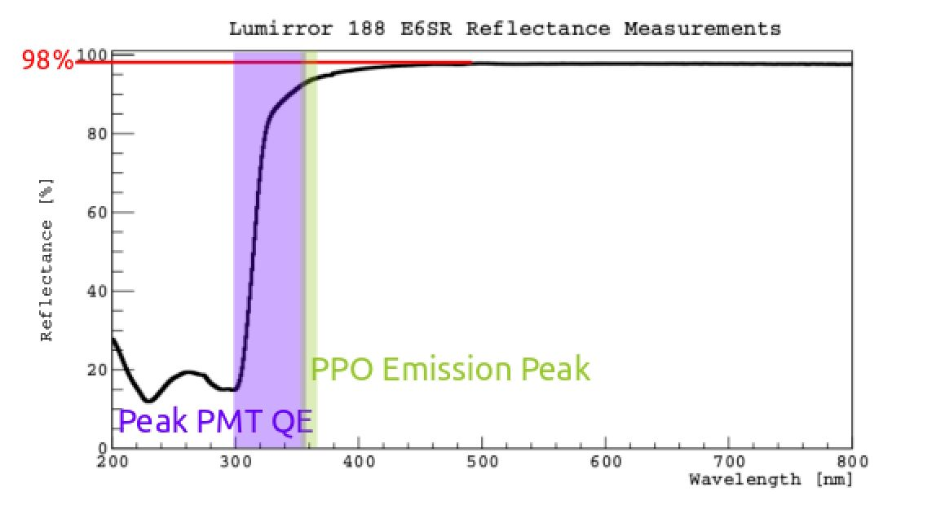
XIV International Conference on Topics in Astroparticle and Underground Physics (TAUP 2015) IOP Publishing
Journal of Physics: Conference Series 718 (2016) 042062 doi:10.1088/1742-6596/718/4/042062
Figure 1. Lumirror 188
E6SR reflectance measure-
ment. (Purple) The area
around the PMT peak quan-
tum efficiency. (Green) The
area around the peak of the
PPO emission spectrum. [7]
filling its voids. Tyvek 4077D has a protective titanium oxide coating. We found that Tyvek
4077D had a cutoff in reflectance below ~400 nm, while Lumirror had a cutoff below ~300 nm.
The lower wavelength cutoff for Lumirror meant that we could get a high light yield without the
use of a secondary wavelength shifter, while we would need one with Tyvek 4077D. As a result,
we decided to use Lumirror in the LSV. It should be noted that while we found the bulk of the
Lumirror maintained a high reflectance when submerged in PC and TMB for an extended period
of time, a slow degradation was observed around the edges, where the reflectance dropped to a
peak reflectance of ~83% at a rate of about 1 cm every nine months. This rate was slow enough
that we did not expect it to be a problem for a three years of running. However, as an additional
safety precaution, we overlapped the layers Lumirror by about 5 cm when we installed them in
the LSV. Figure 1 shows the reflectance measured for Lumirror 188 E6SR compared to the peak
quantum efficiency of the PMTs used in the LSV and the PPO emission spectrum.
Since water does not fill the voids in Tyvek like PC does, we used Tyvek 1082D to line the
inner surfaces of the WCV.
  - Prototype Performance
We then lined the prototype with Lumirror and filled it with the scintillator. Using a 54Mn 7-ray
source, we measured a light yield of 0.466±0.001 photoelectrons/keV (PE/keV). This light yield
decreased by about 0.52±0.02%/week, which we attributed to metal oxides in the stainless steel
reacting with the PC. This effect should scale with the surface-to-volume ratio. We determined
that this effect should be small for a 4 m diameter LSV, and that re-distillation campaigns can
be performed if necessary.
Measurements taken with an 241 AmBe source showed that the a+7Li produced by the neutron
capture on 10B could be seen in the prototype. Optical simulations of the prototype were
performed using measured values for the optical parameters of the relevant materials and agreed
with the measured light yield of the prototype to within ~2%. Scaling this simulatin to the full
LSV geometry planned for DarkSide-50 predicted a light yield of 0.48 PE/keV, high enough to
see the neutron capture reaction products.

5. The DarkSide-50 Veto System
Once the DarkSide-50 detector systems were constructed and filled, we began taking data. Data
taking campaigns can be divided into two phases, based on different scintillator cocktails used
in the LSV. Both campaigns are summarized in Table 1.
The primary difference between the two campaigns is the amount of TMB used. The reason
for this change was that after filling the LSV, we found an overwhelming background from 14C
decays. 14C is present in Earth’s atmosphere and ^-decays with a Q-value of 156 keV and
5
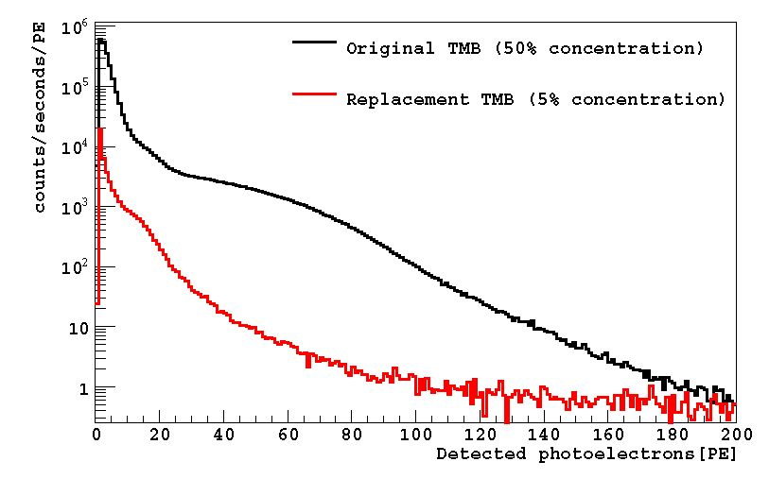
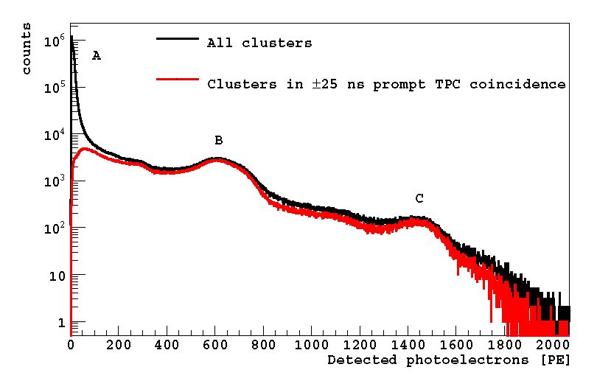
XIV International Conference on Topics in Astroparticle and Underground Physics (TAUP 2015) IOP Publishing
Journal of Physics: Conference Series 718 (2016) 042062 doi:10.1088/1742-6596/718/4/042062
Table 1. Summary of the two different scintillator cocktails used by the DarkSide-50 LSV.
Phase % PC % TMB PPO Concentration [g/L] 14C Activity Light Yield
- 50 50 25 ~200kBq >0.5 PE/keV
- 95 5 1.4 0.245 kBq >0.5 PE/keV
a half-life 5700 years. We found that the supplier from which we bought our TMB derived
their TMB from petroleum in their US plant and plant-based methanol in their European
plant. Since plants exchange carbon with the atmosphere, plant-derived methanol tends to have
approximately atmospheric levels of 14C. However, since petroleum has spent millions of years
underground, shielded from cosmic radiation, most of the 14C has decayed away. While our
initial studies used TMB from the US plant, our initial batch of TMB came from the European
one. As a result, we observed a background of 200 kBq of 14C decays in the LSV.
After measuring the 14C contamination of the TMB from the US plant using the accelerator
mass spectroscopy facilities at Lawrence Livermore National Laboratory, we decided to replace
the high-14C TMB with this new batch. However, due to cost and time constraints, we only
filled back up to 5% TMB and 1.4g/L PPO. Figure 2 shows the change in 14C contamination.
Phase I lasted from November 2013 to June 2014. At this TMB concentration, the thermal
neutron capture time was ~2.2 ^s, and ~ 0.8% of neutrons were expected to capture on 1H.
Phase II began February 2015 and is still ongoing. During this phase, the thermal neutron
capture time is ~ 22 ^s, and ~8% of neutrons are expected to capture on 1H.
6. LSV Performance
Figure 2. The low energy spectrum
around the energy range of the 14C f3-
spectrum. (Black) the spectrum during
Phase I. (Red) The spectrum during Phase
II. [3]
Figure 3. The energy spectrum seen
by the LSV during Phase II. (Black)
The distributions of all scintillation events.
(Red) Those in prompt coincidence with
the TPC. [3]
Figure 3 shows the energy spectrum seen by the LSV with a light yield of ~0.56 PE/keV
during Phase II. The spectrum for all scintillation events observed shows a large spike at low
energies in the region labeled A, which does not appear in the prompt coincidence spectrum.
This low energy spike is largely attributed to afterpulses, though is not yet entirely understood.
The region labeled B is primarily from 60Co decays in the stainless steel of the TPC cryostat.
Since 60Co produces two y-rays with each decay, one at 1.17 MeV and one at 1.33 MeV, it
dominates much of the LSV’s prompt coincidence energy spectrum, since one of these y-rays
may trigger the TPC while the other can go directly into the LSV. At higher energies, around
the region labeled C, is the contribution of 208Tl, which is part of the 232Th decay chain. The
6
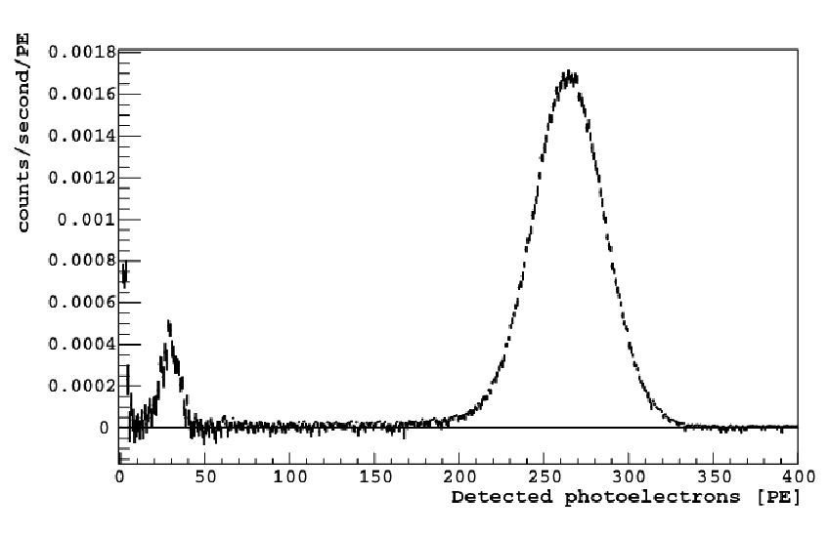
XIV International Conference on Topics in Astroparticle and Underground Physics (TAUP 2015) IOP Publishing
Journal of Physics: Conference Series 718 (2016) 042062 doi:10.1088/1742-6596/718/4/042062
full energy peak of the 2.6 MeV 7-rays from 208Tl is easily identified, as it is the highest energy
y-ray expected to be present in the detector, and it is often in coincidence with a 583 keV Y-ray,
which may trigger the TPC while the 2.6 MeV Y-ray goes into the scintillator.
Figure 4. The neutron capture energy
spectrum measured with an 241AmBe neutron
calibration source. The decay to the 7Li
excited state can be seen in the range 200-320
PE, and the decay directly to the 7Li ground
state can be seen in the range 10-40 PE. [3]
To measure the scintillator’s response to neutron captures, an 241 AmBe (a, n) neutron source
was lowered into the LSV. The energy spectrum for neutron captures during Phase II can be
seen in Figure 4. Between 10 and 40 PE, we can see the energy deposited by the a and 7Li from
the neutron capture on 10B going directly to the ground state of 7Li. This is well above the
detection threshold of the LSV, allowing the LSV to detect neutron captures very efficiently.
7. Neutron Vetoing Efficiency
Based on the calibration data obtained so far, we estimate that the LSV can detect neutron
capture signals with an efficiency > 99.1%. The primary loss comes from the neutrons that
capture on 1H instead of 10B, which we expect to happen for ~7.7% of all neutron captures. We
estimate from calibration data and Monte Carlo simulations that there is a ~8% chance that
the resultant 2.2 MeV Y-ray will go into the TPC cryostat without depositing a visible signal in
the LSV, leading to a 0.62% loss of neutron captures. The next biggest comes from the ~0.23%
of neutrons that capture after the LSV’s data acquisition window; the length of the acquisition
window was chosen so that this source of inefficiency would be adequately small.
The total neutron vetoing efficiency depends on the efficiency with which the LSV can detect
neutron captures and thermalization signals, as well as the probability of neutrons capturing on
the TPC materials without leaving any signal in the LSV at all. Monte Carlo suggests that this
third factor leads to an inefficiency of ~0.05%. We expect the first two to be independent of each
other, given that the neutron enters the LSV. The 241 AmBe calibration source produced too
many Y-rays in prompt coincidence with the neutron to allow us to reliably assess the strength
of the thermalization signal; a calibration campaign with a 241AmC source, which is expected
to have fewer high energy Y-rays, is currently underway and will make this analysis possible.
In the meantime, preliminary estimates based on the quenching model presented in [9] indicate
that the neutron thermalization signal will bring the total neutron vetoing efficiency above the
goal of 99.5% needed to run DarkSide-50 for three years free of neutron backgrounds.
References
- Agnes P et al (The DarkSide Collaboration) 2015 Phys. Lett. B 743 456
- Agnes P et al (the DarkSide Collaboration) 2015 Preprint arXiv:1510.00702
- Agnes P et al (The DarkSide Collaboration) 2015 Preprint arXiv:1512.07896
- Wright A, Mosteiro P, Loer B, and Calaprice F P 2011 Nucl. Inst. Meth. A 644 18
- Empl A, Hungerford E V, Jasim R, and Mosteiro P 2014 JCAP 2014 064
- Chadwick MB et al 2011 Nucl. Data Sheets 112 2887
- Westerdale S, Shields E, and Calaprice F 2015 Preprint arXiv:1509.02782
- Lombardi P 2014 Int. J. Mod. Phys. A 29 1442003
- Hong J et al 2002 Astroparticle Physics 16 333
7

