

Theoretical and Applied Climatology (2020) 140:719-730
https://doi.org/10.1007/s00704-020-03118-2
ORIGINAL PAPER

A selection of weather type classification systems and examples
of their application
Katarzyna Piotrowicz1© • Dominika Ciaranek1
Received: 22 October 2018/Accepted: 24 January 2020/Published online: 3 February 2020
© The Author(s) 2020
Abstract
The paper discusses a selection of the most popular systems classifying weather types found in climatological literature. The
review focuses on the choice of meteorological elements and their value ranges as the differentiating criteria. Examples of the
application of some of these systems are presented, as well as a number of possible analyses that could be attempted. In order to
investigate this, use was made of 1961-2010 meteorological data from stations in Warsaw (Poland) and Cologne (Germany). It
was found that the annual and long-term changes in the types of weather reflect the diversity and variability of the climate in both
cities very well, and allow the stability (non-changeability) of weather to be quantified.
Keywords Weathertypes . Classifications ofweather Complex climatology Stability ofthermal conditions . Warsaw (Poland) ■
Cologne (Germany)

1 Introduction
Any in-depth study of climatic conditions essentially requires
an analysis of the frequency of occurrence of various weather
situations, or types, and of their seasonal variations (Błażejczyk
1979). It is widely agreed that an alternative approach involving
an analysis of individual meteorological elements fails to offer a
full picture of the features of the climate being studied
(Błażejczyk 1985; Woś 1999, 2010; Piotrowicz 2010). This
approach lacks the crucial component of the mutual relation-
ships between the meteorological elements. Indeed, it is their
combined and comprehensive effect in a given geographical
environment, which determines the type of climate.
Weather conditions have a significant influence on human
activity. Complex climatological methods are used to deter-
mine their characteristics, which then find application in nu-
merous areas of life and in the economy (Kozłowska-
* Katarzyna Piotrowicz
k.piotrowicz@uj.edu.pl
Dominika Ciaranek
dominika.ciaranek@doctoral.uj.edu.pl
1 Department of Climatology, Institute of Geography and Spatial
Management, Jagiellonian University, Gronostajowa 7,
30-387 Krakow, Poland
Szczęsna 1965; Hidalgo and Jougla 2018). This is because it
is the entire complex of meteorological elements, rather than
each element individually, that matters for human health and
well-being, for the development of plant life and wildlife and
for transport and industry.
The beginnings of complex climatology (derived from the
Latin complexus meaning to embrace), date back to the 1920s.
The basics of complex climatology were laid down by
Fedorov and his colleagues, including especially Chubukov
(Kozłowska-Szczęsna 1965). The field saw particularly rapid
development in the Soviet Union but also in the USA (Howe
1925; Nichols 1925, 1927; Switzer 1925). This shows that the
search for methods that would link various meteorological
situations in one weather type (or complex) has a long tradi-
tion (Błażejczyk 1985).
The term “weather type” is used in both complex climatol-
ogy and in synoptic meteorology and synoptic climatology.
Depending on the purpose of the weather type classification,
they can be divided into two groups-(1) morphological (con-
sistent with the premises of complex climatology, where
weather type is determined on the basis of similar character-
istics of the daily course of the values of selected meteorolog-
ical elements) and (2) genetic (determined on the basis of the
synoptic situation and/or atmospheric circulation types)
(Kaszewski 1992). In the latter group, the performed classifi-
cation results in the determination of “circulation” weather
types (or synoptic/macrosynoptic weather types; see for

720
K. Piotrowicz, D. Ciaranek
example: Littmann 2000; Bissolli and Dittmann 2001;
Sheridan 2002, 2003; Brown 2004, 2005; Boé and Terray
2008; Moron et al. 2008; Makra et al. 2009; Putnikovic and
Tosić 2018; Schwander et al. 2017). Works drawing on genet-
ic classifications (Philipp et al. 2010) will not be discussed in
this paper, as they do not fit with the main purpose of the
study, whose authors focused on weather types identified on
the basis of morphological classifications.
As already mentioned, the first climate analysis based on a
morphological classification was developed by Fedorov for
Pavlovsk. The weather type for each day was described with
quite a complex letter code including the values of the daily
mean, maximum and minimum air temperature, the difference
between current temperature and that on the previous day,
relative humidity in 20% intervals and at 1 p.m., cloud cover,
precipitation, wind direction and speed and state of ground.
The initial version of this classification was later modified on
numerous occasions, and since 1949 in literature it has most
frequently been referred to as the Fedorov-Chubukov classi-
fication (Kozłowska-Szczęsna 1965). It identifies eight weath-
er types each in the warm and cold seasons of the year on the
basis of air temperature, cloud cover, relative humidity, pre-
cipitation and wind.
In the mid-1920s, morphological classifications of weather
types were created in North and Central America as well.
Howe (1925) distinguished 13 weather types in North
America, taking into consideration 4 air temperature classes,
2 precipitation classes (instead of humidity and cloud cover,
due to data collection difficulties) and 2 wind speed classes.
Switzer (1925) relied on a similar weather type classification
principle in Mexico. However, he distinguished 12, rather
than 13, weather types, using the same meteorological ele-
ments as a basis. In the same year, Nichols (1925) proposed
a classification of as many as 720 different weather types in
the USA. He distinguished 10 air temperature ranges, 6 hu-
midity ranges, 4 wind speed ranges and 3 cloud cover ranges.
In the 1970s, climatology literature again started to refer to
weather type studies based on morphological classifications.
Worth mentioning is the work by Hufty (1971), who distin-
guished 19 weather types in Quebec and Montreal (Canada)
on the basis of daily values of maximum and minimum air
temperature and additional weather indices based on sunshine
and precipitation. Besancenot et al. (1978) distinguished 8
weather types favourable for summer tourism in the Iberian
Peninsula coastal areas on the basis of air temperature, relative
humidity, sunshine and wind. Research based on this
classification was continued by Alcoforado et al. (2004) and
Andrade et al. (2007).
After a hiatus of a dozen years or so, when climatology
literature was largely dominated by papers drawing on circu-
lation weather types (Philipp et al. 2010), studies taking ac-
count of weather types identified in line with the tenets of
complex climatology started to appear again. Worth
mentioning are studies such as the one by Cantat and
Savouret (2014) or Hidalgo and Jougla (2018). In the first
one, the authors analysed weather types in France and identi-
fied 64 weather types, relying on four classes of cloud cover,
four of wind speed, two of temperature and two classes of
precipitation (Cantat and Savouret 2014). In the second paper,
10 weather types identified on the basis of the daily tempera-
ture amplitude (Tmax-Tmin) and the daily means of specific
humidity, precipitation, wind speed and direction were used
to study the urban climate of Toulouse (Hidalgo and Jougla
2018).
After World War II, comprehensive climatology started to
develop dynamically in Poland as well. Especially in the
1960s and 1970s, several weather type classifications were
developed (both genetic and morphological ones). Among
the most important ones were those devised by A. Woś be-
tween 1968 and 2010 (1999, 2010). As the premises of this
classification were used in this paper, it was discussed at
length in the next chapter (“Data and methods”).
Morphological weather classifications are most frequently
used for the general climatic description of a particular loca-
tion (Cantat and Savouret 2014), but they have also been
applied in bio-meteorological and bio-climatic studies, e.g.
in the climate therapy of spa and holiday resorts or in agricul-
tural climatology. The previously mentioned Fedorov-
Chubukov classification makes it possible to distinguish 3
weather groups: helpful, helpful with a restriction and
unhelpful for climate therapy. Alcoforado et al. (2004)
analysed weather types in connection with the visitor numbers
in a tourist area of the Lisbon coast. For that purpose, the
authors used classifications based on cloudiness (3 classes)
and Physiological Equivalent Temperature indicator (3
classes).
In Poland, bioclimatic weather type classifications have
been developed by authors such as Błażejczyk in his papers
published between 1979 and 2004 (Błażejczyk 2004). The
author’s most recent classification, i.e. the biothermal-
meteorological classification of weather, may be used for a
detailed characterization of weather conditions, and also as
basic information about the recreation potential of any area
and/or period (day, month, season, year). In his classification,
Błażejczyk (2004) took into account 7 types, 27 subtypes and
8 weather classes, relying on values of the thermal sensations,
intensity of radiation stimuli, physiological strain, sultriness,
daily amplitude of temperature, precipitation and snow cover
(Błażejczyk and Matzarakis 2007).
Piotrowicz (2010) proposed another classification, building
on the systems devised by Woś (1999) and by Błażejczyk
(2004). The new classification was used to identify weather
types in Krakow on every day of the 1901-2008 period. This
data was used to analyse the city’s climatic variability and to
identify the beginning and end dates of climatological sea-
sons. Since the classification system was built for the purpose
A selection of weather type classification systems and examples of their application
721
of identifying seasons, the author selected air temperature
ranges that were the closest to the threshold values commonly
used for dividing the year into thermal seasons in Poland. The
system by Woś (1999) met the criterion, and his ranges of air
temperature values were adopted. According to Piotrowicz
(2010), they best reflected the everyday variations in thermal
conditions. Also, the threshold values adopted by Woś (1999)
are commonly used in various studies on climate and biocli-
matic conditions, as well as for identifying characteristic days,
i.e. cold, ground-frost and hot days. Piotrowicz (2010) con-
sidered using cloudiness to identify weather types the way it
had been done in the system proposed by Woś (1999).
Eventually, however, she came to the conclusion that relative
sunshine duration would better serve the purpose of her study.
Precipitation is the final element of the weather type classifi-
cation system proposed by Woś (1999). In her study,
Piotrowicz (2010) modified this system by adding a day with
more than 5 mm of precipitation alongside dry and wet days.
The author added snow cover, thunderstorms and sultriness to
her classification system in order to facilitate its intended use
in identifying the timing of seasons and in determining the
influence of the weather and climate on the environment and
on humans (Piotrowicz 2010; Piotrowicz and Ciaranek 2014).
Considering a recent string of atypical winters, the inclusion
of snow cover could help to determine the beginning and end
of such seasons. Snow cover and sultriness were also
employed by Błażejczyk (2004) in his biothermal-
meteorological weather classification. Thunderstorms, includ-
ing precipitation, and sultriness can be used to assess the in-
fluence of weather on human health and well-being, as well as
of plant phenophases and pollen seasons (Piotrowicz 2010;
Piotrowicz and Ciaranek 2014). Altogether, 225 weather types
were identified in Krakow during the period 1901-2008
(Piotrowicz 2010).
A special group consists of papers which present the rela-
tionship of weather as a complex of occurrence of several
meteorological elements with atmospheric circulation, i.e.
those that combine genetic and morphologic weather type
classifications. This group includes publications by Maheras
(1984, 1985), where the author compared the distribution of
weather defined by 7 meteorological elements in 15 circula-
tion types. This research direction was continued by
Michailidou et al. (2009a, 2009b). To identify weather types,
the authors used cluster analysis and meteorological data (air
temperature, precipitation, relative humidity, wind speed and
sunshine), as well as circulation data. In Polish literature, a
similar approach was represented by authors such as
Kaszewski (1992), Bielec-Bąkowska and Piotrowicz (2011),
Piotrowicz and Szlagor (2013).
The study offers two purposes: methodological and cogni-
tive. The first aim was to compare two weather classification
methods and to show examples of their application. The other
aim was to compare seasonal and multiannual fluctuations of
weather conditions in 2 stations representing slightly different
climate patterns: Warsaw (Poland) and Cologne (Germany) in
the period 1961-2010.

2 Data and methods
The analysis was based on data from 1961 to 2010 from two
meteorological stations located at similar latitudes: Warsaw
(52° 09' N, 20° 57' E, 106 m a.s.l.) and Cologne (50° 51' N,
7° 09' E, 92 m a.s.l.). The cities are also similar in size and
population. Warsaw has an area of 517 km2 and is inhabited
by approx. 1.7 million people, while Cologne has an area of
405 km and has 1.0 million residents (data from 2018). The
distribution of the mean monthly air temperatures and precip-
itation at both stations in the multiannual period under study is
presented in Fig. 1.
The data for Warsaw was provided by the Institute of
Meteorology and Water Management-the National Research
Institute, and that for Cologne was obtained from the
European Climate Assessment & Dataset (ECA&D) (Klein
Tank et al. 2002). They consisted of diurnal measurements
of air temperature (maximum, minimum and mean; °C), pre-
cipitation (mm) and cloudiness (%).
The examples of weather type classifications discussed in
the previous chapter differed in terms of the selection of the
meteorological elements and/or the number of ranges to which
the values were classified. Finally, the classification by Woś
(1999) (Table 1) was used in the present study. It draws on the
basic and most frequently analysed meteorological elements.
In Poland, the best known, and the most popular, weather
type classification system was proposed by Woś (1999, 2010)
(Table 1). It provides a good characterization of Poland’s cli-
matic conditions and those of other regions in moderate lati-
tudes areas, and has a universal nature.
Woś (1999) selected three meteorological elements for his
system: air temperature (daily average, maximum and mini-
mum), average daily cloudiness and the daily precipitation
total (Table 1). He divided these values into 16 ranges (includ-
ing 12 for temperature, 3 for cloudiness and 2 for precipita-
tion) ending up with 66 basic weather types. The types are
coded with numbers where the first digit (or first two digits in
the case of the frosty weather type; symbol 10-12) denotes the
thermal conditions, the penultimate digit gives information
about the cloudiness, and the final one about precipitation
(Table 1).
A total of 12 thermal weather types which were distin-
guished, which can be assigned to three groups: warm
(Tmean, Tmax and Tmin > 0 C; symb° 1-5), frosty (Tmax >
0 °C and Tmin < 0 °C; symbol 6-9) and freezing (Tmax and
Tmin < 0 °C; symbol 10-12). Another group in the above clas-
sification is formed by weather subtypes, which contain infor-
mation about cloudiness and diurnal precipitation.
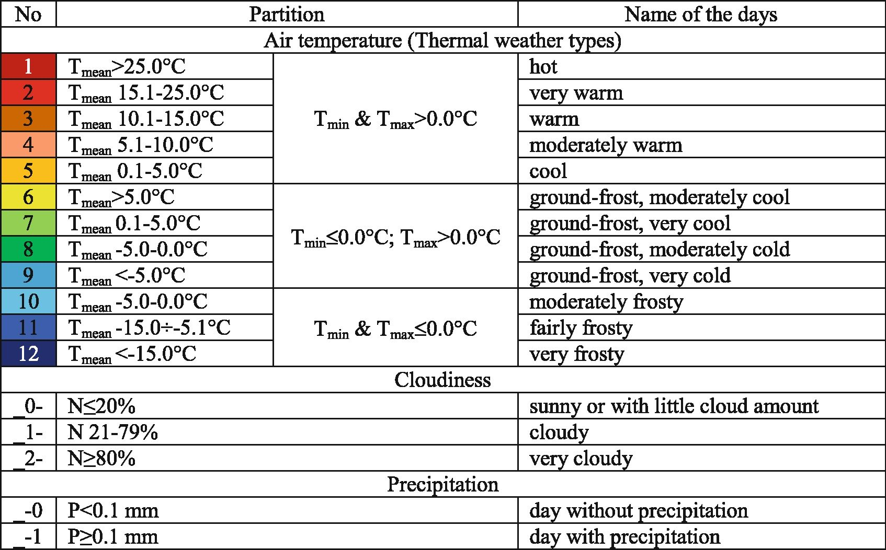

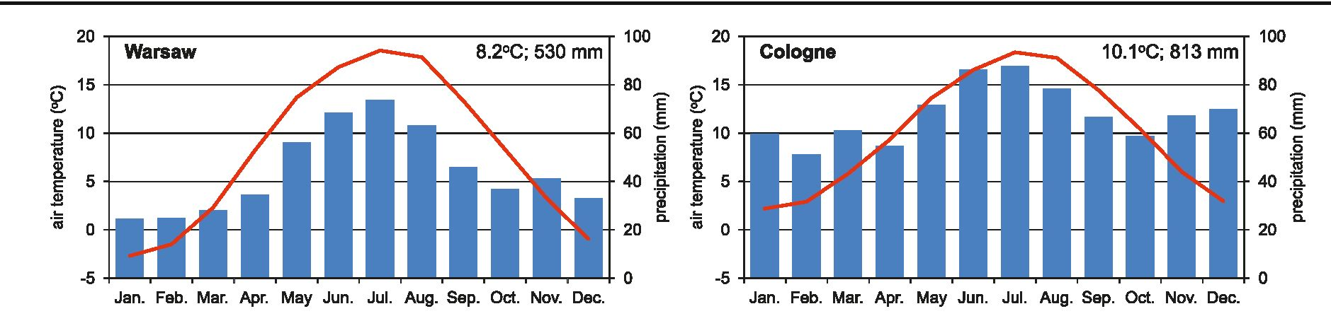
722
K. Piotrowicz, D. Ciaranek
Fig. і Mean monthly and annual air temperature and precipitation totals in Warsaw and Cologne in the period 1961-2010
Woś (1999) also allowed for the identification of weather
types with only some of the elements, such as temperature and
cloudiness or temperature and precipitation, while others are
missing, as well as for joining these elements to produce sets
and groups of weather. The missing element is coded by a
dash (“-”). For example, the type marked 2_- denotes very
warm weather with an average daily temperature of 15.1-
25.0 °C and both maximum and minimum temperature above
0 °C; there is no data on cloudiness or precipitation.
The weather type classification system by Woś (1999)
has been used by many researchers (see, for example,
Bielec-Bąkowska and Piotrowicz, 2011; Kaszewski
1992; Piotrowicz 2010; Piotrowicz and Szlagor 2013;
Piotrowicz and Ciaranek 2014). The system was also
modified by adding an additional element (wind speed)
and by altering the value ranges (Ferdynus and Marsz
2000). In this way, for example, it was possible to use
the system to analyse the weather structure and climate
seasonality in polar areas.
For comparison, the study also presents the results of anal-
yses of the long-term variability and seasonal differences in
thermal weather types distinguished by means of k-means clus-
ter analysis. The method is based on grouping data into rela-
tively homogeneous classes. Unlike the (a priori) method used
by Woś (1999) to determine air temperature ranges, cluster
analysis is perceived as a more objective method (Jolliffe and
Philipp 2010; Hidalgo and Jougla 2018). It consists in entering
data into a clustering algorithm, where the classes are created
automatically (Jolliffe and Philipp 2010). The algorithm itself
moves items into various clusters, seeking to minimize the
variability inside clusters and to maximize that between partic-
ular clusters. The obtained result is a group of clusters with the
greatest intra-cluster similarity and greatest inter-cluster vari-
ability. This method has been used for weather type classifica-
tion by authors such as Hidalgo and Jougla (2018).
The present study uses к-means clustering, which enables the
adoption of a predetermined number of classes. Thanks to this,
the authors were able to compare the results obtained by both
Table 1 Weather type classification by Woś (1999)
For example, 3_10 - warm, cloudy, without precipitation
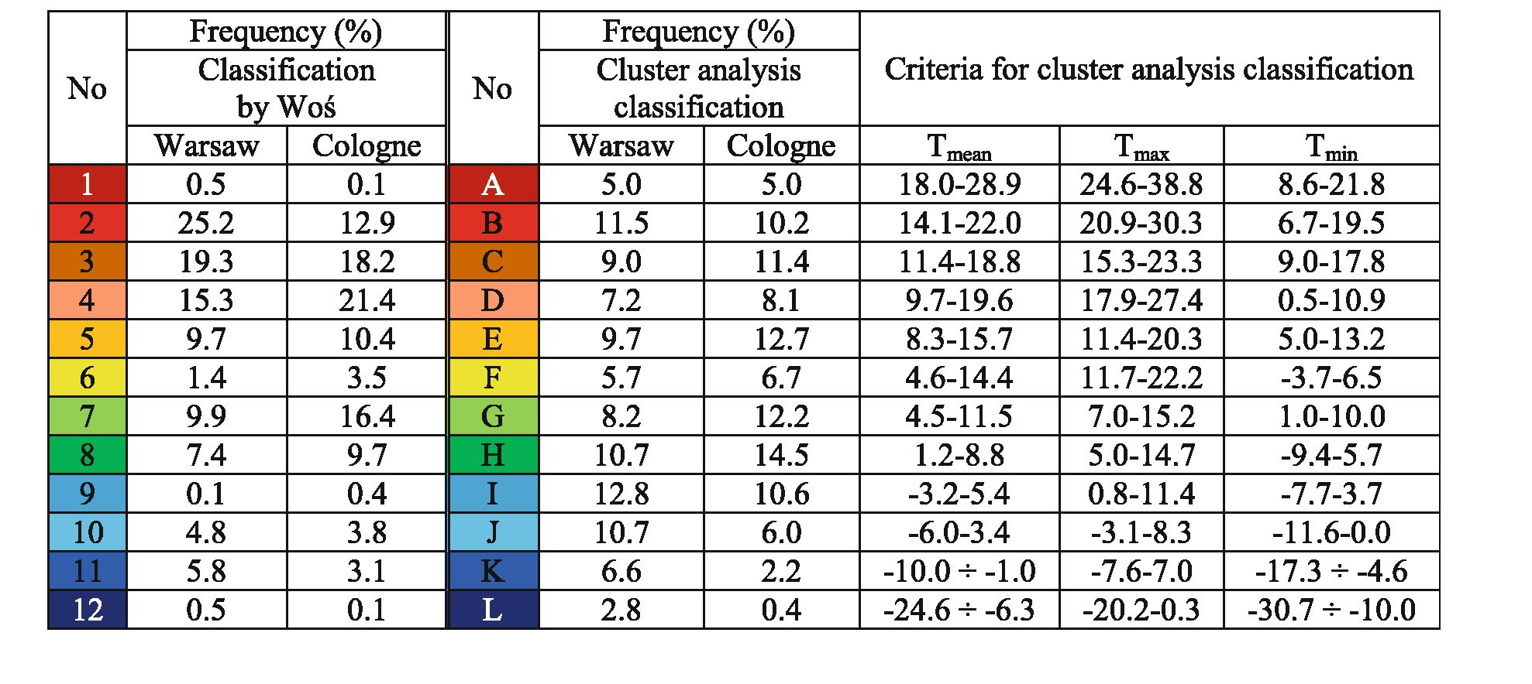
A selection of weather type classification systems and examples of their application
723
methods. Cluster analysis can be used to distinguish thermal
weather types separately for each station, i.e. to apply different
cluster ranges at given stations or, as it was done in this paper, to
distinguish clusters taking into account the air temperature
values for both stations simultaneously. This second approach
makes it easier to compare and determine differences in values
and seasonal temperature variability in both cities. However, the
first approach is more effective when the aim of the study is to
show the separateness of thermal conditions between stations.
The different range of clusters makes it difficult to compare the
temperature values and their seasonal variation between stations.
The air temperatures in the thermal weather types distin-
guished by cluster analysis are presented in Table 2. The method
of distinguishing weather subtypes is the same in both methods.
The study is not limited to the presentation of the annual
and long-term variability (using the linear trend) of the iden-
tified types of weather. More detailed studies were conducted,
including an analysis of the change of thermal weather types
from one day to another. If the same type of weather was
observed on several consecutive days, there was no change,
meaning that the weather during the time was stable.
Following this, strings of days with the same type of weather
were counted for each year. The lower the number of such
sequences, the longer they lasted, which meant that the weath-
er was more stable.

3 Annual and long-term variability of thermal
weather types in Warsaw and Cologne
The thermal weather types demonstrate a clear seasonal pattern
(Fig. 2). The types, distinguished according to the Woś classi-
fication (Table 1), with the highest mean air temperature in
excess of 25 °C (symbol 1), were sporadically recorded in
Warsaw in the months from 29 May to 29 August. The very
warm weather type (2) demonstrated the highest frequency
during the year (Table 3). The potential period with a preva-
lence of this type of weather in the multiannual period under
study was from April to October (Fig. 2). In Cologne, which is
characterized by a more maritime climate, the hot (1), fairly
frosty (11) and very frosty (12) weather types were less frequent
(Table 2). On the other hand, ground-frost (6-9) and moderate-
ly warm days (4) were much more frequent than in Warsaw.
Their potential periods of occurrence comprised: 28 May-28
August (1; only 2 days shorter than in Warsaw), 22 November-
6 March (11; 36 days shorter) and 1-18 January (12; in Warsaw
13 December-28 February) respectively (Fig. 2). Interestingly,
for ground-frost (6-9) and moderately warm days (4), their
periods of occurrence in both cities were very similar, while
the frequency of their occurrence was by one-third lower in
Warsaw. The annual trend of the thermal types of weather dis-
tinguished by means of clustering differed not only in the fre-
quency but also in the period during the year during which they
could potentially occur (Table 3, Fig. 2). However, the picture
of seasonal differences in the thermal conditions at both stations
using the two methods gives a range of interesting possibilities
for the interpretation of the results. They can be used to identify
thermal seasons of the year, make divisions into climatic re-
gions with the same and/or different thermal conditions and
identify the potential period of occurrence, the duration and
sequence of the identified types, especially those that entail
specific consequences for man and the natural environment.
The long-term changes in the thermal types of weather over
the 50-year period illustrate the changeability of the climate in
both cities very well (Fig. 3). Irrespective of the criterion used
for the differentiation of thermal types of weather (1-12 or A-
Table 2 Frequency of occurrence (%) of thermal weather types in Warsaw and Cologne in the period 1961-2010 determined using two classification
methods and criteria for cluster analysis classification
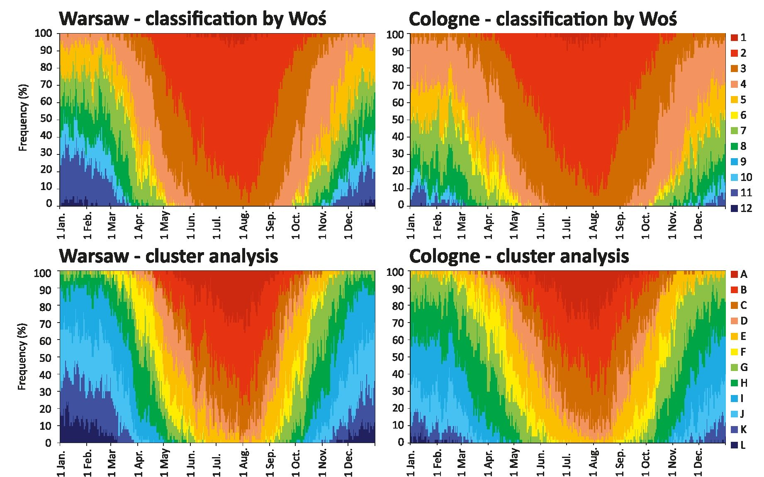
724
K. Piotrowicz, D. Ciaranek
Fig. 2 Frequency (%) of occurrence of thermal weather types determined according to Woś’ classification and clustering analysis in Warsaw and
Cologne in the period 1961-2010 (explanation of the type numbers in Tables 1 and 2)
L; Tables 1 and 2), in recent years both Warsaw and Cologne
have seen a decline in the frequency of fairly frosty (11 and
K), very frosty (12 and L) and cool days (5 and E) and an
increase in hot and very warm days (1-2 and A-B).

4 Stability of thermal weather types
Figure 4 illustrates long-term changes in the number of day
strings during the year using both classifications. As can be
seen, Warsaw and Cologne saw a decrease in the number of
sequences (statistically significant atp < 0.05), which means a
greater stability of thermal conditions according to the Woś
classification (Fig. 4a). The drop in the number of day strings
was caused by an increase in the number of hot (1) and/or very
warm days (2) which occurred in longer several-day-long
strings, and by a decrease in the number of moderately frosty
(10) and fairly frosty (11) days occurring in isolation or in very
short sequences of days. In case of the classification based on
clustering, the trend was not statistically significant (Fig. 4b).
Table 3 Frequency (%) of occurrence of weather types with the highest frequency of the year in Warsaw and Cologne in the period 1961-2010
Classification by Woś |  |  |  | Cluster analysis classification
Warsaw |  | Cologne |  | Warsaw |  | Cologne
Type no (see Table 1) | % | Type no. (see Table 1) | % | Type no. (see Table 2) | % | Type no. (see Table 2) | %
2_10 | 12.6 | 2_10 | 10.4 | B_10 | 5.9 | G_21 | 6.5
3_10 | 7.5 | 4_21 | 9.7 | I_21 | 5.3 | H_21 | 5.7
2 11 | 6.2 | 3_21 | 8.5 | D_10 | 3.9 | E_21 | 5.6
4_10 | 5.0 | 3_10 | 7.2 | J_21 | 3.9 | C_21 | 4.7
4_21 | 4.8 | 2 11 | 6.1 | H_10 | 3.6 | B_10 | 4.5
3_11 | 4.6 | 3_11 | 5.3 | C_10 | 3.5 | D_10 | 4.4
5_21 | 4.5 | 2_21 | 4.8 | E_10 | 3.2 | I_21 | 4.3
3_21 | 4.4 | 4 11 | 4.5 | H_21 | 3.1 | F_10 | 3.3
2_00 | 3.5 | 4_10 | 4.2 | G_21 | 3.1 | H_11 | 3.3
Sum | 53.1 | Sum | 60.7 | Sum | 35.5 | Sum | 42.3

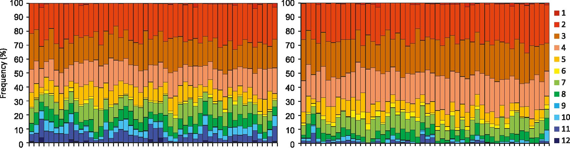
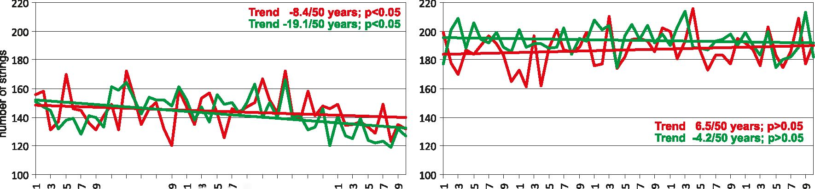

A selection of weather type classification systems and examples of their application
725
Warsaw - classification by Woś

Cologne - classification by Woś
гПЮМЯгПШМЯт-СОЮМЯт-ПЮМВгПЙМЯ
(0(OŒ>(0(osNNNstoœeoco«ocno)0)0)0)ooooo
0)0)0)0)0)0)0)00)0)0)0)0)0)0)0)0)0) 0)0)00000
ł-nifiSO)x-ninNO)T-r9inSO)ł-(OinMJ)>-ninNO)
(DCDÍD!DtDNSNNS0DC0C0C0C00)0)010)0)OOOOO
0)0)0)0)0)0)0)0)0)0)0)0)0)0)0)0)0)0)0)0)00000
x— x— x— x— x— x— x— x— x— x— x— x— x— x— x— x— x— x— x— x— C\JOJC\JCVJC\J
100
90
80
g 70
& 60
3 50
tr
S. 40
30
20
10
Warsaw - cluster analysis
t-niOSa)x-niONO)x-ninM3)^-niflMSx-niOSO)
(û(û(00(ûssssse0(00ûc0c00)0>0)0)0)00000
0)0)0)0)0)0)0)0)0)0)0)0)0)0)0)0)0)0)0)0)00000
x— x— x— x— x— x— x— x— x— x— x— x— x— x— x— x— x— x— x— x— C\JC\JC\JCNC\J
I 100
90
80
70
60
50
40
Cologne - cluster analysis
імрмм
Iіjl. uUlU .. J. НІ J
!l ііі!іні!і(|і| І1-1!
rp)lflSO)r(*)lOSO)x-ninSO)x-niflSO)x-nií)SO)
00(DtD(DSSSSSO3COOOCOMO>O)O)O>O)OOOOO
0)0)0)0)0)0)0)0)0)00)0)0)0)0)0)0)0)0)0) ооооо
X— x— x— x— x— x— x— x— x— x— x— x— x— x— x— x— x— x— x— x— CNJtNCNJCNJCN
Fig. 3 Long-term variability of thermal weather types determined according to Woś classification and clustering analysis in Warsaw and Cologne in the
period 1961-2010 (explanation of the type numbers in Tables 1 and 2)
The above conclusions are also confirmed by earlier studies
by the authors (Ciaranek and Piotrowicz 2014), which focused
on analysing the stability of thermal weather types in Central
Europe. The lack of a statistically significant tendency of
change in the stability of the thermal weather types identified
using cluster analysis classification is linked to the fact that
days with different values of air temperature (especially max-
imum and minimum values) were assigned to a very wide
range of values (above and below 0 °C; see Table 2, types
J-L). The classification of thermal weather types based on
clustering enables days with similar thermal conditions to be
distinguished in a more objective manner, taking into account
the natural variability of air temperature values at a given
station. In recent years in winter (Dec.-Feb.), days with low
air temperature values (J-K) were recorded in shorter strings
a) Classification by Woś (1999)
(thermal conditions in this season were unstable), while in
summer (especially in July) and September the number of
warm days (especially B) and their strings increased notice-
ably, which means that the weather was more stable.

5 Weather subtypes and types
As it has already been noted above, cloudiness and precipita-
tion are necessary for distinguishing weather subtypes accord-
ing to the classification proposed by Woś (1999) (Table 1).
The first two digits (or one letter in cluster analysis classifica-
tion), which indicate air temperature, are followed by two
more digits, which stand for the range of cloudiness and the
presence or absence of rainfall.
b) Cluster analysis classification
H en ІЛ l-N
Г"х г»» г»» Гх
о) о) oi oi
. . . 01 h m m N 01
oo oo oo oo oo m m m oi oi
0)0)00)0)0) 0)00)0)0)
о о о о о
ГМ N N «М і
■ Warsaw
■ Cologne
Fig. 4 Long-term variability of the annual number of strings of days according to the both thermal classifications (a Wo ś, b cluster analysis) in Warsaw
and Cologne in the period 1961-2010

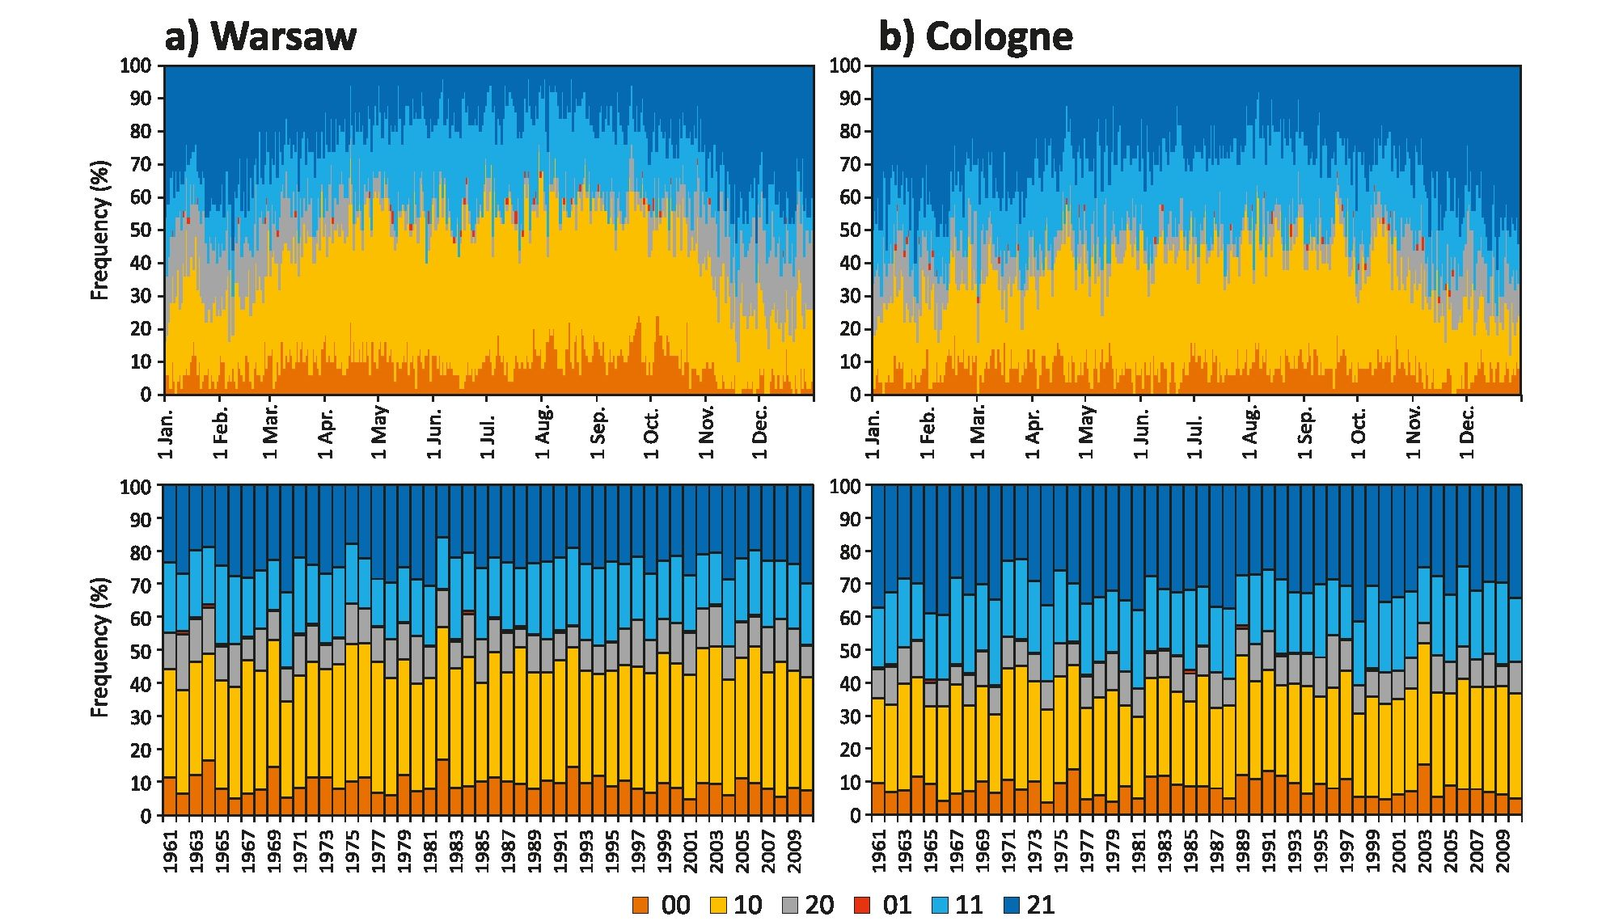
726
K. Piotrowicz, D. Ciaranek
Fig. 5 Frequency (%) of occurrence of weather subtypes in Warsaw and Cologne in annual and long-term course in the period 1961-2010 (explanation
of the subtype numbers in Table 1)
The identified weather subtypes can occur throughout the
year, although those marked with the symbol:
- -_00 (sunny without precipitation) occur more often in
April and August-October in Warsaw, and evenly
throughout the year in Cologne,
- — 10 (cloudy without precipitation) - in summer in
Warsaw, and in April and September in Cologne,
- -_11 (cloudy with precipitation) - in summer at both
stations,
- -_20 (very cloudy without precipitation) and -_21 (very
cloudy with precipitation) - from November to February
at both stations,
- -_01 (sunny with precipitation) - occasionally in Warsaw
and Cologne (Fig. 5).
In Warsaw and Cologne, the long-term weather subtypes
(Fig. 5) saw a statistically significant (p < 0.05) increase in the
number of days with weather -_10 (cloudy without precipita-
tion; 15 days/50 years in Warsaw and 12 days/50 years in
Cologne), which was mainly caused by a decrease in the num-
ber of days with sunny weather without and with precipitation
(-_00 and -_01), although their changes were not statistically
significant (p > 0.05). The other weather subtypes showed no
tendency of change in the multiannual period analysed (Fig. 5).
Table 3 shows the prevalence of the main types of weather
in Warsaw and Cologne distinguished by reference to the three
meteorological elements (temperature, cloudiness and precip-
itation). For air temperature, the division into weather types
was made on the basis of two classifications-that by Woś
(1999) and that relying on cluster analysis. As can be seen,
air temperature is the most strongly differentiating factor for
the weather types. As many as 9 of the dominant types of
weather accounted for 53.1% in Warsaw and 60.7% in
Cologne of all the days in the period under study. As regards
the classification of weather types by cluster analysis, the dif-
ferentiation of the weather types in the multiannual period was
greater, since the 9 predominant weather types represented
only 35.5% and 42.3% of all the types in the period under
investigation (Table 3).
The weather differences in the period under study can also
be examined by analysing the number of weather types in the
individual years (Fig. 6). A lower number of weather types in
a given year means that they form slightly longer series of
days, which indicates greater weather stability. For Warsaw
and Cologne, in the years 1951-2010, there was a statistically
significant downward trend in the number of weather types, as
distinguished by the cluster analysis method. Their number
was particularly low in 1974 (47 in Warsaw and 39 in
Cologne) and 2008 (respectively 47 and 40), which was
caused by the fact that the winter that year was very warm
(there were no days with temperatures in the last range-L,
which usually form one/two-day strings) and summer was
not very hot (there were only a few days with temperatures
in the first range-A). On the other hand, days with the most
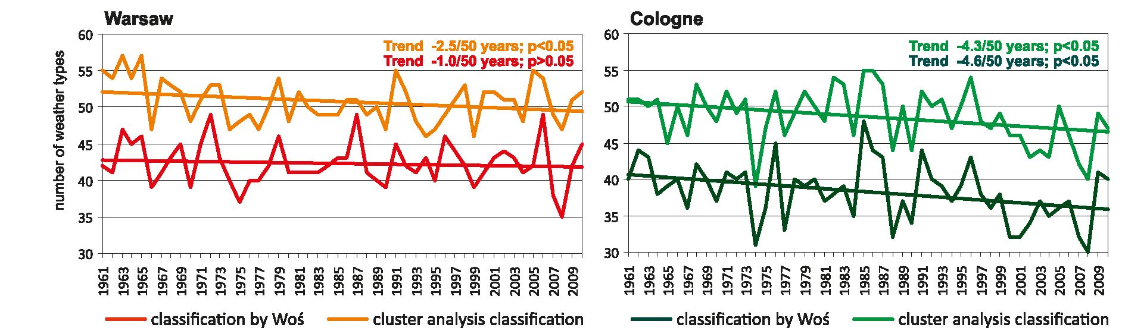
A selection of weather type classification systems and examples of their application
727
Fig. 6 Number of weather types in a multiyear course in Warsaw and Cologne in 1961-2010
frequent occurrence of weather types, especially H_21, I_21
and D_10, formed clearly longer sequences in the years under
consideration. According to Woś’ classification, there was al-
so a statistically significant decrease in the number of weather
types in Cologne (Fig. 6).

6 Discussion and conclusions
In this study, the aim was to discuss the most popular systems
of weather type classification in climatological literature, and
show examples of its application, using a classification by
Woś (1999) and its modifications.
Weather type classification systems can be used in detailed
studies of weather conditions, and also as basic information on
climate variations during any period (month, season, year or
long-term). It is important, however, to start by making a
selection of the meteorological elements and classification
criteria depending on the purpose of the study. As regards
morphological weather type classifications, they most fre-
quently rely on air temperature, precipitation, cloudiness and
wind data (see Introduction). As emphasized by Hidalgo and
Jougla (2018), the main advantage of the “climatological”
approach to weather types, as opposed to “synoptic” weather
types, is the fact that they refer directly to the description of the
atmospheric situation resulting from an analysis of climatic
data. Such analyses better reflect the local climate of a partic-
ular location and are hence better applicable to urban climate
research (Hidalgo and Jougla 2018).
An element of subjectivity is always present in designing a
classification (Hidalgo and Jougla 2018). It is involved in the
selection of the meteorological elements and in the division of
their values into ranges. Accusations of arbitrariness in the
adopted classification criteria are virtually unavoidable. One
must remember, however, that increasing the number of me-
teorological elements and their ranges leads to a growing
number of weather types and makes subsequent analysis more
difficult. In reality, the state of the weather varies enormously
and can never be fully captured in quantitative/qualitative
terms, but can only be approximated using certain features
and grades of the weather elements selected. Therefore, while
this classification system may raise many doubts, it can still be
used to obtain interesting insights into the structure and vari-
ability of the climate in a given area. According to the authors,
it is all the more possible since a comparison of thermal weath-
er types identified using Woś’ (a priori) method and using
cluster analysis, considered to be an objective method
(Hidalgo and Jougla 2018), gives comparable results.
In his classification, Woś set rigid ranges of meteorological
element values based on the climatic conditions prevailing in
the temperate zone. Therefore, the method can be used for
studying the sequences of weather types in many areas, also
those at a great distance from each other. A cluster analysis
conducted for many stations simultaneously can likewise be
used for comparison purposes, since in this case the ranges of
values are the same for all the stations analysed. Of course, it is
possible to distinguish weather types using cluster analysis for
the values from each station separately, but then it is more
difficult to compare the results between stations, especially if
they are located in the same climate zone. However, it must be
remembered that this method is an automatic one, and here
weather types are also determined by taking the frequency of
their occurrence into account.
Both methods of weather type recognition (by Woś and
cluster analysis) have their good points and disadvantages.
The analyses carried out in this work indicate that they give
comparable results, among others in the case of long-term
trends of thermal weather types and their stability. The main
difference in the results obtained with the two methods lies in
the fact that most weather types in the Woś classification can
occur at specific times of year, while the weather types obtained
by means of cluster analysis change more frequently during the
year. Their greater diversity, compared with the Woś classifica-
tion, can clearly be seen especially in the summer months.
The frequency of various weather types during multiyear
periods and individual years, seasons or months can help in
drafting a weather calendar. Such calendars can then be used
in studies of extreme events. Calendars of weather conditions
were performed in Poland by Błażejczyk (2004), Durło
(2003a, b, c) and Piotrowicz (2010), among others. Those
728
K. Piotrowicz, D. Ciaranek
calendars are examples of studies that can be used for various
purposes. Błażejczyk (2004) developed a calendar based on
his own biothermal-meteorological weather classification.
According to the author, the calendar gives the possibility to
get information on the probable weather conditions helpful in
planning outdoor recreation. Durło (2003a, b, c) has made
three different calendars: (1) bioclimatic, presenting the tem-
poral distribution ofthe suitability ofweather types for various
forms of human activity (recreation, tourism, climatotherapy)
(Durło 2003a), (2) climatic, using the classification by Woś,
with broad application in various areas (e.g. planning of field
works, in forest management, gardening) (Durło 2003b) and
(3) synoptic, developing that on the basis of the classification
of circulation types (Durło 2003c). Piotrowicz (2010) has de-
veloped a calendar ofweather types considering the frequency
of the most common and extreme weather types in Krakow in
the period 1901-2008. According to Cantat and Savouret
(2014), rare combinations of weather types must be taken into
consideration as days with such weather often entail environ-
mental and/or human risks. A good example is the weather
type described as warm, sunny with precipitation correspond-
ing to a fine summer’s day with a southerly wind, preceding
the arrival of an active disturbance in the evening or of thun-
derstorms (Cantat and Savouret 2014), or days with last spring
frost and first autumn frost (Tomczyk et al. 2015; Graczyk and
Kundzewicz 2016).
Weather type classification systems, including the one pro-
posed by Piotrowicz (2010), are useful in analysing weather
anomalies. The author tested the impact such phenomena have
on the environment and on humans by looking at specific
cases of phenological emergence of plants and animals and
on the timing of pollen seasons of certain plant taxons, includ-
ing allergenic ones (e.g. grasses and birch tree). They can be
useful in extending the utility of the proposed new methodo-
logical solutions and to determine the influence of climate
change on a range of human activities and the environment
in the temperate climate zone. According to Andrade et al.
(2007), the classification ofweather types can also be success-
fully used as a method to estimate the climate of touristic
regions, especially since the climatic information is available
for touristic purposes and usually comprises only the mean
values of air temperature and precipitation. In turn, research
by Hidalgo and Jougla (2018) suggests that weather typology
can also be successfully used to analyse urban climate, for
example: intensity, duration, frequency, shape and extension
of the Urban Heat Island.
Thermal weather types by Woś (1999, 2010) were distin-
guished on the basis of threshold values corresponding to the
majority of thermal seasons in Central Europe. Cluster analy-
sis also makes it possible to distinguish “natural” seasons in a
year. There are few papers in the climatology literature that
address the problem of season distinction and their long-term
variability. Among those papers, Jaagus and Ahas (2000),
Jaagus et al. (2003), Kożuchowski (2000) and Piotrowicz
(2010) can be found. The seasons determined on the basis
only of thermal or full weather types can be, like in Jaagus
and Ahas (2000) and Jaagus et al. (2003), correlated with
selected phenological phases of plants.
This classification system can also be used to analyse strings
of days with the same weather type to determine its stability
(permanence) and weather variability during the year. The iden-
tified increase in the frequency of days with hot and very warm
weather, and the decrease in the number of days with fairly and
very frosty weather in Warsaw and Cologne is are consistent
with the results of studies by other authors concerning e.g. heat
(Fenner et al. 2019) and cold waves (Smid et al. 2019).
Looking at the long-term variation of weather types that
sometimes take the form of extreme events can supplement,
or even help to verify existing theories on contemporary cli-
mate change or variability at a regional scale. This seems
important both methodologically, in terms of understanding
the climate, and for practical purposes in a range of areas such
as agriculture, construction, transport, manufacturing and
tourism. It was found on the basis of data from Warsaw and
Cologne that between 1961 and 2010 in both cities there was a
downward trend in terms of the number of weather types
occurring during the year. This attests to the fact that within
the 365 (or 366) days of the year, in the multiannual period,
there was, on average a decreasing number of identified
weather types, and consequently, those that did occur were
grouped in longer series. This suggests a growing stability of
weather in Europe. These results are consistent with studies
about changes to thermal conditions in particular seasons of
the year and overnight and with a decrease in the number of
days with precipitation, coupled with an increase in the fre-
quency of occurrence of periods without precipitation
(Moberg and Jones 2005; Moberg et al. 2000). Also, weather
types can be helpful in determining whether the contemporary
weather variability was also observed in the past. The given
examples of weather type analysis can be used with different
classifications. It is useful to be familiar with the prevalence of
weather types in the past, their consequences, and their sea-
sonal and multiannual variations, for instance, while analysing
their impact on human health and well-being, the economy,
and the natural environment.
The stability of certain types of weather is extremely impor-
tant because of the impact it can have on the natural environ-
ment, the human body and the economy. The adaptive mecha-
nisms of organisms and plants respond differently when the
same type of weather prevails over several days than when
weather changes abruptly from one day to another. Even if the
weather is stable, which tends to have a beneficial effect on the
human body, the prevailing type of weather is also relevant.
Longer spells of hot or extremely cold types of weather, which
are strongly stimulating conditions, will not have a positive ef-
fect on human health and well-being, or on animals and plants.
A selection of weather type classification systems and examples of their application
729
Open Access This article is licensed under a Creative Commons
Attribution 4.0 International License, which permits use, sharing, adap-
tation, distribution and reproduction in any medium or format, as long as
you give appropriate credit to the original author(s) and the source, pro-
vide a link to the Creative Commons licence, and indicate if changes were
made. The images or other third party material in this article are included
in the article's Creative Commons licence, unless indicated otherwise in a
credit line to the material. If material is not included in the article's
Creative Commons licence and your intended use is not permitted by
statutory regulation or exceeds the permitted use, you will need to obtain
permission directly from the copyright holder. To view a copy of this
licence, visit http://creativecommons.org/licenses/by/4.0/.

References
Alcoforado MJ, Andrade H, Vieira Paulo MJ (2004) Weather and recre-
ation at the Atlantic shore near Lisbon, Portugal: a study on applied
local climatology. In: Matzarakis A, De Freitas CR, Scott D (eds)
Advances in Tourism Climatology, pp 38-48
Andrade H, Alcoforado MJ, Oliveira S (2007) Methodologies to assess
the effects of climate on tourism: weather type and individual per-
ception. In: Matzarakis A, De Freitas CR, Scott D (eds)
Developments in Tourism Climatology, pp 74-79
Besancenot JP, Mounier J, Lavenne J (1978) Les conditions climatiques
du tourisme littoral: une méthode de recherche compréhensive.
Norois 99:357-382
Bielec-Bąkowska Z, Piotrowicz K (2011) Weather types accompanying
very high pressure in Krakow in the period 1901-2000. Int J
Climatol 31:2183-2193
Bissolli P, Dittmann E (2001) The objective weather type classification of
the German weather service and its possibilities of application to
environmental and meteorological investigations. Meteorol Z
10(4):253-260
Błażejczyk K (1979) Typologia pogody na potrzeby klimatoterapii
[Weather types for climatotherapy]. Dokum Geogr 2:12-24 (in
Polish)
Błażejczyk K (1985) Bioklimatyczne typologie pogody [Bioclimatical
typologies of weather]. Probl Uzdrow 1-2(207-208):80-91 (in
Polish)
Błażejczyk K (2004) Bioklimatyczne uwarunkowania rekreacji i
turystyki w Polsce [Bioclimatic principles of recreation and tourism
in Poland]. Prace Geogr IGiPZ PAN 192:1-291 (in Polish)
Błażejczyk K, Matzarakis A (2007) Assessment of bioclimatic differen-
tiation of Poland based on the human heat balance. Geogr Pol 80(1):
63-82
Boé J, Terray L (2008) A weather-type approach to analyzing winter
precipitation in France: twentieth-century trends and the role of an-
thropogenic forcing. J Clim 21 (13):3118-3133
Brown PR (2004) Weather types associated with extreme temperatures in
England. Part 1: maximum temperatures. J Meteorol 29(294):358-
365
Brown PR (2005) Weather types associated with extreme temperatures in
England. Part 2: minimum temperatures. J Meteorol 30(295):23-30
Cantat O, Savouret E (2014) A catalog of “weather types” in metropolitan
France. Climatologie 11:65-71
Ciaranek D, Piotrowicz K (2014) Stability of thermal conditions in
Central Europe. [in.] M. Kanakidou, N. Mihalopoulos, P. Nastos
(eds), COMECAP, 12 International Conference of Meteorology,
Climatology and Physics of the Atmosphere, 28-31 May 2014,
Heraklion, University of Crete, Greece, 1:198-203
Durło G (2003a) Bioclimatic calendar a new form of climatological elab-
oration. Analele Univ din Oradea, Seria Geogr 13:99-104
Durło G (2003b) Kalendarz jako przykład opracowania
klimatologicznego [Calendar as example of climatological elabora-
tion]. Acta Sci Pol, Formatio Circumiectus 2(2):183-189 (in Polish)
Durło G (2003c) Kalendarz synoptyczny jako metoda opracowania
klimatologicznego [The synoptic calendar as method of climatolog-
ical elaboration]. Wiad IMGW 26(3):87-92 (in Polish)
Fenner D, Holtmann A, Krug A, Scherer D (2019) Heat waves in Berlin
and Potsdam, Germany - long-term trends and comparison of heat
wave definitions from 1893 to 2017. Int J Climatol 39:2422-2437
Ferdynus J, Marsz AA (2000), Struktura stanów pogód i sezonowość
pogodowa [Structure ofweather conditions and weather seasonality.
[in] Główne cechy klimatu rejonu Polskiej Stacji Antarktycznej im.
H. Arctowskiego (Antarktyka Zachodnia, Szetlandy Południowe,
Wyspa Króla Jerzego) [Main climate features of the Polish
Antarctic Station of Arctowski (West Antarctica, South Shetland
Islands, King George Island)], A.A. Marsz and A. Styszyńska
(eds). Wyższa Szkoła Morska, Gdynia, 143-162 (in Polish)
Graczyk D, Kundzewicz ZW (2016) Changes of temperature-related
agroclimatic indices in Poland. Theor Appl Climatol 124:401-410
Hidalgo J, Jougla R (2018) On the use of local weather types classifica-
tion to improve climate understanding: an application on the urban
climate of Toulouse. PLoS One 13(12):1-21. e0208138. https://doi.
org/10.1371/journal.pone.0208138
Howe GF (1925) The summer and winter weather of selected cities in
North America. Mon Weather Rev 10:427-429
Hufty A (1971) Les types de temps dans le Québec méridional - Méthode
pédagogique de description des climats. Cah Geograph Quebec
15(34):29-52. https://doi.org/10.7202/020942ar
Jaagus J, Ahas R (2000) Space-time variations of climatic seasons and
their correlation with the phenological development of nature in
Estonia. Clim Res 15(3):207-219
Jaagus J, Truu J, Ahas R, Aasa A (2003) Spatial and temporal variability
of climatic seasons on the East European Plain in relation to large-
scale atmospheric circulation. Clim Res 23(2):111-129
Jolliffe IT, Philipp A (2010) Some recent developments in cluster analy-
sis. Phys Chem Earth 35:309-315
Kaszewski BM (1992) Typy cyrkulacji a typy pogody w Polsce
[Circulation types and weather types in Poland]. Rozprawy
Habilitacyjne Wydziału Biologii i Nauk o Ziemi UMCS, 42,
Lublin (in Polish)
Klein Tank AMG, Wijngaard JB, Kônnen GP et al (2002) Daily dataset of
20th-century surface air temperature and precipitation series for the
European Climate Assessment. Int J Climatol 22:1441-1453
Kozłowska-Szczęsna T (1965) New soviet publications in the field of
complex climatology. Int J Biometeorol 9(5):261-265
Kożuchowski K (ed.) (2000) Pory roku w Polsce, sezonowe zmiany w
środowisku a wieloletnie tendencje klimatyczne, Łódź (in Polish)
Littmann T (2000) An empirical classification of weather types in the
Mediterranean Basin and their interrelation with rainfall. Theor
Appl Climatol 66:161-171
Maheras P (1984) Weather-type classification by factor analysis in the
Thessaloniki area. J Climatol 4(4):437-443
Maheras P (1985) Correspondences between types of circulation and
weather types. Application to the area of Thessaloniki. Z Meteorol
35(1):26-35
Makra L, Mika J, Bartzokas A, Béczi R, Sümeghy Z (2009) Comparison
of objective air-mass types and the Péczely weather types and their
ability to classify levels of air pollutants in Szeged, Hungary. Int J
Environ Pollut 36(1-3):81-98
Michailidou C, Maheras P, Arseni-Papadimititriou A, Kolyva-Machera F,
Anagnostopoulou C (2009a) A study of weather types at Athens and
Thessaloniki and their relationship to circulation types for the cold-
wet period, part I: two-step cluster analysis. Theor Appl Climatol
97(1-2):163-177
Michailidou C, Maheras P, Arseni-Papadimititriou A, Kolyva-Machera F,
Anagnostopoulou C (2009b) A study of weather types at Athens and
730
K. Piotrowicz, D. Ciaranek
Thessaloniki and their relationship to circulation types for the cold-
wet period, part II: discriminant analysis. Theor Appl Climatol
97(1-2):179-194
Moberg A, Jones PD (2005) Trends in indices for extremes in daily
temperature and precipitation in Central and Western Europe ana-
lyzed 1901-1999. Int J Climatol 25:1149-1171
Moberg A, Jones PD, Barriendos M, Bergstrôm H, Camuffo D, Cocheo
C, Davies TD, Demarée G, Martin-Vide J, Maugeri M, Rodriguez
R, Verhoeve T (2000) Day-to-day temperature variability trends in
160-to 275-year-long European instrumental records. J Geophys
Res Atmos 105:22849-22868
Moron V, Robertson AW, Ward MN, Ndiaye O (2008) Weather types and
rainfall over Senegal. Part I: observational analysis. J Clim 21(2):
266-287
Nichols ES (1925) A classification of weather types. Mon Weather Rev
10:431-434
Nichols ES (1927) Frequencies of weather types at San Jose. Mon
Weather Rev 9:403-405
Philipp A, Bartholy J, Beck C, Erpicum M, Esteban P, Fettweis X, Huth
R, James P, Jourdain S, Kreienkamp F, Krennert T, Lykoudis S,
Michalides SC, Pianko-Kluczynska K, Postm P, Alvarez DR,
Schiemann R, Spekat A, Tymvios FS (2010) Cost733cat - a data-
base of weather and circulation type classifications. Phys Chem
Earth 35:360-373
Piotrowicz K (2010) Sezonowa i wieloletnia zmienność typów pogody w
Krakowie [Seasonal and long-term weather type variability in
Krakow]. IGiGP UJ, Krakow (in Polish)
Piotrowicz K, Ciaranek D (2014) The impact of weather types on air
pollution and health of the residents of Krakow (Poland). In: Air
and weather components of the environment. Cluj University Press,
Romania, pp 40-47
Piotrowicz K, Szlagor J (2013) The link between from day to day change
of weather types and synoptic situations in Kraków during the peri-
od 1961-2010. Quaest Geogr 32(3):69-84
Putniković S, Toški I (2018) Relationship between atmospheric circula-
tion weather types and seasonal precipitation in Serbia. Meteorog
Atmos Phys 130:393-403. https://doi.org/10.1007/s00703-017-
0524-y
Schwander M, Brônnimann S, Delaygue G, Rohrer M, Auchmann R,
Brugnara Y (2017) Reconstruction of Central European daily weath-
er types back to 1763. Int J Climatol 37:30-44
Sheridan SC (2002) The redevelopment of a weather-type classification
scheme for North America. Int J Climatol 22(1):51-68
Sheridan SC (2003) North American weather-type frequency and
teleconnection indices. Int J Climatol 23(1):27-45
Smid M, Russo S, Costa AC, Granell C, Pebesma E (2019) Ranking
European capitals by exposure to heat waves and cold waves.
Urban Clim 27:388-402
Switzer J (1925) Weather types in the climate of Mexico, The Canal
Zone, and Cuba. Mon Weather Rev 10:434-437
Tomczyk AR, Szyga-Pluta K, Majkowska A (2015) Frost periods and
frost-free periods in Poland and neighbouring countries. Open
Geosci 7:812-823. https://doi.org/10.1515/geo-2015-0061
Wo ś A (1999) Klimat Polski [climate of the Poland]. PWN, Warszawa (in
Polish)
Woś A (2010) Klimat Polski w drugiej połowie XX wieku [climate of
Poland in the second half of the 20th century]. Wydawnictwo
Naukowe UAM, Poznań (in Polish)
Publisher's note Springer Nature remains neutral with regard to jurisdic-
tional claims in published maps and institutional affiliations.

