Dispersion of single-wall carbon nanotubes with supramolecular Congo red – properties of the complexes and mechanism of the interaction
Anna Jagusiak*1, Barbara Piekarska1, Tomasz Pańczyk2,
Małgorzata Jemioła-Rzemińska3,4, Elżbieta Bielańska2, Barbara Stopa1, Grzegorz Zemanek1, Janina Rybarska1, Irena Roterman5and LeszekKonieczny1
Abstract
A method of dispersion of single-wall carbon nanotubes (SWNTs) in aqueous media using Congo red (CR) is proposed. Nanotubes covered with CR constitute the high capacity system that provides the possibility of binding and targeted delivery of different drugs, which can intercalate into the supramolecular, ribbon-like CR structure. The study revealed the presence of strong interactions be- tween CR and the surface of SWNTs. The aim of the study was to explain the mechanism of this interaction. The interaction of CR and carbon nanotubes was studied using spectral analysis of the SWNT–CR complex, dynamic light scattering (DLS), differential scanning calorimetry (DSC) and microscopic methods: atomic force microscopy (AFM), transmission (TEM), scanning (SEM) and optical microscopy. The results indicate that the binding of supramolecular CR structures to the surface of the nanotubes is based on the "face to face stacking". CR molecules attached directly to the surface of the nanotubes can bind further, parallel-oriented mole- cules and form supramolecular and protruding structures. This explains the high CR binding capacity of carbon nanotubes. The
presented system – containing SWNTs covered with CR – offers a wide range of biomedical applications.
636
FullResearchPaper OpenAccess
Address: Beilstein J. Nanotechnol.2017,8,636–648.
1ChairofMedicalBiochemistry,FacultyofMedicine,Jagiellonian doi:10.3762/bjnano.8.68University Medical College, Kopernika 7, Kraków 31-034,Poland,
2InstituteofCatalysisandSurfaceChemistry,PolishAcademyof Received: 09 December2016
Science,Niezapominajek8,Kraków30-239,Poland,3Departmentof Accepted: 21 February2017 PlantPhysiologyandBiochemistry,FacultyofBiochemistry, Published: 16 March 2017 Biophysics and Biotechnology, Jagiellonian University,Krakow,
Poland,4MalopolskaCentreofBiotechnology,JagiellonianUniversity, Associate Editor: J.Lahann
Krakow, Poland and5Department of Bioinformatics and Telemedicine,
JagiellonianUniversityMedicalCollege,św.Łazarza16,Kraków ©2017Jagusiaketal.;licenseeBeilstein-Institut. 31-034,Poland License and terms: see end ofdocument.

Email:
Anna Jagusiak*-anna.jagusiak@uj.edu.pl
* Corresponding author Keywords:
Congo red; single-wall carbon nanotubes; supramolecular compounds

Beilstein J. Nanotechnol.2017,8,636–648.
Introduction
Carbon nanotubes (CNTs) present enormous application poten- tial in many areas of chemistry, technology and medicine and are currently one of the most intensely studied nanomaterials. Biomedical use of CNTs includes biosensors[1], bioimaging[2,3], drug delivery[4-9]and tissue engineering[10-12]. Pris- tine CNTs exist in form of bundles composed of hundreds of single tubes bound by van der Waals interactions. Most applica- tions of carbon nanotubes require their dispersion (solubiliza- tion) which can be achieved by either covalent or noncovalent functionalization[8,13,14]. Covalent functionalization modi-fies CNTwalls through introductionofdifferent atomsor groups (e.g.,fluoride, carboxyl, hydroxyl)tothecarbonlattice. Noncovalent functionalization leavesthenanotubewalls intact,butallowsforseparationof thebundlesduetotheir interactionwithdifferent amphiphilic moleculesthatcoverthehydrophobicCNTsurfacewithhydrophilicgroups
[15].
dye molecules bound to regular, beta-structured amyloid fibrils
[29,30].
Congo red molecules self-assemble in water solutions produc- ing supramolecular entities stabilized by π–π interactions be- tween aromatic rings[31-33]. Supramolecular Congo red shows unusual protein-binding properties – it preferentially interacts with partly unfolded beta-sheets and thus stabilizes unstable structural states that may emerge as a result of conformational changes linked with the biologic activity of some proteins (e.g., the alpha-1-proteinase inhibitor, antigen-bound antibodies, cell- surface receptors)[29,34,35]. Congo red supramolecular assem- blies can incorporate (through intercalation) other molecules – especially those containing planar, aromatic rings – e.g., doxorubicin, rhodamine B, other bis-azo dyes[36-38]. Thus CR could play a role of a carrier that indirectly links these mole- cules to CNTs, provided that its supramolecular character is preserved upon binding to the surface of the carbon nanotube. Such CR-conjugated CNTs could show increased drug capacity
as compared to otherwise solubilized CNTs.
Functionalization leads not only to the increased water dispersibility of CNTs but also improves their biocompatibility due to enhanced penetration through biological membranes and reduced cytotoxicity[16,17]. Functionalization also allows for the attachment of biologically active molecules – e.g., drugs, nucleic acids, antibodies or ligands for cell-surface receptors. This is especially important for targeted drug delivery systems based on CNT[13,15,18-21]. Noncovalent functionalization of CNTs is usually performed by sonication of pristine CNTs in an amphiphilic solution. Sonication leads both to the solubiliza- tion and shortening of carbon nanotubes. Shortening, resulting from long-term sonication, takes place at sites of structural defects present on nanotube surface. It is important to note that the length influences CNT toxicity and cellular uptake[22,23]. Surfactants commonly used for dispersion of CNTs include
SDS, CTAB, Triton X-100 or sodium cholate[24-26].
Functionalized single-wall carbon nanotubes (SWNTs) are cur- rently intensely studied as promising drug delivery systems for cancer therapies due to such their properties as: the ability topenetratecellmembrane[16,17],high drugcapacity[8,9],selective retention in the tumour[21], reduced toxic effects of the drug[5,20]. The major advantage of carbon nanotubes, as compared to other potential drug carriers, is based on their high drug-binding surface (both inner and outer) and the possibility of chemical modification (functionalization) of the nanotube surface and adjustment of their length[8]. Both functionaliza- tion and shortening improve the biocompatibility of nanotubes and increase their retention time in the organism. The retention time of carbon nanotubes is longer than that of PLGA particles or immunoliposomes which are quickly taken up by the reticu-loendothelial system cells, thus decreasingtheefficiencyofdrug deliveryto thediseased tissue. Lipophilic SWNTscaneasily penetrate through cellular membranes. CNTs are charac- terized by high mechanical strength and heat conductibility and their magnetic and optical properties may be the basis of their simultaneoususeasdrugcarriersandsensitizersinphotody-
namic therapy.
A less known approach is based on the interaction of CNTs with a bis-azo dye – Congo red (CR)[27]. This original proce- dure was based on the prolonged (2 hours) manual grinding of CR and purified SWNTs in agate mortar with the addition of water to avoid agglomeration of dried CR powder. A greenish black mixture was produced, which was readily dissolved in water[28]. In this paper we present a simpler and more repro- ducible, sonication-based method of obtaining CR-functionali-
zed SWNTs.
The aim of our studies is to explain whether CR-functionalized SWNTs could be used as drug delivery systems. Molecular dy- namics study of SWNT–CR interactions has already been published[39]. These authors studied several combinations of parameters in order to assess how the SWNT diameter and CR density affect the structure and stability of SWNT–CR conju-
gates at various pH conditions. The results show that CR binds
Congo red is best known as an amyloid specific dye, used for years in histochemical analyses for the detection of amyloid fibrils, which – when stained with CR – present characteristic apple-green birefringence under the polarized light microscope.
Birefringence implies anisotropy and ordered arrangement of
637
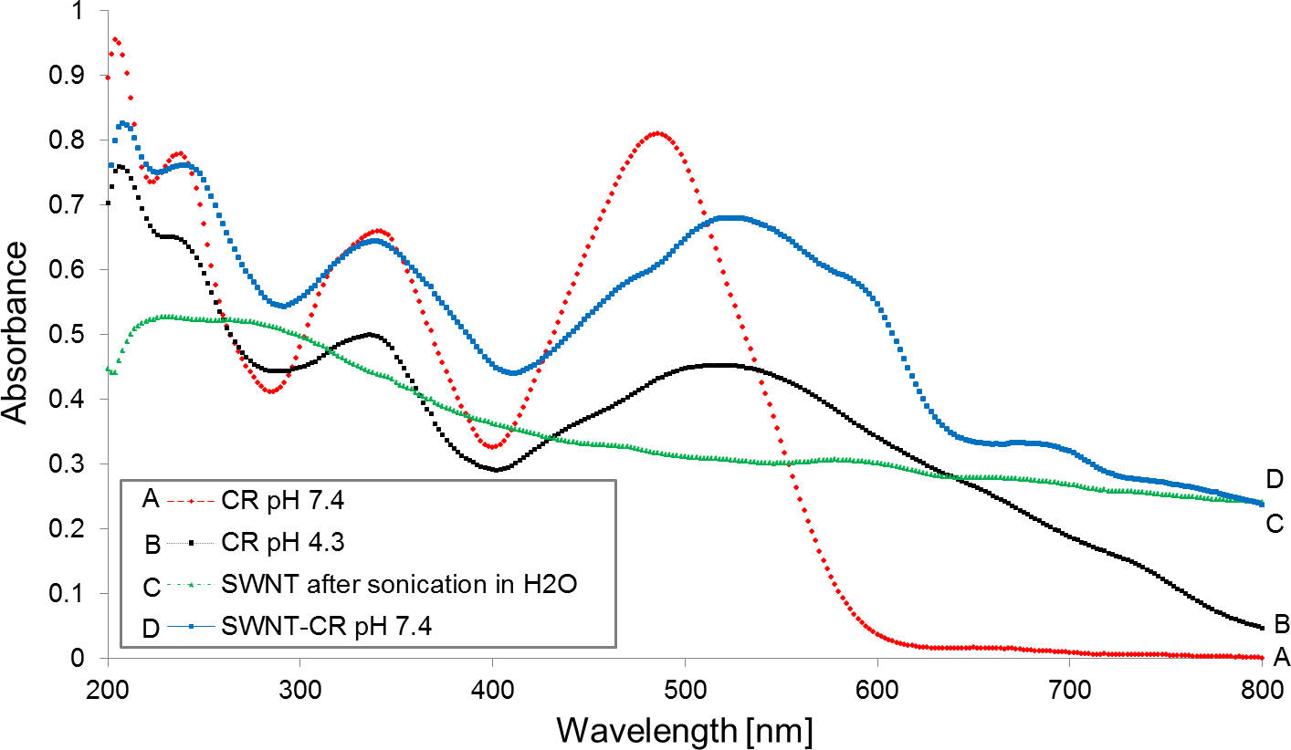
Beilstein J. Nanotechnol.2017,8,636–648.
strongly to the SWNT surface and the SWNT–CR conjugates are thermodynamically stable and that pH changes significantly affect the binding energies of the adsorbed CR. Here we present the experimental analysis of functionalization of nanotubes with Congo red, aimed to explain the role of dye supramolecularity
and the mechanism of nanotube–CR interaction.
change in the electron structure of CR molecule during transi- tion to the quinoid form(Figure 2) which is consistent with the
results presented in[40].
TheexperimentallydeterminedpKvaluefor Congoredamino group pKNH2equals5.0[29]. Thisresultsuggeststhedirect interactionof CRaromatic rings withthesurface
of carbon nanotubes, which are known to be good electrical
conductors.
Results and Discussion
Properties of SWNT–CR complexes – the role of CR supramolecularity
Comparison of the absorption spectra of free CR and CR bound to SWNTs shows that the binding to the carbon nanotube sur- face causes a significant change in the Congo red absorption spectrum(Figure 1, curves A and D). This change resembles that caused by acidification (Figure 1, curve B), although pH of the SWNT–CR sample remains unchanged (7.4). The absorp- tion maximum shifts from 490 to 510 nm, leading to the colour
change from red to purple.
SupramolecularityofCongored inwater solutionsstronglydepends uponthe ionic strength of the solvent. At low ionic strength, negative charges of sulphonic groups are not shieldedbycounterionsand thetendency towards formationofthesupramolecularstructureislow.Additionofsalt(e.g.,
0.15 M NaCl) stabilizes the interaction between CR molecules and increases its supramolecularity[32].Figure 3presents the effect of addition of salt on the amount of CR bound to SWNTs (0.05 M pH 7.4 Tris/HCl buffer with no NaCl and at 0.145 M and 0.264 M NaCl) after 1 or 4 days of incubation at room
temperature.
In both cases – protonation at decreased pH and adsorption to
SWNTs – the shift of the absorption maximum is caused by a
638

Figure 2:Congo red structure: (A) at physiological pH; (B) ionization of the amino groups at acidic pH and conversion to the quinoid form leading to the change of colour.

Figure 1:Absorption spectra of free Congo red (A) and SWNT-bound Congo red (D) (0.05 M Tris/HCl buffer, pH 7.4); Congo red spectrum after acidi- fication to pH 4.3 (B); free SWNT suspension spectrum (C).

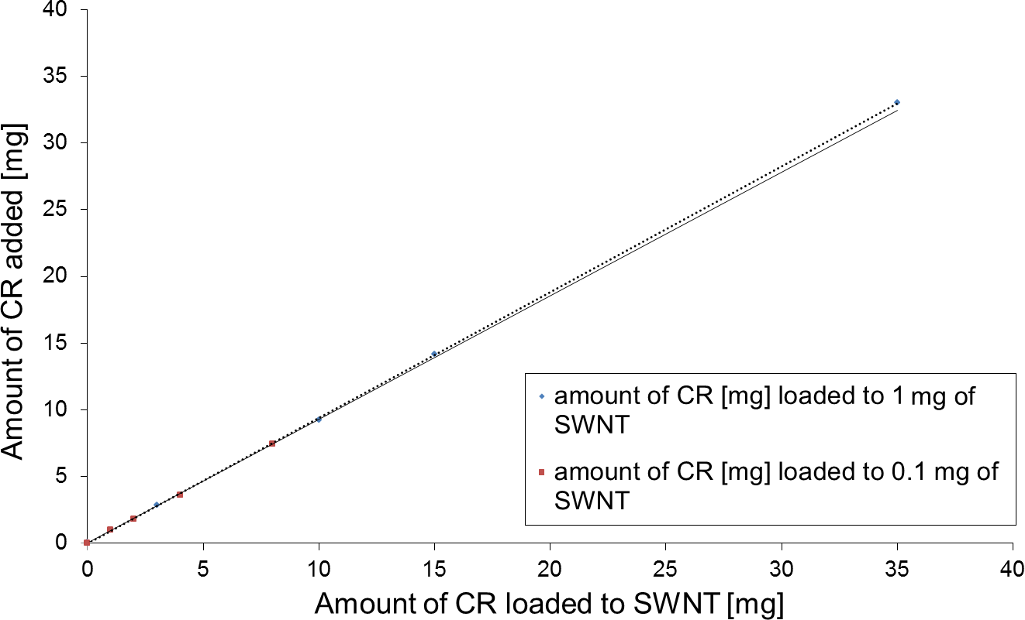
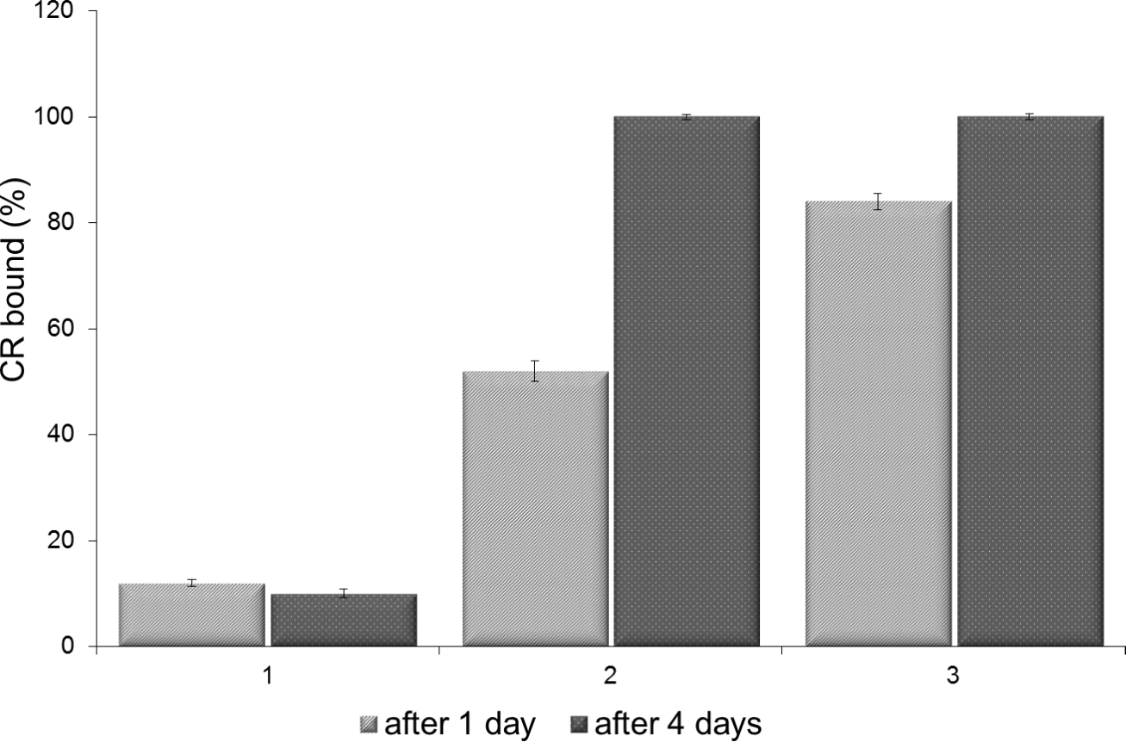
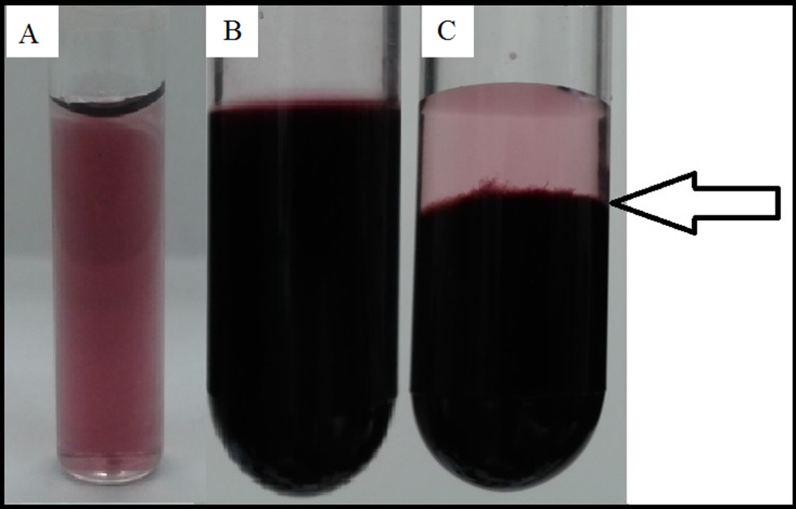
Beilstein J. Nanotechnol.2017,8,636–648.
amount of SWNTs (0.1 or 1 mg), followed by sonication and filtration as described in the Experimental part, led to the conclusion that the amount of bound CR is proportional to the amount of added CR and that no saturation point can be
achieved(Figure 4).
Surprisingly, 0.1 mg of nanotubes could bind even 30 mg ofCR,leadingtotheformationofacomplexthatshowedagel-like consistencyandsedimentedwithinacoupleofdaystothelowerpartofthe test tube butcouldbeeasilydispersed by gentle mixing. This suggests the formation of a “network”createdbyinteractingSWNTsandsupramolecular
CR(Figure 5B,C).
InFigure 3, 100% equals the total amount of CR added to the sample (1 mL of 2 mg/mL CR added to 1 mg of SWNTs, fol- lowed by sonication and filtration, as described in the Experi-
mental part).
Atlowionicstrength(noNaCl)theinteraction ofCRwithSWNTsis low –dispersionofSWNTsisnotobservedandtherearenochangesintheabsorption spectrumofCR.Atboth 0.145 M and 0.264 M NaCl the efficiency of CR bindingishigh,butcomplexesareformedfasteratthehighersalt
concentration.
Congo red binding capacity of SWNTs
Analysis of samples containing SWNT–CR complexes formed in presence of increasing amounts of CR added to the constant
639

Figure 4:Binding of an increasing amount of CR by a constant amount of SWNTs (0.1 or 1 mg).

Figure 5:SWNT–CR complexes formed at different CR/SWNT ratios. Macroscopic images of complexes filtered on PTFE membrane and suspended in pH 7.4 0.05 M Tris/HCl buffer. (A) 1 mL of 2 mg/mL CR added to 1 mg of SWNTs – the complex retained its colloidal stability for up to 3 months; (B) 1 mL of 5 mg/mL CR added to 1 mg of SWNTs
– the gel-like, time-sedimenting (arrow) (C), but easily dispersed com- plex was observed.

Figure 3:Binding of CR to SWNTs in solutions of different ionic strength. All samples were in a 0.05 M Tris-HCl pH 7.4 buffer with:
1) no NaCl; 2) 0.145 M NaCl; 3) 0.264 M NaCl. The amount of CR added to the nanotube portion was taken as 100%.
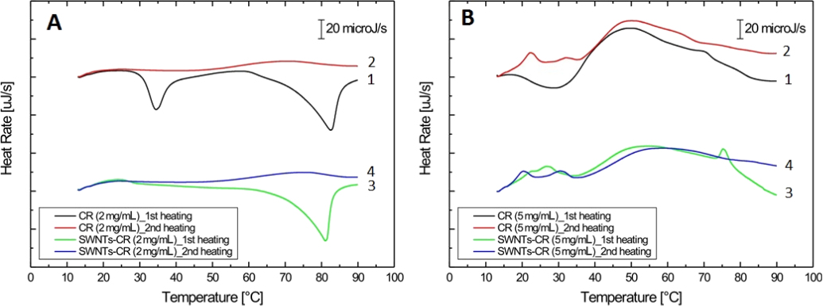
Beilstein J. Nanotechnol.2017,8,636–648.
SWNT–CR complex stability – DSC analysis
Differential scanning calorimetry (DSC) analysis of heat flow changes for SWNT–CR complexes was performed in order to evaluate the stability of the complexes formed at different CR/SWNT ratios. The results were recorded with a calorimeter working in power compensation mode.
heating” thermogram concernsthesample whichwasprevi-ously cooled slowly, in a controlled way – 1 °C/min. The “first heating” curve for free CR sample(Figure 6A, curve 1) shows a phase transition at 30–40 °C (maximum at 34.5 °C). This peakismuchwider (showsahigher valueoffullwidthathalfmaximum) for the higher CR concentration (Figure 6B, curve 1). In both cases the phase transition reflects the formation of organized, liquid-crystalline structures from less ordered assem- blies present in a fast-cooled solution. The rate of cooling is of big importance in case of supramolecular compounds. Abruptly cooled solutions of molecules that show a high self-assembling capability – like CR – create rather disordered assemblies which may beconvertedto anorderedandmore stable(optimum)
form as the temperature is raised slowly.
CR molecules in the supramolecular (liquid-crystalline) form are ordered, but retain partial freedom of movement. Both the translational and rotational freedom of the molecules increaseswith increasing temperature. UsingDSCwecanobservechanges in the heat capacity that accompany heating or cooling of the sample, and thus analyse the melting or the formation of supramolecularstructuresforbothfreeCRandCRattachedto
the carbon nanotube surface.
The presence of a wider peak in the thermogram for the sample with higher CR concentration suggests the existence of less homogenous structures. This transition is not observed for the “second heating” samples(Figure 6Aand B, curves 2), as the controlled, slow cooling (1 °C/min) favours the formation of highly ordered, and relatively stable, ribbon-like assemblies of
CR molecules.
We analysed heat capacity changes in two cycles of tempera- ture changes: heating after fast cooling and heating after very slow cooling. Free CR (2 mg/mL or 5 mg/mL) and SWNT- bound CR (the same amount) were analysed. All samples were
made using 0.05 M Tris/HCl pH 7.4, 0.264 M NaCl buffer.
The thermograms were analysed with respect to the formationoftheordered structures-which lowersthe heatcapacity(downward peaks), and melting of supramolecularstructures
(endothermic processes – upward peaks).
The small upward peak at 22.3 °C observed during the second heating for the 5 mg/mL CR solution(Figure 6B, curve 2) can reflect the breakdown of an undefined, low stability supramo- lecular structure of CR. Melting of an ordered supramolecular CR takes place at about 50 °C – this is clearly visible for the 5mg/mL sample (Figure6B,curve1and 3).Inpreviouslypublished results (for10 mg/mL CR solutions) melting took placeat40to60°C,dependingupontheionicstrengthofthe
solution[32].
Thermograms for free and SWNT-bound CR at two concentra-
tions (2 and 5 mg/mL) are presented inFigure 6.
The “first heating” thermogram was registered for the sample
which was previously quickly cooled while the “second
640

Figure 6:Calorimetric profiles obtained for free CR and CR bound to SWNTs: (A) 2 mg/mL CR; (B) 5 mg/mL CR. The first heating was always preceded by rapid cooling; second heating was preceded by controlled, slow cooling (1 °C/min).
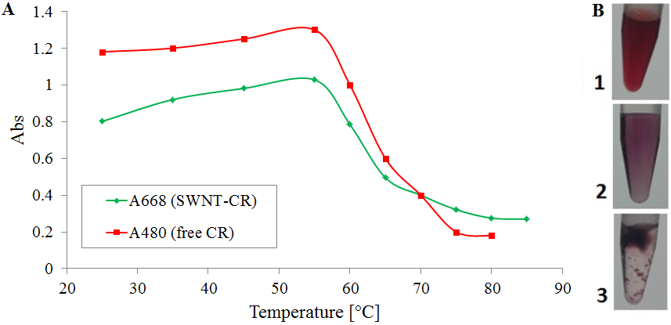
Beilstein J. Nanotechnol.2017,8,636–648.
When thermograms for free CR and SWNT-bound CR are com- pared(Figure 6) the following differences are observed: (1) The lack of 34.5 °C transition in the SWNT–CR complex – proba- bly caused by the interaction of ordered CR at the nanotube sur- face (Figure 6A). This interaction takes place when the soni-cated sample is left in room temperature. High enthalpy of the registered exothermic transition suggests that nanotubes may be responsible for the ordering of bound CR; (2) CR added to SWNTs at a lower (2 mg/mL) concentration creates complexes with nanotubes, which become more ordered and stable when the sample is cooled after the first heating. This results in the absence of the phase transition at 80 °C –Figure 6A, curve 4;
(3) At a higher CR concentration (5 mg/mL), the nanotube- bound CR is also more stable than free CR. The presence of a wide peak at 50–60 °C caused by breakdown of the supramolec- ular structure is observed. It probably corresponds to CR mole- cules being attached indirectly to the nanotube, through face-to- face interaction with CR adhering to the nanotube surface
(Figure 6B).
unclear, but most probably the release of CR molecules from SWNT–CR complexes at increased temperature allows the aggregation of nanotubes, followed by the reassociation of CR with the surface of SWNT bundles (thus the supernatant is
colourless).
Dynamic light scattering analyses
Dynamiclightscattering (DLS)applied toSWNT–CRcom-plexes analysis does not provide precise measurements of thenanotube diameter,butallowstocompareSWNTsamplesdispersed using different factors. We used nanotubes dispersed with sodium cholate as control and a SWNT–CR complex sam- ple obtained through the exchange of cholate to CR. The CR was added to nanotubes initially dispersed with sodium cholate,thesamplewasdialyzed leadingtotheformationoftheSWNT–CR complex as the cholate was removed. This proce- dure ensures the same dispersion of the control sample and the SWNT–CR complexes. Both SWNTs and SWNT–CRprobeswere10timesdilutedbeforemeasurements.
Thermal stability of SWNT–CR complexes
SWNT–CR complexes (1 mg SWNTs + 1 mL of 2 mg/mL CR, sonicated and filtered) are stable at temperatures up to 55 °C. Above that temperature the precipitation of nanotubes isob-served(Figure 7B.3), but CR is not released into the solution).Figure 7Ashows the decrease in absorbance of the supernatant for both free CR (at 480 nm) and for the SWNT–CR complex (at668nm)after20minutesincubationatagiventemperature.
AsshowninFigure8,bothcholate-dispersedSWNTsandSWNT–CR complexes present several maxima.TheSWNT–CR peaksareshifted towards higher values,astheinteractionwithsupramolecularCRincreasesthenanotube
diameter.
Microscopic analyses
SWNT–CR complexes were studied using various microscopic techniques. All analyses showed that interaction with CR signif- icantly increases the diameter of the nanotube, but in an uneven way, which suggests the presence of large, supramolecular CR assemblies attached to the nanotube surface.
The temperature at which the precipitation effect is observed correlates with the melting temperature for the CR supramolec-
ular form[32]. The reason of aggregation of nanotubes is
641

Figure 7:Precipitation of the SWNT–CR complex upon incubation at increasing temperature; (A) absorption spectra of the supernatant – decrease of absorption at 480 nm means that CR is not released from the complex; (B) macroscopic images of the samples: 1. CR solution; 2. SWNT–CR com- plex at room temperature; 3. SWNT–CR complex after heating above 60 °C.
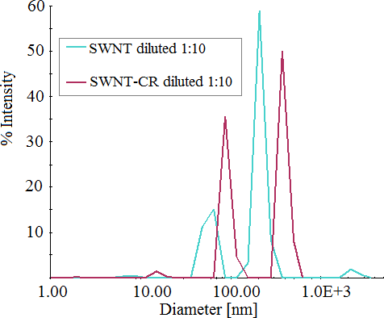
Beilstein J. Nanotechnol.2017,8,636–648.
(Figure 11.2). This can be explained by gel-like properties of the complex formed at high CR/SWNT ratio (seeFigure5B,C),
which is a network of nanotubes and supramolecular CR.
Elasticity measuredasthestiffnessrangeisspecifiedinarbitrary relative units. Elasticity reached of about 200 mArbonthefree SWNT(black) comparedtomica layer(red)(Figure 11.1A). InFigure 11.2A we observed a thick layer of SWNTs covered by CR with elasticity of about 450 mArb, but also bulbs which show much lower stiffness and higher plas-ticity. These bulbswerecharacterizedbysmalleradhesionenergy(Figure11.2B)andhighestdeformation(Figure11.2C)
and in consequence higher plasticity compared to free SWNTs.
The diameter of cholate dispersed nanotubes performed by AFM was 0.6–1 nm, while for CR-dispersed SWNTs 3–4 nm at the sites of weak load(Figure 12). This value may be under- valued due to the thick layer of SWNT–CR, from which protrude measured SWNT–CR. But generally in comparison
with the free SWNTs we see an increase in diameter.
SWNTs dispersed with sodium cholate (control) have approxi- mately 5 nm in diameter as observed with the transmission elec-
tron microscope (Figure 9A).
Conclusion
Direct functionalization of carbon nanotubes based on their interaction with Congo red allows for their dispersion in aqueous media and creates complexes in which the supramolec- ular character of CR is retained. Congo red presents unique properties as it forms ribbon-like supramolecular assemblies which are quite stable in aqueous solutions but simultaneously show some plasticity[35], important not only for binding to carbon nanotubes but also for interaction with proteins (as it can
adapt to the protein binding site) [31,34].
Congo red-covered nanotubes formed at a 1:1 CR/SWNT ratio (in this case all added CR was adsorbed to the nanotubes) are well dispersed, although their surface is not entirely covered with the dye. CR-covered areas show increased diameter – 9 to17 nm(Figure9B).Complexes formedathigher,5:1,CR/SWNT ratio (all added CR was also adsorbed to the nano- tubes) showuneven distributionof adsorbed CR,suggestingthat areas that have already bound CR molecules can preferably bind subsequent molecules of the supramolecular dye. Thus the nanotube diameter can locally increase up to 25 nm, while other areas remain bare (Figure 9C). At a CR/SWNT ratio of 10:1nanotubesarefullycoveredwithCRandtheirdiameter increasesto 28 nmbutlocallymayreach about40nm
(Figure 9D).
At solutions of low ionic strength, when CR supramolecularpropertiesare muchweaker,itsinteractionwithSWNTsisgreatly decreased.Athigher ionic strengthofthesolution,which favours formationofsupramolecularCRassemblies,dispersion of SWNT with CR is observed and the number of CRmoleculesboundto thenanotubescorrelateswithionicstrengthofthesolution,confirmingtheroleofsupramolecu-
larity(Figure 3).
Uneven loading of SWNTs(Figure 10A) with CR is also seeninscanning electron microscope images. CR-coveredareaspresentbulgesinFigure10B–D.Thediameterincreasesupto
50 nm, which is in accordance with TEM results.
Transmission and scanning electron microscopy images are consistent with AFM results. Using the AFM technique we compared cholate-dispersed (control) and CR-dispersed SWNTs (obtained at 5:1 CR/SWNT ratio) analysing mechani- cal parameters such as elasticity, adhesion, dispersion (dissipa-
tion energy) and deformation(Figure 11).
Two possible mechanisms of supramolecular SWNT–CR inter- action were considered: (1) „edge-to-face” – in which the edge of supramolecular ribbon-like CR assembly interacts with the nanotube surface and (2) „face-to-face” – in which aromatic rings of individual CR molecules adhere to the SWNT surface. These directly adsorbed CR molecules can interact with subse- quent CR molecules producing carbon nanotubes decorated with protruding ribbon-like structures of supramolecular CR. Both experimental data and theoretical analyses[39]support the
“face-to-face” model.
Cholate dispersed SWNTs form a monolayer at the mica sur- face(Figure 11.1) while SWNT–CR complexes form a thick
layer with single nanotubes protruding above its surface
642

Figure 8:Dynamic light scattering (DLS) measurements: comparison of SWNT–CR complexes and sodium cholate dispersed SWNTs (control).
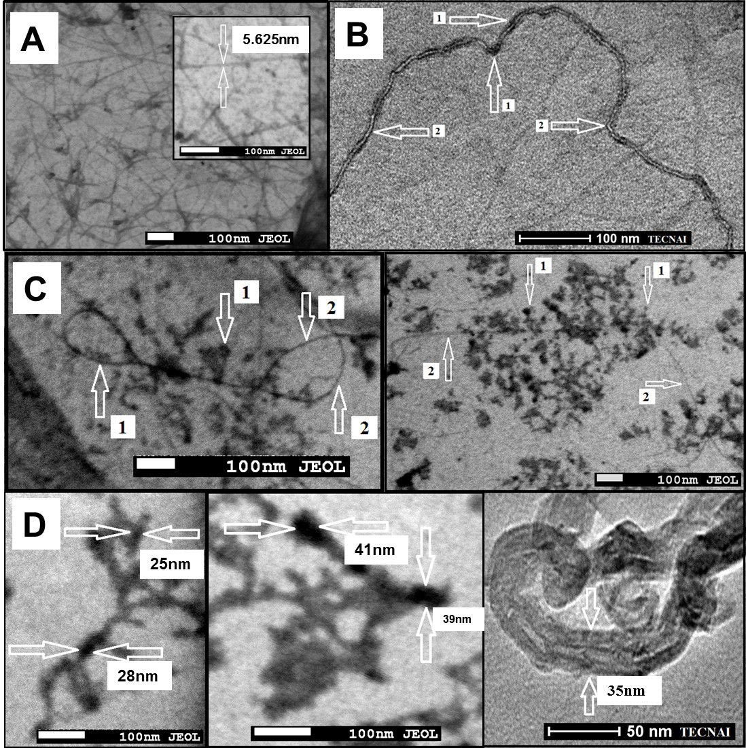
Beilstein J. Nanotechnol.2017,8,636–648.
Stacking of dye’s aromatic rings to the carbon lattice of the nanotube produces a significant shift of the absorption spec- trum (and the red to purple colour change). This shift, similar to that observed at acidic pH, is observed although pH 7.4 is retained. This could be explained by the flow of electrons from the nanotube to CR molecules - both to those directly adsorbed
(trough π–π interactions between CR and a carbon nanotube)
and to the ones indirectly bound as elements of the supramolec- ular assembly. Since carbon nanotubes are conductors, they can serve as donors of electrons to CR, which switches to the
quinoid form(Figure 2) and changes colour.
Molecular modelling analysis[39]showed how aromatic rings
of CR molecules can adhere to the nanotube surface.
643

Figure 9:Transmission electron microscope images. (A) SWNTs dispersed by sodium cholate; the diameter of the individual SWNT – 5.6 nm;
(B) SWNT–CR complex created at low 1:1 CR/SWNT ratio (1 mg SWNTs + 1 mL of 1 mg/mL CR). Arrows indicate (1) CR binding sites and
(2) CR-free areas (Tecnai, Osiris); (C) SWNT–CR complexes formed at 5:1 CR/SWNT ratio (1 mg SWNT + 1 mL of 5 mg/mL CR): nanotubes unevenly covered with CR are visible. Arrows indicate (1) CR binding sites and (2) CR-free areas. The diameter of SWNT–CR complex exceeds 20 nm in thickest areas (Jeol); (D) SWNT–CR complexes formed at very high 10:1 CR/SWNT ratio (1 mg SWNTs + 1 mL of 10 mg/mL CR): CR covers the entire surface of carbon nanotubes, the diameter of SWNT–CR complex exceeds 40 nm in thickest areas.
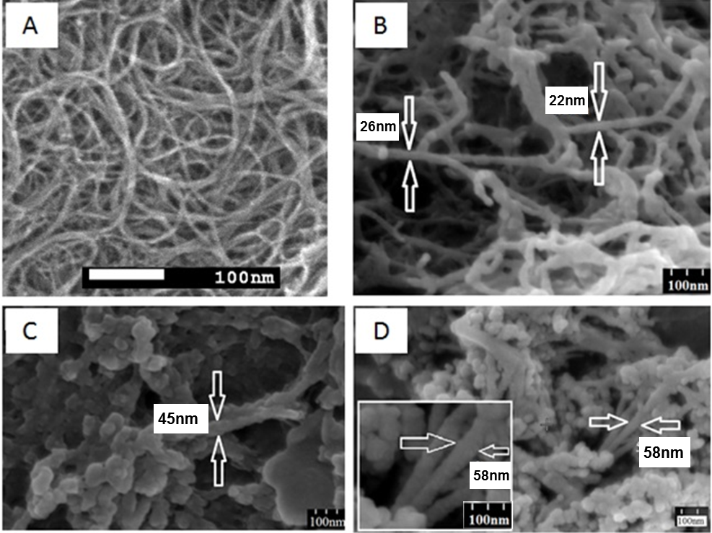
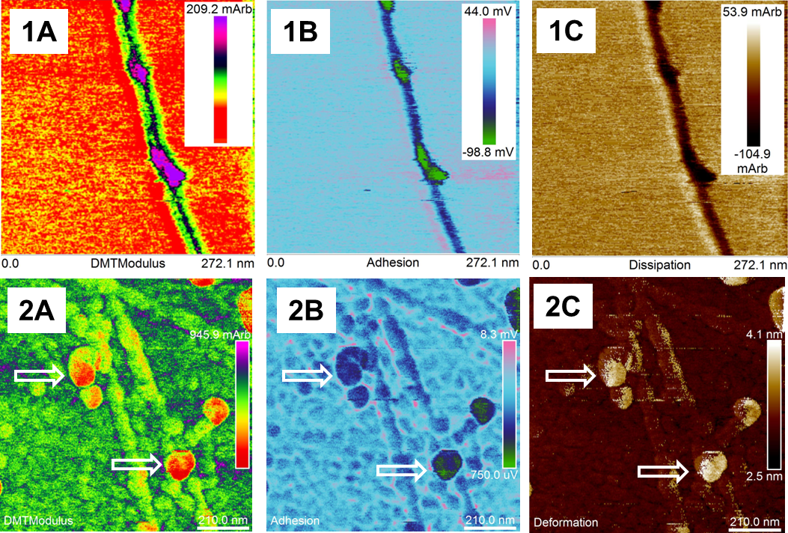
Beilstein J. Nanotechnol.2017,8,636–648.
644

Figure 11:AFM analyses of sodium cholate dispersed SWNTs (1) and SWNT–CR complexes (2); maps of mechanical parameters: (1A; 2A) elas- ticity (Young modulus), red – the lowest value; (1B; 2B) adhesion (green – lowest value); (1C) dissipation (dark – the lowest value); (2C) deformation (white – the highest value). Arrows point to local thickening and decreased stiffness (high plasticity) on the surface of the CR-covered nanotubes.

Figure 10:Scanning electron microscope images. (A) undispersed, raw SWNTs; (B) SWNT–CR complexes formed at high 5:1 CR/SWNT ratio
(1 mg SWNTs + 1 mL of 5 mg/mL CR): CR covers the entire surface of carbon nanotubes,the diameter of the SWNT–CR complex exceeds 20 nm; (C,D)SWNT–CRcomplexesformedatveryhigh10:1CR/SWNTratio(1mgSWNTs+1mLof10mg/mLCR):CRcoverstheentiresurfaceofcar- bon nanotubes,the diameter of the SWNT–CR complex exceeds 40 nm andmore.
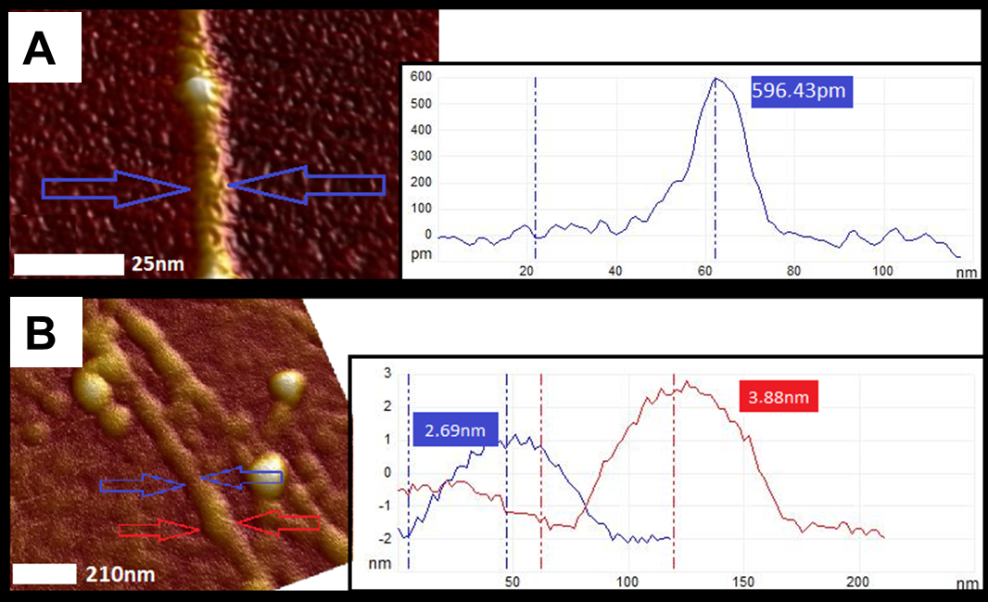
Beilstein J. Nanotechnol.2017,8,636–648.
The flowofelectronsfrom thenanotubetoCRcanlocallychange the properties of the nanotube surface, making its inter- action with other CR molecules less probable. This may explainwhy TEMimagesofSWNT–CR complexes formedat5:1 CR/SWNT ratio show both bare regions and areas covered with a thick CR sheath(Figure 9C). The diameter of CR-loadedSWNTsincreaseswithincreasingCR/SWNT ratio–asobservedinTEM, SEM, AFM and DLS–supportingtheface-to-face mode of the interaction between CR and theSWNT
surface.
complex. Interestingly, at high CR concentrations the complex shows gel-like properties, which can be explained through for- mation of a network containing nanotubes connected by supra-
molecular CR.
Supramolecular ribbon-like assemblies created by CR show a capability to bind (intercalate) many different compounds, pro- vided that at least a part of a molecule is a planar aromatic ring (e.g., Rhodamin B, Titan yellow)[36-38]. Since many drugs show such a structural feature, CR-nanotube complexes can be considered as possible drug-carriers. The ability of nanotubes to bind high amounts of Congo red would be advantageous, as it could increase the drug-binding capacity of the nanotube
carrier.
Differential scanning calorimetry analyses show that the inter- action of CR with nanotubes stabilizes the supramolecular structure of CR. As the sonicated SWNT/CR mixture is left atroom temperature and the CR binds to the nanotube surface, CR molecules become ordered (and the 35 °C transition is not ob- served in DSC analysis –Figure 6A). The ordering of CR is also responsible for the birefringence of the SWNT–CR com- plexes observed using polarized light microscopy (data not shown). CR molecules bound indirectly (and thus more loosely) to the nanotube as distant elements of the CR ribbon, which are more abundant at higher CR/SWNT ratio, can dissociate from the SWNT–CR complex as the temperature is raised, producing
the transition peak at about 55 °C(Figure 6B).
Experimental
Materials
Single-wall carbon nanotubes (SWNTs, purity >90%, length 700 nm, diameter 0.7–0.9 nm), Congo red (CR, 96% purity) and sodium cholate were obtained from Sigma. Polytetrafluoro- ethylene (PTFE) membranes (0.2 µm pore size) were pur- chased from MERCK Millipore. All other reagents used were of analytical grade.
Dispersion of SWNTs by non-covalent attachment of supramolecular Congo red
1 mL of aqueous CR solution (2 or 5 mg/mL) was heated for
3 min at 100 °C, slowly cooled to room temperature and added
Unexpectedly, we could not estimate the maximum amount of CR that could bind to the nanotube(Figure 4) as even at 350:1
(CR/SWNT, w/w) most of the added CR was trapped in the
645

Figure 12:Diameter of nanotubes as measurements of height (AFM cross section analysis): (A) the diameter of a single (cholate dispersed) nano- tube is about 0.6 nm; (B) the diameter of CR covered SWNTs ranges from 2.7 to approx. 4 nm at the sites of weak load.
Beilstein J. Nanotechnol.2017,8,636–648.
to 1 mg of SWNTs. The mixture was sonicated for 2 h (in cooled water bath) and then left for 24 h at room temperature.The SWNT–CR complex was separated from the unbound CR by filtration on PTFE membrane. This allowed to obtain well- dispersed CR-coated SWNTs that were directly used for further experiments. SWNT–CR complexes obtained in the method de- scribed above retained their colloidal stability for at least
3 months (stored at 4 °C or at room temperature).
ment. Each measurement – 20 acquisitions lasting 5 seconds
each – was performed in triplicate.
Transmission electron microscopy (TEM), scanning electron microscopy (SEM), atomic force microscopy (AFM)
Scanning and transmission electron microscopy was conducted on a Jeol JSM-7500F with EDS INCA Pentaflex 3 adapter to analyse the elemental composition of a sample. Scanning elec- tron microscopy was performed on Hitachi S-4700 model equipped with a system of elemental composition analysis based on X-ray energy dispersion (Noran Instruments). High- resolution transmission electron microscopy (HR-TEM) was conducted on a FEI Tecnai Osiris G2 20 TWIN. Atomic force microscopy (AFM) was conducted on a Dimension FastScan or Dimension ICON (Bruker Nano, Santa Barbara, California). Surface of carbon nanotubes was visualised in Peak Force QNM (Quantitative NanoMechanics) mode, allowing the simul-
taneous mapping of the topography and mechanical properties.
The amount of CR bound by SWNTs was determined spec- trophotometrically based on the amount of CR in the eluate as compared to the total amount of CR added to the sample. UV–vis absorption spectra were recorded on a Cary 300Bio Varian spectrophotometer. Absorption coefficient for CR: ε489= 50.46 M−1·cm−1. In order to avoid errors caused by clog-
ging of the membrane (in case of samples containing higher
amounts of CR) the filtering procedure was repeated twice with a fresh filter. For some experiments sodium cholate was used in order to create the control sample – carbon nanotubes dispersed without CR.
The samples were dialyzed for 24 h to deionized water, then a 1µLdropletofSWNT–CR suspensionwasplacedontoa freshly cleaved mica surface (for AFM measurements) or onto a 300 mesh copper TEM grid (for TEM measurements) and dried overnightinadesiccator.ThesamplesforSEMmeasurements
were dried and sprayed with gold in a technical vacuum sputter.
Characterization
Differential scanning calorimetry (DSC)
SWNT–CR complexesfor the DSCanalysiswerepreparedasfollows:1 mg ofSWNTswassuspendedin 1 mL of 2or5mg/mLCRsolution(in 0.05MTris/HCl bufferpH7.4,
0.264 M NaCl), sonicated and filtered as described above to obtain carbon nanotubes differing in the degree of loading with CR. As the controls we analysed thermal capacities of Congo red supramolecular ribbon-like structures formed in 2 mg/mLand5mg/mL solutions.TheanalysiswasperformedusingNANODSCSeriesIIISystem(model 6300)withPlatinumCapillary Cell (TA Instruments) equipped with Nano DSCRun software. In order to avoid the formation of air bubbles during the heating, the samples were degassed for 10–15 minbeforethe measurement using the negative pressure of 0.3–0.5 atm. A reference chamber was filled with a buffer used for the analysed sample. All the measurements were performed at 3 bar pressure in a 0.33 mL capillary cell. Data was collected in therange of
10–90 °C at 1 °C·min−1scan rate for both heating and cooling.
In order to ensure the thermodynamic equilibrium, the measuring system was equilibrated for 10 min at an initial tem- perature (10 °C in the heating mode, and 90 °C in the cooling mode). Baselines were made by recording scans for referencesamples (appropriate buffers). Each set of data was analysed using NanoAnalyze software supplied by TA Instruments.
AFM measurements were performed using SNL-10 probe (type A microcantilever) with silicon tip mounted on a silicon nitride microcantilever. The elasticity constant of the microcantilever was 0.32 N/m. The nominal radius of the tip before the mea- surement was 2 nm. PeakForce QNM (PF QNM) performs a very fast curve at every pixel in the image. Using PF QNM mode visualization, maps of both the surface and mechanical properties were generated simultaneously. This allowed to obtain following characteristic: stiffness (elasticity) of the mate- rial (DMT Modulus; the higher value of the modified Young's modulus means the more stiff material), adhesion forces (it allows mapping the maximum force with which the microcan- tilever is attracted by the sample at the time of retract of the piezoelectric scanner), deformation (the indentation of the sur- face under the tip), dispersion (dissipation, loss of energy of microcantilever of scanning probe when passing through differ-
ent areas on the sample surface).
Acknowledgements
We acknowledge the Labsoft company for performing the AFM analysis, Dr Magdalena Jarosz for providing SEM analysis and Prof. Magdalena Parlińska from Institute of Nanotechnology, University of Rzeszow, Poland for providing TEM analysis. We
thank Prof. dr hab Aleksandra Czyrska-Filemonowicz from
Dynamic light scattering (DLS)
The interaction of CR with carbon nanotubes was studied using the DynaPro NanoStar (Wyatt Technology). The measurements were done after 3 min incubation at 25 °C within the instru-
646
Beilstein J. Nanotechnol.2017,8,636–648.
International Centre of Electron Microscopy for Materials Science, AGH University of Science and Technology, Kraków, Poland for TEM analysis and helpful comments. We thank Dr Jacek Achremowicz from Wyatt Technology for DLS analysis and helpful comments. We acknowledge the financial support from the project Interdisciplinary PhD Studies "Molecular sciences for medicine" (co-financed by the European Social Fund within the Human Capital Operational Programme) and Ministry of Science and Higher Education (grant no. K/DSC/
001370)
- Witus, L. S.; Rocha, J.-D. R.; Yuwono, V. M.; Paramonov, S. E.; Weisman,R.B.;Hartgerink,J.D.J.Mater.Chem.2007,17,1909.doi:10.1039/b700174f
- Zhang,X.;Meng,L.;Lu,Q.;Fei,Z.;Dyson,P.J.Biomaterials2009,30,
6041–6047.doi:10.1016/j.biomaterials.2009.07.025
- Cheng,Z.;AlZaki,A.;Hui,J.Z.;Muzykantov,V.R.;Tsourkas,A.
Science2012,338,903–910.doi:10.1126/science.1226338
- Raffa,V.;Ciofani,G.;Nitodas,S.;Karachalios,T.;D’Alessandro,D.; Masini, M.; Cuschieri, A.Carbon2008,46,1600–1610.doi:10.1016/j.carbon.2008.06.053
- Lacerda, L.; Russier, J.; Pastorin, G.; Herrero, M. A.; Venturelli, E.; Dumortier,H.;Al-Jamal,K.T.;Prato,M.;Kostarelos,K.;Bianco,A.Biomaterials2012,33,3334–3343.doi:10.1016/j.biomaterials.2012.01.024
24. Nepal, D.; Geckeler, K. E.Small2007,3,1259–1265.doi:10.1002/smll.200600511
- Chhikara,B.S.;Misra,S.K.;Bhattacharya,S.Nanotechnology2012,
23,65101.doi:10.1088/0957-4484/23/6/065101
- Backes, C.; Hirsch, A. InChemistry of Nanocarbons;Akasaka, T.; Wudl,F.;Nagase,S.,Eds.;JohnWiley&Sons,Ltd:Chichester,United Kingdom, 2010; pp 1–48.doi:10.1002/9780470660188.ch1
- Szlachta,M.;Wójtowicz,P.WaterSci.Technol.2013,68,2240–2248.doi:10.2166/wst.2013.487
- Hu,C.;Chen,Z.;Shen,A.;Shen,X.;Li,J.;Hu,S.Carbon2006,44,
428–434.doi:10.1016/j.carbon.2005.09.003
- Spólnik, P.; Stopa, B.; Piekarska, B.; Jagusiak, A.; Konieczny, L.; Rybarska,J.;Król,M.;Roterman,I.;Urbanowicz,B.;Zięba-Palus,J.Chem. Biol. Drug Des.2007,70,491–501.
doi:10.1111/j.1747-0285.2007.00589.x
- Klunk, W. E.; Pettegrew, J. W.; Abraham, D. J.J.Histochem.Cytochem.1989,37,1273–1281.doi:10.1177/37.8.2666510
- Król, M.; Roterman, I.; Piekarska, B.; Konieczny, L.; Rybarska, J.; Stopa,B.;Spólnik,P.;Szneler,E.Biopolymers2005,77,155–162.doi:10.1002/bip.20197
- Skowronek,M.;Stopa,B.;Konieczny,L.;Rybarska,J.;Piekarska,B.; Szneler, E.; Bakalarski, G.; Roterman, I.Biopolymers1998,46,267–281.
doi:10.1002/(SICI)1097-0282(19981015)46:5<267::AID-BIP1>3.0.CO;2
-N
- Spólnik, P.; Król, M.; Stopa, B.; Konieczny, L.; Piekarska, B.; Rybarska,J.;Zemanek,G.;Jagusiak,A.;Piwowar,P.;Szoniec,G.; Roterman, I.Eur. Biophys. J.2011,40,1187–1196.doi:10.1007/s00249-011-0750-z
- Roterman, I.; Rybarska, J.; Konieczny, L.; Skowronek, M.; Stopa, B.; Piekarska,B.;Bakalarski,G.Comput.Chem.(Oxford,U.K.)1998,22,61–70.doi:10.1016/S0097-8485(97)00014-4
- Piekarska,B.;Drozd,A.;Konieczny,L.;Król,M.;Jurkowski,W.; Roterman, I.; Spólnik, P.; Stopa, B.; Rybarska,J.
Chem. Biol. Drug Des.2006,68,276–283.doi:10.1111/j.1747-0285.2006.00448.x
- Jagusiak,A.; Piekarska, B.; Chłopaś, K.; Bielańska, E.; Pańczyk,T.
Bio-Algorithms Med-Syst.2016,12,123–132.doi:10.1515/bams-2016-0015
- Chłopaś,K.;Jagusiak,A.;Konieczny,L.;Piekarska,B.;Roterman,I.; Rybarska, J.; Stopa, B.; Zemanek, G.; Bielańska, E.; Piwowar, P.; Sadlik, K.Bio-Algorithms Med-Syst.2015,11,9–17.
doi:10.1515/bams-2015-0001
References
1.
Li, J.; Lu, Y.; Ye, Q.; Cinke, M.; Han, J.; Meyyappan, M.Nano Lett.
2003,3,929–933.doi:10.1021/nl034220x
Ji, S.-r.; Liu, C.; Zhang, B.; Yang, F.; Xu, J.; Long, J.; Jin, C.; Fu, D.-l.; Ni, Q.-x.; Yu, X.-j.Biochim. Biophys. Acta, Rev. Cancer2010,1806,29–35.doi:10.1016/j.bbcan.2010.02.004
Duffy, M. J.Eur. J. Intern. Med.2007,18,175–184.doi:10.1016/j.ejim.2006.12.001
Prato, M.; Kostarelos, K.; Bianco, A.Acc. Chem. Res.2008,41,60–68.doi:10.1021/ar700089b
Chen, J.; Chen, S.; Zhao, X.; Kuznetsova, L. V.; Wong, S. S.; Ojima, I.
J. Am. Chem. Soc.2008,130,16778–16785.doi:10.1021/ja805570f
Vashist, S. K.; Zheng, D.; Pastorin, G.; Al-Rubeaan, K.; Luong, J. H. T.; Sheu, F.-S.Carbon2011,49,4077–4097.
doi:10.1016/j.carbon.2011.05.049
Bhirde, A. A.; Patel, V.; Gavard, J.; Zhang, G.; Sousa, A. A.; Masedunskas, A.; Leapman, R. D.; Weigert, R.; Gutkind, J. S.; Rusling, J. F.ACS Nano2009,3,307–316.doi:10.1021/nn800551s
Pastorin, G., Ed.Carbon nanotubes: From bench chemistry topromising biomedical applications;Pan Stanford Publishing: Singapore, 2011.doi:10.1201/b11122
Wong, B. S.; Yoong, S. L.; Jagusiak, A.; Panczyk, T.; Ho, H. K.; Ang, W. H.; Pastorin, G.Adv. Drug Delivery Rev.2013,65,
1964–2015.doi:10.1016/j.addr.2013.08.005
2.
3.
4.
5.
6.
7.
8.
9.
- Balasubramanian,K.;Burghard,M.Small2005,1,180–192.doi:10.1002/smll.200400118
- Bianco,A.;Kostarelos,K.;Partidos,C.D.;Prato,M.Chem.Commun.
2005,7,571–577.doi:10.1039/b410943k
- Harrison,B.S.;Atala,A.Biomaterials2007,28,344–353.doi:10.1016/j.biomaterials.2006.07.044
- Rastogi,V.;Yadav,P.;Bhattacharya,S.S.;Mishra,A.K.;Verma,N.; Verma, A.; Pandit, J. K.J. Drug Delivery2014,670815.doi:10.1155/2014/670815
- Hamon, M. A.; Chen, J.; Hu, H.; Chen, Y.; Itkis, M. E.; Rao, A. M.; Eklund, P. C.; Haddon, R. C.Adv. Mater.1999,11,834–840.doi:10.1002/(SICI)1521-4095(199907)11:10<834::AID-ADMA834>3.0.CO;2-R
- Liu,Z.;Sun,X.;Nakayama-Ratchford,N.;Dai,H.ACSNano2007,1,
50–56.doi:10.1021/nn700040t
- Kostarelos, K.; Lacerda, L.; Pastorin, G.; Wu, W.; Wieckowski, S.; Luangsivilay,J.;Godefroy,S.;Pantarotto,D.;Briand,J.-P.;Muller,S.; Prato, M.; Bianco, A.Nat. Nanotechnol.2007,2,108–113.doi:10.1038/nnano.2006.209
- Shi Kam, N. W.; Jessop, T. C.; Wender, P. A.; Dai,H.
J. Am. Chem. Soc.2004,126,6850–6851.doi:10.1021/ja0486059
- Tasis,D.;Tagmatarchis,N.;Bianco,A.;Prato,M.Chem.Rev.2006,
106,1105–1136.doi:10.1021/cr050569o
647
Beilstein J. Nanotechnol.2017,8,636–648.
- Stopa, B.; Piekarska, B.; Jagusiak, A.; Kusior, D.; Zemanek, G.; Konieczny, L.Acta Biochim. Pol.2011,58(Suppl. 2), 282. Supramolecular Congo red as a potential drug carrier. Properties of Congo red-doxorubicin complexes. In Proceedings of the 2nd CongressofBiochemistryandCellBiology46thMeetingofthePolish Biochemical Society and 11st Conference of the Polish Cell Biology Society, Kraków, 2011.http://www.actabp.pl/pdf/Supl2_11/S28.pdf
- Panczyk,T.;Wolski,P.;Jagusiak,A.;Drach,M.RSCAdv.2014,88,
47304–47312.doi:10.1039/C4RA06806H
- Pigorsch, E.; Elhaddaoui, A.; Turrell,S.
Spectrochim. Acta, Part A: Mol. Spectrosc.1994,50,2145–2152.doi:10.1016/0584-8539(94)00151-0
648
License and Terms
This is an Open Access article under the terms of the Creative Commons Attribution License (http://creativecommons.org/licenses/by/4.0), which permits unrestricted use, distribution, and reproduction in any medium, provided the original work is properly cited.

The license is subject to theBeilstein Journal ofNanotechnologyterms and conditions: (http://www.beilstein-journals.org/bjnano)

The definitive version of this article is the electronic one which can be found at:
doi:10.3762/bjnano.8.68

