

© Pol J Radiol 2022; 87: e311-e315
DOI: https://doi.org/10.5114/pjr.2022.117569
Received: 30.07.2021
Accepted: 09.08.2021
Published: 08.06.2022
http://www.polradiol.com
Original paper
Volumetric analysis of mandibular lesions with SPECT/CT: a pilot clinical
study of maximum standardized uptake value
Yoshiyuki Minami1B,D, Ruri Ogawa1C,F, Ichiro Ogura1,2,A,E,G
1Quantitative Diagnostic Imaging, Field of Oral and Maxillofacial Imaging and Histopathological Diagnostics, Course of Applied Science, The Nippon Dental University Graduate School of Life Dentistry at Niigata, Niigata, Japan
2Department of Oral and Maxillofacial Radiology, The Nippon Dental University School of Life Dentistry at Niigata, Niigata, Japan
Abstract
Purpose: This study was designed to investigate mandibular lesions using volumetric analysis with bone single-photon emission computed tomography/computed tomography (SPECT/CT).
Material and methods: Eight patients with mandibular lesions underwent SPECT/CT scan acquisition 4 hours after injection of Tc-99m hydroxymethylene diphosphonate (HMDP). Regarding volumetric analysis, maximum standar- dized uptake value (SUV) was obtained using software and a workstation (Q.Volumetrix MI and GEniE-Xeleris 4 DR, respectively). The localization and size of the volume of interest (VOI) can be drawn over the lesion, mesial, distal, and opposite side as normal using the CT, SPECT, and SPECT/CT transaxials, coronals, and sagittals as the anatomical reference. Q.Volumetrix MI can analyse SUV of lesions by organ segmentation using optional pan and zoom imaging. Then, the dosimetry software provided multiple quantitative data for a given VOI. Statistical analyses for the maximum SUV were performed by Mann-Whitney U test. A p-value lower than 0.05 was considered as sta- tistically significant.
Results: Maximum SUVs for medication-related osteonecrosis of the jaw (n = 4, 25.4 ± 4.9), chronic osteomyelitis (n = 3,
14.6 ± 3.1), and squamous cell carcinoma (n = 1, 31.7) were significantly higher than those of the opposite side as normal mandible (3.8 ± 0.7, 4.6 ± 1.8, and 7.4, respectively; p = 0.000).
Conclusions: Volumetric analysis with SPECT/CT could be useful for the evaluation of mandibular lesions, such as detecting and surgical planning.
Keywords: single photon emission computed tomography, radionuclide imaging, bisphosphonate-associated osteonecrosis of the jaw.
SPECT/CT can provide the quantitative parameter
standardized uptake value (SUV) [7,8]. Quantitative SPECT/CT offers the possibility to continue and expand the potential of quantitative nuclear medicine applica- tions [9,10]. Quantitative salivary gland SPECT/CT holds promise as an objective imaging modality for assessment of salivary dysfunction [11-13]. Furthermore, SUV using Q.Metrix [14,15] and GI-BONE [16-19] software could be useful for the evaluation of jaw lesions. In recent years, Q.Volumetrix MI and GEniE-Xeleris 4 DR were developed. However, to the best of our knowledge, no reports have
Introduction
Single-photon emission computed tomography/computed
tomography (SPECT/CT) plays an important role in as- sessing oral and maxillofacial lesions [1-4]. SPECT/CT is useful not only for detecting jaw bone invasion of oral cancer but also for surgical planning [5]. Furthermore, radiologic-pathologic correlation of medication-related osteonecrosis of the jaw (MRONJ) could be achieved using SPECT/CT [6].
Correspondence address:
Ichiro Ogura, Department of Oral and Maxillofacial Radiology, The Nippon Dental University School of Life Dentistry at Niigata, 1-8 Hamaura-cho, Chuo-ku, Niigata, Niigata 951-8580, Japan, phone: +81-25-267-1500, fax: +81-25-267-1134, e-mail: ogura@ngt.ndu.ac.jp
Authors’ contribution:
A Study design ∙ B Data collection ∙ C Statistical analysis ∙ D Data interpretation ∙ E Manuscript preparation ∙ F Literature search ∙ G Funds collection
This is an Open Access journal, all articles are distributed under the terms of the Creative Commons Attribution-Noncommercial-No Derivatives 4.0 International (CC BY-NC-ND 4.0). License (https://creativecommons.org/licenses/by-nc-nd/4.0/).
e311

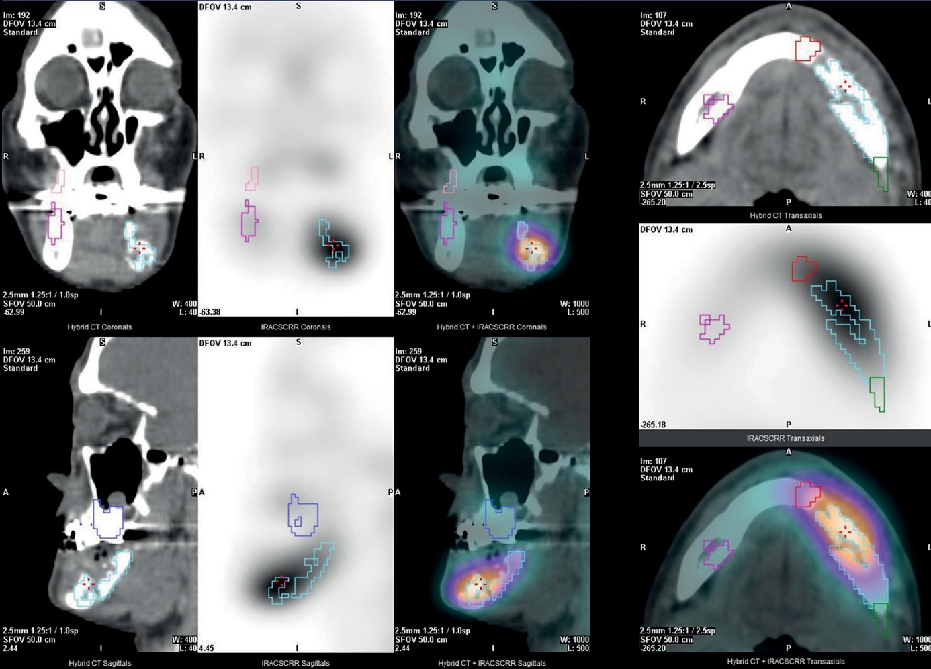
Yoshiyuki Minami, Ruri Ogawa, Ichiro Ogura
been published on SPECT/CT SUV of jaw lesions using
Q.Volumetrix MI and GEniE-Xeleris 4 DR. The aim of this study was to investigate mandibular lesions with SPECT/ CT using Q.Volumetrix MI and GEniE-Xeleris 4 DR.
(99mTc-HMDP, Clear Bone Injectable, Nihon Medi-
Physics, Tokyo, Japan) prior to the SPECT acquisition.
Data analysis
The maximum SUV was obtained by using software and a workstation (Q.Volumetrix MI and GEniE-Xeleris 4 DR, respectively, GE Healthcare, Tokyo, Japan). The localiza- tion and size of volume of interest (VOI) can be drawn over the lesion, mesial, distal, and opposite side as normal us- ing the CT, SPECT, and SPECT/CT transaxials, coro- nals, and sagittals as the anatomical reference (Figure 1). Q.Volumetrix MI can analyse SUV of lesions by organ seg- mentation using optional pan and zoom imaging. Then, the dosimetry software provided multiple quantitative data for a given VOI. The maximum SUV in a given VOI was calculated as follows: maximum SUV = (maximum radio- activity/voxel volume)/(injected radioactivity/body weight).
Material and methods
Subjects
This prospective study was approved by the ethics com- mittee of our university (ECNG-R-318). After provid- ing written informed consent, 8 patients (2 men and 6 women; mean age 71.1 years [range 52-91 years]) with mandibular lesions (4 MRONJ, 3 chronic osteomye- litis, and 1 squamous cell carcinoma) underwent SPECT/ CT at our university hospital from January 2020 to March 2021.
SPECT/CT imaging
SPECT/CT scans were obtained using a SPECT/CT scanner (Optima NM/CT 640, GE Healthcare, Tokyo, Japan), following our institutional protocol [14]. Patients were administered an intravenous injection of 740 MBq of technetium 99m hydroxymethylene diphosphonate
Statistical analysis
Statistical analyses for the maximum SUV were performed by Mann-Whitney U test, using the statistical package IBM SPSS Statistics version 26 (IBM Japan, Tokyo, Japan). A p-value lower than 0.05 was considered as statistically significant.
Figure 1. Q.Volumetrix MI and GEniE-Xeleris 4 DR. Using the computed tomography (CT), single-photon emission computed tomography (SPECT), SPECT/ CT transaxials, coronals, and sagittals as the anatomical reference, the localization and size of volume of interest (VOI) was automatically drawn over the lesion (sky blue), mesial (red), distal (green), and opposite side as normal (pink)
e312
© Pol J Radiol 2022; 87: e311-e315

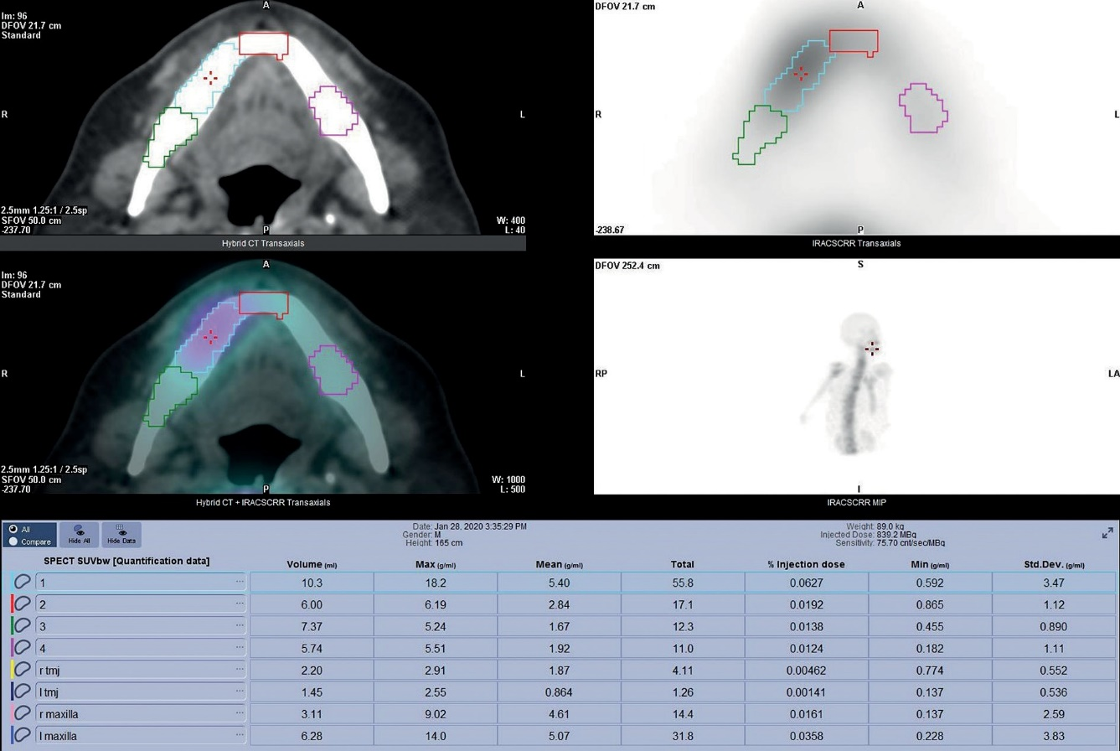
Volumetric analysis of mandibular lesions with SPECT/CT: a pilot clinical study of maximum standardized uptake value
Results
Discussion
Table 1 shows 8 cases of SPECT/CT maximum SUV for
mandibular lesions. Maximum SUVs for MRONJ (n = 4,
25.4 ± 4.9), chronic osteomyelitis (n = 3, 14.6 ± 3.1), and squamous cell carcinoma (n = 1, 31.7) were significantly higher than those of the opposite side as normal mandible (3.8 ± 0.7, 4.6 ± 1.8 and 7.4, p = 0.000), respectively. Fig- ures 2 and 3 indicate cases of chronic osteomyelitis (case 5) and squamous cell carcinoma (case 8), respectively.
Despite SPECT/CT playing an important role in assessing
oral and maxillofacial lesions [1-4], few reports have been published on SPECT/CT SUV of jaw lesions. In our study, SPECT/CT SUV using Q.Volumetrix MI showed potential as a useful parameter for the evaluation of mandibular lesions, such as detection and surgical planning.
Regarding comparison of utility with other molecu- lar imaging applications, Q.Volumetrix MI is better than
Table 1. Cases of single-photon emission computed tomography (SPECT)/computed tomography (CT) maximum standardized uptake value for mandibular lesions
MRONJ – medication-related osteonecrosis of the jaw
Figure 2. Chronic osteomyelitis of the right side of the mandible in a 69-year-old man (case 5). Computed tomography (CT), single-photon emission com- puted tomography (SPECT), SPECT/CT, and maximum intensity projection (MIP) show a hot spot in the mandible. Maximum standardized uptake values (SUVs) of lesion (sky blue), mesial (red), distal (green), and normal (pink) were 18.20, 6.19, 5.24, and 5.51, respectively
© Pol J Radiol 2022; 87: e311-e315
e313
Case Age (years) Gender Lesion

Maximum standardized uptake value
Lesion Mesial Distal Normal
1
80
Woman
MRONJ
32.6
9.7
26.2
3.5
2
91
Woman
MRONJ
24.8
16.5
15.9
3.3
3
72
Woman
MRONJ
22.4
10.8
10.1
4.8
4
83
Woman
MRONJ
21.9
20.8
14.9
3.8
5
69
Man
Chronic osteomyelitis
18.2
6.2
5.2
5.5
6
63
Woman
Chronic osteomyelitis
13.1
3.9
5.6
2.5
7
52
Woman
Chronic osteomyelitis
12.5
4.5
12.4
5.7
8
59
Man
Squamous cell carcinoma
31.7
18.2
18.2
7.4

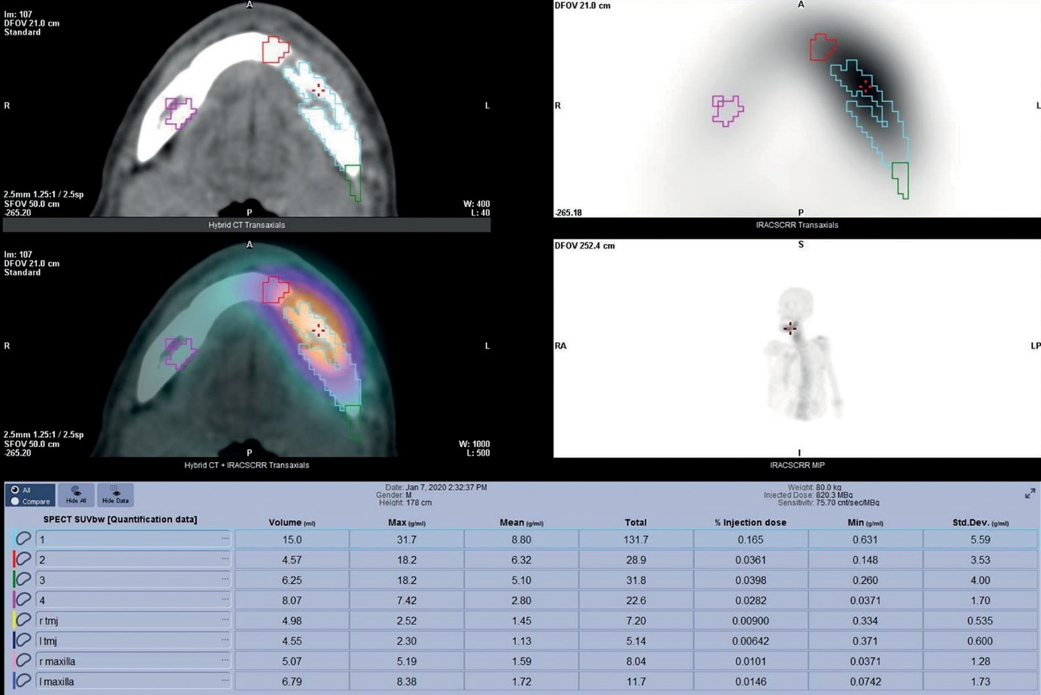
Yoshiyuki Minami, Ruri Ogawa, Ichiro Ogura
Figure 3. Squamous cell carcinoma of the left side of the mandible in a 59-year-old man (case 8). Computed tomography (CT), single-photon emission computed tomography (SPECT), SPECT/CT, and maximum intensity projection (MIP) show a hot spot in the mandible. Maximum standardized uptake values (SUVs) of lesion (sky blue), mesial (red), distal (green), and normal (pink) were 31.70, 18.20, 18.20, and 7.42, respectively
Q.Metrix [14,15] at operability, because SUV analysis
using Q.Volumetrix MI involves 1 step; however, Q.Metrix involves 2 steps (preparation for Q.Metrix and Q.Metrix). Furthermore, Q.Volumetrix MI is better than Q.Metrix regarding resolution, because Q.Volumetrix MI is a 512 matrix; however, Q.Metrix is a 256 matrix. Therefore, the localization and size of VOI can be drawn over the lesion, mesial, distal, and opposite side as nor- mal using the CT, SPECT, and SPECT/CT transaxials, coronals, and sagittals as the anatomical reference by optional pan and zoom imaging. We consider that SUV using Q.Volumetrix MI software could be useful for the evaluation of jaw lesions.
Modabber et al. [3] concluded that SPECT/CT can
safely detect different kinds of inflammatory jaw patholo- gies compared to other conventional imaging modalities; additionally, SPECT/CT assists the surgeon in determin- ing the expansion of the process preoperatively, thereby optimizing surgery planning. Miyashita et al. [6] showed that the presence of regenerative vascularity with necro- sis or inflammation seems to determine bone metabolism in MRONJ using 3-dimensional (3D) SPECT/CT. In this study, maximum SUVs for MRONJ (n = 4, 25.4 ± 4.9) and
chronic osteomyelitis (n = 3, 14.6 ± 3.1) in mandible were
higher than those of the opposite side as normal man- dible (3.8 ± 0.7 and 4.6 ± 1.8, respectively). Furthermore, Ogura et al. [20] showed that surgical specimens from segmental mandibulectomy of MRONJ were analysed
using cone-beam computed tomography (CBCT), and
CBCT could be useful for the post-surgical evaluation of MRONJ. Miyashita et al. [5] indicated that 3D SPECT/CT is useful not only for detecting jaw bone invasion of oral cancer but also for surgical planning. In this study, the maximum SUV for squamous cell carcinoma in mandible (n = 1, 31.7) was higher than that of the opposite side as normal mandible (7.4). Furthermore, Q.Volumetrix MI can analyse SUV of lesions by organ segmentation, such as the lesion, mesial, distal, and opposite side as normal, using optional pan and zoom imaging. We consider that SPECT/CT SUV using volumetric analysis showed poten- tial as a useful parameter for evaluation of MRONJ and malignant tumour of the jaw, such as detecting, surgical planning, and post-surgical evaluation.
There were several limitations of this study. The sam- ple was relatively small. Power calculation because of small sample sizes would strengthen the study, otherwise this is a significant limitation. Furthermore, we showed only maximum SUVs in this study, but there are other parameters concerning volumes and activities that should be utilized. Therefore, further research is necessary to vali- date these results.
Conclusions
This study evaluated mandibular lesions using Q.Volu-
metrix MI and GEniE-Xeleris 4 DR with SPECT/CT.
e314
© Pol J Radiol 2022; 87: e311-e315

Volumetric analysis of mandibular lesions with SPECT/CT: a pilot clinical study of maximum standardized uptake value
Volumetric analysis with SPECT/CT could be useful for
the evaluation of mandibular lesions, such as detection and surgical planning.
Conflict of interest
The authors report no conflict of interest.
References
- Suh MS, Lee WW, Kim YK, et al. Maximum standardized uptake
value of 99mTc hydroxymethylene diphosphonate SPECT/CT for the evaluation of temporomandibular joint disorder. Radiology 2016; 280: 890-896.
- Malina-Altzinger J, Klaeser B, Suter VGA, et al. Comparative eval- uation of SPECT/CT and CBCT in patients with mandibular osteo- myelitis and osteonecrosis. Clin Oral Investig 2019; 23: 4213-4222.
- Modabber A, Schick D, Möhlhenrich SC, et al. Evaluation of SPECT/ CT in the assessment of inflammatory jaw pathologies. Eur J Radiol 2020; 125: 108917.
- Ogawa R, Ogura I. Analysis of medication-related osteonecrosis of the jaw with bone SPECT/CT: relationship between patient charac- teristics and maximum standardized uptake value. Dentomaxillofac Radiol 2021; 50: 20200516.
- Miyashita H, Nakahara T, Asoda S, et al. Clinical value of 3D SPECT/ CT imaging for assessing jaw bone invasion in oral cancer patients. J Craniomaxillofac Surg 2019; 47: 1139-1146.
- Miyashita H, Kameyama K, Morita M, et al. Three-dimensional radiologic-pathologic correlation of medication-related osteonecrosis of the jaw using 3D bone SPECT/CT imaging. Dentomaxillofac Radiol 2019; 48: 20190208.
- Toriihara A, Daisaki H, Yamaguchi A, et al. Semiquantitative analysis using standardized uptake value in 123I-FP-CIT SPECT/CT. Clin Imaging 2018; 52: 57-61.
- Huang K, Feng Y, Liu D, et al. Quantification evaluation of 99mTc- MDP concentration in the lumbar spine with SPECT/CT: compare with bone mineral density. Ann Nucl Med 2020; 34: 136-143.
- Umeda T, Koizumi M, Fukai S, et al. Evaluation of bone metastatic burden by bone SPECT/CT in metastatic prostate cancer patients: defining threshold value for total bone uptake and assessment in ra- dium-223 treated patients. Ann Nucl Med 2018; 32: 105-113.
- Dickson J, Ross J, Vöö S. Quantitative SPECT: the time is now. EJNMMI Phys 2019; 6: 4.
- Kim J, Lee H, Lee H, et al. Quantitative single-photon emission com- puted tomography/computed tomography for evaluation of salivary gland dysfunction in Sjögren’s syndrome patients. Nucl Med Mol
Imaging 2018; 52: 368-376.
- Ninomiya K, Toya S, Ogura I. Single-photon emission computed
tomography/computed tomography for evaluation of salivary gland dysfunction: preliminary study on diagnostic ability of maximum standardized uptake value. Oral Radiol 2020; 36: 163-167.
- Oohashi M, Toshima H, Hayama K, et al. Gallium-67 SPECT/CT for the evaluation of head and neck: preliminary study on maximum standardised uptake value in lesions, and in the parotid and subman- dibular glands. Pol J Radiol 2020; 85: e224-e229.
- Ogura I, Sasaki Y, Sue M, et al. Tc-99m hydroxymethylene diphos- phonate SPECT/CT for the evaluation of osteonecrosis of the jaw: preliminary study on diagnostic ability of maximum standardised uptake value. Clin Radiol 2020; 75: 46-50.
- Toshima H, Ogura I. Assessment of inflammatory jaw pathologies using bone SPECT/CT maximum standardized uptake value. Den- tomaxillofac Radiol 2020; 49: 20200043.
- Ogura I, Kobayashi E, Nakahara K, et al. Quantitative SPECT/CT imaging for medication-related osteonecrosis of the jaw: a prelimi- nary study using volume-based parameters, comparison with chronic osteomyelitis. Ann Nucl Med 2019; 33: 776-782.
- Okui T, Kobayashi Y, Tsujimoto M, et al. Quantitative evaluation of anti-resorptive agent-related osteonecrosis of the jaw using bone single photon emission computed tomography in clinical settings: relationship between clinical stage and imaging. Ann Nucl Med 2020; 34: 620-628.
- Nakai F, Ohbayashi Y, Nakai Y, et al. Bone metabolism of the jaw in response to bisphosphonate: a quantitative analysis of bone scintig- raphy images. Odontology 2020; 108: 653-660.
- Minami Y, Ogura I. Bone single-photon emission computed tomo- graphy-CT peak standardized uptake value for chronic osteomyelitis, osteoradionecrosis and medication-related osteonecrosis of the jaw. J Med Imaging Radiat Oncol 2021; 65: 160-165.
- Ogura I, Minami Y, Ono J, et al. CBCT imaging and histopatho-
logical characteristics of osteoradionecrosis and medication-related osteonecrosis of the jaw. Imaging Sci Dent 2021; 51: 73-80.
© Pol J Radiol 2022; 87: e311-e315
e315

