www.impactjournals.com/oncotarget/
Oncotarget, Vol. 6, No. 12

MET receptor is a potential therapeutic target in high grade
cervical cancer

Katarzyna Miekus1, Marta Pawlowska2, Małgorzata Sekuła2, Grazyna Drabik2,
Zbigniew Madeja4, Dariusz Adamek5, Marcin Majka2
1 Department of General Biochemistry, Faculty of Biochemistry, Biophysics and Biotechnology, Jagiellonian University, Cracow,
Poland
Department of Transplantation, Polish-American Institute of Pediatrics, Jagiellonian University Medical College, Cracow,
Poland
3
Department of Clinical Immunology, Polish-American Institute of Pediatrics, Jagiellonian University Medical College, Cracow,
Poland
4Department of Cell Biology, Faculty of Biochemistry, Biophysics and Biotechnology, Jagiellonian University, Cracow, Poland
5Department of Pathomorphology, Jagiellonian University Medical College, Cracow, Poland
Correspondence to:
Marcin Majka, e-mail: mmajka@cm-uj.krakow.pl
Katarzyna Miekus, e-mail: katarzyna.miekus@uj.edu.pl
Keywords: cervical cancer, MET, CXCR4, differentiation, E-cadherin
Received: December 17, 2014 Accepted: January 17, 2015 Published: April 04, 2015

ABSTRACT
Cervical cancer is one of the leading causes of death among women suffering
from tumors. Current treatment options are insufficient. Here, we investigated the MET
receptor as a potential molecular target in advanced cervical cancer. Downregulation
of MET receptor expression via RNA interference in different cervical carcinoma cell
lines dramatically decreased tumor growth and forced tumor differentiation in vivo.
MET receptor silencing also led to a dramatic decrease in cell size and a decrease in
proliferation rate under normal and stress conditions. MET receptor downregulation
also resulted in decreased cyclin D1 and c-myc levels but did not increase apoptosis.
Subsequent experiments showed that downregulation of the MET receptor decreased
the expression of a key regulator of the epithelial-to-mesenchymal transition, SLUG.
and increased the expression of E-cadherin, a hallmark of the epithelial phenotype.
Moreover, MET downregulation impairs expression and signaling of CXCR4 receptor,
responsible for invasive phenotype.
Taken together, our results strongly suggest that the MET receptor influences the
oncogenic properties of cervical carcinoma cells in vitro and in vivo. These findings
highlight a unique role of the MET receptor in cervical carcinoma cells and indicate
the MET receptor as a potential therapeutic target for advanced cervical carcinoma.

INTRODUCTION
Despite the recent development of a vaccine against
human papillomavirus infection, cervical cancer (CC)
remains the third leading cause of death among women
suffering from cancer, especially in low- and middle-
income countries [1, 2]. The survival rate for CC is related
to the stage of the disease with distant metastasis. There is
currently no effective therapy for advanced cervical cancer,
and it is thus important to identify molecular markers that
can help in the development of new therapeutic strategies
to improve cervical cancer treatment.
The MET receptor belongs to the family of growth
factor receptors with intrinsic tyrosine kinase activity and,
together with its ligand, Hepatocyte Growth Factor (HGF),
is involved in proliferation, inhibition of apoptosis,
motility and dissemination of cancer cells during tumor
development and progression [3, 4]. HGF and the
www.impactjournals.com/oncotarget
10086
Oncotarget
MET receptor are also known to mediate epithelial-
to-mesenchymal transitions (EMT) during embryonic
development [5, 6] and tumorigenesis [7, 8].
EMT is a stage of metastasis in which epithelial cells
acquire characteristics of mesenchymal stem cells [9]. EMT
is regulated by a number of transcription factors, including
SNAIL1, SLUG, ZEB1, ZEB2, and TWIST [10, 11] and
is characterized by E-cadherin suppression, increased
levels of N-cadherin and vimentin expression, and a highly
invasive mesenchymal phenotype [12, 13, 14]. The MET
receptor is overexpressed in a variety of human cancers,
including thyroid carcinoma [15], ovarian cancer [16],
colorectal cancer [17], rhabdomyosarcoma [18], and renal
cell carcinoma [19]. It has been also shown that hepatocyte
growth factor (HGF) and its receptor MET are significantly
increased in ovarian cancer patients who relapse shortly
after chemotherapy [20]. In cervical carcinoma, the
MET receptor has been shown to promote scattering and
morphogenesis of tumor cells [20, 21]. We previously
showed that stimulation of the MET receptor with HGF
alone or together with stromal-derived factor-1 (SDF-1),
the ligand for the CXCR4 receptor, results in migration and
cytoskeletal changes in cervical carcinoma cells [22]. Our
data also showed that activation of both MET and CXCR4
caused the translocation of p-catenin into the nucleus and
the subsequent upregulation of cyclin D1 expression [22].
In the present study, we used cell lines as well as
tumor tissues to evaluate the role of the MET receptor
in cervical cancer. We investigated whether the MET
receptor is involved in the growth and progression
of human cervical carcinoma in vitro and in vivo and
whether silencing of this gene can change the cellular
phenotype into a more benign form and thereby arrest
cancer development. We demonstrate, for the first time,
that downregulation of the MET receptor can reverse the
EMT-driven cervical cancer cell phenotype into a more
epithelial and less aggressive form. We further show
that the MET receptor might be a promising target for
advanced cervical cancer therapy.

RESULTS
MET receptor expression in patients’ samples
Immunohistochemical analysis of 31 patients’ tissues
revealed that MET receptor expression varies depending
on the grade of the tumor (Figure 1). Examples of
immunohistochemical staining of LSIL, HSIL and invasive
carcinoma are presented in Figure 1A. In order to perform
staining analysis of MET receptor we used the scale from
0 to 4, where 0 (+/-) - very poor response/poorly positive
discontinuous, 1 (+) - poor response, 2 (++) - moderate
response, 3 (+++) - quite strong/strong response, 4 (++++) -
very strong response. The immunohistochemical analysis
revealed strong positive staining for MET receptor in over
80% of HSIL samples and strong and very strong positive
reaction for 67% of invasive carcinoma (Figure 1B).
Histopathological examination also showed that LSIL
was characterized mainly by a poor expression of MET
receptor (+). Strong (+++) and very strong (++++) MET
expression we observed for samples described as HSIL
and invasive carcinoma (Figure 1C).
MET downregulation reduces the viability/
proliferation of MET-deficient cells under stress
conditions
Cervical carcinoma cells were transduced with
lentiviral vectors containing anti-MET shRNAs that
were established in our laboratory [23]. The efficiency
of MET downregulation was assessed in cells transduced
with control LacZ (shLacZ) and MET (shMET) shRNA
and compared with control wild-type (WT) cells. MET
receptor expression levels were evaluated at the mRNA
level using real-time RT-PCR (Figure 2A) and at the
protein level using flow cytometry (Figure 2B) and
western blot analysis (Figure 2C). The functionality of
the silenced receptor was tested by a chemotaxis assay
(Supplementary Figure 1).
The growth of tumors in vivo induces specific
conditions associated with limited access to oxygen and
nutrients. The MET receptor promotes cell viability and
proliferation during tumorigenesis [4]. To test whether
the MET receptor influences cell viability/proliferation
under stress conditions, cells were cultured in starvation
medium (0.5% BSA) or under low oxygen (2%), and the
MTT assay was performed. For the HTB-34 and HeLa cell
lines, we did not observe any differences between control
cells and MET-deficient cells under either starvation or low
oxygen conditions (Figure 2D, 2E, left and middle panels).
However, MET receptor downregulation significantly
decreased the viability/proliferation of HTB-35 cells after
48 hours of starvation or hypoxic conditions. The largest
difference between control and MET-deficient cells was
reached after 96 hours of culture (Figure 2D, 2E, right
panels). These data showed that MET receptor expression is
important for viability/proliferation of HTB-35 cells under
stress conditions. It has been already shown that some
tumors are dependent on MET receptor activity for their
growth and survival [24, 25]. In subsequent experiments we
wanted to know whether MET receptor might be relevant
for other characteristics of cervical cancer cells.
MET receptor downregulation inhibits tumor
growth in vivo
The reduced viability observed in the HTB-35
shMET cell line led us to study the influence of MET
receptor silencing on cell behavior during tumor formation
in vivo. To examine the growth of human cervical cell lines
in vivo, we established a xenotransplant model in NOD-
SCID mice. Mice were injected subcutaneously with
www.impactjournals.com/oncotarget
10087
Oncotarget
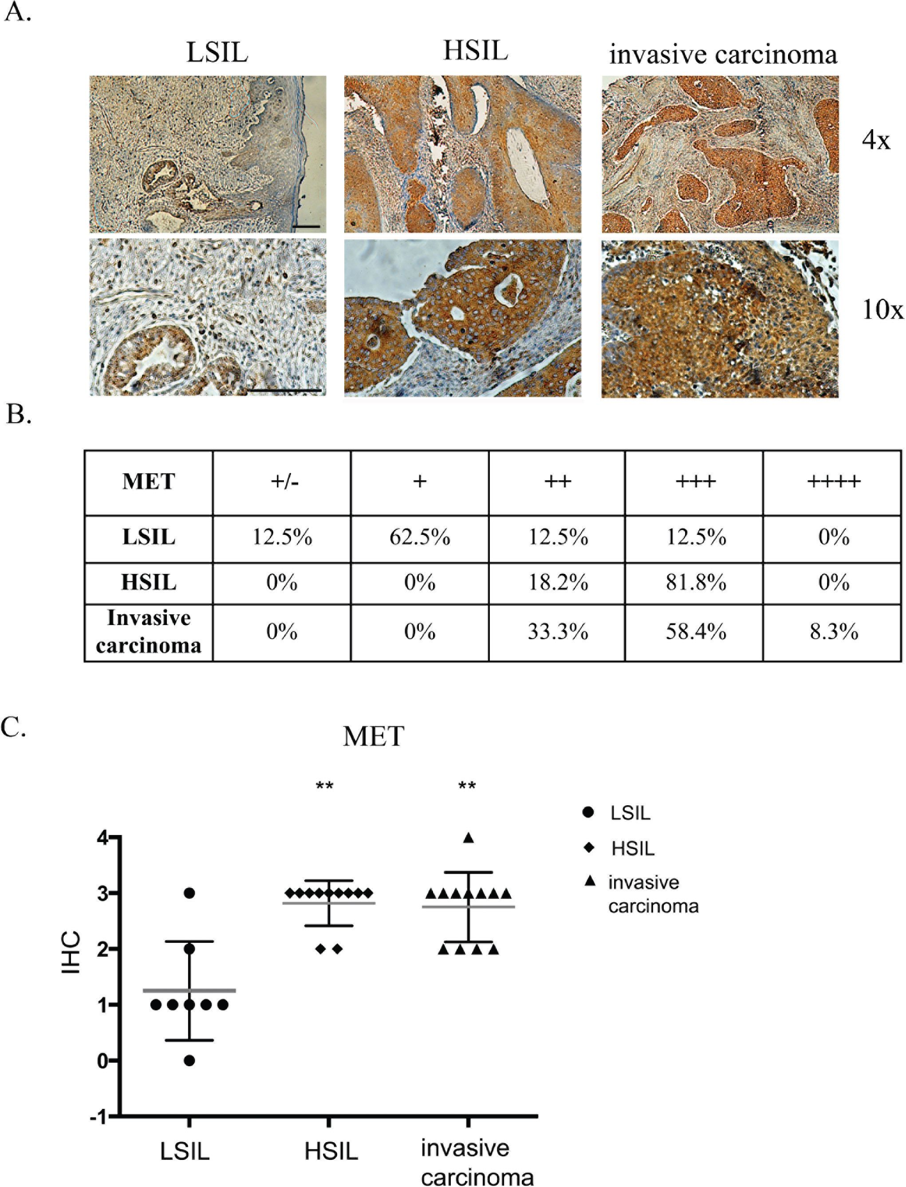
Figure 1: Immunohistochemical analysis of MET receptor expression in patient samples. (A) Examples of
immunohistochemical staining of MET receptor for LSIL, HSIL and invasive carcinoma. (B and C) Immunohistochemical analysis of MET
receptor expression in human samples. In order to perform expression analysis we used the following scale: 0 (+/-) - very poor response/
poorly positive discontinuous, 1 (+) - poor response, 2 (++) - moderate response, 3 (+++) - quite strong/strong response, 4 (++++) -
very strong response. Samples were obtained from patients with mild, moderate or severe dysplasia and invasive cervical carcinoma.
LSIL - Low-grade squamous Intraepithelial Lesion, HSIL - High-grade squamous Intraepithelial Lesion (according to Bethesda system
terminology). The evaluation of the samples was performed with the approval from the Bioethics Committee of the Jagiellonian University
(no. KBET/7/B/2008). n = 31, **p < 0.001. Bar = 200 pm.
5 x 106 WT, shLacZ or shMET cells. After 30 days, the
mice were sacrificed, and the tumors were weighed. We
observed that HTB-34 cells formed tumors with an average
weight of 0.3 grams (Figure 3A, left panel), whereas tumors
formed by HeLa cells weighed on average 1.3 grams
(Figure 3A, middle panel). Despite this discrepancy in
tumor weight, the growth of HTB-34 and HeLa tumors
was not inhibited by MET receptor downregulation
(Figure 3A, left and middle panels). Tumors generated
by WT and shLacZ HTB-35 control cells did not differ
in weight, forming tumors of approximately 1.7 grams
(Figure 3A, right panel). Interestingly, shMET HTB-35
www.impactjournals.com/oncotarget
10088
Oncotarget
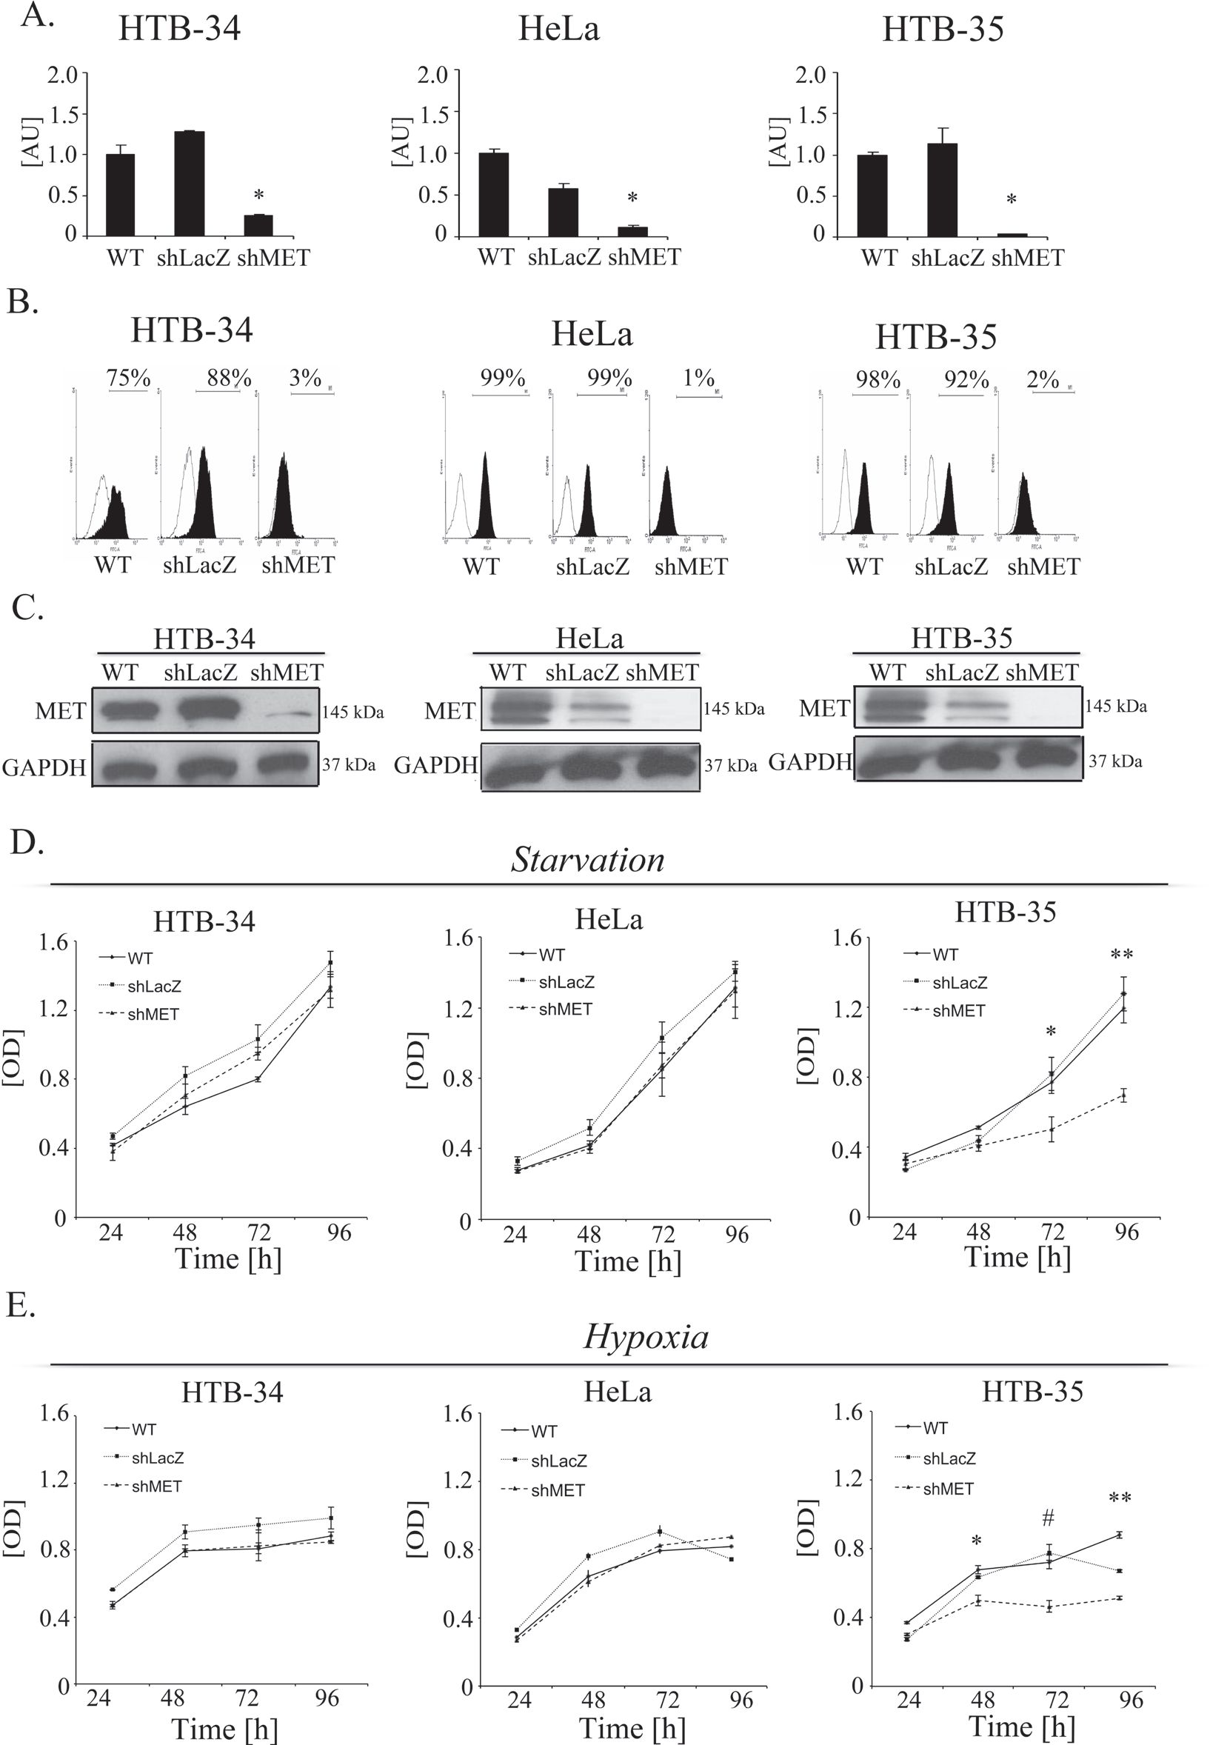
Figure 2: MET downregulation alters proliferation/viability under stress conditions. MET receptor downregulation via
a lentiviral vector containing anti-MET shRNA resulted in decreases at mRNA (A) and protein (B, C) levels. Downregulation of MET
receptor alters proliferation/viability under hypoxia (D) and starvation (E) conditions. A - Real-time RT-PCR revealed significant decreases
in MET transcript levels in MET receptor-silenced cells (shMET) relative to controls (wild type, WT, and shLacZ) in all tested cell lines
(HTB-34, HeLa and HTB-35). B - Flow cytometry analysis of MET receptor expression. C - Western blot analysis revealed complete
downregulation of MET receptor expression in shMET HTB-34, HeLa and HTB-35 cells. D. MTT assay of cells cultured under starvation
conditions (MEM supplemented with 0.5% BSA). E - MTT assay of cells cultured under hypoxic conditions (2% oxygen). Western blot
and FACS analyses were performed at least three times with similar results; representative results are shown. Real-time RT-PCR was
performed at least three times in duplicates. MTT assay was repeated three times in triplicates. *p < 0.01, **p < 0.001.
www.impactjournals.com/oncotarget
10089
Oncotarget
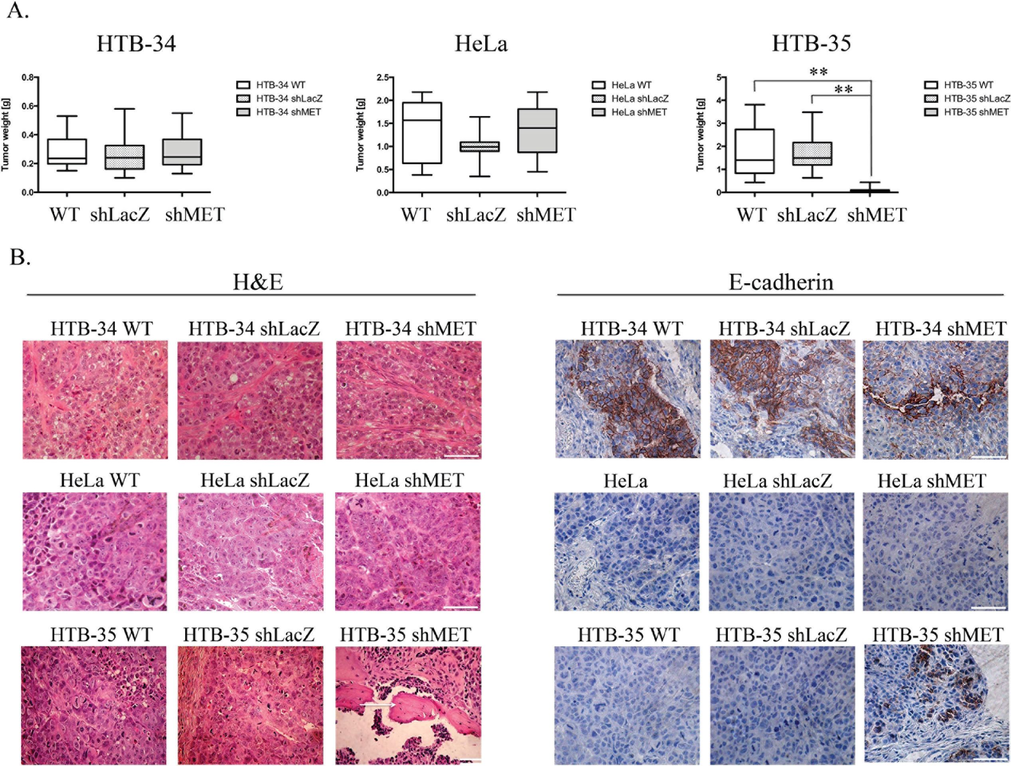
cells formed very small tumors, with a mean weight of
only 0.08 grams (Figure 3A, right panel). Interestingly, 6
of 15 animals injected with HTB-35 shMET cells did not
develop tumors at all.
A histopathological analysis of the tumor lesions
revealed no differences between the tumors generated
by control and MET-deficient HTB-34 and HeLa cells
(Figure 3B, first and second panels). However, tumors
formed by shMET HTB-35 cells clearly differed from
their control counterparts. Here, our histopathological
examination revealed that MET-deficient cells formed
well-differentiated tumors with keratin pearls, i.e., whorl-
shaped accumulations of keratin [26], whereas control
tumors were poorly differentiated and composed of cells
of various sizes and shapes with a large number of mitotic
figures (Figure 3B, last panel). E-cadherin, a marker of
the epithelial phenotype, was highly expressed in tumors
generated by both control and shMET HTB-34 cells
(Figure 3B, first panel). By contrast, both control and MET-
deficient HeLa cells formed tumors that did not express
E-cadherin (Figure 3B, second panel). Interestingly, MET
receptor downregulation in HTB-35 cells led to the re-
expression of E-cadherin in vivo (Figure 3B, last panel).
Downregulation of the MET receptor inhibits
cell proliferation by decreasing cyclin D1 and
c-myc levels
The inhibition of tumor growth observed in our in
vivo studies directed our interest towards the properties
of HTB-35 shMET cells. We first studied the growth of
shMET cells. The cells were incubated under control
conditions (10% FBS) and counted every 24 hours. We
observed growth inhibition of shMET HTB-35 cells
relative to WT and LacZ cells (Figure 4A). The difference
in growth rate between control and shMET cells was
Figure 3: Tumor growth in vivo and histopathological analysis of control and shMET cervical carcinoma cells.
A comparison of tumors derived from control and shMET cervical carcinoma cells revealed differences in tumor weight, morphology and
E-cadherin expression. (A) Tumor growth of WT, shLacZ and shMET cervical carcinoma cells was measured 30 days after subcutaneous
injection of 5 x 106 cells in NOD-SCID mice. (B) H&E staining showing that MET silencing did not influence the morphology of HTB-34
and HeLa tumors, whereas HTB-35 shMET tumors resembled more differentiated tumors with keratin pearls (arrows). E-cadherin is highly
expressed in HTB-34 cells but absent in HeLa cells. Downregulation of MET in HTB-35 cells caused the re-expression of E-cadherin.
These experiments were performed three times with n = 5; **p < 0.001. Representative staining is shown. Bar = 50 pm.
www.impactjournals.com/oncotarget
10090
Oncotarget
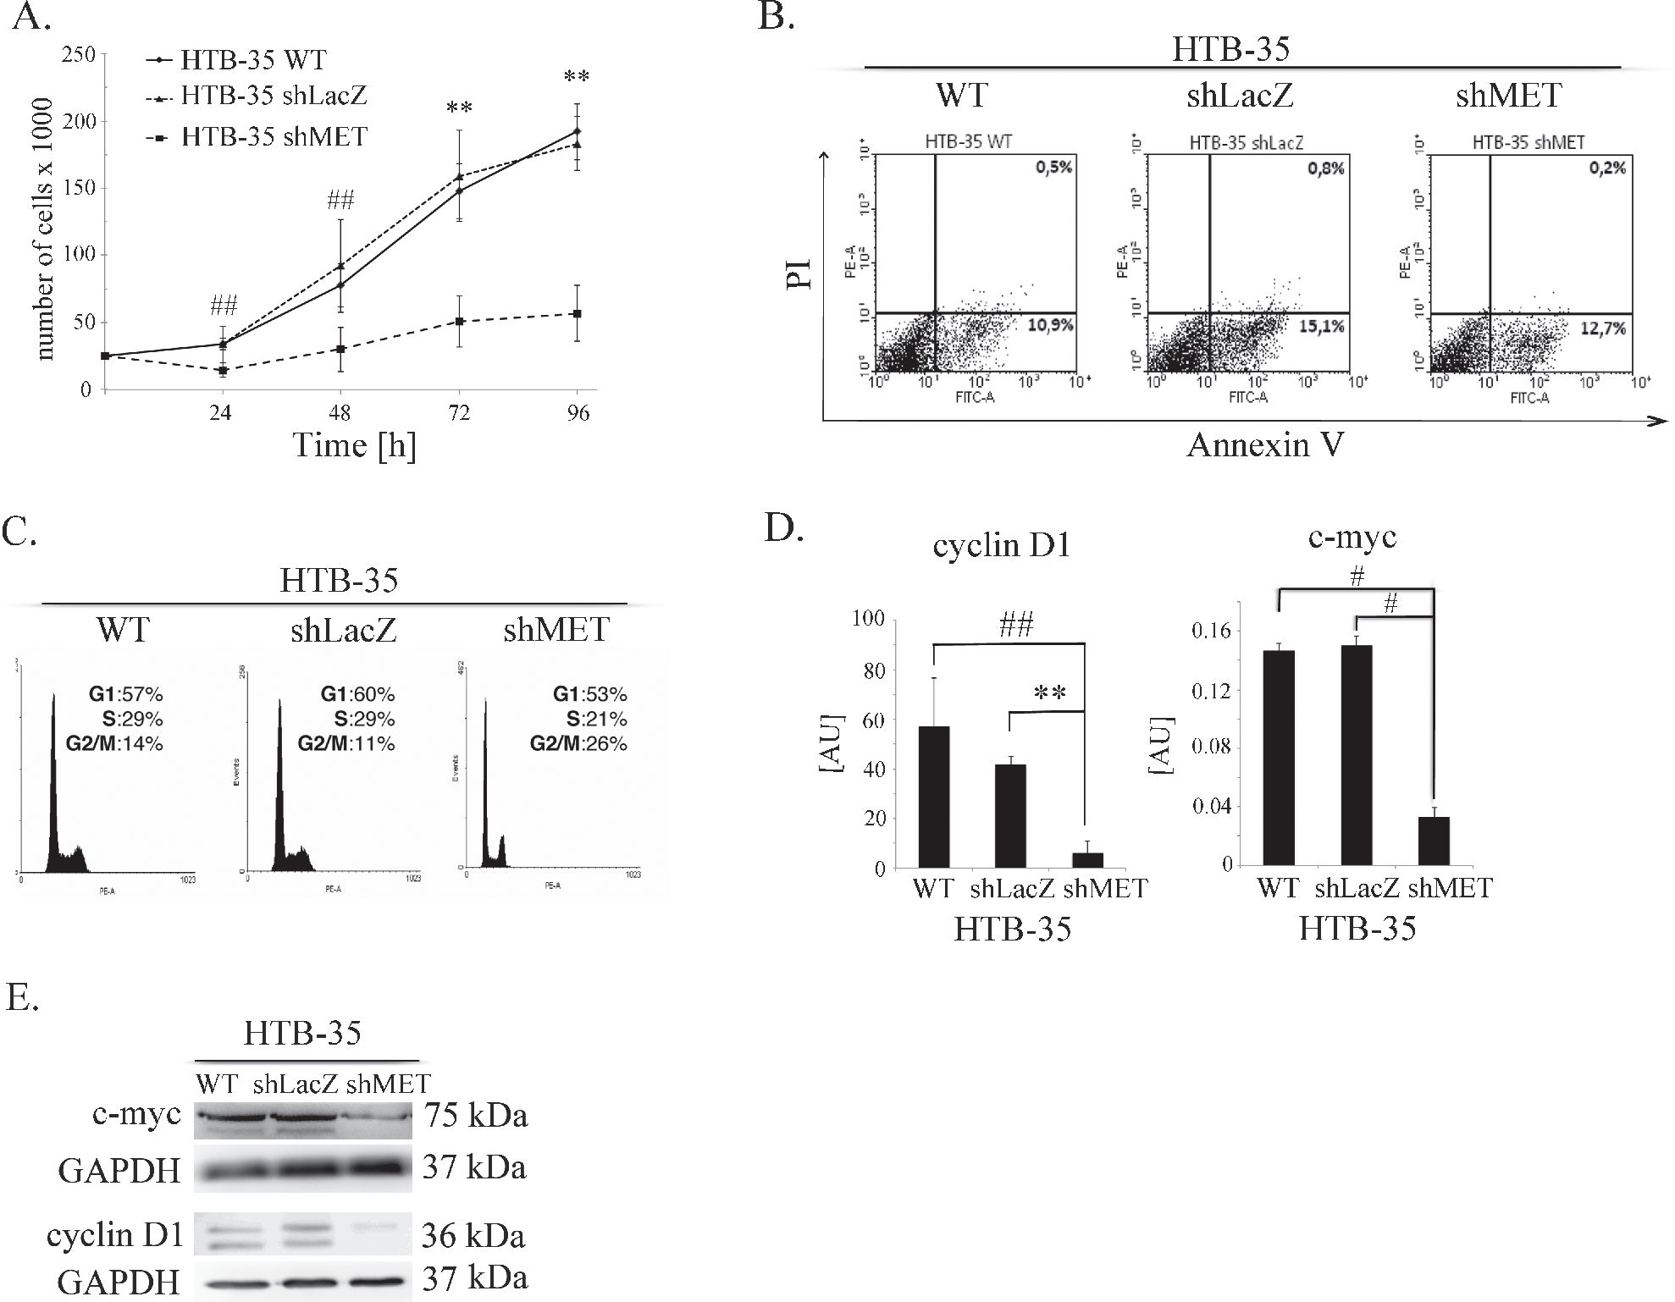
significant at each time point tested. The proliferation rate
of control cells was four times higher than that of shMET
HTB-35 cells after 96 hours of culture.
To explore the reason for the decreased proliferation
of MET-deficient cells, we analyzed apoptosis patterns
and cell cycle progression. HTB-35 shMET cells did not
undergo apoptosis spontaneously, and we did not observe
any differences between control and shMET cells in
early (AnnexinV+PI) or late apoptosis (AnnexinV+PI+)
(Figure 4B). However, there was a difference in cell cycle
progression, as MET receptor downregulation decreased
the number of cells in S phase and increased the number
of cells in G2/M phase (Figure 4C). Cyclin D is known
to regulate the entry into S-phase [27], and c-myc, as
a transcriptional regulator, mediates processes such as
proliferation, differentiation, transformation and prevention
of apoptosis [28, 29]. Transcript levels of both genes were
significantly downregulated after MET downregulation,
with eight- and five-fold reductions observed for cyclin D1
and c-myc, respectively (Figure 4D). To confirm this result,
we measured their protein levels in shMET cells by western
blotting and detected only a faint signal for c-myc and no
signal for cyclin D1 (Figure 4E). We also observed the
influence of the MET receptor depletion on the expression
level of genes correlated with invasive phenotype,
angiogenesis and tumor growth. Downregulation of MET
receptor decreases mRNA level of c-myc, CXCR4 and Slug
and increases mRNA of HGF, CXCR7, HIF-1a, matrix
metalloproteinases -2, -9 (MMP-2, -9) and tissue inhibitor
of metalloproteinases -1, -2 (TIMP-1,-2). (Supplementary
Table 1).
MET downregulation alters cell morphology
MET receptor downregulation significantly affected
the morphology of HTB-35 cells. After transduction with
the shMET lentiviral vector, the cells became small and
rounded, whereas control cells resembled fibroblast-like
cells with an elongated shape (Figure 5A). The values
for all cell morphology parameters (area, periphery,
extension, dispersion and elongation) were significantly
lower in HTB-35 shMET relative to control cells. The
data are summarized in Table 1. We also observed that
MET downregulation altered F-actin organization. In
Figure 4: Influence of the MET receptor on cell function. (A) Proliferation assay in HTB-35 cells. A significant decrease in
proliferation rate was observed after MET silencing. Cells were cultured in medium supplemented with 10% FBS and counted every 24
hours. (B) Flow cytometry analysis of Annexin V and PI staining of control and MET-deficient HTB-35 cells did not reveal any differences.
(C) Cell cycle analysis revealed that MET receptor downregulation decreased the proportion of cells in S phase and caused an accumulation
in G2/M phase. (D) Real-time RT-PCR analysis of cyclin D1 and c-myc expression. Significant downregulation of cyclin D1 and c-myc
was observed at the mRNA level after MET receptor downregulation. (E) Western blot analysis of c-myc and cyclin D1 protein expression.
c-myc was weakly expressed in shMET HTB-35 cells, whereas cyclin D1 decreased to an undetectable level. Proliferation assay was
performed three times in triplicate and real-time RT-PCR assays was performed three times in duplicate. FACS and western blot analyses
were performed at least three times with similar results. Representative results are shown. **p < 0.001. ##. p < 0.005.
www.impactjournals.com/oncotarget
10091
Oncotarget

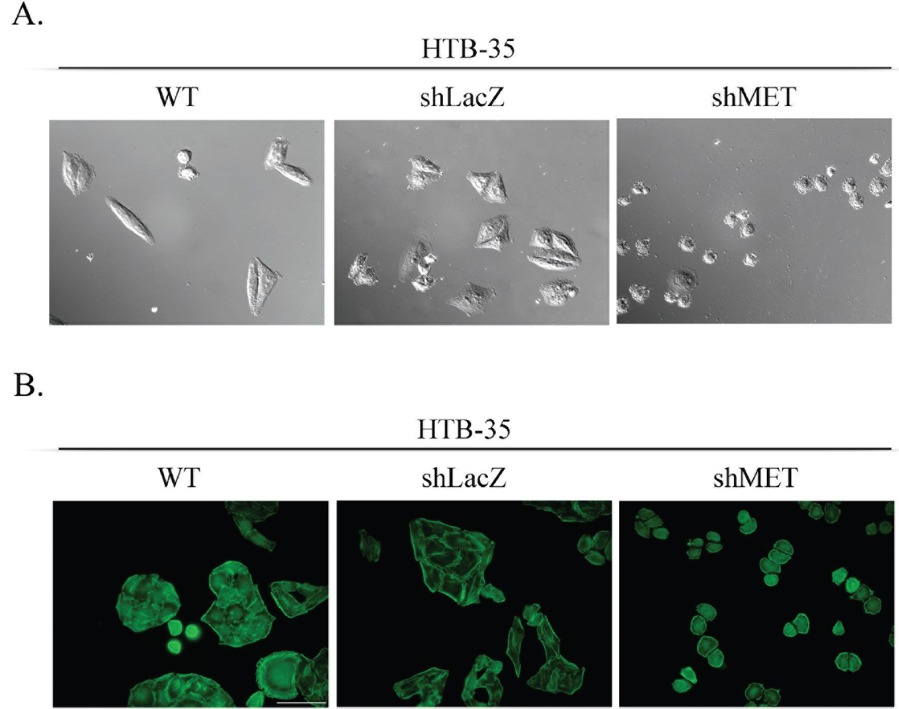
Figure 5: Cell morphology and actin organization after MET silencing. An analysis of cell morphology revealed a decrease
in cell size (A) and changes in F-actin organization (B) in MET-deficient HTB-35 cells. A - Cells were photographed with Nomarski
interference contrast (upper panel) and analyzed with MIGRA software (lower panel). B - Immunofluorescence staining of the F-actin
cytoskeleton shows re-organization of actin filaments from thick contractile bundles in control cells to thin cortical bundles - as in epithelial
cells - in MET-deficient cells. Representative staining is shown. Bar = 50 pm., ##p < 0.005.
Table 1: The values for cell morphology parameters - area, periphery, extension, dispersion and
elongation
Cell line | Area | Periphery | Extension1 | Dispertion1 | Elongation1
HTB-35 WT | 885.85 ± 12.99 | 159.99 ± 5.87 | 1.05 ± 0.56 | 0.17 ± 0.32 | 0.88 ± 0.47
HTB-35 shLacZ | 963.42 ± 423.58 | 178.63 ± 36.73 | 1.07 ± 0.51 | 0.16 ± 0.12 | 0.91 ± 0.46
HTB-35 shMET | 343.94 ± 41.08## | 90.62 ± 15.91## | 0.24 ± 0.13## | 0.03 ± 0.02## | 0.22 ± 0.12##
1Extension,dispersion and elongation take a value 0 if the shape is circular and increases without limit as the shape becomes
less compact [51]. The mean value was obtained from analysis of 50 cells. Statistically significant at ##p < 0.005.
MET-deficient HTB-35 cells, F-actin was located under
the cell membrane and did not form regular stress fibers
as observed in WT and shLacZ cells. Actin filaments
reorganized from thick, parallel, contractile bundles in
control cells to thin cortical bundles - as in epithelial cells
- in MET-deficient cells (Figure 5B).
E-cadherin and slug expression in patients’ samples
Immunohistochemical study of 37 patients’ samp-
les showed low E-cadherin expression in high-grade
intraepithelial lesion (HSIL) and invasive carcinoma
Figure 6A. To our surprise, a significant decrease in the
E-cadherin was also observed for low-grade squamous
intraepithelial lesion (LSIL) in comparison to normal
cervix (Figure 6A, Supplementary Table 2). Slug
expression was higher in HSIL and invasive carcinoma in
comparison to LSIL (Figure 6B; Supplementary Table 3).
MET receptor downregulation influences
E-cadherin and slug expression
Because MET receptor downregulation in HTB-
35 shMET cells led to a lower proliferation rate along
with an altered cell shape and F-actin reorganization, we
assumed that MET silencing at least partially reversed
their phenotype into a less aggressive form. To expand
on these observations, we evaluated potential changes in
the expression of various EMT markers. MET receptor
silencing upregulated E-cadherin and suppressed Slug and
Vimentin mRNA expression in HTB-35 cells (Figure 7A).
An immunofluorescence analysis of E-cadherin distribution
www.impactjournals.com/oncotarget
10092
Oncotarget
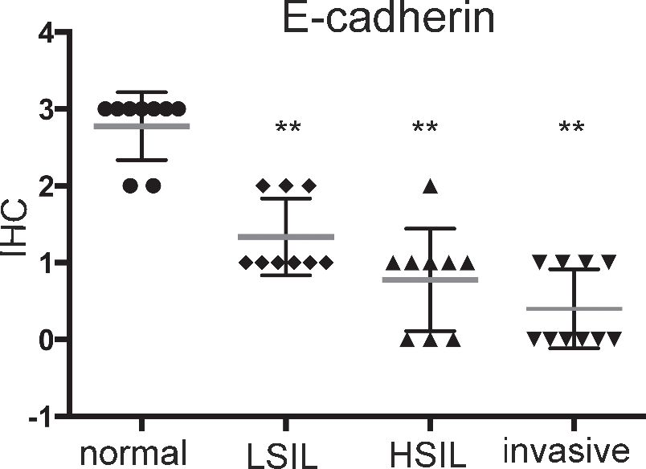
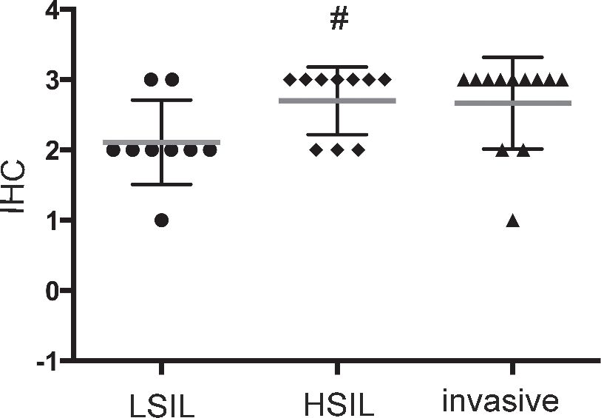
cervix carcinoma

B.
Slug
carcinoma
- normal cervix
- LSIL
a HSIL
▼ invasive carcinoma
- LSIL
- HSIL
a invasive carcinoma
Figure 6: Immunohistochemical analysis of E-cadherin (A) and Slug (B) expression in patient samples. Samples were obtained from
patients with mild, moderate or severe dysplasia and invasive cervical carcinoma. LSIL - Low-grade squamous Intraepithelial Lesion,
HSIL - High-grade squamous Intraepithelial Lesion (according to Bethesda system terminology). **p < 0.001; # p < 0.05.
showed that in control cells, E-cadherin was present in
discrete, disrupted dots, whereas MET-deficient cells
showed lateral membrane localization at sites of cell-cell
contact (Figure 7B). A western blot analysis revealed
that Slug protein levels were very low and absent in the
cytosolic fractions of control and shMET HTB-35 cells,
respectively. In the nuclear fraction, Slug expression was
very strong in control cells but undetectable in MET-
deficient cells (Figure 7C). Based on our in vivo observation
that MET-deficient tumors were more differentiated than
controls and re-expressed E-cadherin, we examined Slug
expression in tumor specimens. This immunohistochemical
analysis revealed that tumors formed by control HTB-35
cells presented high Slug expression in nuclei and low
expression (pale staining) in the cytoplasm. By contrast,
tumors derived from shMET HTB-35 cells exhibited no
Slug expression in nuclei and very low expression in the
cytoplasm (Figure 7D).
Our histopathological analysis showed that
E-cadherin was highly expressed in tumors generated by
both control and shMET HTB-34 cells (Figure 3B) and
we were interested whether MET receptor downregulation
affects expression of some EMT markers (Supplementary
Figure 2). HTB-34 WT, shLacZ and shMET cells
had similar, high level of E-cadherin at mRNA level.
MET deficient HTB-34 cells showed decreased
SLUG expression and undetectable level of Vimentin
(Supplementary Figure 2A). Moreover, we observed
that control and shMET HTB-34 cells have very low
expression of CXCR4 (Supplementary Figure 2B).
MET receptor downregulation impairs CXCR4
expression and activation
SDF-1-CXCR4 axis is a key player responsible
for invasive phenotype and metastatic behavior of many
tumor types [30, 31]. In our study, we evaluated the level
of CXCR4 expression in human samples (n = 31) obtained
from cervical carcinoma patients. Regardless of the cancer
stage, we observed strong and very strong expression of
CXCR4 receptor (Figure 8A; Supplementary Table 4).
We became interested whether downregulation of MET
receptor influences SDF-1/CXCR4 axis. We noticed that
the expression of CXCR4 was strongly decreased in shMET
HTB-35 and unchanged in control HTB-35 cell lines
(Figure 8B). After the activation of CXCR4 receptor with
SDF-1 we found that control cells responded to the ligand
by phosphorylation of AKT and MAPK kinases. However,
the activation of MAPK and AKT after SDF-1 stimulation
was highly impaired in shMET HTB-35 cells (Figure 8C).
These data led us to the question how MET receptor
influence the chemotactive activity of CXCR4 receptor.
We found that downregulation of MET receptor drastically
impaired directed migration towards HGF and SDF-1
ligands (Figure 8D). HTB-34 control and shMET cells did
not express CXCR4 receptor (Supplementary Figure 2).
www.impactjournals.com/oncotarget
10093
Oncotarget
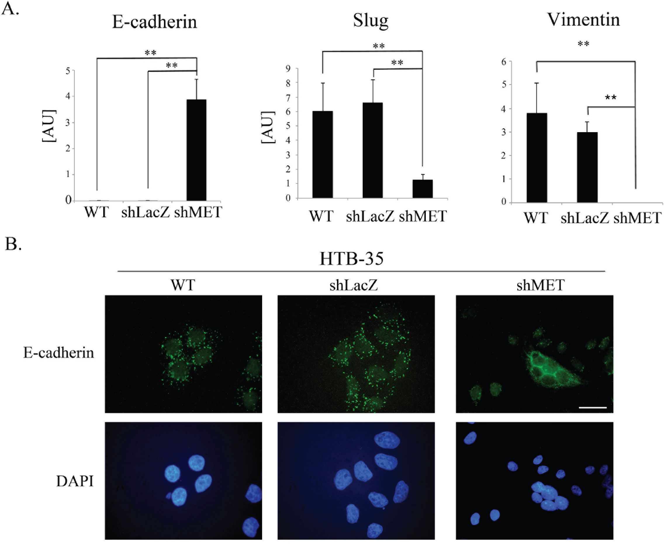
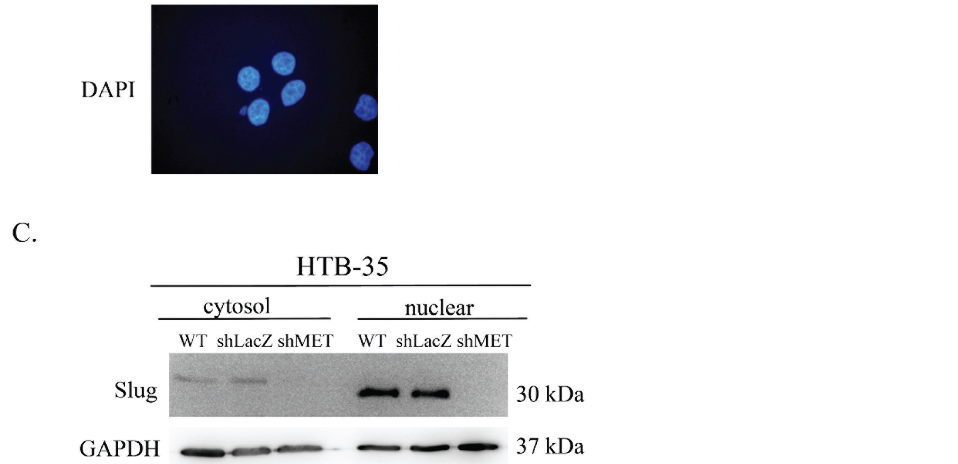
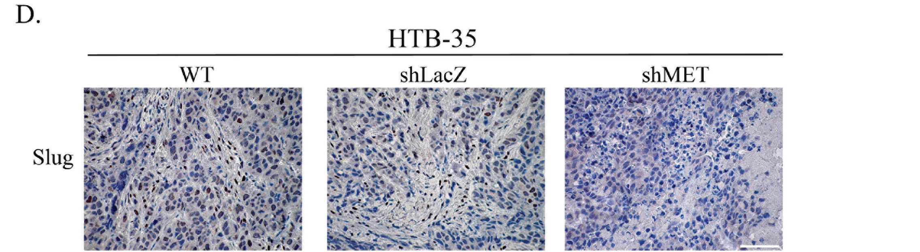
Figure 7: E-cadherin, SLUG and Vimentin expression after MET receptor downregulation. Control cells had undetectable
levels of E-cadherin (a hallmark of the epithelial phenotype) as well as high expression of SLUG (a driver of EMT) and Vimentin.
MET receptor downregulation increased E-cadherin and decreased SLUG and Vimentin expression. (A) Real-time RT-PCR analysis of
E-cadherin, SLUG and Vimentin expression. (B) Immunofluorescence analysis of E-cadherin levels and localization. (C) An analysis of
SLUG expression revealed reduced levels of SLUG mRNA and undetectable SLUG protein in both the cytosolic and nuclear fractions
after MET downregulation. (D) Immunohistochemical staining for SLUG revealed high expression in control cells, with primarily nuclear
localization. Tumors formed by MET-deficient cells did not express SLUG. These experiments were performed at least three times.
Representative staining is shown. Bar = 50 pm. **p < 0.001.
www.impactjournals.com/oncotarget
10094
Oncotarget
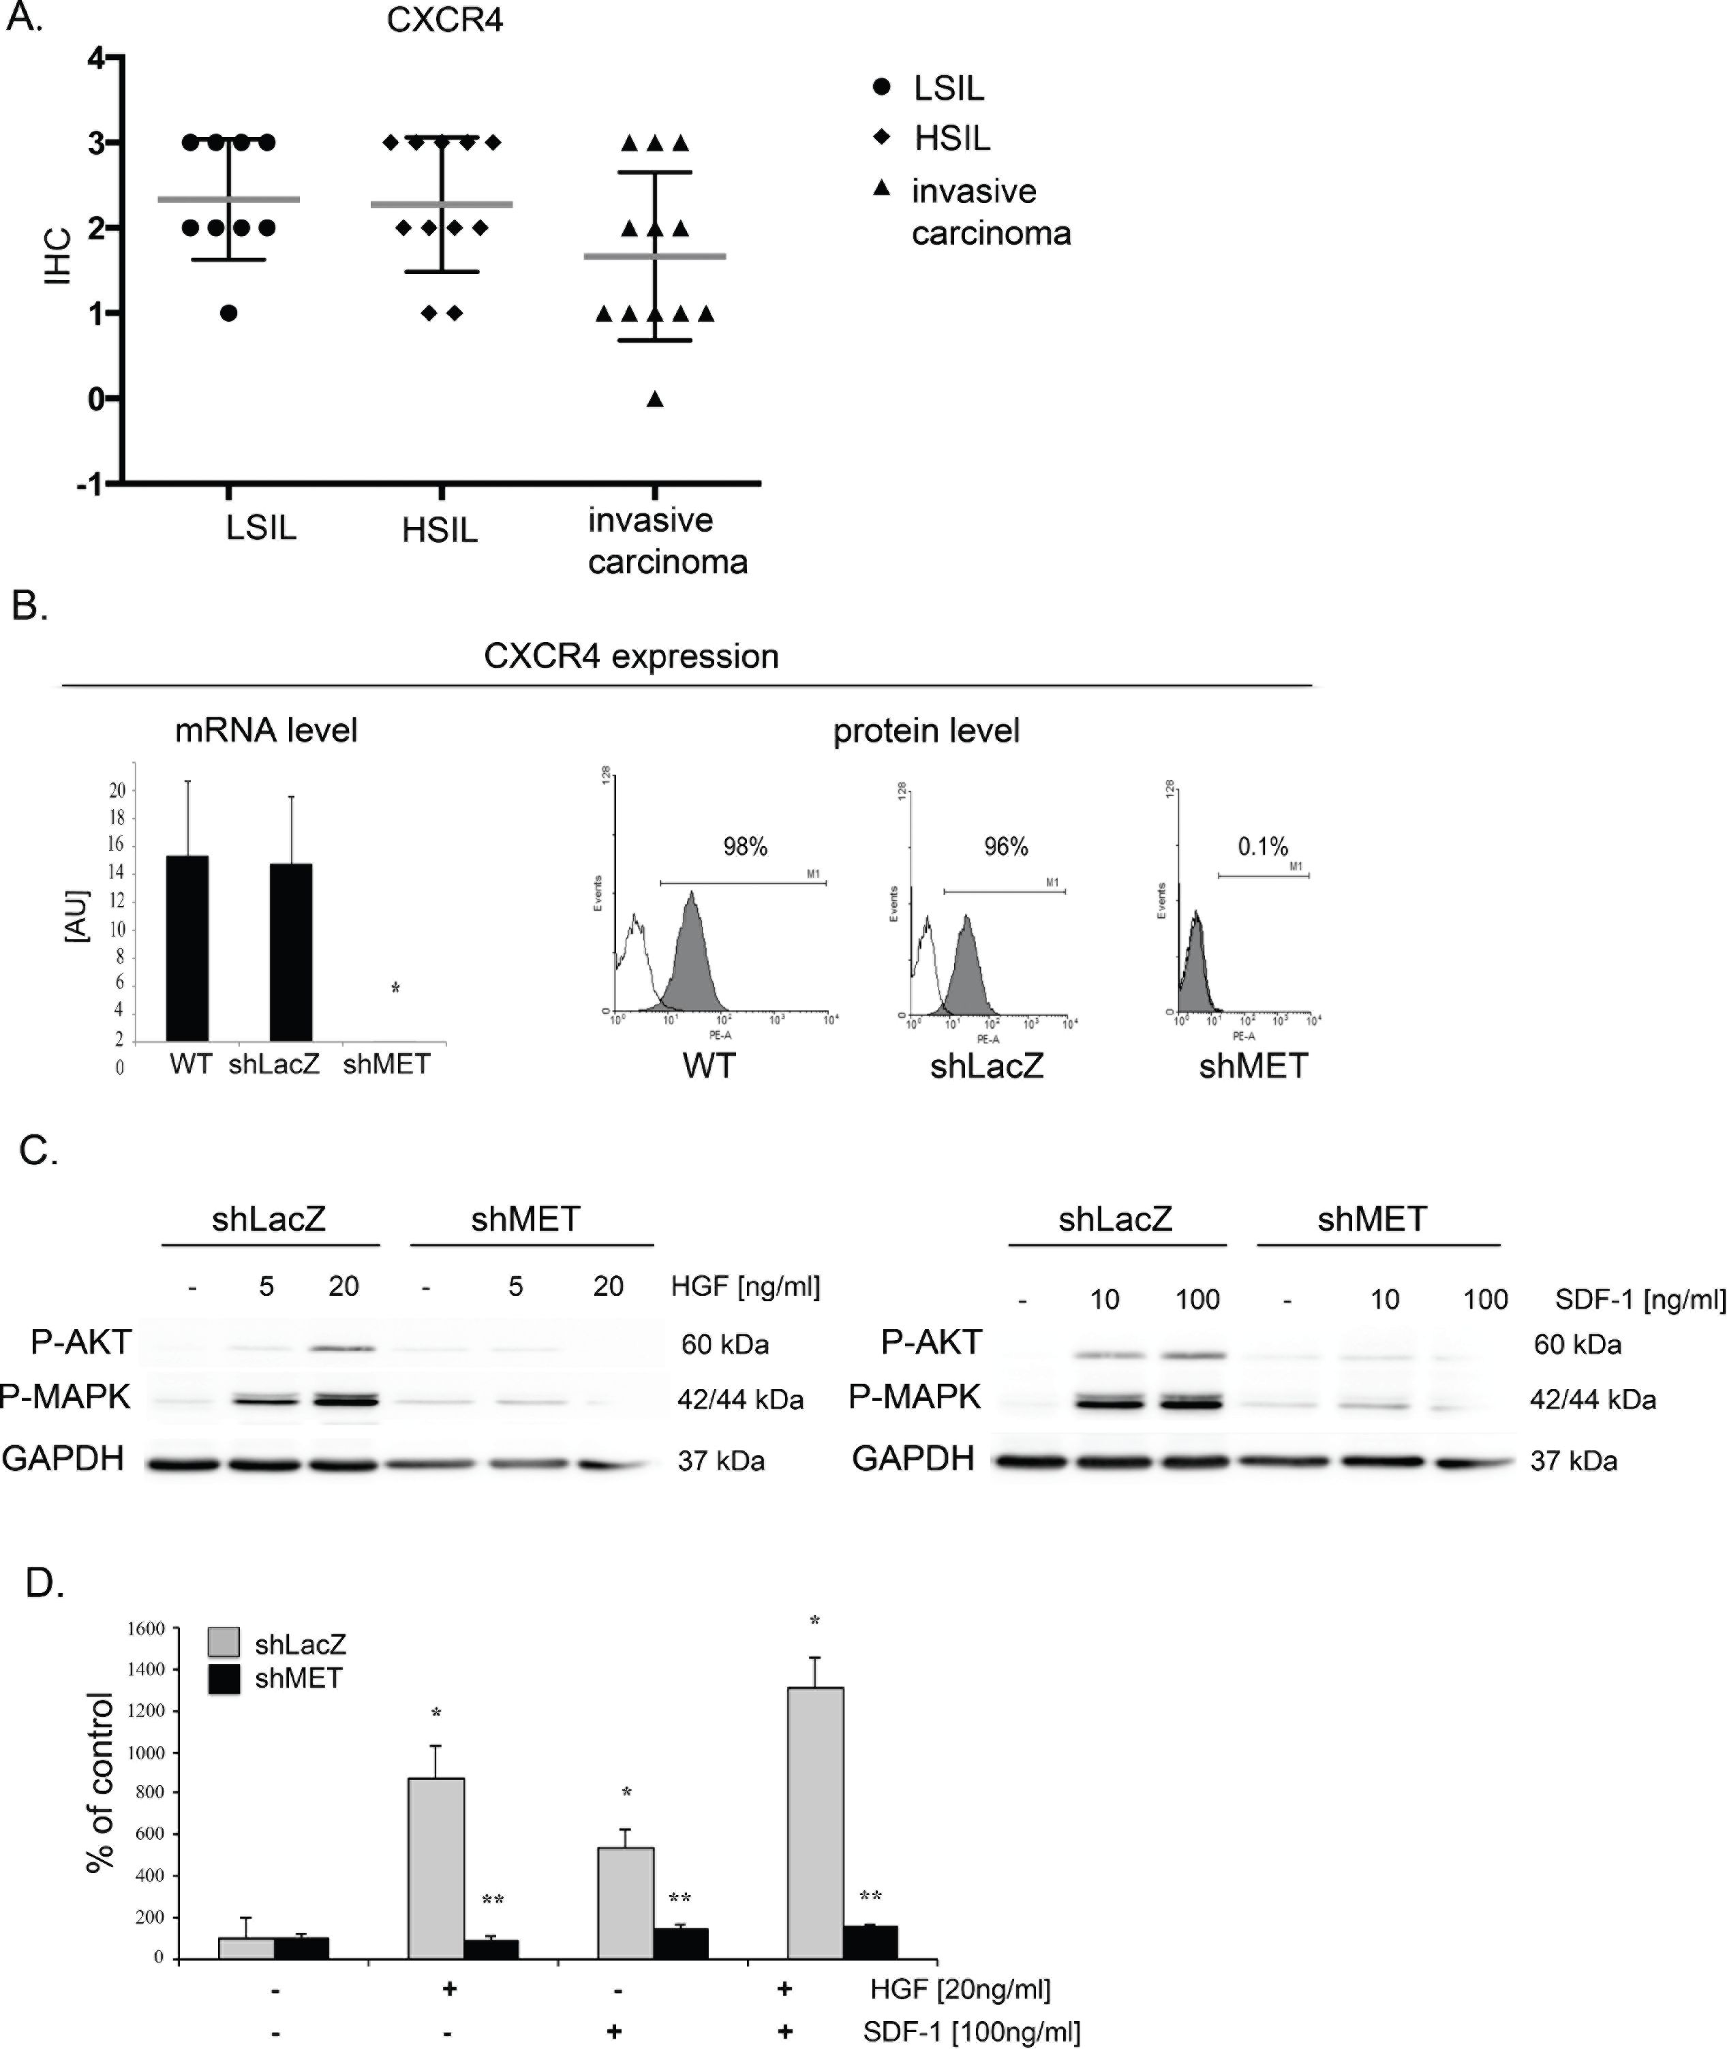
Figure 8: MET receptor downregulation decreases CXCR4 expression and function. (A) Immunohistochemical analysis of
CXCR4 receptor expression in human tissue. (B) Real-time RT-PCR and flow cytometry analysis revealed significant decreases in MET
transcript and protein levels in MET receptor-silenced cells (shMET) relative to controls (wild type, WT, and shLacZ). (C) Western blot
analysis of CXCR4 activation. AKT and MAPK phosphorylation was tested after after HGF and SDF-1 stimulation. (D) In chemotaxis
assay MET-deficient CC cells showed limited chemotactic activity towards HGF and/or SDF-1 gradient. Western blot and FACS analyses
were performed three times with similar results; representative results are shown. Real-time RT-PCR and chemotaxis assays were performed
at least three times in duplicate. *p < 0.01, **p < 0.001.
www.impactjournals.com/oncotarget
10095
Oncotarget

DISCUSSION
Cervical cancer is the third most common tumor
in women. According to WHO statistics, the worldwide
mortality rate from cervical cancer is 52 percent [32,
33]. Global incidence and mortality rates depend upon
the presence of human papillomavirus vaccination and
screening programs for cervical cancer, which are more
commonly available in developed countries. Developing
countries thus carry the largest burden of cervical cancer,
with more than eight out of ten (86%) cases diagnosed there
in 2008 [34]. Therapy for advanced cervical cancer is still
insufficient and presents a very important clinical problem.
In this paper, we examine the role of the MET
receptor in the biology of cervical carcinoma. We show
that MET receptor downregulation reduces the ability
of tumor cells to grow in vitro and in vivo and causes
a change in the cell phenotype to a more epithelial and
less aggressive form, indicating the MET receptor as a
potential therapeutic target.
Stimulation of the MET receptor via its natural
ligand, HGF, results in scattering, angiogenesis,
proliferation, enhanced cell motility, invasion and
metastasis [35]. Overexpression of HGF and the MET
receptor may also stimulate proliferation in cervical
carcinoma cells [36]. Thus, we became interested in
whether the MET receptor influences cell proliferation/
viability under conditions of limited oxygen and nutrients
that resemble the environment of a growing tumor. Our
proliferation/viability analysis revealed that MET receptor
downregulation significantly decreased the proliferation/
viability of HTB-35 cervical carcinoma cells under
these stress conditions. However, MET silencing did not
noticeably alter cell proliferation/viability in two other
cell lines. This discrepancy suggests that some cervical
cancer patients will be more susceptible to MET blocking
than others. Interestingly, based on our unpublished data,
HTB-35 is the most aggressive of the three cell lines tested.
Our results further show that the constant presence
of the MET receptor is crucial for maintaining a high
level of proliferation in cervical cancer cells. Based on
these findings, we became interested in whether the MET
receptor could also influence the growth of cervical cells
in vivo in NOD-SCID mice. We found that MET silencing
in HTB-35 cells dramatically decreased tumor growth.
Our data thus suggest that HTB-35 cells depend
on sustained MET activity for their growth and survival.
This so-called “oncogene addiction” reveals a possible
“Achilles’ heel” of cancer cells, wherein they depend
on a single oncogenic pathway or protein for sustained
proliferation and/or survival [37, 38]. Dependence on
MET has been previously shown by Comoglio’s group,
where MET could be genetically selected for the long-term
maintenance of the primary transformed phenotype, and
some tumors were dependent on sustained MET activity
for their growth and survival [24, 25].
Our group has previously shown that MET
downregulation causes a decrease in the size of tumors
derived from rhabdomyosarcoma (RMS) cells transplanted
into a NOD-SCID mouse model [23]. We also showed that
MET receptor downregulation induces the differentiation
of RMS tumors in vivo [39]. Other groups have also shown
that MET silencing results in the impaired growth of other
tumors, e.g., gastric and pancreatic carcinomas [40].
Here, we demonstrate for the first time that MET
receptor downregulation inhibits cervical cancer cell
growth in vivo in NOD-SCID mice. A histopathological
evaluation revealed that these tumors were more
differentiated than tumors derived from control cells. The
MET receptor has been shown to be important for keeping
cells of mesenchymal origin in an undifferentiated state
(e.g., satellite cells) [41]. It is possible that during tumor
development, some transdifferentiation takes place, which
is more prominently revealed after MET downregulation.
Our data suggest that the reduction in tumor size that
occurs following MET receptor downregulation is,
at least in part, caused by the differentiation of tumor
cells. Our immunohistochemical analysis also revealed
that MET receptor silencing induces the expression of
E-cadherin in tumors formed by MET-deficient cells.
To our knowledge, there have been no reports showing
the re-expression of E-cadherin after MET receptor
downregulation. E-cadherin is a transmembrane protein
that is localized to adherens junctions along the basolateral
surface and plays important roles in the maintenance of
epithelial morphology and the repression of cell invasion
and metastasis [42]. Loss of E-cadherin expression and/
or function is a well-recognized marker of EMT. Previous
studies showed that E-cadherin expression is significantly
decreased in cervical carcinoma tissues and almost absent
when tumor cells invaded deeply into the parametrium or
spread to pelvic lymph nodes [43]. Our findings provide
evidence that MET receptor downregulation in cervical
cancer cells can lead to reversal of the EMT phenotype
through re-expression of E-cadherin.
Our data also provide evidence that the MET
receptor plays an important role in regulating the growth
and invasive behavior of cervical carcinoma cells.
These findings suggest that MET receptor expression
or overexpression might contribute to the resistance of
cervical cancer to conventional methods of treatment.
Tumor growth can be regulated by increased
proliferation, increased survival or both. We show
that MET downregulation decreased cervical cancer
cell proliferation. In contrast to other studies where
MET receptor silencing promoted apoptosis [44], we
did not observe increased apoptosis in MET-deficient
cervical carcinoma cells. Rather, we found that MET
downregulation altered the cell-cycle distribution such that
shMET cells accumulated in G2/M phase. This is likely
a consequence of the decreased expression of c-myc and
cyclin D1 observed in shMET cells. Interestingly, these
www.impactjournals.com/oncotarget
10096
Oncotarget
results are consistent with our previous data where HGF
upregulated cyclin D1 expression in cervical carcinoma
cells [22].
When we examined the effect of MET
downregulation on cell morphology and cytoskeletal
organization, we observed a dramatic change in cell size in
shMET HTB-35 cells. These cells were, on average, half
the size of their control (WT and shLacZ) counterparts.
Moreover, MET downregulation reorganized F-actin
from thick parallel bundles into thin strands under the
membrane. Actin filaments in epithelial cells are organized
into thin cortical bundles, whereas they form thick
contractile stress fibers in transdifferentiated mesenchymal
cells [45]. This similarity suggests that MET-deficient
HTB-35 cells have some epithelial characteristics.
To examine other mechanisms underlying the
reduced tumor growth and change in cell morphology, we
assessed the expression of EMT-related genes in MET-
deficient cells. We found that MET receptor downregulation
dramatically increased E-cadherin levels and redistributed
this protein into the localization pattern characteristic of
epithelial cells, where it is a key component of cell-cell
adherens junctions [46]. The level of E-cadherin correlates
with the expression level of the SLUG transcription factor.
We observed that MET downregulation decreased Slug
levels in cervical cancer cells both in vitro and in vivo,
suggesting its role in regulating E-cadherin expression in
cervical carcinoma cells.
Our results are consistent with previous reports
showing that SLUG plays a major role in EMT during
breast cancer metastasis through partial inhibition of
E-cadherin [47]. Moreover, Bolos et al. found that
stable expression of SLUG in MDCK cells led to the
full repression of E-cadherin and triggered a complete
epithelial-to-mesenchymal transition [48]. Interestingly,
restoring E-cadherin expression in lung cancer cell lines
increased sensitivity to the cytostatic drug, gefitinib [49].
The CXCR4/CXCL12 axis can coordinate
metastasis of a variety of cancers [30, 31]. We have
previously found that CXCR4 expression influenced
invasive properties of cervical carcinoma cells both in
vitro and in vivo [50].
In this study, we have also shown for the first time
that blocking of MET receptor can influence expression and
function of chemokine receptors. Cells with decreased MET
receptor expression had downregulated expression of CXCR4
receptor. Moreover, these cells had impaired intracellular
signaling and chemotaxis toward SDF-1 gradient, which is
in accordance with decreased expression of CXCR4.
Until now, no published studies have evaluated the
role of the MET receptor in promoting the EMT phenotype
in cervical carcinoma. Our findings enable us to postulate
that the MET receptor is a critical agent responsible for
EMT and that blocking of MET receptor function could
reverse this process and thus represent a new therapeutic
strategy for advanced cervical cancer.
Our findings provide also evidence that MET
receptor regulates growth and invasive behavior of
cervical carcinoma cells. Thus, our data might suggest
that MET receptor expression or overexpression could
also contribute to the resistance of cervical cancer to
conventional treatment.

MATERIALS AND METHODS

Cell lines
All cervical carcinoma cell lines used in this study:
HeLa, HTB 34, HTB 35 were obtained from ATCC. Cells
were maintained in MEM (Gibco BRL, Grand Island, New
York, USA) supplemented with 10% heat-inactivated FBS
(Gibco BRL, Grand Island, New York, USA), 100 IU/ml
penicillin, 10 mg/ml streptomycin (Gibco BRL, Grand
Island, New York, USA). Cells were cultured at 37oC, 5%
CO2, 95% humidity. They were split usually twice a week
with medium change.

Analysis of human samples
Formalin-fixed, paraffin-embedded samples from
patients with diagnosed cervical carcinoma or dysplasia
of the cervix were evaluated histopatologically. The
analysis included invasive SCCs (invasive squamous
cell carcinoma) of the cervix (n-12), HSILs (high-
grade squamous intraepithelial lesion) (n-11), LSILs
(low-grade squamous intraepithelial lesion) (n-8) and
normal cervix (n-9). Immunohistochemical evaluation
was performed using primary antibodies: mouse mon-
oclonal anti E-cadherin antibody, 1:25 Clone: NCH-38;
M3612; (DakoCytomation, Denmark), mouse monoclonal
anti CXCR4 (Clone 44716), 1:25 (R&D System,
Minneapolis, MN, USA), rabbit monoclonal anti Slug,
1:25 (Cell Signaling, Danvers, Massachusetts, USA),
rabbit polyclonal antibody anti MET, 1:50 (C-12: sc-10;
Santa Cruz Biotech., Santa Cruz, California, USA) and
EnVision™ Detection Systems Peroxidase/DAB, Rabbit/
Mouse (DakoCytomation, Denmark).
The samples were analysed with the approval from
the Bioethics Committee of the Jagiellonian University
(no. KBET/7/B/2008).
In order to perform expression analysis of the
investigated proteins we used the following scale: 0 (+/-) -
very poor response/poorly positive discontinuous, 1 (+) -
poor response, 2 (++) - moderate response, 3 (+++) - quite
strong/strong response, 4 (++++) - very strong response.

Lentiviral vectors construction, production and
in vitro transduction
Lentiviral vectors production was performed
as described earlier [23]. Shortly, the pENTR vector
containing the MET- or LacZ-specific short hairpin RNA
www.impactjournals.com/oncotarget
10097
Oncotarget
(shRNA) was recombinated with pLenti6/BLOCK-iT™-
DEST expression vector (Invitrogen, Carlsbad, California,
USA). MET shRNA sequence 5'-AGU CCG AGA UGA
AUG UGA Att-3' has been designed with use of available
algorithm from Ambion http://www.ambion.com/techlib/
misc/siRNA finder.html. High titer lentiviral vector stock
was produced in 293FT cells by transient lipofection of the
pLenti6-GW/U6-shRNA and packaging plasmids pLP1,
pLP2, and pLP/VSVG. Tumor cells were transduced
directly with viral supernatants and subsequently selected
with blasticidin (Invitrogen, Carlsbad, California, USA).
Human cervical carcinoma cells transduced with anti MET
shRNA were indexed with shMET, transduced with anti
LacZ - with shLacZ label.

Analysis of cell morphology
In order to characterize the morphology of tumor
cells, HTB-35 WT, shLacZ and shMET cells were seeded
on cover slides and fixed with 2% of paraformaldehyde.
Cells were photographed with Nomarski interference
contrast optics and with epifluorescence mode. The area
of cell surface projection, extension, elongation and
dispersion were calculated as described by Dunn and
Brown [51] with program MIGRA [version 1.1 RTO,
by Ryszard Tokarski]. Extension is the measure of how
much the shape differs from a circle. It takes a value of
zero if the shape is circular and increases without limit as
the shape becomes less compact [51]. Dispersion is the
minimum extension that can be attained by compressing
the shape uniformly. It takes a value of zero if the shape is
circular [51]. Elongation is the measure of how much the
shape must be compressed along its long axis to minimize
its extension. It takes a value of zero if the shape is circular
and increases as the shape becomes less compact [51].
The mean value was obtained from analysis of 50 cells.
Statistically significant at ##p < 0.005.
Cell proliferation
Cell proliferation was measured by using the
[3-(4,5-dimethylthiazol-2-yl)-2,5-diphenyl] tetrazolium
bromide (MTT) assay and cell counting. MTT assay was
performed according to the manufacturer’s recommendat-
ions (Promega, Madison, Wisconsin, USA). Briefly, the
cells were seeded in triplicate or sextuples in flat-bottomed
96-well plates at 1 000 cells per well and allowed to
adhere for 24 hours in serum supplemented (10%) media.
Thereafter, cells were cultured under hypoxia (2% O2,
10% FBS) and starvation (0.5% BSA) conditions. After
24, 48, 72 and 96 hours, 20 pl of CellTiter 96 Aqueous
One Solution reagent were added to each well and plates
were incubated for 4 hours. Subsequently, plates were read
at 490 nm using the ELx800 Universal Microplate Reader
(Bio-tech) and analyzed with KC4 v3.0 with PowerReports
software. For cell counting, cells were seeded in 24-well
plates at 2 x 104/well. After 24, 48, 72 and 96 hours, cell
were dissociated with 0.5% trypsin/EDTA and counted
in a hemocytometer. Each experiment was repeated trice
and each concentration was in triplicates. **p < 0.001 was
considered as significant.

RNA extraction and reverse transcription
Total RNA was extracted using RNeasy Mini Kit
(Qiagen, Valencia, California, USA) followed by DNAse
treatment (Promega, Madison, Wisconsin, USA). The
reverse polymerase transcription was performed using
MMLV reverse transcriptase (Invitrogen, Carlsbad,
California, USA) according to manufacturer’s protocol.

Quantitative real time PCR analysis
Determination of complementary DNA (cDNA)
levels was performed by real-time polymerase chain
reaction on an ABI PRISM 7300 Sequence Detection
System (Applied Biosystems, Foster City, CA, USA).
Specific primers probe sets were purchased from Applied
Biosystems (Foster City, CA, USA). cDNA expression
level for all samples was normalized to the housekeeping
gene glyceraldehyde phosphate dehydrogenase (GAPDH).
The probes sequences were as follows: Human: GAPDH
(Hs99999905_m1), MET (Hs01565589_m1), c-myc
(Hs00153408_m1), cyclin D1 (Hs00765553_m1), Slug
(Hs00950344), E-cadherin (Hs01023894m1), CXCR4
(Hs00237052_m1). 2-AACT method allowed to calculate
relative expression of the genes.

Chemotaxis assay
The directional movement of cells toward HGF and
SDF-1 gradient was evaluated using modified Boyden’s
chamber with 8 pm pore polycarbonate membrane inserts
(Transwell; Costar-Corning, Cambrige, MA, USA).
Cells, detached with 0.25% trypsin, were seeded into the
upper chamber of an insert at a density of 2.5 x 104 in
100 pl, in duplicates. The lower chamber was filled with
pre-warmed medium containing HGF (20 ng/ml) (R&D
System, Minneapolis, MN, USA) or SDF-1 (10, 100 ng/
ml) (PeproTech EC, London, UK). 0.5% BSA DMEM
medium was used as a negative control. After 24 hours,
inserts were removed from the transwell and cells were
fixed with methanol. Cells that did not migrate were
scraped off with cotton wool from the upper membrane
and cells that had transmigrated to the lower side of the
membrane were stained with Wright solution and counted
under high power field (HPF) with inverted microscope.
At least five fields were counted each time and the mean
number of cells per HPF was calculated. Chemotaxis
assay was performed at least three times, always in
duplicates.
www.impactjournals.com/oncotarget
10098
Oncotarget
Flow cytometry
Cells were recovered from plates with Accutase (PAA
Laboratories, Linz, A) and stained with antibody against
MET (monoclonal FITC-labeled anti-human HGFR/c-
MET antibody, clone 95106 (R&D System, Minneapolis,
MN, USA) or monoclonal PE-labeled anti-human CD184
(CXCR4) antibody, clone 12G5 (BD Pharmingen, San
Diego, CA, USA). Briefly, 1 * 105 cells suspended in
100 gL staining buffer (PBS, 2% FBS) were added to a test
tube containing the appropriate amount of each antibody.
Cells were incubated in the dark for 30 minutes at 4°C.
Stained cells were washed and collected using a FACSCanto
cytometer (Becton Dickinson) and analyzed with FACS
Diva software (BD Pharmingen, San Diego, CA).
Cell cycle analysis
Cells were seeded in 100 mm dishes at a density of
5 x 105 per dish. Twenty-four hours later, medium was
changed and after 48 hours both adherent and floating
cells were harvested and lysed for 10 minutes in lysing
buffer (0.1% sodium citrate) (Sigma, St Louis, Missouri,
USA), 0.1% Triton X-100 (Sigma, St Louis, Missouri,
USA), 40 gg/ml Propidium Iodide (Sigma, St Louis,
Missouri, USA). Cells were analyzed for DNA content
by flow cytometry with FACSCanto Cytofluorometer (BD
Pharmingen, San Diego, CA) and the cell-cycle phases
were analyzed using FCS Express V3 with MultiCycle AV
(http://www.denovosoftware.com).The experiments were
performed twice with similar results.
Apoptosis assay by flow cytometry
Apoptosis was measured by flow cytometry using an
Annexin V-FITC Apoptosis Detection kit I (BD Pharmingen,
San Diego, CA). Briefly, cells were cultured in MEM
supplemented with 10% FBS, 1 x 106 cells were washed with
cold PBS and then resuspended in 1 * cold binding buffer
plus 5 gl Annexin V-FITC and 5 gl PI (propidium iodide).
After 15 min incubation at RT in the dark, samples were
analyzed by dual color flow cytometry on a FACSCanto
Cytofluorometer (BD Pharmingen, San Diego, CA).
Western blot
Western blots were done on extracts prepared from
cells as described previously [39, 50]. Briefly, CC cells
were lysed (for 10 min) on ice in M-Per lysing buffer
(Pierce, Rockford, Illinois, USA) containing protease
and phosphatase inhibitors (Sigma, St Louis, Missouri,
USA). Subsequently, the extracted proteins were separated
on a 12% sodium dodecyl sulfate-polyacrylamide gel
electrophoresis (SDS-PAGE) gel, and fractionated proteins
were transferred into a PVDF membrane (BioRad; BioRad
Laboratories, Hecules, CA, USA). Total level of c-myc
was detected by primary rabbit polyclonal antibody (Cell
Signaling, Danvers, Massachusetts, USA). Total level of
cyclin D1 and Slug was assessed using rabbit monoclonal
antibodies (Cell Signaling, Danvers, Massachusetts,
USA). The level of Slug was detected using rabbit
monoclonal anti-Slug antibody, (Cell Signaling, Danvers,
Massachusetts, USA). The phosphorylation of AKT and
MAPK was assessed using primary rabbit anti-phospho-
AKT (Ser 473) and mouse anti-phospho-MAPK (Thr202/
Tyr204) antibodies both from Cell Signaling Danvers,
Massachusetts, USA. They were subsequently detected with
horseradish peroxidase (HRP)-conjugated goat anti-rabbit or
anti-mouse secondary antibody (Santa Cruz Biotech., Santa
Cruz, California, USA). The membranes were developed
with an enhanced chemiluminescence (ECL) reagent
(Amersham Life Sciences, Little Chalfont, UK), dried, and
subsequently exposed to the HyperFilm (Amersham Life
Sciences, Little Chalfont, UK). An equal loading in the
lanes was evaluated by probing with rabbit anti-GAPDH
from Cell Signaling, Danvers, Massachusetts, USA.
Fluorescence microscopy studies
For fluorescence microscopy studies, cells were
plated on glass coverslips. 48 hours after seeding cells
were fixed with 4% paraformaldehyde in PBS for 30 min
at room temperature (RT). For F-actin staining, cells were
incubated with Alexa 488-conjugated phalloidin (Sigma,
St Louis, Missouri, USA), (1:500) diluted in 0.1% BSA for
1 h. To detect E-cadherin cells were permeabilized in PBS
containing 1% triton X-100 for 20 min, blocked with 1%
BSA in PBS for 30 min and then incubated with primary
anti-E-cadherin antibody (BD Pharmingen, San Diego, CA,
USA) (1:50) diluted in 1% BSA, overnight at 4°C. After
several washes with PBS, the samples were incubated with
Alexa Fluor 488-conjugated anti-mouse secondary antibody
(1:1000) (Invitrogen, Carlsbad, California, USA) for 1 h
at RT and embedded in Vectahield (Vector Laboratories,
Burlingame, CA, USA). Cells were visualized in an
Olympus BX-51 microscope with the appropriate filters.
Representative images were taken with a Spot 4.3 digital
camera and software and edited in Adobe Photoshop.
Long-term murine models
For long term-assay 5 x 106 CC cells were injected
subcutaneously into 6-8 weeks NOD-SCID mice.
After 30 days mice were killed and their tumors were
harvested. Tumors were weighted and fixed in formalin.
Immunohistochemical evaluation was performed using
anti-E-cadherin monoclonal primary antibody (Clone:
NCH-38; M3612; DakoCytomation, Denmark) and anti-
Slug rabbit monoclonal antibody (Cell Signaling, Danvers,
Massachusetts, USA) and LSAB+ Kit (DakoCytomation,
Carpinteria, CA, USA). Each experimental group
comprised of 5 animals and experiments were repeated
at least three times. **p < 0.001 was considered as
significant. All experimental procedures were carried out
www.impactjournals.com/oncotarget
10099
Oncotarget
according to the Jagiellonian University guidelines for the
use and care of laboratory animals and were approved by I
Local Ethics Committee in Krakow (no. 55/2011).

Statistical analysis
Statistical analysis, unless otherwise indicated,
was performed using the two-tailed Student’s /-test.
All experiments were performed at least three times
(chemotaxis analysis and real-time RT-PCR additionally
in duplicates). p values, lower than 0.01 (*), 0.001 (**),
0.05 (#), 0.005 (##), were considered as significant.

ACKNOWLEDGMENTS
This work was supported by research grants from
the Polish Ministry of Science and Higher Education
to MM, N N 401 615840 and to KM, N N401 142339,
N N401 054839. The authors would like to thank Ewa
Wybieralska, PhD for her help in the analysis of cell
morphology, Katarzyna Wysocka, MD for help in the
immunohistopathological analysis and Mrs. Małgorzata
Hajduk and Mrs. Katarzyna Wysocka from the Animal
House. Special thanks go to Prof. Isabel Fabregat for her
continuous support.

REFERENCES
- Ferlay J, Shin HR, Bray F, Forman D, Mathers C, Parkin
DM. Estimates of worldwide burden of cancer in 2008.
GLOBOCAN 2008. Int J Cancer. 2010; 27:2893-2917.
- Lowy DR, Schiller JT. Reducing HPV-associated cancer
globally. Cancer Prev Res (Phila). 2012; 5:18-23.
- Boccaccio C, Comoglio PM. Invasive growth: a MET-
driven genetic programme for cancer and stem cells. Nat
Rev Cancer. 2006; 8:637-645.
- Mazzone M, Comoglio PM. The Met pathway: master
switch and drug target in cancer progression. FASEB J.
2006; 20:1611-1621.
- Rosen EM, Nigam SK, Goldberg ID. Scatter factor and
the c-met receptor: a paradigm for mesenchymal/epithelial
interaction. J Cell Biol. 1994; 127:1783-1787.
- Birchmeier C, Gherardi E. Developmental roles of HGF/
SF and its receptor, the c-Met tyrosine kinase. Trends Cell
Biol. 1998; 8:404-410.
- Birchmeier C, Birchmeier W, Gherardi E, Vande Woude
GF. Met, metastasis, motility and more. Nat Rev Mol Cell
Biol. 2003; 4:915-925.
- Cooke VG, LeBleu VS, Keskin D, Khan Z, O’Connell JT,
Teng Y. Pericyte depletion results in hypoxia-associated epi-
thelial-to-mesenchymal transition and metastasis mediated
by met signaling pathway. Cancer Cell. 2012; 21:66-81.
- Polyak K, Weinberg RA. Transitions between epithelial and
mesenchymal states: acquisition of malignant and stem cell
traits. Nat Rev Cancer. 2009; 9:265-273.
- Berx G, Raspe E, Christofori G, Thiery JP, Sleeman JP. Pre-
EMTing metastasis? Recapitulation of morphogenetic pro-
cesses in cancer. Clin Exp Metastasis. 2007; 24:587-597.
- Min C, Eddy SF, Sherr DH, Sonenshein GE. NF-kB and
epithelial to mesenchymal transition of cancer. J Cell
Biochem. 2008; 104:733-744.
- Deluca SM, Gerhart J, Cochran E, Simak E, Blitz J,
Mattiacci-Paessler M, Knudsen K, George-Weinstein M.
Hepato- cyte growth factor/scatter factor promotes a switch
from E- to N-cadherin in chick embryo epiblast cells. Exp
Cell Res. 1999; 251:3-15.
- Cano A, PeRez-Moreno MA, Rodrigo I, Locascio A,
Blanco MJ, Del Barrio MG, Portillo F, Nieto MA. The
transcription factor snail controls epithelial-mesenchymal
transitions by repressing E-cadherin expression. Nat Cell
Biol. 2000; 2:76-83.
- Tomita K, van Bokhoven A, van Leenders GJ, Ruijter ET,
Jansen CF, Bussemakers MJ, Schalken JA. Cadherin
switching in human prostate cancer progression. Cancer
Res. 2000; 60:3650-3654.
- Di Renzo MF, Olivero M, Ferro S, Prat M, Bongarzone I,
Pilotti S, Belfiore A, Costantino A, Vigneri R, Pierotti MA.
Overexpression of the c-MET/HGF receptor gene in human
thyroid carcinomas. Oncogene. 1992; 7:2549-53.
- Di Renzo MF, Olivero M, Katsaros D, Crepaldi T, Gaglia P,
Zola P, Sismondi P, Comoglio PM. Overexpression of the
Met/HGF receptor in ovarian cancer. Int J Cancer. 1994;
58:658-662.
- Di Renzo MF, Olivero M, Giacomini A, Porte H, Chastre E,
Mirossay L, Nordlinger B, Bretti S, Bottardi S, Giordano S,
Plebani M, Gespach C, Comoglio PM. Overexpression and
amplification of the met/HGF receptor gene during the progres-
sion of colorectal cancer. Clin Cancer Res. 1995; 1:147-154.
- Ferracini R, Olivero M, Di Renzo MF, Martano M, De
Giovanni C, Nanni P, Basso G, Scotlandi K, Lollini PL,
Comoglio PM. Retrogenic expression of the MET proto-
oncogene correlates with the invasive phenotype of human
rhabdomyosarcomas. Oncogene. 1996; 12:1697-1705.
- Natali PG, Prat M, Nicotra MR, Bigotti A, Olivero M,
Comoglio PM, Di Renzo MF. Overexpression of the met/
HGF receptor in renal cell carcinomas. Int J Cancer. 1996;
69:212-217.
- Mariani M, McHugh M, Petrillo M, Sieber S, He S,
Andreoli M, Wu Z, Fiedler P, Scambia G, Shahabi S,
Ferlini C. HGF/c-Met axis drives cancer aggressiveness
in the neo-adjuvant setting of ovarian cancer. Oncotarget.
2014; 5:4855-67.
- Wong AS, Leung PC, Auersperg N. Hepatocyte growth fac-
tor promotes in vitro scattering and morphogenesis of human
cervical carcinoma cells. Gynecol Oncol. 2000; 78:158-65.
- Majka M, Drukala J, Lesko E, Wysoczynski M, Jenson AB,
Ratajczak MZ. SDF-1 alone and in co-operation with HGF
regulates biology of human cervical carcinoma cells. Folia
Histochem Cytobiol. 2006; 44:155-164.
www.impactjournals.com/oncotarget
10100
Oncotarget
- Lukasiewicz E, Miekus K, Kijowski J, Drabik G, Wilusz M,
Bobis-Wozowicz S, et al. Inhibition of rhabdomyosarcoma’s
metastatic behavior through downregulation of MET recep-
tor signaling. Folia Histochem Cytobiol. 2009; 47:485-489.
- Comoglio PM, Giordano S, Trusolino L. Drug development
of MET inhibitors: targeting oncogene addiction and expe-
dience. Nat Rev Drug Discov. 2008; 7:504-516.
- Benvenuti S, Lazzari L, Arnesano A, Li Chiavi G,
Gentile A, Comoglio PM. Ron kinase transphosphoryla-
tion sustains MET oncogene addiction. Cancer Res. 2011;
71:1945-1955.
- Wright TC, Ferenczy A, Kurman RJ. Carcinoma and
other tumors of the cervix In: Robert J. Kurman, (editor).
Blaunstein’s Pathology of the Female Genital Track. (Fith
edition: Springer), 2002; pp. 325-382.
- Sherr CJ. Cancer cell cycles. Science. 1996;
274:1672-1677.
- Henriksson M, Lüscher B. Proteins of the Myc network:
essential regulators of cell growth and differentiation. Adv
Cancer Res. 1996; 68:109-182.
- Grandori C, Cowley SM, James LP, Eisenman RN. The
Myc/Max/Mad network and the transcriptional control of
cell behavior. Ann Rev Cell Dev Biol. 2000; 16:653-699.
- Li YM, Pan Y, Wei Y, et al. CXCR4 is a prognostic marker
in acute myelogenous leukemia. Cancer Cell. 2004; 6:459-69.
- Kim J, Takeuchi H, Lam ST, Turner RR, Wang HJ, Kuo C,
Foshag L, Bilchik AJ, Hoon DS. Chemokine receptor
CXCR4 expression in colorectal cancer patients increases
the risk for recurrence and for poor survival. J Clin Oncol.
2005; 23:2744-53.
- WHO/ICO Information Center of HPV and Cervical Cancer
(HPV Information Center). Human Papillomavirus and
Related Cancers in the World. Web Site. http://www.who.
int/hpvcentre/en. Summary Report 2010.
- Ferlay J, Forman D, Mathers CD, Bray F. Breast and cervi-
cal cancer in 187 countries between 1980 and 2010. Lancet.
2012; 379:1390-1391.
- Ferlay J, Steliarova-Foucher E, Lortet-Tieulent J, Rosso S,
Coebergh JW, Comber H, Forman D, Bray F. Cancer inci-
dence and mortality patterns in Europe: estimates for 40
countries in 2012. Eur J Cancer. 2013; 49:1374-1403.
- Weidner KM, Sachs M, Birchmeier W. The Met receptor
tyrosine kinase transduces motility, proliferation, and mor-
phogenic signals of scatter factor/hepatocyte growth factor
in epithelial cells. J Cell Biol. 1993; 121:145-154.
- Walker F, Kermorgant S, Darai E, Madelenat P,
Cremieux AC, Hénin D, Lehy T. Hepatocyte growth factor
and c-Met in cervical intraepithelial neoplasia: overexpres-
sion of proteins associated with oncogenic human papilloma-
virus and human immunodeficiency virus. Clin Cancer Res.
2003; 9:273-284.
- Weinstein IB. Cancer. Addiction to oncogenes-the Achilles
heal of cancer. Science. 2002; 297:63-64.
- Sharma S, Settleman J. Oncogene addiction: setting the
stage for molecularly targeted cancer therapy. Genes Dev.
2007; 21:3214-3231.
- Miekus K, Lukasiewicz E, Jarocha D, Sekula M, Drabik G,
Majka M. The decreased metastatic potential of rhabdomyo-
sarcoma cells obtained through MET receptor downregulation
and the induction of differentiation. Cell Death Dis. 2013; 4.
- Corso S, Migliore C, Ghiso E, De Rosa G, Comoglio PM,
Giordano S. Silencing the MET oncogene leads to regres-
sion of experimental tumors and metastases. Oncogene.
2008; 27:684-693.
- Ponzetto C, Panté G, Prunotto’ C, Ieraci A, Maina F. Met
signaling mutants as tools for developmental studies. Int J
Dev Biol. 2000; 44:645-653.
- Perl AK, Wilgenbus P, Dahl U, Semb H, Christofori G. A
causal role for E-cadherin in the transition from adenoma to
carcinoma. Nature. 1998; 392:190-193.
- Lee M, Chou Y, Tang M, Shen M. Epithelial mesenchymal
transition in cervical cancer: correlation with tumor progres-
sion, epidermal growth factor receptor overexpression, and
snail up-regulation. Clin Cancer Res. 2008; 14:4743-4750.
- Taulli R, Scuoppo C, Bersani F, Accornero P, Forni PE,
Miretti S, Grinza A, Allegra P, Schmitt-Ney M, Crepaldi T,
Ponzetto C. Validation of met as a therapeutic target in
alveolar and embryonal rhabdomyosarcoma. Cancer Res.
2006; 66:4742-4749.
- Haynes J, Srivastava J, Madson N, Wittmann T, Barber DL.
Dynamic actin remodeling during epithelial-mesenchymal
transition depends on increased moesin expression. Mol
Biol Cell. 2011; 22:4750-4764.
- van Roy F, Berx G. The cell-cell adhesion molecule
E-cadherin. Cell Mol Life Sci. 2008; 65:3756-3788.
- Hajra KM, Chen DY, Fearon ER. The SLUG zinc-finger
protein represses E-cadherin in breast cancer. Cancer Res.
2002; 62:1613-1618.
- Bolós V, Peinado H, Pérez-Moreno MA, Fraga MF,
Esteller M, Cano A. The transcription factor slug represses
E-cadherin expression and induces epithelial to mesenchy-
mal transitions: a comparison with snail and E47 repressors.
J Cell Sci. 2003; 116:499-511.
- Witta SE, Gemmill RM, Hirsch FR, Coldren CD,
Hedman K, Ravdel L, Helfrich B, Dziadziuszko R,
Chan DC, Sugita M, Chan Z, Baron A, Franklin W, et al.
Restoring E-cadherin expression increases sensitivity to epi-
dermal growth factor receptor inhibitors in lung cancer cell
lines. Cancer Res. 2006; 66:944-950.
- Sekuła M, Miekus K, Majka M. Downregulation of
the CXCR4 receptor inhibits cervical carcinoma meta-
static behavior in vitro and in vivo. Int J Oncol. 2014;
44:1853-6180.
- Dunn GA, Brown AF. Alignment of fibroblasts on grooved
surfaces described by a simple geometric transformation.
J Cell Sci. 1986; 83:313-340.
www.impactjournals.com/oncotarget
10101
Oncotarget

