EPJ Web of Conferences 66,03096 (2014)
DOI: 10.1051/epjconty 20146 6030 96
© Owned by the authors, published by EDP Sciences, 2014

Three-nucleon reactions with chiral dynamics*
H. Witata1,3, J. Golak1,b, R. Skibiński1 c, and K. Topolnicki1’d
1M. Smoluchowski Institute of Physics, Jagiellonian University, PL-30-059 Kraków, Poland
Abstract. Faddeev calculations using the chiral three-nucleon force at next-to-next-to-
next-to-leading-order show that this force is not able to provide an explanation for the
low-energy A„ puzzle. Also the large discrepancies between data and theory for the
symmetric-space-star and for the neutron-neutron quasi-free-scattering cross sections in
low energy neutron-deuteron breakup cannot be explained by that three-nucleon force.
The discrepancy for the neutron-neutron quasi-free-scattering cross section seems to re-
quire a modification of the 'So neutron-neutron force.

1 Introduction
Recent progress in the construction of chiral nucleon-nucleon (NN) and three-nucleon forces (3NF)
allows one to test chiral dynamics in 3N reactions up to the next-to-next-to-next-to-leading-order
(N3LO) of the chiral expansion. It provides also an opportunity to check if consistent two- and three-
nucleon forces are able to explain the low-energy AtJ puzzle.
The large disagreement between theory and data for the symmetric-space-star (SST) and for the
neutron-neutron quasi-free scattering (nn QFS) cross section in low energy neutron-deuteron (nd)
breakup reaction provides another example where consistent application of N3LO chiral forces is
desirable. The strong dominance of S-waves on the cross section in those configurations indicates the
possibility that two neutrons interaction in a 'So state should be modified.

2 Ay puzzle and the N3LO chiral three-nucleon force
In order to describe the 2N system with the same high precision as provided by standard semi-
phenomenological NN potentials one needs to go to N3LO in chiral expansion [1,2]. In the following,
results of 3N Faddeev calculations [3, 4] based on five versions of chiral N3LO potentials, which use
different cut-off’s for the Lippmann-Schwinger equation and spectral function regularization [1] and
which equally well describe the 2N system, will be presented. In that order of the chiral expansion
*This work was supported by the Polish National Science Center under Grant No. DEC-2011/01/B/ST2/00578. It was
also partially supported by the European Community-Research Infrastructure Integrating Activity “Exciting Physics Of Strong
Interactions” (acronym WP4 EPOS) under the Seventh Framework Programme of EU. The numerical calculations have been
performed on the supercomputer cluster of the JSC, Jiilich.
ae-mail: henryk.witala@uj.edu.pl
^e-mail: jac.ek.golak@uj.edu.pl
ce-mail: roman.skibinski@uj.edu.pl
^ e-mai 1: kacper.topolnicki@uj.edu.pi
This is an Open Access article distributed under the terms of the Creative Commons Attribution License 2.0, which permits
unrestricted use, distribution, and reproduction in any medium, provided the original work is properly cited.
Article available at http://www.epj-conferences.org or http://dx.doi.org/10.1051/epjconf/20146603096
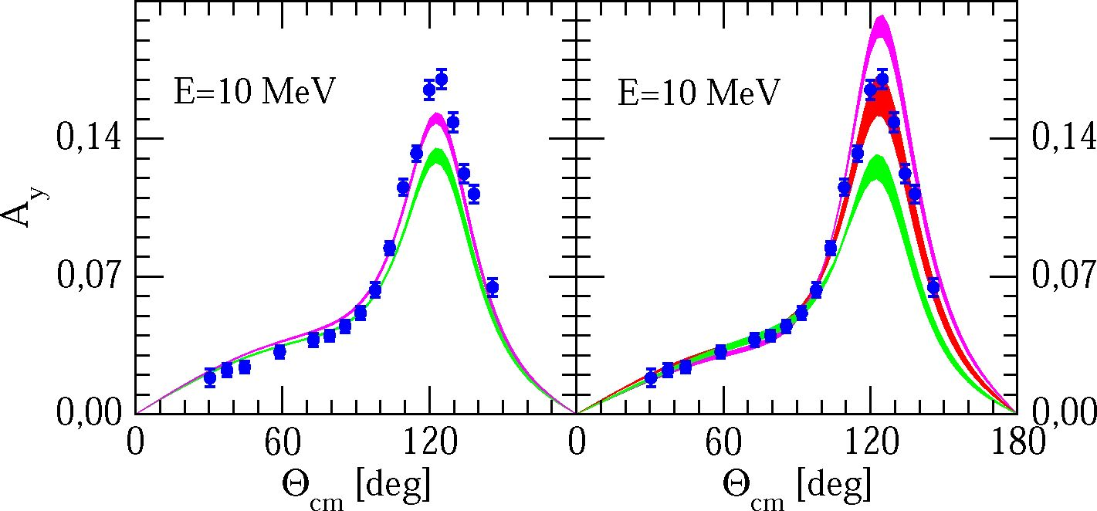
EPJ Web of Conferences
six topologies contribute to the 3NF: 2^-exchange, 2n - 1^-exchange, ring, 1^-exchange-contact, 2n-
exchange-contact and a purely contact term. In addition, there are also leading relativistic corrections.
The first three topologies belong to long-range contributions [5], while others are of short-range char-
acter [6]. These terms do not involve any unknown low-energy constants and the full N3TO 3NF
depends on two parameters, D and E, coming with the 1^-exchange-contact and the purely contact
term, respectively. A recently developed efficient method of partial wave-decomposition [7] allowed
us to apply the N3TO 3NF in 3N Faddeev calculations. First results presented in the following were
obtained without leading relativistic corrections in that 3NF. In the left column of Fig. 1 the AtJ puzzle
is exemplified for nd data taken at 10 MeV. High-precision semi-phenomenological NN potentials
(light shaded band) cannot describe the data and including the 2^-exchange Tucson-Melbourne (TM)
3NF (dark shaded band) only partially fills out the discrepancy in the maximum of Ar Taking the
next-to-leading order (NTO) chiral NN potential overestimates the data for AtJ (upper band in the
right column of Fig. 1), while next-to-next-to-leading order (N2TO) potentials describe the Ay data
quite well (middle band in the right column of Fig. 1). Such behavior can be traced back to the large
sensitivity of AtJ to the 3Pj NN force components and to a poor description, especially for 3Pz, of
the experimental phase-shifts by the NTO and N2TO chiral potentials [1]. Only with the N3TO NN
potentials is the Ay puzzle again regained (lower band in the right column of Fig.l) and predictions
for Ay become similar to those obtained with semi-phenomenological potentials.
Figure 1. (color online) The neutron analyzing power A„ in elastic nd scattering. In the left column the light
shaded (green) and dark shaded (magenta) bands show predictions of realistic NN potentials (AVI 8. CD Bonn.
Nijml and Nijm2) alone or combined with TM 3NF, respectively. In the right column the magenta (upper), red
(middle) and green (low) bands show predictions of NLO, N2LO, and N3LO chiral NN potentials, respectively.
The nd data (full circles) are from [8].
The chiral N3TO 3NF is not able to explain the Ay puzzle (see Fig.2). It lowers the Ay maximum
and even increases the discrepancy to data. A resolution of the Ay puzzle might be achieved either
with the N4TO chiral 3NF [9] or/and using NN forces with corrected low-energy 3Pj phase-shifts.

3 Low energy breakup
Cross sections for the symmetric-space-star (SST) and quasi-free-scattering (QFS) configurations of
the nd breakup are extremely stable with respect to the underlying dynamics. Different potentials,
03096-p.2
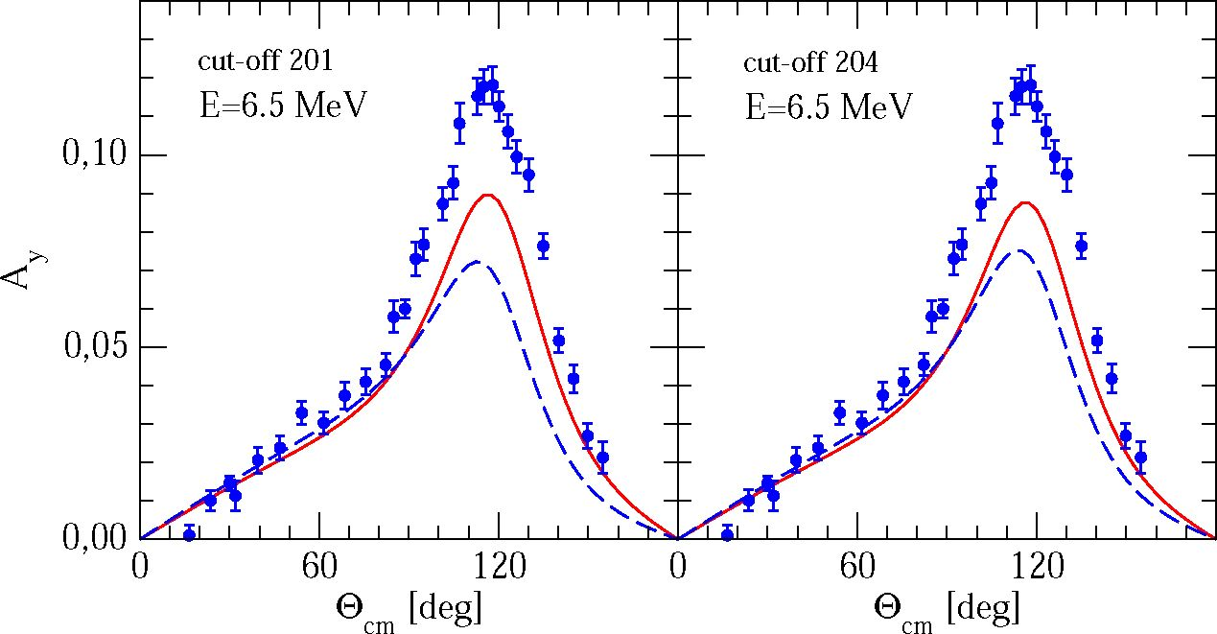
INPC 2013
Figure 2. (color online) The neutron analyzing power Ay in elastic nd scattering. In the left and right column the
solid (red) line shows predictions of N3LO chiral NN potentials alone and the dashed (blue) line when they are
combined with N3LO 3NF composed of l7r-exchange-contact, purely contact, and 2^-exchange-contact terms
supplemented with long-range terms: 2^-exchange, 2n - 1^-exchange, and ring, for two cut-off values used in
Lippmann-Schwinger and spectral function regularization. The nd data (full circles) are from [8].
alone or combined with standard 3N forces, provide practically the same SST and QFS cross sec-
tions. Also, the chiral N3LO 3NF is no exception and cannot explain the discrepancy with the data
found for the SST configuration [10] (Fig.3). At low energies the cross sections in the SST and QFS
configurations are dominated by the S-waves. For the SST configuration the largest contribution to
the cross section comes from the 3Si partial wave while for neutron-neutron (nn) QFS the 35o partial
wave dominates. Neglecting rescatterings the QFS configuration resembles free NN scattering. For
free, low-energy neutron-proton (np) scattering one expects contributions from 35o np and 3Si force
components. For free nn scattering only the 35o nn channel is allowed. That implies that QFS nn
would be a powerful tool to study the nn interaction. The measurement of QFS np cross sections have
shown good agreement of data with theory [11], confirming thus good knowledge of the np force. For
nn QFS it was found that theory underestimates the data by « 20% [11]. The large stability of the QFS
cross sections to the underlying dynamics, implies that the present day 35o nn interaction is probably
incorrect. Modifications of the 35o nn CD Bonn force component by multiplying its matrix elements
by a factor A leads to large changes of the nn QFS cross sections, leaving the np ones practically
unchanged [12-14]. To remove the discrepancy found in experiment for nn QFS one needs A ~ 1.08.

4 Summary
The chiral N3LO 3NF is not able to explain the low-energy AtJ puzzle. It also does not resolve the
discrepancies found for cross sections in the nn QFS and SST configurations of the low-energy nd
breakup.
03096-p.3
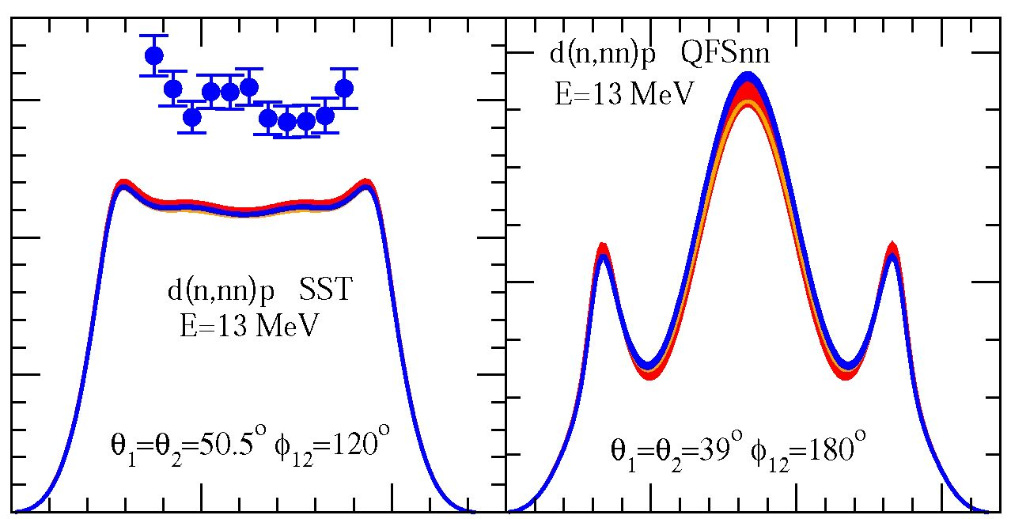
EPJ Web of Conferences
CO
*
>
CD
1,5
Ü 1,0
<N
a
0,5
00
^5
-O
0,0
0
5 10 0
S [MeV]
5 10 15
S [MeV]
Figure 3. (color online) The cross section <fl<r/dQ.\dQ.2dS as a function of the arc-length S in the E1^ = 13MeV
nd breakup reaction for the SST and QFSnn configurations. The light shaded (red) and dark shaded (blue) bands
show predictions of N3LO chiral NN potentials alone and combined with N3LO 3NF (without short-range 2n-
exchange-contact term) for five different cut-offs, respectively. The solid (orange) line is a prediction obtained
with the CD Bonn potential. The nd data for SST configuration (full circles) are from [8].
4
2
0

References
- E. Epelbaum, Prog. Part. Nuci. Phys. 57, 654-741 (2006)
- R. Machleidt, D. R. Entem, Phys. Rep. 503, 1-75 (2011)
- W. Glöckle et al„ Phys. Rep. 274, 107-286 (1996)
- D. Hüber et al„ Acta Phys. Polonica B28, 1677-1685 (1997)
- V. Bernard et al., Phys. Rev. C77, 064004-16 (2008)
- V. Bernard et al., Phys. Rev. C84, 054001-22 (2011)
- R. Skibiński et al., Phys. Rev. C84, 054005-14 (2011)
- W. Tornow et al., Phys. Lett. B257, 273-277 (1991)
- H. Krebs, A. Gasparyan, and E. Epelbaum, Phys. Rev. C85, 054006-20 (2012)
- H. R. Setze et al., Phys. Lett. B388, 229-234 (1996)
- A. Siepe et al., Phys. Rev. C65, 034010-16 (2002)
- H. Witała and W. Glöckle, J. Phys. G: Nuci. Part. Phys. 37, 064003-13 (2010)
- H. Witała and W. Glöckle, Phys. Rev. C83, 034004-11 (2011)
- H. Witała and W. Glöckle, Phys. Rev. C85, 064003-11 (2012)
03096-p.4

