SCRIPTA JUDAICA CRACOVIENSIA * Vol. 4
Kraków 2006
Barbara Zbroja

Jewish Architects in Cracow 1868-19391
The profound political transformations that took place in Austria at the end of the 1850s and the beginning of 1860s exerted a far-reaching influence on the history of Galician Jews. 2 The changes led to the complete abolition of laws discriminating against Jews and brought them the long-awaited emancipation. The liberal constitution of 21 December 1867 proclaimed equality for all citizens. Equally important was the passing of the so-called School Act on 25 May 1868, which limited the public privileges of the Roman Catholic Church and obliged religious communities to control the religious education of their youth. 3 Finally, in October 1868 Home Parliament in Lvov passed an act which granted all civil rights to Galician Jews. 4
The emancipation effected dramatic changes in various spheres of life of the Jewish population. The most significant were the changes in the professional structures. Until then Jews had had limited occupational possibilities, which were mainly restricted to trade and crafts. The new political and legal situation raised new possibilities for Jews of practising professions which they had not had the right to practise until then.
As a result of the new situations, the participation of Jews in the building activity in the area of the city was intensified. It concerned both investing capital in the building activity and taking part in it by the Jews who practised the profession of builders or architects. This phenomenon was promoted by culture-creating functions performed by Cracow towards the end of the nineteenth and at the beginning of the twentieth centuries, as well as the existence of a large, many hundred years old, centre of Jewish culture.
In the early period after achieving the civil rights the participation of the Jewish population of Cracow in the professions requiring formal education was low. 5 In 1880 the Jewish intelligentsia constituted a group of 60 people. 6 By 1910 the situation had changed radically. At that time the Jewish intelligentsia in the city was already a significant social group. Jews predominated in the legal profession and banking. Also, their participation in engineering and building professions increased. In comparison with the state in 1880 the participation of the Jews in engineering professions rose by
1 The present paper is a tribute to the forgotten architects and builders who made a significant contribution to the formation of Krakow’s architectural lownscape. It is based, to a large extent, on archive material, which, for obvious reasons, is not complete and sufficient. Therefore, the author of the paper is appealing to all the readers to send any possible information or directions which could be useful in the further research to her e-mail address: barbarazbroya@op. pl
2 J. Purchla, “Z dziejów mieszczaństwa krakowskiego w XIX wieku, ” Znak 1985, no. 370-371, p. 112.
’ A. Żbikowski, Żydzi krakowscy i ich gmina w latach 1869-1919, Warszawa 1994, pp. 109-110.
4 Ibidem, p. 109.
5 Ibidem, p. 46.
6 Ibidem.

28
Barbara Zbroja
nearly 12 per cent. 7 Since the end of the nineteenth century this circle grew wider and in the interwar period it already consisted of a considerable number of professionally active architects and builders. 8 Apart from private designing offices, the number of both building and installation enterprises increased from year to year. This situation was largely due to the fact that Jews tended to enter the so-called learned professions. The choice of this kind of careers was justified by financial and religious reasons. One important argument for choosing this kind of professions by Jews was the possible threat from an employer who was not a Jew and for whom his Jewish employees’ religious traditions could have been alien. 9 Working on one’s own account enabled stricter observance of religious rules and proper keeping of the Sabbath - the most important Judaic feast. The existence of a large and active circle of architects inclined the Jewish investors to avail themselves of their wide range of services. Such a choice was part of deliberate policy of supporting people of the same faith.
Throughout the nineteenth century Cracow, which, beside Warsaw and Lvov, was the main centre of developing architectural thought, did not possess a higher educational institution teaching future architects. 10 For a long time there existed only a semi- higher college. In 1834 Instytut Techniczny (Institute of Technology) was founded, which in 1876 was transformed into c. k. Instytut Techniczno-Przemyslowy (Imperial- Royal Institute of Technology and Industry), and in 1885 it was established as Państwowa Szkoła Przemysłowa (State School of Industry). 11 It entitled the graduates to perform the professions of independent building contractor, licensed-builder, master mason, carpenter, or stone - mason. 12 The college had a separate Faculty of Building, which educated a great number of builders. Graduating from it guaranteed prompt entering the profession. At the end of the nineteenth century the members of the teaching staff of the college were well-known and esteemed Cracow’s architects, such as Henryk Lindquist, Sławomir Odrzywolski, Teodor Talowski, Tadeusz Munnich, Józef Pokutyński, Władysław Ekielski, and, temporarily, also Jan Zawiejski. At the beginning of the twentieth century the lectures and classes were also given by Zygmunt Harland, Jan Rzymkowski, Jerzy Struszkiewicz and Ludwik Wojtyczko, who performed the function of auxiliary teachers. Because of the fact that the college did not possess the rights of university, the future Cracow’s architects had to obtain the higher professional education abroad. This tendency prevailed especially in the second half of the nineteenth century. 13 The situation changed only after founding Architecture
7 Ibidem, p. 45.
’ The term “builder” is used here to denote a person who graduated from Building Faculty, e g. at Szkoła Przemysłowa (School of Industry) in Cracow, and was licensed both to make designs and carry out building works. This term was also applied to architects who, after graduating from a technical university, passed the builder license exam and were allowed to practice the profession.
’T. Gąsowski, “Żydzi krakowscy krakowscy latach 1796-1939, ” „Krzysztofory”. Zeszyty Naukowe Muzeum Historycznego Miasta Krakowa, no. 15, Kraków 1988, p. 22.
10 J. Purchla, “Architekci krakowscy na Politechnice Wiedeńskiej, ” in: T. Grygiel (ed. ), Architektura XIX i początku XX wieku, Wrocław-Warszawa-Kraków 1991, p. 9.
11 Ibidem, p. 5.
12 Pierwsze sprawozdanie C. K. Państwowej Szkoły Przemysłowej, ogłoszone z końcem roku szkolnego 1888/1889, Kraków 1889, p. 6.
13 J. Purchla, “Architekci krakowscy..., ” op. cit., p. 10.

Jewish Architects in Cracow 1868-1939
29
Department at the Academy of Fine Arts in 1913, which, however, started functioning properly only at the beginning of the academic year 1924/1925. 14
The present knowledge of the circles of architects and builders of Jewish origin working in Cracow from the end of the nineteenth century is insufficient. Practically, no detailed research has been conducted on this quite numerous religious group. It was generally assumed that the majority of them, particularly those who worked at the turn of the nineteenth and the twentieth centuries, were builders of “inferior creativity, ” who transformed designs of recognized architects. 15 The level represented by the architects improved in the interwar period, especially in the 1930s. It was in this period that a lot of architects started their careers in Cracow designing under the strong influence of German modernistic architecture. Unfortunately, there do not exist any biographies or monographs of those designers, although they were authors of numerous buildings classified as public utility architecture, as well as residential architecture. Therefore, it is in the first place the source material, used here on a large scale for the first time that is of primary importance for expanding the present state of research.
The first Jewish architects appeared in the circles of builders in Cracow in the 1880s. At first, those were licensed builders who ran their own building contractors’ enterprises. Undoubtedly, the first ones were Wilhelm Apter, Nachman Kopald, Markus Lieberman and Zygmunt Lurks. Most probably all of them, except for Nachman Kopald, obtained an education in Cracow’s School of Industry. Nachman Kopald, who was licensed to practise as a mason as early as in 1877, started working as the earliest, and since 1882 he worked as a builder. 16 Marcus Lieberman became a licensed builder in 1880; Zygmunt Luks in 1884, and Wilhelm Apter three years later. 17 The tenement houses designed by them were typical of the architecture of Cracow of those times and characterized by eclecticism with the application of neoRenaissance and neo-Baroque elements. 18
It was also at the time that Jozef Sare, associated with the technology department of the Cracow District Office, began his career. He was the first Jewish architect in Cracow who managed to make a brilliant professional career. He obtained an education before achieving the civil rights by the Jewish population. As early as in 1862 he started to attend the lectures at the Cracow Institute of Technology. After graduating, in 1867, he went on to study at Technische Hochschule in Vienna (Vienna University of Technology), where two years later he received the title of engineer. 19 As the head of the technology department and building adviser he signed the designs sent from Vienna or Lvov, as well as the ones executed by his subordinate architects. 20 He was the author and co-author of buildings erected for the Faculty of Medicine of the Jagiellonian
u J E. Dutkiewicz, J. Jeleniewska-Ślcsińska, W. Ślesiński, Materiały do dziejów Akademii Sztuk Pięknych w Krakowie 1895-1939, vol. 2, Wroclaw-Warszawa-Kraków 1969, p. 148.
15 J. Purchla, Jak powstał nowoczesny Kraków, 2nd edition, Kraków 1990, p. 78.
16 Archiwum Państwowe w Krakowie (State Archives in Cracow), quoted further as AP Kr, Akta Magistratu Miasta Krakowa (Files of the Municipal Office of the City of Cracow), quoted further as AMmK, classification no. Kr. 8136.
17 Ibidem.
18 Unlike the others, Marcus Lieberman most probably did not make designing, but only building masonry.
” R. Róg, „Sare (Saare, Sarre) Józef’, in: Polski Słownik Biograficzny, vol. 35, Warszawa-Kraków 1994, p. 189.
20 J. Purchla, Jak powstał..., op. cit., p. 75.

30
Barbara Zbroja
University and constructions connected with education. In the years 1893-1896 he designed, among other things, the building of Collegium Medicum at 16, Grzegórzecka Street, for the needs of the Faculty of Medicine, which is a good example of neoRenaissance (Fig. 1). In 1896-1898 he worked on the construction of the J. Sobieski Secondary School at 9, Sobieskiego Street. More or less at the same time, in 1897— 1899, he built the St. Ann Secondary School at 9, Na Groblach Square. 21 The architecture of the above-mentioned school buildings was characterized by calm, neoRenaissance forms, which were characteristic of this type of buildings on the whole territory of the monarchy. 22 Because of performing administrative duties, initially in the structures of the Cracow District Office, then in the City Council, and since 1905 as vice-president of the City of Cracow, Józef Sare did not run any private building enterprises. In the 1890s the number of qualified Jewish architects with technical university diplomas and Jewish builders increased. One of the most distinguished architects of those times was Benjamin Torbe. He was a graduate of Bauschule in Vienna, which he attended in the years 1880-1884 and later in the academic year 1887/1888. 23 He received the licence to practise the profession of a builder in 1889. 24 His activity was mostly connected with residential architecture. He designed several burgher tenement houses, typical of Cracow’s architecture at the end of the nineteenth and the beginning of the twentieth century, which in terms of stylistics represented mainly the neo-Baroque current. In the 1900s he applied various late historical forms, combining them with common Secession style architectural details. One of his most interesting designs was the alteration of the Tempel Synagogue (Fig. 2), designed in 1860, which was made in the years 1893-1894. The building works carried out by Benjamin Torbe gave the synagogue the eclectic style character, which emphasized the earlier neo-Romanesque and arcaded style elements. 25
Władysław Kleinberger also started his activity at that time. In the years 1887-1891 he was educated at Szkoła Przemysłowa in Cracow and he passed the examination for the licensed builder in 1897 in Lvov. 26 Władysław Kleinberger was the author of numerous burghers tenement houses, in architecture of which it is easy to notice his tendency to consistently replace the historicizing detail with modernized forms. The most interesting are the tenement houses situated at 3, Rakowicka Street (Fig. 3); 5 and 15, Ariańska Street and 3, Siemiradzkiego Street. 27 These designs - particularly the one of the tenement house at 3, Rakowicka Street - related to the picturesque eclectism, popular in the second half of the nineteenth century. There are also noticeable relations to the designs made by Teodor Talowski, one of the most outstanding architects working in Cracow at the end of the nineteenth century. In 1902 Władysław Kleinber-
21 Ibidem, p. 129.
22 Ibidem, p. 48.
23 J. Purchla, “Architekci krakowscy..., ” op. cit., p. 21.
23 AP Kr, AMmK, classification no. Kr. 8136.
25 B. Zbroja, “The Artistic Origins of the Tempel Synagogue in Cracow, ” Scripta Judaica Cracoviensia. vol. 3, Kraków 2005, pp. 59-60.
261 received the information concerning W. Kleinberger’s studies and his building license examination from Mrs Aneta Gluzińska, for which 1 would like to express my thanks.
27 AP Kr, Archiwum Budownictwa Miejskiego (Archives of Municipal Building), quoted further as ABM, ul. Rakowicka 3, fasc. 734; AP Kr, ABM, ul. Ariańska 5, fasc. 7; AP Kr, ABM, ul. Ariańska 15, fasc. 7a; AP Kr, ABM, ul. Siemiradzkiego 3, fasc. 807.

Jewish Architects in Cracow 1868-1939
31
ger made a design of the mortuary at the Jewish cemetery at 55, Miodowa Street, which is a very good example of application of modernized neo-Romanesgue forms (Fig. 4). 28
In the first decade of the twentieth century both the number of Jewish architects with university diplomas and builders increased. It was then that, among others, Ludwik Gutman, Rudolf Hand, Henryk Lamensdorf, Ferdynand Liebling, Jozue Oberleder, Łazarz Rock and Ignacy Tislowitz started their careers. Henryk Lamens- dorfs and Ferdynand Liebling’s works were the most interesting of that group of architects.
Henryk Lamensdorf attended the Building Faculty of the School of Industry in Cracow in the years 1892-1896.29 He served his building internship in Beniamin Torbe’s and Józef Pokutyhski’s enterprise. He received the licence to practise his profession on 17 January 19O2.30 He was an author of several tenement houses in the style of modernized historism, in which he frequently used the so-called “native motifs,” such as the motifs of the attic of the Clothiers’ Hall and of the characteristic windows of the Wawel Castle, which were popular in Cracow at that time. He used such elements in the tenement houses situated at 6, Dunajewskiego Street; 7, Krakowska Street and 38, Piłsudskiego Street, and others.31 One of his most interesting buildings is the tenement house of the Ross Family erected in the years 1912-1914 at 5, Rynek Główny Square.32 Its elevations represent the forms of modernized historicism, harmoniously relating to the adjacent façade of the Szara Kamienica (The Grey House) building (Fig. 5). The tenement houses designed by Henryk Lamensdorf were characterized by high standard of interiors, staircases and halls designs, and in some cases they were equipped with lifts, which was still rather rare in those days. One of the most significant Henryk Lamensdorf s works is the building, which was the seat of Jewish Religious Community authorities, on the comer of Krakowska and Skawińska Streets (Fig. 6).33 The building was erected in the years 1909-1911 and represents forms of modernized historism. Henryk Lamensdorf was also the author of designs for two houses of prayer: the Salomon Deiches, of blessed memory, House of Prayer and the prayer house of “Szejrit B’nei Emuna” Religious Association. The former was designed in 1910 and situated in the courtyard at 6, Brzozowa Street; the latter was built in 1914 at 4, Bocheńska Street.34 Apart from the prayer houses mentioned above and the building of the Jewish Religious Community government, in 1914 H. Lamensdorf designed the establishment of Towarzystwo Szkoły Ludowej i Średniej (Society for Elementary and Secondary Schools) at 3/5, Brzozowa Street intended for
28 B. Zbroja, Inwestycje budowlane Żydowskiej Gminy Wyznaniowej w Krakowie w latach 1868-1939, p. 76. Unpublished text of the master’s degree thesis written at the Faculty of History of the Jagiellonian University in 2003, under supervision of Prof. J. Purchla.
” Piąte sprawozdanie C. K. Państwowej Szkoły Przemysłowej w Krakowie, ogłoszone z końcem roku szkolnego 1892/1893, Kraków 1893, p. 54; Ósme sprawozdanie C.K. Państwowej Szkoły Przemysłowej w Krakowie, ogłoszone z końcem roku szkolnego 1895/1896, Kraków 1896, p. 64.
- AP Kr, AMmK, classification no. Kr. 8136.
” AP Kr, ABM, ul. 1 Maja 6, fase. 555a; AP Kr, ABM, ul. Krakowska 7, fasc. 434; AP Kr, ABM, ul. Manifestu Lipcowego 38, fasc. 560.
12 AP Kr, ABM, Rynek Główny 5, fasc. 759.
” AP Kr, ABM, ul. Krakowska 41, fasc. 439.
34 AP Kr, ABM, ul. Brzozowa 6, fasc. 87; AP Kr, ABM, ul. Bocheńska 4, fasc. 44.

32
Barbara Zbroja
the Jewish community of Cracow.35 Its construction was completed in 1923, and the building represents modernized Classicism, popular in Cracow before the outbreak of the First World War (Fig. 7).
Ferdynand Liebling attended the School of Industry together with Henryk Lamens- dorf in the years 1892-1896.36 In the years 1897-1899 Ferdynand Liebling was a student at Technische Hochschule (University of Technology) in Berlin. He served his designing and building internship under the supervision of Juliusz Reiniger in Przemyśl in the years 1896-1897 and then had a few months’ practice under Józef Pokutynski’s supervision in Cracow. From 1897 to 1899 he served an internship under the supervision of Juliusz Raschdorf in Berlin, and afterwards, until 1900, in Honiger’s and Sedelmeier’s enterprise in Berlin. In 1901-1902, having finished the internship period, he had a professional training under Zygmunt Luks’s supervision in Cracow. He received the licence to practise the profession in 1902.37 In the academic year 1903/1904 he worked as a teaching assistant in the Faculty of Building of the School of Industry in Cracow.38 Ferdynand Liebling executed a lot of interesting designs in the sphere of residential architecture, as well as for buildings serving the Jewish community. He was the author of numerous tenement houses in the style of modernized historism, including his own house situated at 32, Starowiślna Street, designed in 1902, which is especially interesting (Fig. 8).39 Other tenement houses designed by him can be found at 9, Wielopole Street, as well as at 5, Dietla Street and 27, Dietla Street.40 Apart from his independent activity, Ferdynand Liebling ran a building partnership with Szymon and Józef Kahane at the end of the first and at the beginning of the second decade of the twentieth century. In the 1920s he was also an owner of a designing and building office where he cooperated with Jozue Oberleder, who had earlier been an intern in his office.41 In the years 1937-1938 Ferdynand Liebling (but without Jozue Oberleder’s participation) was the author of the design for the extension to the Jewish hospital in Skawińska Street; he extended it by building an additional eastern wing and modernistic synagogue, added to the southern elevation of the building (Fig. 9).42 43
Jozue Oberleder also graduated from the State School of Industry in Cracow. In 1899 he started studying there at the Faculty of Mechanics and Chemistry, but a year later he moved to the Faculty of Building. His cooperation with Ferdynand Liebling resulted mainly in designs for tenement houses. They also executed the alteration of the Tempel Synagogue together. The works conducted in 1924 involved adding aisles and altering the gallery layout. The design for the building works was made relating closely
” AP Kr, ABM, ul. Brzozowa 3/5, fasc. 87.
36 Piąte sprawozdanie..., loc.cit, Ósme sprawozdanie..., loc.cit.
37 B. Zbroja, “The Artistic Origins...,” op.cit., p. 68.
38 Szesnaste sprawozdanie C.K. Państwowej Szkoły Przemysłowej w Krakowie, ogłoszone z końcem roku szkolnego 1903/1904, Kraków 1904, p. 42.
39 AP Kr, ABM, ul. Bohaterów Stalingradu 32, fasc. 57.
40 AP Kr, ABM , ul. Wielopole 9, fasc. 972a; AP K, ABM, ul. Dietla 25, ul. Dietla 27, fasc. 152.
41 AP Kr, AMmK, classification no. Kr. 8136.
42 B. Zbroja, Inwestycje budowlane..., op.cit., pp. 70-73.
43 Dwunaste sprawozdanie C.K. Państwowej Szkoły Przemysłowej, ogłoszone z końcem roku szkolnego 1899/1900, Kraków 1900, p. 71.

Jewish Architects in Cracow 1868-1939
33
to the earlier stylistic character of the elevation of the building and, undoubtedly, was one of the most interesting designs they worked on together.44
Adolf Siódmak started his designing activity just before the outbreak of the First World War. He was a graduate of Technische Hochschule inVienna, where he studied in 1898-1906.45 46 One of his first works was the alteration of “Dom Wenecki” (The Venice House) at 11, Rynek Główny Square, carried out in the years 1913-1917. In the façade of the building the architect placed the characteristic ornamental decoration and a frieze in the Empire style, which related to the earlier decorations from 1808 (Fig. 10). At the same time he also decorated, using a similar frieze, the façade of the building of an orphanage for Jewish children at 13, Kołłątaja Street in Tarnów.47 The mature period of his architectural creativity fell on the interwar period. In the mid- 19205 Adolf Siódmak often applied the classicizing forms which were widespread at the time. In 1922 he designed, using the forms of modernized classicism, the mortuary at the Jewish cemetery at 14, Jerozolimska Street. This design was a fruit of a nationwide competition organized by the Jewish Religious Community authorities in Cracow for Jewish architects. Unfortunately, owing to the enormous costs of the execution of the design, a few elements of the original design were given up. They abandoned among other things, the plan of building a monumental colonnade, which was to accentuate the elevation of the mortuary from the side of the cemetery (Fig. 11).48 The architect also used the classicizing motifs in the building of the Jewish Student Hostel at 3, Przemyska Street, which was erected in the years 1924-1928 (Fig. 12).49 The motifs also appeared in the competition design for the edifice of Jewish Gymnastics House from 1925, which was intended to be situated in the present-day Wietora Street (Fig. 13).50
In the 1920s Adolf Siódmak cooperated, for a short period of time, with Henryk Ritterman who, in all likelihood, was a graduate of Technische Hochschule in Vienna.51 They designed together, among other things, the tenement houses at 10, Krasińskiego Avenue and at 10, Morawskiego Street.52 Adolf Siódmak executed a large number of interesting detached and tenement houses, in designs of which he gradually abandoned the historicizing stylistics. The tenement houses designed by him are situated, among other places, at 5, Ujejskiego Street; 9, Bujwida Street and 16, Chopina Street.53 He was also the author of the Jewish Hostel, which was built in 1921
44 B. Zbroja, “The Artistic Origins”..., op.cit., pp. 66-68.
45 Adolf alias Abraham Siódmak. He was named as Abraham on the university register of students at Technische Hochschule in Vienna: J. Purchla, “Architekci krakowscy...,” loc.cit.
46 AP Kr, ABM, Rynek Główny 11, fasc. 763
47 S. Potęba, Złota era Tarnowa. Architektura i budownictwo >v Tarnowie na przełomie XIX i XX wieku, Tarnów 1998, p. 559.
48 B. Zbroja, “Hala przedpogrzebowa cmentarza żydowskiego przy ul. Jerozolimskiej 14 w Krakowie,” Rocznik Krakowski vol. 59, 2003, pp. 171-186.
49 AP Kr, ABM, ul. Przemyska 3, fasc. 707.
511 Nowy Dziennik, Year 1925, no. 247, p. 7.
51 H. Ritterman gave this information in the personal questionnaire for B’nei B’rith Association, AP Kr, Akta Stowarzyszenia B’nei B’rith, fasc. 309.
52 AP Kr, ABM, al. Krasińskiego 10, fasc. 445a; AP Kr, ABM, ul. Morawskiego 10, fasc. 627.
” AP Kr, ABM, ul. Ujejskiego 5, fasc. 940; AP Kr, ABM, ul. Bujwida 9, fasc. 91; AP Kr, ABM, ul. Szopena 16, fasc. 906.

34
Barbara Zbroja
thanks to funds from the Joint Distribution Committee.54 This building was situated on the present day premises of the Electricity Board in Wawrzyńca Street. One of his most interesting works was the building of the bus station, which was built in the years 1930-1931, situated in the present day Bohaterów Getta Square.55 It possessed a very simple modernistic form, which related to the bus station opened in 1929 in Świętego Ducha Square according to the design by Jerzy Struszkiewicz and Maksymilian Burstin (Fig. 14).
In the 1920s the next generation of architects and builders, who were bom in the 1880s and 1890s, began their activity. These were, among others, Emil Allweil, Samuel Baum, Maksymilian Burstin, Salomon Feldman, Izydor Goldberger, Zygfryd Hausner, Edward Kreisler, Henryk Ritterman, Samuel Singer and Roman Weindling. Most of them, at the initial phase of their activity, designed buildings using the historicizing motifs. In this respect, the most characteristic are the works of Roman Weindling who, after graduating from School of Industry, studied at the Faculty of Architecture at the Academy of Fine Arts in Cracow.56 Initially, he was obviously under the influence of modernized historism in its classicizing variation, but his designs from 1930s are already distinctly modernistic. He designed a relatively large number of tenement houses in Cracow, such as at 4, Biskupia Street; 12, Garbarska Street; or 4, Sobieskiego Street.57 At the end of the 1920s and at the beginning of the 1930s he acted as regional architect of National Health Service Union, for which he erected the building in Bochnia (Fig. 15), Będzin, Myślenice, Ostrowiec Świętokrzyski, Zakopane, Żyrardów, and others.58 Samuel Singer’s activity looked similarly. In 1911 he graduated from the Building Department of the School of Industry in Cracow.59 His architectural activity focused mainly on designing tenement houses and on minor building works, and it evolved from forms of modernized classicism into more modernistic ones. He also made designs of buildings serving the needs of the Jewish community. He was the author of the design of a religious school for Jewish girls, “Bejt Jakow,” built in 1928, which was situated at 10, Św. Stanisława Street.60 61 In the years 1938-1939 he designed the building of “Bejt Lechem” Association at 31, Skawińska Street (Fig. 16). 1 Both buildings are examples of moderate modernism.
The tenement houses designed by Izydor Goldberger are more innovative in form. He attended the lectures at the Building Department of the School of Industry in
5J Nowy Dziennik, Year 1921, no. 44, p. 5.
55 AP Kr, ABM, pl. Bohaterów Getta 19, Case. 48a.
56 Archiwum Akademii Sztuk Pięknych w Krakowie (Archives of Academy of Fine Arts in Cracow), further quoted as ASP, books of certificates from, among other years, 1918/1919, 1919/1920, 1920/1921.
57 AP Kr, ABM, ul. Biskupia 4, fasc. 38; AP Kr, ABM, ul. Garbarska 12, fasc. 249; AP Kr, ABM, ul Sobieskiego 4, fasc. 841a.
” W.W. Weyndling, “Krakowski architekt lat międzywojennych - Roman Weindling,” Teka Komisji Urbanistyki i Architektury, vol. 27, 1995, p. 66; AP Kr, Akta miasta Bochni, (Fiels of Bochnia), Zarząd miejski Bochni (Municipal Government of Bochnia), akta budowlane, (Fiels of Municipial Building), classification no. 366.
” Dwudzieste trzecie sprawozdanie C K. Państwowej Szkoły Przemysłowej, ogłoszone z końcem roku szkolnego 1909/1911, Kraków 1911, p. 66.
“ AP Kr, ABM, ul. Św. Stanisława 10, fasc. 856a.
61 AP Kr, ABM, ul. Skawińska 31, fasc. 820.

Jewish Architects in Cracow 1868-1939
35
Cracow in the years 1908-1914.62 63 By the late 1930s he had designed a large number of luxurious tenement houses. The most interesting of those are, among others, the buildings situated at 17, Kolberga Street (Fig. 17); 8, Szymanowskiego Street; 12, Chopina Street and 6, Pawlikowskiego Street. In 1931 he altered the Markus Tigner, of blessed memory, house of prayer, situated in the courtyard at 28/30, Grodzka Street, which was one of the biggest prayer houses outside the Kazimierz quarter.64
A prosperous designing office was run until 1932 by Maksymilian Burstin together with Jerzy Struszkiewicz. Maksymilian Burstin was a graduate of Politechnika Lwowska (Lvov University of Technology), where studied at the Faculty of Architecture. In the years 1910-1912 he served his internship as an independent designer in the firm owned by Karol Richtman and Stanislaw Ulejski in Lvov, and next, in 1913-1914 in Karol Richtmann’s firm, as a designer and manager of building works.65 Maksymi- lain Burstin and Jerzy Struszkiewicz designed together several prestigious buildings of public utility. In the years 1920-1936 they erected the Clinics of Gynecology and Obstetrics situated at 23, Kopernika Street, which is a perfect example of the persistence of modernized historism in the monumental architecture of Cracow of the interwar period.66 The building of the Nursing School, erected in the years 1923-1924 and situated at 25, Kopernika Street, was created in the same convention (Fig. 18).67 The Hall of Residence for Students of Medicine, situated at 20, Grzegórzecka Street, was built in the years 1925-1931 in simpler forms.68 Apart from the modernized historism, the architects used freely the modernistic forms. An example of that was the bus station in Sw. Ducha Square, non-existent at present, and the building of the “Feniks” Insurance Company at 13-15, Basztowa Street (Fig. 19).69 The latter was built in the years 1930-1933 in the form of an urban “skyscraper” and it housed not only elegant flats, but also a cinema auditorium and a restaurant.70
Towards the end of the 1920s a successive generation of architects and builders began working in Cracow. It was a generation of people who were mostly bom at the turn of the nineteenth and the twentieth century. They became famous for the designs of luxurious tenement houses which were predominantly commissioned by people of Jewish origin, which was very characteristic. They were advocates of modem forms in architecture. Their works in the sphere of residential architecture in Cracow gravitated towards the avant-garde. It was mostly simple, moderately modernistic residential architecture, but it also represented Bauhaus character. It became visible, for example,
62 Dwudzieste pierwsze sprawozdanie C.K. Państwowej Szkoły Przemysłowej, ogłoszone z końcem roku szkolnego!908/1909, Kraków 1909, s. 57. I. Goldberger started his education at Mechanic Department, and in the academic year 1909/1910 he moved to the Building Department.
63 AP Kr, ABM, ul. Kolberga 17, fasc. 392b; AP Kr, ABM, ul. Szymanowskiego 8, fasc. 910; AP Kr, ABM, ul. Chopina 12, fasc. 905a; AP Kr, ABM, ul. Pawlikowskiego 6, fasc. 607a.
w AP Kr, ABM, ul. Grodzka 28/30, fasc. 277a.
65 AP Kr, Dyrekcja Robót Publicznych, (Direction of Public Work), later referred to as DRP, fasc. 141c.
“ M. Fabiański, J. Purchla, Historia architektury Krakowa w zarysie, Kraków 2001, s. 294.
67 AP Kr, ABM, ul. Kopernika 35, fasc. 415a.
68 AP Kr, ABM, ul. Grzegórzecka 20, fasc. 293.
69AP Kr, ABM, Teki Architektoniczno-Urbanistyczne, Budynki Użyteczności Publicznej 47, quoted further as TAU; projekt dworca autobusowego przy pl. Św. Ducha, AP Kr, ABM, ul. Rynek Kleparski 2/4, fasc. 770 and 771.
711 It was erected on the basis of a design made in 1930 by Leopold Bauer, one of the most distinguished Vienna architects: M. Fabiański, J. Purchla, Historia architektury... op.cit., p. 176.

36
Barbara Zbroja
in the architecture of tenement houses built in the environs of Krakowski Park.71 Its main creators were Bernard Birkenfeld, Henryk Jakubowicz, Jakub and Maurycy Silberstein, Saul Wexner and Bernard Zimmermann. At the beginning of the 1930s new people joined this circle. The group of the most talented architects and builders of Jewish origin who began independent activity in that period included, among others, Leopold Bachner, Ignacy Bierer, Alfred Duntuch, Juliusz Eintrach, Leon Feniger, Zygmunt Grünberg, Stefan Landsberger, Leon Lieberman, Samuel (Stanislaw) Manber, Samuel Nebenzahl, Jakub Spira, Rudolf Spohn, Jakub Stendig, Maurycy Stiel, Fryderyk Tadanier and Józef Wetzstein. This professional group also included three women: Irena Bertig, Diana Reiterówna and Rela Schmeidler. It is worth mentioning that they were the first women to practice the profession of an architect in the area of Cracow. Part of the above mentioned architects were graduates of Szkoła Przemysłowa in Cracow. Samuel (Stanisław) Manber attended it in the years 1904-1908.72 Henryk Jakubowicz and Jakub Stendig started studying there in 1910.73 Bernard Birkenfeld, Juliusz Eintrach, Zygmunt Grünberg and Jakub Silberstein appeared there a year later.74 The majority of the above mentioned architects must have completed a higher specialized education, but at the present stage of research it can be confirmed only in a few cases.
Some of them ran large building enterprises. One of the best-known building firms belonged to Henryk Jakubowicz and Saul Wexner who, in all likelihood, was educated at Ingenierschule in Vienna.75 They designed several luxurious tenement houses together, which are situated at 3, 5, 7, and 9, Wenecja Street, 8, and 10, Pawlikowskiego Street, 13, Szymanowskiego Street and 2, Chopina Street.76 In the years 1937— 1939 they designed the building of Szkoła Rzemiosł Towarzystwa Szkoły Ludowej i Średniej (School of Crafts of Elementary and Secondary Schools Association), at 3, Podbrzezie Street.77 It possesses an interesting form, composed on the principle of interpenetrating solids, in the type of moderate modernism (Fig. 20).
Another prosperous building firm belonged to Alfred Düntuch and Stefan Landsberger. Alfred Düntuch graduated from Politechnika Lwowska in 192 5.78 In the academic year 1926/1927 he attended a post-graduate course at the Faculty of Architecture of the Academy of Fine Arts in Cracow.79 Unfortunately, nothing is known about his partner’s education. They cooperated in making designs for luxurious tenement houses, which were always characterized by high quality of execution and
71 J. Purchla, “Urbanistyka, architektura i budownictwo,” in: J. Bieniarzówna, J M. Małecki (eds ), Dzieje Krakowa, vol. IV: Kraków w latach 1918-1939, Kraków 1997, p. 175 and 189.
72 Siedemnaste sprawozdanie C.K. Państwowej Szkoły Przemysłowej, ogłoszone z końcem roku szkolnego 1904/1905, Kraków 1905, p. 62; Dwudzieste sprawozdanie c.k. Państwowej Szkoły Przemysłowej, ogłoszone z końcem roku Szkolnego 1907/1908, Kraków 1908, p. 61.
73 Dwudzieste trzecie sprawozdanie op.cit., p. 65.
73 Dwudzieste czwarte sprawozdanie c.k. Państwowej Szkoły Przemysłowej, ogłoszone z końcem roku szkolnego 1912/1913, Kraków 1913, p. 66.
75 J. Purchla, “Architekci krakowscy...,” op.cit., p. 21.
76 AP Kr, ABM, ul. Wenecja 3, fasc. 965; AP Kr, ABM, ul. Wenecja 5; ul. Wenecja 7; ul. Wenecja 9, fasc. 966; AP Kr, ABM, ul. Pawlikowskiego 8; ul. Pawlikowskiego 10, fasc. 671; AP Kr, ABM, ul. Szymanowskiego 13, fasc. 910a; AP Kr, ABM, ul. Szopena 2, fasc. 903.
77 AP Kr, ABM, Projekt Szkoły Rzemiosł, fasc. 8.
78 Archiwum ASP, Karty wpisowe za I półrocze roku akademickiego 1926/1927, card number 210.
79 J E. Dutkiewicz, J. Jeleniewska-Ślesińska, W. Slesiński, Materiały do dziejów..., op.cit., p. 262

Jewish Architects in Cracow 1868-1939
37
interesting realizations of interiors and elevations. The tenement houses designed and built by their firm can be found, among other places, at 9, Batorego Street; 6, Kalwaryjska Street; 10, and 12, Krzywa Street; 6, Sereno Fenna Street and 24, and 58, Słowackiego Avenue (Fig. 21).80 Alfred Duntuch was also a co-author of the monument commemorating the soldiers of Jewish origin who died in the struggle for the independence of Poland in the years 1914-1921. The design was created in 1937 in cooperation with Edward Kreisler and Józef Taub and the monument was put up in the Jewish cemetery in Miodowa Street (Fig. 22).81
The building enterprise owned by Leopold Bachner and Maurycy Stiel who, most probably, started their activity in the area of Cracow in 1935, was a similar firm. Until the end of the 1930s they built a lot of interesting modernistic tenement houses. These can be found, among others, at 3, and 5, Bujwida Street; 88, Długa Street; 43, and 45, Urzędnicza Street.
Out of the mentioned group of architects, also Bernard Birkenfeld together with Jakub Silberstein ran a building enterprise, which, however, was not as large as Saul Wexner’ and Henryk Jakubowicz’s or Leopold Bachner’s and Maurycy Stiel’s partnerships. Their co-operation was based on the acquaintance from Szkoła Przemysłowa, but it lasted only for about two years. They designed together luxurious, moderately modernistic tenement houses, which can be found, for example, at 61, Krowoderska Street and 56, Słowackiego Avenue.82 Bernard Birkenfeld was also the author of the synagogue in Bochnia, in Trudna Street. That design was made in the years 1931-1932 and was characteristic of modernized historism (Fig. 23).83 84 In the later period Jakub Silberstein began cooperating with his younger brother Maksymilian, and Bernard Birkenfeld with Józef Homik.
A lot of important works, mainly in the sphere of residential architecture, were also created by Ignacy Bierer, Juliusz Eintrach, Zygmunt Griinberg, Leon Lieberman, Samuel Nebenzahl and Józef Wetzstein. Also, Samuel Osiek’s realizations were of interest. In 1933 he made the design for the wooden boathouse of the Żydowski Klub Sportowy (Jewish Sports Club) “Makkabi,” which was situated in close proximity to the Dębnicki Bridge on the right bank of the River Vistula. Its solid was inspired by navy architecture (Fig. 24).8“’
Undoubtedly, one of the best architects working in Cracow at that time was Fryderyk Tadanier. He was the author of both numerous tenement houses and buildings of public utility. He graduated from Politechnika Lwowska in 1913. In the years 1915— 1916 he served an internship in Jan Lewicki’s firm in Lvov, as an independent technical manager. He started working in Cracow in 1923, cooperating with Wacław Krzyżanowski. From 1926 he worked with Adolf Szyszko-Bohusz and Jerzy Struszkiewicz. In June 1926 the District Direction of Public Works charged him with a task of directing the rebuilding of villages near Cracow, but at the present stage of research it is difficult to determine how long he held this position. He passed the
“ AP Kr, ABM, ul. Batorego 9, fasc. 25a; AP Kr, ABM, ul. Pstrowskiego 6, fasc. 910a; AP Kr, ABM, ul. Krzywa 10, fasc. 714a; AP Kr, ABM, ul. Krzywa 12, fasc. 476a; AP Kr, ABM, ul. Jaracza 6, fasc. 328; AP Kr, ABM, al. Słowackiego 24, fasc. 831; AP Kr, ABM, al. Słowackiego 58, fasc. 833a.
81 Gazeta Gminna. Organ Urzędowy Gminy Wyznaniowej Żydowskiej w Krakowie, Year 1: 1937, no. 5, p. 6.
82 AP Kr, ABM, ul. Krowoderska 61, fasc. 456; AP Kr, ABM, al. Słowackiego 56, fasc. 832a.
” AP Kr, DRP, fasc. 131, item 18.
84 AP Kr, ABM, Projekt przystani wioślarskiej Żydowskiego Klubu Sportowego “Makkabi,” fasc. 50.

38
Barbara Zbroja
building license examination in Cracow in 1927.85 One of his first independent works was the alteration of the building of General Post Office in the years 1930-1931. The architect deprived it of the neo-Renaissance stylistic costume, introducing elements of crystal style.86 In the years 1935-1936, with the help from Stefan Strojek, Fryderyk Tadanier made the design for the building of District Department at 20, Słowackiego Avenue, which was preserved in the forms of modernized classicism (Fig. 25).87 Fryderyk Tadanier was also the co-author of the housing estate of Robotnicza Spółdzielnia Mieszkaniowa (Workers’ Housing Cooperative) “Praca,” situated in Praska Street. He cooperated in creating this design with Michał Zakrzewski. This housing estate was built in the years 1935-1939 and it is the best and biggest example of cheap social building in interwar Cracow.88 Its social character was emphasized with the functionalist House of Social Care built in the years 1935-1937, which housed, apart from shops, a kindergarten, a library and a performance hall.89 In the years 1932— 1934 Fryderyk Tadanier designed, with the participation of Stefan Strojek, a sevenstorey edifice of Regional Savings Bank at 5, Szczepański Square. Its size and location caused a scandal at the time. The building has an interesting solid, the shape of which resulted from the character of the comer lot and it is an interesting example of moderate modernism with expressively formed comer (Fig. 26).90 Fryderyk Tanadier also erected a few tenement houses in the type of moderate modernism, including 11, Biskupia Street (the comer with 2, Sereno Fenna Street); 8, Sereno Fenna Street; 8, Św. Marka Street; 40/40 a, Kazimierza Wielkiego Street; 5, Chopina Street; 2, Matejki Square and 11, Biskupi Square.91
Jakub Stendig, who was a graduate of the Faculty of Architecture of the Academy of Fine Arts in Cracow, is also worth mentioning.92 One of his most interesting works is the building of the school for Jewish girls of the “Ognisko Pracy” Society, which was built in the years 1935-1937; located at 7, Wietora Street.93 It was designed very functionally and has a moderately modernistic form (Fig. 27). Rela Schmeidler’s realizations were of similar character. She was a graduate of the Faculty of Architecture of Academy of Fine Arts in Cracow, where she studied in the years 1924—1929.94 In 1939 she made a design for the “Ognisko Pracy” Society boarding school, which was not executed because of the outbreak of the war.95 The boarding school was intended to be built on the empty lot next to the school in Wietora Street, and was to
85 AP Kr, DRP, fasc. 140a.
86 A. Siwek, “Poczta Główna w Krakowie - z dziejów gmachu,” Teki Krakowskie 2, 1995, p. 31-38.
87 AP Kr, ABM, ul. Łobzowska 44, fasc. 539.
88 J. Purchla, “Urbanistyka, architektura...,” op.cit., p. 178.
89 AP Kr, ABM, ul. Praska 52, fasc. 694b.
90AP Kr, Akta Krakowskiej Kasy Oszczędności Powiatów Krakowskiego, fasc. 12; Ilustrowany Kurier Codzienny, Year 1934, no. 273, p. 6.
91 AP Kr, ABM, ul. Biskupia II, fasc. 38b; AP Kr, ABM, ul. Jaracza 8, fasc. 329; AP Kr, ABM, ul. Św. Marka 8, fasc. 571; AP Kr, ABM, ul. Kazimierza Wielkiego 40 a, fasc. 375; AP Kr, ABM, ul. Szopena 5, fasc. 904. He made the design for the tenement house together with Stefan Strojek: AP Kr, ABM, pl. Matejki 2, fasc. 577.
92 Archiwum ASP, the book of certificates 1918/1919.
93 AP Kr, ABM, ul. Fornalskiej 7, fasc. 236.
92 Archiwum ASP, books of certificates from the years 1924-1929, J E. Dutkiewicz, J. Jeleniewska-Ślesińska, W. Ślesiński, Materiały do dziejów..., op.cit., p. 387.
95 AP Kr, ABM, Projekt internatu dla szkoły “Ognisko Pracy,” fasc. 59.

Jewish Architects in Cracow 1868-1939
39
represent the same moderate modernism (Fig. 28). The designs made by Diana Reiter were more innovative, because they related to the architecture promoted by Bauhaus school. She was a graduate of the Faculty of Architecture of Politechnika Lwowska, which she left in 1927. At the beginning of the 1930s she worked for the Direction of Public Works, at the Province Office. In the years 1937-1938 she made a design for the tenement house at 16, Pawlikowskiego Street - an example of functionalism with elements relating to navy architecture (Fig. 29).96
One of the most talented Cracow architects of the 1930s was Edward Kreisler.97 He studied at the Faculty of Architecture at Politechnika Lwowska. He graduated in March 1926 with very good results and distinction in utilitarian building. From April 1926 he worked in the Municipal Building Office in Cracow (in Section A), where he was responsible for designing, carrying out building works and maintaining municipal buildings. At the beginning he worked as a junior clerk, but already from 1 December 1934 he held the position of Head of the Section.98 Until the year 1939 Edward Kreisler’s professional life was connected with his work for the Cracow Municipal Office. In this connection, he was an author and co-author of several designs, mainly for public utility buildings, which were planned and built on the initiative of the municipal authorities. In the years 1930-1931 E. Kreisler created one of his best architectural realizations - the building of Miejski Dom Wycieczkowy (Municipal Tourist Hostel) at 4, Oleandry Street (Fig. 30). Basing on the experience worked out by the Bauhaus school, Edward Kreisler made an interesting design using a composition of two interpenetrating solids, transversal and longitudinal. Unfortunately, his plans were not fully executed. Nevertheless, the architecture of this edifice ranked in the top of modernistic realizations of interwar Cracow.99 Edward Kreisler was also a co-author of the edifice of Muzeum Narodowe (National Museum) at 1, 3 Maja Street. It was made according to the drawings prepared by Edward Kreisler and Czeslaw Boratyński, who cooperated with him in the Municipal Building Office, as well as the winning design from the competition of 1934 made by a team of Warsaw architects - Bolesław Schmidt, Janusz Juraszyński and Juliusz Dumnicki. Only Bolesław Schmidt cooperated on the overall design with the Cracow architects.* 9 10 The design of the Museum represented modernized classicism, popular in the totalitarian states - with the features closest to the architecture of Germany. Its monumental character appears mainly in the heavy and squat proportions, emphasized by thick and “brutal” stone rusticated facing (Fig. 31).
The view layout of the rooms of the building and the conception of the exhibition space were subordinated to the idea of the national character of the museum, which, according to the assumptions of Feliks Kopera, the director of the museum, was to be a shrine to objects of national devotion, as well as the pantheon of art. Unfortunately, the outbreak of the war caused the building works to stop and the design of Bolesław
96 AP Kr, ABM, ul. Pawlikowskiego 16, fasc. 671a.
” B. Zbroja, „Edward Kreisler - krakowski architekt okresu międzywojennego”, unpublished paper delivered at the Towarzystwo Miłośników Historii i Zabytków Krakowa (Society for History and Historie Monuments of Cracow) on 24 May, 2005.
9" 1 obtained all the information concerning E. Kreisler’s education and works from the architect's son, Mr. Adam Kreisler, for which I wish to express my sincere thanks.
” B. Zbroja, „Edward Kreisler”..., op.cit., pp. 7-9.
IO" Sprawozdanie Dyrekcji Muzeum Narodowego w Krakowie za rok 1938/1939, Kraków 1939, p. 4.

40
Barbara Zbroja
Schmidt, Czeslaw Boratyński and Edward Kreisler was never realized in the form it had been planned. During his 13-year work for the Cracow Municipal Office Edward Kreisler made a lot of designs, the majority of which remained on paper. His designs included the building of Śląskie Techniczne Zakłady Naukowe (Silesian Technical Scientific Establishment) in Katowice (together with Czeslaw Boratyński and Roman Stadnicki), the dwelling house for Railway Management in Katowice; the buildings of covered markets in Cracow, and the buildings of the fire station.101
Because of his work for the Municipal Office, Edward Kreisler could not have private building practice. However, he cooperated in designing practice with Jakub Spira, most probably from 1934. Jakub Spira was a sworn court expert in building, reinforced concretes and steels constructions. From the late 1920s he worked as a technical director for the firm owned by Edward Uderski, which specialized in constructions of reinforced concrete.102 It can be concluded from the memories of the architect’s relatives’ that the designs of tenement buildings preserved in the Archives of Municipal Building and signed with the name of Jakub Spira, were actually made by Edrawd Kreisler. It was undoubtedly the case with the tenement house at 13, Lenartowicza Street, which is a rare example of functionalism in the residential architecture of Cracow (Fig. 32).103 Another object designed in the cooperation with J. Spira was the building of Stowarzyszenie Ochrony Starców Żydowskich (Association for Protection of Jewish Old Men) “Asyfas Skeinim”, built in the years 1937-1940, situated at 6, Chmielowskiego Street. Its form relates to the architecture promoted by the Bauhaus school and shows a lot of analogies with Miejski Dom Wycieczkowy (Fig. 33)104 Tfog cooperation with Jakub Spira yielded mostly designs for modernistic tenement houses; none of them, however, had such an innovative form in the architecture of Cracow as the tenement house in Lenartowicza Street.105 The building of the old people’s home of the “Asyfas Skeinim” Association is also extremely interesting in that respect.
It was characteristic of the architects and builders of the Jewish origin to belong to various Jewish institutions and associations. One of the associations that enjoyed the greatest popularity was Stowarzyszenie Humanitarne “Solidarność” (Humanitarian Association “Solidarity”) B’nei B’rith, which gathered exclusively the members of Jewish intellectual elite. In the interwar period the association included, among others, Herman Gutman, Ferdynand Liebling, Henryk Lamensdorf, Władysław Kleinberger, Jozue Oberleder, Henryk Ritterman, Józef Weinberger and Józef Sare.106
In the years 1923-1938 there operated in Cracow Towarzystwo Szkoły Rzemieślniczej (Society for School of Handicrafts) which included, among others, Bernard
101 W. Odorowski, Architektura Katowic w latach międzywojennych 1922-1939, Katowice 1994, pp. 110-114; AP Kr, ABM, TAU, Szkoły 8; projekt konkursowy domu mieszkalnego pracowników Dyrekcji Kolei w Katowicach, AP Kr, ABM, TAU, BUP 20; projekty miejskich hal targowych, AP Kr, ABM; TAU, BUP 38; projekt strażnicy pożarnej przy ul. Wielickiej.
102 AP Kr, Akta Starostwa Grodzkiego (Files of the Municipal District), quoted further as StGkr, fasc. 180.
103 M. Fabiański, J. Purchla, Historia architektury..., op.cit., p. 316.
11,4 B. Zbroja, Inwestycje budowlane..., op.cit., p. 84.
105 Other tenement houses which should be regarded as designed by E. Kreisler (despite J. Spira’s signatures on the designs) are the buildings, inter alia, at 72, Krowoderska Street; 10, Asnyka Street; 12, Pawia Street; 9, Worcella Street, 1, Bujwida Street and 43, Łobzowska Street.
106 Książka adresowa członków Żyd. Stowarzyszeń Humanitarnych "B 'nei B 'rith ” w Polsce, Kraków 1928.

Jewish Architects in Cracow 1868-1939
41
Birkenfeld, Juliusz Eintrach, Zygmunt Griinberg, Jakub Stendig and Bernard Zimmerman.107 The aim of the association was to prepare the Jewish youths theoretically and practically for performing building and craftsman’s jobs, as well as to organize workshops and training courses.
In 1936 Związek Inżynierów Żydów (Union of Jewish Engineers) was established with the seat in Cracow. As a statutory organization it started to operate from 15 January 1937.108 It was founded on the initiative of Isser Harband, Moses Gelber, Henryk Haber, Dawid Feldman and Meilech Rottenberg. It was modelled upon an analogous association operating in Lvov, and it operated in the territory of the provinces of Cracow and Silesia. Its organizational committee included, among others, Alfred Diintuch, Saul Wexner, Diana Reiter and Isser Harband. In 1938 the Union was already composed of 195 members. The basic aims of the union were to deepen the professional education, maintain a library and a reading-room, support the Jewish professional education, publish specialist periodicals and books and organize exhibitions.
Many of the architects and builders of Jewish origin who worked in the region of Cracow in the interwar period were killed during the Second World War. At the beginning of the Nazi occupation, on the strength of the decree of 18 May 1940, some of them were displaced outside the boundaries of Cracow during the action Judenaus- siedlung aus Krakau.109 The main destination for the displaced Jews was the region of Lublin, with the districts of Lublin, Biała Podlaska, and Radzyń, from where the people were transported to German extermination camps in Bełżec, Sobibór and Treblinka.110 In that way, A. Siódmak and his wife, who had been rejected the right to stay in Cracow, found themselves in the ghetto in Międzyrzecze Podlaskie in 1940.111 Many architects were put in the ghetto in Cracow, and later to the concentration camp in Płaszów, like, among others, Izydor Goldberger, Zygmunt Griinberg, Henryk Jakubowicz, Diana Reiter, Jakub Stendig and Samuel Singer.
The list of Jewish architects who contributed to the architectural development of Cracow from the end of the nineteenth century is, of course, far longer. The architects and builders mentioned in the paper were chosen as the most representative for the architectural circles of Cracow at the end of the nineteenth and the beginning of the twentieth century, as well as in the interwar period. They exerted a profound influence on the formation of the city-planning and architectural townscape of Cracow. However, due to the tragic history of the Second World War, these architects and their works fell, to a large extent, into oblivion. Further archive research will probably make it possible to complete the now existing knowledge about the Jewish architects, both about their education and architectural achievements, and will also enable us to “discover” new names, and, finally, will make it possible to elaborate a full scientific description of their output in the form of a personal index.
107 AP Kr, StG Kr, fase. 246.
AP Kr, StGKr, fase. 247.
109 AP Kr, Starosta Miasta Krakowa-Der Stadthauptman der Stadt Krakau 1939-1945 (quoted further as SMKr), Wykaz Żydów przeznaczonych do wysiedlenia w latach 1940-1941, fasc. 722.
1111 R. Kotarba, “Żydzi w Krakowie,” in: Encyklopedia Krakowa, Warszawa-Kraków 2000, p. 1112.
111 AP Kr, SMKr, Kwestionariusze na wydanie dowodów osobistych (Kennkarten) dla Żydów - rozpatrzone odmownie, fasc. 665.

42
Barbara Zbroja
SUPPLEMENT

List of Jewish architects and builders in Cracow112
Abram Abramowicz, b. Cracow 1979
Emil Allweil, b. Czyzowice (district Mościska) 1883
Wilhelm Apter, b. Cracow 1855, d. Cracow 1916
Leopold Bachner, b. Cracow 1905
Samuel Baum, b. Cracow 1898, d. Gdańsk 1941
Irena Bertig, b. Łódź 1905
Ignacy Bierer
Bernard Birkenfeld, b. Cracow 1897, d. Zakliczyn (district Brzesko) 1942
Artur Brenner, b. Cracow 1898
Maksymilian Burstin, b. Lvov 1886, d. Cracow 1932
Alfred Diintuch, b. Cracow 1903
Juliusz Eintrach, b. Cracow 1897, d. district Kermin, Uzbekistan 1942
Leon Feniger, b. Cracow 1901
Salomon (Stefan) Feldman, b. Bibice (district Cracow) 1884
Edward Fuhrschmied
Adam Garde, b. Cracow 1892, d. Cracow 1943
Bernard Albert Glazer, b. Cracow 1882
Ludwik Gintel, b. Cracow 1899
Izydor Goldberger, b. Cracow 1894
Zygmunt Griinberg, b. Cracow 1896, d. Mathausen-Gusen 1945
Herman Gutman, b. Cracow 1882 d. Cracow 1946
Ludwik Gutman, b. Cracow 1874 d. Bełżec 1942
Rudolf Hand, b. Lvov 1861
Isser Harband, b. Tamoplo 1890
Zygfryd Hausner, b. Cracow 1887 d. Russia 1943
Oser Hirt, b. Jarosław 1882
Henryk Jakubowicz, b. Brzesko 1893 d. Cracow 1943
Salomon Jonkler, b. Cracow 1891, d. Tarnowiec (district Jasio) 1943
Władysław Kleinberger, b. Cracow 1872
Nachman Kopald, b. Borzęcin (district Brzesko) 1834
Edward Kreisler, b. Cracow 1903, d. Cracow 1946
Edmund Kusmer, b. Czerlany (district Gródek Jagielloński) 1888, d. Bełżec 1942
Henryk Lamensdorf, b. Cracow 1876, d. Cracow 1928
Stefan Landsberger, b. Cracow 1901
Marian Lebenheim, b. Bochnia 1891, d. Lvov 1942
Ascher Leuchter, b. Cracow 1888, d. district Ferghan, Uzbekistan 1943
Leon Lieberman, b. Cracow 1897
Markus Lieberman, b. Drohobycz 1841
Ferdynand Liebling, b. Cracow 1877, d. Wieliczka 1942
Hugo Lilienthal, b. Zawoja (district Myślenice) 1903
Zygmunt Luks, b. Chrzanów 1844
Samuel Manber, b. Nawarja (district Lvov ) 1877
Samuel Mehl, b. Alwernia (district Chrzanów) 1867, d. Cracow 1943
112 The list includes only the names of the architects who were, to the author knowledge, of Jewish origin. In the case of less known localities, the name of the related until of territorial division is given in the brackets - in the case of Poland, according to the pre - war administrative boundaries.

Jewish Architects in Cracow 1868-1939
43
Szulem (Stanislaw) Mehl, b. Rudze (district Wadowice) 1884, after 1946 Emanuel Morgenbesser, b. Cracow 1901, d. Cracow 1943
Rudolf Morgenbesser, b. Cracow 1899
Samuel Nebenzahl, b. Cracow 1902, d. after 1946
Artur Neuman, b. Zablocie (district Żywiec) 1899
Jozue Oberleder, b. Cracow 1883, d. after 1947
Samuel Osiek, b. Cracow 1904
Zygmunt Prokesz, b. Cracow 1876
Diana Julia Reiter (Reiterówna), b. Drohobycz 1902, d. Cracow 1943 (?) Henryk Ritterman, b. Cracow 1885, d. Cracow 1940
Łazarz Rock, b. Cracow 1872, d. Cracow 1930
Adolf Rottersmann, b. Niepołomice (district Bochnia) 1889
Józef Sare, b. Chorowice (district Wieliczka) 1850, d. Cracow 1929
Rela Schmeidler, b. Cracow 1905, d. after 1944
Edmund Schönberg, b. Cracow 1907, d. after 1946
Jakub Silberstein, b. Cracow 1896
Maksymilian Silberstein, b. Cracow 1900, d. after 1946
Aron Samuel Singer, b. Cracow 1891, d. Cracow 1943
Adolf Siódmak, b. Cracow 1879, d. Gross Rossen 1944
Jakub Spira, b. Cracow 1902
Jakub Stendig, b. Kołomyja 1891, d. 1952
Izydor Stieglitz, b. Cracow 1903
Maurycy Stiel, b. Trzebinia 1906 (?)
Fryderyk Tadanier, b. Kamionka Strumillowa 1892, d. Cracow 1960 Józef Taub, b. Lvov 1889
Łazarz Tennenbaum, b. Cracow 1888
Ignacy Tislowitz, b. Cracow 1885, d. Cracow 1936
Benjamin Torbe, b. Cracow 1856, d. Cracow 1931
Józef Weinberger, b. Cracow 1861, d. Cracow 1936
Roman Weindling, b. Cracow 1884, d. Treblinka 1943
Józef Wetzstein, b. Cracow 1903
Saul Wexner, b. Cracow 1890, d. after 1947
Tobiasz Wexner, b. Cracow 1887
Bernard Zimmermann, b. Borek (district Bochnia) 1885, d. Cracow 1931 Karol Zimmerspitz, b. Zubfi (Moravia) 1902, d. Auschwitz 1945

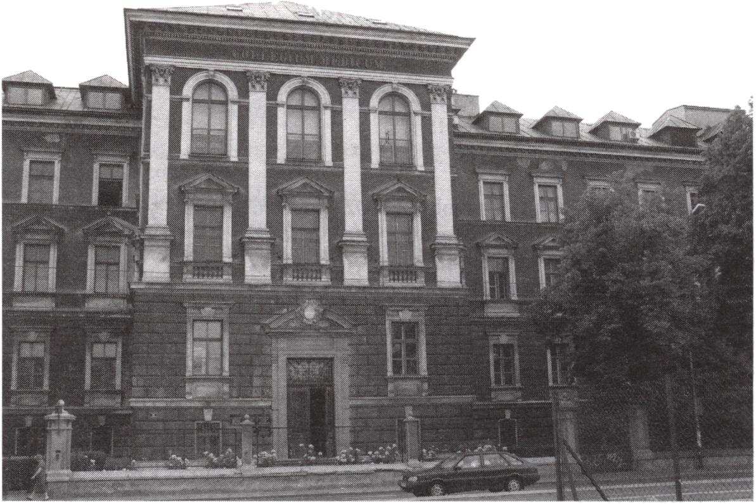
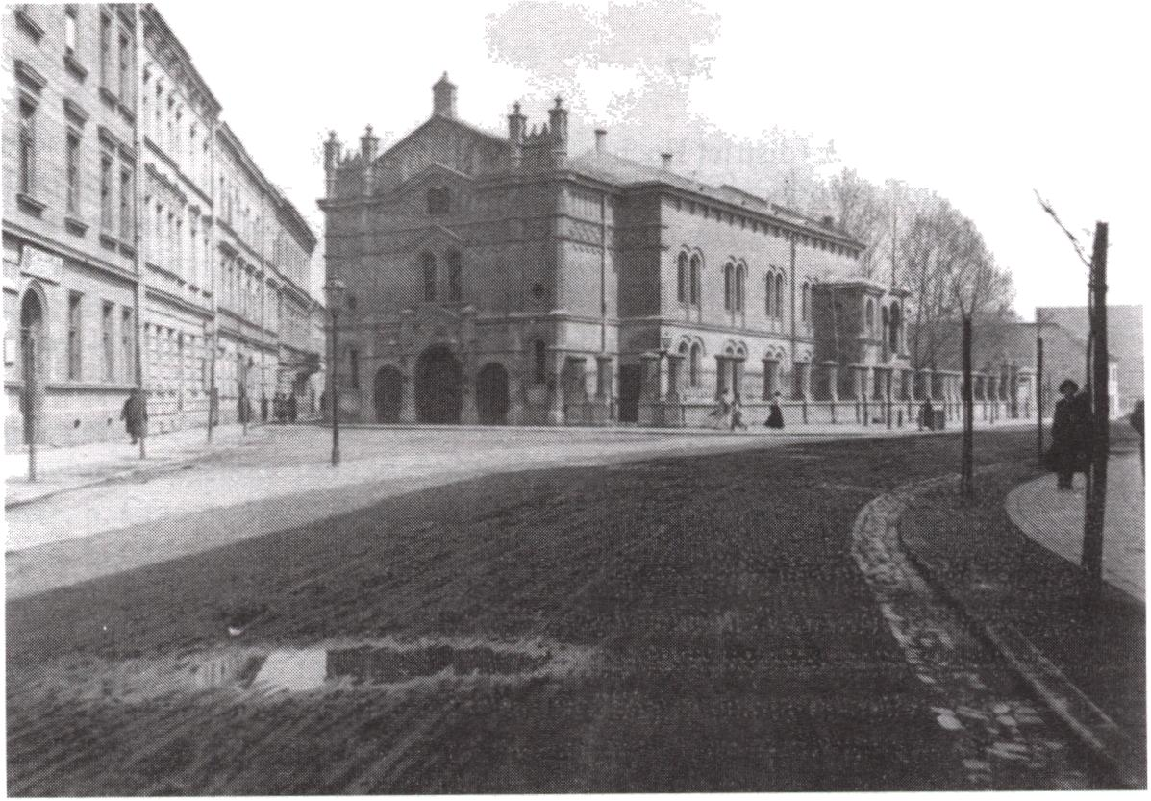
44
Barbara Zbroja
Fig. 1. Józef Sarę, Collegiun Medicum at 16, Grzegórzecka Street, 1893-1896,
photo. B. Zbroja, 2005
Fig. 2. Benjamin Torbę, Tempel Synagogue, state after the alteration in 1893-1894, view of the
facade and southern elevation, 1907 r. Archiwum Państwowe w Krakowie (State Archives in
Cracow), later referred to as AP Kr, iconography collection, A 111/3 5 7,
photo. M. Multarzyńska-Janikowska

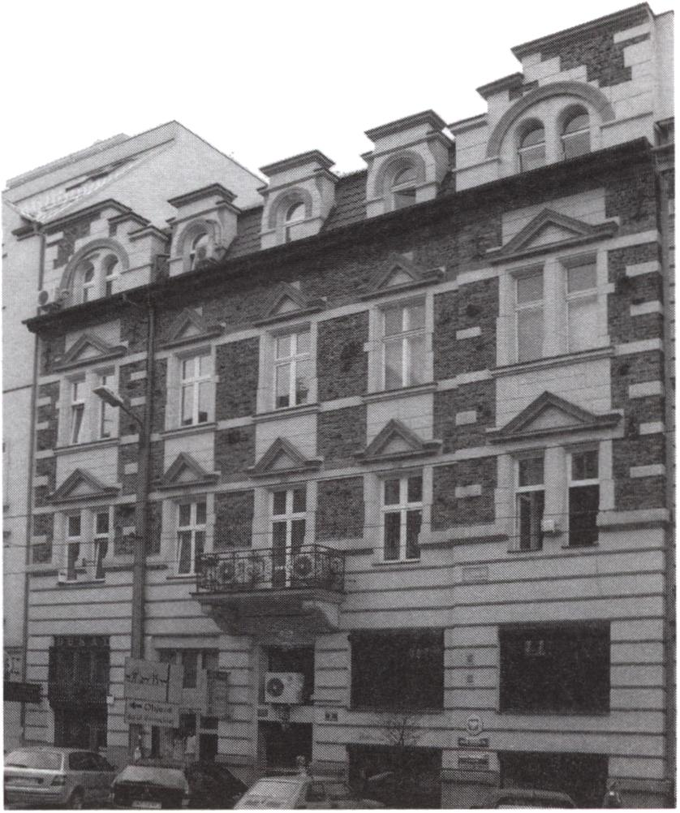
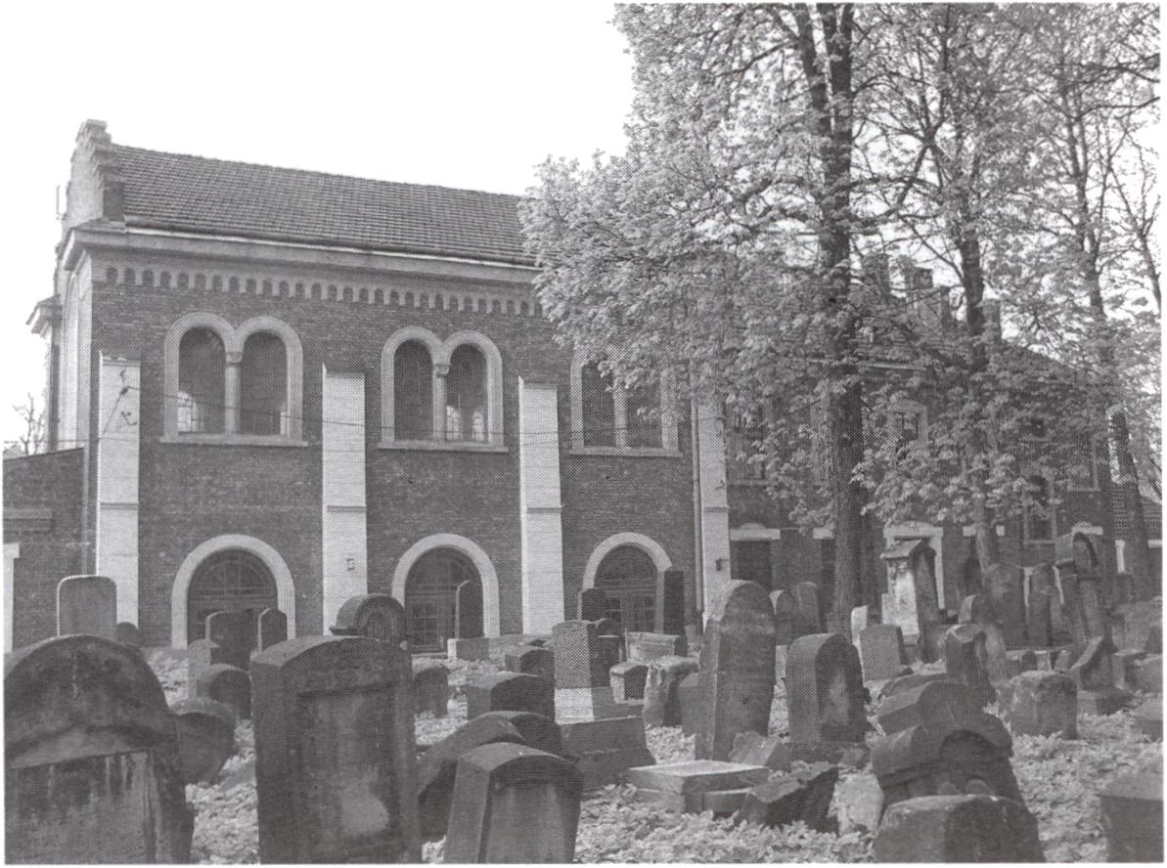
Jewish Architects in Cracow 1868-1939
45
Fig. 3. Władysław Kleinberger, tenement house at 3, Rakowiecka Street, 1899-1900,
photo. H. Dziedzic, 2005
Fig. 4. Władysław Kleinberger, mortuary of the Jewish cemetery at 55, Miodowa Street,
1902-1903, photo by M. Kurzej, 2004

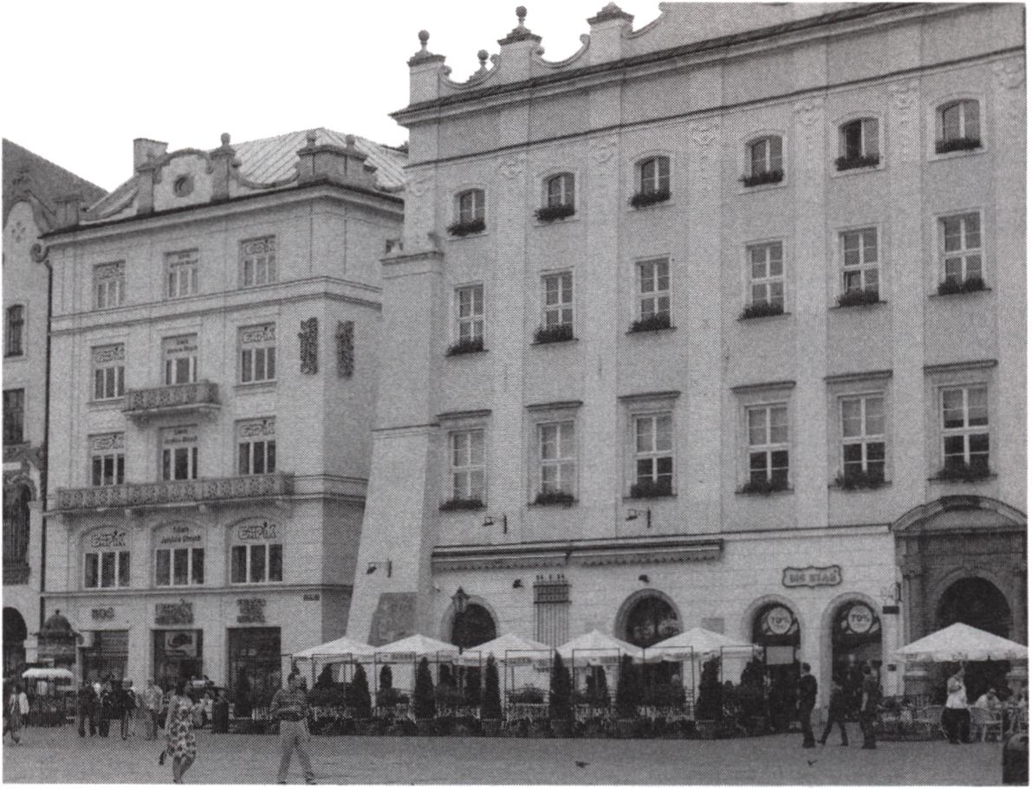
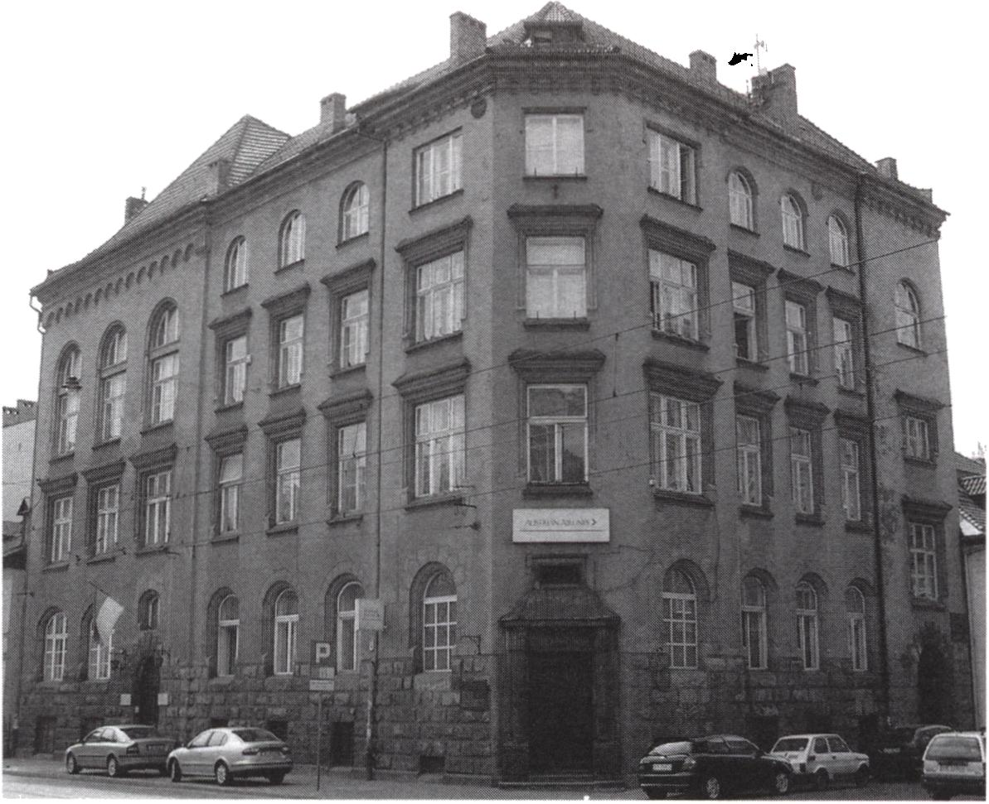
46
Barbara Zbroja
Fig. 5. Henryk Lamensdorf, tenement house at 5, Rynek Główny Square
(first of the left side), 1912-1914, photo. B. Zbroja, 2005
Fig. 6. Henryk Lamensdorf, seat of Jewish Religious Community Govermment at 41 Krakowska
Street, 1909-1911, photo. M. Kurzej, 2004

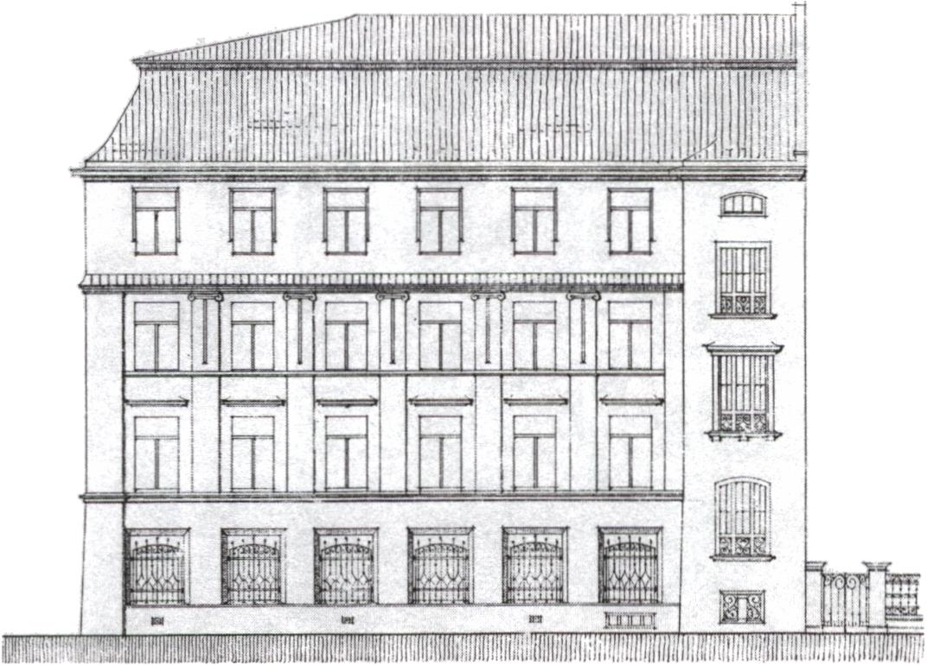
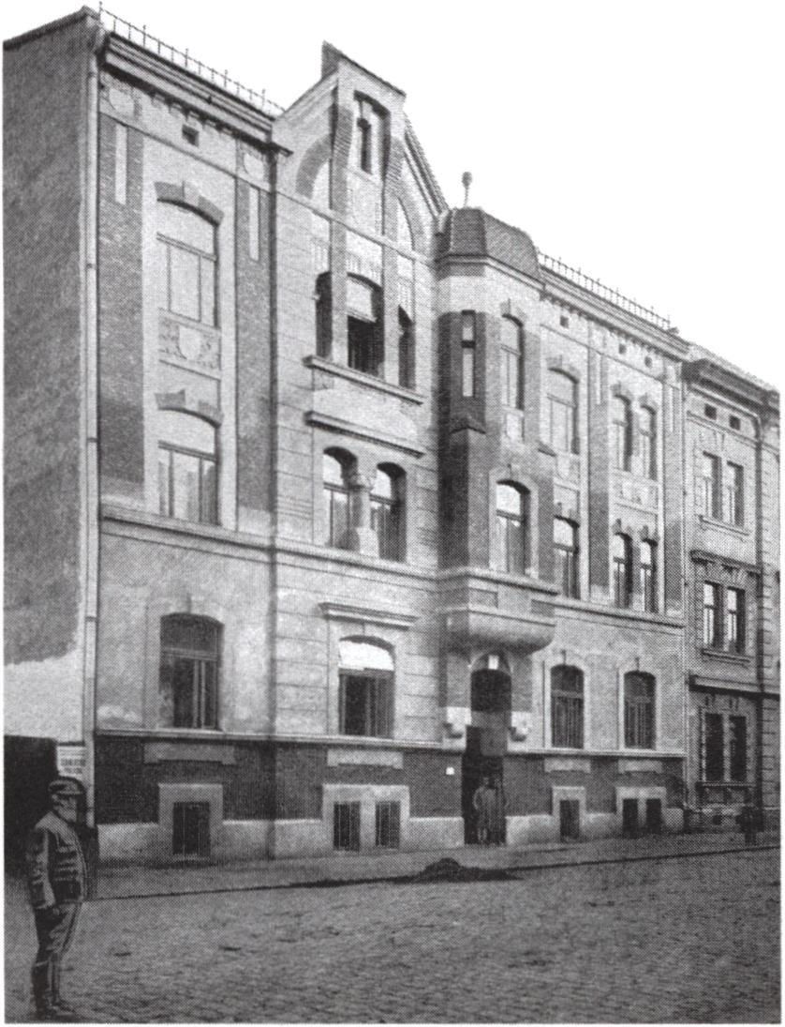
Jewish Architects in Cracow 1868-1939
47
r/ts/m/t a> ia a/s&wm
Fig. 7. Henryk Lamensdorf, design of the facade of the school building of Society of Popular and
Secondary School (Hebrew Secondary School) at 3/5, Brzozowa Street, 1914 r. AP Kr, Archiwum
Budownictwa Miejskiego (Archives of Municipal Building), later referred to as ABM,
ul. Brzozowa 3/5, fasc. 87
Fig. 8. Ferdynand Liebling, own tenement house at 32, Starowiślna Street, 1902-1903, according to
Architekt, Year 1904, table 58

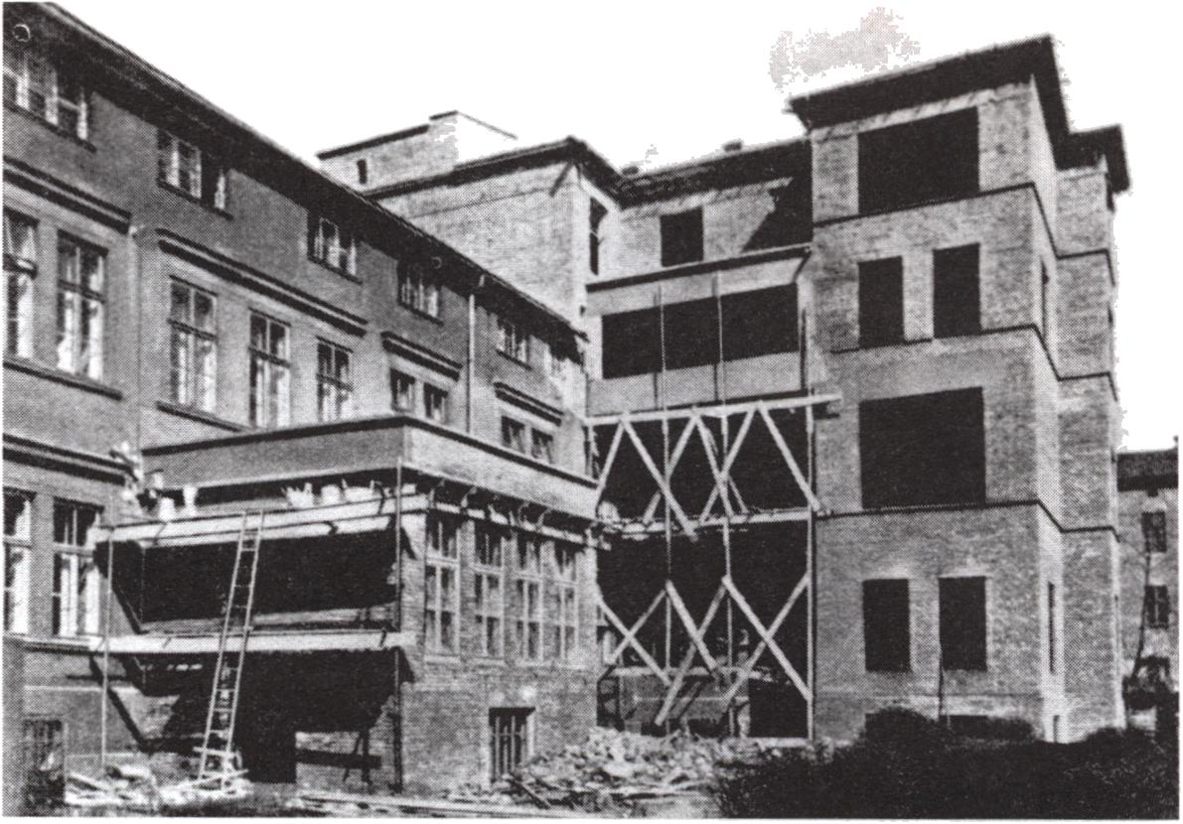
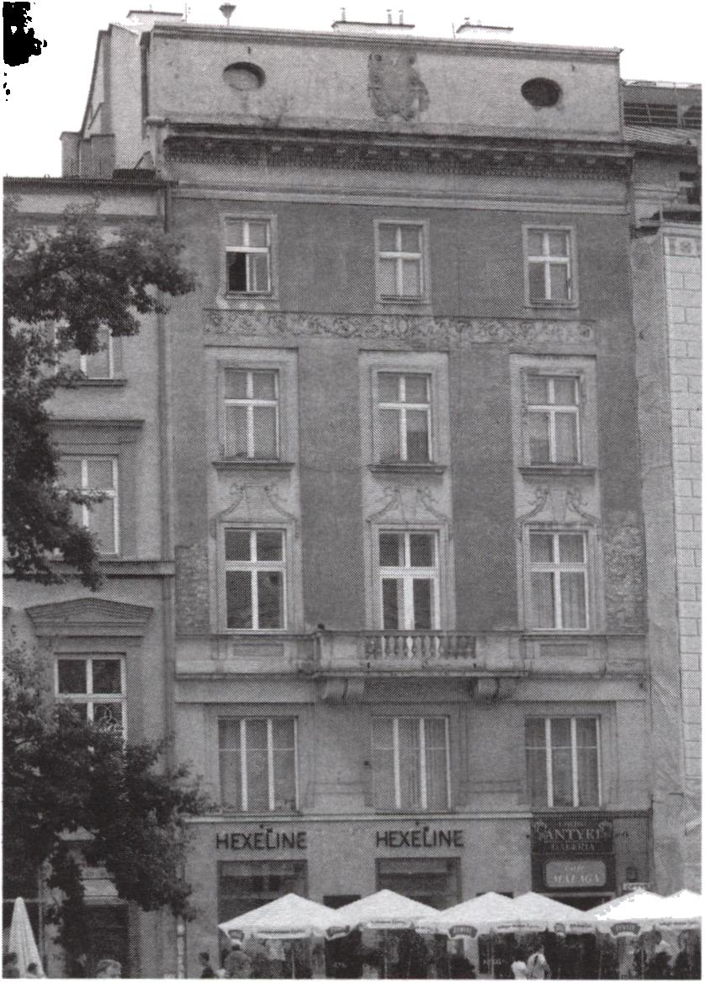
48
Barbara Zbroja
Fig. 9. Ferdynand Liebling, building of the synagogue and the new hospital wing, 1937. According to
Sprawozdanie szpitala Gminy Żydowskiej w Krakowie, za czas od 1 stycznia do 31 grudnia 1937,
Kraków 1938, p. 2, photo. M. Multarzyńska-Janikowska
Fig. 10. Adolf Siódmak, tenement house at 11, Rynek Główny Square, 1913-1917,
photo. B. Zbroja, 2005

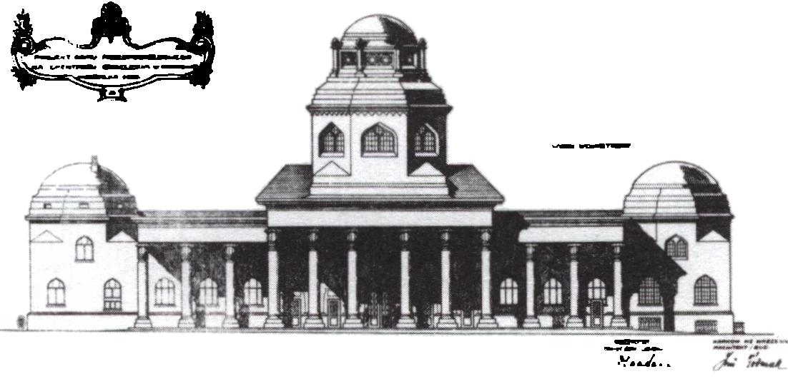
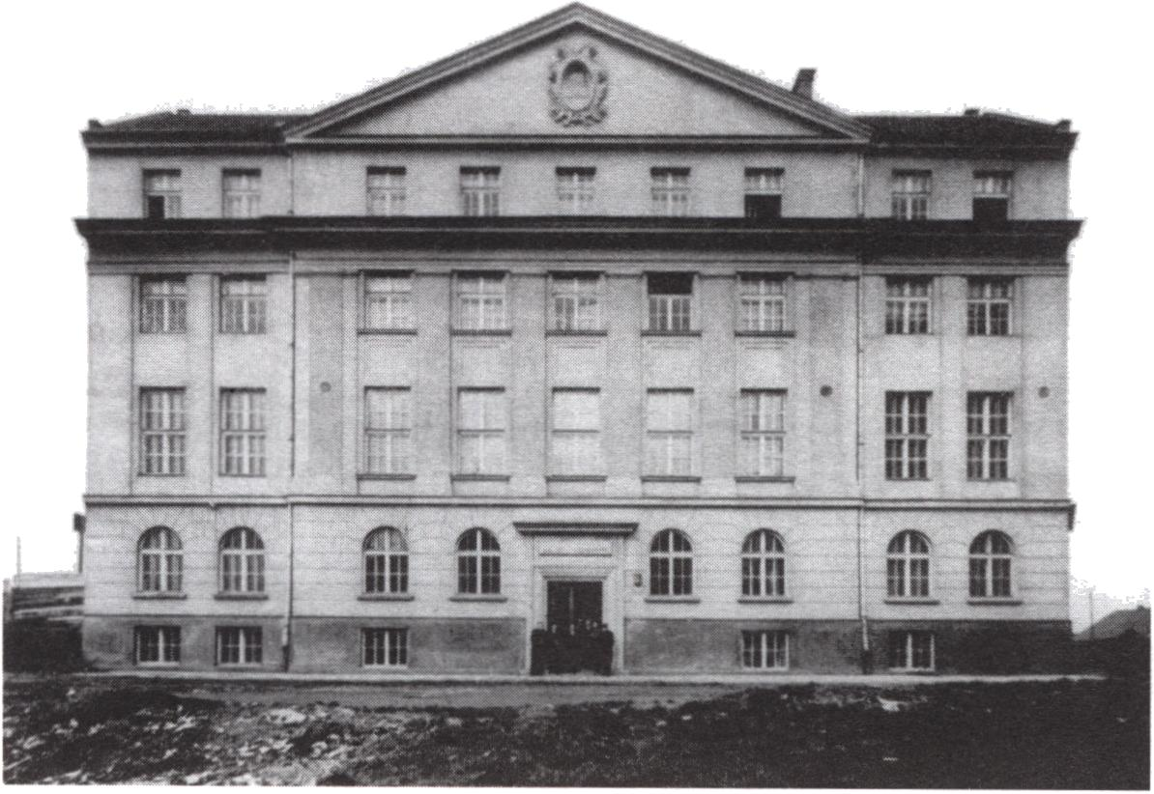
Jewish Architects in Cracow 1868-1939
49
Fig. 11. Adolf Siódmak, design for the mortuary in Jerozolimska Street; view of the elevation from
the side of the cemetery, 1922, AP Kr, ABM; ul. Jerozolimska 14, fasc. 330b,
photo. M. Multarzyńska-Janikowska
Fig. 12. Adolf Siódmak, Żydowski Dom Akademicki (Jewish Student Hostel) at 3, Przemyska Street,
1924—1928, Muzeum Historyczne Miasta Krakowa (Historical Museum of the City of Cracow),
classification no. Fs. 5909/IX

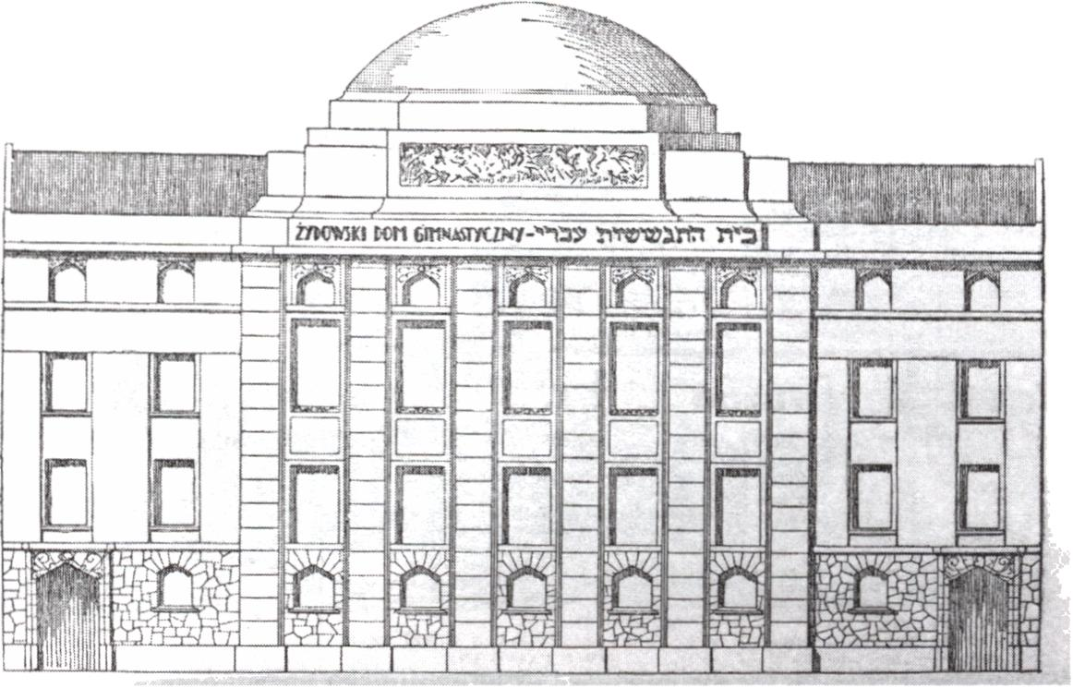
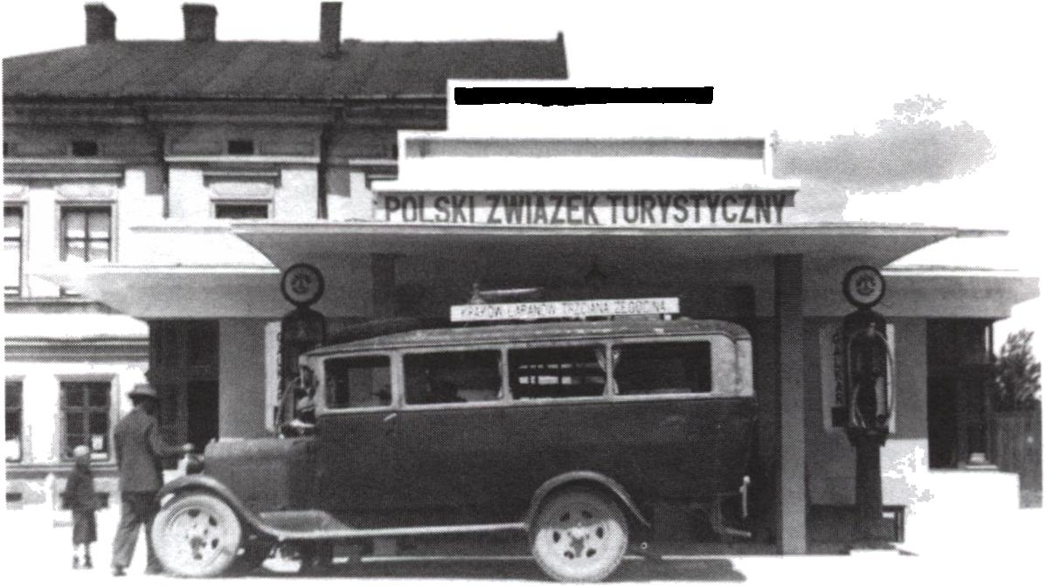
50
Barbara Zbroja
Fig. 13. Adolf Siódmak, competition design for the building ofŻydowski Dom Gimnastyczny
(Jewish Gymnastics House) at 13-15 Wietora Street, 1925, According to Nowy Dziennik,
Year 1925, no. 279, p. 7
Fig. 14. Adolf Siódmak, bus station in Bohaterów Getta Square, 1930-1931, Archiwum
Dokumentacji Mechanicznej w Warszawie (Archives of Technical Documentation in Warsaw),
classification no 1 G 3901

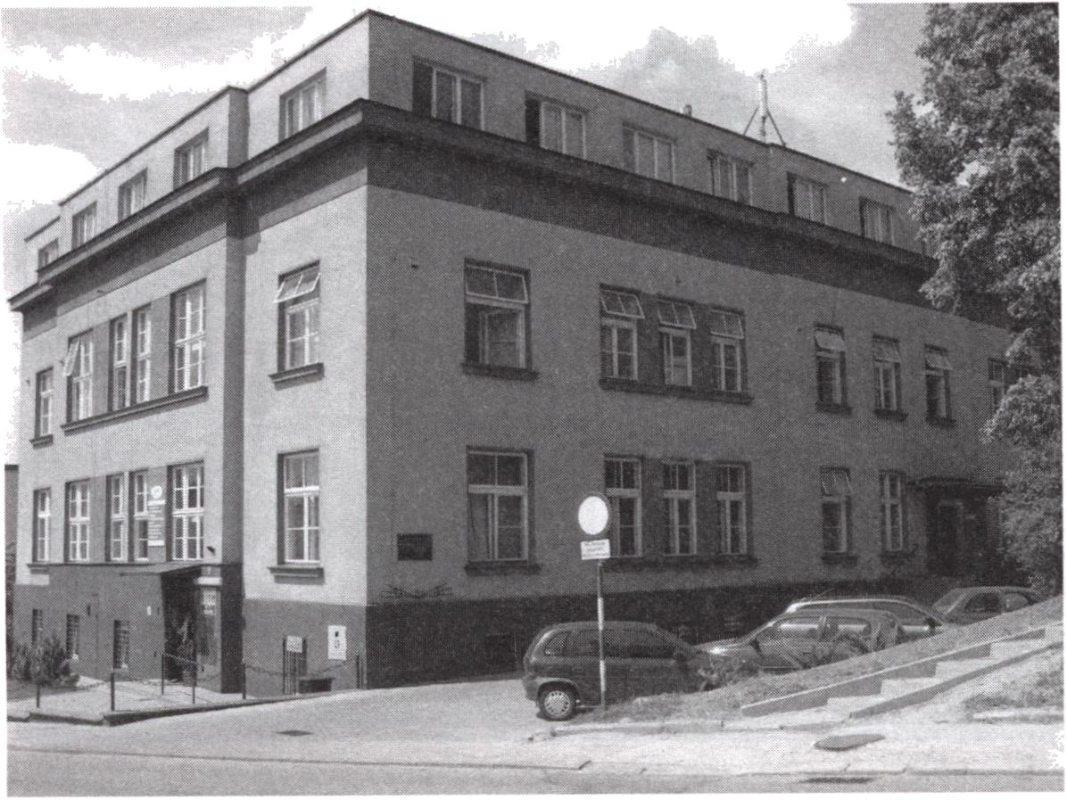
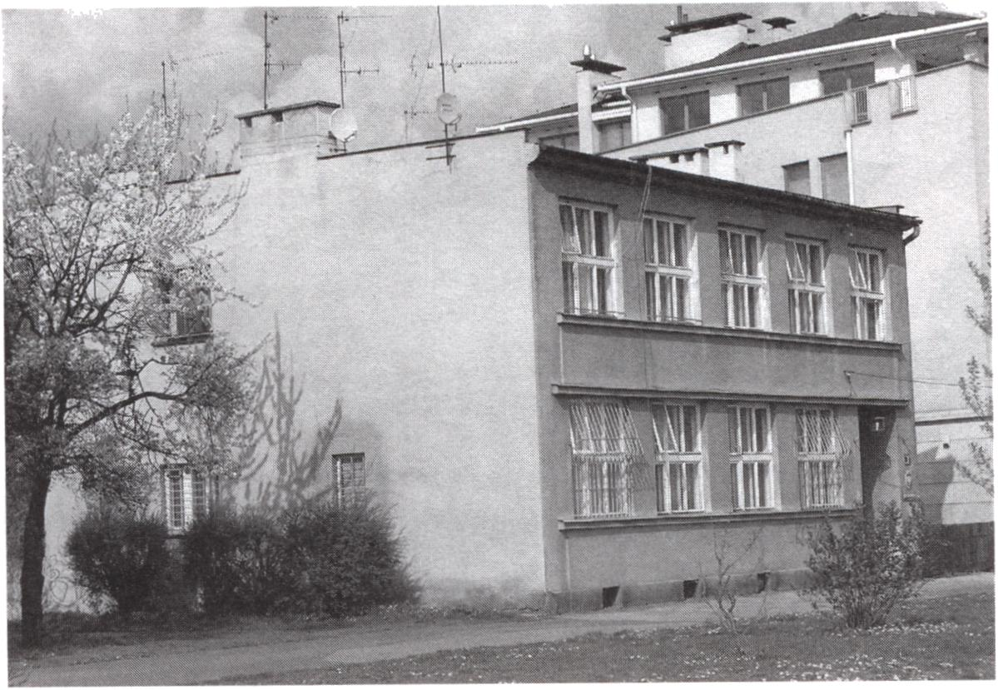
Jewish Architects in Cracow 1868-1939
51
Fig. 15. Roman Weindling, building of the former Kasa Chorych (National Health Service Union)
in Bochnia at 22, Floris Street, 1928-1935, photo. B. Zbroja, 2005
Fig. 16. Samuel Singer, former seat of “Bejt Lechem” Association at 31, Skawińska Street,
1938-1939, photo. M. Kurzej, 2004

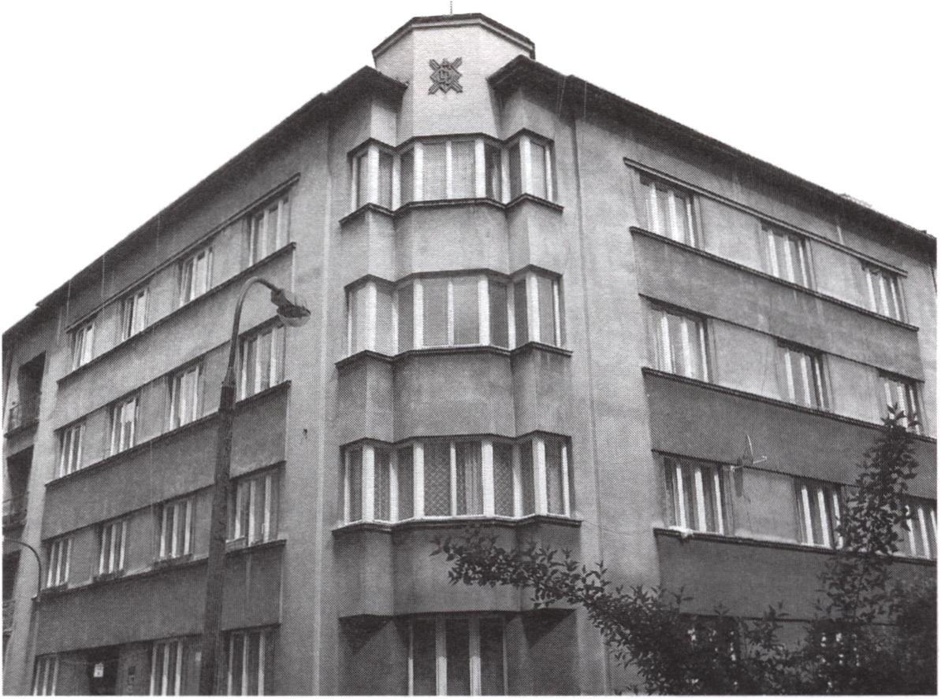
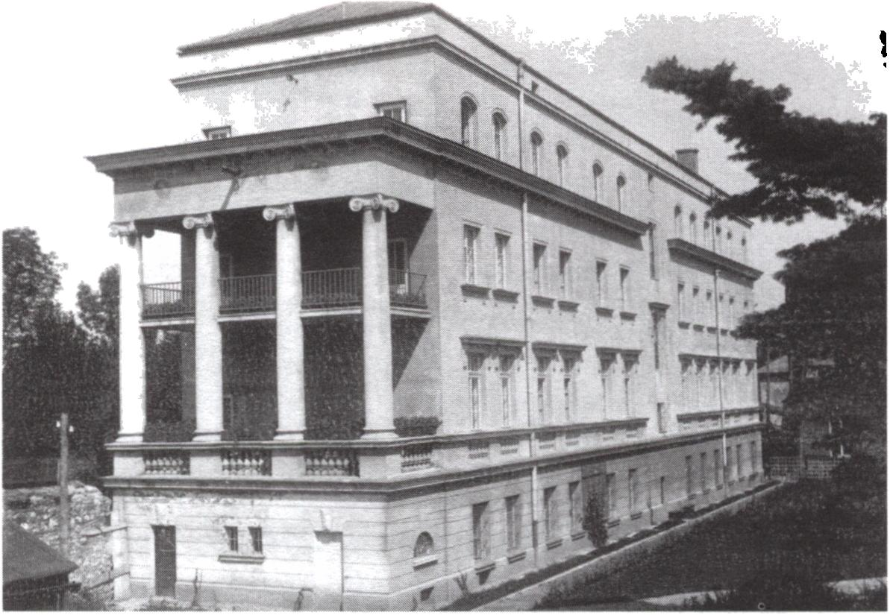
52
Barbara Zbroja
Fig. 17. Izydor Goldberger, tenement house at 17, Kolberga Street, 1936, photo. M. Kurzej, 2004
Fig. 18. Maksymilian Burstin i Jerzy Struszkiewicz, building of the Nursing School at 25, Kopernika
Street, 1923-1926, photo from M. Sosenko’s collection

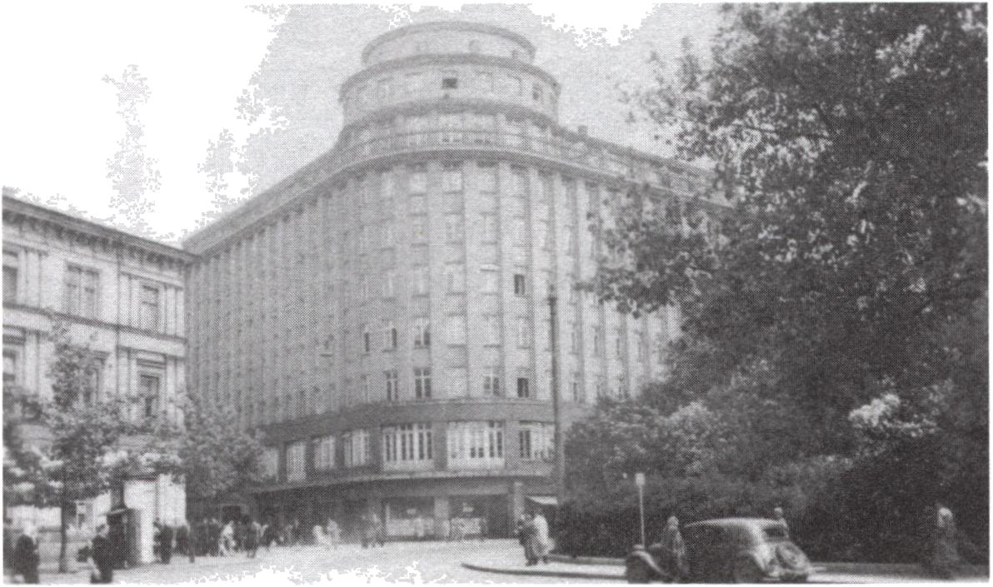
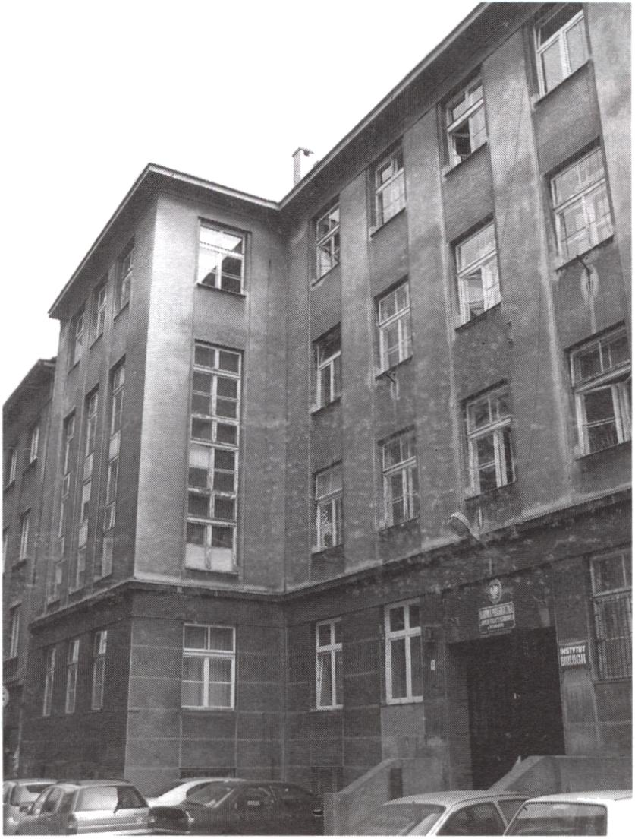
Jewish Architects in Cracow 1868-1939
53
Fig. 19. Maksymilian Burstin i Jerzy Struszkiewicz, former seat of “Feniks” Insurance Bank at 13-15
Basztowa Street, 1930-1933, postcard from B. Zbroja’s collection
Fig. 20. Henryk Jakubowicz i Saul Wexner, former Szkoła Rzemiosł Towarzystwa Szkoły Ludowej
i Średniej (School of Crafts of the Society of Popular and Secondary Schools) at 3, Podbrzezie Street,
1937-1939, photo. M. Kurzej, 2004

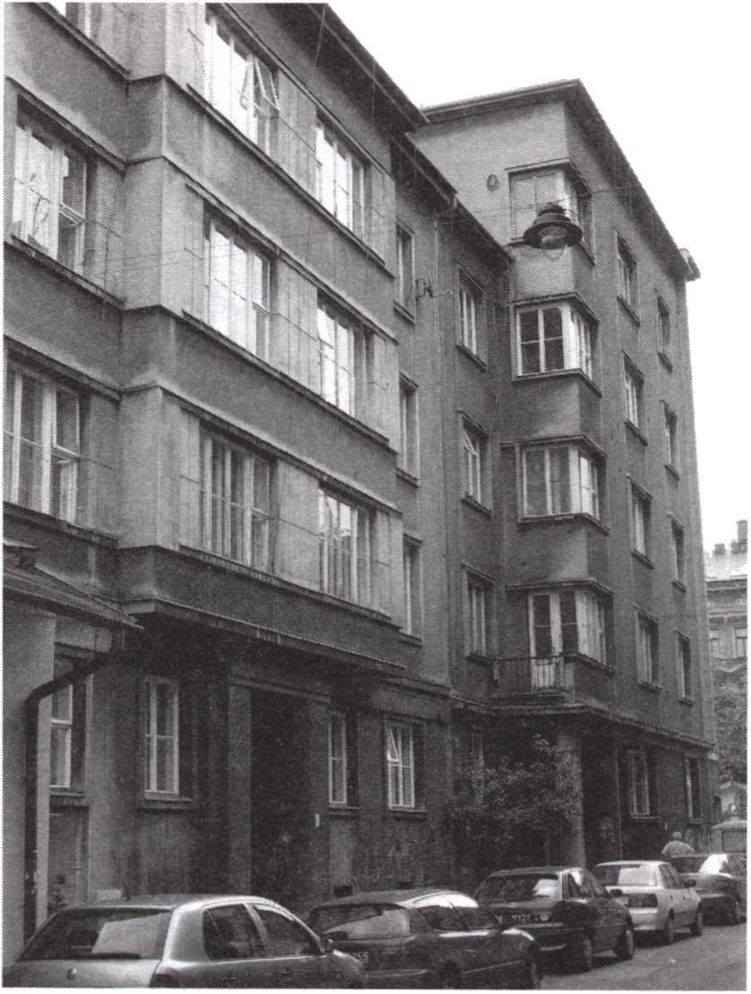
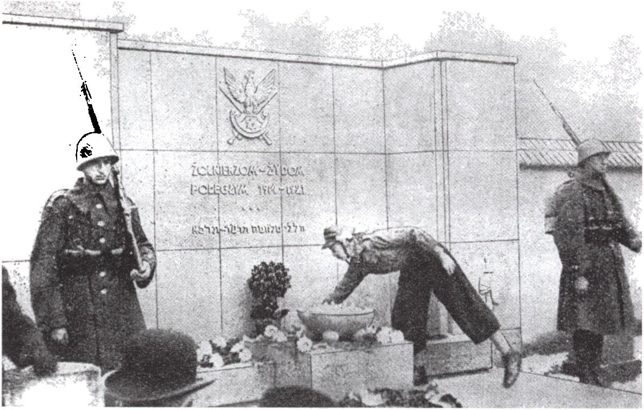
54
Barbara Zbroja
Fig. 21. Alfred Düntuch i Stefan Landsberger, tenement houses at 10, and 12, Krzywa Street,
1937-1938, photo. B. Zbroja, 2005
Fig. 22. Alfred Diintuch, Edward Kreisler, Józef Taub, non-existing monument commemorating the
Jewish soldiers who died in the years 1914-1921 at the Jewish cemetery in Miodowa Street, 1937,
according to Gazeta Gminna. Organ Urzędowy Gminy Wyznaniowej Żydowskiej w Krakowie, Year 1:
1937, no. 6, p. 6

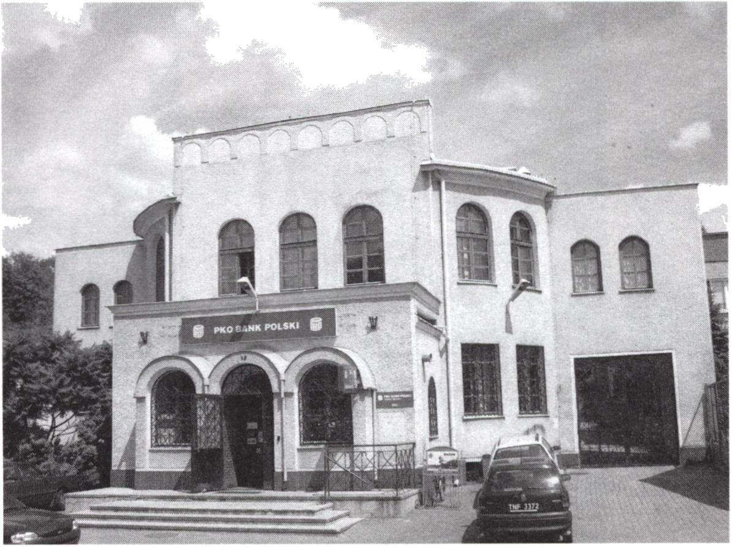
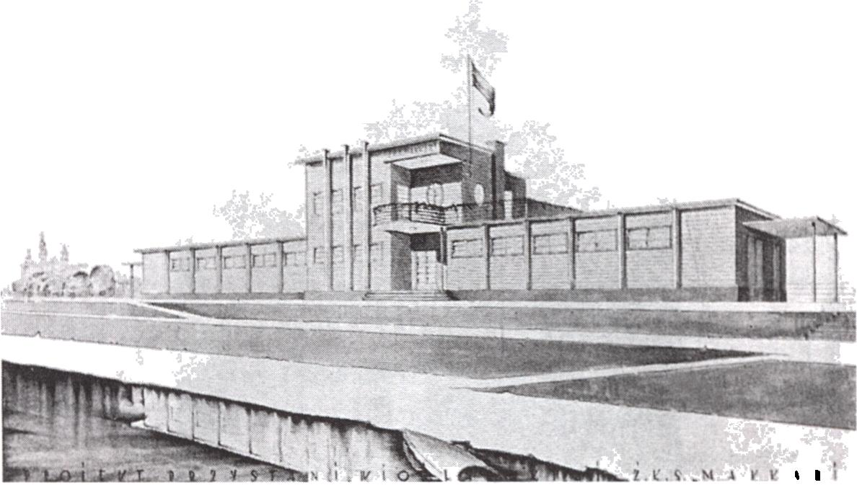
Jewish Architects in Cracow 1868-1939
55
Fig. 23. Bemard Birkenfeld, former synagogue in Bochnia, at 13, Trudna Street, 1932-1939,
photo. B. Zbroja, 2005
Fig. 24. Samuel Osiek, design for the boat-house of Żydowski Klub Sportowy (Jewish Sports Club)
“Makkabi” 1933, postcard from M. Sosenko’s collection

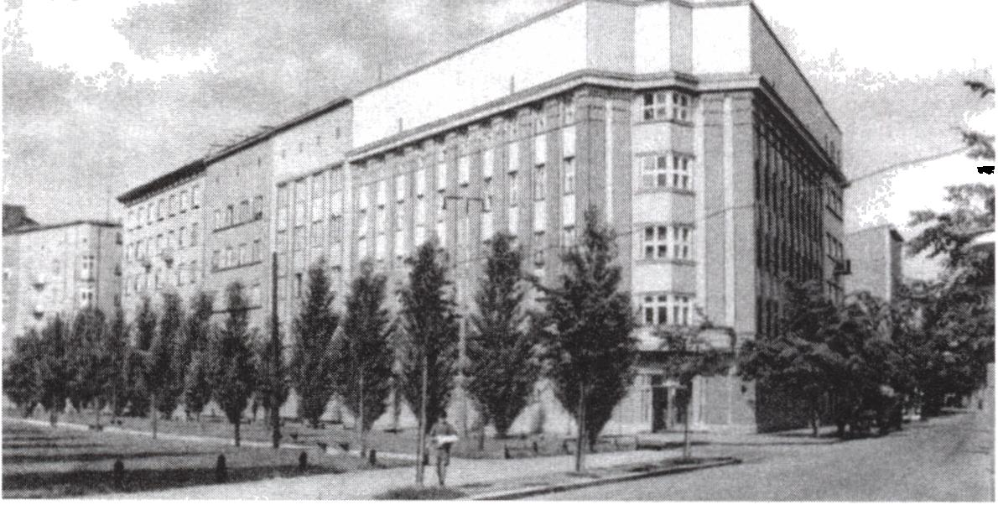
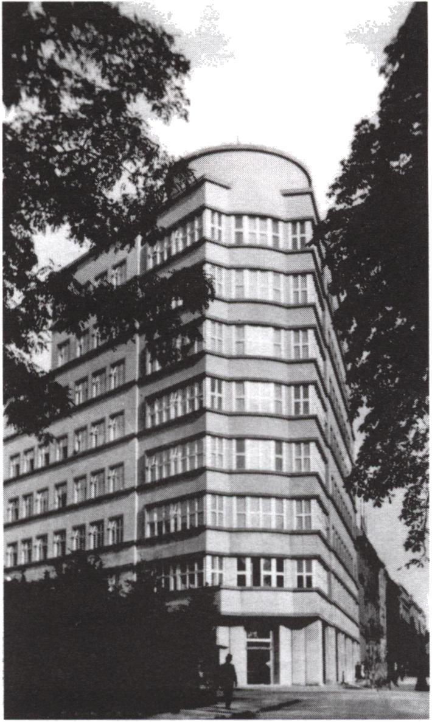
56
Barbara Zbroja

Fig. 25. Fryderyk Tadanier and Stefan Strojek, building of Wydział Powiatowy (District Departament)
at 44, Łobzowska Street, 1935-1936, postcard from B. Zbroja’s collection
Fig. 26. Fryderyk Tadanier and Stefan Strojek, former “Powiatowa Kasa Oszczędności” (Regional
Savings Bank) at 5, Szczepański Square, 1933-1936, postcard from B. Zbroja’s collection

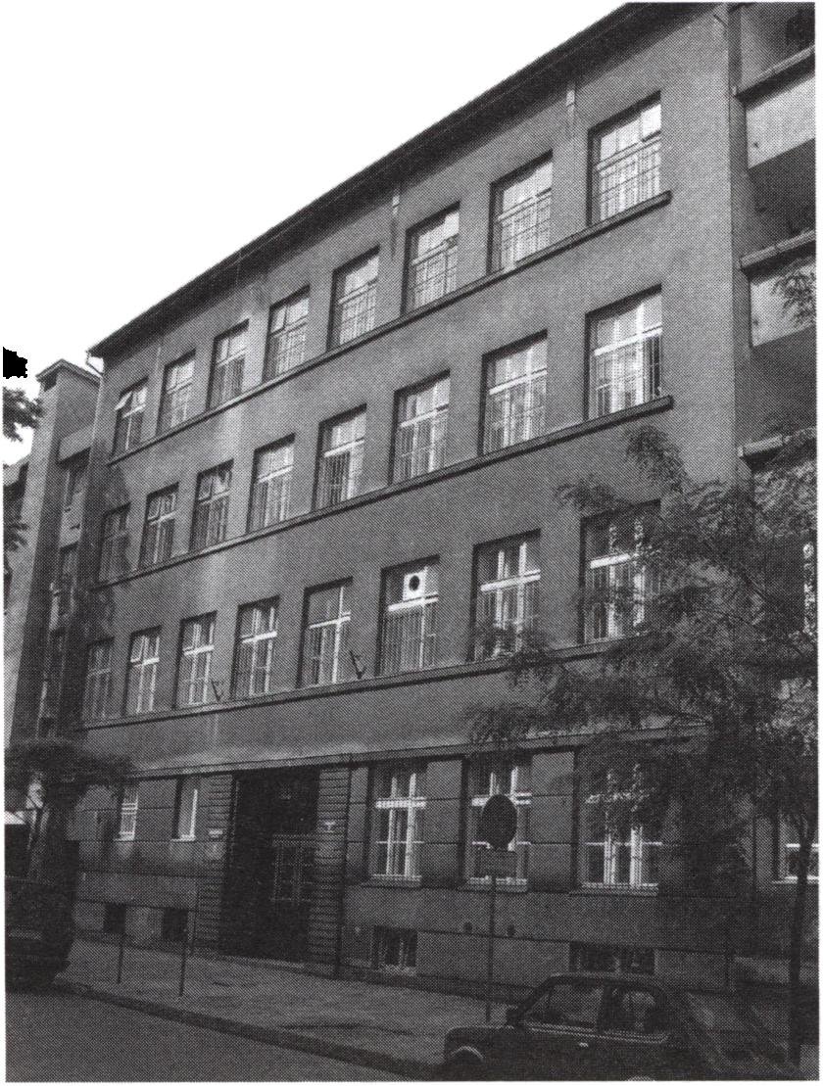
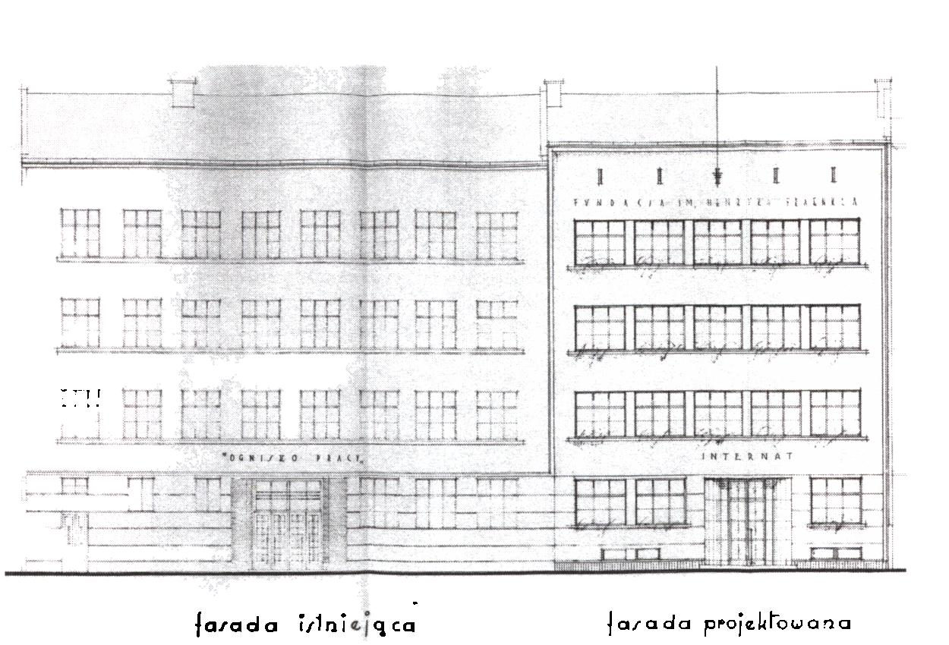
Jewish Architects in Cracow 1868-1939
57
Fig. 27. Jakub Stendig, former building of the “Ognisko Pracy” School at 7, Wietora Street,
1935-1937, photo. B. Zbroja, 2005
Fig. 28. Rela Schmeidler, design for the façade of the boarding school of “Ognisko Pracy” in Wietora
Street, 1939, AP Kr, ABM, fasc. 59

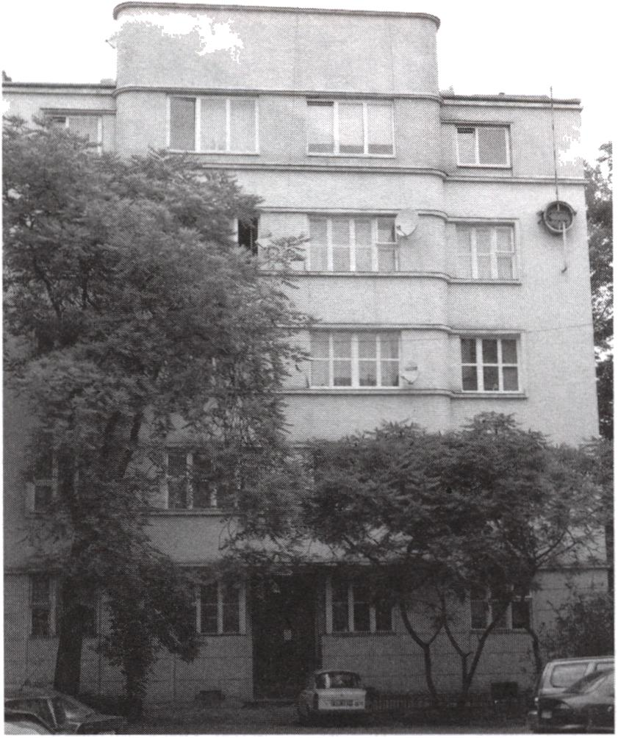
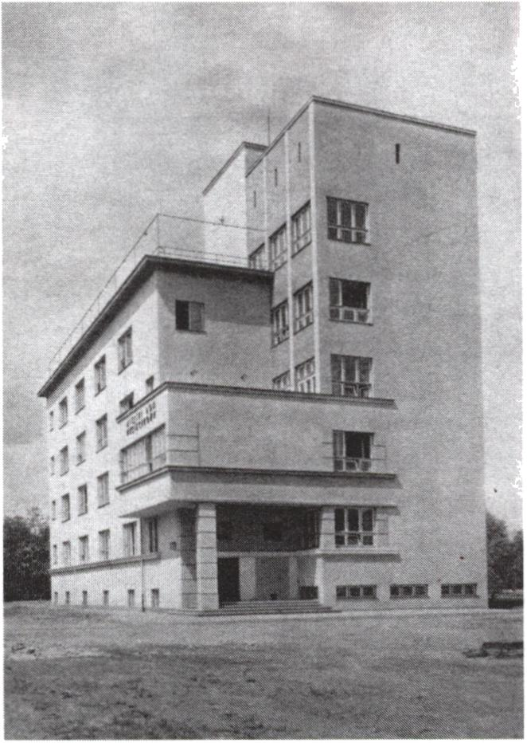
58
Barbara Zbroja
Fig. 29. Dana Reiter, tenement house at 16, Pawikowskiego Street, 1937-1939,
photo. B. Zbroja, 2005
Fig. 30. Edward Kreisler, building of Miejski Dom Wycieczkowy (Municipal Tourist Hostel) at 4,
Oleandry Street, 1929-1931, postcard from B. Zbroja’s collection

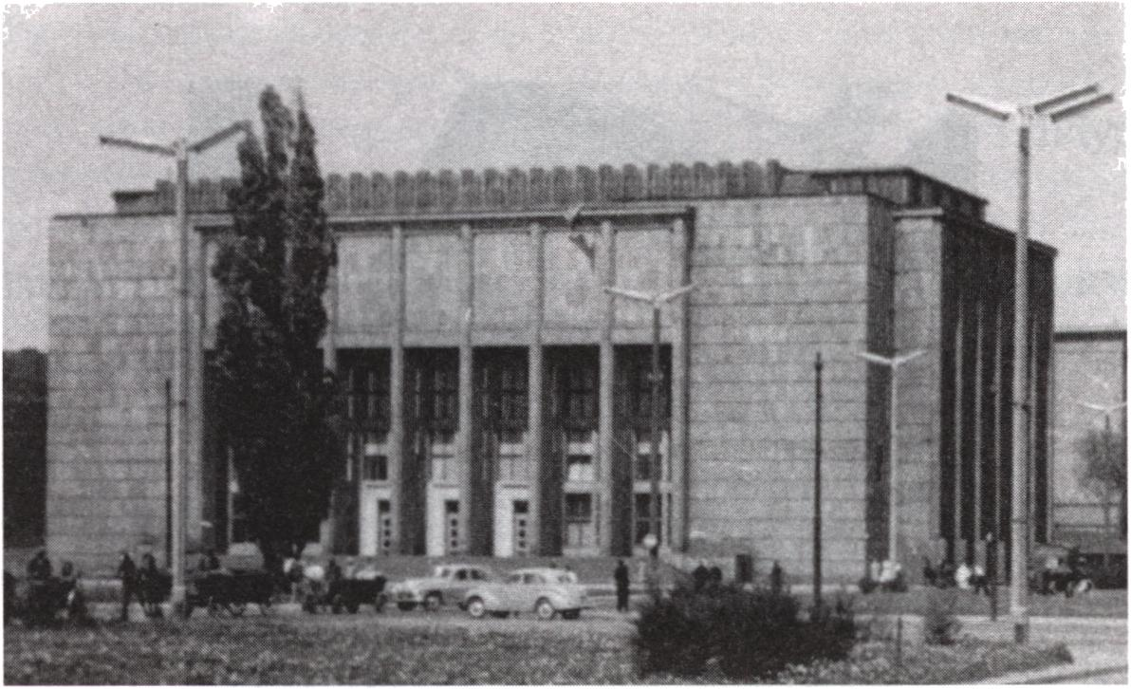
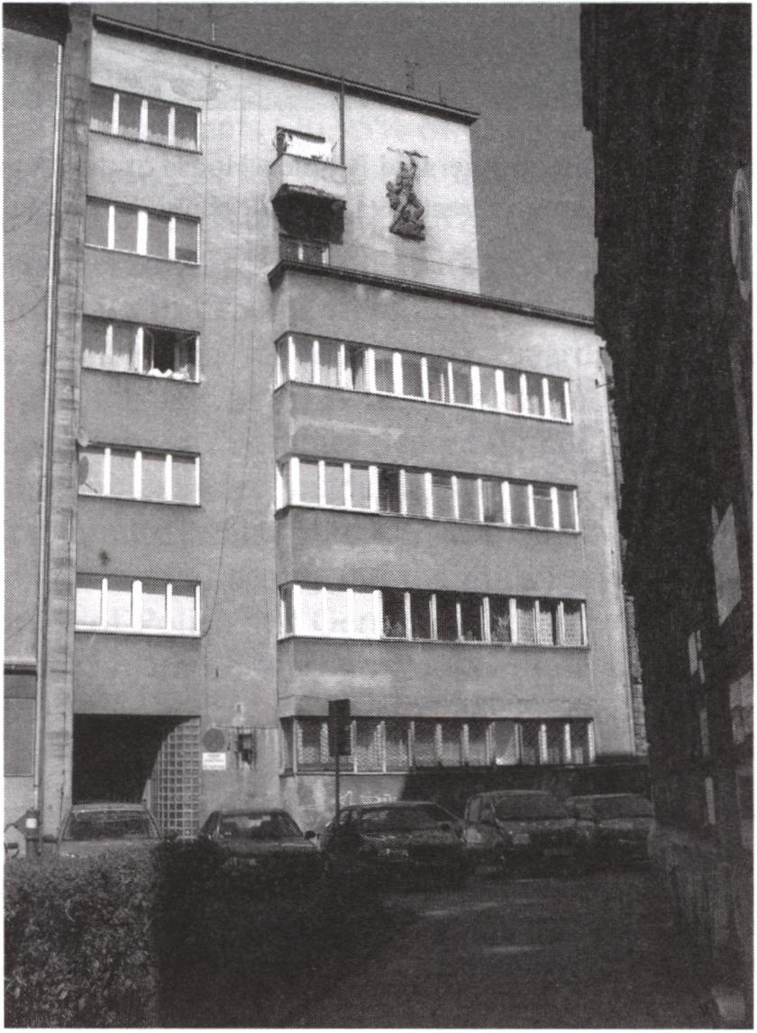
Jewish Architects in Cracow 1868-1939
59
Fig. 31. Czesław Boratyński, Edward Kreisler, Bolesław Schmidt, Edifice of Muzeum Narodowe
(National Museum) at 1, 3 Maja Street, 1933-1938, photo from M. Sosenko’s collection
Fig. 32. Edward Kreisler, Jakub Spira, tcnement house at 13, Lenartowicza Strcet, 1938-1940, photo.
H. Dziedzic, 2005

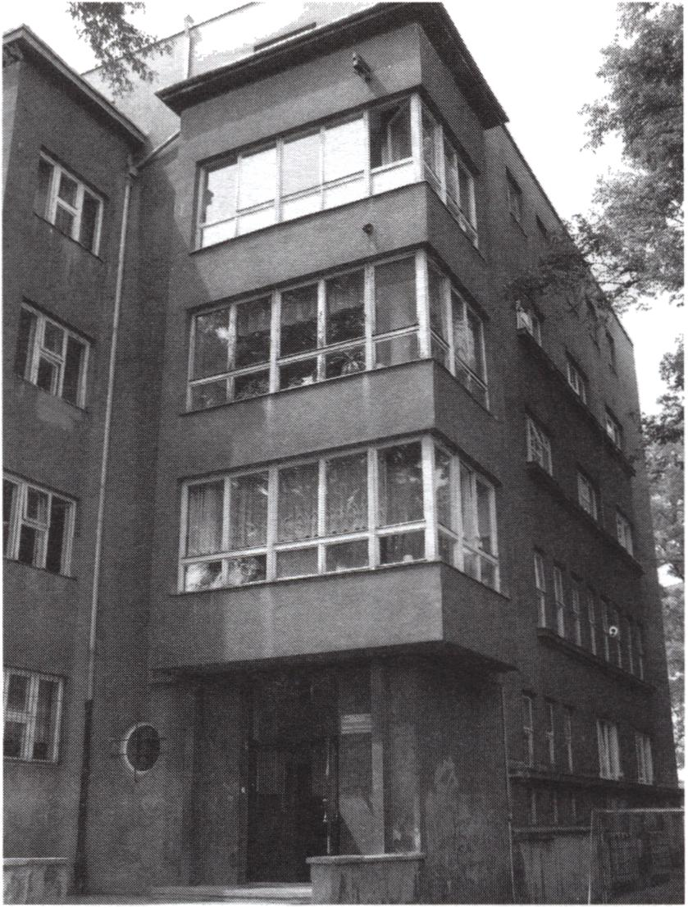
60
Barbara Zbroja
Fig. 33. Edward Kreisler, Jakub Spira, former Old People’s House of the “Asifat Skenim” Association
at 6, Chmielowskiego Street, 1937-1940, photo. B. Zbroja, 2005

