Acta Geologica Polonica, Vol. 61 (2011), No. 4, pp. 341-365

Ascending speleogenesis of Sokola Hill: a step towards
a speleogenetic model of the Polish Jura
MICHAŁ GRADZIŃSKP, HELENA HERCMAN², DITTA KICIŃSKA³, DOMINIK PURA¹-⁴
AND J AN URB AN⁵
¹ Institute of Geological Sciences, Jagiellonian University. Oleandry 2a, 30-063 Krakow\ Poland.
E-mail: michal.gradzinski@uj.edu.pl
- Institute of Geological Sciences, Polish Academy of Sciences, Twarda 51/55: 00-818 Warszawa, Poland.
E-mail: hhercman@twarda.pan.pl
- Ditto Kicińska. Institute of Geology. Adam Mickiewicz University, Maków: Polnych 16. Poznan. Poland.
E-mail: kicinska@amu. edu.pl
⁴present address - GEOPARTNER Sp. z o.o.: Skośna 39 B. 30-383 Kraków\ Poland.
E-mail: dominik.pura@geopartner.pl
⁵ Institute of Nature Conservation. Polish Academy of Sciences, Aleja Mickiewicza 33, 31-120 Kraków>,
Poland. E-mail: urhan@iop.krakow.pl
ABSTRACT:
Gradziński, M., Hercman, H,, Kicińska, D., Pura, D., Urban, J. 2011. Ascending speleogenesis of Sokola Hill:
a step towards a speleogenetic model of the Polish Jura. Acta Geologica Polonica, 61 (4), 341-365. Warszawa.
The paper deals with the origin of caves in Sokola Hill (Polish Jura). The caves abound ill solution cavities hi the
walls and ceilings, many of them arranged hierarchically, some others arranged in rising sets. Blind chimneys and
ceiling half-tubes are also present. These features collectively indicate that the caves originated under plireatic con-
ditions by an ascending flow of water, probably of elevated temperature. Plireatic calcite spar, crystallized from wa-
ter of elevated temperature, lines the cave walls. During the formation of die caves the Jurassic limestone aquifer
was confined by impermeable cover. Three possible scenarios for the origin of the caves are suggested. The first sce-
nario points to formation of the caves during the Palaeogene prior to the removal of the confining Cretaceous marls.
The second connects the origin of the caves with regional palaeoflow driven by tectonic loading by Carpathian nappes
to the south, while die diird refers to local topographically driven palaeoflow. Bodi die second and diird scenarios
assume diat die Polish Jura had a cover of Miocene impermeable elastics. All die scenarios account for die origin of
die caves in Sokola Hill and explain die common occurrence of ascending caves throughout die Polish Jura.
hi die subsequent stages of evolution die caves were partly filled widi various deposits. Conglomerates composed
of Jurassic limestone clasts, quartz sands and sandstones are preserved as erosional remnants, locally covered by or
interfmgered widi calcite flowstones. The clastic deposits were laid down by surface streams diat invaded die caves
earlier dian 1.2 Ma. The caves were not invaded by water from Pleistocene glaciers, which is proved by die assem-
blage of heavy minerals in die cave elastics.
Keywords: Hypogenic caves; Palaeohydrology; Carpathian foreland; Cenozoic; Poland.
INTRODUCTION
Karst features genetically connected with basal in-
put of water have attracted increasing interest in recent
years. The term hypogenic cave has been coined to de-
scribe a cave that originated by ascending circulation of
water. Klimchouk (2007,2009) stresses mainly the hy-
drogeological conditions, and uses this term to any
342
MICHAŁ GRADZIŃSKI ET AL.
cave formed by ascending circulation of water in a
confined setting. Conversely, Ford and Williams (2007,
p. 240-246) and Palmer (2007, p. 209-226) regard as
hypogean or hypogenic caves only those created by wa-
ter of unusual chemistry and elevated temperature, re-
sulting in increased aggressiveness of water towards
carbonate bedrock. They also point to the importance
of mixing of deep and shallow waters for the formation
of hypogenic caves. Flypogenic caves are always con-
nected with upward migration of water and are hence
referred to herein as ascending caves.
One of the first interpretations ascribing an ascend-
ing origin to inactive caves was that by Rudnicki (1978),
concerning Berkowa Cave (Polish: Jaskinia Berkowa),
a small cave in the Polish Jura. Caves formed by as-
cending warm water were recognized in the vicinity of
Budapest, where artesian circulation of thermal water is
still manifested in moderately warm springs (Muller
1989; Dublyansky 1995 and references quoted therein).
The origin of great caves in the Guadelupe Mountains
(New Mexico, USA), including Carlsbad Caverns and
Lechuguilla Cave, is convincingly explained by up-
ward migration of water charged with C0₂ and H₂S
(Hill 2000). An ascending origin is also ascribed to the
giant caves in the Black Hills (Dakota, USA; see dis-
cussion in Palmei' and Palmer 2000). Arecent review by
Klimchouk (2007) provides examples of such caves
from all continents except Antarctica.
Proper identification of inactive artesian caves en-
counters some difficulties since many caves are now lo-
cated in hydrological settings different from those
which prevailed during their formation. Moreover, no
single criterion allows for unequivocal distinction of an
ascending cave from other cave types. Klimchouk
(2007,2009) lists a set of morphological features which
can indicate an ascending origin of a particular cave.
Development of ascending caves is intimately con-
nected with the presence of confined conditions. Thus,
a proper recognition of inactive ascending caves sheds
some light on the palaeohydrological conditions and
may in some cases help to unravel the geological his-
tory of a given karst region.
After the seminal paper by Rudnicki (1978), some
authors have suggested an ascending origin of selected
caves in the Polish Jura (Głazek and Szynkiewicz 1980;
Pulina et al. 2005; Pura et ah 2005; Gradziński et al.
2009; Tyc 2009a, b). Relics of former ascending caves
have also been recognized in the surface relief of lime-
stone crags (Tyc 2009a, b). However, no concise ge-
netic model has been hitherto presented that would ex-
plain the formation of ascending caves in the Polish
Jura in the context of a broad geological, palaeohydro-
logical and tectonic setting. The case of Smocza Jama
(Gradziński et al. 2009) is not typical because the cave
is situated in a local isolated horst. A general model may
be elaborated only when other regional examples are
documented and interpreted.
In this paper we present evidence for an ascending
origin of caves in Sokola Hill, where some of the most
spacious caves of the Polish Jura are located, and we try
to reconstruct the palaeohydrological conditions of
their formation. We also present and discuss hypothe-
ses on their origin in the wider context of the geologi-
cal history of the Polish Jura during the Cenozoic.
GEOLOGICAL AND SPELEOLOGICAL SETTING
Sokola Hill (Polish: Góra Sokola), with an altitude
of 378 m, is located on the Kraków-Wieluń Upland, the
region called the Polish Jura in some geological papers
(Text-fig. 1). The hill belongs to a small hill chain
called the Sokole Hills (Polish: Góry Sokole), stretch-
ing from west to east. They are composed of Upper
Jurassic limestone, exposed in picturesque crags up to
20 m high on their tops and flanks. The hills stand up
to 70 m over the surrounding plains covered with Pleis-
tocene sands. Sokola Hill hosts sixteen caves, includ-
ing Pod Sokolą Górą Cave and Studnisko Cave, both of
which are famous for underground chambers that are
exceptionally spacious for this region (Szelerewicz and
Górny 1986; Urban and Gradziński 2004; Jerzy Zyg-
munt, personal information, 2005).
The picturesque hills in the Polish Jura, including
Sokola Hill, are built of Upper Jurassic microbial-
spongy limestone which also contains brachiopods,
serpulids, bryozoans, peloids and carbonate mud. A
sponge assemblage in the neighbouring Kielniki quarry,
studied by Trammer (1989), is dominated by
Hyalospongea. The limestone is massive, locally thick-
bedded, and represents carbonate buildup deposits. The
poorly exposed bedded facies, represents flank de-
posits of the buildups.
The precise age of the Upper Jurassic limestone in
Sokola Hill is not known. According to Matyja and
Wierzbowski (1992) the hills near Olsztyn, located
nearby, are built of limestone belonging to the Bifur-
catus and Bimammatum Zones. This age is also pos-
tulated for limestone in the neighbouring Kielniki
quarry' (Trammer 1989). Borehole data suggest that
the base of the Upper Jurassic limestone in Sokola Hill
area is located below 250 m a.s.l. (Heliasz et al. 1982).
The Jurassic limestone of Sokola Hill is underlain
by various Lower Oxfordian and Middle Jurassic de-
posits. The Lower Oxfordian is represented by marl-
stone, marl and microbial-spongy limestone, whereas
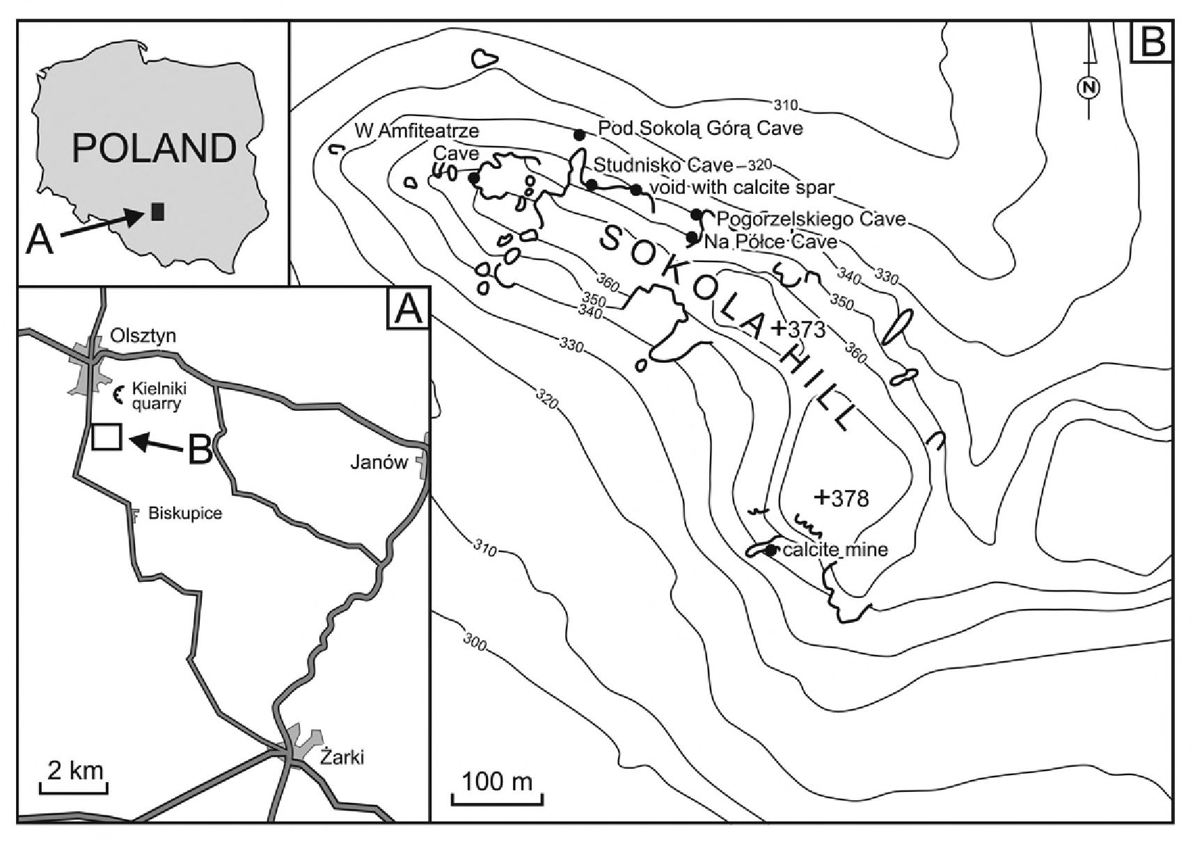
SPELEOGENETIC MODEL OF THE POLISH JURA
343
Text-fig. 1. Location of the caves studied
the Middle Jurassic is composed of sandstone, lime-
stone with various admixtures of siliciclastic material,
sandy clay and clay (Heliasz et al. 1987). The total
thickness of the Oxfordian deposits reaches 300 m.
They dip northeast at an average angle of 2-4°.
Patches of siliciclastic and mixed siliciclastic-car-
bonate Cretaceous deposits, Albian to Turonian in age,
are preserved above the Jurassic limestone, ca 10 km
northeast of Sokola Hill (see Marcinowski 1970). Cre-
taceous deposits formerly covered the whole area of the
Polish Jura, with the upper Upper Cretaceous (‘Senon-
ian’) marly deposits being several hundred metres
thick. The Cretaceous deposits were subsequently
eroded during the long-lasting Palaeogene planation of
the Polish Jura (Klimaszewski 1958), which took place
after the Laramide tilting. The weathered Cretaceous
deposits were the source of material for the so-called
moulding sands which are locally preserved in karst de-
pressions (Gradziński 1977). A more complete se-
quence of Cretaceous deposits still overlying the Upper
Jurassic limestones is preserved, among other areas, in
the neighbouring Nida Basin (Niecka Nidziańska), east
of the Polish Jura (Walaszczyk 1992).
Sokola Hill is bordered by two SSW-NNE-trend-
ing faults, the precise age of which is not known.
Gradziński (1977) assumed that they were post-Palaeo-
gene and postdated deposition of the ‘moulding sands’,
whereas Heliasz et al. (1987) considered that they were
of Miocene age.
The limestone elevation of Sokola Hill is surrounded
by non-cemented Pleistocene elastics, mostly of
glaciofluvial origin. They were probably laid down din-
ing the Odra (Saalian I) glaciation, when the ice-sheet
reached nearly as far as the town of Olsztyn, and stopped
north of Sokola Hill (Klimek 1966; Heliasz et al. 1982;
Lewandowski 1994,2009). However, some of these de-
posits may also be related to an older glaciation, namely
Sanian-2 (Elsterian-2), when ice-sheet lobes engulfed the
Polish Jura, but did not cover it (cf. Różycki 1960).
There are sixteen caves in Sokola Hill (Urban and
Gradziński 2004; Jerzy Zygmunt, personal information,
2006; Pura 2007). The majority of them are short and
do not exceed 10 m in length. Basic morphometric
data and major characteristics of the selected caves are
listed in Table 1. Two caves are definitely outstanding:
Pod Sokolą Górą and Studnisko caves with lengths of
70 m and 337 m respectively. Both caves consist of
chambers which are among the most spacious in the
Polish Jura. All the caves in Sokola Hill lie now in the
vadose zone; they lack any underground watercourses.
Only the lowermost parts of the Studnisko Cave, situ-
ated 77 m below the cave entrance, are located within
the epiphreatic zone. They are periodically filled with
stagnant water, probably due to fluctuations of the wa-

Cave | Entrance  location | Entrance  altitude | Length | Vertical  extent | Forms of cave  relief | Clastic deposits | Carbonate  deposits
W Amfiteatrze | N50°43.728’  E19°16.154’ | 355 m | 12 m | 6 m | solution cavities,  ceiling half-tube |  | calcite spar,  flowstones
Pod Sokolą Górą | N50°43.739’  E19°16.244’ | 330 m | 70 m | 26 m | solution cavities,  blind chimneys | loose sands,  limestone debris | flowstones
Studnisko | N50°43.735’  E19°16.257’ | 346 m | 337 m | -80 m | solution cavities,  blind chimneys | loose sands,  sandstones, sand  concretions,  conglomerates,  limestone debris | calcite spar,  flowstones,  stalagmites,  stalactites
void filled with  calcite spar | N50°43.729  E 19°16.291 | 339 m |  |  |  |  | calcite spar
Pogorzelskiego | N50°43.704’  E19°16.415’ | 340 m | 8m | 0m | solution cavities,  wall notch | loose sands,  sandstones | calcite spar,  flowstones
Na Półce | N50°43.696’  E19°16.417’ | 350 m | 33 m | 10m |  |  | calcite spar,  flowstones
calcite mine | N50°43.502’  E19°16.44U | 350 m | 6 m | 5 m |  |  | calcite spar
Table 1. Major characteristics of the studied caves, the presence of modem soil in the entrance zones is omitted, the morphometric data of caves after unpublished
data of Jerzy Zygmunt
ter table. The caves are thus completely disconnected
from the modem karst drainage system and represent a
subterranean relict karst (sensu Bosak et al. 1989).
Skalski and Wójcik (1968) have noted that the
caves in the Sokole Hills form two distinct levels de-
veloped before the Pleistocene glaciations, but proba-
bly still in Pleistocene time. In their opinion, the caves
were later invaded by glacial meltwater, which remod-
elled the caves and laid down internal clastic deposits.
Conversely, Głazek and Szynkiewicz (1980) suggested
that the spacious caves in the Sokole Hills were formed
as resurgence caves in Eocene-Early Oligocene times.
METHODS AND MATERIALS
The studies of the spatial pattern of the caves and
their rocky relief were conducted in six selected caves.
The authors used published maps of the caves (Szele-
rewicz and Górny 1986) and unpublished documenta-
tion by Jerzy Zygmunt. Relief of cave walls and ceil-
ings was documented in the field by careful measure-
ments of a series of cross-sections with fibreglass tape
and a geological compass with a clinometer. Internal
deposits in the caves were sampled. Sampling was lim-
ited to a minimum due to cave protection.
For measurements of the carbon and oxygen stable
isotope ratios of the carbonates, samples of ca 10 mg
weight were taken with a Dremel drilling machine.
The measurements of carbonate 5^{U}C and 8¹⁸0 were
conducted with a mass spectrometer SUMY at the In-
stitute of Geological Sciences, Academy of Sciences of
Belarus in Minsk. The isotope ratios were measured in
carbon dioxide obtained by reaction of the analysed
samples with 100% orthophosphoric acid. Carbon diox-
ide was subsequently trapped in liquid nitrogen and pu-
rified in vacuum. The analyt ical error for single meas-
urements is ± 0.2 %o.
All U-series analyses were performed at the Qua-
ternary Geochronology Laboratory at the Institute of
Geological Sciences, Polish Academy of Sciences.
Samples containing 10-25 g of clean, compact calcite
with no visible traces of detrital admixtures were an-
alyzed by the standard chemical procedure for the
separation of uranium and thorium from carbonate
samples (Ivanovich and Harmon 1992). A^{22s}Th-²³²U
mixture (UDP10030 tracer solution by Isotrac, AEA
Technology) was used to check the efficiency of the
chemical procedure. Uranium and Th were separated
by ion exchange using DOWEX 1x8 resin. After final
purification, U and Th were electro-deposited on steel
disks. Energetic spectra of alpha particles were col-
lected using an OCTETE PC spectrometer made by
EG&G ORTEC. Spectra analyses and age calcula-
tions were conducted using “URANOTHOR 2.6” soft-
ware, which is a standard software developed in the
Quaternary Geochronology Laboratory' at the Insti-
tute of Geological Sciences, Polish Academy of Sci-
ences (Gorka and Hercman 2002). Each spectrum was
corrected for background and delay' since chemical
SPELEOGENETIC MODEL OF THE POLISH JURA
345
separation. Uranium content in all samples was high
enough for precise measurement. Three samples were
clean enough with a ²³⁰Th/²³²Th activity ratio above 20
(cf. Schwarcz and Latham 1989).
The composition of heavy minerals in the clastic de-
posits was determined in samples collected in
Studnisko Cave, Pod Sokolą Górą Cave and Pogorzel-
skiego Cave (for locations see Text-fig. 1). One sample
of glaciofluvial sands was also taken. The samples
were rinsed with water. Before separation of heavy
minerals, the samples of carbonate-cemented deposits
were dissolved in hot acetate buffer (CH₃COONa).
Half a sample consisting of loose glaciofluvial sands
was also treated with acetate buffer to check for possi-
ble changes in heavy mineral assemblage caused by
such a treatment. Heavy minerals were separated from
the 0.125 to 0.25 mm fraction by standard methods, us-
ing sodium polytungstate (Na^CHjWjjO^jHjO) of
density 2.85 g.cnrf Burkhard’s (1978) classification of
heavy minerals was applied.
RESULTS AND INTERPRETATION
Cave pattern
Studnisko Cave consists of two interconnected spa-
cious chambers: the Entrance Chamber (Polish: Sala
Wejściowa) and the Breakdown Chamber (Polish: Sala
Zawaliskowa). The side narrow passage slopes down to
the cave bottom (Text-fig. 2).
The Entrance Chamber, developed in massive Up-
per Jurassic limestone, measures 36 x 17 m in maxi-
mum lateral dimensions (Text-figs 2, 3). It reaches a
maximum height of 27 m. The volume of the chamber
is around 7,500 m³. The entrance to the cave in the top-
most part of this chamber was artificially opened dur-
ing exploitation of calcite in the 19th century. The ceil-
ing and walls of the chamber delineate a spacious
dome-shaped space. They are well preserved without
traces of major breakdowns and collapses. The cham-
ber lacks a significant amount of clastic deposits at the
bottom, hence its original shape is clearly visible.
The Breakdown Chamber is more complex in shape
(Text-fig. 2). It comprises several smaller, intercon-
nected chambers. Its lateral dimensions are 38 x 22 m
with a mean height of 4 m. The volume of the chamber
is estimated at around 1,500 m³. The shape of the
chamber is clearly modified by breakdowns which fol-
lowed bedding of the Jurassic limestone hosting this
chamber. The ceiling is locally flat and inclined along
a bedding plane. Slabs of single beds and irregular
limestone debris litter the floor of the chamber.
Pod Sokolą Górą Cave consists of a SE-NW-trend-
ing chamber and a short, steeply dipping passage con-
necting the chamber with the cave entrance (Text-fig.
4). The chamber is 40 m long and 18m wide with a
mean height of 4 m; its volume totals around 1,900 m³.
The ceiling in the northwest part of the chamber is
shaped by collapse. The cave entrance is located in a
small collapse doline with rocky walls displaying rem-
nants of solutional relief such as partly collapsed solu-
tion cavities.
The specific volume of the spacious Entrance
Chamber in Studnisko Cave, that is the ratio between
the volume and the longest horizontal dimension,
equals around 200 mlirf¹. According to Dublyansky
(2000b) this parameter of individual chambers ex-
ceeds 100 nf.nr in hydrothermal caves. Other authors
also ascribe the origin of giant chambers to ascending
circulation. Palmer (1991, 2007, p. 145, 215) points to
the hypogenic origin of large chambers. Frumkin and
Fischhendler (2005), based on examples from Israel,
indicate that the origin of spacious circular chambers
is connected with mixing of deeply circulating water
and shallow water. Such chambers, called ‘cathedrals’,
are also common in other caves of ascending origin
(Osborne 2004, 2007).
The specific volumes of two other spacious cham-
bers, the Breakdown Chamber in Studnisko Cave and
the chamber in the Pod Sokolą Góra Cave, are 38
nf.nr and 48 nf.nr¹. respectively. Such values, ac-
cording to data in Dublyansky (1980), are slightly too
high for typical non-hydrothermal caves, which are
characterised by specific volumes less than 20 nf.nr¹,
and usually ranging between 2 and 5 nf.nr¹. In contrast
to the Entrance Chamber in Studnisko Cave, the bottom
of the chambers under discussion is littered with vari-
ous clastic deposits and their primary height was greater
than the present one. Hence, the calculated specific
volume of these chambers is lower than their actual spe-
cific volume.
The other caves in Sokola Hill are small fragments
of bigger caves dissected and fragmented by surface
erosion (Urban and Gradziński 2004). Their dimensions
are definitely smaller than those of the two caves char-
acterized above and the primary shapes and dimensions
of their ancestor caves cannot be credibly inferred.
Cave relief
Dome-shaped solution cavities are abundant in sev-
eral caves in Sokola Hill (Table 1; Text-figs 5A, 6). Their
diameters range from 0.2 m to more than 3 m. The
biggest of them fall within the cupola category, since
their diameter exceeds 1.5 m, the lower limit of this cat-
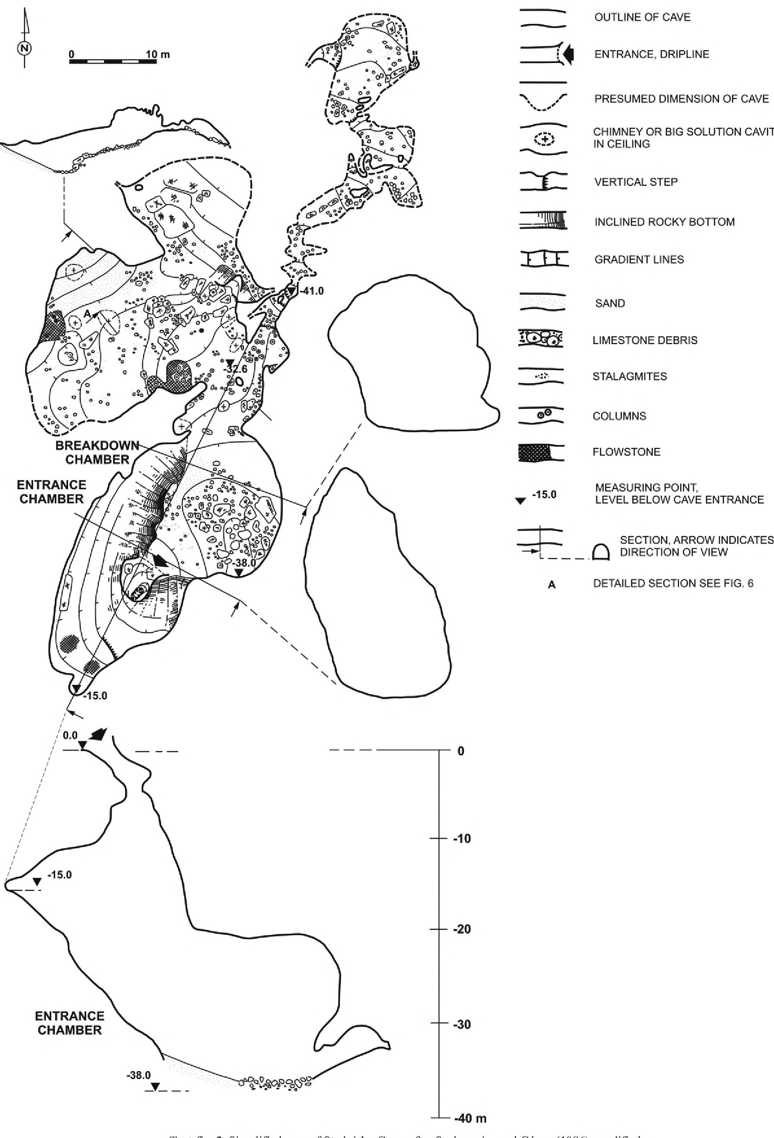
346
MICHAŁ GRADZIŃSKI ET AL.
iext-Iig. I. Simplified map 01 studnisko Cave, alter szelerewicz and uomy (lVeso), modmed

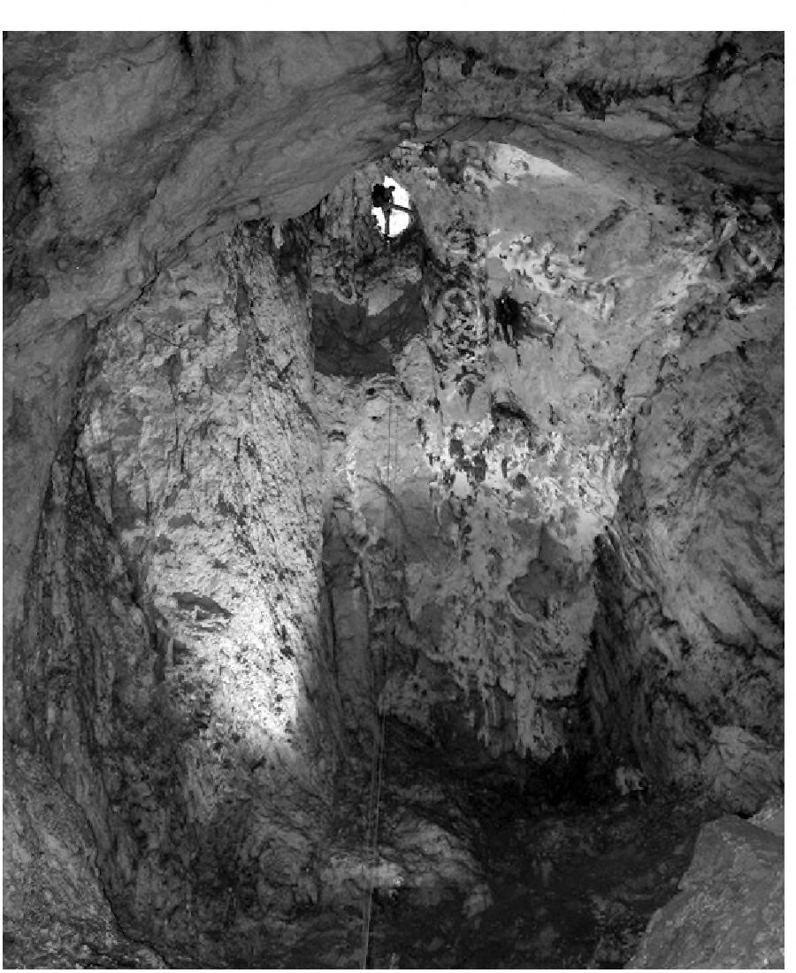
SPELEOGENETIC MODEL OF THE POLISH JURA
347
egory (see Osborne 2004). Smaller forms may be re-
ferred to the solution pockets of Palmer (2007, p. 150—
151). However, the forms studied represent one popu-
lation with a wide range of dimensions, hence they are
collectively called solution cavities in this paper.
The solution cavities occur in the walls and ceilings
of the caves. The majority of them are semicircular in
cross section and open to the cave interior. Some of
them form large wall pockets that are round, circular in
plan view and regular in shape. Only a minority of the
solution cavities, mostly those of elongated shape, are
guided by joints. These joint-guided solution cavities
now host stalactites and draperies. Examples are pres-
ent in the Breakdown Chamber in Studnisko Cave.
Some of the solution cavities coalesce by breaching
of the limestone walls between them. This is testified
by remnant rock bridges within some solution cavities
or remnants of walls preserved as curved rock blades
with biconcave shape, still intervening between two
neighbouring cavities (Text-fig. 5A, 6; see Osborne
2007, 2009).
Some of the larger solution cavities in Pod Sokolą
Górą Cave, as well as in the Breakdown Chamber in
Studnisko Cave, host smaller forms. They collectively
display a hierarchical arrangement. Solution cavities
displaying such a relief are called multicuspate by Ford
and Williams (2007, p. 252). Similar forms are de-
scribed by Rudnicki (1978) from the Berkowa Cave
and from Hungarian caves, and by Gradziński et cil.
(2009) from the Smocza Jama Cave.
In the entrance part of Pod Sokolą Górą Cave, large so-
lution cavities, exceeding 4 m in diameter, are arranged
over one another (see cross section in Text-fig. 4). They
form a so-called rising set of cupolas (see Klimchouk
2007, p. 37). Similarly arranged solution cavities, but
smaller in diameter, have been identified in the ceiling of
W Amfiteatrze Cave, where they form a ceiling half tube.
Blind chimneys are another solution form present in
the ceiling of the caves, of which Pod Sokolą Górą
Cave provides the most spectacular examples. A blind
chimney in the western part of the cave is elliptical in
plan view, and more than 10 m high. A similar fonu is
present in the Entrance Chamber in Studnisko Cave.
The artificial entrance to this cave was opened in the
topmost part of this chimney.
The origin of solution cavities has been exten-
sively discussed (e.g., Osbome 2004; Palmer 2007;
Ford and Williams 2007; Klimchouk 2007, 2009 and
literature quoted therein). They may form in various
ways. Audra et al. (2007), following the opinion by
Szunyogh (1989), postulate their origin just above
bodies of aggressive hot water. However, the lack of
any traces of a stagnant palaeowater table strongly
suggests a different origin for the types of solution cav-
ities under discussion. The mechanism of mixing cor-
rosion can also be ruled out because of the lack of
guiding fractures in most solution cavities. Hence, the
solution cavities were formed below the water table, in
the phreatic zone, by buoyancy-driven slow move-
ment of water. The hierarchical arrangement of solu-
tion cavities suggests that thermal convection was pre-
sumably the main factor responsible for their origin.
This mechanism was put forward to explain similar
forms in a small cave in Berkowa Hill (Polish Jura) in
the classic paper by Rudnicki (1978). Similar hierar-
chically arranged ceiling cavities are also known from
the Budapest caves created by ascending circulation of
thermal water (Muller and Sarvary 1977; Rudnicki
1978; M. Gradziński, unpublished data). The larger so-
lution cavities were formed by the enlargement and co-
alescing of neighbouring smaller ones (Osbome 2007).
The presence in these caves of rising chains of solution
cavities, blind chimneys and ceiling tubes is also note-
worthy.
All of the above discussed forms of cave relief
prove that the caves were predominantly formed under
phreatic conditions. Although none of the forms itself
is an unequivocal criterion of specific speleogenetic
conditions, their widespread occurrence in the caves
definitely is. Klimchouk (2007, 2009) includes the
forms in question in ‘the morphologic suite of rising
Text-fig. 3. Entrance Chamber in Studnisko Cave; photo taken upward at
about 45° angle, note person (black figure) standing at the cave entrance;
photo by Aleksander Dobrzański

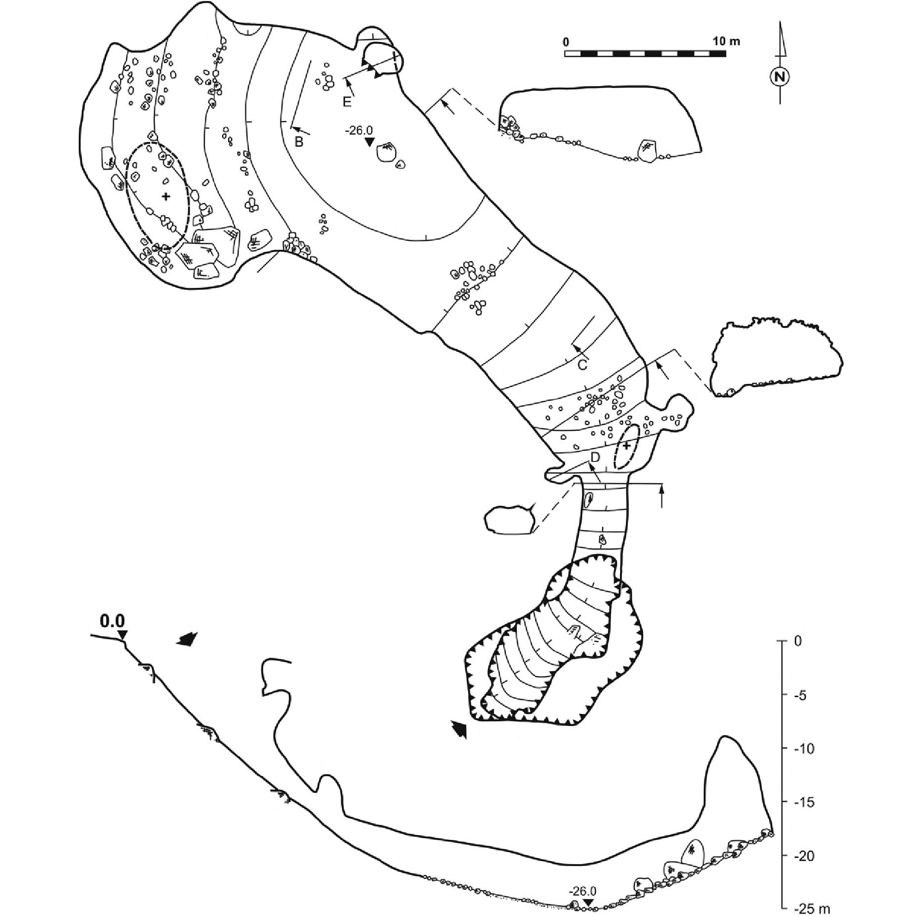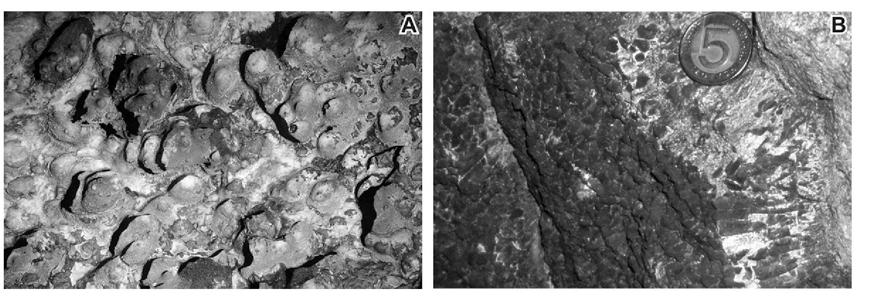
348
MICHAŁ GRADZIŃSKI ET AL.

Text-fig. 5. A - Solution cavities in ceiling of Pod Sokolą Górą Cave; photo taken vertically upward; width of photo ca 4 in; B. - Calcite spar with rhombohedron
terminations covering the cave wall visible on right side of photo; coin is 23 mm across

Text-fig. 4. Simplified map and extended cross-section of Pod Sokolą Górą Cave, after Szelerewicz and Górny (1986), modified; see Text-fig. 3 for symbols
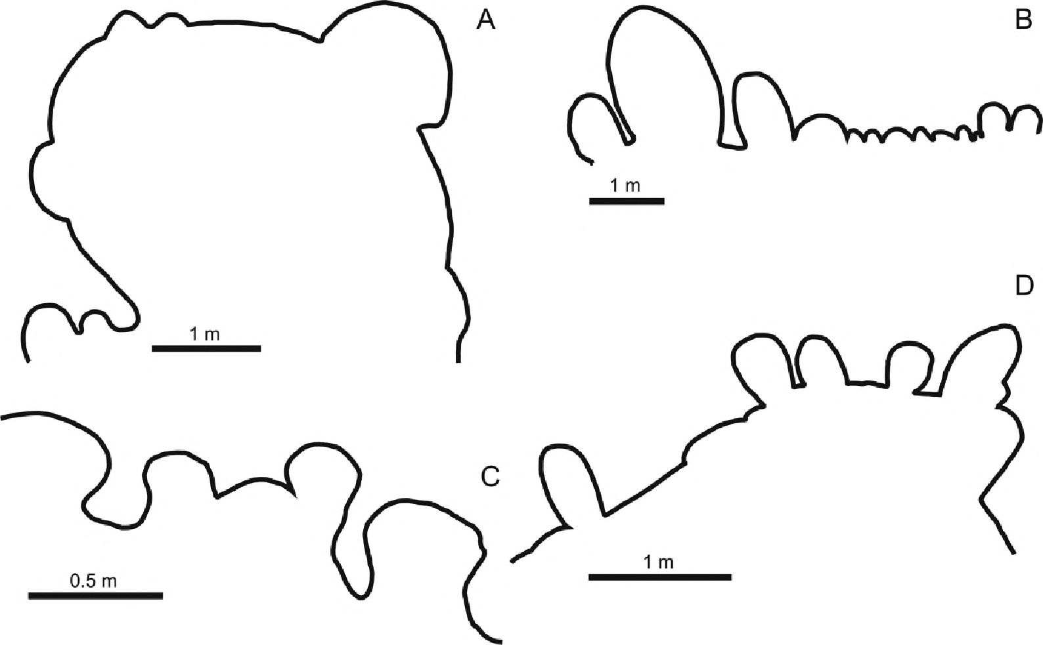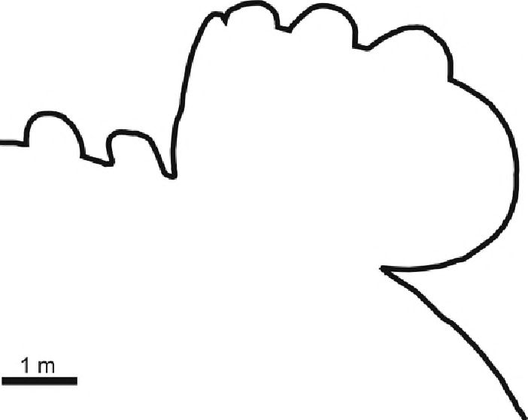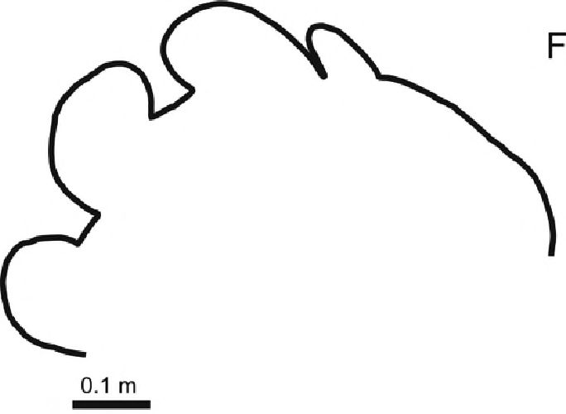
SPELEOGENETIC MODEL OF THE POLISH JURA
349
flow’, typical of hypogenic caves. Osbome (2007) also
regards such forms of cave relief as diagnostic for per
ascendunt speleogenesis. The pattern of the caves, to-
gether with their rocky' relief, thus both indicate their as-
cending origin, presumably by the action of thermal
water. Some parts of the caves under study may have
subsequently been included into normal karst drainage
systems and modified.
Vadose remodelling seems to have been subordinate
since forms of vadose relief are scarce. The only ex-
ample of a wall notch in the caves was identified in the
entrance of the Pogorzelskiego Cave. The notch is 1 m
long, and its vertical aperture is c. 20 cm. The notch is
horizontally incised up to 30 cm into the bedrock.

Calcite spar
Calcite spar occurs in the majority of the caves
(Table 1). It was mined in many of them in the 19th and
the first half of the 20th century (Maślankiewicz 1937;
Wójcik 2004). Some subterranean voids were com-
pletely filled with the calcite spar. An abandoned sub-
terranean mine of calcite spar is a good example of such
voids. This cave was completely filled with calcite
spar which was later partly mined. Another example is
a small karst fonn filled with calcite spar, subsequently
cut by surface erosion and now exposed in a rock cliff
(Text-fig. 1; Table 1).
The calcite spar lines the walls of the caves (Text-
figs 5B, 7). It consists of calcite rhombohedrons,
more or less perpendicularly oriented to the cave
wall. The crystals are either white with a milky ap-
pearance or are yellowish to pinkish and translucent.
The length of particular crystals exceeds 10 cm. The
crystals show well defined acute terminations. Ex-
amination of thin sections proves that crystals do not
contain significant admixtures of non-carbonate im-
purities.

Text-fig. 6. Detailed cross-section through selected ceiling solution cavities, for location of A-E see text-figs 2, 4, F - W Amfiteatrze Cave
Sample | Lab.  No. | U cont.  [ppm] | ²³⁴u/²³⁸u | ²³⁰Th/²³⁴U | 2³⁰Th/23²_{T}h | Age  [ka] | Comment
Pogorzelskiego  Cave, calcite spar | W 1789 | 0.017 ±0.002 | 1,02 ±0.13 | 1.07 ±0.14 | 90 | >350 | sample older  than 1.2 Ma
Studnisko cave  flowstone | W 1788 | 0.040 ± 0.003 | 1.04 ±0.12 | 0.99 ±0.11 | 34 | >350 | sample older  than 1.2 Ma
Studnisko cave  calcite spar | W 1787 | 0.041 ± 0.003 | 0.96 ±0.11 | 0.99 ±0.11 | 117 | >350 | sample older  than 1.2 Ma
Studnisko cave  flowstone | W 2177 | 0.35 ±0.01 | 1.55 ±0.06 | 0.090 ± 0.008 | 4 |  | detrital  contamination
Sample  Table 2. Results of U-series dating of calcite samples  ²³⁰Th/²³⁴U activity ratios of calcite spar samples  (Lab. No. W 1787, 1789) indicate radioactive equilib-  rium and an age of >350 ka (Table 2). Radioactive equi-  librium of the uranium isotopes (²³⁴U/²³⁸U activity ra-  tios within the error limit equalling 1) indicates an age  of >1.2 Ma. The 5¹³C and S¹⁸0 values of the calcite spar  fall within a range from -11.5 %o to -9.0 %o and from  -11.1 %o to -5.4 %o respectively (Table 3).  The calcite spar represents the oldest generation of  cave fills in Sokola Hill since it nucleated directly on  the rocky substrate, and in some places was covered by  clastic deposits. Th e euhedral habit of the calcite crys-  tals, their acicular terminations, and the continuous  crystal lining around the cave perimeter, all testify that  the calcite spar grew under phreatic conditions. Such  phreatic calcite spar, also termed simply ‘phreatic cal-  cite’, is known from several caves, chiefly those of as-  cending origin (e.g., Bakalowicz et al. 1987; Dublyan-  sky 1995; Hill and Forti 1997, p. 101; Bottrell et al.  2001; Immenhauser et al. 2007; Spotl et al. 2009). It  grows slowly under stable conditions below the water  table. This process is commonly stimulated by changes  number | Sample location | Sample type | 8¹³C  [%o VPDB] | 5^{ls}O  [%0 VPDB]
1 | Pogorzelskiego Cave | flowstone | -10.7 | -10.1
2 | Pogorzelskiego Cave | flowstone | -11.8 | -8.6
3 | Pogorzelskiego Cave | flowstone | -9.7 | -8
4 | Pogorzelskiego Cave | flowstone | -10.4 | -10.6
5 | Calcite mine | calcite spar | -10.8 | -8.8
6 | Calcite mine | calcite spar | -10.1 | -11
7 | Calcite mine | calcite spar | -11.5 | -10.2
8 | Calcite mine | calcite spar | -10.4 | -10.9
9 | Calcite mine | calcite spar | -9.0 | -9.3
10 | Studnisko | flowstone | -9.6 | -7.7
11 | Studnisko | flowstone | -9.3 | -5.7
12 | Studnisko | flowstone | -9.9 | -7.1
13 | W Amfiteatrze Cave | flowstone | -9.8 | -0.2
14 | Pod Sokolą Górą Cave | flowstone | -8.3 | -5.2
15 | Pod Sokolą Górą Cave | flowstone | -8.3 | -7.1
16 | void filled with calcite  spar | calcite spar | -10.6 | -11.1
17 | Pogorzelskiego Cave | calcite spar | -9.9 | -7.5
18 | Na Półce Cave | calcite spar | -10.2 | -5.4
19 | Calcite mine | calcite spar | -9.8 | -6.3
Table 3. Stable isotope composition of calcite speleothems
Sample  number | S¹⁸O_{c}  [%0 SMOW] | ty calculated  for  8^{ls}O_{w} = -4%₀  r° c] | ty calculated  for  S¹⁸O_{w} = -6%o  r c] | ty calculated  for  8^{1S}0_{W} = -8%o  r° c] | ty calculated  for  8¹⁸O_{w} = -10%o  r° c] | ty calculated  for  S¹⁸O_{w} = - ll%o  r° c]
5 | 21.84 | 39.2 | 28.7 | 19.2 | 10.5 | 6.5
6 | 19.57 | 52.1 | 40.3 | 29.4 | 20.1 | 15.6
7 | 20.50 | 46.6 | 35.4 | 25.3 | 16.1 | 11.8
8 | 20.19 | 48.4 | 37.0 | 26.7 | 17.4 | 13.0
9 | 21.63 | 40.3 | 29.7 | 20.1 | 11.4 | 7.3
16 | 19.47 | 52.7 | 40.9 | 30.2 | 20.6 | 16.1
17 | 23.18 | 32.2 | 22.4 | 13.5 | 5.3 | 1.5
18 | 25.46 | 21.4 | 12.6 | 4.5 | -2.9 | -6.4
19 | 24.52 | 25.7 | 16.5 | 8.1 | 0.4 | -3.3
Table 4. Calculated values of calcite spar crystallization temperature
352
MICHAŁ GRADZIŃSKI ET AL.
glacial parent waters. It thus seems that the precipitation
of the calcite spar occurred with the participation of wa-
ters of Neogene or Palaeogene age, which is in line with
the results of calcite spar dating.
If the above assumption is correct, the calcite spar
crystallized at a temperature not higher than 52.7 °C.
Similar temperature values have been postulated for the
crystallization of phreatic calcite spar in the Budapest
caves (Dublyansky 1995), and in the Jabal Madar diapir
in Oman (Immenhauser et al. 2007).
The temperatures calculated for any given isotopic
composition of parent water differ significantly from
sample to sample. This implies that the sampled calcite
crystals grew under various thermal conditions and that
they are probably of various ages. This, in turn, implies
that the hydrological system evolved during the crystal-
lization of calcite (cf. Dublyansky 2000b; Palmer 2007,
p. 213). Nonetheless, it cannot be ruled out that at least
some of the calcite spar crystals grew under conditions of
isotopic disequilibrium and that, in such a case, the above
calculations have been based on a false assumption.
Allochthonous cave deposits
Two types of allochthonous clastic deposits have
been identified in the caves: (i) conglomerates, con-
taining Upper Jurassic limestone clasts, and (ii) quartz
sandstones and sands.
Conglomerates
The conglomerates have been found exclusively in
the Entrance Chamber in Studnisko Cave. They form
lenses and patches attached to the inclined walls of the
chamber and locally to the ceiling. Where the base-
ment of the conglomerates is visible, they directly
overlie Upper Jurassic bedrock. Some patches of con-
glomerates are covered with flowstones which are
also dissected by erosion. The patches reach 1 m in
thickness and are located 27 to 32 m below the cave
entrance.
The conglomerates are composed of sub-angular to
sub-rounded clasts of Upper Jurassic limestones (Text-
fig. 8A, B). Sub-rounded blackened pebbles occur sub-
ordinately. The clasts are between a few centimetres
and a few millimetres across and reach a maximum of
20 cm. A subtle tendency to upward decrease in grain
size can be observed in the conglomerate section. The
matrix is red-stained and consists of quartz grains of
sand-size and, sporadically, gravel-size. It additionally
contains rounded speleothem clasts, vertebrate - prob-
ably bat - bones, fine-grained reddish material and
calcite cements (Text-fig. 8C). The conglomerates are
grain-supported in the lowermost patches, whereas in
the uppermost ones they are mud-supported. In the lat-
ter, the conglomerates are interbedded with horizontally
lying flowstones (Text-fig. 8D).
Sands and sandstones
Quartz sand and sandstones are the most common
clastic deposits identified in the caves. They are mod-
erately sorted, medium- to coarse-grained, with an ad-
mixture of granules and pebbles. The sandstones are ce-
mented with calcite.
Loose accumulations of sand are preserved locally
on cave bottoms. In the Breakdown Chamber in
Studnisko Cave a sandy fan descends from the north-
western wall towards the chamber centre. Horizon-
tally layered sand also builds a loose accumulation in
the northern part of the chamber. Sandy concretions at-
tached to the ceiling and walls are present in the same
chamber (Text-fig. 8E, F; Skalski and Wójcik 1968).
They are spherical in shape and reach 25 cm in diam-
eter. Neighbouring concretions are cemented together
and arranged into clusters.
The sandstones attached to the cave ceiling and
walls fill a substantial part of Pogorzelskiego Cave
(Text-fig. 7). They display large-scale cross-bedding.
The rocky floor of the cave is littered with loose sand,
probably originated from weathering of the sandstone.
Heavy’ mineral composition
Heavy minerals make up between 0.08 wt. % and
- 3 wt. % of the allochthonous cave elastics (Table 5).
Opaque minerals predominate in the analyzed samples,
reaching up to 72.8 wt. % (Text-fig. 9). The translucent
minerals are dominated by chemostable ones (Text-fig.
10), kyanite and tourmaline being the most common.
Mechanostable and unstable minerals are less common.
Conversely, a translucent mineral assemblage of
glacifluvial deposits is dominated by mechanostable
minerals, with garnet reaching 66.1 wt. %. These de-
posits have a lower content of opaque minerals than the
cave elastics.
Origin of cave elastics
Allochthonous material brought into the caves is
present as conglomerates, sands and sandstones. Its
presence proves that the caves were connected with the
surface and that streams washed clastic material into the
caves. The occurrence of vertebrate bones in the con-
glomerates supports this interpretation. The age rela-
tionships between the conglomerates and the sands
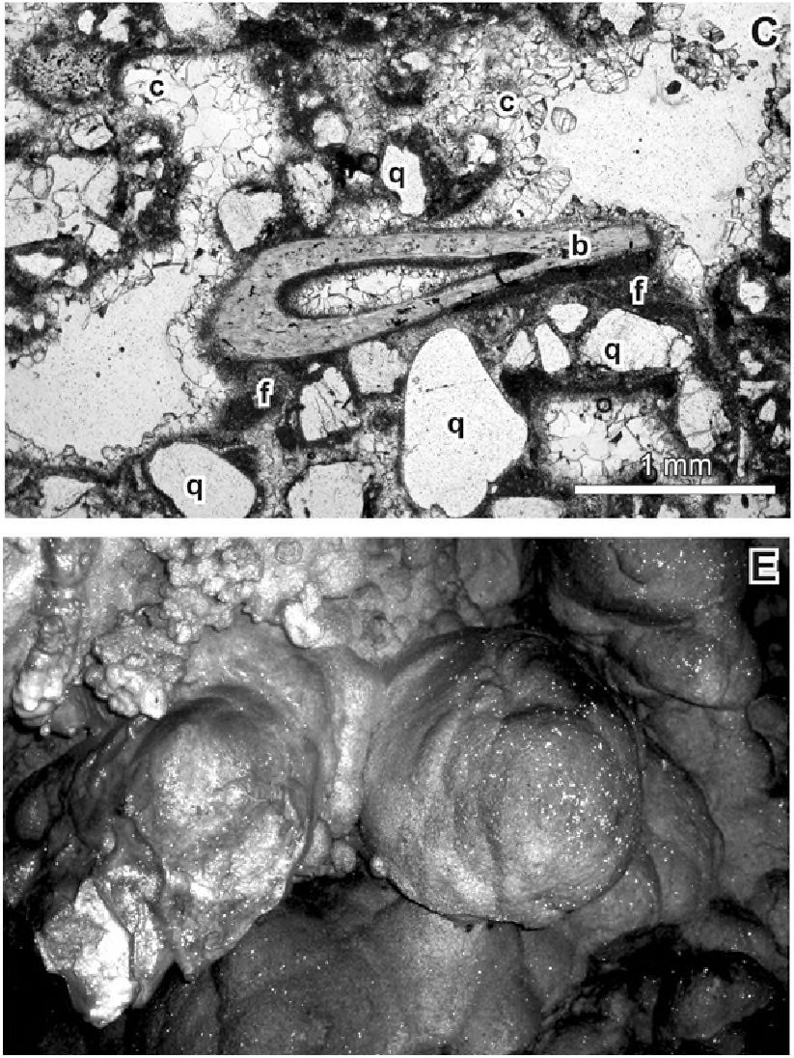
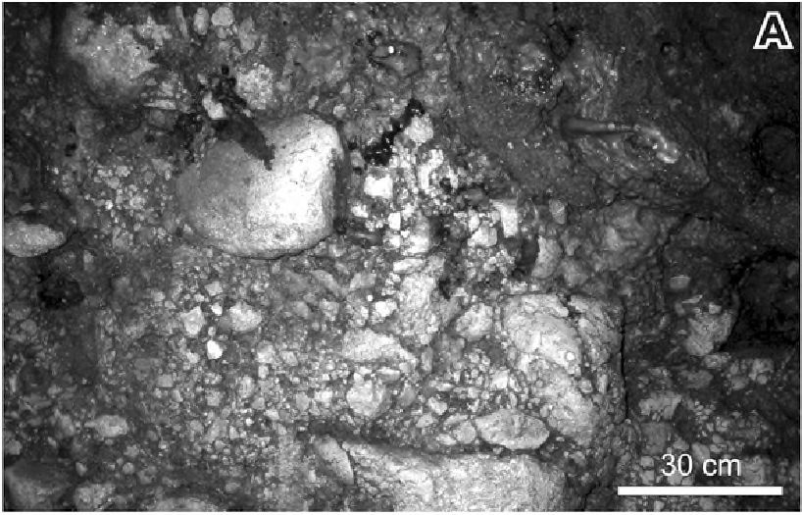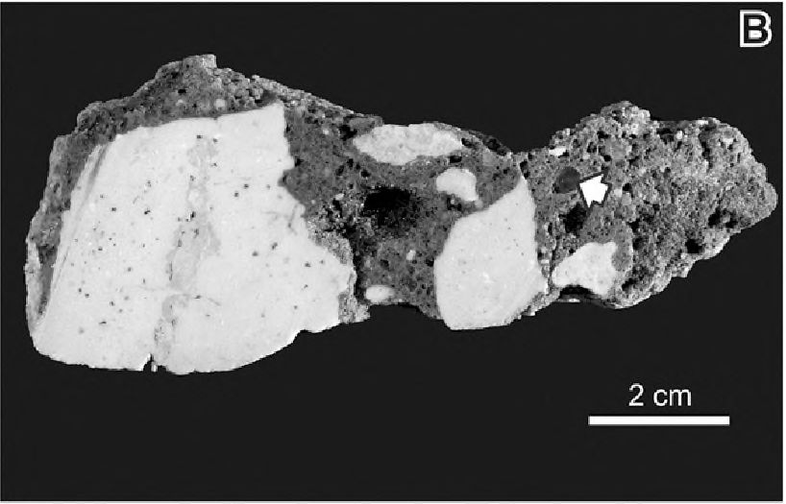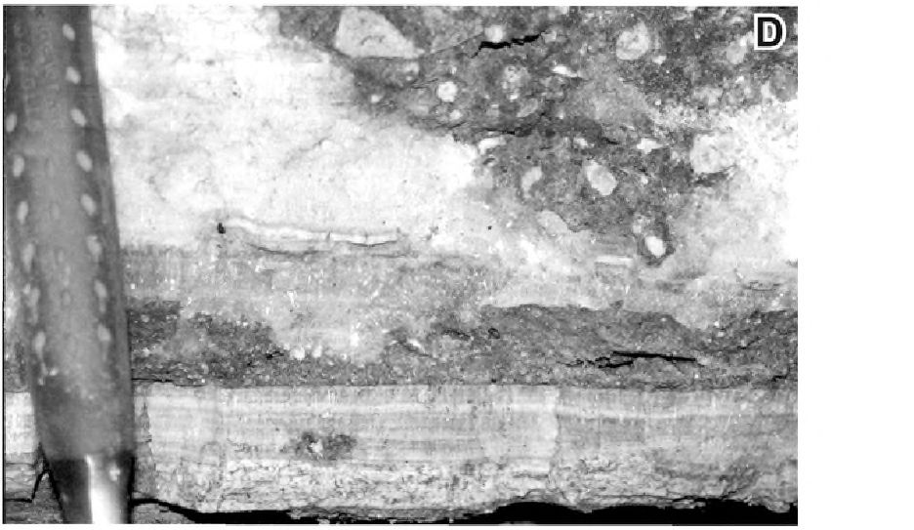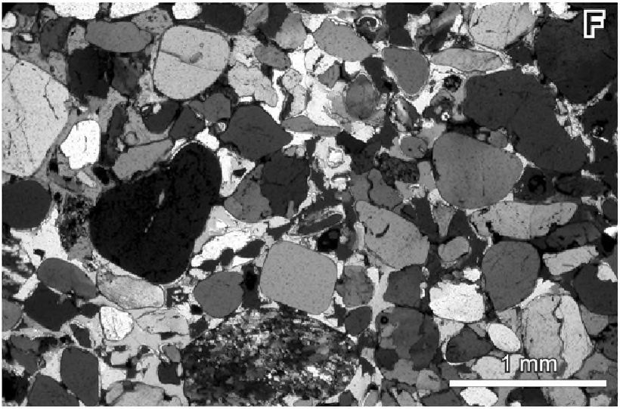
SPELEOGENETIC MODEL OF THE POLISH JURA
353
and sandstones are not known. The deposition of the
elastics took place in several episodes interrupted by
episodes of erosion and episodes during which streams
dwindled or dried up. During the dry episodes, crys-
tallization of vadose speleothems proceeded and the
elastics were undergoing selective cementation. Both
processes depended on the distribution of percolating
supersaturated water. The cemented zones became
more resistant to the subsequent erosion, and are pre-
served as irregular patches of conglomerates or sand-
stones and as sand concretions.
The heavy mineral assemblage dominated by
chemostable minerals differs from that typical of Pleis-
tocene elastics of glacial origin (Table 5, Text-figs 9,
10). The latter comprises mostly mechanostable min-
erals with substantial amount of garnets, as is shown by
reference samples of glacifluvial sands (samples PI,
PI A), and by the data from earlier studies (e.g.,
Krysowska-Iwaszkiewicz 1974; Rutkowskiemu/. 1998;
Racinowski 2008).
The source of the material for the elastics is not
known. The so called mouldic sands that fill extensive
karst depressions in the vicinity' of the Sokole Hills are
characterized by a similar heavy mineral assemblage,
with kyanite, tourmaline, zircone, rutile and staurolite
(Bosak et al. 1978). The cave elastics may derive from
the mouldic sands or may share a common source with
them. Since the Albian and Cenomanian deposits are re-

Text-fig. 8. Cave elastics: A - Conglomerate cemented to ceiling in northern part of the Entrance Chamber in Studnisko Cave, photo taken vertically upward; B -
Conglomerate composed of Upper Jurassic limestone pebbles and red fine-grained matrix, blackened pebble is arrowed, Entrance Chamber, Studnisko Cave, pol-
ished specimen; C - Conglomerate matrix with quartz grains (q), fine-grained elastics (f), calcite cements (c) and vertebrate bone (b), Entrance Chamber, Studnisko
Cave; thin-section, parallel nicols; D - Conglomerates interfinger with flowestone covers, Entrance Chamber, Studnisko Cave; E - Sand concretions cemented to
cave wall, Breakdown Chamber, Studnisko Cave, width of photo ca. 25 cm; F - Quartz grains cemented with calcite composing sand concretions, Zawaliskowa
Chamber, Studnisko Cave; thin-section, crossed nicols
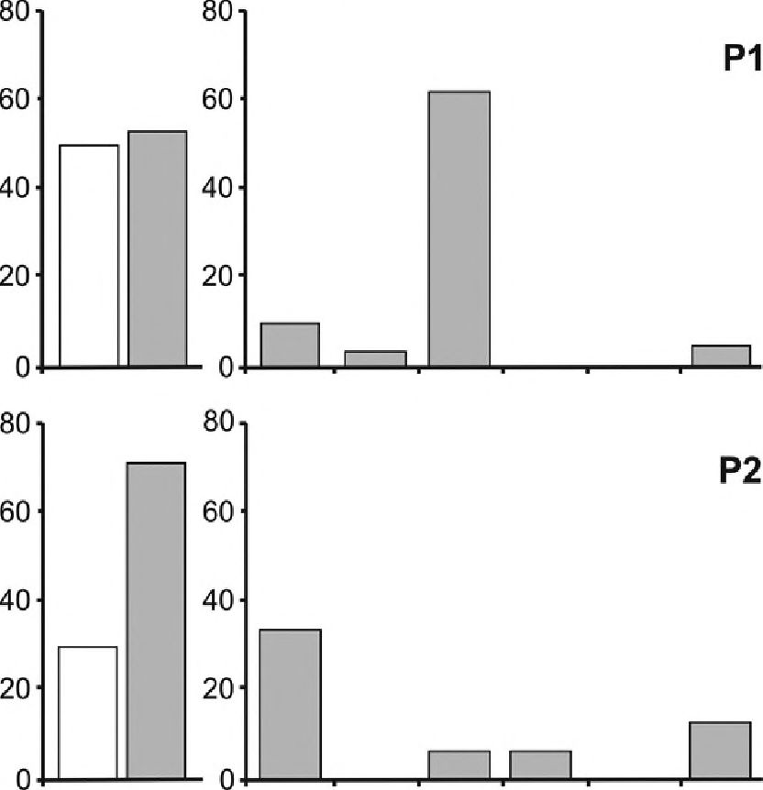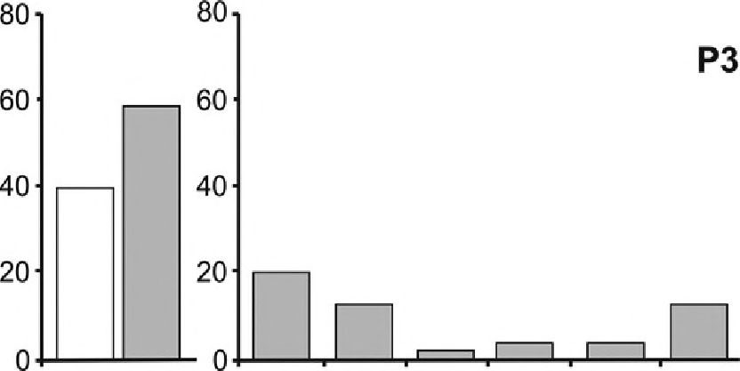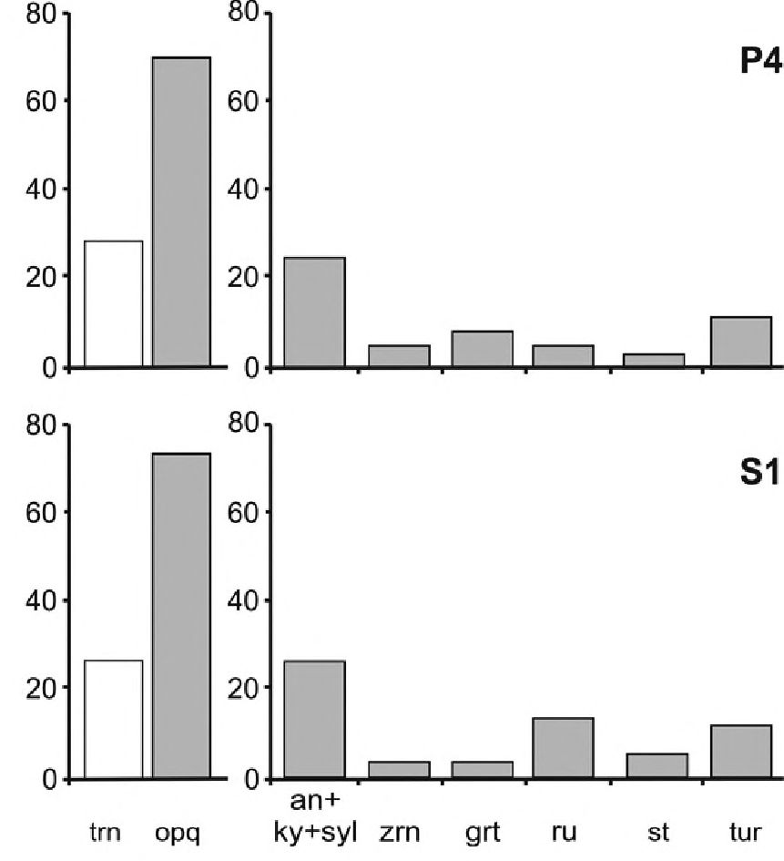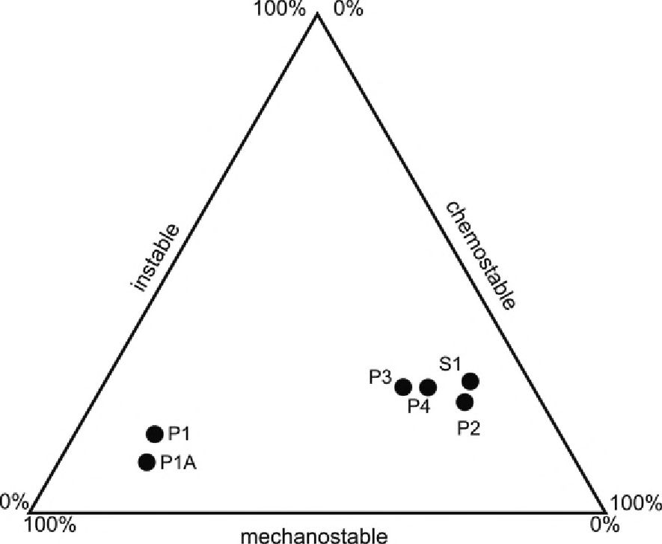
354
MICHAŁ GRADZIŃSKI ET AL.
FREQUENCY
IN HEAVY
FREQUENCY
IN TRANSLUCENT
FRACTION [%! FRACTION [%]

Text-iig. 9. Frequency diagram showing quantitative diversity 01 selected heavy
minerals; tm - translucent, opq - opaque, an+ky+syl - andalusite+ kyanite+ syl-
limanite, zm - zircon, grt - gamet, ru - rutile, st - staurolite, tur - tourmaline
garded as the source for the mouldic sands (Gradziński
1977), these deposits may have also provided material
for the cave elastics. However, any clastic deposits
younger than Cretaceous and presently not preserved in
the vicinity may also have acted as a source for the cave
elastics.

Limestone debris
Limestone debris occurs in the majority of the
caves, especially in Studnisko Cave and Pod Sokolą
Górą Cave. It contains angular or subangular blocks,
centimetres to more than 1 m across. The debris is au-
tochthonous and originated from local breakdown.
Some blocks could have crept down the inclined cave
floor for some distance, as they are found now just be-
neath solution cavities in the ceiling. At least some of
the debris originated during the Pleistocene by ice
wedging mechanisms (cf. Madeyska-Niklewska 1969;
White and White 2000). Larger blocks were detached
from the ceilings along bedding planes.

Vadose speleothems
Flowstones, stalagmites and stalactites are present
in the caves. Some of them have overgrown bat bones
of Holocene age (cf. Postawa 2004). Most of the vadose
speleothems lie beyond the scope of this study. Detailed
observations were carried out only on those which can
throw some light on the development of the caves, es-
pecially on those interbedding or directly covering the
cave elastics (Text-fig. 8E). Such spatial relationships
between flowstones and clastic deposits have been
identified in Studnisko and Pogorzelskiego caves.

Text-fig. 10. Relationship between instable, chemostable and mechanostable heavy
minerals in the studied samples, classification diagram after Burkhardt (1978)
 | PI  glacifluvial  sand | P1A*  glacifluvial  sand | P2  Pogorzelskiego  Cave, sand | P3  Pod Sokolą  Górą Cave, sand | P4*  Pogorzelskiego  Cave, sandstone | SI*  Studnisko Cave,  conglomerate
 | [wt % of | [wt % of | [wt % of heavy | [wt % of heavy | [wt % of heavy | [wt % of heavy
 | heavy  minerals] | heavy  minerals] | minerals] | minerals] | minerals] | minerals]
opaque | 51.5 | 53.8 | 71.6 | 59.5 | 71.8 | 72.8
translucent | 48.5 | 46.2 | 28.4 | 40.5 | 28.2 | 27.2
 | [wt % of | [wt % of | [wt % of | [wt % of | [wt % of | [wt % of
 | translucent | translucent | translucent | translucent | translucent | translucent
 | heavy  minerals] | heavy  minerals | heavy minerals | heavy minerals | heavy minerals | heavy minerals
amphibole | n.d. | n.d. | n.d. | n.d. | n.d. | n.d.
andalusite | 0.8 | 2.7 | 8.3 | 9.2 | 4.3 | 12.9
apatite | 3.9 | 2.7 | 8.3 | 5.6 | 9.8 | 8.1
biotite | n.d. | n.d. | 4.2 | 11.0 | 3.0 | 3.2
chlorite | 4.2 | 1.4 | 14.5 | 5.6 | 12.6 | 16.2
dolomite | n.d. | n.d. | n.d. | n.d. | 1.6 | n.d.
epidote | 10.8 | 6.7 | 6.3 | 10.5 | 8.2 | 9.7
garnets | 61.4 | 66.1 | 6.3 | 1.9 | 8.2 | 3.2
glauconite | n.d. | 1.4 | n.d. | n.d. | n.d. | n.d.
kyanite | 6.9 | 5.4 | 22.7 | 11.0 | 19.7 | 12.9
muscovite | 2.3 | n.d. | 4.2 | 12.6 | 6.3 | 1.6
pyroxene | n.d. | n.d. | n.d. | n.d. | n.d. | n.d.
rutile | 1.2 | n.d. | 6.3 | 3.7 | 4.9 | 12.9
staurolite | n.d. | 2.7 | 2.1 | 3.7 | 3.3 | 4.8
syllimanite | 1.9 | 1.4 | 2.2 | n.d. | 1.6 | n.d.
tourmaline | 3.9 | 5.4 | 12.5 | 12.6 | 11.6 | 11.3
zircon | 2.7 | 4.1 | 2.1 | 12.6 | 4.9 | 3.2
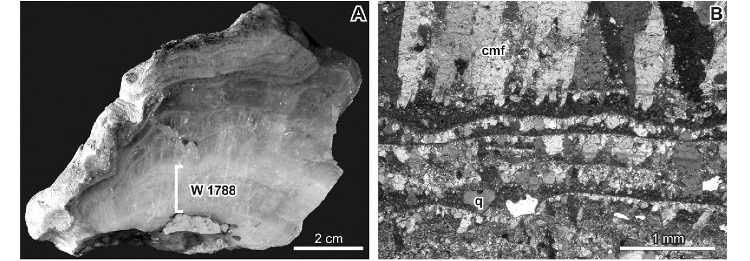
* - sample dissolved in acetete buffer, n.d. - not detected
Table 5. Contents of opaque and translucent heavy minerals in studied samples, composition of translucent heavy mineral assemblage

Text-fig. 11. Vadose speleothems: A-Flowstone covering conglomerates in Entrance Chamber, Studnisko Cave; location of sample for U-series dating is indicated,
polished specimen, B - Calcite flowstone built predominantly of columnar micro facies (cmf), laminae rich in siliciclastic detritus with outstanding quartz grain (q)
are visible at the base, Entrance Chamber, Studnisko Cave; thin section, crossed nicols
356
MICHAŁ GRADZIŃSKI STAL.
base of this flowstone was dated with the U-series
method (sample W 1788, see Text-fig. 11A for loca-
tion). The thin flowstone locally covers the exposed
eroded surface of the conglomerates and hence it
postdates their erosion. This flowstone was also sam-
pled for dating (sample W 2177).
The ^{r,l}ThT³⁴U activity ratio of sample W 1788 in-
dicates radioactive equilibrium and the age of the sam-
ple is >350 ka (Table 2). Radioactive equilibrium of the
manium isotopes (²³⁴U/'^{23!i}U activity ratios within the er-
ror limit equaling 1) suggests the age of these samples
as >1.2 Ma. The only chance for a precise determina-
tion of the age of such old speleothems is the use of U-
Pb methods. However, the very low U content in the
flowstones (in the range 0.01-0.04 ppm) may pose a
problem.
Sample W 2177 - flowstone covering the eroded
surface of the conglomerates - has a significantly
higher concentration of U than other samples stud-
ied. This may indicate a different source of U, prob-
ably owing to different paths of the parent water. The
very low ²³⁰Th/²³⁴U activity ratio suggests a rela-
tively young age - probably Holocene. The meas-
ured value of the activity ratio corresponds to an age
of about 10 ka. However, the presence of ²³²Th
(²³⁰Th/²³²Th activity ratio equaling 20) indicates a
significant detrital contamination and prevents a re-
liable dating of the sample. The assumption that
there is only thorium contamination enables age cor-
rection using the initial ²³⁰Th/²³²Th activity ratio at
the contaminant (B0) as a contamination index. B0
values between 0.5 and 1.7 are commonly used (cf.
Kaufman and Broecker 1965; Geyh 2001). Using the
correction index B0 = 1.5 ± 0.5 (it covers the range
most commonly used for age correction) the cor-
rected age is 6 ± 4 ka.
Thin flowstones, up to 12 mm in thickness, in-
terfinger with sandstones in the Pogorzelskiego Cave.
They are composed of blocky and columnar micro-
facies and are rich in non-carbonate impurities, which
make it impossible to date them by the U-series
method. Thin flowstones also line some solution cav-
ities in the ceiling of Pod Sokolą Górą Cave. Flow-
stone also builds a so-called false floor in the W Am-
fiteatrze Cave, a flowstone cover laid down on clastic
deposits, which were later removed.
Some of the flowstones have incorporated bat
bones, probably Holocene in age (Tomasz Postawa,
personal communication, 2005). Vadose speleothems
show 8¹³C values between -11.8 %o and -8.3 %o,
whereas their 8^{ls}O values range from -10.6 %o to
-0.2 %₀ (Table 3). These values fall within the range
typical of speleothems from a temperate zone.
SPELEOGENESIS OF SOKOLA HILL
Four main stages have been distinguished in the
speleogenesis of Sokola Hill by considering the speleo-
genetic conditions, origin of the cave deposits and their
spatial relationships: (i) formation of the caves, (ii)
crystallization of calcite spar, (iii) invasion of vadose
streams, and (iv) drying of the caves. Each of the stages
may include several episodes whose net effect is reg-
istered as fonnation or modelling of the caves, as dep-
osition of internal sediments within them or as erosion
of these sediments (Text-fig. 12).

Formation of the caves
The caves in Sokola Hill are fully disconnected
from the present-day drainage system and are not re-
lated to the present surface relief, hence they originated
under hydrological and morphological conditions es-
sentially different from the present ones.
Pod Sokolą Górą and Studnisko caves comprise
chambers whose shape and pattern do not bear any re-
semblance to typical fluvial caves (cf. Osbome 2007).
The relief of the cave ceilings proves that they were
formed under plireatic conditions. The hierarchical
arrangements of solution cavities in the cave ceilings
strongly suggest elevated temperature of the water
which formed the caves. The common occurrence of
solution cavities in the cave ceilings, arrangement of
such cavities in raising chains, along with the presence
of blind chimneys and ceiling half-tubes, all testify
that the caves were formed by ascending water. Al-
though small solution cavities similar to some ob-
served in caves of Sokola Hill may also be formed in
eogenetic caves (Ford and Williams 2007, p. 252;
Palmer 2007, p. 211), such a scenario is ruled out be-
cause of the reasons given below. Neither the forms of
cave relief nor the dimension and shape of the cham-
bers show a relationship to eogenetic karstification.
Moreover, eogenetic karstification seems to be im-
probable, taking into account the depositional milieu
of the Oxfordian limestone and the later geological
history of the Polish Jura.
The postulated ascending origin of the caves implies
that they were formed in a confined setting. This is
supported by the lack of scallops on the cave walls, char-
acteristic of wall relief formed in the presence of inte-
grated flow in an unconfined setting (cf. Ford and
Williams 2007, p. 241; Klimchouk 2007, p. 30). Hence,
the caves were formed when the Jurassic limestone
hosting them was covered by confining impermeable
beds. The above view contradicts the concept formu-
lated by Skalski and Wójcik (1968), who related the ori-
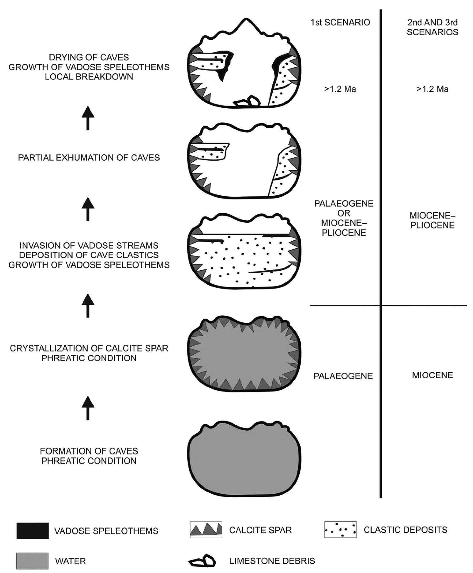
SPELEOGENETIC MODEL OF THE POLISH JURA
357
gin of the caves in Sokola Hill to the so-called water-
table theory (sensu Swinnerton 1932), and claimed that
the caves formed in two phases near the water table.
The caves are located a short distance below the
present top of the Upper Jurassic limestone and more
than 150 m above its base. Thus, the aggressiveness of
the water can be attributed to two mechanisms: (i)
cooling of thermal water during its upward migration
towards the surface, and (ii) interacting of ascending
water with water of shallow circulation (cf. Palmer
1991 2007; Dublyansky 2000a, b). It also seems plau-
sible that both mechanisms operated concomitantly.
The latter must have been connected with penetration
of meteoric water to the Jurassic limestone aquifer,
which was possible if there existed vertical connections
through the overlying confining beds, for instance
along faults or in hydrological windows. Both mecha-
nisms were particularly efficient in a relatively shallow
zone but not just below the palaeosurface. It is doubt-
ful that injection of unsaturated water from below into
the Upper Jurassic limestone series was involved in the
formation of the caves. In such a case the caves would

Text-fig. 12. Simplified history of caves in the Sokola Hill, not to scale, further explanation in the text
358
MICHAŁ GRADZIŃSKI ET AL.
be located at the base of the limestone series, which is
not the case (see discussion in Klimchouk 2009).
Modelling by Andre and Rajaram (2005) suggests
that the creation of cave conduits by ascending ther-
mal water is a slow process. A cave which owes its
origin to such conditions can attain a traversable size
after several hundred thousand years (see also Palmer
1991). Thus, the formation of the caves under dis-
cussion, especially the spacious chambers, demanded
favourable conditions persisting over a relatively long
period of time. Such conditions occurred within a
much larger area of the Polish Jura, as is shown by the
presence of similar underground forms at many sites
over this region (Rudnicki 1978; Głazek and
Szynkiewicz 1980; Pulina et al. 2005; Tyc 2009 a, b).
The palaeohydrological conditions of the phreatic
stage of the cave evolution and timing of the cave for-
mation are discussed below in a separate section.

Crystallization of calcite spar
The calcite spar postdates the formation of the caves,
but it crystallized when the caves were still under
phreatic conditions. However, there is no unequivocal
proof that they were still filled with the same water that
formed the caves. The euhedral habit of the crystals sug-
gests that they grew slowly deeper below the water
table (Ford 1993). The caves were presumably filled
with sluggish water, without vigorous flow towards the
discharge zone (see discussion in Ford 1989). Accord-
ing to Ford et al. (1993) and Dublyansky (1997,2000a)
water loses its aggressiveness near the ground surface
and becomes supersaturated with respect to calcium
carbonate. When the ground surface is lowered by de-
nudation in the course of geological evolution of an area,
the zone of calcite precipitation migrates downward
and calcite spar may crystallize in caves formed during
earlier stages of speleogenesis (see also Palmer 2007,
fig. 8.47). The acceptance of this concept implies that
calcite spar was formed under the same palaeohydro-
logical conditions and from the same water which cre-
ated the caves. This is indirectly supported by calcula-
tions suggesting that the calcite spar grew from water of
slightly elevated temperature, similar to the water which
formed the caves. Nonetheless, the calcite spar may
have crystallized from different water during further
stages of the cave development, but still when the caves
were situated below the water table.

Invasion of vadose streams
The cave elastics containing allochthonous mate-
rial of sand and gravel size are evidence that the caves
were invaded by sinking vadose streams. This marks
a new stage in evolution of the phreatic caves, origi-
nally formed by ascending water circulation and now
included into a completely new karst drainage system.
The lack of distinct vadose modelling in the rocky re-
lief of the caves implies that the invasion of surface
streams was a relatively short-lasting stage in the
evolution of these caves, though the presence of va-
dose relief cannot be excluded beneath sediments that
cover the rock floors of some caves, for instance Pod
Sokolą Górą Cave. Vadose modelling is a common
phenomenon in caves located in the southern part of
the Polish Jura (Gradziński 1962; Madeyska-
Niklewska 1969).
The time of clastic deposition cannot be deter-
mined directly. The age of flowstone cover on the
conglomerates proves that the latter were laid down
earlier than 1.2 Ma. This is in line with the absence of
glacigenic deposits in the caves (cf. Krysowska-
Iwaszkiewicz 1974; Madeyska 2009). The reddish
colour of the elastics resembles that of Pliocene/Lower
Pleistocene deposits cropping out in the northern part
of the Polish Jura, palaeontologically dated to Rus-
cinian, Villanyian and Biharian (Głazek 1989). The
nearest cave with Villanyian faunal remains is Ur-
wista Cave (Jaskinia Urwista) located 1 km east of
Sokola Hill (Horacek and Hanak 1983-1984). How-
ever, they may be also isochronous with mouldic sands
that is, at least partly, deposited in Palaeogene time (cf.
Gradziński 1977).

Drying of the caves
After the deposition of the elastics, the caves were
abandoned by underground streams due to the en-
trenchment of neighbouring valleys. Breakdowns mod-
ified cave interiors. Although there are no precisely
dated speleothems, we may infer, based on the conclu-
sions drawn by Hercman (2000), that they could have
grown in the warm period of the Pleistocene and pre-
sumably also in the Pliocene (see also Głazek 1989).
The lack of glacially derived material in the caves
can be explained in two ways. Firstly, the caves may
have been effectively sealed, but still void, before the
advance of the Scandinavian glaciers. If the caves were
isolated, they could have endured in this state for sev-
eral hundred thousand years. They were reconnected to
the surface by slope erosion, ceiling collapse and hu-
man action, but without erosive activity of streams,
which would have washed glacially-derived sands from
the vicinity into the caves. The individual caves were
reopened at various times and the time of their re-
opening cannot be determined precisely. Some sug-
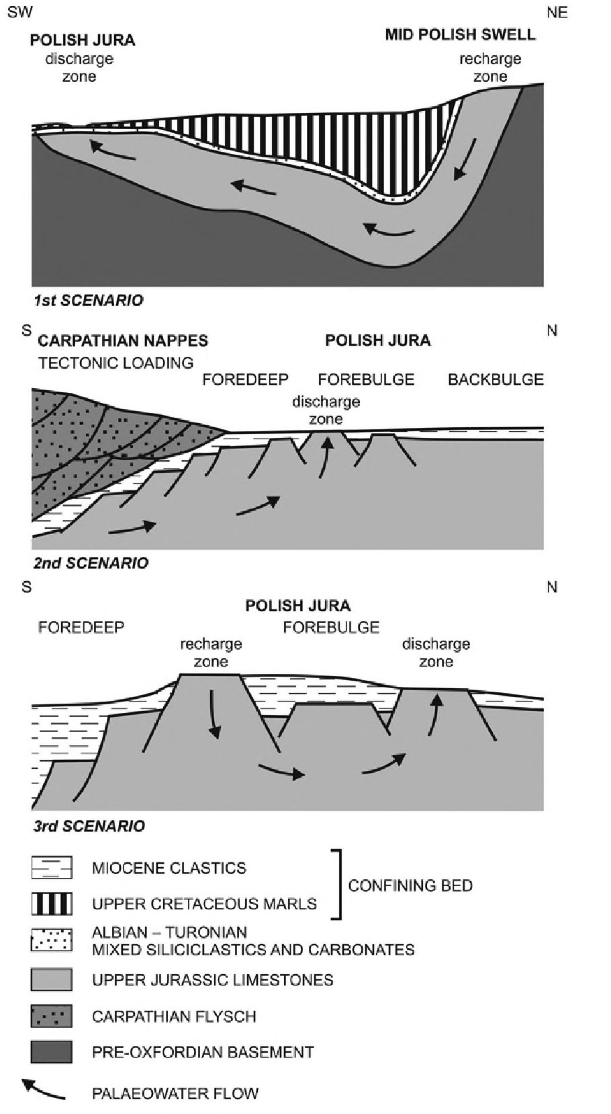
SPELEOGENETIC MODEL OF THE POLISH JURA
359
gestions are nevertheless possible. Pod Sokolą Górą
Cave is a stable cold-cave type. Its microclimate regime
is controlled by the spacious enhance located in the top-
most part of the cave. Such conditions have persisted
at least since the last glacial period, as proved by the oc-
currence of psychrophilic organisms, regarded as gla-
cial relicts (Szymczakowski 1959). Studnisko and Pod
Sokolą Górą caves were entered by bats in the mid-
Holocene, as documented by radiocarbon AMS dating
of the bat bones (Postawa 2004).
The location of the caves above the level reached by
the streams that carried the glacially-derived material
is a second possible explanation for the lack of this ma-
terial in the caves. However, glacially-derived sands are
scattered over the Polish Jura at altitudes higher than
that of the caves. Różycki (1960) mentions their oc-
currence up to an altitude of 400 m, whereas
Lewandowski (1994,2009) quotes the presence of ae-
olian sands, derived probably from older glacifluvial
sands, up to an altitude of 380-400 m. Thin sheets of
aeolian sands occur 0.5 km east of Sokola Hill in the top
part of Donica Hill (Sokole Hills), at an altitude of370-
380 m, that is, higher than the altitude of the caves in-
vestigated (Urban and Gradziński 2004).
karstification of Upper Jurassic limestones, develop-
ment of dolinas and the sedimentation of the so-called
mouldic sands whose precise age is unknown. The
mouldic sands were laid down in Palaeogene time, be-
fore the Miocene faulting of the Polish Jura (Gradz-
iński 1977). Such an age and origin of some small
caves in the Polish Jura have been suggested by Głazek
and Szynkiewicz (1980).
A gravity-driven palaeoflow demands the presence
of a recharge zone lying higher than the discharge zone.
Unambiguous identification of the recharge area in this
scenario is not possible, as the topography of the Polish
Jura has significantly changed since Palaeogene time.
The most feasible candidate for the recharge zone seems
PALAEOHYDROLOGICAL CONDITIONS AND
THE AGE OF CAVE FORMATION
The development of ascending caves demands ful-
filling at least two conditions: the presence of confining
beds over the cave-bearing series; and an upward water-
flow regime in the area where the caves originate. We pro-
pose three alternative scenarios of the cave development,
all taking into account the geological history of the Polish
Jura together with all the observed facts (Text-fig. 13).
Each scenario explains in a different way the general
palaeohydrological pattern and the origin of water which
created the caves. The scenarios are valid not only for the
relatively small area of Sokola Hill but also for the whole
Polish Jura and they aim at providing an adequate expla-
nation for the abundance of ascending caves in this region.

First scenario
The first scenario assumes that low-permeable Up-
per Cretaceous marls, which were completely cover-
ing the Jurassic limestone at the beginning of the
Palaeogene, acted as a confining bed. In this scenario,
the development of ascending plireatic caves post-
dates sedimentation of the Cretaceous marls and pre-
dates their erosion during the Palaeogene. Hence, the
formation of the caves must have preceded the surface
Text-fig. 13. Proposed three possible palaeohydrological scenarios explaining
the development of ascending caves in the Polish Jura below discharge zones
of deeply circulating water, cross-sections, model of the 2nd scenario is partly
based on schematic cross-section published by Jarosiński et al. (2009),
not to scale, further explanation in the text

360
MICHAŁ GRADZIŃSKI ET AL.
to be the Middle-Polish Swell (Mid-Polish Anticlino-
rium) which existed throughout the Palaeogene. It did
not develop high-mountain topography because its up-
lift was compensated by erosion (Kutek and Głazek
1972) but the fact that it provided elastics to adjacent
basins testifies that it was rising to some elevation.
Thus, it could have served as a possible recharge zone
for regional palaeoflow. The palaeoflow within the Up-
per Jurassic limestone series was gravity-driven by a
topographic gradient and oriented south-westward from
the Middle-Polish Swell. The swell was subjected to two
stages of uplift, at the turn of the Mastrichtian and Dan-
ian and in late Palaeocene-early Eocene (Jarosiński et
al. 2008). The palaeoflow may have taken place after
each stage of uplift. The discharge zones were located
in places where the confining Cretaceous marls were
faulted, or in so-called ‘hydrologie windows’. In the for-
mer case, water migrated upward along open fissures.
In the latter case, ascending water flowed to the surface
in those places where Cretaceous marls had been earlier
removed by erosion and Jurassic limestone was directly
exposed at the surface or covered only by permeable Al-
bian-Turonian deposits, which still overlie Jurassic
limestone at the eastern margin of the Polish Jura (Mar-
cinowski 1970, 1974). These deposits facilitated water
circulation directly above the Jurassic limestone,
whereas the overlying thick sequence of ‘Senonian’
marls acted as a confining bed.
The Nida Basin, adjacent to the Polish Jura, may
serve to some extent as a modem analogue of such a hy-
drogeological setting. Water from ‘Senonian’ marls
discharges there mainly in faulted or heavily jointed
zones where water flow is usually very high
(Kleczkowski 1986). However, the discharging water
there does not have an elevated temperature.
Second scenario
The second and third scenarios are based on the
idea that impermeable elastics of middle Miocene age
covered the Polish Jura in late Miocene time. The
presence of such deposits has been postulated by
Głazek and Szynkiewicz (1987) and Głazek (1989),
based on analysis of the age and distribution of the re-
mains of Miocene and Pliocene vertebrate fauna in
southern Poland. According to these authors, in the
Polish Jura marine Miocene deposits interfingered
with floodplain deposits laid down by rivers flowing
from the north. Such a contact is still visible in the area
of the town of Nysa, more than 100 km west of the Pol-
ish Jura (Dyjor and Sadowska 1986). The clastic cover
was removed from the Polish Jura in late Miocene
time. The above view seems to be consistent with the
common opinion that the shore of the Miocene sea was
located farther to the north than the present-day ero-
sional boundary of Miocene marine deposits in the
Kraków area (Oszczypko et al. 2005; see also Ja-
sionowski 1995). The Miocene elastics could have
acted as an efficient confining bed over the Jurassic
limestone. Migration of ascending water was possible
either along faults cutting this cover or through zones
of more permeable deposits. Lateral variation of
coarse- and fine- grained sediments in the preserved
Miocene deposits in the Polish Lowland seems to sup-
port the latter possibility.
According to the second scenario, the ascending cir-
culation would be connected with regional northward
palaeoflow driven by tectonic loading. This concept
refers to the idea of fluid expulsion in the frontal part
of the overthrusting orogenic belt (Olivier 1986).
Machel and Cavell (1999) identified this mechanism in
the foreland of the Rocky Mountains, where fluids mi-
grated up to 150 km outward from the deformation
front. Thus, it seems probable that water expelled by the
tectonic loading of the Carpathian nappes migrated
under confined conditions below the impermeable
Miocene elastics. This scenario satisfactorily accounts
for the widespread occurrence of ascending caves in the
central part of the Polish Jura, where the discharge
zones could have been located. It can also explain a lo-
cal zinc-lead mineralization along faults in Upper Juras-
sic limestone there (Bednarek et al. 1985). Accepting
this scenario one must rule out the deposition of calcite
spar from the same water that formed the caves. Values
of 8^{U}C of the calcite spar indicate its precipitation
from water charged with soil CCU.
In this scenario, the development of the caves was
coeval or only shortly postdated the stages of over-
thrusting of the Carpathian nappes towards the foreland.
Oszczypko et al. (2005) list three main stages, namely
between the Ottnangian and Karpathian, in late Baden-
ian and after Sarmatian time. Of these three stages, the
first preceded the deposition of the potential confining
beds over Jurassic limestones and hence should not be
taken into consideration. Consequently, a Badenian,
Sarmatian or Pannonian age of the ascending caves
seems to be probable according to this scenario.
Third scenario
The third scenario refers to more local, topography-
driven palaeoflow systems. The potential recharge zones
were located on elevated parts of the Polish Jura, from
which Miocene elastics were earlier removed. Such an
area lay, for example, near Podlesice, c. 25 km southeast
of Sokola Hill. There, inPodlesicka Cave (Polish: Jask-
SPELEOGENETIC MODEL OF THE POLISH JURA
361
inia Podlesicka), a rich assemblage of vertebrate bones
dated to the ?Upper Miocene-Lower Pliocene (Turolian-
Ruscinian; MN13-MN14 zones) was found (Stefaniak
et al. 2009 and literature quoted therein). It clearly doc-
uments that Upper Jurassic limestone in this area was ex-
posed at that time. The presence of elevated parts within
the Polish Jura may be related to tectonic deformation of
this area, located in a forebulge zone in front of the
Carpathian orogenic belt (cf. DeCelles and Giles 1996).
The forebulge consisted of several tectonic blocks (cf.
Jarosiński et al. 2009). Exposed blocks could have served
as local recharge zones feeding gravity-driven ascending
circulation. The ascending caves developed below neigh-
bouring discharge zones. Smocza Jama cave, in the city
of Kraków, developed due to ascending circulation in an
analogous setting (Gradziński et al. 2009). This sce-
nario, similarly to the second one, associates the wide-
spread occurrence of ascending caves in the central part
of the Polish Jura with tectonic defonnation in front of
the Carpathians.
CONCLUSIONS
- The caves in Sokola Hill abound in solution cavities
in their ceilings and walls, blind chimneys and ceil-
ing half tubes. The solution cavities display hierar-
chic organization or form rising sets.
- The caves were formed by ascending water, prob-
ably of elevated temperature, under confined con-
ditions. During the cave formation, Upper Juras-
sic limestones were covered by impermeable
deposits which formed a confining bed. Creta-
ceous marls or Miocene elastics may have acted
as this bed. The caves were formed in the Palaeo-
gene or at the turn of the Miocene and Pliocene.
- The calcite spar, commonly found in the caves, is the
oldest recognized cave deposit. It crystallized un-
der phreatic conditions from water of elevated tem-
peratures. During subsequent stages of develop-
ment, the caves were invaded by vadose streams
depositing cave elastics. This took place before
1.2 Ma, probably in Pliocene time.
- The caves were isolated during the Pleistocene
glaciations and were not invaded by surface streams
carrying glacially-derived elastics.
- There are three possible scenarios explaining the ori-
gin of the caves. They refer to: (i) ascending circu-
lation confined by Cretaceous marls in Palaeogene
time, (ii) regional palaeoflow driven by tectonic
loading of the Carpathian nappes, and (iii) local to-
pography-driven circulation beneath impermeable
Miocene elastics.

Acknowledgements
The paper is an outgrowth of Pura’s M.Sc. thesis super-
vised by M. Gradziński. The authors wish to thank Jerzy Zyg-
munt for giving access to lhs unpublished inventory of caves,
Tomasz Postawa for infonnation on Holocene bat remains,
Aleksander Dobrzański for taking some photographs hi the
field, the colleagues from caving clubs, who assisted us dur-
ing the fieldwork, Marek Duliński for critical comments on
the isotopic part of the paper, Mariusz Szelerewicz for per-
mission to reproduce cave maps, Renata Jach for her help
with some figures, as well as Grzegorz Haczewski for assis-
tance with the English. The manuscript was improved by con-
structive comments by AGP editors and reviewers Pavel
Bosak and Derek Ford.
REFERENCES
Andre, B.J. and Rajaram, H. 2005. Dissolution of limestones
fractures by cooling waters: Early development of hypo-
gene karst systems. Water Resources Research, 41:
W01015 JAN 22 2005.
Audra, P., Hoblea, F,, Bigot, J.-Y. andNobecourt, J.-C. 2007.
The role of condensation-corrosion in thermal speleoge-
nesis: study of a hypogenic sulfidic cave hi Aix-les-
Bains, France. Acta Carsologica, 36, 185-194.
Bakalowicz, M.L, Ford, D.C., Miller, T.E., Palmer. A.N. and
Palmer, M.V, 1987. Thermal genesis of dissolution caves
hi the Black Hills, South Dakota. Geological Society of
America Bulletin, 99, 729-738.
Bednarek, J., Górecka, E. and Zapaśnik, T. 1985. Tectonically
controlled development of ore mineralization hi Jurassic
sequence of the Silesian-Cracow Monocline. Rocznik
Polskiego Towarzystwa Geologicznego, 53, 43-62. [hi
Polish, with English summary]
Bosak, P., Ford, D.C. and Głazek, J. 1989. Terminology, hi:
P. Bosak, D.C. Ford, J. Głazek and I. Horaćek (Eds), Pa-
leokarst, A Systematic and Regional Review, pp. 25-32.
Akademia, Prague.
Bosak, P., Głazek, J., Gradziński, R. and Wójcik, Z. 1978.
Orighi and age of the Rudice type pocket deposits. Kras
i Speleologia, 2, 11—15. [In Polish, with English sum-
mary]
Bothell, S,H,, Crowley, S. and Self, C. 2001. hivasion of a
karst aquifer by hydrothermal fluids: evidence from sta-
ble isotopic composition of cave mineralization. Geoflu-
ids, 1, 103-121.
Burkliardt, R. 1978. Heavy minerals as structural indicators
for deposition area. Kras i Speleologia, 2, 17-21. [In
Polish, with English summary]
DeCelles, P.G. and Giles, K.A. 1996. Foreland bashi systems.
Basin Research, 8, 105-123.
362
MICHAŁ GRADZIŃSKI ET AL.
Dublyansky, V.N. 1980. Hydrothermal karst in Alpine folded
belt of the southern part of U.S.S.R. Kras i Speleologia,
3, 18-37.
Dublyansky, Y.V. 1995. Speleogenetic history of the Hun-
garian hydrotliermal karst. Environmental Geology, 25,
- 35.
Dublyansky, Y.V. 1997. Hydrotliermal Cave Minerals. In: C.
Hill and R Forti (Eds), Cave Minerals of the World, pp.
252-255. National Speleological Society, Huntsville.
Dublyansky, Y.V. 2000a. Dissolution of carbonates by geot-
hermal waters, hi: A.B. Klimchouk, D.C. Ford, A.N.
Palmer and W. Dreybrodt (Eds), Speleogenesis. Evolution
of Karst Aquifers, pp. 158-159. National Speleological
Society; Huntsville.
Dublyansky, Y.V. 2000b. Hydrothermal speleogenesis: Its
settings and peculiar features, hi: A.B. Klimchouk, D.C.
Ford, A.N. Palmer and W. Dreybrodt (Eds), Speleogen-
esis. Evolution of Karst Aquifers, pp. 292-297. National
Speleological Society; Huntsville.
Dulmski, M., Florkowski, T., Grabczak, J. and Różański, K.
2001. Twenty-five years of systematic measurements of iso-
topic composition of precipitation hi Poland. Przegląd Ge-
ologiczny, 49,250-256. [In Polish, with English summary]
Dyjor, S. and Sadowska, A. 1986. Correlation of the Younger
Miocene deposits in the Silesian part of the Carpathian
Foredeep and south-western part of the Polish Lowland
Basin. Zeszyty Naukowe AGH. Kwartalnik Geologia, 12,
- 36.
Dziadzio, P., Różniak, R. and Szulc, J. 1993. Origin of the
Pleistocene calcite flowstones of two caves (Jaskinia
Psia and Jaskinia Naciekowa) hi die West Tatra Mts.
Przegląd Geologiczny, 41, 767-775. [In Polish, with
English summary]
Ford, D.C. 1989. Features of die genesis of Jewel Cave and
Whid Cave, Black Hills, South Dakota. National Spele-
ological Society Bulletin, 51, 100-110.
Ford, D.C., Limdberg, J., Palmer, A.N., Palmer, M.V., Drey-
brodt, W., Schwarcz, H.P. 1993. Uranium-series dathig of
die draining of an aquifer: The example of Whid Cave,
Black Hills, South Dakota. Geological Society of Ame-
rica Bulletin, 105, 241-250.
Ford, D. and Williams, P. 2007. Karst Hydrogeology and Geo-
morphology, pp. 1-562. Wiley; Chichester.
Friedman, I. and O’Neil, J.R. 1977. Compilation of stable iso-
tope fractionation factors of geochemical hiterest. In:
Fleischer, M'. (Ed.), Data ofGeochemistiy. US Geologi-
cal Survey Professional Paper, 440-KK, 1-12.
Frumkin, A. and Fischhendler, 1.2005. Morphometry and dis-
tribution of isolated caves as a guide for plireatic and con-
fined paleohydrologial conditions. Geomorphology, 67,
457-471.
Geyh, M.A., 2001. Reflection on the ^{2M}Th/U dathig of dirty
material. Geochronometria, 20, 9-14.
Głazek, J. 1989. Paleokarst of Poland, hi: P. Bosak, D.C. Ford,
J. Głazek and I. Horaćek (Eds), Paleokarst, A Systematic
and Regional Review, pp. 77—105. Akademia; Praga.
Głazek, J. and Szynkiewicz, A. 1980. Karst between die Pilica
and Warta and its practical significance, hi: W. Barczyk
(Ed.), Przewodnik LR Zjazdu Polskiego Towarzystwa Ge-
ologicznego, Bełchatów, 11-14 września 1980. Wydaw-
nictwa Geologiczne, pp. 84—99. Warszawa. [In Polish]
Głazek, J. and Szynkiewicz, A. 1987. Stratigraphy of young
Tertiary and Quaternary karst deposits and dieir palaeo-
geographical significance, hi: A. Jalin and S. Dyjor (Eds),
Problemy młodszego neogenu i eoplejstocenu w Polsce.
Ossolineum, Wroclaw, 113-130. [hi Polish]
Gorka, P. and Hercman, H. 2002. URANOTHOR v. 2.6.
Delphi Code of calculation program and user guide. MS,
Archive of Quaternary Geology Department, Institute of
Geological Sciences, PAS, Warsaw.
Gradziński, M., Motyka, J. and Górny, A. 2009. Artesian ori-
gin of a cave developed hi an isolated horst: A case study
of Smocza Jama (Kraków Upland, Poland). Annales So-
cietatis Geologontm Poloniae, 79, 159-168.
Gradziński, M,, Rospondek, M. and Szulc, J. 1997. Paleoen-
vironmental controls and microfacies variability of the
flowstone cover from the Zvoniva Cave hi the Slovakian
Karst. Slovak Geological Magazine, 3, 299-313.
Gradziński, R. 1962. Origin and development of subter-
ranean karst hi the southern part of the Cracow Upland.
Rocznik Polskiego Towarzjrstwa Geologicznego, 32,429-
492. [In Polish, with English summary]
Gradziński, R. 1977. Sedimentation of “moulding sands” on
karstified limestone surface hi the middle part of Kraków
Wieluń Upland. Kras i Speleologia, 1, 59-70. [In Polish,
with English summary]
Heliasz, Z., Ptak, B., Więckowski, R. and Zieliński, T. 1982.
Detailed geological map of Poland, 1:50 000, sheet
Janów (846). Wydawnictwa Geologiczne, Warszawa.
[In Polish]
Heliasz, Z., Ptak, B., Więckowski, R. and Zieliński, T. 1987.
Explanation to detailed geological map of Poland sheet
Janów (846) 1:50 000, pp. 1-66. Wydawnictwa Geolog-
iczne; Warszawa. [In Polish]
Hercman, H. 2000. Reconstruction of palaeoclimatic changes
hi central Europe between 10 and 200 thousand years BP,
based on analysis of growth frequency of speleothems.
Studia Quaternaria, 17, 35-70.
Hill, C.A. 2000. Overview of the geologic history of cave de-
velopment hi the Guadelupe Mountains, New Mexico and
Texas. Journal of Cave and Karst Studies, 62, 60-71.
Hill, C. and Forti, P. 1997. Cave Minerals of the World, pp.
1^163. National Speleological Society; Huntsville.
Horaćek, I. and Hanak, V. 1983-1984. Comments on the sys-
tematics and phytogeny of Myotis natteieri (Kulil, 1818).
Myotis, 21, 22, 20-29.
SPELEOGENETIC MODEL OF THE POLISH JURA
363
Immenliauser, A., Dublyansky, YV., Verwer, K., Fleitman, D.
and Pashenko, S.E, 2007. Textural, elemental, and iso-
topic characteristics of Pleistocene plireatic cave deposits
(Jabal Madar, Oman). Journal of Sedimentary Research,
77, 68-88.
Ivanovich, M. and Harmon, R.S. 1992. Uranium Series Dis-
equilibrium. Applications to Environmental Problems, pp.
1-571. Clarendon; Oxford.
Jarosiński, M., Poprawa, P. and Ziegler, P. 2009. Cenozoic dy-
namic evolution of the Polish Platform. Geological Quar-
terly, 53, 3-26.
Jarosiński, M., Zuchiewicz, W., Poprawa, P. and Badura, J.
2008. Cenozoic geodynamic evolution of the Carpathian
foreland in Poland, hi: T. McCann (Ed.), The Geology of
Central Europe. Volume 2: Mesozoic and Cenozoic, pp.
1258-1270. The Geological Society; London.
Jasionowski, M. 1995. Geological structure of the western
part of the Carpathian Foredeep. Biuletyn Państwowego
Instytutu Geologicznego, 371, 5-23. [In Polish, with
English summary]
Kaufman, A. and Broecker, W.S. 1965. Comparison of ^{2M}Th
and ¹⁴C ages for carbonate materials from Lakes Lahon-
tan and Bonneville. Journal of Geophysical Research, 70,
4039-4054.
Kleczkowski, A. 1986. Underground waters of the Nida
Basin. Studia Ośrodka Dokumentacji Fizjograficznej,
14, 239-248. [In Polish, with English summary]
Klimaszewski, M. 1958. The geomorphological develolop-
ment of Poland’s territory in the pre-Quatemary period.
Przegląd Geograficzny, 30, 2-43. [In Polish, with Eng-
lish summary]
Klimchouk, A. 2007. Hypogene Speleogenesis. Hydrogeo-
logical and Morphogenetic Perspective, pp. 1—106. Na-
tional Cave and Karst Institute; Carlsbad.
Klimchouk, A. 2009. Morphogenesis of hypogenic caves. Ge-
omorphology, 106, 100-117.
Klimek, K. 1966. Deglaciation of northern part of Silesia-Cra-
cow Upland during the Middle-Polish glaciation. Prace
Geograficzne, Instytut Geografii PAN, 53, 1—117. [In
Polish, with English summary]
Krysowska-Iwaszkiewicz, M, 1974. Mineralogical and pet-
rographical study of Cenozoic continental deposits of
the Cracow Upland. Prace Mineralogiczne, Komisja
Nauk Mineralogicznych PAN. Oddział w Krakowie, 35,
7-82. [hi Polish, English summary]
Kutek, J. and Głazek, J. 1972. The Holy Cross area, Central
Poland, in the Alpine cycle. Acta Geologica Polonica, 22,
603-653.
Lewandowski, J. 1994. Fluvioperiglacial covers of the Częs-
tochowa Upland. Przegląd Geologiczny, 42, 1009-1013.
[In Polish, with English summary]
Lewandowski, J. 2009. Cenozoic development of the Częs-
tochowa Upland - disputable problems. In: K. Stefa-
niak, A. Tyc and P. Socha (Eds), Karst of the Często-
chowa Upland and of the Eastern Sudetes. Palaeoen-
vironments and protection, pp. 57-66. Faculty of Earth
Science University of Silesia, Zoological Institute,
University of Wroclaw; Sosnowiec-Wroclaw.
Machel, H.G. and Cavell, P. 1999. Low-flux, tectonically in-
duced squeegee fluid flow (“hot flush”) into the Rocky
Mountain Foreland Basin. Bulletin of the Canadian Pe-
troleum Geology, 47, 510-533.
Madeyska, T. 2009. Clastic cave sediments in the Często-
chowa Upland. In: K. Stefaniak, A. Tyc and P. Socha
(Eds), Karst of the Częstochowa Upland and of the East-
ern Sudetes. Palaeoenvironments and protection, pp. 67-
84. Faculty of Earth Science University of Silesia, Zoo-
logical Institute, University of Wroclaw; Sosnowiec-
Wroclaw.
Madeyska-Niklewska, T. 1969. Upper Pleistocene deposits
in caves of the Cracow Upland. Acta Geologica
Polonica, 19, 341-392. [In Polish, with English sum-
mary]
Marcinowski, R. 1970. The Cretaceous transgressive de-
posits east of Częstochowa (Polish Jura Cham). Acta
Geologica Polonica, 20, 413-449.
Marcinowski, R. 1974. The transgressive Cretaceous (Upper
Albian through Turonian) deposits of the Polish Jura
Chain. Acta Geologica Polonica, 24, 117-217.
Maślankiewicz, K. 1937. The caverns in the environs of Ol-
sztyn. Ochrona Przyrody, 17, 85-93. [In Polish, with
English summary]
Matyja, B.A. and Wierzbowski, A. 1992. Olsztyn, cyanobac-
teria-sponge biohermal complex; Bifurcatus and Bi-
mammatum Zones. In: BA. Matyja, A. Wierzbowski, and
A. Radwański (Eds), Oxfordian and Kimmeridgian
Workmg Groups Meeting, Guide Book & Abstracts, pp.
35-37. International Subcommission on Jurassic Stratig-
raphy; Warszawa.
Muller, P. 1989. Hydrotliermal paleokarst of Hungary, hi: P.
Bosak, D.C. Ford, J. Głazek and I. Horaćek (Eds), Pale-
okarst, A Systematic and Regional Review, pp. 155—163.
Akademia; Prague.
Muller, P. and Sarvary, 1.1977. Some aspects of development
in Hungarian speleology theories during the last 10 years.
Karszt es Barlang, Special Issue, 53-60.
O’Neil, J.R., Clayton, R.N. and Mayeda, T.K. 1969. Oxygen
isotope fractionation in divalent metal carbonates. Jour-
nal of Chemical Physics, 51, 5547-5558.
Oliver, J. 1986. Fluids expelled tectonically from orogenic
belts: Then role in hydrocarbon migration and other ge-
ologic phenomena. Geologią 14, 99-102.
Osbome, RA.L. 2004. The troubles with cupolas. Acta Car-
sologica, 33, 9-36.
Osborne, R.A.L. 2007. Cathedral Cave, Wellington Caves,
New South Wales, Australia. A multiphase, non-lluvial
364
MICHAŁ GRADZIŃSKI ET AL.
caye.Earth Surface Processes andLandforms, 32,2075-
2103.
Osbome, R.A.L. 2009. Hypogene caves in deformed (fold
belt) strata: observations from Eastern Australia and Cen-
tral Europe. In: A. Klimchouk and D.C. Ford (Eds), Hy-
pogenic Speleogenesis and Karst Hydrology of Artesian
Basin Ukrainian Institute of Speleology,! and Karstology.
Special Paper, 1, 33-43.
Oszczypko, N., Krzywiec, P., Popadyuk, I. and Peryt, T.
2005. Carpathian Foredeep Basin (Poland and Ukraine):
Its sedimentary, structural, and geodynamic evolution, hi:
J. Golonka and F.J. Picha (Eds), The Carpathians and their
Foreland: Geology and Hydrocarbon Resources. Ameri-
can Association of Petroleum Geolog}! Memoir, 84,293-
350.
Palmer, A.N. 1991. Origin and morphology of limestone
caves. Geological Society of America Bulletin, 103,1-21.
Palmer, A.N. 2007. Cave Geology, pp. 1—454. Cave Books;
Dayton.
Palmer, A.N. and Palmer, M. 2000. Speleogenesis of the
Black Hills maze caves, South Dakota, U.S.A. hi: A.B.
Klimchouk, D.C. Ford, A.N. Palmer and W. Dreybrodt
(Eds), Speleogenesis. Evolution of Karst Aquifers, pp.
274-282. National Speleological Society; Huntsville.
Pluta, I. and Zuber, A. 1995. Origin of brines hi the Upper
Silesian Coal Basin (Poland) inferred from stable isotope
and chemical data. Applied Geochemistry, 10, 447-460.
Postawa, T. 2004. Changes hi bat fauna during the Middle and
Late Holocene as exemplified by tlianatocenoses dated
with ¹⁴C AMS from Kraków-Częstochowa Upland caves,
Poland. Acta Chiropterologica, 6, 269-292.
Pulhia, M., Żaba, J. and Polonius, A. 2005. Relation between
karst form of Smoleh-Niegowonice Range and tectonic
activity of Cracow- Wieluń Upland. Kras i Speleologia,
11, 39-85.
Pura, D. 2007. Origin and evolution of caves of Sokola Hill.
Unpublished MSc diesis, Institute of Geological Sci-
ences, Jagiellonian University, pp. 92.
Pura, D., Gradziński, M., Kicińska, D. and Urban, J. 2005.
Remarks on die origin of die caves hi western part of the
Sokole Hills. In: M. Gradziński and M, Szelerewicz
(Eds), Materiały 39. Sympozjum Speleologicznego, p. 40.
Sekcja Speleologiczna PTP; Kraków. [In Polish]
Rachiowski, R. 2008. Significance of heavy minerals analy-
sis hi die shtdies of the Quaternary deposits hi Poland. An-
nales Universitatis Mariae Curie-Skłodowska, B, 63, 7-
44. [hi Polish, widi English summary]
Różycki, S.Z. 1960. Quaternary of die Częstochowa Jura
Chain and die adjacent areas. Przegląd Geologiczny. 8,
424^-29. [hi Polish, widi English summary]
Rudnicki, J. 1978. Role of convection in shaping subter-
ranean karst forms. Kras i Speleologia, 2, 92—101.
Rutkowski, J., Zuchiewicz, W., Bluszcz, A. and Helios-Ry-
bicka, E. 1998. Lhhology and glacial sediments of San-
ian-2 (Elsterian-2) stage hi Tenczynek Bashi, Kraków re-
gion, Soudiem Poland. Annales Societatis Geologorum
Poloniae, 68, 247-265.
Schwarcz, H.P. andLadiamA.G. 1989. Dirty calcites I: Ura-
nium series dating of contaminated calcite using leachates
alone. Isotope Geoscience, 80, 35—43.
Skalski, A. and Wójcik, Z. 1968. Caves of die Sokole Góry
Mts. reserve near Częstochowa. Ochrona Przyrody, 33,
237-279. [In Polish, widi English summary]
Spotl, Ch., Dublyansky, Y., Meyer, M. and Mangini, A. 2009.
Identifying low-temperature hydrothermal karst and
palaeowaters using stable isotopes: a case study from an
alpine cave, Entrische Kirche, Austria. International
Journal of Earth Sciences, 98, 665-676.
Stefaniak, K., Socha, P., Tyc, A., Cyrek, K., and Nada-
chowski, A. 2009. Caves, rock shelters and palaeonto-
logical sites hi quarries of die Częstochowa Upland - cat-
alogue of important speleological features. In: K.
Stefaniak, A. Tyc and P. Socha (Eds), Karst of die Częs-
tochowa Upland and of die Eastern Sudetes, pp. 307-354.
Palaeoenvironments and Protection. Faculty of Earth
Science University of Silesia, Zoological Institute, Uni-
versity of Wroclaw; Sosnowiec-Wroclaw.
Swinnerton, A.C, 1932. Origin of limestone caverns. Bulletin
of the Geological Society of America, 43, 662-693.
Szelerewicz, M. and Górny, A. 1986. Caves of Krakowsko-
Wieluńska Upland, pp. 1-200. Wydawnictwo PTTK
„KRAT’; Warszawa-Kraków.
Szunyogh, G. 1989. Theoretical investigation of die devel-
opment of spheroidal niches of diermal water origin.
Second approximation. In: 10di hiterbnational Congress
of Speleology, Proceedings III, pp. 766-768. Hungarian
Speleological Society; Budapest.
Szymczakowski, W. 1959. Verbreitung der Familie Catopi-
dae (Coleoptera) hi Polen, Polskie Pismo Entomolog-
iczne, 29, 1-271. [In Polish, widi German summary]
Trammer, J. 1989. Middle to Upper Oxfordian sponges of die
Polish Jura. Acta Geologica Polonica, 39, 49-91.
Tyc, A. 2009a. Hypogenic ascending speleogenesis in die
Kraków-Częstochowa Upland (Poland) - Evidence hi
cave morphology and surface relief. In: A. Klimchouk
and D. Ford (Eds), Hypogenic Speleogenesis and Karst
Hydrology of Artesian Basin. Ukrainian Institute of
Speleolog}! and Karstology. Special Paper, 1, 201-208.
Tyc, A. 2009b. Karst and caves of die Częstochowa Upland
- morphology and die oudhie of speleogenesis. hi: K. Ste-
faniak, A. Tyc and P. Socha (Eds), Karst of die Często-
chowa Upland and of die Eastern Sudetes. Palaeoenvi-
ronments and Protection, pp. 11-36. Faculty of Eardi
Science University of Silesia, Zoological Institute, Uni-
versity of Wroclaw; Sosnowiec-Wroclaw.
Urban, J. and Gradziński, M. 2004. Traditions and perspec-
SPELEOGENETIC MODEL OF THE POLISH JURA
365
tives of protection of‘‘Sokole Góry” nature reserve. In:
Partyka, J. (Ed.), Zróżnicowanie i przemiany środowiska
przyrodniczo-kulturowego Wyżyny Krakowsko-Częs-
tochowskiej. Tom 1. Przyroda, pp. 89-95. Ojcowski
Park Narodowy; Ojców. [In Polish, with English sum-
mary]
Walaszczyk, I. 1992. Turonian through Santonian deposits of
the Central Polish Uplands, their facies development,
inoceramid paleontology and stratigraphy. Acta Geolog-
ica Polonica, 42, 1-122,
White, E.L. and White, W.B. 2000. Breakdown morphology,
hi: A.B. Klimchouk, D.C. Ford, A. N. Palmer and W.
Dreybrodt (Eds), Speleogenesis. Evolution of Karst
Aquifers, pp. 427-429. National Speleological Society;
Huntsville.
Wójcik, Z. 2004. On the history of calcareous spar mining hi
Małopolska Upland. In: J. Partyka (Ed.), Zróżnicowanie
i przemiany środowiska przyrodniczo-kulturowego
Wyżyny Krakowsko-Częstochowskiej, Tom 2. Kultura,
pp. 345-350. Ojcowski Park Narodowy; Ojców. [In Pol-
ish, with English summary]
Zuber, A., Weise, S.M., Motyka, J., Osenbriick, K. and
Różański, K. 2004. Age and flow pattern of groundwa-
ter in a Jurassic limestone aquifer and related Tertiary
sands derived from combined isotope, noble gas and
chemical data. Journal of Hydrology, 286, 87-112.
Manuscript submitted: 04^{,h} August 2010
Revised version accepted: 15th September 2011

