Annales Societatis Geologorum Poloniae (2009), vol. 79: 27-39.

CEPHALOPOD FAUNA AND STRATIGRAPHY
OF THE ADNET TYPE RED DEPOSITS OF THE KRIZNA UNIT
IN THE WESTERN TATRA MOUNTAINS, POLAND
Ryszard MYCZYŃSKI¹ & Renata JACH²
¹ Institute of Geological Sciences, Polish Academy of Sciences, Twarda 51/55, 00-818 Warszawa, Poland,
e-mail: rmyczyns@wp.pl
² Institute of Geological Sciences, Jagiellonian University, Oleandry 2a, 30-063 Krakow, Poland,
e-mail: renata.jach@uj. edu.pl
Myczyński, R. & Jach, R., 2009. Cephalopod fauna and stratigraphy ofthe Adnet type red deposits of the Kriżna unit
in the Western Tatra Mountains, Poland. Annales Societatis Geologorum Poloniae, 79: 27-39.
Abstract: The Lower Jurassic Adnet type red limestones and marlstones (Kliny Limestone Member, Huciska
Limestone Formation) of the Kriżna unit in the Tatra Mountains comprise cephalopod fauna represented by
ammonites, belemnites and rarely by nautiloids. Ammonites belong to the families Phyloceratidae, Lytoceratidae,
Hildoceratidae and Dactylioceratidae and indicate Early Toarcian Serpentinum Zone, Middle Toarcian Bifrons
Zone (most probably Sublevisoni and Bifrons Subzones) and Late Toarcian Pseudoradiosa Zone. Hence, the age
of Adnet type deposits may be estimated as Early Toarcian-Late Toarcian. Relatively moderate diversity of
ammonite assemblage is noticed. Ammonites and nautiloids are preserved mainly as internal moulds, only some
specimens display pre r erved call ilied shells. Part of this macrolauna has resedimented character. Studied
ammonite assemblage is closely related to that of the Mediterranean Province.
Key words: ammonites, nautiloids, Toarcian, Western Tethys.
Manuscript received 24 September 2008, accepted 18 March 2009

INTRODUCTION
The ammonites and nautiloids described here derived
from the Lower Jurassic red limestones and marlstones of
the Kriżna unit in the Western Tatra Mountains. Studied red
deposits are traditionally compared to the Adnet limestones
due to the facies type and age covering the span of Early Ju-
rassic, therefore in this paper they will be called as Adnet
type deposits. However, such deposits are also ranked
among Ammonitico Rosso type deposits, since this name is
widely used to describe red nodular carbonate facies of Ju-
rassic age (cf. Wieczorek, 1983; Tucker & Wright, 1990;
Martire, 1996; Böhm et al., 1999). This facies especially
widespread in the Mediterranean realm is known to contain
rich ammonite assemblages.
The described Adnet type depostis represent one of a
few levels within Jurassic succession of the Kriżna unit in
the Western Tatra Mountains, which contain biostratigra-
phically important fauna. Macrofauna from these depostis
has been the subject of research by numerous authors (e.g.,
Zejszner, 1852; Uhlig, 1897; Myczyński & Lefeld, 2003).
On the basis of these findings, Adnet type deposits were as-
signed for long time as Middle Toarcian. Nonethetess, the
pubtished data on ammonites contain scarce information
concerning precise location of the specimens in the sections.
Recently, several sections through these depostis were in-
vestigated in detail; however, cephalopod fauna within the
sections were found almost exclutively at the Huciański
Klin localtiy. The main reason for this phenomenon is the
insufficient state of the other outcrops.
The main purpose of this study is to present previously
undescribed ammonite collections from the Huciański Klin
and Czerwona Skałka sections which are classic localities
of the Kriżna unit in the Western Tatra Mountains. Moreo-
ver, this paper describes the ammonite and nautiloid assem-
blage within Adnet type deposits from the taphonomic point
of view and discuses the age of host deposits, improving the
knowledge of Jurassic biostratigraphy in the Tatra Moun-
tains.

GEOLOGICAL SETTING
The studied Adnet type red deposits crop out in the Pol-
ish part of the Western Tatra Mountains. These deposits be-
long to the Kriżna unit, which in the Western Tatra Moun-
tains is represented by a large slab called the Bobrowiec unit
(Fig. 1; Bac, 1971). This unit comprises Lower Triastic
through Lower Cretaceous deposits.
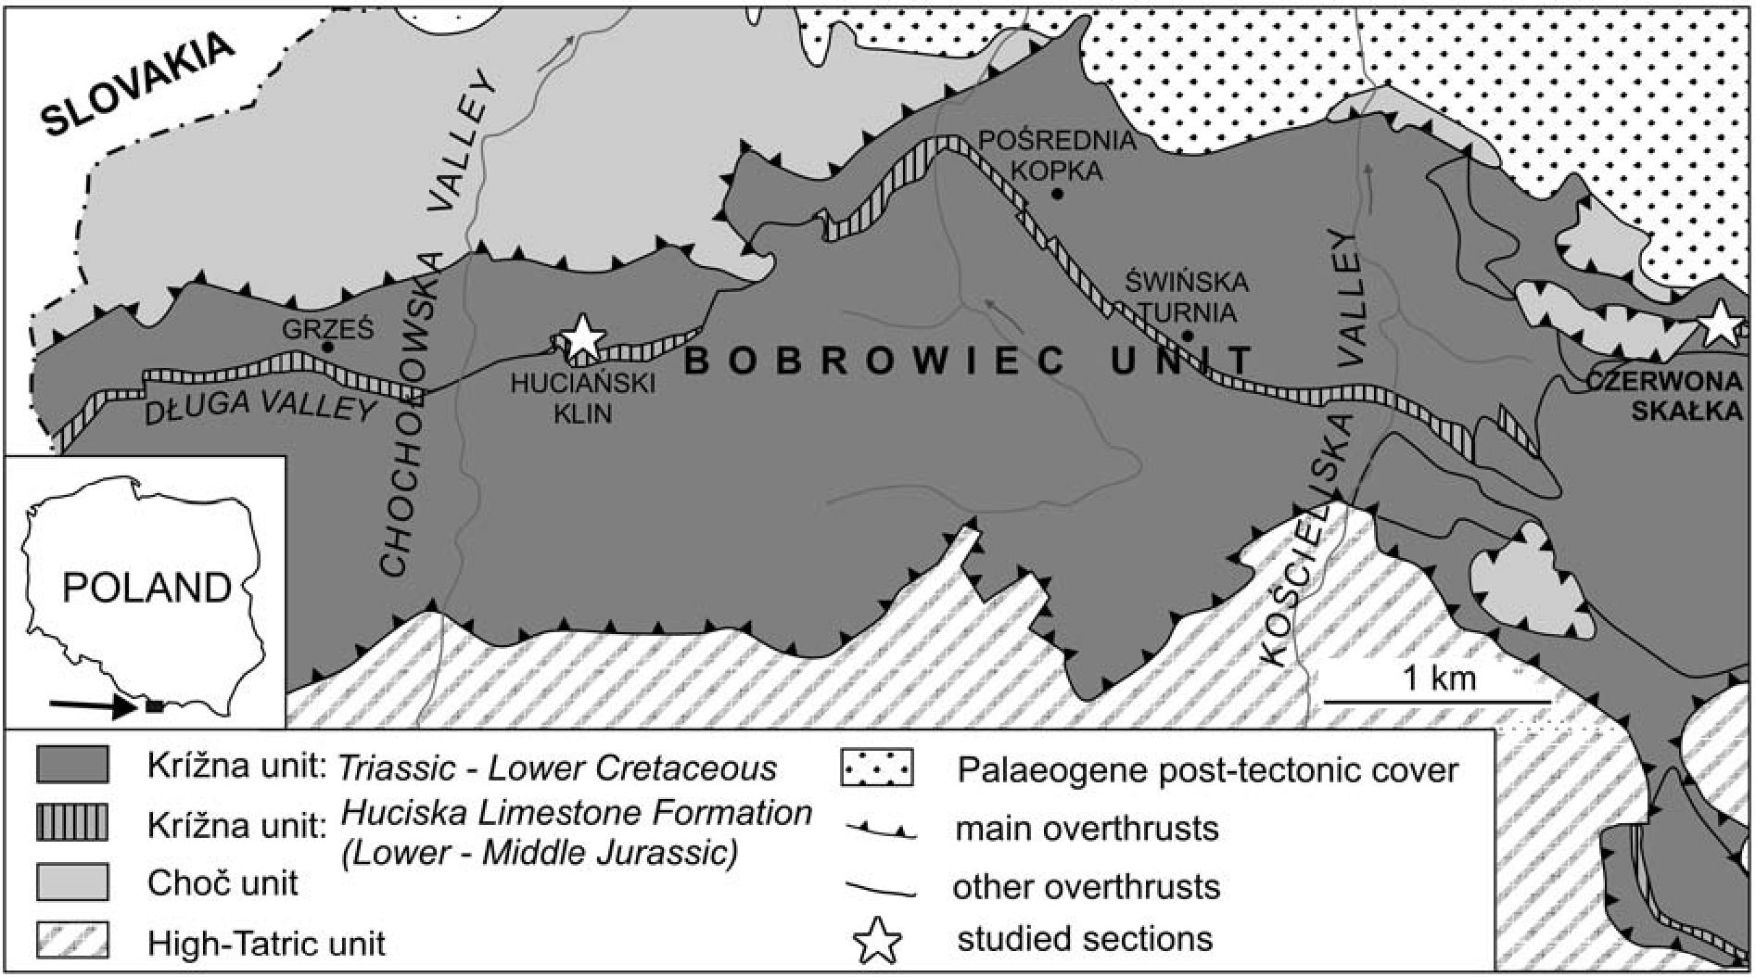
28
R. MYCZYŃSKI & R. JACH

Fig. 1. Geological sketch map of Polish part of the Western Tatra Mountains (after Bac-Moszaszwili et al. 1979, simplified) showing
location of the Huciański Klin and Czerwona Skałka sections
The Adnet type depostis form the lower part of the
Kliny Limestone Member belonging to Huciska Limestone
Formation (Lefeld et al., 1985). The member is7m thick in
the stratotype section at the Huciański Klin crest, north-east
of the Polana Huciska alp in the Chochołowska Valt ey in
the Western Tatra Mountains (Figs 2, 3; Lefeld et al., 1985).
Deposits of this member have been regarded as Middle
Toarcian-Aalenian in age (Lefeld et al., 1985; Myczyński
& Lefeld, 2003). The Adnet type depostis, represented by
limestones and marlstones, are up to 4 m thick and belong to
the lower part of the Kliny Limestone Member (Lefeld et
al., 1985). These deposits overlie crinoidal limestones
(Długa Encrintie Member) and locally, at Huciański Klin
crest, Mn-bearing depos its (Banie Ore Bed; Le teld et al.,
1985; Jach & Dudek, 2005). The age of crinoidal limestones
is estimated as Early Toarcian on the basis of their location
in the section and chemostratigraphic data (Krajewski et al.,
2001). The Adnet type deposits are covered by Bositra
limestones, up to 3 m thick. These limestones belong to the
upper part of the Kliny Limestone Member (Lefeld et al.,
1985). Their age is not precisely determined due to the lack
of diagnostic fossils; however, this facies in the Kriżna unit
is estimated as Aalenian-Early Bathonian in age (Bujnov-
sky & Polak, 1979; Jach, 2007). The Bositra limestones are
covered by nodul ar limes tones and radiol arites of Upper
Bathonian-Lower Kimmeridgian age (Polak et al., 1998).
During Early Jurassic time the Kriżna Basin was disin-
tegrated into several local basins and structural elevations.
Adnet type limestones and marlstones were formed mainly
at elevated parts of the basin. These deposits are partly nod-
utar (Fig. 2). Gradziński et al. (2004) distinguished six
microfacies within these deposits: crinoidal-ostracod pack-
stone, crinoidal packstone, crinoidal wackestone, marly
mudstone, Bositra packstone and Bositra-crinoidal pack-
stone. These deposits display finning-upward trend which is
accompanied by upward increasing abundance of micro-
borings. Structures such as stromatolites and ferruginous
microbial-foraminiferal macrooncoids, being the most
unique feature of these deposits, are abundant in the upper
part of the section (Gradziński et al., 2004). These features
are typical of condensed deposits (cf. Jenkyns, 1971).

PREVIOUS WORK
Adnet type deposits of the Kriżna unit became famous
mainly because of the iron ores, exploited in the 19th cen-
tury. Zejszner (1852) was the first who de t cribed fauna
from several localtiies of the Adnet type depostis in the
Western Tatra Mountains. He listed several ammonite spe-
cies from the Czerwona Skałka section. They are as follows:
Ammonites walcoti (Sowerby) (=Hildoceras bifrons (Bru-
guiere); Uhlig, 1897), A. serpentinus Schlotheim, A. buck-
landii (Sowerby), A. fimbriatus (Sowerby), A. heterophyllus
numismalis (Quenstedt), and Nautilus arratus (Schlotheim).
However, determination and localization of Ammonites
bucklandii (Sowerby) was later questioned by Sokołowski
(1925). Uhlig (1897) noted Harpoceras radians (Reinecke)
from the same outcrop. Moreover Sokołowski (1925) re i
ported from there: Hildoceras bifrons (Bruguiere), H. lae-
visoni (Simpson), Coeloceras commune (Sowerby), Lyto-
ceras aff. francisci (Oppel) and belemnite Passaloteuthis
paxillosus tripartitus (Schlotheim). From the Świńska Tur-
nia section Zejszner (1852) mentioned Ammonites cape-
llinus (Schlotheim) and A. variabilis (d’Orbigny). From the
some localtiy Sokołowski (1925) noticed Lioceras sp. and
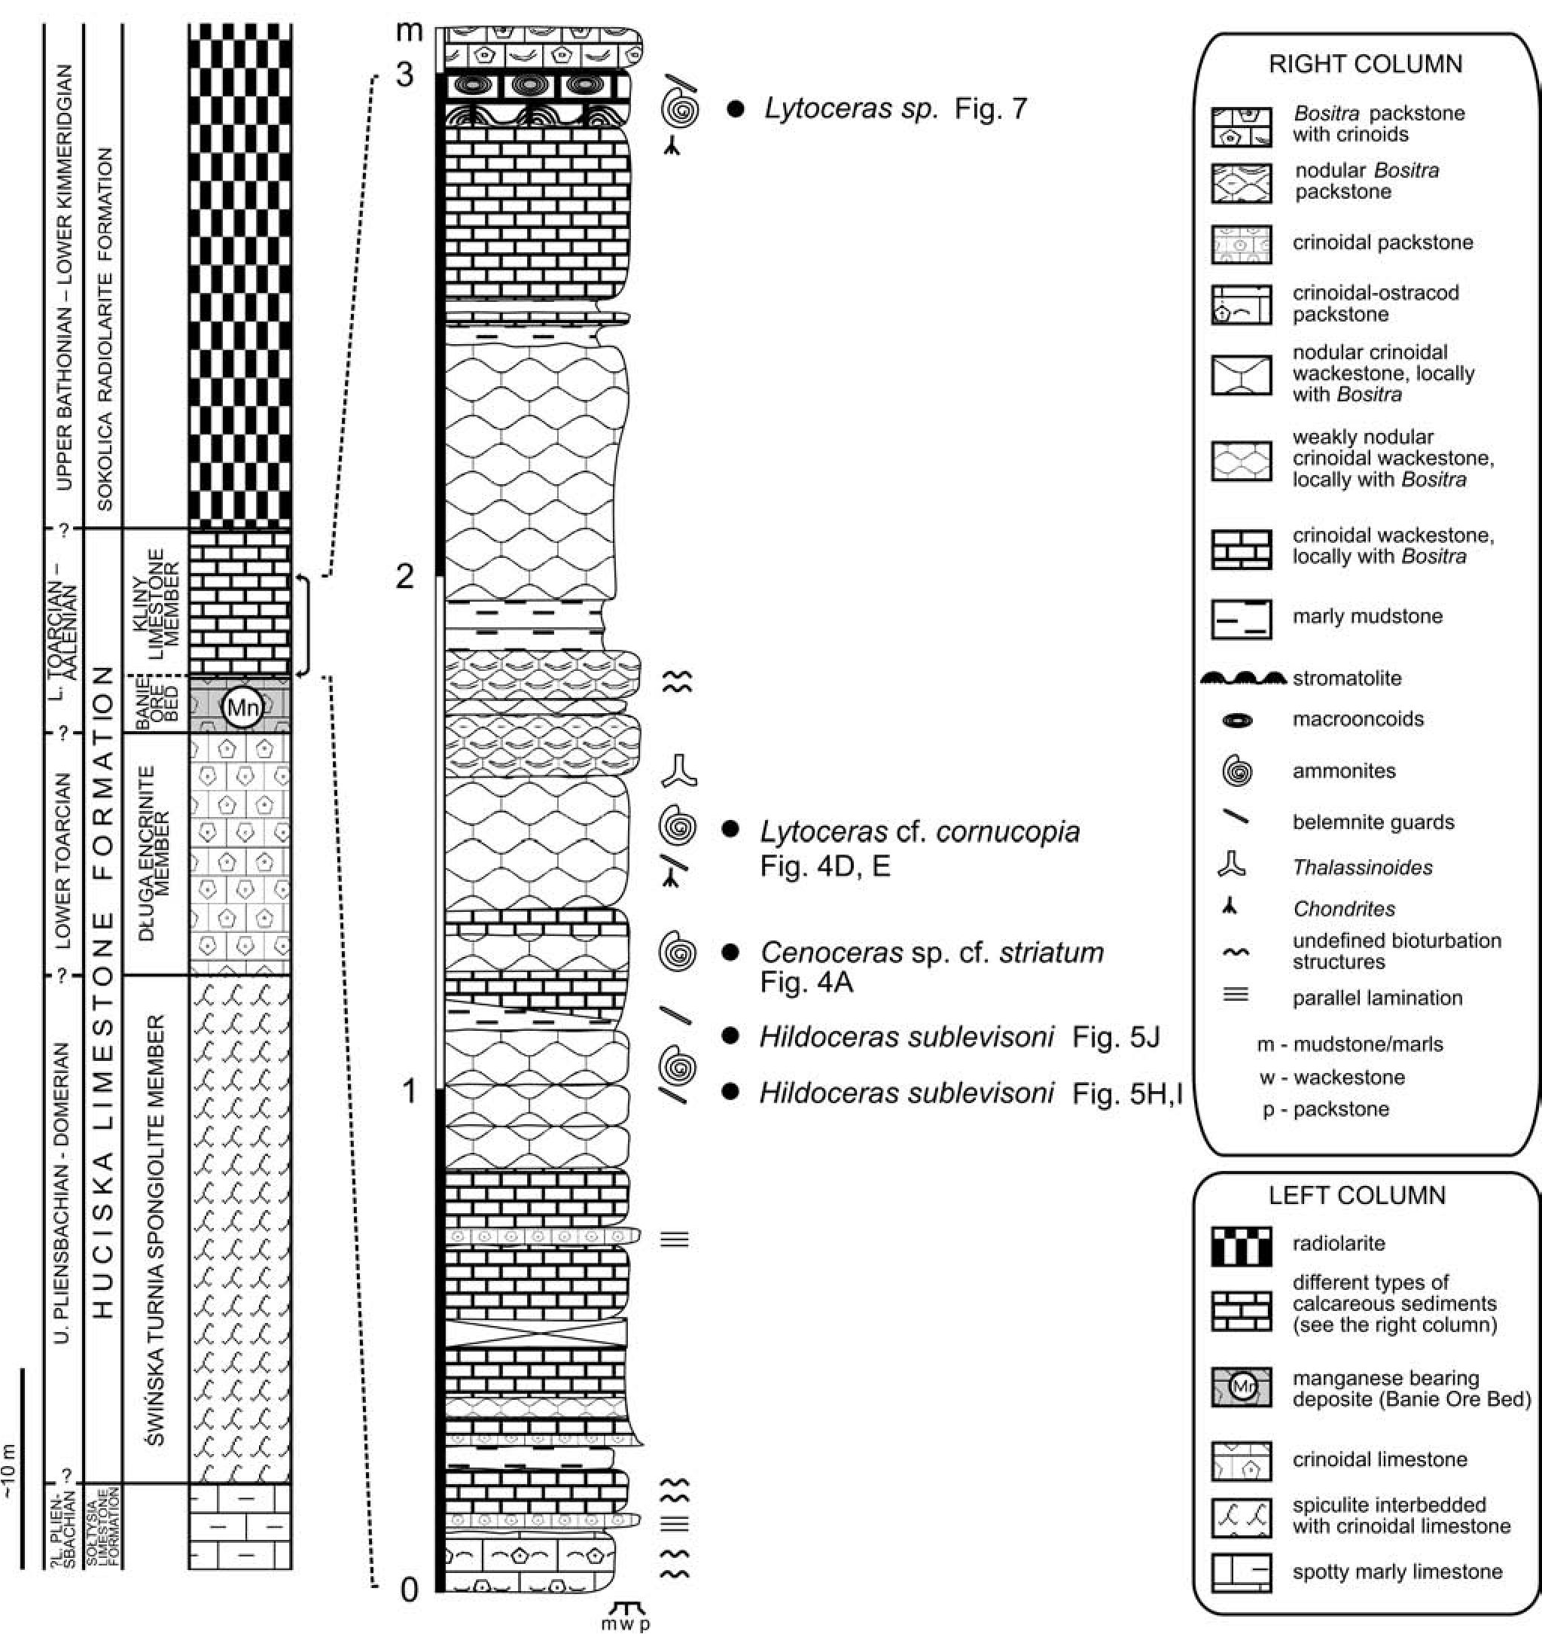
CEPHALOPOD FAUNA, TATRA MOUNTAINS
29

Fig. 2. Lithostratigraphic log of the Lower-Middle Jurassic depostis of the Kriżna unit and chronostratigraphic interpretation (after
Lefeld et al., 1985; left); lithological section of the cephalopod-bearing deposits at the Huciański Klin crest (after Gradziński et al., 2004;
right)
Hildoceras saemanni Dumortier. On the basis of those find-
ings, he estimated the age of Adnet type deposits as lower-
most Upper Liassic. Uhlig (1897) listed from the Huciański
Klin section the foUowmg taxa: Ammonites lilli Hauer, A.
bifrons (Bruguiere), A. serpentines (Reinecke), A.fimbria-
tus (Sowerby), A. variabilis (d’Orbigny), A. tatricus
(Pusch) and Nautilus semistriatus (d’Orbigny). Unfertig
nately, detailed location of the above listed ammonites
within sections became unknown. Moreover, it is difficult
to estimate quality of these determinations. It seems to be
necessary to revise the 19th century diagnosis of ammonites
assembled by Zejszner (1852) and Uhlig (1897), as well as
ammonites assembled later by Siemiradzki (1923).
The latest description of ammonites of the Adnet type
red limestones and marlstones was given by Myczyński and
Lefeld (2003). They described ammonites collected by the
second author and by Sokołowski (1925) and reported sev-
eral forms be!ongmg to Phyloceratidae, Lytoceratidae and
Hil- doceratidae families. From the Huciański Klin section
they described the following specimens: Calliphylloceras
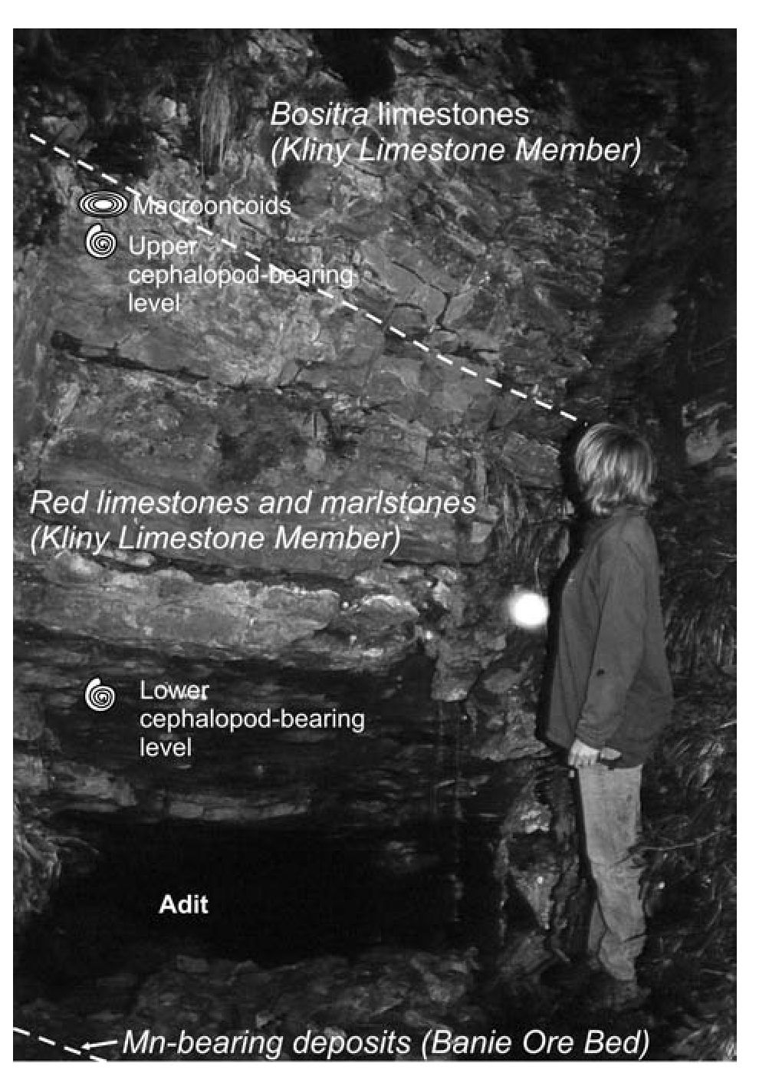
30
R. MYCZYŃSKI & R. JACH
nilssoni (Hebert), Cenoceras aff. striatum (Sowerby), Pa-
chylytoceras sp. gr. P. wrighti Buckman, additionally Har-
poceras serpentinum (Schlotheim) from the Świńska Turnia
section and Cenoceras sp., Phylloceras cf. baconicum
Prinz, Lytoceras fimbriatum (Sowerby) and Catulloceras
dumortieri (Thiolliere) from Czerwona Skałka at the Przy-
słop Miętusi. Moreover, from the Holica section (Eastern
Tatra Mountains), where Adnet type deposits also crop out,
following specimens were described: Calliphylloceras
nilssoni (Hebert), Calliphylloceras sp. gr. C. supraliasicum
(Pom- peckj), Lytoceras cf. cornucopia (Young et Bird),
Pachy- lytoceras sp. gr. P. wrighti Buckman.

MATERIAL AND METHODS
The studied macrofauna assemblage includes 22 speci-
mens. The described ammonites derived from two localt
ties, that is Huciański Klin and Czerwona Skałka at the
Przysłop Miętusi pass (Fig. 2). Generally, due to exploita-
tion of Mn-bearing deposits and ferruginous macrooncoids
in the 19th century the Adnet type deposts are relatively
well exposed, however, the coUapsmg of adits caused that
the sections are not complete. Macrofauna within these de-
posits has been mainly found in the small rock cliffs located
in the vicinity of the adits at the Huciański Klin crest and the
Czerwona Skałka. Adits numeration at the Huciański Klin
locahty presented in this paper is after Jach (2002). Other
sections of the Adnet type deposits can be regarded as refer-
ence sections (e.g., sections at Świńska Turnia, Pośrednia
Kopka and Grześ in the Długa Valley).
Macrofauna from the Huciański Klin section were col-
lected by the second author (R.J.). This collection is kept in
the Geol ogical Museum of the Institute of Geol ogical Sci-
ences, Jagiellonian University (collection number 201P).
The major part of this material was collected directly from
the outcrop and hence the fossils have precise location in the
section (Fig. 2). The stratigraphic position of the samples is
shown in Fig. 2. Only minor part of specimens from this
collection comes from the debris. The second collection de-
scribed here contains specimens assembled at the Czerwona
Skałka section by an anonymous coltector. This colt ection
is housed in the Geological Museum of the Institute of Geo-
logical Sciences, Pohsh Academy of Sciences in Kraków
(collection number ZNG PAN B-I-74). Specimens from this
collection are not accompanied by precise location in the
sec tion.
Classification of the ammonites is based on the papers
by Arkell (1950) and Arkell et al. (1957). The synonymy
list for particular species includes reference to the figured
type specimens and to more recent papers which present a
wider list of references.
The following measurements are used in the description
of ammonites: D - maximum diameter, Wh - whorl height,
Wb - whorl width; U - umbilical diameter, Wh/D - whorl
height/shell diameter, U/D - umbilical diameter/shell di-
ameter, Wb/Wh - whorl width/whorl height.
Fig. 3. Field view of the Huciański Klin locality. Section of the
Adnet type deposits visible in the entrance to the adit no. 7

RE SULTS
Systematic description of cephalopod fauna
Class CEPHALOPODA Cuvier 1798
Subclass NAUTILOIDEA Agassiz 1847
Family NAUTILIDAE d’Orbigny 1840
Genus Cenoceras Hyatt 1883
Type species Nautilus orbigny Prinz 1906
Cenoceras (Cenoceras) sp. cf. striatum (Sowerby 1817)
(Fig. 4A, B)
- Cenoceras stratus (Sowerby): Kümmel, p. 362, pl. 3, figs 1,
2
1964. Cenoceras stratum (Sowerby): Rakus, p. 95, pl. 16, figs 1, 2
Material: Two compressed fragments ofwhorl (201P/RJ5; Wb -
40 mm; ZNG PAN B-I-74/RJ14; Wh - 13 mm; Wb - 50 mm).
Description and remarks: Two ventrally compressed fragments
of the last whorl (Wb - 40 mm and 50 mm). Ventral side rounded.
Suture line is weakly visible, as not very diversified but have si-
nuses lobes (7 on the half whorl). Our specimens show similarity
in whorl shape and the character of suture line to Cenoceras
striatum (Sowerby), iltustrated and described by Kümmel (1956,
p. 362, pl. 3, figs 1, 2) and the specmen from the Pliensbachian
(Jamesoni Zone) of Rovne pod Kriżnou (Vefka Fatra, Slovak Re-
public), depicted by Rakus (1964, p. 95, pl. XVI, figs 1, 2). Poor
preservation of the specimens does not permit identification with
the Sowerby’s species without reservation.

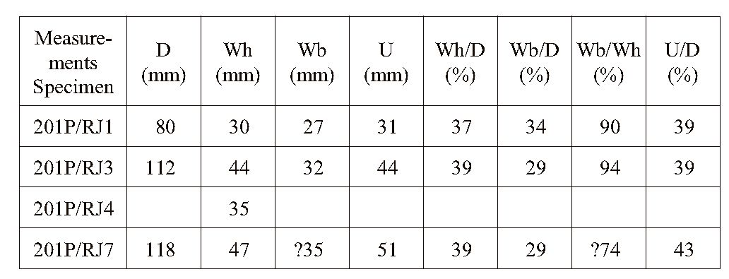
CEPHALOPOD FAUNA, TATRA MOUNTAINS
31
Oc cur rence: Our specimens were found in Adnet type deposits at
the Huciański Klin section (specimen 201P/RJ5, adit no. 7, posi-
tion in section see Fig. 2) and Czerwona Skałka (spedmen ZNG
PAN B-I-74/RJ14), Kriżna unit, Western Tatra Mountains. Ceno-
ceras striatum (Sowerby) is well known from Liassic deposits of
Europe (Rakus, 1964).
Order AMMONOIDEA Zittel 1884
Suborder PHYLLOCERATINA Arkell 1950
Super family PHYLLOCERATINAE Zittel 1884
Family PHYLLOCERATIDAE Zittel 1884
Genus Phylloceras Suess 1865
Type species Ammonites heterophyllus Sowerby 1819
Phylloceras ex gr. heterophyllum (Sowerby 1819)
(Fig. 4C)
- Ammonites heterophyllus Sowerby: p. 119, pl. 266
1976. Phylloceras (Phylloceras) heterophyllum (Sowerby):
Schlegelmilch, p. 25, pl. 1, figs 1, 2
1998. Phylloceras heterophyllum (Sowerby): Rulleau, p. 21, pl. 1,
figs 1-3; pl. 2, fig. 3; text-fig. 5-1
Material: One fragment ofwhorl ZNG PAN B-I-74/RJ28, Wh -
88 mm.
Description and remarks: One fragment of whorl with high-oval
whorl section, weakly convex sides and narrow rounded ventral
side. Maximal shell width is at half of the whorl height. No con-
strictions. These features are simüar to the ammonites presented
by the authors cited in the synonymy list. Poorly preserved suture
line is similar to the suture presented by Neumayr (1871, p. 12, fig.
1). Incomplete preservation of the specimen makes it impossible to
identify it unquestionably.
Occurrence: Czerwona Skałka, Kriżna unit, Western Tatra
Mountains. Phylloceras heterophyllum (Sowerby) is known from
the Serpentinum Zone to Bifrons Subzone (see Rulleau, 1998).
Suborder LYTOCERATINA Hyatt 1889
Superfamily LYTOCERATACEAE Neumayr 1875
Family LYTOCERATIDAE Neumayr 1875
Subfamily LYTOCERATINAE Neumayr 1875
Genus Lytoceras Suess 1865
Type species Ammonites fimbriatus Sowerby 1817
Lytoceras cf. cornucopia (Young etBird 1822)
(Fig. 4D-G)
1968. Lytoceras cornucopia (YoungetBird):Pinna, p.6,pl. 1, fig.
20; text-fig. 2.n.t., fig. 1
1976. Lytoceras cornucopia (Young et Bird): Schlegelmilch, p.
29, pl. 2, fig. 4
1998. Lytoceras cornucopia (Young et Bird): Rulleau, p. 38
Material: Three incomplete specimens (201P/RJ1; 201P/RJ3;
201P/RJ7) and one fragment of whorl (201P/RJ4), preserved as in-
ternal mould.
Dimensions:
De scription and re marks: The specimens are middle-sized with
obliterated sculpture. Whorls grow quickly. Whorl section is oval,
slightly broader than higher. Ventral side slightly flattened and
rounded. Whorl side is narrow and convex. Thicker megastriae oc-
cur cyclically. Shell surface uneven, with depressions and eleva-
tions, most probably remnants of primary morphology. In whorl
section, general shape and dimensions of the specimens are similar
to the ammonites illustrated by Geczy (1967, p. 72, pl. 19, fig. 1;
pl. 64, fig. 26) as Lytoceras cf. cornucopia (Young et Bird), to
those of Schlegelmilch (1976, p. 29, fig. 4) described as Lytoceras
cornucopia (Young et Bird), as well as those described by Rulleau
(1998, p. 39, figs 1-3; pl. 10, figs 1-3; pl. 11, figs 1-3; text-fig. 6
(3-5)) as Lytoceras cornucopia (Young et Bird). Due to poor state
of preservation, the studied specimens have been classified to this
species with reservation.
Oc cur rence: The specimens have been found in the debris and in
the section of the Adnet type deposits at the Huciański Klin section
(specimens 201P/RJ1 - RJ4, adit no. 7, position in the section see
Fig. 2; specimen 201P/RJ7, adit no. 5, collected in debris), Kriżna
unit, Western Tatra Mountains. The species Lytoceras cornucopia
(Young et Bird), to which our spedmen has been classified, is
known mainly from the Bifrons Zone of Europe (see Rulleau,
1998, p. 39).
Lytoceras cf. L. verpillierense Rulleau 1998
(Fig. 4H, I)
1998. Lytoceras verpillierense Rulleau: Rulleau, p. 42, pl. 12, figs
4-6; pl. 35, figs 5-6; text-fig. 6-2
Material: two fragments ofwhorl (201P/RJ10; Wh- 51 mm; Wb
- 33 mm; ZNG PAN B-I-74/RJ13, Wh - 50 mm).
De scription and re marks: Whorl sect ion is highly oval. Whorl
side is slightly convex. Ventral side is rounded. Weakly marked
constriction is visible on whorl side. The suture line is poorly pre-
served. Incompleteness of the spedmen makes its exact determi-
nation impossible. In its transverse section, and with the presence
of constriction, it seems to stand close to Lytoceras verpillierense
Rulleau (see Rulleau, 1998).
Oc cur rence: Spec imen 201P/RJ10 was found at the Huciański
Klin section (adit no. 7, coltected in debris) and spedmen ZNG
PAN B-I-74/RJ13 at the Czerwona Skałka, Kriżna unit, Western
Tatra Mountains. The species Lytoceras verpillierense Rulleau is
known from the Bifrons Zone of France (Rulleau, 1998).
Superfamily EODEROCERATACEAE Arkell 1950
Family DACTYLIOCERATIDAE Hyatt 1867
Subfamily DACTYLIOCERATINAE Hyatt 1867
Genus Nodicoeloceras Buckman 1926
Type species Ammonites crassoides Simpson 1855
Nodicoeloceras cf. crassoides (Simpson 1855)
(Fig. 5A)
1963. Nodicoeloceras cf. crassoides (Simpson): Zanzzuchi, p.
117, pl. 14, figs 8, 8a
1976. Nodicoeloceras cf. crassoides (Simpson):Schlegelmilch, p.
78, pl. 39, fig. 4
Material: One incomplete spedmen (ZNG PAN B-I-74/RJ18;
Wh = 17 mm).
De scription and re marks: Shell serpenticone, with elipsoidal
cross section of the whorl. Whorl side convex. Ventral side
rounded, slightly flattened. Umbilical margin rounded. Umbilical
wall inclined. Umbilicus moderately wide and deep. Ornamenta-
tion consists of the moderately robust, slightly backward inclined,
simple, primary ribs bifurcated on the ventro-lateral margin. Sec-
ondary bifurcate ribs are slightly weaker then the primary ones.

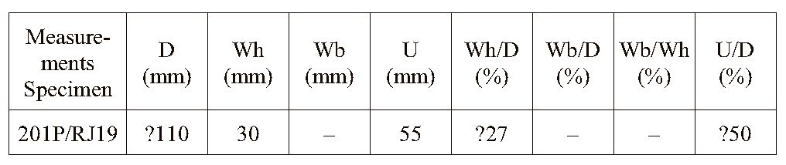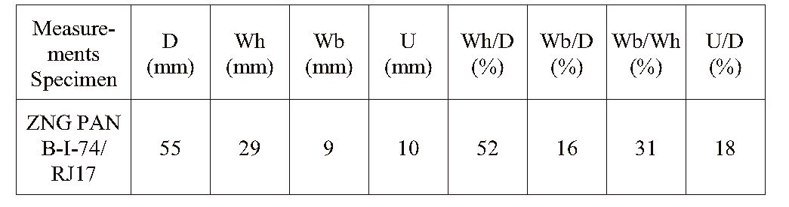
32
R. MYCZYŃSKI & R. JACH
Small tubercles occur in the bifurcation point. The shape of the
shell and ornamentation of specimen is very similar to the species
Nodicoeloceras crassoides (Simpson), which was described and
illustrated by Zanzzuchi (1963) and Schlegelmilch (1976). How-
ever, the incomplete preservation of it makes unquestionable de-
termination to this species impossible.
Occurrence: Czerwona Skałka section, Kriżna unit, Western
Tatra Mountains. Species Nodicoeloceras crassoides (Simpson) is
known from the Exaratum Zone (actual Serpentinum Zone) of
England (Schlegelmilch, 1976).
Superfamily HILDOCERATACEAE Hyatt 1867
Family HILDOCERATIDAE Hyatt 1867
Subfamily PHYMATOCERATINAE Hyatt 1867
Genus Phymatoceras Hyatt 1867
Type species Phymatoceras robustum Hyatt 1867 =
Ammonites tirolensis Dumortier 1874
Phymatoceras cf. robustum Hyatt 1867
(Fig. 5B)
- Phymatoceras robustum Hyatt: Arkell, p. L265, fig. 302
1966. Phymatoceras robustum Hyatt: Geczy, p. 16, pl. 1, fig. 2; pl.
37, fig. 1
1968. Phymatoceras robustum Hyatt: Pelosio, p. 156, pl. 21, fig. 1
a-c
- Phymatoceras robustum Hyatt: Gabilly,1975, p. 45, pl. 1,
figs 6-8, 12 = Phymatoceras cf. robustum Hyatt
Material: One specimen (201P/RJ19).
Dimensions:
Description and remarks: Shell evolute with slowly growtng
whorls. It has a subtrapezoidal cross section. Whorl side is slightly
convex. Ventral side wide, slightly flattened and rounded with
keel. Umbilical margin rounded. Umbilical wall almost vertical.
Umbilicus wide and shallow. Ornamentation consists of the retro-
verse, simple and united ribs (about 10 on the 1/4 of the whorl).
The points of the ribs union are marked by presence of massive tu-
bercles projected on the umbilical margin. Deep constriction is
present. Shape and ornamentation of the specimen well respond to
the characteristic features of the species Phymatoceras robustum
Hyatt (see Arkell, 1957; Geczy, 1966; Pelosio, 1968 and Ga-
billy,1975) but incomplete preservation of specimen does not per-
mit admittedly to refer it to Hyatt’s species.
Occurrence: Specimen 201P/RJ19 was collected in debris at the
Huciański Klin section, Kriżna unit, Western Tatra Mountains.
Species is known from the Bifrons Zone of NW Europe and Medi-
terranean area (Gabilly, 1975; Elmi et al., 1997).
Superfamily HILDOCERATACEAE Hyatt 1967
Family HILDOCERATIDAE Hyatt 1867
Subfamily HARPOCERATINAE Neumayr 1875
Genus Cleviceras Howarth 1992
Type species Ammonites exaratum Young & Bird 1828
Cleviceras elegans (Sowerby 1815)
(Fig. 5C)
1815. Ammonites elegans Sowerby: p. 213, pl. 94
1976. Harpoceras elegans (Sowerby): Schlegelmilch, p. 87, pl.
45, fig. 6
1992. Cleviceras elegans (Sowerby): Howarth, p. 100, pl. 12, figs
6-19; pl. 13, fig. 3; pl. 14, figs 1-17; pl. 15, figs 1, 2; text-figs
16, 18D, 19D, 21, 22
Material: One specimen (ZNG PAN B-I-74/RJ17).
Dimensions:
De scription: Specimen is involute, small-sized microconch (D =
about 60 mm) with compressed whorl section, higher whorls, slop-
ing umbilical walls and small umbilicus. Ventral side narrow with
keel. Ornamentation preserved only on the body-chamber which
consists of the weak falcoid ribs. Suture line is poorly preserved.
Remarks: General shape of the spedmen and its characteristics
such as dimensions, sloping umbilical walls, narrow umbilicus,
and weak ornamentation well justify classification of it to Cle-
viceras elegans (Sowerby). The described spedmen corresponds
well to the descriptions and illustrations of this species shown in
the papers given in the synonymy list.
Occurrence: Czerwona Skałka section, Kriżna unit, Western
Tatra Mountains. Species Cleviceras elegans (Sowerby) is known
from the Falciferum Subzone (Serpentinum Zone) of Engl and,
Germany and Switzerland (Howarth, 1992).
Genus Harpoceras Waagen, 1869
Type species Ammonites falcifer Sowerby 1820
Harpoceras ex gr. falciferum (J. Sowerby 1820)
(Fig. 5D-F)
- Ammonites falcifer Sowerby: p. 99, pl. 254, fig. 2
1885. Harpoceras lythensis gigas Quenstedt: p. 353, pl. 43, figs
10, 11
1976. Harpoceras falciferum (Sowerby): Schlegelmilch, p. 86, pl.
45, fig. 4
1992. Harpoceras falciferum (Sowerby): Howarth, p. 119, pl. 18,
fig. 3; pl. 19, figs 2-4; pl. 20, figs 1-11; text-figs 18F, 19B,
27-34 (with given synonymy list)
Material: Three fragments ofwhorl (ZNG PAN B-I-74/RJ24, Wh
►
Fig. 4. A - Cenoceras sp. cf. striatum (Sowerby, 1817). Huciański Klin section, adit no. 7, specimen 201P/RJ5; B - Cenoceras sp. cf.
striatum (Sowerby, 1817); lateral and ventral view of the specimen. Czerwona Skałka, specimen ZNG PAN B-I-74/RJ14; C - Phylloceras
ex gr. heterophyllum (Sowerby, 1817). Czerwona Skałka, specimen ZNG PAN B-I-74/RJ28; D, E - Lytoceras cf. cornucopia (Young et
Bird, 1822). Huciański Klin section, adit no. 7, specimens 201P/RJ1 and 201P/RJ3; F - Lytoceras cf. cornucopia (Young et Bird, 1822).
Huciański Klin, adit no. 5, specimen 201P/RJ7; G - Lytoceras cf. cornucopia (Young et Bird, 1822). Huciański Klin, adit no. 7, specimen
201P/RJ4; H - Lytoceras sp. cf. L. verpillierense Rulleau, 1998. Czerwona Skałka, specimen ZNG PAN B-I-74/RJ13; I - Lytoceras sp. cf.
L. verpillierense Rulleau, 1998. Huciański Klin, adit no. 7, specimen 201P/RJ10

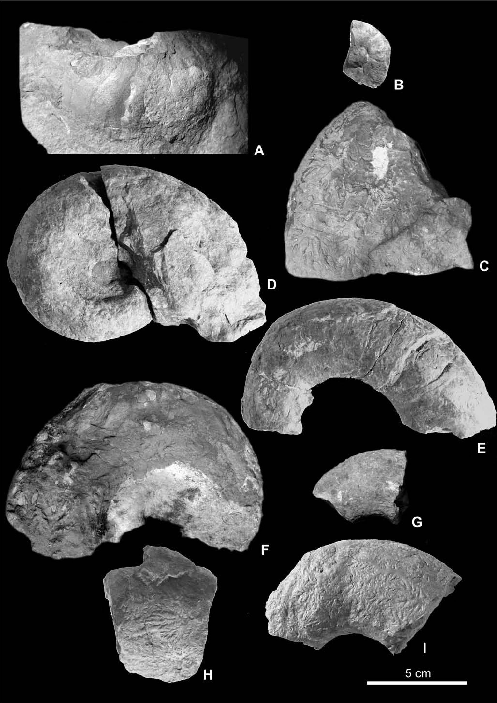
CEPHALOPOD FAUNA, TATRA MOUNTAINS
33

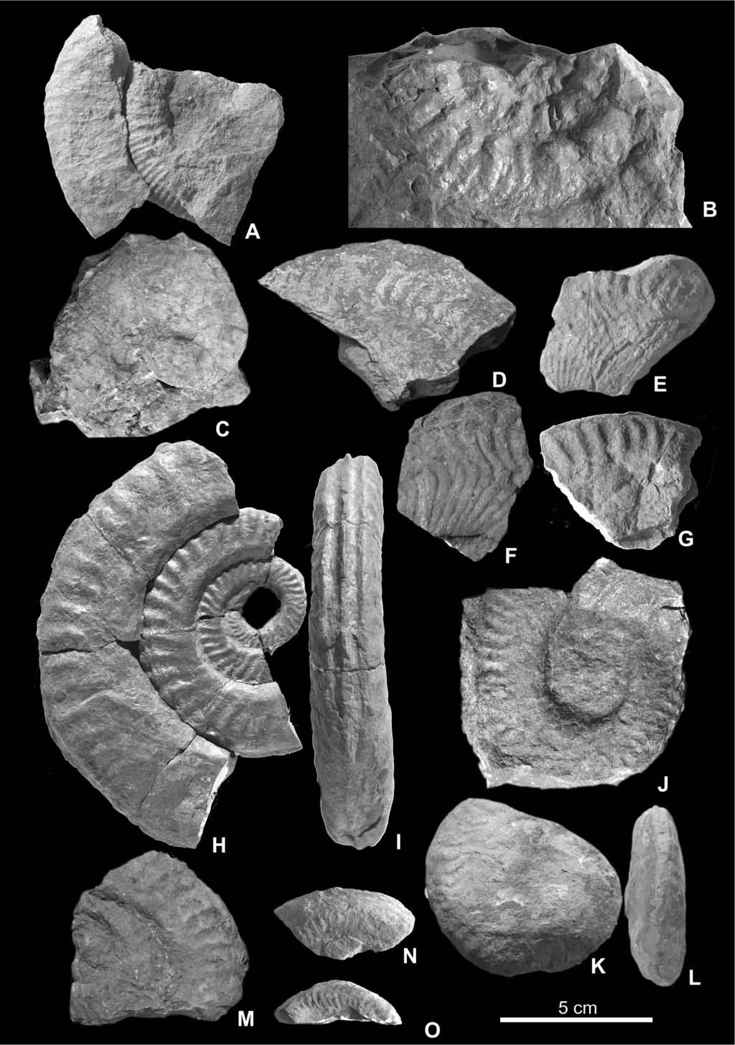
34
R. MYCZYŃSKI & R. JACH

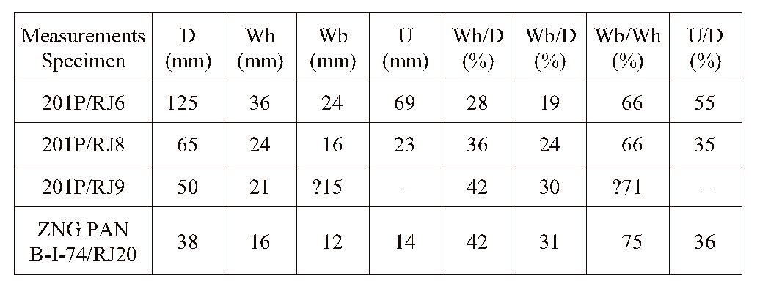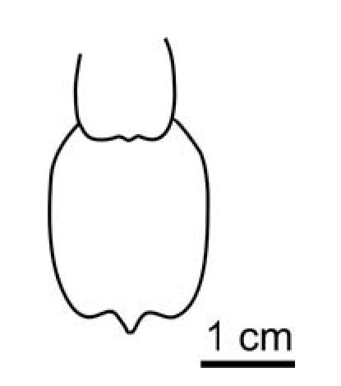
CEPHALOPOD FAUNA, TATRA MOUNTAINS
35
Fig. 5. A - Nodicoeloceras cf. crassoides (Simpson, 1855). Czerwona Skałka, specimen ZNG PAN B-I-74/RJ18; B - Phymatoceras
cf. robustum Hyatt, 1867. Huciański Klin, adit no. 5, specimen 201P/RJ19; C - Cleviceras elegans (Sowerby, 1815). Czerwona Skałka,
spedmen ZNG PAN B-I-74/RJ17; D-F - Harpoceras ex gr. falciferum (Sowerby, 1820). Czerwona Skałka, spedmens ZNG PAN
B-I-74/RJ24, ZNG PAN B-I-74/26 and ZNG PAN B-I-74/27; G - Hildoceras sublevisoni Fucini, 1919; Czerwona Skałka, specimen ZNG
PAN B-I-74/RJ16; H, I - Hildoceras sublevisoni Fucini, 1919; lateral (H) and ventral (I) view of the specimen. Huciański Klin, adit no. 7,
specimen 201P/RJ6; J - Hildoceras sublevisoni Fucini, 1919; Huciański Klin, adit no. 7, spedmen 201P/RJ8; K, L - Hildoceras
sublevisoni Fucini, 1919; lateral (K) and ventral (L) view of the specimen. Huciański Klin, adit no. 4, spedmen 201P/RJ9; M-O -
Hildoceras sublevisoni Fucini, 1919; Czerwona Skałka, spedmens ZNG PAN B-I-74/RJ20, ZNG PAN B-I-74/RJ11 and ZNG PAN
B-I-74/RJ12
<
- 48 mm; ZNG PAN B-I-74/RJ26, Wh - 41 mm; ZNG PAN
B-I-74/RJ27, Wh - 40 mm).
De scription and re marks: Three fragments of whorl with flat-
tened transverse section and weakly convex sides. Ribs wavy and
dense, robust on the ventro-lateral part of the whorl. Character of
ornamentation agrees well with that of Harpoceras falciferum
(Sowerby) as given in the papers cited in the synonymy list.
Occurrence: The spedmens come from Czerwona Skałka sect
tion, Kriżna unit, Western Tatra Mountains. The species Harpo-
ceras falciferum (Sowerby) is known from the Falciferum Sub-
zone of Serpentinum Zone and Bifrons Zone of Great Britain,
France, Luxembourg, Germany, Switzerland, Greece, Caucasus,
NE Siberia and New Zealand (Howarth, 1992).
Subfamily HILDOCERATINAE Hyatt 1867
Genus Hildoceras Hyatt 1867
Type species Ammonites bifrons Bruguiere 1789
Hildoceras sublevisoni Fucini 1919
(Fig. 5G-O; Fig. 6)
1972. Hildoceras sublevisoni (Fucini): Guex, pl. VI, fig. 2
- Hildoceras (Hildoceras) sublevisoni Fucini: Schlegel-
milch, p. 85, pl. 43, fig. 6
1990. Hildoceras sublevisoni (Fucini): Goy et Martinez, p. 23, pl.
2, fig. 1
2002. Hildoceras sublevisoni Fucini: Neige et Rouget, p. 772, figs
4 C-E; 8 D-F
Material: Four spedmens preserved as internal moulds (201P/
RJ6; 201P/RJ8; 201P/RJ9; ZNG PAN B-I-74/RJ20) and three
fragments of the whorl (ZNG PAN B-I-74/RJ11, Wh - 23; ZNG
PAN B-I-74/RJ12, Wh - 24 mm; ZNG PAN B-I-74/RJ16).
Dimensions:
Description: Small-sized, evolute spedmens, with subquadrate
whorl section and broad tricarinate-bisulcate venter. Umbihcal
margin is rounded. Umbilical wall inclined, almost vertical. Umbi-
licus is wide (201P/RJ6) and moderately wide (only in 201P/RJ8
specimen; in 201P/RJ9 umbilicus is covered). Dorsal area smooth
and not very conspicuous. Spiral groove on the side of the whorl
not present. Robust ornamentation, similar to that of Hildoceras
bifrons is represented by moderately dense, strongly backward ar-
cuate ribs on the outer two-thirds of the whorl.
Fig. 6. Whorl sections of Hildoceras sublevisoni Fucini, 1919;
specimen 201P/RJ6
Re marks: The ammonites described here as species Hildoceras
sublevisoni Fucini,1919 are also similar to the species Hildoceras
bifrons (Bruguiere) but differ from it in the lack of spiral groove
on the whorl side. Our spedmens indicate also simüarity to the
species Hildoceras lusitanicum Meister but differ by more reduced
dorsal smooth area.
Occurrence: The spedmens were found at the Huciański Klin
section in the adits no. 7 and no. 4 (specimens 201P/RJ6 and
201P/RJ8, adit no. 7, position in the section see Fig. 2; specimen
201P/RJ9, adit no. 4, coltected in debris). Specimens ZNG PAN
B-I-74/RJ11, ZNG PAN B-I-74/RJ12 and ZNG PAN B-I-74/RJ20
were collected at the Czerwona Skałka section, Kriżna unit, West-
ern Tatra Mountains. The species Hildoceras sublevisoni Fucini is
known from the Lower Toarcian (Sublevisoni Subzone of the
Bifrons Zone; Goy & Martinez, 1990; Elmi et al., 1997).

Cephalopod fauna state of preservation
Macrofauna of the Adnet type deposits at the Huciański
Klin section occurs in two well defined levels. Ammonites
are accompanied by other nektonic fauna remains, such as
nautiloids, belemnites and fish teeth (Gradziński et al.,
2004). The lower cephalopod-bearing level occurs in the
middle part of the section built of partly nodular red lime-
stones alternated with marlstones (Fig. 2). Ammonites and
nauti- loids occur as complete calcareous concretionary in-
ternal moulds of light-red colour with visMe suture line;
however, they were fragmented while have been collected.
Their state of preservation is poor or moderately good, de-
spite the fact that no signs of reworking, abrasion or round-
ness have been observed. Macrofauna is hori zont ally ori-
ented, mainly with no evidence of compaction. Internal sed-
iment of moulds is different in texture from the sedimentary
matrix. Moulds are composed of mudstones with rare frag-
ments of Bositra shells and echinoderms, whereas matrix is

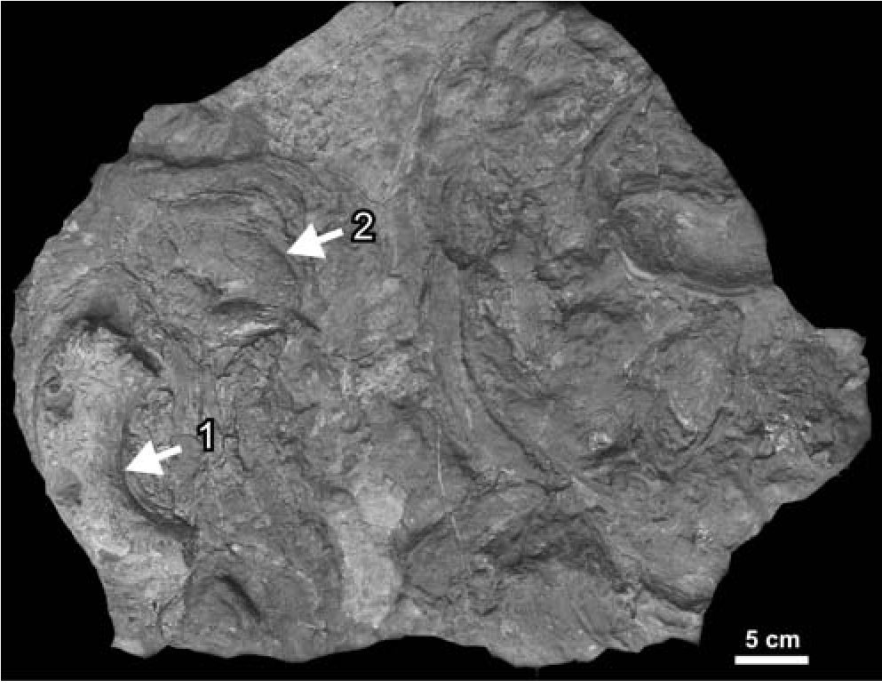
36
R. MYCZYŃSKI & R. JACH

represented by Bositra packstones. The boundary between
moulds and matrix is sharp.
The upper cephalopod-bearing level occurs in the up-
permost part of the Adnet type deposit section. This level
has the charact er of condensed bed. Its surface is accentu-
ated by accumulation of ferruginous microbial-forami-
niferal macrooncoids and fragmented int ernal moulds of
ammonites, locally covered by stromatolites or thin Fe
crusts. It was noticed that ammonite fragments often formed
nudei of macrooncoids (cf. Zejszner, 1852). Ammonite
fauna from this level is far less diverse than from the lower
level, because it is represented almost exclusively by Lyto-
ceras sp. Internal moulds of phragmocones are dommant
fossils. The state of preservation of ammonites is relatively
poor. Accumulated elements are usually fragmented, but
bear no signs of roundmg. Some of spedmens have pre i
served calcified shells, especially those encrusted by micro-
bial stromatolite (Fig. 7). Internal sedment fillmg moulds
differs slightly from host deposits. It is composed of wacke-
stones with abundant juvenile ammonites, rare Bositra
shells and fragmented echinoderm spines, while wacke-
stone type host deposit cont ains echinoderms and bivalve
shell fragments, juvenile ammonites and foraminifers.

DISCUSSION

Taphonomy
A few metres thick Adnet type deposts of the Kriżna
unit in the Western Tatra Mountains include moderately di-
verse cephalopod fauna. Preservation of specimens from the
lower cephalopod-bearing level as concretionary internal
moulds filled with mudstone endosed by Bositra pack-
stones proves early lithification processes (Fig. 2). Internal
moulds bearing no signs of roundmg or abrasion indicate
that they were not influenced by reworking. Only host sedi-
ment was affected by winnowing. This process is also evi-
denced by accumulation of Bositra shells in the host deposit
(cf. Jach, 2007). Probably larger specimens such as ammo-
nites were not influenced by weak currents while lying on
the seafloor. This level does not show clearly visMe fea-
tures of condensation; however, Bositra packstone type sed-
iment is indicative of low rate of sedimentation and a low-
energy setting (Jach, 2007).
The upper cephalopod-bearing level, which has the
character of condensed bed, contains mainly Lytoceras sp.
Generally, ammonite fauna of this level shows a very high
proportion of incomplete phragmocones (Fig. 7). Fragmen-
tation of the shells evidences their reworking. This process
was probably related to resedimentation (i.e., displacement
on the sea bottom be tore their burial) than reelaboration
(i.e., exhumation and displacement before their final burial;
terminology after Fernandez-López, 2007). Ammonite frag-
ments show no traces of roundness, which evi dences that
turbulence near water/sediment surface was relatively low
(cf. Fernandez-López, 2007). Aragonitic shells of some
specimens were not dissolved exclusively in the case of that
encrustated by a stromatolite (cf. Jenkyns, 1971; Pallini et
al., 2003-2004).
Adnet type deposits of the Kriżna unit are interpreted as
laid down in pelagic conditions during gradual deepening of
the basin. This is proved by vertical trends described within
the section (Gradziński et al., 2004). As deposits of the up-
per part of the section, with distontinuity surfaces with
ammonites and macrooncoids, developed in the elevated
parts of the basin, probably in a perched subbasin, therefore
ammonites of this level must have been resedimented only
in situ (cf. Pallini et al., 2003-2004). They were broken and
reworked during long-lasting sedimentary break. Uncom-
pacted ammonite shells testify early lithification of their in-
ternal sediment, whereas low sedimentation rate is proved
by ferruginous macrooncoids and stromatolites, Fe crusts,
fine-grained sediment removal and macrofauna concen-
tration.

Re marks on stra tig ra phy
The fauna in question occurs in two levels, but only
lower one has stratigraphic importance. Nevertheless, scar-
city of biostratigraphic data within Jurassic deposhs of the
Kriżna unit causes that new data are of special importance.
Howtver, the lack of stratigraphically ditgnostic fostils
hindered precise age determination of under- and overlying
deposits; Bositra limestones are ascribed to the Aalenian-
Lower Bathonian since they are covered by Upper Batho-
nian-Lower Kimmeridgian radiolarites (Polak et al., 1998;
Jach, 2007).
The described ammonite assemblage of the Adnet type
deposits includes species belonging to the families: Phylo-
ceratidae, Lytoceratidae, Hildoceratidae and Dactylioce-
ratidae. Some of the described spedmens from the Adnet
type deposits have not been yet reported from the Kriżna se-
quence, for extmple Cleviceras elegans (Sowerby). Re i
corded ammonite association from lower cephalopod-bear-
ing level shows abundant spedmens correspondmg to the
upper Lower Toarcian Serpentinum Zone and lower Middle
Toarcian Bifrons Zones. The Serpentinum Zone may be re-
cognised by occurrence of Harpoceras serpentinum (Schlo-
Fig. 7. Lytoceras sp. moulds (1) and shells (2) partly covered
with stromatolites. Huciański Klin section
CEPHALOPOD FAUNA, TATRA MOUNTAINS
37
theim), Phylloceras ex gr. heterophyllum (Sowerby), Cle-
viceras elegans (Sowerby), Harpoceras falciferum (So-
werby) and Nodicoeloceras cf. crassoides Simpson (see
also Myczyński & Lefeld, 2003; cf. Elmi et al., 1997). Mid-
dle Toarcian Sublevisoni Subzone of the Bifrons Zone is
characterized by the occurrence of Hildoceras sublevisoni
Fucini and Harpoceras falciferum (Sowerby). The Bifrons
Subzone (Lusitanicum, Apertum and Bifrons horizons) is
recognized on the basis of Phylloceras ex gr. heterophyllum
(Sowerby), Phymatoceras cf. robustum Hyatt, Lytoceras cf.
cornucopiae (Young et Bird) and Hildoceras bifrons
(Bruguiere) (see also Zejszner, 1952; Sokołowski, 1925;
Myczyński & Lefeld, 2003). Other age indicators described
by previous authors are Harpoceras serpentinum (Schlot-
heim) and Hildoceras bifrons (Bruguiere) (Zejszner, 1852;
Myczyński & Lefeld, 2003).
The Adnet type deposits in the whole Kriżna Batin
have strongly diachronic lower boundary (Misik & Rakus,
1964). The record of beginning of their sedimentation is no-
ticed from Lotharingian, based on the occurrence of Aste-
roceras obtusum (Sowerby), Echioceras raricostatum (Zie-
ten), Oxynticeras oxynotum (Quenstedt), to the Middle
Toarcian based on Hildoceras bifrons (Bruguiere) as it was
evidenced in the papers by Rakus (1964) and Misik and
Rakus (1964). The Hildoceras sublevisoni Fucini from the
Adnet type deposits in the Huciański Klin section derive
from the middle part of the section, that is from the lower
cephalopod-bearing level, and it corresponds in age to the
Middle Toarcian Sublevisoni Subzone of the Bifrons Zone.
However, Lower Toarcian Serpentinum Zone could be rec-
ognized on the baiis of ammonites derived form debris.
Therefore the lower age range may be estimated as Lower
Toarcian Serpentinum Zone.
Dumortieria cf. levesquei (Orbigny) and Catulloceras
aff. dumortieri (Thiolliere), which indicate Late Toarcian,
evidenced the youngest Adnet type deposits known from
the Kriżna unit (Rakus, 1964; Bujnovsky & Polak, 1979).
Similarly, Late Toarcian age of these deposits in the West-
ern Tatra Mountains was proved by the occurrence of
Catulloceras cf. dumortieri from the Czerwona Skałka sec-
tion (Myczyński & Lefeld, 2003). However, the location of
this ammonite in the section is not known. These data make
it possible to estimate the upper age range of the Adnet type
deposits as Late Toarcian (Levesquei Subzone of the Pseu-
doradiosa Zone; Elmi et al., 1997). However, one cannot
exclude their younger age, since the stratigraphically impor-
tant fauna is not known from the uppermost part of these de-
posits. This part comprises discontinuity surfaces, pointing
to its ori gin in the condition of low sediment ation rate.
Moreover, overlying Bositra limestones, do not contain di-
agnostic fauna fossils either.
The Toarcian was a period when long lasting provincio-
nalism between the North-Western Europe and Mediterra-
nean Domains really existed. The only exceptions were the
Middle Toarcian Bifrons Zone andUpper Toarcian Aalensis
Zone periods. The Middle Toarcian Bifrons Zone is a mo-
ment of unification of ammonite assemblages in the North-
Western Europe and Mediterranean Domains (Elmi et al.,
1997). The Kriżna Basin was an integrate part of the Tethys
Ocean which was connected with the epicontinental sea of
the North-Western Europe. Fluctuation of these connec i
tions during Toarcian caused that the influence of North-
Western Europe ammonite taxa is observed in Late Toar-
cian sediments in the Kriżna Basin (Rakus, 1964). In spite
of the fact that Middle Toarcian Bifrons Zone is a period of
ammonite fauna unification within the North-Western Eu-
rope and Mediterranean Domains, the studied ammonite
fauna represents taxonomic composition typical of the Me-
diterranean Province (cf. Geczy & Szente, 2006 and refer-
ences cited herein).

CON CLU SIONS
Two cephalopod-bearing levels were recognized within
the Adnet type red deposits of the Kriżna unit in the West-
ern Tatra Mountains. The Serpentinum Zone of the Early
Toarcian were identified only on the basis of ammonite as-
semblage collected from the debris. The Middle Toarcian
Sublevisoni and Bifrons Subzones of Bifrons Zone were
recognized on the baiis of ammonites derived from the
lower cephalopod-bearing level in the Huciański Klin sec-
tions. The upper age range of Adnet type deposits repre i
sents the Late Toarcian (probably Levesquei Subzone of the
Pseudoradiosa Zone) due to occurrence of characteristic
taxa mentioned by previous authors. Therefore, the Adnet
type deposits of the Kriżna unit in the Western Tatra Moun-
tains rep re sents Serpentinum Zone of the Early Toarcian -
Pseudoradiosa Zone of the Late Toarcian.
Ammonites and nautiloids are preserved as internal
moulds or resedimented internal moulds rarely with relicts
of shells. The latter are related to low sedimentation rate due
to deposition at the elevated parts of the Kriżna Basin. The
determined ammonite assemblage is closely related to fauna
of the Mediterranean Domain.

Acknowledgement
Thanks are due to Cyprian Kulicki from the Institute of
Palaeobiology of the Polish Academy of Sciences for making pho-
tographs of ammonites used as illustrations in this paper. We are
also grateful to the authority of the Tatra National Park for giving
the permission for the field work. The authors thank for providing
the access to the ammonite collections of the Geological Museum
of the Institute of Geoiogical Sciences, Polish Academy of Sci-
ences in Kraków. The paper has benefited from valuable com-
ments and constructive criticism by the reviewers Prof. Andrzej
Wierzbowski and Dr. Jan Schlögl.

REFERENCES
Arkell, W. J., 1950. A classification of the Jutassic ammonites.
Journal of Palaeontology, 24: 354-364.
Arkell, W. J., Kümmel, B. & Wright, C. W., 1957. Me tozoic
Ammonoidea. In: Moore, R. C. (ed.), Trea tise on In ver te brate
Paleontology, Part L. Mollusca (4), Cephalopoda, Ammo-
noidea. Geological Society of America and University of
Kansas Press, Lawrence, pp. 29-402.
Bac, M., 1971. Tektonika jednostki Bobrowca w Tatrach Za-
chodnich. Acta Geologica Polonica, 21: 279-315.
38
R. MYCZYŃSKI & R. JACH
Bac-Moszaszwili, M., Burchart, J., Głazek, J., Iwanow, A.,
Jaroszewski, W., Kotański, Z., Lefeld, J., Mastella, L.,
Ozimkowski, W., Roniewicz, P., Skupiński, A. & West-
walewicz-Mogilska, E., 1979. Geological map of the Polish
Tatra Mountains 1:30000. Wydawnictwa Geologiczne.
Warszawa.
Böhm, F., Ebli, O., Krystyn, L., Lobitzer, H., Rakus, M. & Siblik,
M., 1999. Fauna, stratigraphy and depositional environment
of the Hettangian-Sinemurian (Early Jurassic) of Adnet (Salz-
burg, Austria). Abhandlungen der Geologischen Bundes-
anstalt, 56: 143-271.
Bujnovsky, A. & Polak, M., 1979. Korelacia mezozoickych lito-
stratigrafickych jednotiek Malej Fatry, Vehkej Fatry a sz.
casti Nizkych Tatier. Geologickeprace, Spravy, 72: 77-96.
Elmi, S., Rulleau, L., Gabilly, J. & Mouterde, R., 1997. 4 -
Toarcien, In: Cariou, E. & Hantzpergue, P. (eds), Bio-
stratigraphie du Jurassique Ouest-Europeen et Medite-
rraneen: Zonations paralleles et distribution des invertebres
et microfossiles. Bulletin du Centre de Recherches Elf Explo-
ration Production, Memoire, 17: 25-36.
Fernandez-López, S., 2007. Ammonoid taphonomy, palaeoenvi-
ronments and sequence stratigraphy at the Bajocian/Batho-
nian boundary on the Bas Auran area (Subalpine Basin,
south-eastern France). Lethaia, 40: 377-391.
Gabilly, J., 1975. Evolution et systematique des Phymatoceratinae
et des Grammoceratinae (Hildocerataceae, Ammonitia) de la
region de Thouars, stratotype du Toarcien. Memoires de la
Societe Geologique de France, Nouvelle Serie, 54: 1-196.
Geczy, B., 1966. Ammonoides jurassiques de Csernye, Montagne
Bakony, Hongrie. Part I (Hammatoceratidae). Geologia Hun-
garica, Series Palaeontologica, 34: 1-275.
Geczy, B., 1967. Ammonoides jurassiques de Csernye, Montagne
Bakony, Hongrie. Part II (excl. Hammatoceratidae). Geologia
Hungarica, Series Palaeontologica, 35: 1-413.
Geczy, B. & Szente, I., 2006. Middle Toarcian Ammonitina from
the Gerecse Mts, Hungary. Acta Geologica Hungarica, 49:
223-252.
Goy, A. & Martinez, G., 1990. Biozonación del Toarciense en el
area de la Almunia de Dońa Godina-Ricla (Sector Central de
la Cordillera Iberica). Cuadernos de Geologia Iberica, 14:
11-53.
Gradziński, M., Tyszka, J., Uchman, A. & Jach R., 2004. Large
microbial-foraminiferal oncoids from condensed Lower -
Middle Jurassic deposits: A case study from the Tatra Moun-
tains, Poland. Palaeogeography, Palaeoclimatology, Palaeo-
ecology, 213: 133-151.
Guex, J., 1972. Repartition biostratigraphique des ammonitesdu
Toarcien moyen de la bordure sud des Causses (France) et
revisiondes ammonites descrites et figurees par Monestier
(1931). Ecloge Geologicae Helvetiae, 65: 611-645.
Howarth, M. K., 1992. The Ammonite fami ly Hildoceratidae in
the Lower Jurassic of Britain. Monograph of the Palaeonto-
graphical Society, part 2, 146: 107-200.
Jach, R., 2002. Traces of historical exploitation of manganiferous
ores in the Western Tatra Mountains. (In Polish, English sum-
mary). Przegląd Geologiczny, 50: 1159-1164.
Jach, R., 2005. Storm-dominated deposition of the Lower Jurassic
crinoidal limestone in the Kriżna unit, Western Tatra Moun-
tains, Poland. Facies, 50: 561-572.
Jach, R. & Dudek, T., 2005. Origin of a Toarcian manganese car-
bonate/silicate deposits from the Kriżna Unit, Tatra Moun-
tains, Poland. Chemical Geology, 224: 136-152.
Jach, R., 2007. Bositra limestones - a step towards radiolarites:
case study from the Tatra Mountains. Annales Societatis Geo-
logorum Poloniae, 77: 161-170.
Jenkyns, H., 1971. The genetis of condensed sequences in the
Tethyan Jurassic. Lethaia, 4: 327-352.
Krajewski, K. P., Lefeld, J. & Łącka, B., 2001. Early diagenetic
processes in the format ion of carbonate-hosted Mn ore de-
posit (Lower Jurassic, Tatra Mountains) as indicated from its
carbon isotopic record. Bulletin ofthe Polish Academy ofSci-
ences, Earth Sciences, 49: 13-29.
Kümmel, B., 1956. Post-Triassic Nautiloid genera. Bulletin of the
Museum of Comparative Zoology at Harvard College, Cam-
bridge, 114: 319-494.
Lefeld, J., Gaździcki, A., Iwanow, A., Krajewski, K. & Wójcik,
K., 1985. Jurassic and Cretaceous litostratigraphic units in the
Tatra Mountains. Studia Geologica Polonica, 84: 7-93.
Martire, L., 1996. Stratigraphy, facies and synsedimentary tecton-
ics in the Jurassic Rosso Ammonitico Veronese (Altopiano di
Asiago, NE Italy). Facies, 35: 209-236.
Misik, M. & Rakus, M., 1964. Bemerkungen zu räumlichen Bezie-
hungen des Lias und zur Paläogeographie des Mesozoikum in
der Grossen Fatra. Sbornik Geologickych Vied, Zapadne Kar-
paty, 1: 157-199.
Myczyński, R. & Lefeld, J., 2003. Toarcian ammonites (Adneth
facies) from the Subtatric Succession of the Tatra Mts (West-
ern Tatra Carpathians). Studia Geologica Polonica, 121: 51-
79.
Neige, P. & Rouget, I., 2002. Les ammonites du Toarcien de
Chantonnay (Vendee, France) analyse paleontologique, bio-
stratigraphie et reflexion sur les Hildoceratinae. Geodiver-
sitas, 24: 765-784.
Neumayer, M., 1871. Jura studien, 3. Die Phylloceraten des
Dogger und Malm. Jahrbuch der Kaiserlich-Königlichen
Geologischen Reichsanstalt, Wien, 21: 297-378.
Pallini, G., Elmi, S. & Gasparri, F., 2003-2004. Late Toarcian -
Late Aalenian ammonites assemblage from Mt. Magaggiaro
(Western Sicily, Italy). GeologicaRomana, 37: 1-66.
Pelosio, G., 1968. Ammoniti del Lias superiore (Toarciano)
dell’Alpe Turati (Erba, Como). Part IV: generi Hildoceras,
Phymatoceras, Paroniceras e Frechiella. Conclusioni gene-
rali. Memorie della Societa Italiana di Science Naturali e del
Museo Civico di Storia Naturale di Milano, 17: 143-204.
Pinna, G., 1968. Ammoniti del Lias superiore (Toarciano)
dell’Alpe Turati (Ebra, Como). Part III: famiglie Lyto-
ceratidae, Nannolytoceratidae, Hammatoceratidae (excl.
Phymatoceratidae), Hildoceratidae (excl. Hildoceratinae e
Bouleiceratinae). Memorie della Societa italiana di Scienze
naturali e del Museo Civico di Storia naturale di Milano,
Milano, 17: 1-69.
Polak, M., Ondrejickova, A. & Wieczorek, J., 1998. Lithostrati-
graphy of the Zdiar Formation of the Kriżna nappe. Slovak
Geological Magazine, 4: 35-52.
Quensted, F. A., 1885. Die Ammoniten des Schwäbischen Jura. I,
Der Schwarze Jura (Lias). pp. 241-440.
Rakus, M., 1964. Paläontologische Studien im Lias der Grossen
Fatra und des westlichen Teils der Niederen Tatra. Sbornik
Geologickych Vied, Zapadne Karpaty, 1: 93-199.
Rulleau, L., 1998. Evolution et systematique des Phylloceratidae
et des Lytoceratidae du Toarcien et du Dogger inferieur de la
region Lyonnaise. Documents des Laboratoires de Geologie
Lyon, 149: 1-167.
Schlegelmilch, R., 1976. Die Ammoniten des süddeutschen Lias.
Fischer Verlag, Stuttgart, 212 pp.
Siemiradzki, J., 1923. Fauna utworów liasowych i jurajskich Tatr
i Podhala. Towarzystwo Naukowe, Lwów, 52 pp.
Sokołowski, S., 1925. Beobachtungen über das Alter und die
Entwicklung des subtatrischen Lias im Tatragebirge. (In
Polish, German summary). Rocznik Polskiego Towarzystwa
CEPHALOPOD FAUNA, TATRA MOUNTAINS
39
Geologicznego, 2: 78-84.
Sowerby, J., 1815. The Mineral conchology of Great Britain. Tay-
lor, London, 2: 1-28.
Sowerby, J., 1819. The Mineral conchology of Great Britain. Tay-
lor, London, 3: 1-186.
Sowerby, J., 1820. The Mineral conchology of Great Britain. Tay-
lor, London, 3: 254-271.
Tucker, M. E. & Wright, V. P., 1990. Carbonate Sedimentology.
Blackwell, Oxford, 482 pp.
Uhlig, V., 1897. Die Geologie des Tatragebirges. I. Einleitung und
stratigraphischer Teil. Denkschrifte der Akademie Wissen-
schaftliche in Wien, Matematische-Naturwissentschaftliche
Klasse, 64: 643-684.
Wieczorek, J., 1983. Uwagi o facji “ammonitico rosso”. (In
Polish, Engl ish summary). Przegląd Geologiczny, 31: 247-
252.
Zanzzuchi, G., 1963. Le Ammoniti del Lias superiore (Toarciano)
di Entratico in val Cavallina (Bergamasco orientale).
Memorie della Societa Italiana di Science Naturali e del
Museo Civico di Storia Naturale di Milano, 13: 101-146.
Zejszner, L., 1852. Monograficzny opis wapienia liasowego w
Tatrach i przyległych pasmach karpackich. (In Polish).
Rocznik Towarzystwa Nauk, Oddział Nauk Przyrodniczych i
Lekarskich, 6: 157-343.

