



Magn Reson MaterPhy
DOI 10.1007/s10334-016-0563-2
MRI-based assessment ofliverperfusion and hepatocyte injury
in the murine model of acute hepatitis
KatarzynaByk1·KrzysztofJasinski1·ZanetaBartel1·AgnieszkaJasztal2·BarbaraSitek2·BoguslawTomanek1,3·StefanChlopicki2,4·TomaszSkorka1
Received:14 February 2016 /Revised:9April 2016 /Accepted: 20April 2016
©TheAuthor(s) 2016.This article is published with open access at Springerlink.com
Abstract
ObjectiveToassessalterationsinperfusionandliverfunc-tionintheconcanavalinA(ConA)-inducedmousemodelofacuteliverfailure(ALF)usingtwomagneticresonanceimaging(MRI)-basedmethods:dynamiccontrast-enhancedMRI(DCE-MRI)withGd-EOB-DTPAcontrastagentandarterial spin labelling (ASL).
MaterialsandmethodsBALB/cmicewerestudiedusinga
9.4TMRIsystem.TheIntraGateFLASHTMandFAIR-EPIpulsesequenceswereusedforoptimummouseabdomenimaging.
ResultsTheaverageperfusionvaluesfortheliverofthecontrolandConAgroupwereequalto245±20and200±32ml/min/100g(p=0.008,respectively).DCE-MRIshowedthatthetimetothepeakoftheimageenhancementwas6.14±1.07minand9.72±1.69mininthecontrolandConAgroup(p<0.001,respectively),
whiletherateofthecontrastwash-outinthecontrolandConAgroupwas0.037±0.008and0.021±0.008min−1(p=0.004,respectively).TheseresultswereconsistentwithhepatocyteinjuryintheConA-treatedmiceascon-
firmedbyhistopathologicalstaining.

ConclusionsBoththeASLandDCE-MRItechniquesrep-resentareliablemethodologytoassessalterationsinliverperfusion andhepatocyteintegrityin murine hepatitis.
KeywordsAcuteliverfailure·Arterialspinlabelling·DCE-MRI·Empiricalmathematicalmodelling·Perfusion
Introduction
Acuteliverfailureisadiseaseassociatedwithhighmor-talityandmultiorgandysfunction[1].TheaetiologyofALFiscomplex[2]asitcanbecausedbyviruses,reac-tionstodrugs,vasculardiseasesormetabolicsyndromes[2,3].ALFisassociatedwithaprimaryliverdysfunction,activationofpro-inflammatoryresponsesincludingpro-inflammatorycytokines,acutephaseproteins[4],andacti-vationofliversinusoidalendothelialcells(LSEC),Kupffercellsandrecruitmentofimmunecells[5].ALFinvariablyleadstothelossofhepatocyteintegrityasmirroredbytheelevatedlevelsoftheliverspecificenzymes[alanineami-notransferase(ALT)andaspartateaminotransferase(AST)]inblood[6].Italsoinfluencesthefunctionalstateoftheliverleadingtohaemodynamicdisturbances,inappropriatevasodilatationand reduction of perfusion [7–9].
TheConA-inducedmodelofALFwasoriginallyusedforstudiesofthepathophysiologyoflymphocyteT-dependentliverinjuryandinpre-clinicalstudiesonliverinflammation[10].ConA–inducedhepatitisinvolvescooperativeactivationofnaturalkillerT(NKT)withcon-ventionalTcellsandKupffercellsandIL-4-,TNF-α-andIFN-γ-mediatedliverinflammationinmicewithsubse-quentdevelopmentofhepatocellularapoptosisandnecrosis[10–12]thateventuallyresultsinendotheliumdisintegra-tion and necrosis ofhepatocytes[10].
*
TomaszSkorkaTomasz.Skorka@ifj.edu.pl
1
Department of Magnetic Resonance Imaging, Institute
of NuclearPhysics,PolishAcademy of Sciences,Krakow,Poland
Jagiellonian Centre for ExperimentalTherapeutics (JCET),JagiellonianUniversity,Krakow,Poland
Divisionof MedicalPhysics,Department ofOncology,UniversityofAlberta, Edmonton,Alberta, Canada
Department of ExperimentalPharmacology,Chair
ofPharmacology,MedicalCollege,JagiellonianUniversity,Krakow,Poland
2
3
4
13
RESEARCHARTICLE

Magn Reson MaterPhy
MRI-basedmethodscanbeappliedforthequantitativemeasurementofliverfunctioninhepatitisusingsmallani-malsmodels;howeverthestudiesarechallengingbecauseofthelowsignal-to-noiseratioandrespiratoryartefacts.AnimalswithadvancedALFmaydevelopcomplicationssuchasacutelunginjuryorrespiratorydistresssyndrome[1]causinguncontrolledmotionandthusfurtherimagedis-tortions.Thereforeproperpulsesequencesmustbeselectedto ensure optimum imagequality.
ComplexdiagnosisofALFincludesinvestigationofhepatocyteintegrityandliverperfusion.TheMRItech-nique,arterialspinlabelling(ASL),wasdevelopedforperfusionmeasurements[13].Thedouble-triggeredflow-sensitivealternatinginversionrecovery(FAIR)[14]withrapidsingle-shotechoplanarimaging(EPI)acquisitionisaparticulartypeofASL.FAIRregistersbloodinflowsfromdifferentdirections[14];thereforeitisadvantageousoverothertypesofASLmodalitiesforperfusionimagingoftheliverwithacomplexmicrocirculatorybed.Moreo-ver,theFAIR-EPItechniqueallowsobtainingmapsofthe
T1relaxationtime,whichwaspreviouslyreportedasanindicatorofliverdisease[15,16].DCE-MRIwasusedinstudiesofliverinjury[17,18],butwasalsoreportedto
beusefulforassessmentofperfusionchanges[19,20].TheT1-weightedfastgradientechosequencesareusedforDCE-MRI,buttheyneedtriggering.Thereforetheself-gatedIntraGateFLASHTM[21]techniqueseemsvaluableespeciallyforsmallanimalimaging.Thissequenceallowscontinuousscanninginsteady-stateconditionsandretro-spectiveremovalofthedataalteredbyrespirationartifacts.IntraGateFLASHTMhasbeenusedinstudiesofmouseheartmapping[22]andmousecholangiography[23],forexample.
The aim of ourworkwasto measure perfusion andhepatocyteinjuryinthemousemodelofacutehepatitisinducedwithConAwiththeuseoftwocomplementaryMRI-basedmethods.Alterationsinthehepatocyteintegrityandfunctionalstateofmicrocirculationoftheliverwereassessedastheyareimportantfactorsdeterminingliverfunction and response toinjury.
kgb.w.ConAin1Mphosphate-bufferedsaline(PBS),andthecontrolgroupreceivedthesamevolumeofsaline.Themicewerefedastandardlaboratorydietandweremain-tainedina12-hlight/darkcycleat23°Ctemperature.AllprocedureswereapprovedbythelocalEthicsCommitteeonAnimalTesting.
MRI
TheMRIexperimentswereperformedusinga9.4T/21-cm(BioSpec94/20USR,Bruker,Germany)horizontalscannerequippedwithahigh-performancegradientsystemanda36-mm-diameter1Hquadraturetransmit/receiveradio-fre-quency(RF)volumecoil.
Theanimalswereanesthetisedwith2%isofluraneinamixtureofairandoxygendeliveredviaanosecone.Theanestheticwasreducedto1.7%whenanimalswereplacedinthemagnet.Electrocardiography(ECG),respirationandtemperatureweremonitoredwiththeMonitoringandGat-ingSystem(SAInstrumentsInc.,StonyBrook,NY,USA).Bodytemperaturewasmaintainedat37°C.Theanimalswereplacedproneandmaintainedthroughouttheexperi-ments,usually2.5hlong.BeforetheMRIexperiments375µlofsalinewasinjectedintraperitoneallytopreventdehydration.Acatheterwasinsertedintothetailveinforcontrast agent administration.
Theimagingslicewaspositionedperpendicularlytothelargebloodvessels(aorta,venacavaand postalvein).
ASLimagingwasconductedusingtheFAIR-EPIpulsesequence(Fig.1)withthefollowingparam-eters:TE=6.324ms,TR=8000ms,NA=4,
FOV=45×30mm,matrixsize=96×64,slicethick-
ness=1mm,selectiveinversionslicethickness=2.5mmand10inversionrecoverytimes(IRs)from50to4500ms.
Fatsuppressionwasusedwithafrequencyselective90°pulse.Thetotalmeasurementtimewasapproximately10 min.
DCE-MRIwasperformedusingtheIntraGateFLASH™sequencewiththefollowingparameters:TE=0.838ms,TR=4.212ms,NA=1500or200,flipangle=18°,
FOV=30×30mm,matrixsize=128×128,slicethickness=1mmandnavigatorslicethickness=8mm.
Thetotalmeasurementtimewas90min;10µl/1gb.w.of0.0025Mhepatotropicgadolinium-basedcontrastagent(Primovist®,BayerScheringPharmaAG,Germany)[24]wasinjectedintothetailvein2minafterthefirstimageacquisition.MRimageswerecollectedinthreeseries(150imageseach),each10minlong,atotalof30min,toobservethecontrastuptakeandthemaximumenhancementoflivertissuewithhightemporalresolution;1500averageswereusedforeachseries.Duringtheremaining1h,oneimagewasacquiredevery10 min with 200averages.
Materials and methods
Animals studies
Fourteen3-month-oldBALB/cmicewereusedinthisstudy.AcutehepatitiswasinducedbyConA(Sigma-Aldrich,USA)administeredintravenously.MRImeas-urementswereperformed24hafterConAinjection.Theanimals weredividedinto the control and ConA group
(n=7ineachgroup).Thetreatedgroupreceived8mg/
13

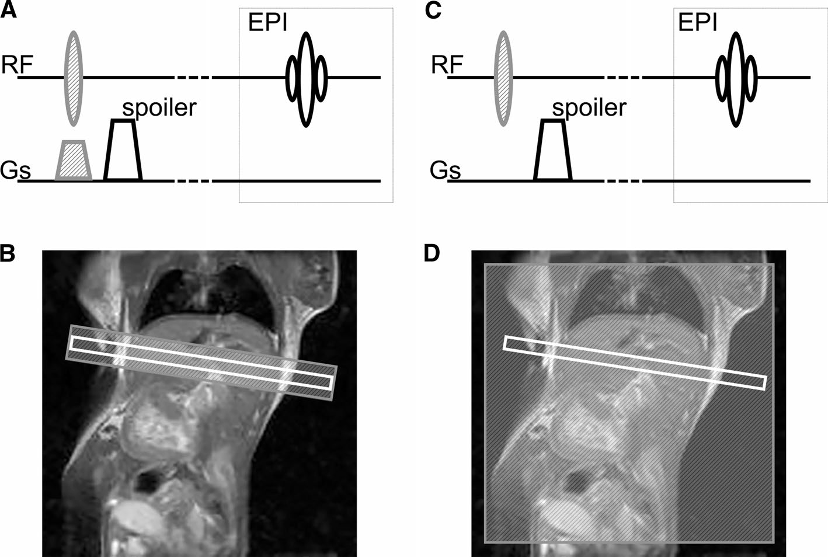
Magn Reson MaterPhy
Fig.1TheFAIRpulsesequencewithEPIreadout.TwoMRimagesarenecessaryforperfusionimaging,onewithselective(a,b)andonewithnon-selectiveinversionofspins(c,d).aTheRFpulseisappliedsimultaneouslywiththesliceselectivegradient(shadedgrey)fortheselectiveinversionofspins.Theslicegradientisfollowedbythespoilergradientformagnetisationrefocussing.bTheselective
inversioniswiderthantheselectedslice(inwhite)toensureuniforminversion.cAsacontrolimage,theRFpulseisappliedwithouttheslice-selectivegradientprovidingexcitationofallspins.dTheareaofnon-selectiveinversioncoverstheentiresensitiveregionoftheRFcoil.TheFAIRpulsesequenceisfollowedbytheEPIsequencetocreate the MR image [14]
ImmediatelyaftertheMRexperimentstheanimalswerekilled,bloodwascollectedforanalysis,andtheliverswereharvestedfor histological staining.
−γt
C(t)=A·(1−e−αt)q·e−βt·1+e ,
2
whereAistheupperlimitofthesignal,αistherateofthecontrastuptake(1/min),βistherateofthecontrastwash-out(1/min),γistheinitialrateofthecontrastwash-out(1/min),andqistheparameterrelatedtotheslopeoftheearlyuptakeandthecurvatureofthetransitionfromuptaketowash-out.Fouradditionalparameterswerealsocalculated:
Data analysis
PerfusionandT1mapswerecreatedusingASLPerfusionMacrosoftware(ParaVision5.1,Bruker,Germany).TheT1valueswereobtainedfromthecontrolT1mapswithnon-selectivespininversion.Thethresholdwasappliedtothe
perfusionmapstorejectfalsevalues(higherthan500ml/min/100gornegative).ImageJsoftware(NIH,USA)wasusedforthethresholding.Threeregionsofinterest(ROI)placed in theliverparenchymawere used for analysis.
ThetimecoursesoftheDCE-MRIimageswerepro-cessedwithImageJ.Anoval-shapedROIcomprising137pixelsforeachMRimagewasplacedintherightliverlobe.Themeanvalues(±SD)ofthesignalintensitieswithinROIswerecalculatedforeachimage.Thedatawerepro-
cessedwithOriginPro8.6.0(OriginLab,MA,USA).Thesignal-timecurveswerenormalisedbyaveragingthesig-nalvaluesofthepre-contrastimagesandsubtractingtheaveragevaluefromtheentiretimecourse.Thefinalcurveswerefittedwiththeempiricalmathematicalmodel(EMM)proposed byFanet al. [25]:
timetopeak
[Tpeak,
(min)],enhancementslope[ES,(1/
min)],areaunderthecurve(AUC)andeliminationhalf-lifetime[T1/2,(min)].TpeakwascalculatedaccordingtotheformulaproposedbyFanetal.[25].ESwascalculatedas
theratioofCmax/Tpeak,whereCmaxwasdetermineddirectlyfromthesignal-timegraph.AUCwascomputedfromtime0–90min.TheT1/2wasassessedbyfittingtheexponentialcurveto thewash-outslope.
Biochemical and histopathological analysis
FollowingtheMRmeasurementsbloodsampleswereobtainedfromtherenalveinonethylenediaminetetraaceticacid(EDTA)andcentrifugedfor10minat1000gatatem-peratureof4°C(Sigma2-16PK,Sigma,Germany).Blood
plasmawasfrozenat−80°Candstored.Thecontentof
13

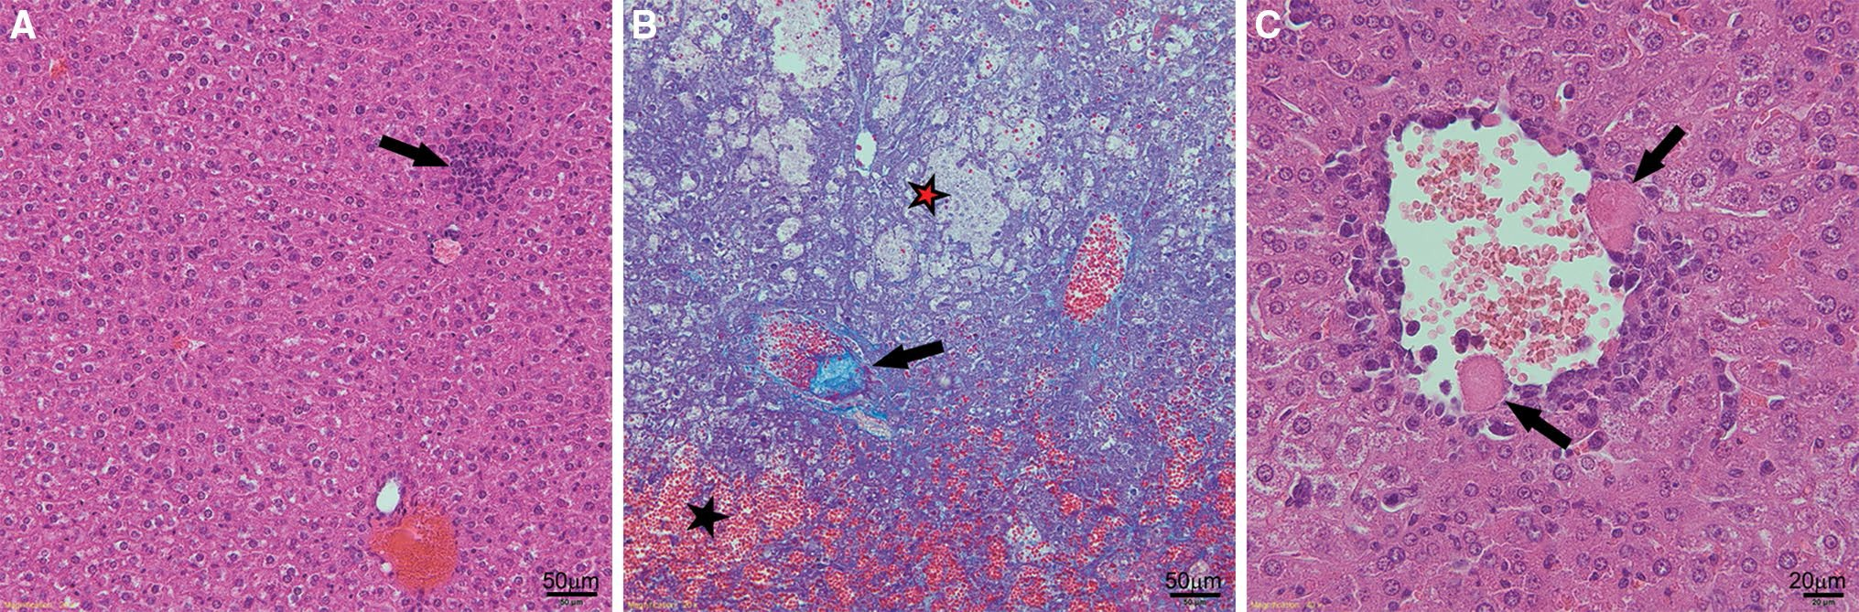
Magn Reson MaterPhy
ALTandASTinbloodplasmawasdeterminedwithcalori-metricmethodsusinganABXPenta400biochemicalana-lyzer (Horiba Medical, Japan).
Followingthebloodsampling,theliverswerehar-vestedandfixedin4%formaldehydephosphatebuffersolution.Theliverlobeswereembeddedinparaffin.Thesectionswere5µmthickandwerecutintwoareas(twoslicesperarea)approximately100µmapart.Theregionswiththenecrotic(haemorrhagicandcoagulativenecro-sis)andthecollectivetissuechangeswereevaluatedasapercentageofthetotalsectionarea.Theinfiltrationofvesselwallsbyimmunecellswasclassifiedonafour-pointscale,wherethescore0wasassignedtothetissuewithoutinfiltrationofvesselwallsandthescore3wasassignedtothesamplesinwhichtheinfiltrationwasnoticedineachvessel.Thesampleswerestainedwithhaematoxylinandeosin(H&E)andGomoritrichrome(TRICHROME).
Results
Developmentof acuteliverinjury after ConA injection
Weightof the animals
Theweightoftheanimalswasmeasuredjustbeforeand24hafterConA/salineinjection.TheweightoftheConA-treatedgroupwas20.9±0.8gand19.9±1.1gbeforeand
24hafterConA,respectively.Theweightofthecontrol
animalsremainedstableat20.1±1.4gbeforeand24hafterthesalineinjection.Inbothgroups,thechangeintheweightwasnotstatisticallysignificant(p>0.05).
Histopathologyof the liver
Histologicalstainingofthelivertissuefromthecontrolgroupshowedapoptosisofsinglehepatocytesandtracesofinflam-mation(Fig.2a).Nootherabnormalitieswereobserved.Histologicalcross-sectionsofthecontrolanimalswerenor-mal.IntheConA-treatedgrouppathologicalchangessuchashyperaemia,coagulativeandhaemorrhagicnecrosis,inflammatoryinfiltrationinthebloodvesselswallandliverparenchyma,embolisminthevessellumens,disintegrationoftheendothelium,hepatocyteblebsandhaemorrhageweredetected(Fig.2b,c;Table1).Numerousfociofnecrosisscat-teredthroughouttheparenchymaintheliversoftheConAgroupwereobserved.Cellularinfiltrationoftheparenchymawasnoticedaroundandintheareasofnecrosis(Fig.2b).
Statistical analysis
All
parametric
parameters
were presented
as
(mean±STD);histologicalparameterswerepresented
asmedian.Thedata,exceptforthehistologicalinforma-tion,wasverifiedfornormalitywiththeShapiro-Wilktest(p=0.05).Parameterswithnormaldistributionwere
analysedwiththettest(p=0.05).TheMann-WhitneyU
testwasapplied(p=0.05)toqualitativeparametersdeter-minedontheintervalscaleandparametricparameterswith
substantialdistribution.Correlationsamong perfusion,EMMparametersandhistologicaloutcomesweretestedwiththeSpearmanrankordercorrelation(p=0.05).Sta-tisticalanalysiswasperformedwithStatistica8.0(StatSoft,Tulsa,OK, USA).
Biochemicalparameters
Biochemicalanalysisshowedsubstantiallyelevatedlev-elsofenzymesinbloodplasmaintheConAgroup.ALT
Fig.2Representativemicrophotographsofcrosssectionsoftheliversharvestedfromathecontrolgroup(H&Estaining;×200);bConAgroup(TRICHROMEstaining;×200);cConAgroup(H&Estaining;×400).Asmallinflammationfocusisvisible(arrow)in
a.Haemorrhage(markedwithablackstar),haemorrhagicnecrosis(markedwitharedstar)andembolisminavessel(arrow)arevisibleinb.Hepatocyteblebs(arrows)are visible inc
13

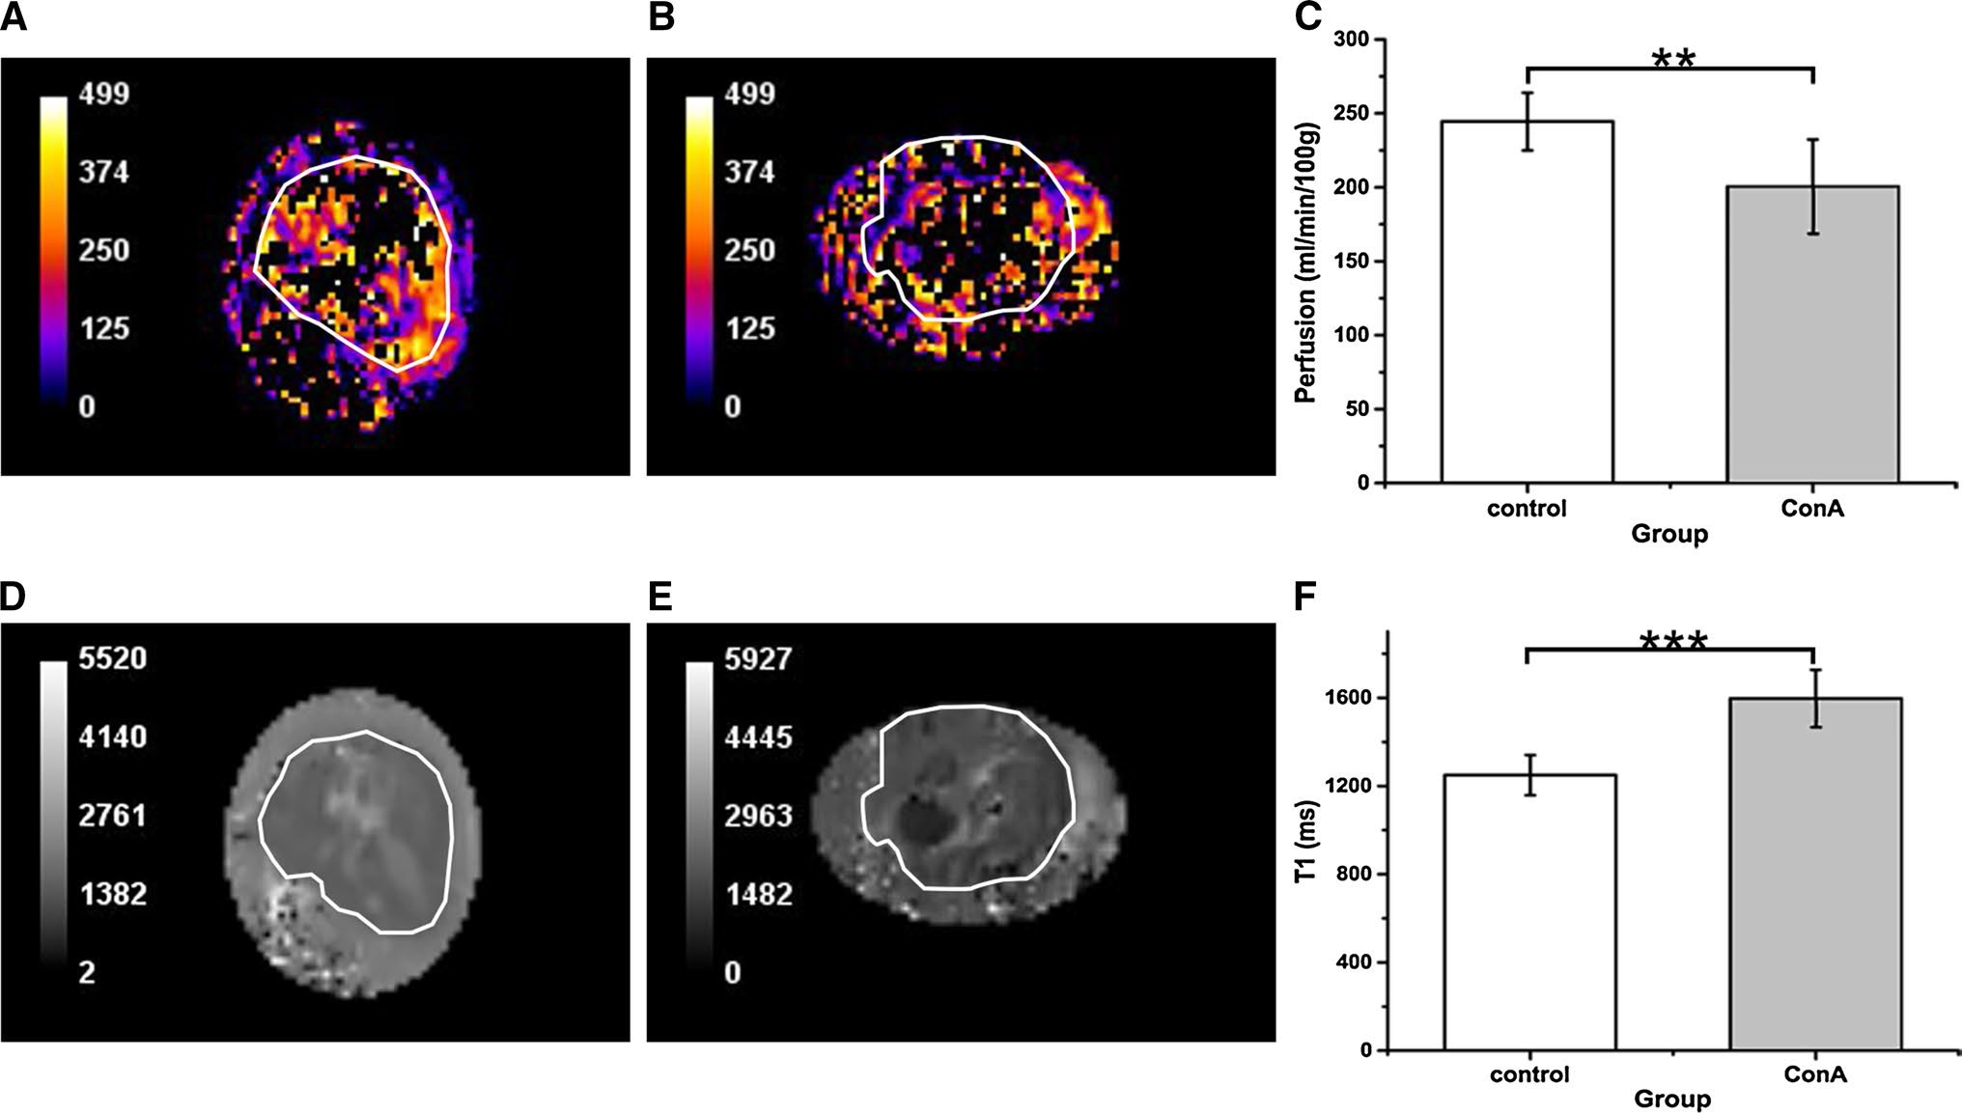
Magn Reson MaterPhy
Table1Histopathologicalevaluationofcontrolmiceandmicewithliverinjury induced by ConA
significantlydifferentbetweenthegroupswiththefollow-ingpvalues:ALT(p< 0.001);AST (p< 0.001).
Parameter
Control group
n=7
ConA group
n=7
pvalue
Assessment of perfusion andT1relaxationtimewith arterial spin labelling
Median
Rank sum
Median
Rank sum
Haemorrhagic necrosis [%]
Coagulativenecrosis [%]
Vesselwallinfil-tration [a.u.]
Tissuechanges[%]
0
42
0
63
0.2
TheexamplesoftheperfusionmapsarepresentedinFig.3a,b.PerfusionintheliverROIswasequalto245±20ml/min/100ginthehealthygroupand
200±32ml/min/100gintheConAgroup(Fig.3c).The
ttestindicatedthattheperfusionvaluesweresignificantlydifferent(p=0.008)betweenthecontrolandConAgroupanddecreasedby18%inthetreatedgroup.Athreshold
wasappliedtothepixelswithperfusionvalueshigherthan500ml/min/100goftissue.Asaresult,thepixelsinthecentralareaoftheinitialMRimageswereremovedbecause of the presence ofthevenacavaand portalvein.
TheexamplesoftheT1mapsarepresentedinFig.3dande.TheT1relaxationtimeintheliversofthecontrolgroupacrossallanimalswasequalto1249±91mswhileintheConAgroupitwas1597±130ms(Fig.3f).ThedifferenceinT1betweenthecontrolandtreatedgroupwassignificant(p<0.001).
0
31.5
10
73.5
0.009
0
28
2
77
0.002
0
28
40
77
0.002
Hyperaemia,coagulativenecrosisandvesselwallinfiltrationwereobservedinthesamplesfromtheConAgroup.AmedianandranksumfromtheMann-WhitneyUtestareshown.Testresultswereassumedtobesignificantlydifferentatp<0.05(italics)
wasequalto38±7and1627±1075U/linthecontrol
andConAgroup,respectively,whilethecorrespond-ingASTvalueswere61±15and1977±1285U/l.TheMann-WhitneyUtestshowedthattheseparameterswere
Fig.3Examplesoftheperfusion[ml/min/100g](a,b)andT1[ms](c,e)maps.Bothmapswererescaledfromtheoriginalsizeto256×171pixels.Thresholdingofpixelvaluesgreaterthan500ml/min/100gwasappliedtotheperfusionmaps.Perfusion(c)andT1values(f)wereassessedforsevencontrolandseventreatedani-
mals.aPerfusionmapofthecontrolliver.bPerfusionmapofthe
ALFliver.cPerfusionvalueswithinROIsintheliversofthecon-trolandConAgroup. ThedifferenceinperfusionbetweenthecontrolandConAgroupisstatisticallysignificant(**p=0.008).dT1mapofcontrolliver.eT1mapof ALFliver.fT1valuesinthecontroland
ConAgrouparesignificantlydifferent(***p<0.001).Areasofliver
in MR images (a–d) are contoured inwhite
13

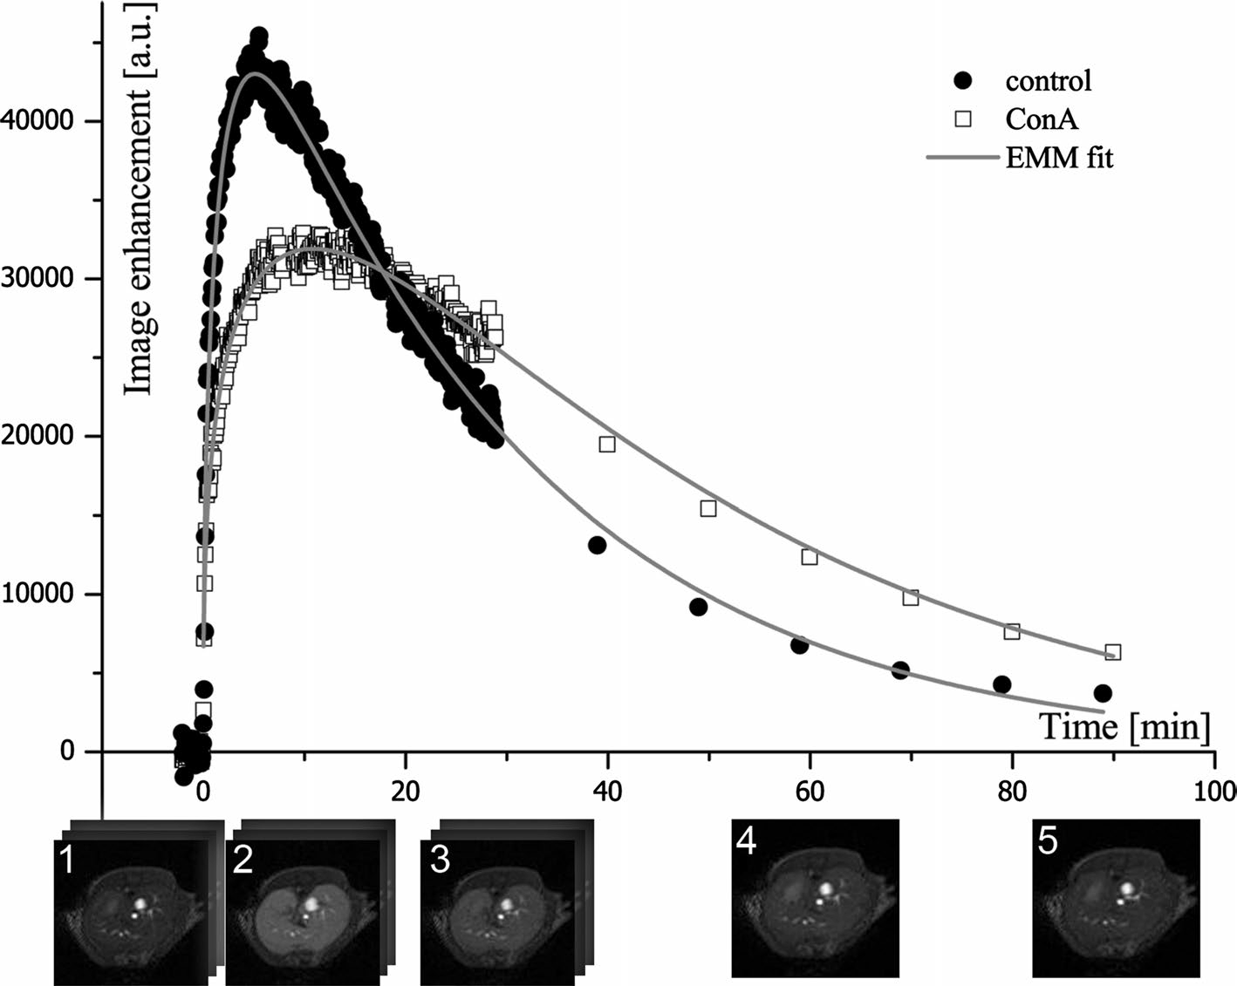
Magn Reson MaterPhy
Fig.4Examples of the timecourses of signal changes in thecontrol and ConA group with thefittedempiricalmathemati-cal model.Thedifferencesinthecurvaturesof the enhance-ment peaks andwash-outregionsof thecurvesfor theConA and the control are vis-ible.The corresponding DCE-MR images of theliverfromthe control group areshownbeneath the horizontal axis: (1)pre-contrast; (2) 6 min aftercontrast injection (maximum enhancement ofliverparen-
chymais visible,Tpeakincontrolgroupwasequal to 6.14 min);(3) 30 min; (4) 60 min; (5)
90 min after contrast injec- tion (contrast iswashedoutfrom thelivertissue). Duringthe initial 30 min, MR imageswere acquired in three series, 150 images each.After 30 min,one imagewasacquiredevery10 min
Assessment of the hepatocyte integrity with theDCE-MRI and empirical mathematical model
Table2ParametersobtainedbyfittingtheEMMequationtotheexperimentaldata for both groups
Param-eter
Control group
n=7
ConA group
n=7
pvalue
TheGd-EOB-DTPAcompoundisahepatocyte-specificcontrastagentthatistakenupbylivinghepatocytes.AsshowninFig.4theGd-EOB-DTPAsignaldisplaysdiffer-entpatternsinthecontrolandConAmice.Gd-EOB-DTPAwaswashedawayfasterintheliversofthecontrolanimalsthanintheliversoftheConAanimals.TheMRsignalintensityofparenchymainthecontrolsreturnedtothepre-injectionvaluewithin90min.IntheConAgrouptheinten-sityoftheliverMRimagesremainedelevateduntiltheendof the measurements (Fig.4).
TofurtherquantifydifferencesintheGd-EOB-DTPAwash-outbetweenthecontrolandConAgroup,theEMMequationwasfittedtotheexperimentaldata(R2>0.98).ThevaluesoftheparameterscalculatedfromtheEMMandpvaluesareshowninTable2.Therateoftheinitialwashout(γ)showssubstantialdistributionandwastestedwiththeMann-WhitneyUtest.Theremainingparametersweretestedwiththettest.Fiveparameterswerestatisti-callydifferentbetweenthecontrolandtheConAgroup:
A
α[1/
min]
q
β[1/
min]
γ[1/
min]
Tpeak
[min]
ES [1/
min]
T1/2
[min]
AUC
57,100±9669
0.20±0.11
0.432±0.064
0.037±0.008
0.001±0.002(r.s.43)
6.14±1.07
6587±1731
31.7±7.3
1,312,380±252,093
67,355±31747
0.11±0.08
0.380±0.064
0.021±0.008
0.004±0.007(r.s.62)
9.72±1.69
4002±1113
66.5±10.5
1,786,030±229,748
0.43
0.1
0.15
0.004
0.25
<0.001
0.006
<0.001
0.003
Theparameters,exceptγ,weretestedwiththettest.γwastestedwiththeMann-WhitneyUtest;ranksumisplacedinparentheses.Statisticalsignificancewasassumedatp<0.05(italics)
β(p=0.004),
Tpeak
(p<0.001),ES(p=0.006),
T1/2
(p<0.001)andAUC(p=0.003).Theparametersβand
1/mininwhilethe
thecontrolandConAgroup,respectively,
T1/2
describethewash-outslopeoftheDCE-MRIcurve.
corresponding
T1/2
valueswere31.7±7.3
ThesignificantdifferenceintheseparametersbetweenthegroupsconfirmedthattransportofthecontrastagentviahepatocyteswasdisturbedbytheALFprocesses.Thevalueofβwasequalto0.037±0.008and0.021±0.008
and66.5±10.5min.Asignificantdifferencewasalso
observedintheAUCparameter,whichwaslargerintheConA group thanin thecontrol group:179±23×104and131±25×104,respectively.Theuptakeofthecontrast
13

Magn Reson MaterPhy
Table3Spearman rank order correlations between EMM parameters and histological and biochemical parameters
Tpeak[min]
A
α[1/min]
β[1/min]
γ[1/min]
q
T1/2[min]
ES
AUC
Haemorrhagic necrosis [%]Coagulativenecrosis [%]Vesselwallinfiltration[a.u.]Tissuechanges [%]
ALT[U/l]
AST [U/l]
0.588
0.880
0.789
0.907
0.828
0.776
0.279
0.059
0.111
0.000
−0.159
−0.095
−0.558
−0.522
−0.410
−0.482
−0.441
−0.332
−0.224
−0.665
−0.723
−0.707
−0.700
−0.723
0.282
0.215
0.401
0.229
0.216
0.090
−0.398
−0.445
−0.429
−0.509
−0.654
−0.574
0.429
0.748
0.756
0.853
0.784
0.789
−0.579
−0.782
−0.510
−0.810
−0.733
−0.631
0.322
0.635
0.841
0.721
0.815
0.859
CorrelationswerecalculatedforsevenanimalsinthecontrolgroupandsevenintheALFgroup.Correlationsmarkedinitalicsareassumedsig-nificantatp<0.05
agentfrombloodbyhepatocyteswasalsodisturbedintheConAgroupasconfirmedbytheTpeakandESparameters.Themaximumenhancementofimageintensitywasnoticedat6.14±1.07mininthecontrolgroup,whileintheConA
groupitoccurredlaterat9.72±1.69min.TheESvalueof
6587±1731and4002±11131/mininthecontrolandtheConAgroup,respectively,confirmedthatperfusioninthe
ConA animalswasaffectedbyALF.
mirrorsautoimmuneorviralhepatitisinhumans[10].Theactivatedlymphocytescausethereleaseofpro-inflamma-torymediators(e.g.INFγ,TNFα,IL-4),disruptionoftheendotheliumandhepatocytedamage[10,26,27].Ourstudy,performed24hafterConAadministration,allowedobservingcoagulativeandhaemorrhagicnecrosis,inflam-matoryinfiltrationinthebloodvesselwallsandliverparen-chymaaswellaselevatedlevelsofbiochemicalmarkers.Allchangesresembledthelesionsinhepatitis,confirmingthepreviousreports on this model [6,28].
TheASLstudyshowedthatperfusionintheliverparen-chymainthecontrolanimalswas245±20ml/min/100g,whichisingoodagreementwiththepreviouslyreportedvaluesof220±30ml/min/100ginBalb/cmiceobtainedusingtheFAIR-ASLtechniquewiththeLook-Locker
readout[29].Inourstudy,perfusioninALFwasimpairedby18%,likelyduetotheinflowofactivatedandthere-foreinflexibleandmoreviscousleucocytesintothesiteofinflammation[30–32].Thesinusoidsmayalsobepluggedbytheactiveplatelets,whichcirculateinbloodandarenotcleared by the damagedliver[8,9].However,some authorsindicatedthatALFwasassociatedwithinappropriatevaso-dilation andvasoconstriction[7,9].
TheT1relaxationtimewashigherintheConAgroupthaninthecontrolgroup.TheT1valueinthecontrolgroupwas1249±91ms,whichiscomparabletothepreviouslyreported1360±60ms[29].ThecorrelationbetweenT1andperfusionsuggestedthatthechangeobservedinthe
valueoftherelaxationtimeislinkedwiththehaemody-namics.TheincreasedT1timeintheConAgroupmaybecausedbywateraccumulationinthediseasedtissue.Bloodflowthroughthelivermaybeinefficientbecauseofvesselembolismswithplateletsandsequestrateleucocytesaswellthereductionofthesinusoidsizecausedbythedisturbedvasoconstrictorsandvasodilatorsecretion [9].
AlthoughliverfunctionassessedbytheDCEtechniqueisalsodeterminedbyliverperfusion,hepaticuptakeoftheGd-EOB-DTPAcontrastagentisstronglydependentonthehepatocyteintegrityasGd-EOB-DTPAisselectivelytakenupbythehepatocytesviatheorgan-aniontransporters
Correlationsbetween MRI-based parametersand histopathological and biochemical outcomes
TheSpearmanrankordercorrelationshowedthatperfu-sionmeasuredwithASLcorrelateswiththeparameterscalculatedwithEMM:α(rS=0.635),γ(rS=−0.591),
Tpeak(rS=−0.732)andT1/2(rS=−0.609).Perfusionalso
correlateswithT1(rS=−0.534)andtwohistopathologi-caloutcomes:vesselwallinfiltration(rS=−0.766)andtissuechanges(rS=−0.565).TheT1relaxationtimecor-relatedwithperfusion(inthetext),Tpeak(rS=0.754),β(rS=−0.640),T1/2(rS=0.859),ES(rS=−0.582)and
AUC(rS=0.613),coagulativenecrosis(rS=0.689),vesselwallinfiltration(rS=0.785),tissuechanges(rS=0.801),ALT(rS=0.716)andAST (rS=0.736). CorrelationsbetweenEMMandhistologicalaswellasbiochemi-
calparameterswerealsofound(Table3).Allhistologicalparameterswerepositivelycorrelatedwiththebiochemicalmarkers(p< 0.05).
Discussion
Theaimofthisstudywastomeasureperfusionandhepato-cyteinjuryinamousemodelofALFinducedwithConAusingtwoMRI-basedmethods.TheresultsdemonstratedthattheDCE-MRIandASLtechniquesallowreliableassessmentofalterationsinliverperfusionandhepatocyteintegrityinduced by ConA invivo.
ConA-inducedliverinjuryisanestablishedmodelofT-cell-mediatedliverinflammationthattosomeextent
13

Magn Reson MaterPhy
(OATPB1/B3)andexcretedviaATP-dependentmultidrugresistanceproteins(MRP2/3/4)[24,33,34].Thehighval-uesoftheR2coefficientsconfirmedaverygoodfitoftheEMMequation[25]totheDCE-MRIdata.Nodifferencesbetweentheanimalgroupsintherateofcontrastuptake(α),initialrateofcontrastuptake(q)andmaximalampli-tudeofimageenhancement(A)wereobserved.Interest-ingly,αcorrelatedwiththeperfusionvalueobtainedusingASL.FurthermoreadifferencewasobservedintheTpeak
andESparameters,whichmayindicatealterationsinthe
bloodcirculation,liverfilteringfunctionandhepatocyteintegrity.Theα,TpeakandESparameterswerepreviouslyassignedasperfusionindicators[19,20],whichwascon-firmedinourstudybytheobtainedcorrelations.Atthesametimewealsoobservedcorrelationsoftheseparame-terswithpathologicalchangesinhistologicalstaining,sup-portingthetheorythatcontrastuptakeandsignalenhance-ment depend onseveralfactors.Thewash-outslope oftheDCE-MRIcurveintheConAanimalswasaffectedbydisturbedtransportofthecontrastagentviahepatocytesbecauseofinflammationandtherecoveryprocesses.Thedifferencesbetweenthegroupswerevisibleintheshapeofthewash-outslopeandtheintensitiesoftheliverimagesobtainedduringthefinalstageofMRexperiments.Thedeterioratedliverfunctionwasapparentintheeliminationhalf-lifetime(T1/2)valueandtherateofthecontrastwash-out(β).BothoftheseparametersindicatedsignificantlyprolongedcontrastremovalintheConAgroup.Theirgoodcorrelationwithhistology(coagulativenecrosis,tis-suechangesandvesselwallinfiltrations)aswellasbloodmarkersimpliesanassociationwithdamagedhepatocytes.Althoughthedifferencesobservedinthehistologicalsam-plesbetweenthegroupsarelargerwhencomparedtothedifferencesobtainedintheMRIparameters,itshouldbestressedthatMRIprovidesinvivomeasurementscorre-spondingtopathophysiologicalprocessesandenablesnon-invasivelyassessingtheprogressionorregressionoftheliverdisease.
ThedrawbackoftheASLtechniqueisitslowin-planespatialresolution(0.469mm/pixel).Thelowresolutionoftheobtainedimagesandneedtoremovethepixelswithextremevaluesintroducedadditionalcomplicationstothedataprocessingandanalysis.The500ml/min/100gthresh-oldwasappliedtoexcludethebloodvesselsandthepixelswithnegativevaluesfromtheMRimages.Additionally,thecirculatory bed in theliverhas acomplexstructure contain-ingnotonlyarteriesandveinsbutalsotheportaltriadsandsinusoid.Henceitisdifficulttoextractonlytheparenchy-mal area in the image.
DCE-MRIdatawerecollectedusingtheself-triggeredIntraGateFLASH™sequence.InthismethodcardiacandrespirationcyclesarederivedfromtheMRsignalandareusedtoreduceartifactswithoutsacrificingtemporal
resolution,whichisespeciallyimportantduringthefirstpassageofthebolus,providinginformationonperfusion[35,36].Thedatainthisstudywerecollectedathightem-poralresolution(lessthan4sperimage)duringthecon-trastwash-inphase.
ClinicalevaluationofpatientswithALFisbasedontheKing’sCollegeHospitalcriteria,whichincorporatetheaetiologyofthediseaseandbloodtests[37].Theimag-ingmodalitiesusedinthediagnosisofALFincludeX-rayimaging,Dopplerultrasound,electroencephalography(ECG)andechocardiograms[37].Nevertheless,MRhasbeenusedinclinicalstudiesofhepatitis,mostlyfortheassessmentofliverfibrosisandcirrhosisinchronicliverfailureusingMRelastography[38,39],diffusion-weightedMRI [40,41] and DCE-MRI [41–43].
TheAmericanCollegeofRadiologists[44]indicatedthatMRI,withorwithoutacontrastagent,isasuitabletechniqueforclinicalimagingofseveralliverdiseases.TheapplicationofASLtomeasureliverperfusioninhumanshas been also reported with promising results [45,46].Hencetheresultsofourresearch,supportedbytheprevi-ousstudies,suggestpossibleapplicationsofourapproachtoclinics,inparticularforassessingALFphysiologyandpatientmonitoring,eitherduringonsetoftheliverdiseaseor,forexample,afterlivertransplantation.
Conclusion
Wehavedemonstratedthatretrospectivelygateddynamic contrast-enhancedMRI(DCE-MRI) withthehepatocyte-specificcontrastagentandarterialspinlabelling(ASL)techniqueallowsmonitoringofthealterationsinhepatocyteintegrityandinperfusionofthemicrocirculationinmurinehepatitisinducedbyConA.Theresultscorrelatedwiththehistopathologicalandbiochemical parametersofliverinflammationandinjury.Theresultssuggestthatboththeself-triggeredIntra-GateFLASH™andFAIR-EPIsequencesarewellsuitedforcomprehensiveimagingofliverinjuryinmiceat9.4
T.Thismethodcouldbeusedtoinvestigatetheeffectsofpharmacologicaltreatmentontheprogressionorregres-sionofliverdiseaseinothermodelsofliverinjury.TheIntraGateFLASH™andFAIR-EPIpulsesequencescouldbeimplementedintheclinicalsettingstopoten-tiallyimprovetheALFdiagnosisinpatientsbysimul-taneousassessmentofalterationsinliverperfusionandhepatocyteintegrityinhepatitisorotherliverinjuries.Hencethemethodmayproveusefulinthediagnosisandtherapyofliverdiseases.
AcknowledgmentsThisworkwassupportedbytheEuropeanUnionforEuropeanRegionalDevelopmentFund(grantcoordinatedbythe
13

Magn Reson MaterPhy
JagiellonianCentreforExperimentalTherapeutics—JagiellonianUniversity,No.WND-POIG.01.01.02-00-069/09-00)andpartiallybyNational Science Centre Grant No. DEC-2015/16/W/NZ4/00070.
15.
ChowAM,GaoDS,FanSJ,QiaoZ,LeeFY,YangJ,ManK,WuEX(2012)MeasurementofliverT1andT2relaxationtimesinanexperimentalmousemodelofliverfibrosis.JMagnResonImaging36(1):152–158
StarkD,FelderR,WittenbergJ,SainiS,ButchR,WhiteM,EdelmanR,MuellerP,SimeoneJ,CohenA(1985)Mag-neticresonanceimagingofcavernoushemangiomaoftheliver:tissue-specificcharacterization.AJRAmJRoentgenol145(2):213–222
MoriyamaY,SaitoS,KobayashiS,OgiharaR,KotoD,KitamuraA,MatsushitaT,NishiuraM,MuraseK(2012)EvaluationofconcanavalinA-inducedacuteliverinjuryinratsusinganempiri-calmathematicalmodelanddynamiccontrast-enhancedMRimagingwithGd-EOB-DTPA.MagnResonMedSci11(1):53–60GoshimaS,KanematsuM,WatanabeH,KondoH,KawadaH,MoriyamaN,BaeKT(2012)Gd-EOB-DTPA-enhancedMRimaging:predictionofhepaticfibrosisstagesusinglivercontrastenhancementindexandliver-to-spleenvolumetricratio.JMagnReson Imaging 36(5):1148–1153
PositanoV,SantarelliMF,LandiniL(2003)Automaticcharac-terizationofmyocardialperfusionincontrastenhancedMRI.EURASIP JAppl Signal Process 2003:413–421
TarroniG,CorsiC,AntkowiakPF,VeronesiF,KramerCM,EpsteinFH,WalterJ,LambertiC,LangRM,Mor-AviV(2012)Myocardialperfusion:near-automatedevaluationfromcontrast-enhancedMRimagesobtainedatrestandduringvasodilatorstress. Radiology 265(2):576–583
BovensSM,teBoekhorstB,OudenKd,vandeKolkKW,NauerthA,NederhoffMG,PasterkampG,tenHoveM,vanEchteldCJ(2011)Evaluationofinfarctedmurineheartfunc-tion:comparisonofprospectivelytriggeredwithself-gatedMRI.NMRBiomed 24(3):307–315
CoolenBF,GeelenT,PaulisLE,NauerthA,NicolayK,Strijk-ers GJ (2011)Three-dimensionalT1 mapping of the mouse heartusingvariableflipanglesteady-stateMRimaging.NMRBiomed24(2):154–162
TabibianJH,MacuraSI,O’HaraSP,FidlerJL,GlocknerJF,TakahashiN,LoweVJ,KempBJ,MishraPK,TietzPS(2013)Micro-computedtomographyandnuclearmagneticresonanceimagingfornoninvasive,live-mousecholangiography.LabInvest93(6):733–743
VanBeersBE,PastorCM,HussainHK(2012)Primovist,Eovist:what toexpect?J Hepatol 57(2):421–429
FanX,MedvedM,KarczmarGS,YangC,FoxleyS,ArkaniS,RecantW,ZamoraMA,AbeH,NewsteadGM(2007)Diagno-sisofsuspiciousbreastlesionsusinganempiricalmathematicalmodelfordynamiccontrast-enhancedMRI.MagnResonImag-ing 25(5):593–603
SternakM,JakubowskiA,CzarnowskaE,SlominskaEM,Smo-lenskiRT,SzafarzM,WalczakM,SitekB,WojcikT,JasztalA(2015)DifferentialinvolvementofIL-6intheearlyandlatephaseof1-methylnicotinamide(MNA)releaseinConcanavalinA-induced hepatitis. Int Immunopharmac 28(1):105–114MizuharaH,O’NeillE,SekiN,OgawaT,KusunokiC,OtsukaK,SatohS,NiwaM,SenohH,FujiwaraH(1994)Tcellactivation-associatedhepaticinjury:mediationbytumornecrosisfactorsandprotectionbyinterleukin6.JExpMed179(5):1529–1537
SternakM,KhomichTI,JakubowskiA,SzafarzM,Szczepan´skiW,BiałasM,StojakM,Szymura-OleksiakJ,ChłopickiS(2010)NicotinamideN-methyltransferase(NNMT)and1-methylnicoti-namide(MNA)inexperimentalhepatitisinducedbyconcanava-linA in the mouse. Pharm Rep 62(3):483–493
RamasawmyR,Campbell-WashburnA,WellsJ,JohnsonS,PedleyR,Walker-SamuelS,LythgoeM(2015)Hepaticarterial
Compliance with ethical standards
16.
ConflictofinterestTheauthorsdeclarethattheyhavenoconflictofinterest.
WelfareofanimalsAllapplicablenationalandinstitutionalguide-linesforthecareanduseofanimalswerefollowed.Allprocedureswereapprovedby the local Ethics Committee onAnimalTesting.
17.
OpenAccessThisarticleisdistributedunderthetermsoftheCrea-tiveCommonsAttribution4.0InternationalLicense(http://crea-tivecommons.org/licenses/by/4.0/),whichpermitsunrestricteduse,distribution,andreproductioninanymedium,providedyougiveappropriatecredittotheoriginalauthor(s)andthesource,providealinktotheCreativeCommonslicense,andindicateifchangesweremade.
18.
19.
20.
References
1.
BernalW,WendonJ(2013)Acuteliverfailure.NEnglJMed369(26):2525–2534
SassDA,ShakilAO(2005)Fulminanthepaticfailure.LiverTranspl11(6):594–605
O’GradyJG(2005)Acuteliverfailure.PostgradMedJ81(953):148–154
BerryP,AntoniadesC,HussainM,McPhailM,BernalW,Ver-ganiD,WendonJ(2010)Admissionlevelsandearlychanges
21.
2.
3.
4.
22.
inseruminterleukin-10acuteliverfailureand30(5):733–740
arepredictiveofpooroutcomeindecompensatedcirrhosis.LiverInt
23.
5.
AntoniadesCG,BerryPA,WendonJA,VerganiD(2008)Theimportanceofimmunedysfunctionindeterminingoutcomeinacuteliverfailure.J Hepatol 49(5):845–861
SassG,HeinleinS,AgliA,BangR,SchümannJ,TiegsG(2002)Cytokineexpressioninthreemousemodelsofexperimentalhep-atitis. Cytokine 19(3):115–120
TrewbyP,WilliamsR(1977)Pathophysiologyofhypotensioninpatients with fulminant hepaticfailure.Gut 18(12):1021–1026HughesR,WendonJ,GimsonA(1991)Acuteliverfailure.Gut32(Suppl):S86–S91
VollmarB,MengerMD(2009)Thehepaticmicrocirculation:mechanisticcontributionsandtherapeutictargetsinliverinjuryandrepair.PhysiolRev89(4):1269–1339
TiegsG,HentschelJ,WendelA(1992)ATcell-dependentexper-imentalliverinjuryinmiceinduciblebyconcanavalinA.JClinInvest90(1):196
GantnerF,LeistM,LohseAW,GermannPG,TiegsG(1995)ConcanavalinA—inducedT-cell—mediatedhepaticinjuryinmice:theroleoftumornecrosisfactor.Hepatology21(1):190–198
KnollePA,GerkenG,LöserE,DienesH-P,GantnerF,TiegsG,MeyerzumBüschenfeldeK,LohseAW(1996)Roleofsinu-soidalendothelialcellsoftheliverinconcanavalinA-inducedhepatic injury in mice. Hepatology 24(4):824–829
DetreJA,LeighJS,WilliamsDS,KoretskyAP(1992)Perfusionimaging. Magn Reson Med 23(1):37–45
ZhouXJ(2004)ArterialSpinTagging.In:BernsteinMA,KingKF,ZhouXJ(eds)HandbookofMRIpulsesequences,vol1.ElsevierAcademic Press, USA, pp 802–829
6.
24.
7.
25.
8.
9.
26.
10.
11.
27.
12.
28.
13.
14.
29.
13

Magn Reson MaterPhy
spinlabellingMRI:aninitialevaluationinmice.NMRBiomed28(2):272–280
BauerM,MarziI,ThumaB,BachF,BührenV,LarsenR(1994)Dose-relatedpatternofsinusoidalleukocyteadhesioninsublob-ularregionsof theliverafter systemic endotoxin challenge in therat. Shock 1(2):135–140
FrankRS(1990)Time-dependentalterationsinthedeformabil-ityofhumanneutrophilsinresponsetochemotacticactivation.Blood76(12):2606–2612
DowneyGP,ElsonEL,SchwabB,ErzurumSC,YoungSK,WorthenGS(1991)Biophysicalpropertiesandmicrofilamentassemblyinneutrophils:modulationbycyclicAMP.JCellBiol114(6):1179–1190
VerlohN,UtpatelK,HaimerlM,ZemanF,FellnerC,Fichtner-FeiglS,TeufelA,StroszczynskiC,EvertM,WiggermannP(2015)LiverfibrosisandGd-EOB-DTPA-enhancedMRI:ahis-topathologiccorrelation. Sci Rep 5:15408
NojiriS,KusakabeA,FujiwaraK,ShinkaiN,MatsuuraK,IioE,MiyakiT,JohT(2013)NoninvasiveevaluationofhepaticfibrosisinhepatitisCvirus-infectedpatientsusingethoxy-benzyl-magneticresonanceimaging.JGastroenterolHepatol28(6):1032–1039
SourbronS(2010)TechnicalaspectsofMRperfusion.EurJRadiol76(3):304–313
KhalifaF,SolimanA,El-BazA,El-GharMA,El-DiastyT,Gimel’farbG,OusephR,DwyerAC(2014)Modelsandmeth-odsfor analyzing DCE-MRI: areview.MedPhys41(12):124301PathikondaM,MunozSJ(2010)Acuteliverfailure.AnnHepatol9(1):7–14
HuwartL,PeetersF,SinkusR,AnnetL,SalamehN,terBeekLC,HorsmansY,VanBeersBE(2006)Liverfibrosis:non-invasiveassessmentwithMRelastography.NMRBiomed19(2):173–179
RouviereO,YinM,DresnerMA,RossmanPJ,BurgartLJ,FidlerJL,EhmanRL(2006)MRelastographyoftheliver:pre-liminary results 1. Radiology 240(2):440–448
40.
TaouliB,ChouliM,MartinAJ,QayyumA,CoakleyFV,VilgrainV(2008)Chronichepatitis:roleofdiffusion-weightedimaginganddiffusiontensorimagingforthediagnosisofliverfibrosisandinflammation.JMagnResonImaging28(1):89–95
PatelJ,SigmundEE,RusinekH,OeiM,BabbJS,TaouliB(2010)DiagnosisofcirrhosiswithintravoxelincoherentmotiondiffusionMRIanddynamiccontrast-enhancedMRIaloneandincombination:preliminaryexperience.JMagnResonImaging31(3):589–600
ChenB-B,HsuC-Y,YuC-W,WeiS-Y,KaoJ-H,LeeH-S,ShihTT-F(2012)Dynamiccontrast-enhancedmagneticresonanceimagingwithGd-EOB-DTPAfortheevaluationofliverfibrosisinchronic hepatitis patients. Eur Radiol 22(1):171–180
NorénB,ForsgrenMF,LeinhardOD,DahlströmN,KihlbergJ,RomuT,KechagiasS,AlmerS,SmedbyÖ,LundbergP(2013)Separationofadvancedfrommildhepaticfibrosisbyquantifica-tionofthehepatobiliaryuptakeofGd-EOB-DTPA.EurRadiol23(1):174–181
NelsonRC,KamelI,BakerM,Al-RefaieW,CashB,HarrisonS,HindmanN,KaurH,McNamaraM,QayyumA,TulchinskyM,YarmishG,RosenM(2014)ACRAppropriatenesscriteria®
liverlesion—initialcharacterization.http://www.guideline.gov/content.aspx?id=48283.Accessed7April2016
KatadaY,ShukuyaT,KawashimaM,NozakiM,ImaiH,Natori
T,TamanoM(2012)AcomparativestudybetweenarterialspinlabelingandCTperfusionmethodsonhepaticportalvenousflow.JpnJRadiol30(10):863–869
CoxE,GhezziA,PatelM,JacksonA,CostiganC,JamesM,RyderS,GowlandP,AithalG,FrancisS(2012)AnovelMRIprotocoltoexaminehaemodynamiccompartmentsincompen-satedlivercirrhosis. Gut 61(Suppl 2):A195–A196
30.
41.
31.
32.
42.
33.
43.
34.
44.
35.
45.
36.
46.
37.
38.
39.
13

