
Obesity Surgery (2019) 29:361-368
https://doi.org/10.1007/s11695-018-3546-8
ORIGINAL CONTRIBUTIONS

Effectiveness and Safety of Roux-en-Y Gastric Bypass in Elderly
Patients—Systematic Review and Meta-analysis
(ft
CrossMark
Paweł Marczuk1,2 • Michał J. Kubisa
1,2,3
• Michał Święch1,2 • Maciej Walędziak1 • Piotr Kowalewski1 • Piotr Major4
Michał Pędziwiatr4,5 • Krzysztof Paśnik1 • Michał R. Janik1
Published online: 23 October 2018
© The Author(s) 2018
Abstract
Introduction As the population ages, there is more interest in bariatric surgery for older patients. There are controversies
regarding the safety and effectiveness of surgical weight loss in this population.
Aim The aim of this study was to compare the safety and efficacy of Roux-en-Y gastric bypass in patients over the age of 60 years
with younger patients.
Methods The available literature was searched for eligible studies up to February 2018. Inclusion criteria were reports on
mortality, morbidity, percentage excess weight loss (%EWL), remission of diabetes, remission of hypertension, and remission
of obstructive sleep apnea. Random effects meta-analyses were performed.
Results The initial search yielded 2000 references. The final meta-analysis involved nine studies and revealed significant
differences in mortality (odds ratio 4.38, 95% confidence interval [1.25, 15.31], p = 0.02), morbidity (OR 1.88, CI [1.07,
3.30], p = 0.03), %EWL(meandifference - 5.86, 95% CI [— 9.15, - 2.56], p <0.001), and remission of comorbidities.
Conclusion Higher mortality and morbidity were found in the group of older patients. The analysis suggested lower
effectiveness of Roux-en-Y gastric bypass for weight loss and improvement in comorbidity in older patients when
compared with younger patients.
Keywords Bariatric surgery . Obesity . Safety . Efficacy . Roux-y . Gastric bypass . Elderly

Introduction
In the next decade, 25% of Europeans will reach 60 years of
age or older, and the prevalence of obesity in this group will
range from 20 to 30%. The number of patients qualified for
bariatric surgery will increase concomitantly [1]. However,
* Michał R. Janik
janiken@gmail.com
1 Department of General, Oncologic, Metabolic and Thoracic Surgery,
Military Institute of Medicine, Ul. Szaserów 128,
04-141 Warsaw, Poland
- Medical University in Warsaw, Warsaw, Poland
- Department of Experimental and Clinical Pharmacology, Centre for
Preclinical Research and Technology (CEPT), Warsaw, Poland
- 2nd Department ofGeneral Surgery, Jagiellonian University Medical
College, Krakow, Poland
- Centre for Research, Training and Innovation in Surgery (CERTAIN
Surgery), Krakow, Poland
there are controversies regarding the safety and effectiveness
of surgical weight loss in older patients. Roux-en-Y gastric
bypass (RYGB) is one of the most popular bariatric proce-
dures [2, 3]. Its weight loss effect and impact on obesity-
related diseases is established in the literature [4]. While stud-
ies regarding the feasibility of RYGB in older patients are
available, there still are no clear guidelines on the optimal
procedure for this age category [5, 6]. The main goal of this
study was to compare the safety and efficacy of RYGB in
patients over the age of 60 with younger patients.

Methods
Data Sources
A systematic search of the Pubmed, Scopus, Embase,
Medline, and Google Scholar electronic databases was con-
ducted to identify all eligible studies that compared RYGB in
patients aged 60 years or above with younger ones. The World
Health Organization defines 65 years as the cut-off age for
Springer
362
OBES SURG (2019) 29:361-368
older patients. However, the 60 years’ criterion was chosen
because it was used in the majority of bariatric studies [5].
Search terms included “gastric bypass,” “old,” “elderly,”
“obesity,” and “obese,” using the Boolean operators “AND”
and “OR.” Restrictions were as follows: only English lan-
guage studies, human subjects, and the availability of full-
text reports. The most recent search was performed on
February 1, 2018. Studies eligible for further analysis had to
meet the following criteria: (1) comparison of percentage ex-
cess weight loss (%EWL) between older and younger pa-
tients, (2) objective evaluation of early complications and
mortality within 30 days after operation, (3) remission of type
2 diabetes mellitus (T2DM), (4) remission of obstructive sleep
apnea (OSA) syndrome, and (5) remission of hypertension.
Studies were excluded when they (1) lacked comparative data,
(2) lacked primary outcomes or had insufficient data for anal-
ysis, or (3) described procedures other than RYGB.

Outcomes of Interest
Primary outcomes of interest were as follows: overall morbid-
ity and mortality rates and %EWL. Secondary outcomes of
interest were remission of diabetes, hypertension, or OSA as
well as length of hospital stay.

Data Extraction and Quality Assessment
All references were reviewed and evaluated by two re-
searchers. In case of any doubts about eligibility for inclusion,
an attempt was made to reach consensus between the two
researchers. Conflicts were resolved by discussion with a third
researcher. Data from included studies were extracted inde-
pendently. Only full-length articles were eligible for extrac-
tion. When available, the following data were extracted: au-
thor, country, date of publication, number of older and youn-
ger patients, mean age, preoperative BMI and comorbidities,
gender distribution, %EWL, length of hospital stay (LOS),
perioperative complications, and mortality. The Newcastle-
Ottawa Scale was used to assess the quality of included stud-
ies (Table 1). Each study was scored from zero to nine points,
and studies achieving at least six points were considered high
quality. The study was performed according to the Preferred
Reporting Items for Systematic Reviews and Meta-Analyses
(PRISMA) guidelines consensus statement [15].

Data Analysis
Review Manager (RevMan), [Computer program]. Version
5.3. Copenhagen: The Nordic Cochrane Centre, The
Cochrane Collaboration 2014 was used for statistical analysis.
For continuous data (%EWL and LOS), mean difference
(MD) with 95% confidence interval (CI) was used, while for
dichotomous variables (remission of T2DM, OSA,
hypertension, and perioperative mortality and morbidity),
odds ratio (OR) with 95% CI was obtained. A random effects
model was used for calculating the pooled estimates. A two-
sided p <0.05 was regarded as statistically significant. To as-
sess heterogeneity, the inconsistency test (I) was performed.
Inconsistency was defined as significant for I >50% [ 16]. To
identify the reason for high heterogeneity, subgroup analysis
was conducted when possible. We chose the p <0.1 as statis-
tically significant for the inconsistency test. Sensitivity analy-
sis was performed to determine whether included studies were
robust. Begg’s and Egger’s tests were not conducted to assess
risk of bias, because studies show that these tests are reliable
only for analyses including at least ten studies [17].

Results
An initial reference search yielded 2000 articles. After remov-
ing 648 duplicates, 1352 articles were evaluated through titles
and abstracts; 23 papers were suitable for full-text review. One
reviewer mailed inquiries to corresponding authors of two
eligible studies to request unpublished data; however, no re-
sponse was received [6, 18]. Ultimately, nine studies were
selected for data extraction, with a combined total of 4391
patients (366 in the older group, 4025 in the younger group).
Four of the included studies were case-matched [5, 8, 12,13].
A flowchart of the analyzed studies is presented in Fig. 1.
According to the Newcastle-Ottawa Scale, the quality of these
studies was moderate, with the majority scoring at least six
points. Baseline study information is presented in Table 1.
Three studies included patients after open or laparoscopic
RYGB (LRYGB). Five studies included only patients after
laparoscopic approach. To analyze mortality and morbidity,
patients were divided into subgroups according to surgical
approach: (1) LRYGB and RYGB and (2) LRYGB.
The rate of complications during the first 30 days after
surgery was reported in eight studies. In the LRYGB sub-
group, a significant difference was recorded between two co-
horts (OR 2.07, CI [1.00, 4.28], p = 0.05), and in the second
subgroup, the difference was not statistically significant (OR
1.64, CI [0.57,4.74],p = 0.36). Overall, there were more early
complications in older patients (OR 1.88, CI [1.07, 3.30],p =
0.03) (Fig. 2).
Mortality rate during the 30-day observation was obtained
from seven studies. The overall mortality was significantly higher
in older patients (OR 4.38, 95% CI [1.25, 15.31], p = 0.02).
However, subgroup analysis did not find any difference in mor-
tality between older and younger ones (LRYGB subgroup: OR
6.18, 95% CI [0.76, 50.49], p = 0.18; LRYGB and RYGB sub-
group: OR 3.40, 95% CI [0.58, 20.03], p = 0.18) (Fig. 3).
The %EWL was reported in only three studies; each of
them reported a different follow-up interval. In a study by
Dunkle-Blatter et al., %EWL was assessed at least 12 months
Springer

Table 1 Baseline information
Study | Patients no.  (elderly/  younger) | Mean age  (elderly/  younger) | Mean preoperative  BMI (elderly/  younger) | Type of  operation | Follow-up | T2DM remission  (elderly/younger) | Flypertension  remission (elderly/  younger) | OSA remission  (elderly/  younger) | The Newcastle-Ottawa  Quality Assessment  Scale
Hallowell Peter T.  2007, USA [7] | 892 (46/846) | 61.6/42.3 | 50.4/50.5 | LRYGB/RYGB | -/- | -/- | -/- |  | 6
Montastier Emilie  2016, France [8] | 227 (45/182) | -/- | 43.9/43.8 | LRYGB | 24 months | 59%/79% | 27%/63% | 80%/85% | 7
Ritz Patrie 2014,  France [9] | 824 (57/767) | -/- | -/- | LRYGB  /RYGB | -/- | -/- | -/- | -/- | 8
Robert Maud 2014,  France [5] | 52 (16/36) | 61.7/41.15 | 41.3/41.7 | LRYGB | 12 months/6 months | 37%/33% | 45%/56% | -/- | 6
Sosa J. L. 2004, USA  [10] | 550 (23/527) | 64.4/38.2 | 48.5/48.8 | LRYGB | 12 months | 75%/- | 91%/- | 67%/- | 8
St Peter Shawn D.  2005, USA [11] | 130 (20/110) | 65.2/45.0 | 46.4/48.2 | LRYGB | 3-17 months | -/- | -/- | 50%/66.7% | 7
Thereaux Jeremie  2014, France [12] | 126 (42/84) | 62.6/42.9 | 45.6/47.3 | LRYGB | 36 months | 53.3%/66.7% | 18.8%/53.8% | 60.6%/87.9% | 9
Van Nieuwenhove Y  2016, Belgium [13] | 577 (56/521) | 63.8/41.6 | 43.5/43.4 | LRYGB | 24/18/12 months | 65.4%/56.4% | -/- |  | 8
Dunkle-Blatter  Stephanie E. 2007,  USA [14] | 1013 (61/952) | 62.0/43.0 | 49.3/51.1 | LRYGB  /RYGB | At least 12 months | 53.5%/56.8% | 30%/40.1% |  | 8
BMI body mass index, T2DM type 2 diabetes mellitus, OSA obstructive sleep apnea, LRYGB laparoscopic Roux-Y Gastric Bypass, RYGB Roux-Y Gastric Bypass
1
OBES SURG (2019) 29:361-368 363

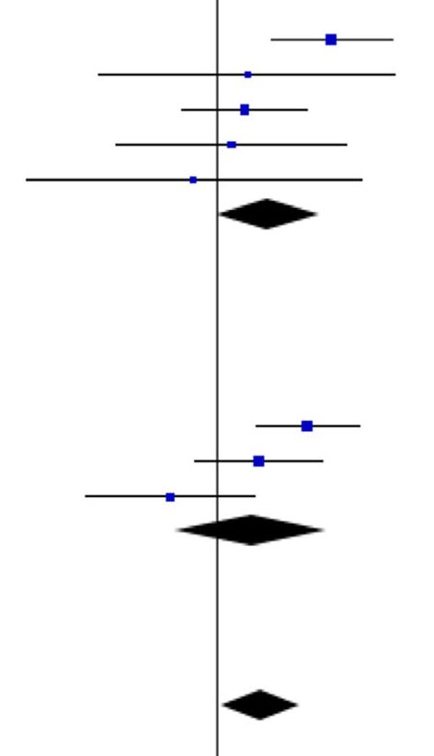
364
OBES SURG (2019) 29:361-368
Fig. 1 Study selection flow chart
Study or Subgroup
Elderly
Events Total
Younger
Events Total
Odds Ratio
Weight M-H, Random, 95% Cl
Odds Ratio
M-H. Random, 95% Cl
- Laparoscopic RYGB
Van Nieuwenhove Y. 2016
SosaJ. L. 2004
Montastier Emilie 2016
St Peter Shawn D. 2005
Robert Maud 2014
Subtotal (95% Cl)
Total events
Heterogeneity: Tau= = 0.22; ChP = 6.01, df
Test for overall effect: Z= 1.97 (P = 0.05)
- Open and Laparoscopic RYGB
Ritz Patrie 2014
Hallowell Peter T. 2007
Dunkle-Blatter Stephanie E. 2007
Subtotal (95% Cl)
Total events
Heterogeneity: Tau3 = 0.65; Chi= = 8.00, df=
Test for overall effect: Z= 0.92 (P = 0.36)
9 | 56 | 19 | 521 | 16.9% | 5.06 [2.17,11.81]
1 | 23 | 15 | 527 | 5.9% | 1.55(0.20,12.28]
8 | 45 | 23 | 182 | 16.4% | 1.49 [0.62, 3.61]
2 | 20 | 9 | 110 | 8.5% | 1.25 [0.25,6.25]
1 | 16 | 3 | 36 | 4.8% | 0.73 [0.07,7.64]
 | 160 |  | 1376 | 52.4% | 2.07 [1.00,4.28]
21 |  | 69
4 (P = 0.20); P = 33%
11 | 57 | 48 | 767 | 18.9% | 3.58 [1.74, 7.36]
6 | 46 | 64 | 846 | 16.2% | 1.83 [0.75,4.49]
3 | 61 | 85 | 952 | 12.4% | 0.53 [0.16,1.72]
 | 164 |  | 2565 | 47.6% | 1.64 [0.57,4.74]
20 |  | 197
2 (P= 0.02); I3 =75%
Total (95% Cl) 324 3941
Total events 41 266
Heterogeneity: Tau= = 0.30; Chi== 14.09, df= 7 (P = 0.05); P= 50%
Test for overall effect: Z= 2.19 (P = 0.03)
Test for subarouc differences: ChP= 0.13. df= 1 fP
100.0%
1.88(1.07,3.30]
I-
0.01
0.1
10
100
Favours [experimental] Favours [control]
0.72V P= 0%
Fig. 2 Pooled estimates of morbidity rate. CI confidence interval, df degrees of freedom, RYGB Roux-en-Y gastric bypass
Springer
Records identified through
database searching
(n = 2 000 )
Additional records identified
through other sources
(n = 0 )
Records after duplicates removed
(n = 1 352 )
Records screened
(n = 1 352 )
Records excluded
(n = 1 329 )
Full-text articles assessed
for eligibility
(n = 23 )
Full-text articles
excluded, with reasons
(n = 14)
Studies included in
qualitative synthesis
(n = 9 )
Studies included in
quantitative synthesis
(meta-analysis)
(n = 9 )

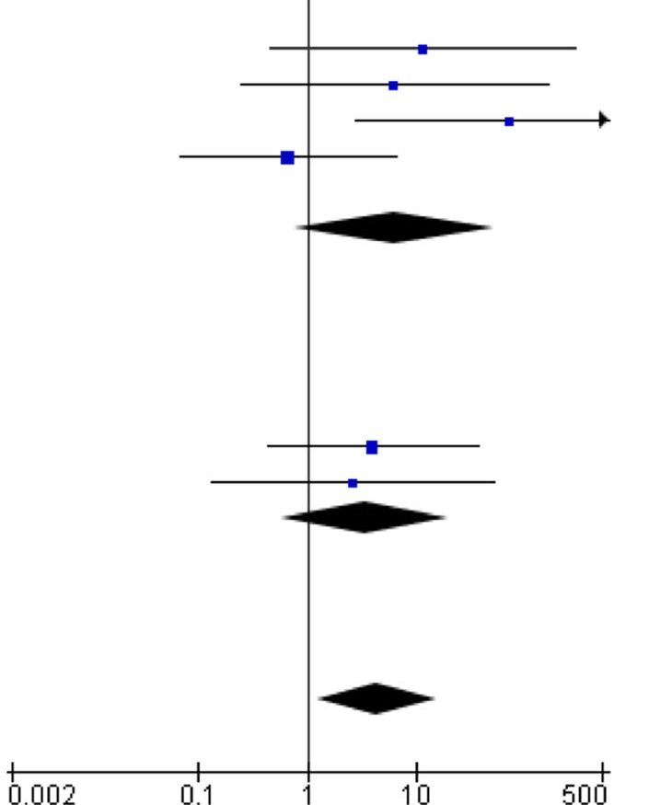
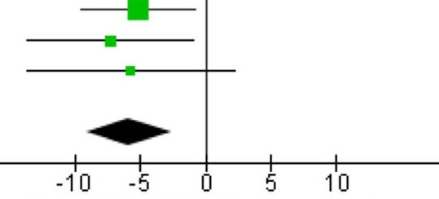
OBES SURG (2019) 29:361-368
365
Study or Subgroup
Elderly Younger Odds Ratio
Events Total Events Total Weight M-H, Random, 95% Cl
Odds Ratio
M-H, Random, 95% Cl
- Laparoscopic RYGB
Montastier Emilie 2016
Robert Maud 2014
Sosa J. L. 2004
Thereaux Jeremie 2014
Van Nieuwenhove Y. 2016
Subtotal (95% Cl)
Total events
Heterogeneity: Tau= = 2.30; ChP =
Test for overall effect: Z= 1.70 (P ■
1 | 48 | 0 | 182 | 13.0% | 11.53 [0.46, 287.47]
1 | 24 | 0 | 48 | 12.9% | 6.19(0.24,157.82]
1 | 23 | 0 | 527 | 12.9% | 70.33 [2.79,1774.98]
1 | 42 | 3 | 84 | 22.5% | 0.66 [0.07,6.53]
0 | 56 | 0 | 521 |  | Not estimable
 | 193 |  | 1362 | 61.3% | 6.18 [0.76, 50.49]
4 |  | 3
6.05, df=
: 0.09)
3 (P = 0.11); l== 50%
- Open and Laparoscopic RYGB
Dunkle-Blatter Stephanie E. 2007
Hallowell Peter T. 2007
Subtotal (95% Cl)
Total events
Heterogeneity: Tau2 = 0.00; ChP = 0.05, df:
Test for overall effect: Z= 1.35 (P = 0.18)
1 | 61 | 4 | 952 | 23.9%
0 | 46 | 3 | 846 | 14.8%
 | 107 |  | 1798 | 38.7%
1 |  | 7
1 (P= 0.82); P= 0%
3.35 (0.43, 35.83]
2.53 [0.13, 50.31]
3.40 [0.58, 20.03]
4.38 [1.25,15.31]
Total (95% Cl) 300 3160 100.0%
Total events 5 10
Heterogeneity: Tau== 0.44; ChP= 6.10, df= 5 (P = 0.30); F= 18%
Test for overall effect. Z-2.31 (P-0.02) Favours elderly Favours younger
Test for suborouo differences: ChP= 0.18. df= 1 (P= 0.671. P= 0%
Fig. 3 Pooled estimates of mortality rate. CI confidence interval, df degrees of freedom, RYGB Roux-en-Y gastric bypass
postsurgery [14]. In research reported by Montastier et al.,
%EWL was recorded after 2 years [8]. Thereaux et al. docu-
mented a 3-year follow-up interval [12]. Because of the lim-
ited number of studies, we decided to include all ofthem in the
analysis. This analysis showed a significantly lower %EWL in
the older population (MD - 5.86, 95% CI [— 9.15, - 2.56],
p < 0.001). The heterogeneity was very low (Fig. 4).
T2DM remission was reported in four studies. However,
some of them presented different definitions of remission. Two
studies defined remission as HbA1c<6.0% without medica-
tions, and in the other two studies, the criterion was defined as
HbA1c<6.5%. For this reason, subgroup analysis was per-
formed. There were no significant differences in the analyzed
subgroups (HbA1c < 6.0% without medications: OR 0.54, 95%
CI [0.27, 1.08], p = 0.08; HbA1c<6.5%: OR 0.64, 95% CI
[0.29, 1.42], p = 0.27). Yet, the overall analysis showed that pa-
tients older than 60 years experienced significantly lower remis-
sion of T2DM than younger patients (OR 0.64, 95% CI [0.42,
0.97], p = 0.04). The heterogeneity was very low (Fig. 5).
Data on hypertension remission were extracted from three
studies. The remission criteria included systolic pressure <
140 mmHg without medications in research performed by
Dunkle-Blatter et al. and blood pressure < 140/90 mmHg
without medications in Montastier et al. and Thereaux et al.
[8, 12, 14]. Analysis of extracted data showed a significantly
lower remission rate in the older patients (OR 0.33, 95% CI
[0.14, 0.74], p = 0.007). (Fig. 6) The heterogeneity was very
high (I2 = 61%,_p = 0.08). Sensitivity analysis was performed,
indicating that the study conducted by Dunkle-Blatter et al.
was responsible for the inconsistency [14]. This was caused
by (1) shorter follow-up (at least 12 months in the Dunkle-
Blatter et al. study, 24 months in the Montastier et al. study,
and 36 months in the Thereaux et al. study) and (2) signifi-
cantly higher preoperative BMI in younger patients (mean
BMI 51.1 in the Dunkle-Blatter et al. report, to BMI 43.8 in
the Montastier et al. report, and BMI 47.3 in the Thereaux
et al. study), as well as the type of operation (LRYGB in the
Montastier et al. and Thereaux et al. articles, LRYGB and
RYGB in the Dunkle-Blatter et al. article). After removing
this publication from analysis, heterogeneity dropped to 0%
(no heterogeneity), and the results remained significant (OR
0.21, 95% CI [0.10, 0.43],p <0.0001).
Elderly
Younger
Mean Difference
Study or Subgroup
Mean SD Total Mean SD Total Weight IV, Random, 95% Cl
Mean Difference
IV, Random, 95% Cl
Dunkle-Blatter Stephanie E. 2007 54.9 16.6 61 60.1 17.4
Montastier Emilie 201 6 77 19 45 84.3 21
Thereaux Jeremie 2014 63 18.7 42 68.7 26.1
Total (95% Cl) 148
Heterogeneity: Tau2= 0.00; Chi== 0.29, df = 2 (P = 0.87); P= 0%
Test for overall effect: Z= 3.48 (P = 0.0005)
527 55.6% -5.20 [-9.62,-0.78]
182 27.1% -7.30 [-13.63,-0.97]
84 17.2% -5.70[-13.65,2.25]
793 100.0% -5.86 [-9.15,-2.56]
Favours younger Favours elderly
Fig. 4 Pooled estimates of %EWL. CI confidence interval, df degrees of freedom, %EWL percentage excess weight loss, SD standard deviation
^ Springer

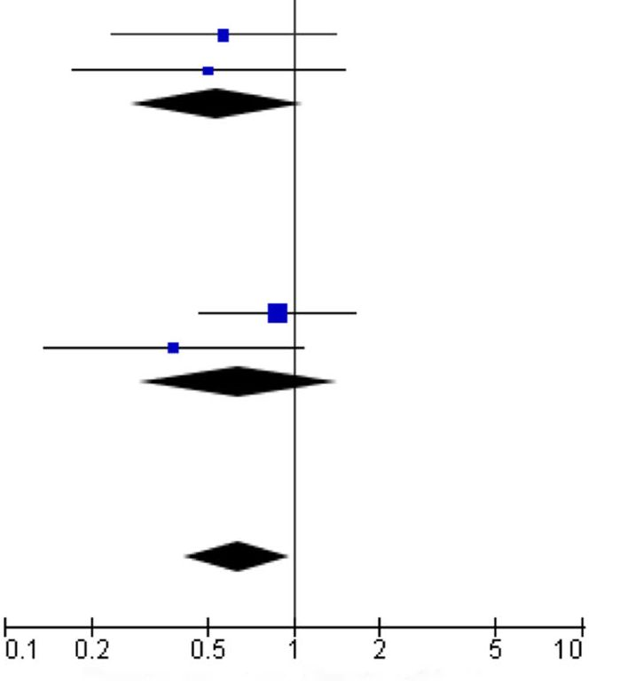
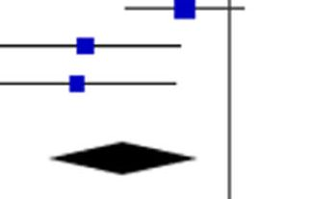
366
OBES SURG (2019) 29:361-368
Study or Subgroup
Elderly Younger Odds Ratio
Events Total Events Total Weight M-H, Random, 95% Cl
Odds Ratio
M-H, Random, 95% Cl
- Remission criterium: HbA1c <6.5%
Thereaux Jeremie 2014
Van Nieuwenhove Y. 2016
Subtotal (95% Cl)
Total events
Heterogeneity: Tau= = 0.00; Chf = 0.03, df
Test for overall effect: Z= 1.73 (P = 0.08)
- Remission criterium: HbA1c<6.0%
Dunkle-Blatter Stephanie E. 2007
Montastier Emilie 2016
Subtotal (95% Cl)
Total events
Heterogeneity: Tau= = 0.15; ChP = 1.30, df
Test for overall effect: Z= 1.09 (P = 0.27)
16 | 30 | 40 | 60 | 22.5%
25 | 31 | 91 | 102 | 15.2%
 | 61 |  | 162 | 37.8%
41 |  | 131
0.57 [0.23,1.40]
0.50 [0.17,1.50]
0.54 [0.27,1.08]
1 (P = 0.86); l== 0%
23 | 43 | 229 | 404 | 45.4%
16 | 27 | 38 | 48 | 16.8%
 | 70 |  | 452 | 62.2%
39 |  | 267
1 (P= 0.18); F = 45%
131
614 100.0%
0.88 [0.47,1.65]
0.38 [0.14,1.08]
0.64 [0.29,1.42]
0.64 [0.42,0.97]
Total (95% Cl)
Total events 80 398
Heterogeneity: Tau= = 0.00; ChP = 2.16, df = 3 (P = 0.54); P = 0%
Test for overall effect. Z- 2.08 (P- 0.04) Favours younger Favours elderly
Test for subarouo differences: ChP = 0.10. df= 1 (P= 0.751. P= 0%
Fig. 5 Pooled estimates of type 2 diabetes mellitus remission. CI confidence interval, df degrees of freedom
OSA remission was reported in three studies. All of these
studies defined remission as a cessation of use of nighttime
positive-pressure devices. The overall remission rate for OSA
was lower in the older patients (OR 0.38, 95% CI [0.18, 0.80],
p = 0.01) (Fig. 7). The heterogeneity was low.
The LOS was reported in three studies. There were no
significant differences (MD 0.44, 95% CI [— 0.51, 1.39],p =
0.37) and the heterogeneity was moderate I2 = 44% (Fig. 8).
The quality of included studies was moderate.

Discussion
Studies have shown that the efficacy of bariatric surgery for
weight loss and comorbidity improvement is excellent [4].
More importantly, remarkable improvement in quality of life
is observed [19, 20]. The implementation of enhanced recov-
ery after surgery for bariatric procedures allowed optimization
of perioperative care [21]. Because the population is aging,
there is more interest in bariatric surgery for older patients, yet
there are concerns regarding the safety of bariatric procedures
in this population. There are no clearly defined guidelines
concerning the indications for bariatric surgery in the older
age group or recommendations regarding the type of bariatric
procedure.
This is the first systematic review of included studies com-
paring outcomes of RYGB in older and younger patients. The
main findings show that age above 60 years is associated with
higher overall mortality and morbidity. The wide 95% confi-
dence interval (1.25-15.31) for mortality indicates the fragility
of this result. Interestingly, when a subgroup analysis was done
according to surgical approach, no difference in mortality was
observed. However, the subgroup including only laparoscopic
RYGB showed a tendency for higher incidence of peri-
operative complications in older patients. The results are con-
sistent with the recent report of the Metabolic and Bariatric
Surgery Accreditation and Quality Improvement Program
showing that older patients who undergo RYGB have an in-
creased risk of peri-operative morbidity and mortality following
laparoscopic bariatric surgery [22]. Based on our systematic
review, we recommend that patients aged 60 years and above
be informed about the potentially higher risk of adverse events.
The duration of surgery is a recognized risk factor for post-
operative complications in laparoscopic bariatric surgeries
Study or Subgroup
Elderly Younger Odds Ratio
Events Total Events Total Weight M-H, Random, 95% Cl
Odds Ratio
M-H, Random, 95% Cl
Dunkle-Blatter Stephanie E. 2007 15 51 210 525 41.3%
Montastier Emilie 2016 7 26 41 65 29.9%
Thereaux Jeremie 2014 6 32 28 52 28.8%
0 63 (0 33,1.17]
0.22 (0.08, 0.59]
0.20 [0 07, 0.56]
0.33 [0.14,0.74]
Total (95% Cl) 109 642 100.0%
Total events 28 279
Heterogeneity: Tau= = 0.32; ChP = 5.15, df = 2 (P = 0.08); P= 61 %
Test for overall effect: Z= 2.70 (P= 0.007)
Fig. 6 Pooled estimates of hypertension remission. CI confidence interval, df degrees of freedom
0.05
—t—
0.2
20
Favours younger Favours elderly
Springer

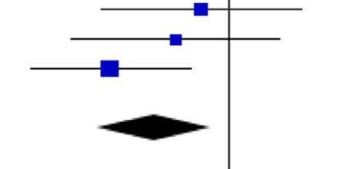
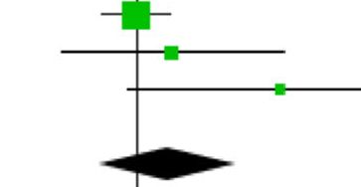
OBES SURG (2019) 29:361-368
367
Study or Subgroup
Elderly Younger Odds Ratio
Events Total Events Total Weight M-H, Random, 95% Cl
Odds Ratio
M-H, Random, 95% Cl
Montastier Emilie 2016
St Peter Shawn D. 2005
Thereaux Jeremie 201 4
Total (95% Cl)
Total events
20 | 25 | 34
5 | 10 | 30
20 | 33 | 51
 | 68
40
45
58
29.6%
26.7%
43.7%
143 100.0%
0.71 [0.19, 2.61]
0.50 [0.13, 2.00]
0.21 [0.07, 0.61]
0.38 [0.18,0.80]
45
115
-t-
0.05
—I—
0.2
Heterogeneity: Tau= = 0.04; Chi== 2.20, df= 2 (P = 0.33); P= 9%
Testforoverall effect: Z= 2.55 (P= 0.01) Favours younger Favours elderly
Fig. 7 Pooled estimates of obstructive sleep apnea remission. CI confidence interval, df degrees of freedom
20
[23]. In our analysis, only three studies provided data regard-
ing operating time. The study published by Robert et al. sup-
ports this thesis and showed that older patients had a longer
operating time compared with the control group [5]. Yet, in the
study by van Nieuwenhove et al., no difference in operative
time was noted, and Hallowell et al. demonstrated an extended
surgery time in younger patients [7, 13]. Based on these re-
sults, it is difficult to make any reliable conclusion about the
influence of the operative time on observed outcomes.
Only three studies presented data on LOS [7, 12, 13].
Results suggest that there are no significant differences in
LOS between both groups. Because of the low number of
eligible studies, this finding has to be treated with caution
and further studies are necessary.
The main purpose of bariatric surgery is to reduce body
weight and, what is more important, to achieve remission of
or at least improvement in obesity-related diseases. Despite
the fact that weight loss was found in the majority of studies,
meta-analysis of all of them was not possible because of dif-
ferences in reporting the weight loss. We analyzed only a few
studies that presented weight loss as %EWL and included at
least 1-year follow-up [8, 12, 14]. Findings showed that
weight loss was significant in both groups, but LRYGB was
less effective in older patients when compared with younger
controls. This observation might be caused by the less active
lifestyle that can be associated with advanced age. Other stud-
ies included in the review expressed weight loss as BMI re-
duction, percentage total weight loss (%TWL), or percentage
of initial weight loss [9, 11, 13]. Peter et al. and Ritz et al.
reported significantly lower weight loss in the older popula-
tion [9, 11]. Only the report published by van Nieuwenhove
et al. showed no difference in %TWL between younger and
older patients [13]. However, these results should not be
interpreted universally, because of the variability in follow-
up rate. This issue needs to be investigated further. We suggest
the use ofunified and recommended terms in the expression of
weight loss in future studies.
Not all studies reported data on remission of comorbidities.
For the purpose of our analysis, we focused on articles
reporting remission of hypertension, T2DM, or OSA. The
studies showed improvement of comorbidities in both age
groups; however, the overall remission rates for all considered
comorbidities were significantly higher in younger patients.
Based on our meta-analysis, we can assume that the metabolic
effect is better in the population of patients younger than
60 years of age. Yet, this finding must be interpreted with
caution because we were not able to provide any additional
data on the severity of analyzed comorbidities. It is likely that
there were differences between groups. Therefore, further
studies on this topic are warranted.
Our review has some limitations. First, the effectiveness of
RYGB was measured using %EWL and comorbidity remis-
sion rates. We did not analyze quality of life. This issue should
be explored in future studies. Second, most of the included
studies did not consider the length of the alimentary and
biliopancreatic loop. Third, few studies presented data after
LRYGB and open RYGB collectively. Considering that the
majority of RYGB procedures are currently performed
laparoscopically, future analyses should perhaps select only
minimally invasive cases [2, 3]. At the time of selecting our
inclusion criteria and building our search strategy, surgical
access was not limited. In addition, information on the sur-
geons’ experience and institutional volume were not available
in the included studies. We did not find data about smokers
among the study groups. These factors could be important
confounders of the safety analysis.
Study or Subgroup
Elderly Younger Mean Difference
Mean SD Total Mean SD Total Weight IV, Random, 95% Cl
Mean Difference
IV, Random, 95% Cl
Dunkle-Blatter Stephanie E. 2007 2.9 1.7 61 2.9 2.8 952 59.5% 0.00 [-0.46,0.46]
Hallowell PeterT. 2007 3.7 5.2 46 3.2 3.9 846 24.9% 0.50 [-1.03,2.03]
Van Nieuwenhove Y. 2016 6 8 56 4 3 521 15.7% 2.00 [-0.11,4.11]
Total (95% Cl) 163
Heterogeneity: Tau= = 0.34; Chi== 3.54, df= 2 (P = 0.17); P
Test for overall effect: Z= 0.90 (P = 0.37)
2319 100.0% 0.44 [-0.51,1.39]
■ 44%
-2 0 2
Favours elderly Favours younger
Fig. 8 Pooled estimates of length of hospital stay. CI confidence interval, df degrees of freedom, SD standard deviation
^ Springer
368
OBES SURG (2019) 29:361-368

Conclusion
While higher morbidity and mortality were found in the older
group, these consequences are still relatively low. The analysis
suggests a lower effectiveness of RYGB in older compared
with younger patients for weight loss and comorbidity im-
provement. However, the quality of included studies and re-
ported data were limited. Therefore, well-designed trials are
needed to fully establish the potential role of bariatric surgery
in older patients.
Acknowledgments We thank Andrea Baird, MD, from Edanz Group, for
editing a draft of this manuscript.

Compliance with Ethical Standards
Ethical Approval and Consent This article does not contain any studies
with human participants or animals performed by any of the authors.
For this type of study, formal consent is not required. Informed con-
sent does not apply.
Conflict of Interest The authors declare that they have no conflict of
interest.
Open Access This article is distributed under the terms of the Creative
Commons Attribution 4.0 International License (http://
creativecommons.org/licenses/by/4.0/), which permits unrestricted use,
distribution, and reproduction in any medium, provided you give appro-
priate credit to the original author(s) and the source, provide a link to the
Creative Commons license, and indicate if changes were made.

References
- Mathus-Vliegen EMH. Obesity and the elderly. J Clin
Gastroenterol United States. 2012;46:533-44.
- Angrisani L, Santonicola A, Iovino P, et al. Bariatric surgery world-
wide 2013. Obes Surg. 2015;25:1822-32.
- Janik MR, Stanowski E, Paśnik K. Present status of bariatric sur-
gery in Poland. Wideochirurgia I Inne Tech Maloinwazyjne.
2016;11:22-5.
- Colquitt J, Pickett K, Loveman E, et al. Surgery for weight loss in
adults (Review). Cochrane Database Syst Rev. 2014;8:CD003641.
- Robert M, Pasquer A, Espalieu P, et al. Gastric bypass for obesity in
the elderly: is it as appropriate as for young and middle-aged pop-
ulations? Obes Surg. United States. 2014;24:1662-9.
- Abbas M, Cumella L, Zhang Y, Choi J, Melvin WS. Outcomes of
laparoscopic sleeve gastrectomy and Roux-en-Y gastric bypass in
patients older than 60. 2015;2251-6.
- Hallowell PT, Stellato TA, Schuster M, et al. Avoidance of compli-
cations in older patients and Medicare recipients undergoing gastric
bypass. Arch Surg United States. 2007;142:502-6.
- Montastier E, Becouarn G, Berard E, et al. Gastric bypass in older
patients: complications, weight loss, and resolution of comorbidi-
ties at 2 years in a matched controlled study. Obes Surg. United
States. 2016;26:1806-13.
- Ritz P, Topart P, Benchetrit S, Tuyeras GG, Lepage B, Mouiel J,
et al. Benefits and risks of bariatric surgery in patients aged more
than 60 years. Surg Obes Relat Dis. United States: Elsevier.
2014;1-6.
- Sosa JL, Pombo H, Pallavicini H, et al. Laparoscopic gastric bypass
beyond age 60. Obes Surg. United States. 2004;14:1398-401.
- Peter SDS, Craft RO, Tiede JL, Swain JM. Impact of Advanced
Age on Weight Loss and Health Benefits After Laparoscopic
Gastric Bypass. 2005;140:165-8.
- Thereaux J, Poitou C, Barsamian C, et al. Midterm outcomes of
gastric bypass for elderly (aged >/= 60 yr) patients: a comparative
study Surg Obes Relat Dis. United States. 2015;11:836-41.
- Van Nieuwenhove Y, Spriet E, Sablon T, et al. Metabolic surgery in
patients over 60 years old: short- and long-term results. Acta Chir
Belg. England. 2016;116:362-6.
- Dunkle-Blatter SE, St Jean MR, Whitehead C, et al. Outcomes
among elderly bariatric patients at a high-volume center. Surg
Obes Relat Dis. United States. 2007;3:163-70.
- Moher D, Liberati A, Tetzlaff J, et al. Preferred reporting items for
systematic reviews and meta-analyses: the PRISMA statement. Int J
Surg. England. 2010;8:336-41.
- Schroll JB, Moustgaard R, Gotzsche PC. Dealing with substantial
heterogeneity in Cochrane reviews. Cross-sectional study. BMC
Med Res Methodol. 2011. p. 22.
- Deeks JJ, Macaskill P, Irwig L. The performance of tests of publi-
cation bias and other sample size effects in systematic reviews of
diagnostic test accuracy was assessed. J Clin Epidemiol. United
States. 2005;58:882-93.
- Gonzalez-Heredia R, Patel N, Sanchez-Johnsen L, Masrur M,
Murphey M, Chen J, et al. Does age influence bariatric surgery
outcomes? Bariatr. Surg. Pract. Patient Care. 140 Huguenot
Street, 3rd FloorNew Rochelle, NY 10801, USA; 2015. p. 74-8.
- Janik MR, Rogula T, Bielecka I, et al. Quality of life and bariatric
surgery: cross-sectional study and analysis of factors influencing
outcome. Obes Surg. 2016;26:1-7. Available from: http://link.
springer.com/10.1007/s11695-016-2220-2.
- Major P, Matłok M, Pędziwiatr M, et al. Quality of life after bariat-
ric surgery. Obes Surg. 2015;25:1703-10.
- Małczak P, Pisarska M, Piotr M, et al. Enhanced recovery after
bariatric surgery: systematic review and meta-analysis. Obes Surg.
2017;27:226-35.
- Haskins IN, Ju T, Whitlock AE, et al. Older age confers a higher
risk of 30-day morbidity and mortality following laparoscopic bar-
iatric surgery: an analysis of the metabolic and bariatric surgery
quality improvement program. United States: Obes Surg; 2018.
- Wang Y, Yi X, Li Q, et al. The effectiveness and safety of sleeve
gastrectomy in the obese elderly patients: a systematic review and
meta-analysis. Obes Surg United States. 2016;26:3023-30.
Springer

