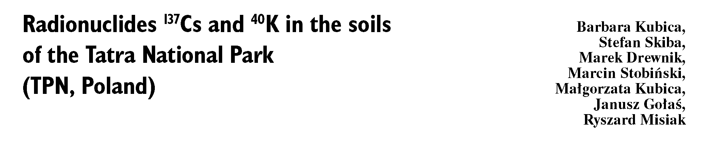
Abstract. The paper presents the results of radioactivity determination of artificial ¹³⁷Cs and natural ⁴⁰K in soil samples
taken from the Tatra Mountains in Poland (Tatra National Park - TPN). Soil samples were collected as the cores of
10 cm in diameter and 10 cm in depth. These cores were divided into 3 slices. It has been found that the content of ¹³⁷Cs
was the highest at the sites of the altitude over 1300 m a.s.l. The values of ¹³⁷Cs concentration in the soils examined
varied - from 55.8 Bq-kg⁻¹ (dry mass) (417.8 Bq-m⁻²) for the Tomanowa Pass (1685 m a.s.l.) to 5111 Bq-kg⁻¹ (dry mass)
(8400 Bq-m⁻²) for the Krzyżne Pass (2112 m a.s.l.). In most cases, the values were lower than the average radiocaesium
concentration established for Poland.
Key words: ¹³⁷Cs • ⁴⁰K • the Tatra mountains • gamma spectrometry • maps of the radioisotopes
B. Kubica^
The Henryk Niewodniczański Institute of Nuclear
Physics of Polish Academy of Sciences,
152 Radzikowskiego Str., 30-341 Kraków, Poland
and Faculty of Fuels and Energy,
AGH University of Science and Technology,
30 A. Mickiewicza Ave., 30-059 Kraków, Poland,
Tel.: +48 12 662 8394, Fax: +48 12 662 8458,
E-mail: Barbara.Kubica@ifj.edu.pl
S. Skiba, M. Drewnik
Faculty of Biology and Earth Sciences,
Jagiellonian University,
7 Gronostajowa Str., 30-387 Kraków, Poland
M. Stobiński, M. Kubica, R. Misiak
The Henryk Niewodniczański Institute of Nuclear
Physics of Polish Academy of Sciences,
152 Radzikowskiego Str., 30-341 Kraków, Poland
J. Gołaś
Faculty of Fuels and Energy,
AGH University of Science and Technology,
30 A. Mickiewicza Ave., 30-059 Kraków, Poland
Received: 12 February 2010
Accepted: 17 May 2010

Introduction
Among the radioisotopes, one could distinguish some
that are natural and those, which are derived from hu-
man activities (artificial isotopes). In the earth crust,
there are about 60 natural radionuclides, and addi-
tionally few of them are generated by cosmic radiation
[6]. Artificial radionuclides are produced by nuclear
weapon tests (mostly performed in the atmosphere),
nuclear industry (neutron activation in reactors) and
as the result of accidents of nuclear power plants. The
most serious event occurred in the Chernobyl nuclear
reactor in April 1986. The reactor was destroyed and the
amounts of radioactive material (more than 10¹⁹ Bq in
total) were released to the environment [7, 12, 19]. The
radioactive gases and airborne particles released in the
accident were initially carried by the wind in westerly
and northerly directions.
The pattern contamination from radionuclides was
divided into two types: drop condensing mode and
“fuel-like” drop mode [9]. The radioactive fuel-like
drop deposition consisted mainly of plutonium (Pu)
and other actinides, the lanthanides like cerium (Ce)
and europium (Eu), also niobium (Nb), zirconium (Zr),
ruthenium (Ru) and strontium (Sr). These elements
were associated and formed “hot particles fuel-like
drop” [1, 2, 9]. The main component of radioactive de-
position found in the area of Poland (condensation drop

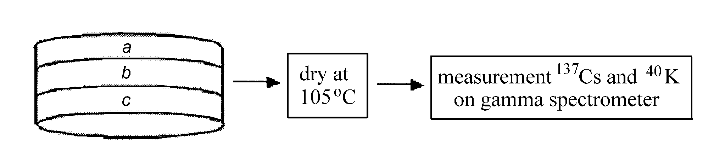
mode) is the long half-life (30.7 y) caesium-137 [8, 13].
The other source of artificial ¹³⁷Cs in the environment,
except for Chernobyl accident, was the atmospheric
nuclear weapon tests performed at the beginning of
the sixties of the last century [20]. The nuclear weapon
trials resulted in releasing also significant quantities
of other radionuclides, for instance, ⁹⁰Sr, ²⁴¹ Am and
plutonium isotopes.
All aspects of radioactive contamination are still of
vivid interest. Numerous reports were focused on the
monitoring of ¹³⁷Cs, ¹³⁴Cs, ¹⁰⁶Ru, ¹⁴⁴Ce, ¹²⁵Sb, ⁹⁰Sr, ²³⁸Pu,
¹³⁹+²⁴⁰Pu, ²⁴¹Pu, ²⁴¹Am levels in the forest litter collected
from the area of Poland. Among those surveys, the
most striking issue was the contamination of natural
environment with caesium-134 and caesium-137 [14].
The authors compared the level of ¹³⁷Cs and natural
radionuclide K (⁴⁰K) in soil and plant samples collected
in the Tatra National Park (the Polish part of the Tatra
Mts) [5, 10, 11, 17, 18].

Material
Tatra Mts are the highest Carpatian range (Gerlach,
2655 m a.s.l.). Their specific features are the complex
geological structure and the alpine relief. The Tatra Mts
are High Mountains having fully developed climat-plant
vegetations and provide the barrier for the moving air
masses.
In the Tatras, like in other mountain areas, the
soil spatial diversity strictly depends on the geological
bedrock, the intensity of geomorphological processes
and also on the height mediated diversification of
climat-plant conditions [15]. Massive and hard bed-
rock (granitoids, metamorphic rocks and carbonate
rocks) cause the formation of soils that are similar in
mineral composition to bedrocks. Finally, this leads to
generation of flat structures containing the amount of
rock pieces in the soil. Intensity of geomorphological
events results in establishing fragmented (dainty) soil
cover. The soils possess weakly developed initial stage of
profile and also erosive rocky or rubble structures that
have no organic soil horizons. Mountain topography
is dealing with lateral movement of soil solutions and
growing amounts of the acidic and faint decomposed
organic material with altitude [16].
The aim of this work is to demonstrate distribution
and the concentration of radionuclides (natural ⁴⁰K and
artificial ¹³⁷Cs) in the Tatras soils.

Methodology
To monitor the level of radioisotope contamination,
we chose the 60 sampling points that represented ei-
ther spatial or altitudinal variability of soil cover in the
TPN area. The samples were collected with cylindrical
samplers that provide “soil cores” about 10 cm heigh
(Fig. 1). These cores were sliced into three patch-like
parts that represented different layers starting from
the soil surface: 0-3, 3-6 and 6-10 cm (samples: a, b,
c, respectively). The procedure allows the collection
of three samples from each sampling point. The soil
samples were dried at 105°C to stable mass, then the
Fig. 1. The methodology of sampling.
volume density was designated and the samples were
sieved (mesh diameter = 1 mm). The residual activ-
ity of radionuclides was measured by a gamma-ray
spectrometer (Silena HPGe detector, efficiency 10%.
Full width at half maximum (FWHM) = 1.8 keV for
1173 keV of Co-60. The analyses were performed within
72 h. As control, the standards IAEA-375 and IAFA-154
were used. Minimum detectable activity (MDA), ac-
cording to the definition by Curie [3], were about 10 and
100 Bq/kg for ¹³⁷Cs and ⁴⁰K, respectively.
The concentration of artificial ¹³⁷Cs and natural ⁴⁰K
are shown in two modes:
- The activity of ¹³⁷Cs in the upper core part (up to
10 cm) [Bq-m⁻²];
- The concentration of ¹³⁷Cs per mass unit [Bq-kg⁻¹]
in each of the examined patch-like parts (samples
a, b, c).
These data presentations allow to compare the total
radioactivity between all the sampling points and the
isotope concentration per mass unit in respect to the
soil depth. The results are also presented in the form
of maps. Having in mind that the examined radioiso-
topes have limited life-time and that the monitoring
has lasted a few years, the data were recalculated for
September 1, 2000.

Results and discussion
The data indicate a significant variability in radioiso-
tope concentration in the soil cover in the TPN area.
The ¹³⁷Cs level in the mountain soils ranged between
55.8 Bq-kg⁻¹ (417.8 Bq-m⁻²) for the Tomanowa Pass
(1685 m a.s.l.) to 5111 Bq-kg⁻¹ (8400 Bq-m⁻²) for the
Krzyżne Pass (2112 m a.s.l.). The level of ¹³⁷Cs and ⁴⁰K
in soil samples collected from the five main valleys in the
TNP is shown in Table 1 and on the maps (Figs. 2 and
3). There is no relation between the radiocaesium level
and the soil type (see the map ‘Concentration of artificial
¹³⁷Cs and natural ⁴⁰K in the soil surface layers collected
from Tatra National Park’ - Fig. 2). Also, there is no
significant correlation between the ¹³⁷Cs concentration
and the localization of sampling points. For instance, one
does not observe any increase in radiocaesium activity
in the western part of TPN, what can be expected due
to western circulation dominance and the amount of
deposited air pollution.
We demonstrated a weak, but increasing trend
line of ¹³⁷Cs concentration with altitude, however
that correlation is not statistically significant (Fig. 4).
The correlation coefficient reaches the highest value
(about 18%) for the ¹³⁷Cs level in the soil surface
(3 cm) in relation to the altitude (Fig. 5).
We noticed a strong link between the radiocae-
sium activity and the volume density of soil samples
(Fig. 6). This correlation is observed for each of the
three examined layers (Fig. 7), the higher soil volume
density, the lower radioisotope concentration.

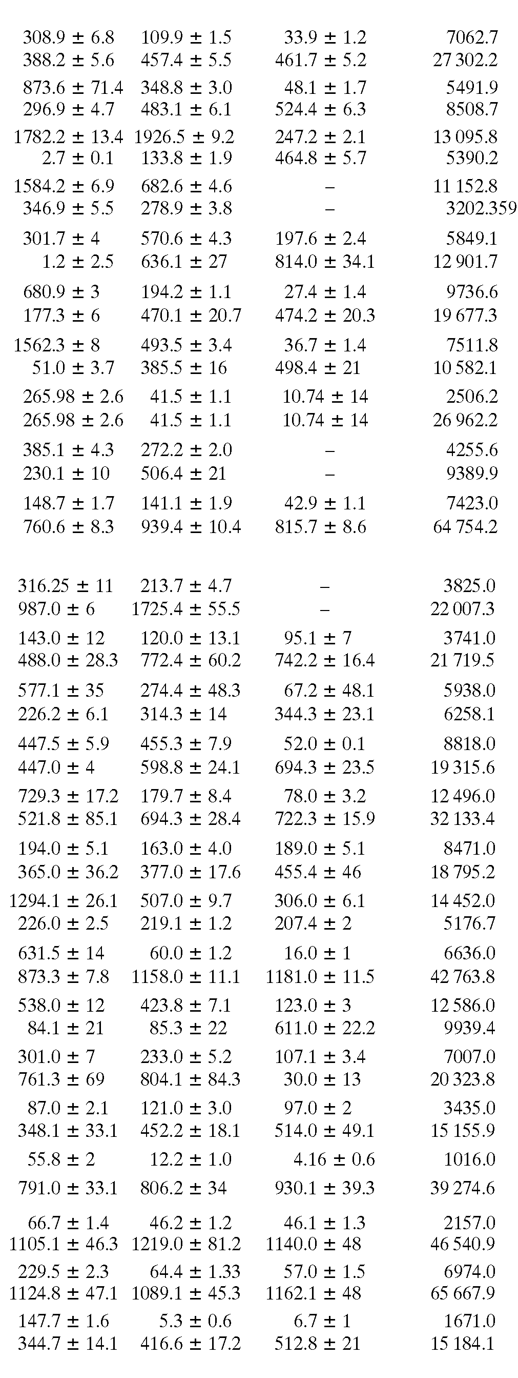
Table 1. Activity of ¹³⁷Cs and ⁴⁰K in the soil samples taken from five main valleys localized in the Polish part of Tatra Mts (West-
-East direction - Chochołowska Valley, Kościeliska Valley, Bystra Valley, Sucha Woda Valley and Rybi Potok Valley)
Chochołowska Valley
Near pathway to Iwaniacka Pass 1061 0.708
Chochołowska Valley near shelter- ^80 0 27
home near pathway to Wołowiec Mt
Bobrowiecka Pass 1355 0.17
Grześ Mt 1653 0.38
Wyżnia Chochołowska Glade 1720 0.16
Pathway to Grześ Mt 1150 0.33
Rakoń Mt 1879 0.17
Upłaz Mt 1794 0.58
Starorobociańska Valley 1434 0.46
Chochołowska Valley near
_{T} . ^{J} 1224 0.62
Lejowa Valley
Kościeliska Valley
Kościeliska Valley near chapel 1005 0.49
Pisana Glade 1012 0.77
Smreczyński Lake 1192 0.44
Ornak Glade 1094 0.45
Chuda Pass 1853 0.63
Upłaz Glade 1353 0.75
Piec Glade 1474 0.44
Ciemniak Mt 2076 0.56
Lejowa Valley 927 0.61
Lejowa Valley 913 0.72
Lejowa Valley 960 0.52
Tomanowa Pass 1685 0.63
Przysłop Miętusi Glade 1115 0.79
Iwaniacka Pass 1455 0.79
Ornak Mt (middle) 1837 0.60

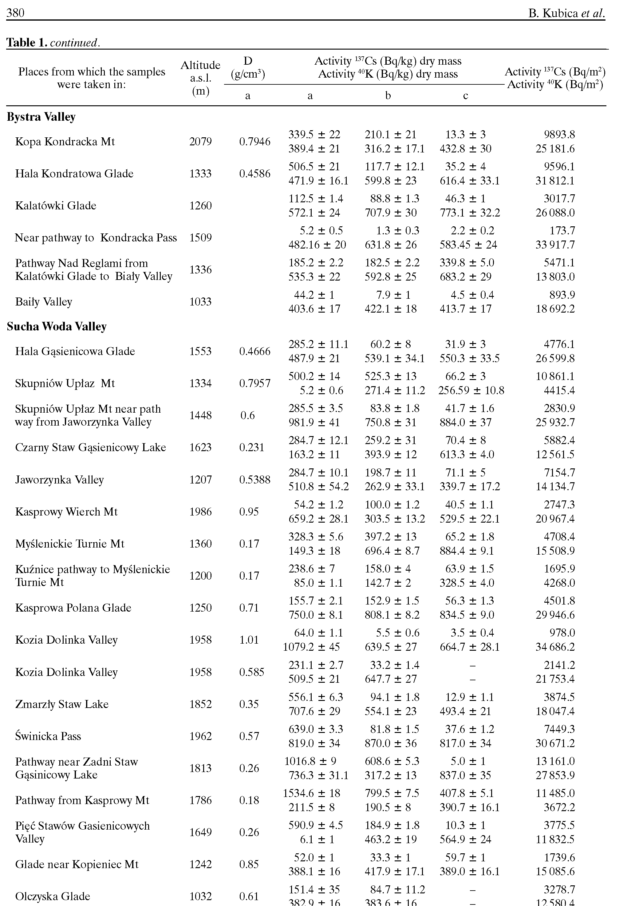

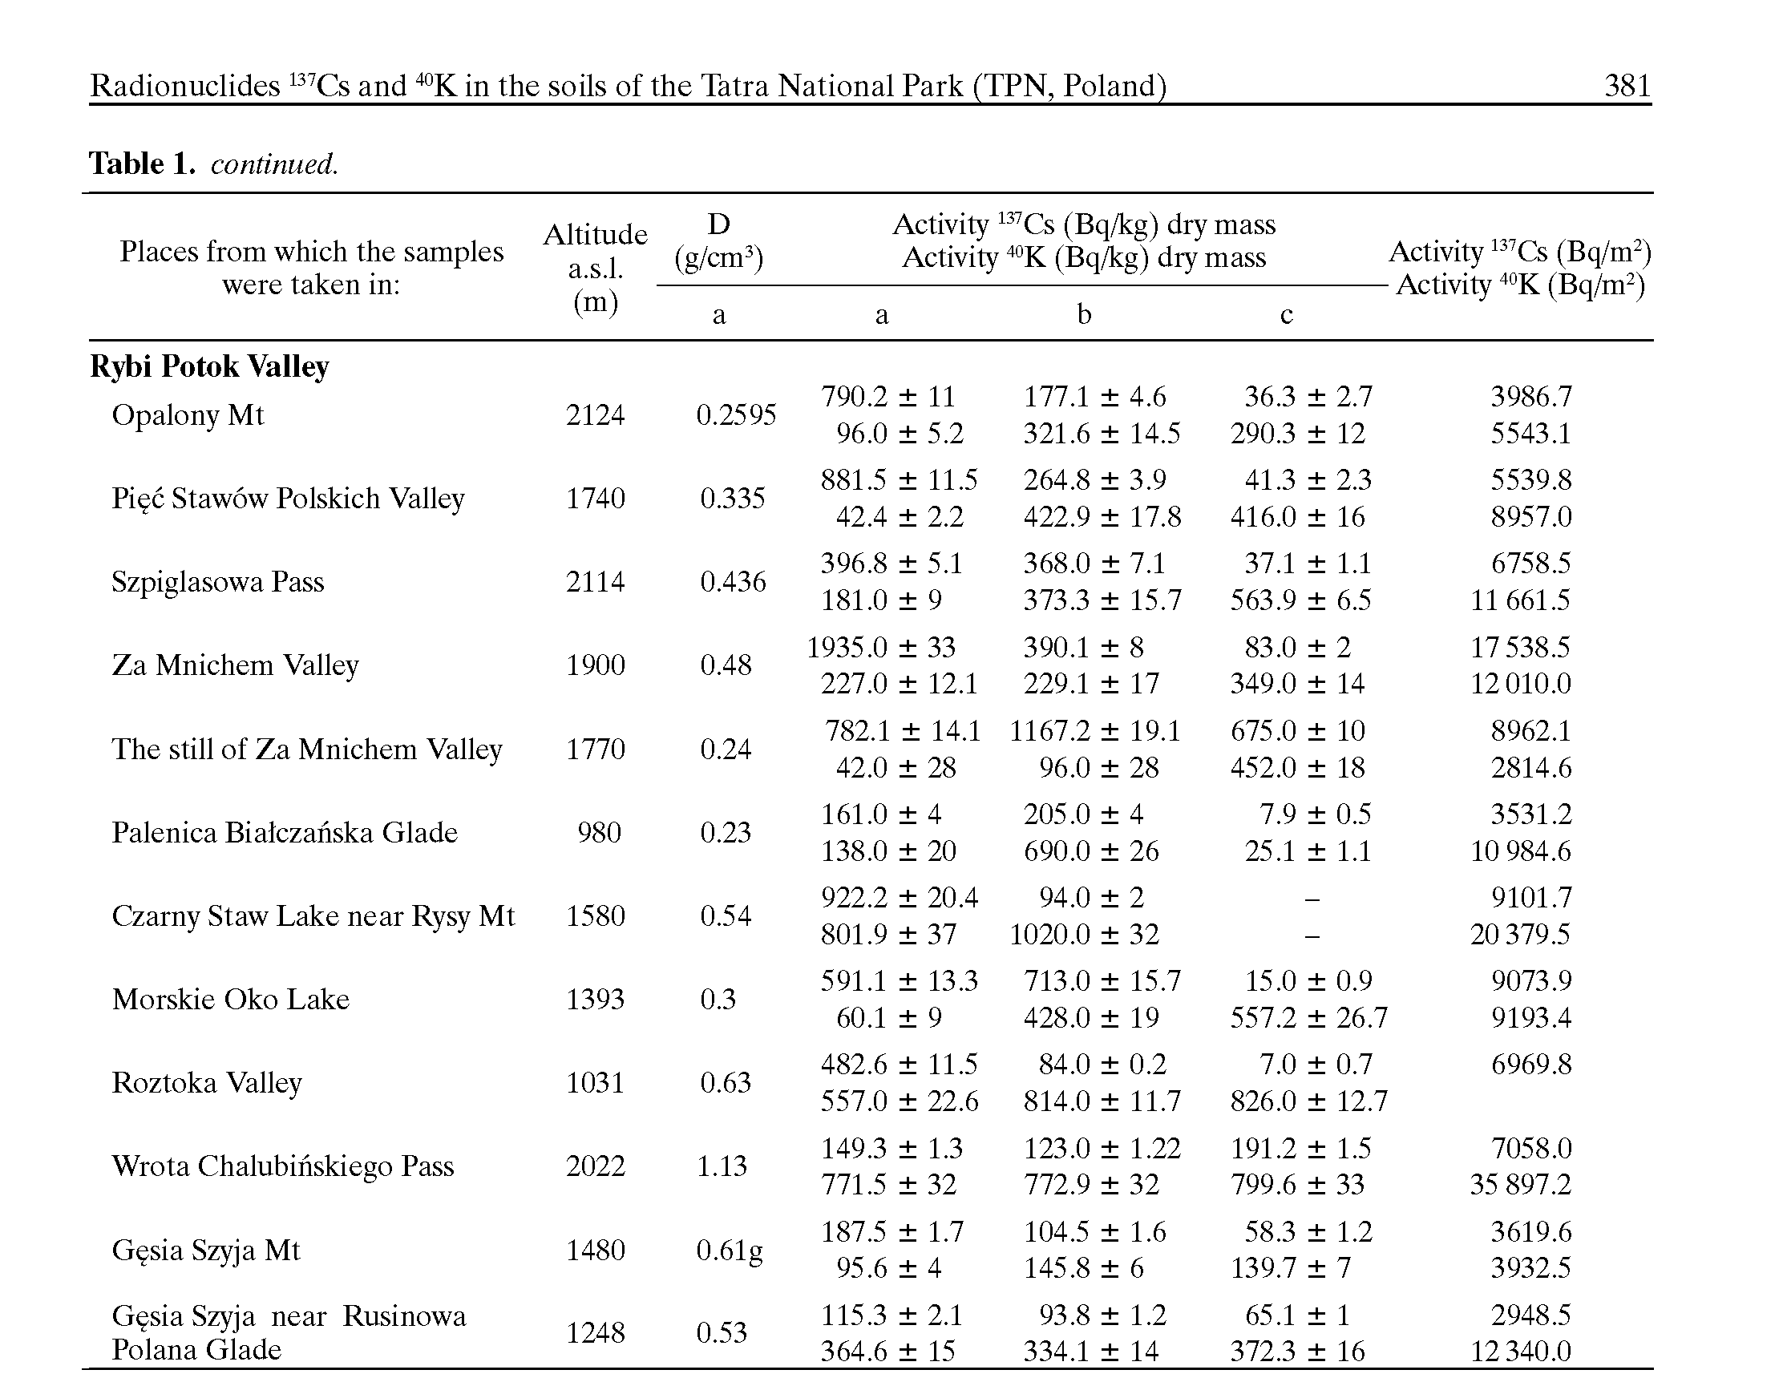
The relations between the ¹³⁷Cs level, altitude and
the soil volume density are interconnected. It is well
documented that the mountain soil properties are alter-
ing with altitude, in particular, the features of the upper
soil layers (O horizon, first 10 cm) change. In these
surface layers, the level of organic material increases
with altitude (included the subalpine zone). Moreover,
one could notice not only changes in the quantity of
organic mass, but also in its decomposition stages, the
huminification level and the content of humic and fulvic
acids (the ratio of humic acids in humus (organic mat-
ter) [4]. The humus modification also implies changes
in soil volume density. The relation between the soil
volume density and the radiocaesium activity could
then reflect the interdependence between the altitude
and ¹³⁷Cs level and might suggest an indirect secondary
phenomenon.
The concentration of caesium-137 is the highest in
the O horizon of the examined soils and its quantity
declines with soil depth (Fig. 8) what is shown on a
map ‘Concentration of artificial ¹³⁷Cs and natural ⁴⁰K
in soil upper layers collected from Tatra National Park’
(Fig. 2). Elevated accumulation of radiocaesium in the
surface layers indicates its atmospheric deposition on
one side and also could be the result of strong sorption
by organic components of the soil.
The concentration of ⁴⁰K is directly dependent on
the total potassium (1 g of potassium shows 31.7 Bq
of ⁴⁰K) and its quantity reflects the presence of alumi-
nosillicate particles in the soil. The noticeable feature
of Tatras soils is the accumulation of well-decomposed
organic material the amount of which gradually de-
creases with depth of the soil. The level of radiopotas-
sium significantly increases with depth because K is
the major component of the soil mineral layer (Fig. 9).
This observation is confirmed by the experimental data
shown on a map (Figs. 2 and 3).
There is no correlation between the ⁴⁰K concentra-
tion and the altitude of the sampling sites (Fig. 10).
The activity of radiocaesium for the soil samples
ranged from 0 to 1000 Bqkg⁻¹ (dry mass), (Fig. 11).
In view of the fact that the average range of mea-
sured ¹³⁷Cs concentration for Poland varies from 300 to
500 Bqkg⁻¹ (dry mass) [10], the obtained data appear
to lie within the average for Poland.
Both ⁴⁰K and ¹³⁷Cs belong to the lithium group
(Group IA, alkali metals) and possess similar chemi-
cal and physical properties. For this reason, one could
expect very much alike behaviour of those elements
in the soil sorption complex. The competition of the
elements have already been demonstrated in the distri-
bution analysis data where the ¹³⁷Cs level declines and,
at the same time, the ⁴⁰K concentration increases with
depth of the soil. Recently, some reports pointed out the
mechanisms of the competition phenomenon between
elements [10], now we could also add the competitive-
ness of these two radioisotopes. The notion is likewise
supported by the data revealed on maps (Figs. 2 and 3)
where the concentration of the radioisotopes in the sur-
face layer is indirectly proportional to the area unit.

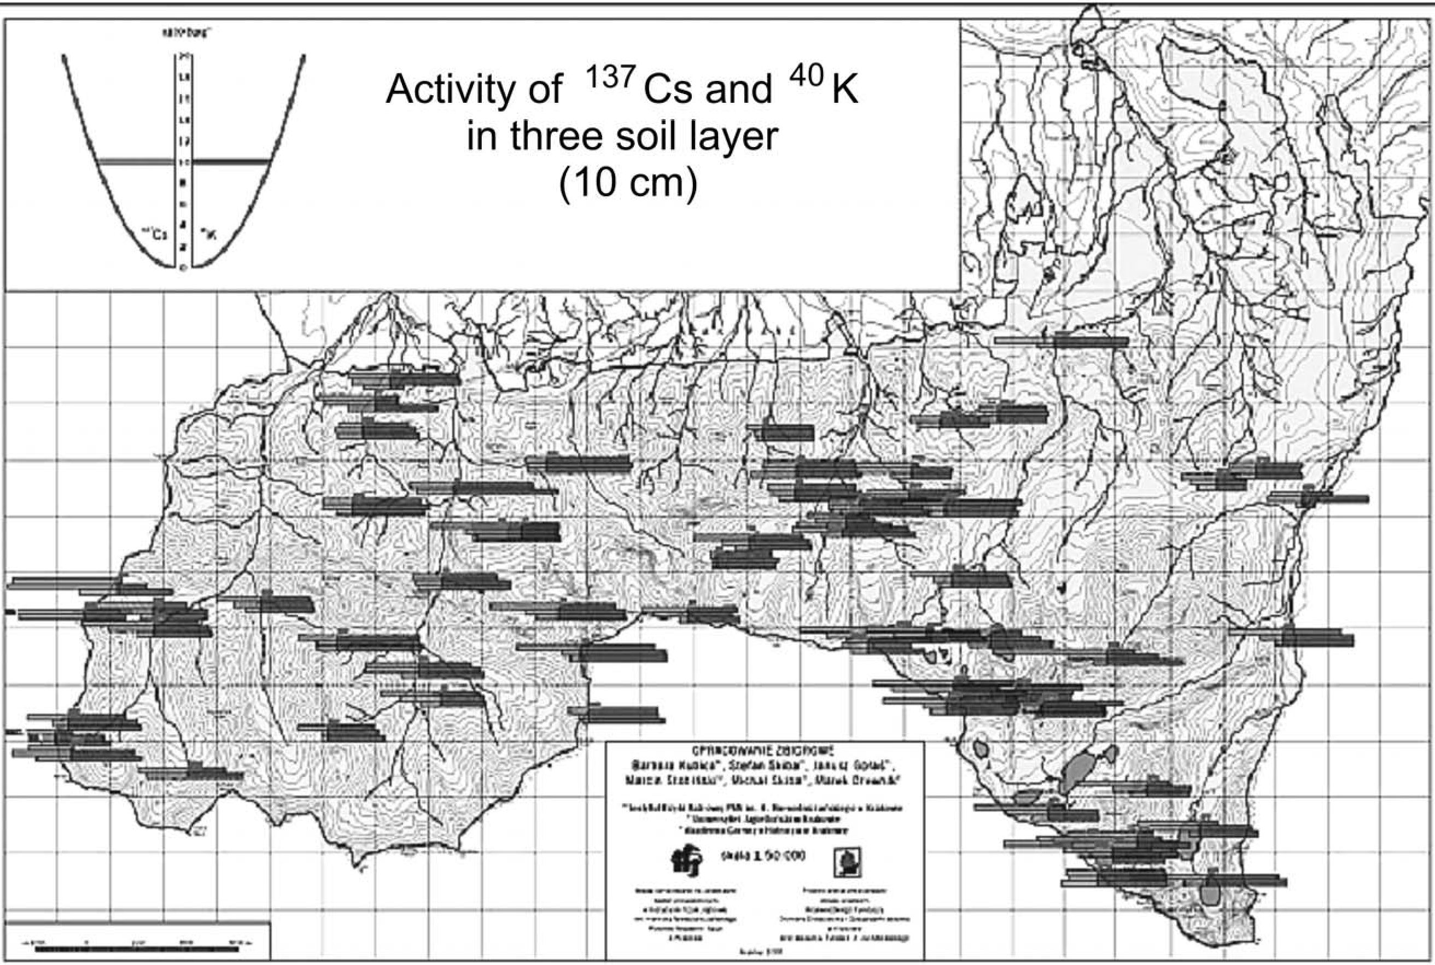

Fig. 2. Concentration of ¹³⁷Cs and ⁴⁰K [Bq/kg] (dry mass) in soil surface of three layers collected from the Tatra National Park.
382 B. Kubica et al.
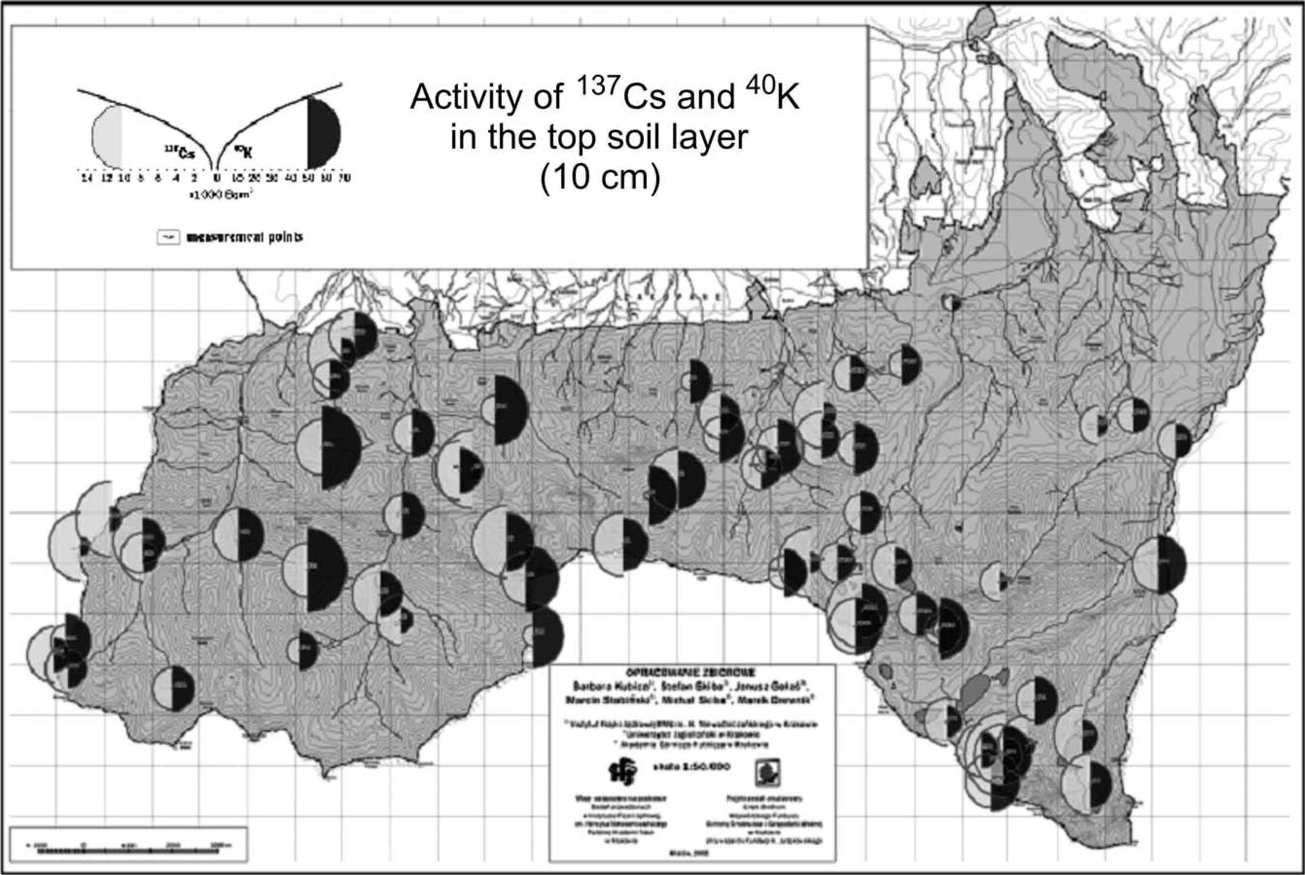

Fig. 3. Concentration of ¹³⁷Cs and ⁴⁰K [Bq/m²] in the 10 cm thick top layers collected from the Tatra National Park.
Radionuclides ¹³⁷Cs and ⁴⁰K in the soils of the Tatra National Park (TPN, Poland)
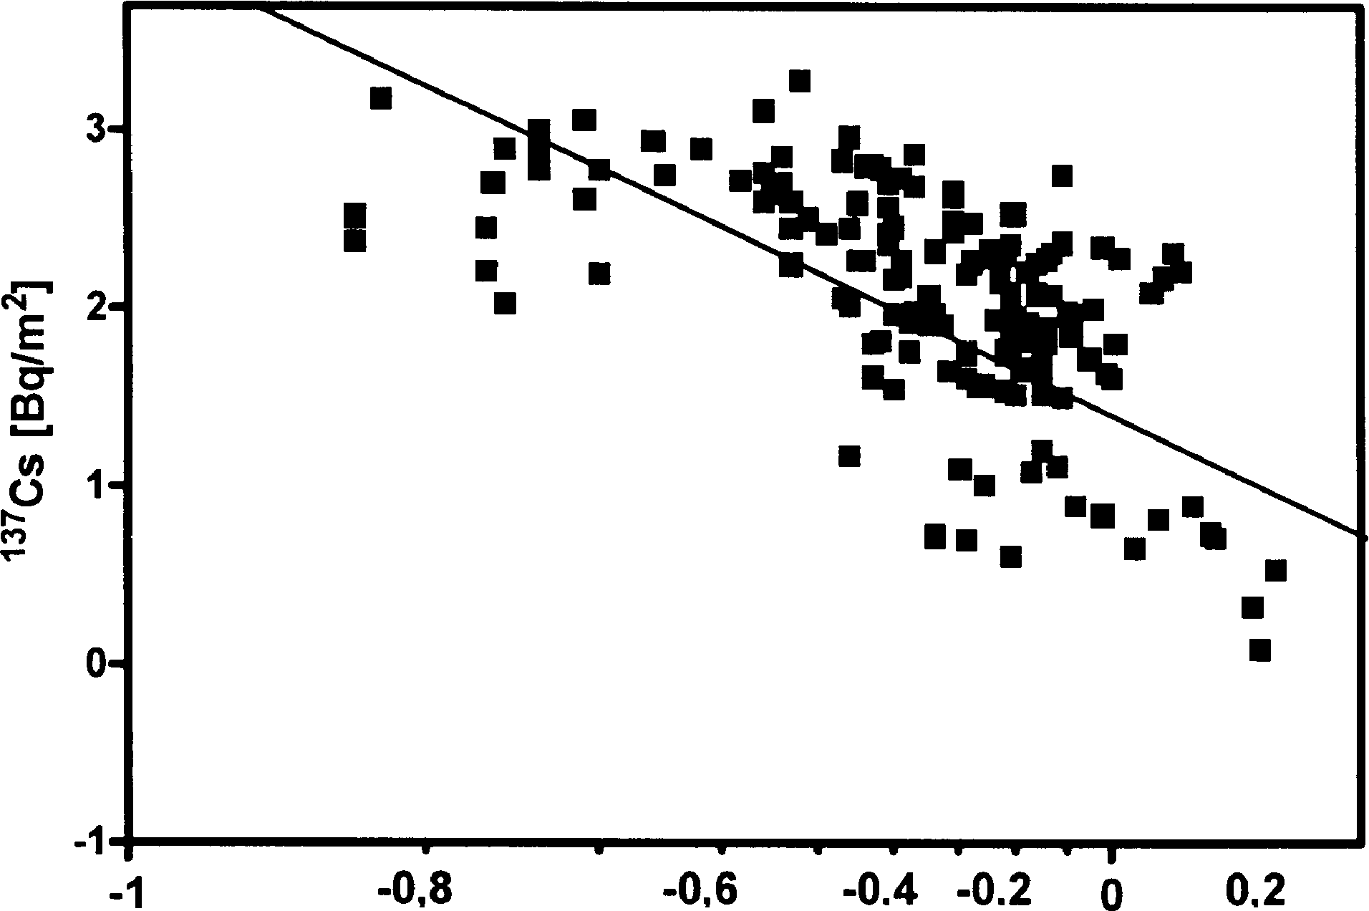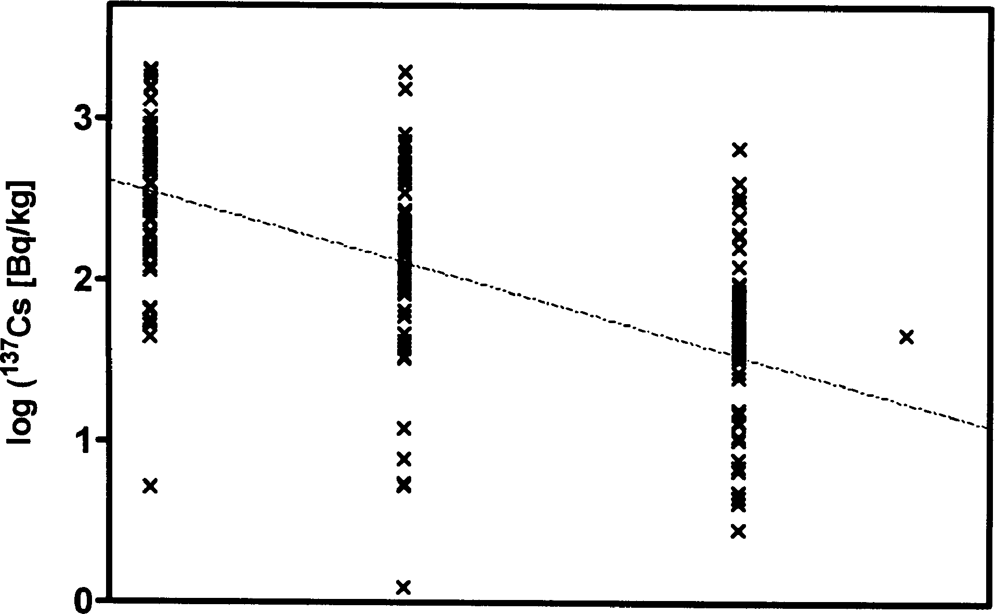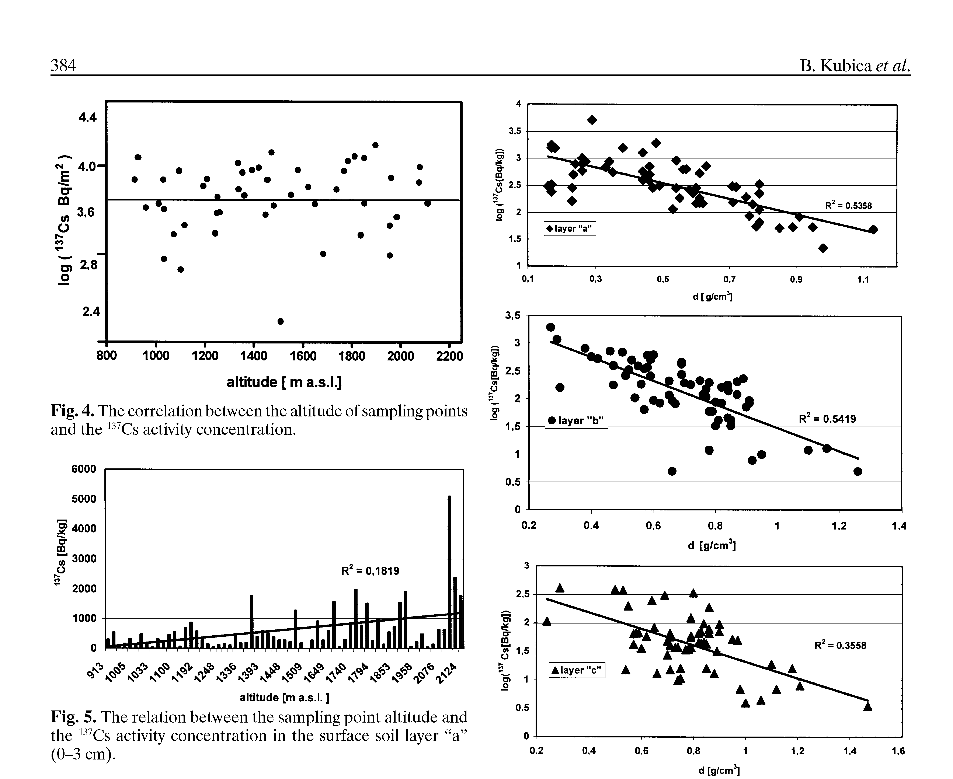

soil density [d [g/cm³]
Fig. 6. Correlation between the radiocaesium activity and the
volume density of soil samples.

Conclusions
Based on the obtained data, we conclude that:
- The concentration of ¹³⁷Cs in Tatras soils varies -
from 55.8 Bq-kg⁻¹ (dry mass) (417.8 Bq-m⁻²) for
the Tomanowa Pass (1685 m a.s.l.) to 5111 Bq-kg⁻¹
(8400 Bq-m⁻²) for the Krzyzne Pass (2112 m a.s.l.).
In most cases, the values are not high, moreover,
they are lower than the average radiocaesium con-
centration found for Poland.
- Variation of ¹³⁷Cs level in the TPN soil samples
depends mostly on the soil volume density and on
Fig. 7. Correlation between the radiocaesium activity and the
soil density for layers a, b and c.

layer a layer b layer c layer d
Fig. 8. The ¹³⁷Cs activity as a function of the depth of sam-
pling points.
the concentration of organic material, what is the
main factor of the soil sorption complex. We ob-
served the secondary effect of ¹³⁷Cs augmentation
in the soils that appears with altitude. There was
no other notion regarding to radiocaesium spatial
distribution.
- The methodology of ¹³⁷Cs determination in soils
should take into account soil volume density and
the level of organic components, whereas soil type
is not a crucial factor.

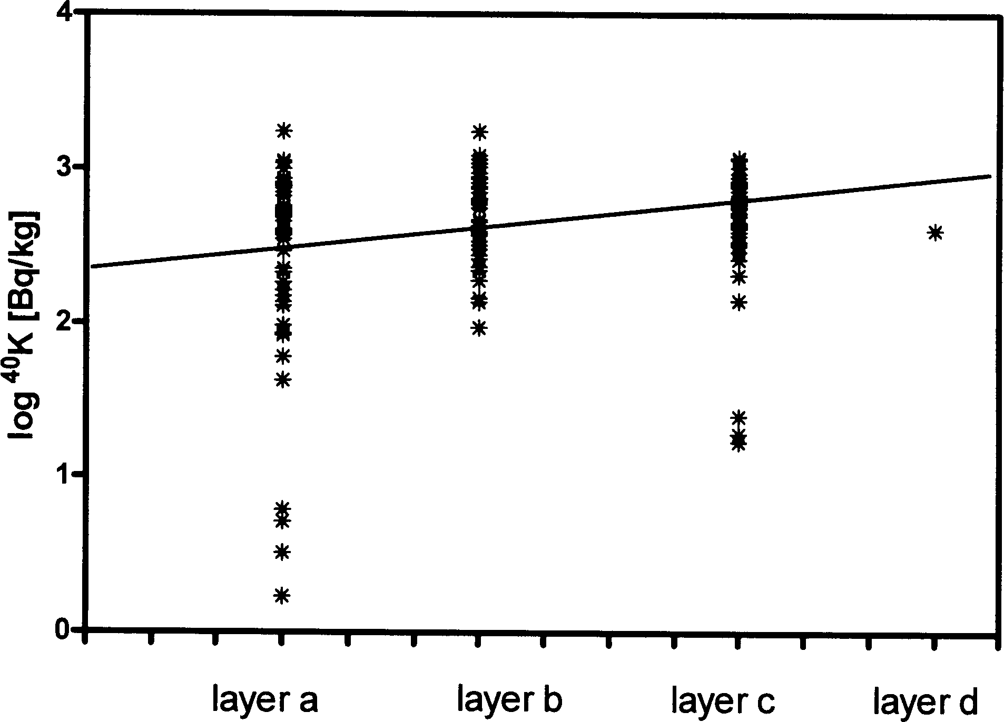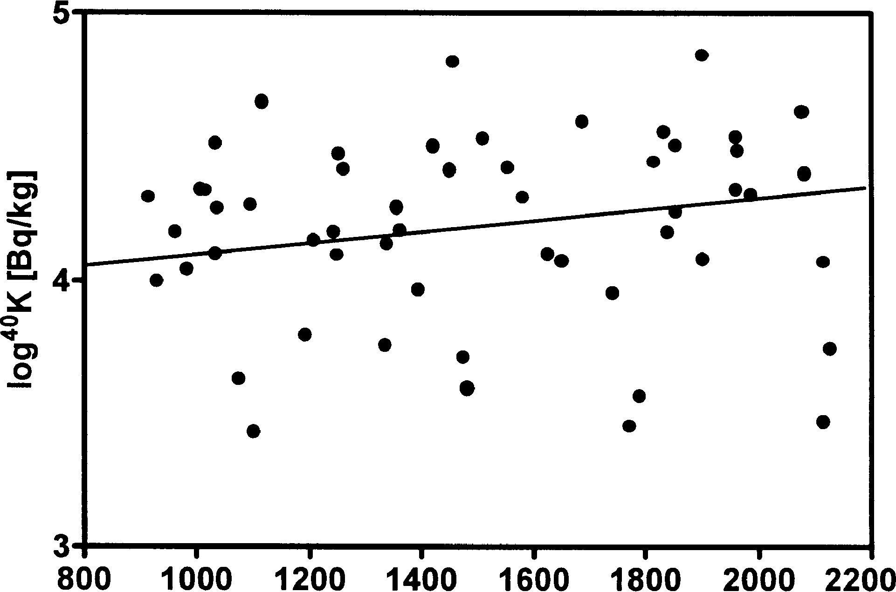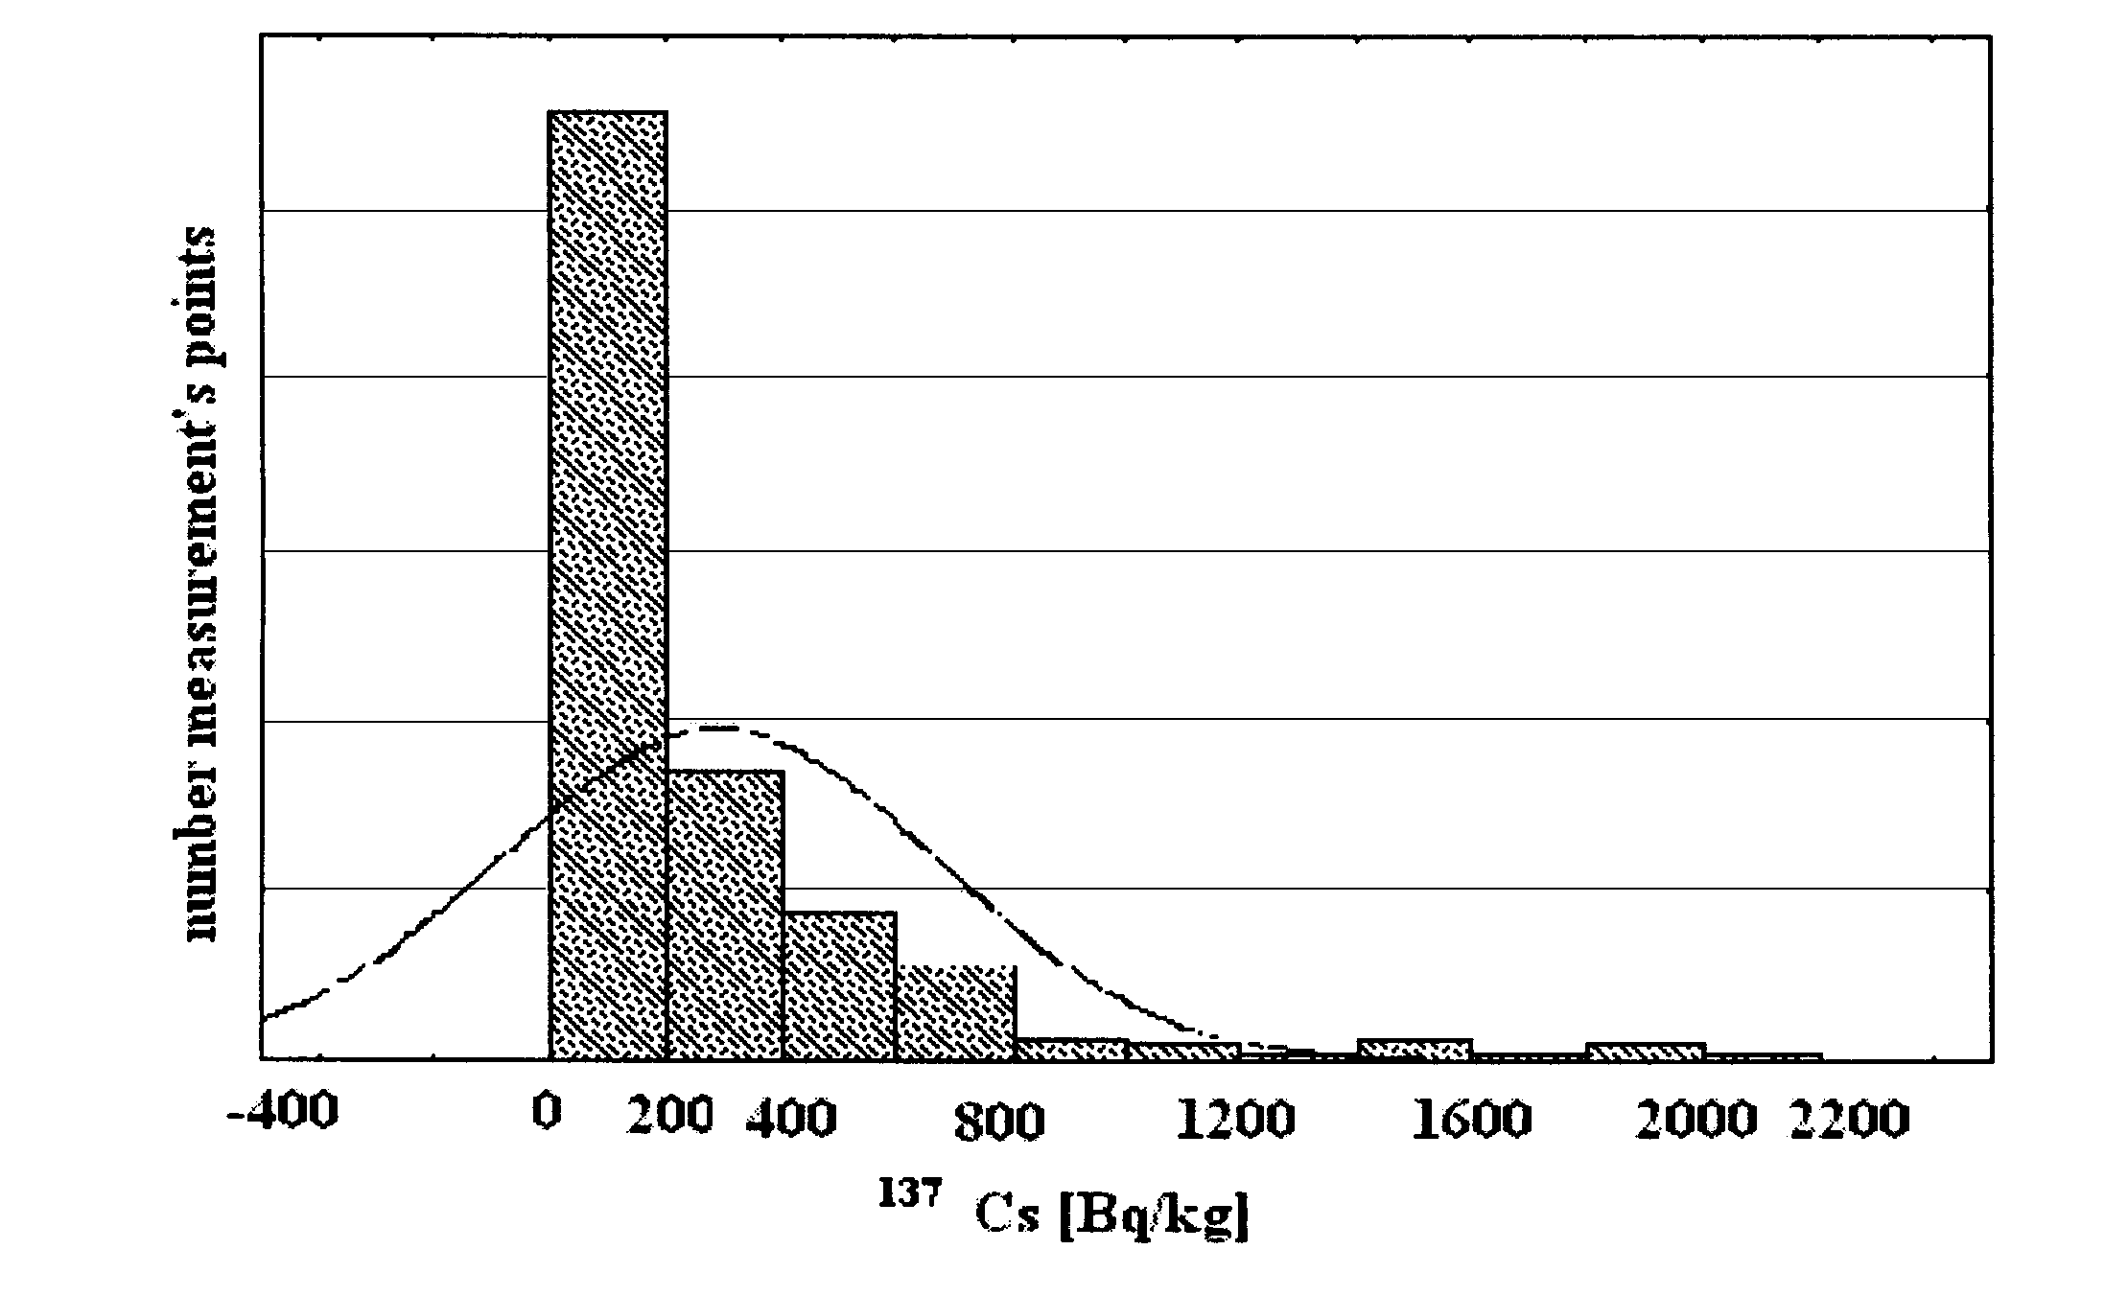

Fig. 9. The ⁴⁰K concentration as a function of the depth of
sampling points.

Altitude [ m a.s.l.]
Fig. 10. The ⁴⁰K concentration as a function of the altitude.
Fig. 11 . The number of observations (measurements) in rela-
tion to the ¹³⁷Cs level.
- The ⁴⁰K concentration increases with depth of
the soil, whereas the ¹³⁷Cs concentration declines
with soil depth in the 10 cm thin layer. The result
supports the hypothesis that the radiocaesium
involved is derived mostly from the atmospheric
deposition. On the other hand, the data obtained
could also confirm the competitiveness of Cs and K
due to their similar chemical properties.
Acknowledgment. This work was mostly supported by
Regional Fund for Environmental Protection (Krakow,
Poland) and partly by the project N305 011 31/0403 from
the State Committee for Scientific Research (Warsaw,
Poland). A part of this work has been carried out with
financial support from the Kościuszko Foundation (pro-
vided by Alfred Jurzykowski Foundation). The authors
acknowledge Mr Zbigniew Krzan, PhD, for making this
study possible.

References
- Broda R (1987) Gamma spectroscopy analysis of hot
particles from the Chernobyl fallout. Acta Phys Pol B
18:935-951
- Broda R, Kubica B, Szeglowski Z, Zuber K (1989) Alpha
emitters in Chernobyl hot particles. Radiochim Acta
48:89-96
- Currie L (1968) Limits for qualitative detection and quan-
titative determination: application to radiochemistry.
Anal Chem 40:585-593
- Drewnik M (2002) Transformation of the natural environ-
ment of the Tatra Mountains. TPN-PTPNoZ. Kraków-
-Zakopane, pp 101-106
- Górski M, udziak S (1991) ¹³⁷Cs in selected plants and
soils of the Tatra National Park. Annales UMCS Sect C
46:1-6
- Hrynkiewicz A (1993) Doses and biological effects of ion-
izing radiation. Report PAA-IFJ, Warszawa-Kraków
- IAEA (1991) The International Chernobyl Project:
technical report and surface contamination maps. Inter-
national Atomic Energy Agency, Vienna
- Jaracz P, Piasecki E, Mirowski S, Wilhelmi Z (1991)
Analysis of gamma-radioactivity of “hot particles” re-
leased after the Chernobyl accident. J Radioanal Nucl
Chem, Art 141:243-259
- Krasnov WP (1998) Radioekologija lisiv Polissja Ukrainy.
Zhytomyr, “Wolyn” 112
- Kubica B, Mietelski JW, Tomankiewicz E, Jasińska M,
Gaca P, Kozak K (2001) Pilot testing of radionuclides in
soil samples taken from Tatra National Park. Report IFJ
no. 1873/C. IFJ, Kraków
- Kubica B, Skiba S, Mietelski JW et al. (2004) Transect sur-
vey of artificial ¹³⁷Cs and natural ⁴⁰K in moss and bilberry
leaf samples from two main valleys from Tatra National
Park. Pol J Environ Stud 13;2:153-159
- Liljnzin JO, Skalberg M, Persson G, Ingemansson T,
Aronsson PO (1988) Analysis of the fallout in Sweden
from Chernobyl. Radiochim Acta 43:1-25
- Pieńkowski L, Jastrzębski J, Tys J et al. (1987) Isotopic
composition of the radioactive fallout in eastern Poland
after the Chernobyl accident. J Radioanal Nucl Chem
Lett 6:379-409
- Polish Society of Radiation Research (1996) Proc of the
XVI Autumn School of the Polish Society of Radiation
Research. Chernobyl - 10 years later. Health effects,
environmental pollution and food, 14-18 October 1996,
Zakopane, Poland. (Collective work)
- Skiba S (2002) The soil map of the Tatra National Park.
Transformation of the natural environment of the Tat-
ras. Collective work. Borowiec W (ed.) TPN-PTPNoZ,
Kraków-Zakopane, pp 21-26
- Skiba S, Drozd J (1997) Characteristics of the organic
matter of ectohumus horizons in the soils of different
mountain regions in Poland. The role of humic substances
in the ecosystems and in environmental protection. (IHSS
- International Humic Substances Society), pp 497-505
- Skiba S, Kubica B, Skiba M (2005) The content of gamma
radionuclides ¹³⁷Cs and ⁴⁰K in the soils of north-western
part of Chornohora, eastern Carpathians. Ukraine Biesz-
czady Mts Ann 13:325-332

386
B. Kubica et al.
- Skiba S, Kubica B, Skiba M, Stobiński M (2006) Content
of the gamma radionuclides of ¹³⁷Cs and ⁴⁰K in the soils
samples of the Tatra Mts (Poland) and Czarnohora Mts
(Ukraina). Pol J Soil Sci 138;2:119-126
- Strzelecki R, Wolkowicz S, Szewczyk J, Lewandowski P
(1993) Radioecological maps of Poland. Part I. Geological
Institute, Warsaw
- UNSCEAR (1977) Ionizing radiation sources and biologi-
cal effects. Report to the General Assembly with Annexes.
UN Pub., New York

