
Regular paper

Vol. 60, No 3/2013
313-321
on-line at: www.actabp.pl

Splenic melanosis during normal murine C57BL/6 hair cycle and
after chemotherapy*

Dominika Michalczyk-Wetula, Aleksander Salwiński#, Małgorzata Popik##, Monika Jakubowska
and Przemysław M. Płonka*
Department of Biophysics, Faculty of Biochemistry, Biophysics and Biotechnology, Jagiellonian University, Kraków, Poland
Cancer chemotherapy is associated with serious side ef-
fects, including temporary hair loss and impairment of
pigmentation. We suspect that ectopic melanin deposi-
tion occurring due to chemotherapy may add to these
effects worsening the already unpleasant symptoms. We
associated the ectopic occurrence of follicular melanin af-
ter chemotherapy with splenic melanosis — an interest-
ing example of extradermal melanin localization — and
we expected an increase in splenic melanin deposition
after chemotherapy. Using the C57BL/6 murine model of
synchronized hair cycle induced by depilation, we visu-
alized splenic melanin by means of several histological
and histochemical protocols of staining: hematoxylin and
eosin, May-Grunwald-Giemsa and Fontana-Masson. Un-
expectedly, the splenic deposition of melanin decreased
due to application of cyclophosphamide (i.p. 120 mg/
kg body weight on day 9 post depilation). The drop was
abrupt and lasted for at least 5 days (day 13-18 post de-
pilation), as compared with normal hair cycle. Moreover,
in mice with normal, depilation-induced hair cycle we
observed a similar drop shortly before entering catagen
(day 15 post depilation), followed by a slow and partial
increase in splenic melanization up to day 27 post depila-
tion in both groups. We conclude that cyclophosphamide
negatively affects splenic melanization and/or extrader-
mal transfer of ectopic melanin from the dystrophic hair
follicles, but the most powerful down-regulator of splenic
melanosis is normal and dystrophic catagen — the phase
of hair follicle involution and re-modelling.
Key words: cyclophosphamide, Fontana-Masson, hematoxylin and
eosin, May-Grunwald-Giemsa, melanin, spleen
Received: 15 May, 2013; accepted: 26 June, 2013; available on-line:
05 July, 2013
INTRODUCTION
One of the most acute side effects of cancer chem-
otherapy is hair loss and impairment of hair pigmen-
tation. This phenomenon adds to the overall depres-
sive condition of patients making them feel devastated
and is sometimes a reason for giving up chemotherapy
(McGarvey et al, 2001). Understanding the underlying
mechanisms is, consequently, an important factor of the
success in cancer therapy. One of the related problems
is the fate of epidermal and follicular melanin which is
initially deposited ectopically in response to chemother-
apy (Braun-Falco, 1961). This melanin is toxic in itself
(Slominski et al, 1996; Swartz et al, 2005; Wood et al,
2009) and affects the general condition of the organism.
Moreover, the pigmented tumors (melanotic melanoma)
may also reveal symptoms of deregulated melanogenesis,
which may influence the process of therapy (Plonka et
al, 2003; Lazova et al, 2010). This makes the topic of
extradermal melanin transfer important also from the
oncological point of view (Michalczyk et al, 2009).
Melanin, an amorphous polymer responsible for skin
and hair pigmentation, may be also found in other or-
gans. In higher vertebrates, including humans (Wasser-
man, 1967), melanin has been reported, besides skin, in
visceral organs, and its presence and origin in such ex-
tradermal locations is enigmatic. Pigmentation of murine
spleens was noted for the first time by Weissman (1967).
Early studies delivered numerous hypotheses concern-
ing the identity of the pigment. In (1978) Crichton et al.
identified the pigment as lipofuscin. In (1989) Veninga et
al. postulated deposition of hemosiderin as the cause of
spleen pigmentation. Work of Sundberg et al. (1991) and
van der Heijden et al. (1995) finally confirmed the pres-
ence of melanin. Simultaneously, they excluded lipofuscin
— the pigment characteristic for ageing, since the phe-
nomenon was observed in young animals. The presence
of melanin was directly proved by Plonka et a. (2005)
by means of electron paramagnetic resonance (EPR, also
called electron spin resonance, ESR). In (2009) Michal-
czyk et al. indicated that partial melanization of spleens
is observed in young C57BL/6 mice (younger than 10
weeks) with synchronized hair cycle. Meanwhile, over
one-year-old mice revealed no splenic melanosis, instead,
“melanin debris” could be observed in some of these old
mice.
Excessive melanin deposition (melanosis) of inner or-
gans is a long-studied phenomenon (Wasserman, 1967).
It has recently turned out that melanophores play an im-
portant part in amphibian metamorphosis, which includes
total re-building of the tissues, including skin. An inter-
esting manifestation of this process is deposition of mel-
*e-mail: przemyslaw.plonka@uj.edu.pl
*Presented at 40th Jubilee Winter School of the Faculty of Bio-
chemistry, Biophysics and Biotechnology of the Jagiellonian Uni-
versity "Contemporary insights into cancer. Risk, perspectives, ex-
pectations”, February 16-21, 2013, Zakopane, Poland.
•Present address: Institute of Organic and Analytical Chemistry
(ICOA), UMR 7311, University of Orléans, BP 6759 45067 Orléans
cedex 2, France.
••Present address: IBSS BIOMED S.A., Sosnowa 8, 30-224 Krakow,
Poland.
Abbreviations: C57BL/6, Cross 57th-generation female x 52nd-
genertion male BLack, 6th sub-strain (inbred mouse strain); CYP,
cyclophosphamide; DPPH, 1,1,-diphenyl-2-picrylhydrazyl; EPR, elec-
tron paramagnetic resonance; ESR, electron spin resonance; FM,
Fontana-Masson; HE, hematoxylin and eosin; MGG, May-Grünwald-
Giemsa.
314
D. Michalczyk-Wetula and others
2013
anin in the liver and other visceral organs of the animals
(Divya et al, 2010). Understanding the origin and mecha-
nism of splenic melanization in mice is, therefore, im-
portant from the point of view of general biology, evolu-
tion of the skin, and experimental dermatology (Rakers et
al, 2010). The most important, hypothetical extrasplenic
source of the murine spleen melanin are the hair follicle
melanocytes.
The mammalian hair follicle is a mini organ, which
undergoes continuous remodelling through the whole
animal life in the process called hair cycle (Chase, 1954;
Muller-Rover et al, 2001). In many animals, includ-
ing mice, it is synchronized over big areas of skin (Dry,
1926). The hair grows and gains melanin only in anagen
— the stage of hair growth. In the subsequent stage —
catagen (well synchronized in young C57BL/6 mice, and
followed by telogen, the “resting” stage), follicular mel-
anocytes undergo massive apoptosis, and the melanin-
containing apoptotic bodies are phagocytosed initially by
the Langerhans cells (Tobin, 1998) and then transferred
further, probably as far as to the spleen. In the mean-
time melanin undergoes partial degradation (Borovansky
& Elleder, 2003; Plonka et al., 2005). Therefore, splenic
melanization must be correlated with the progress of the
hair cycle.
Impairment of the hair cycle and of the related mela-
nin production is often associated with ectopic deposition
of the pigment in the hair follicle outside the hair shaft.
Such pathological melanization is a side-effect of cancer
chemotherapy with cyclophosphamide (CYP) in humans
(Braun-Falco, 1961), and in model mice (Kostanecki et
al, 1967). This is a rationale to suppose that in such a
case a particular increase in splenic melanin deposition
can be expected. On the other hand, in normal mice we
found less splenic melanin in early telogen than in late
telogen (Plonka et al, 2005) while one of the ways through
which hair follicles can recover from CYP-related dystro-
phy is to enter dystrophic catagen followed by dystrophic
telogen (Paus et al, 1994a). It creates the necessity to as-
sess splenic melanosis over the whole hair cycle, in its
every stage, with and without CYP administration. The
presence of melanocytes in murine skin is limited al-
most exclusively to hair follicles (Chase, 1954; Slominski
et al, 2005). Since these laboratory rodents exhibit the
wave-like type of hair growth (Dry, 1926; Chase, 1954;
Chase & Eaton, 1959), synchronization of every stage of
the hair cycle is possible, which is even more prominent
in the case of the depilation-induced cycle (Paus et al,
1990). Therefore, this model is of particular suitability to
study correlation between splenic melanosis and hair cy-
cling.
For microscopic examination of splenic melanosis we
chose three methods of histological staining often ap-
plied in experimental dermatology: hematoxylin and eosin
(HE; Paus et al, 1999b; Muller-Rover et al, 2001; Shirai
et al, 2001; Hendrix et al, 2005), May-Grunwald-Giemsa
(MGG; Paus et al, 1994b; Muller-Rover et al, 2001; Lu et
al, 2009), as well as Fontana-Masson (FM; Slominski &
Paus, 1993; Slominski et al, 1994; 2004; 2005).
One of the most popular and widely applied is hema-
toxylin and eosin staining (Mayer, 1891; 1904). It em-
ploys two dyes specific for different cell compartments.
Hematoxylin, a blue dye, possesses affinity to basophilic
(acidic) structures within the cell (mainly chromatin,
therefore the nucleus is visualized very efficiently). To
obtain a sharp contrast with the blue hematoxylin sig-
nal, the staining with purple eosin Y is used. This dye
shows affinity to acidophilic structures (usually positive-
ly charged, because eosin is an acid). In practice, eosin
stains the entire cytoplasm and cell membrane of various
types of cells (Romeis, 1991; Avwioro, 2011).
Another staining method whose specificity is based on
electrostatic interactions between the dye and the target
structures is May-Grunwald-Giemsa stain (MGG). May-
Grunwald staining solution is composed of eosin Y and
methylene blue. Giemsa solution is applied separately and
is composed of azure-type dyes: azure II is a mixture of
methylene blue and its derivative in 1 : 1 proportions, and
of eosin. The Properties of azures and methylene blue
are similar to those of hematoxylin — these dyes, car-
rying a positive charge, stain nuclei and basophilic cells
(Barcia, 2007).
The third staining procedure is based on the reduction
of diamminesilver(I) nitrate to metallic silver(0) under
the influence of reductive agents present in the cell. This
method, described by Fontana (1912) and Masson (1914),
was applied by Fontana for visualization of a spirochete
(Treponema pallidum), and in its basic version it is known
as Fontana-Masson (FM) staining. Masson applied ‘silver
solution’ for visualization of neuronal structures (Moore
et al, 2001). Cells which reduce diamminesilver(I) nitrate
to metallic silver(0) are referred to as argentaffins. A pos-
itive result of such ‘silver stain’ is mostly correlated with
the presence of serotonin (Barter & Pearse, 1955) and
other biogenic amines such as dopamine or ephedrine
(Lundqvist et al, 1990). Melanins are composed mainly
of derivatives of dihydroxyindole monomers that can be
oxidized by diamminesilver(I) nitrate and thus melanins
can be marked with metallic silver(0) (reaction 1).
'n{[Ag(I)(NH3)2l+(aq) + e -> Ag,0,| + 2NH,(aq)}
melanin(reduced) * melanin(oxidized) + we
Reaction 1. Schematic illustration of the principle of silver(I)-de-
pendent oxidation of melanin.
EPR spectroscopy is widely used to investigate mel-
anin-containing tissues. Paramagnetic properties of this
pigment were pointed out for the first time in 1954
(Commoner et al, 1954). Since then EPR has been ap-
plied to quantitative (Pilas & Sarna, 1985; Slominski et al,
1994), and qualitative (Sealy et al, 1982) assays of mela-
nin and of its microenvironment in the tissue (Felix et al,
1978; Plonka et al., 2005). It is, however, not able to lo-
calize melanin spatially in the spleen tissue. Instead one is
bound to use standard histological methods.
In the present paper we compared HE and MGG
staining and the FM method, which is melanin-specific
in terms of quality and potential to visualize melanin
and the contours of individual cells, in murine C57BL/6
spleens. The presence of melanin was verified indepen-
dently by means of EPR spectroscopy. We checked the
presence of splenic melanosis on subsequent days after
induction of the hair cycle by depilation. We also exam-
ined whether chemotherapy with CYP increases or de-
creases splenic pigmentation, and discussed what implica-
tions it may have for cancer treatment.

MATERIALS AND METHODS
Instruments. Paraffin slices were prepared using a
manual Finesse 325 microtome (Thermo Shandon, Run-
corn, UK), images of stained tissues were taken by a re-
versed Eclipse Ti microscope (Nikon Corporation, Tokyo,
Japan) equipped with the Nis elements F 3.0 imaging soft-
ware (Nikon Corporation, Tokyo, Japan), and an analog
camera (PENTAX ME, Asahi Opt. Co., Tokyo, Japan)
equipped with 1:4.5/8—20 mm Soligor MC lenses (Sun

Vol. 60
Splenic melanosis during hair cycle
315
Optical Co., Ltd., Ichikawa, Japan) adjusted for mac-
rophotography. EPR spectra were recorded by an E-3
spectrometer (Varian, Sunnyvale, LA, USA) in a Wil-
mad finger quartz Dewar WG-816-B-Q (Rototec-Spintec
GmbH, Griesheim, Germany). Animals were shaved with
an animal shaver (Braun AG, Kronberg, Germany).
Reagents. Giemsa, May-Grunwald, ethyl eosin and
1,1-diphenyl-2-picrylhydrazyl (DPPH) were purchased
from Sigma-Aldrich Corporation, (St. Louis, MO, USA),
Mayer hematoxylin from Aqua-Med (Łódź, Poland), sil-
ver nitrate, methyl red, sodium thiosulfate, methyl sa-
licylate, sodium thiosulfate, ethanol, formaldehyde and
xylene from POCh (Gliwice, Poland), ammonia from
Eurochem Service Poland Sp. z o.o. (Warszawa, Poland),
Sedazin® from Biowet Puławy Sp. z o.o. (Puławy, Po-
land), ketamine (Ketanest 50®) from Parke-Davis GmbH
(Berlin, Germany), cyclophosphamide (CYP; Endoxan®)
from ASTA Medica AG (Frankfurt, Germany), saline
from Polpharma SA (Stargard Gdański, Poland), paraffin
from Thermo Shandon (Runcorn, UK), beeswax from
Aldrich Chemical Co. (USA), and gum rosin from Sigma
Chemical Co. (USA). For histology, Polysine® slides and
Consult Mount (mounting medium) were obtained from
Thermo Shandon, (Pittsburgh, USA), and cover glasses
(Citoglas®, China) from ElektroMed (Niepołomice, Po-
land).
Biological material. The biological material was col-
lected over a long time and during several different ex-
periments, all of which were approved by the 1st Local
Committee for Animal Research in Kraków (221/95,
303/97, 15/OP/2004). Female, 6-8-week-old C57BL/6
mice (Animal Breeding Facility, Silesian Medical Acad-
emy, Katowice-Ligota, Poland) were selected for depila-
tion based on the pink color of their back skin (all hair
follicles in telogen, Paus et al, 1990). Depilation was ex-
ecuted in ketamine anesthesia by application of melted
1:1 mixture of beeswax and gum rosin and peeling out
the hair coat after hardening, according to Paus et al.,
(1990). On day 9 post depilation (p.d.) the CYP-treated
animals were administered a single i.p. dose (120 mg/kg
body weight) in a small volume (ca. 0.1—0.2 ml) of sa-
line (Paus et al., 1994a; Hendrix et al., 2005), while the
control animals were given vehicle. At subsequent time
points (see Fig. 1) the animals were shaved if necessary,
photographed, and killed by cervical dislocation in deep
ketamine anesthesia, whereupon the skin was separated
at the level of subcutis, spread on a piece of cardboard,
and fixed in buffered 5% formalin (phosphate buffer,
pH = 7.4). We determined the stage of the hair cycle and
dystrophy of the hair follicles based on the tabularized
criteria of histomorphometry (Muller-Rover et al, 2001;
Hendrix et al, 2005).
The spleens of animals were carefully examined on
necropsy for macroscopic evidence of melanosis and
fixed in the formalin solution for histology. We estimat-
ed the area of melanosis and calculated the percentage
of melanotic spleens per a given experimental group of
mice. A part of spleens was frozen in liquid nitrogen for
EPR measurement.
Preparation of tissue slices for histology. To pre-
pare paraffin blocks, the spleens, after a long fixation in
formalin, were rinsed with water (24 h), dehydrated in
the series of aqueous solutions with increasing concentra-
tion of ethanol (50%—1 h, 70%—2 h, 80%—2 h, 96%—12 h,
100%—40 min, 100%—1 h) and then in methyl salicylate
(4 h), xylene (10 min) (all at room temperature) and
embedded in paraffin blocks. Shortly before cutting into
5 pm slices the paraffin blocks with embedded spleens
were additionally cooled in icy water. We found it an im-
portant step preventing the spleen tissue from crumbling.
The middle-dorsal pieces of skin were flushed with
water (24 h), dehydrated in a series of ethanol solu-
tions (50%-1.5 h, 70%-1.5 h, 80%-1.5 h, 96%-12 h,
2 x 100%—30 min), immersed in anhydrous ethanol and
xylene (1 : 1, v : v) (2 x 30 min) and xylene (30 min) (all at
room temperature), embedded in paraffin blocks, and cut
in 8 pm slices.
Pre-treatment of slides with tissue sections. Par-
affin sections of spleen tissues on Polysine® slides were
deparaffinized by: a) incubation of the slides in 56°C for
20 min to melt paraffin and to attach the tissue to the
surface of glass, b) dissolution of the melted paraffin in
xylene (5 min) and then immersing the slides in fresh
xylene several times, and c) re-hydration of the tissue by
immersing the slides in a series of aqueous solutions with
decreasing concentration of ethanol (100, 96, 80, 70, 50,
0% of ethanol, v/v, respectively).
Hematoxylin and eosin (HE) staining. The depar-
affinized slices were incubated in hematoxylin working
solution (12 min) at room temperature, flushed with tap
water (15 min), counterstained for 1.5 min in 0.1% etha-
nol solution of eosin acetified with a few drops of acetic
acid, dehydrated in the ethanol se-
ries (70%, 2 x 96%, 2 x 100%, v/v,
respectively), 2 x xylene (all at room
temperature), sealed in balsam and
covered (Romeis, 1991).
May-Grunwald-Giemsa (MGG)
staining. Working solution of
Giemsa was prepared by mixing 0.5
ml of concentrated Giemsa stock
solution with 200 ml of distilled
water. The MG working solution
was prepared by mixing 15 ml of
MG stock solution with 160 ml of
distilled water. Deparaffinized slides
with samples were incubated in MG
working solution for 20 min at 37°C
in a Coplin jar covered with alumin-
ium foil to protect against light. The
samples were then introduced into
Giemsa working solution for 40 min
at 37°C, immersed quickly in 0.15%
solution of acetic acid to obtain neu-
tral pH, washed in distilled water,
day after | •O- | ■o  cm  ■o  ■cm  ■o | O O | O
depilation | 0 | 5 9 13 14 15 18 | 21 24 | 27
1 1
depilation (dO) Lp. CYP (d9)
1 1
day after | telogen | anagen I-VI _ dystrofic anagen and catagen | recovery
depilation | 0  I | 9 | 27  DYSTROPHIC HAIR CYCLE
day after | \  telogen | anagen I-VI anagen VI ^catagcji | telogen
day after |  |  | >
depilation | 0 | 9 16 18 | 20 27  NORMAL HAIR CYCLE
Figure 1. Experimental design.
Empty circles, harvesting of spleens; black circles, harvesting of skin. Below, general
scheme of normal hair cycle in C57BL/6 mice, and dystrophic hair cycle after administra-
tion of cyclophosphamide (i.p. 120 mg/kg body weight) on day 9 post depilation (accord-
ing to Müller-Rover et al., 2001, and Hendrix et al., 2005).
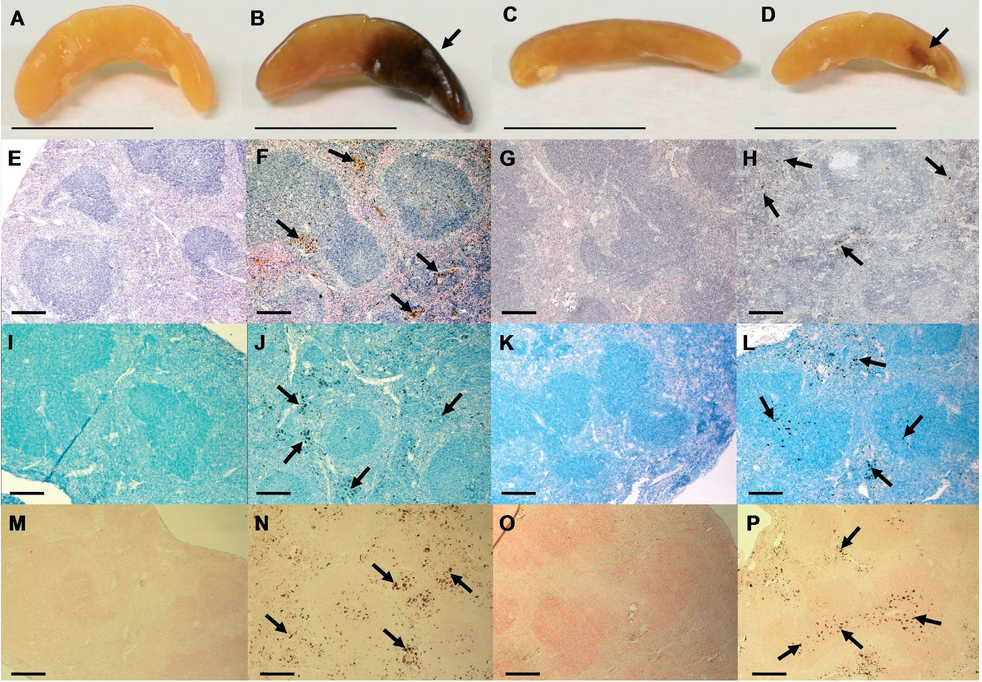
316
D. Michalczyk-Wetula and others
2013
dehydrated, sealed in balsam and covered with glass cov-
erslip like for HE staining (Zawistowski, 1983).
Fontana-Masson (FM) staining for melanin. Due
to the sensitivity of the applied ammoniacal silver nitrate,
it was prepared immediately before the staining proce-
dure. Concentrated ammonia was added drop by drop
to 20 ml of 10% solution of silver nitrate until the white
precipitate of silver(I) oxide was almost dissolved (hardly
noticeable opalescence). The obtained solution was dilut-
ed by adding 20 ml of distilled water, then filtered and
stored at 4°C in a bottle protected from light.
Deparaffinized slides with samples were rinsed in dis-
tilled water and incubated in silver solution for 40 min at
56°C in a Coplin jar covered with aluminium foil, while
the control slides were incubated similarly in distilled wa-
ter. After washing in distilled water, the slides were incu-
bated in 5% sodium thiosulphate (3 min), flushed with
tap water (3 min), counterstained in 0.5% aqueous so-
lution of toluylene red (neutral red) for 5 min to stain
nuclei, flushed with tap water again, dehydrated by im-
mersion for a few seconds in the ethanol series (70, 96
and 100%, v/v; x 2 each) and then in xylene (10 min),
whereupon the slides were conserved with balm and cov-
ered with a glass coverslip (Bancroft & Stevens, 1982).
EPR measurements. Whole amelanotic and melanot-
ic spleens were analyzed in a Dewar quartz tube in liquid
nitrogen (77 K) at X-band (ca. 9.2 GHz), 4 mW micro-
wave power and 5 Gs modulation amplitude. Amplifica-
tion of the s ignal was set at 8 x 105 (melanotic spleens)
or 1.25 x 106 (amelanotic spleens). Each spectrum was
averaged from 3 scans at 200 s scan time and 0.3 s time
constant.
Statistical evaluation of the data. We examined 1-5
experimental groups, each of 2-8 animals, per time point
(5-22 animals per time point). We expressed the aver-
age melanotic area of a spleen (% of the total area) as
the mean of the pooled data for a time point ± S.E. We
also calculated the total percentage of spleens revealing
melanosis per time point (i.e. pooled groups examined at
a given time point). Altogether we examined 161spleens
(92 control and 69 CYP-treated). The two-tailed inde-
pendent Student’s ¿-test was used to evaluate the statis-
tical significance of the differences between the means,
and the Snedecor F test to assess the significance of the
differences in variances. The differences were accepted as
significant for p < 0.05.
RESULTS AND DISCUSSION
Visualisation of splenic melanin
Splenic melanosis manifests itself macroscopically
(Fig. 2A-D) and has been described in C57BL mice as
“black spots” (Weissman, 1967). It is a “yes-or-no”
phenomenon, and for yet unknown reasons in all inves-
tigated groups there are animals with either melanotic,
or non-melanotic spleens. As a result, in a given animal
the existence of splenic melanosis cannot be determined
without laparotomy (Weissman, 1967; van der Heijden et
Figure 2. Macroscopic (A-D) and microscopic (E-P) manifestation of splenic melanosis in C57BL/6 mice.
Black spots in normal (B); and cyclophosphamide-treated (D; i.p. 120 mg/kg body weight, on day 9 p.d.) spleens and amelanotic spleens
(A, C, respectively). E-P, corresponding histological examinations of spleens from pictures A-D (respectively). E-H, hematoxylin and eosin
staining; I-L May-Grunwald-Giemsa staining; M-P, Fontana-Masson histochemistry. Arrows, melanin. Untreated amelanotic spleen (A, E, I,
M) — day 15 p.d., the other pictures — day 13 p.d. Scale bars: A-D, 1 cm; E-P, 100 pm.

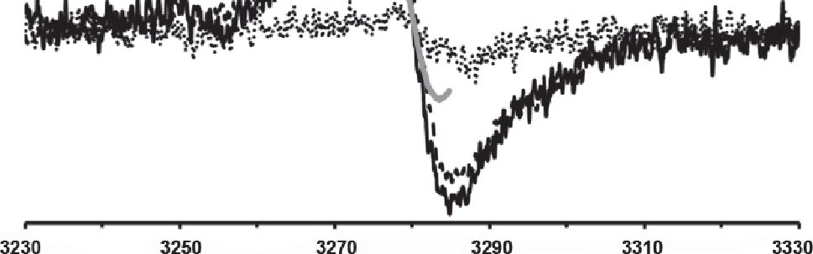
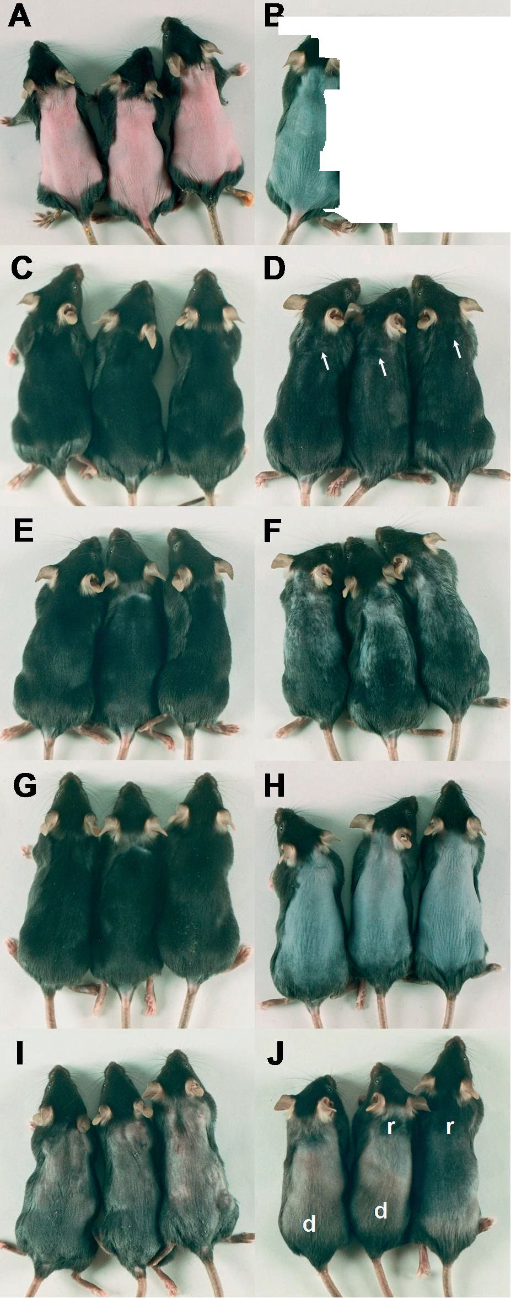

Vol. 60
Splenic melanosis during hair cycle
317
md+_01
md+_02
mel-
DPPH
Magnetic Field [Gs]
Figure 3. Electron paramagnetic resonance signals of normal
C57BL/6 murine spleens.
mel +_01, mel +_02, melanotic spleens (day 15, and day 0 p.d.,
respectively). mel-, amelanotic spleen (day 0 p.d.). DPPH, the free
radical standard. For parameters of EPR assay see "Material and
Methods”.
aL, 1995; Plonka et al., 2005). On the other hand, as the
black spot is sharply separated from the amelanotic back-
ground, it is easy to assess melanosis macroscopically as
the average percentage of the melanotic area of spleens
and the percentage of mice revealing melanosis in a giv-
en group.
We have shown here that melanin granules can be
histologically visualized by means of all the applied meth-
ods. As it can be seen in Fig. 2E—P, the depicted melanin
granules are dyed in a comparable way — the gamut of
colors ranges from yellow-brown to black. On the basis
of the properties of the applied chromophore molecules,
one may attribute the positive result of staining to basic
dyes (methylene blue and its derivatives) due to the nega-
tive net charge of melanin. However, a touch of yellow
(e.g. Fig. 2F) suggests a contribution of eosine Y, pos-
sibly thanks to the n-n stacking interaction (similar to
that present in the aggregates of eumelanin promolecules;
Meredith & Sarna, 2006).
Metallic silver (Fig. 2M—P) has been shown to be an
effective marker of melanin granules in Fontana-Masson
staining (Slominski et al, 1994; 1996; 2004; 2005). How-
ever, to prevent ‘false positive’ results, the time of incu-
bation in the solution of diamminesilver(I) nitrate should
not be exceeded. According to our observations, a sig-
nificant concentration of melanin may sometimes lead to
the excessive intensity of silver deposition, and prolonga-
tion of the incubation time may lead to non-specific pre-
cipitation of silver(0), possibly due to other mild reducing
agents apparently present in cells. Nevertheless, while the
time of incubation in “silver solution” should always be
carefully considered, sometimes a slight prolongation or
even moderate heating of the bath increases the quality
of the picture. To sum up, a negative control (incubation
without silver nitrate) is always indispensable.
It should be stressed that neither of the two “non-sil-
ver” methods (HE or MGG), stains melanin specifically.
Their role is to increase the contrast between the back-
ground and melanin granules. On the contrary, FM stain-
ing is the method which directly, histo chemically stains
melanin and as such, it may be applied to confirm the
reducing potential of the previously visualized granules.
A perfect, independent method to determine direct-
ly the presence of melanin in a given sample is EPR
spectroscopy (Sarna & Plonka, 2005). The results of
EPR assay of the spleens of young mice with the pres-
ence (mel+) and the absence of visible melanization
(mel-) are shown in Fig. 3. Additionally, an EPR spec-
trum of DPPH was recorded as a free radical standard
(g = 2.0037 ± 0.0002; Wertz & Bolton, 1984). The shape
Figure 4. Macroscopic manifestation of hair cycle and cyclophos-
phamide-induced alopecia in C57BL/6 mice.
(A) female, 7 week-old mice were depilated in telogen (day 0, note
the pink color of the back skin), and (B) injected i.p. CYP (120 mg/
kg body weight ) on day 9, i.e. at the beginning of anagen VI (note
the dark-blue color of the skin due to intensive melanogenesis).
The first symptoms of alopecia were noticeable on day 13 p.d. (D
— white arrows), and progressed through day 14 (F) up to day
15 (H), while in control mice the hair follicles produced a normally
pigmented hair coat (C, E, G — vehicle control, day 13, 14, 15 p.d.,
respectively). Note the deep-blue color of the bald skin on day 15
p.d. (H). The hair coat of the CYP-treated animals was still recover-
ing on day 27 (J) when the skin still revealed symptoms of dystro-
phy (impaired pigmentation — d) beside regions of skin with hair
follicles in the 2nd (recovery) anagen (r), while the hair of control
mice (I) had been for a long time in deep telogen (note the pink
color of the skin uncovered by shaving).
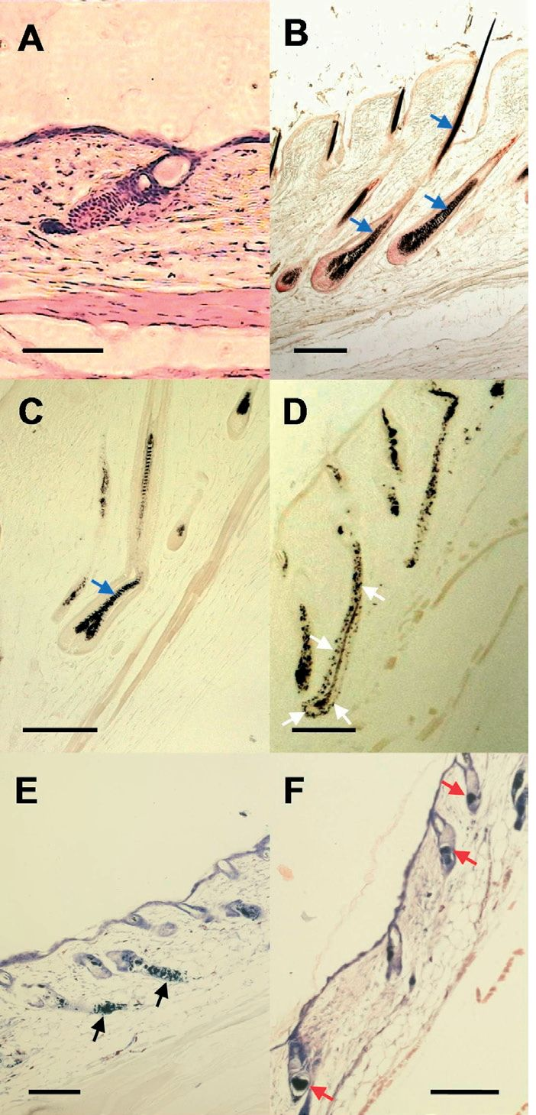
318
D. Michalczyk-Wetula and others
2013
of the splenic signal and its position prove that all the
observed radical centres are isolated and each contains
only one unpaired electron not coupled with any other
electron or nuclear spin, therefore confirming the pres-
ence of eumelanin in the spleens (Meredith & Sarna,
2006).
The mel- signal is distinctly weaker than both the mel+
ones, and originates from endogenous free radicals asso-
ciated with mitochondrial respiration (Fig. 3; Slominski
et al, 1994; Plonka et al, 2003; Elas et al, 2008). Since,
due to a relatively small amount of melanin in the spleen,
the melanin-derived signal is rather weak as compared to
the non-melanin one, the quantitative EPR determination
of melanin may be charged with a relatively substantial
experimental error. Moreover, despite direct and unam-
biguous correlation between the presence of melanin
spots on the tested spleens and the occurrence of the
EPR signal characteristic of eumelanins, EPR spectros-
copy does not provide resolution on the “cellular” level.
The recently reported attempts to employ the technique
of EPR imaging (EPRI; Godechal et al., 2012) did not
provide a satisfactory resolution. As such, EPR consti-
tutes a complementary approach to histological staining
protocols which gives an insight into the distribution of
melanin in the tissue.
Hair cycle and melanogenesis
In the murine trunk skin mature, melanin-producing
melanocytes are present only in the anagen hair follicles
(Slominski & Paus, 1993; Slominski et al, 1994). Mac-
roscopically it is manifested by a grey—to—black color
of the skin (Fig. 4B, C), in contrast to the pink telogen
skin (Fig. 4A, I), totally devoid of mature (i.e. melanin-
producing) melanocytes (Fig. 5A). The changes of mac-
roscopic skin are particularly well noticeable in the de-
pilated skin (Fig. 4A, B). The active melanogenesis starts
about day 5 p.d. (anagen III), and lasts to the end of ana-
gen VI (day 15—16 p.d.; Muller-Rover et al, 2001). The
hair follicle in anagen VI is fully developed and contains
a strongly melanized hair shaft and a developed popula-
tion of mature, melanin-producing melanocytes (Fig. 5B,
C).
If a strong alkylating chemotherapeuticum, like CYP, is
applied on day 9 p.d., i.e. at the beginning of anagen VI
(Fig. 1, 4B, 5B), the hair follicles react by acute dystro-
phy (Braun-Falco, 1961; Kostanecki et al, 1967; Paus et
al, 1994a; Slominski et al, 1996). The whole population
of multiplying melanocytes and keratinocytes undergo
abrupt apoptosis (Hendrix et al, 2005), resulting in alope-
cia (Fig. 4D, F, H), whereas in the control skin (Fig. 4C,
E, G) the anagen VI hair follicles still produce normally
pigmented hair shafts (Fig. 5B, C). As a result, on day
15 the CYP-treated animals are almost completely devoid
of hair (Fig. 4H). The color of the skin, however, still
indicates the presence of melanin. And indeed, ectopic,
extracellular melanin deposition (Fig. 5D—F) is associated
with both possible pathways that allow the dystrophic hair
follicles to recover from the CYP-induced impairment:
via dystrophic anagen (Fig. 1, 5D), or via dystrophic cat-
agen (Fig. 1, 5E) and telogen (Fig. 1, 5F), each accompa-
nied by a transient hair loss (Paus et al, 1994a; Slominski
et al, 1996; Hendrix et al, 2005). This may be particularly
well appreciated in comparison to normal anagen VI hair
follicles, in the histological pictures with the FM staining
of melanin (Fig. 5C). Actually, the CYP-induced dystro-
phy may be very strong (Hendrix et al, 2005) and it af-
fects the apparatus of hair follicle melanogenesis, causing
ectopic (hair root sheaths, sebaceous gland etc.) melanin
Figure 5. Histological manifestation of hair cycle-related mel-
anogenesis and its impairment due to cyclophosphamide in
C57BL/6 mice.
(A) a telogen hair follicle without melanocytes on day 0. (B, C)
normal anagen VI hair follicles with normally pigmented hair shafts
(blue arrows) on day 9 (B), and 15 p.d. (C). (D, E, F) dystrophic hair
follicles on day 15 p.d in late dystrophic anagen (white arrows),
late dystrophic catagen (black arrows) and dystrophic telogen (red
arrows). The criteria of dystrophy — according to Hendrix et al.,
(2005). The black and white arrows point at both the granules of
ectopic melanin, and melanin clumping in the hair channel (red
arrows). This melanin was expected to be scavenged by melano-
phages and transported to the spleen. A, E, F — HE; B, C, D — FM.
Scale bars, 100 pm.
deposition and clumping of the amorphous melanin mass
in the hair channel (Slominski et al, 1996; Hendrix et al,
2005; Paus et al, 2013). We suspected this ectopic mela-
nin (Fig. 5D—F) to be the source of the presumptive in-
crease in melanin deposition expected by us to occur in
the spleen after CYP-induced alopecia.
Splenic melanosis during normal and CYP-impaired hair
cycle
In Fig. 6 we have shown the summary of our exten-
sive observations of the correlation between splenic mel-
anosis and the progress of hair cycle, at particular time
points after depilation. The samples were collected over
a long time and pooled from several independent experi-
ments and from the control groups of other experiments.
As the splenic melanization is a “yes-or-no” phenom-
enon (Plonka et al, 2005), only such an extensive study
could deliver any quantitative comparisons.
And indeed, as it can be seen in Fig. 6A, the intensity
of splenic melanosis changes according to the progress
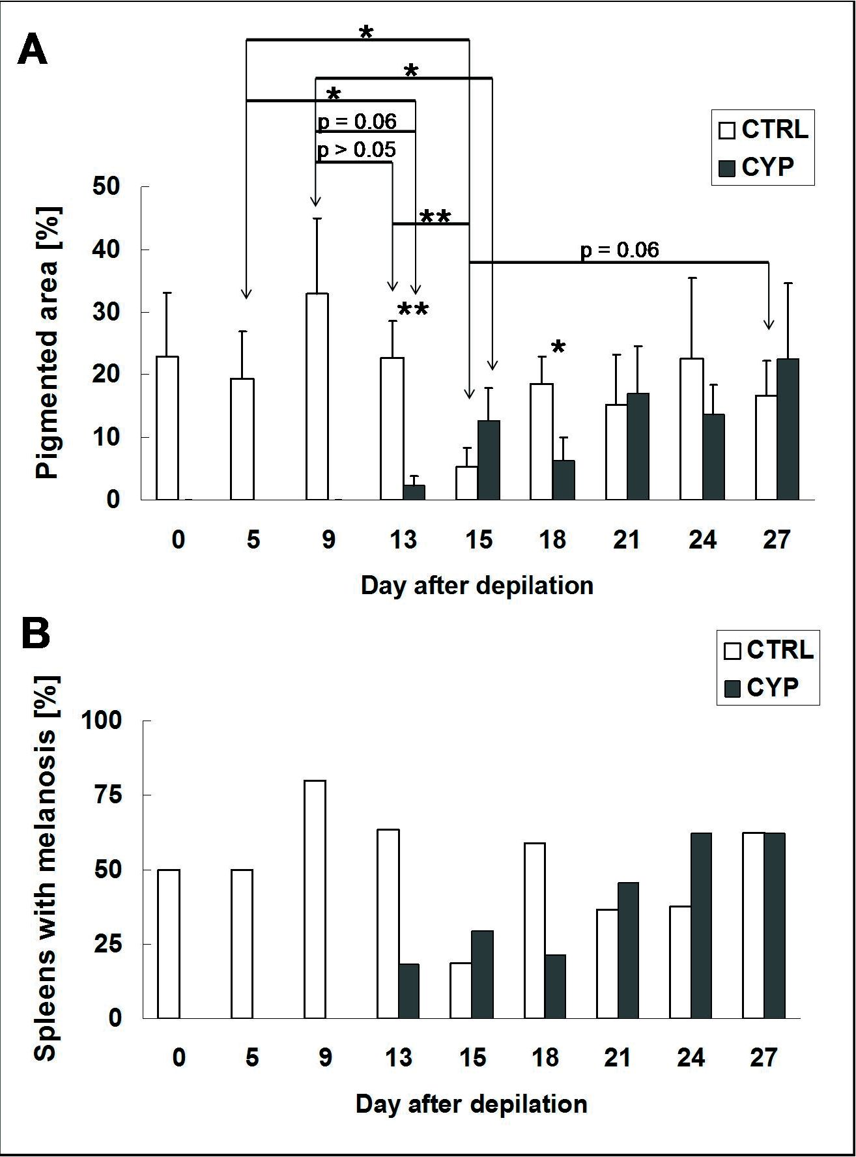
Vol. 60
Splenic melanosis during hair cycle
319
Figure 6. Splenic melanosis at particular time points of depilation induced, normal
(CTRL) and dystrophic (CYP) hair cycle in C57BL/6 mice.
(A) average area of melanosis (means ± S.E.M.); (B) total percentage of melanotic
spleens observed at a particular time point. CYP, cyclophosphamide (i.p. 120 mg/kg
body weight on day 9 p.d.). *0.05 > p > 0.01, **0.01 > p > 0.001.
of normal hair cycling. The most important observa-
tion concerns the period shortly preceding and following
the onset of catagen, with a strong drop in the melani-
zation (Fig. 6A, B, day 15). This drop was followed by
an increase during the subsequent long telogen period,
confirming our earlier observations (Plonka et al, 2005).
Catagen, as other stages of the synchronized hair cycle,
is a phenomenon systemically influencing the murine or-
ganism (Slominski et al, 1997; Paus et al, 1999). Here we
show its association with a drop in splenic melanosis in
C57BL/6 mice.
If this is the case, the drop should be observed also
in the CYP-treated animals, moreover, earlier than in the
controls. And indeed, we found it happening, as shown
in Fig. 6 (day 13). The decrease is abrupt and followed
by a gradual re-storage of melanin in the spleens, up to
the level of the control (Fig. 6, days 13—27). This can be
confirmed with macroscopic (Fig. 2C, D), and histologi-
cal examination of the spleens, revealing smaller and few-
er deposits of melanin in the organ using the FM stain-
ing (Fig. 2P) confirmed by the MGG (Fig. 2L), and HE
(Fig. 2H) visualization.
As chemotherapy with CYP influences strongly the
follicular melanogenesis, we expected a reverse effect in
the spleens. We expected scavenging of
the abundant CYP-induced ectopic mela-
nin mass (Fig. 4D—F) by melanophages,
and consequently, its massive and de-
layed deposition in the spleen. Mean-
while, we have found poorer melanization
of CYP-treated than untreated spleens
for at least 6 days (Fig. 2 D, L, H, P, 6
day 13—18) and a slow re-melanization of
the spleens to the level of the control.
The overall picture of the splenic
melanosis in parallel to the progress of
normal or CYP-disrupted hair cycle is
as follows. There are three clear phases
of the phenomenon. Initially, melanosis
is quite high, and culminates on day 9.
Next, it drops down till day 15, i.e. the
day directly preceding catagen. Finally,
it increases slowly back on the border
of statistical significance for the next 12
days (during telogen). If CYP is adminis-
tered on day 9, the drop is much more
abrupt, (the minimal value on day 13),
followed by a 15-day re-pigmentation.
However, on day 18 the CYP-treated
spleen pigmentation is still significantly
lower than the control. The CYP-treated
spleens reveal decreased pigmentation
longer than the normal ones. It can be
manifested both macroscopically (Fig.
2C, D), and histologically (Fig. 2G, H,
K, L, O, P), as well as supported quanti-
tatively (Fig. 6).
The peak of splenic melanization can
be observed on day 9, i.e. at the onset
of anagen VI. As this is also the point
of the highest activity of the hair-cycle-
associated melanin synthesis (Plonka
et al, 1995), splenic melanosis could be
associated with skin melanogenesis, if it
was not for the presence of splenic mela-
nosis in the absence of melanin synthe-
sis in the telogen skin (from day 18 to
day 27; see Fig. 4I ). During this time the
CYP-treated skin is a mosaic of all the
phases of normal and dystrophic hair cy-
cle (Plonka et al, 2006; see also Fig. 4J). The lowest in-
tensity of splenic melanization is associated with the on-
set of dystrophic anagen and catagen (Fig. 5D—F), which,
after injection of CYP on day 9, can be observed on day
12—13, i.e. earlier than in the control animals (Paus et
al, 1994a; Hendrix et al, 2005). Concluding, our observa-
tions strongly suggest that the primary factor responsible
for splenic melanosis is the stage of the hair cycle, not
the content of ortho- or ectopic melanin in the hair fol-
licle. However, since even in the CYP-treated mice, ca.
one fifth of the spleens (Fig. 6B) revealed weak (Fig. 6A)
melanosis on day 13 we still cannot explain the reason
of such a “digital” (“zero-or-one”) manifestation of this
phenomenon in C57BL/6 mice.

CONCLUSIONS
The results of our experiments lead to important prac-
tical implications. First of all, CYP abruptly and for a consid-
erable period decreases splenic melanosis despite deposition of
ectopic melanin in the CYP-treated skin. During normal
catagen melanin is released from the apoptotic melano-
320
D. Michalczyk-Wetula and others
2013
cytes and keratinocytes in the form of apoptotic bodies
easy to phagocyte and partially degrade (Tobin, 1998).
CYP causes massive apoptosis of various cells and depo-
sition of melanin in the form of amorphous agglomer-
ates, which are probably difficult to be absorbed (Paus et
al, 1994a; Hendrix et al, 2005). Moreover, the popula-
tion of phagocytic cells (Quemeneur et al, 2003; Hirsch
et al, 2004; Meinhardt et al., 2011) including splenocytes
(Teryukova et al, 2011) may be transiently decreased and
their capacity of devouring melanin — transiently limited.
This means that the “naked”, toxic melanin remains in
the CYP-treated skin (see Fig. 5D—F), where it may add
to the bad condition of skin and, consequently, of the
whole organism (Chuong et al, 2002; Tobin, 2006). CYP
may also negatively influence the spleen itself, which, be-
sides poorer melanosis, may be manifested by e.g. a smaller
size of the organ (Fig. 2C, D; Teryukova et al, 2011).
The second important conclusion concerns the sys-
temic effects of the hair cycle: catagen, both normal
and dystrophic, is always associated with a drop in the
splenic melanosis. Whatever mechanism stands behind
this phenomenon, catagen in the depilation-induced hair
cycle causes systemic effects. Therefore, regulation of
this phase is probably dependent on factors affecting the
whole organism.
Acknowledgements
This study was supported in part by grant PBZ-
KBN-101/T09/2003/12 from the Ministry of Science and
Informatization, Poland, to P.M.P. The Faculty of Bio-
chemistry, Biophysics and Biotechnology of the Jagiel-
lonian University is a beneficiary of structural funds
from the European Union (grant No: POIG.02.01.00-12-
064/08 — Molecular biotechnology for health).
REFERENCES
Avwioro G (2011) Histochemical uses of haematoxylin — a review. J
Pharm Clin Sci 1: 24—34.
Bancroft JD, Stevens A (1982) Theory and practice of histological techniques.
Churchill Livingstone, Edinburgh, Scotland.
Barcia JJ (2007) The Giemsa stain: its history and applications. Int J
Surg Pathol 15: 292—196.
Barter R, Pearse AGE (1955) Mammalian enterochromaffin cells as
the source of serotonin (5-hydroxytryptamine). J Pathol Bacteriol 69:
25-31.
Borovansky J, Elleder M (2003) Melanosome degradation: fact or fic-
tion. Pigment Cell Res 16: 280-286.
Braun-Falco O (1961) Klinik und Pathomechanismus der Endoxan-
Alopecie als Beitrag zum Wesen cytostatischer Alopecien. Arch Klin
Exp Dermatol 212: 194-216 (in German).
Chase HB (1954) Growth of the hair. Physiol Rev 34: 113-126.
Chase HB, Eaton GJ (1959) The growth of hair follicles in waves. Ann
N Y Acad Sci 83: 365-368.
Chuong CM, Nickloff BJ, Elias PM, Goldsmith LA, Macher E,
Maderson PA, Sundberg JP, Tagami H, Plonka PM, Thestrup-Ped-
ersen K, Bernard BA, Schröder JM, Dotto P, Chang MHC, Williams
ML, Feingold KR, King LE, Kligman AM, Rees JL, Christophers E
(2002) What is the ‘true' function of skin? Exp Dermatol 11: 159-187.
Commoner B, Townsend J, Pake GW (1954) Free radicals in bio-
logical materials. Nature 174: 689-691.
Crichton DN, Busutil A, Price WH (1978) Splenic lipofuscinosis in
mice. J Pathol 126: 113-120.
Divya L, Beyo RS, Sreejith P, Akbarsha MA,Oommen OV (2010) Skel-
etal muscle-melanocyte association during tadpole tail resorption in a
tropical frog, Chnotarsus curtipes Jerdon (Anura, Ranoidea). Zoology 113:
175-183.
Dry FW (1926) The coat of the mouse (Mus musculus). J Genet 16: 281-
340.
Elas M, Bielanska J, Pustelny K, Plonka PM, Drelicharz L, Skorka T,
Tyrankiewicz U, Wozniak M, Heinze-Paluchowska S, Walski M, Wo-
jnar L, Fortin D, Ventura-Clapier R, Chlopicki S (2008) Detection
of mitochondrial dysfunction by EPR technique in mouse model of
dilated cardiomyopathy. Free Radic Biol Med 45: 321-328.
Felix CC, Hyde JS, Sarna T, Sealy RC (1978) Melanin photo reactions
in aerated media: electron spin resonance evidence for production
of sup er oxide and hydrogen peroxide. J Am Chem Soc 100: 3922-
3926.
Fontana A (1912) Verfahren zur intensiver und raschen Farbung des
Treponema pallidum und anderer Spirochäten. Dermatol Wochenschr 55:
1003-1004 (in German).
Godechal Q, Leveque P, Marot L, Baurain JF, Gallez B (2012) Optimi-
zation of electron paramagnetic resonance imaging for visualization
of human skin melanoma in various stages of invasion. Exp Dermatol
21: 341-346.
Hendrix S, Handjiski B, Peters EM, Paus R (2005) A guide to assessing
damage response pathways of the hair follicle: lessons from cyclo-
phosphamide-induced alopecia in mice. J Invest Dermatol 125: 42-51.
Hirsh M, Carmel J, Kaplan V, Livne E, Krausz MM (2004) Activity
of lung neutrophils and matrix metalloproteinases in cyclophospha-
mide-treated mice with experimental sepsis. Int J Exp Pathol 85:
147-157.
Kostanecki W, Kwiatkowska E, Zak R (1967) Der Einfluß des Endoxans
auf die Haarmelanogenese und das Haarwachstum bei Mäusen. Arch Klin
Exp Dermatol 230: 396-401 (in German).
Lazova R, Klump V, Pawelek J (2010) Autophagy in cutaneous malig-
nant melanoma. J Cutan Pathol 37: 256-268.
Lu Z, Fischer TW, Hasse S, Sugawara K, Kamenisch Y, Krengel S,
Funk W, Berneburg M, Paus R (2009) Profiling the response of
human hair follicles to ultraviolet radiation. J Invest Dermatol 129:
1790-1804.
Lundqvist M, Arnberg H, Candell J, Malmgren M, Wilander E, Grime-
lius L, Öberg K (1990) Silver stains for identification of neuroen-
docrine cells. A study of the chemical background. Histochem J 22:
615-623.
Masson P (1914) La grande endocrine de l’intestin chez l’homme. Les
Comptes Rendus de l’Academie des Sciences (Paris) 138: 59-61 (in French).
Mayer P (1891) Ueber das Farben mit Hämatoxylin. Mitt Zool Stat. Ne-
apel 10: 170-186 (in German).
Mayer P (1904) Notiz über Hämatein und Hämalaun. Z Wiss Mikrosk
20: 409-411 (in German).
McGarvey EL, Baum LD, Pinkerton RC, Rogers LM (2001) Psycho -
logical sequelae and alopecia among women with cancer. Cancer Pract
9: 283-289.
Meinhardt C, Büning J, Fellermann K, Lehnert H, Schmidt KJ (2011)
Cyclophosphamide therapy in Sweet's syndrome complicating refrac-
tory Crohn’s disease — Efficacy and mechanism of action. J Crohns
Colitis 5: 633-637.
Meredith P, Sarna T (2006) The physical and chemical properties of
eumelanin. Pigment Cell Res 19: 572-594.
Michalczyk D, Popik M, Salwinski A, Plonka PM (2009) Extradermal
melanin transfer? Lack of macroscopic spleen melanization in old
C57BL/6 mice with de-synchronized hair cycle. Acta Biochim Pol 56:
343-353.
Moore S, Seemayer TA, Tremblay G (2001) The career and influence
of Pierre Masson (1875-1959). Int J Surg Pathol 9: 231-236.
Müller-Röver S, Handjiski B, van der Veen C, Eichmüller S, Foitzik K,
McKay IA, Stenn KS, Paus R (2001) A comprehensive guide for the
accurate classification of murine hair follicles in distinct hair cycle
stages. J Invest Dermatol 117: 3-15.
Paus R, Stenn KS, Link RE (1990) Telogen skin contains an inhibitor
of hair growth. Br J Dermatol 122: 777-784.
Paus R, Handjiski B, Eichmüller S, Czarnetzki BM (1994a) Chemother-
apy-induced alopecia in mice. Induction by cyclophosphamide, inhi-
bition by cyclosporine A, and modulation by dexamethasone. Am J
Pathol 144: 719-734.
Paus R, Maurer M, Slominski A, Czarnetzki BM (1994b) Mast cell in-
volvement in murine hair growth. Dev Biol 163: 230-240.
Paus R, Christoph T, Müller-Röver S (1999a) Immunology of the hair
follicle: a short journey into terra incognita. J Invest Dermatol Symp
Proc 4: 226-234.
Paus R, Müller-Röver S, Van Der Veen C, Maurer M, Eichmüller
S, Ling G, Hofmann U, Foitzik K, Mecklenburg L, Handjiski B
(1999b) A comprehensive guide for the recognition and classifica-
tion of distinct stages of hair follicle morphogenesis. J Invest Dermatol
113: 523-532.
Paus R, Haslam IS, Sharov AA, Botchkarev VA (2013) Pathobiology of
chemotherapy-induced hair loss. Lancet Oncol 14: e50-e59.
Pilas B, Sarna T (1985) Quantitative determination of melanin in pig-
mented cells by electron spin resonance spectroscopy. In Pigment Cell
1985. Biological, Molecular and Clinical Aspects of Pigmentation. Bagnara J,
Klaus S N, Paul E, Schartl M, eds, pp. 97—103. University of Tokyo
Press, Tokyo.
Plonka P, Plonka B, Paus R (1995) Biophysical monitoring of melano-
genesis as a tool for pigment and hair research. Arch Dermatol Res
287: 687-690.
Plonka PM, Slominski AT, Pajak S, Urbanska K (2003) Transplantable
melanomas in gerbils (Meriones unguiculatus). II: Melanogenesis. Exp
Dermatol 12: 356-364.
Plonka PM, Michalczyk D, Popik M, Handjiski B, Slominski A, Paus R
(2005) Splenic eumelanin differs from hair eumelanin in C57BL/6
mice. Acta Biochim Pol 52: 433-441.
Vol. 60
Splenic melanosis during hair cycle
321
Plonka PM, Handjiski B, Michalczyk D, Popik M, Paus R (2006) Oral
zinc sulphate causes murine hair hypopigmentation and is a potent in-
hibitor of eumelanogenesis in vivo. Br J Dermatol 155: 39-49.
Quemeneur L, Michallet MC, Ferraro-Peyret C, Saint-Mezard P,
Benetiere J, Ducluzeau MT, Nicolas JF, Revillard JP (2003) Immu-
nosuppressive antimetabolites inhibit induction of contact hypersen-
sitivity while lymphoablative drugs also prevent its expression. Eur J
Dermatol 13: 540-547.
Rakers S, Gebert M, Uppalapati S, Meyer W, Maderson P, Sell AF,
Kruse C, Paus R (2010) ‘Fish matters’: the relevance of fish skin
biology to investigative dermatology. Exp Dermatol 19: 313-324.
Romeis B (1991) Mikroskopische Technik. Urban & Schwarzenberg,
Muenchen, Germany (in German).
Sarna T, Plonka PM (2005) Biophysical studies of melanin: paramag-
netic, ion-exchange and redox properties of melanin pigments and
their photoreactivity. In Biomedical ESR. Biological Magnetic Resonance
Series. Eaton SS, Eaton GR, Berliner LJ, eds, vol 23, pp 125—146.
Kluwer Academic Publishers, The Netherlands, New York, Boston.
Sealy RC, Hyde JS, Felix CC, Menon IA, Prota G (1982) Eumela-
nins and pheomelanins: characterization by electron spin resonance
spectroscopy. Science 217: 545-547.
Shirai A, Tsunoda H, Tamaoki T, Kamiya T (2001) Topical application
of cyclosporine A induces rapid-remodeling of damaged anagen hair
follicles produced in cyclophosphamide administered mice. J Derma-
tol Sci 27: 7-13.
Slominski A, Paus R (1993) Melanogenesis is coupled to murine anagen:
towards new concepts for the role of melanocytes and the regula-
tion of melanogenesis in hair growth. J Invest Dermatol 101: 90S-97S.
Slominski A, Paus R, Plonka P, Chakraborty A, Maurer M, Pruski D,
Lukiewicz S (1994) Melanogenesis during the anagen-catagen-telogen
transformation of the murine hair cycle. J Invest Dermatol 102: 862-
869.
Slominski A, Paus R, Plonka P, Handjiski B, Maurer M, Chakraborty
A, Mihm MC Jr: (1996) Pharmacological disruption of hair follicle
pigmentation by cyclophosphamide as a model for studying the mel-
anocyte response to and recovery from cytotoxic drug damage in
situ. J Invest Dermatol 106: 1203-1211.
Slominski A, Goodman-Snitkoff G, Maurer M, Paus R (1997) Hair
cycle-associated changes in splenocyte proliferation. In Vivo 11: 101-
102.
Slominski A, Tobin D J, Shibahara S, Wortsman J (2004) Melanin pig-
mentation in mammalian skin and its hormonal regulation. Physiol
Rev 84: 1155-1228.
Slominski A, Wortsman J, Plonka PM, Schallreuter KU, Paus R, Tobin
DJ (2005) Hair follicle pigmentation. J Invest Dermatol 124: 13-21.
Sundberg JP (1991) Pigmented spleens in C57BL mice. Labor Anim 25:
85-86.
Swartz HM, Mason RP, Hogg N, Kalyanaraman B, Sarna T, Plonka PM,
Zareba M, Gutierrez PL, Berliner LJ (2005) Free Radicals and Medi-
cine. In Biomedical ESR. Biological Magnetic Resonance Series. Eaton SS,
Eaton GR, Berliner LJ, eds, vol 23, pp 25—74. Kluwer Academic
Publishers, The Netherlands, New York, Boston.
Teryukova NP, Pogodina ON, Blinova GI, Ivanov VA (2011) Immu-
nomodulating effect of cyclophosphamide on cytotoxic activity of
rats and mice splenocytes. Cell Tissue Biol 5: 586-594.
Tobin DJ (1998) A possible role for Langerhans cells in the removal of
melanin from early catagen hair follicle. Br J Dermatol 168: 795-798.
Tobin DJ (2006) Biochemistry of human skin — our brain on the out-
side. Chem Soc Rev 35: 52-67.
van der Heijden A, van Dik JE, Lemmens AG, Beynen AC (1995)
Spleen pigmentation in young C57BL mice caused by accumulation
of melanin. Labor Anim 29: 459-463.
Veninga TS, Wieringa RA, Morse H (1989) Pigmented spleens in
C57BL mice. Labor Anim 23: 16-20.
Wassermann HP (1967) Extension of the concept “vertebrate epider-
mal melanin unit” to embrace visceral pigmentation and leucocytic
melanin transport. Nature 213: 282-283.
Weissman I (1967) Genetic and histochemical studies on mouse spleen
black spots. Nature 215: 315.
Wertz J, Bolton J (1986) Electron spin resonance. Elementary theory and practi-
cal applications. Chapman & Hall, New York, London.
Wood JM, Decker H, Hartmann H, Chavan B, Rokos H, Spencer JD,
Hasse S, Thornton MJ, Shalbaf M, Paus R, Schallreuter KU (2009)
Senile hair graying: H2O2-mediated oxidative stress affects human
hair color by blunting methionine sulfoxide repair. FASEB J 23:
2065-2075.
Zawistowski S (1983) Histological technique, histology and the principles of his-
topathology. State Company of Medical Editors PZWL, Warsaw (in
Polish).

